Daffodil International University
Department of Computer Science and Engineering
MSc. in Computer Science and Engineering
Course Code: CSE698/CSE699, Course Title: Project/Thesis (Phase I)
Proposal Approval Form
Submitted by
Student Name: Md. Robiul Islam Rabby
Student ID: 1910046
PERFORMANCE EVALUATION OF YOLO MODELS FOR OBJECT DETECTION IN AUTONOMOUS VEHICLES UNDER ADVERSE WEATHER CONDITIONS

Abstract
This research evaluates the performance of various YOLO-based object detection models (YOLOv8x, YOLOv11n, YOLOv11s, YOLOv11m, YOLOv11l, YOLOv11x, and YOLOv12x) in the context of autonomous vehicles operating in adverse weather conditions, such as fog, rain, snow, and sandstorms. The goal is to assess the models' robustness and accuracy in environments where visibility is significantly reduced, which is critical for ensuring safe autonomous driving in real-world scenarios. The methodology includes training, validating, and testing the models on the DAWN dataset, augmented with weather-specific conditions. Performance metrics such as precision, recall, F1 score, accuracy, mAP, and mAP@50-95 were used to compare the models' performance. Larger models like YOLOv8x and YOLOv12x outperformed smaller models, showing better detection accuracy under these challenging conditions.
Keywords: Autonomous Vehicles, YOLO, Object Detection, Adverse Weather, Deep Learning, Computer Vision, DAWN Dataset

1. Introduction
1.1 Overview
This chapter introduces the thesis, starting with the motivation behind the research and why this topic was chosen. It then reviews the existing literature, methodologies, and key findings in the field, highlighting the gaps in knowledge that this study aims to address.
1.2 Background and Motivation
The growth of autonomous vehicles (AVs) promises to transform transportation globally. However, their success heavily depends on effective object detection systems that help vehicles accurately perceive their surroundings. A major challenge in real-world use is the effect of weather conditions like fog, rain, snow, and dust storms, which can weaken the performance of visual sensors such as cameras. YOLO-based models, including YOLOv11 variants, YOLOv8x, and YOLOv12x, have proven to be effective for real-time object detection.
2. Problem Statement
Object detection is a crucial task for autonomous systems. However, adverse weather conditions such as rain, snow, fog, and sandstorms severely impact the quality of images captured by sensors like cameras, LiDAR, and radar, reducing the accuracy of object detection.
2.1 Insufficient Focus on Extreme Adverse Weather
A significant gap in current research is the lack of attention to extreme weather conditions, such as sandstorms, blizzards, and sun glare.
2.2 Lack of Comprehensive Datasets
Current research often relies on datasets like DAWN, which primarily focus on fog, rain, and snow.
2.3 Hyperparameter Optimization for AWCs
While YOLO-based models perform well in normal conditions, their effectiveness in adverse weather is limited due to suboptimal configurations.
2.4 Need for Advanced Image Enhancement
Image enhancement techniques like CLAHE and Dehazing improve object detection but are less effective in extreme conditions.
2.5 Real-Time Performance Challenges
Real-time performance for autonomous vehicles is challenging, especially with degraded images from adverse weather conditions.
3. Research Objectives
Based on the identified research gaps, this study aims to achieve the following objectives:
- Evaluate the performance of multiple YOLO-based object detection models under adverse weather conditions.
- Assess model robustness and accuracy in environments with significantly reduced visibility.
- Compare the models' performance using metrics such as precision, recall, F1 score, accuracy, mAP, and mAP@50-95.
- Investigate the trade-off between model size/complexity and detection accuracy.
- Provide insights for selecting appropriate YOLO model variants for autonomous vehicle applications.
- Analyze the impact of weather-specific data augmentation techniques on model generalization.

4. Literature Review
4.1 Case 1: Deep Learning Models for Adverse Weather
Studies by Appiah and Mensah (2023) [1] and Ashraf et al. (2024) [2] have demonstrated that deep learning models like YOLOv5, YOLOv7, and YOLOx can perform well in certain adverse weather conditions.
4.2 Case 2: YOLO Variants Performance
Ashraf et al. (2024) [2] investigated the use of YOLOx for detecting vehicles in snow, sandstorms, rain, and fog. YOLOx-s achieved a mAP of 0.8983 in snow and 0.8656 in sandstorm conditions.
4.3 Case 3: Image Enhancement Techniques
Techniques like CLAHE, Dehazing, and ESRGAN [3] are used to enhance images before feeding them to object detection models.
4.4 Case 4: Hybrid Approaches and Sensor Fusion
Zihan Chu et al. (2024) [4] integrated YOLOv5 with Generative Adversarial Networks (GANs) to boost the resilience of object detection.
4.5 Case 5: Metaheuristic Optimization
Özcan et al. (2024) [5] explored GWO, ARO, and CLEO optimization techniques with YOLOv5, YOLOv7, and YOLOv9, showing a 6% increase in mAP for YOLOv9.
4.6 Case 6: Multi-Sensor Integration
Ashraf et al. (2024) [6] demonstrated that integrating camera and LiDAR data significantly enhanced vehicle detection accuracy.
4.7 Case 7: Small Object Detection
Ashraf et al. (2024) [7] incorporated small-object detection modules into their YOLO-based model.
4.8 Case 8: Speed-Accuracy Trade-off
Research shows that real-time detection can still be achieved by optimizing models and pre-enhancing images.

5. Research Methodology
5.1 Data Collection
The DAWN dataset is utilized for training and evaluating YOLO-based object detection models.
Data Split:
• Training Set: 974 images
• Validation Set: 425 images
• Test Set: Populated using a 70/20/10 split rule
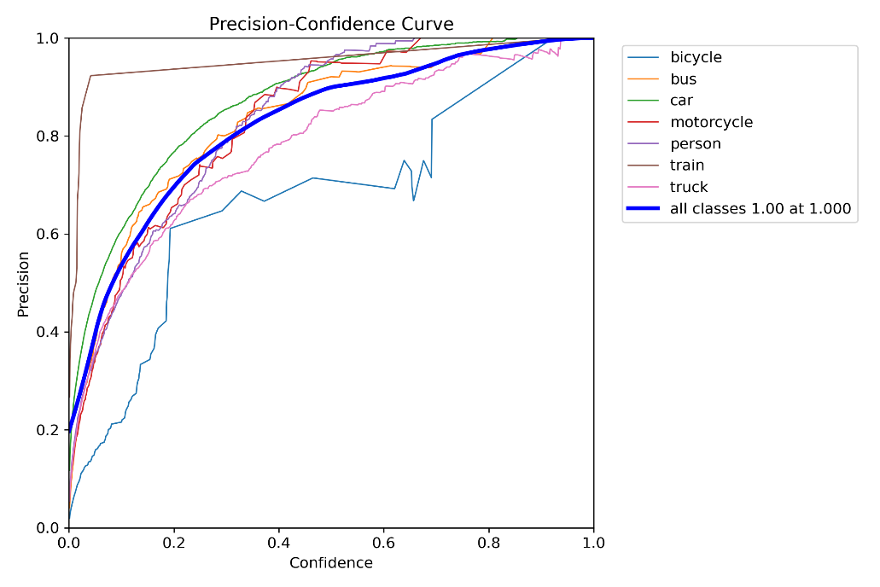
Fig. 2.1: Methodology Workflow
5.2 Data Preprocessing
Data augmentation techniques are employed:
• Fog Simulation: Reduces visibility and introduces blur.
• Rain Simulation: Adds water droplets to the lens.
• Snow Simulation: Introduces snowflakes, causing motion blur.
• Sandstorm Simulation: Adds dust particles, resulting in noise and blur.
5.3 Model Selection
Table 3.1: Model Description
Model | Backbone | Neck | Head | Key Features
YOLOv8x | CSPDarknet | PANet | Multi-task loss | High accuracy, robust under fog, rain, and occlusion
YOLOv11n | Smaller CSPDarknet | Simplified neck | Standard YOLO head | Lightweight, fast inference
YOLOv11s | CSPDarknet (increased depth) | FPN | YOLO head | Balanced speed and accuracy
YOLOv11m | Deeper CSPDarknet | PANet | Multi-task loss | High accuracy, suitable for complex scenes
YOLOv11l | Deeper CSPDarknet | Enhanced PANet | Refined head | High precision for complex environments
YOLOv11x | Deepest CSPDarknet | Optimized PANet | Refined YOLO head | Maximum detection precision
YOLOv12x | Advanced backbone with multi-modal sensor fusion | PANet + FPN | Self-attention mechanisms | Advanced architecture, superior performance

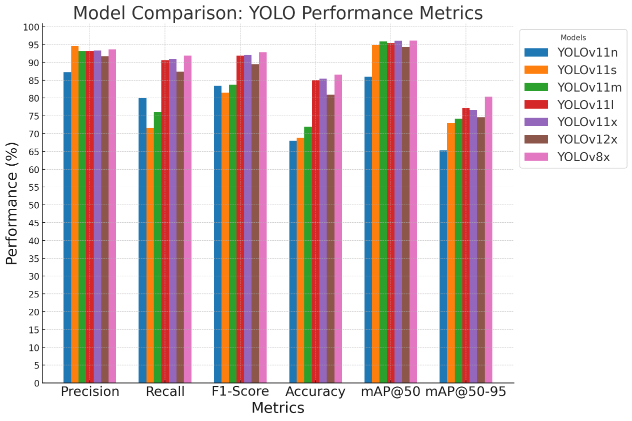
Fig. 3.1: YOLOv8 Basic Architecture
5.4 Training Details
All models are trained with:
• Optimizer: AdamW with learning rate schedules
• Epochs: 120 epochs for each model variant
• Batch Size: 4
• Learning Rate: 0.000909
• Hardware: NVIDIA T4 GPU on Kaggle notebook environment
5.5 Evaluation Metrics
The models are evaluated using:
• Precision: Measures how many predicted objects were correct.
• Recall: Measures how many actual objects were detected.
• F1-Score: A balanced metric combining precision and recall.
• Accuracy: Overall correctness of the model.
• mAP (mean Average Precision): Average precision at various IoU thresholds.
• mAP@50-95: Mean Average Precision evaluated at IoU thresholds from 50% to 95%.

6. Expected Research Outcomes
- Comprehensive performance comparison of seven YOLO model variants under diverse adverse weather conditions.
- Identification of optimal YOLO model configurations for autonomous vehicle applications.
- Quantitative analysis of how different weather conditions affect object detection performance.
- Insights into the effectiveness of weather-specific data augmentation techniques.
- A framework for selecting appropriate YOLO models based on deployment requirements.
- Preliminary findings on the potential of larger YOLO models (YOLOv8x, YOLOv12x) to maintain high detection accuracy.

7. Preliminary Results
The following tables present the preliminary performance analysis of the YOLO models trained on the DAWN dataset with adverse weather augmentations.
7.1 Individual Model Performance
Table 4.1: YOLOv11n Performance
Model | Precision | Recall | F1-Score | Accuracy | mAP@50 | mAP@50-95
YOLOv11n | 87.21% | 79.93% | 83.41% | 67.95% | 85.92% | 65.27%

Table 4.2: YOLOv11s Performance
Model | Precision | Recall | F1-Score | Accuracy | mAP@50 | mAP@50-95
YOLOv11s | 94.57% | 71.61% | 81.51% | 68.79% | 94.84% | 72.94%

Table 4.3: YOLOv11m Performance
Model | Precision | Recall | F1-Score | Accuracy | mAP@50 | mAP@50-95
YOLOv11m | 93.10% | 76.03% | 83.70% | 71.97% | 95.87% | 74.20%

Table 4.4: YOLOv11l Performance
Model | Precision | Recall | F1-Score | Accuracy | mAP@50 | mAP@50-95
YOLOv11l | 93.17% | 90.61% | 91.87% | 84.96% | 95.40% | 77.16%

Table 4.5: YOLOv11x Performance
Model | Precision | Recall | F1-Score | Accuracy | mAP@50 | mAP@50-95
YOLOv11x | 93.36% | 90.91% | 92.12% | 85.39% | 96.08% | 76.63%

Table 4.6: YOLOv12x Performance
Model | Precision | Recall | F1-Score | Accuracy | mAP@50 | mAP@50-95
YOLOv12x | 91.70% | 87.34% | 89.47% | 80.94% | 94.30% | 74.58%

Table 4.7: YOLOv8x Performance
Model | Precision | Recall | F1-Score | Accuracy | mAP@50 | mAP@50-95
YOLOv8x | 93.64% | 91.96% | 92.80% | 86.56% | 96.14% | 80.44%

7.2 YOLOv11n Performance Graphs
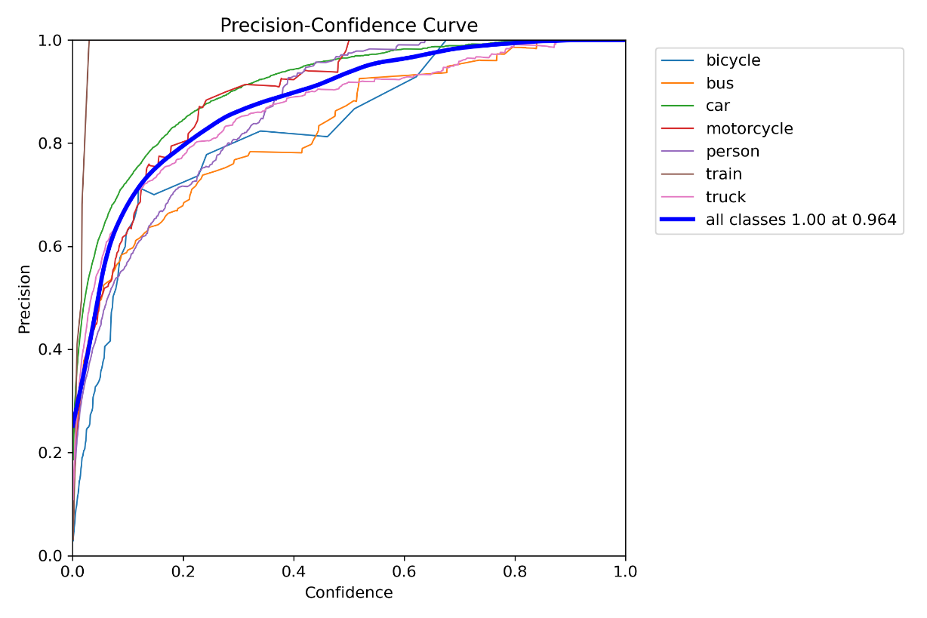
Fig. 4.1: Precision graph for YOLOv11n
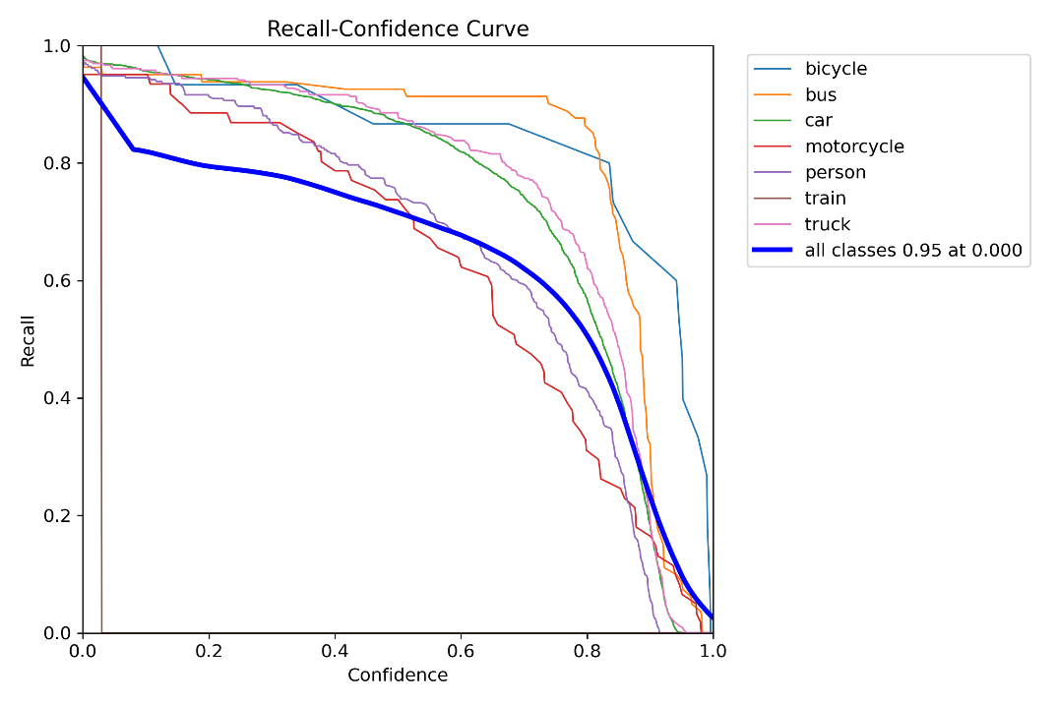
Fig. 4.3: Precision-Recall graph for YOLOv11n
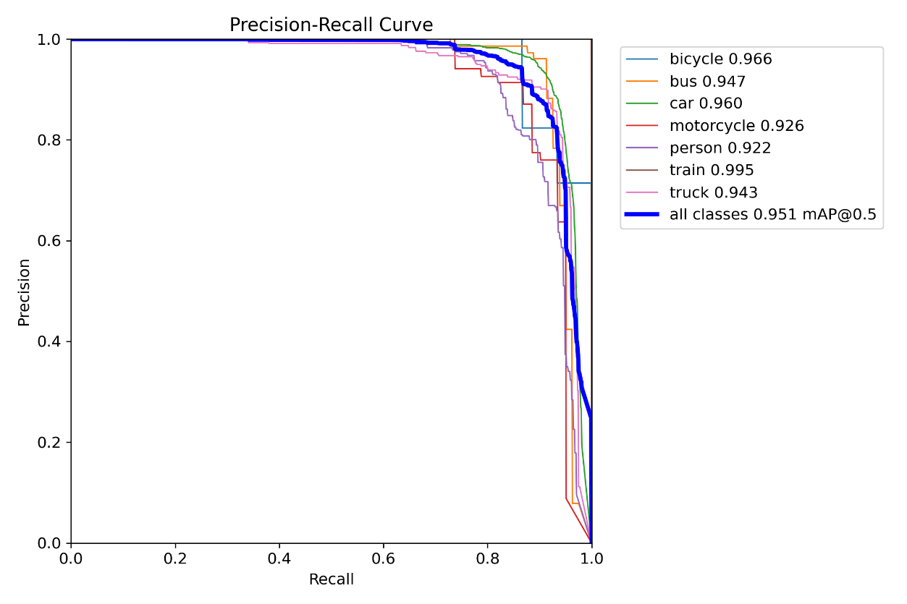
Fig. 4.4: F1-score graph for YOLOv11n
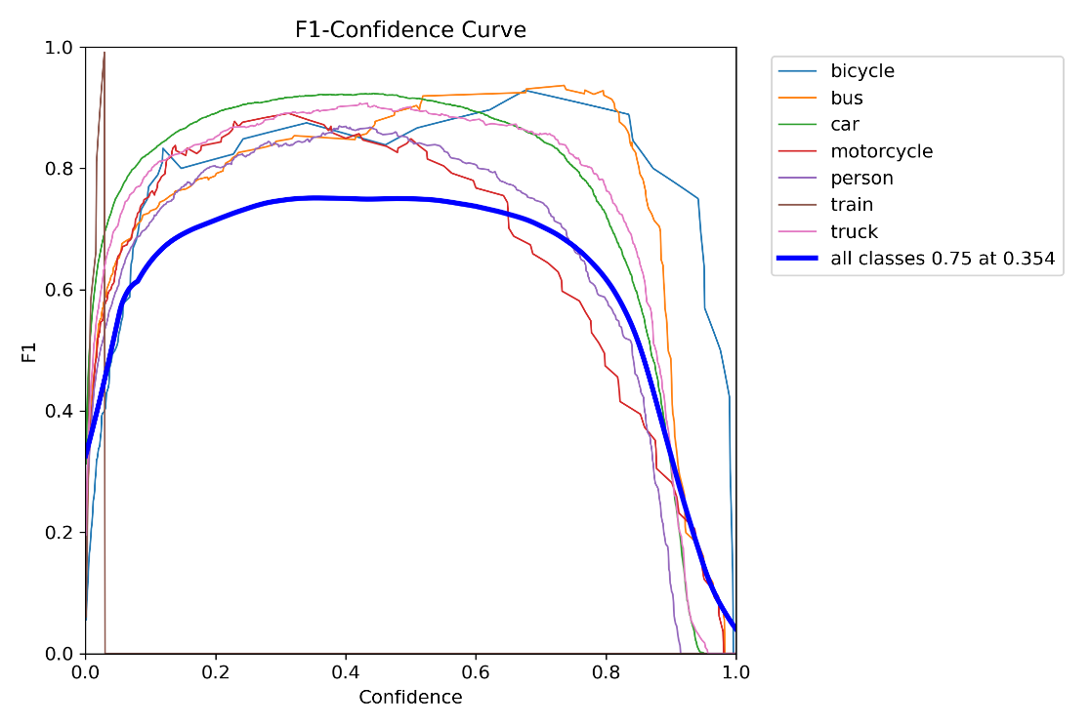
Fig. 4.5: Confusion matrix for YOLOv11n
7.3 YOLOv11s Performance Graphs
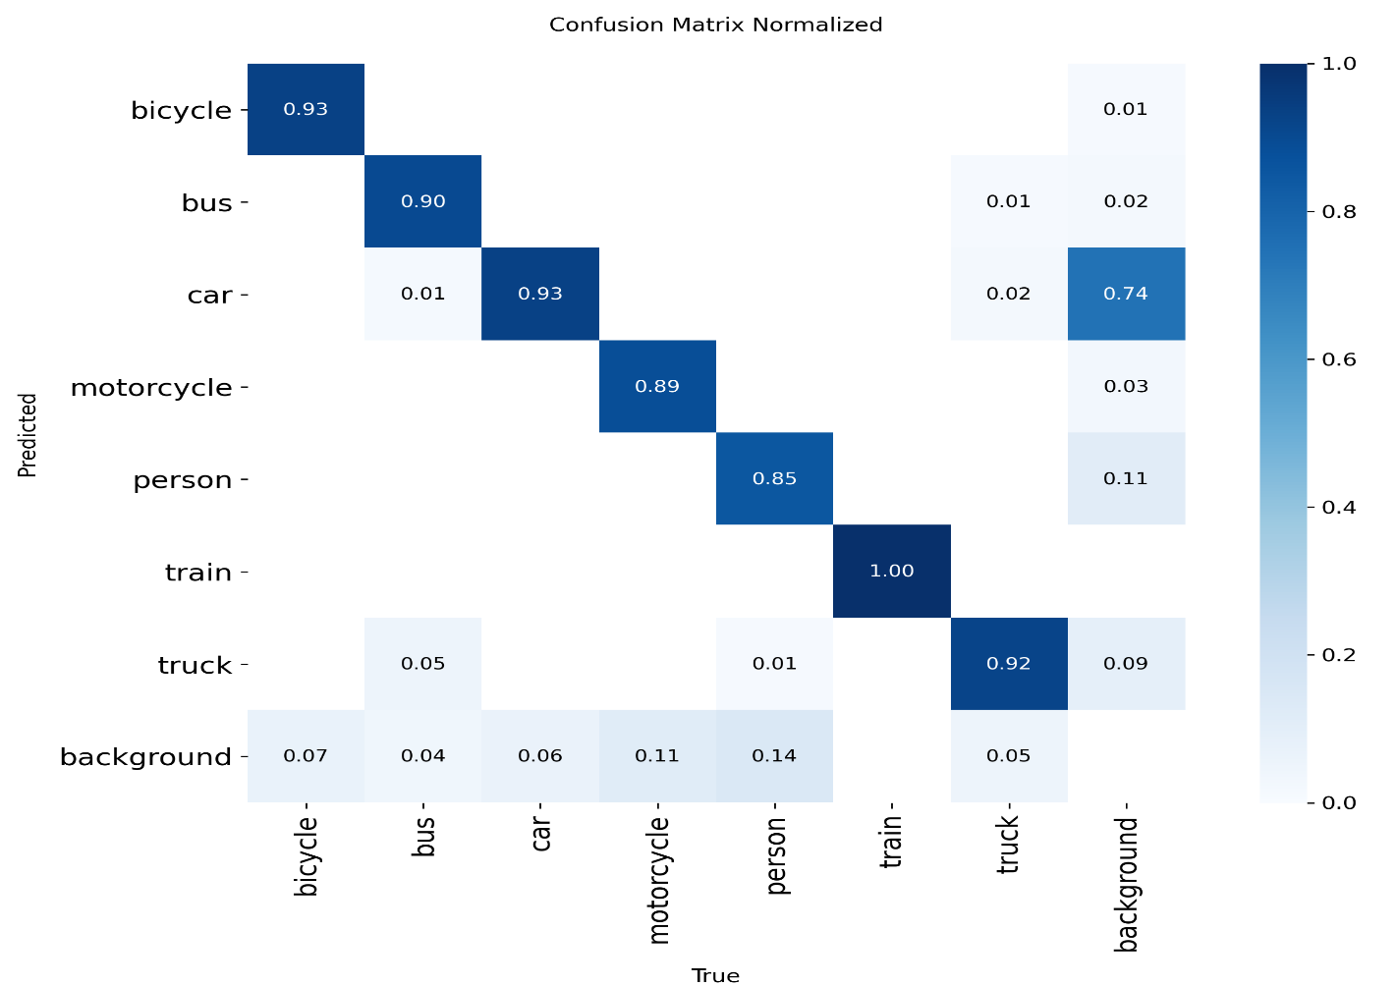
Fig. 4.6: Precision graph for YOLOv11s
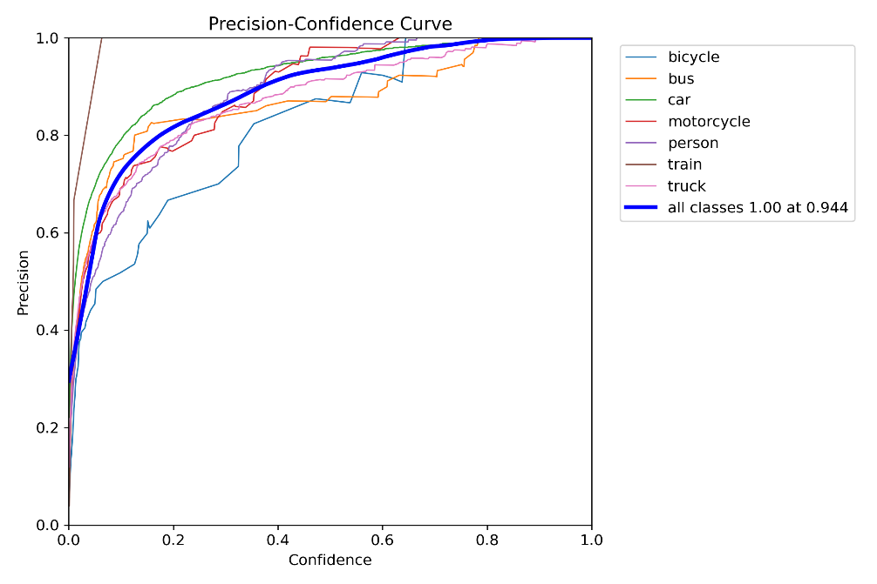
Fig. 4.7: Recall graph for YOLOv11s
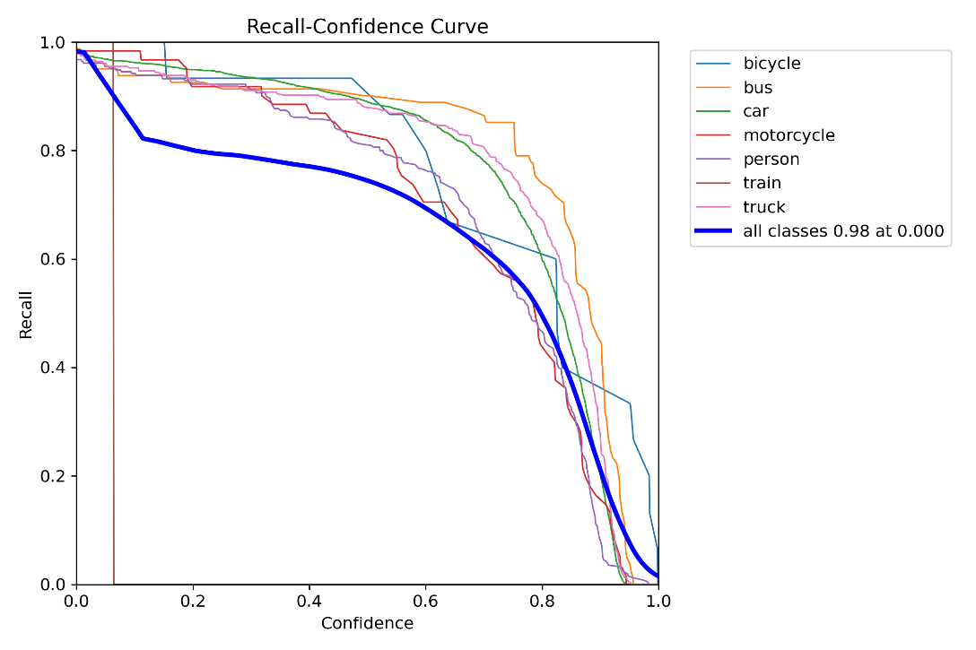
Fig. 4.8: Precision-Recall graph for YOLOv11s
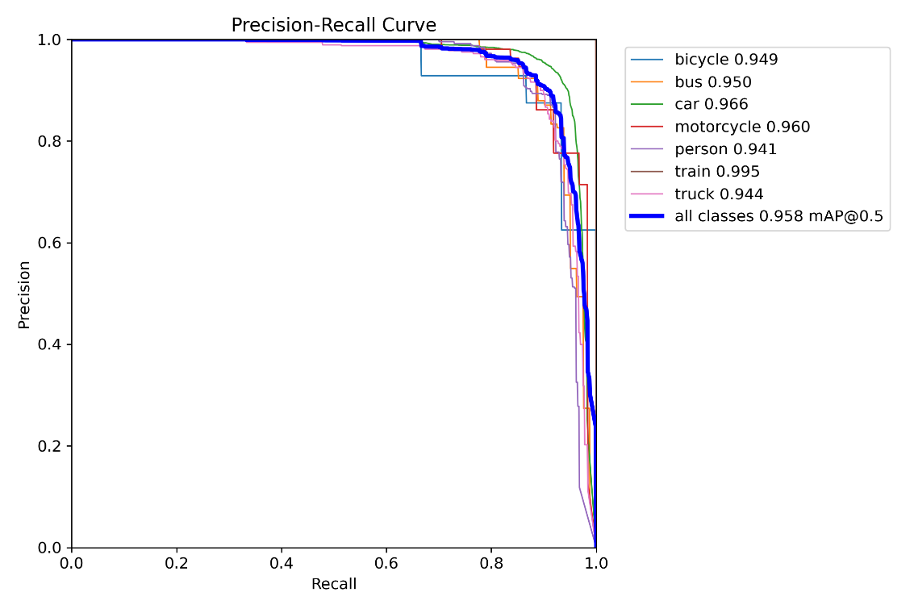
Fig. 4.9: F1-score graph for YOLOv11s
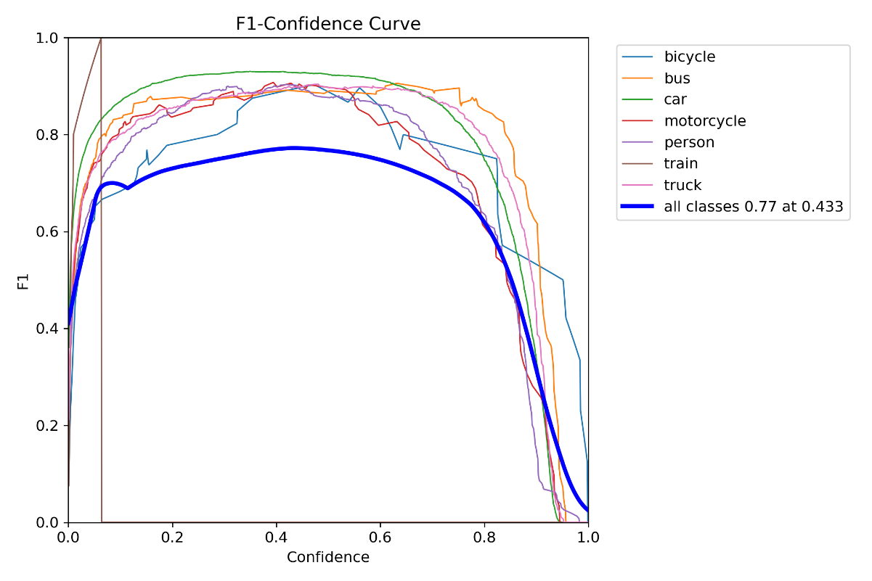
Fig. 4.10: Confusion matrix for YOLOv11s
7.4 YOLOv11m Performance Graphs
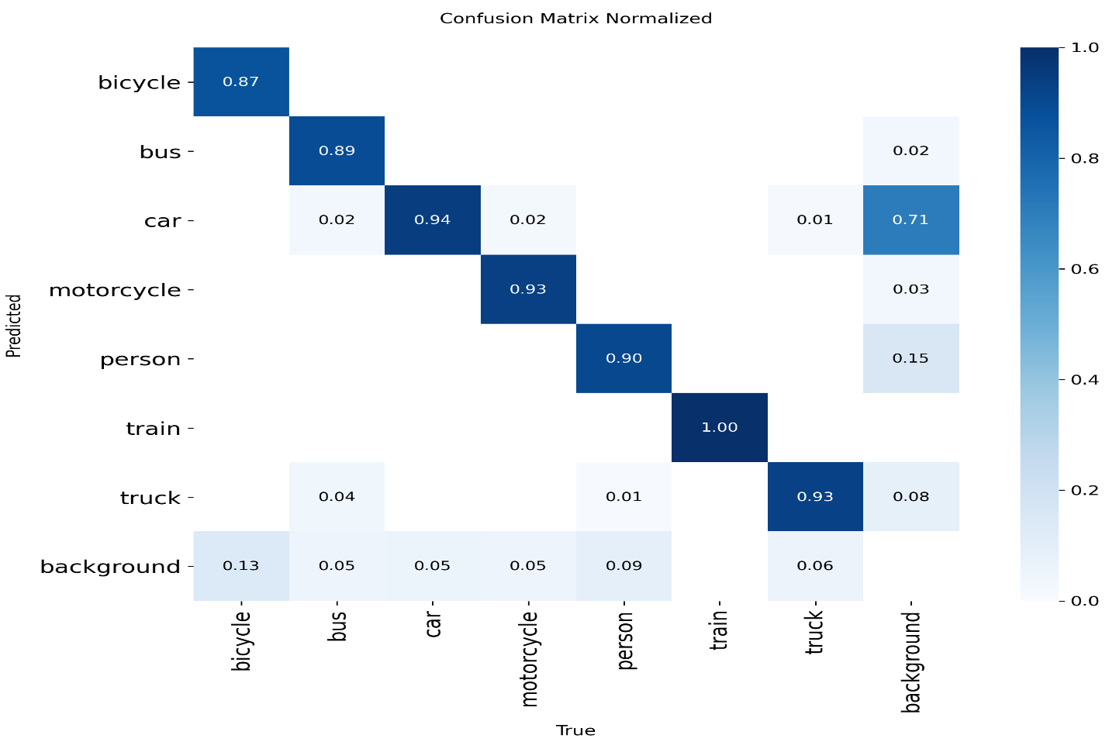
Fig. 4.11: Precision graph for YOLOv11m
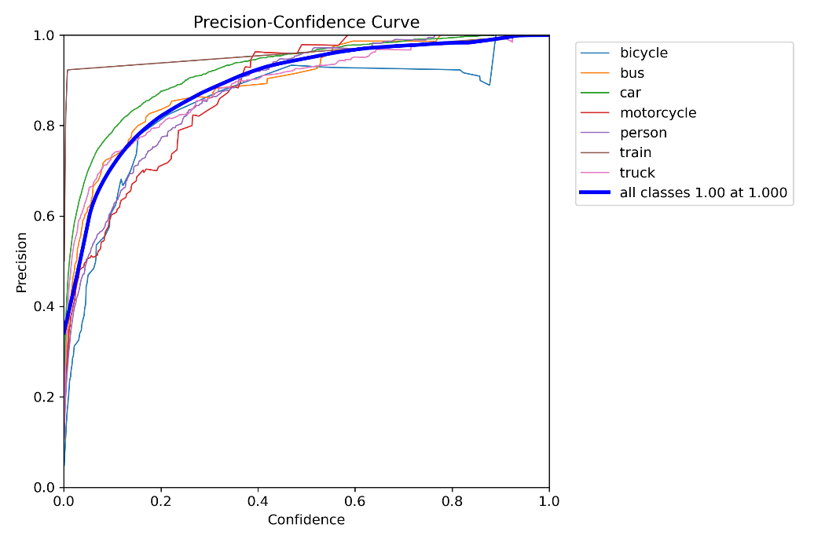
Fig. 4.12: Recall graph for YOLOv11m
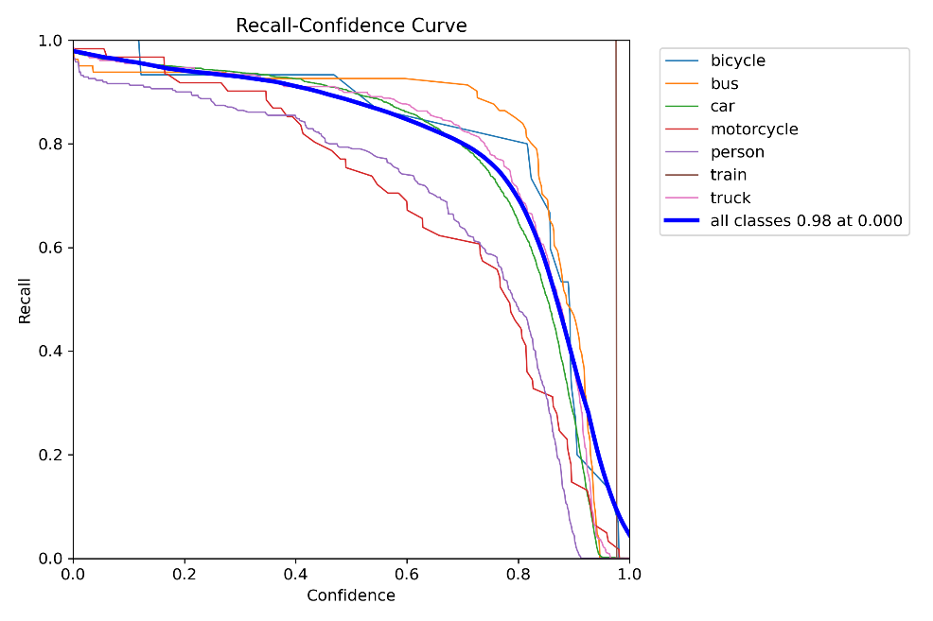
Fig. 4.14: F1-score graph for YOLOv11m
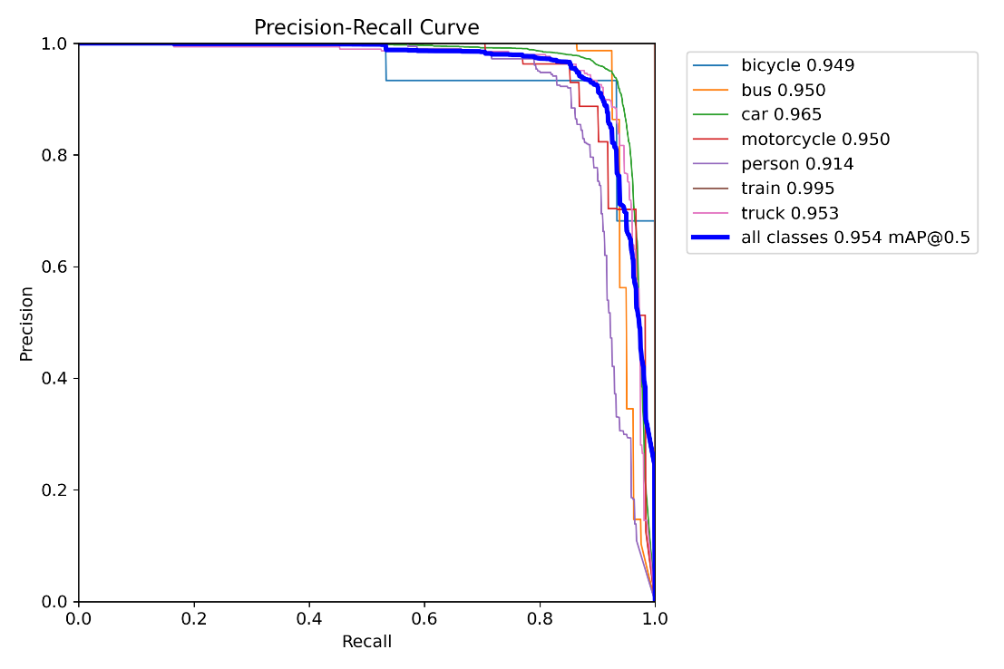
Fig. 4.15: Confusion matrix for YOLOv11m
7.5 YOLOv11l Performance Graphs
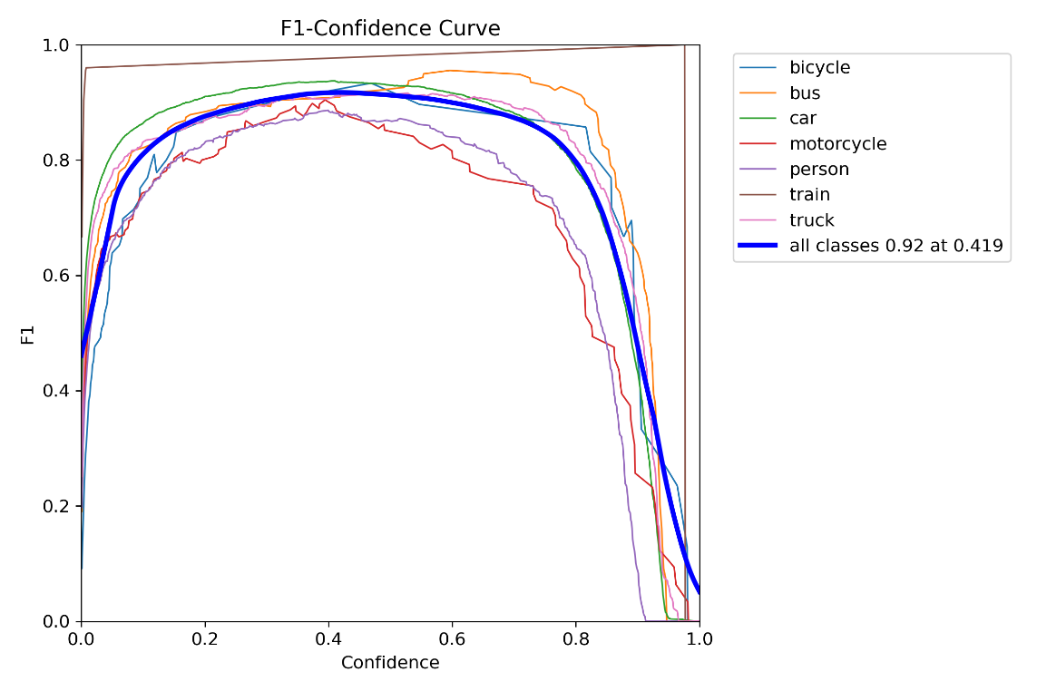
Fig. 4.16: Precision graph for YOLOv11l
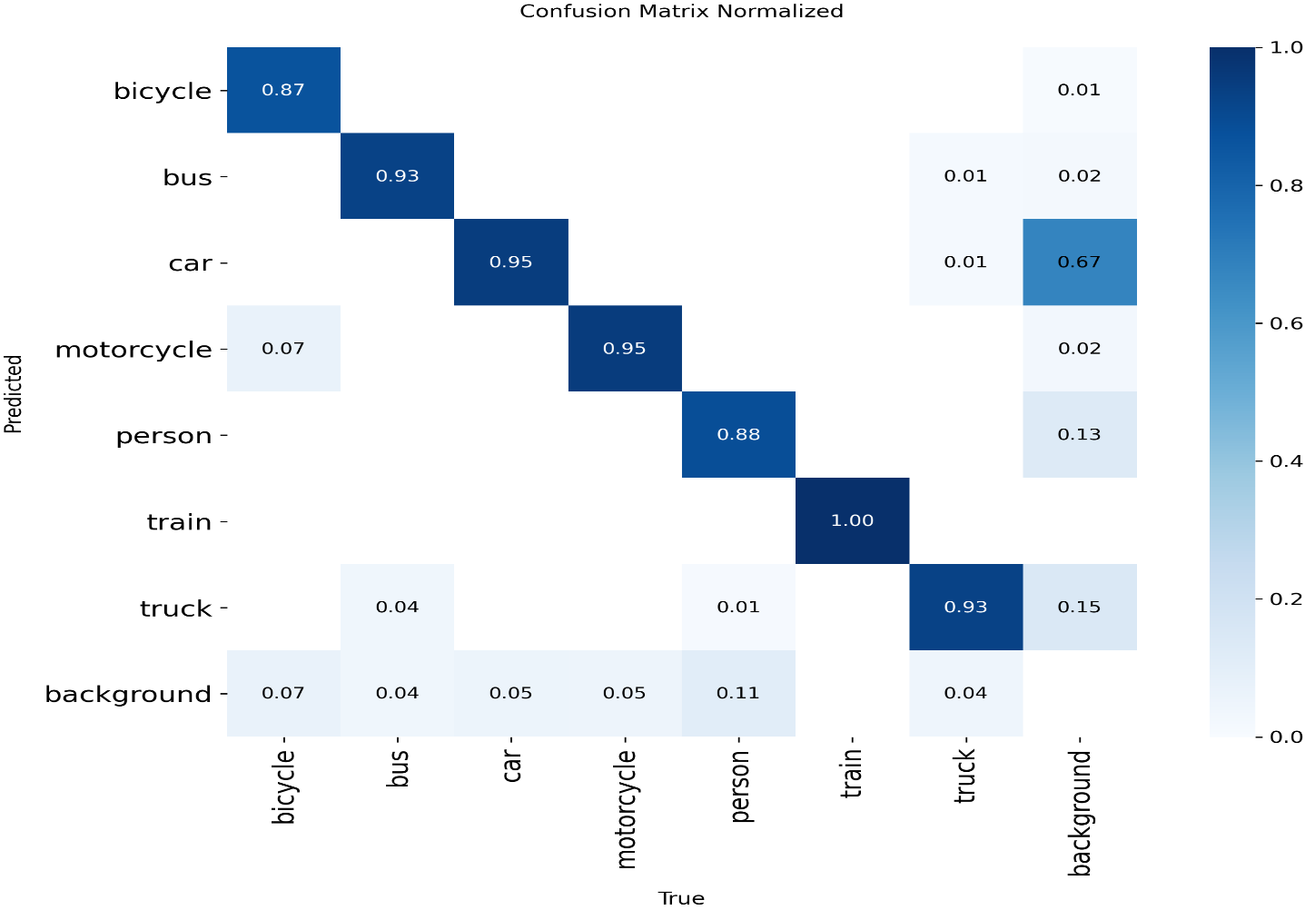
Fig. 4.17: Recall graph for YOLOv11l
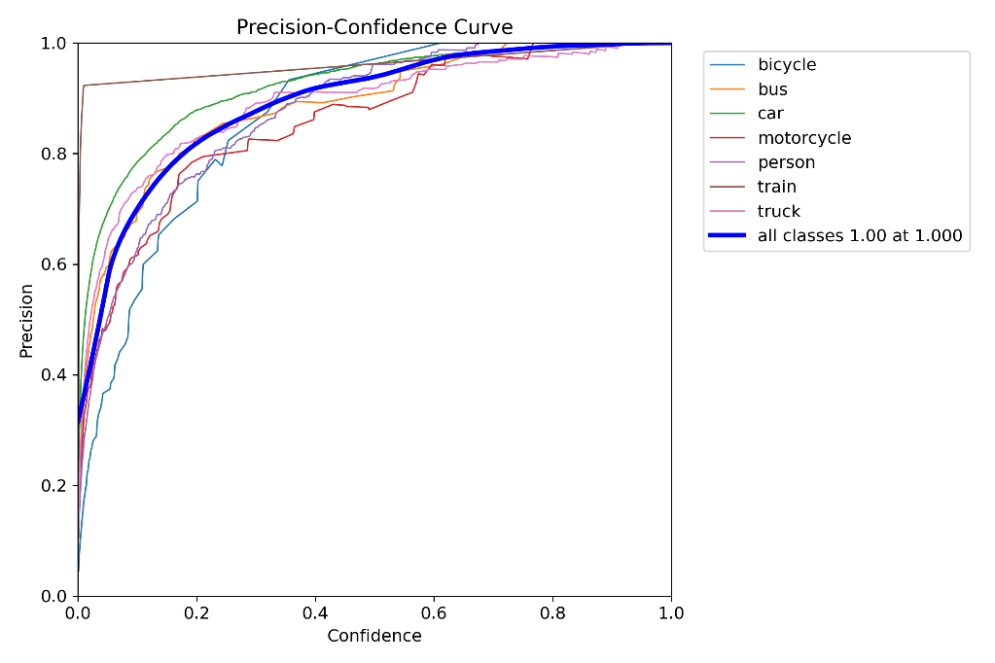
Fig. 4.18: Precision-Recall graph for YOLOv11l
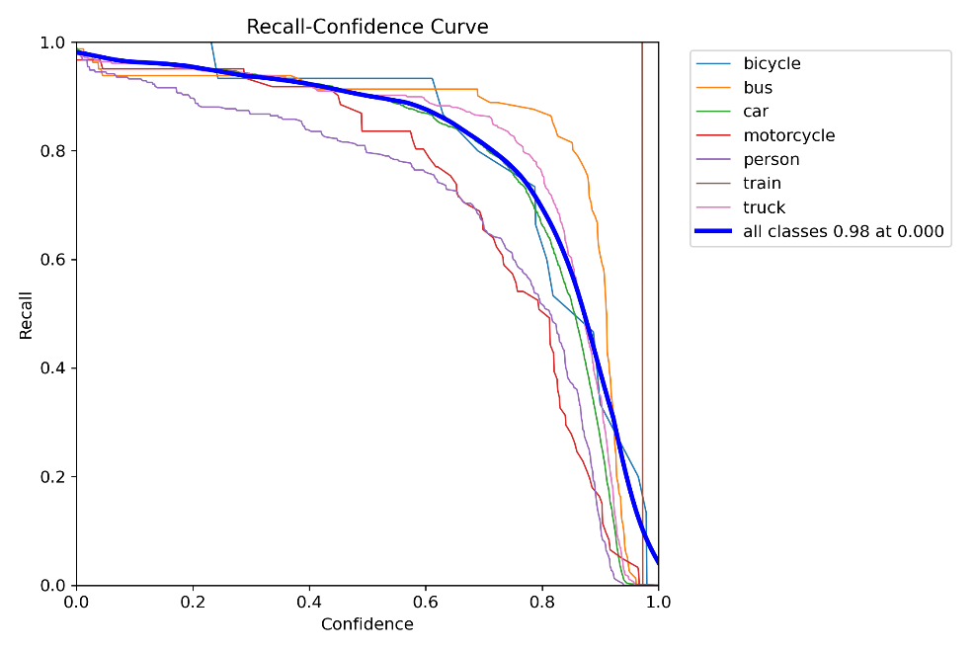
Fig. 4.19: F1-score graph for YOLOv11l
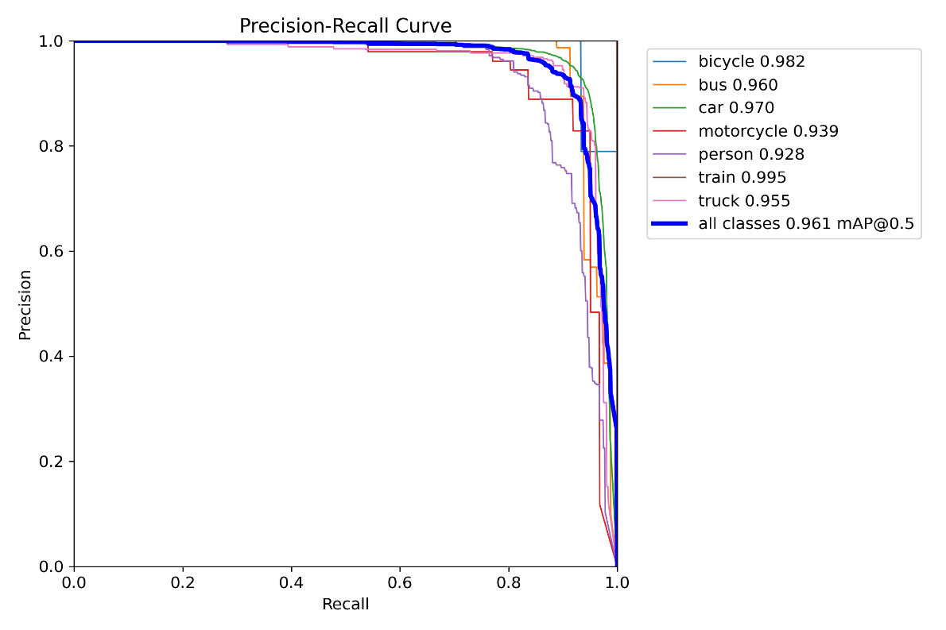
Fig. 4.20: Confusion matrix for YOLOv11l
7.6 YOLOv11x Performance Graphs
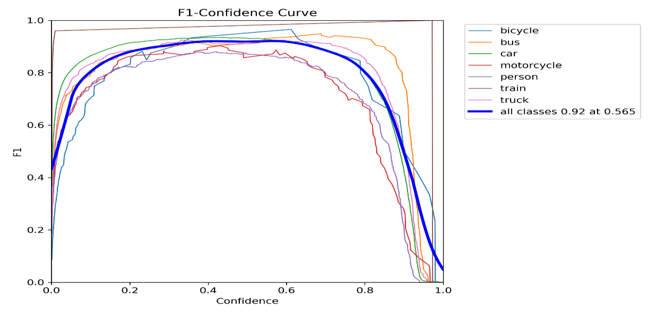
Fig. 4.21: Precision graph for YOLOv11x
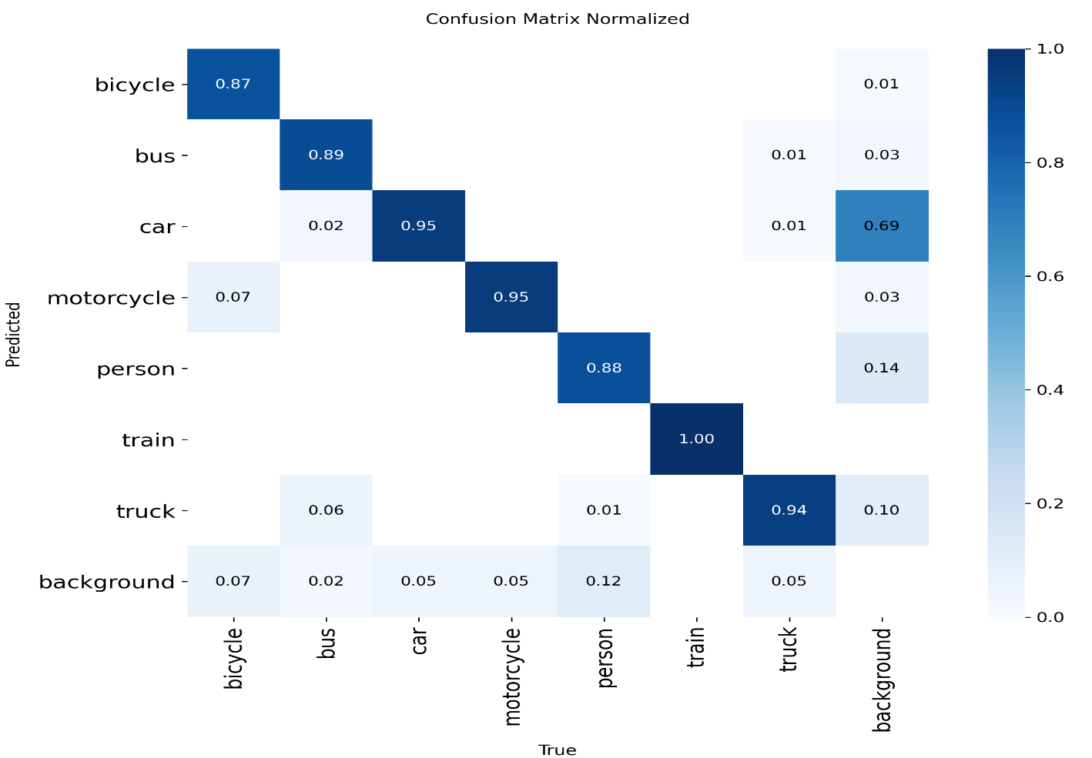
Fig. 4.22: Recall graph for YOLOv11x
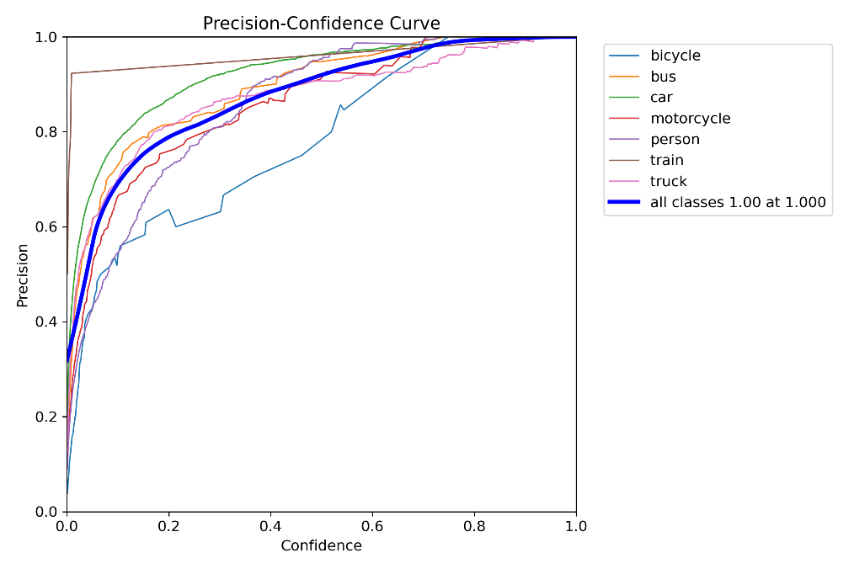
Fig. 4.23: Precision-Recall graph for YOLOv11x
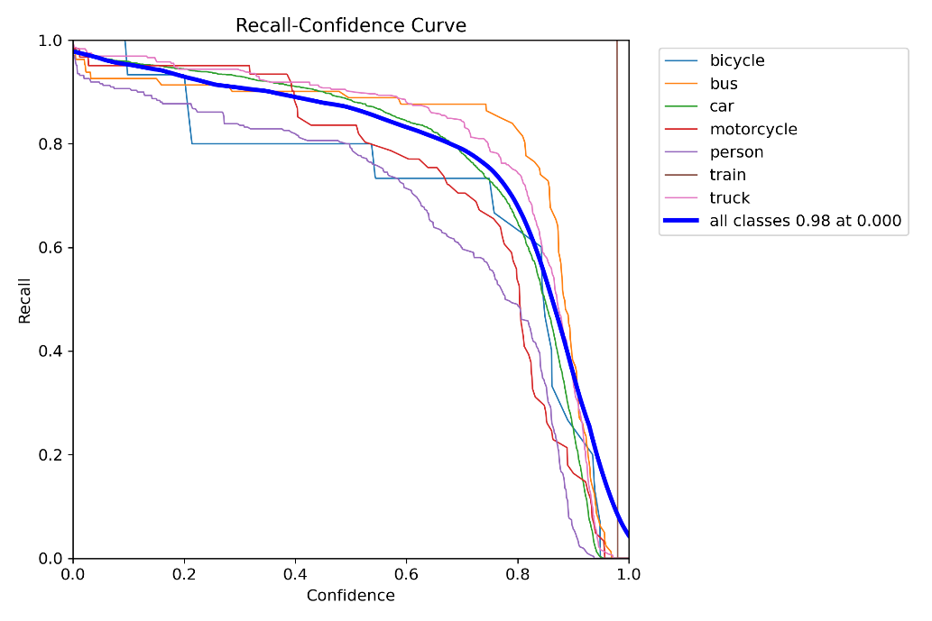
Fig. 4.24: F1-score graph for YOLOv11x
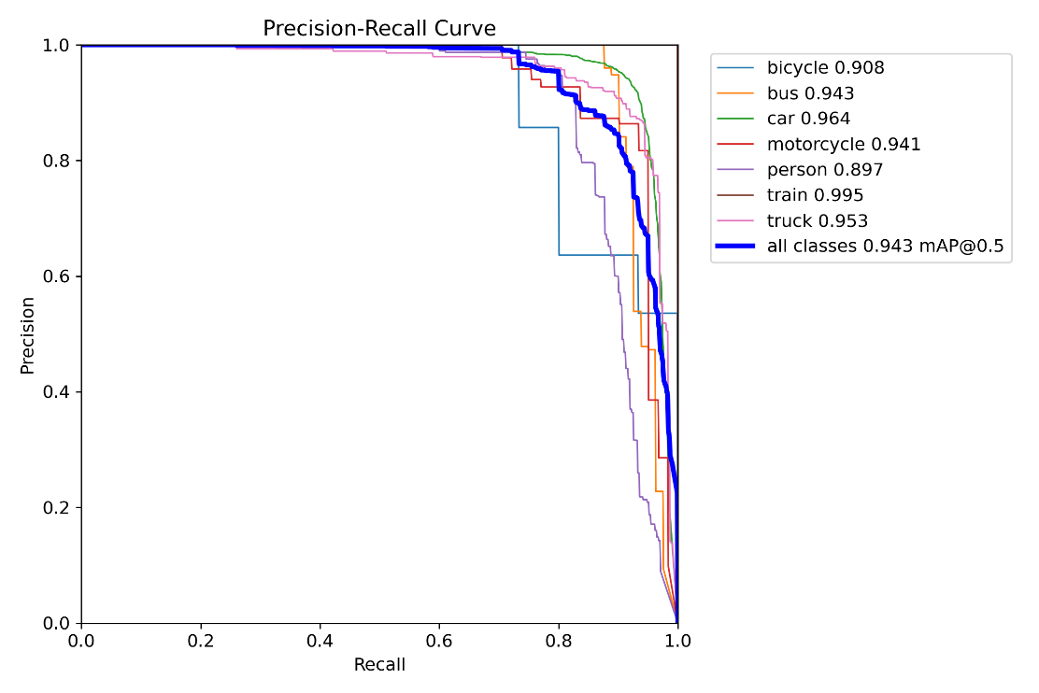
Fig. 4.25: Confusion matrix for YOLOv11x
7.7 YOLOv12x Performance Graphs
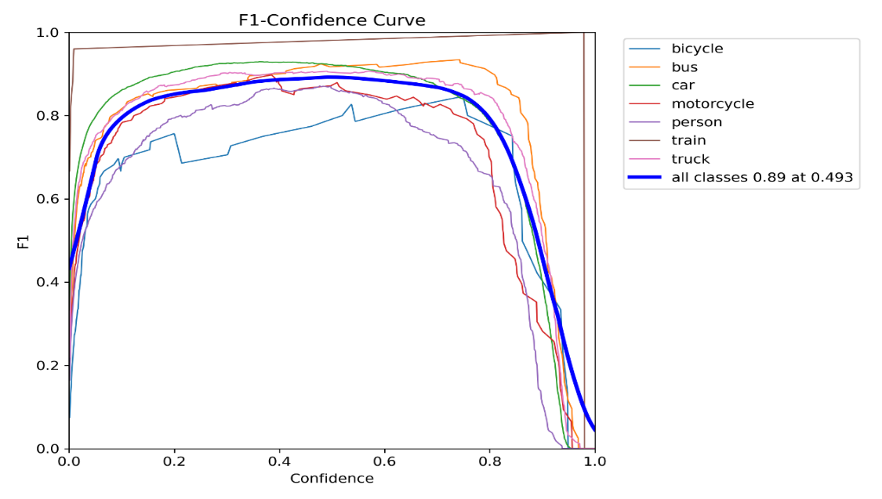
Fig. 4.26: Precision graph for YOLOv12x
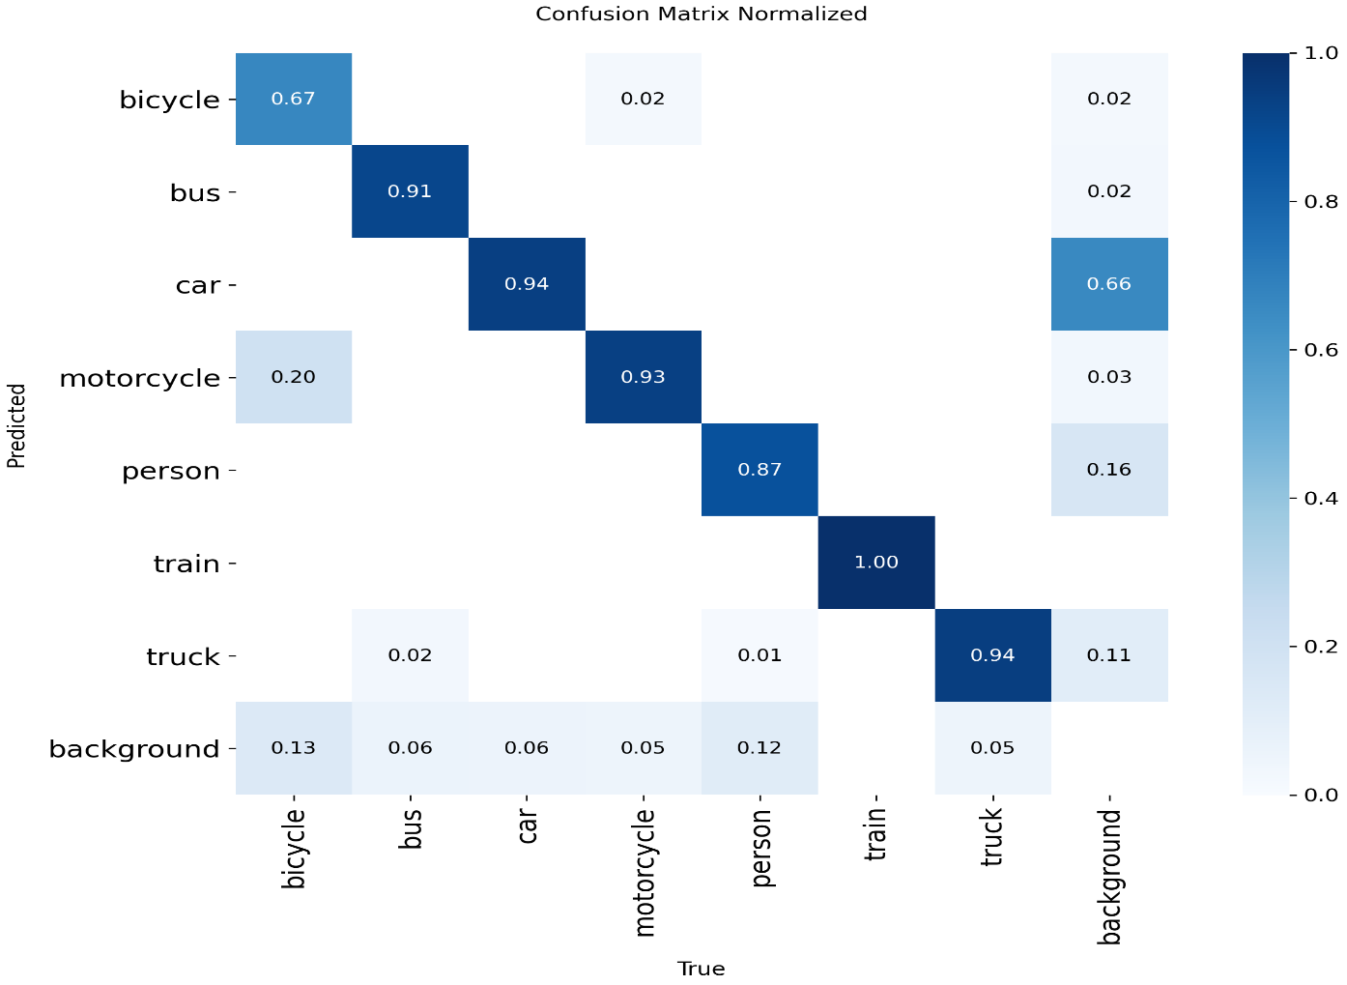
Fig. 4.27: Recall graph for YOLOv12x
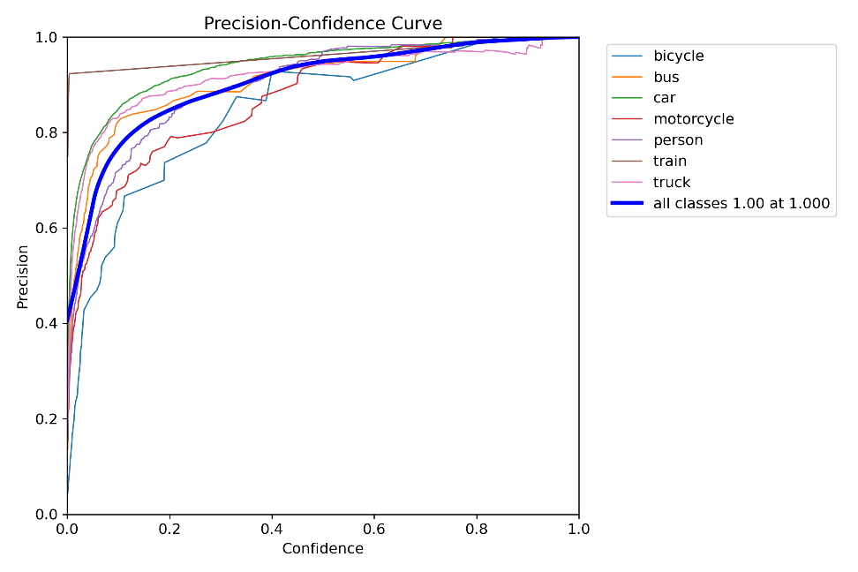
Fig. 4.28: Precision-Recall graph for YOLOv12x
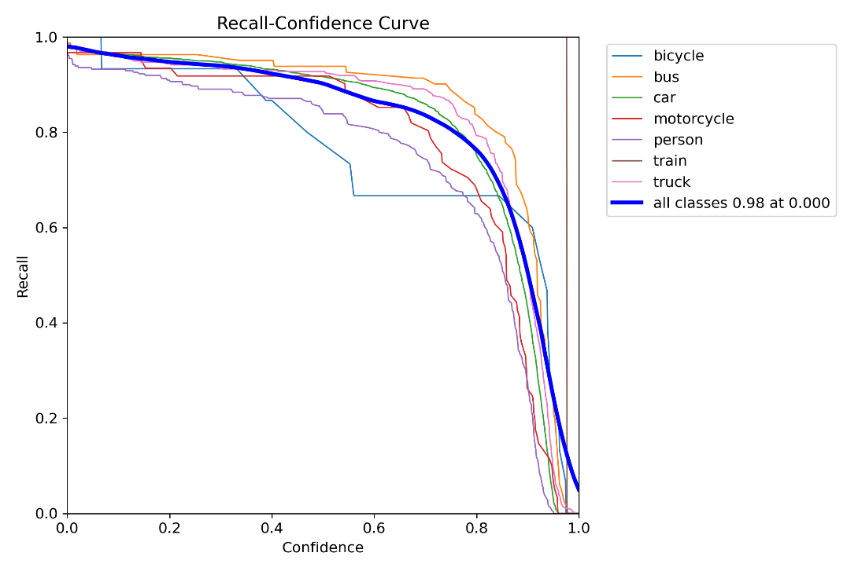
Fig. 4.29: F1-score graph for YOLOv12x
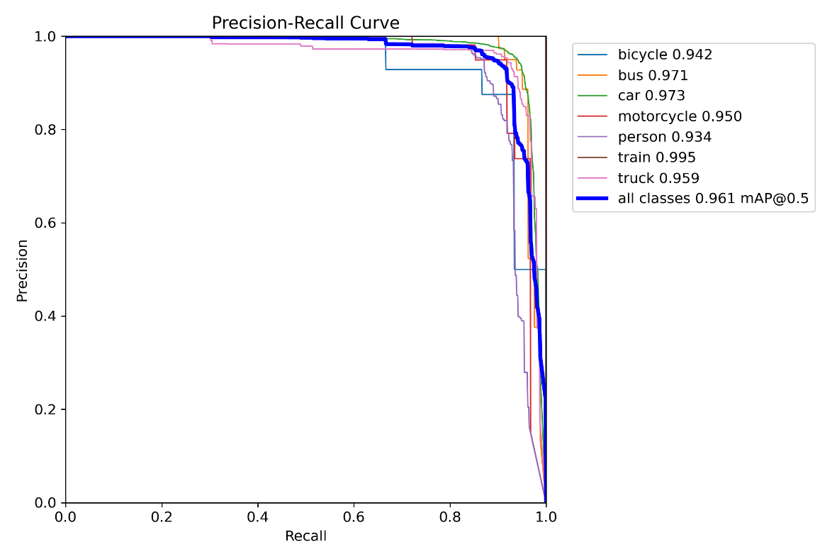
Fig. 4.30: Confusion matrix for YOLOv12x
7.8 YOLOv8x Performance Graphs
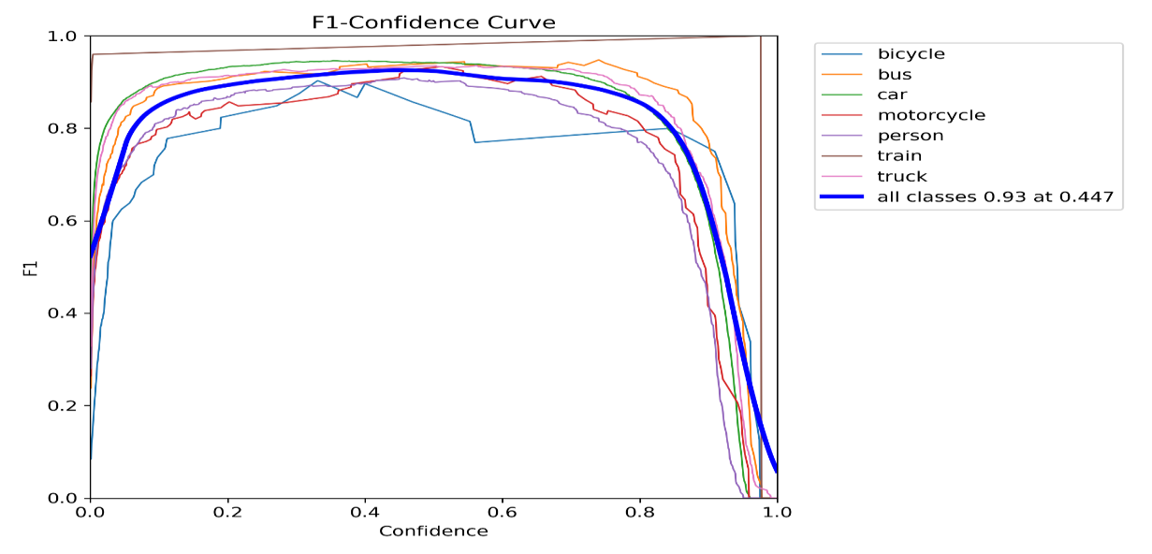
Fig. 4.31: Precision graph for YOLOv8x
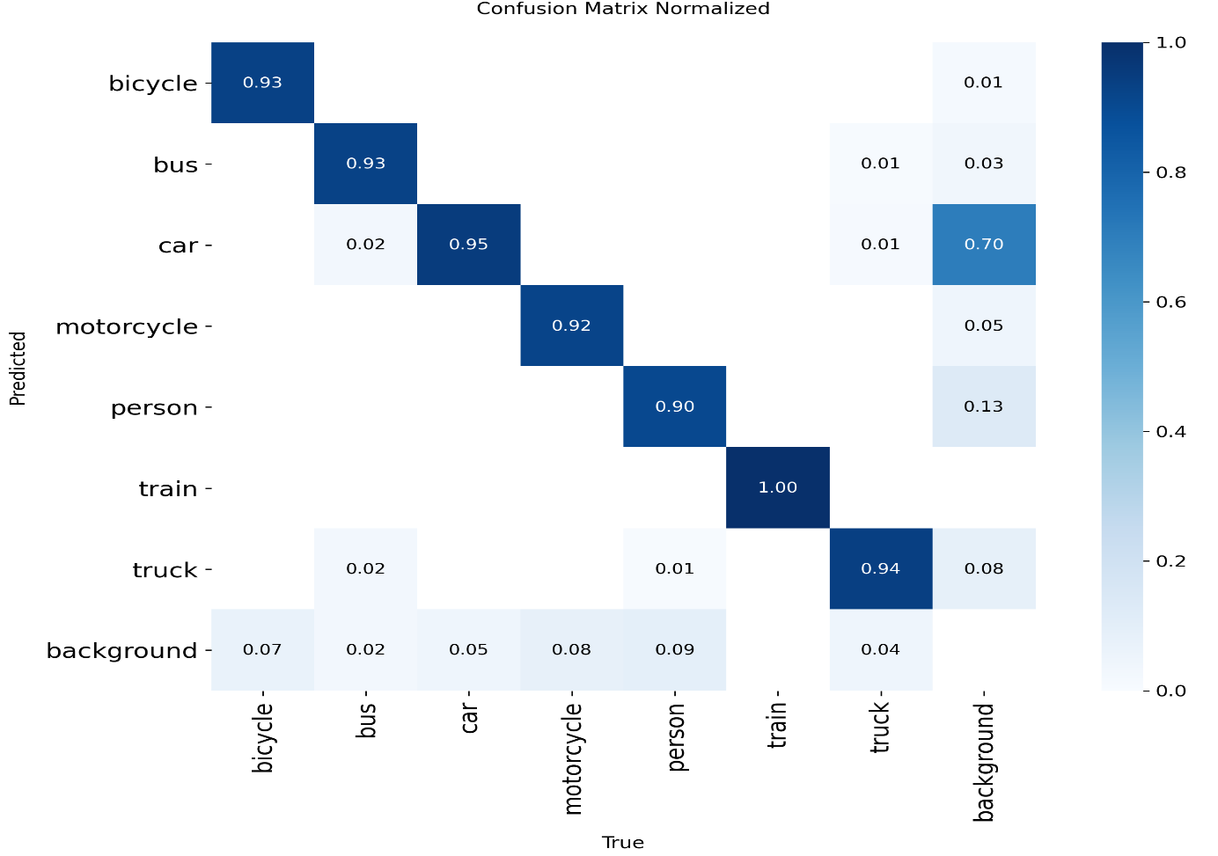
Fig. 4.32: Recall graph for YOLOv8x
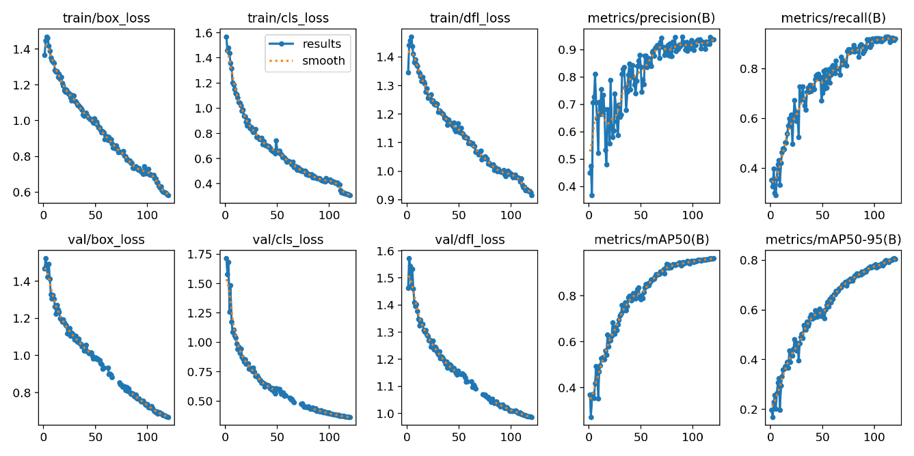
Fig. 4.33: Precision-Recall graph for YOLOv8x
7.9 Comparative Analysis
Table 4.8: All YOLO Models Performance Analysis
Model | Precision | Recall | F1-Score | Accuracy | mAP@50 | mAP@50-95
YOLOv11n | 87.21% | 79.93% | 83.41% | 67.95% | 85.92% | 65.27%
YOLOv11s | 94.57% | 71.61% | 81.51% | 68.79% | 94.84% | 72.94%
YOLOv11m | 93.10% | 76.03% | 83.70% | 71.97% | 95.87% | 74.20%
YOLOv11l | 93.17% | 90.61% | 91.87% | 84.96% | 95.40% | 77.16%
YOLOv11x | 93.36% | 90.91% | 92.12% | 85.39% | 96.08% | 76.63%
YOLOv12x | 91.70% | 87.34% | 89.47% | 80.94% | 94.30% | 74.58%
YOLOv8x | 93.64% | 91.96% | 92.80% | 86.56% | 96.14% | 80.44%

Fig. 4.36: Result graph for YOLOv8x
Key Findings from Preliminary Results:
• YOLOv8x demonstrates the best overall performance with the highest precision (93.64%), recall (91.96%), F1-score (92.80%), accuracy (86.56%), and mAP@50-95 (80.44%).
• YOLOv11x shows high precision and recall, performing nearly as well as YOLOv8x.
• YOLOv11l performs exceptionally well with high recall (90.61%) and strong precision.
• Smaller models like YOLOv11n and YOLOv11s show lower accuracy and mAP.
• All larger models demonstrate superior robustness to environmental distortions.

8. References
[1] J. Appiah and R. Mensah, "Enhancing Object Detection in Fog, Rain, and Snow Using YOLOv7 and ESRGAN," Int. J. Comput. Vis. Appl., vol. 45, no. 2, pp. 122–134, 2023.
[2] A. Ashraf, M. N. Rehman, and S. U. Islam, "YOLOx-Based Vehicle Detection in Snow, Sandstorms, Rain, and Fog Using Retinex and Sensor Fusion," IEEE Access, vol. 12, pp. 45123–45135, 2024.
[3] J. Wang, Y. Zhang, and Z. Li, "Multi-Scale Attention GAN for Real-World Image Super-Resolution," IEEE Transactions on Image Process, vol. 31, pp. 5678–5690, 2022.
[4] Z. Chu, Q. Li, and L. Wang, "GAN-Augmented YOLOv5 for Object Detection Under Fog and Rain," IEEE Trans. Intell. Transp. Syst., vol. 25, no. 3, pp. 2091–2104, 2024.
[5] H. Özcan, F. Kaya, and A. Yilmaz, "Hyperparameter Optimization in YOLO Models Using GWO, ARO, and CLEO Under Adverse Weather," Pattern Recognit. Lett., vol. 164, pp. 78–86, 2024.
[6] A. Ashraf, M. N. Rehman, and S. U. Islam, "Sensor Fusion with LiDAR and YOLOx for Small Object Detection in Snow and Fog," J. Adv. Auton. Driving, vol. 3, no. 1, pp. 44–59, 2024.
[7] A. Ashraf et al., "Tiny Object Detection in Harsh Weather Using Modular YOLOx Extensions," Sensors, vol. 24, no. 3, Art. no. 1983, 2024.
[8] A. Ashraf et al. and H. Özcan et al., "Performance Trade-offs in Real-Time Object Detection Under Adverse Weather," IEEE Trans. Intell. Vehicles, vol. 6, no. 4, pp. 623–634, 2024.
[9] F. Aloufi et al., "Performance Analysis of YOLOv5 and YOLOv7 in Sandy Weather Environments," J. Auton. Veh. Syst., vol. 8, no. 1, pp. 22–35, 2023.
[10] DAWN Dataset for Object Detection in Adverse Weather, Roboflow, 2024. [Online]. Available: https://www.roboflow.com/datasets/dawn
[11] M. Sharma, R. Singh, and A. K. Sangaiah, "Improved Grey Wolf Optimizer with Adaptive Parameters for Feature Selection in Image Classification," Expert Systems with Applications, vol. 213, p. 119085, 2023.
[12] F. W. Wibowo, E. Sediyono, and H. D. Purnomo, "Chimpanzee Leader Election Optimization," Math. Comput. Simul., vol. 201, pp. 68–95, Sep. 2022.
[13] Kaggle, "Free GPU Notebooks for Machine Learning," 2025. [Online]. Available: https://www.kaggle.com/
[14] NVIDIA, "T4 GPU Specifications," 2025. [Online]. Available: https://www.nvidia.com/en-us/data-center/tesla-t4/
[15] Y. Zhang, J. Li, and K. Sun, "CF-YOLO: Cross Fusion YOLO for Object Detection in Adverse Weather Conditions," IEEE Transactions on Intelligent Transportation Systems, vol. 24, no. 5, pp. 5678–5689, May 2023.
[16] Albumentations, "Image Augmentation Library," 2024. [Online]. Available: https://albumentations.ai/

Submission Last Date: 5th January 2026
Approved by
__________________________
Supervisor Name, Signature with Date
Md. Robiul Islam Rabby, MSc. in CSE, Department of CSE, Daffodil International University

