**MASTER II PROJET**

**HUBBY: COOKING APP**



Preamble:

Within the Catholic University of Lille, more specifically at the Faculty of Management and Science, a 200-hour project must be carried out for the validation of semester 4 of the master 2 in computer science. This document lists all development, technical, visual and project management information about the project.

Youssef TOUGGANI – M2 III

Table of contents

Assessment: 3

Project idea: 3

Competitors: 3

Marmiton: 3

750g: 4

Functionalities: 5

User functionalities: 5

Administrator functionalities: 5

Application main functionalities: 5

Technical functionalities: 5

Technical presentation 6

React native 6

Django 6

MySQL 7

Heroku 7

Netlify 7

GITHUB 8

Docker 8

CircleCI 8

Adobe XD 8

GIMP 8

Project managment : 9

Trello 9

Favro 9

Mock-up 10

Illustration 10

Logo 10

Other 10

General presentation of the project

## Assessment:

A lot of close relations, friends or even myself don't know what to eat tonight. It is often the same culinary routines and that tires us. A problem that leads us to be bothered to look for new ideas too often without an answer. From this observation, the complete idea of developing a platform referencing hundreds of recipes around the world and features that make cooking more enjoyable.

## Project idea:

Based on a mobile application (tablet), HUBBY will be an application in the "Lifestyle" category. It will allow you to access recipes from around the world in a few seconds and to be able to share them with your community.

The application will offer you, in relation to what you have in your fridge and your desires, a dish and its detailed recipe.

The project will be realize only by me, Youssef Touggani in order to prove to myself that I can lead a project alone and to learn to manage a project.

## Competitors:

### Marmiton:

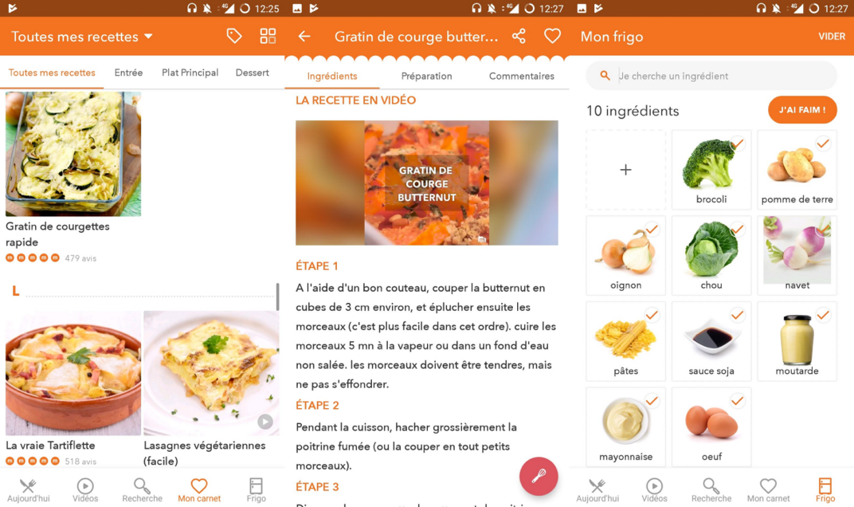

+Clarity of explanations

+Effective filters

+Possibility to save your favourite recipes

-No dishes offered compared to what we have

-Random Mode

-International recipe

### 750g:

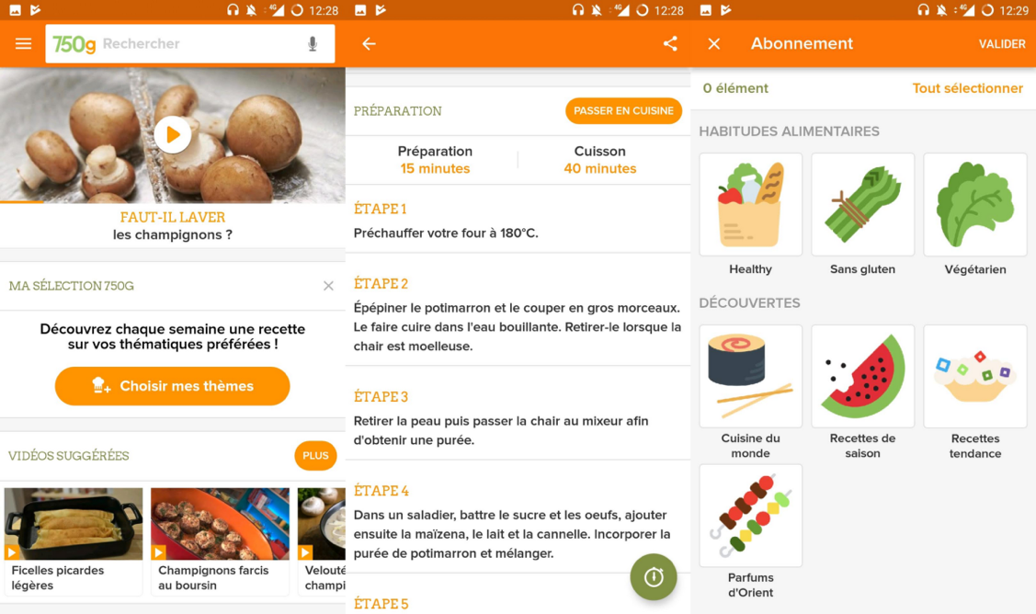

+ Clearly detailed recipe steps

+ "Go to kitchen" mode and on-board timer

+ Rich editorial content

+ Possible personalization of suggestions

-No dishes offered compared to what we have

-Random Mode

-International recipe

-Effective filters

-Lots of ads and it is possible to get lost quickly on the application

The two biggest applications in the culinary field have many advantages that users expect not only by their functionality but also by their notoriety. By considering what they lack and the negative points that users of these applications state, we can highlight them on our HUBY application. The main element is the ergonomics and ease of use of the mobile application. Indeed, the users are either infrequent users of mobile applications and who can get lost quite quickly on them or users who seek their information quickly and smoothly. Main features on the concept such as the random mode or the wide range of international recipes.

## Functionalities:

### User functionalities:

* Create an account
* Manage an account (modify, delete)
* Publish and delete publications
* Like
* Save a menu

### Administrator functionalities:

* Create a user
* Manage a user (modify, delete)
* Add content
* Delete content

### Application main functionalities:

* Manage the products we have at hand (add, delete, modify)
* Randomly generate a menu
* Generate a menu according to criteria (product, allergy, type of food, etc.)
* List recipes by country/by feature
* Research
* Refine searches and lists (time, average, etc.)
* Step by step recipe display

### Technical functionalities:

* Reading in portrait and landscape mode
* Different languages

# Technical presentation

Which technologies and why?

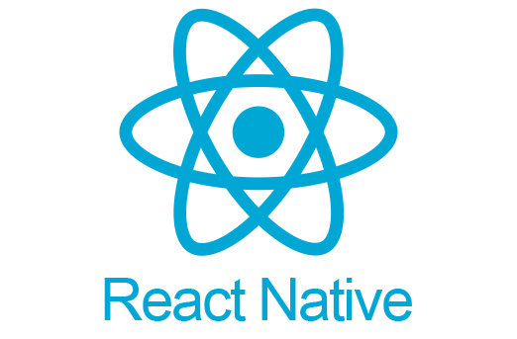

### React native

React Native is a Framework developed in 2015 by Facebook to develop mobile applications for Android and IOS and all on a single code base.

For this project, the native React will be interesting first on development. Indeed, many advantages such as the "Hot reload" allow a much higher development speed on other frameworks. The libraries offered by React and its community are rich and updated very regularly which allows a certain stability and security of these components (ex: Stripe offers a library on native React allowing to add an easy and secure means).

In terms of improvement and modification, React allows you to do it quickly and efficiently. For example, we can offer a web version of the application by importing the code in React, practically like React Native.

It is interesting to use React Native in my case since it is a technology on which I have some experience.

Finally, the React Native allows and adapts very well to the rest of the technologies that we want to use in the development of this application.



### Django

Django is an open-source python framework for building front-end and backend applications. Django is a quick framework to set up on an application. This framework also offers many features allowing the creation of APIs as we will need in this project since we will be working on the creation of a mobile application.

Advantages of using Django:

* Active community: Correction of security vulnerabilities, addition of plugins, constant improvement of the framework
* ORM (object relational mapping): An ORM is a database access abstraction layer that gives the illusion of no longer working with queries but of manipulating objects. This allows us to no longer worry about the database system because we no longer use SQL queries but only query functions offered by Django. The ORM will also allow code homogeneity, a simple structure to read and maintain and work with optimized queries promoting the speed of the application.
* Plugins greatly facilitating the work and making it more secure: We can find authentication plugins such as OAuth which will make it possible to manage the entire authentication system in a safe and secure manner.
* Administrator interface: Django offers a default administrator interface that allows you to manage a lot of data such as users, actions performed on the application, etc.
* Train myself on a new technology



### MySQL

MySQL is a relational database management system. It will store the data used on the application. We will store data such as recipes, recipe details, users etc. Django will use MySQL to access, save or delete data.

Advantages of using MySQL:

* High performance: our application will use a very large number of data which will require rigor for the storage of data and requests to have an optimized application.
* Secure database: We will store sensitive data such as user data. This must then be secure so as not to have a data leak.
* Flexible: It is a database that can be modified and improved without problem. If the application leads to data additions for its future improvements, then we will have no problem modifying our database.



### Heroku

Heroku is known for running applications in dynos, virtual servers. Here we will use a web dyno (http requests) for API calls. Our application will therefore be able to make its API calls from Heroku.

Advantages of using Heroku:

* Free environment: Heroku allows you to deploy and manage any type of application

- Powerful back end: Heroku manages back-end applications smoothly and keeps their performance.

- Compatibility with other technologies: Heroku goes well with other technologies used for this project such as git which controls the versions and stores the application and with MySQL

- Heroku is compatible with PHP (Django)

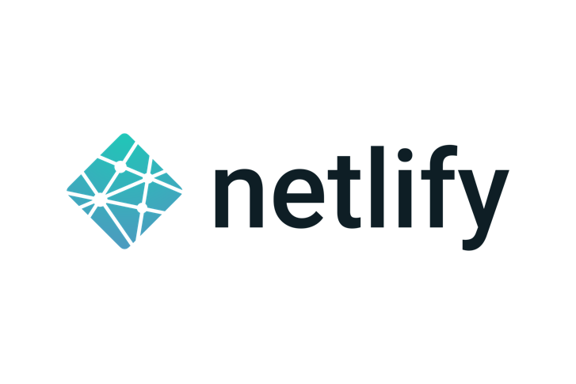

### Netlify

According to Jamstatic, "Netlify — a contraction of Net and Simplify — aims to simplify release and provide all the modern tools needed for agile deployment strategies." This will allow using CircleCI, GitHub and Docker to achieve continuous integration throughout the project, including monitoring the project and managing it more simply.

Since the upload prices are quite expensive on Apple Store and Play Store, it is better to use Netlify for the release.

Benefits of using Netlify:

* Production: Simple and efficient production management. It is possible to put into production or change versions quickly in the event of a malfunction of an online version. This allows the proper functioning of the application
* Subdomain and deployment of different GitHub branches: The creation of a subdomain of a site allows a multitude of functionality such as the creation of a pre-production site
* Generate SSL certificates: SSL certificates are very important for user trust. This ensures security on the site or application.
* A freedom to be able to control a lot of functionality.

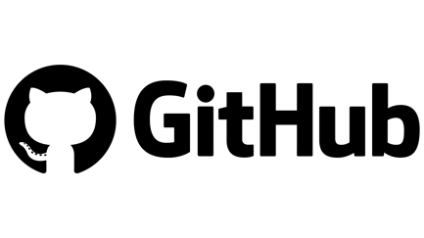

### GITHUB

GitHub is a web hosting and software development management service, using Git version control software. The site also provides access control and features for collaboration such as bug tracking, feature requests, task management, and a wiki for each project.

GitHub will allow us to store our project and have easy access to it. It will also allow us to manage the versions of the application and thus follow changes and developments. Git remains an indispensable tool in IT development because it gives access to codes to all team members while managing access. Here, we do not necessarily need a tool like git since the work can be done locally and tracking tools such as CircleCI can be used. However, we will still put it in place to ensure the project process.

GitHub repository:

<https://github.com/touggani/HUBBY>

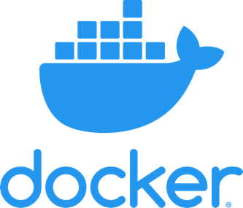

### Docker

Docker is a platform for launching certain applications in software containers. Docker is a tool that can package an application and its dependencies into an isolated container, which can be run on any server.

Docker will be very important in our project since it is made in React Native. First let’s state the benefits of Docker. Docker will allow you to launch any type of application without having any version problems. The user who launches the Docker will have access to the application without having to install packages or software.

On React Native, it is possible to have many external packages with different versions. Nodejs used by React, is also constantly evolving. All of this can lead to version issues if not handled well.

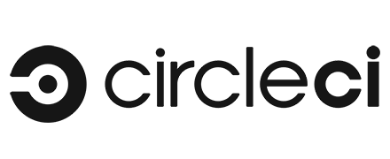

### CircleCI

CircleCI is a CI/CD hosting service that connects to your repository and runs your build steps on every new commit.

Usable on GitHub, CircleCI will allow us to run our project to test how it works.



### Adobe XD

Adobe XD is a vector-based user experience design tool for web apps and mobile apps, developed and published by Adobe.

Adobe XD will make it possible to develop models and graphic elements specific to the application. This technology will be more useful in terms of UX design of the application.



### GIMP

GIMP is an image editing and retouching tool, released under the GPLv3 license as free and open-source software. Its royalty-free, open source and free asset has allowed it to be preferred to Photoshop. GIMP will allow you to retouch and create the logos and other graphic elements of the application.

# Project management:

The project is carried out alone. This will allow me to be able to manage an entire project, while deciding on developments, changes or even functionalities or technologies. The project will nevertheless be monitored to achieve and respect the deadlines.

Project management will be personalized but will be strongly inspired by the agile method. This implies that each week, a check must be carried out on the progress of the project, the deadlines, or another parameter of the project.

## Trello

A full list of features will be put together with estimated duration dates. Each week, this list can be modified if the progress takes longer or is faster. The use of Trello will make it possible to list the functionalities to be developed and to be able to have a clear follow-up. Comments can be used so that the project goes as well as possible.

Link to access to Trello:

<https://trello.com/invite/b/gycjSy2p/d0183a5e2222f8ebd0bb51bfa836fa2c/suivi-davancement>

## Favro

Favro is a complete project management tool that makes it easier to organize the tasks to be carried out. Favro will be used in addition to Trello.

Indeed, what I like and seems interesting to me on this platform are the functionalities such as the creation of roadmaps or even GANTT graphs.

Favro will be used only if Trello is not sufficient.

# Mock-up

The models were entirely conceptualized by me using Adobe XD. The design and certain points of the latter can be modified if necessary.

The models are available in XD format in the “Maquettes/HUBBY_FOODAPP_Maquettes.xd” folder. The models are available in PNG format in the “Maquettes/maquettes_png” folder if Adobe XD is not installed on the computer.

## Illustration

## Logo

The logos were made by me using GIMP. You can view them in the "Illustrations/Logo" folder. Here's a preview of the app's logo.



## Other

Any other type of image, illustration or video will be retrieved from royalty-free image sites or created by myself.

The sites where the images can be taken:

<https://pixabay.com/fr/>

<https://www.pexels.com/fr-fr/>