Central Platform Architecture and Interoperability Framework
  - Federated government revenue collection and national oversight
Version 1.0 | Proposed design | 8 October 2026

Purpose and recommended model
We propose a federated model in which each concessionaire operates its own revenue collection system within its authorised concession and reports standardised information to a Central Revenue Oversight and Integration Platform, referred to in this framework as the Central Platform. Government receives a consolidated view of assessments, collections, settlements, messaging and operating performance.
This framework defines the responsibilities, architecture, data contracts, security controls and operating rules needed to connect the independent systems. It provides a basis for consortium agreement, Government review and subsequent detailed design. It does not award concessions, establish regulatory authority or determine software ownership.

Design commitments
- Concessionaire systems retain operational control of registration, assessment, billing, collection channels and customer support.
- The Central Platform receives durable events and provides national monitoring, reconciliation, audit and approved shared services.
- Government controls the oversight mandate, access policy, concession register and approved reporting standards.
- A central outage does not normally stop authorised local collection. Queued reports are delivered and reconciled after recovery.
- Central acceptance of a report is distinct from provider confirmation of payment and bank confirmation of settlement.

Assumptions requiring agreement
The number of concessionaires, territories, revenue types, settlement accounts and contracting entities remain to be confirmed. iDARMS is treated as one potential concessionaire platform. Its existing assets and the assets of other members remain subject to their verified ownership and agreed licences. All numerical service targets in this framework are proposed planning values, not existing commitments.

Reading guide
Sections 1 to 3 cover responsibilities and architecture; sections 4 to 7 define interoperability and financial controls; sections 8 to 10 cover security, operations and governance; sections 11 and 12 set out implementation and approval requirements.

1 Operating model and responsibility boundaries
A concession is an authorisation to collect specified revenue within a defined scope and period. A concessionaire may be a company or a consortium. A consortium partner does not gain collection authority solely through membership. The Central Platform must identify the legally authorised concessionaire separately from its technology provider and any member companies.
Function | Concessionaire responsibility | Central responsibility
Registration and identity | Maintain customer and revenue accounts | Map approved identifiers and resolve authorised reference queries
Assessment and billing | Apply approved rules and issue bills | Receive assessment versions and monitor totals
Collection and receipts | Initiate payments and issue verifiable receipts | Record reported outcomes and verify receipt references
Agents and devices | Manage staff, POS and field operations | Validate concession scope and monitor registered identifiers
Financial reconciliation | Resolve local payment and settlement issues | Reconcile independent evidence and manage national exceptions
Messaging and support | Request messages and handle customers | Provide shared delivery and monitor escalations
Data and reporting | Keep complete local records and report events | Provide national reporting with completeness indicators
Availability and recovery | Queue events and restore local services | Restore ingestion, replay and rebuild national views

Authority and isolation
The Government-approved concession register defines concessionaire ID, authority, jurisdiction codes, revenue codes, effective dates, settlement arrangements and status. Versioned changes have future or explicit effective dates. Offline collection uses an approved cached scope with a defined expiry and risk policy; central validation flags out-of-scope reports for investigation rather than silently discarding financial evidence.
Each concessionaire accesses its own records and approved shared references. Government and auditors access wider data only under assigned roles. Competitors do not receive each other’s identifiable customers, pricing or detailed operating data through shared dashboards.

Money movement
Funds move through approved payment providers and bank accounts under the concession and Government settlement arrangements. The Central Platform records and reconciles those flows. Authority to initiate refunds, move funds, deduct fees or distribute commissions requires a separately approved mandate and financial controls.

2 Reference architecture
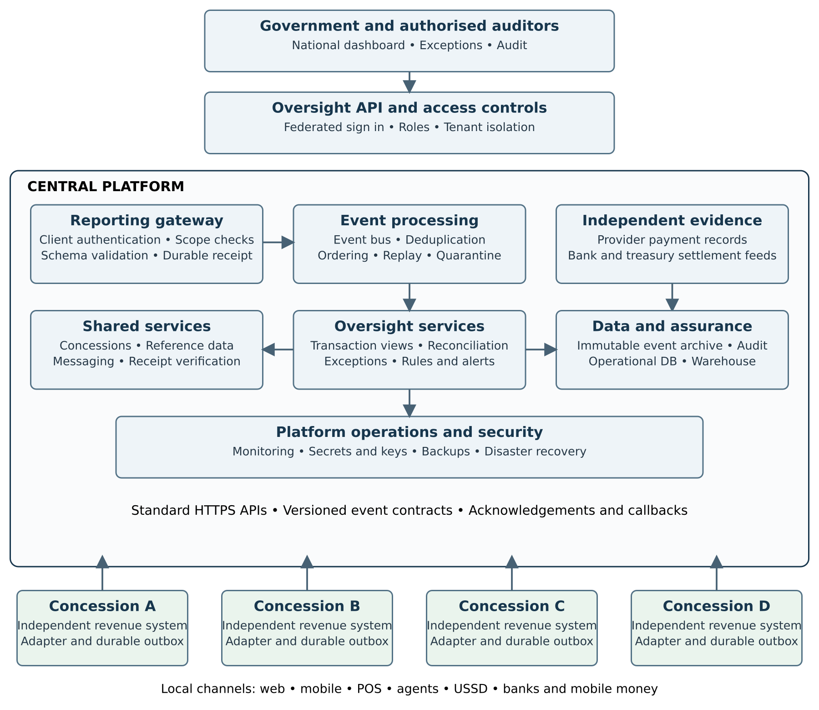
Figure 1 Logical architecture. Local reports flow upwards into central services. Acknowledgements, reference updates and messaging outcomes return through the same authenticated integration boundary. Independent financial feeds support reconciliation. The diagram shows logical services rather than a required number of servers.

3 Central services and deployment design

Integration and event processing
The external reporting gateway authenticates each concessionaire, checks authorised scope and validates contract versions. It stores accepted submissions durably before returning a receipt. An internal event bus delivers them to transaction processing, reconciliation, messaging, audit and analytical consumers. Separate queues and quotas prevent one concessionaire’s backlog from exhausting national capacity.
Invalid business records enter a restricted quarantine with a reason and correction route. Unauthenticated requests are rejected. Processing failures use retries and a dead-letter queue. Accepted raw events remain available for replay, and consumer checkpoints support rebuilding derived views without changing financial history.

Data services
- Operational repository stores validated transaction histories, current views, concession references and exception cases.
- Event archive preserves original accepted payloads, hashes, processing decisions and correction links under controlled retention.
- Warehouse receives curated, minimised data for national analytics. Dashboards show reporting lag, missing feeds and financial verification status.
- Audit service records administrative changes, queries of sensitive records, approvals, exports and privileged activity.

Deployment topology
Use separate development, test, certification and production environments. Production should span independent failure domains with redundant gateways, processing nodes and database replicas. Place public ingress behind network filtering and application protection; keep brokers and databases on private networks. Deploy a separately recoverable disaster recovery environment and test failover with each concessionaire.
A practical starting stack is containerised services, a relational operational database, a durable message broker, object storage for the event archive, and a warehouse or reporting database. Product choice follows workload tests and support capacity. Kubernetes, Kafka, RabbitMQ and a separate data lake are options, not mandatory prerequisites. A smaller well-operated platform can meet initial needs.

External interfaces
Independent provider and bank adapters import authenticated APIs, webhooks or protected signed files. Each feed records origin, extraction time, coverage period and completeness. Government, identity and GIS integration uses authorised interfaces. No connection to a national identity system is assumed until the responsible authority approves access.

4 Interoperability rules and API catalogue
All concessionaires implement the same externally published contracts while retaining their internal technology. The Central Platform operator maintains a sandbox, OpenAPI descriptions, event schemas, code lists, examples and a certification suite. The API catalogue below is a proposed baseline, not an implemented interface.
Interface | Purpose and required behaviour
POST /v1/events | Submit one event; return durable ingestion ID and status URL.
POST /v1/event-batches | Submit bounded batches; return a result for every item.
GET /v1/ingestions/{id} | Check received, validated, applied or quarantined status.
GET /v1/reference-data | Retrieve versioned authorities, revenue codes and scope data.
POST /v1/messages | Request an approved message with an idempotency key.
GET /v1/messages/{id} | Retrieve provider acceptance and delivery status separately.
GET /v1/receipts/{id}/verification | Verify a receipt with minimal disclosure and rate limits.
POST /v1/control-totals | Submit period counts, amounts and manifest references.
GET /v1/exceptions | View scoped cases; controlled actions use separate permissions.
POST /v1/provider-evidence | Restricted independent financial-feed submission.

Transport and responses
Use HTTPS with JSON encoded in UTF-8, UTC timestamps with explicit offsets, fixed decimal money or integer minor units, currency codes and published identifiers. Define size limits, pagination and timeouts in the contract. HTTP 202 indicates durable receipt only. Item status determines business acceptance. Invalid schemas return an explanatory 4xx response; rate limits return 429 with retry guidance. Transient 5xx errors and timeouts are retried using the original event ID.

Authentication and versioning
Use separate machine credentials for each concessionaire and environment, short-lived OAuth access tokens, and mutual TLS for reporting clients. Tokens identify the client and permitted scopes. Human access uses federated OpenID Connect with multi-factor authentication. Apply OAuth security guidance [3].
Pin an OpenAPI version compatible with all partners [1], and use CloudEvents 1.0 metadata for the event envelope [2]. API major versions and payload schema versions are explicit. Additive optional fields may be compatible; changed meanings or mandatory fields require a new version. Proposed policy: publish breaking changes at least 180 days before retirement, support old and new versions in parallel, and certify every partner before cutover.

5 Canonical data model and event catalogue
The event envelope uses CloudEvents attributes id, source, specversion and type, with time, subject and dataschema supplied by this framework. The combination of source and id identifies an event. The payload carries concession and financial references. The gateway derives the authorised tenant from credentials and checks it against the payload.
Field group | Required content and rule
Event identity | Stable event ID, source, event type, schema version and correlation ID.
Business identity | Concessionaire ID, concession ID, authority code, jurisdiction code and revenue code.
Object references | Assessment, invoice, payment and receipt IDs as applicable; namespace with issuer.
Money | Currency, gross amount, fee, net amount and allocation lines as applicable; no binary floating point.
Payment evidence | Provider ID and reference, channel, payment time and declared outcome.
Timing and ordering | Occurred time, local recorded time, central received time, aggregate ID and aggregate version.
Customer reference | Opaque revenue account reference; approved identity mappings stored separately.
Field operation | Agent and device ID where relevant; location only when justified.
Corrections | Original event or transaction reference, reason, authorisation reference and replacement version.

Minimum event families
AssessmentCreated, AssessmentAmended, AssessmentCancelled; InvoiceIssued and InvoiceCancelled; PaymentInitiated, PaymentConfirmed, PaymentFailed and PaymentReversed; ReceiptIssued; RefundRequested, RefundApproved and RefundCompleted; SettlementReported and SettlementConfirmed; AgentStatusChanged and DeviceStatusChanged; MessageRequested and MessageDeliveryUpdated. Independent provider evidence remains distinguishable from concessionaire reports.

Identity and reference policy
Account, person, property, business and invoice are separate entities. A phone number is a contact channel and must not be treated as a unique person identifier. Use approved identity references only where needed. Concessionaire account IDs map to a central opaque reference through a controlled process; uncertain matches require review. Ownership changes to a property or business preserve historical liability and payment records.
Money allocations support partial payments, one payment against several invoices, and several payments against one invoice. A failed attempt creates no collected revenue. Refunds, reversals and amendments preserve original records and link compensating entries. Published code lists define each state and its allowed transitions.

6 Reliable reporting and offline recovery

Local commit and durable delivery
The concessionaire writes the business transaction and its reporting event to a durable outbox in the same local database transaction, or implements an equivalent tested atomic mechanism. A delivery worker sends pending events, retains receipt IDs and retries with exponential backoff and jitter. A lost acknowledgement triggers resend of the same event, not creation of a new financial event.
The central gateway durably records the envelope before acknowledgement. Consumers apply an event idempotently, so repeated delivery produces one business effect. A duplicate with the same identity and matching payload returns the original status. The same identity with different content is quarantined as a conflict. Delivery is at least once; the design does not assume exactly-once network transport.

Ordering and completeness
Ordering applies per business object, using an aggregate version. A refund arriving before its payment waits for its predecessor or enters a dependency exception. There is no requirement for a single global sequence. Late events retain their occurred time and central received time so accounting-period updates remain traceable.
Each partner sends period manifests containing event counts, financial totals by currency and event family, first and last sequence markers, and missing sequence declarations where applicable. Compare these with central receipts and applied events. A heartbeat confirms connectivity only; it does not prove that all transactions were reported.

Offline collection
Field devices use encrypted local storage, unique local references, authenticated operators and approved cached concession rules. Offline payment capture must distinguish a collection claim from confirmed electronic payment. Receipts indicate provisional status where confirmation is unavailable. Cash collection requires separate deposit and reconciliation controls. Device synchronisation feeds the concessionaire system before central reporting.

Central outage and backlog recovery
- Keep collecting within the approved continuity policy and preserve the local outbox.
- Show Government that the national view is stale, with last received time by concessionaire.
- On recovery, throttle replay, prioritise recent critical events without losing backlog, and preserve business ordering.
- Compare control totals and independent evidence; resolve missing and conflicting records through exception cases.
- Remove local queue entries only under the agreed retention and acceptance policy; retain replay evidence.
Reporting failures do not automatically reverse a payment. Any decision to restrict collection follows authorised operational procedures rather than a gateway timeout.

7 Reconciliation messaging and national reporting

Independent financial reconciliation
Match concessionaire reports against provider confirmation, provider settlement statements and destination bank or treasury records. A reported payment, a confirmed provider payment, a settled amount and a reconciled Government credit are separate states. National reports expose all four. Central reconciliation is authoritative only to the extent that evidence coverage and unresolved exceptions support it.
Match using provider references, amount, currency, time window and allocation IDs. Settlement batches may combine many payments; store a batch-to-payment allocation. Compare gross collections, approved fees, refunds, chargebacks, timing differences and net credited funds. An unmatched difference is an exception until classified, not automatically fraud.

Financial approvals and exceptions
Assign each exception an owner, severity, evidence links, due date and status. Refund approval, bank-detail changes and reconciliation overrides use maker-checker approval and reason codes. Freeze original evidence. Corrections generate linked events, and closed accounting periods require controlled adjustment entries. Rules distinguish pending settlements from overdue ones using approved provider calendars.

Shared messaging
Concessionaires submit a business notification request with recipient reference, template version, language, channel, transaction reference and deduplication key. The central service applies approved sender identity, routing, consent or other authorised communication basis, rate limits and cost allocation. It records request, provider acceptance, delivery outcome and failure separately.
An uncertain delivery result must not trigger uncontrolled cross-channel duplicates. Fallback policy defines timing, alternate channels and whether a message can be resent. Transactional and promotional communication have different controls. A local fallback gateway, if approved, reports its outcomes centrally and uses the same notification identity. USSD is normally a customer-initiated session; session integration is distinct from SMS or push delivery.

National dashboards and measures
Display assessments, confirmed collections, outstanding balances, settled funds, unresolved differences and collection efficiency by authority, period, concession and revenue type. Define numerator, denominator, exclusions and period for every KPI. Separate payment attempts from successful collections. Mark late or incomplete data; present receipt time and last completed reconciliation alongside totals.
Auditors can trace a national figure through warehouse records to applied events and independent evidence. Receipt verification discloses only the fields necessary to establish authenticity. Automated anomaly rules raise review cases; they do not independently impose sanctions or authorise financial changes.

8 Security privacy and data governance

Access and trust boundaries
Government oversight, concessionaire operations, external financial feeds and platform administration are distinct trust zones. Enforce tenant and jurisdiction scope at the API, application and data layers. Concessionaire identifiers supplied by clients never override authenticated scope. Human roles separate national viewing, audit, operations, finance approval and technical administration.
- Use multi-factor authentication for privileged users, time-limited elevated access and documented emergency access.
- Rotate client certificates and credentials, revoke compromised clients and keep secrets in managed storage.
- Encrypt network traffic, databases, archives and backups; document key ownership and recovery procedures.
- Protect ingress with quotas, request validation and application filtering. Test authorisation across tenants.
- Record sensitive exports, data changes and administrative actions with actor, time, scope and reason.

Data minimisation and lawful access
Approve a field-level sharing schedule before integration. The central oversight dataset should contain only the identity and contact data needed for authorised reporting, reconciliation and messaging. Keep contact details and identity mappings in restricted services. Use synthetic or irreversibly de-identified records for testing. Exclude card security codes, full payment credentials and unnecessary identity-document images from event payloads.
Confirm data-controller and processor responsibilities, hosting locations, permitted transfers, retention periods, incident duties and access arrangements through the appropriate Government and legal review. This framework proposes technical controls; it does not determine the lawful basis or declare any particular hosting location legally sufficient.

Records and citizen rights
Data governance must distinguish Government records, personal data, concessionaire business information and software IP. Access to records follows the Government mandate and applicable agreements; holding data does not itself establish proprietary ownership. Provide approved correction, access and deletion processes with documented exceptions for required financial retention.
An append-only archive protects audit integrity during an approved retention period. It is not a promise to retain all personal data indefinitely. Partition or tokenise personal fields so retention expiry and authorised deletion can be implemented without destroying the minimum financial evidence lawfully retained.

Incident handling
Maintain a common incident procedure with named contacts, detection and containment steps, evidence preservation, credential revocation and required notification routes. The central operator and affected concessionaire coordinate recovery, while Government retains oversight. Test data exposure, fraudulent client submissions and compromised field-device scenarios before production.

9 Service levels capacity and operational assurance
The following are proposed starting targets. Government and the concessionaires must approve them after sizing, pilot results and a business-impact assessment. Measure central and local availability separately.
Measure | Proposed planning target | Measurement
Central ingestion availability | 99.9 percent per calendar month | Eligible minutes with durable receipt available; agreed exclusions explicit.
Connected reporting delay | 95 percent within 60 seconds | Local committed time to central durable receipt.
Dashboard freshness | 95 percent within 5 minutes | Central receipt to visible operational view.
Offline backlog | Drain within 24 hours of stable recovery | Subject to measured backlog and agreed replay throughput.
Central disaster recovery | RPO at most 5 minutes and RTO at most 4 hours | All components tested; replay reconciles acknowledged data gaps.
Reconciliation | Daily cycle after evidence availability | Coverage and exception ageing reported by provider.
Critical incident acknowledgement | 15 minutes under continuous support | Measured from agreed alert or incident receipt.

Sizing and data integrity
Obtain transactions per day, peak events per second, events per payment, payload sizes, messaging volume, offline backlog, provider schedules and retention periods. Size for measured peaks and concurrent catch-up. Estimate archive growth from event count × mean payload size × retention, then add indexes, replication and backups. Load tests include partner isolation and reconciliation workload.
A nonzero disaster-recovery RPO can lose recently acknowledged events. Partners must retain accepted outbox history for an agreed replay window and compare manifests after failover. An ingestion status that disappears after recovery triggers safe replay. If durable acceptance must survive without loss, specify and test an RPO of zero with an appropriate replication design and cost.

Monitoring and operational evidence
Monitor backlog depth, oldest pending event, rejection rate, duplicate conflicts, delayed predecessors, consumer lag, reporting completeness, provider-feed freshness and warehouse lag. Alerts have an owner and response playbook. Monitor certificate expiry, failed authentication, unusual exports and backup success alongside service performance.

Recovery verification
Test backup restoration, primary-region loss, database failure, broker recovery and corrupted projections. Rebuild derived views from retained events and verify financial totals. Recovery is complete only when service health, event completeness and financial reconciliation meet the agreed criteria. Messaging requires its own replay rules to prevent resending old notifications.

10 Governance ownership and concession transition

Government and shared operator
Government should approve the oversight standards, concession scope, reporting access, KPI definitions and audit policy. A designated Central Platform operator implements and supports those controls under an approved service agreement. The operator may be Government, an independent provider or an SPV; selection remains open.
If concessionaires jointly own the operator, establish Government oversight, independent audit, conflict disclosure, access separation and a route for admitting future concessionaires on equivalent terms. Equity participation does not grant unrestricted access to competitors’ data or unilateral control over interoperability rules.

Decision rights
Decision | Proposed approval route
Concession scope and collecting authority | Responsible Government authority.
Common API and data contracts | Technical committee recommends; Government oversight approves.
Provider and settlement arrangements | Authorised Government finance function and contract parties.
Technical releases within approved design | Central operator under controlled change management.
Material cost sharing and operator ownership | Affected parties through written commercial agreement.
Background IP licence or assignment | Verified IP owner through an explicit signed agreement.
Sensitive data access and national exports | Designated Government data owner under approved policy.

Intellectual property and funding
Maintain a Background IP register for each participant, including iDARMS where applicable, identifying owners, components, licences and third-party restrictions. Interface conformity does not require disclosure of local source code. Separate ownership of central code, central operating licences, Government usage rights, local applications and the public interoperability specification.
Agree central development and operating costs separately from collection revenue shares. Allocate costs transparently using fixed participation, measured usage or another approved basis. Prevent central-service fees from being deducted from public collections without express authorisation. Government continuity rights, source access or escrow arrangements require explicit terms.

Concession expiry or replacement
Use effective-dated authority changes and identify who services outstanding assessments, refunds and disputes. Freeze new collection rights at the agreed cutover while permitting authorised historical reporting. Export agreed data and evidence to Government or an approved successor, rotate credentials and reconcile balances. Transfer of records does not automatically transfer proprietary software. Test transition through a rehearsal before expiry.

11 Implementation plan and acceptance criteria
Stage | Required outputs | Acceptance evidence
1 Agreement and discovery | Authority model, data schedule, volumes, financial flows and ownership register | Government and partner approval of boundaries and unresolved decisions.
2 Contracts and sandbox | Schemas, code lists, OpenAPI, event examples and certification environment | All partners can validate and authenticate sample submissions.
3 Central foundation | Gateway, durable event store, broker, scope registry, audit and operations | Security, replay, tenant isolation and restoration checks pass.
4 Partner adapters | Local outbox, delivery worker, receipt tracking and control totals | Each partner passes independent conformance tests.
5 Finance and shared services | Provider and bank feeds, reconciliation, messaging and dashboards | End-to-end financial trace and message deduplication demonstrated.
6 Controlled pilot | Limited live scope with parallel reconciliation | Totals match evidence; reporting and recovery targets met.
7 Phased rollout | Concession onboarding, support and transition procedures | Approved production readiness and staged rollout sign-off.

Mandatory integration tests
- Duplicate submission and lost acknowledgement cause one business effect.
- Different payloads using the same event identity are flagged without overwriting evidence.
- Out-of-order payment, receipt, reversal and refund events resolve consistently.
- A batch with mixed valid and invalid items returns individual results without silent losses.
- A concessionaire cannot read or submit records under another concessionaire’s identity.
- Offline replay and central failover restore completeness against control totals.
- Partial payments, multi-invoice allocations, fees and settlement batches reconcile correctly.
- Missing bank evidence, provider delay and unexplained differences appear as open exceptions.
- Message retry, fallback and callback replay do not create unauthorised duplicate notifications.
- Credential revocation, expired concessions and approved historical reporting behave as specified.

Production readiness
Before launch, approve runbooks, support contacts, monitoring, recovery evidence, penetration-test findings, privacy controls and Government access. Record defects, owners and acceptance decisions. A partner is certified for a specific schema and scope; material changes require targeted recertification. Dates and rollout volumes should be set after discovery rather than inferred from this framework.

12 Decisions and detailed design deliverables

Decisions for the next joint meeting
- Confirm the collecting entities, concession boundaries and responsible Government authority.
- Approve the separation of local operations, central oversight and independent financial evidence.
- Select the central operating and ownership model, including conflict safeguards.
- Agree mandatory reporting fields, event families and financial state definitions.
- Confirm whether messaging is mandatory centrally or permits audited local fallback.
- Approve settlement mandates, evidence access, fee treatment and exception ownership.
- Set hosting, data access, retention and identity integration policies.
- Assign funding, delivery responsibilities, pilot participants and acceptance approvers.

Deliverables after approval
The detailed design should produce a system context and deployment diagram; OpenAPI files; JSON event schemas; event and code-list registries; example requests and responses; data-sharing and retention schedules; concession scope rules; authentication profiles; reconciliation rules; financial allocation models; messaging templates and fallback rules; sizing and service-level schedules; recovery runbooks; partner certification scripts; and a responsibility matrix with named owners.

Illustrative payment reporting record
Example only. IDs and code values are fictitious; actual values come from the approved registries. The payment reference identifies the business payment, while the event ID identifies this particular statement about it. Amounts are integer minor units, so 125000 represents GHS 1,250.00.
{
"specversion": "1.0",
"id": "evt-A-000018", "source": "urn:concessionaire:A",
"type": "revenue.payment.confirmed.v1",
"time": "2026-10-08T13:30:00Z",
"subject": "payment/pay-A-000041",
"datacontenttype": "application/json",
"dataschema": "urn:revenue:schema:payment-confirmed:1",
"data": {
"concessionaireId": "A", "concessionId": "CN-001",
"authorityCode": "AUTH-01", "jurisdictionCode": "J-01",
"revenueCode": "REV-01", "paymentId": "pay-A-000041",
"accountRef": "acct-A-008", "currency": "GHS",
"grossMinor": 125000, "providerRef": "PSP-739",
"providerId": "PSP-01", "aggregateVersion": 2,
"allocations": [{"invoiceId": "inv-A-021", "minor": 125000}]
}
}

Technical references
[1] OpenAPI Initiative specification index — https://spec.openapis.org/
[2] CloudEvents specification — https://github.com/cloudevents/spec/blob/main/cloudevents/spec.md
[3] IETF RFC 9700 OAuth 2.0 Security Best Current Practice — https://www.rfc-editor.org/rfc/rfc9700.html
These references support contract and security conventions. The architecture, governance model and numerical targets above are proposals for this project, not requirements asserted by those standards.

