CMSC 636 Neural Nets and Deep Learning  
Spring 2022, Instructor: Dr. Milos Manic, *http://www.people.vcu.edu/~mmanic* Homework 2

*Student certification:*

*Team member 1:  
Print Name: Md Touhiduzzaman Date: 3 March 2022   
I have contributed by doing the following: 2.1.1, 2.1.2, 2.1.3*  
*Signed: Touhid*

*Team member 2:   
Print Name: Maher Al Islam Date: 3 March 2022   
I have contributed by doing the following: 2.2, 2.5  
Signed: Maher*

*Team member 3:  
Print Name: Samah Ahmed Date: 3 March 2022   
I have contributed by doing the following: 2.3, 2.4*  
*Signed: Samah*

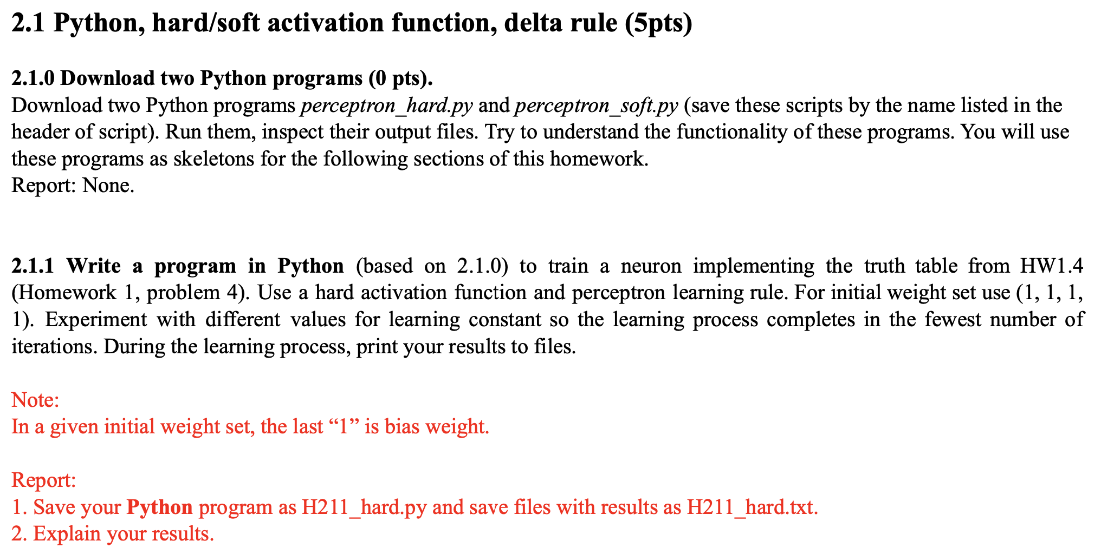

**Answer to 2.1.1:**

From the truth table of the previous homework’s problem 1.4, we had 3 boolean inputs as A, B & C and so there were 8 patterns as [0, 0, 0], [0, 0, 1], [0, 1, 0], [0, 1, 1], [1, 0, 0], [1, 0, 1], [1, 1, 0] & [1, ,1, 1]. Additionally, there was a bias input as always 1. So, the designed neuron has 4 inputs and two outputs as binary 0 & 1.

We have defined our hard activation function like the following two ones:

def unipolar_hard_activation_function(x):  
 return 1 if x > 0 else 0  
  
  
 def bipolar_hard_activation_function(x):  
 return 1 if x > 0 else -1

Then the provided “*perceptron_hard.py”* script is modified to run for 100 number of learning rates ranging from 0.1 to 19.9 with 0.2 increment at each level, i.e., α = [0.1, 20). The updated code is saved in the “*H211_hard.py”* file, as instructed in the question.

**Discussion of Results:**

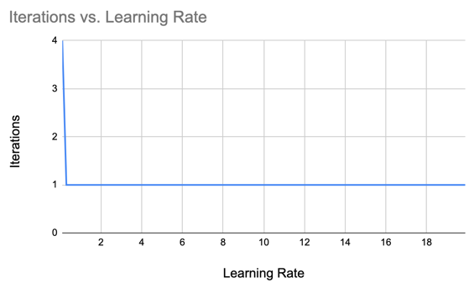For the unipolar hard activation function, the neuron converged with 0 error after 4 iterations with α=0.1 and after only 1 iteration with all the other higher values of learning rates. The required number of iterations versus the learning rate and a few samples of the results are shown in the table below:

|  |  |  |  |
| --- | --- | --- | --- |
| Learning Rate (α) | Iterations | Final Error | Final Weight |
| 0.1 | 4 | 0.0 | 0.4, 0.1, 0.4, -0.7 |
| 0.3 | 1 | 0.0 | 0.4, 0.1, 0.4, -0.7 |
| 0.5 | 1 | 0.0 | 0.4, 0.1, 0.4, -0.7 |
| 1.1 | 1 | 0.0 | 0.4, 0.1, 0.4, -0.7 |
| 19.9 | 1 | 0.0 | 0.4, 0.1, 0.4, -0.7 |

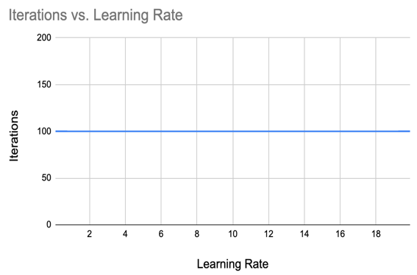But for the bipolar hard activation function, the neuron never converged to 0 error, even after running for preset max 100 iterations with any of the aforementioned 100 values of the learning rate. A few sample results for this case with the iteration vs learning rate graph are shown below:

|  |  |  |  |
| --- | --- | --- | --- |
| Learning Rate (α) | Iterations | Final Error | Final Weight |
| 0.1 | 100 | 10.0 | 0.2, 0.0, 0.2, -0.2 |
| 0.3 | 100 | 6.00 | 0.8, 0.0, 0.8, -0.8 |
| 0.5 | 100 | 10.0 | 1.8, -1.0, 1.8, -1.8 |
| 1.1 | 100 | 10.0 | 4.0, -1.0, 1.8, -1.8 |
| 19.9 | 100 | 6.0 | 32.8, 32.0, 42.0, -74.8 |

So, with an optimal value of learning rate 0.3, we can train the neuron with the fewest number of iterations. which is 1, using unipolar hard activation function.

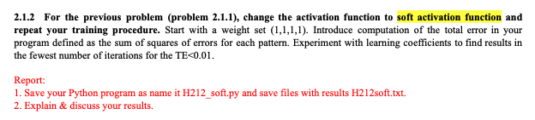

**Answer to 2.1.2:**

The solution to this question is almost similar to our answer to 2.1.1, but we have only replaced our activation function with the following sigmoid function, which is a soft activation function:

def sigmoid(x):  
 k = 1  
 return 1 / (1 + exp(-1 * k * x))

Using the soft activation function, the neuron nearly converges to 0 error after running for preset max 100 iterations with larger values of the learning rate. A few sample results achieving total error less than 0.01 or completing 100 iterations for this case are shown below:

|  |  |  |  |
| --- | --- | --- | --- |
| Learning Rate (α) | Iterations | Final Error | Final Weight |
| 0.1 | 100 | 0.23827773 | 2.88, -0.46, 2.85, -4.22 |
| 0.3 | 100 | 0.02900223 | 5.3, -0.38, 5.27, -7.85 |
| 0.5 | 62 | 0.009968878 | 6.42, -0.36, 6.4, -9.54 |
| 1.1 | 1 | 0.009921703 | 6.54, -0.35, 6.51, -9.66 |
| 19.9 | 1 | 0.000004324 | 68.3, -2.04, 19.79, -44.05 |

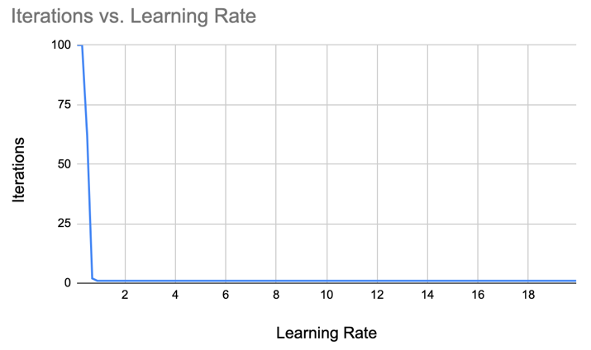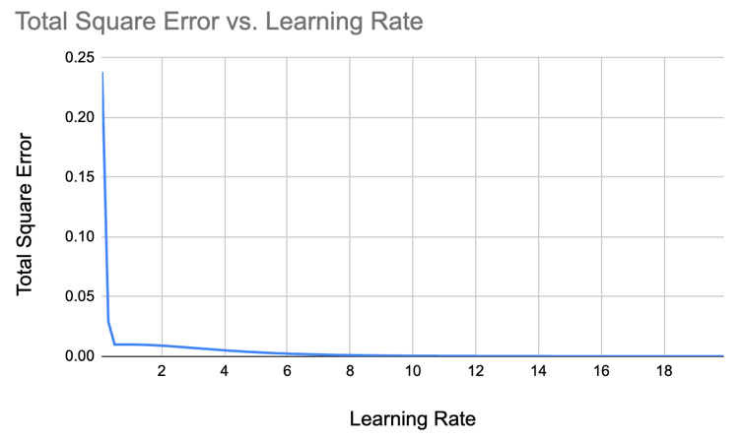

All the outputs of the program are saved inside *“H212soft.txt”* file and the code can be found inside the *“H212_soft.py”* file.

As a separate experiment, we also considered experimenting with bipolar sigmoid function, as shown in the below code block. But the error never converges to 0 for any value of learning rate out of the 100 tested values within [0.1, 20) range, which is also depicted in the following table & graphs.

def sigmoid_bipolar(x):  
 k = 1  
 return 2 / (1 + exp(-2 * k * x)) – 1

|  |  |  |  |
| --- | --- | --- | --- |
| Learning Rate (α) | Iterations | Final Error | Final Weight |
| 0.1 | 100 | 0.81286948 | 0.66, 0.0, 0.63, -0.33 |
| 0.3 | 100 | 1.31937963 | 0.86, -0.0, 0.74, -0.43 |
| 0.5 | 100 | 2.4331252 | 1.24, -0.0, 0.97, -0.62 |
| 1.1 | 100 | 6.95935419 | 3.69, 0.6, 2.59, -1.72 |
| 19.9 | 100 | 6.00000 | 68.3, -2.04, 19.79, -44.05 |

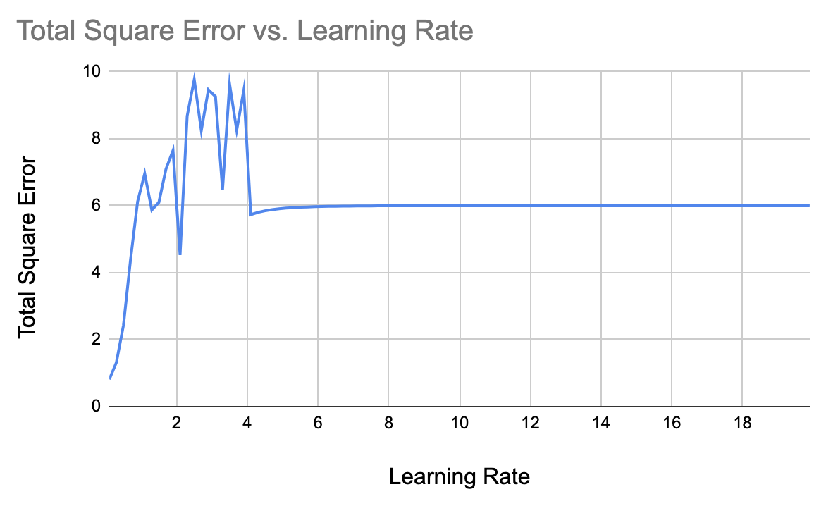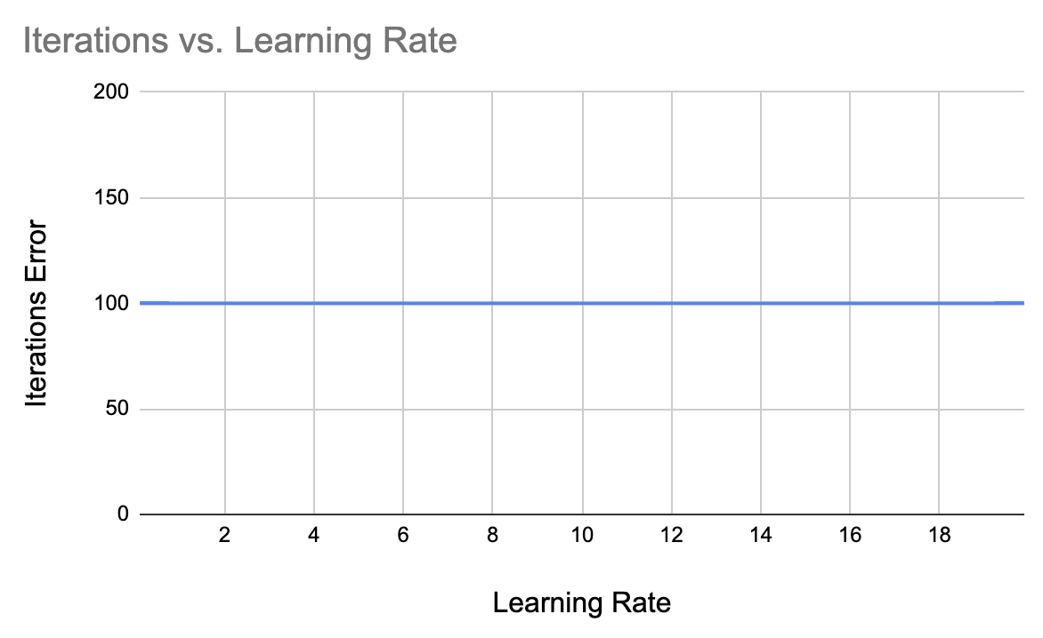

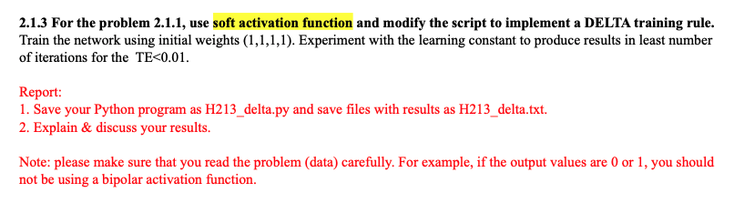

**Answer to 2.1.3:**

To find out the impact of delta learning in the above solution using soft activation function, we have defined the following unipolar delta & activation (sigmoid) functions:

def sigmoid(x):  
 k = 1  
 return 1 / (1 + exp(-1 * k * x))  
  
 def delta(x):  
 k = 1  
 s = sigmoid(x)  
 return k * s * (1 - s)

Then we have run our experiment for 100 values of learning rates ranging within [0.1, 20) and found out that lower iterations are required for higher values of the learning rate. A few samples are shown in the following table with respective graphs of total square error and required iterations against the learning rates.

|  |  |  |  |
| --- | --- | --- | --- |
| Learning Rate (α) | Iterations | Final Error | Final Weight |
| 0.1 | 100 | 0.79768623 | 1.12, -0.24, 1.11, -1.78 |
| 0.3 | 100 | 0.31494453 | 2.46, -0.28, 2.44, -3.62 |
| 0.5 | 100 | 0.14067711 | 3.44, -0.24, 3.43, -5.11 |
| 1.9 | 96 | 0.00998363 | 6.3, -0.19, 6.3, -9.44 |
| 19.9 | 1 | 0.0049191 | 7.1, -0.18, 7.08, -10.58 |

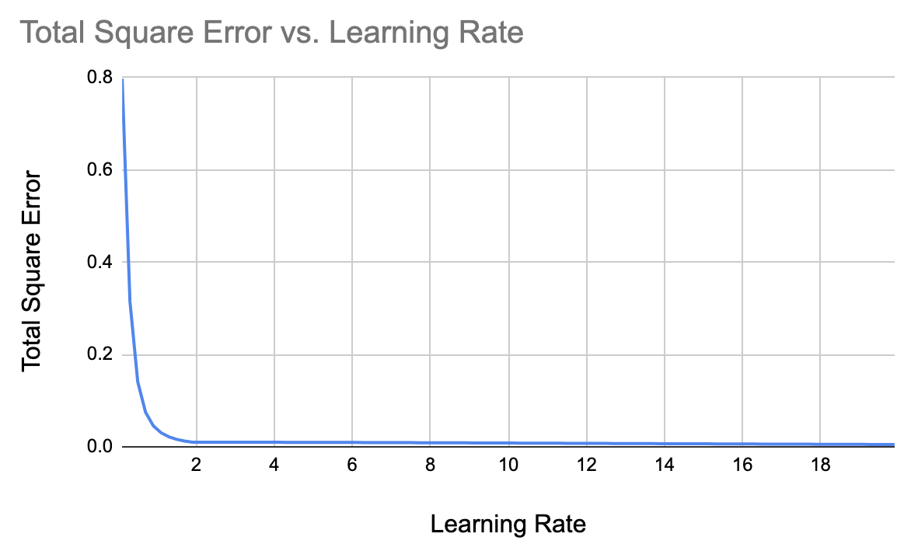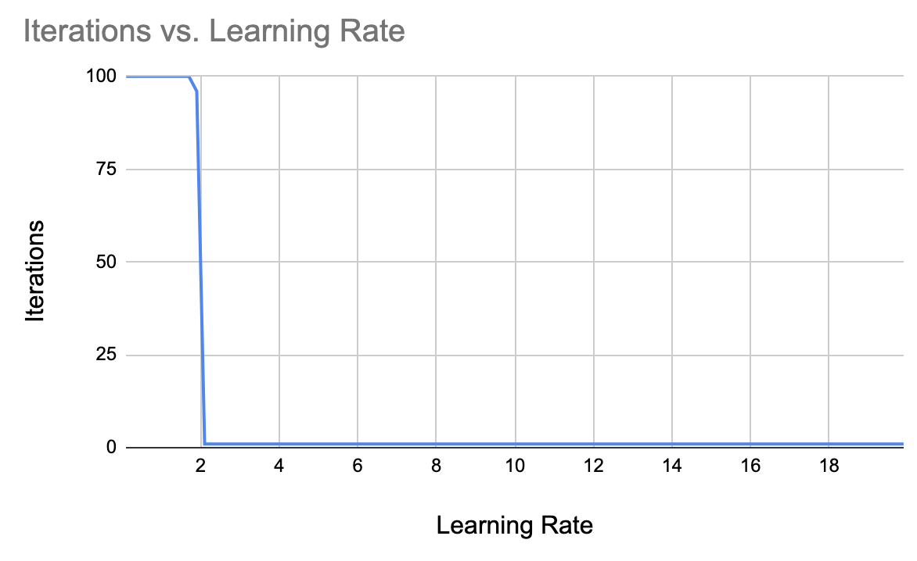

Therefore, an optimal value of learning constant can be taken as 2.1, which can deliver outputs with TE=0.00997 for only one iteration.

All the outputs of the program are saved inside *“H213_delta.txt”* file and the code can be found inside the *“H213_delta.py”* file.

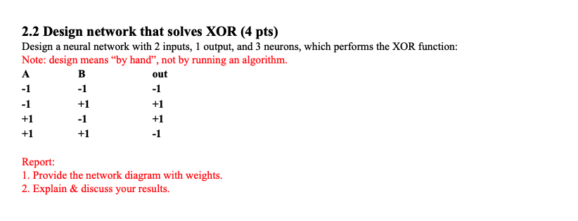

**Answer to 2.2:**

From the given truth table, it is seen that the given XOR operation is of bipolar in nature.

For boolean operation, we know that, if there are two inputs A & B, then the XOR operation can be stated as: A ⊕ B = (A & (!B)) + ((!A) & B)

So, we can have 2 AND neurons having direct and inverted inputs, i.e., with positive & negative weights, from A & B and finally an OR neuron, combining the outputs of the 2 AND neurons, can give the XOR output.

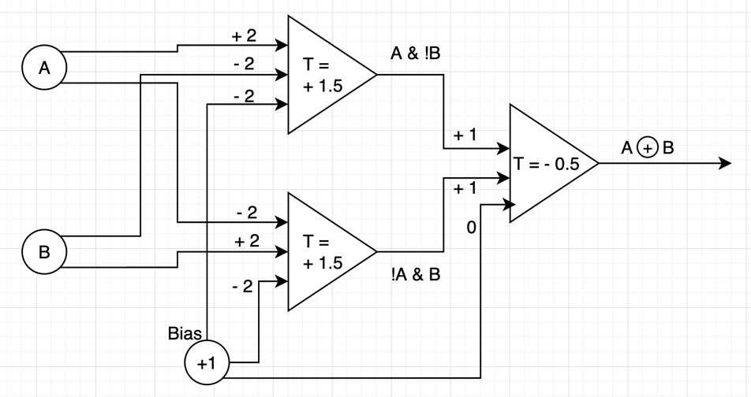The design is shown below with respective weights and thresholds(T):

All the given 4 cases are discussed in details below for the above designed neural network.

**First Case:**

For A=-1 & B=-1, the first neuron output is: -1*2 + -1*-2 - 2= -2 < T

& the second neuron output is: -1*-2+ -1*2 - 2 = -2 < T

So, the first and second neuron do not fire.

The third neuron output gets to be: -1*1 + -1*1 = -2 < T.

Thereby, the final output neuron does not fire and so the output becomes -1.

**Second Case:**

For A=-1 & B=+1, the first neuron output is: -1*2 + 1*-2 -2 = -6 < T

& the second neuron output is: -1*-2 + 1*2 - 2 = +2 > T

So, the first neuron does not fire, but the second one does.

The third neuron output gets to be: -1 + 1 = 0 > T. ⊕

Thereby, the final output neuron fires and so the output become +1.

**Third Case:**

For A=+1 & B=-1, the first neuron output is: 1*2 + -1*-2 - 2 = +2 > T

& the second neuron output is: 1*-2 + -1*2 - 2 = - 6 < T

So, the first neuron fires, but the second one does not fire.

The third neuron output gets to be: 1 + (-1) = 0 > T.

Thereby, the final output neuron fires and so the output become +1.

**Fourth Case:**

For A=+1 & B=+1, the first neuron output is: 1*2 + 1*-2 - 2 = -2 < T

& the second neuron output is: 1*-2 + 1*2 - 2 = -2 < T

So, the first and second neuron do not fire.

The third neuron output gets to be: (-1) + (-1) = -2 < T.

Thereby, the final output neuron does not fire and so the output becomes -1.

So, the given bipolar XOR gate is properly handled by the designed neural network.

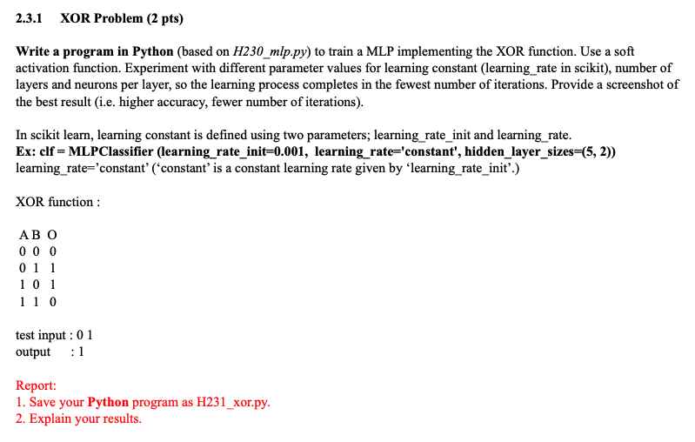

**Answer to 2.3.1:**

We have modified the given H230_mlp.py to generate H231_xor.py Python script, which delivers the XOR neural network with several hidden layers, node &, learning constants using the hyperbolic-tan as a soft activation function.

The implemented code is:

import numpy  
from sklearn.metrics import accuracy_score  
from sklearn.neural_network import MLPClassifier  
  
if __name__ == '__main__':  
 # Input/Output patterns  
 X = [[0, 0], [0, 1], [1, 0], [1, 1]]  
 y = [0, 1, 1, 0]  
 lr_ite_csv_file = open('lr_ite_xor.csv', 'w')  
 for alpha in numpy.arange(0.1, 10, 0.1):  
 # Create model object  
 clf = MLPClassifier(hidden_layer_sizes=(1, 1), random_state=5, verbose=True, alpha=alpha,  
 activation='tanh', learning_rate_init=alpha,learning_rate='constant')  
 # Fit data onto the model  
 clf.fit(X, y)  
  
 # Make prediction on test dataset  
 yPred = clf.predict([[0, 1]])  
 print('prediction', yPred)

# Calculate accuracy  
 acc_score = accuracy_score([1], yPred)  
 print(acc_score)  
 lr_ite_csv_file.write(str(round(alpha, 1)) + ',' + str(clf.n_iter_)

+ ',' + str(clf.loss_) + ',' + str(acc_score) + '\n')  
 lr_ite_csv_file.close()

For a neural network setup with 2-nodes in each of 2 hidden-layers, we have achieved the following iteration and loss curves against the learning rates in range [0.1, 10):

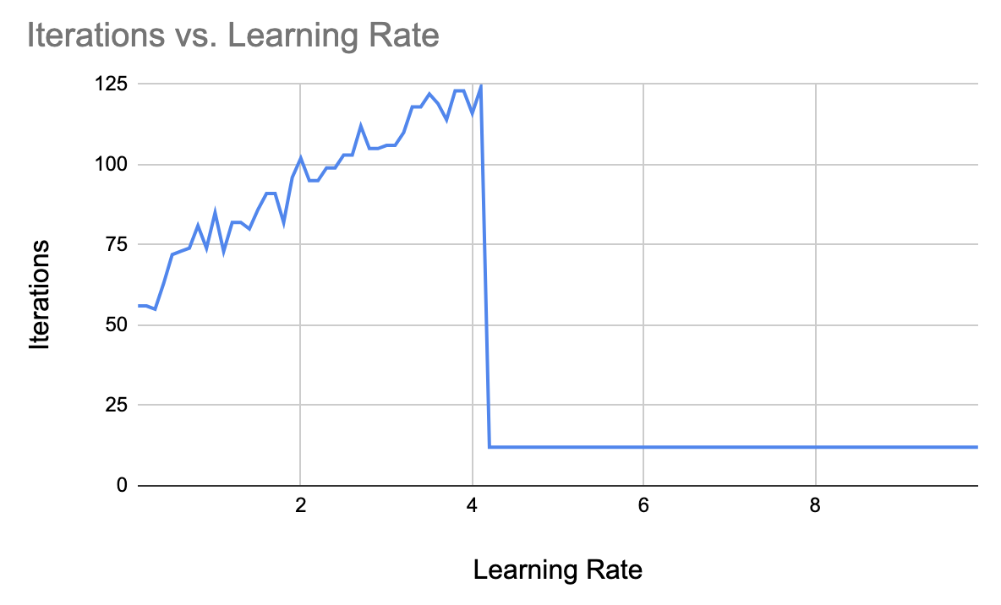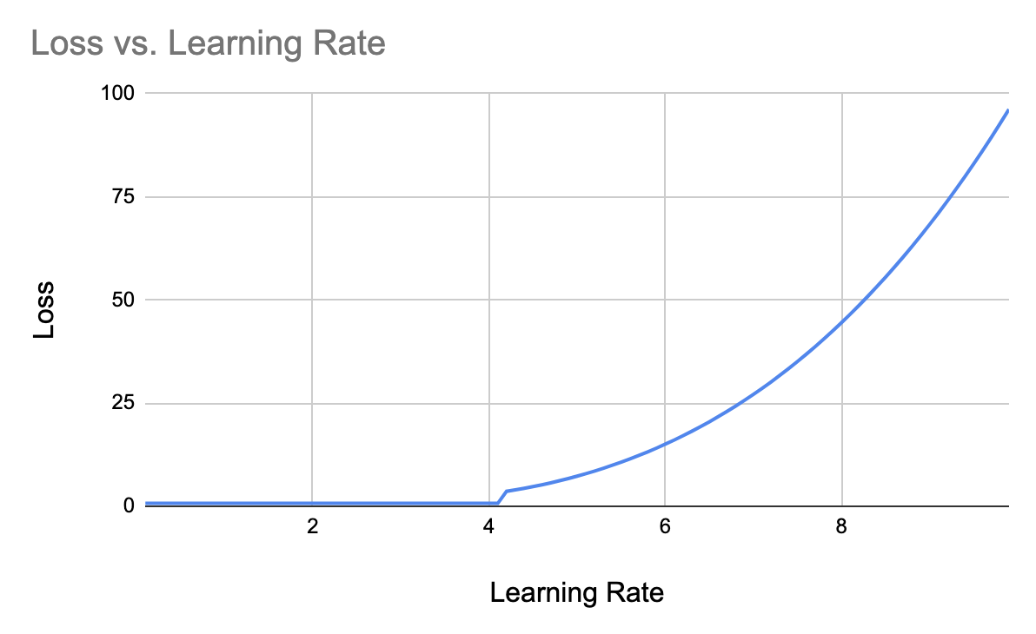

Similarly, for 1 node in a single hidden layer, the following graphs are obtained:

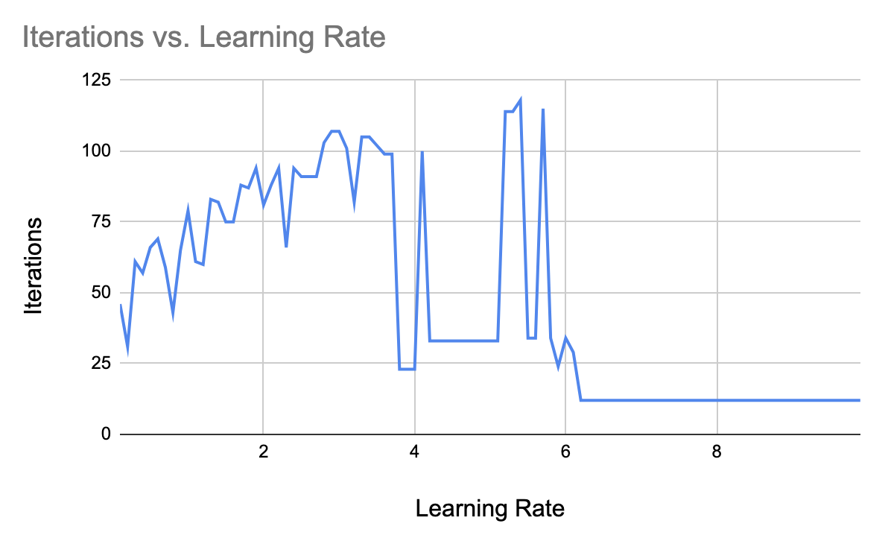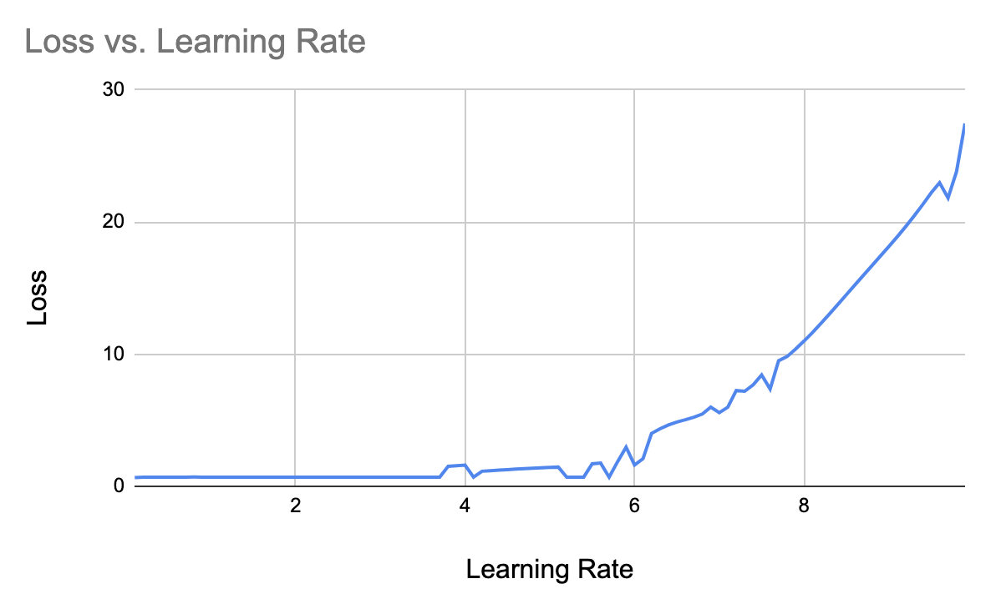

The following graphs are obtained using 2 nodes in each of 3 hidden layers:

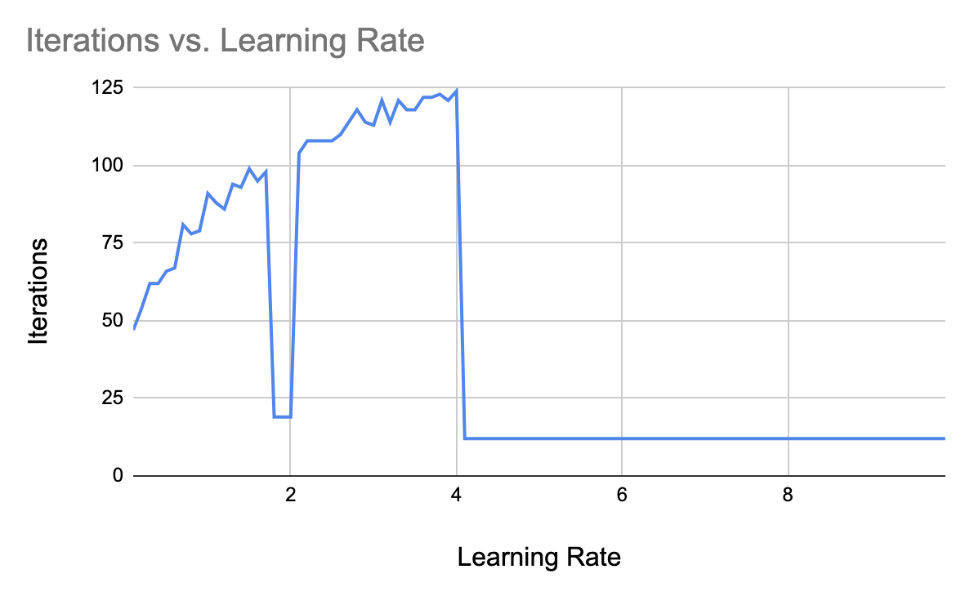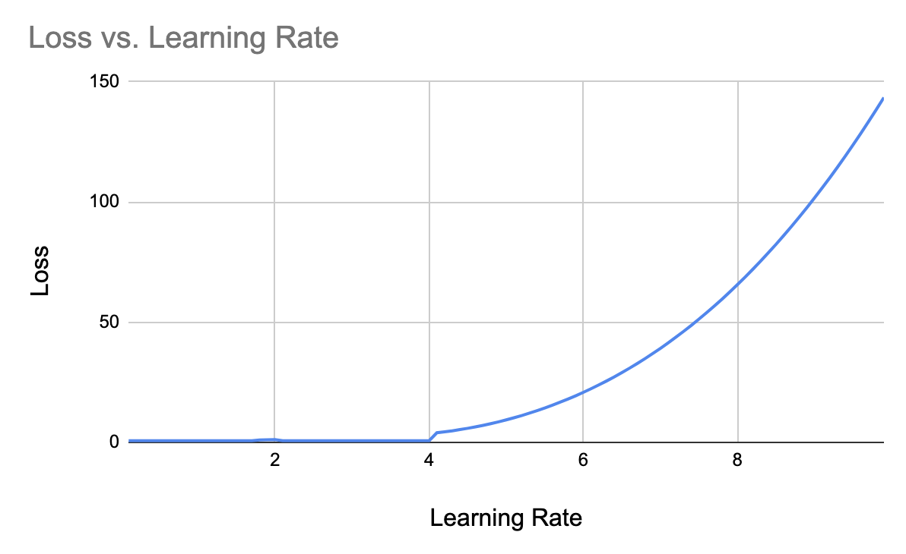

Finally, the following graphs are found using 5 nodes in each of 3 hidden layers:

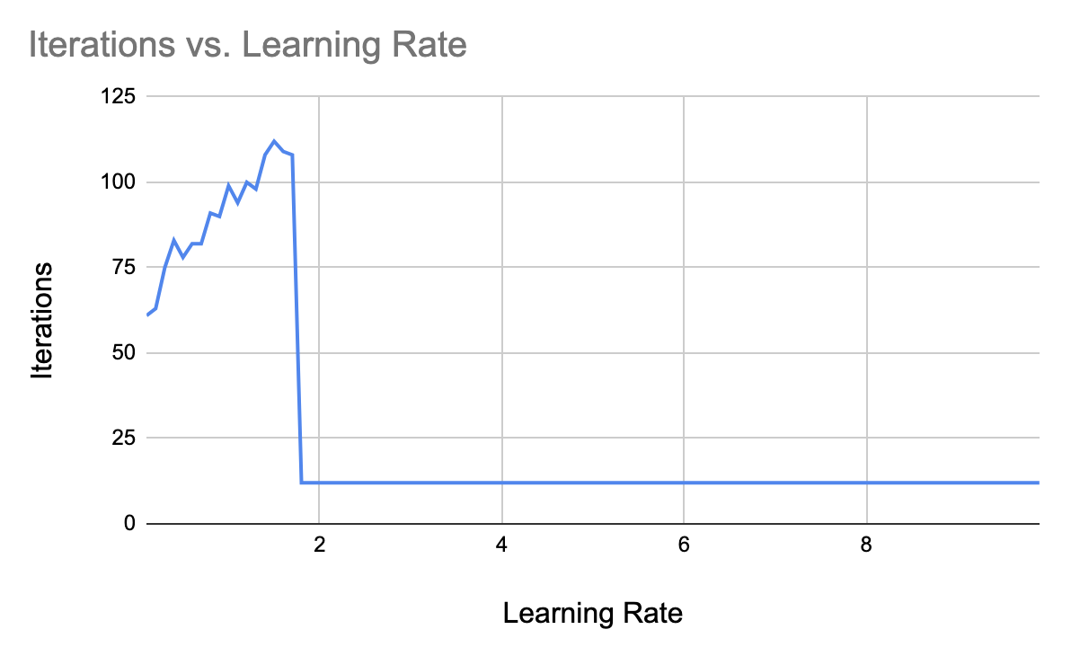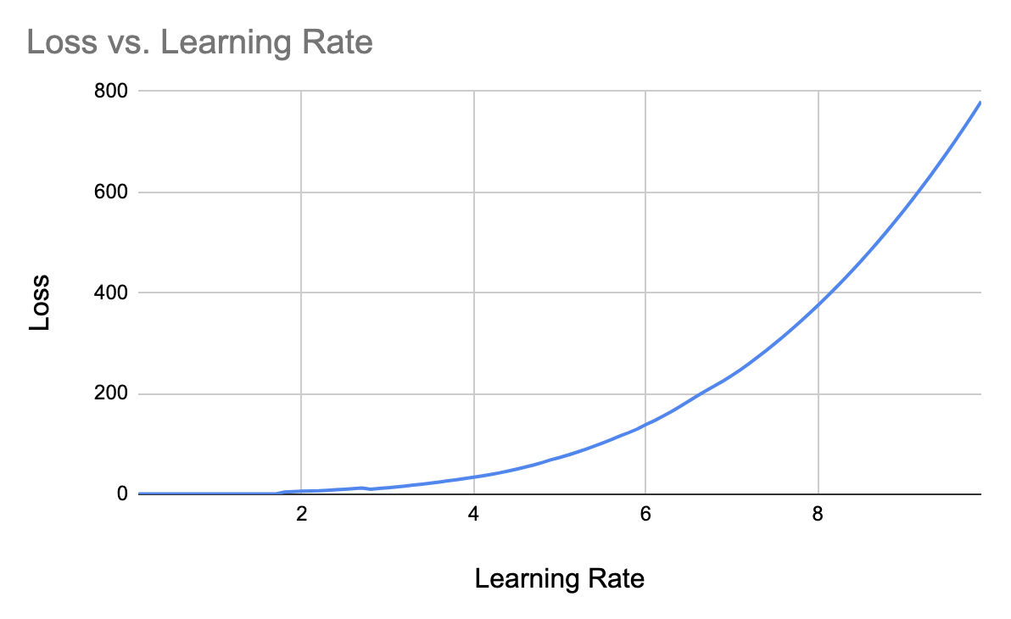

In general, it is seen that **lower** values of the **learning** rate generate **less loss** and **less nodes** in the hidden layers require **less iterations** to let the network converge on some optimal state. Comparing all the run experiments, we can consider the setup of 2-nodes in each of the 3 hidden layers with learning constant 0.1 to be a good candidate. A screenshot of that specific run’s ending situation is given in the figure below:

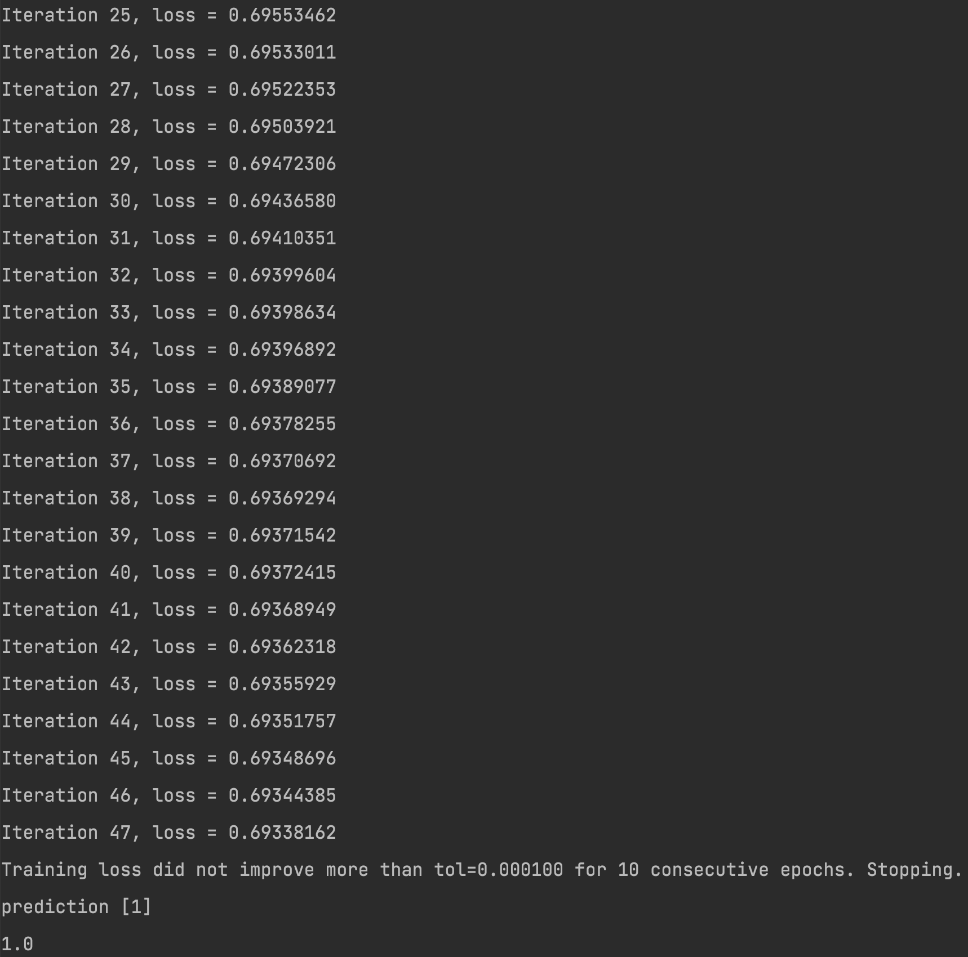

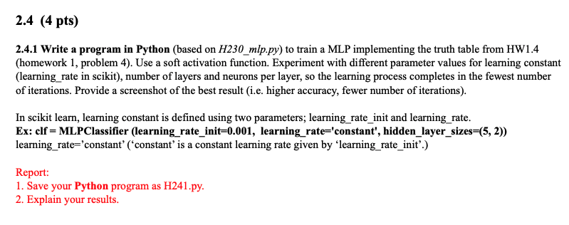

**Answer to 2.4.1:**

The required code implementation is like the following:

import numpy  
from sklearn.metrics import accuracy_score  
from sklearn.neural_network import MLPClassifier  
  
if __name__ == '__main__':  
 # Input/Output patterns  
 X = [ # Patterns as a 2-dimensional list  
 [0, 0, 0, 1], [0, 0, 1, 1], [0, 1, 0, 1], [0, 1, 1, 1], # Each item = [A, B, C, Bias]  
 [1, 0, 0, 1], [1, 0, 1, 1], [1, 1, 0, 1], [1, 1, 1, 1]]  
 y = [0, 0, 0, 0, 0, 1, 0, 1]  
  
 lr_ite_csv_file = open('lr_ite_hw14_222.csv', 'w')  
 for alpha in numpy.arange(0.1, 10, 0.1):  
 # Create model object  
 clf = MLPClassifier(hidden_layer_sizes=(2, 2, 2), random_state=5,verbose=True,

alpha=alpha,activation='tanh', learning_rate_init=alpha, learning_rate='constant')  
 # Fit data onto the model  
 clf.fit(X, y)  
  
 # Make prediction on test dataset  
 yPred = clf.predict([[1, 0, 1, 1], [1, 1, 0, 1], [0, 1, 0, 1], [1, 1, 1, 1]])  
 print('prediction', yPred)  
  
 # Calculate accuracy  
 acc_score = accuracy_score([1, 0, 0, 1], yPred)  
 print(acc_score)  
 lr_ite_csv_file.write(str(round(alpha, 1)) + ',' + str(clf.n_iter_) + ','

+ str(clf.loss_) + ',' + str(acc_score) + '\n')  
 lr_ite_csv_file.close()

For a neural network setup with 2-nodes in each of 3 hidden-layers, we have achieved the following iteration and loss curves against the learning rates in range [0.1, 10):

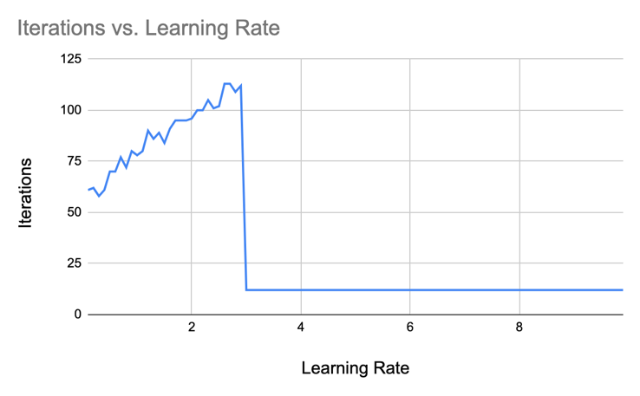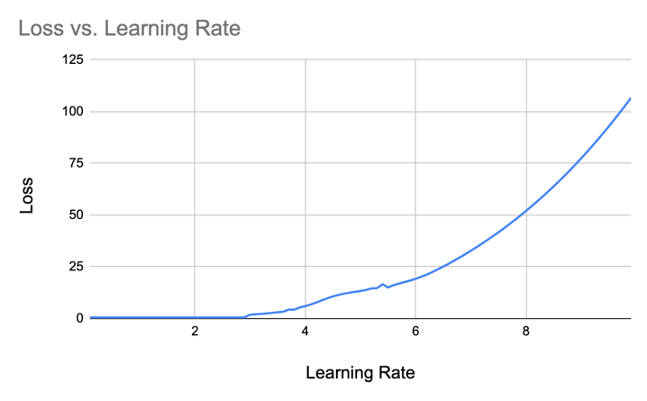

The following graphs are obtained using 2 nodes in each of 2 hidden layers:

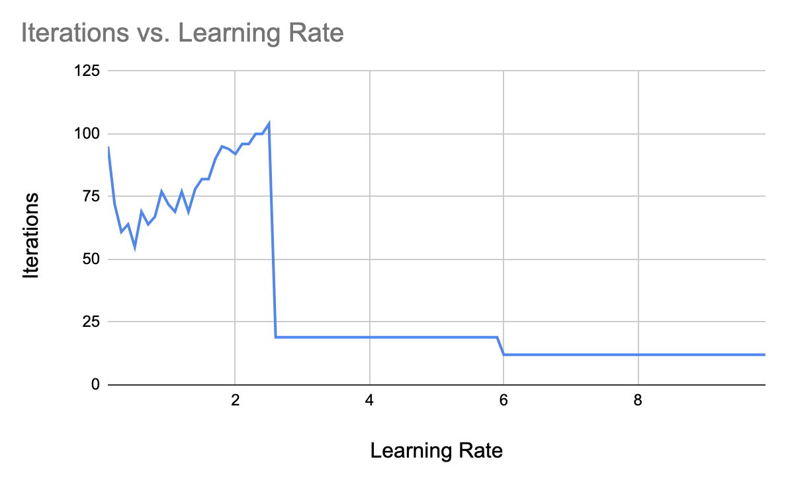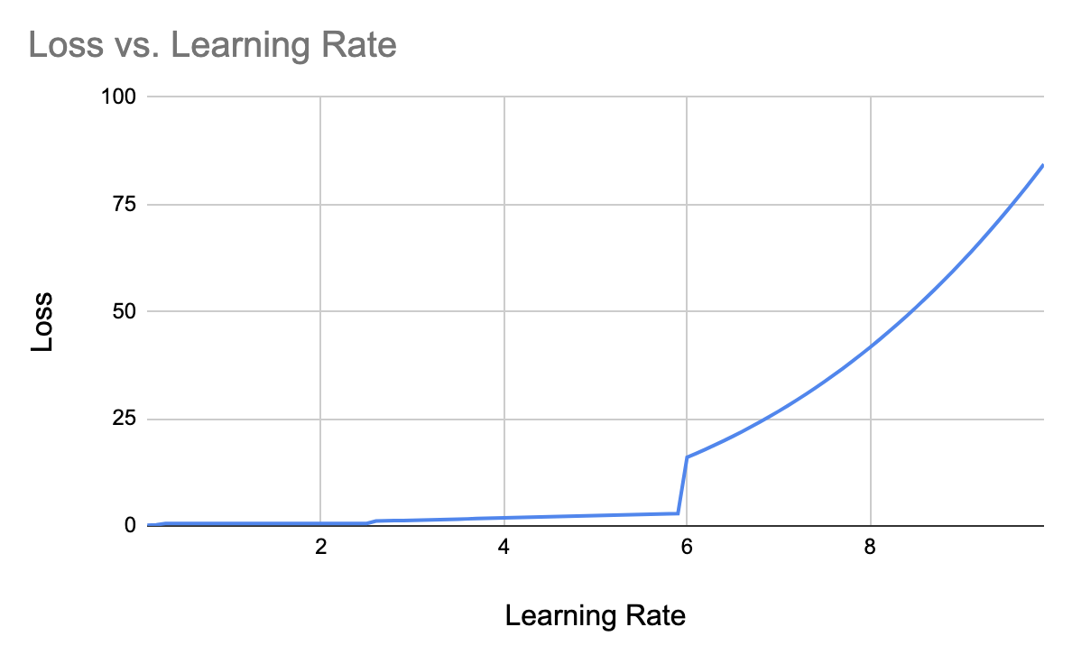

Similarly, for a single node in just a single hidden layer, we get the following graphs:

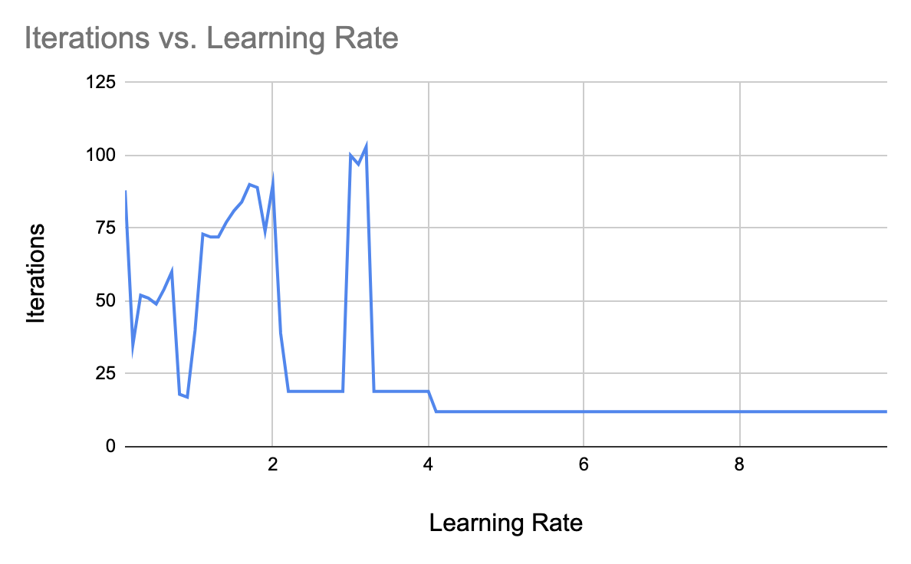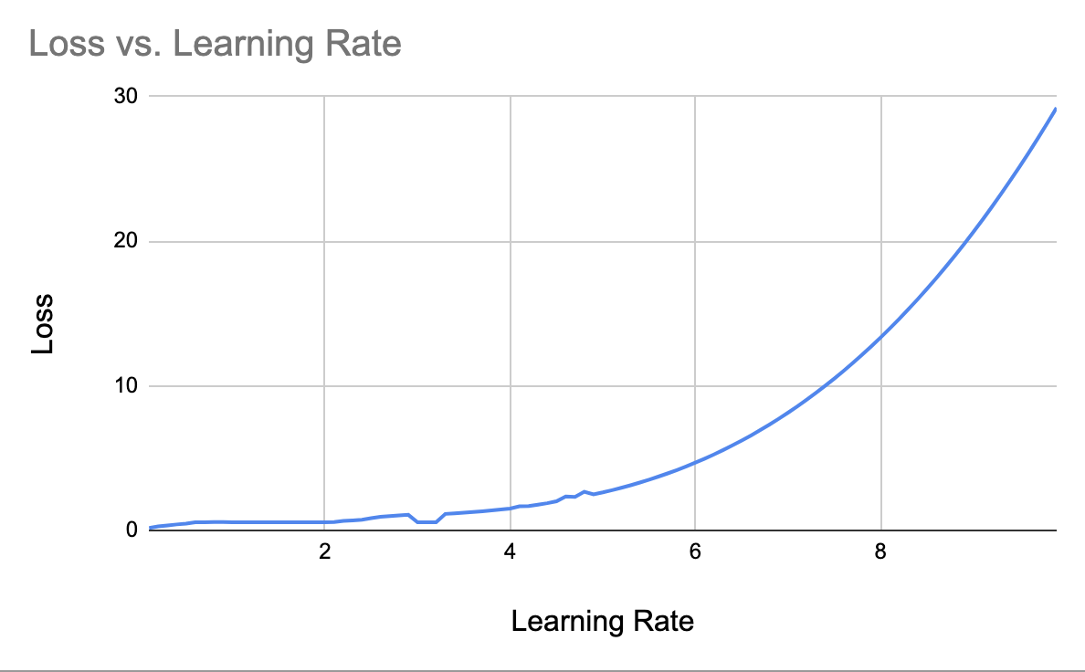

As a final setup, we got the following graphs by running the experiment on a neural network with 5 nodes each in 3 hidden layers:

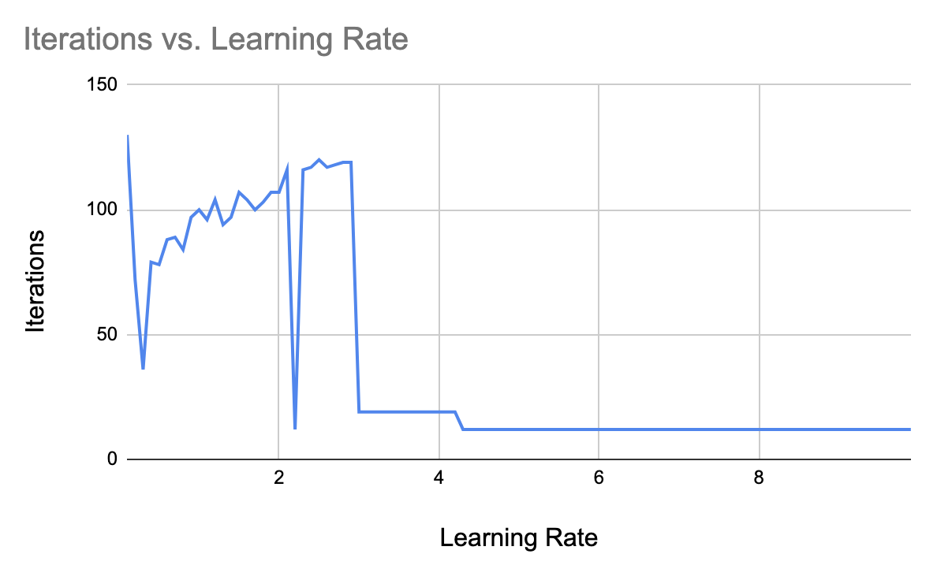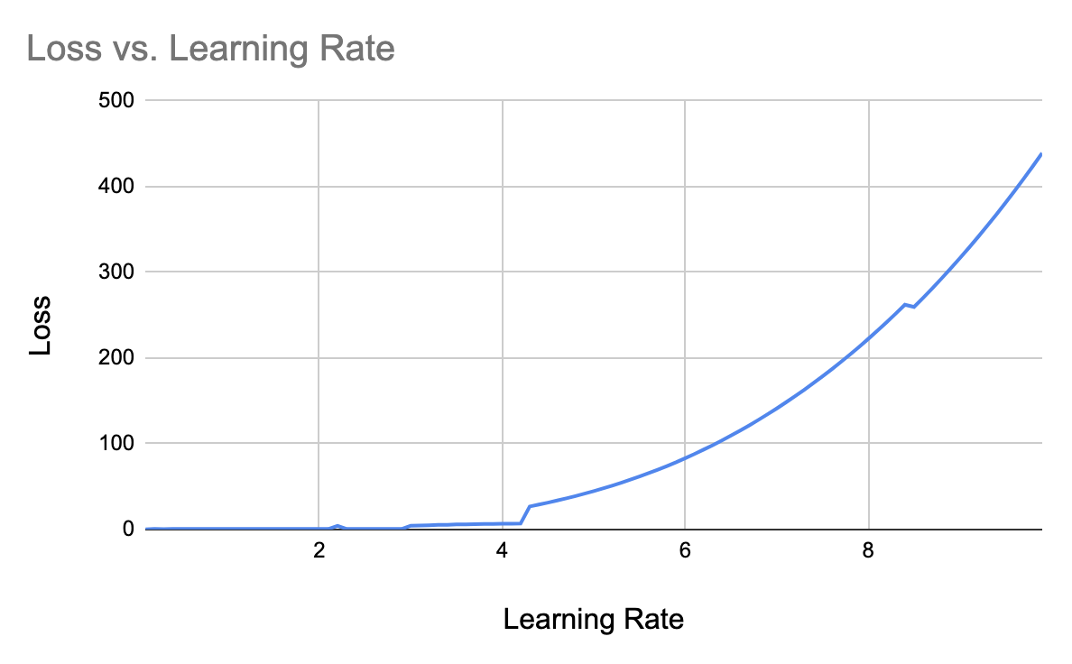

For the 1node-1layer setup, the required number of iterations is seen much lower, but the loss is comparatively higher for this setup. The least amount of loss is seen for 2node-3layer and 5node-3layer setups, but the latter one required much lower iterations to converge. So, we can take 5-node and 3 layers setup with learning rate as 0.3 as an optimal setup, which converged within 36 iterations of our program.

A screenshot of this specific run is given below:

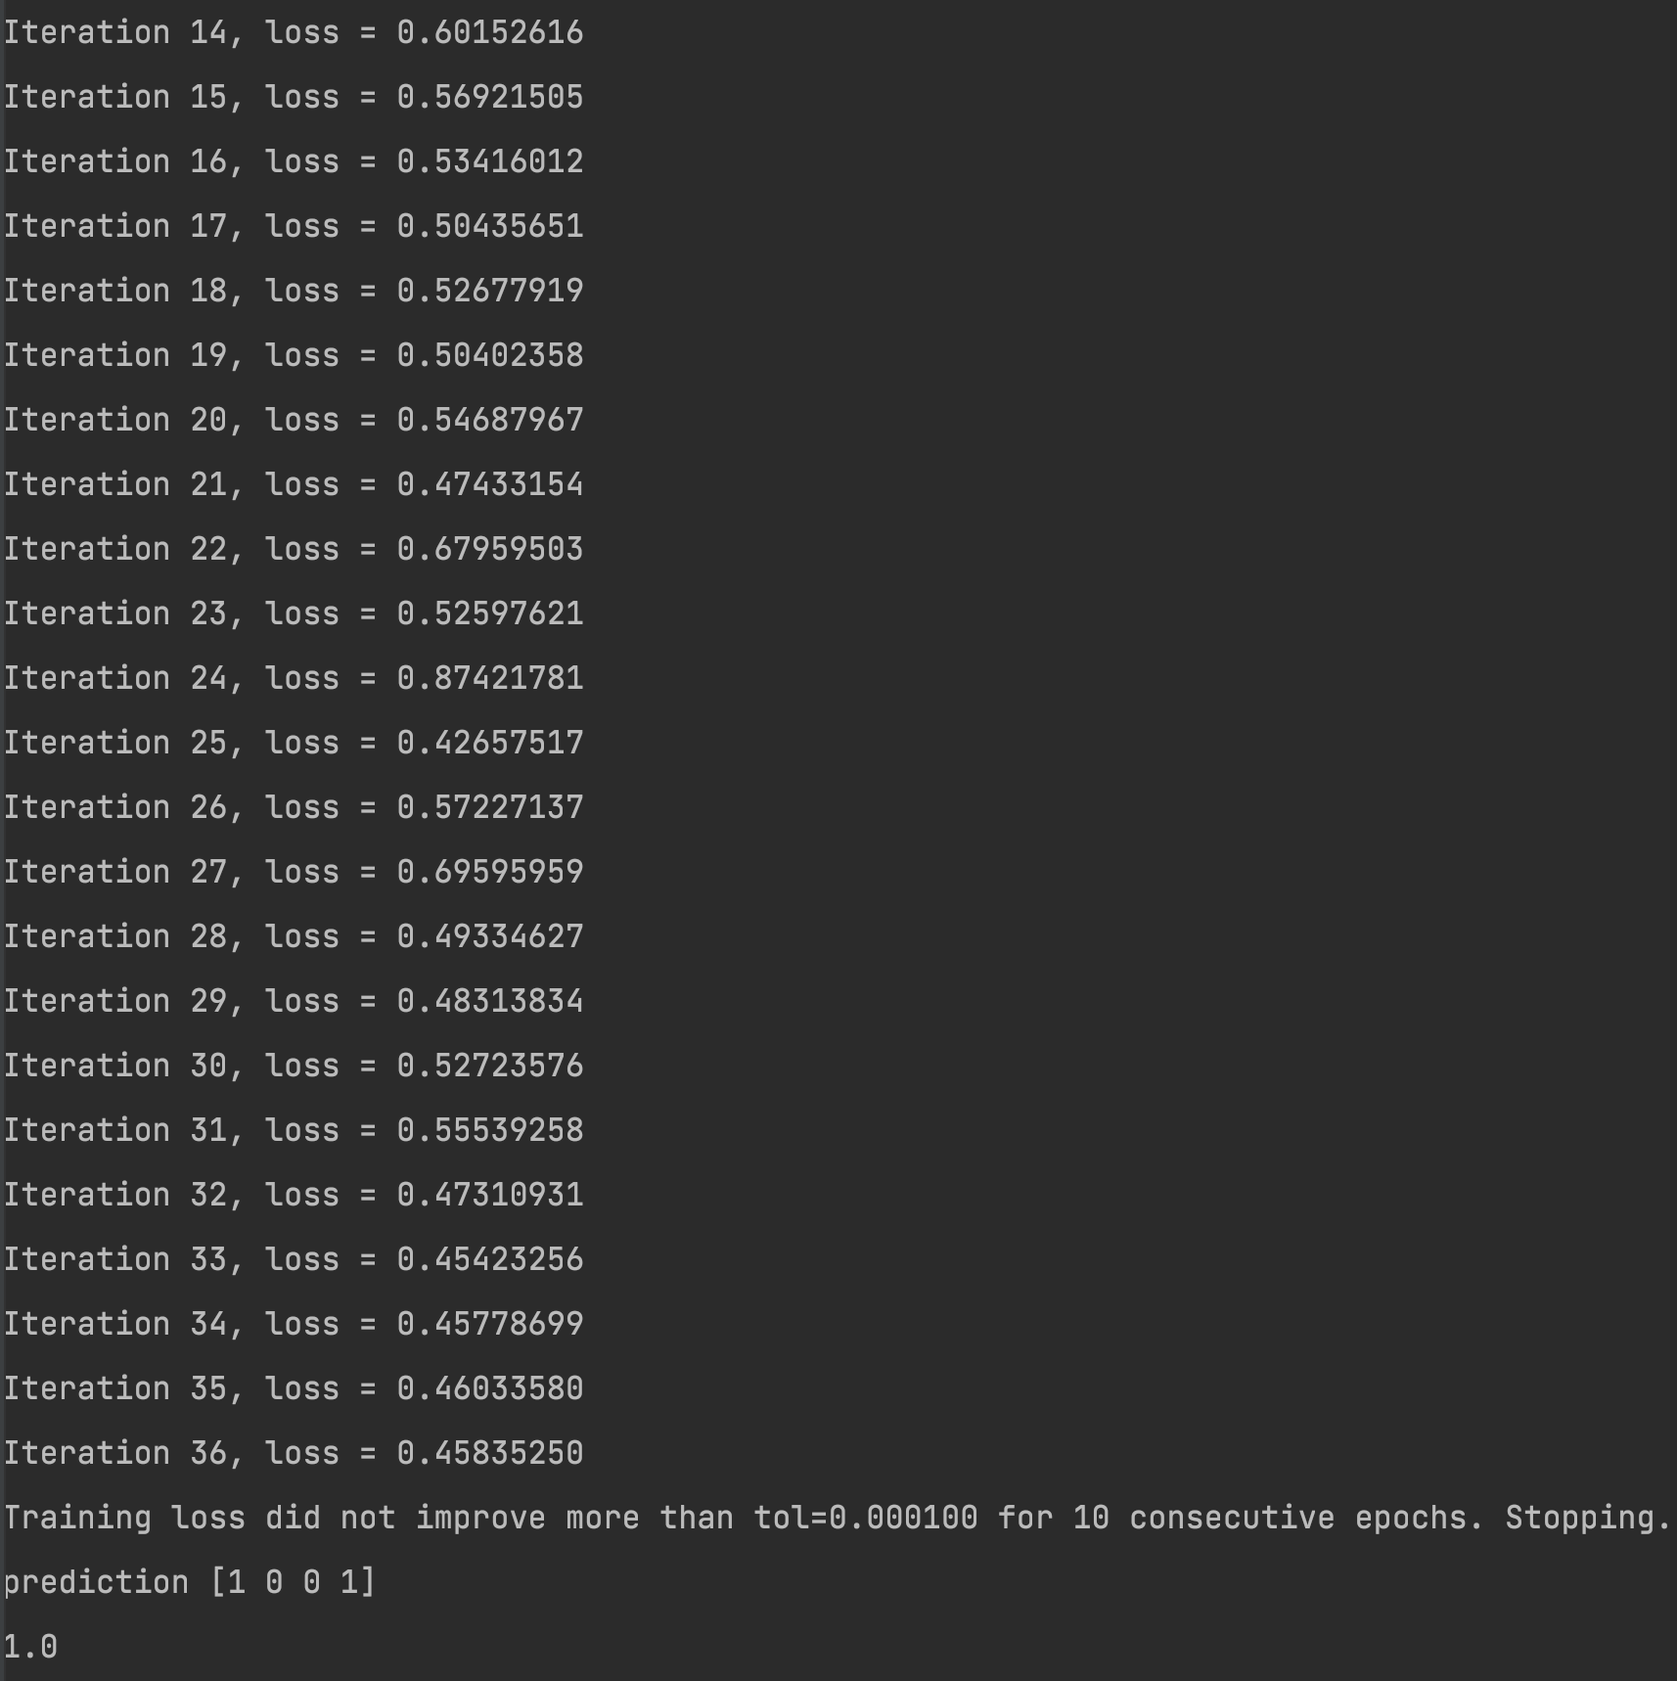

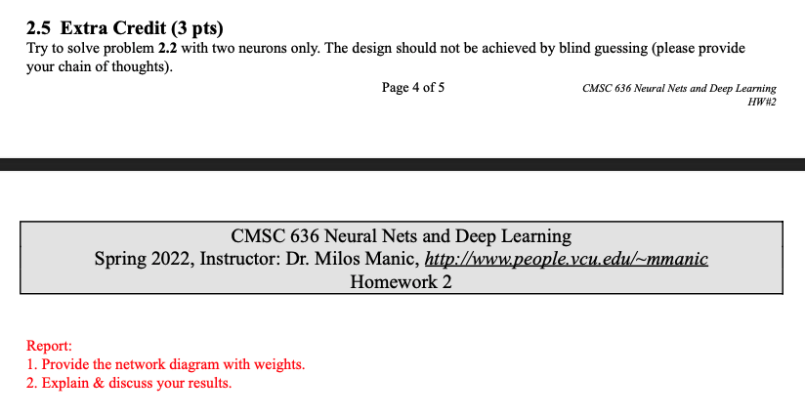

Answer to 2.5:

From the truth table and 3-neuron solution of problem number 2.2 above, we can estimate some rubrics about the weights and thresholds of a 2-neuron XOR gate, like – the 2-variable XOR operation can be rewritten as, A ⊕ B = (A + B) – (A . B).

Now, if we design an AND gate feeding largely negative weighted input to another OR gate for the same set of inputs, then the above negation operation can be performed using 2 neurons.

The neural network design, with respective weights and thresholds, can shown as the following:

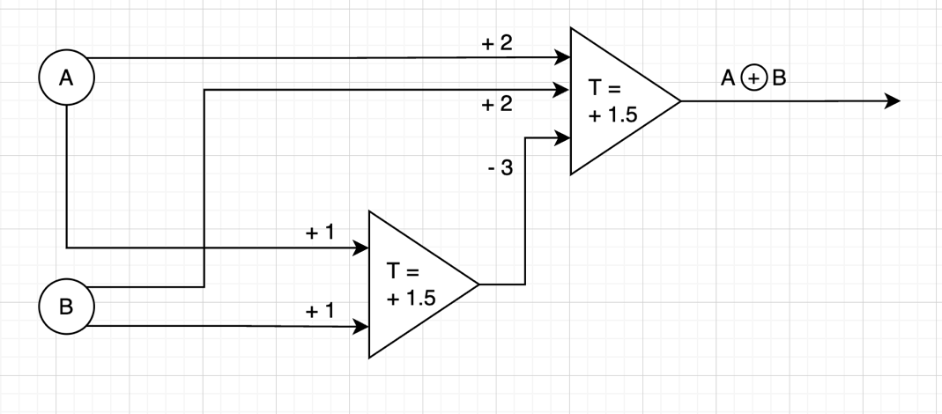

All the 4 possible cases of XOR operation of 2 -variables are discussed in details below for the above designed neural network.

**First Case:**

For A=-1 & B=-1, the first neuron output is: -1*1 + -1*1= -2 < T

& the second neuron output is: -1*2+ -1*2 – 3 * -1 = -1 < T

Thereby, the final output neuron does not fire and so the output becomes -1.

**Second Case:**

For A=-1 & B=+1, the first neuron output is: -1*1 + 1*1 = 0 < T

& the second neuron output is: -1*2 + 1*2 – 3 * -1 = +3 > T

So, the second neuron fires, while the first one does not fire.

Thereby, the final output neuron fires and so the output become +1.

**Third Case:**

For A=+1 & B=-1, the first neuron output is: 1*1 + -1*1 = 0 < T

& the second neuron output is: 1*2 + -1*2 – 3 * -1 = + 3 > T

So, the second neuron fires, while the first one does not fire.

Thereby, the final output neuron fires and so the output become +1.

**Fourth Case:**

For A=+1 & B=+1, the first neuron output is: 1*1 + 1*1 = +2 > T

& the second neuron output is: 1*2 + 1*2 – 3 * 1 = +1 < T

So, the first neuron fires and the second neuron does not fire.

Thereby, the final output neuron does not fire and so the output becomes -1.

So, the XOR gate is properly handled by the designed neural network with only 2 neurons.

~~~~~~ [The End] ~~~~~~