|  |  |
| --- | --- |
| Md Touhiduzzaman | Milos Manic |
| Departament of Computer Science | Department of Computer Science |
| Virginia Commonwealth University | Virginia Commonwealth University |
| Richmond, VA, 23284, USA | 401 West Main Street |
| [*touhiduzzamm@vcu.edu*](mailto:touhiduzzamm@vcu.edu) | Richmond, VA, 23284, USA |
|  | *[misko@ieee.org](mailto:misko@ieee.org)* |

[1]

**Human Presence & Activity Detection from WiFi CSI Data using DNN**

*Abstract*— This paper describes…..(one paragraph only).

*Index Terms*— for ex. artificial neural networks, neurons.

# INTRODUCTION AND BACKGROUND

Problem description goes here…

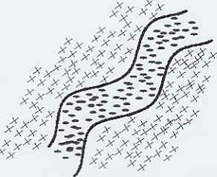

Fig.1. For ex. The image of the road provided by the sensors.

.

# SOLUTION APPROACH

# IMPLEMENTATION

# EXPERIMENTAL RESULTS AND ANALYSIS

# Conclusion

(One paragraph only)

# REFERENCES

[1] Doe, J., “*Title,,,,,…”,* Int. Jrn., Boston, 1996.

# APPENDIX

The code goes here…

1.