Project Proposal: Entrepreneur Management and Promotion Website

# 1. Introduction

Entrepreneurship plays a crucial role in economic development by fostering innovation, job creation, and business expansion. This project aims to develop an Entrepreneur Management and Promotion Website to provide a digital ecosystem where entrepreneurs can connect, promote their businesses, and access essential tools for financial growth. This platform will integrate social networking, e-commerce, digital wallet services, and entertainment to enhance user engagement and business opportunities.

# 2. Goals and Objectives

- Develop a user-friendly platform for entrepreneurs to showcase their businesses.  
- Integrate social networking features to enable communication and collaboration.  
- Provide marketplace functionality for entrepreneurs buying and selling goods/services.  
- Implement a secure digital wallet for customers and entrepreneurs to provide financial transactions   
- Ensure scalability and security to accommodate a growing user base.

# 3. Background study

With the increasing digitalization of business, platforms like Facebook Marketplace, RingID, and Daraz have become popular in Bangladesh. However, these platforms do not fully cater to small and medium entrepreneurs who need a dedicated platform for business networking, digital transactions, and promotional tools. Our project seeks to address this gap by creating a trusted and feature-rich digital space for entrepreneurs.

## 4. Deliverables

The final system will include:

### 4.1 User & Entrepreneur Features

1. User Registration, Entrepreneur Registration & Profile Management  
2. Social Networking Features  
3. Marketplace  
4. Digital Wallet & Payments

### 4.2 Admin Features

1. Admin Dashboard  
2. Advertisement Management  
3. Transaction & Security Monitoring

# 5. Languages & Tools

- Frontend: HTML, CSS, JavaScript (Vanilla or React.js)  
- Backend: PHP(Laravel), Python (Django), or Node.js (Express.js)  
- Database: MySQL / MongoDB  
- Payment Integration: SSLCommerz, bKash API, Nagad API  
- Hosting & Deployment: AWS / Firebase / DigitalOcean  
- Version Control: GitHub

# 6. Timeline (4 Months)

Phase-wise breakdown of the project development:

|  |  |  |
| --- | --- | --- |
| **Phase** | **Tasks** | **Duration** |
| Planning & Research | Define requirements, research competitors | 2 weeks |
| Backend Development | Develop user authentication, database, and API | 4 weeks |
| Frontend Development | Implement UI, and integrate with the backend | 4 weeks |
| Payment | Integrate payment gateway | 3 weeks |
| Testing & Debugging | Fix bugs, optimize performance | 2 weeks |
| Deployment & Launch | Deploy the platform, final testing | 1 week |

# 7. Flowchart

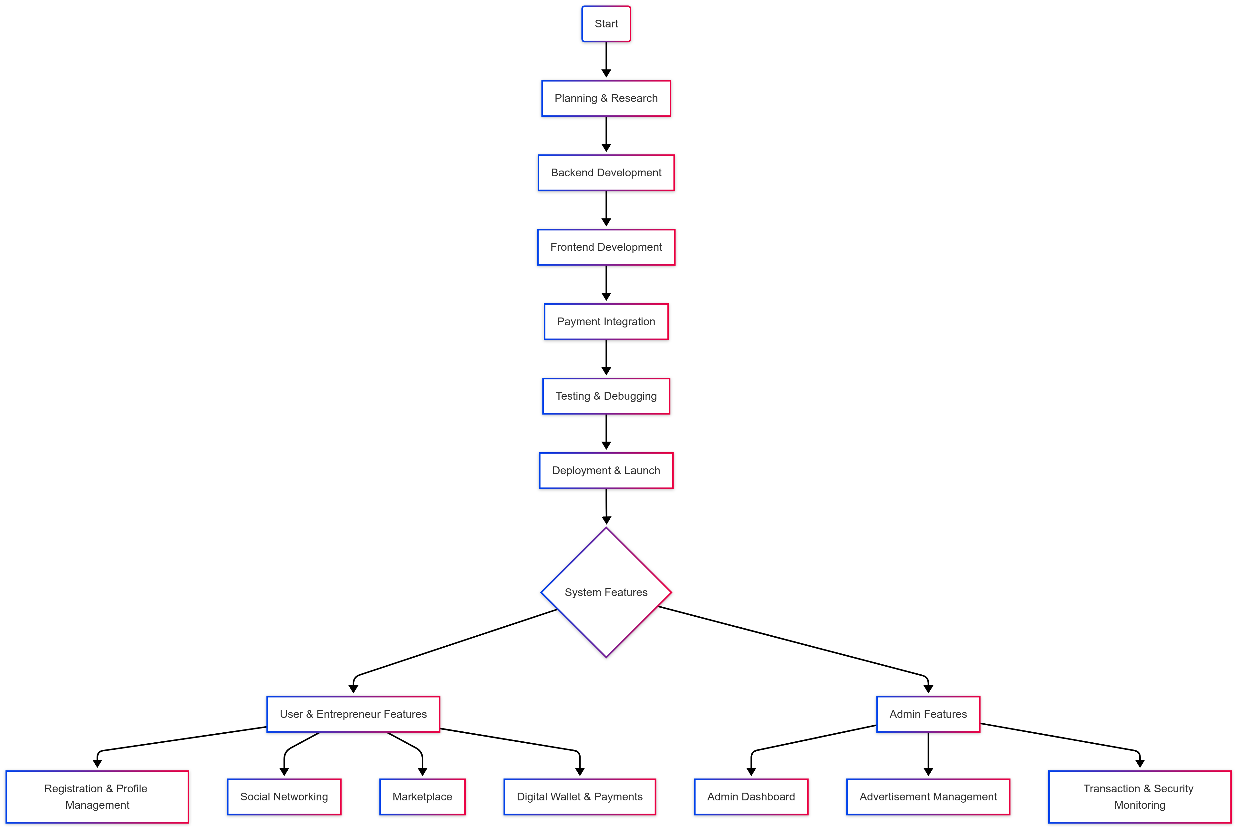

# 8. Budget (Estimated)

The estimated cost breakdown for the project:

|  |  |
| --- | --- |
| **Item** | **Estimated Cost (BDT)** |
| Domain & Hosting | 5,000 – 10,000 |
| Web Development | 20,000 – 50,000 |
| API & Payment Integration | 10,000 – 15,000 |
| Marketing & Promotion | 10,000 – 20,000 |
| Miscellaneous | 5,000 |
| **Total Estimated Cost** | **50,000 – 100,000 BDT** |

# 9. Future Work

- Mobile App Development for Android & iOS.  
- AI-powered Business Suggestions based on user activity.  
- Blockchain-based Smart Contracts for secure transactions.  
- Partnerships with local businesses for promotions.

- live streaming and monetization options for content creators and businesses.

- Entertainment Section

# 10. Conclusion

This project aims to create a comprehensive digital platform that enables entrepreneurs to network, promote, and grow their businesses with integrated social media, marketplace, and financial services. By providing a secure and scalable system, this platform has the potential to become a leading business hub for entrepreneurs in Bangladesh and beyond.