ComposeForm
Module Architecture Overview

Overview
The app is split into several modules, each owning exactly one concern — including one module per real screen or flow, plus a small module for helpers shared across those screens. This split is enforced by the build configuration itself, not just a convention engineers are expected to remember — a module that tries to reach outside its own responsibility simply fails to compile. Two boundaries matter most: only one module may touch the underlying UI toolkit directly, and only one module may touch the underlying networking libraries directly. Everything else works through what those two modules expose.
The split between the networking module and the data module in particular follows the shape of Google's own open-source “Now in Android” reference app — a raw networking layer kept separate from the repository layer built on top of it, with every screen depending on the repository layer only, never the networking layer directly. It's adapted here rather than copied wholesale — the UI-toolkit boundary and the local-storage module aren't part of that reference shape, they're this project's own addition on top of it.

The Modules
What each module owns, and — just as importantly — what it deliberately does not own.
Module | Role in the app | What it is NOT responsible for
App shell | Hosts every screen and the navigation between them — a small home/launcher screen and a couple of demo flows directly, and every other real screen by assembling the feature modules below into its navigation graph; supplies environment-specific configuration (which server to talk to, how a session gets stored) down into the layers that need it. | Does not define reusable UI components, does not know how networking works internally, does not decide what data looks like on the wire, and does not implement a real screen's own logic once that screen has its own feature module.
Feature modules | One module per real screen or flow — e.g. the lead dashboard list, and the acquisition approval list/detail/decision flow. Each owns that screen's UI, state, and the calls it makes for its own data, end to end. | Does not talk to a network client or a server directly, does not define its own UI primitives, and never depends on the app shell or on another feature module.
Shared feature helpers | Holds the small UI helpers used by more than one feature screen — a copy-to-clipboard control, an infinite-scroll-trigger, an empty-state placeholder — so feature modules can share them without depending on each other or being pulled back into the app shell. | Does not hold any single feature's own screen logic or state — only what's genuinely reused across two or more of them.
Design system | Owns every visual building block the app is made of — buttons, text fields, cards, dialogs, and so on — built on top of the underlying UI toolkit. It is the only module allowed to use that toolkit directly. | Does not know about screens, navigation, or data — it only renders whatever it is told to render.
Form builder | Turns a JSON description of a form into an actual on-screen form, built entirely out of the design system's components. | Does not fetch data, does not talk to a server, does not decide what a form's data means — it only renders a given schema.
Network | Owns everything about talking to a server: what endpoints exist, what a request/response looks like, and turning connection problems, server errors, or timeouts into one predictable, typed result instead of letting raw technical failures escape. It is the only module allowed to use networking libraries directly. | Does not decide when to fetch something or what to do with a result — it has no notion of screens or business flow.
Database | Owns everything about saving data on the device itself and reading it back — the only module allowed to use the on-device storage library directly. | Does not decide when something should be saved or read, does not know about screens or servers — it only stores and returns whatever it's asked to, and never substitutes itself for a network call.
Data | Sits directly on top of the network module and (for on-device saves) the database module, and is the actual entry point the rest of the app uses to get, send, or locally save data. One entry point per external service, plus one for local storage. Also responsible for storing a session token after a successful sign-in, so nothing above it manages that by hand. | Does not build or send HTTP requests itself, does not touch the storage library itself, does not know about screens — it only exposes a clean, typed way to ask for data.

How They Connect
Dependencies only ever point one way — a module never depends on something built on top of it. Each arrow points from a module to what it depends on; grey boxes are the external libraries each boundary protects, each reachable from exactly one module.
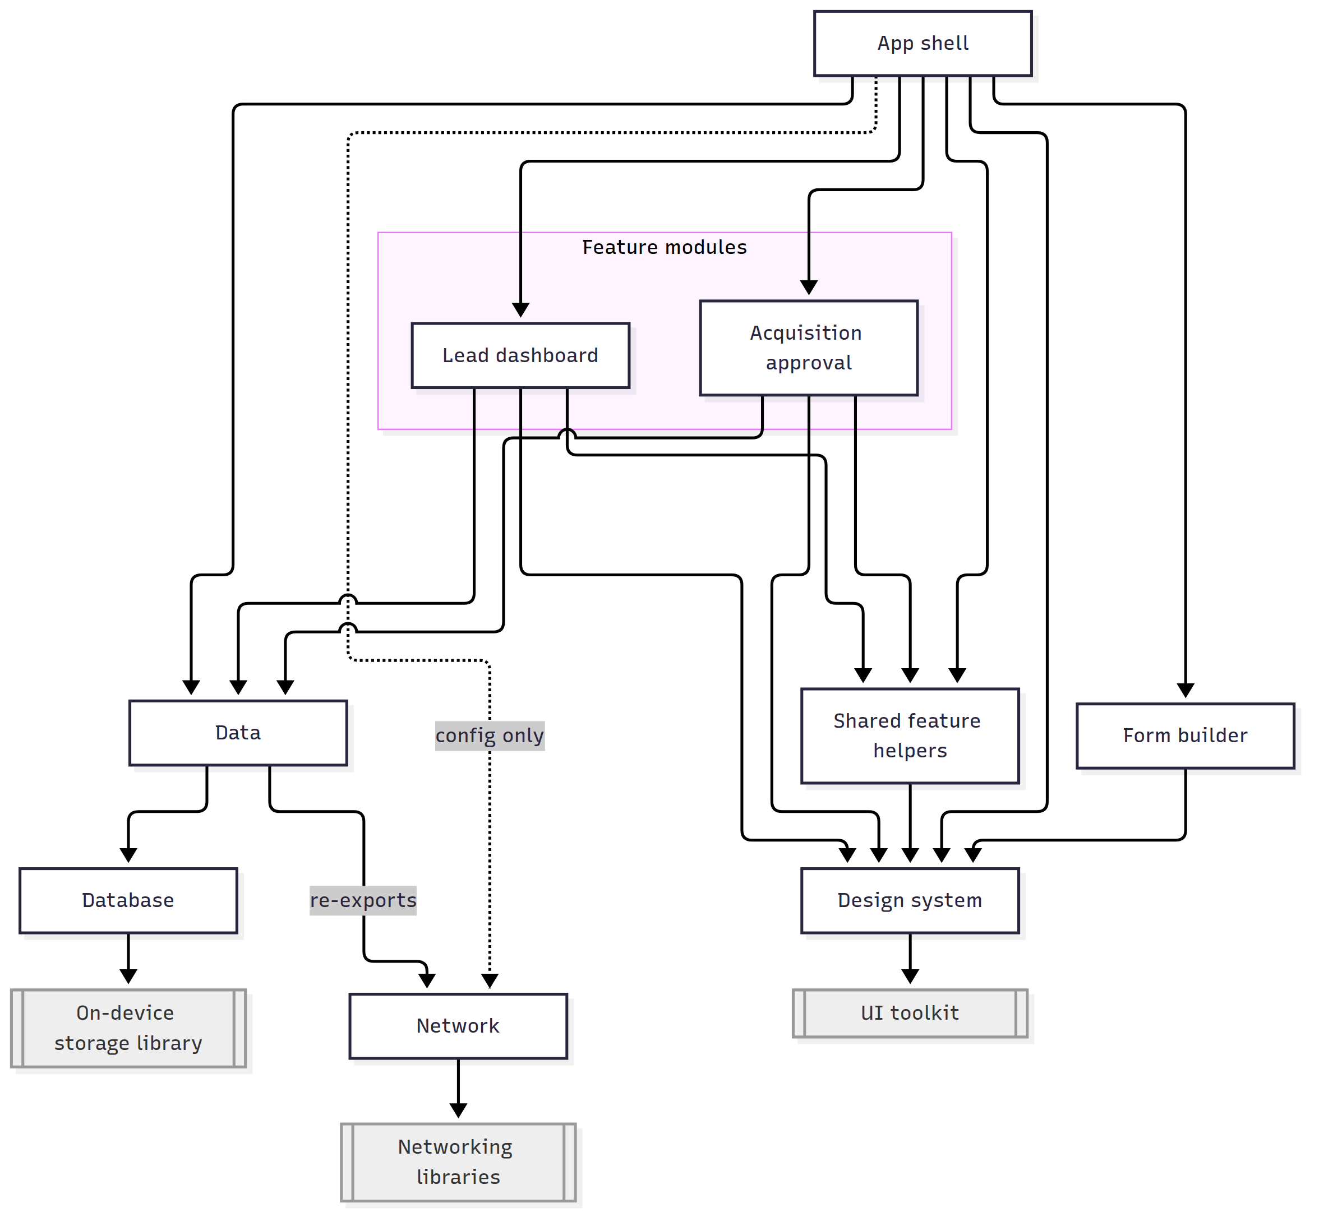
Module | Depends on | Why
App shell | Design system, Form builder, Network, Data, Shared feature helpers, Feature modules | Assembles screens from the design system, form builder, and feature modules; calls the data module directly for its own remaining demo/local screens; configures the network module directly (server address, session storage) — a separate relationship from fetching data.
Feature modules | Data, Design system, Shared feature helpers | Calls the data module for its own screen's data — the same single entry point the app shell itself uses — builds its UI from the design system, and reuses shared helpers instead of re-implementing them or depending back on the app shell, which would run the dependency graph backwards.
Shared feature helpers | Design system only | Built purely from design-system components — the same foundation every other UI-facing module sits on; has no reason to know about data or networking.
Design system | Nothing else in the app | It is the foundation layer — everything else depends on it, it depends on nothing above the raw UI toolkit.
Form builder | Design system only | Renders forms purely out of design-system components; has no reason to know about data or networking.
Data | Network, Database | Wraps the network module's raw calls, and the database module's local saves/reads, into the app-facing entry points the rest of the app actually uses — one repository per external service, plus one for on-device storage.
Network | Nothing else in the app | The foundation of the data side — only the underlying networking libraries sit below it.
Database | Nothing else in the app | Independent of the network module entirely — it depends on nothing but the on-device storage library, and the two never talk to each other.

Layered view
The same relationships, read top to bottom as the app actually runs. Network and database sit at the same level on purpose — the data module depends on both, but they don't depend on each other or talk to each other; one reaches a server, the other reaches the device's own storage.
Screens & Navigation (app-wide) — App shell
Feature Screens (one module per real screen/flow) — Feature modules
Shared Feature Helpers — Shared feature helpers
Reusable UI Components + Dynamic Form Rendering — Design system & Form builder
Data Access (the app-facing entry point for data) — Data
Raw Networking (requests, responses, error handling) — Network
On-Device Storage (saved records, independent of the network) — Database
External Servers / The Device's Own Storage — outside the app

Enforced Boundaries

UI toolkit boundary
Only the design system module can use the underlying UI toolkit's raw building blocks. Every other module — including the app shell itself — is missing that toolkit from its build configuration entirely, so it is physically unable to reach past the design system's own components, even by accident.

Networking boundary
Only the network module can use the underlying networking libraries. The app shell and every other module are missing those libraries from their build configuration too, so any network activity has to go through the data module's entry points — there is no shortcut around it.

Local storage boundary
Only the database module can use the on-device storage library. Every other module, the data module included, is missing that library from its build configuration, so a local save or read has to go through the data module's own entry point for it — the same shape as the networking boundary above, just for a different library and a different destination (the device itself, not a server).

Why enforce this at build time instead of just in code review
- A rule that only lives in a code-review checklist gets missed eventually — a build-time rule cannot be missed.
- It keeps each concern swappable: the UI toolkit or the networking library could each be replaced without touching modules that never depended on them directly.
- It keeps the “correct” way to do something the only available way — there's no second, ad-hoc path to fetch data or render UI that bypasses the safety each boundary provides.

A Request Walkthrough
Example: a screen needs to load a list of records from a server.
- A screen asks the data module for the records it needs.
- The data module's entry point for that service calls into the network module's definition of that endpoint.
- The network module performs the actual request. If anything goes wrong — no connection, a server error, a timeout, an unexpected response — it turns that into one clear, predictable failure result instead of letting a raw technical exception escape upward.
- The data module hands the result back to the screen as either “here is the data” or “here is what went wrong,” never a half-finished or ambiguous state.
- The screen, built from the design system's components, renders the result — the list itself, or an error message with a retry action.

Example: signing in
- A user submits their credentials on a screen.
- The data module calls the network module's sign-in endpoint.
- On success, the data module stores both tokens the server returns — the one used to authenticate every request, and a second, longer-lived one used only to obtain a new one — using storage the app shell supplies underneath. The data module knows two tokens need storing, but not the storage details themselves.
- Every subsequent request the network module makes automatically attaches the first token, so no screen or higher-level code ever manages it by hand.

Example: a token quietly expiring mid-session
The access token is short-lived by design, so this happens routinely — the app never needs a screen to notice or react to it.
- Some later request is sent with a now-expired token, and the server rejects it.
- Before that rejection ever reaches the data module or the screen that asked for it, the network module catches it and tries once to recover: it uses the second, longer-lived token to obtain a fresh one.
- If that succeeds, the original request is retried automatically with the new token, and the caller sees a normal, successful result — no failure was ever visible above the network module.
- If it fails instead — the longer-lived token is missing or the server rejects it too — the network module treats the session as over: it clears both stored tokens and raises a signal that something above it can react to.
- That signal is deliberately just a signal, not an action — the network module doesn't know what “session is over” should do (show a sign-in screen, clear other local state, ...). Reacting to it is left to whichever part of the app is equipped to decide that, the same deferral used for where a token gets stored in the first place.

Why Feature Screens Skip a Domain Layer
A common way to structure an app like this — the shape a lot of Clean Architecture guidance recommends — is three layers: presentation (screens), domain (reusable business rules, sitting behind its own interfaces), and data (repositories). Here, a feature screen's own code calls straight into the data module's entry point — there is no separate domain layer in between. That's a deliberate omission, not an oversight, and it's worth being explicit about why.
A domain layer earns its place for two reasons: it gives presentation code an abstraction to depend on instead of a concrete data implementation, and it's where business rules that don't belong to any single screen get to live once more than one screen needs them. The first reason is already satisfied one layer down — the data module exposes an entry point per external service as an interface, not as the class that actually does the work, so a feature screen's own tests can already substitute a fake without touching a real network client. Adding a domain layer on top wouldn't strengthen that boundary; the abstraction it would provide already exists.
The second reason is where it's worth being precise about what actually earns a domain layer, because “two feature modules end up calling the same API service” is not, by itself, that trigger. Say the lead dashboard and the acquisition flow both come to need the same service — profile lookup, say. Both can already call that same repository entry point directly, from their own module, with zero duplication at the transport level: the data module's entry point is the one shared thing precisely so that two feature modules calling the same service is not a problem to solve. That's ordinary reuse of an existing shared layer, not a gap in the architecture.
What would actually justify a domain layer is duplicated logic wrapped around that shared call — if both feature modules needed to build the same non-trivial request, combine that call with a second one in the same way, or apply the same rule to the result, copying that surrounding logic into two ViewModels is the real waste a domain layer prevents. That hasn't happened yet: today's shared calls, where they exist, are used as-is by each caller, with no repeated logic around them to factor out. The moment that changes — the same non-trivial orchestration or rule needed by two or more feature modules around a shared call — that's the concrete signal to introduce a shared use case for it, in one place, rather than waiting for a third copy to appear. Until then, adding the layer pre-emptively is the same speculative-reuse trap this project avoids elsewhere: presentation and data are already cleanly separated by a real, compiler-checked boundary, and that's the separation that was actually needed so far.

Alternatives Considered — And Why Not
None of the choices above were the only option. A few genuine alternatives were weighed along the way; this is what they would have looked like, and the concrete reason each one was set aside.
Alternative | What it would look like | Why it wasn't chosen
One module instead of five | Everything — screens, UI components, networking, data access — living in a single module, relying on team discipline and code review to keep the concerns apart. | Nothing would actually stop a screen from reaching straight into a networking library. The five-module split turns that rule into something the build itself enforces, so it can't quietly erode over time.
An extra business-logic layer between screens and data access | A dedicated layer of reusable “use cases” sitting between the screens and the data-access layer, so a screen never calls the data layer directly. | Today's screens each drive their own single, simple operation — there's no shared logic between screens that would need its own layer. Adding one now would double the boilerplate for no real benefit; worth revisiting if genuinely shared logic emerges later.
Translating server responses into a separate app-facing model | A mapping step that converts whatever shape the server returns into a second, hand-designed model before a screen ever sees it, insulating the app from the server's own shape. | That doubles the number of model types and adds a mapping step for every field, for a backend that isn't misbehaving badly enough to justify it. The simpler choice — screens use the same model the server returns — is kept until a real inconsistency actually causes pain.
Detecting a failed request from a field inside the response body | Every response carrying its own “was this an error” flag inside the body, checked instead of (or alongside) the standard status code. | That flag turned out to be sent inconsistently across different endpoints, which made it an unreliable signal. Detection now relies on the standard, well-understood status code; the response body is still read afterwards, only to produce a clearer failure message.
One shared connection pool for every external service | A single pool of connections and background threads reused across all of the app's external services, instead of giving each one its own. | A shared pool means one slow or failing external service can delay or block calls to a completely unrelated one. Giving each service its own pool costs a little extra overhead but keeps their failures independent of each other.
A reactive-streams style for network calls | Each network call returning a stream that gets combined/transformed with a reactive-streams library, a common pattern in other codebases. | The language's own native async functions already integrate cleanly with everything else here and need no extra library. Reactive-streams support was included early on, went unused, and was later removed rather than kept “just in case.”
Baking each environment's server address in at build time | One build per environment (staging, production, ...), with the server address fixed into that build and never read at runtime. | Simpler and avoids ever having an empty value, but means switching environments requires a full rebuild. On-device runtime storage was chosen instead for flexibility, accepting that a value has to be supplied before the first real use.

Why Split It This Way
- Each module can be understood, tested, and changed on its own — a change to how a network request is retried never touches a screen, and a new screen never has to think about how networking works.
- The boundary between “raw networking” and “the data the app actually uses” is deliberate: it means the messy details of talking to a server (retries, error shapes, timeouts) stay in one place, and the rest of the app only ever sees a clean, predictable result.
- The same shape repeats for every external service the app talks to, so adding a new one is a known, repeatable pattern rather than a one-off decision each time.

Local Storage
Alongside the servers it talks to, the app also saves some data on-device — a user opts into keeping something available offline — and reads back the list of what's been saved. This is deliberately not an “offline-first” design: there is no single method that quietly decides “read from the local database if offline, otherwise call the server,” and no plan to build one. Saving and reading locally are their own explicit actions a screen asks for, kept completely separate from the network-backed calls.
- The database module owns the on-device storage library the same way the network module owns its own networking libraries — the same enforced, compiler-checked boundary, just for a different library (see “Local storage boundary” above).
- The data module exposes this through its own dedicated repository — not extra methods bolted onto an existing one — since saving, listing, and (as the need grows) updating or deleting a saved entry is its own self-contained set of operations, unrelated to any single external service.
- A feature screen that wants this calls that repository directly, exactly like it already calls the others — one explicit call to save, one to list, with no branching on whether the app happens to be online.

The one real wrinkle: local storage needs its own record type
A local storage library typically requires its own specially-annotated class to describe a saved row — that's a hard technical requirement, not a stylistic choice, so it's a different situation from the earlier decision to keep one model instead of adding a translation layer. Here's what it means concretely, using a case that will actually come up: a decision made in the acquisition approval flow, which a user should be able to save on-device for later instead of submitting it immediately.
That decision already has a shape defined once, in the network module, matching exactly what the server expects to receive. The local storage module needs its own version of that shape to save it — not because the data is different, but because a saved row also needs things the server-facing shape has no place for (when it was saved, whether it's still waiting to be submitted or already sent) and because only the storage module is allowed to depend on the local-storage library that requires that annotated class in the first place — putting that annotation on the network module's own class would force the network module to depend on a library that has nothing to do with talking to a server.
So there end up being two small shapes instead of one, and the data module — already the one place that sits between the network module and the database module — is where they meet: it converts one into the other at the exact point it saves or reads a row, and nowhere else. Crucially, a feature screen never sees that second shape at all. It asks to save a decision and reads saved decisions back using the very same shape it already uses to submit one over the network — so the “one model is enough” principle still holds from where it actually matters, the feature module's own code. The second shape is invisible outside the data module, the same way the network module's own JSON parsing is already invisible to everything above it.

