Technical Lab Test – S3 Innovate Bangladesh

Applicant Name:
Job Title:

There are two problem listed below. Each problem have individual marks. So please do not wait for the result of first one, carry on the second one.
Note: Both problem source codes need to be uploaded in git and share the link separately. Also for the problem number 2 need to send the screenshot of create and list page.
Problem # 1 (C# Console Application) need to be submitted within 1 hour.
Problem # 2 (Web Application) need to be submitted by 3 days (including interview taking date, means if interview taken at date 1 then need to submit by 3)
- Calculate mobile bill between two date times.
Peak Hour: 9.00.00 am to 10.59.59 pm
20 second pulse and each pulse rate 30 paisa

Off-peak Hour: 12.00.00 am to 8.59.59 am and 11.00.00 pm to 11.59.59 pm
20 second pulse and each pulse rate 20 paisa

Note: If pulse overlap (peak to off-peak or off-peak to peak) then take peak hour rate for that pulse.

Sample input:
Start time: 2019-08-31 08:59:13 am
End time: 2019-08-31 09:00:39 am

Breakdown (Optional to show):
2019-09-31 08:59:13 + 20 second (2019-09-31 08:59:33) = 20 paisa
2019-09-31 08:59:34 + 20 second (2019-09-31 08:59:54) = 20 paisa
2019-09-31 08:59:55 + 20 second (2019-09-31 09:00:15) = 30 paisa
2019-09-31 09:00:16 + 20 second (2019-09-31 09:00:36) = 30 paisa
2019-09-31 09:00:37 + 3 second (2019-09-31 09:00:39) = 30 paisa

Sample output: 1.3 taka

- Build a single page application (spa) crud operation using dot net/dot net core framework in back-end API and AngularJS/Angular in front-end. Sample UI design given below. Design can be done at own way, this is just demo. Feature and functions are listed as below:
  - Trade and Level dropdown will have cascade relation e.g. if we select trade then respective levels of that trade should be loaded in level dropdown.
  - Language checkbox list should have a validation that at least one need to be selected before submission. Can be selected one or more. Once multiple selected then need to show these languages in comma separated in the list view.
  - Syllabus Name input text field. Mandatory field.
  - Two files upload (Syllabus and Test plan) can be done. Need to be validated that only PDF and DOC files are allowed to upload.
  - Development Officer input text field. Mandatory field.
  - Manager input text field. Mandatory field.
  - Active Date will be a date picker. Mandatory field. Need to validate the valid data string.
  - In the list view/ grid view files name need to be clickable and after click the file need to be downloaded.
Create Page
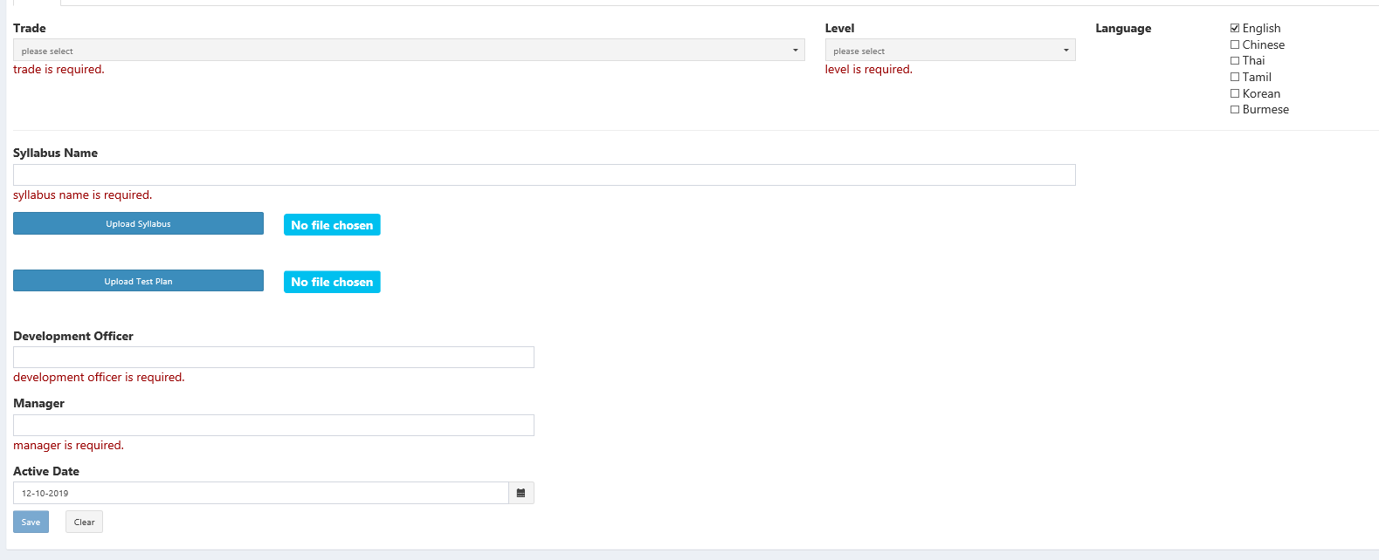
List Page