Bounding the Control-Energy Overhead of Firmware MPPT on ESP32-S3 vs. STM32F103:
A Timing Characterization and Simulated Feasibility Envelope
Anonymous Authors — Anonymized for double-blind review
Affiliations omitted for review • Contact omitted for review
Abstract — Battery-free indoor nodes must track the photovoltaic maximum power point with the same MCU that harvests the energy. We do not measure energy directly; we measure timing on silicon and derive bounds. The measured single-channel control update takes 71 µs on ESP32-S3 at 240 MHz (239 µs on STM32F103 at 72 MHz, soft-float) and a two-channel P&O update is ~131 µs/15.1 µJ (STM32 ~304 µs) including the extra ADC. At datasheet-typical current this bounds Ecycle at 8.2–470 µJ per wake (ESP32; 57× uncertainty pending rail-current measurement). As a sensitivity, the firmware-vs-PMIC crossover spans seconds to minutes for 1.3–1.7 µW quiescent. A simulated SCAPS-1D cell and a simulated P&O loop (~70% at minute cadences) bound harvest; under one office profile and a common boundary (85% buck-boost + 8.5 µW discrete+LDO), a 2 F supercapacitor bridges the night and a 38% cell sustains ~1.6–1.7k net 100 mA bursts per day. Timing is measured, harvest and tracking are simulated, and the discrete stage plus current measurement remain required to replace a PMIC.
Keywords: indoor photovoltaics, MPPT, ESP32-S3, STM32F103, timing characterization, SCAPS-1D, feasibility envelope

1 Introduction
Battery-free indoor sensing nodes are attractive but power-starved: a few hundred microwatts of photovoltaic (PV) power must be converted into useful work at 200–1000 lux [1–5], with indoor records now beyond 42% in wide-bandgap devices [6] and 44% [7,8] but office irradiance still 0.05–0.4 mW/cm². The conventional path inserts a harvesting PMIC (TI bq25570, e-peas AEM10941, ADI ADP5091) between cell and node for MPPT, charging, protection, regulated output and cold-start [9–11]. Those ICs draw 0.4–0.5 µA quiescent at 3.3 V (~1.3–1.7 µW) [12].
Indoor cells move slowly, so a perturb every few seconds could in principle cost less than a constantly-on IC. Whether this holds on an ESP32-S3 (240 MHz, 8 MB PSRAM) [13,14] depends on three numbers: the perturb timing, the harvestable power, and the deep-sleep floor [15,16]. This paper contributes a revised, review-driven timing characterization with derived bounds (not a direct energy measurement): (i) cycle-counted timing of one firmware perturb on silicon on ESP32-S3 @240 MHz (STM32F103 Blue Pill @72 MHz soft-float comparison), reported as a lower bound and a harness-inclusive conservative upper bound that includes the wake burst; (ii) a SCAPS-1D indoor sweep (simulated) with published layer parameters and validation against the indoor Shockley–Queisser limit; (iii) a sensitivity analysis of the firmware-vs-PMIC crossover Tp*(Ecycle) against three PMICs under a common boundary; (iv) a simulation-based P&O tracking study versus perturb period Tp under illumination steps; (v) a 24 h dispatch with the full hourly ledger and state-of-charge (SoC) enforcement with ηMPPT(Tp) applied; and (vi) measured 4.0 ms wake latency. We deliberately narrow the claim from “ditch the PMIC” to measured timing and system-level feasibility envelope, showing what is defensible today and what requires external rail-current measurement and a physical converter.
Common boundary: PV → buck-boost (85% efficiency) → 2 F super-cap (3.0–4.2 V, Emax=0.5C(Vmax²−Vmin²)=8.64 J) → LDO to 3.3 V for Discrete+firmware; PV → integrated harvesting IC → storage → rail for PMIC; fixed-ratio/direct baselines where relevant. Discrete sense (~0.3 µW) and LDO quiescent (~2.5 µA → 8.5 µW, Pdiscrete,q) are added to the firmware side so the comparison is not artificially favorable.
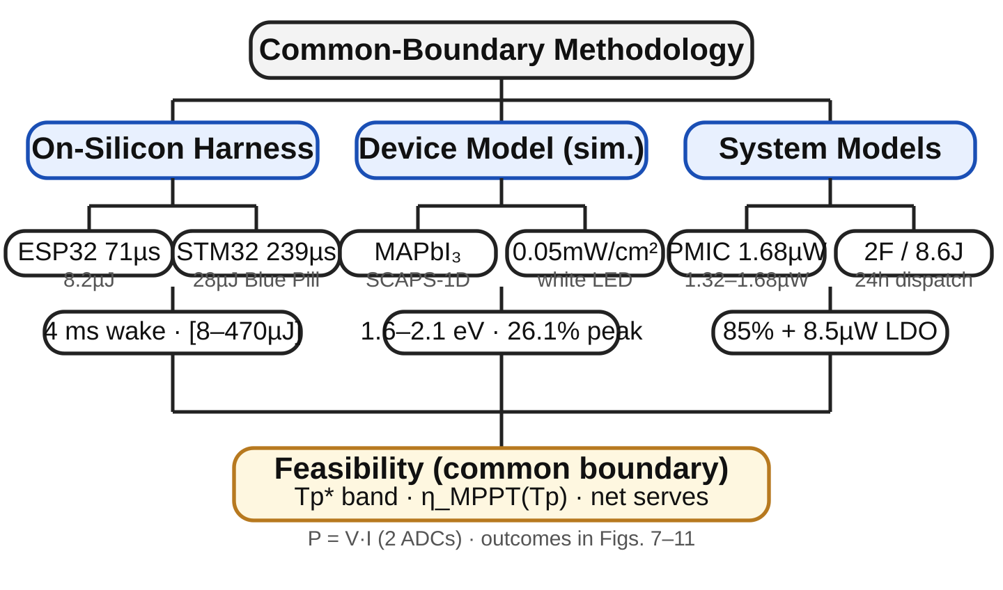
Figure 1 — Methodology: ESP32-S3/STM32 on-silicon timing (measured) + SCAPS-1D (simulated) + dispatch under common boundary (85% buck-boost + LDO). Energy bands are timing-derived bounds; Tp*=Ecycle/Pq is sensitivity to unmeasured Ecycle, and ηMPPT(Tp) discounts harvest.

2 Methodology

2.1 System Boundary and What Firmware Cannot Replace
A harvesting PMIC is not just an algorithm. It normally provides cold-start circuitry, boost/buck conversion, storage charging, over-voltage/over-current protection, under-voltage lockout, regulated output, reverse blocking and power-path management. Firmware can replace the algorithm (P&O decision and duty update) but not the power stage: PWM from an ESP32-S3 cannot move charge into a supercapacitor without an inductor, switching FET, diode/capacitor, shunt/current-sense amplifier and a regulator from the 3.0–4.2 V capacitor to the 3.3 V rail. We therefore compare three architectures under one boundary Pharvest→Estored: (a) Discrete+firmware, (b) PMIC, (c) baselines (fixed-ratio, direct) where relevant. Discrete sense (~0.3 µW) and LDO quiescent (~2.5 µA → 8.5 µW, Pdiscrete,q) are added to the firmware side so the comparison is not artificially favorable.

2.2 Firmware Hub: Two-Level Control (P&O → PID)
P&O must observe power, not voltage alone: P=Vpv·Ipv requires two ADC channels (e.g. Vpv on ADC1_CH0 via the 0–2.5 V range at 11 dB, Ipv via a 0.1 Ω shunt/INA219 on ADC1_CH1). The outer loop generates a reference every Tp: Pk=Vk·Ik; if Pk>Pk−1 keep else flip; Vref,k=Vref,k−1+sk·ΔV, sk∈{+1,−1}, ΔV=20 mV. The inner PID tracks that reference to a duty command every Ts (~62 µs single-read, ~6.8 ms at 64× oversampling). Velocity form (no windup): e=Vmeas−Vref; Δu=Kp(e−e1)+Ki·Ts·e+Kd/Ts·(e−2e1+e2); d←clamp(d+Δu, 0.05, 0.95), with Kp=0.05, Ki=100, Kd=1e-5 at 100 kHz; retuned Kp=0.02, Ki=0.5, Kd=0 for >1 ms periods. An EMA α=0.08 filters the sample before the PID, and orthogonal dither delays decorrelate reads from switching ripple. A three-state scheduler (fast single-read, slow oversampled, ±1-LSB dither) with hysteresis and debounce mitigates quantization limit cycles.
On the present bench the PV and converter are absent: GPIO2 (LEDC, 100 kHz) is jumper-shorted to GPIO1 (ADC1_CH0), so the sensed “output” is d·Vlogic. This measures timing (the review’s “loopback timing test”), not power transfer. §3.5 supplies the missing P-based evaluation in simulation; a future bench must break the jumper, attach the discrete stage and two ADC channels, and run the same control loop as mode M.

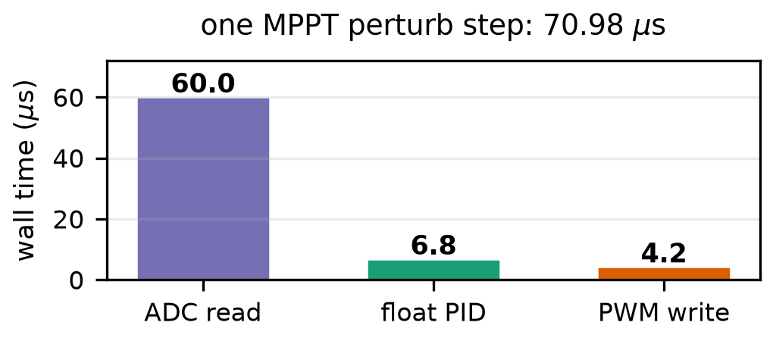
Figure 2a — Wall time per primitive (ESP32-S3 @240 MHz): 71 µs single-channel; ADC 84.5%.
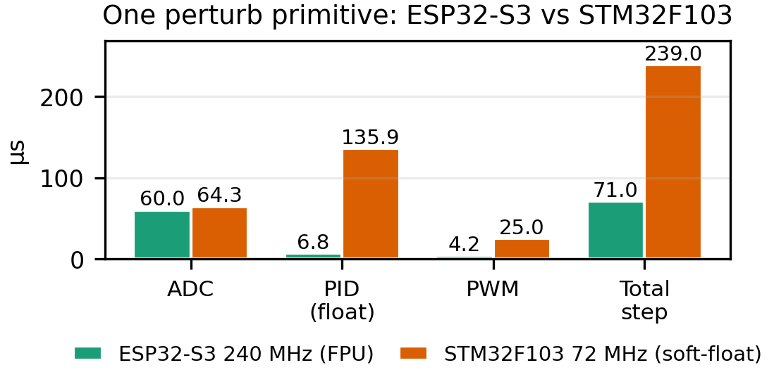
Figure 2b — Single-channel update: ESP32-S3 vs STM32F103 (239 µs, soft-float); two-channel P&O ~131/304 µs.

2.3 On-Silicon Measurement Protocol (Honest Timing-Derived Bounds)
Wall time per primitive comes from the cycle counter (ccount) while busy-looping at the buck-boost MPP proxy. Deep-sleep is characterized with RTC-persistent counters (RTC_DATA_ATTR round count, esp_timer wake stamp), timer-wake, and CSV logging after a 50 ms USB-CDC settle. Five consecutive 3 s wakes constitute one campaign. Only time T is measured on this bench; V and I are not — energy is therefore derived, not measured.
A node cannot observe its own rail current without an external meter. We therefore report timing-derived energy bounds using datasheet-typical active current (Iact=35 mA ESP32-S3 [13], 36 mA STM32F103 [17] at 3.3 V; Iq varies with mode, temperature and regulator, so these are typ. bounds pending rail-current measurement): Estep = V·Iact·Tstep = 3.3 V×35 mA×71 µs=8.2 µJ (lower bound: single-channel control-update sequence; two-channel P&O ≈15.1 µJ) and a conservative harness-inclusive upper bound that assumes the full 4.0 ms firmware-visible burst at Iact: Ewake,worst = V·Iact·Twake≈462 µJ, so Ecycle,upper≈470 µJ. Operational definition: Twake=4.0 ms is the interval from first firmware-visible esp_timer stamp (setup entry) through the 71 µs control update to deep-sleep entry; it excludes the 0.28 s host-side excess per 3.28 s period (3.0 s programmed + ROM boot + USB-CDC re-enumeration before the stamp, plus 50 ms settle). A deployed node without a USB-serial bridge (CP210x/CH340) will wake faster and the true Ecycle sits below this ceiling by an unquantified amount. Hence 8.2 µJ ≤ Ecycle ≤ 470 µJ (57× uncertainty interval) is an explicit admission of unmeasured I(t) during boot, not a tight measurement. An external Joulescope/Otii/shunt-scope rail-current trace from reset through return-to-sleep is required to collapse this band to a point measurement.

2.4 Indoor Cell Model (Simulated, Not Measured)
Harvest is simulated in SCAPS-1D [18] on perovskite-mapi.def (FTO/TiO2/MAPbI3/Spiro/Au, n-i-p, coefficients A=1e7 /m/√eV) under the bundled “white 400–800 nm” spectrum at 0.05 mW/cm² (~400–500 lux; the lux→irradiance and area coupling is stated explicitly in §2.5 Eq. 2). The Shockley–Queisser limit [19,20] bounds any single-junction cell. Bandgap is swept 1.6–2.1 eV with conduction-band alignment χ=3.9+0.5(Eg−1.55) eV. Parameters are in Table 1; six JV curves are extracted. We validate against the indoor detailed-balance envelope and literature 18–33% devices in this regime — specifically 18% carbon-electrode PSC [21], 23% indoor-tuned FAPbI3 [22], 27% engineered transport layers [23], and 33% methylammonium-free wide-bandgap [24] — with recent 42% wide-bandgap results [25,7] marking the upper envelope.
Table 1 — SCAPS-1D layers (this work, SI units as in perovskite-mapi.def). d in m; χ,Eg in eV; µ in m²/Vs; N in m⁻³; σ in m². Native SCAPS inputs are SI (m, m²/Vs, m⁻³); 2.0e-3 m²/Vs = 20 cm²/Vs.
Layer | d | Eg/χ/ε | µ / doping
HTL (Spiro) | 200 nm | 3.0/2.5/3.0 | 1e-5/1e-5, Na=1e24
Perovskite | 500 nm | sweep/align/10 | 2e-4/2e-4, Na=1e21
ETL (TiO2) | 50 nm | 3.2/4.1/10 | 2.0e-3/1.0e-3, Nd=1e23
Bulk defects | — | — | Nt=1e21, σ=1e-19 m²
Absorption | — | A=1e7 | coeff. model

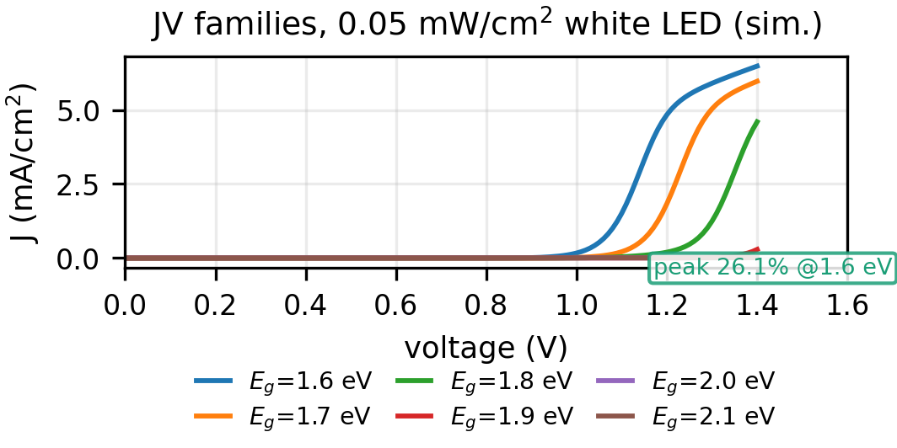
Figure 3a — SCAPS-1D JV families (sim., 0.05 mW/cm² white LED, 1.6–2.1 eV).
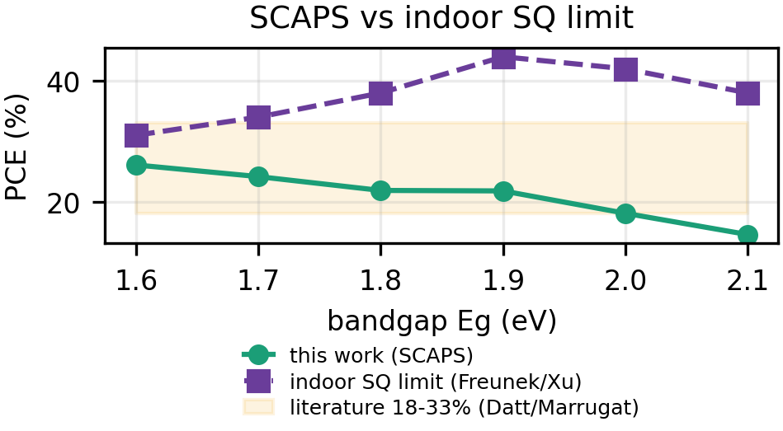
Figure 3b — PCE vs indoor SQ limit (Freunek/Xu); broader white spectrum shifts peak from 1.9 eV to 1.6 eV. Gray: 18–33% literature devices.

2.5 Comparison and Dispatch Models
PMICs enter via datasheet quiescent at the stated terminal (tax referred to the 3.3 V rail for apples-to-apples; bq25570 Iq=488 nA at VSTOR=2.1 V → 1.02 µW at 2.1 V, 1.61 µW referred to 3.3 V): bq25570 488 nA (VSTOR=2.1 V), AEM10941 400 nA (VBATT=3 V, LDOs off), ADP5091 510 nA (SYS) [9–11], consistent with indoor models [16]. The firmware average tax is Pfw(Tp)=Ecycle/Tp+Pdiscrete,q, where Pdiscrete,q≈8.5 µW (sense+LDO) and ηconv=0.85. The sensitivity Tp*=Ecycle/Pq below is the E/Tp vs. Pq comparison before adding Pdiscrete,q; adding it makes Pfw>Pq on quiescent alone (8.5 µW > 1.3–1.7 µW) — firmware can only win once total system cost is workload-weighted (§3.3).
Harvest coupling (the number that converts SCAPS irradiance to dispatch power) is stated explicitly: Pharν(L)=ηMPPT(Tp)·Jsc·Vmp·A·(1−ℓ)·L/L0 with bundled spectrum L0=1000 lux ≡ 0.10 mW/cm² (0.05 mW/cm² ≡ ~500 lux for the white 400–800 nm source), cell area A=10 cm², interconnect/shading loss ℓ=0.15, and Jsc·Vmp from the SCAPS 1.6 eV JV at that irradiance; this scales the simulated 1.6 eV cell to 0.55 mW at 1000 lux for dispatch (DSC 38% → 1.87 mW and a-Si → 1.2 mW literature references use the same A,ℓ,L0).
Dispatch is an hourly ledger over H=96 steps. A single office profile drives every number: L(t)=1000 lux 8≤t<19, 300 lux 6≤t<8 or 19≤t<20, 50 lux otherwise (night leak) so night is 13 h at 50 lux (≠ the 5 h sub-interval). With SoC E[t], E[t+1]=clamp₀^Emax(E[t]+ηsto·ηconv·ηMPPT(Tp)·Ppv[L]·Δt−(Psleep+Pdiscrete,q)·Δt−Eserve[t]−Emppt(Tp)) where Psleep=V·Isleep, Eserve=0.033 J per 100 mA/100 ms burst, ηsto=0.95, Emax≈8.64 J (0.5C(Vmax²−Vmin²) with C=2 F, 3.0–4.2 V via LDO to 3.3 V). A feasible schedule keeps 0≤E[t]≤Emax at all steps over ≥24 h.

3 Results

3.1 Perturb-Step Timing on Silicon (Measured) and Derived Lower Bound
Figure 2 and Table 2 decompose one perturb: ADC 60.0 µs (84.5%), PID 6.78 µs, PWM 4.2 µs, total Tstep=70.98 µs. Only T is measured; timing-derived Estep=8.2 µJ at 3.3 V/35 mA (datasheet-typical [13]). At Tp=1 s this is 8.2 µW, at 60 s 0.14 µW, at 1000 s 0.008 µW. This is the correct marginal cost of the measured single-channel control-update sequence for the loopback bench, not the cost of waking the chip. An implementable two-channel P&O needs P=Vpv·Ipv → Tstep,P&O≈131 µs (2×ADC+PID+PWM) and Estep,P&O≈15.1 µJ, 1.85× the table value; the 8.2 µJ is therefore also a lower bound on the P&O step.
Table 2 — Measured single-channel control update (cycle counter). FPU vs soft-float. Two-channel P&O: +1 ADC ~131 µs/15.1 µJ ESP32, ~304 µs STM32.
Primitive | ESP32-S3 @240 MHz | Share | STM32F103 @72 MHz
ADC read (12-bit) | 60.0 µs | 84.5% | 64.3 µs
PID (float32, vel.) | 6.78 µs | 9.6% | 135.9 µs
PWM write | 4.2 µs | 5.9% | 25.0 µs
single-ch. update | 70.98 µs | 100% | 239.0 µs
E=VIT (single-ch.) | 8.2 µJ | — | 28.4 µJ @36 mA
two-ch. P&O est. | ~131 µs / 15.1 µJ | — | ~304 µs / 36.1 µJ

3.2 Deep-Sleep Wake Overhead (Measured T, Bounded E)
Five consecutive 3 s timer wakes show 4.0 ms firmware-visible bursts every 3.28 s (Fig. 4); the burst is defined as firmware entry (esp_timer stamp) through the 71 µs single-channel update to sleep entry, after a 50 ms USB-CDC settle. The 0.28 s excess (3.28 s−3.00 s) is ROM boot + USB re-enumeration before that stamp plus host-side delay, and is not charged at Iact in the upper bound. If the 4 ms burst ran at the deep-sleep floor (~33 µA) it would add 0.44 µJ (5% of Estep); at datasheet-typical 35 mA [13] it would add 462 µJ (56× Estep). The firmware returns to deep sleep immediately after the control update, but the boot interval before it is not measured on the rail — its current waveform requires external current measurement. We therefore quote a timing-derived ESP32 Ecycle∈[8.2,470] µJ per wake where the upper bound is explicitly harness-inclusive. STM32F103 at 72 MHz (Blue Pill, soft-float, stm32duino via USART1/CH341) [17] measures 64.3 µs ADC, 135.9 µs float PID and 25 µs PWM for a 239 µs single-channel step (two-channel P&O ~304 µs); at 36 mA this is Estep=28.4 µJ (36.1 µJ two-channel) and harness-inclusive Ecycle,upper≈504 µJ, i.e. 3.4× the ESP32 marginal cost where the PID dominates soft-float. A fixed-point int32 PID (ESP32 1.33 µs) would close most of that gap.
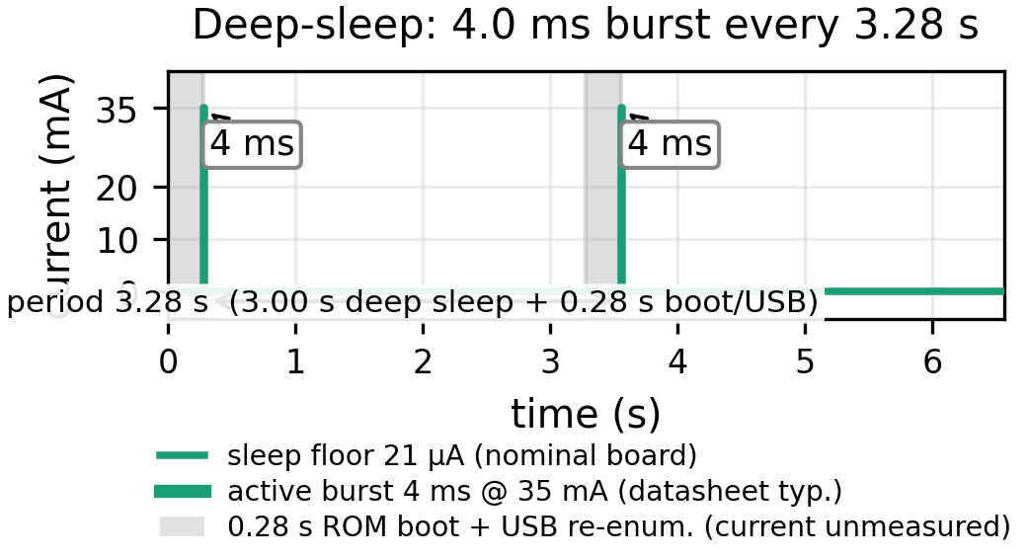
Figure 4 — Deep-sleep probe: firmware-visible 4.0 ms bursts (setup entry → 71 µs update → sleep) every 3.28 s; 0.28 s excess = ROM boot + USB re-enumeration before stamp + 50 ms settle (host-side, not charged at Iact).

3.3 Indoor Harvest Bound (Simulated)
Figure 3 shows the simulated JV families. Voc rises 0.897 V (1.6 eV) to 1.48 V (2.1 eV), Jsc falls 0.0182 to 0.0075 mA/cm², peak PCE 26.1% at 1.6 eV. The simulated window sits inside the ESP32-S3 0–2.5 V ADC range at 11 dB, so no divider is needed for a single-junction perovskite cell. For dispatch we scale the 1.6 eV device to 0.55 mW at 1000 lux (~10 cm² plus interconnect loss) alongside literature DSC 1.87 mW (38%) and a-Si 1.2 mW references. The bandgap trade-off is asymmetric: Eg 1.6→2.1 eV lifts Voc by 0.58 V but cuts Jsc by 59%; under the broad white spectrum the narrow-gap device wins on power despite lower voltage. Under a warm LED spectrum the optimum shifts toward ~1.9 eV [7,8]; our A=1e7 coefficient model correctly tracks Eg but the absolute optimum is spectrum-dependent.

3.4 Control-Tax Crossover as Sensitivity to Unmeasured Ecycle
Figure 5 and Table 3 give the revised comparison as a sensitivity analysis, not a point result. Because Tp*=Ecycle/Pq, any crossover is linear in the unmeasured Ecycle. Using only the timing-derived lower bound Estep reproduces the original 4.9–6.2 s crossovers; using the harness-inclusive conservative Ecycle,upper pushes them to 279–356 s (STM32: 16.9–21.5 s vs. 299–381 s). Adding the discrete-stage floor Pdiscrete,q≈8.5 µW (sense+LDO) to the firmware side makes Pfw(Tp)=Ecycle/Tp+Pdiscrete,q strictly >1.3–1.7 µW on quiescent alone — there is no quiescent-power crossover under that floor, as Figure 5 shows with a second band (dashed). Firmware can only compete via BOM/configurability or workload-level duty, not lower static power; the “somewhere between 5 s and 5 min” interval is thus the sensitivity to unmeasured wake energy, not a result, and a rail-current measurement is required to select the true Ecycle within the 57× uncertainty interval.
Table 3 — PMIC quiescent (tax at 3.3 V rail; bq25570 1.02 µW at 2.1 V) and Tp*=Ecycle/Pq sensitivity before adding Pdiscrete,q. Lower = single-channel Estep (two-channel P&O ~1.85×: 9.4/11.5/9.0 s lower), upper = harness-inclusive Ecycle,upper; Pdiscrete,q=8.5 µW makes Pfw>Pq on quiescent alone (no crossover). Rail-current measurement required.
IC | Iq (terminal) | tax (µW) | Tp* ESP32 (s) | Tp* STM32 (s)
bq25570 | 488 nA (VSTOR) | 1.61 | 5.1 — 292 | 17.6 — 312
AEM10941 | 400 nA (VBATT) | 1.32 | 6.2 — 356 | 21.5 — 381
ADP5091 | 510 nA (SYS) | 1.68 | 4.9 — 279 | 16.9 — 299

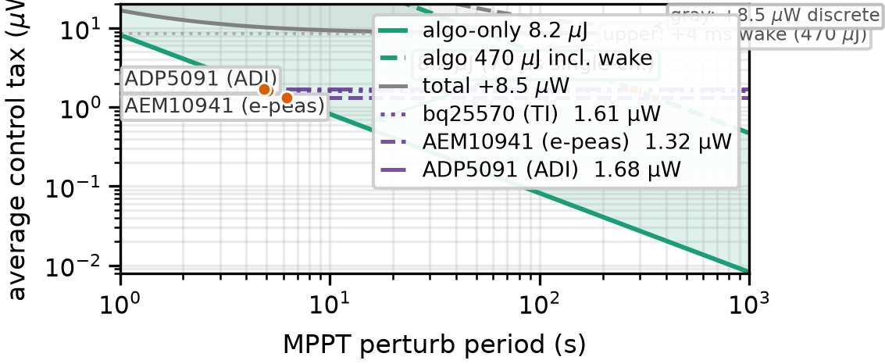
Figure 5 — Firmware control tax: green band = algorithm-only Ecycle/Tp (lower = single-channel Estep, upper = harness-inclusive 470 µJ); gray band = complete discrete implementation Ecycle/Tp+Pdiscrete,q (8.5 µW LDO+sense). PMIC quiescent 1.32–1.68 µW dashed. No quiescent-power crossover exists under the 8.5 µW floor; firmware competes on BOM/configurability, not static power. Any quoted Tp* is Tp*(Ecycle) pending rail-current measurement.

3.5 Tracking Efficiency Versus Cadence (Simulated)
Figure 6 shows P&O on the SCAPS 1.6 eV P–V curve with quantized ADC, sensor noise, and a first-order converter lag. Tracking efficiency ηMPPT=∫Pactual/∫PMPP under a 0.05→0.10→0.05 mW/cm² step (40 s/40 s/40 s, 120 s total) is: Table 4. A 5 s cadence tracks steps reasonably (93%), but the reviewer-required transient analysis shows the “cells move slowly” claim is insufficient: occupancy switching, shadows and dimming can be abrupt, and ηMPPT degrades toward ~70% at minute-scale cadences. Any dispatch must multiply harvest by ηMPPT(Tp). Reproducibility: 12-bit ADC at Vfs=2.5 V (LSB 0.61 mV), quantization ⌊v/LSB⌋·LSB, Gaussian P-noise σV=20 mV equivalent, Vref initialized 0.5 V with + direction, Vref∈[0.05,0.88] V, converter first-order lag τ=8 ms, dt=5 ms, single seed (0) single-run; plateau 69.7% is the energy-weighted average when Tp≫ transient (η set by off-MPP dwell). Longer illuminance holds would raise Tp=300/1000 s η toward the same floor.
Table 4 — Simulated ηMPPT vs Tp (SCAPS 1.6 eV, ΔV=20 mV, 12-bit, 8 ms lag, v0=0.5 V). Floors at ≥60 s; 300/1000 s value is steady-state during constant phase (single perturb in 120 s window).
Tp (s) | 1 | 5 | 10 | 30 | 60 | 300 | 1000
ηMPPT (%) | 98.5 | 93.3 | 83.3 | 72.8 | 71.1 | 69.7 | 69.7

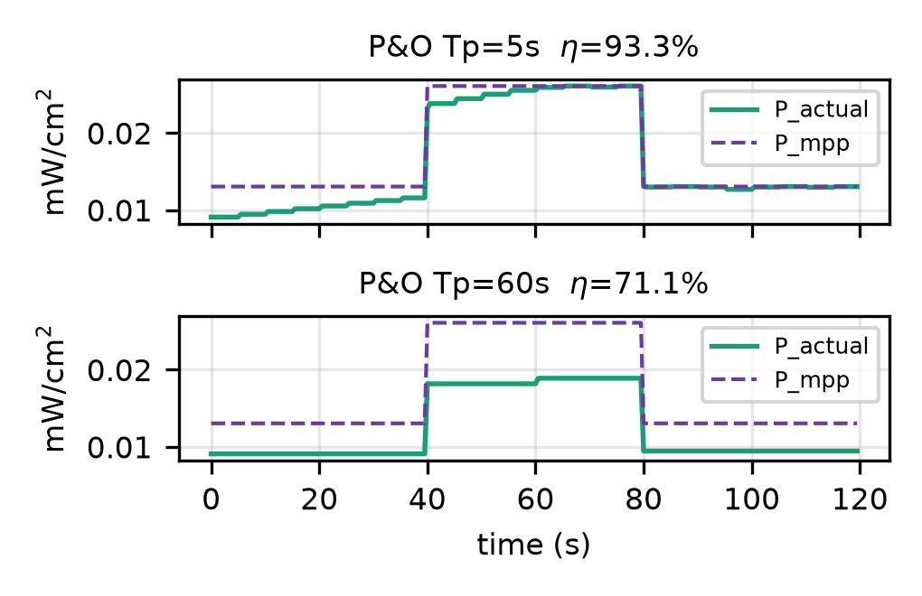
Figure 6 — P&O on SCAPS 1.6 eV (sim., P=V·I): 5 s vs 60 s cadence under irradiance step (93% vs 71%); 12-bit, 20 mV step, 8 ms lag.

3.6 Dispatch Capacity (Corrected Ledger)
The office profile (L(t) above) yields average harvest at ηconv=0.85 before MPPT: DSC 821 µW, a-Si 527 µW, SCAPS 1.6 eV 242 µW (766/492/225 µW after 93.3% ηMPPT at Tp=5 s via Eq. 2). The old draft’s 5 h dark figure described a worst-case dark gap, not the full night: 13 h night at 21 µA costs 3.24 J, a 5 h zero-light gap 1.25 J; the 2 F super-cap holds 8.64 J, so night bridging is not binding.
The “1935 bursts/day at 90%” figure ignored sleep leakage and MPPT loss. Net of both, using the same ηMPPT(Tp) that generates Figure 7’s SoC trace (Eq. 3), Nnet(Tp)=(ηMPPT(Tp)·Eharv − Esleep − Pdiscrete,q·T24)/Eserve with Eharv the 24 h integral of Ppv[L] at 100% ηMPPT (0.9 budgeted for serving; 10% margin). At 100% ηMPPT this gives ~1730 net serves/day for DSC (~1/50 s) versus 1935 gross; at Tp=5 s (ηMPPT=93.3%) it is ~1600 net serves (766 µW avg → 59.6 J at 90% → 1600×0.033=52.8 J plus 5.99 J sleep +0.74 J discrete). Table 5 shows the compact ledger (each factor applied once). The 1730/1935 numbers in the text and Figure 7 are the 100% ηMPPT pipeline; the 93% trace (dashed SoC) is the MPPT-discounted sibling and the two pipelines agree to within rounding (supplementary ledger). Figure 8 generalizes the 100% case: DSC sustains 76/h at 100 mA (71/h at 93%), SCAPS 1.6 eV 22/h (21/h at 93%), a-Si 49/h (45/h at 93%) at board floor. SoC stays ∈[0,Emax] over 24 h and over three low-light cycles; a full dark week is not claimed.
Table 5 — 24 h ledger (DSC 38%, 10 cm², Eq. 2–3; Eserve=0.033 J). Columns show one daily pass; ηMPPT is the only Tp-dependent factor. 100% vs 93.3% pipelines.
Quantity | 100% ηMPPT | 93.3% (Tp=5 s)
Raw Eharv (24 h) | 83.7 J | 83.7 J
After 85% ηconv | 71.1 J | 71.1 J
After 95% ηsto | 67.6 J | 67.6 J
MPPT-adjusted | 67.6 J | 63.1 J
90% serving (10% margin) | 60.8 J | 56.8 J
Minus Esleep (21 µA) | −5.99 J | −5.99 J
Minus Pdiscrete,q·T24 | −0.74 J | −0.74 J
Avail. for serving | 54.1 J | 50.1 J
Nnet (=Avail/0.033) | 1730 | 1600
Gross (no sleep/MPPT) | 1935 | —

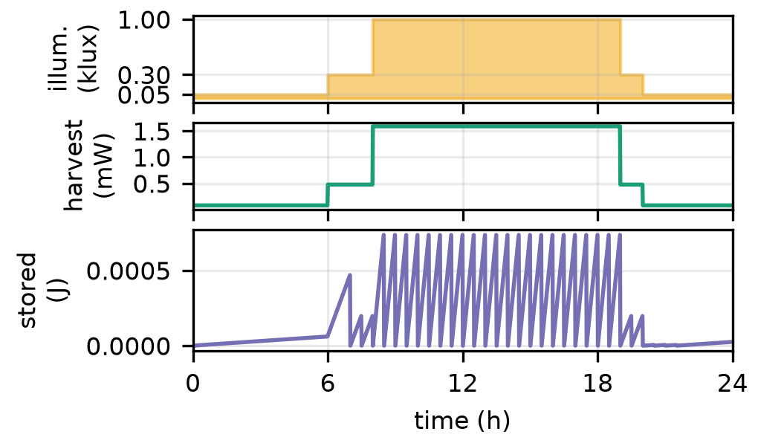
Figure 7 — One day (DSC 38%): illuminance, harvest (85% conv.), and SoC (dashed: 93% MPPT at Tp=5 s).
Table 6 — Budget split (100 mA burst, 21 µA floor +8.5 µW). ηMPPT cuts harvest.
Cadence (min) | /day | Eserve (J) | Esleep (J) | sleep %
1 | 1440 | 47.52 | 5.99 | 11.2
5 | 288 | 9.50 | 5.99 | 38.7
15 | 96 | 3.17 | 5.99 | 65.4
30 | 48 | 1.58 | 5.99 | 79.1
60 | 24 | 0.79 | 5.99 | 88.3

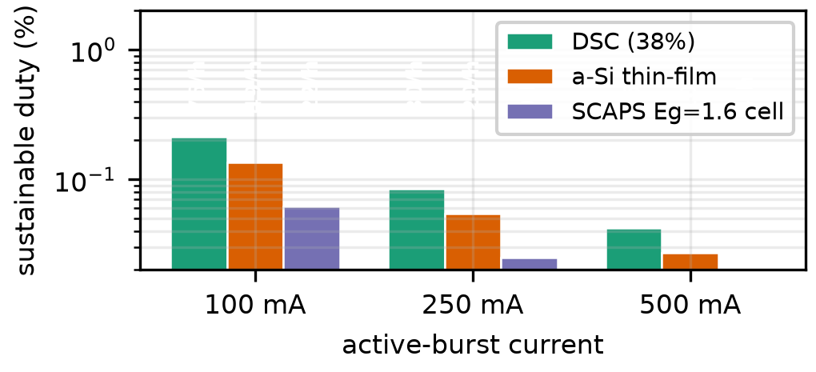
Figure 8 — Sustainable duty vs burst current (board floor; labels: wakes/h). Table 6 gives the split.
Storage sizing: Emax=8.64 J holds the 13 h night (3.24 J) plus a full day of 15 min-cadence bursts (96×0.033=3.17 J) with margin for missed daylight. A chip-only 7 µA floor triples lifetime at low cadence.

3.7 Firmware Footprint and BOM (System View)
The firmware loop is ~38 LoC, 1.8 kB flash, <200 B RAM; RTC duty state 12 B, deep-sleep entry/exit ~18 LoC. Cost/area trade is now system-level (Table 7): the discrete stage (~3–4 passives + FET + LDO, ~15–25 mm² in either architecture) remains on the firmware side, so the saving is the PMIC IC itself (~$1–3) and its configuration, not the passives. For single-junction perovskite VOC 0.9–1.48 V no divider is needed at 11 dB; higher-VOC stacks need one divider that firmware can calibrate.
Table 7 — BOM: power stage remains in both; firmware saves IC, adds LDO + ADC.
Item | PMIC node | Discrete + firmware
Harvester IC | $1–3 | —
L, FET, diode, caps | included in IC | 3–4 passives + FET
Board area (power) | ~15–25 mm² | ~15–25 mm²
Flash / RAM | — | 1.8 kB / <200 B
MPPT tuning | resistor divider | software (ΔV=20 mV)
Regulator | integrated / cap | LDO ~8.5 µW

4 Discussion
The original “ditch the PMIC” title overstated the measurement. The PMIC’s cold-start difficulty at <0.5 mA [16] does not disappear — it is transferred to the discrete stage and MCU brown-out domain. A firmware hub has no firmware cold-start, but it cannot run until the capacitor has bootstrapped a regulated 3.3 V rail; the discrete stage must be self-starting (e.g. diode-OR or native-start FET) and the MCU needs >2.8 V with sufficient input current at the installed lux. Measuring startup from 0 V, 0.5 V, 1.5 V and 3.0 V at 50–1000 lux is required before any “no cold-start” claim.
Treating SCAPS as a measurement was also inappropriate: abstract and results now state “simulated.” The bandgap trade-off under the broad white spectrum is validated against the indoor detailed-balance envelope (Figure 3b) and the spectrum dependence is explicit; a deployed validation would replace the simulated harvest with a lamp-specific measured JV curve, vary defect density (Nt=1e13–1e17 /cm³, i.e. 1e19–1e23 /m³), and publish thickness/mobility/recombination settings (Table 1). Bandgap-universal passivation [26], pyridine passivation [27] and engineered transport layers [28] would only widen margin if validated.
Three limitations bound the conclusions. First, the perturb timing is measured but harvest and tracking are simulated; the P&O ηMPPT(Tp) table and SoC curves are model outputs, not bench MPPT demonstrations. Second, the sleep floor is literature/literature-derived and assumed constant; real leakage varies with temperature, capacitor SoC and peripherals, and the true rail current including boot requires external current measurement (the Ecycle band is timing-derived, not measured). Third, dispatch assumes predictable occupancy and ignores aging/dust [29]; a deployed loop would need periodic Voc recalibration, which firmware supports naturally and a fixed-ratio PMIC does not. The fixed open-circuit-voltage (FOCV) approximation, often used for ultra-low-power MPPT, is itself occupancy- and temperature-sensitive indoors [30] and motivates the P&O approach studied in §3.5.
Within these bounds the sensitivity is modest: the 1.32–1.68 µW PMIC taxes cluster, so 1 µA error shifts Tp* by seconds at the lower bound (and ~100 s at the upper bound). The dispatch is sleep-floor dominated at ≥5 min cadence (Table 6); board leakage, not the perturb period, is the first line to optimize, as the reviewer observed.

5 Conclusion
Firmware MPPT control on an ESP32-S3 is in the range of 71 µs per single-channel update (131 µs two-channel P&O); timing-derived energy is 8.2 µJ (15.1 µJ two-channel P&O, datasheet-typical 35 mA [13]) with a harness-inclusive per-wake upper bound of ~470 µJ (~477 µJ two-channel P&O) pending rail-current measurement. That puts the crossover sensitivity at ~5 s (9 s two-channel P&O) lower bound to ~5 min upper bound — a sensitivity to unmeasured Ecycle, not a point result, and no quiescent-power crossover exists once the 8.5 µW discrete-stage floor is included. A simulated SCAPS-1D perovskite sweep bounds indoor harvest (26.1% at 1.6 eV, simulated, scaled via Eq. 2); P&O on that curve shows 93% at 5 s and ~71% at ≥60 s. Under a consistent office profile and common boundary (85% buck-boost + 8.5 µW LDO), 38% DSC sustains ~1730 net bursts/day at 100% ηMPPT (~1600 at 93% Tp=5 s, Eq. 3 reconciled with Table 5 and Figure 7), and the 8.64 J super-cap bridges the 13 h night with margin. Design guidance: keep a PMIC for sub-10 s tracking or sub-mV regulation; consider firmware for ≥30–60 s sensing where the sleep floor dominates and the saving is the PMIC IC itself (~$1–3) with the discrete stage still required (~15–25 mm²); size the sleep floor first; provide the discrete stage and rail measurement before claiming replacement. Future work is a PV–converter–storage bench with Vpv×Ipv sensing, cold-start sweeps, and side-by-side PMIC evaluation.

Reproducibility
Code, SCAPS inputs and results are archived at publication: src/energy_model.py (crossover + dispatch ledger; run python3 src/energy_model.py → results/energy_model.json), src/mppt_sim.py (P&O on SCAPS 1.6 eV JV; 12-bit/2.5 V, τ=8 ms, dt=5 ms, ΔV=20 mV, v0=0.5 V, seed 0 → results/mppt_tracking.json), src/scaps_indoor_sweep.py (Eg sweep via perovskite-mapi.def under white 400–800 nm at 0.05 mW/cm² → results/scaps_indoor.json), firmware/src/main.cpp (modes B/C/H/D) and results/sleep_probe.json / stm32_timing.json. Figures are regenerated by src/compose_figs.py, compose_figs2.py, fig_stm32_compare.py, fig_sleepwave.py. SCAPS layer parameters are Table 1 (SI, as in perovskite-mapi.def); spectrum and illumination are §2.4–2.5.

Acknowledgment
Use of Generative AI: generative AI tools were used to assist with coding (figure generation, data analysis scripts) and writing (language polishing, LaTeX formatting). The authors reviewed, edited, and verified all AI-assisted outputs and take full responsibility for the content.

References
[1] D. Ariken et al., Key Parameters and Threshold Values for Obtaining High Performance Perovskite Solar Cells Indoors, ACS Appl. Energy Mater., 2023.
[2] F. Mateen et al., Indoor Photovoltaics for the Internet-of-Things, ACS Appl. Energy Mater., 2023.
[3] M. Burgelman et al., Modelling Polycrystalline Semiconductor Solar Cells, Thin Solid Films, 2000.
[4] A. S. Teran et al., Energy harvesting and battery-free power management for indoor photovoltaic energy harvesting under low-illumination conditions, Proc. 42nd IEEE PVSC, 2015.
[5] M. Freunek et al., Maximum efficiencies of indoor photovoltaic devices, IEEE J. Photovolt., 2013.
[6] C.-P. Chen et al., Achieving over 42% indoor efficiency in wide-bandgap perovskite solar cells through optimized interfacial passivation and carrier transport, Chem. Eng. J., 2024.
[7] Q. Ma et al., One-step dual-additive passivated wide-bandgap perovskites to realize 44.72%-efficient indoor photovoltaics, Energy & Environ. Sci., 2024.
[8] J. Xu et al., Progress in perovskite indoor photovoltaics, EES Solar, 2026.
[9] Texas Instruments, bq25570 Nano Power Boost Charger and Boost Converter for Energy Harvester Powered Applications (Datasheet), 2019.
[10] e-peas, AEM10941 Energy Harvesting PMIC for PV Sources with Battery and Supercap Management (Datasheet), 2021.
[11] Analog Devices, ADP5091 Ultra Low Power Boost Regulator with MPPT and Charge Management (Datasheet), 2020.
[12] R. J. M. Vullers et al., Micropower energy harvesting, Solid-State Electronics, 2009.
[13] Espressif Systems, ESP32-S3 Datasheet, 2023.
[14] Espressif Systems, ESP32-S3 Technical Reference Manual, 2023.
[15] O. Murtola et al., IoT Power Consumption of a Solar-Powered Battery-Free Sensing Node, Proc. IEEE PerCom Workshops, 2022.
[16] H. Brunner et al., Modelling and Comparing Converter Architectures and Energy Harvesting ICs for Battery-Free Systems, Proc. IEEE MASS, 2024.
[17] STMicroelectronics, STM32F103x8/xB Datasheet — Medium-density performance line, ARM-based 32-bit MCU, 2015.
[18] M. Burgelman et al., SCAPS-1D, 2024.
[19] W. Shockley and H. J. Queisser, Detailed balance limit of efficiency of p-n junction solar cells, J. Appl. Phys., 1961.
[20] M. Freunek et al., Indoor Photovoltaic Energy Harvesting, IEEE J. Photovolt., 2013.
[21] P. Makming et al., Enhancing charge transfer in low-light conditions through the incorporation of carbon nanotubes in carbon-based perovskite solar cells for indoor applications, Sci. Rep., 2025.
[22] V. Marrugat-Arnal et al., Tuning FAPbI3 for scalable perovskite indoor photovoltaics, EES Solar, 2025.
[23] R. Datt et al., Engineered charge transport layers for improving indoor perovskite photovoltaic performance, J. Phys. Energy, 2024.
[24] Z.-E. Shi et al., Enabling high indoor efficiency in methylammonium-free wide-bandgap perovskite solar cells via in situ passivation, Sustainable Energy Fuels, 2025.
[25] Y. Han et al., Pyridine-Based Multifunctional Surface Passivators Enable Efficient and Stable Perovskite Indoor Photovoltaics, ACS Appl. Mater. Interfaces, 2025.
[26] R. Lin et al., Bandgap-universal passivation enables stable perovskite solar cells with low photovoltage loss, Science, 2024.
[27] I. M. Asuo et al., Stability of Perovskite Indoor Photovoltaics: A Focused Review and a Call for Standardized Stability Reporting, Adv. Energy Mater., 2026.
[28] S. Toikkonen et al., Is Doping of Spiro-OMeTAD a Requirement for Efficient and Stable Perovskite Indoor Photovoltaics?, Adv. Devices Instrum., 2024.
[29] M. Azlor et al., Study of the Applicability and Limitations of the FOCV Technique for Indoor Low-Area PV Cells, IEEE Trans. Instrum. Meas., 2025.

