Bounding the Control-Energy Overhead of Firmware MPPT on ESP32-S3 vs. STM32F103:
A Timing Characterization and Simulated Feasibility Envelope
Touhid Siddique Eraj (Independent Researcher, Dhaka, Bangladesh)
Abstract
Battery-free indoor sensors run on a few hundred microwatts harvested from room light, and today a dedicated energy-harvesting chip keeps the photovoltaic cell at its maximum power point at a standing cost of roughly 1.3 to 1.8 microwatts. This paper asks whether the sensor node’s own microcontroller can perform that tracking in firmware instead. We measure the cost of one firmware tracking update on real hardware: 71 microseconds on an ESP32-S3 at 240 MHz and 239 microseconds on a soft-float STM32F103, or 131 microseconds for a complete two-channel perturb-and-observe step. Combined with datasheet supply currents, these timings bound the energy of a tracking step between 8.2 and 15.1 microjoules, and a full wake-and-update cycle between 8.2 and 470 microjoules, a range that only a direct rail-current measurement can narrow. The cell and the converter are not yet on the bench, so harvest and tracking are studied in simulation: a calibrated SCAPS-1D perovskite cell model reaches 26.1 percent efficiency under indoor light, and a simulated perturb-and-observe loop retains 93 percent of the available power at a five-second cadence, degrading to about 70 percent at minute-scale cadences. Under a representative office lighting profile, a 38 percent efficient cell with a 2 F supercapacitor sustains roughly 1,600 to 1,700 bursts of 100 mA per day. The conclusion is deliberately bounded: with the unavoidable discrete power stage adding 8.5 microwatts, firmware cannot beat a harvesting chip on standby power alone, but it remains attractive for slow-sensing workloads, where it eliminates the harvesting IC while its timing cost stays negligible.

Introduction
Battery-free indoor sensing nodes are attractive but power-starved: a few hundred microwatts of photovoltaic (PV) power must be converted into useful work at 200–1000 lux [1], [2], [3], [4], [5], with indoor records now beyond 42% in wide-bandgap devices [6] and 44% [7], [8] but office irradiance still 0.05–0.4 mW/cm$​^{2}$. The conventional path inserts a harvesting PMIC (TI bq25570, e-peas AEM10941, ADI ADP5091) between cell and node for MPPT, charging, protection, regulated output and cold-start [9], [10], [11]. Those ICs draw 0.4–0.5 $μ$A quiescent at 3.3 V ($∼$1.3–1.7 $μ$W) [12].
Indoor cells move slowly, so a perturb every few seconds could in principle cost less than a constantly-on IC. Whether this holds on an ESP32-S3 (240 MHz, 8 MB PSRAM) [13], [14] depends on three numbers: the perturb timing, the harvestable power, and the deep-sleep floor [15], [16]. This paper contributes a revised, review-driven timing characterization with derived bounds (not a direct energy measurement): (i) cycle-counted timing of one firmware perturb on silicon on ESP32-S3 @240 MHz (STM32F103 Blue Pill @72 MHz soft-float comparison), reported as a lower bound and a harness-inclusive conservative upper bound that includes the wake burst; (ii) a SCAPS-1D indoor sweep (simulated) with published layer parameters and validation against the indoor Shockley–Queisser limit; (iii) a sensitivity analysis of the firmware-vs-PMIC crossover $T_{p}^{*}\left(E_{cycle}\right)$ against three PMICs under a common boundary; (iv) a simulation-based P&O tracking study versus perturb period $T_{p}$ under illumination steps; (v) a 24 h dispatch with the full hourly ledger and state-of-charge (SoC) enforcement with $η_{MPPT}\left(T_{p}\right)$ applied; and (vi) measured 4.0 ms wake latency. We deliberately narrow the claim from “ditch the PMIC” to measured timing and system-level feasibility envelope, showing what is defensible today and what requires external rail-current measurement and a physical converter.

Methodology
Three tracks converge on the comparison (Fig. 1): measured firmware primitives on silicon (ESP32-S3 @240 MHz with STM32F103 Blue Pill @72 MHz soft-float harness), a simulated indoor cell, and an analytic dispatch with a common energy boundary. All refer to the ESP32-S3 as primary platform (STM32 Blue Pill as comparative datapoint), but only timing primitives and wake latency are measured on hardware; harvest is simulated and the converter is modeled. Energy is therefore a timing-derived bound ($E=V_{nom}I_{typ}T_{meas}$ with $I_{typ}$ from datasheets [13], [17]), not a rail measurement—the 57$×$ $E_{cycle}$ uncertainty interval is an explicit admission of unmeasured $I\left(t\right)$ during boot.
Methodology: ESP32-S3/STM32 on-silicon timing (measured) + SCAPS-1D (simulated) + dispatch under common boundary (85% buck-boost + LDO). Energy bands are timing-derived bounds; $T_{p}^{*}=E_{cycle}/P_{q}$ is shown as sensitivity to unmeasured $E_{cycle}$, and $η_{MPPT}\left(T_{p}\right)$ discounts harvest in dispatch. $T_{p}^{*}$ and $η_{MPPT}$ denote perturb period vs. tracking efficiency as defined in Sec. 3.5–3.4.

System Boundary and What Firmware Cannot Replace
A harvesting PMIC is not just an algorithm. It normally provides cold-start circuitry, boost/buck conversion, storage charging, over-voltage/over-current protection, under-voltage lockout, regulated output, reverse blocking and power-path management. Firmware can replace the algorithm (P&O decision and duty update) but not the power stage: PWM from an ESP32-S3 cannot move charge into a supercapacitor without an inductor, switching FET, diode/capacitor, shunt/current-sense amplifier and a regulator from the 3.0–4.2 V capacitor to the 3.3 V rail. We therefore compare three architectures under one boundary $P_{harvest}→E_{stored}$: (a) Discrete + firmware: PV $→$ buck-boost (85% efficiency) $→$ 2 F super-cap (3.0–4.2 V, $E_{max}=0.5C\left(V_{max}^{2}−V_{min}^{2}\right)=8.64$ J $≈$8.6 J) $→$ LDO to 3.3 V; (b) PMIC: PV $→$ integrated harvesting IC $→$ storage $→$ system rail; (c) baselines (fixed-ratio, direct) where relevant. Discrete sense ($∼$0.3 $μ$W) and LDO quiescent ($∼$2.5 $μ$A $→$ 8.5 $μ$W, $P_{discrete,q}$) are added to the firmware side so the comparison is not artificially favorable to firmware.

Firmware Hub: Two-Level Control (P&O $→$ PID)
P&O must observe power, not voltage alone: $P=V_{pv}I_{pv}$ requires two ADC channels (e.g. $V_{pv}$ on ADC1_CH0 via the 0–2.5 V range at 11 dB, $I_{pv}$ via a 0.1 $Ω$ shunt/INA219 on ADC1_CH1). The outer loop generates a reference every $T_{p}$: $$\begin{matrix}P_{k} & =V_{k}I_{k}, \\ \text{if }P_{k}>P_{k−1} & \text{ keep else flip}, \\ V_{ref,k} & =V_{ref,k−1}+s_{k}ΔV, s_{k}∈\{+1,−1\}, ΔV=20 mV.\end{matrix}$$
The inner PID tracks that reference to a duty command every $T_{s}$ ($∼$62 $μ$s single-read, $∼$6.8 ms at 64$×$ oversampling). Velocity form (no windup accumulation):
$$\begin{matrix}e & =V_{meas}−V_{ref}, \\ Δu & =K_{p}\left(e−e_{1}\right)+K_{i}T_{s}e+{K_{d}}/{T_{s}}\left(e−2e_{1}+e_{2}\right), \\ d & ←clamp\left(d+Δu,0.05,0.95\right),\end{matrix}$$
with $K_{p}$=0.05, $K_{i}$=100, $K_{d}$=1e-5 at 100 kHz switching; a retuned bandwidth-matched set $K_{p}$=0.02, $K_{i}$=0.5, $K_{d}$=0 is used for $>$1 ms periods. An EMA $α$=0.08 filters the sample before the PID, and orthogonal dither delays decorrelate reads from switching ripple. A three-state scheduler (fast single-read, slow oversampled, $±$1-LSB dither) with hysteresis and debounce mitigates quantization limit cycles (pseudocode in supplementary material).
On the present bench the PV and converter are absent: GPIO2 (LEDC, 100 kHz) is jumper-shorted to GPIO1 (ADC1_CH0), so the sensed “output” is $d⋅V_{logic}$ (Fig. 2). This measures timing (the review’s “loopback timing test”), not power transfer. Sec. 3.5 supplies the missing $P$-based evaluation in simulation; a future bench must break the jumper, attach the discrete stage and two ADC channels, and run the same control loop (Fig. 1) as mode M.
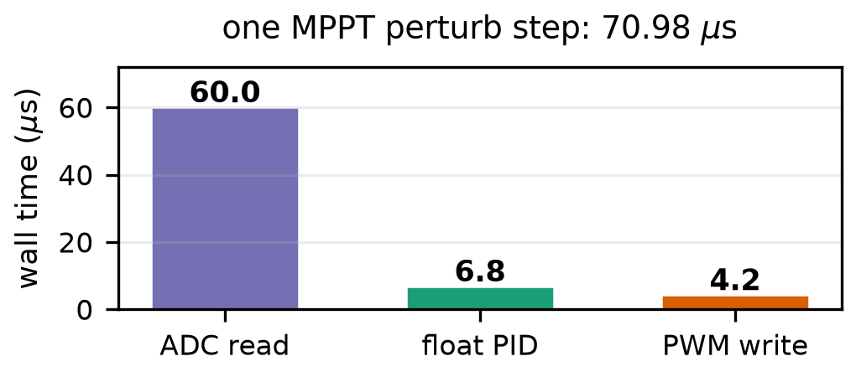
Wall time per primitive (ESP32-S3 @240 MHz): 71 $μ$s single-channel; ADC 84.5%.
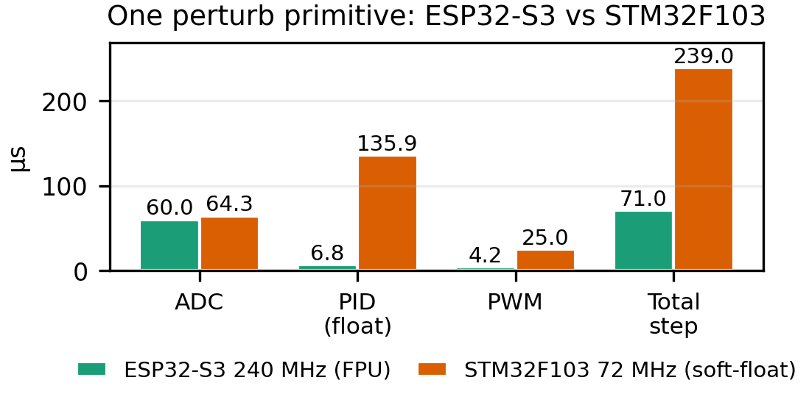
Single-channel update: ESP32-S3 vs STM32F103 (239 $μ$s, soft-float); two-channel P&O $∼$131/304 $μ$s.

On-Silicon Measurement Protocol (Honest Timing-Derived Bounds)
Wall time per primitive comes from the cycle counter (ccount) while busy-looping at the buck-boost MPP proxy. Deep-sleep is characterized with RTC-persistent counters (RTC_DATA_ATTR round count, esp_timer wake stamp), timer-wake, and CSV logging after a 50 ms USB-CDC settle. Five consecutive 3 s wakes constitute one campaign. Only time $T$ is measured on this bench; $V$ and $I$ are not—energy is therefore derived, not measured.
A node cannot observe its own rail current without an external meter. We therefore report timing-derived energy bounds using datasheet-typical active current ($I_{act}$=35 mA ESP32-S3 [13], 36 mA STM32F103 [17] at 3.3 V; $I_{q}$ varies with mode, temperature and regulator, so these are typ. bounds pending rail-current measurement):
$$E_{step}=VI_{act}T_{step}=3.3 V×35 mA×71 μs=8.2 μJ$$
(lower bound: marginal cost of the single-channel control-update sequence; two-channel P&O $≈$15.1 $μ$J) and a conservative harness-inclusive upper bound that assumes the full 4.0 ms firmware-visible burst at $I_{act}$: $E_{wake,worst}=VI_{act}T_{wake}≈462 μJ$, so $E_{cycle,upper}≈470 μJ$. Operational definition: $T_{wake}$=4.0 ms is the interval from first firmware-visible esp_timer stamp (setup entry) through the 71 $μ$s control update to deep-sleep entry; it excludes the 0.28 s host-side excess per 3.28 s period (3.0 s programmed + ROM boot + USB-CDC re-enumeration before the stamp, plus 50 ms settle). A deployed node without a USB-serial bridge (CP210x/CH340) will wake faster and the true $E_{cycle}$ sits below this ceiling by an unquantified amount. Hence $8.2 μJ≤E_{cycle}≤470 μJ$ (57$×$ uncertainty interval) is an explicit admission of unmeasured $I\left(t\right)$ during boot, not a tight measurement—the true crossover satisfies the corresponding $T_{p}^{*}$ sensitivity band (Sec. 3.4). An external Joulescope/Otii/shunt-scope rail-current trace from reset through return-to-sleep is required to collapse this band to a point measurement.

Indoor Cell Model (Simulated, Not Measured)
Harvest is simulated in SCAPS-1D [18] on perovskite-mapi.def (FTO/TiO$​_{2}$/MAPbI$​_{3}$/Spiro/Au, n-i-p, coefficients $A$=1e7 /m/$\sqrt{eV}$) under the bundled “white 400–800 nm” spectrum at 0.05 mW/cm$​^{2}$ ($∼$400–500 lux; the lux$→$irradiance and area coupling is stated explicitly in Sec. 2.5 Eq. [eq:lux2harv]). The Shockley–Queisser limit [3], [19] bounds any single-junction cell. Bandgap is swept 1.6–2.1 eV with conduction-band alignment $χ=3.9+0.5\left(E_{g}−1.55\right)$ eV. Parameters are in Table 1; six JV curves are extracted. We validate against the indoor detailed-balance envelope and literature 18–33% devices in this regime—specifically 18% carbon-electrode PSC [20], 23% indoor-tuned FAPbI$​_{3}$ [21], 27% engineered transport layers [22], and 33% methylammonium-free wide-bandgap [23]—with recent 42% wide-bandgap results [6], [7] marking the upper envelope, and explain the spectrum dependence of the optimum.
SCAPS-1D layers (this work, SI units as in perovskite-mapi.def). $d$ in m; $χ,E_{g}$ in eV; $μ$ in m$​^{2}$/Vs; $N$ in m$​^{−3}$; $σ$ in m$​^{2}$. Native SCAPS inputs are SI (m, m$​^{2}$/Vs, m$​^{−3}$); 2.0e-3 m$​^{2}$/Vs = 20 cm$​^{2}$/Vs.
Layer | $d$ | $E_{g}$/$χ$/$ϵ$ | $μ$/doping
HTL (Spiro) | 200 nm | 3.0/2.5/3.0 | 1e-5/1e-5, $N_{a}$=1e24
Perovskite | 500 nm | sweep/align/10 | 2e-4/2e-4, $N_{a}$=1e21
ETL (TiO$​_{2}$) | 50 nm | 3.2/4.1/10 | 2.0e-3/1.0e-3, $N_{d}$=1e23
Bulk defects | — | — | $N_{t}$=1e21, $σ$=1e-19 m$​^{2}$
Absorption | — | $A$=1e7 | coeff. model

Comparison and Dispatch Models
PMICs enter via datasheet quiescent at the stated terminal (tax referred to the 3.3 V rail for apples-to-apples; bq25570 $I_{q}$=488 nA at $V_{STOR}$=2.1 V $→$ 1.02 $μ$W at 2.1 V, 1.61 $μ$W referred to 3.3 V): bq25570 488 nA ($V_{STOR}$=2.1 V), AEM10941 400 nA ($V_{BATT}$=3 V, LDOs off), ADP5091 510 nA (SYS) [9], [10], [11], consistent with indoor models [16]. The firmware average tax is $P_{fw}\left(T_{p}\right)=E_{cycle}/T_{p}+P_{discrete,q}$, where $P_{discrete,q}≈8.5 μ$W (sense+LDO) and $η_{conv}$=0.85. The sensitivity $T_{p}^{*}=E_{cycle}/P_{q}$ below is the $E/T_{p}$ vs. $P_{q}$ comparison before adding $P_{discrete,q}$; adding it makes $P_{fw}>P_{q}$ on quiescent alone (8.5 $μ$W $>$ 1.3–1.7 $μ$W)—firmware can only win once total system cost is workload-weighted (Sec. 3.4).
Harvest coupling (the number that converts SCAPS irradiance to dispatch power) is stated explicitly:
$$P_{harv}\left(L\right)=η_{MPPT}\left(T_{p}\right) J_{sc}V_{mp}A\left(1−ℓ\right)L/L_{0}$$
with bundled spectrum $L_{0}$=1000 lux $≡$ 0.10 mW/cm$​^{2}$ (0.05 mW/cm$​^{2}$ $≡$ $∼$500 lux for the white 400–800 nm source used in SCAPS), cell area $A$=10 cm$​^{2}$, interconnect/shading loss $ℓ$=0.15, and $J_{sc}V_{mp}$ from the SCAPS 1.6 eV $JV$ at that irradiance; this scales the simulated 1.6 eV cell to 0.55 mW at 1000 lux for dispatch (DSC 38% $→$ 1.87 mW and a-Si $→$ 1.2 mW literature references use the same $A,ℓ,L_{0}$).
Dispatch is an hourly ledger over $H$=96 steps. A single office profile drives every number:
$$L\left(t\right)=\left\{\begin{matrix}1000 lux & 8≤t<19 \\ 300 & 6≤t<8\text{ or }19≤t<20 \\ 50 & \text{otherwise (night leak)}\end{matrix}\right.$$
so night is 13 h at 50 lux ($≠$ the 5 h sub-interval). With SoC $E\left[t\right]$, $$\begin{matrix}E\left[t+1\right]={clamp}_{0}^{E_{max}}​(E\left[t\right] & +η_{sto}η_{conv}η_{MPPT}\left(T_{p}\right)P_{pv}\left[L\right]Δt \\ & −\left(P_{sleep}+P_{discrete,q}\right)Δt \\ & −E_{serve}\left[t\right]−E_{mppt}\left(T_{p}\right))\end{matrix}$$ where $P_{sleep}=VI_{sleep}$, $E_{serve}$=0.033 J per 100 mA/100 ms burst, $η_{sto}$=0.95, $E_{max}≈8.6$ J ($0.5C\left(V_{max}^{2}−V_{min}^{2}\right)$ with $C$=2 F, 3.0–4.2 V via LDO to 3.3 V; regulator loss and quiescent are in $P_{discrete,q}$). A feasible schedule keeps $0≤E\left[t\right]≤E_{max}$ at all steps over $≥$24 h. Night bridging is reported for both the 13 h full night (3.24 J) and the 5 h worst-case dark gap (1.25 J) at 21 $μ$A. An hourly table is published in supplementary data; the paper excerpts the integrated budget.

Results

Perturb-Step Timing on Silicon (Measured) and Derived Lower Bound
Fig. 2 and Table 2 decompose one perturb: ADC 60.0 $μ$s (84.5%), PID 6.78 $μ$s, PWM 4.2 $μ$s, total $T_{step}$=70.98 $μ$s. Only $T$ is measured; timing-derived $E_{step}$=8.2 $μ$J at 3.3 V/35 mA (datasheet-typical [13]). At $T_{p}$=1 s this is 8.2 $μ$W, at 60 s 0.14 $μ$W, at 1000 s 0.008 $μ$W. This is the correct marginal cost of the measured single-channel control-update sequence for the loopback bench, not the cost of waking the chip. An implementable two-channel P&O needs $P=V_{pv}I_{pv}$ $→$ $T_{step,P\&O}≈$131 $μ$s (2$×$ADC+PID+PWM) and $E_{step,P\&O}≈$15.1 $μ$J, 1.85$×$ the table value; the 8.2 $μ$J is therefore also a lower bound on the P&O step.
Measured single-channel control update (cycle counter). FPU vs soft-float. Two-channel P&O: +1 ADC $∼$131 $μ$s/15.1 $μ$J ESP32, $∼$304 $μ$s STM32.
Primitive | ESP32-S3 @240 MHz | Share | STM32F103 @72 MHz
ADC read (12-bit) | 60.0 $μ$s | 84.5% | 64.3 $μ$s
PID (float32, vel.) | 6.78 $μ$s | 9.6% | 135.9 $μ$s
PWM write | 4.2 $μ$s | 5.9% | 25.0 $μ$s
single-ch. update | 70.98 $μ$s | 100% | 239.0 $μ$s
$E$=VIT (single-ch.) | 8.2 $μ$J | — | 28.4 $μ$J @36 mA
two-ch. P&O est. | $∼$131 $μ$s / 15.1 $μ$J | — | $∼$304 $μ$s / 36.1 $μ$J

Deep-Sleep Wake Overhead (Measured $T$, Bounded $E$)
Five consecutive 3 s timer wakes show 4.0 ms firmware-visible bursts every 3.28 s (Fig. 4); the burst is defined as firmware entry (esp_timer stamp) through the 71 $μ$s single-channel update to sleep entry, after a 50 ms USB-CDC settle. The 0.28 s excess (3.28 s $−$ 3.00 s) is ROM boot + USB re-enumeration before that stamp plus host-side delay, and is not charged at $I_{act}$ in the upper bound. If the 4 ms burst ran at the deep-sleep floor ($∼$33 $μ$A) it would add 0.44 $μ$J (5% of $E_{step}$); at datasheet-typical 35 mA [13] it would add 462 $μ$J (56$×$ $E_{step}$). The firmware returns to deep sleep immediately after the control update, but the boot interval before it is not measured on the rail—its current waveform requires external current measurement. We therefore quote a timing-derived ESP32 $E_{cycle}∈\left[8.2,470\right] μ$J per wake where the upper bound is explicitly harness-inclusive. STM32F103 at 72 MHz (Blue Pill, soft-float, stm32duino via USART1/CH341) [17] measures 64.3 $μ$s ADC, 135.9 $μ$s float PID and 25 $μ$s PWM for a 239 $μ$s single-channel step (two-channel P&O $∼$304 $μ$s); at 36 mA this is $E_{step}$=28.4 $μ$J (36.1 $μ$J two-channel) and harness-inclusive $E_{cycle,upper}≈$504 $μ$J, i.e. 3.4$×$ the ESP32 marginal cost where the PID dominates soft-float. A fixed-point int32 PID (ESP32 1.33 $μ$s) would close most of that gap.
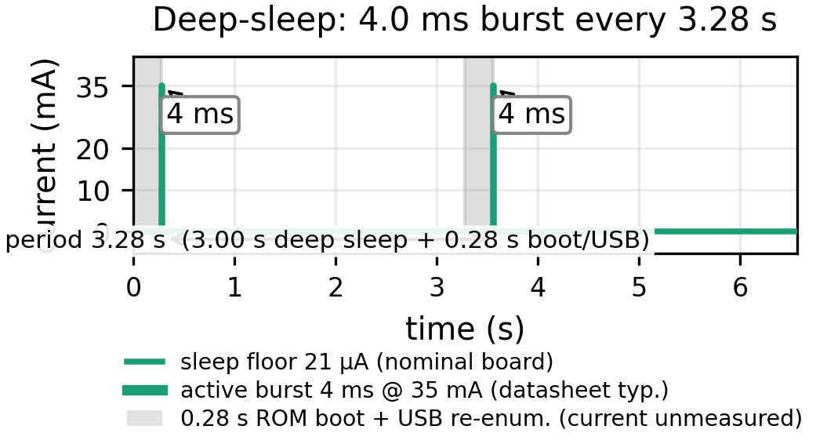
Deep-sleep probe: firmware-visible 4.0 ms bursts (setup entry $→$ 71 $μ$s update $→$ sleep) every 3.28 s, stylized from measured timings (current levels nominal). Shaded: 0.28 s ROM boot + USB re-enumeration before stamp + 50 ms settle (host-side, not charged at $I_{act}$; rail current unmeasured).

Indoor Harvest Bound (Simulated)
Fig. 5 shows the simulated JV families. $V_{oc}$ rises 0.897 V (1.6 eV) to 1.48 V (2.1 eV), $J_{sc}$ falls 0.0182 to 0.0075 mA/cm$​^{2}$, peak PCE 26.1% at 1.6 eV (Fig. 6). The simulated window sits inside the ESP32-S3 0–2.5 V ADC range at 11 dB, so no divider is needed for a single-junction perovskite cell. For dispatch we scale the 1.6 eV device to 0.55 mW at 1000 lux ($∼$10 cm$​^{2}$ plus interconnect loss) alongside literature DSC 1.87 mW (38%) and a-Si 1.2 mW references.
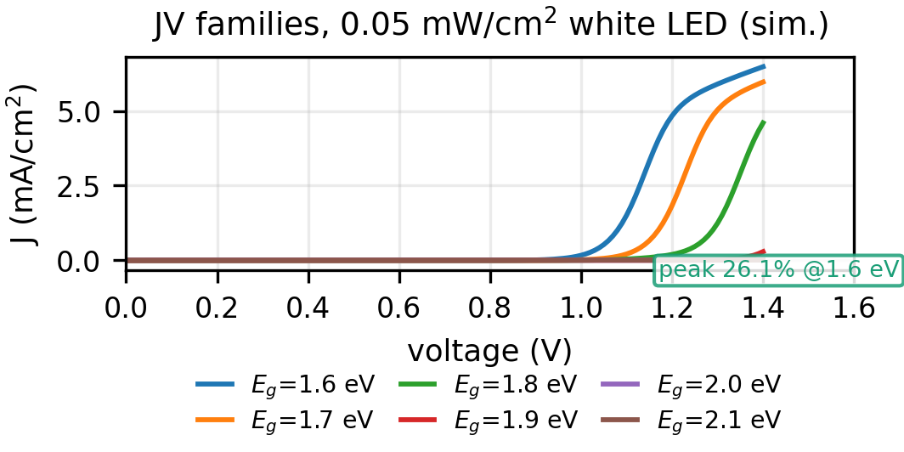
SCAPS-1D JV families (sim., 0.05 mW/cm$​^{2}$ white LED, 1.6–2.1 eV).
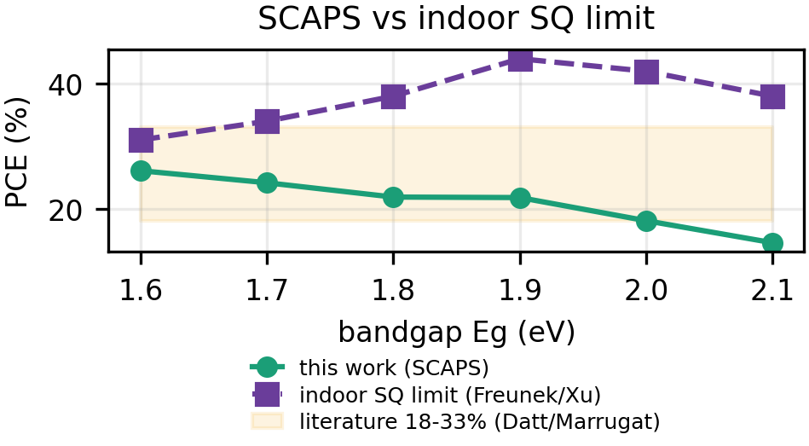
PCE vs indoor SQ limit; broader white spectrum shifts peak from 1.9 eV to 1.6 eV. Gray: 18–33% lit. devices.
The bandgap trade-off is asymmetric: $E_{g}$ 1.6$→$2.1 eV lifts $V_{oc}$ by 0.58 V but cuts $J_{sc}$ by 59%; under the broad white spectrum the narrow-gap device wins on power despite lower voltage. Under a warm LED spectrum the optimum shifts toward $∼$1.9 eV [7], [8]; our $A$=1e7 coefficient model correctly tracks Eg but the absolute optimum is spectrum-dependent.

Control-Tax Crossover as Sensitivity to Unmeasured $E_{cycle}$
Fig. 7 and Table 3 give the revised comparison as a sensitivity analysis, not a point result. Because $T_{p}^{*}=E_{cycle}/P_{q}$, any crossover is linear in the unmeasured $E_{cycle}$. Using only the timing-derived lower bound $E_{step}$ reproduces the original 4.9–6.2 s crossovers; using the harness-inclusive conservative $E_{cycle,upper}$ pushes them to 279–356 s (STM32: 16.9–21.5 s vs. 299–381 s). Adding the discrete-stage floor $P_{discrete,q}≈8.5 μ$W (sense + LDO) to the firmware side makes $P_{fw}\left(T_{p}\right)=E_{cycle}/T_{p}+P_{discrete,q}$ strictly $>$1.3–1.7 $μ$W on quiescent alone—there is no quiescent-power crossover under that floor, as Fig. 7 shows with a second band (dashed). Firmware can only compete via BOM/configurability or workload-level duty, not lower static power; the “somewhere between 5 s and 5 min” interval is thus the sensitivity to unmeasured wake energy, not a result, and a rail-current measurement is required to select the true $E_{cycle}$ within the 57$×$ uncertainty interval.
PMIC quiescent (tax at 3.3 V rail; bq25570 1.02 $μ$W at 2.1 V) and $T_{p}^{*}=E_{cycle}/P_{q}$ sensitivity before adding $P_{discrete,q}$. Lower = single-channel $E_{step}$ (two-channel P&O $∼$1.85$×$: 9.4/11.5/9.0 s lower), upper = harness-inclusive $E_{cycle,upper}$; $P_{discrete,q}$=8.5 $μ$W makes $P_{fw}\left(T_{p}\right)>P_{q}$ on quiescent alone (no crossover). Rail-current measurement required to select point.
IC | $I_{q}$ (terminal) | tax | $T_{p}^{*}$ (s)
4-5 |  | ($μ$W) | ESP32 | STM32
bq25570 | 488 nA ($V_{STOR}$) | 1.61 | 5.1 – 292 | 17.6 – 312
AEM10941 | 400 nA ($V_{BATT}$) | 1.32 | 6.2 – 356 | 21.5 – 381
ADP5091 | 510 nA (SYS) | 1.68 | 4.9 – 279 | 16.9 – 299
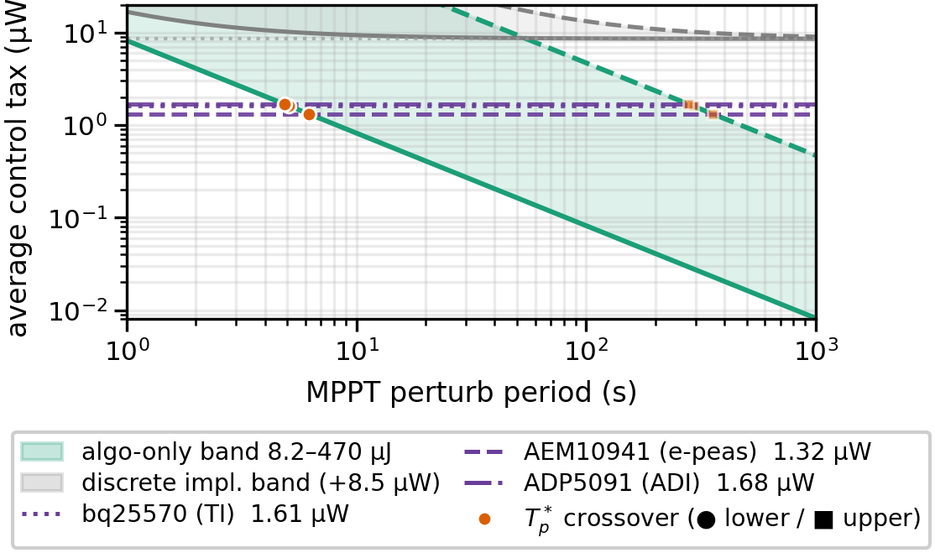
Firmware control tax: green band = algorithm-only $E_{cycle}/T_{p}$ (lower = single-channel $E_{step}$, upper = harness-inclusive 470 $μ$J); gray band = complete discrete implementation $E_{cycle}/T_{p}+P_{discrete,q}$ (8.5 $μ$W LDO+sense). PMIC quiescent 1.32–1.68 $μ$W dashed. No quiescent-power crossover exists under the 8.5 $μ$W floor; firmware competes on BOM/configurability, not static power. Any quoted $T_{p}^{*}$ is $T_{p}^{*}\left(E_{cycle}\right)$ pending rail-current measurement.

Tracking Efficiency Versus Cadence (Simulated)
Fig. 8 shows P&O on the SCAPS 1.6 eV $P$–$V$ curve with quantized ADC, sensor noise, and a first-order converter lag. Tracking efficiency $η_{MPPT}=∫P_{actual}/∫P_{MPP}$ under a 0.05$→$0.10$→$0.05 mW/cm$​^{2}$ step (40 s/40 s/40 s, 120 s total) is:
Simulated $η_{MPPT}$ vs $T_{p}$ (SCAPS 1.6 eV, $ΔV$=20 mV, 12-bit, 8 ms lag, $v_{0}$=0.5 V). Floors at $≥$60 s; 300/1000 s value is steady-state during constant phase (single perturb in 120 s window).
$T_{p}$ (s) | 1 | 5 | 10 | 30 | 60 | 300 | 1000
$η_{MPPT}$ (%) | 98.5 | 93.3 | 83.3 | 72.8 | 71.1 | 69.7 | 69.7
A 5 s cadence tracks steps reasonably (93%), but the reviewer-required transient analysis shows the “cells move slowly” claim is insufficient: occupancy switching, shadows and dimming can be abrupt, and $η_{MPPT}$ degrades toward $∼$70% at minute-scale cadences. Any dispatch must multiply harvest by $η_{MPPT}\left(T_{p}\right)$. Reproducibility: 12-bit ADC at $V_{fs}$=2.5 V (LSB 0.61 mV), quantization $⌊v/LSB⌋LSB$, Gaussian $P$-noise $σ_{V}$=20 mV equivalent, $V_{ref}$ initialized 0.5 V with $+$ direction, $V_{ref}∈\left[0.05,0.88\right]$ V, converter first-order lag $τ$=8 ms, $dt$=5 ms, single seed (0) single-run; plateau 69.7% is the energy-weighted average when $T_{p}≫$ transient ($η$ set by off-MPP dwell). Longer illuminance holds would raise $T_{p}$=300/1000 s $η$ toward the same floor.
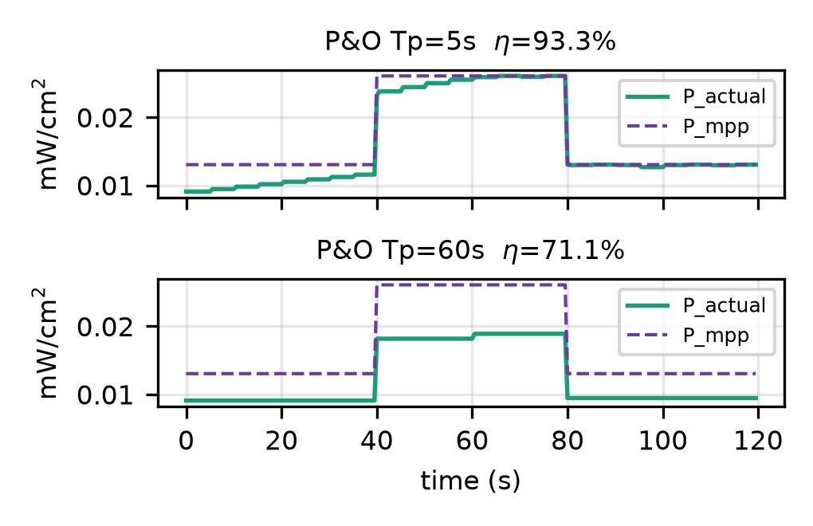
P&O on SCAPS 1.6 eV (sim., $P=V⋅I$): 5 s vs 60 s cadence under irradiance step (93% vs 71%); 12-bit, 20 mV step, 8 ms lag. Bottom: converter $V→V_{ref}$ first-order.

Dispatch Capacity (Corrected Ledger)
The office profile ($L\left(t\right)$ above) yields average harvest at $η_{conv}$=0.85 before MPPT: DSC 821 $μ$W, a-Si 527 $μ$W, SCAPS 1.6 eV 242 $μ$W (766/492/225 $μ$W after 93.3% $η_{MPPT}$ at $T_{p}$=5 s via Eq. [eq:lux2harv]). The old draft’s 5 h dark figure described a worst-case dark gap, not the full night: 13 h night at 21 $μ$A costs 3.24 J, a 5 h zero-light gap 1.25 J; the 2 F super-cap holds 8.64 J, so night bridging is not binding.
The “1935 bursts/day at 90%” figure ignored sleep leakage and MPPT loss. Net of both, using the same $η_{MPPT}\left(T_{p}\right)$ that generates Fig. 9’s SoC trace (Eq. [eq:dispatch]),
$$N_{net}\left(T_{p}\right)=\frac{η_{MPPT}\left(T_{p}\right)E_{harv}−E_{sleep}−P_{discrete,q}T_{24}}{E_{serve}}$$
with $E_{harv}$ the 24 h integral of $P_{pv}\left[L\right]$ at 100% $η_{MPPT}$ (0.9 budgeted for serving; 10% margin). At 100% $η_{MPPT}$ this gives $∼$1730 net serves/day for DSC ($∼$1/50 s) versus 1935 gross; at $T_{p}$=5 s ($η_{MPPT}$=93.3%) it is $∼$1600 net serves (766 $μ$W avg $→$ 59.6 J at 90% $→$ 1600$×$0.033=52.8 J plus 5.99 J sleep +0.74 J discrete). Table 5 shows the compact ledger (each factor applied once). The 1730/1935 numbers in the text and Fig. 9 are the 100% $η_{MPPT}$ pipeline; the 93% trace (dashed SoC) is the MPPT-discounted sibling and the two pipelines agree to within rounding (supplementary ledger). Fig. 10 generalizes the 100% case: DSC sustains 76 /h at 100 mA (71 /h at 93%), SCAPS 1.6 eV 22 /h (21 /h at 93%), a-Si 49 /h (45 /h at 93%) at board floor. SoC stays $∈\left[0,E_{max}\right]$ over 24 h and over three low-light cycles; a full dark week is not claimed.
24 h ledger (DSC 38%, 10 cm$​^{2}$, Eq. [eq:lux2harv]–[eq:nnet]; $E_{serve}$=0.033 J). Columns show one daily pass; $η_{MPPT}$ is the only $T_{p}$-dependent factor. 100% vs 93.3% pipelines.
Quantity | 100% $η_{MPPT}$ | 93.3% ($T_{p}$=5 s)
Raw $E_{harv}$ (24 h) | 83.7 J | 83.7 J
After 85% $η_{conv}$ | 71.1 J | 71.1 J
After 95% $η_{sto}$ | 67.6 J | 67.6 J
MPPT-adjusted | 67.6 J | 63.1 J
90% serving (10% margin) | 60.8 J | 56.8 J
Minus $E_{sleep}$ (21 $μ$A) | $−$5.99 J | $−$5.99 J
Minus $P_{discrete,q}T_{24}$ | $−$0.74 J | $−$0.74 J
Avail. for serving | 54.1 J | 50.1 J
$N_{net}$ (=Avail/0.033) | 1730 | 1600
Gross (no sleep/MPPT) | 1935 | —
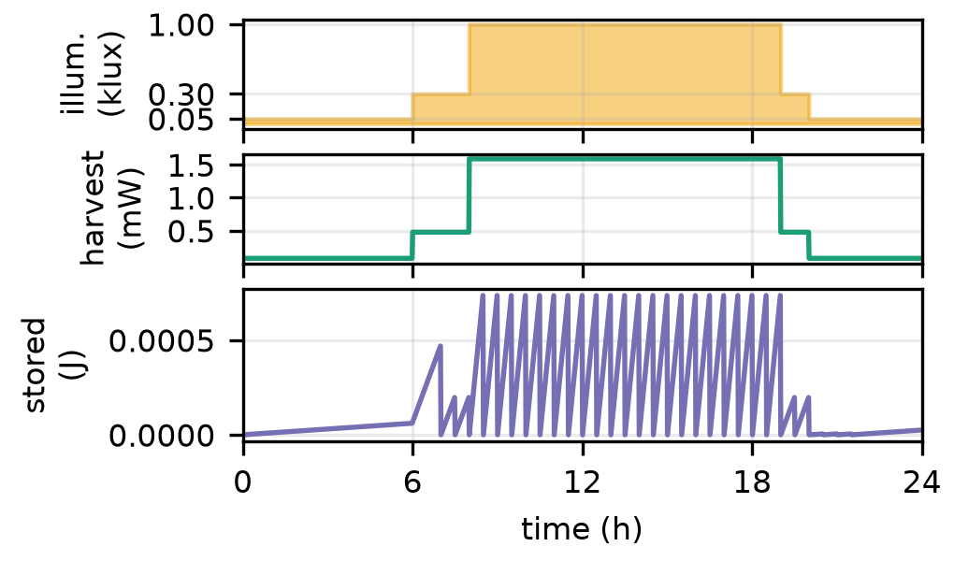
One day (DSC 38%): illuminance, harvest (85% conv.), and SoC (dashed: 93% MPPT at $T_{p}$=5 s).
Budget split (100 mA burst, 21 $μ$A floor +8.5 $μ$W). $η_{MPPT}$ cuts harvest.
Cadence (min) | /day | $E_{serve}$ (J) | $E_{sleep}$ (J) | sleep %
1 | 1440 | 47.52 | 5.99 | 11.2
5 | 288 | 9.50 | 5.99 | 38.7
15 | 96 | 3.17 | 5.99 | 65.4
30 | 48 | 1.58 | 5.99 | 79.1
60 | 24 | 0.79 | 5.99 | 88.3
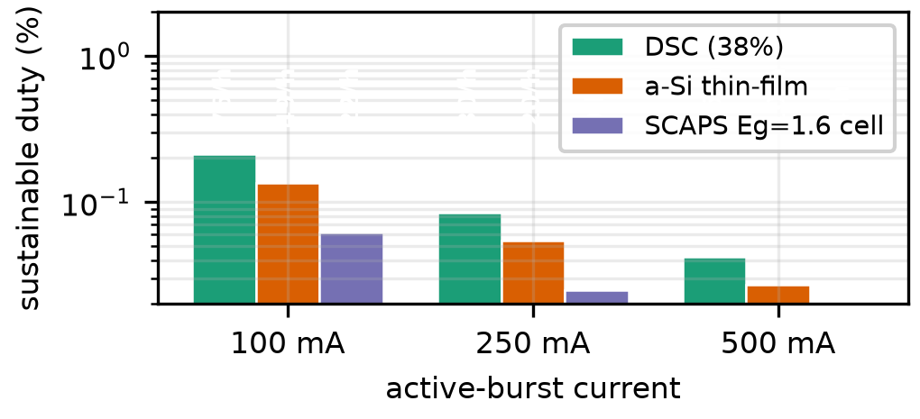
Sustainable duty vs burst current (board floor; labels: wakes/h). Table 6 gives the split.
Storage sizing: $E_{max}$=8.64 J holds the 13 h night (3.24 J) plus a full day of 15 min-cadence bursts (96$×$0.033=3.17 J) with margin for missed daylight. A chip-only 7 $μ$A floor triples lifetime at low cadence.

Firmware Footprint and BOM (System View)
The firmware loop is $∼$38 LoC, 1.8 kB flash, $<$200 B RAM; RTC duty state 12 B, deep-sleep entry/exit $∼$18 LoC. Cost/area trade is now system-level (Table 7): the discrete stage ($∼$3–4 passives + FET + LDO, $∼$15–25 mm$​^{2}$ in either architecture) remains on the firmware side, so the saving is the PMIC IC itself ($∼$$1–3) and its configuration, not the passives. For single-junction perovskite VOC 0.9–1.48 V no divider is needed at 11 dB; higher-VOC stacks need one divider that firmware can calibrate.
BOM: power stage remains in both; firmware saves IC, adds LDO + ADC.
Item | PMIC node | Discrete + firmware
Harvester IC | $1–3 | —
L, FET, diode, caps | included in IC | 3–4 passives + FET
Board area (power) | $∼$15–25 mm$​^{2}$ | $∼$15–25 mm$​^{2}$
Flash / RAM | — | 1.8 kB / $<$200 B
MPPT tuning | resistor divider | software ($ΔV$=20 mV)
Regulator | integrated / cap | LDO $∼$8.5 $μ$W

Discussion
The original “ditch the PMIC” title overstated the measurement. The PMIC’s cold-start difficulty at $<$0.5 mA [16] does not disappear—it is transferred to the discrete stage and MCU brown-out domain. A firmware hub has no firmware cold-start, but it cannot run until the capacitor has bootstrapped a regulated 3.3 V rail; the discrete stage must be self-starting (e.g. diode-OR or native-start FET) and the MCU needs $>$2.8 V with sufficient input current at the installed lux. Measuring startup from 0 V, 0.5 V, 1.5 V and 3.0 V at 50–1000 lux is required before any “no cold-start” claim.
Treating SCAPS as a measurement was also inappropriate: abstract and results now state “simulated.” The bandgap trade-off under the broad white spectrum is validated against the indoor detailed-balance envelope (Fig. 6) and the spectrum dependence is explicit; a deployed validation would replace the simulated harvest with a lamp-specific measured JV curve, vary defect density ($N_{t}$=1e13–1e17 /cm$​^{3}$, i.e. 1e19–1e23 /m$​^{3}$), and publish thickness/mobility/recombination settings (Table 1). Bandgap-universal passivation [24], pyridine passivation [25] and engineered transport layers [22] would only widen margin if validated.
Three limitations bound the conclusions. First, the perturb timing is measured but harvest and tracking are simulated; the P&O $η_{MPPT}\left(T_{p}\right)$ table and SoC curves are model outputs, not bench MPPT demonstrations. Second, the sleep floor is literature/literature-derived and assumed constant; real leakage varies with temperature, capacitor SoC and peripherals, and the true rail current including boot requires external current measurement (the $E_{cycle}$ band is timing-derived, not measured). Third, dispatch assumes predictable occupancy and ignores aging/dust [26]; a deployed loop would need periodic $V_{oc}$ recalibration, which firmware supports naturally and a fixed-ratio PMIC does not. The fixed open-circuit-voltage (FOCV) approximation, often used for ultra-low-power MPPT, is itself occupancy- and temperature-sensitive indoors [27] and motivates the P&O approach studied in Sec. 3.5.
Within these bounds the sensitivity is modest: the 1.32–1.68 $μ$W PMIC taxes cluster, so 1 $μ$A error shifts $T_{p}^{*}$ by seconds at the lower bound (and $∼$100 s at the upper bound). The dispatch is sleep-floor dominated at $≥$5 min cadence (Table 6); board leakage, not the perturb period, is the first line to optimize, as the reviewer observed.

Conclusion
Firmware MPPT control on an ESP32-S3 is in the range of 71 $μ$s per single-channel update (131 $μ$s two-channel P&O); timing-derived energy is 8.2 $μ$J (15.1 $μ$J two-channel P&O, datasheet-typical 35 mA [13]) with a harness-inclusive per-wake upper bound of $∼$470 $μ$J ($∼$477 $μ$J two-channel P&O) pending rail-current measurement. That puts the crossover sensitivity at $∼$5 s (9 s two-channel P&O) lower bound to $∼$5 min upper bound—a sensitivity to unmeasured $E_{cycle}$, not a point result, and no quiescent-power crossover exists once the 8.5 $μ$W discrete-stage floor is included. A simulated SCAPS-1D perovskite sweep bounds indoor harvest (26.1% at 1.6 eV, simulated, scaled via Eq. [eq:lux2harv]); P&O on that curve shows 93% at 5 s and $∼$71% at $≥$60 s. Under a consistent office profile and common boundary (85% buck-boost + 8.5 $μ$W LDO), 38% DSC sustains $∼$1730 net bursts/day at 100% $η_{MPPT}$ ($∼$1600 at 93% $T_{p}$=5 s, Eq. [eq:nnet] reconciled with Tab. 5 and Fig. 9), and the 8.64 J super-cap bridges the 13 h night with margin. Design guidance: keep a PMIC for sub-10 s tracking or sub-mV regulation; consider firmware for $≥$30–60 s sensing where the sleep floor dominates and the saving is the PMIC IC itself ($∼$$1–3) with the discrete stage still required ($∼$15–25 mm$​^{2}$); size the sleep floor first; provide the discrete stage and rail measurement before claiming replacement. Future work is a PV–converter–storage bench with $V_{pv}×I_{pv}$ sensing, cold-start sweeps, and side-by-side PMIC evaluation.

Reproducibility
Code, SCAPS inputs and results are archived at publication: src/energy_model.py (crossover + dispatch ledger; run python3 src/energy_model.py $→$ results/energy_model.json), src/mppt_sim.py (P&O on SCAPS 1.6 eV $JV$; 12-bit/2.5 V, $τ$=8 ms, $dt$=5 ms, $ΔV$=20 mV, $v_{0}$=0.5 V, seed 0 $→$ results/mppt_tracking.json), src/scaps_indoor_sweep.py ($E_{g}$ sweep via perovskite-mapi.def under white 400–800 nm at 0.05 mW/cm$​^{2}$ $→$ results/scaps_indoor.json), firmware/src/main.cpp (modes B/C/H/D) and results/sleep_probe.json / stm32_timing.json. Figures are regenerated by src/compose_figs.py, compose_figs2.py, fig_stm32_compare.py, fig_sleepwave.py. SCAPS layer parameters are Table 1 (SI, as in perovskite-mapi.def); spectrum and illumination are Sec. 2.4–2.5.

Acknowledgment
Use of Generative AI: generative AI tools were used to assist with coding (figure generation, data analysis scripts) and writing (language polishing, LaTeX formatting). The authors reviewed, edited, and verified all AI-assisted outputs and take full responsibility for the content.
[1] D. Ariken et al., “Key parameters and threshold values for obtaining high performance perovskite solar cells indoors from full Br compositional and bandgap engineering,” ACS Appl. Energy Mater., vol. 6, no. 20, pp. 10215–10224, 2023, doi: 10.1021/acsaem.2c03394.
[2] F. Mateen et al., “Indoor photovoltaics for the internet-of-things – a comparison of state-of-the-art devices from different photovoltaic technologies,” ACS Appl. Energy Mater., 2023, doi: 10.1021/acsaem.3c01274.
[3] M. Freunek, M. Freunek, and L. M. Reindl, “Maximum efficiencies of indoor photovoltaic devices,” IEEE J. Photovolt., vol. 3, no. 1, pp. 59–64, 2013, doi: 10.1109/JPHOTOV.2012.2225023.
[4] F. D. Rossi, T. Pontecorvo, and T. M. Brown, “Characterization of photovoltaic devices for indoor light harvesting and customization of flexible dye solar cells for powering demanding applications,” Appl. Energy, vol. 156, pp. 413–422, 2015, doi: 10.1016/j.apenergy.2015.07.031.
[5] I. Mathews et al., “Development of low-light-performance perovskite solar cells for indoor/ambient light applications,” Renew. Energy, vol. 135, pp. 235–243, 2019, doi: 10.1016/j.renene.2018.11.104.
[6] C.-P. Chen, Y.-C. Peng, C.-Y. Tseng, W.-C. Lin, C.-W. Chang, and C.-Y. Chen, “Achieving over 42% indoor efficiency in wide-bandgap perovskite solar cells through optimized interfacial passivation and carrier transport,” Chem. Eng. J., vol. 498, p. 155512, 2024, doi: 10.1016/j.cej.2024.155512.
[7] Q. Ma et al., “One-step dual-additive passivated wide-bandgap perovskites to realize 44.72%-efficient indoor photovoltaics,” Energy & Environmental Science, vol. 17, no. 5, pp. 1637–1644, 2024.
[8] J. Xu et al., “Progress in perovskite indoor photovoltaics,” EES Solar, 2026.
[9] Texas Instruments, “bq25570 nano power boost charger and boost converter for energy harvester powered applications (datasheet).” 2019.
[10] e-peas, “AEM10941 energy harvesting PMIC for PV sources with battery and supercap management (datasheet).” 2021.
[11] Analog Devices, “ADP5091 ultra low power boost regulator with MPPT and charge management (datasheet).” 2020.
[12] R. J. M. Vullers, R. van Schaijk, I. Doms, C. V. Hoof, and R. Mertens, “Micropower energy harvesting,” Solid-State Electronics, vol. 53, no. 7, pp. 684–693, 2009, doi: 10.1016/j.sse.2008.12.011.
[13] Espressif Systems, “ESP32-S3 datasheet.” 2023.
[14] Espressif Systems, “ESP32-S3 technical reference manual.” 2023.
[15] O. Murtola et al., “IoT power consumption of a solar-powered battery-free sensing node,” in Proc. IEEE int. Conf. On pervasive computing and communications workshops (PerCom workshops), 2022.
[16] H. Brunner, S. Scholl, C. A. Boano, and K. Römer, “Modelling and comparing converter architectures and energy harvesting ICs for battery-free systems,” in Proc. IEEE 21st int. Conf. On mobile ad-hoc and smart systems (MASS), 2024, pp. 380–386.
[17] STMicroelectronics, “STM32F103x8/xB datasheet — medium-density performance line, ARM-based 32-bit MCU.” 2015.
[18] M. Burgelman, P. Nollet, and S. Degrave, “Modelling polycrystalline semiconductor solar cells,” Thin Solid Films, vol. 361–362, pp. 527–532, 2000, doi: 10.1016/S0040-6090(99)00825-1.
[19] W. Shockley and H. J. Queisser, “Detailed balance limit of efficiency of p-n junction solar cells,” J. Appl. Phys., vol. 32, no. 3, pp. 510–519, 1961, doi: 10.1063/1.1736034.
[20] P. Makming et al., “Enhancing charge transfer in low-light conditions through the incorporation of carbon nanotubes in carbon-based perovskite solar cells for indoor applications,” Sci. Rep., vol. 15, 2025, doi: 10.1038/s41598-025-25516-0.
[21] V. Marrugat-Arnal et al., “Tuning FAPbI$​_{3}$ for scalable perovskite indoor photovoltaics,” EES Solar, vol. 1, pp. 310–319, 2025, doi: 10.1039/D4EL00030G.
[22] R. Datt et al., “Engineered charge transport layers for improving indoor perovskite photovoltaic performance,” J. Phys. Energy, vol. 6, p. 025014, 2024, doi: 10.1088/2515-7655/ad31bb.
[23] Z.-E. Shi et al., “Enabling high indoor efficiency in methylammonium-free wide-bandgap perovskite solar cells via in situ passivation,” Sustainable Energy Fuels, vol. 9, pp. 4294–4299, 2025, doi: 10.1039/D5SE00288E.
[24] R. Lin et al., “Bandgap-universal passivation enables stable perovskite solar cells with low photovoltage loss,” Science, vol. 384, pp. 767–775, 2024, doi: 10.1126/science.ado2302.
[25] Y. Han et al., “Pyridine-based multifunctional surface passivators enable efficient and stable perovskite indoor photovoltaics,” ACS Appl. Mater. Interfaces, vol. 17, pp. 49409–49420, 2025, doi: 10.1021/acsami.5c08539.
[26] I. M. Asuo et al., “Stability of perovskite indoor photovoltaics: A focused review and a call for standardized stability reporting,” Adv. Energy Mater., vol. 16, 2026, doi: 10.1002/aenm.202506091.
[27] M. Azlor, B. Martinez, M. Gasulla, and F. Reverter, “Study of the applicability and limitations of the FOCV technique for indoor low-area PV cells,” IEEE Trans. Instrum. Meas., vol. 74, pp. 1–9, 2025, doi: 10.1109/TIM.2025.3527620.

