Structured Scoping Review with Bibliometric Classification
Is Wireless Security
Ready for the AI Era?
Evidence from a Curated Corpus of 130 Studies, 2020–2026

Authors: | Hussain Touhid Siddiquee
 | Md. Abul Malek Fahim
Affiliation: | Leading University, Sylhet,
 | Bangladesh
ORCID (Siddiquee): | 0009-0002-8804-6195
ORCID (Fahim): | 0009-0009-4196-4328
Correspondence: | touhidsiddiqueeraj@gmail.com
Supplementary artifact: | dataset_papers.csv + analysis scripts
Date: | October 2026

Abstract
Machine learning (ML) is now central to published radio-link authentication research — and simultaneously the adversary’s standard toolkit. This scoping review classifies 130 curated studies (2020–2026): a 121-study core on ML for wireless-link security or attacks on it (84 defense, 30 threat, 7 dual attack-plus-defense), plus 9 post-quantum-cryptography studies in a separate stratum. Each study is coded on six fields — security function, AI method, track, data source, validation practice, and readiness (R1–R5) — by a single coder and independently validated by a second author.
Validation practice splits by kind: 16 of 30 threat studies demonstrate on testbeds or over the air, while simulation-only and standard-split evaluations carry much of the defense mass; closed-loop evaluation appears in 14 of 121 core studies (11.6%). Reproducibility is near-absent (4 verified artifact releases, 3.3%), and standards alignment outside the post-quantum stratum is mention-level only (9.9%). Real-time, update, and multi-agent-trust requirements are essentially unaddressed (1–2 papers each).
Because 110 of 130 rows were coded from abstracts by a single coder, cross-group comparisons are indicative rather than measured effects. The paper releases the classified dataset for independent checking, distills six structural research gaps, and closes with a twelve-item reporting checklist (WIRELESS-AI-RC).
Keywords: wireless security; physical-layer authentication; RF fingerprinting; adversarial machine learning; physical-layer key generation; anti-jamming; post-quantum migration.

1 Introduction

1.1 The radio link under AI pressure
Wireless links broadcast by physics: every transmission is receivable by anyone in range, which makes the radio link the natural attack surface for interception, impersonation, and jamming. The classical answer — encryption, authentication and key agreement (AKA), and physical-layer techniques — now faces three simultaneous strains. First, software-defined radios put laboratory-grade interception and transmission in every adversary’s hands. Second, machine learning turns raw captures into fingerprints, keys, and exploits automatically, without hand-built demodulators. Third, autonomous systems (drones, vehicles, swarms, IoT/edge fleets) need authentication under real-time deadlines, over-the-air updates, and multi-agent trust — requirements the literature rarely addresses together. The question this review asks is whether the radio-link security literature has kept pace with the adversary it has itself equipped.

1.2 How AI entered wireless security
AI entered through authentication. Deep networks learned RF fingerprints from raw I/Q, outperforming hand-crafted features, and physical-layer key generation promised lightweight secrets from channel reciprocity without public-key infrastructure. The adversarial turn followed quickly: white-box FGSM/PGD perturbations and black-box universal perturbations (81.7% success with almost no victim knowledge) break RFFI classifiers on real LoRa captures [T03]; reinforcement-learned impersonation needs only binary accept/reject feedback for >90% penetration [T18]; GAN-spoofed signals pass PHY authentication at 76% [T09]. Two results reset expectations: far-field deep-learning side-channel recovery of BLE AES-128 at 15 m from fewer than 400 traces [T01], and Magmaw [T30] (NDSS’25) — protocol- and modality-agnostic universal perturbations, SDR-demonstrated at noise-level power, surviving adversarial training, subtraction, detection, and oracle defenses, including against an encrypted image channel. Authentication learned from waveforms, it turned out, could be unlearned by waveforms. Fig. 1 places these turning points on a timeline: with two exceptions (a 2022 joint attack-plus-defense ensemble receiver and a 2025 proactive-authentication defense), every milestone is an attack (milestones author-selected to mark field turns, not sampled).
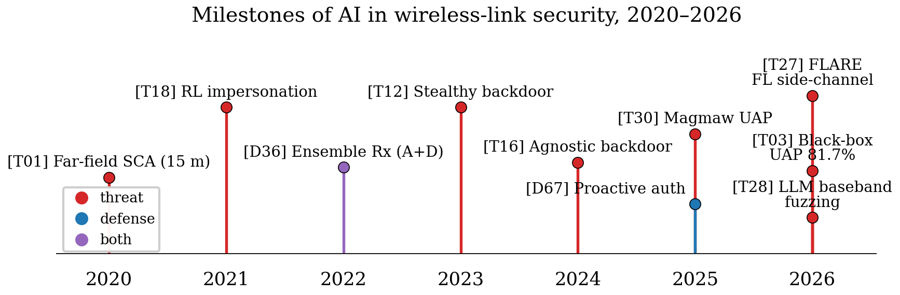
Figure 1: Milestones of AI in wireless-link security, 2020–2026. Red markers are threats, blue defenses, purple joint attack-plus-defense work.

1.3 Existing reviews and the literature gap
The review literature has grown alongside the applications, but it is fragmented along the same axes as the primary studies. Function-specific surveys cover RF fingerprinting [BG3]; method-specific ones follow adversarial ML [BG7]; the closest cross-functional account is a physical-layer-authentication survey for the ML era [BG2]. Table 1 compares their scope and method against this review. What is largely missing is a cross-functional, quantitative account of the field’s trajectory: which AI method families are used for which security functions, on which data, validated how, and how that shifted over 2020–2026. This gap matters because the field’s self-image drives research allocation: if most published authenticators are validated on closed-set, single-receiver, static-channel benchmarks, progress is calibrated to a regime far from deployment under adaptive adversaries. Readers seeking per-function depth should consult those surveys directly — [BG3] for fingerprinting practice, [BG7] for the adversarial attack surface, [BG2] for authentication design; this review complements them at corpus level.
Table 1: Prior surveys closest to this review: scope, method, and what differs here.
Survey | Scope | Method | This review instead
[BG3] Jagannath 2022 | RFFI only | Narrative | 8 functions quantified jointly
[BG7] Adesina 2023 | Adversarial wireless ML | Narrative | Plus defenses, validation grade, trends
[BG2] Hoang 2024 | PLA/auth in ML era | Narrative | Plus threats, readiness scores, checklist

1.4 Contribution of this paper
This paper makes four contributions. First, it assembles a verified corpus of 121 core studies (2020–2026) on AI in wireless-link security broadly construed, plus 9 post-quantum contextual studies kept in a separate stratum (130 records total), in which every record carries a resolvable identifier verified record-by-record (journal/conference DOI, arXiv/ePrint ID, USENIX paper URL, or publisher landing page — no identifier fabricated, none shared). Corpus construction, deduplication adjudications, and the same-team companion-pair sensitivity checks are documented in §2.3. Second, it develops a two-axis classification framework — security function × AI method family — extended with track, data-source, validation-practice, and readiness fields, applies it uniformly to all 130 papers, and releases the classified dataset so independent coders can check, correct, or extend it. Third, it quantifies the field’s six-year evolution across functions, methods, data, and validation (§3) — as a descriptive account of this curated sample. Fourth, it provides a critical, function-by-function review of what the corpus actually demonstrates (§§4–6), a cross-cutting analysis of the threat–defense asymmetry (§7), and distills a gap-driven research agenda plus a reporting checklist (§8).
Fig. 5 previews the analysis, mapping the corpus across security functions and method families: the field’s center of gravity sits squarely in the RFFI × (adversarial + deep-supervised) complex, key generation is a simulation-heavy island, and LLM-assisted work is only now appearing. The remainder of the paper is organised as follows. §2 details the review methodology. §3 presents the corpus overview and bibliometric analysis. §§4–6 review threats, defenses, and the quantum-era context. §7 examines cross-cutting directions. §8 formulates gaps and the checklist. §9 concludes.

2 Review Methodology

2.1 Scope and objective
The objective is to characterise the state and evolution of AI applied to radio-link security broadly construed: authentication/RFFI (including localisation-fingerprint attacks where geofence bypass breaks an authorisation boundary), key generation/distribution/exchange/management, anti-jamming/secure communications, protocol/traffic/signal analysis where the classifier is the security boundary, side-channel analysis, federated privacy, and learned primitives — crossed with AI as attacker tool, defender tool, or learned primitive — over 2020-01-01–2026-10-11, plus readiness gaps for autonomous systems (drones, vehicles, swarms, IoT/edge). Post-quantum migration forms a separate contextual stratum (9 studies, several of which meet neither the AI-link nor the radio-link criterion on their own and are retained as context only), never pooled with AI claims. No in-corpus paper joins AI-driven attack with PQC implementation over a radio link; that join is recorded as a scoping result with the caveat that the stratum was assembled without an AI-linkage requirement, so its emptiness describes this corpus, not the field. The title question — is wireless security ready for the AI era? — is answered in §9: no, on current evidence.

2.2 Literature search strategy
Three collection paths were used; no formal stopping rule was applied — collection stopped after the seeded rounds, two OpenAlex runs, and the adjudication pass, with a 241-record programmatic pool held unscreened as backup. Path A (programmatic: 16 Crossref plus 10 arXiv queries) yielded 1,945 unique records but zero included studies after gating, so triangulation rests on the seeded and database paths. Path B (expert-seeded, 29 logged search rounds) gave 126 unique candidates. Path C (database: 10 OpenAlex queries, no subscription required) gave 894 hits, 662 unseen after deduplication against Paths A–B. Query strings, code, and logs are released (code/openalex_run.py, run log.md); full per-query detail is in the supplementary material.
Crossref is a metadata registry, not a discovery engine; topical recall for this IEEE/ACM-heavy literature is ∼50% by token overlap, which is why triangulation — not single-source retrieval — is the design. Subscription-database runs (Scopus/IEEE Xplore/Web of Science) remain pending for lack of institutional access; OpenAlex is the executed substitute, and its yield (14 eligible papers missed by 29 seeded rounds plus 26 API queries) is reported as evidence about seeded-search recall limits, not a census. The seeded path inherits expert-search bias toward notable recent work; trend statements describe this verified English-language sample, not the field in aggregate.

2.3 Screening and selection procedure
The funnel (Fig. 2) ran each path through a validity floor (V1 peer/in-range/retrievable, V2 evaluable evidence, V3 traceable claims). Seeded path: 126 candidates → 109 includes + 12 background + 4 backup + 1 exclusion. OpenAlex run 1: 894 hits → 662 unseen → 130 title-gated → 14 included (D70–D77, T41–T46) + 2 background + 1 excluded. Rerun (2026-10-12): 994 hits → 743 post-dedupe → 136 title-gated (20 new) → 12 included (D78–D88, T47) + 8 excluded with logged reasons. Adjudication cuts on the merged 135 froze the corpus at 130 (105 seeded + 13 OpenAlex + 12 rerun), with 15 background, 4 backup, and 14 excluded rows. The 241 programmatic extension-pool records are released with disposition and were never merged silently. Full per-path accounting is in the supplementary material.
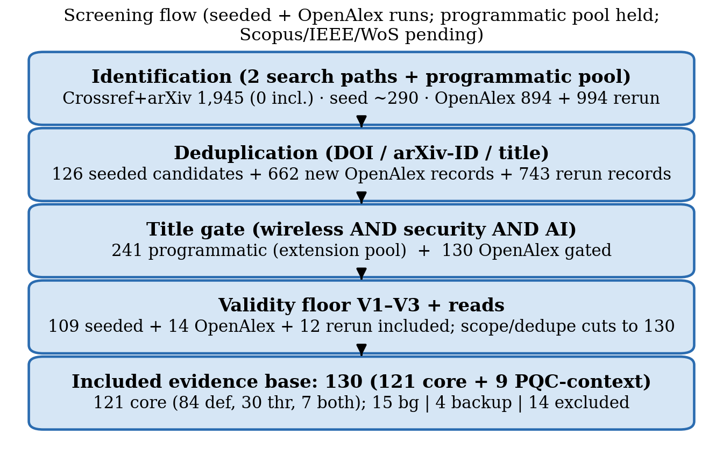
Figure 2: Study-selection flowchart. Programmatic records were retrieved from the Crossref and arXiv APIs (Path A, 241 gated extension-pool records released with disposition, not merged silently), OpenAlex database hits were deduplicated against them and title-gated (Path C), the expert-seeded path and two OpenAlex database runs were screened against the validity floor, and an adjudication pass applied scope and dedupe cuts before the corpus froze at 130 studies (105 seeded + 13 OpenAlex + 12 rerun). Every record carries a verified resolvable identifier (see §1.4).
Two same-team companion pairs are counted as distinct records with logged disclosure (D55/T15, D20/T20); dropping either pair moves N to 129/128 without changing the §3.1 patterns. One conference-to-journal extension was deduped (T02 subsumed by T03) and two mis-keyed records corrected against publisher metadata (D20, D55). Full adjudication detail is in the supplementary material.
Full-text curation of arXiv-path records — full text is retrievable for every record on that path — upgraded readiness scores where body text confirmed testbeds, threat models, costs, or artifacts (fulltext_reads.md). A later reconciliation pass aligned R2 to the validation mapping (§2.5), which moved track-level R2 means by up to about 0.6 (dual +0.57) while preserving their order; neither pass changed the ordering of track means, but the drift magnitude bounds the stability of every cross-group readiness comparison reported in §3 and is carried explicitly through the paper’s claims (see §2.6).
Ten arXiv-path rows have since been confirmed as published (venue/DOI resolved 2026-10-11) across three resolution rounds; the corpus carries 19 preprints (14.6%), none re-statused without a logged resolution. Per-record resolution detail is in the supplementary material.
The rerun delta was dominated by the previously rate-limited FL query (coverage artifact, not one-day field growth): its 7 wireless-FL-privacy defense additions nearly triple the federated-privacy function (4 → 11), which is reported as a coverage correction in §3, not field growth. Corpus IDs are archival and non-contiguous: the gaps at T10, T13, T32, T33, and P02 reflect rows removed before the corpus froze, and the disclosed backup rows (T26, T29, D51, P07) are held outside the 130.

2.4 Inclusion and exclusion criteria
Table 2 summarises the criteria. Inclusion required: (i) radio-link/wireless population; (ii) security link (broad wireless-ML-security scope per §1: encryption, authentication including localisation-fingerprint attacks where geofence bypass breaks an authorisation boundary, key exchange/management/generation, physical-layer security, anti-jamming/secure communications, signal/traffic analysis where the classifier is the security boundary, side-channel analysis, federated privacy); (iii) AI involvement; (iv) dated 2020–2026, English, retrievable; (v) evaluable evidence (experiment, testbed, simulation, proof, cryptanalysis); (vi) peer-reviewed venue or reputable arXiv preprint (ID+version+access date; published supersedes; preprints ≤40% — observed 14.6%).
Exclusion: not wireless; no security or AI link; survey/opinion without primary mechanism (background only); pre-2020; non-English; retracted; unretrievable; duplicate; no evaluable evidence; preprint without evaluation. Key adjudications: cellular fuzzing without ML content excluded (T07); Wi-Fi localisation-fingerprint attacks count where geofence bypass breaks an authorisation boundary (T42); signal-classifier attacks count where the classifier is the boundary (T44); IoT traffic-classifier attack-plus-defense counts as dual-track protocol work (T46); wireless-FL-privacy counts where the guarantee is channel-produced (D24 precedent); acoustic/vibration PQC-SCA (T45), non-security Wi-Fi sensing (T34), and security-link-free 5G robustness (T35) excluded; Xplore-hosted rows count as peer-reviewed; author-claimed venues without proceedings records coded preprint (D26, T05-preliminary, D46-submitted, D48, P09-accepted), publisher-confirmed claims stay peer-reviewed (D41, D52, T28). The full adjudication log is in the supplementary material.
Table 2: Inclusion and exclusion criteria applied during corpus screening.
Dimension | Included | Excluded
Population | Radio-link/wireless systems | Wired-only, pure sensing without crypto link
Concept | Crypto primitive + AI involvement | Missing either link
Document | Peer-reviewed + reputable arXiv (≤40%) | Surveys w/o mechanism, evidence-free preprints
Period | 2020–2026 | Pre-2020
Verification | DOI/arXiv-ID resolved | Unresolvable, retracted, duplicate
Language | English | Non-English

Who screened and coded (all humans): the first author performed 100% title/abstract screening, retrievability checks, eligibility coding (full text where retrieved, abstracts otherwise — 110 rows abstract-only including 30 of 32 Unclear-source rows; 20 rows body-read), and charting. Two independent verifiers correctively checked a 22-record sample (raw inclusion-disagreement 1/22, inclusion decisions only — not a coding-reliability statistic). The second author independently reviewed the completed coding and every derived result against the released dataset and confirmed agreement before submission — a validation review, not blind second coding, so no agreement statistic is attached. R-score blind rescores were not completed. AI assistance was limited to candidate pooling, prose drafting, and copy-editing under human control. Bibliography verification: every record carries a resolvable identifier checked against Crossref, arXiv, ACM, or USENIX (D20/D55 re-keyed; D31 2024→2025 and T38 2021→2022 corrected; T03/T28 confirmed published; D48 recoded preprint). No blind double-coding was completed, so no κ is claimed; a 20–25% blind double-code with Cohen’s κ and weighted κ/ICC(2,1) remains future work.

2.5 Classification framework
Each paper was classified on six fields: (1) security function (8 values: Authentication/RFFI, Key generation/distribution, Anti-jamming/secure comms, Protocol/traffic/cryptanalysis, PQC-migration contextual, Federated/privacy FL, Learned primitives/crypto, Side-channel analysis); (2) AI method family (12 values; Table S1); (3) track (threat 30 / defense 84 / both 7 / PQC-context 9; T05/T14 dual-track under the develops-and-evaluates-both rule); (4) primary data source; (5) validation approach; (6) readiness R1–R5, each 0–2: R1 attacker-capability explicitness (0 absent / 1 implicit / 2 explicit capability + assumptions); R2 evaluation realism (0 theory/proof without data evaluation / 1 controlled evaluation — simulation, reused data, or cross-domain protocols on collected data / 2 author-conducted OTA/testbed demonstration or demonstrated real key recovery); R4 artifact release (0 neither / 1 code or data / 2 both or artifact-evaluated); R3 defense/learned-crypto cost (0 none / 1 latency or energy + hardware target / 2 both + target); R5 standards alignment (0 none / 1 mentions 3GPP/IETF/NIST/ETSI / 2 evaluated against a profile). Totals sum applicable items only; dominant value per field; conservative coding (abstract-level except logged full-text reads). As applied, simulation-only rows score R2 = 1 (an earlier downgrade-to-0 pass stands reversed and logged); the mapping is asserted programmatically over all 130 rows with one documented override (T01: standard-split validation with R2 = 2 for demonstrated over-the-air key recovery — without it the threat mean would read 1.50). R3 and R5 apply to attack rows with an observable attacker-cost or standards signal (6 rows R3 = 1, 5 rows R5 = 1, all mention-level; rows without score 0). Corpus-level counts (Table S3) include these values and per-track means report them; defense-side comparisons never pool attacker-side with defender-side cost. Anchor examples — one archetypal row per score level per item — are published in the supplementary material (Table S10).
Two properties of the rubric are disclosed with the corpus. First, the R5 rubric’s upper tier (2 = evaluated against a profile) is unexercised in this sample: no row of 130 meets it, so every standards signal in §3 is mention-level (R5 = 1; 17 rows). The PQC-versus-core R5 contrast is therefore an ordering claim, and its absolute level would read zero under a stricter reading that discounts mention-level signals. Second, R2’s middle tier (1 = controlled evaluation) deliberately merges standard-split, cross-domain, and simulation-only designs: 57 of 84 defense rows score R2 = 1 (19 standard-split, 22 cross-domain, 16 simulation-only) against 12 of 30 threat rows, so defense R2 means pool evaluation kinds that the validation field separates. Cross-track R2 comparisons in §3 are therefore read jointly with the validation cross-tabulation (Tables 3–4) rather than alone, and both sensitivities are carried into the claims of §§3–7. Anchor examples — one archetypal corpus row per score level per rubric item — are published in the supplementary material (Table S10).
Each paper also carries a venue channel — journal (65), conference/workshop (46), preprint (19) — for the §3.5 analysis. Verifier and second-author passes were corrective/validatory, not blind second coding; no agreement statistic is claimed. Counts are one documented coding with second-author validation, and the dataset (dataset_papers.csv) is released so independent coders can check, correct, or extend it (glossary: data/glossary.md).

2.6 Comparative synthesis approach
Quantitatively, classification fields are aggregated into cross-tabulations — function by year, method by year, data, validation, readiness per track — that characterise the corpus as a sample (§3); every figure and count was generated programmatically from the released dataset (see code/; check_consistency.py gates export on sums and caption n-values). One derived measure is used repeatedly and is defined here rather than later: closed-loop evaluation denotes dual-track studies plus any threat paper that evaluates against a stated defense and any defense paper that evaluates against a stated attack. It reaches at least 14 of 121 core (11.6%, a lower bound — abstract wording may hide further cases; a full-text audit is future work); the narrow dual-track-only count is 7 of 130 (5.4%), and both counts are reported wherever the number appears.
Limitations readers should weigh: open-web seeding favors notable work (the two OpenAlex yields are recall evidence, with the caveat that run 1 was incomplete — its FL query hit rate limits); no formal stopping rule was applied and Path A contributed zero includes, so triangulation rests on seeded + database paths; title-gating can miss nonstandard terminology; preprint inclusion (19, 14.6%) adds recency at version-instability cost (frozen by ID+version+date; sensitivity-checked); single-coder classification with second-author validation but no blind double-coding statistic; multi-registry triangulation pending (Scopus/IEEE/WoS) with OpenAlex as substitute; 110 rows abstract-coded (30 of 32 Unclear-source rows; paywalled journals 23/32), 20 body-read; body reads only ever upgraded scores, so R3–R5 rates are lower bounds — and full-text rows skew simulation-heavy (5/20) versus abstract-coded rows (13/110), with full R3–R5 body reads future work. Fig. S4 and Table 3 mix coding depths, like the rest of §3.
Every cross-track readiness comparison in §3 is therefore a single-coder descriptive statistic; §3.4 also reports the like-depth (abstract-only) version of the threat–defense comparison so the coding-depth confound is visible. §3 is a structured sample, not a census — a scoping review with bibliometric classification, not a meta-analysis. No pooled effect sizes or significance tests: metric heterogeneity (accuracy vs KGR vs secrecy rate vs attack-success rate) forbids pooling; cross-tabulations are descriptive, and WIRELESS-AI-RC is scored against the corpus descriptively in §8.

3 Corpus Overview and Six-Year Evolution

3.1 Publication trend
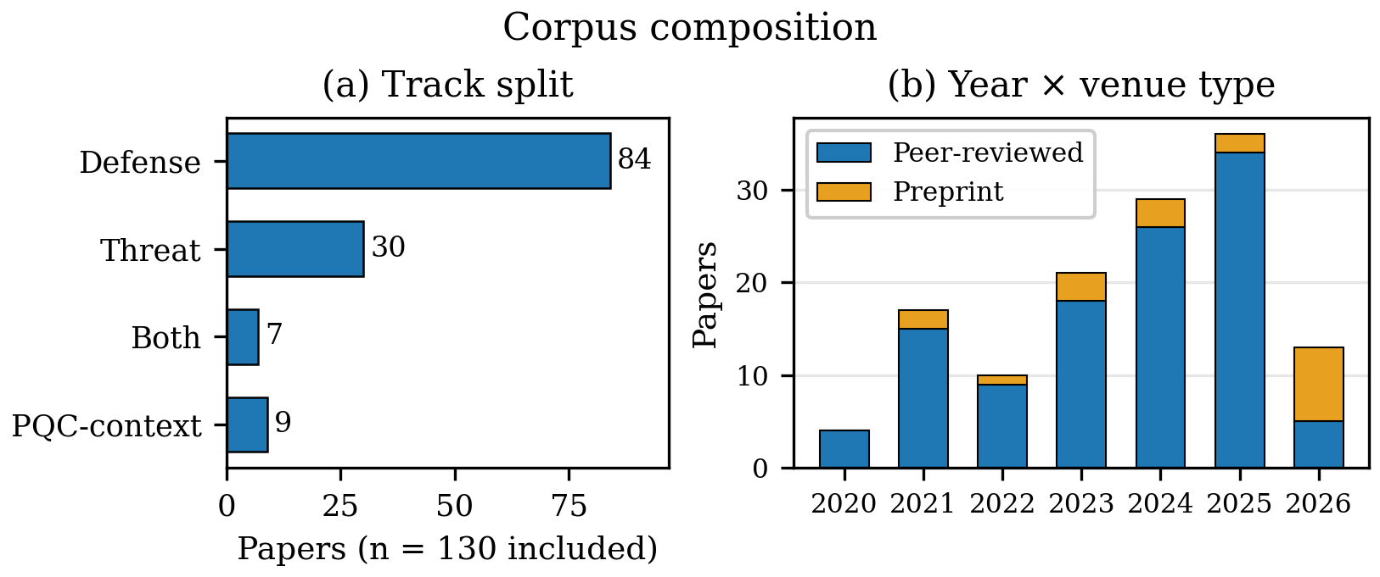
Figure 3: Corpus composition: (a) track split (n=130); (b) year × venue type. Preprint share is highest in the partial 2026 window (8 of 13).
The corpus spans 2020–2026 with a rising but non-monotonic profile: 4 (2020), 17 (2021), 10 (2022), 21 (2023), 29 (2024), 36 (2025), 13 (2026 partial) (Fig. 3). The 2021 bump is substantially coverage: 5 of 7 rerun-added FL-privacy papers date to 2021, without which the year reads 12. Excluding those 7 (N=123): defense R2 reads 1.32 not 1.27, threat R2 unchanged at 1.53, simulation-only 16 not 18 — the threat-realism lead, lowest dual-track realism, and RFFI dominance hold either way. The curve partly reflects curation as well as field growth; preprint share concentrates in partial 2026 (8 of 13 vs 0–14% in 2020–2025), the velocity justification for inclusion (§3.5). With those caveats, the profile matches post-2020 SDR democratisation and the 2024–2025 adversarial-ML surge.
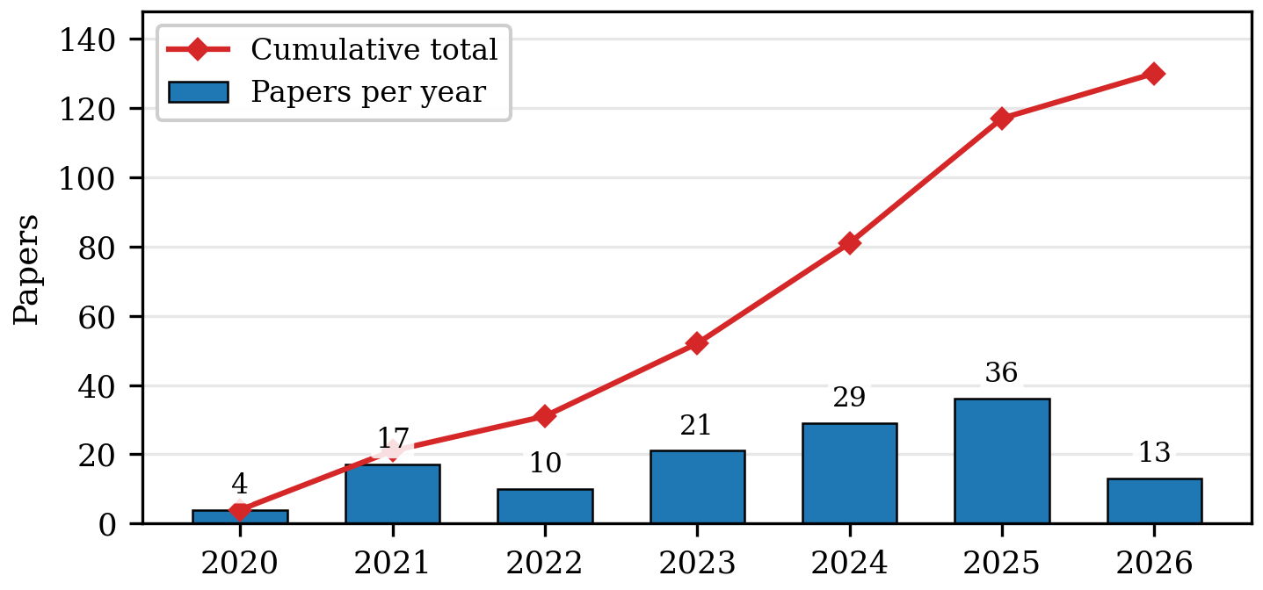

3.2 Method-family evolution
Deep supervised learning leads with 45 papers against 40 adversarial ML (Table S1) — a 5-paper margin that is not robust: the rerun added 4 deep-supervised RFFI papers while dedupe removed two adversarial ones (T02 subsumed; T35 excluded), and the federated-privacy additions sit in neither family. Deep supervised led every year through 2023, ties 2024 (10–10) and 2025 (11–11, the joint peak), with partial 2026 at 3–4. Only 33 of its 45 address RFFI (remainder: key generation 8, side-channel 2, anti-jamming 1, protocol/traffic 1), so ‘deep supervised fingerprinting’ mislabels the family. Adversarial ML spans white-box, black-box UAP, GAN-spoofing, backdoors, and universal PHY perturbations, with the 2025–2026 wave adding self-supervised-target backdoors [T41], over-the-air Wi-Fi attacks [T42], and frequency-selective strikes [T44]. Reinforcement/DRL holds at 9, all defense-side; PQC implementation (9) concentrates 2024–2026; federated/private learning climbs to 12 (nearly tripled by the rerun coverage correction); the long tail (traffic-analysis 2, one LLM-assisted fuzzer [T28], defensive/robust 2, dataset/benchmark 2, survey 6, classical/Bayesian 1, optimisation-based 1) is detailed in Table S1. Dominant-family coding understates mixing.
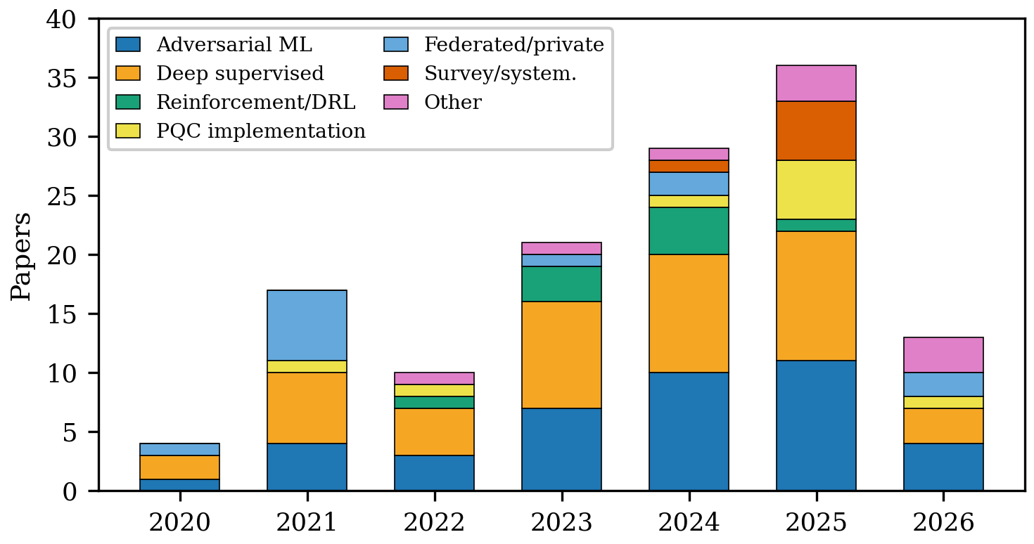

Three observations qualify this trajectory. First, the families overlap in practice and dominant-family coding understates method mixing. Second, the adversarial rise is partly a response to the recognised brittleness of fingerprint classifiers under domain shift — but attack papers are, on average, evaluated no more stringently against adaptive defenses than defense papers are against adaptive attacks (§4), and no cited threat paper exploits domain shift as a standalone vector (T40 documents consistent cross-device misclassification under domain shift and demonstrates its use as a backdoor for system intrusion on real-world experiments — attack surface with a demonstrated trigger, not a deployed exploit). Third, the LLM-assisted cluster is too small to represent a trend; its significance is that LLM-based baseband analysis is appearing at all.

3.3 Application-area distribution
Functionally the corpus is dominated by Authentication/RFFI: 69 of 121 core (57.0%), followed by Anti-jamming/secure comms (14), Key generation/distribution (12), Federated/privacy FL (11), Protocol/traffic/cryptanalysis (10), PQC-context (9), Learned primitives (3), Side-channel analysis (2) (Fig. 5, Table S2). The center of gravity sits in RFFI × (adversarial 27 + deep-supervised 33) — deep supervised now leads inside RFFI as well as overall. By contrast, learned primitives (3) are thin — telling, since these are where cryptographic consequences are most direct. Cutting the same data by track (Fig. 4) sharpens the asymmetry that §§4–5 develop: adversarial ML splits 20 threat / 7 dual / 13 defense across tracks (the dedupe moved two attack-plus-defense papers to dual-track), deep supervised learning remains predominantly a defense instrument (42 defense vs 3 threat), and all reinforcement learning in the corpus sits on the defense side. Method-by-track figures pool dual-track papers with threat for readability; the text always gives the three-way split (for adversarial ML: 20 threat / 7 dual / 13 defense).
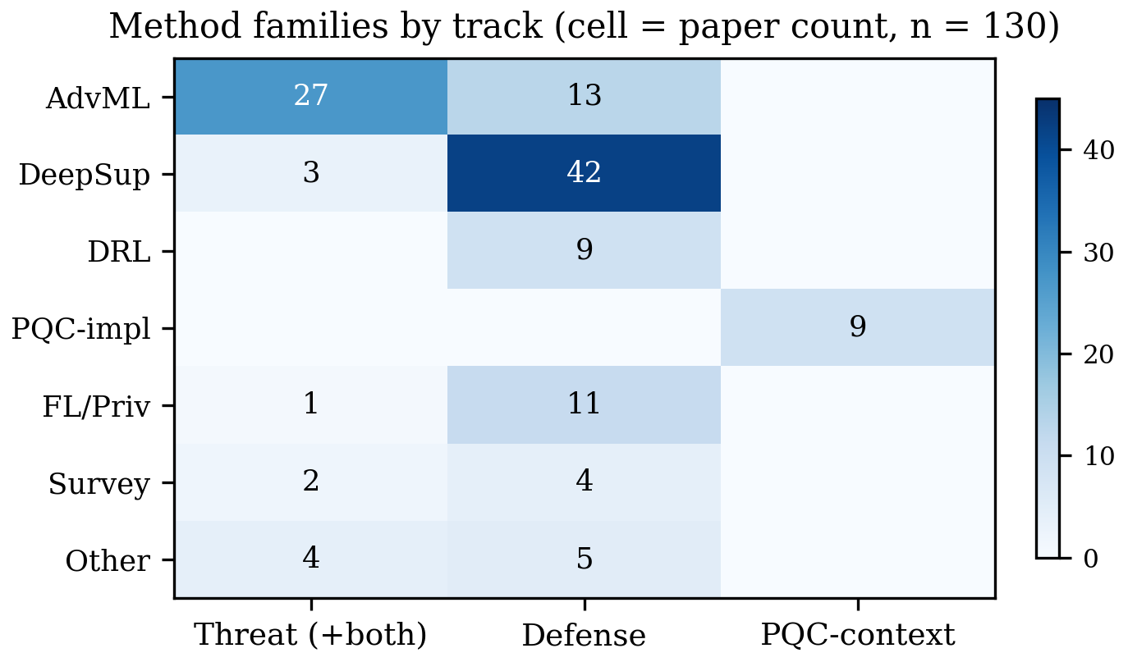
Figure 4: Method families by track. Adversarial ML attacks; deep supervised learning defends; reinforcement learning is defense-only in this corpus.

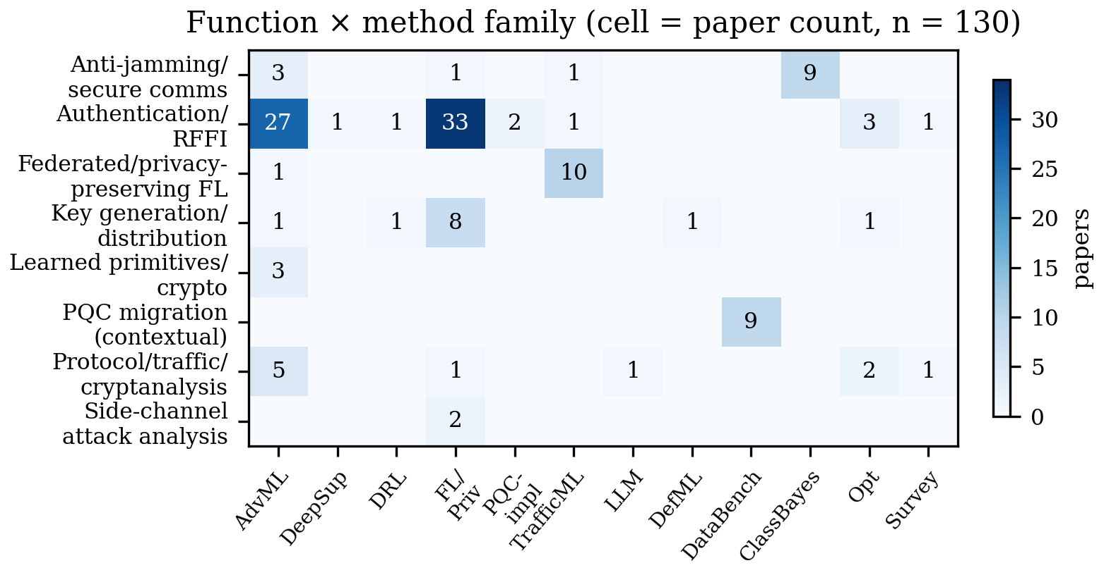
Figure 5: The corpus mapped across security functions and AI method families (n=130). Cell values are paper counts.

3.4 Data landscape and validation practice
Data sources: Testbed/OTA measurement 46, Collected datasets/traces 26, Simulation 20, Analysis/benchmark 6, Unclear from abstract 32 (Fig. 6, left; Table S5; data-source field, not validation). Validation: Testbed/field demonstration 47 (36%), Cross-domain/generalisation 26 (20%), Simulation-only 18 (14%), Standard split/unclear 35, Benchmark/analysis 4 (right panel). Crossing validation with track substantiates the section’s descriptive headline (Fig. S3): among threat papers (n=30), 16 are testbed/field demonstrations, 9 standard splits, 2 cross-domain, 2 simulation-only, 1 benchmark — measured plurality, not norm, with 6 threat data-sources unclear from abstract; key generation carries the simulation-only mass (7 of 12 keygen papers simulation-only; defense sim-only 16 of 84 — Table 4).
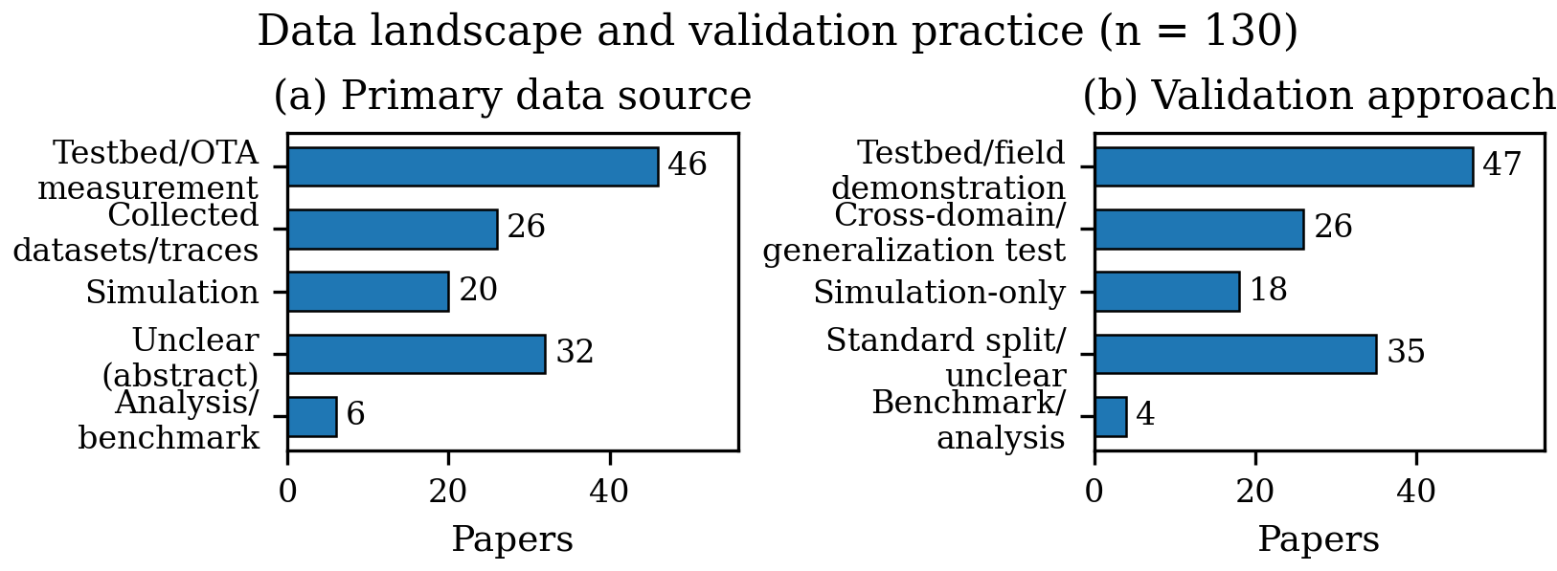
Figure 6: Primary data sources (left) and validation approaches (right) across the corpus (n=130). Testbed/field demonstration is the modal validation; simulation-only work concentrates in key generation (7/12) with a smaller FL-privacy-analysis cluster.

Readiness means per track: threat R1 1.70 / R2 1.53 / R3 0.20 / R5 0.17; defense R1 1.14 / R2 1.27 / R3 0.19 / R4 0.02 / R5 0.07; both (n=7) R1 1.86 / R2 1.14 (lowest realism); PQC-context R3 1.11 / R5 0.56 — the only stratum with real cost and standards numbers (ESP32 DTLS 313 ms, sub-12 kB Dilithium, Cortex-M4 cycles; FIPS 203/186, 3GPP, 802.11, O-RAN references). Attack rows with an observable cost or standards signal are coded 1 (6 rows R3 = 1, 5 rows R5 = 1, all mention-level); rows without score 0. These enter per-track means and corpus counts (Table S3) but never defense-side comparisons. Medians: R3 0 on defense, R5 0 on defense/dual and 1 on PQC-context. Fig. 7 plots the means; Table S4 shows flat cost/artifact/standards reporting by year even as validation grade improves by share — volume and maturity do not move together.
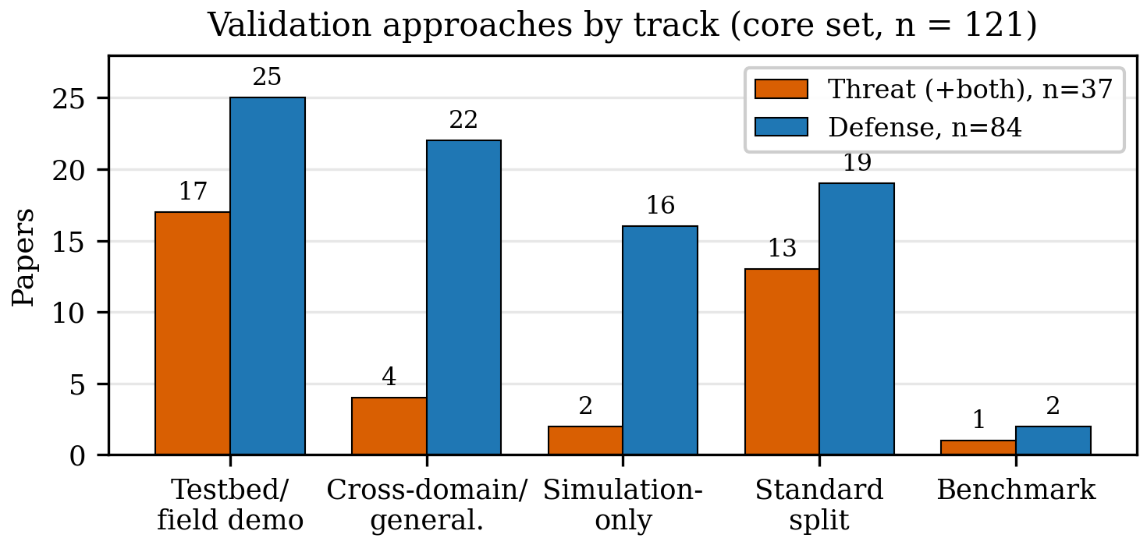
The threat–defense R2 gap (1.53 vs 1.27, 0.26) is single-coder over mixed coding depth: 10 of 16 threat testbed rows abstract-coded, 6 full-text; the 20 body-read rows skew toward defense upgrades. Restricted to abstract-only rows (110: threat 22, defense 74, dual 5, PQC 9), the gap attenuates but persists — threat 1.50 vs defense 1.30 (0.20), dual lowest (1.00). Both figures are reported wherever the comparison carries weight; the reconciliation drift (§2.3, up to ≈0.6) remains the dominant uncertainty.

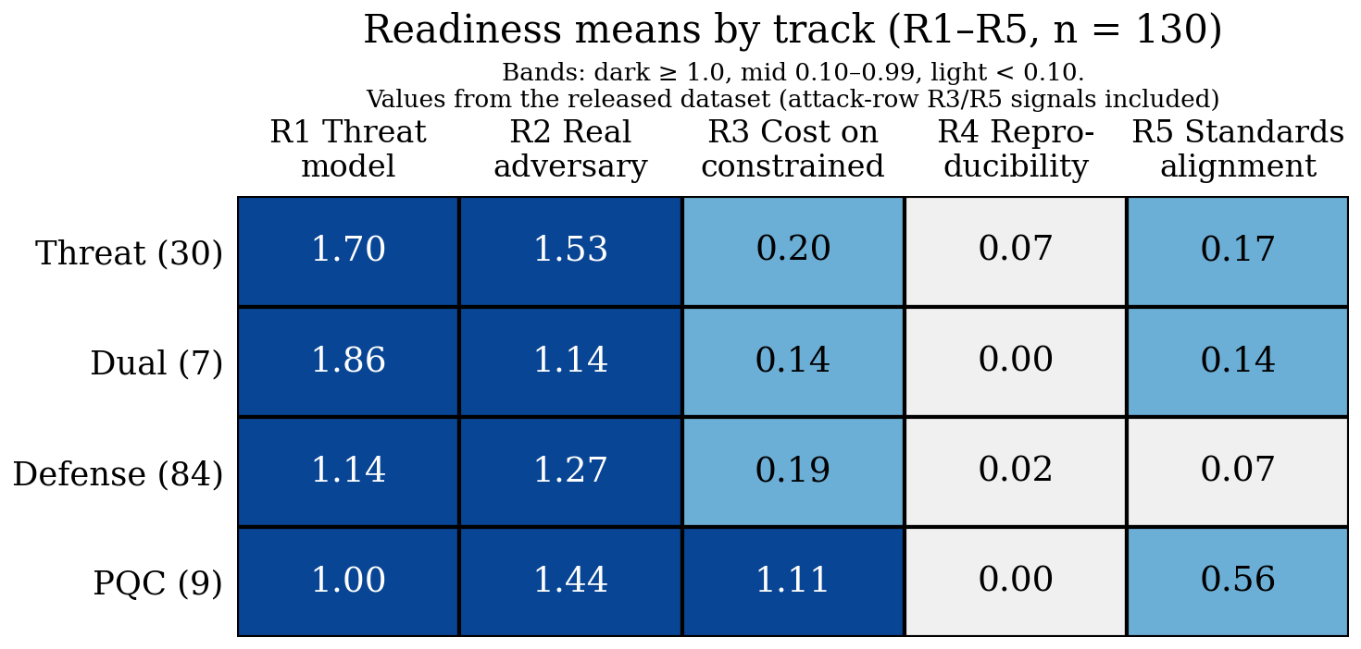
Figure 7: Readiness means by track (R1–R5, n=130; bands: dark ≥1.0, mid 0.10–0.99, light <0.10; Dual row n=7). Attacker-side cost and standards signals observed on threat papers are mention-level and included (threat R3 0.20, R5 0.17; §2.5); threat work releases almost nothing (R4 0.07), and only the PQC-context stratum reports real onboard costs (R3 1.11).
Table 3: Validation practices across the corpus.
Validation | Papers | Interpretation
Testbed/field demonstration | 47 | Deployment-relevant; threat-cluster plurality (16/30), not norm
Cross-domain/generalization | 26 | Strongest lab protocol; defense-cluster best (22/84)
Simulation-only | 18 | Model-fidelity dependent; keygen-heavy (7/12 keygen; 16/84 defense)
Standard split/unclear | 35 | Optimistic without isolation argument (9/30 threat)
Benchmark/analysis | 4 | No empirical validation (proof/analysis-grade); FL-privacy analyses

Table 4: Validation practice by security function (rows sum to function totals, n=130). Values derived programmatically from the released dataset; simulation-only work concentrates in key generation (7/12); RFFI is evaluated across all grades.
Function | Testbed | Cross-dom. | Sim-only | Std/unclear | Bench.
Authentication/RFFI (69) | 23 | 22 | 4 | 20 | 0
Anti-jamming/secure comms (14) | 8 | 1 | 4 | 1 | 0
Key generation/distribution (12) | 3 | 1 | 7 | 1 | 0
Federated/privacy FL (11) | 2 | 0 | 3 | 4 | 2
Protocol/traffic/cryptanalysis (10) | 3 | 2 | 0 | 4 | 1
PQC-context (9) | 5 | 0 | 0 | 3 | 1
Learned primitives (3) | 2 | 0 | 0 | 1 | 0
Side-channel analysis (2) | 1 | 0 | 0 | 1 | 0
Column total (130) | 47 | 26 | 18 | 35 | 4

Reading these panels together yields the section’s headline — the field’s empirical base is bifurcated, not uniformly weak: attacks are demonstrated; defenses are benchmarked. The year-by-year cut (Fig. S4) shows the evidence grade improving by share: testbed plus cross-domain work rises from about 40% in 2021–22 to about 60% in 2023–26 while simulation-only falls from about a quarter to 8–14% by 2023–26 — though year arms hold only 10–36 papers each, so these shares are noisy, and absolute simulation-only counts hold roughly flat rather than being displaced.
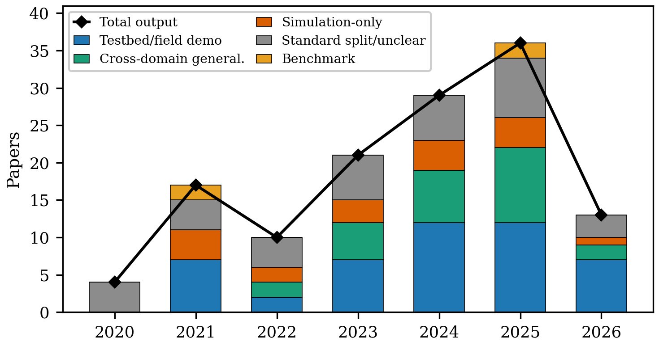

3.5 Sensitivity analysis: is peer review too slow for AI security?
Because the corpus mixes slow and fast publication channels — 65 journal papers, 46 conference/workshop papers, and 19 preprints (venue channel coded from confirmed venue strings; §2) — headline findings could in principle be a channel artifact. We therefore ask the question directly: do frontier methods appear first in fast channels, and does journal peer review compensate with stronger validation? The timing answer, within this verified sample, is partial; the rigor answer favors fast channels, noisily.
Frontier methods debut in fast channels, with stated exceptions. Conferences publish the first adversarial-ML paper in 2020 ([T39] WiseML) a year before journals (2021); first DRL April 2022 ([D34] WCNC) versus April 2023 journals ([D22]); deep-supervised debuts tie in 2020 ([T01] ASHES, [D81] journal) — [T01] is the first deep-supervised side-channel threat demonstration in-corpus, not the first fingerprinting paper. Journals lag conferences on adversarial-ML and DRL first appearance only (2 of 4 families); PQC reverses it (TCHES 2021 [P05] precedes the in-corpus ACNS 2022 paper). Table S6 gives each cell with month granularity. The composition gap persists in shares: adversarial ML is 28% of conference papers, 37% of preprints, 31% of journal papers (Fig. S5).

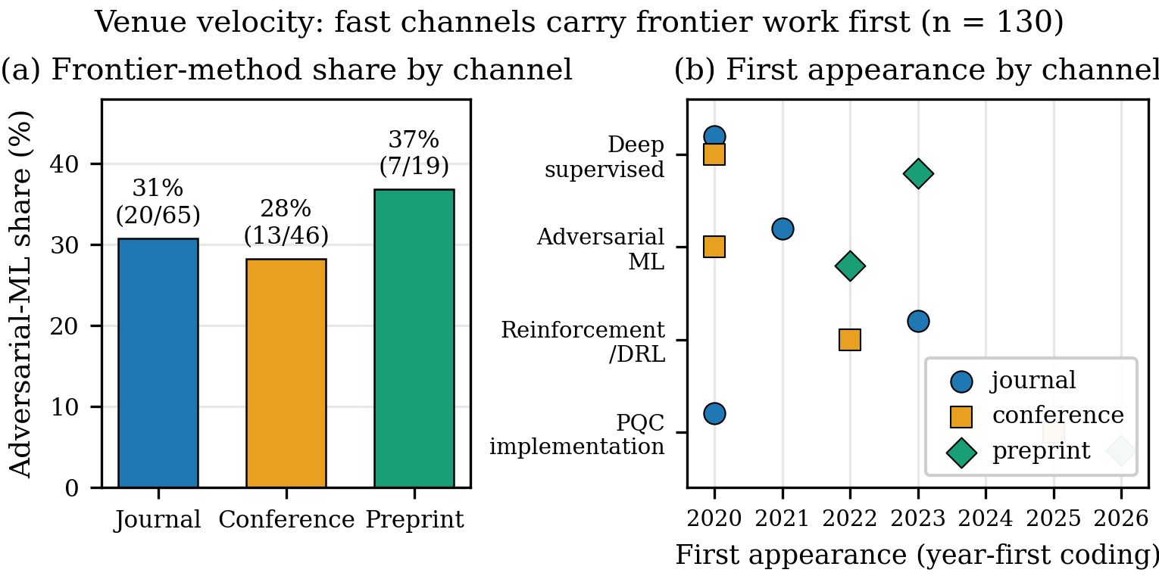
Journals lead conferences on validation share (testbed 40% vs 30%, Table S7) and mean realism (R2 1.40 vs 1.26; preprints 1.32) — but both gaps are small relative to arm sizes (65/46/19) and sensitive to single-coder judgment (drift up to ≈0.6), so no prestige gradient is claimed either way; the durable channel result is the timing lag. The P03 ACNS 2022 proceedings version is coded journal; the PQC reversal holds either way. An earliest-public-date audit over all 15 DOI-year mismatches moves no first-appearance cell (only P05 shifts: December-2020 online-first vs 2021 issue, widening the reversal). The preprint stratum (37% testbed, heavily selected) cannot carry a channel claim alone. No significance tests, per §2.
Three caveats, the third most serious. First, the preprint arm is small (n=19), conferences mix with workshops, and each first-appearance cell rests on one paper — wide uncertainty. Second, the LLM-assisted family has one published paper ([T28]) and supports no channel claim. Third, seeded search favors notable, well-evidenced preprints, so preprint scores partly reflect selection. What selection cannot explain is the journal ledger: trailing conferences ~1 year on adversarial-ML/DRL first appearance while running close on validation. For a field where the adversary reads arXiv, that lag is deployment-relevant — and it strengthens the §8 checklist case, since speed without standards reproduces the §3 validation gap.

4 AI-Enabled Threats: What the Corpus Demonstrates
RFF/authentication attacks form the densest cluster (Table S8): white-box FGSM/PGD and black-box UAP at 81.7% with ∼no victim knowledge on real LoRa captures [T03], RL impersonation at >90% from binary feedback [T18], GAN-spoofing at 76% PHY-auth pass [T09], backdoors surviving Neural Cleanse/STRIP [T12] and working model-agnostically [T16], self-supervised-target backdoors [T41], over-the-air Wi-Fi attacks [T42], and fingerprint erasure as privacy attack [T06]. EM/RF side-channels move key recovery over the air at meters: BLE AES-128 at 15 m from <400 traces [T01], and nRF AES-CCM at 1 m with BLE re-keying LTK leakage in ∼30 traces [T08]. Protocol/traffic attacks show the stack above PHY is equally exposed: padding/shaping defeated by packet-size distributions [T19], and LLM-assisted semantic baseband fuzzing (ConSeT: 7 vulns including 3 CVEs across 542 phone models, plus 29 OAI-UE crash sites, USENIX Security 2026 [T28]). Critical assessment: attacks are evaluated against real systems with stated — often weak but honest — threat models (strong R2, narrow R1). The missing attack science is adaptive-defense evaluation: most stop at undefended classifiers, which is why Magmaw [T30] matters — it survives adversarial training, subtraction, detection, and oracle defenses. Domain shift is attack surface, not demonstrated exploit: no cited threat paper exploits shift as a standalone vector.

5 AI-Assisted Defenses: What the Corpus Demonstrates
RFF/PLA defenses chase domain shift: contrastive embeddings, receiver-agnostic training, open-set/few-shot enrollment, cross-receiver calibration [D75], multi-distance generalisation [D73], domain-adaptive features [D72], satellite fingerprinting [D71], proactive authentication — accuracy under shift, rarely under attack. Key generation defenses improve KDR/KGR mostly in simulation, with a 2026 channel-informed neural scheme [D74] grounding features in over-the-air channel soundings. DRL anti-jamming optimises relay/power/secrecy-rate without onboard-cost reporting. Federated privacy demonstrates differentially private OTA aggregation at small scale.
Critical assessment: the wall between §4 and this section is the finding — dual-track studies are 7 of 130 (5.4%; 7 of 121 core, 5.8%), and dual-track realism runs lowest (mean R2 1.14 vs 1.53 threat, 1.27 defense — a 0.13 margin at n=7, so a descriptive remark, not a ranking claim; single-coder, and fragile at this n), so closed-loop evaluation exists but is least realistic. RFF accuracy ≠ authentication; domain-shift misclassification is attack surface (T40), not demonstrated exploit. The defense literature’s strongest protocols (cross-receiver, cross-day, open-set) are exactly the threat literature’s attack surface.

6 Quantum-Era Context (Separate Stratum)
Compute is feasible on ESP32/Pi-class hardware (ML-KEM DTLS 313 ms, beating classical baselines; sub-12 kB Dilithium; Cortex-M4 cycle counts); bandwidth expansion is the blocker; WKyber [P08] and LAKE [P11] attack exactly that. Short-range radio key-recovery evidence (far-field BLE SCA [T01]) shows keys can be pulled over the air, but no in-corpus paper addresses store-now-decrypt-later against the PQC transition for wireless fleets. The AI-threat × PQC join is empty: no in-corpus paper mounts ML-driven cryptanalysis of a PQC implementation over a radio link (an acoustic–vibration proximity study was excluded for failing the radio-link population; see §2). The join is recorded as an explicit gap (§8), and the stratum stays separate so that no pooled AI-security claim is made over it.

7 Cross-Cutting Directions
Three threads cut across the function-level reviews: closed-loop evaluation, autonomous trust, and reproducibility. Closed-loop evaluation (§2.6) reaches at least 14 of 121 core (11.6%, a lower bound): the 7 dual-track papers (D08, D36, D37, T05, T11, T14, T46 — 5 under a stricter title-only dual rule with T05/T14 reverting to threat; T31 stays threat either way since its mitigation is secondary), 3 threat papers that demonstrate against defenses (T30 against adversarial training, subtraction, detection, and oracle defenses; T12 by bypassing Neural Cleanse and STRIP; T31 assessing a distillation defense on an OTA O-RAN testbed), and 4 defense papers that demonstrate against attacks (D67 against GAN-based impersonation; D54 against Byzantine poisoning; D32 against live impersonating UAVs; D48 flagging evasive queries). The broader measure remains the exception (the §4–§5 wall), autonomous trust (real-time deadlines unbenchmarked; OTA crypto-agility essentially unaddressed; multi-agent trust in 1–2 papers while FL-for-drones falls to deauth→impersonation chaining [T36]), and reproducibility (4 verified artifact releases among 121 core, 3.3%) are the three cross-cutting threads (Fig. 9). Dual-track realism is lowest (mean R2 1.14, n=7; §5), which complicates any closed-loop optimism: evaluation exists but is least realistic.
Function × validation cross-tabulations are descriptive (no significance tests; metric heterogeneity forbids pooling). The field optimises estimators while adversaries optimise exploitability — a mismatch no single-function advance can fix. A venue-community check does not explain the asymmetry away: stratifying R2 by security venues (NDSS, CCS, USENIX, TIFS, WiseML and kin) versus comms and other venues, comms-venue threats outscore comms-venue defenses on realism (means 1.61 vs 1.31, n=23/68), while security-venue papers score lower in both tracks (threat 1.29, n=7 — T01, T19, T20, T23, T28, T30, T39, of which T01, T28 and T30 score 2 and the analysis/workshop remainder scores 0–1; defense 1.12, n=16) — small-n and caution-worthy, but running against the community-norms confound rather than with it. Fig. 8 stacks the corpus by layer to make the coverage gap visible: the signal layer is contested, the link layer half-defended, the protocol layer thinly covered, and the system layer essentially absent.
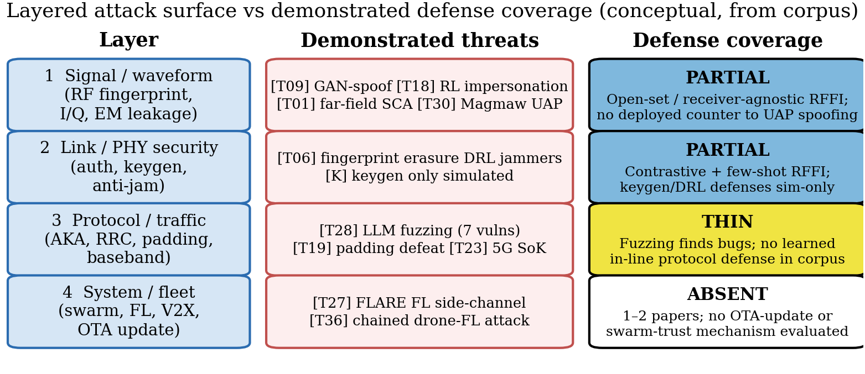
Figure 8: Layered attack surface versus demonstrated defense coverage, synthesised from the corpus (conceptual). Coverage thins with every step up the stack.
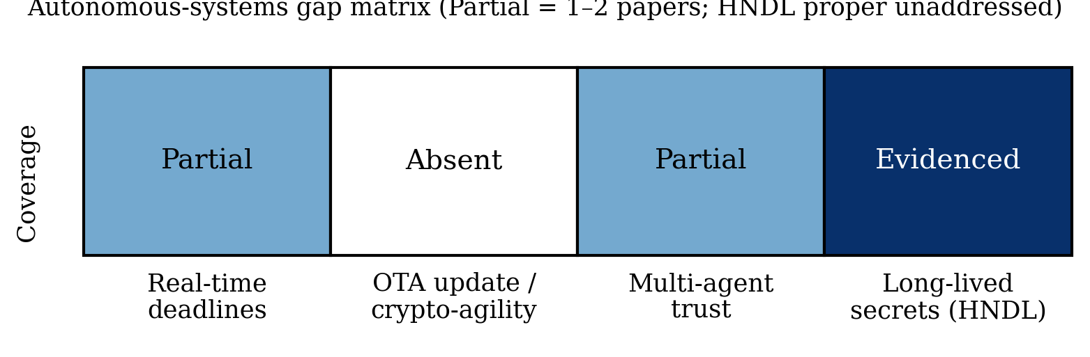
Figure 9: Autonomous-systems gap matrix. Real-time deadlines and multi-agent trust are Partial (1–2 papers each: nascent coverage, far from deployment-grade, hence “essentially unaddressed” in the abstract); OTA update/crypto-agility is absent; long-lived secrets show short-range key-recovery evidence (BLE far-field SCA) while store-now-decrypt-later against the PQC transition is unaddressed.

8 Research Gaps and Future Directions
Cross-referencing the bibliometric analysis of §3 with the function-level reviews of §§4–7 yields six structural gaps, summarised in Table 5 and operationalised into the concrete reporting checklist in Table 6. The ordering is deliberate: the first three rows concern how the field evaluates and shares evidence, the fourth how it reports cost, and the last two where the evidence stops short of deployment needs. None of the six requires a new method family, and all are measurable against the released dataset — a rerun of this review in two years should be able to score each row as narrowed, unchanged, or widened. The checklist is the review’s most actionable artifact: the minimum metadata a study must disclose for its claims to be comparable, reproducible, and poolable in future syntheses. Each item corresponds to a practice whose absence the corpus analysis showed to be distorting — undisclosed splits, unnamed datasets, or unquantified compute.
Table 5: Structural research gaps and corresponding future directions.
Gap | Evidence | Direction
Closed-loop evaluation | Dual-track 7/130 (5.4%); dual R2 1.14 lowest (fragile margin, §5); broader measure 14/121 core (11.6%) | Adversarial-benchmark suites with OTA mandates
Reproducibility | 3.3% verified releases (4/121 core); R4 means 0.00–0.07 | Artifact-evaluated security tracks; dataset DOIs
Standards alignment | 9.9% outside PQC (13.1% incl. PQC); RFF 6/69; defense R5 0.07 overall; no row reaches the profile-evaluated tier | Authentication profiles (3GPP/IETF) for learned PHY-auth
Onboard cost | DRL/semantic cost-silent; defense R3 0.19 (16/84 rows) | Latency/energy/memory as required reporting
Autonomous trust | 1–2 papers per need | Real-time auth, OTA agility, swarm insider models
AI×PQC join | Empty in-corpus (non-radio proximity study excluded) | ML-SCA of PQC over the air; migration prioritization

Table 6: Proposed WIRELESS-AI-RC reporting checklist (12 items).
# | Item | Must report
1 | Dataset/testbed identity | Name, version, download or testbed description
2 | Device/link population | Radios, channels, distances, day/receiver splits
3 | Adversary model | Knowledge, capability, RF/compute budget
4 | Split protocol | Within/cross-receiver/day/domain + isolation argument
5 | OTA vs simulation | Declaration; sim-only flagged as such
6 | Closed-loop evaluation | Attack paper: defenses tested; defense paper: attacks tested
7 | Baselines | ≥1 classical alongside proposed method, identical data
8 | Randomness | Seeds or repeated-run statistics
9 | Uncertainty | Error bars, not point estimates alone
10 | Onboard cost | Latency/energy/memory on stated platform
11 | Failure analysis | ≥1 documented failure mode + distribution
12 | Artifacts | Code/data DOI or explicit exemption

Checklist adherence in-corpus is reported only for coded items (descriptive, single-coder); Table S9 consolidates the per-item counts against the released dataset so the baseline is directly reusable. Items 7–9 and 11 (baselines, seeds, uncertainty, failure analysis) were never coded, so no corpus claim is made about them — they are prospective requirements, as is the checklist as a whole beyond the coded items. We suggest venues adopt the checklist as a submission requirement and authors attach it to their released datasets: it costs little, and it is what lets the next synthesis do its job.

9 Conclusion
Three conclusions stand out, answering the title question for the research literature directly: no — the published literature does not demonstrate wireless security ready for the AI era on current evidence (a statement about literature maturity in this curated sample, not a measurement of deployed systems, and one drawn entirely from single-coder, second-author-validated descriptive statistics). First, the method center moved from fingerprint classifiers to adversarial science — attacks are cheap, largely demonstrated on captures/testbeds (threat plurality 16/30 testbed, not norm), and OTA-demonstrated in the strongest cases; this is the corpus’s most robust contrast because it rests on categorical validation counts. Second, the application center stayed in RFFI accuracy, which is not authentication — defenses are rarely adversarially evaluated (broader closed-loop ≥14 of 121 core, 11.6%; dual-track detail in §7). Third, readiness does not follow publication volume: reproducibility, standards, onboard cost, and autonomous-trust evidence trail accuracy claims in volume and maturity; standards alignment is mention-level wherever it exists, and venue channels differ modestly on rigor (testbed 40% journals vs 30% conferences; R2 1.40 vs 1.26, gaps small relative to arm sizes) (§3.5).
These are the findings a future update of this corpus can most cheaply overturn or confirm: a 20–25% blind double-code with agreement statistics (§2.4), a full-text audit of the R1/R2 fields, and a two-year rerun scoring each gap of Table 5 as narrowed, unchanged, or widened. If the last five years were about discovering what learning can extract from radio signals, the next five will be decided by what it can be trusted to protect — under adaptive adversaries, on constrained radios, at fleet scale.

Declarations
Funding. No specific funding for this work. Conflicts. None declared. Author contributions. Hussain Touhid Siddiquee (correspondence: touhidsiddiqueeraj@gmail.com) performed 100% title/abstract screening, full-text eligibility review, charting, coding, formal analysis, and drafting; Md. Abul Malek Fahim independently reviewed and validated the coding decisions and all derived results, and both authors are in agreement with the reported findings; two independent verifiers performed corrective verification checks on a 22-record sample. Both authors read and approved the submitted manuscript. Data availability. The classified corpus (dataset_papers.csv), screening log, retrieval records, and analysis scripts accompany this submission as supplementary material and are openly available in the public research archive at https://github.com/touhidsiddiqueeraj-bit/Is-Wireless-Security-Ready-for-the-AI-Era-. Code availability. Coding and figure-generation scripts are included in the supplementary archive and rerun from the released dataset; check_consistency.py gates export. Ethics. Not applicable. AI use. AI assistance was limited to candidate pooling, prose drafting, and copy-editing; no screening, coding, counting, or verification decision was delegated to AI, and all counts were computed programmatically from the released dataset under human control (first-author coding; second-author validation; independent verifier sample; no blind κ claimed). Every record carries a resolvable identifier verified against Crossref, arXiv, ACM, or USENIX; no identifier was fabricated or shared. The authors take full responsibility for the content.

References (corpus, keyed by corpus ID)
Corpus IDs (e.g. [T30]) are the citation keys used in the text. The full classified dataset maps each ID to its coding. Corpus IDs are archival and non-contiguous: gaps reflect rows removed before the corpus froze (§2.3), and backup rows (T26, T29, D51, P07) are held outside the 130.
D01 Coutaud et al., “Learning asymmetric encryption using adversarial neural networks,” Engineering Applications of Artificial Intelligence (Elsevier), 2023. https://www.sciencedirect.com/science/article/abs/pii/S0952197623004049
D02 Guo Y; Zhang J; Hong Y-WP, “Practical Physical Layer Authentication for Mobile Scenarios Using a Synthetic Dataset Enhanced Deep Learning Approach,” IEEE Trans Inf Forensics Secur, 2025. https://doi.org/10.1109/TIFS.2025.3602265
D03 Wang R; Tang J; Shi Y; Chang SY, “Deep Learning Based Adaptive Physical Layer Key Distribution,” IEEE NCIC, 2023. https://doi.org/10.1109/NCIC61838.2023.00046
D04 Dentremont C; Liu H, “Deep Learning Dataset Generation for Physical Layer Authentication in Wireless Sensor Networks (WSN),” IEEE IWCMC, 2024. https://doi.org/10.1109/IWCMC61514.2024.10592476
D05 Li J; Zhang S; Xing M; Qiao Z; Zhang X, “Mobile Device Identification Based on Two-dimensional Representation of RF Fingerprint with Deep Learning,” IEEE ISCC, 2022. https://doi.org/10.1109/ISCC55528.2022.9913038
D06 Lu Z; Wang T; Liu X; Li N, “Deep Learning Based Wireless Device Identification Using RF Fingerprint,” IEEE NNICE, 2023. https://ieeexplore.ieee.org/document/10105692
D07 Shen G; Zhang J; Marshall A; Woods R, “Towards Receiver-Agnostic and Collaborative Radio Frequency Fingerprint Identification,” IEEE Trans Mobile Computing, 2024. https://doi.org/10.1109/tmc.2023.3340039
D08 Papangelo L; et al., “Adversarial machine learning for image-based radio frequency fingerprinting: Attacks and defenses,” IEEE Communications Magazine vol 62(11) pp 108-113, 2024. https://ieeexplore.ieee.org/document/10384628
D09 Feng C; Sun L, “Physical Layer Key Generation from Wireless Channels with Non-ideal Channel Reciprocity: A Deep Learning Based Approach,” IEEE VTC Spring, 2022. https://doi.org/10.1109/VTC2022-Spring54318.2022.9860995
D10 Chen C; Zhang J; Lu T; Sandell M; Chen L, “Machine Learning-Based Secret Key Generation for IRS-assisted Multi-antenna Systems,” IEEE ICC, 2023. https://arxiv.org/abs/2301.08179
D11 Zhang X; Li G; Zhang J; Hu A; Xiao B, “Deep Learning-based Physical-Layer Secret Key Generation for FDD Systems (KGNet),” IEEE Internet of Things Journal, 2021. https://doi.org/10.1109/jiot.2021.3109272
D12 Jiao L; Sun G; Le J; Zeng K, “Machine Learning-Assisted Wireless PHY Key Generation with Reconfigurable Intelligent Surfaces,” ACM WiseML, 2021. https://doi.org/10.1145/3468218.3469042
D13 Shi Y; Tang J; Wang R; Wen H, “Physical Layer Key Distribution Technology on Deep Learning,” IEEE NCIC, 2023. https://doi.org/10.1109/ncic61838.2023.00027
D14 Liu X; Wang X; Xu Y; Du Z; Xu Y; Han H, “Lightweight Reinforcement Learning with State Abstraction for Dynamic Spectrum Anti-Jamming Communications,” IEEE WCNC, 2024. https://doi.org/10.1109/WCNC57260.2024.10571324
D15 Lv Z; Xiao L; Du Y; Niu G, “Multi-Agent Reinforcement Learning Based UAV Swarm Communications Against Jamming,” IEEE Trans Wireless Commun vol 22(12), 2023. https://doi.org/10.1109/twc.2023.3268082
D16 Shao Z; Yang H; Xiao L; et al., “Deep Reinforcement Learning-Based Resource Management for UAV-Assisted Mobile Edge Computing Against Jamming,” IEEE Trans Mobile Computing vol 23(12), 2024. https://doi.org/10.1109/TMC.2024.3432491
D17 Su G; Dai M; Chen B; Lin X, “Reinforcement Learning Aided Secure UAV Communications against Roaming Adversaries,” IEEE ICOIN, 2024. https://doi.org/10.1109/ICOIN59985.2024.10572192
D18 Zhou; Wang; Ma; Fan; Xiao, “Physical Layer Authentication for UAV Communications Under Rayleigh and Rician Channels,” IEEE Trans Wireless Commun vol 24 pp 2722-2733, 2025. https://doi.org/10.1109/TWC.2024.3524210
D19 Amin H; Kaldari J; Mohamed N; Aman W; Al-Kuwari S, “Hybrid PLS-ML Authentication Scheme for V2I,” IEEE ISNCC, 2023. https://doi.org/10.1109/isncc58260.2023.10323824
D20 Cheng Q; et al., “Physical Layer Authentication in UAV Communications (spoofing),” IEEE Transactions on Vehicular Technology, 2025. https://doi.org/10.1109/tvt.2025.3532982
D21 Song; Guo; Hu; Yang, “Deep Reinforcement Learning-Based Anti-Jamming Rate Adaptation (UAV ad hoc),” IEEE Trans Consumer Electronics (Nov), 2025. https://doi.org/10.1109/tce.2025.3627267
D22 Dong; Wang; Tian; Cheng, “Deep Reinforcement Learning Based UAV for Securing mmWave Communications,” IEEE Trans Vehicular Technology (Apr), 2023. https://doi.org/10.1109/tvt.2022.3224959
D23 Zhang Z; Guo Y; Fang Y; Gong Y, “Communication and Energy Efficient Wireless Federated Learning with Intrinsic Privacy (PFELS),” IEEE Trans Dependable Secure Comput, 2023. https://arxiv.org/abs/2304.07460
D24 Seif M; Tandon R; Li M, “Wireless Federated Learning with Local Differential Privacy,” IEEE ISIT 2020 (pp 2604-2609), 2020. https://doi.org/10.1109/ISIT44484.2020.9174426
D25 Aghdam SR; Amid E; Furdek M; Graell i Amat A, “Privacy-Preserving Wireless Federated Learning Exploiting Inherent Hardware Impairments,” IEEE CAMAD Workshops, 2021. https://doi.org/10.1109/camad52502.2021.9617764
D26 Mao J; et al., “Providing Differential Privacy for Federated Learning Over Wireless: A Cross-layer Framework,” IEEE ICC (presented per authors), 2024. https://arxiv.org/abs/2412.04408
D27 Wu; Chen; Sun; Fang, “Open Set RF Fingerprint Identification for Wireless Communications,” IEEE Wireless Commun Lett (Mar), 2025. https://doi.org/10.1109/lwc.2024.3523271
D28 Xie W; et al., “A Novel Radio Frequency Fingerprint Identification Scheme for Few-shot Open-set Recognition,” IEEE Internet of Things Journal vol 12 pp 25691-25706, 2025. https://doi.org/10.1109/jiot.2025.3559183
D29 Liu; Zhao; Chen, “A Novel Framework for Few-Shot RF Fingerprint Identification Using Signal Recurrence Plot and Broad Learning,” IEEE Commun Lett (Sep), 2025. https://doi.org/10.1109/lcomm.2025.3588073
D30 Cai; Shan; Gao; He, “Open Set RF Fingerprinting Identification: A Joint Prediction and Siamese Comparison Framework,” IEEE ICC, 2025. https://doi.org/10.1109/icc52391.2025.11160882
D31 Ma Z; Fang S; Fan Y, “Open-Set Radio Frequency Fingerprint Identification Based on Multi-Task Prototype Learning,” Sensors, 2025. https://doi.org/10.3390/s25175415
D32 Huang Y; Li R; Chen M; Zhao F; Zhang D; Tu W, “Securing UAV Communications by Fusing Cross-Layer Fingerprints (SecureLink),” IEEE Internet of Things Journal, 2025. https://doi.org/10.1109/jiot.2025.3631020
D33 Tyler JH; Fadul MKM; Reising DR, “Random Adversarial Data Obfuscation Model (RANDOM) Adversarial Neural Cryptography,” venue unconfirmed (arXiv 2411.10287), 2024. https://arxiv.org/abs/2411.10287
D34 Abdalla AS; Behfarnia A; Marojevic V, “Aerial Base Station Positioning and Power Control for Securing Communications: A Deep Q-Network Approach,” IEEE WCNC, 2022. https://doi.org/10.1109/wcnc51071.2022.9771893
D35 Hoseini SA; Bouhafs F; Aboutorab N, “Cooperative Jamming for Physical Layer Security Enhancement Using Deep Reinforcement Learning,” IEEE GLOBECOM Workshops, 2023. https://doi.org/10.1109/gcwkshps58843.2023.10465104
D36 Sahay R; Brinton CG; Love DJ, “A Deep Ensemble-based Wireless Receiver Architecture for Mitigating Adversarial Attacks in Automatic Modulation Classification,” IEEE Trans Cogn Commun Networking (Mar 2022), 2022. https://doi.org/10.1109/tccn.2021.3114154
D37 Meng; Qi; Zheng; Cai; Zhou; Jiang, “Adversarial Attack and Reliable Defense Based on Frequency Domain Feature Enhancement for Automatic Modulation Classification,” IEEE Trans Inf Forensics Secur vol 20 pp 3731-3744, 2025. https://doi.org/10.1109/TIFS.2025.3553806
D38 Gao N; Han Y; Li N; Jin S; Matthaiou M, “When Physical Layer Key Generation Meets RIS: Opportunities Challenges and Road Ahead,” IEEE Wireless Communications, 2024. https://doi.org/10.1109/mwc.013.2200538
D39 Alwazani H; Chaaban A, “Disruptive RIS for Enhancing Key Generation and Secret Transmission in Low-Entropy Environments,” venue unconfirmed (arXiv 2409.15303), 2024. https://arxiv.org/abs/2409.15303
D40 Guo J; Gao N; Zuo Y; Xu H; Jin S; Wong KK, “A Fluid Antenna Enabled Physical Layer Key Generation for Next-G Wireless Networks,” IEEE WCSP, 2025. https://doi.org/10.1109/wcsp68525.2025.1010537
D41 Zhang X; Li G; Zhang J; et al., “Enabling Deep Learning-based Physical-layer Secret Key Generation for FDD-OFDM Systems in Multi-Environments,” IEEE Trans Vehicular Technology (accepted per arXiv), 2024. https://arxiv.org/abs/2211.03065
D42 Shahiri V; Li G; Behroozi H, “RIS-Assisted Physical Layer Group Key Generation,” venue unconfirmed (arXiv 2507.00714; under review), 2025. https://arxiv.org/abs/2507.00714
D43 Chen Z, “Secure-IRS: Defending Against Adversarial Physical-Layer Sensing,” IEEE ICNC 2025 (pp 436-440), 2025. https://doi.org/10.1109/ICNC64010.2025.10993984
D44 Chen J; Wong W-K; Hamdaoui B, “Unsupervised Contrastive Learning for Robust RF Device Fingerprinting Under Time-Domain Shift,” IEEE ICC, 2024. https://arxiv.org/abs/2403.04036
D45 Razak FA; Yilmaz Y, “Dynamic and Open-Set RF Fingerprinting and Localization in Crowded Indoor Environments through Contrastive CSI Learning,” venue unconfirmed (arXiv 2605.15593), 2026. https://arxiv.org/abs/2605.15593
D46 Zeng S; Shen Y; Zhang Y; Shen Y; Tan Z; Song HH, “HoRFFI: High-Openness RF Fingerprint Identification with Similarity-Enhanced Variational Information Bottleneck,” venue unconfirmed (arXiv 2608.04881; INFOCOM-2026 submission label inconsistent with Aug-2026 posting), 2026. https://arxiv.org/abs/2608.04881
D47 Parpart GG; et al., “Transformer Masked Autoencoders for RF Device Fingerprinting,” IEEE MILCOM, 2024. https://doi.org/10.1109/MILCOM61039.2024.10773654
D48 Mahajan A; Burleson W, “Watermarking and Anomaly Detection in Machine Learning Models for LoRa RF Fingerprinting,” IEEE ICASSP (per arXiv comment), 2025. https://arxiv.org/abs/2509.15170
D49 Johnson B; Albousayri H; Hamdaoui B, “Domain-Adaptive Device Fingerprints for Network Access Authentication,” IEEE Network, 2025. https://doi.org/10.1109/mnet.2025.3587300
D50 Puppo L; Wong W-K; Hamdaoui B, “HiNoVa: A Novel Open-set Detection Method for Automating RF Device Authentication,” IEEE ISCC, 2023. https://doi.org/10.1109/iscc58397.2023.10217841
D52 Amiriara H; et al., “A Physical Layer Security Framework for IRS-Assisted Integrated Sensing and Semantic Communication Systems,” IEEE Trans Cogn Commun Networking vol 11 pp 2955-2969, 2025. https://doi.org/10.1109/TCCN.2025.3589577
D53 Li Y; Shi Z; Hu H; Fu Y; Wang H; Lei H, “Secure Semantic Communications: From Perspective of Physical Layer Security,” IEEE Communications Letters, 2024. https://doi.org/10.1109/lcomm.2024.3452715
D54 Huang S; Zhou Y; Wang T; Shi Y, “Byzantine-Resilient Federated Machine Learning via Over-the-Air Computation,” IEEE ICC Workshops, 2021. https://doi.org/10.1109/iccworkshops50388.2021.9473694
D55 Hanna S; Karunaratne S; Cabric D, “Open Set Wireless Transmitter Authorization: Deep Learning Approaches and Dataset Considerations,” IEEE Trans Cogn Commun Networking vol 7 pp 59-72, 2021. https://doi.org/10.1109/tccn.2020.3043332
D56 Shen G; Zhang J; Marshall A; et al., “Radio frequency fingerprint identification for LoRa using deep learning,” IEEE J Sel Areas Commun vol 39 pp 2604-2616, 2021. https://doi.org/10.1109/jsac.2021.3087250
D57 Rajendran S; Sun Z, “RF impairment model-based IoT physical-layer identification for enhanced domain generalization,” IEEE Trans Inf Forensics Secur vol 17 pp 1285-1299, 2022. https://doi.org/10.1109/tifs.2022.3158553
D58 Jagannath A; Jagannath J, “Embedding-assisted attentional deep learning for real-world RF fingerprinting of Bluetooth,” IEEE Trans Cogn Commun Networking vol 9 pp 940-949, 2023. https://doi.org/10.1109/tccn.2023.3269764
D59 Jiang Q; Sha J, “Radio frequency fingerprint identification in low SNR scenarios for automatic identification system,” IEEE Trans Wireless Commun vol 23 pp 2070-2081, 2024. https://doi.org/10.1109/twc.2023.3294988
D60 Kong; Chen, “DeepCRF: Deep learning-enhanced CSI-based RF fingerprinting for channel-resilient WiFi device identification,” IEEE Trans Inf Forensics Secur, 2025. https://doi.org/10.1109/tifs.2024.3515796
D61 Yang; Feng; Wang; Wu, “OpenRFI: Open-Set Radio Frequency Fingerprint Identification via Test-Time Fine-Tuning,” IEEE Trans Mobile Computing (Nov), 2025. https://doi.org/10.1109/tmc.2025.3582980
D62 Hu Y; Du Y; et al., “Few-shot cross-receiver radio frequency fingerprinting identification based on feature separation,” IET Communications vol 18, 2024. https://doi.org/10.1049/cmu2.12841
D63 Wang W; Liao H; Gan L, “Open-Set RF Fingerprinting via Improved Prototype Learning,” venue unconfirmed (arXiv 2306.13895), 2023. https://arxiv.org/abs/2306.13895
D64 Zhao T; et al., “Cross-domain, scalable, and interpretable RF device fingerprinting,” IEEE INFOCOM (pp 2099-2108), 2024. https://doi.org/10.1109/infocom52122.2024.10621423
D65 Zhao T; et al., “Few-shot learning and data augmentation for cross-domain UAV fingerprinting,” ACM MobiCom (pp 2389-2394), 2024. https://doi.org/10.1145/3636534.3698248
D66 Yin P; et al., “Multi-Channel CNN-Based Open-Set RF Fingerprint Identification for LTE Devices,” IEEE Trans Cogn Commun Networking, 2024. https://ieeexplore.ieee.org/document/10505882
D67 Pei S; Huang S; Liu H; et al., “Proactive Radio Frequency Fingerprinting-Based Authentication Leverage IQ Perturbation,” IEEE TrustCom (pp 556-565), 2025. https://doi.org/10.1109/Trustcom66490.2025.00068
D68 Li Y-T; Liu Y; Su J; Yang X, “SV-NPR: an Open-Set RF Fingerprint Identification Framework Based on Siamese Network,” IEEE ISCC, 2025. https://doi.org/10.1109/ISCC65549.2025.11326374
D69 Yang; Bao; Zhang; Wang, “A Hybrid Model With Bayesian Nonparametric Inference for RF Fingerprint Identification,” IEEE Trans Mobile Computing (Feb), 2026. https://doi.org/10.1109/tmc.2025.3611135
D70 Elmaghbub A; Hamdaoui B, “No Blind Spots: On the Resiliency of Device Fingerprints to Hardware Warm-Up Through Sequential Transfer Learning,” ACM WiSec, 2024. https://doi.org/10.1145/3643833.3656138
D71 Oligeri G; Sciancalepore S; Raponi S; Di Pietro R, “PAST-AI: Physical-Layer Authentication of Satellite Transmitters via Deep Learning,” IEEE Trans Inf Forensics Secur, 2022. https://doi.org/10.1109/tifs.2022.3219287
D72 Elmaghbub A; Hamdaoui B, “Distinguishable IQ Feature Representation for Domain-Adaptation Learning of WiFi Device Fingerprints,” IEEE Trans Mach Learn Commun Netw, 2024. https://doi.org/10.1109/tmlcn.2024.3446743
D73 Ahmed A; Quoitin B; Fontaine J; Shahid A, “On the Generalization of Deep Learning Based Radio Frequency Fingerprint Identification System in a Multi-Distance Scenario,” IEEE PIMRC, 2025. https://doi.org/10.1109/pimrc62392.2025.11275484
D74 Sanchez Viloria JA; Sklivanitis G; Pados D; Bentley ES, “Channel-Informed Neural Network for Physical Layer Key Generation,” venue unconfirmed (arXiv 2609.16341), 2026. https://arxiv.org/abs/2609.16341
D75 He J; Wang Y; He F; Huang S, “Deep Learning based Cross-Receiver Radio Frequency Fingerprint Identification Under Varying Channels,” venue unconfirmed (arXiv 2603.08402), 2026. https://arxiv.org/abs/2603.08402
D76 Liu C; Meng R; Liu Y; Xu X, “IPRU: Input-Perturbation-based Radio Frequency Fingerprinting Unlearning for LAWNs,” venue unconfirmed (arXiv 2604.24022), 2026. https://arxiv.org/abs/2604.24022
D77 Yin Z; Li J; Wang Z; Qian Y, “UAV Communication Against Intelligent Jamming: A Stackelberg Game Approach With Federated Reinforcement Learning,” IEEE Trans Green Commun Netw, 2024. https://doi.org/10.1109/tgcn.2024.3373886
D78 Tiantian Zhang; Pinyi Ren; Zhanyi Ren, “Deep Radio Fingerprint ResNet for Reliable Lightweight Device Identification,” IEEE Vehicular Technology Conference, 2021. https://doi.org/10.1109/vtc2021-fall52928.2021.9625375
D79 Jing Ma; Pinyi Ren; Tiantian Zhang; Zhanyi Ren, “Deep Radio Frequency Fingerprinting Based on Wavelet Scattering Network,” IEEE Wireless Communications and Networking Conference, 2023. https://doi.org/10.1109/wcnc55385.2023.10119009
D80 Aishwarya Jawne; Georgios Sklavanitis; Dimitris A. Pados; Elizabeth Serena Bentley, “AI-Assisted RF Fingerprinting for Identification of User Devices in 5G and FutureG,” FutureG Symposium, 2025. https://doi.org/10.14722/futureg.2025.23009
D81 Shenhua Wang; Hongliang Jiang; Xiaofang Fang; Yulong Ying, “Radio Frequency Fingerprint Identification Based on Deep Complex Residual Network,” IEEE Access, 2020. https://doi.org/10.1109/access.2020.3037206
D82 Kang Wei; Jun Li; Chuan Ma; Ming Ding, “Low-Latency Federated Learning over Wireless Channels with Differential Privacy,” arXiv, 2021. https://doi.org/10.48550/arxiv.2106.13039
D83 Anis Elgabli; Jihong Park; Chaouki Ben Issaid; Mehdi Bennis, “Harnessing Wireless Channels for Scalable and Privacy-Preserving Federated Learning,” IEEE Transactions on Communications, 2021. https://doi.org/10.1109/tcomm.2021.3078783
D84 Anthony Ayli; Khalil Harris; Jihad Fahs; Mohamad Assaad, “Privacy-Enhanced Zero-Order Federated Learning via xMK-CKKS over Wireless Channels,” arXiv, 2026. https://doi.org/10.48550/arxiv.2605.30123
D85 Shuzhen Chen; Dongxiao Yu; Yifei Zou; Jiguo Yu, “Decentralized Wireless Federated Learning with Differential Privacy,” arXiv, 2021. https://doi.org/10.48550/arxiv.2109.09142
D86 Mohamed Seif; Wei-Ting Chang; Ravi Tandon, “Privacy Amplification for Federated Learning via User Sampling and Wireless Aggregation,” IEEE International Symposium on Information Theory (ISIT), 2021. https://doi.org/10.1109/isit45174.2021.9518031
D87 Nima Tavangaran; Mingzhe Chen; Zhaohui Yang; Jose Mairton B. da Silva, “On differential privacy for federated learning in wireless systems with multiple base stations,” IET Communications, 2024. https://doi.org/10.1049/cmu2.12722
D88 Helin Yang; Jun Zhao; Zehui Xiong; Kwok-Yan Lam, “Privacy-Preserving Federated Learning for UAV-Enabled Networks: Learning-Based Joint Scheduling and Resource Management,” IEEE Journal on Selected Areas in Communications, 2021. https://doi.org/10.1109/jsac.2021.3088655
P01 Lopez J; Cadena V; Rahman MS, “Evaluating Post-Quantum Cryptographic Algorithms on Resource-Constrained Devices,” IEEE QCE, 2025. https://www.computer.org/csdl/proceedings-article/qce/2025/573602a655/2c5MluHf5tK
P03 Abdulrahman A; Hwang V; Kannwischer MJ; Sprenkels A, “Faster Kyber and Dilithium on the Cortex-M4,” ACNS (LNCS), 2022. https://doi.org/10.1007/978-3-031-09234-3_42
P04 Kim Y; Yoon S; Seo SC, “Vectorized Implementation of Kyber and Dilithium on 32-bit ARM Cortex-A,” IEEE Access, 2024. https://doi.org/10.1109/access.2024.3435451
P05 Greconici DOC; Kannwischer MJ; Sprenkels A, “Compact Dilithium Implementations on Cortex-M3 and Cortex-M4,” IACR TCHES, 2021. https://doi.org/10.46586/tches.v2021.i1.1-24
P06 Nguyen; Dam; Duong; et al., “Efficient Hardware Implementation of the Lightweight CRYSTALS-Kyber,” IEEE Trans Circuits and Systems I (Feb), 2025. https://doi.org/10.1109/tcsi.2024.3443238
P08 Gonzalez de la Torre MA; Morales Sandoval IA; Freitas de Abreu GT, “Post-Quantum Wireless-based Key Encapsulation Mechanism via CRYSTALS-Kyber for Resource-Constrained Devices,” IEEE Access, 2025. https://doi.org/10.1109/access.2025.3560023
P09 Kudaloor A; Aijaz A, “Toward Quantum-Safe 6G: Experimental Evaluation of Post-Quantum Cryptography,” IEEE Communications Standards Magazine (accepted), 2026. https://arxiv.org/abs/2605.06881
P10 Blanco-Romero J; Garcia-Nino YM; Almenares Mendoza F; Diaz-Sanchez D, “Post-Quantum Entropy as a Service for Embedded Systems,” Lecture Notes in Networks and Systems (book chapter), 2025. https://doi.org/10.1007/978-3-032-16995-2_30
P11 Nasiraee H, “LAKE: Lattice-Code Accelerated Kyber Encapsulation,” Int Conf Combinatorics Cryptography Comput Sci (via eprint 2025/2293), 2025. https://eprint.iacr.org/2025/2293
T01 Wang R; Wang H; Dubrova E, “Far Field EM Side-Channel Attack on AES Using Deep Learning,” 4th ACM Workshop on Attacks and Solutions in Hardware Security (ASHES@CCS), 2020. https://doi.org/10.1145/3411504.3421214
T03 Ma J; Zhang J; Shen G; Marshall A; Chang C-H, “Adversarial Attacks Against Deep Learning-Based Radio Frequency Fingerprint Identification,” IEEE Transactions on Mobile Computing vol 25 pp 7831-7844, 2026. https://doi.org/10.1109/TMC.2025.3646257
T04 Liu B; Zhang H; Wan Y; Zhou F; Wu Q; Ng D, “Robust Adversarial Attacks on Deep Learning-Based RF Fingerprint Identification,” IEEE Wireless Communications Letters vol 12(6), 2023. https://doi.org/10.1109/LWC.2023.3259432
T05 Sagduyu YE; Erpek T, “Adversarial Attack and Defense for LoRa Device Identification and Authentication via Deep Learning,” IEEE MILCOM 2023 (preliminary); full version 2024, 2023. https://arxiv.org/abs/2412.21164
T06 Lu Z; Tu M; Xie X; Xu W, “Erasing Radio Frequency Fingerprinting via Active Adversarial Perturbation,” IEEE Trans Network Science and Engineering 2025, 2025. https://doi.org/10.1109/TNSE.2025.3568824
T08 Ji Y; Dubrova E; Wang R, “Is Your Bluetooth Chip Leaking Secrets via RF Signals?,” IEEE ISMVL, 2025. https://doi.org/10.1109/ismvl64713.2025.00035
T09 Shi Y; Davaslioglu K; Sagduyu YE, “Generative Adversarial Network in the Air: Deep Adversarial Learning for Wireless Signal Spoofing,” IEEE Trans Cogn Commun Netw, 2021. https://doi.org/10.1109/tccn.2020.3010330
T11 Huang; Al-Hourani, “Physical Layer Spoof Detection and Authentication for IoT,” IEEE Trans ML in Commun Networking, 2024. https://doi.org/10.1109/tmlcn.2024.3417806
T12 Zhao T; Tang Z; Zhang T; et al., “Stealthy Backdoor Attack on RF Signal Classification,” IEEE ICCCN, 2023. https://doi.org/10.1109/ICCCN58024.2023.10230152
T14 Shi Y; Sagduyu YE, “Membership Inference Attack and Defense for Wireless Signal Classifiers with Deep Learning,” IEEE Trans Mobile Computing, 2023. https://doi.org/10.1109/tmc.2022.3148690
T15 Karunaratne et al., “Open Set RF Fingerprinting using Generative Outlier Augmentation,” IEEE GLOBECOM 2021, 2021. https://arxiv.org/abs/2108.13099
T16 Zhao T; Wang X; Zhang J; Mao S, “Explanation-Guided Backdoor Attacks on Model-Agnostic RF Fingerprinting,” IEEE INFOCOM Workshops, 2024. https://doi.org/10.1109/INFOCOM52122.2024.10621289
T17 Zhang; Krunz; Ditzler, “Stealthy Adversarial Attacks on Machine Learning-Based Classifiers of Wireless Signals,” IEEE Trans ML in Commun Networking, 2024. https://doi.org/10.1109/tmlcn.2024.3366161
T18 Karunaratne S; Krijestorac E; Cabric D, “Penetrating RF Fingerprinting-based Authentication with a Generative Adversarial Attack,” IEEE ICC 2021, 2021. https://doi.org/10.1109/ICC42927.2021.9500893
T19 Engelberg A; Wool A, “Classification of Encrypted IoT Traffic Despite Padding and Shaping,” ACM WPES, 2022. https://doi.org/10.1145/3559613.3563191
T20 Morales; Bienek-Parrish; Jenkins; Slavin, “Protocol-agnostic IoT Device Classification on Encrypted Traffic,” ACM CPS-IoT Week (pp 19-24), 2023. https://doi.org/10.1145/3576914.3587487
T21 Nakhla; Song; Vandenberghe; Islam, “Analysis of encrypted wireless traffic for identification of IoT devices,” IEEE World AI IoT Congress (May), 2025. https://doi.org/10.1109/aiiot65859.2025.11105346
T22 Haydar J; Kanaan L; Mokdad A; Beydoun A, “Network Traffic Fingerprinting for IoT Device Identification Using Machine Learning,” IEEE NTMS 2025 (Paris), 2025. https://doi.org/10.1109/NTMS65597.2025.11076619
T23 Eleftherakis S; Giustiniano D; Kourtellis N, “SoK: Evaluating 5G Protocols Against Legacy and Emerging Privacy and Security Attacks,” ACM WiSec, 2025. https://doi.org/10.1145/3734477.3734716
T25 Xie H; Tan J; Zhang X; et al., “Low-Interception Waveform: To Prevent the Recognition of Spectrum Waveform Modulation via Adversarial Examples,” URSI GASS 2021, 2021. https://doi.org/10.23919/URSIGASS51995.2021.9560360
T27 Shuvo MNH; Hossain M; Mallik A; Twigg J; Dagefu F, “FLARE: A Wireless Side-Channel Fingerprinting Attack on Federated Learning,” IEEE INFOCOM, 2026. https://doi.org/10.1109/infocom59046.2026.11571658
T28 Huang Q; Wang X; Guo W; Gu G; Hu H, “Semantics Over Syntax: Uncovering Pre-Authentication 5G Baseband Vulnerabilities,” 35th USENIX Security Symposium 2026 (pp 457-476), 2026. https://www.usenix.org/conference/usenixsecurity26/presentation/huang-qiqing
T30 Chang J-W; Sun K; et al., “Magmaw: Modality-Agnostic Adversarial Attacks on Machine Learning-Based Wireless Communication Systems,” NDSS, 2025. https://doi.org/10.14722/ndss.2025.23336
T31 Shah et al., “System-level Analysis of Adversarial Attacks and Defenses on Intelligence in O-RAN based Cellular Networks,” ACM WiSec, 2024. https://arxiv.org/abs/2402.06846
T36 Sabo SM; et al., “Chained Attacks on Drone-Based Federated Learning: From Network Disruption to Device Impersonation,” venue unconfirmed (arXiv 2607.20280), 2026. https://arxiv.org/abs/2607.20280
T38 Bao Z; Lin Y; Zhang S; Li Z; Mao S, “Threat of adversarial attacks on DL-based IoT device identification,” IEEE Internet of Things Journal vol 9 pp 9012-9024, 2022. https://doi.org/10.1109/jiot.2021.3120197
T39 Restuccia F; et al., “Generalized wireless adversarial deep learning,” ACM WiseML (2nd Workshop Wireless Secur Mach Learn), 2020. https://doi.org/10.1145/3395352.3402625
T40 Cao X; Adhikari B; Zhao S; Wu J, “An Adversarial-Driven Experimental Study on Deep Learning for RF Fingerprinting,” IEEE MILCOM, 2025. https://doi.org/10.1109/milcom64451.2025.11309917
T41 Yao Z; Gui G, “Backdoor Attack on Self-Supervised Learning-Based RFF Identification Using Spectrum Enhanced Insensitive Perturbation Trigger,” IEEE Trans Inf Forensics Secur, 2025. https://doi.org/10.1109/tifs.2025.3577013
T42 Xiao F; Huang Y; Zuo Y; Kuang W, “Over-The-Air Adversarial Attacks on Deep Learning Wi-Fi Fingerprinting (FooLoc),” venue unconfirmed (arXiv 2301.03760), 2023. https://arxiv.org/abs/2301.03760
T43 Huang Y; Liu W; Wang H-M, “Hidden Backdoor Attack: A New Threat to Learning-Aided Physical Layer Authentication,” IEEE Ucom, 2023. https://doi.org/10.1109/ucom59132.2023.10257584
T44 Ke D; Wang X; Huang Z, “Frequency-Selective Adversarial Attack Against Deep Learning-Based Wireless Signal Classifiers,” IEEE Trans Inf Forensics Secur, 2024. https://doi.org/10.1109/tifs.2024.3352423
T46 Li C; Zhang X, “Security Analysis of IoT Traffic Classification Systems Under Adversarial Machine Learning Attacks,” J Cyber Secur Mobility, 2026. https://doi.org/10.13052/jcsm2245-1439.1547
T47 Yi Shi; Yalin E. Sagduyu, “Jamming Attacks on Federated Learning in Wireless Networks,” arXiv, 2022. https://doi.org/10.48550/arxiv.2201.05172
Background surveys (not counted in N)
Background-row identifiers BG1–BG11 are retained from the search log for provenance. BG10 (a systematic O-RAN analysis) and BG11 (a conceptual quantum-ML deployment plan) are context records without a primary mechanism and are not corpus candidates; the entries cited in the text are listed below, and the full log ships in the supplementary archive.
BG2 Hoang T. M. et al., “Physical Layer Authentication and Security Design in the Machine Learning Era,” IEEE Communications Surveys & Tutorials vol. 26(3), 2024. https://ieeexplore.ieee.org/document/10428002
BG3 Jagannath A., Jagannath J., et al., “A Comprehensive Survey on Radio Frequency (RF) Fingerprinting,” Computer Networks (Elsevier), 2022. https://arxiv.org/abs/2201.00680
BG7 Adesina D., Hsieh C.-C., Sagduyu Y. E., Qian L., “Adversarial Machine Learning in Wireless Communications Using RF Data: A Review,” IEEE Communications Surveys & Tutorials vol. 25, pp. 77–100, 2023. https://doi.org/10.1109/COMST.2022.3205184
The review protocol (protocol.md) and a PRISMA-ScR checklist mapping each item to its manuscript section accompany the supplementary archive.

