Supplementary Material: Extended Methods, Supplementary Figures and Tables
Hussain Touhid Siddiquee; Md. Abul Malek Fahim — Leading University, Sylhet, Bangladesh. Companion to the main manuscript “Is Wireless Security Ready for the AI Era?” (v2, IET Communications submission). Corpus IDs below resolve via the main-text reference list and the released dataset (dataset_papers.csv).

S1 Extended methodological detail
This section retains the full audit-trail detail condensed in §2 of the main manuscript.

S1.1 Deduplication adjudications (full text of main §2.3 detail)
Two deduplication adjudications deserve explicit documentation because they change N. Two same-team companion pairs are counted as distinct records with disclosure (D55/T15: TCCN authorisation framework plus datasets vs GLOBECOM outlier-augmentation method — the arXiv preprint carries the GLOBECOM title and cites the TCCN paper as prior work, confirming distinct records; D20/T20: TVT UAV-PLA paper vs CPS-IoT Week encrypted-traffic paper); dropping either pair would move N to 129/128 without changing the headline patterns of §3.1. One same-team conference-to-journal extension was deduped (T02 subsumed by T03, which covers its FGSM/PGD results and adds black-box UAP). Two initially mis-keyed records were corrected against publisher metadata (D20 to its TVT paper, D55 to its TCCN paper).

S1.2 Preprint resolution rounds (full record)
Ten of those arXiv-path rows have since been confirmed as published (venue and DOI resolved 2026-10-11), and a second resolution round confirmed nine more; a third round confirmed nine of the remainder (D25 CAMAD21, D35 GC Wkshps23, D38 Wireless Commun24, D49 Network25, D50 ISCC23, D53 Commun Lett24, T09 TCCN21, T14 TMC23, T19 WPES22). The final corpus carries 19 preprints (14.6%): 14 venue-unconfirmed arXiv-only entries (D33, D39, D42, D45, D63, D74–D76, T36, T42, D82, D84, D85, T47), 2 presented-or-preliminary rows (D26 presented at ICC per authors; T05 MILCOM23 preliminary with a 2024 full version), 1 submitted row (D46; stated INFOCOM target inconsistent with its August-2026 posting, held as submitted/unconfirmed), and 2 author-claimed rows (D48, ICASSP per arXiv comment; P09, Standards Magazine accepted — neither with a proceedings record found); no entry changed status without a logged resolution.

S1.3 Inclusion adjudication log (full text)
Exclusion: not wireless; no security link; no AI link; survey/opinion without primary mechanism (background only); pre-2020; non-English; retracted; unretrievable; duplicate (§2.3 adjudications); no evaluable evidence; preprint without evaluation. Adjudications logged: domain-informed cellular fuzzing without ML content is excluded for failing AI involvement (T07, consistent with the T24 exclusion); Wi-Fi localisation-fingerprint attacks count where geofence bypass breaks an authorisation boundary (T42 included on that ground, not on a forgery-breaks-authentication claim); signal-classifier attacks count where the classifier is the security boundary (T44 included under D36/D37 precedent); IoT traffic-classifier attack-plus-defense counts as dual-track protocol work (T46 included); wireless-FL-privacy work counts where the privacy guarantee is produced by channel properties (over-the-air superposition, channel-noise differential privacy) — a physical-layer mechanism under the D24 precedent — while generic FL-application papers without a channel-produced guarantee are excluded; acoustic/vibration SCA on PQC fails the radio-link population (T45 excluded to related work); Wi-Fi sensing without security link moved to background (including T34); 5G regression-robustness work without a security boundary excluded (T35); Xplore-hosted rows counted as peer-reviewed (Xplore hosts only peer-reviewed content), venue reverified at full-text read; author-claimed venues without proceedings records coded preprint (D26, T05-preliminary, D46-submitted, D48, P09-accepted), while author claims confirmed by a publisher record stay peer-reviewed (D41 TVT proceedings record, D52 TCCN proceedings record, T28 USENIX proceedings).

S1.4 Classification rubric (full text of main §2.5)
Each paper was classified along six fields: (1) security function (8 values: Authentication/RFFI, Key generation/distribution, Anti-jamming/secure comms, Protocol/traffic/cryptanalysis, PQC migration contextual, Federated/privacy-preserving FL, Learned primitives/crypto, Side-channel attack analysis); (2) AI method family (adversarial ML, deep supervised, PQC implementation, reinforcement/DRL, federated/private, traffic-analysis ML, LLM-assisted, defensive/robust ML, classical/Bayesian, optimisation-based, dataset/benchmark, survey); (3) track (threat 30 / defense 84 / both 7 / pqc-context 9, with T05/T14 moved to dual-track under the develops-and-evaluates-both rule); (4) primary data source; (5) validation approach; (6) readiness R1–R5 with an explicit rubric — R1 (all): 0 absent / 1 implicit / 2 explicit attacker capability + assumptions; R2 (all): 0 theory/proof/analysis without data evaluation / 1 controlled evaluation (simulation, reused datasets or traces, cross-domain protocols on collected data) / 2 author-conducted OTA/testbed demonstration or demonstrated real key recovery — as applied, simulation-only rows score 1 per the protocol rubric (an earlier pass that had downgraded confirmed-simulation rows to 0 stands reversed and logged; the mapping is asserted programmatically over all 130 rows with one documented override (T01: Standard-split validation with R2=2 for demonstrated over-the-air key recovery — without it the threat mean would read 1.50); R4 (all): 0 neither / 1 code OR data / 2 both or artifact-evaluated; R3 defense/learned-crypto/auth: 0 no cost / 1 latency OR energy + HW target / 2 both + HW target; R5 defense/PQC-context: 0 none / 1 mentions 3GPP/IETF/NIST/ETSI / 2 evaluated against profile — each 0–2 (report medians/ranges per track; total = sum of applicable items only). Papers take a single dominant value per field; conservative coding throughout (abstract-level except where full-text reads are logged in fulltext_reads.md; 32 Unclear-source rows remain a stated limitation). R3 and R5 apply to attack papers whenever the abstract states an observable attacker-cost or standards signal: 6 attack rows carry R3 = 1 and 5 carry R5 = 1, and rows without such a statement score 0 (24 of 30 for R3, 25 of 30 for R5). Corpus-level counts (Table 5) include these values and per-track means report them (threat R3 0.20, R5 0.17); defense-side comparisons never pool attacker-side cost with defender-side cost.

S2 Supplementary figures
Figure S1: Corpus composition by publication year (bars) with cumulative total (line). 2026 is a partial year.
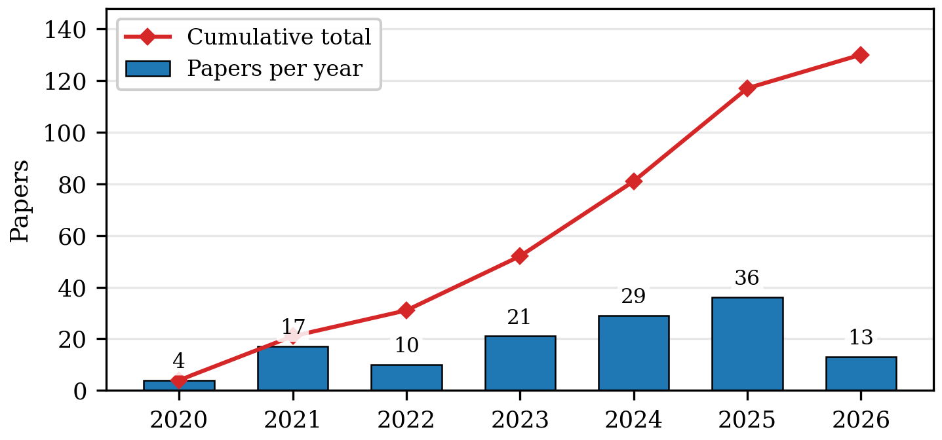
Figure S2: Method-family counts by publication year (n=130). Deep supervised learning led every year through 2023; the families then tie in 2024 (10–10) and 2025 (11–11, the corpus-wide peak for both); the partial 2026 window stands 3–4.
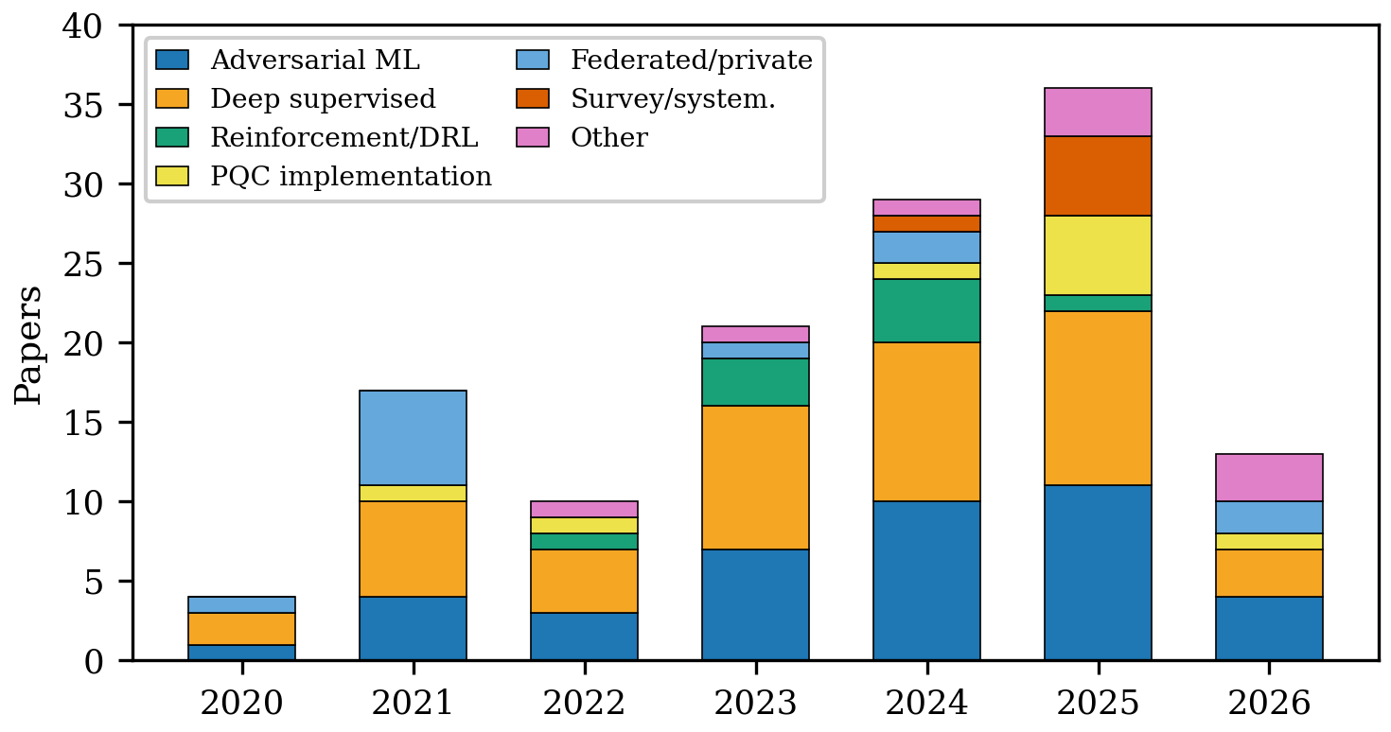
Figure S3: Validation approaches by track (core set, n=121: 84 defense, 37 threat+both). Threat+both: 17 testbed/field, 4 cross-domain, 2 sim-only, 13 standard/unclear, 1 benchmark — measured plurality, not norm; defense carries the simulation-only mass (16 of 84). Data-source and validation fields are distinct — see text.
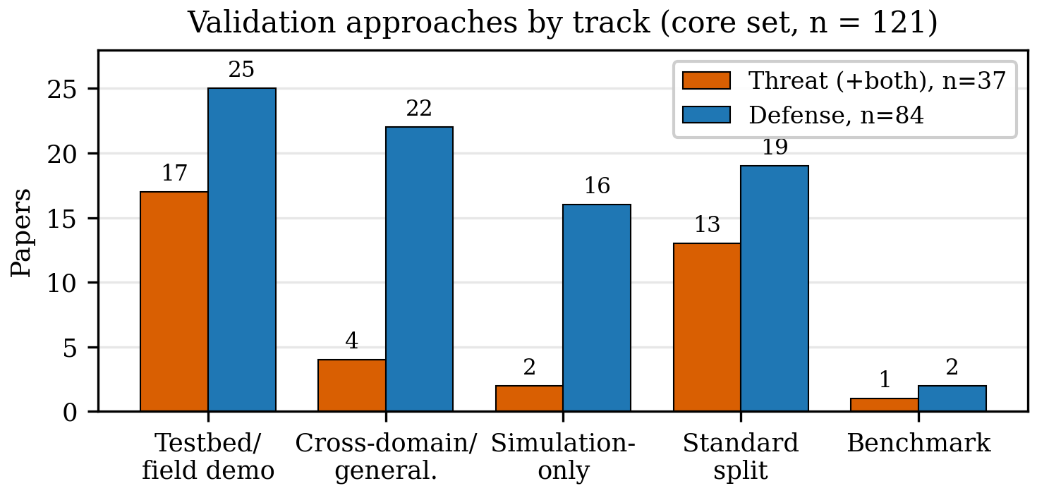
Figure S4: Validation mix by year (stacked) against total output (diamonds). Evidence grade improves by share (testbed plus cross-domain) while absolute simulation-only counts hold flat; year arms span n=4–36, so shares are noisy.
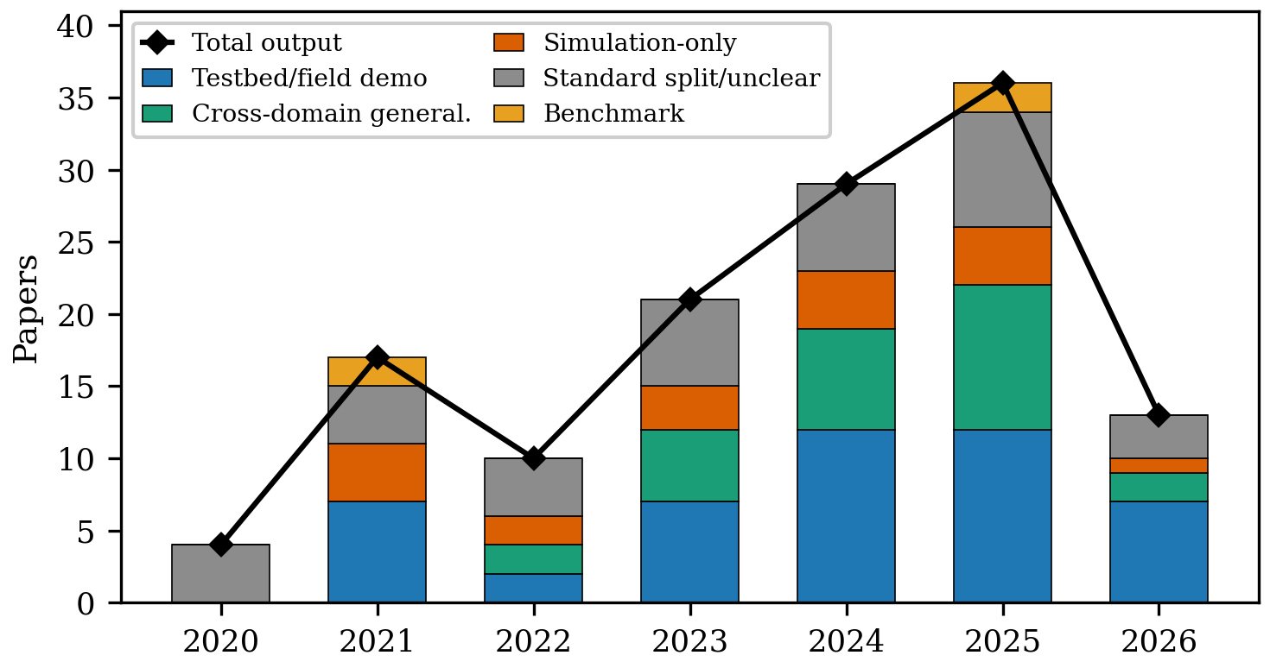
Figure S5: Venue velocity. (a) Adversarial-ML share is highest in preprints (37%, 7/19), then journals (31%, 20/65), lowest in conferences (28%, 13/46). (b) First appearance of the four focal method families by channel (year-first coding; Table 10): conferences lead journals on adversarial ML (2020 vs 2021) and DRL (2022 vs 2023); deep-supervised debuts tie in 2020; PQC reverses the pattern (journal December 2020 online-first / 2021 issue vs conference 2025). Channel markers are offset within each family row.
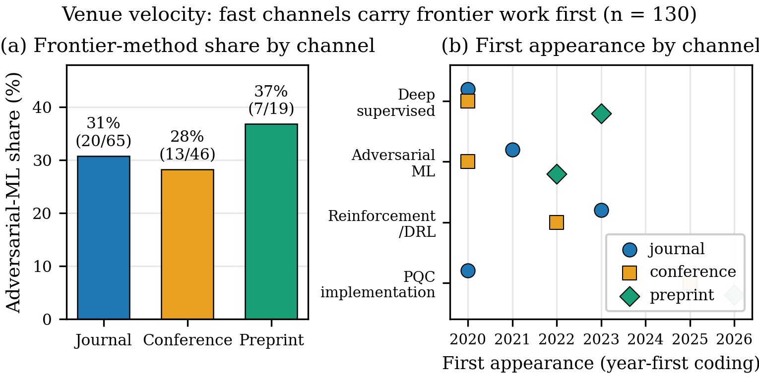

S3 Supplementary tables
Table S1: Method families in the corpus: representative techniques, strengths, and limitations.
Table S2: Corpus composition: security function by publication year (130 papers). Machine-generated from the released dataset.
Table S3: Readiness-score count distributions (0/1/2) over all 130 rows. R3/R5 zeros include attack-only rows without an observable signal (24 of 30 for R3, 25 of 30 for R5); attack rows with an observable cost or standards signal are coded 1 (§2.5).
Table S4: Readiness means by publication year (n in parens): cost/artifact/standards reporting stays flat while output grows.
Table S5: Data sources recurring across the corpus.
Table S6: First-appearance papers by method family and channel, with issue, online-first, and arXiv-v1 months where evidenced. Lags stand under both issue-year and earliest-date coding except P05 (Dec-2020 online-first vs 2021 issue).
Table S7: Venue-channel sensitivity: validation mix across journals (n=65), conferences (n=46), and preprints (n=19). Machine-generated from the released dataset.
Table S8: Representative corpus studies by function and method family. Entries gloss each study as: study summary (data basis; headline contribution).
Table S9: WIRELESS-AI-RC adherence in this corpus, coded items only (descriptive, single-coder; machine-generated from the released dataset).

S4 Readiness-rubric anchor examples
This appendix publishes one archetypal corpus row per score level per rubric item, so that independent coders can calibrate against the same anchors the released coding used (dataset_papers.csv; coding per §2.5 of the main manuscript). Anchors are real corpus rows, not constructed examples; where a level is unexercised in this sample the table says so explicitly. The R5 profile-evaluated tier (level 2) is empty across all 130 rows — every standards signal in this corpus is mention-level — and no row scores R1 = 0. These unexercised levels are themselves findings about the corpus, and they bound what the readiness means in §3 can support: the R5 contrast is an ordering claim, not an absolute one.
Table S10: Anchor examples for the R1–R5 rubric (§2.5), one archetypal corpus row per level. Unexercised levels are marked.
A 20–25% blind double-code against these anchors, with Cohen’s κ for the categorical fields and quadratic-weighted κ/ICC(2,1) for R1–R5, remains the highest-priority item of future work (§2.4, §9).
Family | Papers | Techniques | Strengths | Limitations
AdvML | 40 | FGSM/UAP, GAN-spoof, backdoor | Threat evidence; OTA-demo | Split 20 threat / 7 dual / 13 defense
DeepSup | 45 | CNN/RNN/Transf., open-set | Closed-set accuracy | Accuracy ≠ auth
PQC-impl | 9 | ML-KEM/ML-DSA, WKyber, LAKE | Onboard costs | Bandwidth blocks
DRL | 9 | Anti-jam power/relay | Adaptive control | Mixed grades (5 testbed); cost-silent
Fed/priv | 12 | DP-OTA-FL, robust aggregation | Privacy + wireless-aware | Small scale; coverage-corrected
DataBench | 2 | Trace sets, open-set benchmarks | Reusable evidence | Rarely released
DefML | 2 | Robust training, unlearning | Adversary-aware training | Thin
TrafficML | 2 | Flow/classifier models | Deployed-boundary relevance | Evasion-prone
Survey | 6 | Reviews, maps | Maps field | No primary validation
Other | 3 | KNN/SVM, SCA/SDR, LLM fuzzing | Niche depth | Thin, scattered
Function | ’20 | ’21 | ’22 | ’23 | ’24 | ’25 | ’26 | Total
Authentication/RFFI | 2 | 6 | 5 | 12 | 15 | 21 | 8 | 69
Anti-jamming/secure comms | 0 | 0 | 2 | 3 | 6 | 3 | 0 | 14
Key generation/distribution | 0 | 2 | 1 | 3 | 3 | 2 | 1 | 12
Federated/privacy FL | 1 | 7 | 0 | 1 | 1 | 0 | 1 | 11
Protocol/traffic/cryptanalysis | 0 | 0 | 1 | 2 | 2 | 3 | 2 | 10
PQC migration (contextual) | 0 | 1 | 1 | 0 | 1 | 5 | 1 | 9
Learned primitives | 0 | 1 | 0 | 0 | 1 | 1 | 0 | 3
Side-channel analysis | 1 | 0 | 0 | 0 | 0 | 1 | 0 | 2
Total | 4 | 17 | 10 | 21 | 29 | 36 | 13 | 130
Score | 0 | 1 | 2
R3 cost | 101 | 25 | 4
R4 artifacts | 126 | 4 | 0
R5 standards | 113 | 17 | 0
 | 2020 (4) | 2021 (17) | 2022 (10) | 2023 (21) | 2024 (29) | 2025 (36) | 2026 (13)
R3 mean | 0.00 | 0.29 | 0.10 | 0.24 | 0.28 | 0.25 | 0.38
R4 mean | 0.00 | 0.00 | 0.00 | 0.00 | 0.00 | 0.08 | 0.08
R5 mean | 0.00 | 0.12 | 0.10 | 0.05 | 0.17 | 0.14 | 0.23
Data source | Papers | Typical use
Testbed/OTA measurement | 46 | SDR captures, LoRa/Wi-Fi/UAV field demos
Collected datasets/traces | 26 | WiSig-style RFFI, RF-SCA trace sets
Simulation | 20 | Keygen channels, DRL jamming games, FL-privacy analysis
Analysis/benchmark | 6 | Proofs, systematizations, information-theoretic analyses
Unclear from abstract | 32 | Body-text resolution pending for paywalled rows (limitation; OA rows resolved where available; 2 of the 32 were body-read yet stayed unresolved)
Family | Conference cell | Journal cell | Preprint cell
Adversarial ML | T39 WiseML, Jul 2020 | T09 TCCN, Mar 2021 (D36 Mar 2022; arXiv Apr 2021) | T47 arXiv Jan 2022
Reinforcement/DRL | D34 WCNC, Apr 2022 | D22 TVT, Apr 2023 (no online-first record) | —
Deep supervised | T01 ASHES, Nov 2020 | D81 IEEE Access 2020 | D63 arXiv Jun 2023
PQC implementation | P10 LNNS 2025 | P05 TCHES 2021 issue (online Dec 2020) | —
Validation | Journal | Conference | Preprint
Testbed/field demonstration | 26 (40%) | 14 (30%) | 7 (37%)
Cross-domain/generalization | 13 (20%) | 11 (24%) | 2 (11%)
Simulation-only | 6 (9%) | 8 (17%) | 4 (21%)
Standard split/unclear | 20 (31%) | 10 (22%) | 5 (26%)
Benchmark/analysis | 0 | 3 (7%) | 1 (5%)
Function | Family | Representative studies
RFF/auth attack | Adversarial | White-box FGSM/PGD plus black-box UAP 81.7% on LoRa captures (CNN/LSTM/GRU; no victim knowledge) [T03]; RL impersonation >90% (SDR; binary feedback) [T18]; GAN-spoof 76% (OTA; PHY-auth pass) [T09]; SSL-target backdoor [T41]; FooLoc OTA WiFi geofence-bypass [T42]
Side-channel | Deep supervised | Far-field BLE AES-128 at 15 m, <400 traces (OTA) [T01]; nRF AES-CCM at 1 m with BLE LTK recovery in ∼30 traces [T08]
Protocol/traffic | Fuzzing/ML | LLM baseband fuzzing, 3 CVEs (phones; ConSeT) [T28]; padding defeat (traces; traffic-shape exploit) [T19]
Universal PHY | Adversarial | Magmaw, NDSS’25 (SDR; protocol-agnostic UAP vs encrypted link) [T30]
Defense RFFI | Robust/open-set | Contrastive, receiver-agnostic, open-set/few-shot, cross-receiver calibration [D75], multi-distance [D73], satellite PLA [D71] (captures; accuracy under shift)
Keygen | Deep/DRL | KDR/KGR improvements (mostly simulation; reciprocity + IRS/relay)
Anti-jamming | DRL + testbed UAV | Relay/power/secrecy-rate control (mixed: 8 testbed, 4 sim-only; costs mostly unreported)
PQC-context | Implementation | ML-KEM DTLS 313 ms on ESP32 (hardware; compute fine, bandwidth blocks); WKyber/LAKE (bandwidth attacks) [P08][P11]
AI×PQC join | — | Empty in-corpus (non-radio proximity study excluded; recorded gap)
# | Item | In-corpus status
1 | Dataset/testbed identity | Present for 72 testbed-or-collected rows; 32 unclear-source rows pending body-text resolution
2 | Device/link population | Not coded in-corpus (prospective)
3 | Adversary model | Explicit (R1=2) in 39 of 130 rows
4 | Split protocol | Rarely isolated: 35 standard/unclear validations
5 | OTA vs simulation | Declared via validation field (47 testbed/field, 18 simulation-only)
6 | Closed-loop evaluation | ≥14 of 121 core (11.6%) by the §2.6 rule; 7 of 130 dual-track
7 | Baselines | Never coded (prospective)
8 | Randomness | Never coded (prospective)
9 | Uncertainty | Never coded (prospective)
10 | Onboard cost | Present on 16 of 84 defense rows (defense R3 mean 0.19)
11 | Failure analysis | Never coded (prospective)
12 | Artifacts | Released for 4 of 121 core (3.3%): D30, D32, T28, T30
Item | Level | Anchor row (corpus ID) and why it anchors the level
R1 threat model | 0 absent | Unexercised: no corpus row scores 0
R1 threat model | 1 implicit | [D03] adaptive PLA key distribution — adversary implied by the spoofing setting, no capability statement
R1 threat model | 2 explicit | [T03] white-box FGSM/PGD + black-box UAP with stated victim-knowledge assumptions; [D36] defense evaluated against a stated adversarial-ML attack
R2 evaluation realism | 0 analysis/proof | [T23] 5G protocol SoK (analysis-grade); [D85], [D86] privacy analyses without data evaluation
R2 evaluation realism | 1 controlled | [D11] KGNet key generation, simulation-only; [D08] standard-split evaluation on reused captures
R2 evaluation realism | 2 OTA/testbed | [T30] Magmaw, SDR-demonstrated universal perturbations; [D74] channel-informed keygen grounded in over-the-air channel soundings
R3 onboard cost | 0 none | [D01] learned encryption, no cost reporting (101 of 130 rows score 0)
R3 onboard cost | 1 latency OR energy + HW | [D02] latency with stated hardware target (25 rows)
R3 onboard cost | 2 both + HW | [P01] ML-KEM on resource-constrained devices: latency, energy, memory on stated platform (4 rows: P01, P04, P05, P09)
R4 artifacts | 0 neither | [D07] receiver-agnostic RFFI, no code or data release (126 of 130 rows score 0)
R4 artifacts | 1 code OR data | [D30] open-set RFFI with released code; [T28] ConSeT fuzzer artifact; also T30, D32 (4 rows total)
R5 standards | 0 none | [D11] KGNet, no standards mention (113 of 130 rows score 0)
R5 standards | 1 mention | [D02] references an IEEE standard profile in evaluation context; [T23] charts affected 3GPP items (17 rows, the only exercised standards tier)
R5 standards | 2 profile-evaluated | Unexercised: no corpus row scores 2 — every standards signal is mention-level (§2.5)

