Structured Scoping Review with Bibliometric Classification
Is Wireless Security
Ready for the AI Era?
Evidence from a Curated Corpus of 130 Studies, 2020–2026

Authors: | Hussain Touhid Siddiquee
 | Md. Abul Malek Fahim
Affiliation: | Leading University, Sylhet,
 | Bangladesh
ORCID (Siddiquee): | 0009-0002-8804-6195
ORCID (Fahim): | 0009-0009-4196-4328
Correspondence: | touhidsiddiqueeraj@gmail.com
Supplementary artifact: | dataset_papers.csv + analysis scripts
Date: | October 2026

Abstract
Machine learning (ML) is now central to published radio-link authentication research — and simultaneously the adversary’s standard toolkit. This scoping review classifies a verified corpus of 130 curated studies (2020–2026): a 121-study core on ML for wireless-link security or attacks on it — 84 defense, 30 threat, and 7 dual attack-plus-defense studies — plus 9 post-quantum-cryptography (PQC) contextual studies kept in a separate stratum. The corpus is assembled from a seeded expert path, two OpenAlex database runs, and a programmatic extension pool; it is a structured, English-language, tripath sample, not a census, and every record carries a resolvable identifier. Each study is coded on six fields — security function, AI method family, track, primary data source, validation practice, and readiness (R1–R5) — by a single coder and independently validated by a second author, so every comparative quantity reported below is a descriptive statistic for this sample.
Three descriptive patterns hold. First, validation practice splits by kind: 16 of 30 threat studies demonstrate on testbeds or over the air, while simulation-only and standard-split evaluations carry much of the defense mass; closed-loop evaluation (defined in §2.6) appears in at least 14 of 121 core studies (11.6%). Second, reproducibility is near-absent (4 verified artifact releases among 121 core, 3.3%, a lower bound), and standards alignment outside the PQC stratum is mention-level only (12 of 121 core rows carry any standards signal, 9.9%). Third, real-time, update, and multi-agent-trust requirements are essentially unaddressed (1–2 papers each). Deep supervised learning leads the method mix (45 studies) over adversarial ML (40); Authentication/RFFI absorbs 69 of 121 core (57.0%).
Because classification was single-coder and 110 of 130 rows were coded from abstracts, cross-group readiness comparisons are indicative rather than measured effects: a documented reconciliation pass moved track-level R2 means by up to about 0.6 — more than several margins the corpus supports — and the readiness rubric’s standards tier is unexercised in this sample. The paper therefore frames its findings as descriptive, releases the classified dataset (dataset_papers.csv) so independent coders can check, correct, or extend it, distills six structural research gaps, and closes with a twelve-item reporting checklist (WIRELESS-AI-RC).
Keywords: wireless security; physical-layer authentication; RF fingerprinting; adversarial machine learning; physical-layer key generation; anti-jamming; post-quantum migration; scoping review.

1 Introduction

1.1 The radio link under AI pressure
Wireless links broadcast by physics: every transmission is receivable by anyone in range, which makes the radio link the natural attack surface for interception, impersonation, and jamming. The classical answer — encryption, authentication and key agreement (AKA), and physical-layer techniques — now faces three simultaneous strains. First, software-defined radios put laboratory-grade interception and transmission in every adversary’s hands. Second, machine learning turns raw captures into fingerprints, keys, and exploits automatically, without hand-built demodulators. Third, autonomous systems (drones, vehicles, swarms, IoT/edge fleets) need authentication under real-time deadlines, over-the-air updates, and multi-agent trust — requirements the literature rarely addresses together. The question this review asks is whether the radio-link security literature has kept pace with the adversary it has itself equipped.

1.2 How AI entered wireless security
AI entered through authentication. Deep networks learned RF fingerprints from raw I/Q, outperforming hand-crafted features, and physical-layer key generation promised lightweight secrets from channel reciprocity without public-key infrastructure. The adversarial turn followed quickly: white-box FGSM/PGD perturbations and black-box universal perturbations (81.7% success with almost no victim knowledge) break RFFI classifiers on real LoRa captures [T03]; reinforcement-learned impersonation needs only binary accept/reject feedback for >90% penetration [T18] (an adversarial-ML attack — the defense-side DRL family counts control methods only, so Fig. 6 shows no DRL threat rows); GAN-spoofed signals pass PHY authentication at 76% [T09]. Two results reset expectations for the field: far-field deep-learning side-channel recovery of BLE AES-128 at 15 m from fewer than 400 traces [T01], and Magmaw [T30] (NDSS’25) — protocol- and modality-agnostic universal perturbations, SDR-demonstrated at noise-level power, surviving adversarial training, subtraction, detection, and oracle defenses, including against an encrypted image channel. Authentication learned from waveforms, it turned out, could be unlearned by waveforms. Fig. 1 places these turning points on a timeline: with two exceptions (a 2022 joint attack-plus-defense ensemble receiver and a 2025 proactive-authentication defense), every milestone is an attack (milestones author-selected to mark field turns, not sampled).
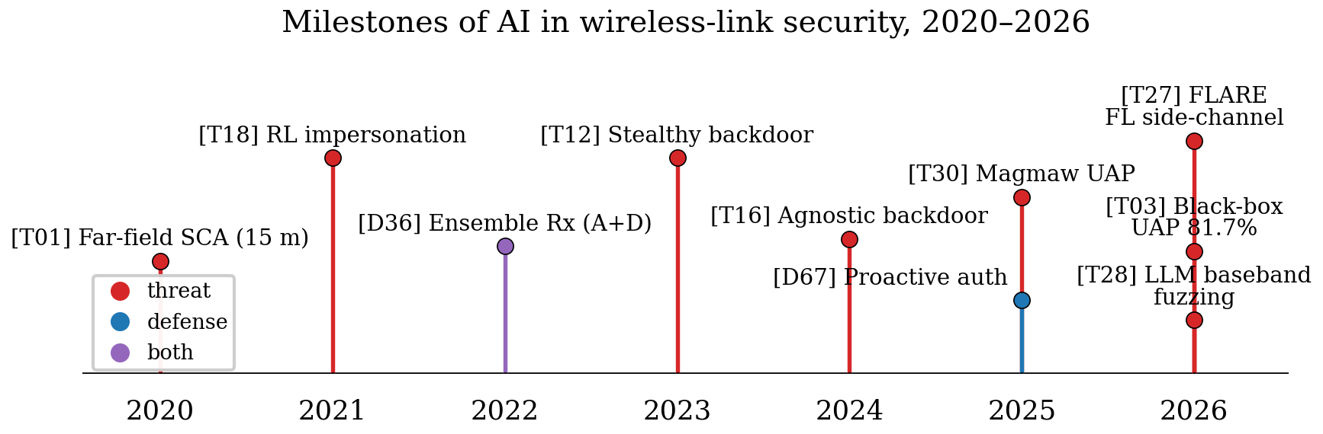
Figure 1: Milestones of AI in wireless-link security, 2020–2026. Red markers are threats, blue defenses, purple joint attack-plus-defense work.

1.3 Existing reviews and the literature gap
The review literature has grown alongside the applications, but it is fragmented along the same axes as the primary studies. Function-specific surveys cover RF fingerprinting [BG3]; method-specific ones follow adversarial ML [BG7]; the closest cross-functional account is a physical-layer-authentication survey for the ML era [BG2]. Table 1 compares their scope and method against this review. What is largely missing is a cross-functional, quantitative account of the field’s trajectory: which AI method families are actually being used for which security functions, on which data, validated how, and how that picture has shifted over 2020–2026. This gap matters because the field’s self-image drives its research allocation. If most published authenticators are validated on closed-set, single-receiver, static-channel benchmarks, the community’s sense of progress is calibrated to a regime that differs sharply from deployment under adaptive adversaries. Answering such questions requires a corpus-level, cross-functional account rather than another narrative synthesis of one function. Conversely, readers seeking per-function depth should still consult those surveys directly — [BG3] for RF fingerprinting practice, [BG7] for the adversarial-ML attack surface, and [BG2] for physical-layer authentication design; this review complements them at the corpus level.
Table 1: Prior surveys closest to this review: scope, method, and what differs here.
Survey | Scope | Method | This review instead
[BG3] Jagannath 2022 | RFFI only | Narrative | 8 functions quantified jointly
[BG7] Adesina 2023 | Adversarial wireless ML | Narrative | Plus defenses, validation grade, trends
[BG2] Hoang 2024 | PLA/auth in ML era | Narrative | Plus threats, readiness scores, checklist

1.4 Contribution of this paper
This paper makes four contributions. First, it assembles a verified corpus of 121 core studies (2020–2026) on AI in wireless-link security broadly construed, plus 9 post-quantum contextual studies kept in a separate stratum (130 records total), in which every record carries a resolvable identifier verified record-by-record (journal/conference DOI, arXiv/ePrint ID, USENIX paper URL, or publisher landing page — no identifier fabricated, none shared). Corpus construction, deduplication adjudications, and the same-team companion-pair sensitivity checks are documented in §2.3. Second, it develops a two-axis classification framework — security function × AI method family — extended with track, data-source, validation-practice, and readiness fields, applies it uniformly to all 130 papers, and releases the classified dataset so independent coders can check, correct, or extend it. Third, it quantifies the field’s six-year evolution across functions, methods, data, and validation (§3) — as a descriptive account of this curated sample. Fourth, it provides a critical, function-by-function review of what the corpus actually demonstrates (§§4–6), a cross-cutting analysis of the threat–defense asymmetry (§7), and distills a gap-driven research agenda plus a reporting checklist (§8).
Fig. 7 previews the analysis, mapping the corpus across security functions and method families: the field’s center of gravity sits squarely in the RFFI × (adversarial + deep-supervised) complex, key generation is a simulation-heavy island, and LLM-assisted work is only now appearing. The remainder of the paper is organized as follows. §2 details the review methodology. §3 presents the corpus overview and bibliometric analysis. §§4–6 review threats, defenses, and the quantum-era context. §7 examines cross-cutting directions. §8 formulates gaps and the checklist. §9 concludes.

2 Review Methodology

2.1 Scope and objective
The objective is to characterize the state and evolution of AI applied to radio-link security broadly construed: authentication/RFFI (including localization-fingerprint attacks where geofence bypass breaks an authorization boundary), key generation/distribution/exchange/management, anti-jamming/secure communications, protocol/traffic/signal analysis where the classifier is the security boundary, side-channel analysis, federated privacy, and learned primitives — crossed with AI as attacker tool, defender tool, or learned primitive — over 2020-01-01–2026-10-11, plus readiness gaps for autonomous systems (drones, vehicles, swarms, IoT/edge). Post-quantum migration forms a separate contextual stratum (9 studies, several of which meet neither the AI-link nor the radio-link criterion on their own and are retained as context only), never pooled with AI claims. No in-corpus paper joins AI-driven attack with PQC implementation over a radio link; that join is recorded as a scoping result with the caveat that the stratum was assembled without an AI-linkage requirement, so its emptiness describes this corpus, not the field. The title question — is wireless security ready for the AI era? — is answered in §9: no, on current evidence.

2.2 Literature search strategy
Two search paths plus a programmatic extension pool were used; no formal stopping rule was applied — collection stopped after the seeded rounds, two OpenAlex runs, and the adjudication pass, with the 241-record programmatic pool held unscreened as backup. Path A contributed zero included records, so triangulation rests on the seeded and database paths. Path A (programmatic): Crossref REST API, 16 topical queries (rows=100, date/type filtered) plus arXiv API, 10 queries (max 50) → 1,945 unique records after DOI/arXiv-ID deduplication (1,555 Crossref + 390 arXiv; records.json). Path B (expert-seeded): 29 structured open-web search rounds (∼290 records, fully logged in run log.md) → 126 unique candidates by paper ID after deduplication (109 includes + 12 background + 4 backup + 1 exclusion). Path C (database): 10 topical queries against the OpenAlex index (no subscription required), 894 hits deduplicated against Paths A–B to 662 new records, title-gated to 130 candidates (code/openalex_run.py, code/openalex_gate.py).
Two properties of this design should be stated plainly. First, Crossref is a metadata registry, not a discovery engine like Scopus or Web of Science; topical recall for this IEEE/ACM-heavy, terminology-variant literature is ∼50% by token overlap, which is why triangulation — not single-source retrieval — is the design. Subscription-database runs (Scopus/IEEE Xplore/Web of Science) remain pending for lack of institutional access; OpenAlex, which indexes the same publishers, is the executed database substitute (Path C satisfies database triangulation in part; full multi-registry triangulation remains future work), and its yield is reported below. The 10-query OpenAlex run surfaced 14 eligible papers missed by 29 seeded rounds plus 26 API queries, which is reported as evidence about seeded-search recall limits, not as a census. Second, the seeded path inherits expert-search bias toward notable and recent work; all trend statements are statements about trends within this verified, English-language sample rather than about the field in the aggregate.

2.3 Screening and selection procedure
The funnel is shown in Fig. 2. From 1,945 deduplicated programmatic records, a title-level relevance gate requiring wireless AND crypto/auth AND AI terminology retained 241 records (gated.json); these 241 extension-pool records are released with disposition (overlap with seeded set vs held for future screening) and were not merged silently into the evidence base, which rests on fully screened paths. The seeded path went 126 unique candidates → validity floor (V1 peer/in-range/retrievable, V2 evaluable evidence, V3 claims traceable) → 109 seeded includes + 12 background (survey-only landmarks) + 4 backup needs-check rows (D51/T26/T29/P07, held) + 1 title-gate exclusion (T24, EAP-AKA with no AI link). The first OpenAlex run went 894 hits → 662 unseen records → title gate 130 → abstract-level V1–V3 screening → 14 included (D70–D77, T41–T46) + 2 background (BG10 systematic O-RAN analysis and BG11 conceptual QML plan, both without primary mechanism) + 1 excluded (EX01, no crypto link), remainder out-of-scope surveys, non-radio, or IDS-only work. The 2026-10-12 rerun went 994 hits → 743 post-dedupe → title gate 136 (20 new) → abstract-level V1–V3 screening → 12 included (D78–D88, T47) + 8 excluded with logged reasons. An adjudication pass then applied scope and dedupe cuts to the merged 135 and the corpus froze at 130 included studies (105 seeded + 13 OpenAlex + 12 rerun) alongside 15 background, 4 backup, and 14 excluded rows.
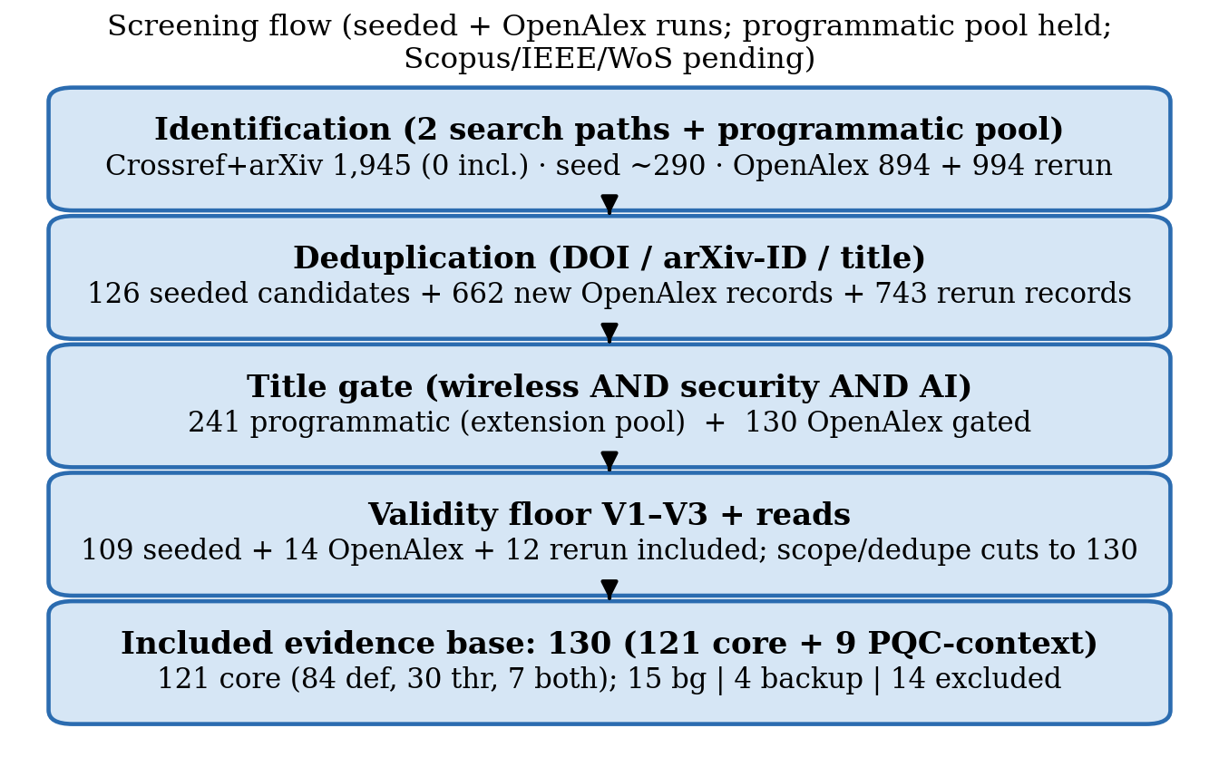
Figure 2: Study-selection flowchart. Programmatic records were retrieved from the Crossref and arXiv APIs (Path A, 241 gated extension-pool records released with disposition, not merged silently), OpenAlex database hits were deduplicated against them and title-gated (Path C), the expert-seeded path and two OpenAlex database runs were screened against the validity floor, and an adjudication pass applied scope and dedupe cuts before the corpus froze at 130 studies (105 seeded + 13 OpenAlex + 12 rerun). Every record carries a verified resolvable identifier (see §1.4).
Two deduplication adjudications deserve explicit documentation because they change N. Two same-team companion pairs are counted as distinct records with disclosure (D55/T15: TCCN authorization framework plus datasets vs GLOBECOM outlier-augmentation method — the arXiv preprint carries the GLOBECOM title and cites the TCCN paper as prior work, confirming distinct records; D20/T20: TVT UAV-PLA paper vs CPS-IoT Week encrypted-traffic paper); dropping either pair would move N to 129/128 without changing the headline patterns of §3.1. One same-team conference-to-journal extension was deduped (T02 subsumed by T03, which covers its FGSM/PGD results and adds black-box UAP). Two initially mis-keyed records were corrected against publisher metadata (D20 to its TVT paper, D55 to its TCCN paper).
Full-text curation of arXiv-path records — full text is retrievable for every record on that path — upgraded readiness scores where body text confirmed testbeds, threat models, costs, or artifacts (fulltext_reads.md). A later reconciliation pass aligned R2 to the validation mapping (§2.5), which moved track-level R2 means by up to about 0.6 (dual +0.57) while preserving their order; neither pass changed the ordering of track means, but the drift magnitude bounds the stability of every cross-group readiness comparison reported in §3 and is carried explicitly through the paper’s claims (see §2.6).
Ten of those arXiv-path rows have since been confirmed as published (venue and DOI resolved 2026-10-11), and a second resolution round confirmed nine more; a third round confirmed nine of the remainder (D25 CAMAD21, D35 GC Wkshps23, D38 Wireless Commun24, D49 Network25, D50 ISCC23, D53 Commun Lett24, T09 TCCN21, T14 TMC23, T19 WPES22). The final corpus carries 19 preprints (14.6%): 14 venue-unconfirmed arXiv-only entries (D33, D39, D42, D45, D63, D74–D76, T36, T42, D82, D84, D85, T47), 2 presented-or-preliminary rows (D26 presented at ICC per authors; T05 MILCOM23 preliminary with a 2024 full version), 1 submitted row (D46; stated INFOCOM target inconsistent with its August-2026 posting, held as submitted/unconfirmed), and 2 author-claimed rows (D48, ICASSP per arXiv comment; P09, Standards Magazine accepted — neither with a proceedings record found); no entry changed status without a logged resolution.
The rerun delta was dominated by the previously rate-limited FL query (coverage artifact, not one-day field growth): its 7 wireless-FL-privacy defense additions nearly triple the federated-privacy function (4 → 11), which is reported as a coverage correction in §3, not field growth. Corpus IDs are archival and non-contiguous: the gaps at T10, T13, T32, T33, and P02 reflect rows removed before the corpus froze, and the disclosed backup rows (T26, T29, D51, P07) are held outside the 130.

2.4 Inclusion and exclusion criteria
Table 2 summarizes the criteria. Inclusion required: (i) radio-link/wireless population; (ii) security link (broad wireless-ML-security scope per §1: encryption, authentication including localization-fingerprint attacks where geofence bypass breaks an authorization boundary, key exchange/management/generation, physical-layer security, anti-jamming/secure communications, signal/traffic analysis where the classifier is the security boundary, side-channel analysis, federated privacy); (iii) AI involvement; (iv) dated 2020–2026, English, retrievable; (v) evaluable evidence (experiment, testbed, simulation, proof, cryptanalysis); (vi) peer-reviewed venue or reputable arXiv preprint (ID+version+access date; published supersedes; preprints ≤40% — observed 14.6%).
Exclusion: not wireless; no security link; no AI link; survey/opinion without primary mechanism (background only); pre-2020; non-English; retracted; unretrievable; duplicate (§2.3 adjudications); no evaluable evidence; preprint without evaluation. Adjudications logged: domain-informed cellular fuzzing without ML content is excluded for failing AI involvement (T07, consistent with the T24 exclusion); Wi-Fi localization-fingerprint attacks count where geofence bypass breaks an authorization boundary (T42 included on that ground, not on a forgery-breaks-authentication claim); signal-classifier attacks count where the classifier is the security boundary (T44 included under D36/D37 precedent); IoT traffic-classifier attack-plus-defense counts as dual-track protocol work (T46 included); wireless-FL-privacy work counts where the privacy guarantee is produced by channel properties (over-the-air superposition, channel-noise differential privacy) — a physical-layer mechanism under the D24 precedent — while generic FL-application papers without a channel-produced guarantee are excluded; acoustic/vibration SCA on PQC fails the radio-link population (T45 excluded to related work); Wi-Fi sensing without security link moved to background (including T34); 5G regression-robustness work without a security boundary excluded (T35); Xplore-hosted rows counted as peer-reviewed (Xplore hosts only peer-reviewed content), venue reverified at full-text read; author-claimed venues without proceedings records coded preprint (D26, T05-preliminary, D46-submitted, D48, P09-accepted), while author claims confirmed by a publisher record stay peer-reviewed (D41 TVT proceedings record, D52 TCCN proceedings record, T28 USENIX proceedings).
Table 2: Inclusion and exclusion criteria applied during corpus screening.
Dimension | Included | Excluded
Population | Radio-link/wireless systems | Wired-only, pure sensing without crypto link
Concept | Crypto primitive + AI involvement | Missing either link
Document | Peer-reviewed + reputable arXiv (≤40%) | Surveys w/o mechanism, evidence-free preprints
Period | 2020–2026 | Pre-2020
Verification | DOI/arXiv-ID resolved | Unresolvable, retracted, duplicate
Language | English | Non-English

Who screened and coded (all humans): the first author performed 100% title/abstract screening and full-text retrievability checks on every included record, with eligibility coding from full text where retrieved and from abstracts otherwise (110 rows abstract-only, including 30 of the 32 Unclear-source rows (two were body-read yet unresolved); 20 rows body-read as logged), plus 100% charting; two independent verifiers performed corrective checks on a 22-record sample (verifier_pack.csv) with raw inclusion-disagreement 1/22 (4.5%, 95% exact interval roughly 0.1–23%) on inclusion decisions only — it says nothing about coding reliability. The second author then independently reviewed the completed coding and every derived result against the released dataset and confirmed agreement with the reported findings before submission; this was a validation review of coding decisions and outputs, not a blind second coding, so no agreement statistic is attached to it. Blind R-score rescores were not completed; the reconciliation pass of §2.3 was a single-coder rule-alignment, not a second coding. AI assistance was limited to candidate pooling, prose drafting, and copy-editing under human control — no screening, coding, or counting decision was delegated (see Declarations). No blind double-coding was completed, so no κ is claimed: single-coder classification with second-author validation is the stated provenance, and a 20–25% blind double-code with Cohen’s κ (binary) and quadratic-weighted κ/ICC(2,1) (R1–R5) remains future work. Bibliography verification (no IDs fabricated, none shared): every record carries a resolvable identifier checked against Crossref, arXiv, ACM, or USENIX; record-level corrections re-keyed D20 (true TVT paper) and D55 (true TCCN paper), corrected D31 year 2024→2025 and T38 year 2021→2022 to published versions, confirmed T03 (TMC 2026) and T28 (USENIX Security 2026 proceedings) as published, and recoded D48 to preprint (ICASSP per author comment only).

2.5 Classification framework
Each paper was classified along six fields: (1) security function (8 values: Authentication/RFFI, Key generation/distribution, Anti-jamming/secure comms, Protocol/traffic/cryptanalysis, PQC migration contextual, Federated/privacy-preserving FL, Learned primitives/crypto, Side-channel attack analysis); (2) AI method family (adversarial ML, deep supervised, PQC implementation, reinforcement/DRL, federated/private, traffic-analysis ML, LLM-assisted, defensive/robust ML, classical/Bayesian, optimization-based, dataset/benchmark, survey); (3) track (threat 30 / defense 84 / both 7 / pqc-context 9, with T05/T14 moved to dual-track under the develops-and-evaluates-both rule); (4) primary data source; (5) validation approach; (6) readiness R1–R5 with an explicit rubric — R1 (all): 0 absent / 1 implicit / 2 explicit attacker capability + assumptions; R2 (all): 0 theory/proof/analysis without data evaluation / 1 controlled evaluation (simulation, reused datasets or traces, cross-domain protocols on collected data) / 2 author-conducted OTA/testbed demonstration or demonstrated real key recovery — as applied, simulation-only rows score 1 per the protocol rubric (an earlier pass that had downgraded confirmed-simulation rows to 0 stands reversed and logged; the mapping is asserted programmatically over all 130 rows with one documented override (T01: Standard-split validation with R2=2 for demonstrated over-the-air key recovery — without it the threat mean would read 1.50); R4 (all): 0 neither / 1 code OR data / 2 both or artifact-evaluated; R3 defense/learned-crypto/auth: 0 no cost / 1 latency OR energy + HW target / 2 both + HW target; R5 defense/PQC-context: 0 none / 1 mentions 3GPP/IETF/NIST/ETSI / 2 evaluated against profile — each 0–2 (report medians/ranges per track; total = sum of applicable items only). Papers take a single dominant value per field; conservative coding throughout (abstract-level except where full-text reads are logged in fulltext_reads.md; 32 Unclear-source rows remain a stated limitation). R3 and R5 apply to attack papers whenever the abstract states an observable attacker-cost or standards signal: 6 attack rows carry R3 = 1 and 5 carry R5 = 1, and rows without such a statement score 0 (24 of 30 for R3, 25 of 30 for R5). Corpus-level counts (Table 5) include these values and per-track means report them (threat R3 0.20, R5 0.17); defense-side comparisons never pool attacker-side cost with defender-side cost.
Two properties of the rubric are disclosed with the corpus. First, the R5 rubric’s upper tier (2 = evaluated against a profile) is unexercised in this sample: no row of 130 meets it, so every standards signal in §3 is mention-level (R5 = 1; 17 rows). The PQC-versus-core R5 contrast is therefore an ordering claim, and its absolute level would read zero under a stricter reading that discounts mention-level signals. Second, R2’s middle tier (1 = controlled evaluation) deliberately merges standard-split, cross-domain, and simulation-only designs: 57 of 84 defense rows score R2 = 1 (19 standard-split, 22 cross-domain, 16 simulation-only) against 12 of 30 threat rows, so defense R2 means pool evaluation kinds that the validation field separates. Cross-track R2 comparisons in §3 are therefore read jointly with the validation cross-tabulation (Tables 8–9) rather than alone, and both sensitivities are carried into the claims of §§3–7. Anchor examples — one archetypal corpus row per score level per rubric item — are published in Appendix A.
Each paper additionally carries a venue channel — journal (65), conference/workshop (46), or preprint (19) — coded from confirmed venue strings for the channel analysis in §3.5. Independent verifiers reviewed a 22-record sample correctively (raw inclusion-disagreement 1/22) rather than by blind double-coding, and the second author validated the full coding and all derived results against the released dataset — neither pass is a blind second coding, no agreement statistic is claimed, and counts should be read as one documented coding with second-author validation. The complete dataset is released as dataset_papers.csv precisely so independent coders can check, correct, or extend it; a glossary of frequently cited corpus IDs accompanies the archive (data/glossary.md).

2.6 Comparative synthesis approach
Quantitatively, classification fields are aggregated into cross-tabulations — function by year, method by year, data, validation, readiness per track — that characterize the corpus as a sample (§3); every figure and count was generated programmatically from the released dataset (see code/; check_consistency.py gates export on sums and caption n-values). One derived measure is used repeatedly and is defined here rather than later: closed-loop evaluation denotes dual-track studies plus any threat paper that evaluates against a stated defense and any defense paper that evaluates against a stated attack. It reaches at least 14 of 121 core (11.6%, a lower bound — abstract wording may hide further cases; a full-text audit is future work); the narrow dual-track-only count is 7 of 130 (5.4%), and both counts are reported wherever the number appears.
The methodology has limitations readers should weigh: open-web seeding favors notable work (the two OpenAlex yields — 14 then 12 eligible — are reported as recall evidence with the caveat that the first run was incomplete: its FL query hit rate limits, so the “14 papers missed by seeded search” says more about seeded-search limits than about saturation); no formal stopping rule was applied — collection stopped after the rerun plus adjudication pass, and Path A contributed zero included records, so triangulation rests on the seeded and database paths with the programmatic pool held as backup; title-gate screening can miss nonstandard terminology; preprint inclusion adds recency at the cost of version instability (frozen by ID+version+date; 19 preprints, 14.6%, sensitivity-checked); classification was performed by one coder and validated by the second author but carries no blind double-coding reliability statistic (§2.5; blind κ remains future work; raw inclusion-disagreement on the verifier sample was 1/22); full multi-registry triangulation is pending (Scopus/IEEE/WoS) with OpenAlex as executed substitute; 110 rows are coded from abstracts (including 30 of the 32 Unclear-source rows, concentrated in paywalled journals 23/32) and only 20 rows were body-read; body reads only ever upgraded scores, so all R3–R5 rates are lower bounds by construction, Fig. 11 and Table 8 mix coding depths — full-text rows skew simulation-heavy (5/20) relative to abstract-coded rows (13/110) — and full R3–R5 body reads remain future work.
Because of this, every cross-track readiness comparison in §3 is a single-coder descriptive statistic; §3.4 additionally reports the like-depth (abstract-only) version of the central threat–defense comparison so readers can see the coding-depth confound directly. §3 should be read as a structured sample, not a census — which is why this paper describes itself as a scoping review with bibliometric classification rather than a meta-analysis. No pooled effect sizes or significance tests are reported: metric heterogeneity (accuracy vs KGR vs secrecy rate vs attack-success rate) forbids pooling — a deliberate choice; function × validation cross-tabulations are descriptive, and the WIRELESS-AI-RC checklist is scored against the corpus descriptively in §8.

3 Corpus Overview and Six-Year Evolution

3.1 Publication trend
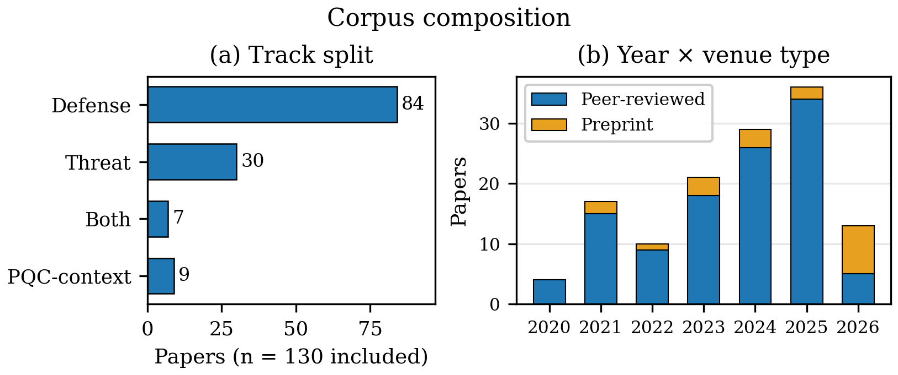
Figure 3: Corpus composition: (a) track split (n=130); (b) year × venue type. Preprint share is highest in the partial 2026 window (8 of 13).
The corpus spans 2020–2026 with a rising but non-monotonic profile: 4 (2020), 17 (2021), 10 (2022), 21 (2023), 29 (2024), 36 (2025), 13 (2026 partial) (Figs. 3–4). The 2021 bump is substantially a coverage effect: 5 of the 7 rerun-added FL-privacy papers date to 2021, without which the year reads 12. Excluding those 7 as a sensitivity check (N=123): defense R2 reads 1.32 instead of 1.27 while threat R2 is unchanged at 1.53, and simulation-only reads 16 instead of 18 — the threat-realism lead, dual-track lowest realism, and RFFI dominance hold either way. Two caveats: the corpus is curated, so the curve partly reflects curation as well as field growth; and the preprint share concentrates in the partial 2026 window (8 of 13 papers, against 0–14% in 2020–2025), which is the velocity justification for their inclusion (§3.5). With those caveats, the profile matches the field’s post-2020 SDR-democratization and the 2024–2025 adversarial-ML surge. Sensitivity: dropping either duplicate-ID pair (D55/T15 or D20/T20) moves yearly totals by at most one paper and leaves the acceleration pattern unchanged.
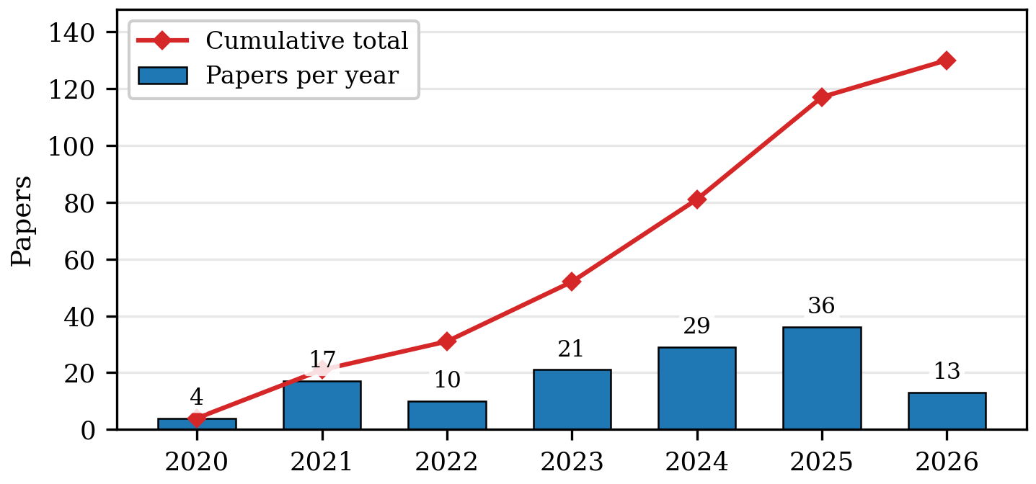
Figure 4: Corpus composition by publication year (bars) with cumulative total (line). 2026 is a partial year.

3.2 Method-family evolution
Deep supervised learning leads with 45 papers against 40 adversarial ML (Fig. 5, Table 3), a 5-paper margin that is not robust: the database-rerun merge added 4 deep-supervised RFFI papers while the dedupe cut removed two adversarial papers (T02 subsumed by T03; T35 excluded), and the federated-privacy additions sit in neither family. Deep supervised work led in every year through 2023 (2–1 in 2020 through 9–7 in 2023); the families then tie in 2024 (10–10) and again in 2025 (11–11, the corpus-wide peak for both), and the partial 2026 window stands 3–4 with adversarial ML narrowly ahead. Deep supervised totals 21 papers through end-2023, and only 33 of its 45 address RFFI, so “deep supervised fingerprinting” mislabels the family (remainder: key generation 8, side-channel 2, anti-jamming 1, protocol/traffic 1). Adversarial ML spans white-box, black-box UAP, GAN-spoofing, backdoors, and universal PHY perturbations, with the 2025–2026 wave adding self-supervised-target backdoors [T41], over-the-air Wi-Fi attacks [T42], and frequency-selective strikes [T44]. Reinforcement/DRL holds at 9, all defense-side (anti-jamming, UAV relay, secrecy-rate optimization). PQC implementation (9) concentrates 2024–2026. Federated/private learning climbs to 12 — nearly tripled by the rerun coverage correction, reported as such rather than as field growth — traffic-analysis ML (2), a single LLM-assisted fuzzer (ConSeT [T28], 2026), defensive/robust ML (2), dataset/benchmark contributions (2), survey/systematization (6), classical/Bayesian (1), and optimization-based (1) fill the long tail; protocol fuzzing/analysis leaves the taxonomy with T07’s exclusion. The sole classical/Bayesian paper sits under RFFI. The families are not mutually exclusive in practice; dominant-family coding understates mixing.
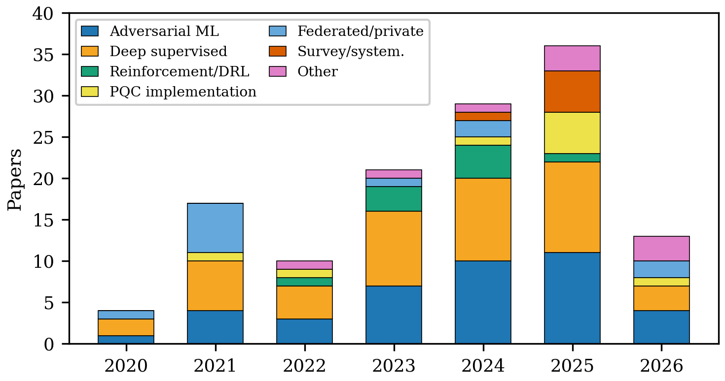
Figure 5: Method-family counts by publication year (n=130). Deep supervised learning led every year through 2023; the families then tie in 2024 (10–10) and 2025 (11–11, the corpus-wide peak for both); the partial 2026 window stands 3–4.
Table 3: Method families in the corpus: representative techniques, strengths, and limitations.
Family | Papers | Techniques | Strengths | Limitations
AdvML | 40 | FGSM/UAP, GAN-spoof, backdoor | Threat evidence; OTA-demo | Split 20 threat / 7 dual / 13 defense
DeepSup | 45 | CNN/RNN/Transf., open-set | Closed-set accuracy | Accuracy ≠ auth
PQC-impl | 9 | ML-KEM/ML-DSA, WKyber, LAKE | Onboard costs | Bandwidth blocks
DRL | 9 | Anti-jam power/relay | Adaptive control | Mixed grades (5 testbed); cost-silent
Fed/priv | 12 | DP-OTA-FL, robust aggregation | Privacy + wireless-aware | Small scale; coverage-corrected
DataBench | 2 | Trace sets, open-set benchmarks | Reusable evidence | Rarely released
DefML | 2 | Robust training, unlearning | Adversary-aware training | Thin
TrafficML | 2 | Flow/classifier models | Deployed-boundary relevance | Evasion-prone
Survey | 6 | Reviews, maps | Maps field | No primary validation
Other | 3 | KNN/SVM, SCA/SDR, LLM fuzzing | Niche depth | Thin, scattered

Three observations qualify this trajectory. First, the families overlap in practice and dominant-family coding understates method mixing. Second, the adversarial rise is partly a response to the recognized brittleness of fingerprint classifiers under domain shift — but attack papers are, on average, evaluated no more stringently against adaptive defenses than defense papers are against adaptive attacks (§4), and no cited threat paper exploits domain shift as a standalone vector (T40 documents consistent cross-device misclassification under domain shift and demonstrates its use as a backdoor for system intrusion on real-world experiments — attack surface with a demonstrated trigger, not a deployed exploit). Third, the LLM-assisted cluster is too small to represent a trend; its significance is that LLM-based baseband analysis is appearing at all.

3.3 Application-area distribution
Functionally the corpus is dominated by Authentication/RFFI: 69 of 121 core (57.0%), followed by Anti-jamming/secure comms (14), Key generation/distribution (12), Federated/privacy FL (11), Protocol/traffic/cryptanalysis (10), PQC-context (9), Learned primitives (3), Side-channel analysis (2) (Fig. 7, Table 4). The center of gravity sits in RFFI × (adversarial 27 + deep-supervised 33) — deep supervised now leads inside RFFI as well as overall. By contrast, learned primitives (3) are thin — telling, since these are where cryptographic consequences are most direct. Cutting the same data by track (Fig. 6) sharpens the asymmetry that §§4–5 develop: adversarial ML splits 20 threat / 7 dual / 13 defense across tracks (the dedupe moved two attack-plus-defense papers to dual-track), deep supervised learning remains predominantly a defense instrument (42 defense vs 3 threat), and all reinforcement learning in the corpus sits on the defense side. Method-by-track figures pool dual-track papers with threat for readability; the text always gives the three-way split (for adversarial ML: 20 threat / 7 dual / 13 defense).
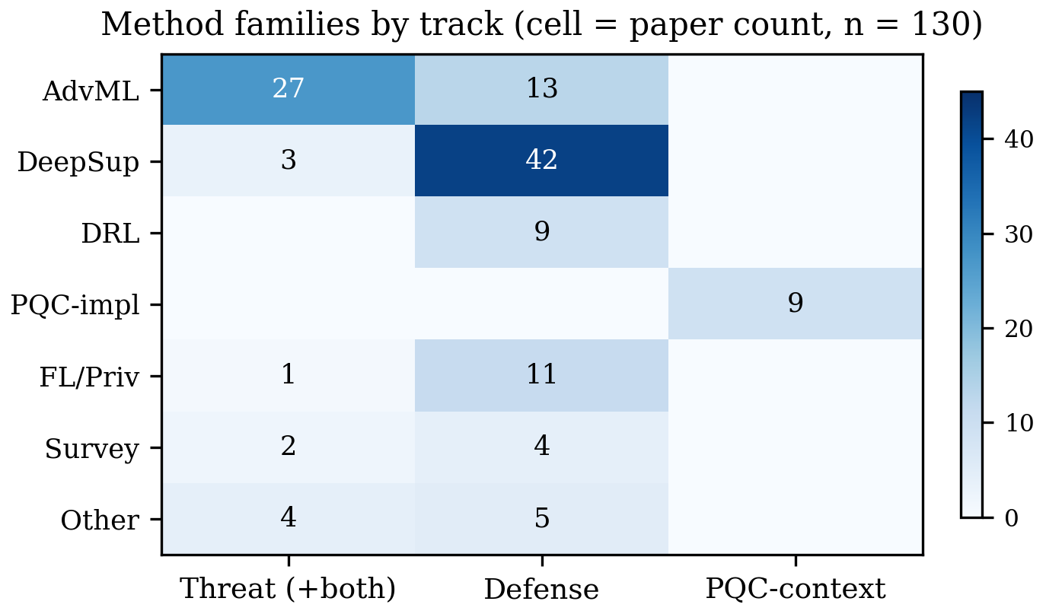
Figure 6: Method families by track. Adversarial ML attacks; deep supervised learning defends; reinforcement learning is defense-only in this corpus.
Table 4: Corpus composition: security function by publication year (130 papers). Machine-generated from the released dataset.
Function | ’20 | ’21 | ’22 | ’23 | ’24 | ’25 | ’26 | Total
Authentication/RFFI | 2 | 6 | 5 | 12 | 15 | 21 | 8 | 69
Anti-jamming/secure comms | 0 | 0 | 2 | 3 | 6 | 3 | 0 | 14
Key generation/distribution | 0 | 2 | 1 | 3 | 3 | 2 | 1 | 12
Federated/privacy FL | 1 | 7 | 0 | 1 | 1 | 0 | 1 | 11
Protocol/traffic/cryptanalysis | 0 | 0 | 1 | 2 | 2 | 3 | 2 | 10
PQC migration (contextual) | 0 | 1 | 1 | 0 | 1 | 5 | 1 | 9
Learned primitives | 0 | 1 | 0 | 0 | 1 | 1 | 0 | 3
Side-channel analysis | 1 | 0 | 0 | 0 | 0 | 1 | 0 | 2
Total | 4 | 17 | 10 | 21 | 29 | 36 | 13 | 130

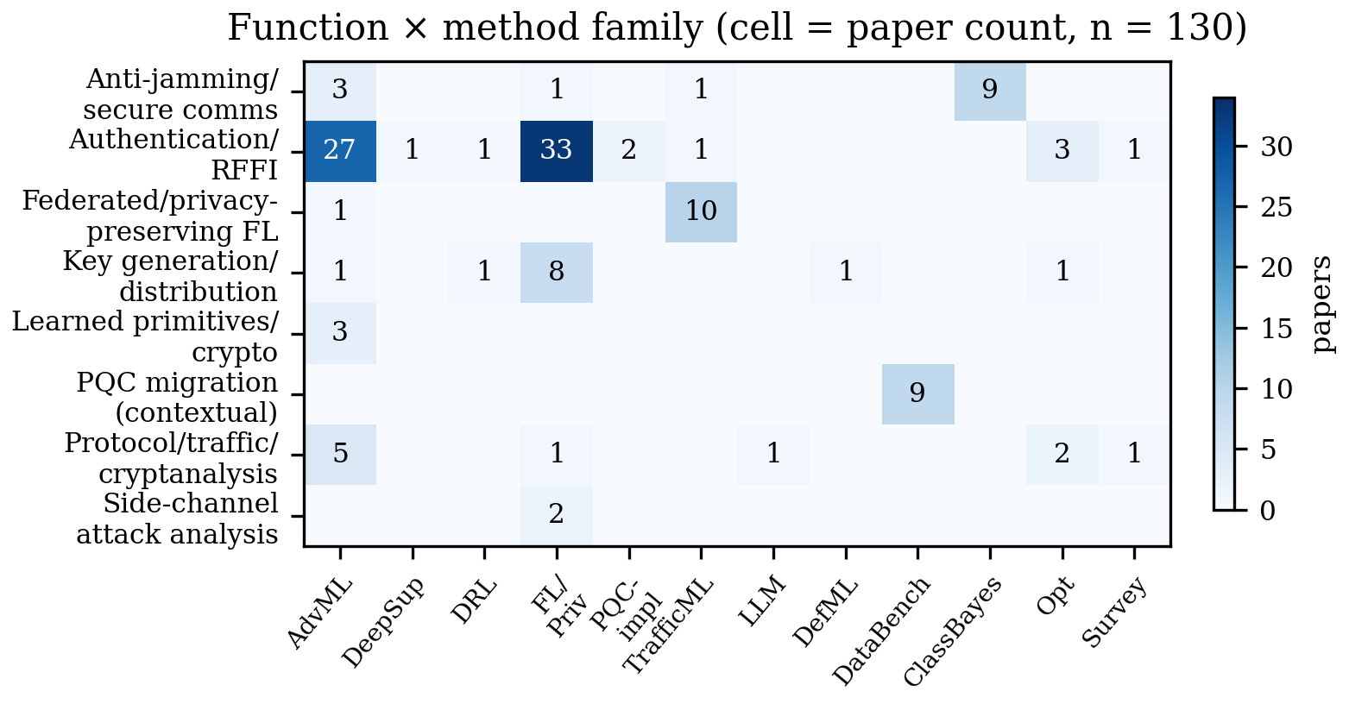
Figure 7: The corpus mapped across security functions and AI method families (n=130). Cell values are paper counts.

3.4 Data landscape and validation practice
Data sources: Testbed/OTA measurement 46, Collected datasets/traces 26, Simulation 20, Analysis/benchmark 6, Unclear from abstract 32 (Fig. 8, left; Table 7; data-source field, not validation). Validation: Testbed/field demonstration 47 (36%), Cross-domain/generalization 26 (20%), Simulation-only 18 (14%), Standard split/unclear 35, Benchmark/analysis 4 (right panel). Crossing validation with track substantiates the section’s descriptive headline (Fig. 9): among threat papers (n=30), 16 are testbed/field demonstrations, 9 standard splits, 2 cross-domain, 2 simulation-only, 1 benchmark — measured plurality, not norm, with 6 threat data-sources unclear from abstract; key generation carries the simulation-only mass (7 of 12 keygen papers simulation-only; defense sim-only 16 of 84 — Table 9).
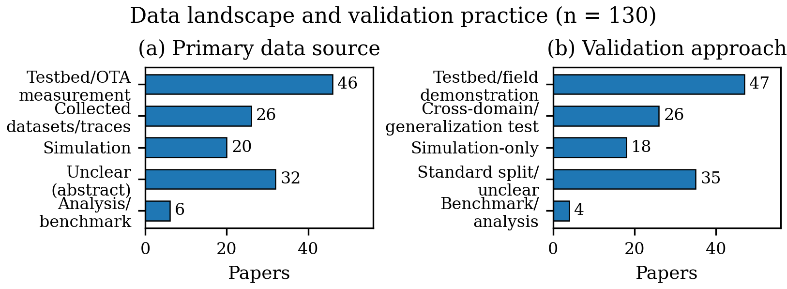
Figure 8: Primary data sources (left) and validation approaches (right) across the corpus (n=130). Testbed/field demonstration is the modal validation; simulation-only work concentrates in key generation (7/12) with a smaller FL-privacy-analysis cluster.
Table 5: Readiness-score count distributions (0/1/2) over all 130 rows. R3/R5 zeros include attack-only rows without an observable signal (24 of 30 for R3, 25 of 30 for R5); attack rows with an observable cost or standards signal are coded 1 (§2.5).
Score | 0 | 1 | 2
R3 cost | 101 | 25 | 4
R4 artifacts | 126 | 4 | 0
R5 standards | 113 | 17 | 0

Table 6: Readiness means by publication year (n in parens): cost/artifact/standards reporting stays flat while output grows.
 | 2020 (4) | 2021 (17) | 2022 (10) | 2023 (21) | 2024 (29) | 2025 (36) | 2026 (13)
R3 mean | 0.00 | 0.29 | 0.10 | 0.24 | 0.28 | 0.25 | 0.38
R4 mean | 0.00 | 0.00 | 0.00 | 0.00 | 0.00 | 0.08 | 0.08
R5 mean | 0.00 | 0.12 | 0.10 | 0.05 | 0.17 | 0.14 | 0.23

Readiness means per track: threat R1 1.70 / R2 1.53 / R3 0.20 / R5 0.17; defense R1 1.14 / R2 1.27 / R3 0.19 / R4 0.02 / R5 0.07; both (n=7) R1 1.86 / R2 1.14 (lowest realism); PQC-context R3 1.11 / R5 0.56 — the only stratum with real cost and standards numbers (ESP32 DTLS 313 ms, sub-12 kB Dilithium, Cortex-M4 cycles; FIPS 203/186, 3GPP, 802.11, O-RAN references). R3 and R5 are coded on attack-only rows whenever the abstract states an observable attacker-cost or standards signal — 6 attack rows carry R3 = 1 and 5 carry R5 = 1, all mention-level — while rows without such a statement score 0 (24 of 30 for R3, 25 of 30 for R5); these values enter per-track means and corpus-level counts (Table 5) but are never pooled into defense-side comparisons. Medians are reported with the rubric in §2: R3 median 0 on defense rows, R5 median 0 on defense and dual rows and 1 on PQC-context rows. Fig. 10 plots the means by track. Table 5 gives the underlying 0/1/2 count distributions (means are reported alongside, never alone), and Table 6 shows readiness reporting by year: cost/artifact/standards reporting stays flat while output multiplies, even as validation grade improves by share — volume and maturity do not move together.
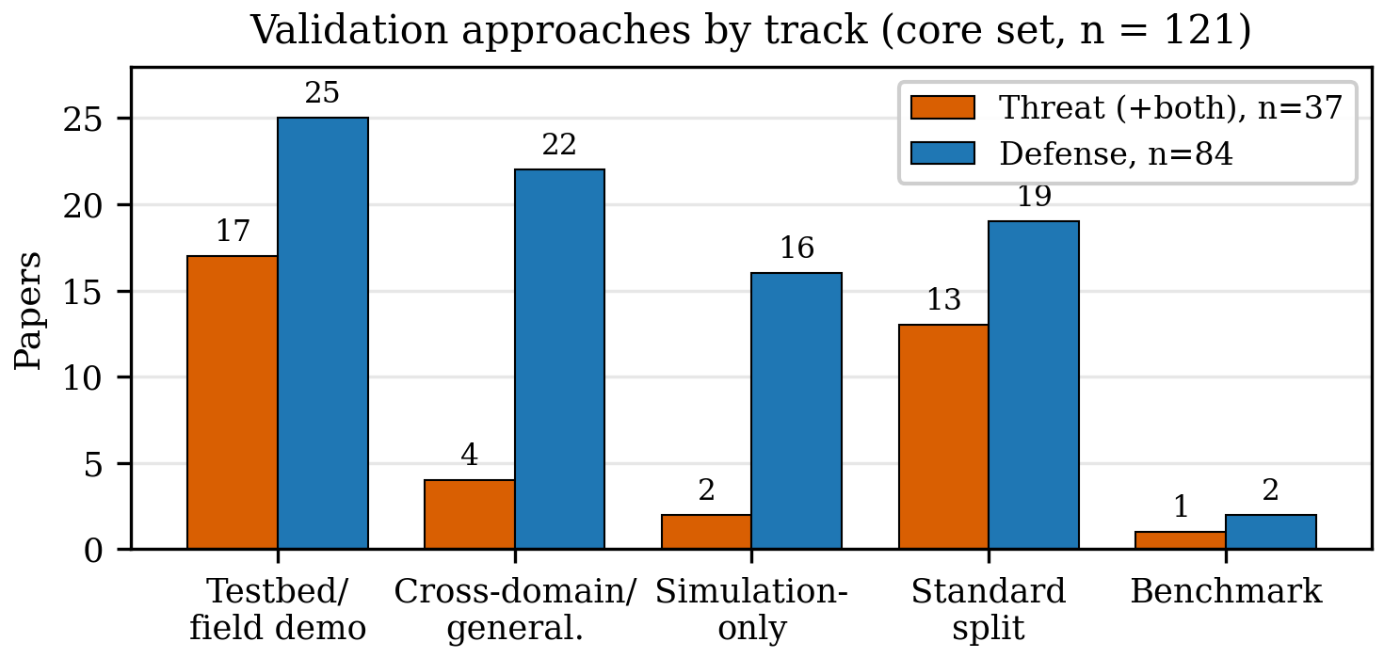
Figure 9: Validation approaches by track (core set, n=121: 84 defense, 37 threat+both). Threat+both: 17 testbed/field, 4 cross-domain, 2 sim-only, 13 standard/unclear, 1 benchmark — measured plurality, not norm; defense carries the simulation-only mass (16 of 84). Data-source and validation fields are distinct — see text.
Coding-depth context for the readiness comparison. The threat–defense R2 gap (1.53 vs 1.27, 0.26) is a single-coder descriptive statistic computed over rows of mixed coding depth: 10 of the 16 threat testbed/field rows were coded from abstracts and 6 from full text, while the 20 body-read rows overall skew toward defense-side upgrades. Restricted to the like-depth abstract-only stratum (110 rows: threat n=22, defense n=74, dual n=5, PQC n=9), the gap attenuates but persists in the same direction — threat R2 1.50 vs defense R2 1.30 (0.20), with the dual-track stratum lowest (1.00). The like-depth figure is the more conservative of the two, and both are reported wherever the comparison carries interpretive weight; the reconciliation drift of §2.3 (up to ≈0.6) remains the dominant uncertainty on any such margin.
Table 7: Data sources recurring across the corpus.
Data source | Papers | Typical use
Testbed/OTA measurement | 46 | SDR captures, LoRa/Wi-Fi/UAV field demos
Collected datasets/traces | 26 | WiSig-style RFFI, RF-SCA trace sets
Simulation | 20 | Keygen channels, DRL jamming games, FL-privacy analysis
Analysis/benchmark | 6 | Proofs, systematizations, information-theoretic analyses
Unclear from abstract | 32 | Body-text resolution pending for paywalled rows (limitation; OA rows resolved where available; 2 of the 32 were body-read yet stayed unresolved)

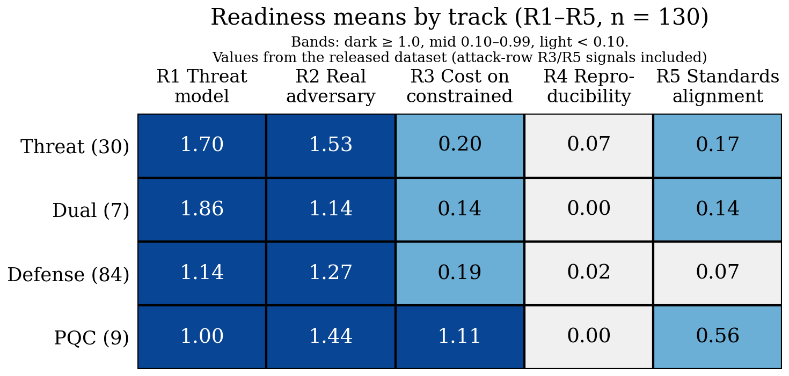
Figure 10: Readiness means by track (R1–R5, n=130; bands: dark ≥1.0, mid 0.10–0.99, light <0.10; Dual row n=7). Attacker-side cost and standards signals observed on threat papers are mention-level and included (threat R3 0.20, R5 0.17; §2.5); threat work releases almost nothing (R4 0.07), and only the PQC-context stratum reports real onboard costs (R3 1.11).
Table 8: Validation practices across the corpus.
Validation | Papers | Interpretation
Testbed/field demonstration | 47 | Deployment-relevant; threat-cluster plurality (16/30), not norm
Cross-domain/generalization | 26 | Strongest lab protocol; defense-cluster best (22/84)
Simulation-only | 18 | Model-fidelity dependent; keygen-heavy (7/12 keygen; 16/84 defense)
Standard split/unclear | 35 | Optimistic without isolation argument (9/30 threat)
Benchmark/analysis | 4 | No empirical validation (proof/analysis-grade); FL-privacy analyses

Table 9: Validation practice by security function (rows sum to function totals, n=130). Values derived programmatically from the released dataset; simulation-only work concentrates in key generation (7/12); RFFI is evaluated across all grades.
Function | Testbed | Cross-dom. | Sim-only | Std/unclear | Bench.
Authentication/RFFI (69) | 23 | 22 | 4 | 20 | 0
Anti-jamming/secure comms (14) | 8 | 1 | 4 | 1 | 0
Key generation/distribution (12) | 3 | 1 | 7 | 1 | 0
Federated/privacy FL (11) | 2 | 0 | 3 | 4 | 2
Protocol/traffic/cryptanalysis (10) | 3 | 2 | 0 | 4 | 1
PQC-context (9) | 5 | 0 | 0 | 3 | 1
Learned primitives (3) | 2 | 0 | 0 | 1 | 0
Side-channel analysis (2) | 1 | 0 | 0 | 1 | 0
Column total (130) | 47 | 26 | 18 | 35 | 4

Reading these panels together yields the section’s headline — the field’s empirical base is bifurcated, not uniformly weak: attacks are demonstrated; defenses are benchmarked. The year-by-year cut (Fig. 11) shows the evidence grade improving by share: testbed plus cross-domain work rises from about 40% in 2021–22 to about 60% in 2023–26 while simulation-only falls from about a quarter to 8–14% by 2023–26 — though year arms hold only 10–36 papers each, so these shares are noisy, and absolute simulation-only counts hold roughly flat rather than being displaced.
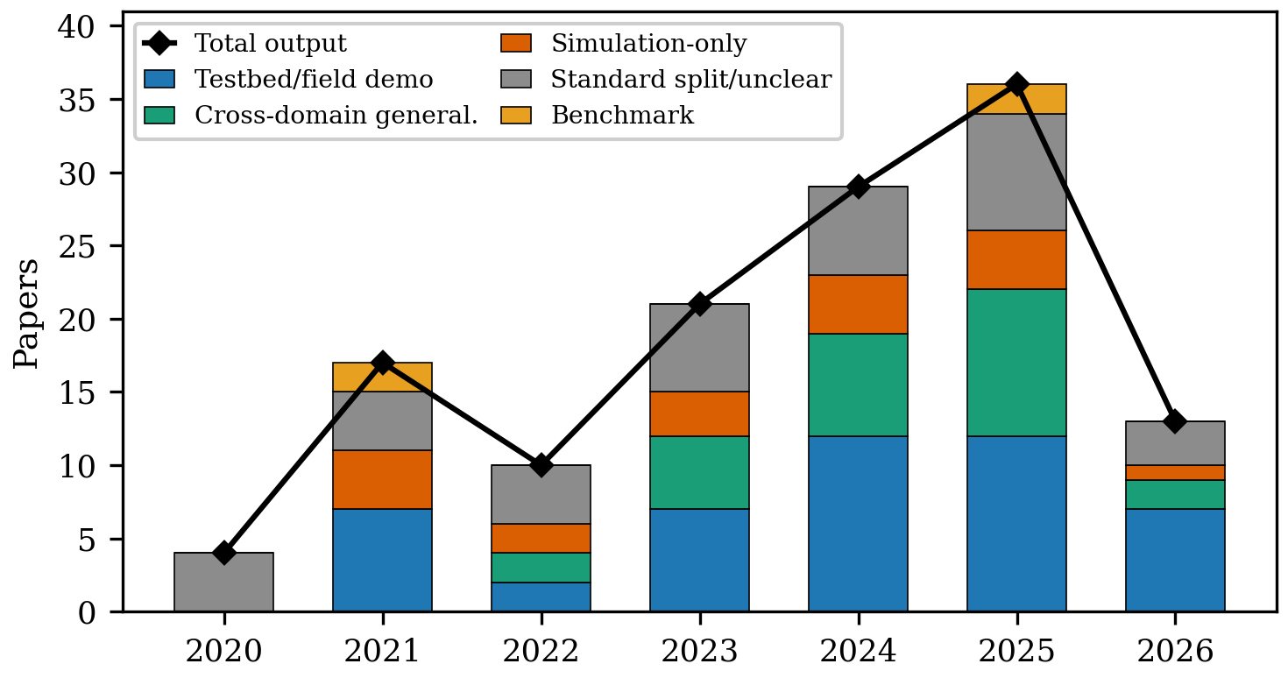
Figure 11: Validation mix by year (stacked) against total output (diamonds). Evidence grade improves by share (testbed plus cross-domain) while absolute simulation-only counts hold flat; year arms span n=4–36, so shares are noisy.

3.5 Sensitivity analysis: is peer review too slow for AI security?
Because the corpus mixes slow and fast publication channels — 65 journal papers, 46 conference/workshop papers, and 19 preprints (venue channel coded from confirmed venue strings; §2) — headline findings could in principle be a channel artifact. We therefore ask the question directly: do frontier methods appear first in fast channels, and does journal peer review compensate with stronger validation? The timing answer, within this verified sample, is partial; the rigor answer favors fast channels, noisily.
Frontier methods debut in fast channels, with stated exceptions. Conferences publish the first adversarial-ML paper in 2020 ([T39] WiseML) a year before the first journal one (2021); the first DRL paper in April 2022 ([D34] WCNC) a year before the first journal one (April 2023 [D22], earliest of the two 2023 journal DRL papers); deep-supervised work debuts tied in 2020 in both channels ([T01] ASHES workshop and the journal paper [D81]) — [T01] is the first deep-supervised side-channel threat demonstration in-corpus, not the first fingerprinting paper. Journals lag conferences on adversarial-ML and DRL first appearance only (2 of 4 families); the PQC-context exception is noted (TCHES 2021 [P05] precedes the in-corpus ACNS 2022 PQC-wireless paper). Table 10 gives each cell with month granularity. The composition gap persists in shares: adversarial ML is 28% of conference papers and 37% of preprints but 31% of journal papers (Fig. 12, panel a; first-appearance map, panel b).
Table 10: First-appearance papers by method family and channel, with issue, online-first, and arXiv-v1 months where evidenced. Lags stand under both issue-year and earliest-date coding except P05 (Dec-2020 online-first vs 2021 issue).
Family | Conference cell | Journal cell | Preprint cell
Adversarial ML | T39 WiseML, Jul 2020 | T09 TCCN, Mar 2021 (D36 Mar 2022; arXiv Apr 2021) | T47 arXiv Jan 2022
Reinforcement/DRL | D34 WCNC, Apr 2022 | D22 TVT, Apr 2023 (no online-first record) | —
Deep supervised | T01 ASHES, Nov 2020 | D81 IEEE Access 2020 | D63 arXiv Jun 2023
PQC implementation | P10 LNNS 2025 | P05 TCHES 2021 issue (online Dec 2020) | —

Table 11: Venue-channel sensitivity: validation mix across journals (n=65), conferences (n=46), and preprints (n=19). Machine-generated from the released dataset.
Validation | Journal | Conference | Preprint
Testbed/field demonstration | 26 (40%) | 14 (30%) | 7 (37%)
Cross-domain/generalization | 13 (20%) | 11 (24%) | 2 (11%)
Simulation-only | 6 (9%) | 8 (17%) | 4 (21%)
Standard split/unclear | 20 (31%) | 10 (22%) | 5 (26%)
Benchmark/analysis | 0 | 3 (7%) | 1 (5%)

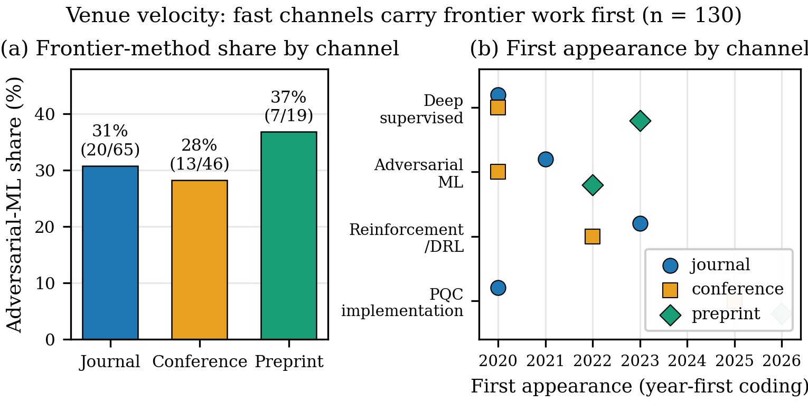
Figure 12: Venue velocity. (a) Adversarial-ML share is highest in preprints (37%, 7/19), then journals (31%, 20/65), lowest in conferences (28%, 13/46). (b) First appearance of the four focal method families by channel (year-first coding; Table 10): conferences lead journals on adversarial ML (2020 vs 2021) and DRL (2022 vs 2023); deep-supervised debuts tie in 2020; PQC reverses the pattern (journal December 2020 online-first / 2021 issue vs conference 2025). Channel markers are offset within each family row.
Journals lead conferences on both validation share (Table 11: testbed 40% vs 30%) and mean evaluation-realism scores (R2 1.40 vs 1.26; preprints 1.32) — but both gaps are small relative to arm sizes (n=65/46/19), and the R2 gap is sensitive to single-coder judgment (reconciliation moved means by up to about 0.6), so no prestige gradient is claimed in either direction; the durable channel result is the timing lag, not a rigor ranking. Conferences lead journals by roughly a year on adversarial ML and DRL first appearance (deep-supervised debuts tied in 2020; PQC reverses the pattern: journal December 2020 online-first (2021 issue) against a 2025 conference debut). P03’s ACNS 2022 proceedings version is coded to the journal channel; the reversal holds under either coding. An earliest-public-date audit over all 15 DOI-year mismatches (Crossref online/print dates) moves no first-appearance cell — the D22 TVT paper printed April 2023 despite its 2022 DOI number, and D36’s own arXiv dates to April 2021 — so the lags stand under both issue-year and earliest-date coding; only P05 shifts (December-2020 online-first vs 2021 issue), which widens the PQC reversal. The preprint stratum (37% testbed, heavily selected — see caveats) cannot carry a channel claim on its own. Consistent with the no-formal-tests rule (§2), no significance tests are run on these splits.
Three caveats bound this finding, and the third is the most serious. First, the preprint arm is small (n=19), the conference arm mixes full conferences with workshops, and each first-appearance cell rests on a single paper in a curated sample at year granularity, so both the shares and the lags carry wide uncertainty. Second, the LLM-assisted family has a single published paper (USENIX Security 2026 [T28]) and cannot support any channel claim. Third, seeded expert search favors notable, well-evidenced preprints — weak preprints are never found or shortlisted — so the preprint stratum’s scores partly reflect selection, not the channel. What selection cannot explain is the journal side of the ledger: journals trail conferences by roughly a year on adversarial ML and DRL first appearance while running close on validation (testbed 40% vs 30%; R2 1.40 vs 1.26). For a field where the adversary reads arXiv, that lag is a deployment-relevant result in itself — and it strengthens, rather than weakens, the case for the reporting checklist in §8, since speed without standards is how the validation gap in §3 reproduces itself.

4 AI-Enabled Threats: What the Corpus Demonstrates
RFF/authentication attacks form the densest cluster (Table 12): white-box FGSM/PGD and black-box UAP at 81.7% with ∼no victim knowledge on real LoRa captures [T03], RL impersonation at >90% from binary feedback [T18], GAN-spoofing at 76% PHY-auth pass [T09], backdoors surviving Neural Cleanse/STRIP [T12] and working model-agnostically [T16], self-supervised-target backdoors [T41], over-the-air Wi-Fi attacks [T42], and fingerprint erasure as privacy attack [T06]. EM/RF side-channels move key recovery over the air at meters: BLE AES-128 at 15 m from <400 traces [T01], and nRF AES-CCM at 1 m with BLE re-keying LTK leakage in ∼30 traces [T08]. Protocol/traffic attacks show the stack above PHY is equally exposed: padding/shaping defeated by packet-size distributions [T19], and LLM-assisted semantic baseband fuzzing (ConSeT: 7 vulns including 3 CVEs across 542 phone models, plus 29 OAI-UE crash sites, USENIX Security 2026 [T28]). Critical assessment: attacks are evaluated against real systems with stated — often weak but honest — threat models (strong R2, narrow R1). The missing attack science is adaptive-defense evaluation: most stop at undefended classifiers, which is why Magmaw [T30] matters — it survives adversarial training, subtraction, detection, and oracle defenses. Domain shift is attack surface, not demonstrated exploit: no cited threat paper exploits shift as a standalone vector.

5 AI-Assisted Defenses: What the Corpus Demonstrates
RFF/PLA defenses chase domain shift: contrastive embeddings, receiver-agnostic training, open-set/few-shot enrollment, cross-receiver calibration [D75], multi-distance generalization [D73], domain-adaptive features [D72], satellite fingerprinting [D71], proactive authentication — accuracy under shift, rarely under attack. Key generation defenses improve KDR/KGR mostly in simulation, with a 2026 channel-informed neural scheme [D74] grounding features in over-the-air channel soundings. DRL anti-jamming optimizes relay/power/secrecy-rate without onboard-cost reporting. Federated privacy demonstrates differentially private OTA aggregation at small scale.
Critical assessment: the wall between §4 and this section is the finding — dual-track studies are 7 of 130 (5.4%; 7 of 121 core, 5.8%), and dual-track realism runs lowest (mean R2 1.14 vs 1.53 threat, 1.27 defense — a 0.13 margin at n=7, so a descriptive remark, not a ranking claim; single-coder, and fragile at this n), so closed-loop evaluation exists but is least realistic. RFF accuracy ≠ authentication; domain-shift misclassification is attack surface (T40), not demonstrated exploit. The defense literature’s strongest protocols (cross-receiver, cross-day, open-set) are exactly the threat literature’s attack surface.

6 Quantum-Era Context (Separate Stratum)
Compute is feasible on ESP32/Pi-class hardware (ML-KEM DTLS 313 ms, beating classical baselines; sub-12 kB Dilithium; Cortex-M4 cycle counts); bandwidth expansion is the blocker; WKyber [P08] and LAKE [P11] attack exactly that. Short-range radio key-recovery evidence (far-field BLE SCA [T01]) shows keys can be pulled over the air, but no in-corpus paper addresses store-now-decrypt-later against the PQC transition for wireless fleets. The AI-threat × PQC join is empty: no in-corpus paper mounts ML-driven cryptanalysis of a PQC implementation over a radio link (an acoustic–vibration proximity study was excluded for failing the radio-link population; see §2). The join is recorded as an explicit gap (§8), and the stratum stays separate so that no pooled AI-security claim is made over it.
Table 12: Representative corpus studies by function and method family. Entries gloss each study as: study summary (data basis; headline contribution).
Function | Family | Representative studies
RFF/auth attack | Adversarial | White-box FGSM/PGD plus black-box UAP 81.7% on LoRa captures (CNN/LSTM/GRU; no victim knowledge) [T03]; RL impersonation >90% (SDR; binary feedback) [T18]; GAN-spoof 76% (OTA; PHY-auth pass) [T09]; SSL-target backdoor [T41]; FooLoc OTA WiFi geofence-bypass [T42]
Side-channel | Deep supervised | Far-field BLE AES-128 at 15 m, <400 traces (OTA) [T01]; nRF AES-CCM at 1 m with BLE LTK recovery in ∼30 traces [T08]
Protocol/traffic | Fuzzing/ML | LLM baseband fuzzing, 3 CVEs (phones; ConSeT) [T28]; padding defeat (traces; traffic-shape exploit) [T19]
Universal PHY | Adversarial | Magmaw, NDSS’25 (SDR; protocol-agnostic UAP vs encrypted link) [T30]
Defense RFFI | Robust/open-set | Contrastive, receiver-agnostic, open-set/few-shot, cross-receiver calibration [D75], multi-distance [D73], satellite PLA [D71] (captures; accuracy under shift)
Keygen | Deep/DRL | KDR/KGR improvements (mostly simulation; reciprocity + IRS/relay)
Anti-jamming | DRL + testbed UAV | Relay/power/secrecy-rate control (mixed: 8 testbed, 4 sim-only; costs mostly unreported)
PQC-context | Implementation | ML-KEM DTLS 313 ms on ESP32 (hardware; compute fine, bandwidth blocks); WKyber/LAKE (bandwidth attacks) [P08][P11]
AI×PQC join | — | Empty in-corpus (non-radio proximity study excluded; recorded gap)

7 Cross-Cutting Directions
Three threads cut across the function-level reviews: closed-loop evaluation, autonomous trust, and reproducibility. Closed-loop evaluation (§2.6) reaches at least 14 of 121 core (11.6%, a lower bound): the 7 dual-track papers (D08, D36, D37, T05, T11, T14, T46 — 5 under a stricter title-only dual rule with T05/T14 reverting to threat; T31 stays threat either way since its mitigation is secondary), 3 threat papers that demonstrate against defenses (T30 against adversarial training, subtraction, detection, and oracle defenses; T12 by bypassing Neural Cleanse and STRIP; T31 assessing a distillation defense on an OTA O-RAN testbed), and 4 defense papers that demonstrate against attacks (D67 against GAN-based impersonation; D54 against Byzantine poisoning; D32 against live impersonating UAVs; D48 flagging evasive queries). The broader measure remains the exception (the §4–§5 wall), autonomous trust (real-time deadlines unbenchmarked; OTA crypto-agility essentially unaddressed; multi-agent trust in 1–2 papers while FL-for-drones falls to deauth→impersonation chaining [T36]), and reproducibility (4 verified artifact releases among 121 core, 3.3%) are the three cross-cutting threads (Fig. 14). Dual-track realism is lowest (mean R2 1.14, n=7; §5), which complicates any closed-loop optimism: evaluation exists but is least realistic.
Function × validation cross-tabulations are descriptive (no significance tests; metric heterogeneity forbids pooling). The field optimizes estimators while adversaries optimize exploitability — a mismatch no single-function advance can fix. A venue-community check does not explain the asymmetry away: stratifying R2 by security venues (NDSS, CCS, USENIX, TIFS, WiseML and kin) versus comms and other venues, comms-venue threats outscore comms-venue defenses on realism (means 1.61 vs 1.31, n=23/68), while security-venue papers score lower in both tracks (threat 1.29, n=7 — T01, T19, T20, T23, T28, T30, T39, of which T01, T28 and T30 score 2 and the analysis/workshop remainder scores 0–1; defense 1.12, n=16) — small-n and caution-worthy, but running against the community-norms confound rather than with it. Fig. 13 stacks the corpus by layer to make the coverage gap visible: the signal layer is contested, the link layer half-defended, the protocol layer thinly covered, and the system layer essentially absent.
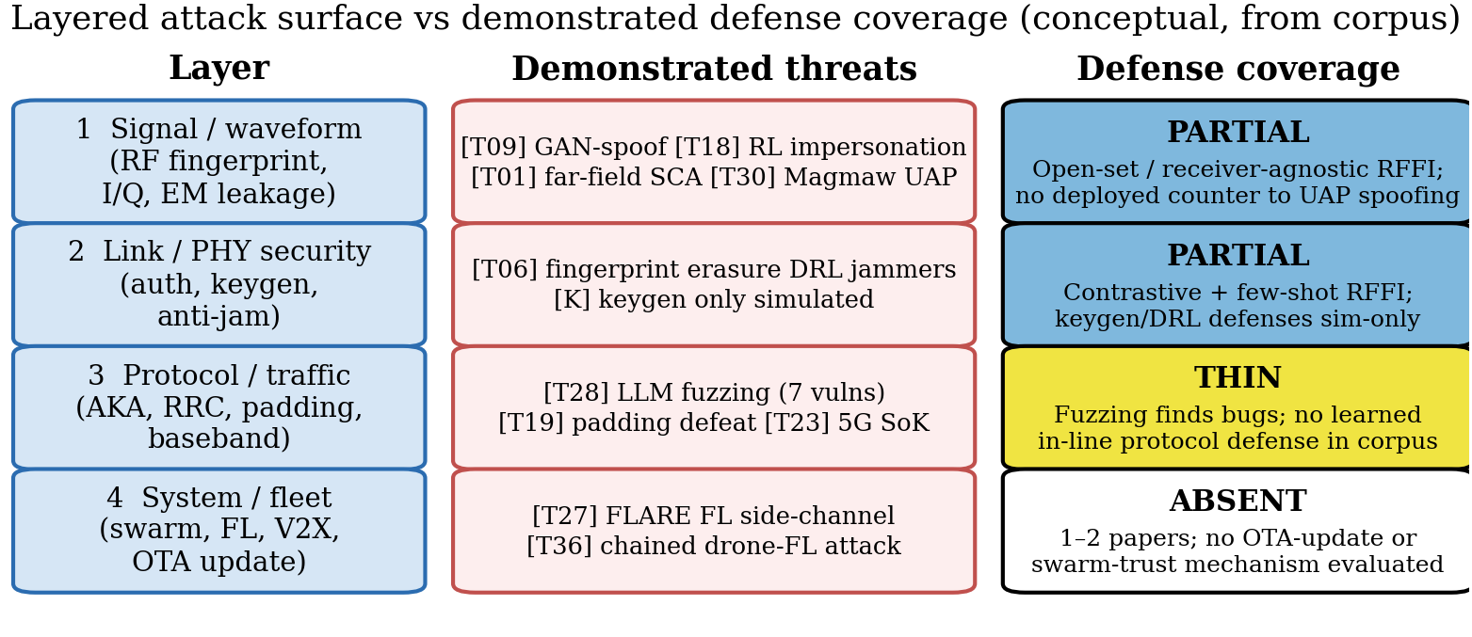
Figure 13: Layered attack surface versus demonstrated defense coverage, synthesized from the corpus (conceptual). Coverage thins with every step up the stack.
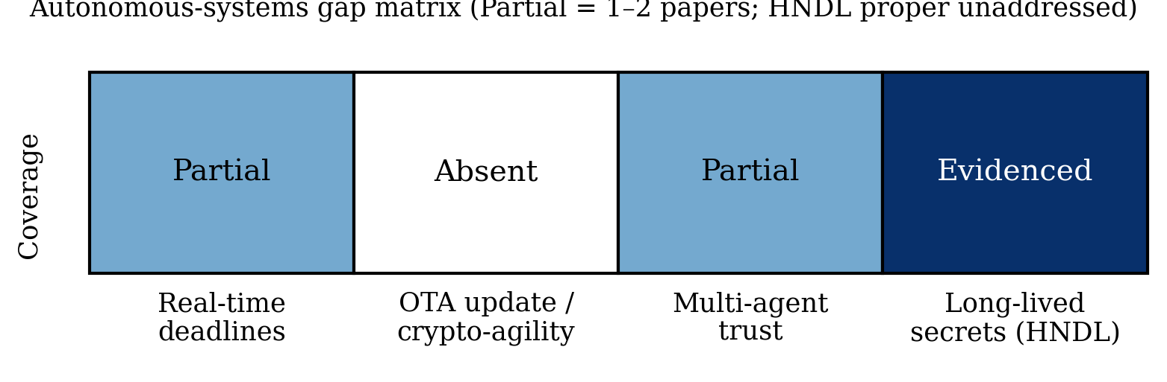
Figure 14: Autonomous-systems gap matrix. Real-time deadlines and multi-agent trust are Partial (1–2 papers each: nascent coverage, far from deployment-grade, hence “essentially unaddressed” in the abstract); OTA update/crypto-agility is absent; long-lived secrets show short-range key-recovery evidence (BLE far-field SCA) while store-now-decrypt-later against the PQC transition is unaddressed.

8 Research Gaps and Future Directions
Cross-referencing the bibliometric analysis of §3 with the function-level reviews of §§4–7 yields six structural gaps, summarized in Table 13 and operationalized into the concrete reporting checklist in Table 14. The ordering is deliberate: the first three rows concern how the field evaluates and shares evidence, the fourth how it reports cost, and the last two where the evidence stops short of deployment needs. None of the six requires a new method family, and all are measurable against the released dataset — a rerun of this review in two years should be able to score each row as narrowed, unchanged, or widened. The checklist is the review’s most actionable artifact: the minimum metadata a study must disclose for its claims to be comparable, reproducible, and poolable in future syntheses. Each item corresponds to a practice whose absence the corpus analysis showed to be distorting — undisclosed splits, unnamed datasets, or unquantified compute.
Table 13: Structural research gaps and corresponding future directions.
Gap | Evidence | Direction
Closed-loop evaluation | Dual-track 7/130 (5.4%); dual R2 1.14 lowest (fragile margin, §5); broader measure 14/121 core (11.6%) | Adversarial-benchmark suites with OTA mandates
Reproducibility | 3.3% verified releases (4/121 core); R4 means 0.00–0.07 | Artifact-evaluated security tracks; dataset DOIs
Standards alignment | 9.9% outside PQC (13.1% incl. PQC); RFF 6/69; defense R5 0.07 overall; no row reaches the profile-evaluated tier | Authentication profiles (3GPP/IETF) for learned PHY-auth
Onboard cost | DRL/semantic cost-silent; defense R3 0.19 (16/84 rows) | Latency/energy/memory as required reporting
Autonomous trust | 1–2 papers per need | Real-time auth, OTA agility, swarm insider models
AI×PQC join | Empty in-corpus (non-radio proximity study excluded) | ML-SCA of PQC over the air; migration prioritization

Table 14: Proposed WIRELESS-AI-RC reporting checklist (12 items).
# | Item | Must report
1 | Dataset/testbed identity | Name, version, download or testbed description
2 | Device/link population | Radios, channels, distances, day/receiver splits
3 | Adversary model | Knowledge, capability, RF/compute budget
4 | Split protocol | Within/cross-receiver/day/domain + isolation argument
5 | OTA vs simulation | Declaration; sim-only flagged as such
6 | Closed-loop evaluation | Attack paper: defenses tested; defense paper: attacks tested
7 | Baselines | ≥1 classical alongside proposed method, identical data
8 | Randomness | Seeds or repeated-run statistics
9 | Uncertainty | Error bars, not point estimates alone
10 | Onboard cost | Latency/energy/memory on stated platform
11 | Failure analysis | ≥1 documented failure mode + distribution
12 | Artifacts | Code/data DOI or explicit exemption

Checklist adherence in-corpus is reported only for coded items (descriptive, single-coder); Table 15 consolidates the per-item counts against the released dataset so the baseline is directly reusable. Items 7–9 and 11 (baselines, seeds, uncertainty, failure analysis) were never coded, so no corpus claim is made about them — they are prospective requirements, as is the checklist as a whole beyond the coded items. We suggest venues adopt the checklist as a submission requirement and authors attach it to their released datasets: it costs little, and it is what lets the next synthesis do its job.
Table 15: WIRELESS-AI-RC adherence in this corpus, coded items only (descriptive, single-coder; machine-generated from the released dataset).
# | Item | In-corpus status
1 | Dataset/testbed identity | Present for 72 testbed-or-collected rows; 32 unclear-source rows pending body-text resolution
2 | Device/link population | Not coded in-corpus (prospective)
3 | Adversary model | Explicit (R1=2) in 39 of 130 rows
4 | Split protocol | Rarely isolated: 35 standard/unclear validations
5 | OTA vs simulation | Declared via validation field (47 testbed/field, 18 simulation-only)
6 | Closed-loop evaluation | ≥14 of 121 core (11.6%) by the §2.6 rule; 7 of 130 dual-track
7 | Baselines | Never coded (prospective)
8 | Randomness | Never coded (prospective)
9 | Uncertainty | Never coded (prospective)
10 | Onboard cost | Present on 16 of 84 defense rows (defense R3 mean 0.19)
11 | Failure analysis | Never coded (prospective)
12 | Artifacts | Released for 4 of 121 core (3.3%): D30, D32, T28, T30

9 Conclusion
Three conclusions stand out, answering the title question for the research literature directly: no — the published literature does not demonstrate wireless security ready for the AI era on current evidence (a statement about literature maturity in this curated sample, not a measurement of deployed systems, and one drawn entirely from single-coder, second-author-validated descriptive statistics). First, the method center moved from fingerprint classifiers to adversarial science — attacks are cheap, largely demonstrated on captures/testbeds (threat plurality 16/30 testbed, not norm), and OTA-demonstrated in the strongest cases; this is the corpus’s most robust contrast because it rests on categorical validation counts. Second, the application center stayed in RFFI accuracy, which is not authentication — defenses are rarely adversarially evaluated (broader closed-loop ≥14 of 121 core, 11.6%; dual-track detail in §7). Third, readiness does not follow publication volume: reproducibility, standards, onboard cost, and autonomous-trust evidence trail accuracy claims in volume and maturity; standards alignment is mention-level wherever it exists, and venue channels differ modestly on rigor (testbed 40% journals vs 30% conferences; R2 1.40 vs 1.26, gaps small relative to arm sizes) (§3.5).
These are the findings a future update of this corpus can most cheaply overturn or confirm: a 20–25% blind double-code with agreement statistics (§2.4), a full-text audit of the R1/R2 fields, and a two-year rerun scoring each gap of Table 13 as narrowed, unchanged, or widened. If the last five years were about discovering what learning can extract from radio signals, the next five will be decided by what it can be trusted to protect — under adaptive adversaries, on constrained radios, at fleet scale.

Declarations
Funding. No specific funding for this work. Conflicts. None declared. Author contributions. Hussain Touhid Siddiquee (correspondence: touhidsiddiqueeraj@gmail.com) performed 100% title/abstract screening, full-text eligibility review, charting, coding, formal analysis, and drafting; Md. Abul Malek Fahim independently reviewed and validated the coding decisions and all derived results, and both authors are in agreement with the reported findings; two independent verifiers performed corrective verification checks on a 22-record sample. Both authors read and approved the submitted manuscript. Data availability. The classified corpus (dataset_papers.csv), screening log, retrieval records, and analysis scripts accompany this submission as an anonymized supplementary archive (mirrored on an anonymized hosting service for review); a public repository will be named only upon acceptance. Code availability. Coding and figure-generation scripts are included in the supplementary archive and rerun from the released dataset; check_consistency.py gates export. Ethics. Not applicable. AI use. AI assistance was limited to candidate pooling, prose drafting, and copy-editing; no screening, coding, counting, or verification decision was delegated to AI, and all counts were computed programmatically from the released dataset under human control (first-author coding; second-author validation; independent verifier sample; no blind κ claimed). Every record carries a resolvable identifier verified against Crossref, arXiv, ACM, or USENIX; no identifier was fabricated or shared. The authors take full responsibility for the content.

References (corpus, keyed by corpus ID)
Corpus IDs (e.g. [T30]) are the citation keys used in the text. The full classified dataset maps each ID to its coding. Corpus IDs are archival and non-contiguous: gaps reflect rows removed before the corpus froze (§2.3), and backup rows (T26, T29, D51, P07) are held outside the 130.
D01 Coutaud et al., “Learning asymmetric encryption using adversarial neural networks,” Engineering Applications of Artificial Intelligence (Elsevier), 2023. https://www.sciencedirect.com/science/article/abs/pii/S0952197623004049
D02 Guo Y; Zhang J; Hong Y-WP, “Practical Physical Layer Authentication for Mobile Scenarios Using a Synthetic Dataset Enhanced Deep Learning Approach,” IEEE Trans Inf Forensics Secur, 2025. https://doi.org/10.1109/TIFS.2025.3602265
D03 Wang R; Tang J; Shi Y; Chang SY, “Deep Learning Based Adaptive Physical Layer Key Distribution,” IEEE NCIC, 2023. https://doi.org/10.1109/NCIC61838.2023.00046
D04 Dentremont C; Liu H, “Deep Learning Dataset Generation for Physical Layer Authentication in Wireless Sensor Networks (WSN),” IEEE IWCMC, 2024. https://doi.org/10.1109/IWCMC61514.2024.10592476
D05 Li J; Zhang S; Xing M; Qiao Z; Zhang X, “Mobile Device Identification Based on Two-dimensional Representation of RF Fingerprint with Deep Learning,” IEEE ISCC, 2022. https://doi.org/10.1109/ISCC55528.2022.9913038
D06 Lu Z; Wang T; Liu X; Li N, “Deep Learning Based Wireless Device Identification Using RF Fingerprint,” IEEE NNICE, 2023. https://ieeexplore.ieee.org/document/10105692
D07 Shen G; Zhang J; Marshall A; Woods R, “Towards Receiver-Agnostic and Collaborative Radio Frequency Fingerprint Identification,” IEEE Trans Mobile Computing, 2024. https://doi.org/10.1109/tmc.2023.3340039
D08 Papangelo L; et al., “Adversarial machine learning for image-based radio frequency fingerprinting: Attacks and defenses,” IEEE Communications Magazine vol 62(11) pp 108-113, 2024. https://ieeexplore.ieee.org/document/10384628
D09 Feng C; Sun L, “Physical Layer Key Generation from Wireless Channels with Non-ideal Channel Reciprocity: A Deep Learning Based Approach,” IEEE VTC Spring, 2022. https://doi.org/10.1109/VTC2022-Spring54318.2022.9860995
D10 Chen C; Zhang J; Lu T; Sandell M; Chen L, “Machine Learning-Based Secret Key Generation for IRS-assisted Multi-antenna Systems,” IEEE ICC, 2023. https://arxiv.org/abs/2301.08179
D11 Zhang X; Li G; Zhang J; Hu A; Xiao B, “Deep Learning-based Physical-Layer Secret Key Generation for FDD Systems (KGNet),” IEEE Internet of Things Journal, 2021. https://doi.org/10.1109/jiot.2021.3109272
D12 Jiao L; Sun G; Le J; Zeng K, “Machine Learning-Assisted Wireless PHY Key Generation with Reconfigurable Intelligent Surfaces,” ACM WiseML, 2021. https://doi.org/10.1145/3468218.3469042
D13 Shi Y; Tang J; Wang R; Wen H, “Physical Layer Key Distribution Technology on Deep Learning,” IEEE NCIC, 2023. https://doi.org/10.1109/ncic61838.2023.00027
D14 Liu X; Wang X; Xu Y; Du Z; Xu Y; Han H, “Lightweight Reinforcement Learning with State Abstraction for Dynamic Spectrum Anti-Jamming Communications,” IEEE WCNC, 2024. https://doi.org/10.1109/WCNC57260.2024.10571324
D15 Lv Z; Xiao L; Du Y; Niu G, “Multi-Agent Reinforcement Learning Based UAV Swarm Communications Against Jamming,” IEEE Trans Wireless Commun vol 22(12), 2023. https://doi.org/10.1109/twc.2023.3268082
D16 Shao Z; Yang H; Xiao L; et al., “Deep Reinforcement Learning-Based Resource Management for UAV-Assisted Mobile Edge Computing Against Jamming,” IEEE Trans Mobile Computing vol 23(12), 2024. https://doi.org/10.1109/TMC.2024.3432491
D17 Su G; Dai M; Chen B; Lin X, “Reinforcement Learning Aided Secure UAV Communications against Roaming Adversaries,” IEEE ICOIN, 2024. https://doi.org/10.1109/ICOIN59985.2024.10572192
D18 Zhou; Wang; Ma; Fan; Xiao, “Physical Layer Authentication for UAV Communications Under Rayleigh and Rician Channels,” IEEE Trans Wireless Commun vol 24 pp 2722-2733, 2025. https://doi.org/10.1109/TWC.2024.3524210
D19 Amin H; Kaldari J; Mohamed N; Aman W; Al-Kuwari S, “Hybrid PLS-ML Authentication Scheme for V2I,” IEEE ISNCC, 2023. https://doi.org/10.1109/isncc58260.2023.10323824
D20 Cheng Q; et al., “Physical Layer Authentication in UAV Communications (spoofing),” IEEE Transactions on Vehicular Technology, 2025. https://doi.org/10.1109/tvt.2025.3532982
D21 Song; Guo; Hu; Yang, “Deep Reinforcement Learning-Based Anti-Jamming Rate Adaptation (UAV ad hoc),” IEEE Trans Consumer Electronics (Nov), 2025. https://doi.org/10.1109/tce.2025.3627267
D22 Dong; Wang; Tian; Cheng, “Deep Reinforcement Learning Based UAV for Securing mmWave Communications,” IEEE Trans Vehicular Technology (Apr), 2023. https://doi.org/10.1109/tvt.2022.3224959
D23 Zhang Z; Guo Y; Fang Y; Gong Y, “Communication and Energy Efficient Wireless Federated Learning with Intrinsic Privacy (PFELS),” IEEE Trans Dependable Secure Comput, 2023. https://arxiv.org/abs/2304.07460
D24 Seif M; Tandon R; Li M, “Wireless Federated Learning with Local Differential Privacy,” IEEE ISIT 2020 (pp 2604-2609), 2020. https://doi.org/10.1109/ISIT44484.2020.9174426
D25 Aghdam SR; Amid E; Furdek M; Graell i Amat A, “Privacy-Preserving Wireless Federated Learning Exploiting Inherent Hardware Impairments,” IEEE CAMAD Workshops, 2021. https://doi.org/10.1109/camad52502.2021.9617764
D26 Mao J; et al., “Providing Differential Privacy for Federated Learning Over Wireless: A Cross-layer Framework,” IEEE ICC (presented per authors), 2024. https://arxiv.org/abs/2412.04408
D27 Wu; Chen; Sun; Fang, “Open Set RF Fingerprint Identification for Wireless Communications,” IEEE Wireless Commun Lett (Mar), 2025. https://doi.org/10.1109/lwc.2024.3523271
D28 Xie W; et al., “A Novel Radio Frequency Fingerprint Identification Scheme for Few-shot Open-set Recognition,” IEEE Internet of Things Journal vol 12 pp 25691-25706, 2025. https://doi.org/10.1109/jiot.2025.3559183
D29 Liu; Zhao; Chen, “A Novel Framework for Few-Shot RF Fingerprint Identification Using Signal Recurrence Plot and Broad Learning,” IEEE Commun Lett (Sep), 2025. https://doi.org/10.1109/lcomm.2025.3588073
D30 Cai; Shan; Gao; He, “Open Set RF Fingerprinting Identification: A Joint Prediction and Siamese Comparison Framework,” IEEE ICC, 2025. https://doi.org/10.1109/icc52391.2025.11160882
D31 Ma Z; Fang S; Fan Y, “Open-Set Radio Frequency Fingerprint Identification Based on Multi-Task Prototype Learning,” Sensors, 2025. https://doi.org/10.3390/s25175415
D32 Huang Y; Li R; Chen M; Zhao F; Zhang D; Tu W, “Securing UAV Communications by Fusing Cross-Layer Fingerprints (SecureLink),” IEEE Internet of Things Journal, 2025. https://doi.org/10.1109/jiot.2025.3631020
D33 Tyler JH; Fadul MKM; Reising DR, “Random Adversarial Data Obfuscation Model (RANDOM) Adversarial Neural Cryptography,” venue unconfirmed (arXiv 2411.10287), 2024. https://arxiv.org/abs/2411.10287
D34 Abdalla AS; Behfarnia A; Marojevic V, “Aerial Base Station Positioning and Power Control for Securing Communications: A Deep Q-Network Approach,” IEEE WCNC, 2022. https://doi.org/10.1109/wcnc51071.2022.9771893
D35 Hoseini SA; Bouhafs F; Aboutorab N, “Cooperative Jamming for Physical Layer Security Enhancement Using Deep Reinforcement Learning,” IEEE GLOBECOM Workshops, 2023. https://doi.org/10.1109/gcwkshps58843.2023.10465104
D36 Sahay R; Brinton CG; Love DJ, “A Deep Ensemble-based Wireless Receiver Architecture for Mitigating Adversarial Attacks in Automatic Modulation Classification,” IEEE Trans Cogn Commun Networking (Mar 2022), 2022. https://doi.org/10.1109/tccn.2021.3114154
D37 Meng; Qi; Zheng; Cai; Zhou; Jiang, “Adversarial Attack and Reliable Defense Based on Frequency Domain Feature Enhancement for Automatic Modulation Classification,” IEEE Trans Inf Forensics Secur vol 20 pp 3731-3744, 2025. https://doi.org/10.1109/TIFS.2025.3553806
D38 Gao N; Han Y; Li N; Jin S; Matthaiou M, “When Physical Layer Key Generation Meets RIS: Opportunities Challenges and Road Ahead,” IEEE Wireless Communications, 2024. https://doi.org/10.1109/mwc.013.2200538
D39 Alwazani H; Chaaban A, “Disruptive RIS for Enhancing Key Generation and Secret Transmission in Low-Entropy Environments,” venue unconfirmed (arXiv 2409.15303), 2024. https://arxiv.org/abs/2409.15303
D40 Guo J; Gao N; Zuo Y; Xu H; Jin S; Wong KK, “A Fluid Antenna Enabled Physical Layer Key Generation for Next-G Wireless Networks,” IEEE WCSP, 2025. https://doi.org/10.1109/wcsp68525.2025.1010537
D41 Zhang X; Li G; Zhang J; et al., “Enabling Deep Learning-based Physical-layer Secret Key Generation for FDD-OFDM Systems in Multi-Environments,” IEEE Trans Vehicular Technology (accepted per arXiv), 2024. https://arxiv.org/abs/2211.03065
D42 Shahiri V; Li G; Behroozi H, “RIS-Assisted Physical Layer Group Key Generation,” venue unconfirmed (arXiv 2507.00714; under review), 2025. https://arxiv.org/abs/2507.00714
D43 Chen Z, “Secure-IRS: Defending Against Adversarial Physical-Layer Sensing,” IEEE ICNC 2025 (pp 436-440), 2025. https://doi.org/10.1109/ICNC64010.2025.10993984
D44 Chen J; Wong W-K; Hamdaoui B, “Unsupervised Contrastive Learning for Robust RF Device Fingerprinting Under Time-Domain Shift,” IEEE ICC, 2024. https://arxiv.org/abs/2403.04036
D45 Razak FA; Yilmaz Y, “Dynamic and Open-Set RF Fingerprinting and Localization in Crowded Indoor Environments through Contrastive CSI Learning,” venue unconfirmed (arXiv 2605.15593), 2026. https://arxiv.org/abs/2605.15593
D46 Zeng S; Shen Y; Zhang Y; Shen Y; Tan Z; Song HH, “HoRFFI: High-Openness RF Fingerprint Identification with Similarity-Enhanced Variational Information Bottleneck,” venue unconfirmed (arXiv 2608.04881; INFOCOM-2026 submission label inconsistent with Aug-2026 posting), 2026. https://arxiv.org/abs/2608.04881
D47 Parpart GG; et al., “Transformer Masked Autoencoders for RF Device Fingerprinting,” IEEE MILCOM, 2024. https://doi.org/10.1109/MILCOM61039.2024.10773654
D48 Mahajan A; Burleson W, “Watermarking and Anomaly Detection in Machine Learning Models for LoRa RF Fingerprinting,” IEEE ICASSP (per arXiv comment), 2025. https://arxiv.org/abs/2509.15170
D49 Johnson B; Albousayri H; Hamdaoui B, “Domain-Adaptive Device Fingerprints for Network Access Authentication,” IEEE Network, 2025. https://doi.org/10.1109/mnet.2025.3587300
D50 Puppo L; Wong W-K; Hamdaoui B, “HiNoVa: A Novel Open-set Detection Method for Automating RF Device Authentication,” IEEE ISCC, 2023. https://doi.org/10.1109/iscc58397.2023.10217841
D52 Amiriara H; et al., “A Physical Layer Security Framework for IRS-Assisted Integrated Sensing and Semantic Communication Systems,” IEEE Trans Cogn Commun Networking vol 11 pp 2955-2969, 2025. https://doi.org/10.1109/TCCN.2025.3589577
D53 Li Y; Shi Z; Hu H; Fu Y; Wang H; Lei H, “Secure Semantic Communications: From Perspective of Physical Layer Security,” IEEE Communications Letters, 2024. https://doi.org/10.1109/lcomm.2024.3452715
D54 Huang S; Zhou Y; Wang T; Shi Y, “Byzantine-Resilient Federated Machine Learning via Over-the-Air Computation,” IEEE ICC Workshops, 2021. https://doi.org/10.1109/iccworkshops50388.2021.9473694
D55 Hanna S; Karunaratne S; Cabric D, “Open Set Wireless Transmitter Authorization: Deep Learning Approaches and Dataset Considerations,” IEEE Trans Cogn Commun Networking vol 7 pp 59-72, 2021. https://doi.org/10.1109/tccn.2020.3043332
D56 Shen G; Zhang J; Marshall A; et al., “Radio frequency fingerprint identification for LoRa using deep learning,” IEEE J Sel Areas Commun vol 39 pp 2604-2616, 2021. https://doi.org/10.1109/jsac.2021.3087250
D57 Rajendran S; Sun Z, “RF impairment model-based IoT physical-layer identification for enhanced domain generalization,” IEEE Trans Inf Forensics Secur vol 17 pp 1285-1299, 2022. https://doi.org/10.1109/tifs.2022.3158553
D58 Jagannath A; Jagannath J, “Embedding-assisted attentional deep learning for real-world RF fingerprinting of Bluetooth,” IEEE Trans Cogn Commun Networking vol 9 pp 940-949, 2023. https://doi.org/10.1109/tccn.2023.3269764
D59 Jiang Q; Sha J, “Radio frequency fingerprint identification in low SNR scenarios for automatic identification system,” IEEE Trans Wireless Commun vol 23 pp 2070-2081, 2024. https://doi.org/10.1109/twc.2023.3294988
D60 Kong; Chen, “DeepCRF: Deep learning-enhanced CSI-based RF fingerprinting for channel-resilient WiFi device identification,” IEEE Trans Inf Forensics Secur, 2025. https://doi.org/10.1109/tifs.2024.3515796
D61 Yang; Feng; Wang; Wu, “OpenRFI: Open-Set Radio Frequency Fingerprint Identification via Test-Time Fine-Tuning,” IEEE Trans Mobile Computing (Nov), 2025. https://doi.org/10.1109/tmc.2025.3582980
D62 Hu Y; Du Y; et al., “Few-shot cross-receiver radio frequency fingerprinting identification based on feature separation,” IET Communications vol 18, 2024. https://doi.org/10.1049/cmu2.12841
D63 Wang W; Liao H; Gan L, “Open-Set RF Fingerprinting via Improved Prototype Learning,” venue unconfirmed (arXiv 2306.13895), 2023. https://arxiv.org/abs/2306.13895
D64 Zhao T; et al., “Cross-domain, scalable, and interpretable RF device fingerprinting,” IEEE INFOCOM (pp 2099-2108), 2024. https://doi.org/10.1109/infocom52122.2024.10621423
D65 Zhao T; et al., “Few-shot learning and data augmentation for cross-domain UAV fingerprinting,” ACM MobiCom (pp 2389-2394), 2024. https://doi.org/10.1145/3636534.3698248
D66 Yin P; et al., “Multi-Channel CNN-Based Open-Set RF Fingerprint Identification for LTE Devices,” IEEE Trans Cogn Commun Networking, 2024. https://ieeexplore.ieee.org/document/10505882
D67 Pei S; Huang S; Liu H; et al., “Proactive Radio Frequency Fingerprinting-Based Authentication Leverage IQ Perturbation,” IEEE TrustCom (pp 556-565), 2025. https://doi.org/10.1109/Trustcom66490.2025.00068
D68 Li Y-T; Liu Y; Su J; Yang X, “SV-NPR: an Open-Set RF Fingerprint Identification Framework Based on Siamese Network,” IEEE ISCC, 2025. https://doi.org/10.1109/ISCC65549.2025.11326374
D69 Yang; Bao; Zhang; Wang, “A Hybrid Model With Bayesian Nonparametric Inference for RF Fingerprint Identification,” IEEE Trans Mobile Computing (Feb), 2026. https://doi.org/10.1109/tmc.2025.3611135
D70 Elmaghbub A; Hamdaoui B, “No Blind Spots: On the Resiliency of Device Fingerprints to Hardware Warm-Up Through Sequential Transfer Learning,” ACM WiSec, 2024. https://doi.org/10.1145/3643833.3656138
D71 Oligeri G; Sciancalepore S; Raponi S; Di Pietro R, “PAST-AI: Physical-Layer Authentication of Satellite Transmitters via Deep Learning,” IEEE Trans Inf Forensics Secur, 2022. https://doi.org/10.1109/tifs.2022.3219287
D72 Elmaghbub A; Hamdaoui B, “Distinguishable IQ Feature Representation for Domain-Adaptation Learning of WiFi Device Fingerprints,” IEEE Trans Mach Learn Commun Netw, 2024. https://doi.org/10.1109/tmlcn.2024.3446743
D73 Ahmed A; Quoitin B; Fontaine J; Shahid A, “On the Generalization of Deep Learning Based Radio Frequency Fingerprint Identification System in a Multi-Distance Scenario,” IEEE PIMRC, 2025. https://doi.org/10.1109/pimrc62392.2025.11275484
D74 Sanchez Viloria JA; Sklivanitis G; Pados D; Bentley ES, “Channel-Informed Neural Network for Physical Layer Key Generation,” venue unconfirmed (arXiv 2609.16341), 2026. https://arxiv.org/abs/2609.16341
D75 He J; Wang Y; He F; Huang S, “Deep Learning based Cross-Receiver Radio Frequency Fingerprint Identification Under Varying Channels,” venue unconfirmed (arXiv 2603.08402), 2026. https://arxiv.org/abs/2603.08402
D76 Liu C; Meng R; Liu Y; Xu X, “IPRU: Input-Perturbation-based Radio Frequency Fingerprinting Unlearning for LAWNs,” venue unconfirmed (arXiv 2604.24022), 2026. https://arxiv.org/abs/2604.24022
D77 Yin Z; Li J; Wang Z; Qian Y, “UAV Communication Against Intelligent Jamming: A Stackelberg Game Approach With Federated Reinforcement Learning,” IEEE Trans Green Commun Netw, 2024. https://doi.org/10.1109/tgcn.2024.3373886
D78 Tiantian Zhang; Pinyi Ren; Zhanyi Ren, “Deep Radio Fingerprint ResNet for Reliable Lightweight Device Identification,” IEEE Vehicular Technology Conference, 2021. https://doi.org/10.1109/vtc2021-fall52928.2021.9625375
D79 Jing Ma; Pinyi Ren; Tiantian Zhang; Zhanyi Ren, “Deep Radio Frequency Fingerprinting Based on Wavelet Scattering Network,” IEEE Wireless Communications and Networking Conference, 2023. https://doi.org/10.1109/wcnc55385.2023.10119009
D80 Aishwarya Jawne; Georgios Sklavanitis; Dimitris A. Pados; Elizabeth Serena Bentley, “AI-Assisted RF Fingerprinting for Identification of User Devices in 5G and FutureG,” FutureG Symposium, 2025. https://doi.org/10.14722/futureg.2025.23009
D81 Shenhua Wang; Hongliang Jiang; Xiaofang Fang; Yulong Ying, “Radio Frequency Fingerprint Identification Based on Deep Complex Residual Network,” IEEE Access, 2020. https://doi.org/10.1109/access.2020.3037206
D82 Kang Wei; Jun Li; Chuan Ma; Ming Ding, “Low-Latency Federated Learning over Wireless Channels with Differential Privacy,” arXiv, 2021. https://doi.org/10.48550/arxiv.2106.13039
D83 Anis Elgabli; Jihong Park; Chaouki Ben Issaid; Mehdi Bennis, “Harnessing Wireless Channels for Scalable and Privacy-Preserving Federated Learning,” IEEE Transactions on Communications, 2021. https://doi.org/10.1109/tcomm.2021.3078783
D84 Anthony Ayli; Khalil Harris; Jihad Fahs; Mohamad Assaad, “Privacy-Enhanced Zero-Order Federated Learning via xMK-CKKS over Wireless Channels,” arXiv, 2026. https://doi.org/10.48550/arxiv.2605.30123
D85 Shuzhen Chen; Dongxiao Yu; Yifei Zou; Jiguo Yu, “Decentralized Wireless Federated Learning with Differential Privacy,” arXiv, 2021. https://doi.org/10.48550/arxiv.2109.09142
D86 Mohamed Seif; Wei-Ting Chang; Ravi Tandon, “Privacy Amplification for Federated Learning via User Sampling and Wireless Aggregation,” IEEE International Symposium on Information Theory (ISIT), 2021. https://doi.org/10.1109/isit45174.2021.9518031
D87 Nima Tavangaran; Mingzhe Chen; Zhaohui Yang; Jose Mairton B. da Silva, “On differential privacy for federated learning in wireless systems with multiple base stations,” IET Communications, 2024. https://doi.org/10.1049/cmu2.12722
D88 Helin Yang; Jun Zhao; Zehui Xiong; Kwok-Yan Lam, “Privacy-Preserving Federated Learning for UAV-Enabled Networks: Learning-Based Joint Scheduling and Resource Management,” IEEE Journal on Selected Areas in Communications, 2021. https://doi.org/10.1109/jsac.2021.3088655
P01 Lopez J; Cadena V; Rahman MS, “Evaluating Post-Quantum Cryptographic Algorithms on Resource-Constrained Devices,” IEEE QCE, 2025. https://www.computer.org/csdl/proceedings-article/qce/2025/573602a655/2c5MluHf5tK
P03 Abdulrahman A; Hwang V; Kannwischer MJ; Sprenkels A, “Faster Kyber and Dilithium on the Cortex-M4,” ACNS (LNCS), 2022. https://doi.org/10.1007/978-3-031-09234-3_42
P04 Kim Y; Yoon S; Seo SC, “Vectorized Implementation of Kyber and Dilithium on 32-bit ARM Cortex-A,” IEEE Access, 2024. https://doi.org/10.1109/access.2024.3435451
P05 Greconici DOC; Kannwischer MJ; Sprenkels A, “Compact Dilithium Implementations on Cortex-M3 and Cortex-M4,” IACR TCHES, 2021. https://doi.org/10.46586/tches.v2021.i1.1-24
P06 Nguyen; Dam; Duong; et al., “Efficient Hardware Implementation of the Lightweight CRYSTALS-Kyber,” IEEE Trans Circuits and Systems I (Feb), 2025. https://doi.org/10.1109/tcsi.2024.3443238
P08 Gonzalez de la Torre MA; Morales Sandoval IA; Freitas de Abreu GT, “Post-Quantum Wireless-based Key Encapsulation Mechanism via CRYSTALS-Kyber for Resource-Constrained Devices,” IEEE Access, 2025. https://doi.org/10.1109/access.2025.3560023
P09 Kudaloor A; Aijaz A, “Toward Quantum-Safe 6G: Experimental Evaluation of Post-Quantum Cryptography,” IEEE Communications Standards Magazine (accepted), 2026. https://arxiv.org/abs/2605.06881
P10 Blanco-Romero J; Garcia-Nino YM; Almenares Mendoza F; Diaz-Sanchez D, “Post-Quantum Entropy as a Service for Embedded Systems,” Lecture Notes in Networks and Systems (book chapter), 2025. https://doi.org/10.1007/978-3-032-16995-2_30
P11 Nasiraee H, “LAKE: Lattice-Code Accelerated Kyber Encapsulation,” Int Conf Combinatorics Cryptography Comput Sci (via eprint 2025/2293), 2025. https://eprint.iacr.org/2025/2293
T01 Wang R; Wang H; Dubrova E, “Far Field EM Side-Channel Attack on AES Using Deep Learning,” 4th ACM Workshop on Attacks and Solutions in Hardware Security (ASHES@CCS), 2020. https://doi.org/10.1145/3411504.3421214
T03 Ma J; Zhang J; Shen G; Marshall A; Chang C-H, “Adversarial Attacks Against Deep Learning-Based Radio Frequency Fingerprint Identification,” IEEE Transactions on Mobile Computing vol 25 pp 7831-7844, 2026. https://doi.org/10.1109/TMC.2025.3646257
T04 Liu B; Zhang H; Wan Y; Zhou F; Wu Q; Ng D, “Robust Adversarial Attacks on Deep Learning-Based RF Fingerprint Identification,” IEEE Wireless Communications Letters vol 12(6), 2023. https://doi.org/10.1109/LWC.2023.3259432
T05 Sagduyu YE; Erpek T, “Adversarial Attack and Defense for LoRa Device Identification and Authentication via Deep Learning,” IEEE MILCOM 2023 (preliminary); full version 2024, 2023. https://arxiv.org/abs/2412.21164
T06 Lu Z; Tu M; Xie X; Xu W, “Erasing Radio Frequency Fingerprinting via Active Adversarial Perturbation,” IEEE Trans Network Science and Engineering 2025, 2025. https://doi.org/10.1109/TNSE.2025.3568824
T08 Ji Y; Dubrova E; Wang R, “Is Your Bluetooth Chip Leaking Secrets via RF Signals?,” IEEE ISMVL, 2025. https://doi.org/10.1109/ismvl64713.2025.00035
T09 Shi Y; Davaslioglu K; Sagduyu YE, “Generative Adversarial Network in the Air: Deep Adversarial Learning for Wireless Signal Spoofing,” IEEE Trans Cogn Commun Netw, 2021. https://doi.org/10.1109/tccn.2020.3010330
T11 Huang; Al-Hourani, “Physical Layer Spoof Detection and Authentication for IoT,” IEEE Trans ML in Commun Networking, 2024. https://doi.org/10.1109/tmlcn.2024.3417806
T12 Zhao T; Tang Z; Zhang T; et al., “Stealthy Backdoor Attack on RF Signal Classification,” IEEE ICCCN, 2023. https://doi.org/10.1109/ICCCN58024.2023.10230152
T14 Shi Y; Sagduyu YE, “Membership Inference Attack and Defense for Wireless Signal Classifiers with Deep Learning,” IEEE Trans Mobile Computing, 2023. https://doi.org/10.1109/tmc.2022.3148690
T15 Karunaratne et al., “Open Set RF Fingerprinting using Generative Outlier Augmentation,” IEEE GLOBECOM 2021, 2021. https://arxiv.org/abs/2108.13099
T16 Zhao T; Wang X; Zhang J; Mao S, “Explanation-Guided Backdoor Attacks on Model-Agnostic RF Fingerprinting,” IEEE INFOCOM Workshops, 2024. https://doi.org/10.1109/INFOCOM52122.2024.10621289
T17 Zhang; Krunz; Ditzler, “Stealthy Adversarial Attacks on Machine Learning-Based Classifiers of Wireless Signals,” IEEE Trans ML in Commun Networking, 2024. https://doi.org/10.1109/tmlcn.2024.3366161
T18 Karunaratne S; Krijestorac E; Cabric D, “Penetrating RF Fingerprinting-based Authentication with a Generative Adversarial Attack,” IEEE ICC 2021, 2021. https://doi.org/10.1109/ICC42927.2021.9500893
T19 Engelberg A; Wool A, “Classification of Encrypted IoT Traffic Despite Padding and Shaping,” ACM WPES, 2022. https://doi.org/10.1145/3559613.3563191
T20 Morales; Bienek-Parrish; Jenkins; Slavin, “Protocol-agnostic IoT Device Classification on Encrypted Traffic,” ACM CPS-IoT Week (pp 19-24), 2023. https://doi.org/10.1145/3576914.3587487
T21 Nakhla; Song; Vandenberghe; Islam, “Analysis of encrypted wireless traffic for identification of IoT devices,” IEEE World AI IoT Congress (May), 2025. https://doi.org/10.1109/aiiot65859.2025.11105346
T22 Haydar J; Kanaan L; Mokdad A; Beydoun A, “Network Traffic Fingerprinting for IoT Device Identification Using Machine Learning,” IEEE NTMS 2025 (Paris), 2025. https://doi.org/10.1109/NTMS65597.2025.11076619
T23 Eleftherakis S; Giustiniano D; Kourtellis N, “SoK: Evaluating 5G Protocols Against Legacy and Emerging Privacy and Security Attacks,” ACM WiSec, 2025. https://doi.org/10.1145/3734477.3734716
T25 Xie H; Tan J; Zhang X; et al., “Low-Interception Waveform: To Prevent the Recognition of Spectrum Waveform Modulation via Adversarial Examples,” URSI GASS 2021, 2021. https://doi.org/10.23919/URSIGASS51995.2021.9560360
T27 Shuvo MNH; Hossain M; Mallik A; Twigg J; Dagefu F, “FLARE: A Wireless Side-Channel Fingerprinting Attack on Federated Learning,” IEEE INFOCOM, 2026. https://doi.org/10.1109/infocom59046.2026.11571658
T28 Huang Q; Wang X; Guo W; Gu G; Hu H, “Semantics Over Syntax: Uncovering Pre-Authentication 5G Baseband Vulnerabilities,” 35th USENIX Security Symposium 2026 (pp 457-476), 2026. https://www.usenix.org/conference/usenixsecurity26/presentation/huang-qiqing
T30 Chang J-W; Sun K; et al., “Magmaw: Modality-Agnostic Adversarial Attacks on Machine Learning-Based Wireless Communication Systems,” NDSS, 2025. https://doi.org/10.14722/ndss.2025.23336
T31 Shah et al., “System-level Analysis of Adversarial Attacks and Defenses on Intelligence in O-RAN based Cellular Networks,” ACM WiSec, 2024. https://arxiv.org/abs/2402.06846
T36 Sabo SM; et al., “Chained Attacks on Drone-Based Federated Learning: From Network Disruption to Device Impersonation,” venue unconfirmed (arXiv 2607.20280), 2026. https://arxiv.org/abs/2607.20280
T38 Bao Z; Lin Y; Zhang S; Li Z; Mao S, “Threat of adversarial attacks on DL-based IoT device identification,” IEEE Internet of Things Journal vol 9 pp 9012-9024, 2022. https://doi.org/10.1109/jiot.2021.3120197
T39 Restuccia F; et al., “Generalized wireless adversarial deep learning,” ACM WiseML (2nd Workshop Wireless Secur Mach Learn), 2020. https://doi.org/10.1145/3395352.3402625
T40 Cao X; Adhikari B; Zhao S; Wu J, “An Adversarial-Driven Experimental Study on Deep Learning for RF Fingerprinting,” IEEE MILCOM, 2025. https://doi.org/10.1109/milcom64451.2025.11309917
T41 Yao Z; Gui G, “Backdoor Attack on Self-Supervised Learning-Based RFF Identification Using Spectrum Enhanced Insensitive Perturbation Trigger,” IEEE Trans Inf Forensics Secur, 2025. https://doi.org/10.1109/tifs.2025.3577013
T42 Xiao F; Huang Y; Zuo Y; Kuang W, “Over-The-Air Adversarial Attacks on Deep Learning Wi-Fi Fingerprinting (FooLoc),” venue unconfirmed (arXiv 2301.03760), 2023. https://arxiv.org/abs/2301.03760
T43 Huang Y; Liu W; Wang H-M, “Hidden Backdoor Attack: A New Threat to Learning-Aided Physical Layer Authentication,” IEEE Ucom, 2023. https://doi.org/10.1109/ucom59132.2023.10257584
T44 Ke D; Wang X; Huang Z, “Frequency-Selective Adversarial Attack Against Deep Learning-Based Wireless Signal Classifiers,” IEEE Trans Inf Forensics Secur, 2024. https://doi.org/10.1109/tifs.2024.3352423
T46 Li C; Zhang X, “Security Analysis of IoT Traffic Classification Systems Under Adversarial Machine Learning Attacks,” J Cyber Secur Mobility, 2026. https://doi.org/10.13052/jcsm2245-1439.1547
T47 Yi Shi; Yalin E. Sagduyu, “Jamming Attacks on Federated Learning in Wireless Networks,” arXiv, 2022. https://doi.org/10.48550/arxiv.2201.05172
Background surveys (not counted in N)
Background-row identifiers BG1–BG11 are retained from the search log for provenance. BG10 (a systematic O-RAN analysis) and BG11 (a conceptual quantum-ML deployment plan) are context records without a primary mechanism and are not corpus candidates; the entries cited in the text are listed below, and the full log ships in the supplementary archive.
BG2 Hoang T. M. et al., “Physical Layer Authentication and Security Design in the Machine Learning Era,” IEEE Communications Surveys & Tutorials vol. 26(3), 2024. https://ieeexplore.ieee.org/document/10428002
BG3 Jagannath A., Jagannath J., et al., “A Comprehensive Survey on Radio Frequency (RF) Fingerprinting,” Computer Networks (Elsevier), 2022. https://arxiv.org/abs/2201.00680
BG7 Adesina D., Hsieh C.-C., Sagduyu Y. E., Qian L., “Adversarial Machine Learning in Wireless Communications Using RF Data: A Review,” IEEE Communications Surveys & Tutorials vol. 25, pp. 77–100, 2023. https://doi.org/10.1109/COMST.2022.3205184
The review protocol (protocol.md) and a PRISMA-ScR checklist mapping each item to its manuscript section accompany the supplementary archive.

Appendix A: Readiness-Rubric Anchor Examples
This appendix publishes one archetypal corpus row per score level per rubric item, so that independent coders can calibrate against the same anchors the released coding used (dataset_papers.csv; coding per §2.5). Anchors are real corpus rows, not constructed examples; where a level is unexercised in this sample the table says so explicitly. The R5 profile-evaluated tier (level 2) is empty across all 130 rows — every standards signal in this corpus is mention-level — and no row scores R1 = 0. These unexercised levels are themselves findings about the corpus, and they bound what the readiness means in §3 can support: the R5 contrast is an ordering claim, not an absolute one.
Table A1: Anchor examples for the R1–R5 rubric (§2.5), one archetypal corpus row per level. Unexercised levels are marked.
Item | Level | Anchor row (corpus ID) and why it anchors the level
R1 threat model | 0 absent | Unexercised: no corpus row scores 0
R1 threat model | 1 implicit | [D03] adaptive PLA key distribution — adversary implied by the spoofing setting, no capability statement
R1 threat model | 2 explicit | [T03] white-box FGSM/PGD + black-box UAP with stated victim-knowledge assumptions; [D36] defense evaluated against a stated adversarial-ML attack
R2 evaluation realism | 0 analysis/proof | [T23] 5G protocol SoK (analysis-grade); [D85], [D86] privacy analyses without data evaluation
R2 evaluation realism | 1 controlled | [D11] KGNet key generation, simulation-only; [D08] standard-split evaluation on reused captures
R2 evaluation realism | 2 OTA/testbed | [T30] Magmaw, SDR-demonstrated universal perturbations; [D74] channel-informed keygen grounded in over-the-air channel soundings
R3 onboard cost | 0 none | [D01] learned encryption, no cost reporting (101 of 130 rows score 0)
R3 onboard cost | 1 latency OR energy + HW | [D02] latency with stated hardware target (25 rows)
R3 onboard cost | 2 both + HW | [P01] ML-KEM on resource-constrained devices: latency, energy, memory on stated platform (4 rows: P01, P04, P05, P09)
R4 artifacts | 0 neither | [D07] receiver-agnostic RFFI, no code or data release (126 of 130 rows score 0)
R4 artifacts | 1 code OR data | [D30] open-set RFFI with released code; [T28] ConSeT fuzzer artifact; also T30, D32 (4 rows total)
R5 standards | 0 none | [D11] KGNet, no standards mention (113 of 130 rows score 0)
R5 standards | 1 mention | [D02] references an IEEE standard profile in evaluation context; [T23] charts affected 3GPP items (17 rows, the only exercised standards tier)
R5 standards | 2 profile-evaluated | Unexercised: no corpus row scores 2 — every standards signal is mention-level (§2.5)

A 20–25% blind double-code against these anchors, with Cohen’s κ for the categorical fields and quadratic-weighted κ/ICC(2,1) for R1–R5, remains the highest-priority item of future work (§2.4, §9).

