When Battery Failure Models Appear to Transfer: Exposing Health-State Shortcuts Under Dataset and Chemistry Shift
Abstract— This paper builds a multi-horizon failure-risk framework for lithium-ion batteries, one that combines probability calibration, cross-dataset evaluation, and significance testing, and uses it to ask a pointed question: when these models appear to transfer across datasets and chemistries, are they actually learning something about degradation, or are they just reading a health-state variable that already encodes how close a cell is to the failure line? We train three tree ensembles (XGBoost, LightGBM, Random Forest) plus a GRU baseline on the NASA and CALCE LCO datasets, then test them on the Oxford and Severson LFP datasets across four horizons. Within the training datasets, every model reaches an AUC of at least 0.85. But the central finding is what happens under a State-of-Health (SOH) ablation: cross-dataset transfer that looks near-perfect with SOH included (AUC up to 1.00) collapses to as low as 0.58 once SOH is removed, and a simple, unfitted rule based on distance to the SOH threshold reproduces most of that “transfer” on its own. Because SOH also partly defines the failure label itself, these with-SOH numbers are upper bounds; relabeling failure using voltage sag alone cuts the apparent transfer by a quarter. Same-chemistry controls show the collapse tracks dataset shift as much as chemistry shift, so SOH is acting as a shortcut tied to the dataset and chemistry, not a genuinely transferable signal.
Keywords—battery management systems, machine learning, probability calibration, prognostics and health management, transfer learning, dataset shift.

I. Introduction and Related Work
Lithium-ion batteries have become the default choice for electric vehicles and grid-scale energy storage, thanks to their high energy density, fast charging capability, and long cycle life. The same electrochemistry, however, degrades in complicated and highly nonlinear ways, which is precisely what makes failure prediction difficult. Individual failures may be uncommon, but the safety hazards and economic losses they cause are serious enough that battery management systems need forecasts they can genuinely rely on [1]. Research effort has accordingly concentrated on state-of-health (SOH) estimation and remaining useful life (RUL) prediction. Reviews of conventional SOH methods, covering everything from coulomb counting and impedance spectroscopy to Kalman filtering, fuzzy logic, and machine learning, are well established [1]. More recently, deep learning has reshaped much of this landscape: STL-LSTM models with spatio-temporal attention [2], multilayer perceptrons [3], and SHAP-assisted feature engineering [4] are representative examples, and comprehensive reviews of RUL prediction are also available [5]–[7]. On the modeling side, LightGBM [8], GRU-based [9], hybrid neural [10], and convolutional [11] architectures have each reported competitive lifetime prediction, and survival analysis is steadily gaining ground as an alternative way to frame the problem [12]–[14]. What has received surprisingly little attention, by contrast, is what happens when a trained model is pointed at a different chemistry. Pang et al. [15] proposed a Transformer–BiLSTM framework for multi-chemistry SOH estimation, but their focus remained SOH rather than failure prediction. Probability calibration is similarly neglected, despite the availability of established methods [16]–[18]. In the background, SHAP-based interpretability [19] and a growing collection of public benchmark datasets [20], [21] continue to advance the field as a whole.
Taken together, these threads leave a clear gap. Most studies still evaluate a single dataset, chemistry, horizon, or metric, and cross-dataset transfer, calibration, and significance testing are rarely examined together. There is also a more basic concern that is easy to overlook: it is often unclear whether apparent transfer performance reflects genuine degradation knowledge or simply a health-state shortcut. The composite failure label is defined from SOH, and SOH happens to be the strongest input feature, so a model can score well on transfer while doing little more than reading the label criterion. A further practical issue concerns the DeLong test [22], the usual tool for comparing ROC curves, which treats every cycle-level prediction as independent even though cycles within a cell are strongly correlated. Finally, although the Severson dataset [23] makes large-scale LFP validation possible, it has rarely been paired with cross-chemistry experiments.
This paper addresses that gap. We train XGBoost, LightGBM, Random Forest, and a GRU baseline on the NASA and CALCE LCO datasets under cell-disjoint folds, evaluate on the Oxford and Severson LFP datasets across four horizons (10, 20, 30, 50 cycles), compare Platt and isotonic calibration under a leakage-free cross-fitted protocol, run an SOH ablation with cell-level bootstrap confidence intervals, and add same-chemistry cross-laboratory controls (NASA$↔$CALCE and Severson$→$Oxford) that separate dataset shift from chemistry shift. The key finding is that apparent cross-chemistry transfer success depends largely on SOH acting as a dataset- and chemistry-dependent health-state shortcut, not a shared degradation pattern.

II. Methodology
Fig. 1 overviews the workflow: LCO training cells and LFP transfer targets are represented by per-cycle features and composite failure labels, four model families are trained per horizon, calibrated with leakage-free cross-fitted functions, and evaluated with cell-disjoint reliability checks, transfer experiments, and shortcut controls.
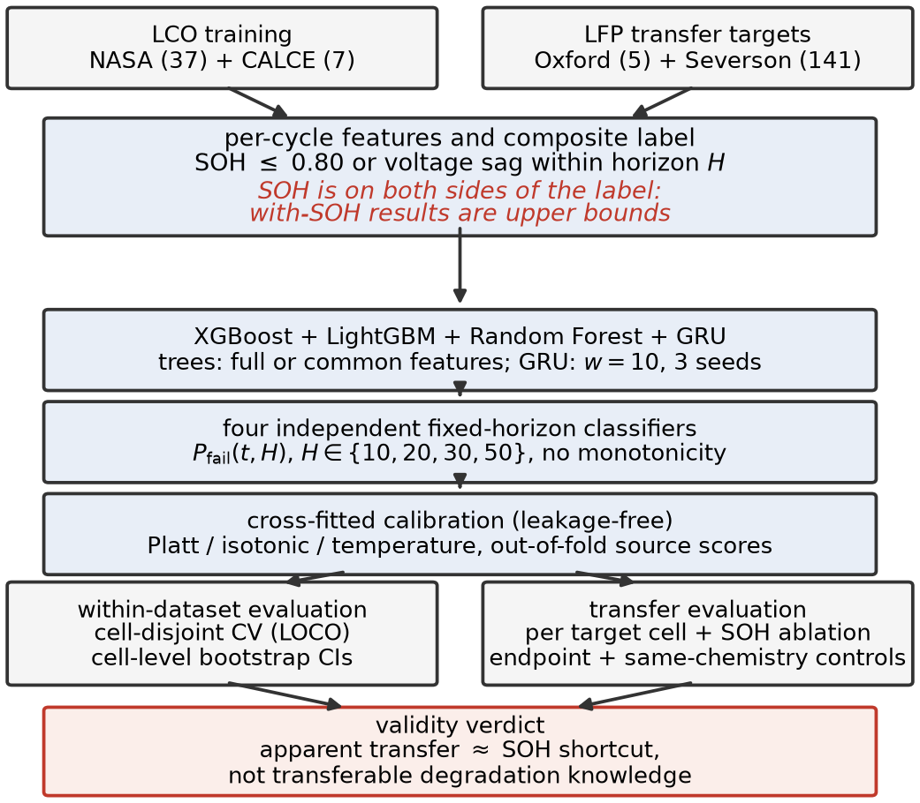
Overview of the proposed multi-horizon failure-risk framework.

II-A Datasets and Feature Representation
Four public datasets spanning two battery chemistries are used (Table I). The NASA PCoE [24] and CALCE CX2 [25] datasets are used for training, while the Oxford Battery Degradation Dataset [26] and MIT–Stanford Severson [23] datasets serve as cross-chemistry transfer targets. A battery is labeled as failed when SOH falls below 0.80 or the average voltage sag drops below 94% of the first ten-cycle baseline.
Summary of the Four Battery Datasets
Dataset | Cells | Chem. | Cycles/Cell | Role
NASA 18650 [24] | 37 | LCO | 1–445 | Training
CALCE CX2 [25] | 7 | LCO | 775–1,961 | Training
Oxford LFP [26] | 5 | LFP | 46–78 | Transfer
Severson [23] | 141 | LFP | 101–2,237 | Transfer
Two properties of these datasets matter for interpretation. First, the Oxford release logs discharge summaries at roughly 100-cycle intervals, so after preprocessing only 46–78 usable cycles per cell remain and every horizon is shorter than the sampling interval; Oxford failure labels are identical across all four horizons, and Oxford scores measure pooled failure detection rather than horizon-resolved prediction (per-cell statistics effectively cover four of its five cells). Second, because chemistry, laboratory, cell manufacturer, cycling protocol, and logging resolution all change simultaneously between any source and target, the shift evaluated here is cross-dataset as well as cross-chemistry; “cross-chemistry” is used as shorthand and Section II-E describes the controls that separate the two.
The feature vector consists of standard battery management system (BMS) measurements requiring no additional sensors,
$$x_{t}=\{{SOH}_{t},{\overset{‾}{V}}_{t},I_{t},T_{t},{dur}_{t},t\}, \text{(1)}$$
used directly by the tree ensembles, while the GRU processes a rolling window of $w=10$ cycles,
$$X_{t}^{(w)}=\left[x_{t−w+1}, …, x_{t}\right]∈R^{w×d}. \text{(2)}$$
In the CALCE dataset, average temperature and duration are completely missing and are zero-imputed for the tree models; this is harmless within a single dataset but a constant-zero column can act as a dataset identifier in pooled training, which Section III-C controls for with a common-feature variant. The GRU excludes those two features and uses only cycle, average voltage, minimum voltage, and SOH during transfer; the tree ensembles are additionally evaluated on this identical common feature set, so that architecture and feature availability are not confounded when comparing models under shift.

II-B Operational Reliability Formulation
Rather than estimate SOH or remaining useful life directly, we predict failure probability within a fixed operating horizon,
$$Y_{t,H}=\left\{\begin{matrix}1, & \text{if failure occurs within }(t,t+H] \\ 0, & \text{otherwise}\end{matrix}\right. \text{(3)}$$
with conditional failure probability
$$P_{fail}(t,H)=P​\left(T_{f}≤t+H∣T_{f}>t, x_{t}\right), \text{(4)}$$
where $T_{f}$ is the failure cycle. This framing treats battery prognostics as a discrete-time survival problem, aligned with how a BMS would use the output operationally. Two honesty notes are essential. First, (5) is a fixed-horizon cumulative failure-risk target: each horizon is an independent binary classifier, no cycle-level hazard or survival product is estimated, and no monotonicity constraint $P_{10}≤P_{20}≤P_{30}≤P_{50}$ is enforced (violations reach up to 45% of within-dataset rows), which is why we say failure-risk classification rather than hazard modeling. Second, the label is partially defined by SOH itself and SOH is also an input feature (Eq. (1)); with-SOH results are upper bounds that include this label-proximity leakage, and Section III-E quantifies it directly.

II-C Models and Training
We evaluate XGBoost (max_depth 4, learning rate 0.05, subsample 0.8, colsample 0.8, min_child_weight 5), LightGBM with matched hyperparameters, Random Forest (300 trees, max_depth 6), and a single-layer GRU (8 hidden units, 10-cycle window, Adam at learning rate 0.005, early stopping). Within-dataset evaluation uses 5-fold cell-grouped cross-validation on NASA (37 cells) and leave-one-cell-out on CALCE (7 cells): every cycle from a given cell stays on one side of every split, models are retrained per horizon, and the cell, not the cycle, is the experimental unit.

II-D Probability Calibration
Raw predictions are calibrated with Platt scaling [16],
$$P_{cal}=\frac{1}{1+exp(A s+B)}, \text{(5)}$$
which fits the logistic parameters $A$ and $B$ on out-of-fold scores $s$, and isotonic regression [17],
Pcal=giso(s), giso=arg ming non-decreasingi​(yi−g(si))2, (6)
a non-decreasing step fit, with temperature scaling ($P_{cal}=σ​\left(lns/{1−s}/T\right)$) as a reference. The protocol is leakage-clean: calibrators are fitted only on out-of-fold scores produced by an inner cell-disjoint split of the training cells, and the untouched test cells are scored by a model trained on all training cells. No calibrator is ever fitted on the scores it is applied to, which removes the optimistic bias of in-sample fitting (an earlier version of this study fitted calibrators directly on training-fold predictions; the absolute calibration numbers here are accordingly more conservative). Calibration quality is assessed by the Brier score, expected calibration error (ECE, ten equal-width bins), and the slope of a logistic recalibration of the predicted probabilities (slope 1 indicates perfect probabilistic calibration).

II-E Transfer Protocol and Statistical Testing
Models are trained on NASA, CALCE, or their combination and evaluated per cell on Oxford and Severson, with pooled results accompanied by cell-level bootstrap 95% confidence intervals (resampling cells, not cycles). We consider two feature settings, the full feature set and SOH removed, to test whether cross-chemistry performance reflects transferable degradation or mainly depends on SOH, and additionally a distance-to-threshold baseline that scores each cycle by the unfitted rule $0.80−SOH$, which is the correct first baseline if the health state itself is what transfers. Significance is assessed with the DeLong test [22] as secondary evidence only: the test treats cycle-level predictions as independent despite within-cell correlation, which can produce anti-conservative inference and artificially small $p$-values (pseudoreplication). We therefore use DeLong only as a directional consistency check.

III. Results and Discussion

III-A Within-Dataset Reliability
Table II reports fold-mean Platt-calibrated AUC per horizon. All 32 model–horizon–dataset combinations reach a fold-mean AUC of at least 0.85 under the clean protocol (Fig. 2); the GRU shows the largest fold-to-fold variance while the tree ensembles remain stable, and Brier scores stay low. Platt calibration preserves these rankings at comparable calibration error (Table III).
Within-Dataset AUC and Brier Score
Model | Dataset | H=10 | H=20 | H=30 | H=50 | Mean | Brier
XGBoost | NASA | 0.903 | 0.899 | 0.910 | 0.918 | 0.907 | 0.182
XGBoost | CALCE | 0.965 | 0.967 | 0.967 | 0.943 | 0.961 | 0.075
LightGBM | NASA | 0.912 | 0.909 | 0.892 | 0.901 | 0.903 | 0.206
LightGBM | CALCE | 0.967 | 0.968 | 0.943 | 0.942 | 0.955 | 0.075
Random Forest | NASA | 0.911 | 0.901 | 0.912 | 0.927 | 0.913 | 0.201
Random Forest | CALCE | 0.934 | 0.933 | 0.917 | 0.903 | 0.922 | 0.070
GRU | NASA | 0.872 | 0.893 | 0.884 | 0.856 | 0.876 | 0.307
GRU | CALCE | 0.952 | 0.959 | 0.935 | 0.921 | 0.942 | 0.130
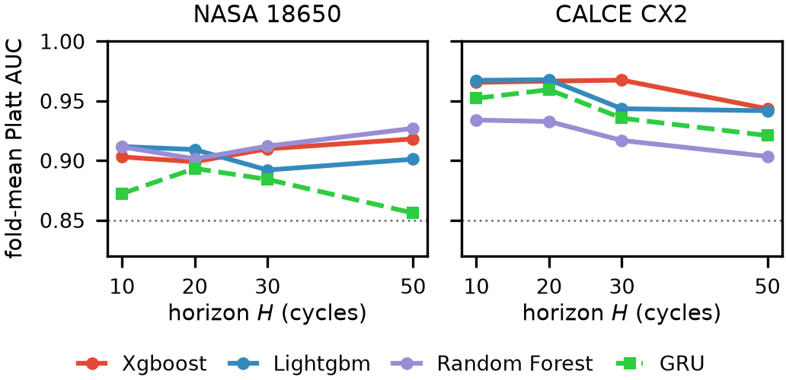
Within-dataset fold-mean Platt AUC across horizons.
Calibration Method Comparison
Dataset | Method | AUC | Brier | ECE | Slope
NASA | Isotonic | 0.854 | 0.207 | 0.151 | 0.48
NASA | Platt | 0.908 | 0.196 | 0.136 | 0.90
NASA | Temperature | 0.908 | 0.178 | 0.107 | 1.22
CALCE | Isotonic | 0.915 | 0.067 | 0.049 | 0.41
CALCE | Platt | 0.946 | 0.073 | 0.029 | 0.01
CALCE | Temperature | 0.945 | 0.080 | 0.067 | 0.53

III-B Calibration: Platt Preserves Discrimination Best
Table III compares the three calibrators. A fitted calibrator is a monotone re-mapping, so per-fold ranking is preserved up to the ties it introduces and fold-mean AUC differences are small. Isotonic’s tied step groups cost precision–recall, and Platt’s fitted slope on CALCE is only 0.01: under leave-one-cell-out the out-of-fold sigmoid reduces confidence toward the base rate while preserving ranking. Platt therefore preserves discrimination best while achieving calibration error comparable to or better than isotonic, and raw scores remain the safest ranking signal when the operating context is uncertain (Fig. 3).
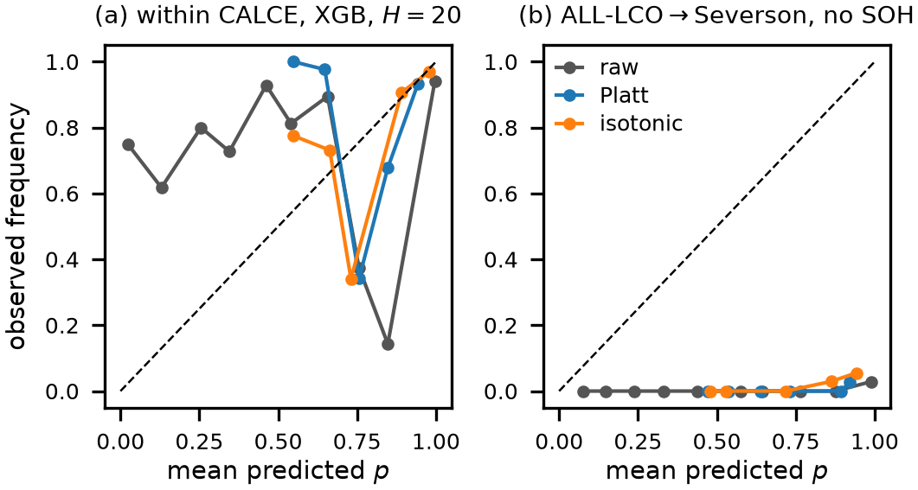
Reliability diagrams under the cross-fitted protocol. (a) Within CALCE. (b) ALL-LCO$→$Severson without SOH.

III-C Cross-Dataset Transfer and the SOH Shortcut
Table IV reports transfer at $H=20$ with and without SOH as a feature; transfer is reported in raw AUC because calibration parameters are dataset-specific. With SOH included, the tree ensembles reach pooled AUC between 0.85 and 1.00. Removing SOH reduces every tree model substantially: on NASA+CALCE$→$Oxford, XGBoost falls from 0.917 to 0.429, no no-SOH configuration exceeds 0.59 on Oxford or 0.78 on Severson, and several configurations fall below 0.5, meaning the remaining sensor features rank the target distribution worse than chance. The GRU is unstable across training seeds under shift (per-cell AUC from 0.21 to 1.00 at fixed settings) and shows no transfer advantage despite using the same common feature set as the trees in the matched comparison. Fig. 4 summarizes the AUC drop caused by removing SOH across all source, target, and model configurations.
Cross-Dataset Transfer at $H=20$ (Pooled Raw AUC)
Training | Model | Oxford w/ SOH | Oxford no SOH | Severson w/ SOH | Severson no SOH
NASA | XGBoost | 0.957 | 0.518 | 0.871 | 0.595
NASA | LightGBM | 1.000 | 0.533 | 0.849 | 0.527
NASA | Random Forest | 1.000 | 0.521 | 0.861 | 0.674
NASA | GRU | 0.143 | 0.152 | 0.832 | 0.766
CALCE | XGBoost | 0.850 | 0.416 | 0.850 | 0.682
CALCE | LightGBM | 0.889 | 0.462 | 0.863 | 0.643
CALCE | Random Forest | 0.850 | 0.501 | 0.902 | 0.665
CALCE | GRU | 0.120 | 0.100 | 0.777 | 0.524
NASA+CALCE | XGBoost | 0.917 | 0.429 | 0.896 | 0.750
NASA+CALCE | LightGBM | 0.971 | 0.332 | 0.882 | 0.718
NASA+CALCE | Random Forest | 0.989 | 0.581 | 0.889 | 0.746
NASA+CALCE | GRU | 0.053 | 0.015 | 0.799 | 0.748
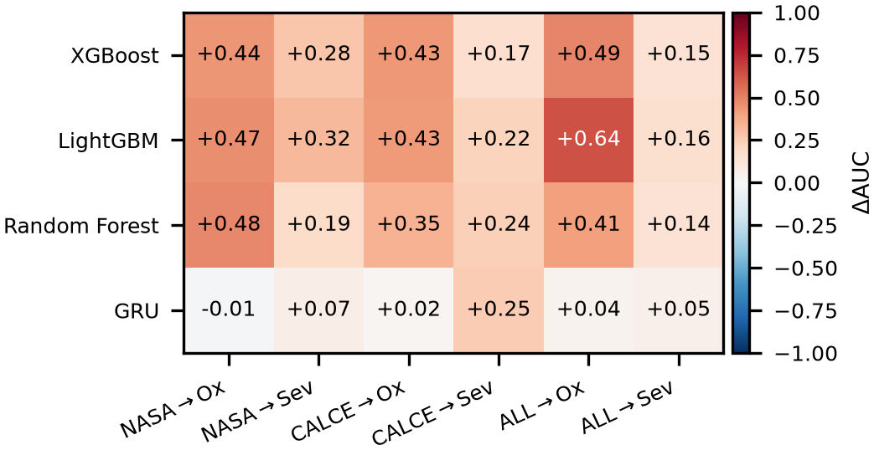
Transferability collapse map at $H=20$.
A first control is the distance-to-threshold rule $0.80−SOH$, which involves no fitting: it transfers to Severson at pooled AUC 0.912 (95% CI [0.84, 1.00]) for the ALL-LCO source, within the confidence range of the tuned ensembles. Most of the apparent transfer is therefore explained by the SOH coordinate itself. The remaining controls are the subject of the next subsection.

III-D Failure-Definition Ablation and Same-Chemistry Controls
The ablation of Table V relabels failure by a single endpoint at a time (SOH $≤0.80$ only, voltage sag only, or both). With-SOH transfer increases with the share of SOH in the label definition. Under an SOH-only label, transfer to Severson is 0.985; under the combined label it is 0.896; under the voltage-sag label, which SOH does not enter, it is 0.723. The residual with-SOH advantage under the voltage-sag endpoint (0.723 versus 0.611 without SOH) is consistent with SOH retaining some genuine health-state information even when it does not directly define the endpoint.
Failure-Definition Ablation at $H=20$
Label endpoint | Oxford w/ SOH | Oxford no SOH | Severson w/ SOH | Severson no SOH
Combined (SOH or sag) | 0.917 | 0.429 | 0.896 | 0.750
SOH only | 0.995 | 0.464 | 0.985 | 0.759
Voltage sag only | — | — | 0.723 | 0.611
Same-Chemistry Controls at $H=20$
Pair | w/ SOH | no SOH
NASA$→$CALCE (LCO$→$LCO) | 0.870 | 0.849
CALCE$→$NASA (LCO$→$LCO) | 0.543 | 0.566
Severson$→$Oxford (LFP$→$LFP) | 0.997 | 0.471
Oxford$→$Severson (LFP$→$LFP) | 0.688 | 0.500
If the collapse were a chemistry effect, transfer should survive when chemistry is held constant; Table VI shows it does not. Severson$→$Oxford (both LFP) reproduces the pattern of the cross-chemistry shifts: 0.997 with SOH falls to 0.471 without. NASA$→$CALCE (both LCO) transfers partially even without SOH (0.870 to 0.849), helped by the very different per-cell cycle lives of the two datasets. Conversely, CALCE$→$NASA stays near chance even with SOH, showing that a small, heterogeneous source limits transfer in both directions. Much of the observed cross-dataset, cross-chemistry discrimination is therefore attributable to SOH, partly because SOH defines the failure criterion itself, and the same-chemistry controls attribute the collapse to dataset shift at least as much as to chemistry.

III-E Multi-Horizon Analysis, Monotonicity, and a Discrete-Time Hazard Model
Across the fixed-horizon classifiers, fold-mean AUC varies by less than 0.05 over $H∈\{10,20,30,50\}$ on both training datasets (Fig. 2), with slightly larger variation at short horizons due to class imbalance. Because the four horizons are independent classifiers, cumulative risk coherence is not guaranteed: the requirement $P_{10}≤P_{20}≤P_{30}≤P_{50}$ is violated in 32–45% of within-dataset rows and up to 96% of rows on the transferred Severson target.
Fixed-Horizon Versus Hazard Model AUC
Setting | Fixed $H=20$ | Hazard $H=20$ | Fixed $H=50$ | Hazard $H=50$
NASA | 0.899 | 0.935 | 0.918 | 0.927
CALCE | 0.967 | 0.893 | 0.943 | 0.889
NASA$→$Oxford | 0.957 | 0.971 | — | —
NASA$→$Severson | 0.871 | 0.884 | — | —
CALCE$→$Oxford | 0.850 | 0.466 | — | —
CALCE$→$Severson | 0.850 | 0.737 | — | —
NASA+CALCE$→$Oxford | 0.917 | 0.314 | — | —
NASA+CALCE$→$Severson | 0.896 | 0.866 | — | —
We therefore also fit an explicit discrete-time hazard model. For each observed cycle $t$ and offset $ℓ∈\{1,…,L\}$ with $L=50$, the hazard conditional on the features measured at $t$ (operational: no future measurements) is
$$h_{ℓ}(t)=P\left(T_{f}=t+ℓ∣T_{f}≥t+ℓ, x_{t}\right), \text{(7)}$$
estimated by one pooled classifier on the offset-expanded at-risk training rows $(x_{t},ℓ)$ with $ℓ$ as an additional input feature. Cumulative failure risk follows the survival product
$$R(t,H)=1−\prod_{ℓ=1}^{H}{\left(1−{\hat{h}}_{ℓ}(t)\right)}, \text{(8)}$$
which is monotone non-decreasing in $H$ by construction and yields all four horizons from a single fit (Table VII). Within datasets the survival product matches the fixed-horizon classifier at no cost. Under transfer it inherits the same SOH dependence as every other model, because formulating the output does not exempt the inputs from dataset shift, and behaves source-dependently (0.97 down to 0.31 pooled on Oxford). Its monotonicity violation rate is zero by construction.

III-F Operational Threshold Evaluation
AUC weights all errors equally, whereas a BMS must trade false negatives against false positives. We select the decision threshold on source out-of-fold scores with a 10% false-alarm budget and apply it unchanged to the target (Table VIII). On Severson with SOH, the transferred threshold misses 32% of target failures while holding false alarms to 4%; without SOH the miss rate rises to 70% with the full budget spent. The three score types differ only marginally in this setting. On Oxford, nearly every row is positive under the coarse pooled labels, so no discriminating operating point exists (Section II-B).
Operational Evaluation at $H=20$ (FNR% / FPR%)
Target | Features | raw | Platt | Isotonic
Oxford | with SOH | 0 / 93 | 0 / 93 | 0 / 93
Oxford | no SOH | 0 / 92 | 0 / 92 | 0 / 92
Severson | with SOH | 32 / 4 | 32 / 4 | 31 / 6
Severson | no SOH | 70 / 10 | 70 / 10 | 67 / 12
SOH Ablation at $H=20$ (Bootstrap CI, DeLong $p$)
Target | Model | w/ SOH | w/o | $Δ$AUC [95% CI] | DeLong $p$
Oxford | XGBoost | 0.917 | 0.429 | +0.488 [NA; n=5] | $7.2e−51$
Oxford | LightGBM | 0.971 | 0.332 | +0.639 [NA; n=5] | $2.6e−64$
Oxford | Random Forest | 0.989 | 0.581 | +0.409 [NA; n=5] | $6.5e−36$
Severson | XGBoost | 0.896 | 0.750 | +0.146 [0.10, 0.23] | $<{10}^{−300}$
Severson | LightGBM | 0.882 | 0.718 | +0.164 [0.13, 0.23] | $<{10}^{−300}$
Severson | Random Forest | 0.889 | 0.746 | +0.143 [0.11, 0.23] | $<{10}^{−300}$
Table IX states the central comparison with the cell as the experimental unit. On Severson the bootstrap interval on $Δ$AUC excludes zero by a wide margin for every model. On Oxford the equivalent interval is uninformative (five cells, effectively four), so the cycle-level DeLong $p$-values, which treat correlated cycles as independent and can therefore be anti-conservatively small under pseudoreplication, are not used as primary evidence. Within-dataset model comparisons at $H=20$ are mostly not significant after honest accounting (DeLong on pooled rows: XGBoost vs. LightGBM $1.4×{10}^{−2}$ on NASA, $6.9×{10}^{−28}$ on CALCE; XGBoost vs. Random Forest $3.3×{10}^{−1}$ and $8.5×{10}^{−1}$), so no architecture superiority is claimed.

IV. Conclusion
This paper built a multi-horizon failure-risk framework for lithium-ion batteries across datasets and chemistries, and used it to run a validity check rather than just another benchmark. Under cell-disjoint evaluation with leakage-free calibration, performance within each training dataset is consistently strong, every one of the 32 model–horizon–dataset combinations reaches a fold-mean AUC above 0.85. But the cross-dataset results point to a narrower and more useful conclusion than the raw transfer numbers suggest: most of the apparent cross-dataset, cross-chemistry discrimination comes down to SOH, partly because SOH is baked into how failure is defined in the first place, not because the remaining measured features carry real degradation information. Same-chemistry controls back this up, showing the collapse tracks dataset shift just as much as it tracks chemistry shift. Platt scaling comes out ahead for preserving discrimination at comparable calibration error, though no calibrator fitted on the source data actually repairs calibration once the target has shifted.
A few limits are worth flagging. The fixed-horizon classifiers don’t enforce any monotonicity across horizons. Oxford’s coarse, 100-cycle sampling means it only supports pooled-detection use rather than horizon-specific claims. CALCE contributes just seven cells. Cross-chemistry testing here only covers LCO and LFP. And all four datasets are lab-scale rather than field data. Next steps include making minimal-feature baselines standard practice, running controlled same-lab cross-chemistry campaigns, moving toward continuous time-to-failure modeling, and testing all of this against larger, industrial-scale datasets.

Acknowledgment
The authors would like to acknowledge the use of writing-support and language-enhancement tools, including OpenAI ChatGPT, Grammarly, and QuillBot, during the preparation of this manuscript. These tools were used to assist with grammar correction, readability improvement, language refinement, and sentence restructuring. All technical content, analysis, interpretations, and research contributions are those of the authors.
26
M. Berecibar, I. Gandiaga, I. Villarreal, N. Omar, J. Van Mierlo, and P. Van den Bossche, “Critical review of state of health estimation methods of Li-ion batteries for real applications,” Renewable and Sustainable Energy Reviews, vol. 56, pp. 572–587, 2016, doi: 10.1016/j.rser.2015.11.042.
G. Xu, J. Xu, and Y. Zhu, “LSTM-based estimation of lithium-ion battery SOH using data characteristics and spatio-temporal attention,” PLoS ONE, vol. 19, no. 12, Art. no. e0312856, 2024, doi: 10.1371/journal.pone.0312856.
B. Bairwa, K. Pareek, and V. K. Jadoun, “Cycle based state of health estimation of lithium-ion cells using deep learning architectures,” Scientific Reports, vol. 15, Art. no. 37078, 2025, doi: 10.1038/s41598-025-20995-7.
T. Tetik, “Feature engineering and explainable artificial intelligence for state of health estimation of lithium-ion batteries,” Journal of Energy Storage, vol. 144, Art. no. 119873, 2026, doi: 10.1016/j.est.2025.119873.
S. Jin, X. Sui, X. Huang, S. Wang, R. Teodorescu, and D.-I. Stroe, “Overview of machine learning methods for lithium-ion battery remaining useful lifetime prediction,” Electronics, vol. 10, no. 24, Art. no. 3126, 2021, doi: 10.3390/electronics10243126.
Y. Li, H. Shi, S. Wang, Q. Huang, C. Liu, S. Nie, X. Jia, and T. Luo, “A comprehensive review of remaining useful life prediction methods for lithium-ion batteries: Models, trends, and engineering applications,” Journal of Energy Chemistry, vol. 112, pp. 384–414, 2026, doi: 10.1016/j.jechem.2025.08.056.
A. Thelen, X. Huan, N. Paulson, S. Onori, Z. Hu, and C. Hu, “Probabilistic machine learning for battery health diagnostics and prognostics—review and perspectives,” npj Materials Sustainability, vol. 2, Art. no. 14, 2024, doi: 10.1038/s44296-024-00011-1.
H. Li, “Battery health prediction of new energy vehicles based on LightGBM,” in Proc. Int. Workshop on Advances in Deep Learning for Image Analysis and Computer Vision (IWADIC 2025), 2026, pp. 80–89, doi: 10.2991/978-94-6239-648-7_10.
Z. Wang, Q. Ma, and Y. Guo, “Remaining useful life prediction of lithium-ion batteries based on deep learning and soft sensing,” Actuators, vol. 10, no. 9, Art. no. 234, 2021, doi: 10.3390/act10090234.
A. Rastegarpanah, M. E. Asif, and R. Stolkin, “Hybrid neural networks for enhanced predictions of remaining useful life in lithium-ion batteries,” Batteries, vol. 10, no. 3, Art. no. 106, 2024, doi: 10.3390/batteries10030106.
L. Sun, X. Huang, J. Liu, J. Song, and S. Wu, “Remaining useful life prediction of lithium batteries based on jump connection multi-scale CNN,” Scientific Reports, vol. 15, Art. no. 32873, 2025, doi: 10.1038/s41598-025-08619-6.
R. Ibraheem, T. I. Cannings, T. Sell, and G. dos Reis, “Robust survival model for the prediction of Li-ion battery lifetime reliability and risk functions,” Energy and AI, vol. 19, Art. no. 100465, 2025, doi: 10.1016/j.egyai.2024.100465.
T. Li, Z. Zhou, A. Thelen, D. A. Howey, and C. Hu, “Predicting battery lifetime under varying usage conditions from early aging data,” Cell Reports Physical Science, vol. 5, no. 4, Art. no. 101891, 2024, doi: 10.1016/j.xcrp.2024.101891.
J. Yao, Q. Gao, T. Gao, B. Jiang, and K. M. Powell, “A physics-guided machine learning approach to capacity fading mechanism detection and fading rate prediction using early cycle data,” Batteries, vol. 10, no. 8, Art. no. 283, 2024, doi: 10.3390/batteries10080283.
H. Pang, X. Qu, K. Chen, X. Yan, A. F. Burke, and J. Zhao, “A transferable deep learning framework for cross-chemistry and cross-scale state of health estimation in lithium-ion batteries,” Energy, vol. 354, Art. no. 141079, 2026, doi: 10.1016/j.energy.2026.141079.
J. C. Platt, “Probabilistic outputs for support vector machines and comparisons to regularized likelihood methods,” in Advances in Large Margin Classifiers, Cambridge, MA, USA: MIT Press, 1999, pp. 61–74.
B. Zadrozny and C. Elkan, “Transforming classifier scores into accurate multiclass probability estimates,” in Proc. 8th ACM SIGKDD Int. Conf. Knowledge Discovery and Data Mining, Edmonton, AB, Canada, 2002, pp. 694–699.
M. Goldstein, X. Han, A. Puli, and R. Ranganath, “X-CAL: Explicit calibration for survival analysis,” in Advances in Neural Information Processing Systems 33 (NeurIPS 2020), 2020, pp. 12759–12771.
S. M. Lundberg and S.-I. Lee, “A unified approach to interpreting model predictions,” in Advances in Neural Information Processing Systems 30 (NeurIPS 2017), 2017, pp. 4768–4777.
G. dos Reis, C. Strange, M. Yadav, and S. Li, “Lithium-ion battery data and where to find it,” Energy and AI, vol. 5, Art. no. 100081, 2021, doi: 10.1016/j.egyai.2021.100081.
D. Li, J. Nan, A. F. Burke, and J. Zhao, “Battery prognostics and health management: AI and big data,” World Electric Vehicle Journal, vol. 16, no. 1, p. 10, 2025, doi: 10.3390/wevj16010010.
E. R. DeLong, D. M. DeLong, and D. L. Clarke-Pearson, “Comparing the areas under two or more correlated receiver operating characteristic curves: A nonparametric approach,” Biometrics, vol. 44, no. 3, pp. 837–845, 1988.
K. A. Severson, P. M. Attia, N. Jin, et al., “Data-driven prediction of battery cycle life before capacity degradation,” Nature Energy, vol. 4, pp. 383–391, 2019, doi: 10.1038/s41560-019-0356-8.
B. Saha and K. Goebel, “Battery Data Set,” NASA Ames Prognostics Data Repository, NASA Ames Research Center, Moffett Field, CA, USA, 2007.
CALCE Battery Research Group, “Battery aging datasets,” Center for Advanced Life Cycle Engineering, Univ. of Maryland, College Park, MD, USA, 2023.
D. Howey and C. Birkl, “Oxford Battery Degradation Dataset 1,” Univ. of Oxford, Oxford, U.K., 2017.

