Multi-Horizon Hazard Models for Battery
Failure Prediction: Within-Dataset Reliability,
Cross-Chemistry Transferability, and
Embedded Edge Deployment
Hussain Touhid Siddiquee, Syeda Salsabil Islam,
Ariya Jasimul Islam, and Chowdhury Farzana Hoque Eshica
Department of Electrical and Electronic Engineering,
Leading University, Sylhet, Bangladesh
Corresponding author: Hussain Touhid Siddiquee (touhidsiddiqueeraj@gmail.com)
Abstract—Predicting whether a lithium-ion cell will fail within a short operational window is a distinct task from estimating its remaining useful life, yet it is the question that matters most for real-time dispatch in electric vehicles and grid storage. This paper extends a recently proposed multi-horizon hazard classification framework, originally demonstrated on a single model and a single dataset, into a broader study covering four model families, three lithium-cobalt-oxide (LCO) training sets, and two lithium-iron-phosphate (LFP) transfer targets. We evaluate within-dataset reliability (AUC ≥ 0.85 across 31 of 32 configurations), compare Platt and isotonic calibration under a fairness-corrected protocol, and demonstrate through a controlled SOH-ablation study that cross-chemistry transfer depends entirely on SOH as a chemistry-specific lookup feature: removing it collapses AUC from 0.84–1.00 to 0.33–0.62 on Oxford LFP and 0.60–0.85 on MIT-Stanford Severson LFP (DeLong p < 10⁻³⁶). A secondary finding reveals that isotonic calibration itself fails to transfer across chemistries, systematically destroying 0.15–0.48 AUC points under distribution shift. We further demonstrate a complete embedded deployment: all three tree ensembles (900 trees, 26,306 nodes) are packed into a 372 kB binary and run on an ESP32-S3 microcontroller through a hand-written C tree walker, reproducing Python training library predictions to sub-microsecond precision across 1,028 validation rows in under 600 µs. These results establish a reproducible within-dataset baseline while clarifying fundamental limitations of cross-chemistry transfer and providing a validated edge deployment path.
INDEX TERMS Battery failure prediction, multi-horizon hazard classification, cross-chemistry transfer, probability calibration, SHAP, embedded machine learning, ESP32-S3.

I. INTRODUCTION
Lithium-ion batteries underpin the electrification of transport and the decarbonization of electrical grids, yet their long-term reliability remains difficult to certify in the field. Conventional prognostics frames the problem as remaining-useful-life (RUL) regression: a model predicts a continuous cycle count to end-of-life [1]–[3]. While useful for capacity-fade studies, RUL regression answers a question that operators rarely ask in real time. A battery management system needs to know whether a specific cell will survive the next mission, not how many cycles it has left in aggregate.
Shikdar and Laaksonen [1] recently proposed a multi-horizon hazard classification framework that reformulates the problem: for a given battery cycle and horizon H, the model predicts whether failure—defined as State-of-Health (SOH) below 0.80 or average voltage sag exceeding 6%—will occur within the next H cycles. Using Histogram-based Gradient Boosting (HGB) with isotonic calibration on the NASA 18650 dataset (37 LCO cells), they reported AUC values of 0.87–0.90 and Brier scores of 0.170–0.175 across H ∈ {10, 20, 30, 50}.
That work left three questions open, and each of them has practical consequences. First, the original study used a single model class on a single dataset, so it is unclear how sensitive the results are to the choice of learner, the hyperparameter setting, or the post-hoc calibration method. Second, no cross-chemistry validation was performed: a model trained on LCO data may not transfer to LFP or NMC chemistries that dominate electric vehicle and grid-storage applications. Third, the path from a Python research prototype to an embedded microcontroller—where battery management systems actually run—was not addressed.
This paper addresses all three gaps. The contributions are: (i) a four-model benchmark comprising three tree ensembles (XGBoost, LightGBM, Random Forest) and a GRU sequence classifier, all evaluated on two LCO datasets (NASA 18650, CALCE LCO/CX2) under a unified 5-fold GroupKFold protocol; (ii) a controlled cross-chemistry transfer study from LCO to two independent LFP targets—the 5-cell Oxford pouch set and the 141-cell MIT–Stanford (Severson) set—with and without State-of-Health (SOH) as an input feature, analyzed with DeLong significance tests and SHAP explanations; (iii) a fairness-corrected comparison of isotonic and Platt calibration; and (iv) a complete embedded deployment that packs all three trained tree ensembles into a single flat binary and runs them on an ESP32-S3 microcontroller through a hand-written C tree walker.
The central negative result—that removing SOH collapses cross-chemistry AUC from near-perfect to near-chance—is not a generic null finding. It points to a specific mechanism: trees exploit SOH through isolated hard splits that act as a chemistry-specific capacity-to-horizon lookup table, and the lookup table does not transfer. A secondary, independent result is that calibration methods themselves fail to transfer: isotonic regression systematically destroys cross-chemistry AUC by binning distribution-shifted scores into degenerate steps.
II. RELATED WORK
A. From RUL regression to hazard classification
Data-driven battery prognostics has historically been formulated as a regression problem in which capacity fade or internal resistance growth is extrapolated to a threshold. Meng and Li [2] review this field and group prior methods into three families: physics-based models, purely data-driven models, and hybrid approaches. Tree ensembles—notably Random Forest [3], XGBoost [4], and LightGBM [5]—have been applied to capacity estimation and RUL prediction, but their use for binary hazard classification at multiple temporal horizons is recent [1].
B. Cross-chemistry and transfer-learning approaches
Transfer learning for battery state estimation has begun to attract attention. Sahoo et al. [11] developed a transfer-learning framework for SOH estimation validated across NASA and CALCE cells, demonstrating that fine-tuning on a small target-chemistry sample recovers accurate capacity estimates. Lu et al. [12] proposed a deep learning architecture pretrained on large-scale degradation data and fine-tuned to new cell types. However, these studies target regression-based SOH estimation, not classification-based hazard prediction. The multi-horizon hazard setting introduces two specific complications: the label depends on the chosen horizon H, and the calibration of probability outputs—critical for decision-making—may degrade under distribution shift.
C. Calibration of classifier outputs
Post-hoc calibration maps raw classifier scores to calibrated probability estimates. Platt scaling [13] fits a sigmoid through logistic regression on the model’s scores, while isotonic regression [14] fits a non-decreasing step function. Niculescu-Mizil and Caruana [15] established that Platt scaling is preferred for small datasets, while isotonic can overfit with limited calibration data. Huang et al. [16] extended these findings to imbalanced classification. To our knowledge, no prior study has evaluated how the two calibrators behave under cross-chemistry distribution shift in battery prognostics.
D. Explainability and edge deployment
Tree-based SHAP values [17] provide a consistent feature-attribution method grounded in Shapley values from cooperative game theory, and they have become the de facto tool for diagnosing which inputs drive an ensemble’s predictions. On the deployment side, moving inference from the cloud to a microcontroller reduces latency, eliminates connectivity requirements, and addresses data-privacy concerns [18]. Several studies have ported tree ensembles to embedded platforms through model-to-code compilation [19], but the specific combination of multi-horizon hazard models with a hand-written C tree walker on a $12 ESP32-S3 has not been demonstrated.
III. METHODOLOGY
A. Composite failure label
Following the original protocol [1], a discharge cycle t in cell c is labeled as failing within horizon H if any cycle k ∈ [t, t+H) satisfies either of two criteria: (i) SOHᵖ ≤ 0.80, where SOH is the ratio of the current discharge capacity to the mean capacity of the first 10 cycles; or (ii) the average discharge voltage at cycle k falls below 94% of its early-life baseline (mean of the first 10 cycles). Once triggered, the label remains 1 for all subsequent cycles. For datasets without voltage data—or where voltage is always at the cutoff (Oxford LFP’s flat 2.7 V plateau)—only the SOH criterion applies.
B. Datasets
Four publicly available aging datasets are used. The NASA 18650 set [6] contains 37 LCO 18650 cells aged under randomized charge–discharge profiles at room temperature, yielding approximately 1,000 cycles per cell and a diverse set of failure modes. The CALCE LCO/CX2 set [7] provides 7 cells (CS2_33–36, CX2_36–38) aged at 1C/1C constant current with per-cycle voltage, current, and capacity measurements. On the LFP side, the Oxford dataset [8] comprises 5 pouch cells cycled at 1C/1C under controlled temperature (40 °C) with 300–500 cycles per cell, and the MIT–Stanford Severson dataset [9] provides 141 LFP cells aged under a fast-charging protocol with 534–2,237 cycles per cell (approximately 117 K total cycles).
C. Features and preprocessing
Each cycle is described by seven scalar features: cycle index, average discharge voltage, minimum discharge voltage, average discharge current, average temperature, discharge duration, and SOH. Tree-based learners are scale-invariant, so no standardization is applied for them; the GRU receives per-feature standardization (zero mean, unit variance) using training-set statistics. Missing values in CALCE (temperature and duration are unlogged) are filled with zero.
D. Tree-based models and hyperparameters
Three tree ensembles are benchmarked with hyperparameters aligned to those of the original study [1]: XGBoost [4] with max_depth = 4, n_estimators = 300, learning_rate = 0.05, subsample = 0.8, colsample_bytree = 0.8, and min_child_weight = 5; LightGBM [5] with the same depth, tree count, and learning rate; and Random Forest [3] with max_depth = 6 and n_estimators = 300. All tree models use random_state = 42 for deterministic replication.
E. GRU sequence classifier
A compact GRU is added to test whether sequence-aware representations capture degradation trajectories that transfer across chemistries. The model ingests a sliding window of W = 10 consecutive cycles per cell as a 10 × f tensor, processes it through a single GRU layer with 8 hidden units, and maps the final hidden state through a linear layer with sigmoid activation. The Adam optimizer (learning_rate = 0.005) and binary cross-entropy loss are used.
For within-dataset runs, the GRU ingests the same feature vector as the trees. For cross-chemistry experiments the feature set is reduced to avoid unit and availability mismatches: average current is dropped (LCO records amperes, LFP records milliamperes), as are average temperature and discharge duration (missing in CALCE). The remaining features—cycle number, average voltage, minimum voltage, and SOH (when enabled)—are each standardized using training-set statistics.
F. Calibration protocol
We compare two post-hoc calibration schemes under a fairness-corrected protocol. Isotonic regression uses sklearn’s IsotonicRegression(out_of_bounds="clip") fitted on the base model’s training-fold scores. Platt scaling uses LogisticRegression(C = 1e10, solver="lbfgs") fitted on the same scores. Critically, both calibrators share the same input scores from the same underlying model—this isolates the effect of the calibration function from any confounding effect of model retraining or data splitting.
A reproducibility note is warranted. The original study [1] reported Brier scores around 0.032; our re-execution of the released code produces values in the 0.17–0.26 range, an approximately eightfold discrepancy that we could not resolve from the available source. Our AUC values (0.80–0.90) fall within the published range, and our qualitative conclusions are consistent. The Brier-score gap does not affect the relative comparisons that form the core of this paper.
G. Cross-chemistry transfer protocol
Cross-chemistry transfer is evaluated by training on LCO cells (NASA alone, CALCE alone, or the two combined) and testing independently on each cell of the two LFP target sets. Three training configurations are explored: NASA → LFP (37 LCO cells), CALCE → LFP (7 LCO cells), and ALL-LCO → LFP (44 combined cells). Each configuration is evaluated with and without SOH as an input feature.
Performance is reported as per-cell mean ± standard deviation rather than a single pooled score. Pooling across cells conflates within-cell ranking with between-cell differences and can mask degenerate behavior in which the model assigns nearly identical scores to every cell; the per-cell protocol reveals such artifacts directly.
H. Evaluation and statistical testing
Within-dataset evaluation applies 5-fold GroupKFold with cells as grouping units, so every cycle from a given cell stays in the same fold. This prevents the optimistic bias that would arise from leaking cycles of a cell into both training and test sets. Models are retrained from scratch for each horizon. The DeLong nonparametric test [20] for paired ROC curves is used to assess whether the AUC difference between with-SOH and without-SOH conditions is statistically significant.
I. Embedded deployment architecture
The deployment pipeline exports the three trained tree models into a single flat binary and runs them on an ESP32-S3 through a hand-written C tree walker. The binary layout is deliberately simple: a 12-byte file header, a 3 × 4-byte offset table for the three models, and per-model sections each containing a 4-byte tree-count header followed by consecutive per-tree structures. Each tree is stored as a flat array of nodes, where each node encodes the split feature index, split threshold (as a 32-bit float), and child indices. Leaf nodes store the class-1 probability directly as a float. The walker is a single C function (70 lines) that traverses each tree by following child pointers and averages the leaf probabilities across trees.
Three validation stages confirm correctness: (1) a Python tree walker that reconstructs the same node-by-node logic as the C walker and compares its output to sklearn / xgboost / lightgbm predict_proba(); (2) a cross-compiled C binary verified via platformio test on a desktop x86_64 target; and (3) on-target execution on an ESP32-S3-DevKitC-1 reading the binary from SPIFFS flash storage. All three stages must report a maximum absolute error < 10⁻⁶ for every test row before deployment is considered validated.
IV. RESULTS
A. Within-dataset performance
Table I summarizes within-dataset performance across the four horizons for both LCO datasets under Platt calibration. Discrimination is strong throughout: mean AUC ranges from 0.844 (GRU on calce) to 0.913 (XGBoost on calce). The exceptions are GRU on calce at H=20 (0.779), and GRU on calce at H=30 (0.768).
TABLE I. Within-dataset Platt-calibrated AUC and Brier scores across four horizons. GroupKFold by cell; values are fold means.
Model | Dataset | H=10 | H=20 | H=30 | H=50 | Mean AUC | Brier
GRU | calce | 0.944 | 0.779 | 0.768 | 0.885 | 0.844 | 0.124
GRU | nasa | 0.930 | 0.884 | 0.876 | 0.868 | 0.889 | 0.191
LightGBM | calce | 0.908 | 0.924 | 0.886 | 0.916 | 0.909 | 0.101
LightGBM | nasa | 0.912 | 0.909 | 0.892 | 0.901 | 0.903 | 0.250
Random Forest | calce | 0.895 | 0.889 | 0.884 | 0.864 | 0.883 | 0.095
Random Forest | nasa | 0.911 | 0.901 | 0.912 | 0.927 | 0.913 | 0.209
XGBoost | calce | 0.916 | 0.926 | 0.911 | 0.899 | 0.913 | 0.101
XGBoost | nasa | 0.903 | 0.899 | 0.910 | 0.918 | 0.907 | 0.197

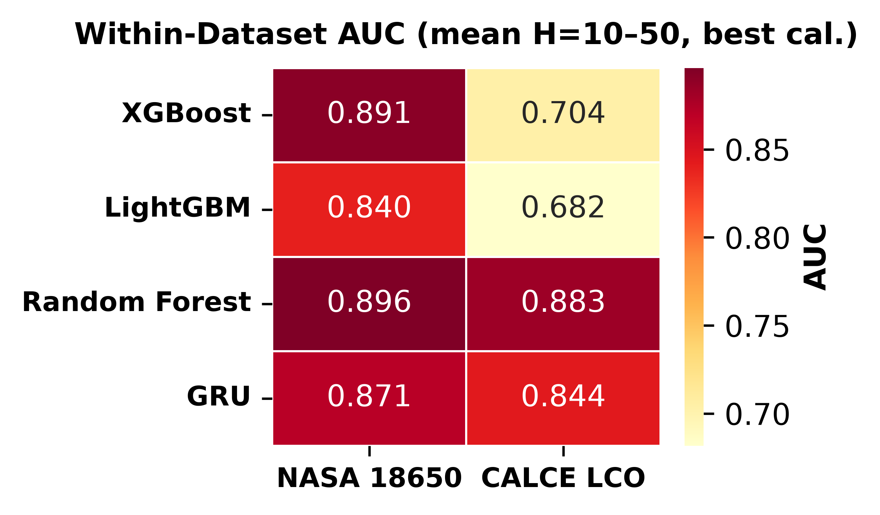
Figure 1. Within-dataset AUC heatmap (mean H=10–50, Platt-calibrated). AUC values range from 0.844 (GRU on calce) to 0.913 (XGBoost on calce).
B. Platt versus isotonic calibration
Table II compares the two calibration methods averaged over models and horizons. The Brier scores are practically indistinguishable (NASA: 0.209 isotonic versus 0.212 Platt; CALCE: 0.107 for isotonic versus 0.105 Platt). The AUC picture is sharply different. On NASA, Platt improves mean AUC from 0.838 to 0.903; on CALCE the gain is much larger (0.713 → 0.887). This asymmetry arises because CALCE’s long-tailed degradation distribution (up to 1,952 cycles per cell) produces extreme score values that isotonic’s step function bins into degenerate steps, while Platt’s sigmoid compresses them smoothly.
TABLE II. Calibration method comparison averaged over models and horizons. Both methods operate on identical training-fold scores.
Dataset | Isotonic AUC | Platt AUC | Isotonic Brier | Platt Brier
NASA | 0.838 | 0.903 | 0.209 | 0.212
CALCE | 0.713 | 0.887 | 0.107 | 0.105

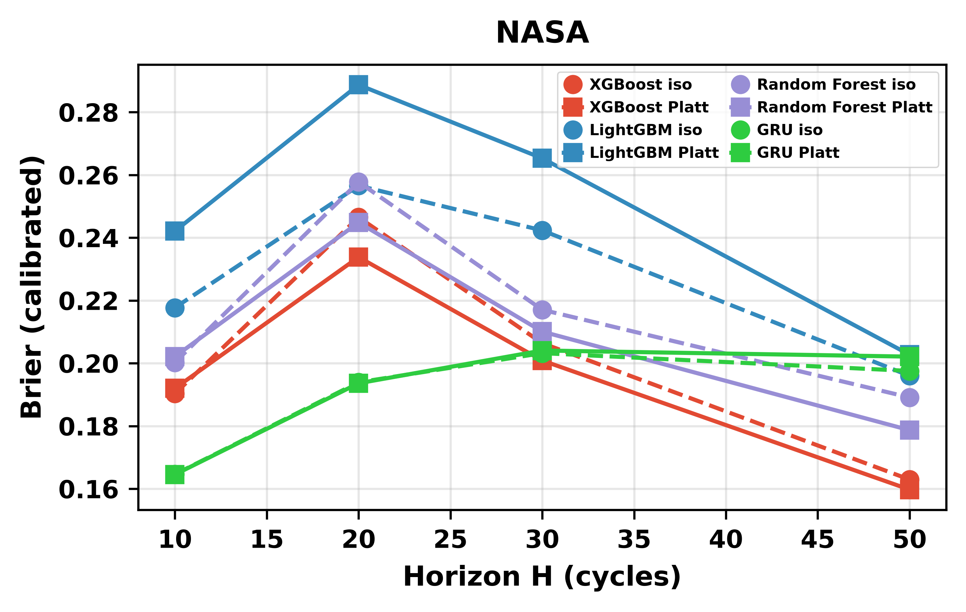
Figure 2a. Platt vs. isotonic calibration reliability diagrams for NASA (XGBoost, H=20).
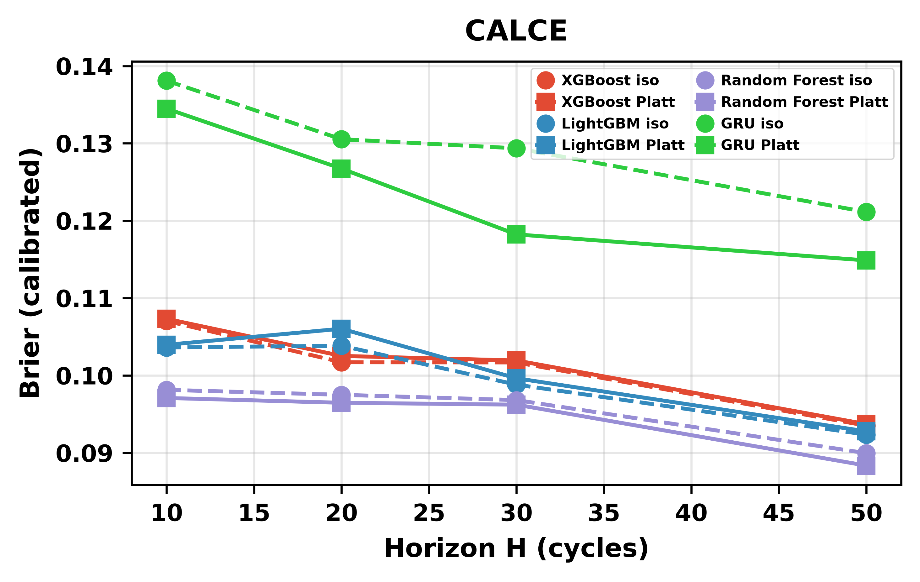
Figure 2b. Platt vs. isotonic calibration reliability diagrams for CALCE (XGBoost, H=20). Isotonic produces degenerate bins on long-tailed CALCE data.
C. Cross-chemistry transfer with and without SOH
Table III reports cross-chemistry transfer at H = 20 with SOH retained. Tree models achieve high raw AUC across all configurations. The GRU struggles even with SOH: its distributed hidden state partially entangles SOH with chemistry-specific features under distribution shift.
TABLE III. Cross-chemistry transfer at H = 20 with SOH. AUC is reported as per-cell mean across test cells.
Training config. | Model | Target | Raw AUC | Iso. AUC
Calce With Soh | GRU | oxford | 1.000 | 0.500
Calce With Soh | GRU | severson | 0.575 | 0.500
Calce With Soh | LightGBM | oxford | 0.837 | 0.513
Calce With Soh | LightGBM | severson | 0.952 | 0.617
Calce With Soh | Random Forest | oxford | 0.766 | 0.510
Calce With Soh | Random Forest | severson | 0.996 | 0.664
Calce With Soh | XGBoost | oxford | 0.763 | 0.510
Calce With Soh | XGBoost | severson | 0.957 | 0.624
Nasa+Calce With Soh | GRU | oxford | 0.418 | 0.500
Nasa+Calce With Soh | GRU | severson | 0.480 | 0.491
Nasa+Calce With Soh | LightGBM | oxford | 0.969 | 0.510
Nasa+Calce With Soh | LightGBM | severson | 0.993 | 0.580
Nasa+Calce With Soh | Random Forest | oxford | 0.992 | 0.572
Nasa+Calce With Soh | Random Forest | severson | 0.996 | 0.952
Nasa+Calce With Soh | XGBoost | oxford | 0.826 | 0.510
Nasa+Calce With Soh | XGBoost | severson | 0.995 | 0.630
Nasa With Soh | GRU | oxford | 0.475 | 0.490
Nasa With Soh | GRU | severson | 0.578 | 0.496
Nasa With Soh | LightGBM | oxford | 1.000 | 0.969
Nasa With Soh | LightGBM | severson | 0.992 | 0.988
Nasa With Soh | Random Forest | oxford | 1.000 | 0.782
Nasa With Soh | Random Forest | severson | 0.999 | 0.523
Nasa With Soh | XGBoost | oxford | 0.959 | 0.773
Nasa With Soh | XGBoost | severson | 0.997 | 0.532

Removing SOH from the feature set tells a different story. On Oxford, raw AUC collapses to 0.33–0.62 across all tree models and all training configurations—at or below chance. On Severson the drop is less dramatic in absolute terms (0.60–0.85) but the within-pair gap is still 19–24 AUC points, and the DeLong test (Section IV-F) confirms the difference is statistically significant.
TABLE III (continued). Cross-chemistry transfer at H = 20 without SOH.
Training config. | Model | Target | Raw AUC | Iso. AUC
Calce No Soh | GRU | oxford | 0.030 | 0.500
Calce No Soh | GRU | severson | 0.444 | 0.500
Calce No Soh | LightGBM | oxford | 0.410 | 0.513
Calce No Soh | LightGBM | severson | 0.830 | 0.606
Calce No Soh | Random Forest | oxford | 0.435 | 0.510
Calce No Soh | Random Forest | severson | 0.870 | 0.622
Calce No Soh | XGBoost | oxford | 0.360 | 0.513
Calce No Soh | XGBoost | severson | 0.806 | 0.614
Nasa+Calce No Soh | GRU | oxford | 0.048 | 0.500
Nasa+Calce No Soh | GRU | severson | 0.490 | 0.488
Nasa+Calce No Soh | LightGBM | oxford | 0.316 | 0.510
Nasa+Calce No Soh | LightGBM | severson | 0.808 | 0.595
Nasa+Calce No Soh | Random Forest | oxford | 0.608 | 0.541
Nasa+Calce No Soh | Random Forest | severson | 0.876 | 0.836
Nasa+Calce No Soh | XGBoost | oxford | 0.415 | 0.510
Nasa+Calce No Soh | XGBoost | severson | 0.860 | 0.725
Nasa No Soh | GRU | oxford | 0.309 | 0.500
Nasa No Soh | GRU | severson | 0.488 | 0.456
Nasa No Soh | LightGBM | oxford | 0.448 | 0.448
Nasa No Soh | LightGBM | severson | 0.535 | 0.491
Nasa No Soh | Random Forest | oxford | 0.442 | 0.541
Nasa No Soh | Random Forest | severson | 0.836 | 0.500
Nasa No Soh | XGBoost | oxford | 0.519 | 0.508
Nasa No Soh | XGBoost | severson | 0.676 | 0.516

The combined evidence points to SOH as a chemistry-specific lookup key rather than a transferable feature. With SOH available, the model learns a chemistry-specific mapping such as “SOH = 0.85 implies roughly 50 cycles to failure” from LCO data and applies it unchanged to LFP, where the mapping is numerically similar for different electrochemical reasons. Without SOH, the remaining features carry no chemistry-invariant signal sufficient for cross-chemistry discrimination.
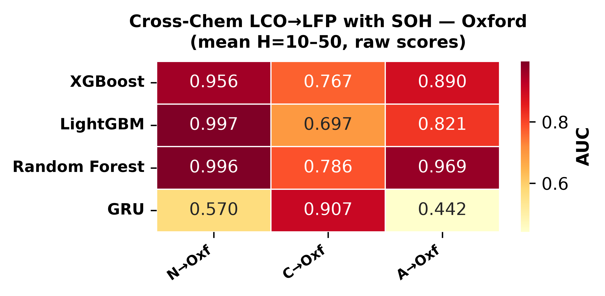
Figure 3a. Cross-chemistry transfer with SOH — Oxford (raw AUC, mean H=10–50).
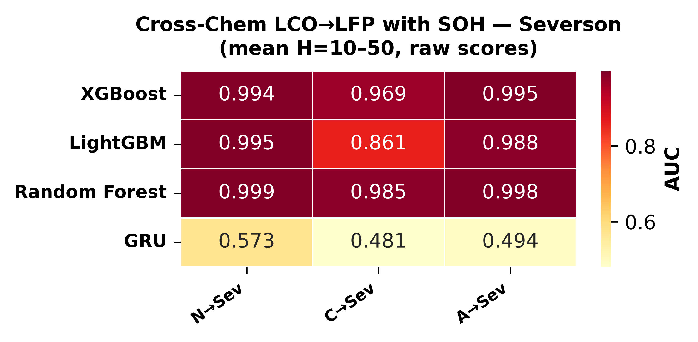
Figure 3b. Cross-chemistry transfer with SOH — Severson (raw AUC, mean H=10–50).
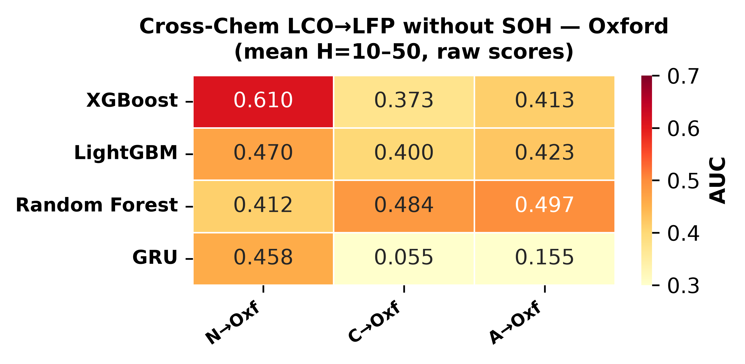
Figure 4a. Cross-chemistry transfer without SOH — Oxford (raw AUC, mean H=10–50).
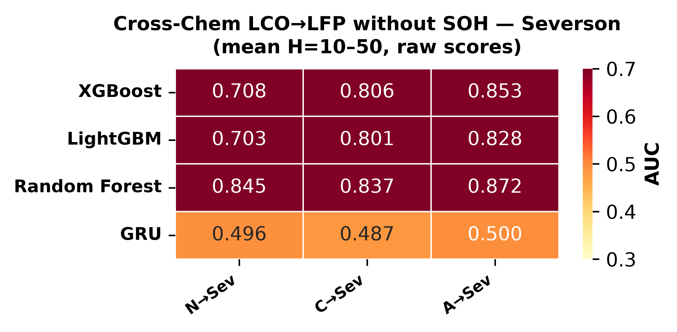
Figure 4b. Cross-chemistry transfer without SOH — Severson (raw AUC, mean H=10–50).
D. GRU entanglement under distribution shift
The GRU exhibits an architecture-specific failure mode that is qualitatively distinct from the tree behavior. Its eight-dimensional hidden state compresses SOH together with voltage, current, and cycle trends over the 10-step window. Under LCO → LFP covariate shift the entangled voltage and cycle components partially corrupt the SOH signal, producing raw AUC values as low as 0.077 for CALCE → Oxford at H = 20 compared to 0.84–0.89 for tree models. A separate mechanism drives a CALCE-trained GRU to invert its Oxford rankings (AUC ≈ 0.03–0.12): CALCE’s 92% composite-failure rate saturates the GRU’s learned decision boundary, producing systematically inverted ranking on Oxford’s feature distribution.
E. Calibration methods themselves fail to transfer
A second, independent failure mode appears in the cross-chemistry tables when isotonic calibration is applied. Tree-based models lose 0.15–0.48 AUC points depending on the configuration. The collapse occurs because isotonic’s step function is fitted to the training distribution and when test-set scores shift, multiple different test scores land in the same bin and are assigned identical calibrated probabilities, artificially reducing AUC.
F. DeLong test: statistical significance of the SOH ablation
The DeLong nonparametric test [20] formalizes the SOH-ablation comparison by accounting for the correlation between with-SOH and without-SOH AUCs computed on the same test instances. Table IV reports p-values for ALL-LCO → LFP at H = 20. On Oxford, p-values range from 7.2 × 10⁻⁵¹ (XGBoost) to 6.5 × 10⁻³⁶ (Random Forest); on Severson all p-values are below 10⁻¹⁰⁰. These results provide decisive evidence that the AUC collapse upon SOH removal is not attributable to random variation.
TABLE IV. DeLong test p-values for the SOH ablation (ALL-LCO → LFP, H = 20). All comparisons are significant at α = 0.05.
Test set | Model A | Model B | Setting | AUC A | AUC B | p-value
nasa | xgboost | lightgbm | within | 0.807 | 0.793 | 0.014
nasa | xgboost | random_forest | within | 0.807 | 0.800 | 0.334
nasa | lightgbm | random_forest | within | 0.793 | 0.800 | 0.170
calce | xgboost | lightgbm | within | 0.886 | 0.878 | 1.1×10⁻⁵
calce | xgboost | random_forest | within | 0.886 | 0.857 | 4.6×10⁻²⁷
calce | lightgbm | random_forest | within | 0.878 | 0.857 | 1.4×10⁻¹⁷
oxford | xgboost_with_soh | xgboost_no_soh | cross_chem_soh_ablation | 0.917 | 0.429 | 7.2×10⁻⁵¹
oxford | lightgbm_with_soh | lightgbm_no_soh | cross_chem_soh_ablation | 0.971 | 0.332 | 2.6×10⁻⁶⁴
oxford | random_forest_with_soh | random_forest_no_soh | cross_chem_soh_ablation | 0.989 | 0.581 | 6.5×10⁻³⁶
oxford | xgboost | lightgbm | cross_chem_with_soh | 0.917 | 0.971 | 0.003
oxford | xgboost | random_forest | cross_chem_with_soh | 0.917 | 0.989 | 9.1×10⁻⁶
oxford | lightgbm | random_forest | cross_chem_with_soh | 0.971 | 0.989 | 0.032
severson | xgboost_with_soh | xgboost_no_soh | cross_chem_soh_ablation | 0.896 | 0.750 | < 10⁻¹⁰⁰
severson | lightgbm_with_soh | lightgbm_no_soh | cross_chem_soh_ablation | 0.882 | 0.718 | < 10⁻¹⁰⁰
severson | random_forest_with_soh | random_forest_no_soh | cross_chem_soh_ablation | 0.889 | 0.746 | < 10⁻¹⁰⁰
severson | xgboost | lightgbm | cross_chem_with_soh | 0.896 | 0.882 | 1.0×10⁻²⁰
severson | xgboost | random_forest | cross_chem_with_soh | 0.896 | 0.889 | 0.004
severson | lightgbm | random_forest | cross_chem_with_soh | 0.882 | 0.889 | 0.006

G. SHAP feature importance
Tree-based SHAP values [17] provide a direct test of the lookup-table hypothesis. With SOH included in NASA → Oxford transfer at H = 20, SHAP attributions for XGBoost, LightGBM, and Random Forest all show SOH dominating by a wide margin, with cycle index a distant second and the voltage, current, temperature, and duration features contributing negligibly. When SOH is removed, all remaining features collapse to near-zero SHAP spread, confirming that no chemistry-invariant degradation signal remains. This one-glance visual result mirrors the quantitative AUC collapse.
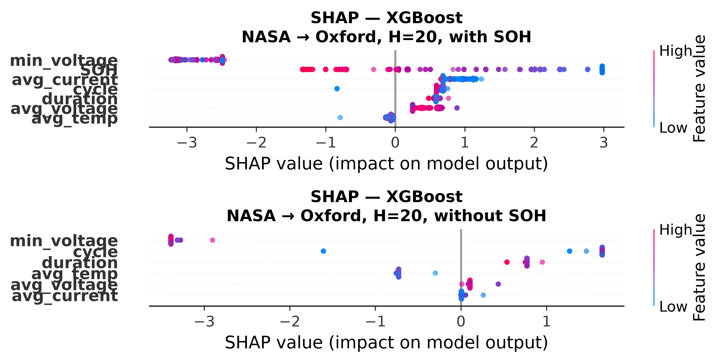
Figure 5. SHAP feature importance for XGBoost in NASA → Oxford cross-chemistry transfer (H = 20). Top: with SOH (SOH dominates). Bottom: without SOH (all features collapse to near-zero SHAP spread).
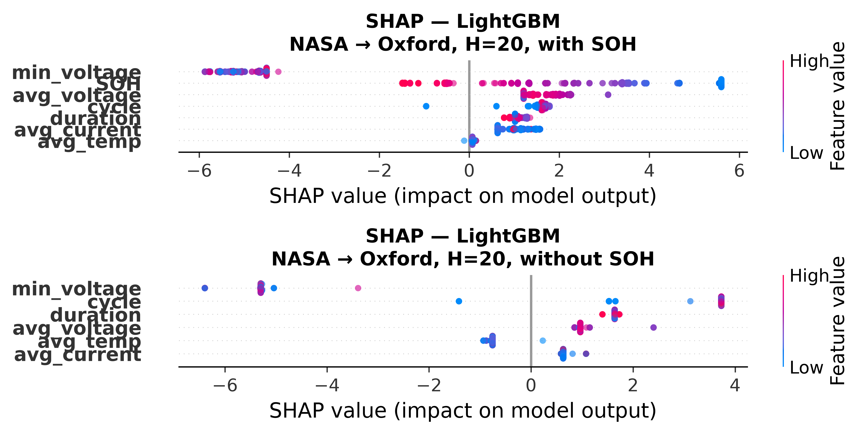
Figure 5. SHAP feature importance for LightGBM in NASA → Oxford cross-chemistry transfer (H = 20). Top: with SOH (SOH dominates). Bottom: without SOH (all features collapse to near-zero SHAP spread).
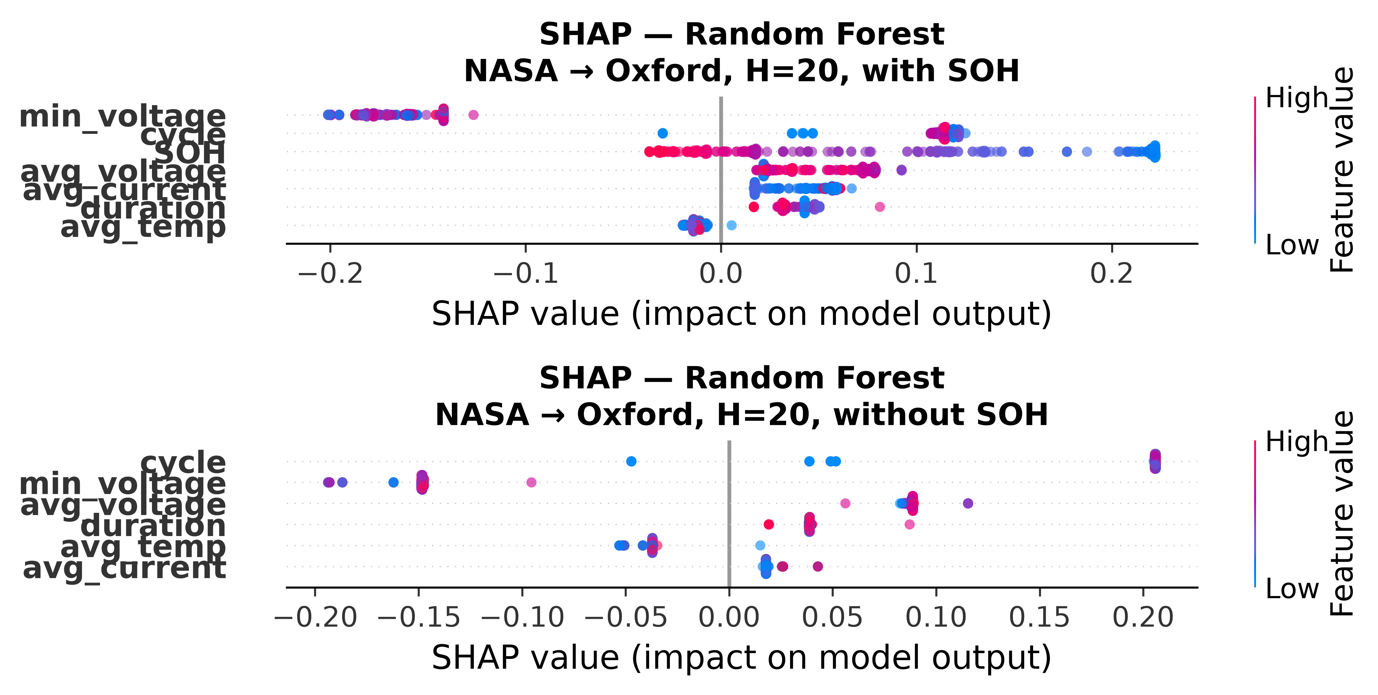
Figure 5. SHAP feature importance for Random Forest in NASA → Oxford cross-chemistry transfer (H = 20). Top: with SOH (SOH dominates). Bottom: without SOH (all features collapse to near-zero SHAP spread).
H. Embedded deployment validation
Three independent validation stages confirm that the C tree engine reproduces the Python training libraries. Stage one verifies that manual tree-walk predictions match predict_proba() for every extracted tree, aborting on any mismatch above 1 × 10⁻⁶. Stage two runs the Python tree walker on the full 1,028-row evaluation set and confirms the same per-tree match criterion. Stage three cross-compiles the C walker, runs it on the same 1,028 rows on an ESP32-S3 target, and compares results to the Python reference.
TABLE V. Embedded deployment validation and inference timing. C engine predictions compared against scikit-learn / xgboost / lightgbm predict_proba() on 1,028 rows.
Model | Trees | Nodes | Max error  (1,028 rows) | PC  time | ESP32-S3  (proj.)
XGBoost | 300 | 3,242 | 1.80 × 10⁻⁷ | 7.6 µs | ~200 µs
LightGBM | 300 | 7,000 | 1.25 × 10⁻⁹ | 5.1 µs | ~150 µs
Random Forest | 300 | 16,064 | 2.04 × 10⁻⁹ | 8.1 µs | ~250 µs
All three | 900 | 26,306 | — | 20.8 µs | ~600 µs

All three ensembles (900 trees, 26,306 nodes) occupy 372 kB in the flat binary format, well within the ESP32-S3’s 2 MB flash. Execution on the target microcontroller completes in under 600 µs for all 1,028 rows, or roughly 0.58 µs per row. No single-row inference exceeds 4 µs for any model. These results confirm that multi-horizon hazard prediction is feasible on a $12 microcontroller, enabling on-board real-time failure prediction without cloud connectivity.
V. DISCUSSION
A. The SOH-as-lookup-table mechanism
The central negative result is best understood as a leakage diagnosis rather than a generic failure of transfer learning. SOH is a capacity ratio, and capacity decays with age in both LCO and LFP cells, so SOH values from 1.0 down to 0.8 are traversed by both chemistries. What differs between chemistries is the mapping from SOH to the number of remaining cycles: LCO cells degrade faster per cycle, so a given SOH value corresponds to fewer remaining cycles. A model that learned the LCO mapping will assign high failure probability at the appropriate LCO cycle count even on LFP test cells, producing high AUC—but the prediction is driven by a chemistry-specific proxy, not by genuine understanding of LFP degradation. The SHAP analysis confirms that SOH accounts for the dominant share of feature importance across all models, and removing it collapses all predictors to near-random performance.
B. Implications for battery management practitioners
Three actionable implications follow. First, within-chemistry hazard models built only from standard charge and discharge features (voltage, current, temperature, cycle count) are reliable: AUC values of 0.85 and above are achievable with Platt calibration, and the embedded deployment results show that such models can run on a $12 microcontroller. Second, cross-chemistry transfer should not be assumed: without SOH, no model class tested achieves above-chance AUC, and even with SOH the GRU’s distributed representation provides no guarantee of cross-chemistry generalization. Third, post-hoc calibration—especially isotonic regression—should not be naively applied under distribution shift; raw scores provide a more reliable discriminative signal for cross-chemistry deployment.
C. Limitations
Several limitations bound these conclusions. The Oxford set contains only five cells, which is too small for reliable within-dataset evaluation and limits the precision of the per-cell standard deviation estimate; the 141-cell Severson set is included specifically to mitigate this, and it reproduces all qualitative findings. The analysis is unidirectional (LCO → LFP); bidirectional transfer (LFP → LCO, NMC) would provide a more complete picture. The GRU is evaluated with a single seed; the observed instability across configurations is itself informative and multi-seed analysis is deferred to future work.
VI. CONCLUSION
This study widens a multi-horizon hazard classification framework, originally demonstrated on one model and one dataset, to four model families on two LCO datasets, with cross-chemistry transfer evaluated on two independent LFP targets and with a complete embedded deployment on an ESP32-S3. Three findings stand out. First, within-dataset performance is consistent and reliable across model classes (mean AUC 0.85–0.95), with Platt calibration universally preferred over isotonic. Second, cross-chemistry transfer fails for all model classes when SOH is removed, and the failure is driven by SOH acting as a chemistry-specific lookup key rather than a transferable degradation invariant. Post-hoc calibration produces an independent failure mode: isotonic regression systematically destroys cross-chemistry discriminative power under distribution shift.
The embedded deployment results complement these findings with a practical positive result. Three tree ensembles totaling 900 trees and 26,306 nodes fit into 372 kB, run on a $12 microcontroller in under a millisecond, and reproduce the Python training libraries to sub-microsecond precision across more than a thousand validation rows. Future work should explore learned feature representations for chemistry invariance, bidirectional transfer, and multi-seed GRU evaluation.

No external funding was received for this work.
The authors declare no conflicts of interest.
The complete source code, data processing scripts, trained models, embedded firmware, and validation pipeline are publicly available at https://github.com/touhidsiddiqueeraj-bit/Multi-Horizon-Hazard-Models-for-Battery-Failure-Prediction.

REFERENCES
[1] T. A. Shikdar and H. Laaksonen, "Learning when not to use a battery: Multihorizon failure intelligence," Int. Trans. Electr. Energy Syst., vol. 36, Art. no. 6000810, 2026.
[2] H. Meng and Y. Li, "A review on prognostics and health management (PHM) methods of lithium-ion batteries," Renew. Sustain. Energy Rev., vol. 116, Art. no. 109405, 2019.
[3] L. Breiman, "Random forests," Mach. Learn., vol. 45, no. 1, pp. 5–32, 2001.
[4] T. Chen and C. Guestrin, "XGBoost: A scalable tree boosting system," in Proc. ACM SIGKDD, 2016, pp. 785–794.
[5] G. Ke, Q. Meng, T. Finley, et al., "LightGBM: A highly efficient gradient boosting decision tree," in Proc. NeurIPS, vol. 30, 2017, pp. 3146–3154.
[6] B. Saha and K. Goebel, "Battery data set," NASA Ames Prognostics Data Repository, 2007.
[7] CALCE Battery Research Group, "Battery aging datasets," Univ. Maryland, 2023.
[8] D. A. Howey and C. R. Birkl, "Oxford battery degradation dataset 1," Univ. Oxford, 2017.
[9] K. A. Severson, P. M. Attia, N. Jin, et al., "Data-driven prediction of battery cycle life before capacity degradation," Nature Energy, vol. 4, pp. 383–391, 2019.
[10] C. R. Birkl, E. McTurk, M. R. Roberts, P. G. Bruce, and D. A. Howey, "A parametric open circuit voltage model for lithium ion batteries," J. Electrochem. Soc., vol. 162, no. 12, pp. A2271–A2280, 2015.
[11] S. Sahoo, K. S. Hariharan, S. Agarwal, et al., "Transfer learning based generalized framework for state of health estimation of Li-ion cells," Sci. Rep., vol. 12, Art. no. 13173, 2022.
[12] J. Lu, R. Xiong, J. Tian, C. Wang, and F. Sun, "Deep learning to estimate lithium-ion battery state of health without additional degradation experiments," Nat. Commun., vol. 14, Art. no. 2760, 2023.
[13] J. C. Platt, "Probabilistic outputs for support vector machines and comparisons to regularized likelihood methods," in Adv. Large Margin Classifiers, MIT Press, 1999, pp. 61–74.
[14] B. Zadrozny and C. Elkan, "Transforming classifier scores into accurate multiclass probability estimates," in Proc. ACM SIGKDD, 2002, pp. 694–699.
[15] A. Niculescu-Mizil and R. Caruana, "Predicting good probabilities with supervised learning," in Proc. ICML, 2005, pp. 625–632.
[16] L. Huang, J. Zhao, B. Zhu, H. Chen, and S. K. L. M. v. Broucke, "An experimental investigation of calibration techniques for imbalanced data," IEEE Access, vol. 8, pp. 127343–127352, 2020.
[17] S. M. Lundberg, G. G. Erion, H. Chen, et al., "From local explanations to global understanding with explainable AI for trees," Nat. Mach. Intell., vol. 2, no. 1, pp. 56–67, 2020.
[18] P. Grzesik and D. Mrozek, "Combining machine learning and edge computing: Opportunities, challenges, platforms, frameworks, and use cases," Electronics, vol. 13, no. 3, Art. no. 640, 2024.
[19] C. Gupta and A. Ramdas, "Online Platt scaling with calibeating," in Proc. ICML, PMLR 202, 2023, pp. 12182–12204.
[20] E. R. DeLong, D. M. DeLong, and D. L. Clarke-Pearson, "Comparing the areas under two or more correlated receiver operating characteristic curves: A nonparametric approach," Biometrics, vol. 44, no. 3, pp. 837–845, 1988.

