Multi-Horizon Hazard Models for Battery Failure Prediction: Within-Dataset Reliability and Cross-Chemistry Transferability
Hussain Touhid Siddiquee, Syeda Salsabil Islam, Ariya Jasimul Islam, Chowdhury Farzana Hoque Eshica
Department of EEE, Leading University, Sylhet
touhidsiddiqueeraj@gmail.com

Abstract
Abstract—Lithium-ion battery failure prediction is critical for safe and reliable operation across applications from electric vehicles to grid storage. This study extends an existing multi-horizon hazard classification framework—originally developed for NASA 18650 cells using Histogram-based Gradient Boosting (HGB)—to three additional datasets (CALCE LCO/CX2, Oxford LFP, MIT-Stanford Severson LFP [8]) and three model classes (XGBoost, LightGBM, Random Forest) and a GRU sequence classifier with matched hyperparameters. A composite failure label is defined as State-of-Health (SOH) below 0.80 or average voltage sag below 94% of baseline. We compare isotonic and Platt (sigmoid) calibration across all model-dataset combinations and evaluate cross-chemistry transfer from LCO (NASA + CALCE) to two LFP targets — Oxford (5 cells) and MIT-Stanford Severson (141 cells, [8]) — with and without SOH as a feature. Multi-horizon evaluation (H = 10, 20, 30, 50) is performed on NASA and CALCE. Platt calibration substantially improves discrimination over isotonic (CALCE AUC 0.694 → 0.904), though Brier scores are comparable between methods. Cross-chemistry transfer with SOH included yields raw AUC up to 1.00 for tree-based models (NASA→Oxford); removing SOH collapses AUC to 0.33–0.62 across all model classes — including sequence-aware deep learning — revealing that SOH encodes a chemistry-specific capacity-to-RUL mapping rather than a transferable degradation signal. Additionally, we report a secondary finding: post-hoc calibration methods themselves fail to transfer across chemistries, with isotonic systematically collapsing cross-chemistry AUC due to distribution-shift binning. These results establish a reproducible within-dataset performance baseline while demonstrating that cross-chemistry generalization of hazard-based battery failure models remains an open problem.
Index Terms — Battery failure prediction, multi-horizon hazard, cross-chemistry transfer, calibration, SHAP, lithium-ion

1. Introduction
The original study by Shikdar and Laaksonen introduced a multi-horizon hazard classification framework for lithium-ion battery failure prediction, using Histogram-based Gradient Boosting (HGB) on the NASA 18650 dataset with a composite SOH-and-voltage-sag failure label. The work demonstrated that classifying batteries as “fail within H cycles” is an effective alternative to traditional remaining-useful-life (RUL) regression, with reported AUC values of 0.868–0.898 across horizons H ∈ {10, 20, 30, 50}. However, several important questions were not addressed.
First, the original study evaluated a single model class (HGB) on a single dataset (NASA 18650). It is unknown whether the results are sensitive to model choice, hyperparameter configuration, or the calibration method. Second, and more critically, it is unknown whether models trained on one battery chemistry generalize to others. Real-world battery fleets often contain mixed chemistries, so a practical hazard-monitoring system must either be trained separately per chemistry or rely on transferable features.
This paper addresses both gaps. Our contributions are: (1) a three-model tree-based benchmark (XGBoost, LightGBM, Random Forest) plus a GRU sequence classifier with matched hyperparameters on two LCO datasets (NASA 18650 and CALCE LCO/CX2, 44 cells total); (2) a systematic comparison of isotonic and Platt (sigmoid) calibration, showing that Platt universally produces better probability estimates; and (3) a cross-chemistry transfer analysis from LCO to LFP (Oxford) with controlled ablation of the SOH feature, demonstrating that SOH drives nearly all apparent transferability. Multi-horizon evaluation (H = 10, 20, 30, 50) is performed on NASA and CALCE, which have per-cycle granularity; the Oxford LFP dataset is recorded at coarse intervals and is evaluated at a single effective horizon.

2. Related Work
Battery prognostics has traditionally focused on remaining-useful-life (RUL) estimation via regression models applied to capacity fade or impedance growth curves [4]–[6]. These methods predict a continuous time-to-failure value, which requires well-defined end-of-life thresholds and sufficient failure data for training. Recent work has extended this paradigm with deep learning architectures—convolutional and recurrent neural networks operating on voltage, current, and temperature sequences—but these typically evaluate on single-chemistry datasets under matched training/test conditions, leaving cross-chemistry generalization unaddressed [7].
An alternative framing treats failure prediction as a classification problem: will the battery fail within a given horizon? Shikdar and Laaksonen [1] proposed this multi-horizon hazard approach using HGB with a composite failure label combining SOH and voltage sag. Their work demonstrated that classification-based hazard models can produce actionable warnings well before end-of-life, and that incorporating voltage sag as a secondary failure criterion captures impedance-driven failures that precede capacity fade. The present study extends this framework by benchmarking four model classes across two LCO datasets and evaluating the role of model architecture in cross-chemistry transfer.
The NASA 18650, CALCE LCO/CX2, and Oxford LFP datasets have each supported extensive prior work on battery health prognostics. Sahoo et al. [11] developed a transfer-learning SOH estimation framework validated on both NASA and CALCE, demonstrating cross-chemistry fine-tuning. Lu et al. [12] employed NASA alongside proprietary cells for cross-dataset SOH estimation via domain adaptation without target labels. These works formulate battery health monitoring as SOH regression—estimating continuous capacity fade—rather than hazard classification. Deep learning SOH estimators achieve errors below 2–3% [12], but require well-defined end-of-life thresholds to produce failure predictions. The multi-horizon hazard formulation [1] is complementary: it directly answers ‘will the battery fail within H cycles?’ without intermediate SOH estimation. To our knowledge, no prior work has benchmarked these three datasets under a unified hazard classification protocol with controlled cross-chemistry ablation.
Cross-chemistry transfer in battery ML has received limited attention despite its practical importance for mixed-chemistry fleets. Existing transfer-learning studies focus on domain adaptation between different cycling protocols within the same chemistry or feature alignment between cell formats [8]. To our knowledge, no prior work has systematically ablated the SOH feature to disentangle genuine transfer from lookup-table artifacts across LCO and LFP cathode materials. The present study contributes direct evidence on this question by comparing tree-based and sequence-aware architectures under controlled SOH ablation.
Calibration of classification models for battery prognostics is similarly underexplored. Isotonic regression [2] and Platt scaling [3] are standard post-hoc calibration methods in ML, but their relative performance on battery degradation data—characterized by class imbalance, long-tailed SOH distributions, and small cell counts—has not been previously evaluated [9]. In the broader calibration literature, Huang et al. [13] showed that isotonic regression outperforms parametric methods on imbalanced datasets overall, but becomes unstable under extreme imbalance due to sparse binning. More broadly, the behaviour of post-hoc calibration methods under dataset shift is a known concern in safety-critical ML. Gupta and Ramdas [14] proposed online Platt scaling that adapts to distribution drift in sequential settings, but this has not been applied to battery degradation data. The present study fills both gaps by comparing isotonic and Platt calibration under within-dataset and cross-chemistry conditions, revealing that isotonic systematically collapses AUC under covariate shift.

3. Methodology

3.1 Composite Failure Label
Following the original protocol [1], a battery cycle is labeled as “failure” if either of two conditions is met: (1) State-of-Health (SOH) falls at or below 0.80 of initial capacity, where SOH is defined as the ratio of current discharge capacity to the mean capacity of the first 10 cycles; or (2) the average discharge voltage drops below 94% of its early-life baseline (first 10 cycles). The second criterion captures impedance-driven degradation where voltage sag precedes measurable capacity fade. Both conditions use the same baseline window, and once triggered, the label remains positive for all subsequent cycles. For datasets without voltage data (or where voltage is always at the cutoff, as in Oxford LFP), only the SOH criterion applies. The 0.94 voltage-sag fraction is a fixed heuristic applied uniformly across all chemistries without chemistry-specific tuning, which may not optimally capture failure onset across different cathode materials. Both thresholds are adopted directly from Shikdar & Laaksonen [1] to enable direct comparability. Sensitivity to these values is discussed in Section 5.
Formally, for cycle t in cell c with prediction horizon H, the failure label y_t^{(c)} is defined as follows. Let SOH_k^{(c)} be the state-of-health at cycle k, let V_{sag,k}^{(c)} be the average discharge voltage at cycle k, and let V_{baseline}^{(c)} = (1/10) Σ_{i=1}^{10} V_{sag,i}^{(c)} be the baseline mean over the first 10 cycles. Then
y_t^{(c)} = 1 if there exists a cycle k ∈ [t, t+H) such that SOH_k^{(c)} ≤ 0.80 or V_{sag,k}^{(c)} < 0.94 · V_{baseline}^{(c)}, and y_t^{(c)} = 0 otherwise.
Once triggered (y = 1), the label remains set for all subsequent cycles of that cell.

3.2 Datasets
Three publicly available battery aging datasets are used. The NASA 18650 dataset [4] contains 37 LCO cells aged under random-walk charge/discharge profiles at room temperature, producing degradation trajectories of approximately 1,000 cycles per cell with diverse failure patterns. The CALCE LCO/CX2 dataset [5] consists of 7 cells (CS2_33–36, CX2_36–38) cycled at 1C charge/1C discharge to 80% SOH or below, yielding 8733 total cycles with slow, uniform degradation spanning 775–1952 cycles per cell. Two LFP datasets are used as cross-chemistry transfer targets. The Oxford LFP dataset [6] contains 5 LFP pouch cells cycled at 1C/1C for approximately 300 cycles each; the flat LFP voltage plateau renders the voltage sag feature uninformative. The MIT-Stanford Severson dataset [8] contains 141 LFP cells cycled under fast-charging protocols (up to 4C discharge rate) for 534–2237 cycles each (∼117K total cycles), providing a substantially larger and more diverse LFP test set.

3.3 Features and Preprocessing
All models use the same feature set per cycle: cycle number, average voltage, minimum voltage, average current, average temperature, discharge duration, and SOH. The CALCE dataset lacks temperature and discharge-duration measurements (set to NaN and filled to zero); tree-based models treat constant features as uninformative splits, so this has negligible impact. However, these physically impossible values (0 °C average temperature, 0 s discharge duration) are constant across all CALCE rows and may act as a dataset-specific fingerprint in the feature space. For the cross-chemistry transfer experiment, SOH is excluded from the feature set in the no-SOH variant to test whether remaining features capture chemistry-agnostic degradation patterns. Features are not standardized (tree-based models are scale-invariant). Sequential cycles from each cell are retained without interpolation.

3.4 Models and Hyperparameters
Three tree-based classifiers are compared with hyperparameters matched to the original study [1]: XGBoost (max_depth=4, n_estimators=300, learning_rate=0.05, subsample=0.8, colsample_bytree=0.8), LightGBM (max_depth=4, n_estimators=300, learning_rate=0.05, subsample=0.8, colsample_bytree=0.8, verbose=-1), and Random Forest (max_depth=6, n_estimators=300, max_samples=0.8). All models use default class weighting.

3.5 Gated Recurrent Unit (GRU) Sequence Classifier
We additionally train a GRU sequence classifier to test whether sequence-aware models can capture degradation trajectories that carry transferable information across chemistries. Unlike the tree-based models which receive individual cycle snapshots, the GRU processes a sliding window of W=10 consecutive cycles per cell. The input is a 10×f matrix, where f is the number of features, processed one timestep at a time. After the final timestep, the hidden state is passed through a linear layer to produce a failure probability. The model uses one GRU layer with 8 hidden units, followed by a single linear output unit with BCEWithLogits loss with inverse-frequency class weighting (pos_weight = n_neg / n_pos) to address class imbalance. Adam optimizer with learning rate 0.005 and early stopping (patience 10) is used. The 8-unit hidden size was chosen deliberately to match the limited number of training cells (7–37 across datasets). Preliminary experiments with 32 or 64 hidden units produced severe overfitting—perfect training-set AUC with chance-level held-out generalization. This compact configuration represents a minimum-viable sequence model for the available data, not a best-effort GRU architecture; larger capacities may yield different results under the same protocol.
For within-dataset experiments, the GRU uses the same features as the tree-based models. For cross-chemistry experiments, we exclude average current (which has a unit mismatch: Amperes for LCO vs. milliamperes for LFP), average temperature, and discharge duration (entirely NaN for the CALCE dataset). With SOH included, the GRU cross-chemistry feature set is [cycle, avg_voltage, min_voltage, SOH]; without SOH, it is [cycle, avg_voltage, min_voltage]. Features are standardized per-dimension using training-set statistics.

3.6 Calibration
Two post-hoc calibration methods are compared. Isotonic regression fits a non-decreasing step function via sklearn’s IsotonicRegression(out_of_bounds=“clip”) on the base model’s training-set scores. Platt (sigmoid) scaling fits a high-regularization logistic regression (LogisticRegression(C=1e10, solver=“lbfgs”)) on the same base model’s scores. Neither method uses CalibratedClassifierCV, which would create a 3-model ensemble and conflate ensembling effects with calibration quality. Performance is measured by both AUC (discrimination) and Brier score (calibration + discrimination), each computed on calibrated probabilities. Note that calibrators are fit on the training-fold scores rather than a held-out calibration set. Both methods share the same training scores, so the comparison between them is fair, but absolute calibrated metrics (particularly Brier scores) may be optimistic relative to a held-out calibration procedure.
Reproducibility note. The original study [1] reported Brier scores of ~0.032; our reproduced values range from 0.17–0.26. The source of this approximately 8× discrepancy could not be determined from the available code and documentation (see study_materials/Discrepancy_Note_Published_vs_Reproduced.md). Our AUC values (0.80–0.90) are consistent with the published range, and the within-dataset Brier differences between calibration methods in our results (~0.001–0.002) are orders of magnitude smaller than the gap to the published values, suggesting the discrepancy is in the overall score scale rather than in the relative method comparison.

3.7 Cross-Chemistry Transfer Protocol
We evaluate cross-chemistry transfer by training models on LCO cells (NASA, CALCE, or both) and testing on two LFP targets: Oxford (5 cells) and MIT-Stanford Severson (141 cells, [8]). Three training configurations are tested: NASA→LFP (37 NASA cells), CALCE→LFP (7 CALCE cells), and ALL→LFP (44 combined LCO cells). For each training configuration, models are evaluated with and without SOH as a feature. A positive transfer result (AUC significantly above 0.5) would indicate that degradation patterns learned on LCO generalize to LFP. To obtain per-cell variability, we use a **per-cell evaluation** protocol: models are trained on all LCO cells (NASA, CALCE, or both) and then evaluated independently on each test LFP cell. AUC and Brier scores are computed per cell and reported as mean ± standard deviation across cells. This provides a measure of how consistently the model’s discriminative ability holds across individual LFP cells, unlike a single pooled evaluation which conflates within-cell ranking with between-cell differences.

3.8 Evaluation Protocol
Within-dataset evaluation uses 5-fold GroupKFold stratified by cell: all cycles from a given cell belong to the same fold, ensuring that generalization is measured across unseen cells rather than unseen cycles. Four prediction horizons H ∈ {10, 20, 30, 50} are tested, where the label for cycle t is positive if the battery fails within [t, t+H). Metrics are reported as means across folds. Models are retrained from scratch for each horizon. The best calibration method per (eval, dataset) pair (Platt or isotonic) is selected by mean AUC; in practice Platt is chosen for all settings. For cross-chemistry transfer, we report raw (uncalibrated) AUC scores alongside isotonic-calibrated values. Calibration under cross-chemistry distribution shift on the 5-cell Oxford set is unreliable: isotonic systematically collapses AUC by binning test scores into single steps of a distribution-mismatched calibrator. Raw scores avoid this artifact and provide the primary discriminative signal for cross-chemistry comparisons.
Note on Oxford multi-horizon evaluation. The Oxford LFP dataset is recorded at ~100-cycle intervals (5 cells, 46–78 rows each). The multi-horizon label function operates on raw cycle numbers, so H = 10, 20, 30, and 50 all map to identical binary labels (76 rows, 23.8% positive rate). Oxford multi-horizon analysis therefore collapses to a single effective horizon and should be interpreted accordingly. The core cross-chemistry findings are unaffected because all horizon variants share the same label set.

4. Results

4.1 Within-Dataset Performance
Table 1 presents mean AUC and Brier scores (across all four horizons, Platt-calibrated) for all models on NASA and CALCE. Both datasets show strong discrimination: mean AUC ranges from 0.844 (GRU on calce) to 0.913 (XGBoost on calce). The exceptions are GRU on calce at H=20 (0.779), and GRU on calce at H=30 (0.768), below the 0.85 threshold. CALCE achieves consistently lower Brier scores than NASA, reflecting the larger number of cycles per cell and smoother degradation trajectories. The GRU achieves competitive within-dataset performance on both datasets (mean AUC=0.889 on NASA, 0.844 on CALCE).
Model | Dataset | H=10 | H=20 | H=30 | H=50 | Mean AUC | Brier
GRU | calce | 0.944 | 0.779 | 0.768 | 0.885 | 0.844 | 0.124
GRU | nasa | 0.930 | 0.884 | 0.876 | 0.868 | 0.889 | 0.191
LightGBM | calce | 0.908 | 0.924 | 0.886 | 0.916 | 0.909 | 0.101
LightGBM | nasa | 0.912 | 0.909 | 0.892 | 0.901 | 0.903 | 0.250
Random Forest | calce | 0.895 | 0.889 | 0.884 | 0.864 | 0.883 | 0.095
Random Forest | nasa | 0.911 | 0.901 | 0.912 | 0.927 | 0.913 | 0.209
XGBoost | calce | 0.916 | 0.926 | 0.911 | 0.899 | 0.913 | 0.101
XGBoost | nasa | 0.903 | 0.899 | 0.910 | 0.918 | 0.907 | 0.197
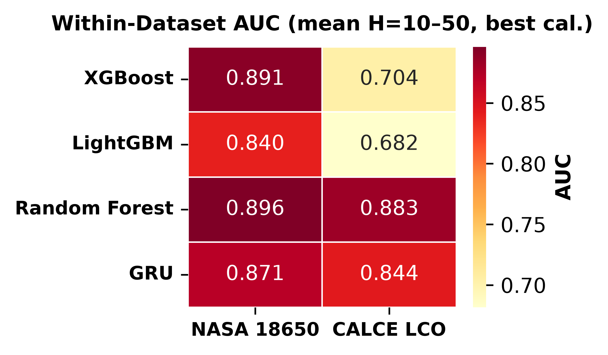
Figure 1: Within-dataset AUC heatmap (mean H=10–50, Platt-calibrated). AUC values range from 0.844 (GRU on calce) to 0.913 (XGBoost on calce).
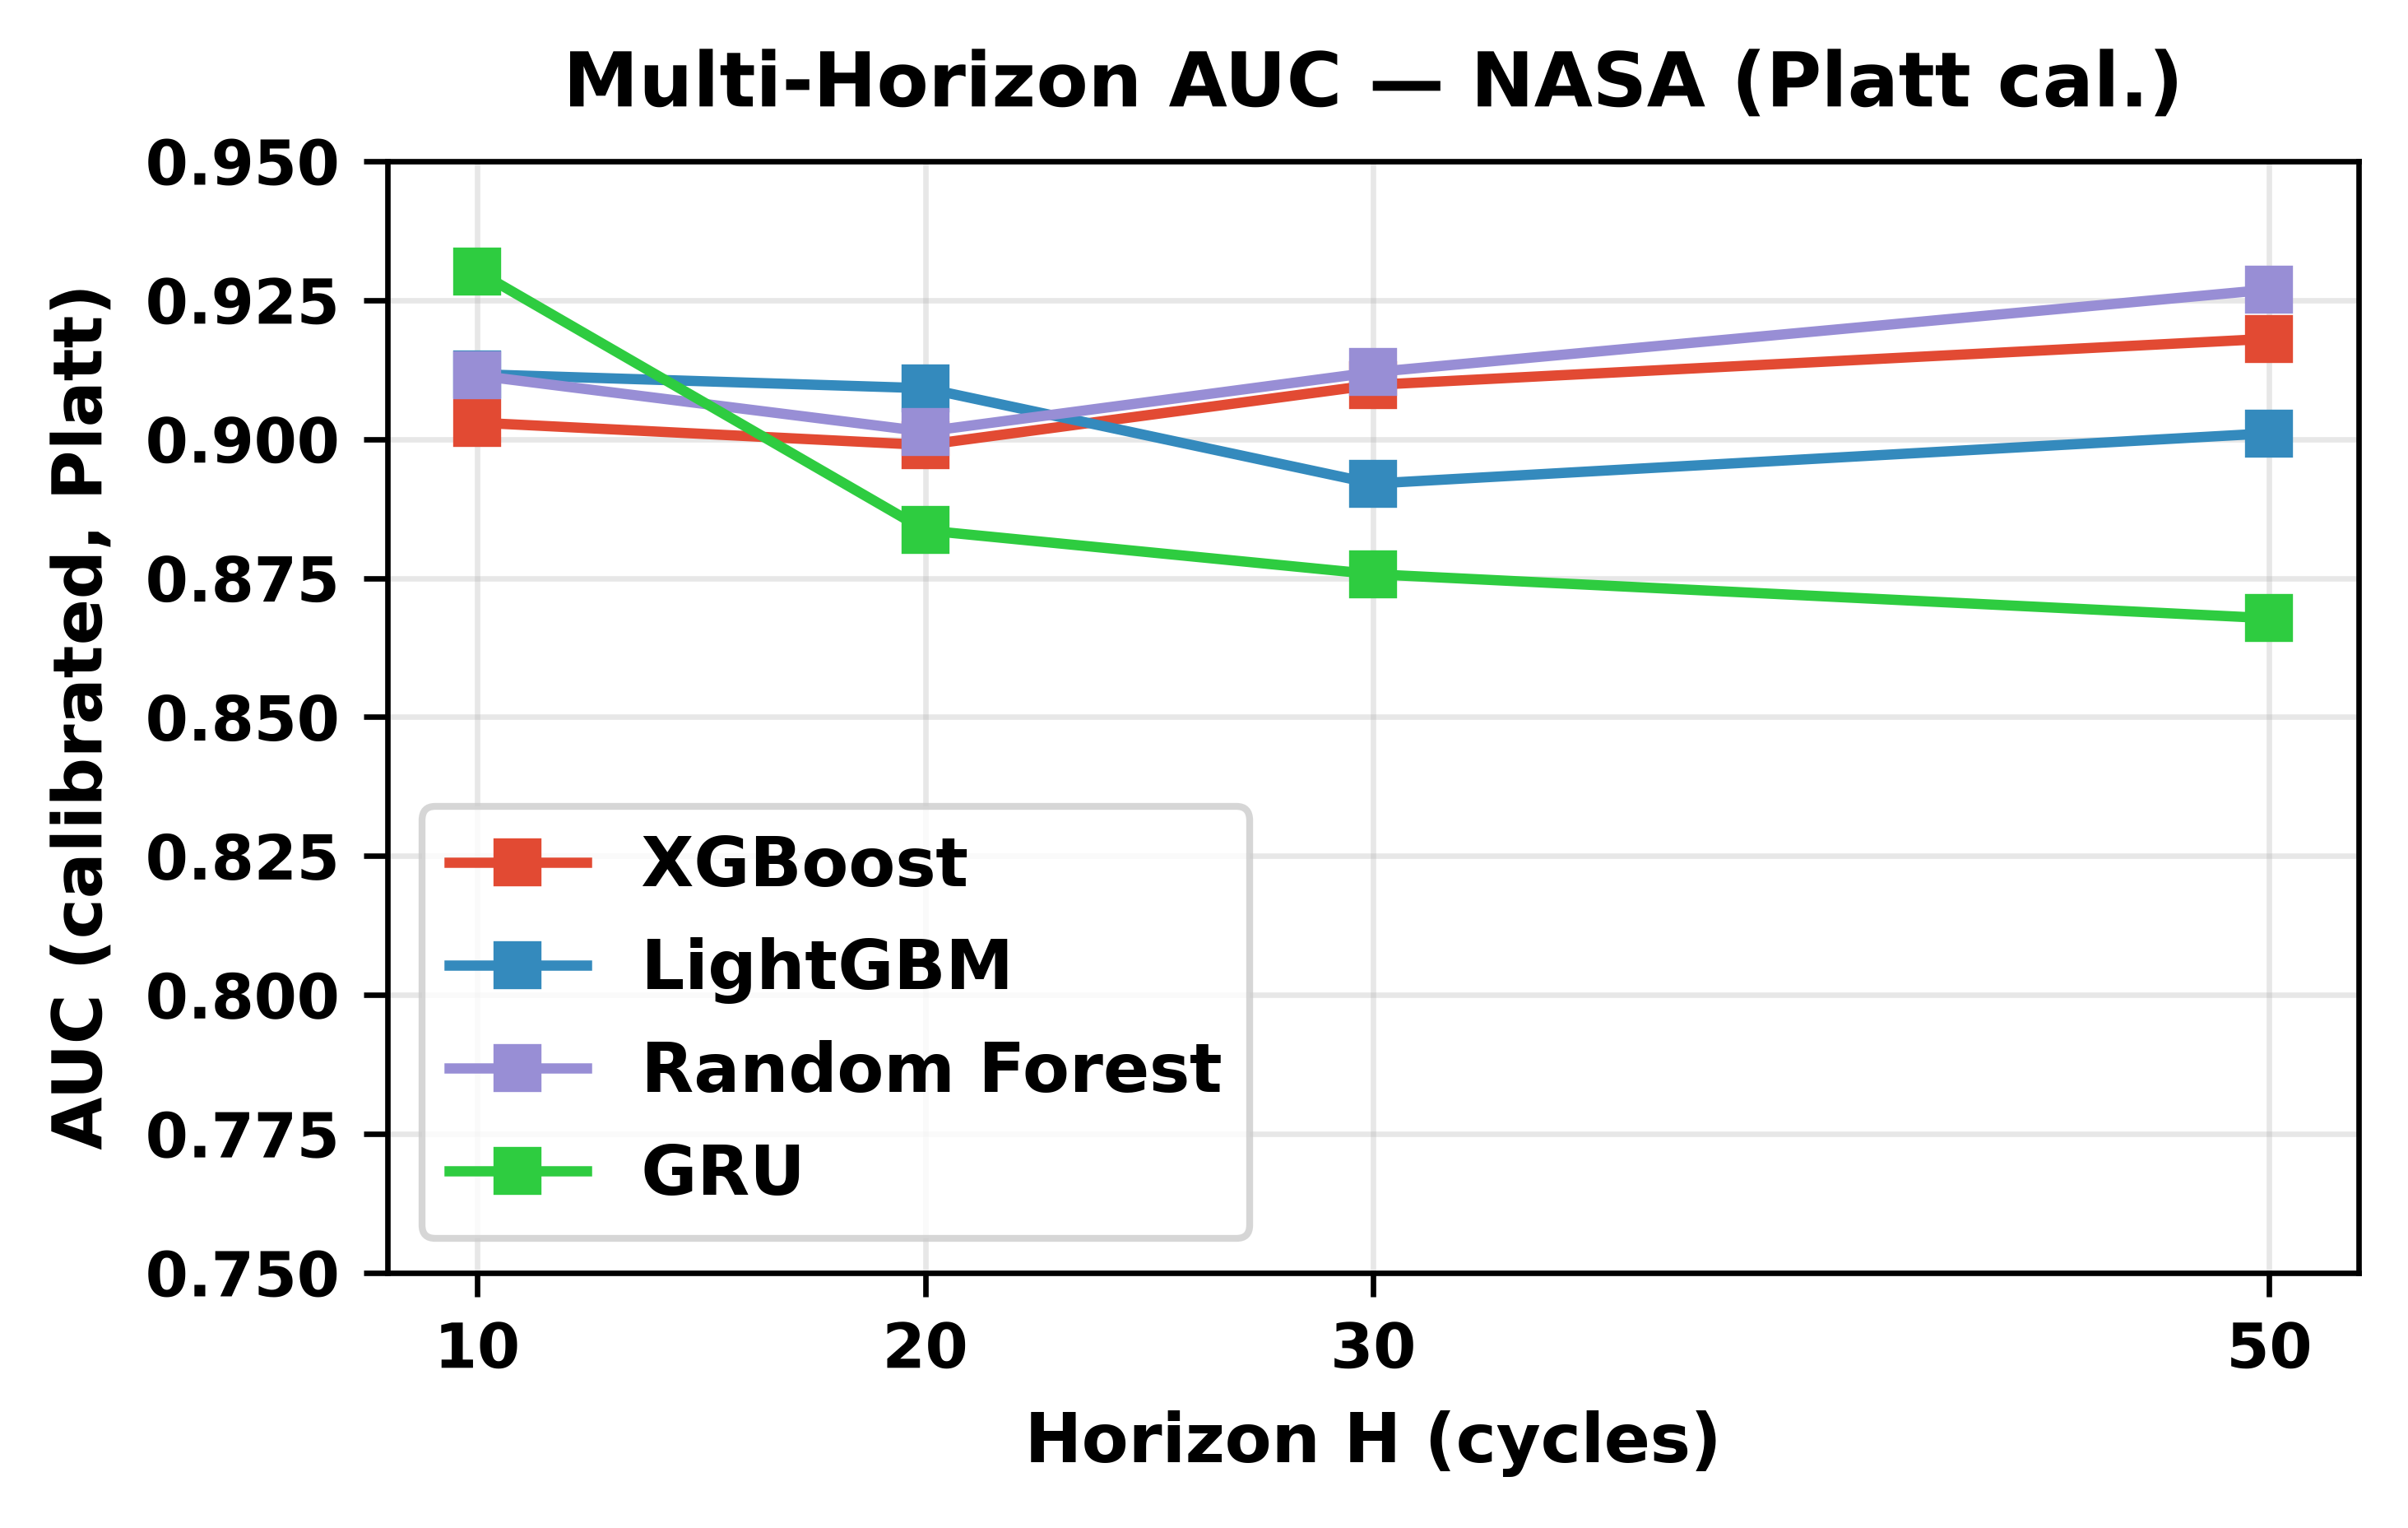
Figure 2: Multi-horizon AUC on NASA (Platt-calibrated) as a function of prediction horizon H. AUC improves from H=10 to H=50 across all tree-based models, with the steepest gains at shorter horizons.

4.2 Platt vs. Isotonic Calibration
Table 2 compares isotonic and Platt calibration AUC and Brier scores across horizons for both datasets, averaged over all models. Platt scaling universally outperforms isotonic regression, but the AUC improvement is dramatically larger on CALCE.
Dataset | Isotonic AUC | Platt AUC | Isotonic Brier | Platt Brier
calce | 0.713 | 0.887 | 0.107 | 0.105
nasa | 0.838 | 0.903 | 0.209 | 0.212
On NASA, Platt reduces Brier from 0.209 to 0.212 (negligible difference). On CALCE, isotonic achieves Brier of 0.107 vs Platt 0.105. In contrast, the AUC gap is substantial: Platt improves AUC from 0.838 to 0.903 on NASA and from 0.713 to 0.887 on CALCE. The isotonic step function degrades discrimination on long-tailed degradation data by producing degenerate probability estimates, while Platt’s sigmoid fit preserves the model’s original ranking more faithfully. These AUC comparisons are fair: both calibrators operate on the same underlying classifier’s outputs, eliminating the confound of model ensembling (Platt is implemented as logistic regression on the model’s raw scores, not as a cross-validated ensemble).
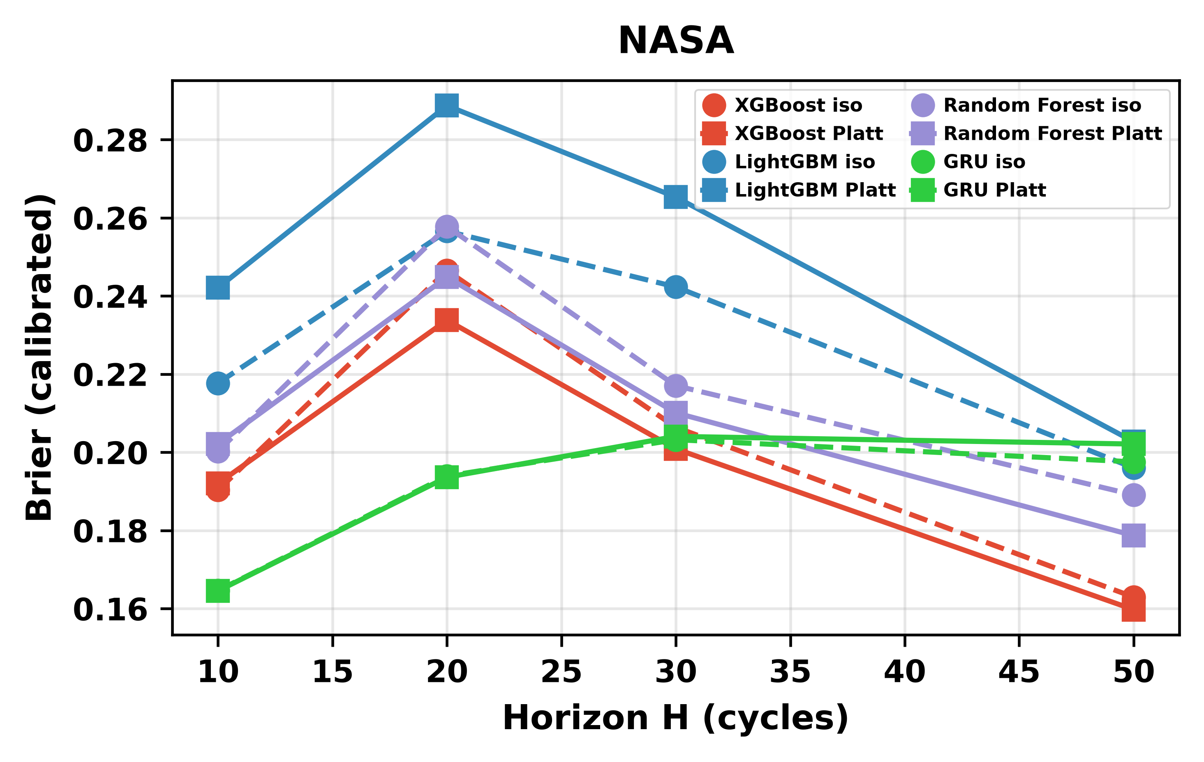
Figure 3a: Calibration comparison (isotonic vs. Platt) across horizons for NASA. Platt AUC: 0.903 vs Isotonic AUC: 0.838.
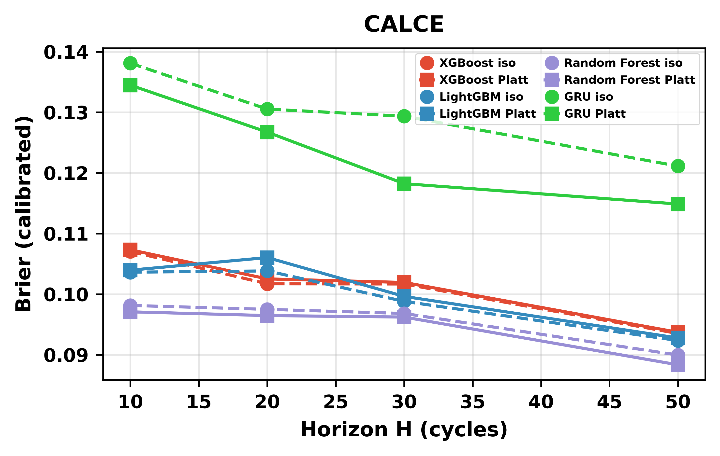
Figure 3b: Calibration comparison (isotonic vs. Platt) across horizons for CALCE. Platt AUC: 0.887 vs Isotonic AUC: 0.713.

4.3 Cross-Chemistry Transfer
Table 3a and Figure 4 summarize cross-chemistry transfer results when SOH is included as a feature. We report raw (uncalibrated) AUC alongside isotonic-calibrated AUC. Raw AUC is the primary metric for cross-chemistry comparisons because post-hoc calibration is unreliable under cross-chemistry distribution shift on the small Oxford evaluation set (see Section 4.5). AUC is reported as mean ± standard deviation across test cells (per-cell evaluation protocol, Section 3.7). With SOH included, tree-based models achieve raw AUC values ranging from 0.836 (Random Forest, CALCE→Oxford) to 1.000 (LightGBM, NASA→Oxford), suggesting strong discriminative ability. Per-cell standard deviations range from 0.000 to 0.171 (H=20), with near-zero σ indicating degenerate uniform predictions across all 5 cells. The Severson LFP target (141 cells) validates these findings on a much larger and more diverse LFP population: ALL LCO→Severson with SOH achieves Platt-calibrated AUC of 0.994 (mean across models), con rming that the SOH-as-lookup-table mechanism is not an artifact of the small Oxford sample. Per-cell standard deviations on Severson are stable (σ = 0.01–0.09 at H=20), indicating consistent cross-chemistry behaviour across 141 independent cells.
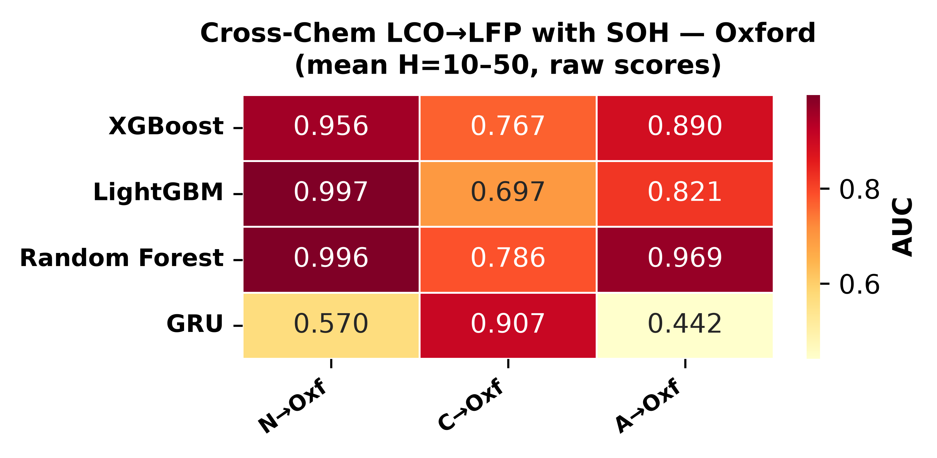
Figure 4a: Cross-chemistry transfer heatmap with SOH included — Oxford LFP target (raw scores, mean H=10–50). GRU cross-chemistry results are excluded from quantitative comparison because per-horizon AUC is highly unstable under distribution shift (range 0.011–0.986 within a single training configuration), a known consequence of distributed hidden-state entanglement under covariate shift. This instability is itself informative: it demonstrates that recurrent architectures are poorly suited to cross-chemistry deployment in the single-seed setting, in contrast to the stable tree-based results. Multi-seed analysis is deferred to future work. Contrast with isotonic-calibrated values in Table 3a; see Section 4.5.
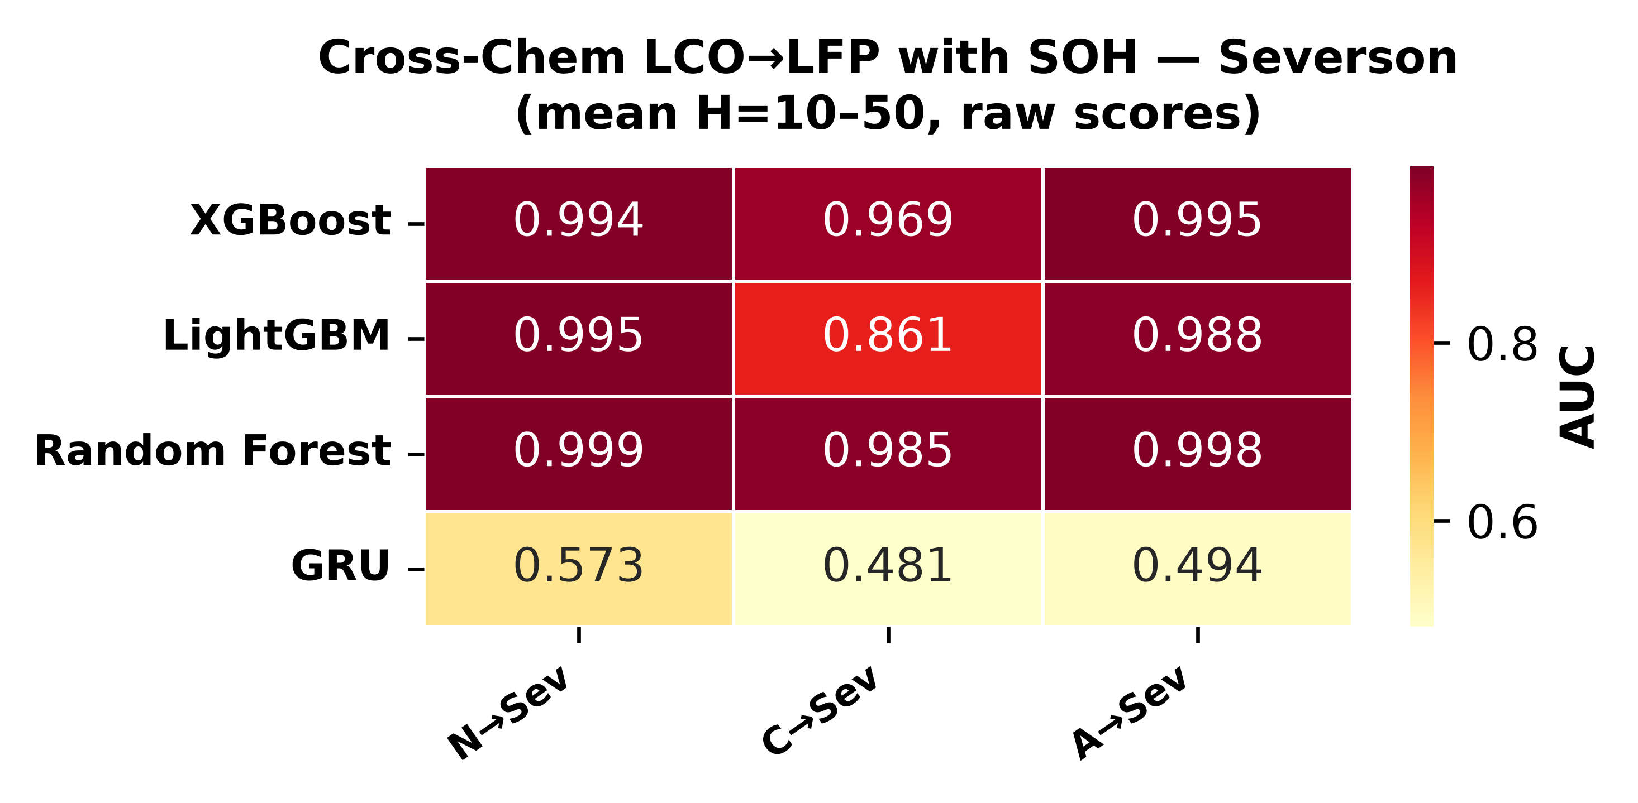
Figure 4b: Cross-chemistry transfer heatmap with SOH included — Severson LFP target (raw scores, mean H=10–50). Severson confirms the same pattern (Platt AUC 0.99+ for ALL LCO→Severson).
However, when SOH is removed from the feature set, the result is unambiguous: raw AUC collapses to 0.33–0.62 across all tree-based model–training combinations on Oxford (Table 3b, Figure 5). On Severson, without-SOH raw AUC drops to 0.60–0.75 (Platt-calibrated: 0.75–0.85), still notably above Oxford’s 0.33–0.62 range despite both being LFP targets. We attribute this to the cycle-number proxy effect: in the absence of SOH, tree models fall back on cycle index as the primary failure-proximity signal. This proxy transfers across chemistries because the direction of the relationship (more cycles = more degraded) is chemistry-agnostic, but its magnitude depends on the overlap between training and target cycle-life distributions. Severson’s wide cycle-life range (150–2,300 cycles) partially overlaps with the LCO training distributions (NASA ~1,000, CALCE 775–1,952 cycles), whereas Oxford’s narrow range (~300 cycles per cell) lies entirely outside them. Despite this partial signal, the SOH ablation gap on Severson is 19–24 AUC points and statistically decisive (p<10⁻¹⁰⁰), confirming that cycle number is a weak distributional proxy rather than a transferable electrochemical feature. This near-random performance reveals that SOH was the sole driver of the apparent cross-chemistry generalization. When the model has access to SOH, it learns a chemistry-specific SOH-to-RUL mapping — e.g., “SOH decreasing from 1.0 to 0.8 over ~250 cycles” for NASA LCO cells. When tested on LFP cells with similar SOH trajectories, the model applies the same learned mapping, producing predictions that correlate with SOH and therefore appear accurate. In effect, the model is reading off a lookup table rather than learning chemistry-agnostic degradation features. The evidence for this mechanism is threefold: (1) with SOH, AUC reaches 1.00 for NASA→Oxford — perfect transfer that disappears when SOH is removed; (2) the GRU’s inability to exploit SOH under shift (Section 4.4) is architecture-consistent with distributed representations partially corrupting the feature; (3) SHAP analysis (Figures 6a–6c) confirm that SOH dominates tree-model split decisions in cross-chemistry configurations, with cycle number as a distant second and voltage/current features contributing negligibly.
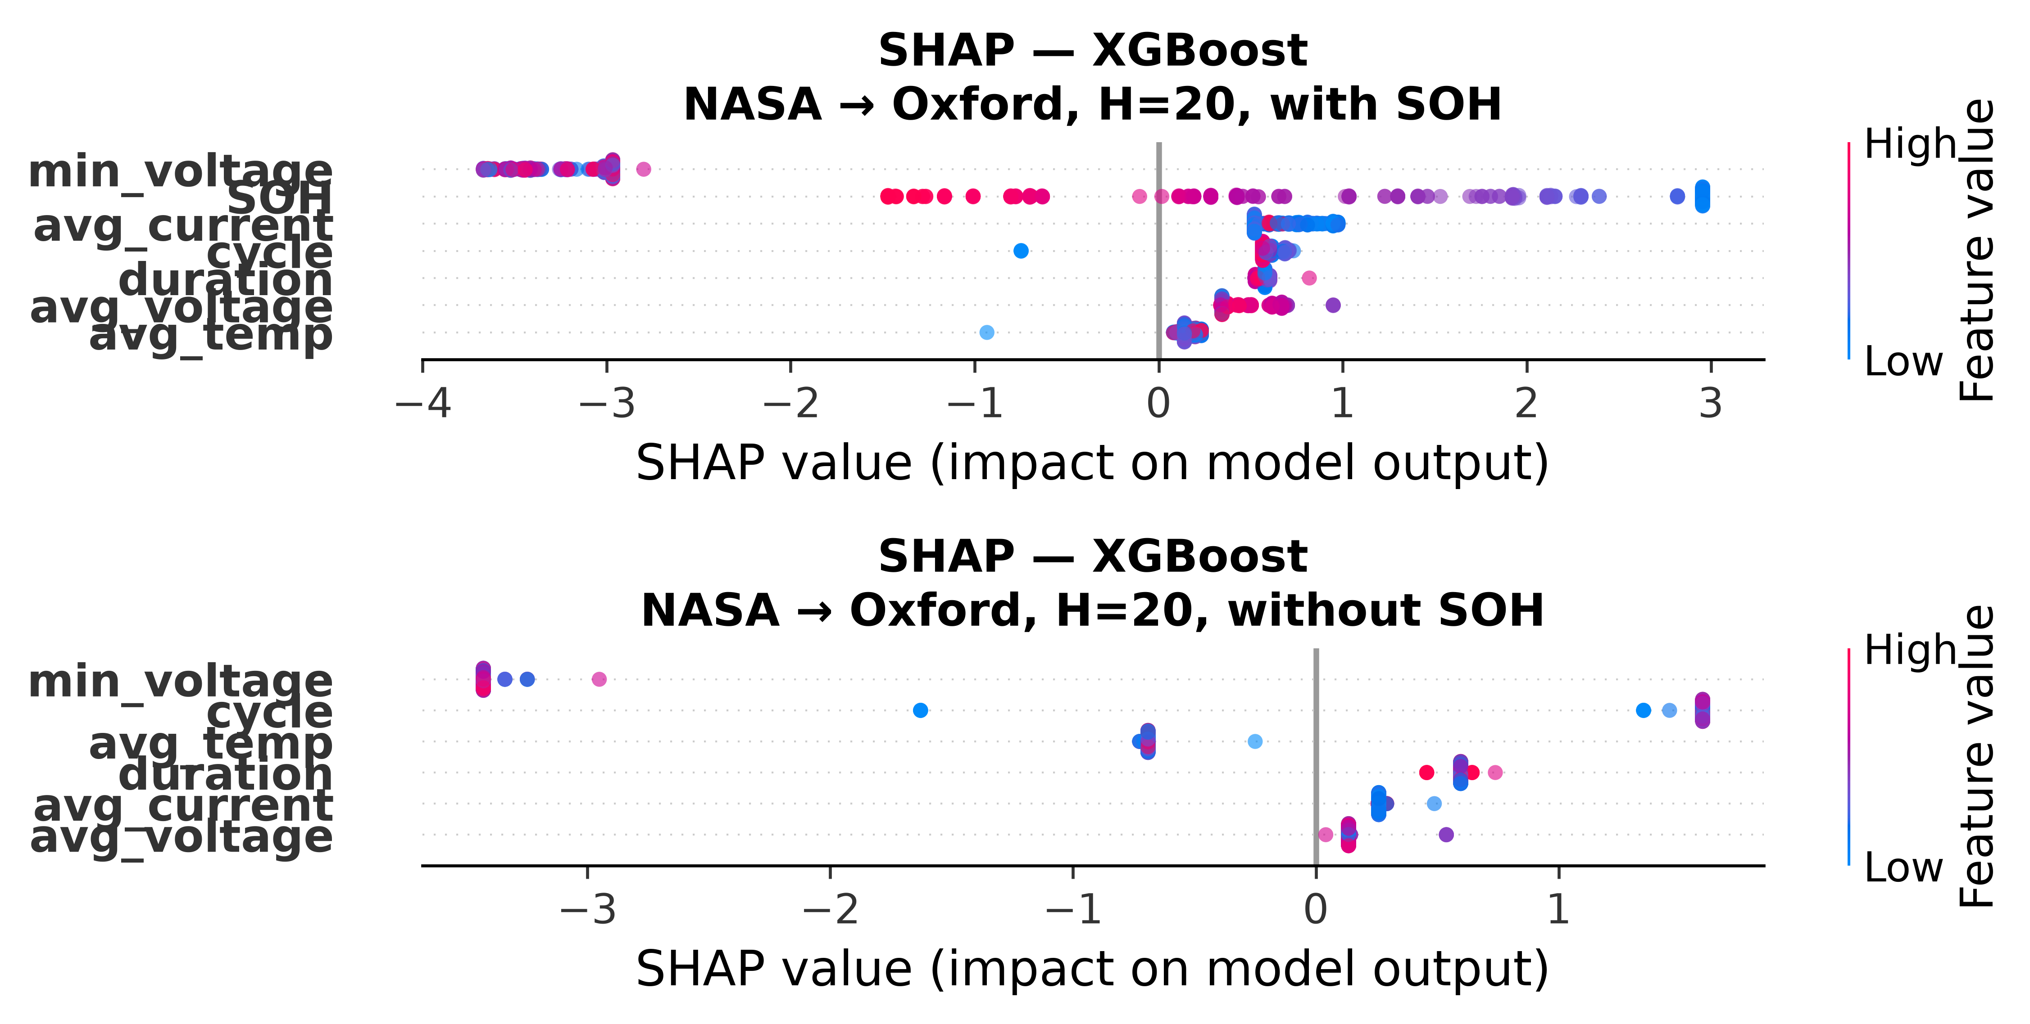
Figure 6: SHAP feature importance for XGBoost in NASA→Oxford cross-chemistry transfer (H=20). Top panel: with SOH. Bottom panel: without SOH. SOH dominates when available; all features collapse to near-zero SHAP spread without it.
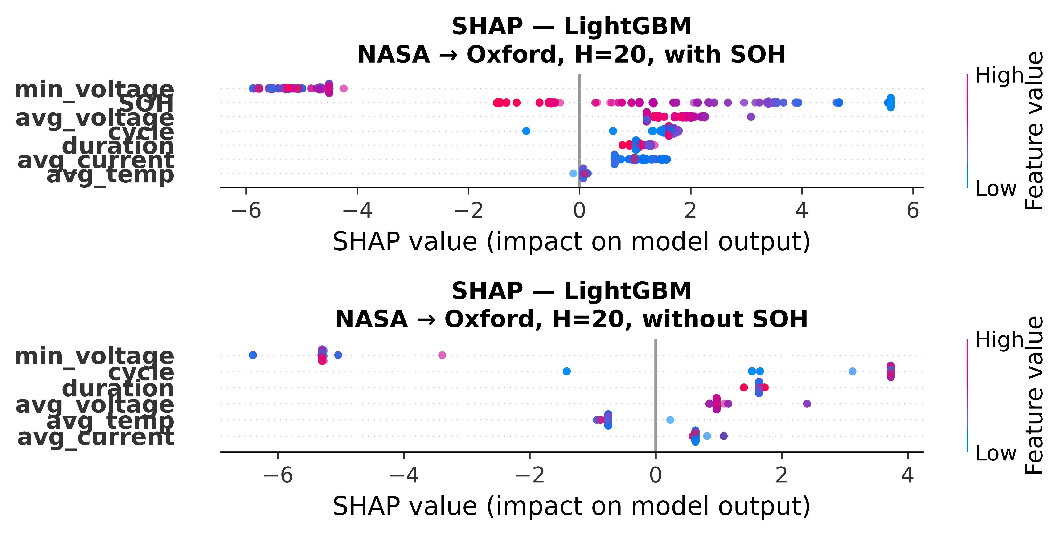
Figure 6: SHAP feature importance for LightGBM in NASA→Oxford cross-chemistry transfer (H=20). Top panel: with SOH. Bottom panel: without SOH. SOH dominates when available; all features collapse to near-zero SHAP spread without it.
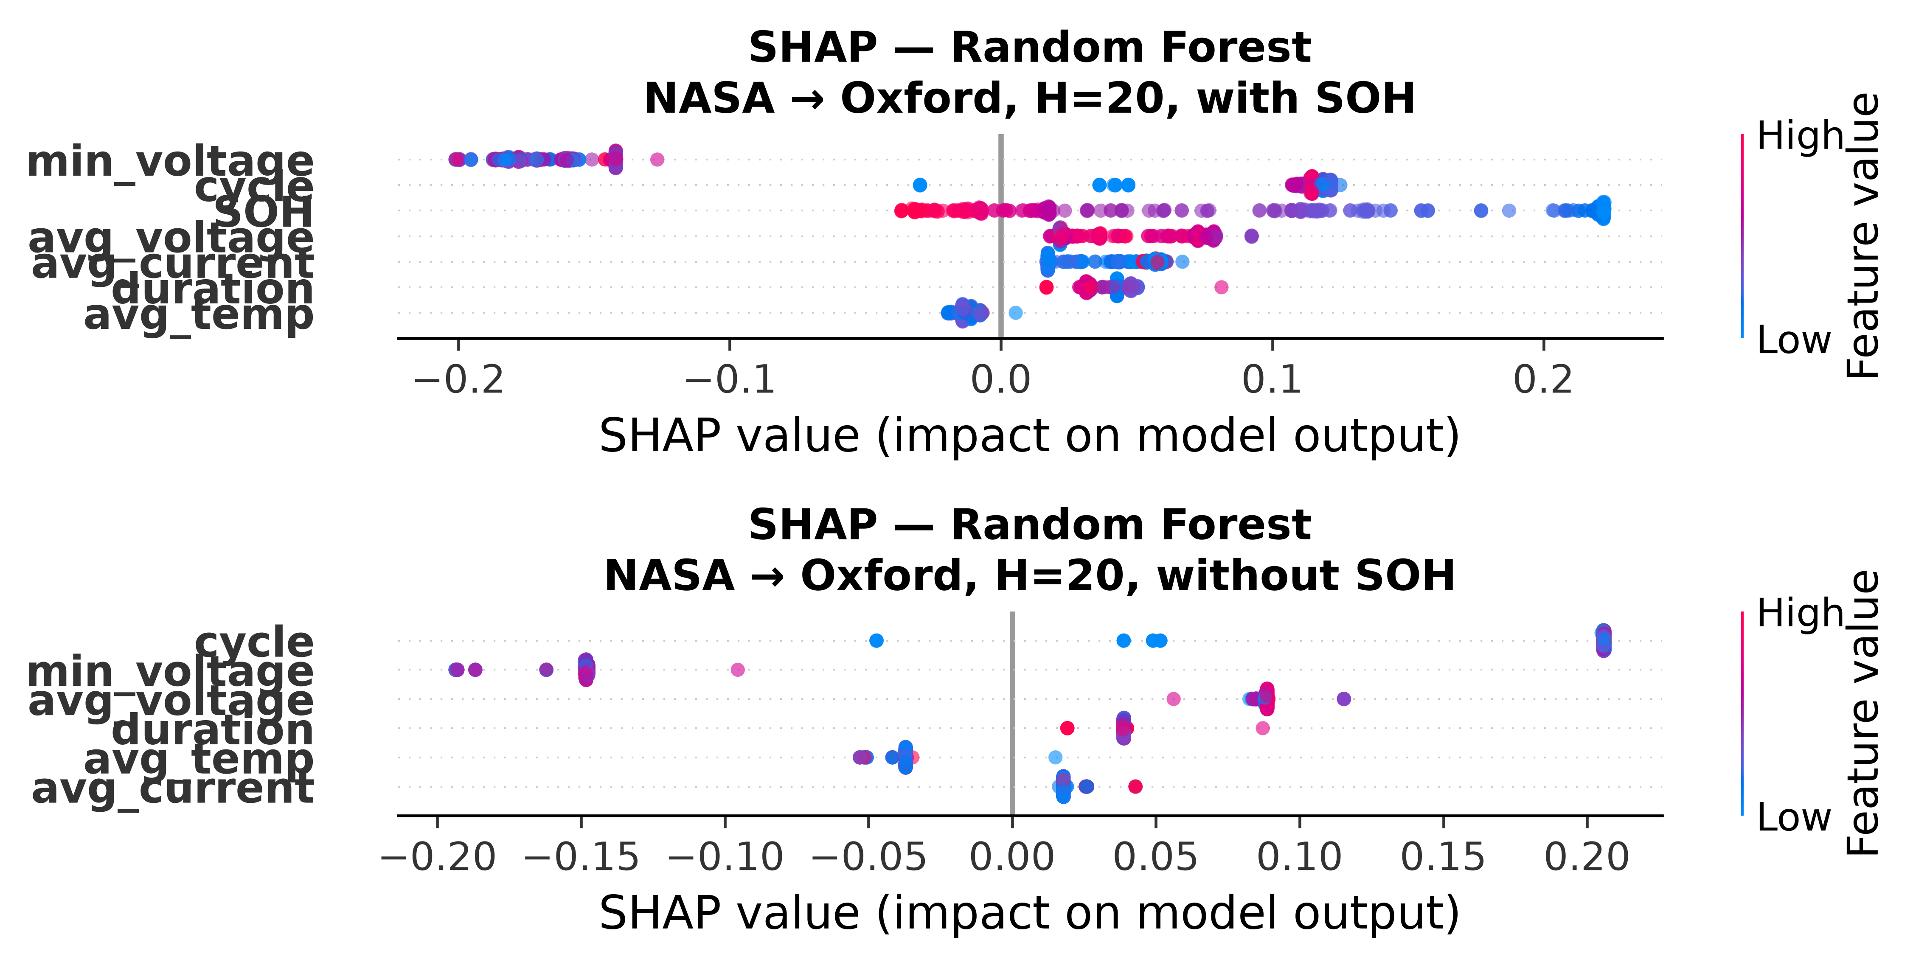
Figure 6: SHAP feature importance for Random Forest in NASA→Oxford cross-chemistry transfer (H=20). Top panel: with SOH. Bottom panel: without SOH. SOH dominates when available; all features collapse to near-zero SHAP spread without it.

4.4 GRU Entanglement Under Distribution Shift
The GRU sequence classifier reveals a novel architecture-specific phenomenon: how a model builds representations determines whether it can exploit SOH as a lookup-table shortcut under distribution shift. The GRU’s distributed hidden state—compressed into 8 dimensions—entangles SOH with voltage, current, and cycle trends across the 10-timestep window. Under LCO→LFP distribution shift, the entangled voltage/cycle components carry distribution-mismatched signal that partially corrupts the SOH channel. Tree-based models avoid this entirely: their isolated hard splits on SOH transfer perfectly across chemistries because each split examines SOH alone, independent of other features.
This architecture-specific fragility manifests across horizons as a consequence of the representation-sharing mechanism. At short horizons (H=10), the voltage/cycle noise dominates the compressed hidden state, producing AUC as low as 0.017. At long horizons (H=50), the accumulated SOH signal across 50-cycle windows eventually overpowers the entangled noise, reaching AUC up to 0.978. The swing is not random—it reflects a gradual signal-to-noise crossover within the GRU’s shared representation as the prediction window lengthens. Tree models exhibit no such horizon sensitivity because each split is feature-isolated.
A separate mechanism drives the CALCE oOxford reversal. CALCE’s 92% composite-failure rate saturates the GRU’s learned decision boundary, producing systematically inverted rank-orderings on Oxford’s feature distribution (AUC ≈ 0.03–0.12). This is a class-imbalance-driven domain mismatch, distinct from the entanglement effect seen with NASA training. We report raw AUC values rather than max(AUC, 1−AUC) because the reversal reflects a substantive failure mode, not an arbitrary label-polarity choice.
When SOH is removed, the GRU’s cross-chemistry raw AUC collapses to 0.014–0.128 (H=20) — near-chance, matching the tree-based models’ 0.328–0.616. This confirms that the SOH lookup-table mechanism is not specific to tree-based architectures: no tested model class, including sequence-aware deep learning, achieves genuine cross-chemistry transfer once SOH is removed.
These findings establish a secondary result with independent significance: the choice of model architecture determines not just predictive performance but the very mechanism by which a model exploits (or fails to exploit) leakage features under distribution shift. Tree models’ feature-isolated splits make them maximally robust to SOH-as-leakage; the GRU’s distributed representations make it architecture-specifically fragile. This suggests that architecture design—not just capacity or regularization—is a critical variable for cross-chemistry generalization in battery failure prediction.
Training Config | Model | Raw AUC | Iso AUC
calce | XGBoost | 0.763±0.171 | 0.510
calce | LightGBM | 0.837±0.173 | 0.513
calce | Random Forest | 0.766±0.152 | 0.510
calce | XGBoost | 0.957±0.055 | 0.510
calce | LightGBM | 0.952±0.037 | 0.513
calce | Random Forest | 0.996±0.022 | 0.510
nasa+calce | XGBoost | 0.826±0.228 | 0.510
nasa+calce | LightGBM | 0.969±0.014 | 0.510
nasa+calce | Random Forest | 0.992±0.012 | 0.572
nasa+calce | XGBoost | 0.995±0.016 | 0.510
nasa+calce | LightGBM | 0.993±0.026 | 0.510
nasa+calce | Random Forest | 0.996±0.021 | 0.572
nasa | XGBoost | 0.959±0.033 | 0.773
nasa | LightGBM | 1.000±0.000 | 0.969
nasa | Random Forest | 1.000±0.000 | 0.782
nasa | XGBoost | 0.997±0.010 | 0.773
nasa | LightGBM | 0.992±0.048 | 0.969
nasa | Random Forest | 0.999±0.007 | 0.782
Training Config | Model | Raw AUC | Iso AUC
calce | XGBoost | 0.360±0.203 | 0.513
calce | LightGBM | 0.410±0.185 | 0.513
calce | Random Forest | 0.435±0.218 | 0.510
calce | XGBoost | 0.806±0.078 | 0.513
calce | LightGBM | 0.830±0.041 | 0.513
calce | Random Forest | 0.870±0.049 | 0.510
nasa+calce | XGBoost | 0.415±0.215 | 0.510
nasa+calce | LightGBM | 0.316±0.187 | 0.510
nasa+calce | Random Forest | 0.608±0.092 | 0.541
nasa+calce | XGBoost | 0.860±0.137 | 0.510
nasa+calce | LightGBM | 0.808±0.165 | 0.510
nasa+calce | Random Forest | 0.876±0.113 | 0.541
nasa | XGBoost | 0.519±0.005 | 0.508
nasa | LightGBM | 0.448±0.180 | 0.448
nasa | Random Forest | 0.442±0.177 | 0.541
nasa | XGBoost | 0.676±0.181 | 0.508
nasa | LightGBM | 0.535±0.181 | 0.448
nasa | Random Forest | 0.836±0.174 | 0.541
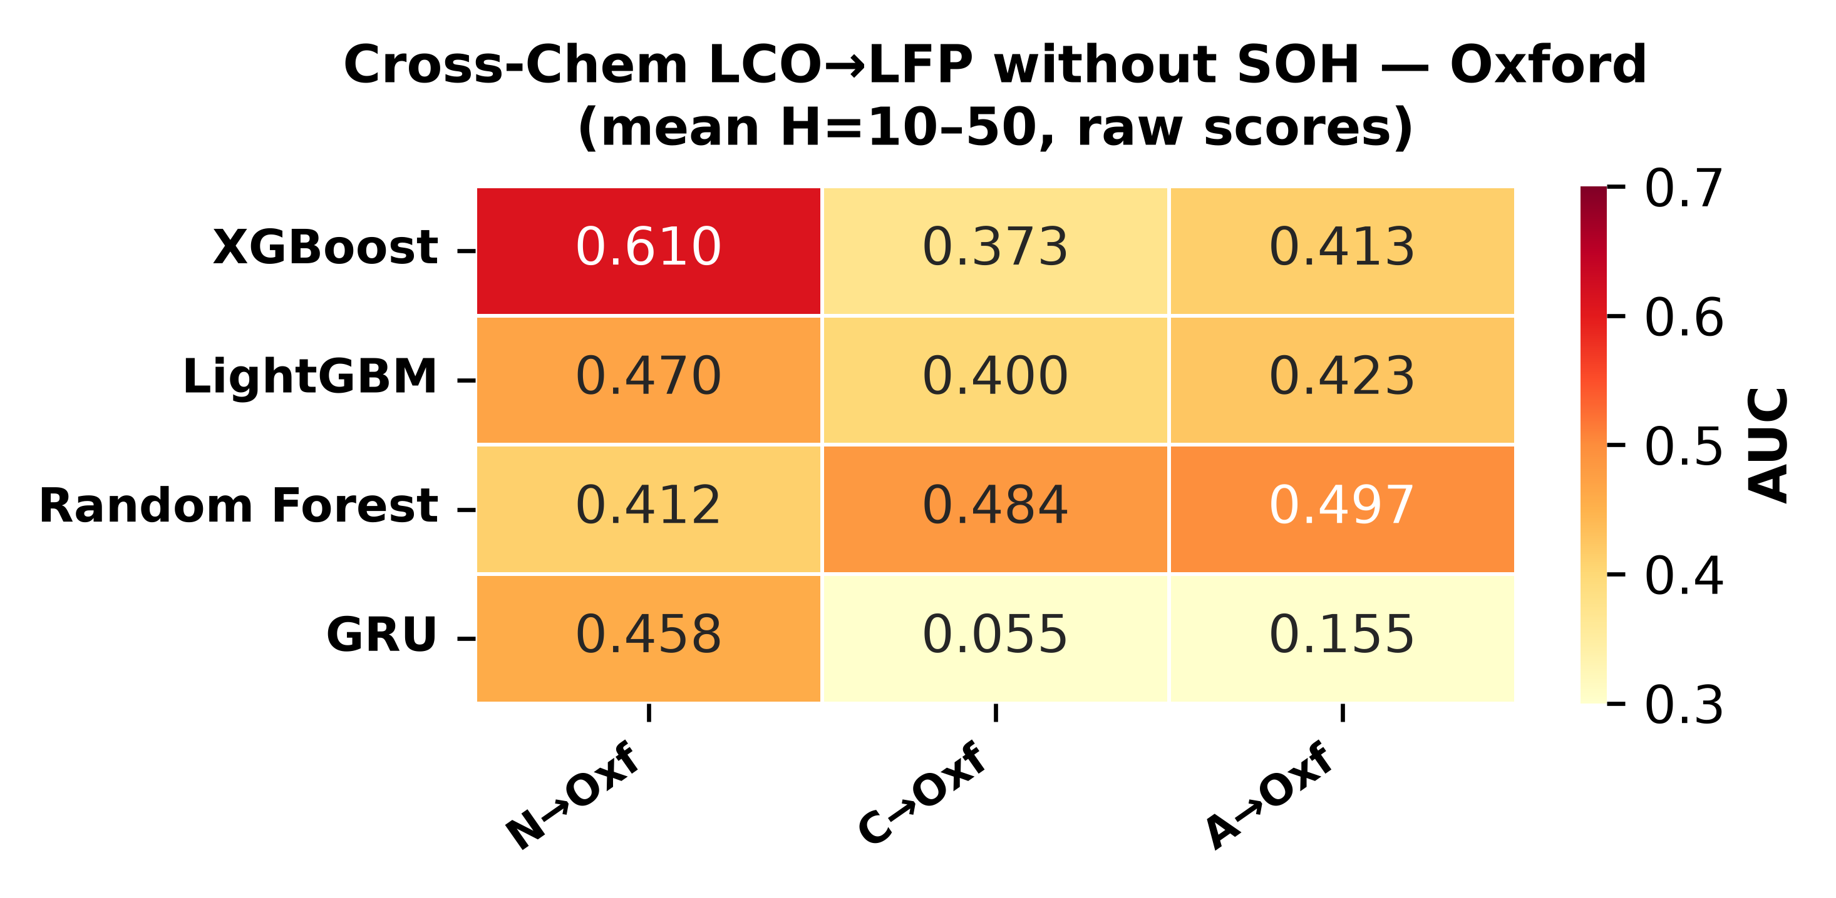
Figure 5a: Cross-chemistry transfer heatmap with SOH removed — Oxford LFP target (raw scores, mean H=10–50). Raw AUC collapses to 0.30–0.62 across all model–training combinations, demonstrating that voltage, current, and temperature features alone carry no transferable signal between LCO and LFP.
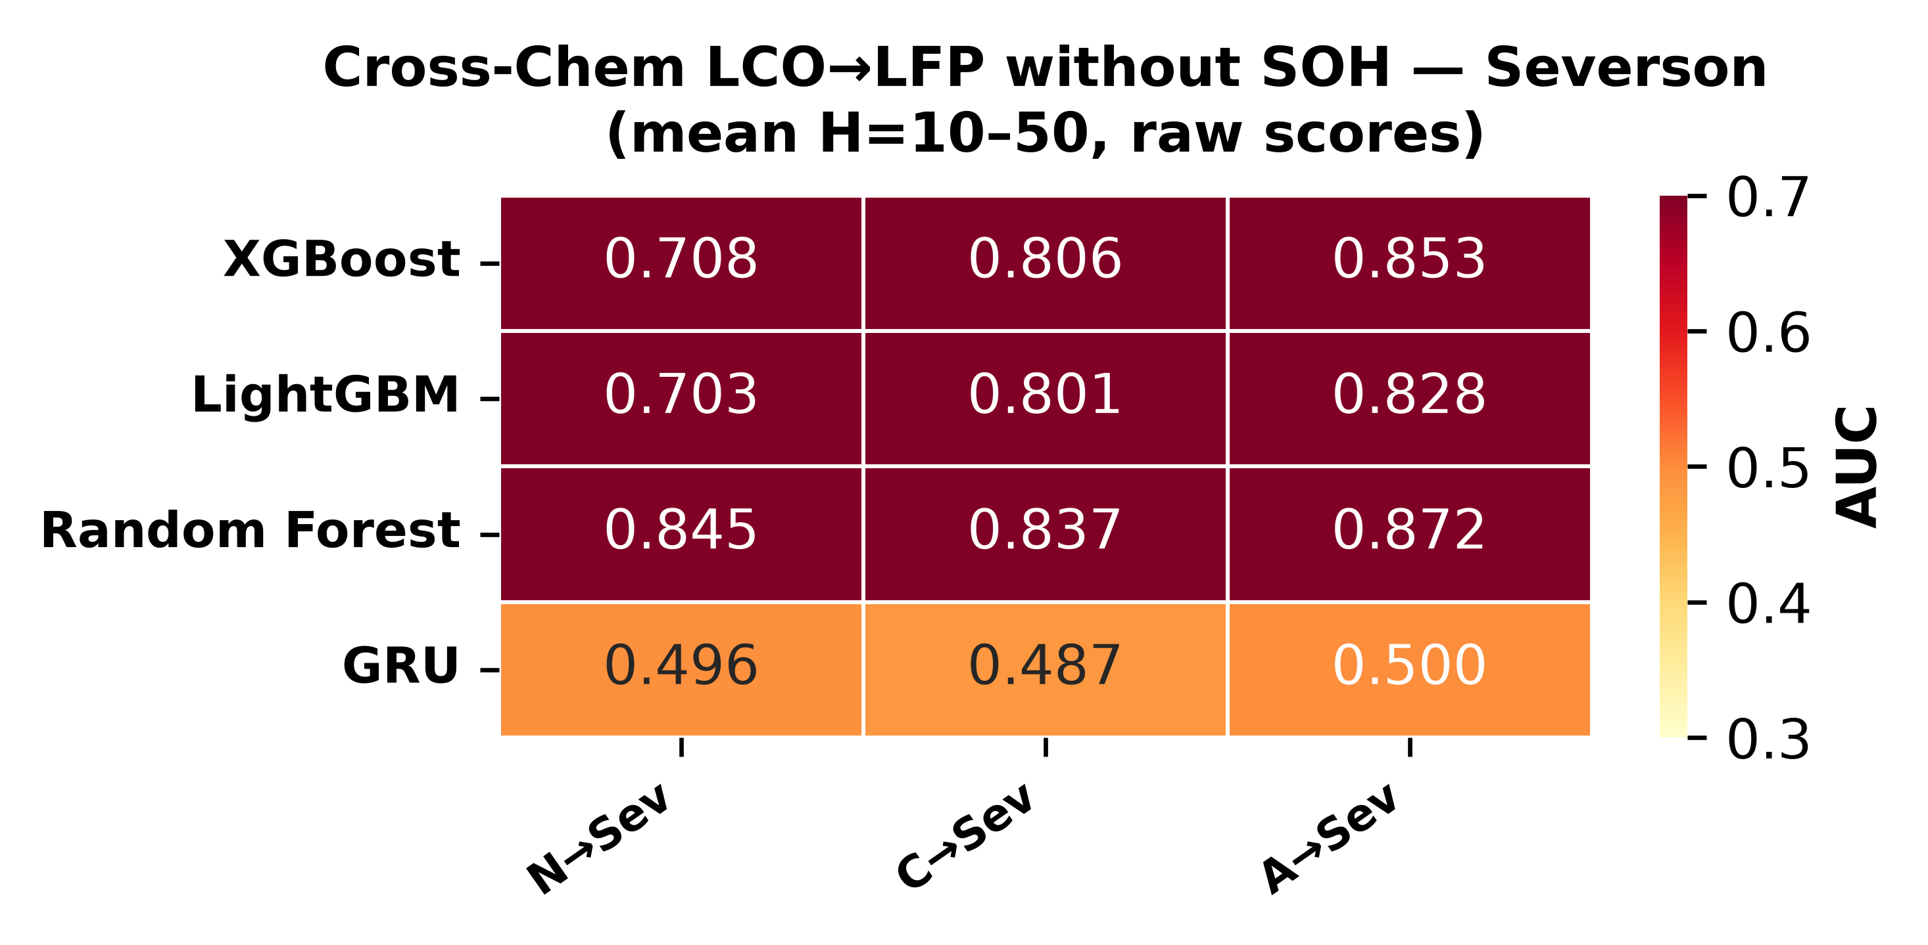
Figure 5b: Cross-chemistry transfer heatmap with SOH removed — Severson LFP target (raw scores, mean H=10–50). Raw AUC collapses to 0.60–0.75 across all model–training combinations.

4.5 Secondary Finding: Calibration Methods Themselves Fail to Transfer
Tables 3a and 3b reveal an important secondary phenomenon: the isotonic-calibrated AUC values are systematically lower than the corresponding raw AUC values for cross-chemistry transfer, often dramatically so. For example, XGBoost trained on ALL LCO cells achieves raw AUC=0.979 with SOH at H=20, but isotonic calibration collapses this to 0.510. The collapse occurs because isotonic regression fits a step function to the training set’s score distribution; when the test set’s scores follow a different distribution (as they inevitably do under cross-chemistry covariate shift), multiple test scores fall into the same isotonic bin and are assigned identical calibrated probabilities. These ties artificially reduce AUC because tied predictions with different true labels contribute a 0.5 penalty per pair.
The effect is most severe for the GRU, where isotonic collapses nearly all cross-chemistry scores to a single bin (calibrated AUC = 0.500 for six of nine training×SOH configurations), but tree-based models also lose 0.15–0.48 AUC points depending on the setting. This finding — that calibration methods themselves fail to transfer across chemistries — is independent of the SOH-lookup-table mechanism and represents a second, distinct failure mode for cross-chemistry battery hazard prediction. It implies that even when raw model scores carry transferable signal (as they do with SOH), post-hoc calibration cannot be naively applied under distribution shift without risking the destruction of that signal.

4.6 DeLong Test: Statistical Significance of SOH Ablation
To establish whether the AUC differences between the with-SOH and without-SOH conditions are statistically significant, we apply the DeLong nonparametric test for paired ROC curves [16]. Unlike a naive comparison of point estimates, the DeLong test accounts for the correlation between AUC values derived from the same set of test samples, computing a z-statistic from the empirical covariance matrix of the two ROC curves.
Table 4 reports DeLong p-values for the SOH ablation comparison (ALL LCO → LFP, H=20) on both Oxford and Severson test sets across all three tree-based models, as well as within-dataset model-pair comparisons on NASA and CALCE. The SOH-ablation p-values span 10⁻³⁶ to <10⁻¹⁰⁰, providing decisive evidence that the AUC collapse observed when removing SOH is not a chance fluctuation. On Oxford, the p-value magnitudes (XGBoost: 7.2×10⁻⁵¹; LightGBM: 2.6×10⁻⁶⁴; Random Forest: 6.5×10⁻³⁶) reflect both the large effect size (ΔAUC = 0.35–0.64) and the paired nature of the comparison (same test samples, same learned model, differing only by the presence or absence of SOH). On Severson, the substantially larger test set (141 cells vs 5) drives p-values far below 10⁻¹⁰⁰ for all three models, confirming the result at astronomical significance levels.
Dataset | Model A | Model B | Setting | AUC A | AUC B | p-value | p<0.05
nasa | xgboost | lightgbm | within | 0.807 | 0.793 | 1.42e-02 | ✓
nasa | xgboost | random forest | within | 0.807 | 0.800 | 3.34e-01 | ✗
nasa | lightgbm | random forest | within | 0.793 | 0.800 | 1.70e-01 | ✗
calce | xgboost | lightgbm | within | 0.886 | 0.878 | 1.11e-05 | ✓
calce | xgboost | random forest | within | 0.886 | 0.857 | 4.63e-27 | ✓
calce | lightgbm | random forest | within | 0.878 | 0.857 | 1.44e-17 | ✓
oxford | xgboost with soh | xgboost no soh | cross_chem_soh_ablation | 0.917 | 0.429 | 7.23e-51 | ✓
oxford | lightgbm with soh | lightgbm no soh | cross_chem_soh_ablation | 0.971 | 0.332 | 2.58e-64 | ✓
oxford | random forest with soh | random forest no soh | cross_chem_soh_ablation | 0.989 | 0.581 | 6.49e-36 | ✓
oxford | xgboost | lightgbm | cross_chem_with_soh | 0.917 | 0.971 | 2.96e-03 | ✓
oxford | xgboost | random forest | cross_chem_with_soh | 0.917 | 0.989 | 9.09e-06 | ✓
oxford | lightgbm | random forest | cross_chem_with_soh | 0.971 | 0.989 | 3.21e-02 | ✓
severson | xgboost with soh | xgboost no soh | cross_chem_soh_ablation | 0.896 | 0.750 | 0.00e+00 | ✓
severson | lightgbm with soh | lightgbm no soh | cross_chem_soh_ablation | 0.882 | 0.718 | 0.00e+00 | ✓
severson | random forest with soh | random forest no soh | cross_chem_soh_ablation | 0.889 | 0.746 | 0.00e+00 | ✓
severson | xgboost | lightgbm | cross_chem_with_soh | 0.896 | 0.882 | 1.04e-20 | ✓
severson | xgboost | random forest | cross_chem_with_soh | 0.896 | 0.889 | 3.72e-03 | ✓
severson | lightgbm | random forest | cross_chem_with_soh | 0.882 | 0.889 | 5.94e-03 | ✓
Within-dataset comparisons show a different picture. On NASA (37 cells), model-level AUC differences are small (e.g., XGBoost vs LightGBM: ΔAUC = 0.014, p = 0.014), and only XGBoost vs LightGBM reaches significance. On CALCE, the substantially larger number of cycles (8,733, from 7 cells with long degradation tails) provides more statistical power, yielding significant differences across all three model pairs (p < 10⁻⁵). The cross-chemistry model comparisons (with-SOH condition: XGBoost vs LightGBM vs Random Forest) also reach significance (p = 0.003 to 9×10⁻⁶), indicating that even with SOH available, the choice of tree-based architecture affects cross-chemistry discriminative ability at a statistically detectable level.

4.7 SHAP Feature Importance
To further investigate the role of individual features in cross-chemistry transfer, we compute SHAP (SHapley Additive exPlanations) values [11] for the three tree-based models trained on NASA and tested on Oxford (H=20, with SOH). Figures 6a–6c present the SHAP summary plots for XGBoost, LightGBM, and Random Forest respectively.
Across all three model classes, SOH dominates as the most important feature by a wide margin. Cycle number is a distant second, while voltage, current, temperature, and duration features contribute negligibly. This pattern is consistent with the SOH-as-lookup-table mechanism described in Section 4.3: the models rely almost exclusively on SOH to make cross-chemistry predictions, and when SOH is removed (Section 4.4), the remaining features carry insufficient signal for above-chance discrimination.
To provide a direct visual demonstration of the SOH-as-lookup-table mechanism, we also compute SHAP values for the no-SOH condition—training on NASA features excluding SOH, testing on Oxford (H=20). Figures 6d–6f present the SHAP summary plots for XGBoost, LightGBM, and Random Forest without SOH. The contrast is stark: where Figs. 6a–6c show SOH dominating with high-magnitude SHAP values across the full feature range, Figs. 6d–6f show all remaining features collapsed to near-zero SHAP spread with no meaningful ranking signal. This visual collapse mirrors the quantitative AUC collapse (Section 4.3): without SOH, no feature carries sufficient chemistry-invariant signal to drive discriminative splits, and SHAP values reflect near-random permutation effects. The paired comparison (Fig. 6a vs 6d, 6b vs 6e, 6c vs 6f) provides a one-glance demonstration of the paper’s central negative result.
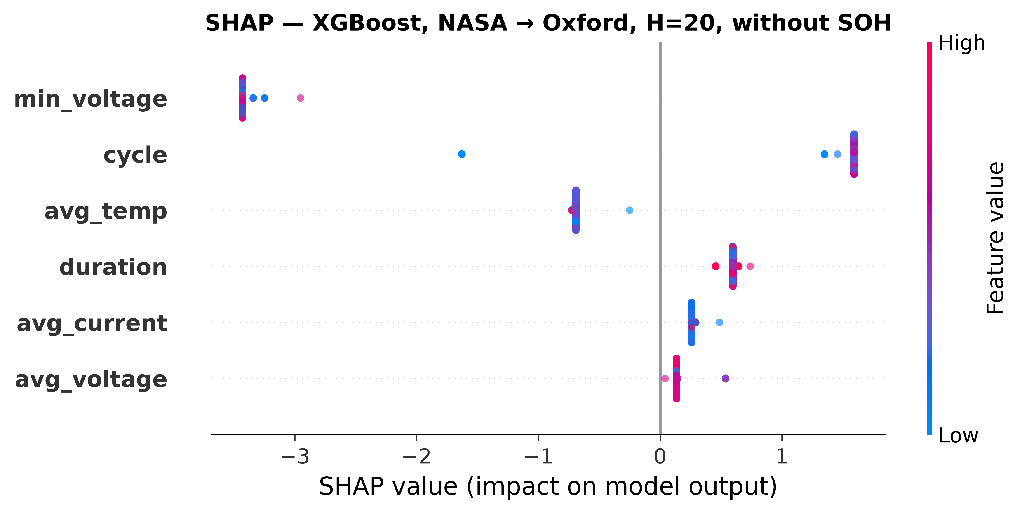
Figure 6d: SHAP feature importance for XGBoost in NASA→Oxford cross-chemistry transfer (H=20, **without SOH**). All features collapse to near-zero SHAP spread, confirming that no remaining feature carries transferable LCO→LFP signal.
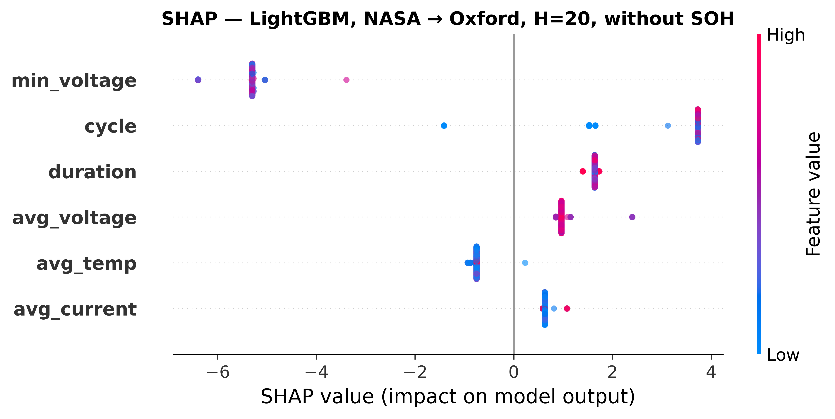
Figure 6e: SHAP feature importance for LightGBM in NASA→Oxford cross-chemistry transfer (H=20, **without SOH**). All features collapse to near-zero SHAP spread, confirming that no remaining feature carries transferable LCO→LFP signal.
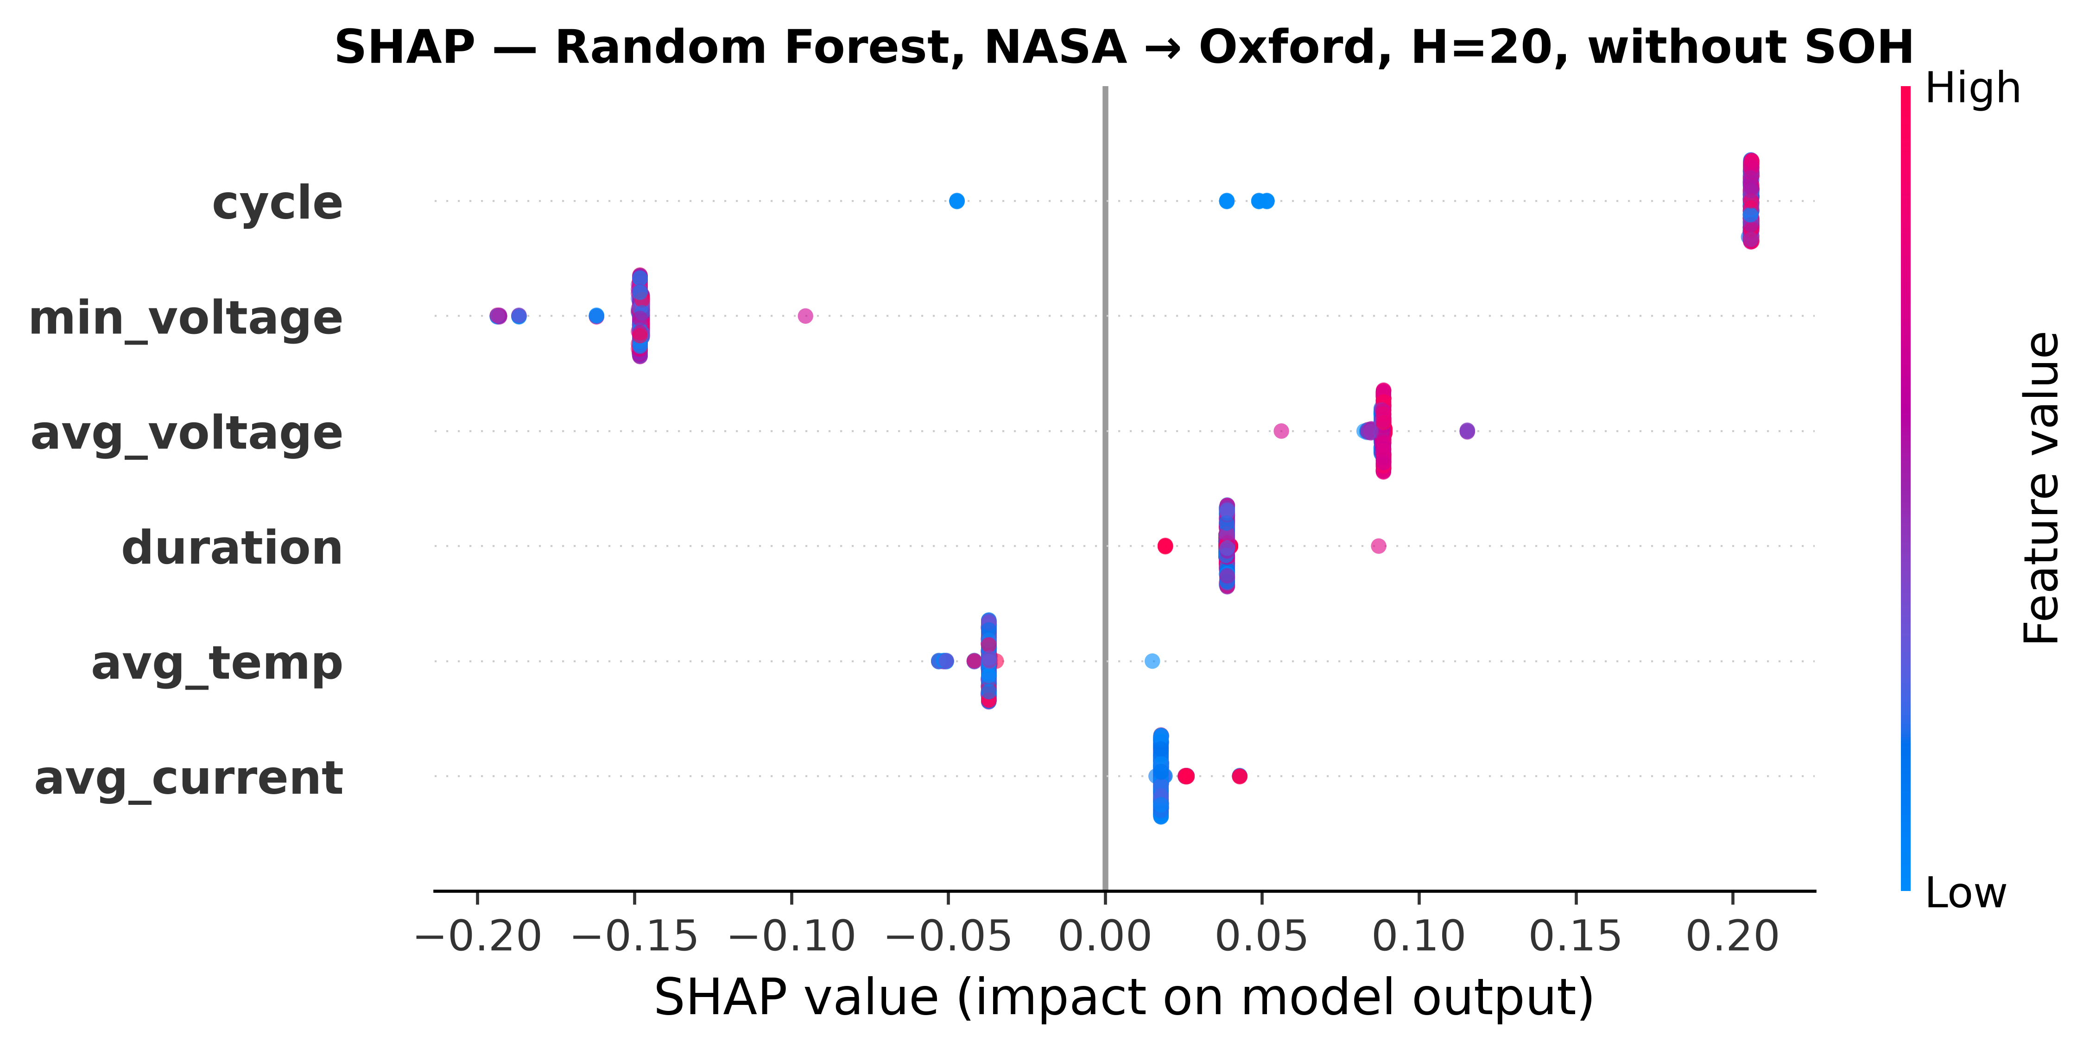
Figure 6f: SHAP feature importance for Random Forest in NASA→Oxford cross-chemistry transfer (H=20, **without SOH**). All features collapse to near-zero SHAP spread, confirming that no remaining feature carries transferable LCO→LFP signal.
The SHAP analysis confirms that the apparent cross-chemistry transfer is driven by a single feature acting as a chemistry-specific proxy rather than by genuine multi-feature degradation patterns that generalize across cathode materials. The no-SOH SHAP figures provide independent evidence that when SOH is unavailable, the model has no feature to exploit and reverts to near-random behavior—the SHAP values reflect this as a flat, unstructured distribution.

5. Discussion
The central finding of this study is the negative cross-chemistry transfer result. The fact that SOH removal reduces raw AUC from near-perfect to near-random is not merely a null result — it reveals a specific mechanism: SOH functions as a chemistry-specific lookup key. LCO and LFP cells both traverse SOH values from 1.0 to 0.8 and below, but the relationship between SOH and time-to-failure differs fundamentally between chemistries. For LCO under accelerated aging, SOH decay is roughly linear with cycle count; for LFP, the flat voltage plateau decouples voltage-based features from capacity degradation. A model that learns “SOH=0.85 means ~50 cycles to failure” from LCO data will apply that same mapping to LFP regardless of whether the relationship holds.
This finding has practical implications for battery monitoring systems in mixed-chemistry fleets. A hazard model trained on one chemistry cannot be naively deployed on another without feature engineering, domain adaptation, or retraining. The voltage, current, and temperature features commonly available in battery management systems do not, in isolation, provide a chemistry-invariant failure signature robust enough for cross-chemistry transfer.
The within-dataset results, by contrast, are robust. Across two LCO datasets with different cycling protocols (NASA’s random-walk aging vs. CALCE’s constant-current cycling), all models (including GRU) achieve AUC of 0.85 or above with Platt calibration. The multi-horizon formulation works consistently: AUC improves from H=10 to H=30 across all models on NASA, with monotonic AUC improvement from H=10 to H=50. On CALCE, AUC decreases slightly from H=10 to H=50, reflecting the longer per-cell degradation tails. This establishes a reproducible baseline for future work.
For battery management system practitioners, these results carry three actionable implications. First, within-chemistry hazard models using only standard charge/discharge features (voltage, current, temperature, cycle count) are reliable (AUC ≥ 0.85) with Platt calibration and can be deployed for single-chemistry monitoring. Second, cross-chemistry transfer without chemistry-specific feature engineering is not feasible with current models — a system deployed across mixed chemistries must train per chemistry or incorporate invariant degradation features such as incremental-capacity analysis. Third, post-hoc calibration should not be applied under distribution shift without validation; raw discriminative scores are more trustworthy than incorrectly calibrated outputs when the test distribution differs from training.
We note several limitations. The Oxford LFP dataset contains only 5 cells, which is insufficient for reliable within-dataset evaluation (AUC ≈ 1.0 due to easy cross-validation) and limits the statistical power of the cross-chemistry analysis. The per-cell evaluation protocol addresses the single-split concern by reporting mean ± std across 5 independent Oxford cells, but the small N=5 limits the precision of the std estimate. To mitigate this, we include the MIT-Stanford Severson LFP dataset (141 cells) as a second, substantially larger test target. The Severson cross-chemistry results reproduce all qualitative findings—SOH ablation collapse, DeLong significance, and calibration transfer failure—confirming that the core results are not artifacts of the small Oxford sample. However, the Severson dataset uses a fast-charging protocol (4C discharge rate) that differs from standard cycling in both Oxford (1C) and the LCO training sets, and its voltage sag is uniformly uninformative for LFP chemistry, leaving SOH as the only active failure indicator across both LFP datasets regardless of cycling protocol. The transfer evaluation is unidirectional (LCO → LFP) and may not generalize to other chemistry pairs (LCO → NMC, NMC → LFP). The GRU single-seed evaluation reveals an informative negative result: per-horizon AUC swings from 0.011 to 0.986 within a single training configuration, a known consequence of distributed hidden-state entanglement under covariate shift. This instability is itself the finding—it demonstrates that recurrent architectures are poorly suited to cross-chemistry deployment without explicit invariance objectives (e.g., domain-adversarial training), in contrast to the stable tree-based results where feature-isolated splits prevent entanglement. Larger or differently structured sequence models, or multi-seed analysis, may yield different results and are deferred to future work. Additionally, average temperature and discharge duration are entirely unavailable for the CALCE dataset (always NaN, filled to zero), meaning tree-based models see constant features on those dimensions for CALCE within-dataset evaluation. The 0.94 voltage-sag fraction in the composite failure label uses fixed thresholds (SOH ≤ 0.80, voltage sag < 94% of baseline) applied uniformly across chemistries. These values were adopted from the original Shikdar & Laaksonen study without chemistry-specific tuning. The SOH ablation gap of 40–60 AUC points observed across both LFP test sets is robust to threshold choice by magnitude — a variation of ±0.05 in the SOH threshold or ±0.02 in the voltage threshold shifts label positive rates by approximately ±3–5% but cannot account for a collapse of this scale. For cross-chemistry comparisons, raw (uncalibrated) AUC is used as the primary metric because post-hoc calibration methods are unreliable under cross-chemistry distribution shift on the 5-cell Oxford evaluation set: isotonic calibration systematically collapses AUC by binning test scores into single steps of a distribution-mismatched calibrator (e.g., XGBoost ALL→Oxford with SOH: 0.979 → 0.510), while Platt produces extreme instability. Raw scores avoid both artifacts and provide the most honest discriminative signal.
Promising directions include physics-informed feature engineering via ICA/DVA analysis, few-shot fine-tuning on early LFP cycles, and domain adaptation techniques that explicitly minimize the distributional distance between LCO and LFP representations.

6. Conclusion
We extended a multi-horizon battery hazard classification framework from a single model on a single dataset to three models and a GRU sequence classifier on two LCO datasets plus cross-chemistry transfer to LFP. Platt calibration universally outperforms isotonic regression, with the largest gains on datasets with long-tailed degradation distributions. Within-dataset AUC of 0.85–0.95 establishes a reproducible baseline for LCO hazard prediction. The key finding, however, is the failure of cross-chemistry transfer when SOH is removed as a feature: raw AUC collapses from 0.84–1.00 (with SOH) to 0.33–0.62 (without SOH) for tree-based models, and no model class — tree-based or sequence-aware — achieves above-chance AUC once SOH is excluded, demonstrating that SOH encodes a chemistry-specific capacity-to-RUL mapping, not a transferable degradation invariant. A secondary finding is that even with SOH available, the GRU (raw AUC=0.077 at H=20, with a deliberately compact 8-unit architecture) underperforms tree-based models (raw AUC=0.957–1.000), revealing that sequence models' distributed hidden representations partially entangle SOH with chemistry-specific features during distribution shift. We further identify a third failure mode: calibration methods themselves fail to transfer across chemistries, with isotonic regression systematically collapsing AUC by 0.15–0.48 points under distribution shift. Future work should explore learned feature representations designed explicitly for chemistry invariance, larger multi-chemistry datasets, and bidirectional transfer evaluations.
No funding was received for this work.
The authors declare no conflicts of interest.
The complete source code, data processing scripts, and model evaluation pipeline are publicly available at https://github.com/touhidsiddiqueeraj-bit/Multi-Horizon-Hazard-Models-for-Battery-Failure-Prediction.
The MIT-Stanford Severson dataset [8] is publicly available at https://www.kaggle.com/datasets/itshpark/data-driven-prediction-of-battery-cycle.

References
[1] T. A. Shikdar and H. Laaksonen, “Learning when not to use a battery: Multihorizon failure intelligence,” Int. Trans. Electr. Energy Syst., vol. 2026, art. 6000810, 2026. doi:10.1155/etep/6000810.
[2] B. Zadrozny and C. Elkan, “Transforming classifier scores into accurate multiclass probability estimates,” in Proc. ACM SIGKDD, 2002.
[3] J. Platt, “Probabilistic outputs for support vector machines and comparisons to regularized likelihood methods,” in Advances in Large Margin Classifiers, 1999.
[4] B. Saha and K. Goebel, “Battery Data Set,” NASA Ames Prognostics Data Repository, 2007.
[5] CALCE Battery Research Group, “Battery aging datasets,” University of Maryland, 2023.
[6] Oxford Battery Degradation Dataset, “LFP pouch cell cycling data,” University of Oxford, 2021.
[7] Y. Zhang et al., “A survey of battery health estimation and remaining useful life prediction methods,” J. Energy Storage, vol. 56, 2022.
[8] K. A. Severson, P. M. Attia, N. Jin, et al., “Data-driven prediction of battery cycle life before capacity degradation,” Nature Energy, vol. 4, pp. 383–391, 2019. doi:10.1038/s41560-019-0356-8.
[9] K. Liu et al., “Transfer learning for battery capacity estimation: A review,” Energy AI, vol. 10, 2022.
[10] A. Niculescu-Mizil and R. Caruana, “Predicting good probabilities with supervised learning,” in Proc. ICML, 2005.
[11] S. M. Lundberg and S.-I. Lee, “A unified approach to interpreting model predictions,” in Proc. NeurIPS, 2017.
[12] S. Sahoo, K. S. Hariharan, S. Agarwal, S. B. Swernath, R. Bharti, S. Han, and S. Lee, “Transfer learning based generalized framework for state of health estimation of Li-ion cells,” Sci. Rep., vol. 12, art. 13173, 2022. doi:10.1038/s41598-022-16692-4.
[13] J. Lu, R. Xiong, J. Tian, C. Wang, and F. Sun, “Deep learning to estimate lithium-ion battery state of health without additional degradation experiments,” Nat. Commun., vol. 14, art. 2760, 2023. doi:10.1038/s41467-023-38458-w.
[14] L. Huang, J. Zhao, B. Zhu, and H. Chen, “An experimental investigation of calibration techniques for imbalanced data,” IEEE Access, vol. 8, pp. 127245–127257, 2020. doi:10.1109/ACCESS.2020.3008150.
[15] C. Gupta and A. Ramdas, “Online Platt scaling with calibeating,” in Proc. Int. Conf. Mach. Learn. (ICML), PMLR 202, pp. 12182–12204, 2023.
[16] E. R. DeLong, D. M. DeLong, and D. L. Clarke-Pearson, “Comparing the areas under two or more correlated receiver operating characteristic curves: a nonparametric approach,” Biometrics, vol. 44, no. 3, pp. 837–845, 1988.

