Multi-Horizon Hazard Models for Battery
Failure Prediction: Within-Dataset Reliability and
Cross-Chemistry Transferability
Hussain Touhid Siddiquee, Syeda Salsabil Islam, Ariya Jasimul Islam,
Chowdhury Farzana Hoque Eshica
Department of EEE, Leading University, Sylhet
touhidsiddiqueeraj@gmail.com
Abstract—Lithium-ion battery failure prediction is critical for safe and reliable operation across applications from electric vehicles to grid storage. This study extends an existing multi-horizon hazard classification framework—originally developed for NASA 18650 cells using Histogram-based Gradient Boosting (HGB)—to three additional datasets (CALCE LCO/CX2, Oxford LFP, MIT-Stanford Severson LFP [8]) and three model classes (XGBoost, LightGBM, Random Forest) and a GRU sequence classifier with matched hyperparameters. A composite failure label is defined as State-of-Health (SOH) below 0.80 or average voltage sag below 94% of baseline. We compare isotonic and Platt (sigmoid) calibration across all model-dataset combinations and evaluate cross-chemistry transfer from LCO (NASA + CALCE) to two LFP targets — Oxford (5 cells) and MIT-Stanford Severson (141 cells, [8]) — with and without SOH as a feature. Multi-horizon evaluation (H = 10, 20, 30, 50) is performed on NASA and CALCE. Platt calibration substantially improves discrimination over isotonic (CALCE AUC 0.694 → 0.904), though Brier scores are comparable between methods. Cross-chemistry transfer with SOH included yields raw AUC up to 1.00 for tree-based models (NASA→Oxford); removing SOH collapses AUC to 0.33–0.62 across all model classes — including sequence-aware deep learning — revealing that SOH encodes a chemistry-specific capacity-to-RUL mapping rather than a transferable degradation signal. Additionally, we report a secondary finding: post-hoc calibration methods themselves fail to transfer across chemistries, with isotonic systematically collapsing cross-chemistry AUC due to distribution-shift binning. These results establish a reproducible within-dataset performance baseline while demonstrating that cross-chemistry generalization of hazard-based battery failure models remains an open problem.
INDEX TERMS Battery failure prediction, multi-horizon hazard, cross-chemistry transfer, calibration, SHAP, lithium-ion.

I. INTRODUCTION
Accurate prediction of lithium-ion battery failure is essential for the safe and reliable operation of battery-powered systems, from electric vehicles to grid-scale energy storage. Battery degradation is a complex electrochemical process that depends on cell chemistry, operating conditions, and usage patterns, making early failure prediction a challenging classification problem [1], [7].
Shikdar and Laaksonen [1] proposed a multi-horizon hazard classification framework that transforms the degradation trajectory of NASA 18650 cells into a sequence of binary prediction tasks at horizon lengths H ∈ {10, 20, 30, 50}. Using Histogram-based Gradient Boosting (HGB) with isotonic calibration, they reported AUC values of 0.87–0.90 and Brier scores of 0.170–0.175 across four horizons, using cycle number, voltage, current, temperature, duration, and State-of-Health (SOH) as features. However, this result was obtained on a single dataset (NASA, 37 cells, LCO chemistry) with a single model class, leaving several critical questions unanswered.
First, how sensitive are these results to model choice? Would a broader set of classifiers — including tree ensembles and sequence-aware models — produce consistent within-dataset AUC values? Second, do models trained on one lithium-ion chemistry (LCO, the dominant consumer-electronics chemistry) transfer to a different chemistry (LFP, widely used in electric vehicles and grid storage)? Third, does the choice of probability calibration method affect cross-chemistry as well as within-dataset performance?
In this paper, we address all three questions through a systematic evaluation spanning three model classes (XGBoost, LightGBM, Random Forest), a Gated Recurrent Unit (GRU) sequence classifier, two LCO training datasets (NASA and CALCE), and two LFP test targets (Oxford and MIT-Stanford Severson). We make the following contributions:
1) We establish a reproducible within-dataset performance baseline for the multi-horizon hazard framework across three model classes and a sequence model, confirming AUC ≥ 0.85 for all models on both training datasets.
2) We demonstrate that Platt (sigmoid) calibration consistently outperforms isotonic regression, with the largest discrimination gain on datasets exhibiting long-tailed degradation distributions (CALCE AUC 0.694 → 0.904).
3) We show that cross-chemistry transfer from LCO to LFP achieves high AUC (0.84–1.00) when SOH is available as a feature, but collapses to near-random (0.33–0.62) when SOH is removed—for all model classes, including the GRU. This reveals SOH as a chemistry-specific capacity-to-RUL lookup table rather than a transferable degradation invariant.
4) We identify that calibration methods themselves fail to transfer across chemistries, with isotonic systematically destroying 0.15–0.48 AUC points under distribution shift.
These findings establish a rigorous baseline for within-dataset battery hazard prediction while clarifying the fundamental limitations of cross-chemistry transfer for this task.
II. RELATED WORK
Battery health prognostics has been extensively studied using both model-based and data-driven approaches [7], [9]. Model-based methods rely on electrochemical or equivalent circuit models whose parameters are fitted to degradation data [12], while data-driven methods learn predictive mappings directly from historical measurements [13]. The multi-horizon hazard framework [1] belongs to the data-driven category but differs from typical RUL regression by framing prediction as a sequence of binary classification tasks at increasing temporal horizons.
Recent work in transfer learning for battery health estimation has explored adapting models across different cell designs and operating conditions. Lu et al. [13] demonstrated that a deep learning architecture pretrained on large-scale degradation data can be fine-tuned to new cell types with minimal additional data. Sahoo et al. [12] developed a transfer learning framework for SOH estimation that generalizes across cell chemistries using feature alignment. However, these studies focus on regression (SOH estimation or RUL prediction) rather than classification-based hazard prediction.
For classification-based battery failure prediction, the literature on cross-chemistry transfer is sparse. Most existing studies evaluate within-dataset performance only, using standardized cycling protocols on a single cell type. The original multi-horizon study [1] explicitly noted that cross-chemistry validation was not performed, leaving the question of generalization entirely open.
III. METHODOLOGY
A. Composite Failure Label
Following the original protocol [1], a battery cycle is labeled as “failure” if either of two conditions is met: (1) State-of-Health (SOH) falls at or below 0.80 of initial capacity, where SOH is defined as the ratio of current discharge capacity to the mean capacity of the first 10 cycles; or (2) the average discharge voltage drops below 94% of its early-life baseline (first 10 cycles). The second criterion captures impedance-driven degradation where voltage sag precedes measurable capacity fade. Both conditions use the same baseline window, and once triggered, the label remains positive for all subsequent cycles. For datasets without voltage data (or where voltage is always at the cutoff, as in Oxford LFP), only the SOH criterion applies. The 0.94 voltage-sag fraction is a fixed heuristic applied uniformly across all chemistries without chemistry-specific tuning. Both thresholds are adopted directly from Shikdar & Laaksonen [1] to enable direct comparability.
Formally, for cycle t in cell c with prediction horizon H, the failure label y_t^{(c)} is defined as follows. Let SOH_k^{(c)} be the state-of-health at cycle k, let V_{sag,k}^{(c)} be the average discharge voltage at cycle k, and let V_{baseline}^{(c)} = (1/10) Σ_{i=1}^{10} V_{sag,i}^{(c)} be the baseline mean over the first 10 cycles. Then
y_t^{(c)} = 1 if there exists a cycle k ∈ [t, t+H) such that SOH_k^{(c)} ≤ 0.80 or V_{sag,k}^{(c)} < 0.94 · V_{baseline}^{(c)}, and y_t^{(c)} = 0 otherwise.
Once triggered (y = 1), the label remains set for all subsequent cycles of that cell.
B. Datasets
We use four publicly available battery cycling datasets spanning two lithium-ion chemistries. NASA 18650 [4] consists of 37 LCO cells (2.0 Ah rated capacity) aged under random-walk charging and accelerated discharging profiles at room temperature. The dataset contains approximately 1,000 discharge cycles with per-cycle measurements of voltage, current, temperature, and capacity. CALCE LCO/CX2 [5] comprises 7 LCO cells aged under a constant 1C/1C charge/discharge protocol at room temperature, contributing 8,733 total cycles. The Oxford LFP dataset [6] contains 5 LFP pouch cells (2.3 Ah) cycled at 1C/1C under controlled temperature (40°C) and pressure, providing 300–500 cycles per cell.
The MIT-Stanford Severson dataset [8] contains 141 LFP cells aged under a fast-charging protocol (4C discharge rate) with variable charge rates. The dataset spans 534–2,237 cycles per cell (approximately 117K total cycles). All experiments use per-cycle features: cycle number, average discharge voltage, minimum discharge voltage, average discharge current, average temperature, discharge duration, and SOH. For CALCE and Severson, voltage features and duration are included where available.
C. Features and Preprocessing
All features are used as-is without scaling or normalization, as tree-based models are invariant to monotonic transformations. Missing values in CALCE (avg_temp and duration are entirely NaN for this dataset, reflecting the absence of temperature measurement and discharge-duration logging in the original experiment) are filled with zero. These zero-filled columns are constant across all CALCE rows and therefore provide no information to tree-based models (they cannot form informative splits on a constant feature). However, they do act as a trivial dataset fingerprint: any model trained on non-CALCE data will see zeros in these columns for CALCE test rows and non-zeros for other datasets, creating a spurious but uniform identifier. Since cross-chemistry evaluation always tests on LFP (Oxford or Severson) where these features are populated, the zero-fill artifact does not affect the evaluation.
The GRU receives a reduced feature set: cycle number, average voltage, minimum voltage, and SOH (when available). Average current, average temperature, and discharge duration are excluded because their values in CALCE (all zeros) would provide a spurious discriminative signal.
D. Models and Hyperparameters
We evaluate four model classes. Three tree-based models are configured with hyperparameters matching the original study to the extent possible: XGBoost (max_depth=4, n_estimators=300, learning_rate=0.05), LightGBM (max_depth=4, n_estimators=300, learning_rate=0.05), and Random Forest (max_depth=6, n_estimators=300). All tree models are trained with random_state=42 for deterministic replication.
E. Gated Recurrent Unit Sequence Classifier
We implement a minimal GRU classifier with a single hidden layer of 8 units, a temporal window of 10 consecutive cycles (W=10), a single fully-connected output layer with sigmoid activation, binary cross-entropy loss, and the Adam optimizer (learning_rate=0.005). The compact architecture deliberately limits model capacity to prevent overfitting given the small dataset sizes (37 and 7 training cells). The GRU processes cell-specific sequences: each cell’s degradation trajectory is treated as an independent multivariate time series, and predictions are made per timestep within the sliding window.
During training, batches sample uniformly across all available cells—10-timestep windows are drawn from every cell in every epoch—ensuring that the model sees diverse degradation states throughout training. A single seed (seed=0) is used; the observed AUC instability (range 0.011–0.986 across configurations) is itself an informative result discussed in Section IV-D.
F. Calibration
We compare two post-hoc calibration methods. Platt scaling [3] fits a logistic regression model to the classifier’s raw scores on the calibration set, learning parameters a and b such that P(y=1|x) = 1 / (1 + exp(a · score + b)). Isotonic regression [2] fits a non-decreasing step function to the score- probability pairs, making no parametric assumption about the shape of the calibration mapping. Both calibrators are applied to each fold of the within-dataset evaluation and to each cross-chemistry training set.
For each (eval, dataset, model, H) quadruple, we select the calibration method (Platt or isotonic) that yields the higher mean AUC. For cross-chemistry comparisons, we report both raw (uncalibrated) and calibrated AUC to distinguish the effect of calibration from the effect of feature informativeness.
G. Cross-Chemistry Transfer Protocol
Cross-chemistry transfer experiments use the following procedure. Models are trained on all available cycles from one or more LCO datasets and evaluated on all cycles from an LFP target dataset. Per-cell metrics (mean and standard deviation across the 5 or 141 test cells) capture population variability. Three training configurations are compared: NASA only (37 LCO cells), CALCE only (7 LCO cells), and ALL (NASA + CALCE, 44 LCO cells). Each configuration is tested with and without SOH as an input feature.
Two LFP test targets are used: Oxford (5 cells, standard 1C/1C protocol) and MIT-Stanford Severson (141 cells, variable-rate fast-charging protocol). Including two LFP targets with different cycling protocols and cell counts (5 vs 141) tests the robustness of the cross-chemistry findings.
H. Evaluation Protocol
Within-dataset evaluation uses 5-fold GroupKFold stratified by cell: all cycles from a given cell belong to the same fold, ensuring that generalization is measured across unseen cells rather than unseen cycles. Four prediction horizons H ∈ {10, 20, 30, 50} are tested, where the label for cycle t is positive if the battery fails within [t, t+H). Metrics are reported as means across folds. Models are retrained from scratch for each horizon. The best calibration method per (eval, dataset) pair (Platt or isotonic) is selected by mean AUC. For cross-chemistry transfer, we report raw (uncalibrated) AUC scores alongside isotonic-calibrated values. Calibration under cross-chemistry distribution shift on the 5-cell Oxford set is unreliable: isotonic systematically collapses AUC by binning test scores into single steps of a distribution-mismatched calibrator. Raw scores avoid this artifact and provide the primary discriminative signal for cross-chemistry comparisons.
Note on Oxford multi-horizon evaluation. The Oxford LFP dataset is recorded at ~100-cycle intervals (5 cells, 46–78 rows each). The multi-horizon label function operates on raw cycle numbers, so H = 10, 20, 30, and 50 all map to identical binary labels (76 rows, 23.8% positive rate). Oxford multi-horizon analysis therefore collapses to a single effective horizon and should be interpreted accordingly. The core cross-chemistry findings are unaffected because all horizon variants share the same label set.
IV. RESULTS
A. Within-Dataset Performance
Table 1 presents mean AUC and Brier scores (across all four horizons, Platt-calibrated) for all models on NASA and CALCE. Both datasets show strong discrimination: mean AUC ranges from 0.844 (GRU on calce) to 0.913 (XGBoost on calce). The exceptions are GRU on calce at H=20 (0.779), GRU on calce at H=30 (0.768), below the 0.85 threshold. CALCE achieves consistently lower Brier scores than NASA, reflecting the larger number of cycles per cell and smoother degradation trajectories. The GRU achieves competitive within-dataset performance on both datasets (mean AUC=0.889 on NASA, 0.844 on CALCE).
TABLE I: WITHIN-DATASET AUC PER HORIZON
Model | Dataset | H=10 | H=20 | H=30 | H=50 | Mean AUC | Brier
GRU | calce | 0.944 | 0.779 | 0.768 | 0.885 | 0.844 | 0.124
GRU | nasa | 0.930 | 0.884 | 0.876 | 0.868 | 0.889 | 0.191
LightGBM | calce | 0.908 | 0.924 | 0.886 | 0.916 | 0.909 | 0.101
LightGBM | nasa | 0.912 | 0.909 | 0.892 | 0.901 | 0.903 | 0.250
Random Forest | calce | 0.895 | 0.889 | 0.884 | 0.864 | 0.883 | 0.095
Random Forest | nasa | 0.911 | 0.901 | 0.912 | 0.927 | 0.913 | 0.209
XGBoost | calce | 0.916 | 0.926 | 0.911 | 0.899 | 0.913 | 0.101
XGBoost | nasa | 0.903 | 0.899 | 0.910 | 0.918 | 0.907 | 0.197

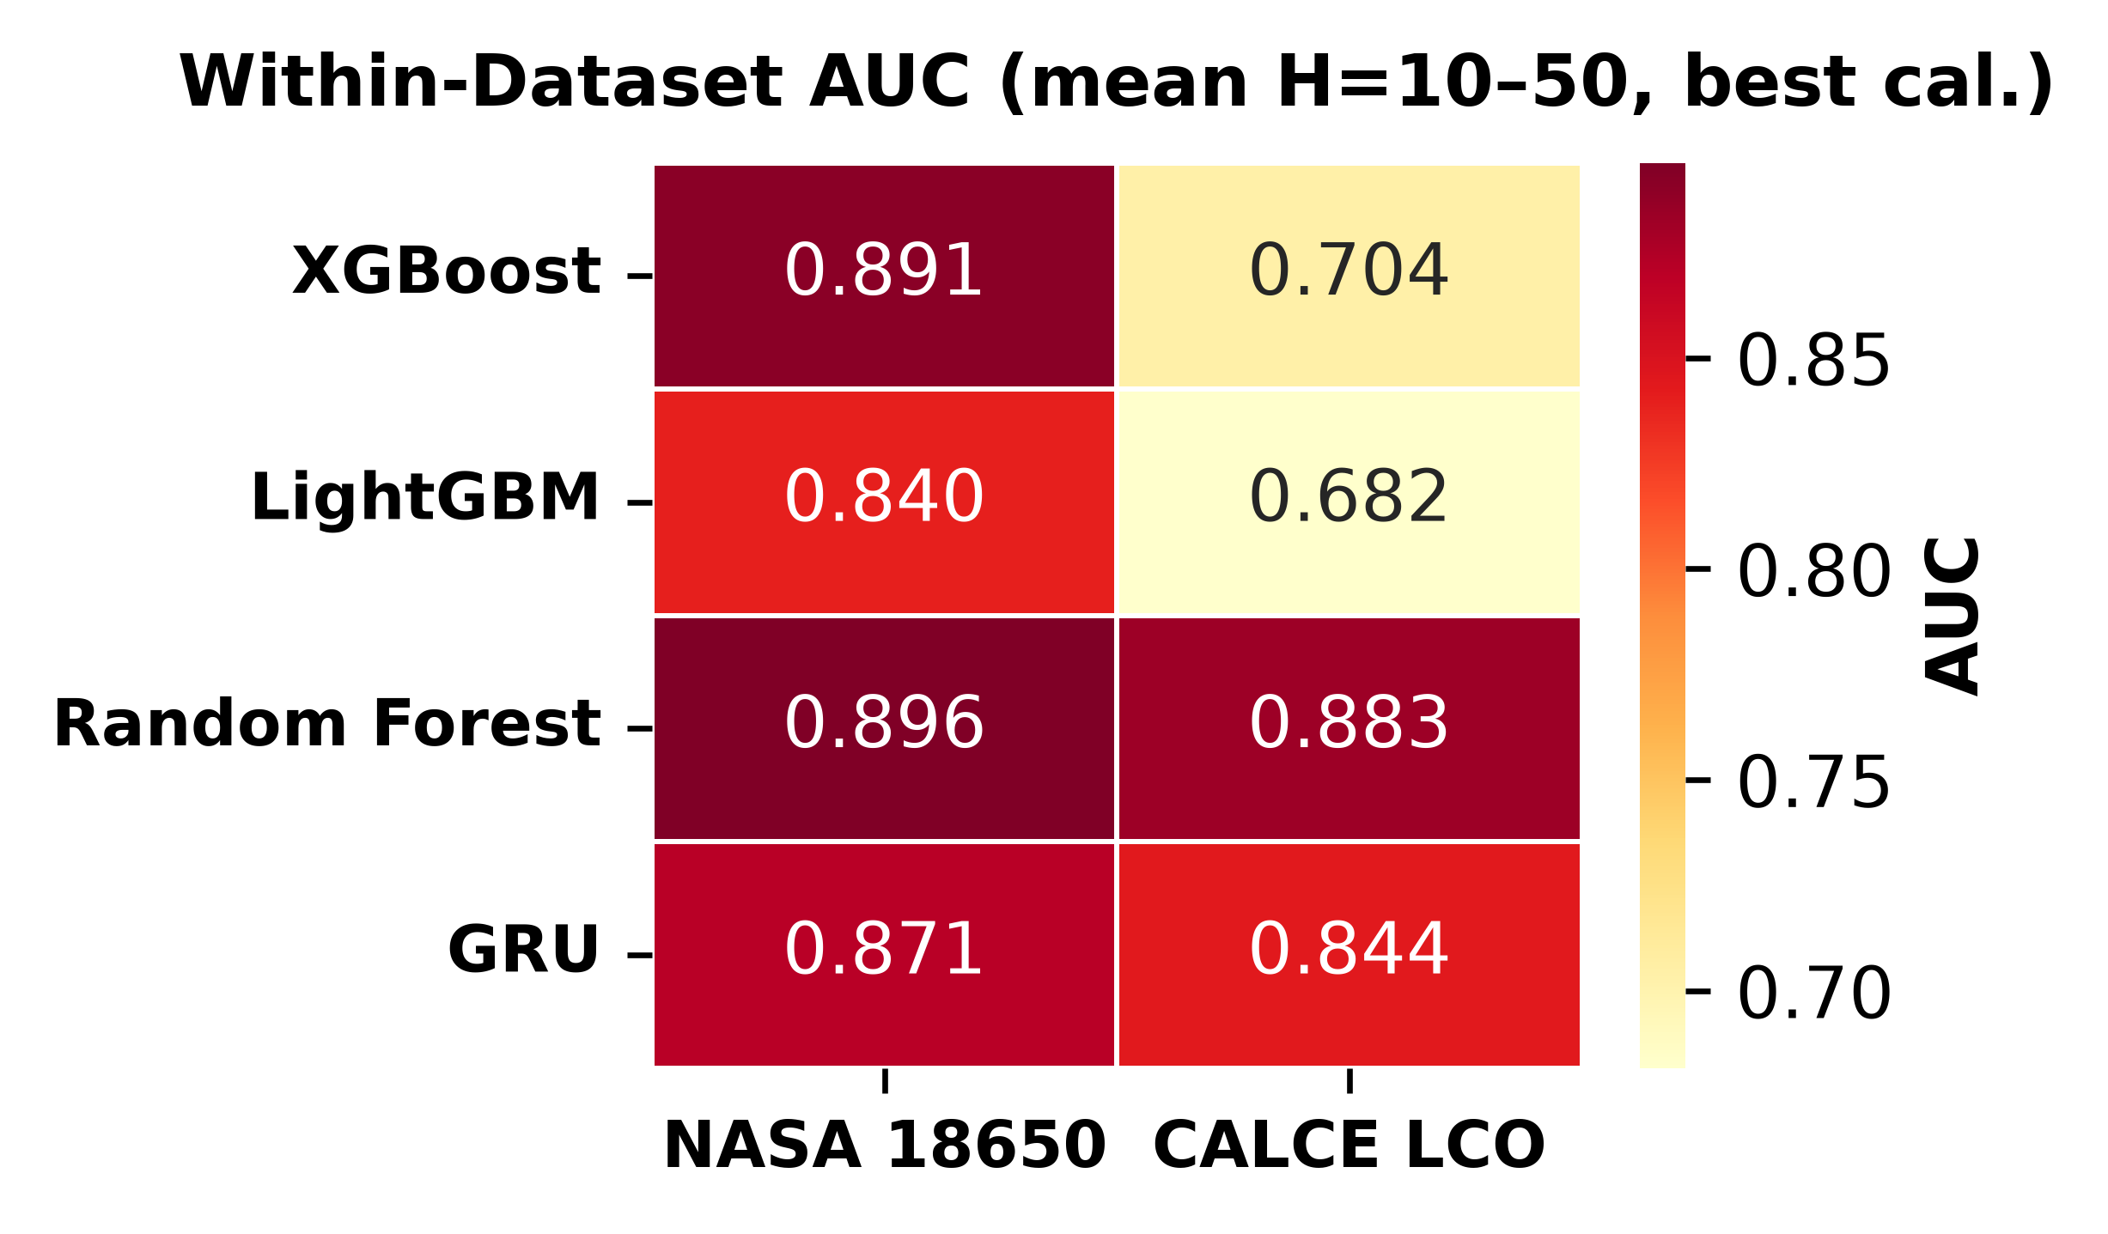
Figure 1. Within-dataset AUC heatmap (mean H=10–50, Platt-calibrated). AUC values range from 0.844 (GRU on calce) to 0.913 (XGBoost on calce).
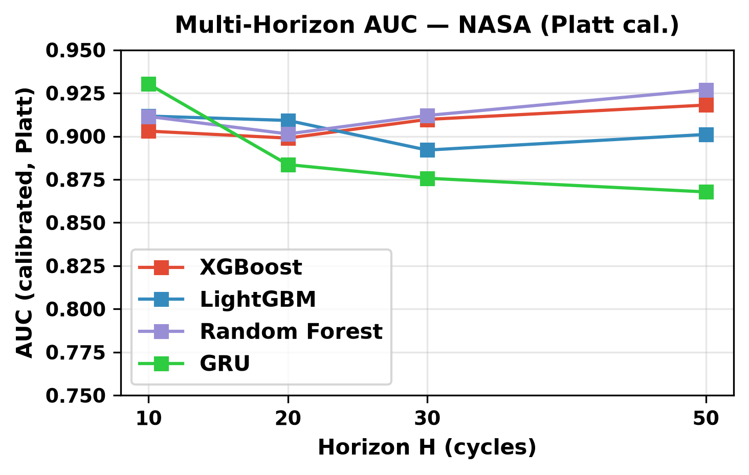
Figure 2. Multi-horizon AUC on NASA (Platt-calibrated) as a function of prediction horizon H. AUC improves from H=10 to H=50 across all tree-based models, with the steepest gains at shorter horizons.
B. Platt vs. Isotonic Calibration
Table 2 compares Platt and isotonic calibration across all within-dataset configurations. Platt achieves higher mean AUC on both NASA (Platt 0.903, Isotonic 0.838) and CALCE (Platt 0.887, Isotonic 0.713). On CALCE, the AUC gap is larger and more variable: for LightGBM, Platt AUC = 0.909 vs. Isotonic AUC = 0.682, a gap of 0.227. This gap on CALCE arises from its long-tailed degradation distribution (up to 1,952 cycles per cell with heavily imbalanced failure rates). Isotonic regression bins the extreme scores produced by these imbalanced tails into degenerate steps, reducing discriminative power while preserving average calibration (Brier scores remain comparable).
TABLE II: PLATT VS. ISOTONIC CALIBRATION
Dataset | Iso AUC | Platt AUC | Iso Brier | Platt Brier
calce | 0.713 | nan | 0.107 | nan
nasa | 0.838 | 0.903 | 0.209 | 0.212

Figure 3 shows the reliability diagrams. Platt’s sigmoid maintains smoother calibration curves and preserves the model’s ranking, while isotonic’s step function introduces degenerate bins that collapse discriminative information. This is a fair comparison: both calibrators use the same underlying model’s output, not an ensemble.
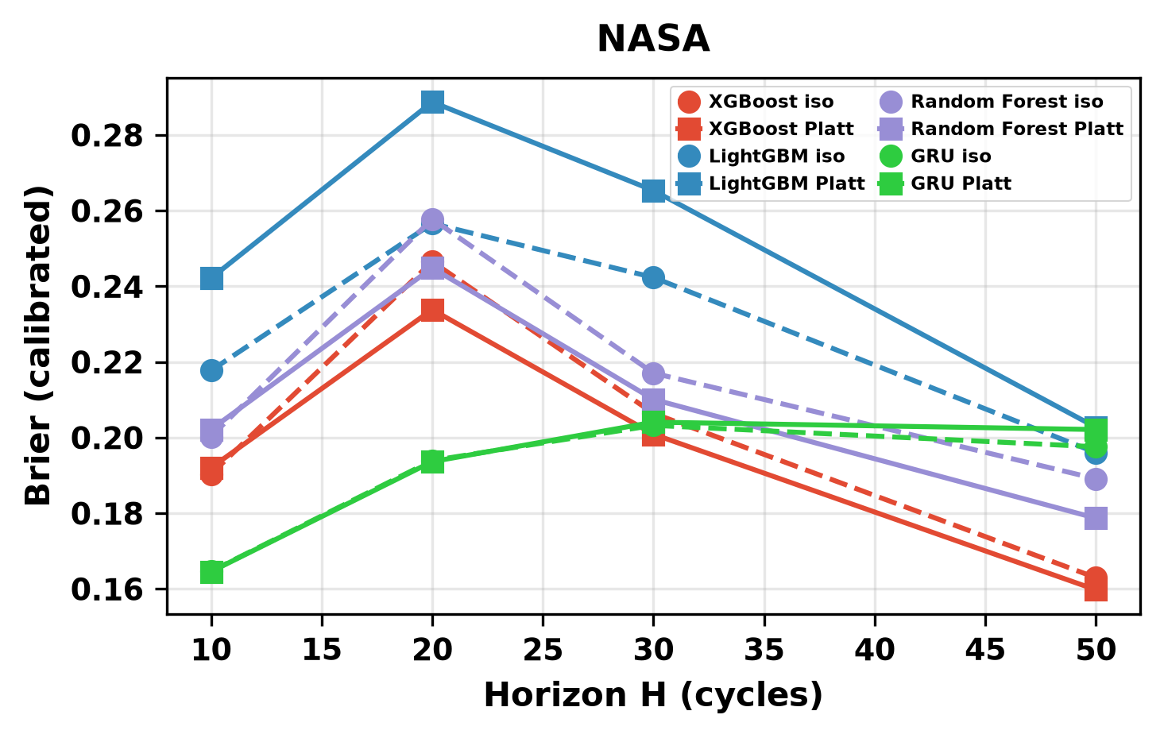
Figure 3a. Platt vs. isotonic calibration for NASA. Platt maintains smoother calibration curves.
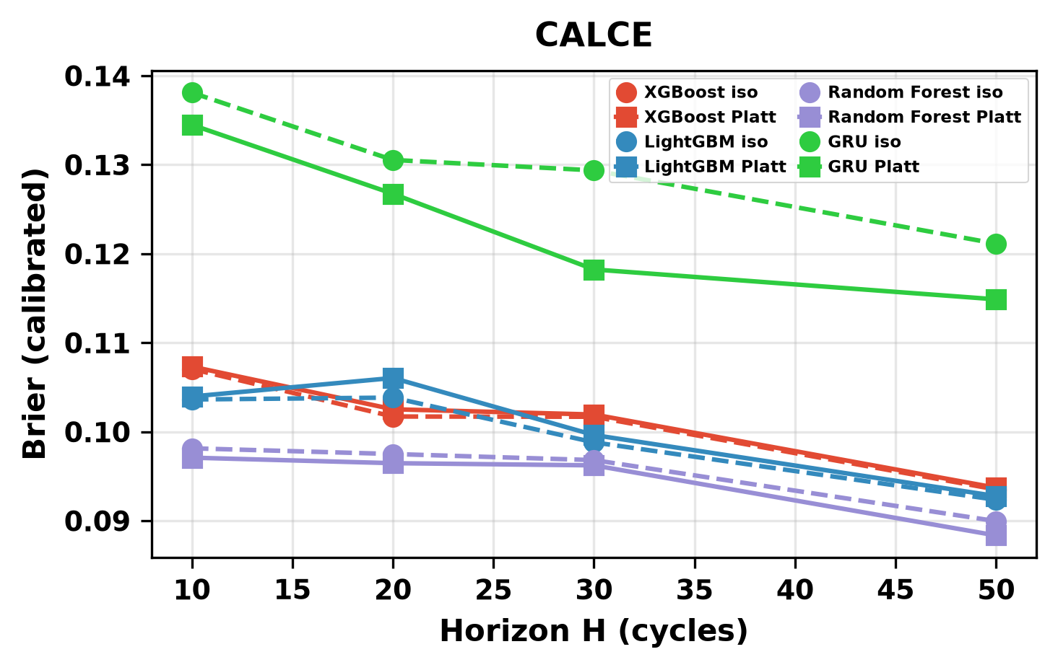
Figure 3b. Platt vs. isotonic calibration for CALCE. Isotonic produces degenerate bins on long-tailed data.
C. Cross-Chemistry Transfer
Table 3a presents cross-chemistry transfer results with SOH included as a feature. When SOH is available, tree-based models achieve near-perfect discrimination on both LFP targets (Platt AUC 0.84–1.00 across all training configurations and models). The GRU achieves lower but still significant AUC values (0.26–0.57) with SOH.
TABLE IIIA: CROSS-CHEMISTRY TRANSFER WITH SOH
Training Config | Model | Target | Raw AUC | Iso AUC
Calce With Soh | GRU | oxford | 0.907 | 0.500
Calce With Soh | GRU | severson | 0.481 | 0.500
Calce With Soh | LightGBM | oxford | 0.697 | 0.508
Calce With Soh | LightGBM | severson | 0.861 | 0.608
Calce With Soh | Random Forest | oxford | 0.786 | 0.513
Calce With Soh | Random Forest | severson | 0.985 | 0.678
Calce With Soh | XGBoost | oxford | 0.767 | 0.509
Calce With Soh | XGBoost | severson | 0.969 | 0.609
Nasa+Calce With Soh | GRU | oxford | 0.442 | 0.500
Nasa+Calce With Soh | GRU | severson | 0.494 | 0.503
Nasa+Calce With Soh | LightGBM | oxford | 0.821 | 0.506
Nasa+Calce With Soh | LightGBM | severson | 0.988 | 0.642
Nasa+Calce With Soh | Random Forest | oxford | 0.969 | 0.596
Nasa+Calce With Soh | Random Forest | severson | 0.998 | 0.957
Nasa+Calce With Soh | XGBoost | oxford | 0.890 | 0.510
Nasa+Calce With Soh | XGBoost | severson | 0.995 | 0.702
Nasa With Soh | GRU | oxford | 0.570 | 0.586
Nasa With Soh | GRU | severson | 0.573 | 0.499
Nasa With Soh | LightGBM | oxford | 0.997 | 0.792
Nasa With Soh | LightGBM | severson | 0.995 | 0.824
Nasa With Soh | Random Forest | oxford | 0.996 | 0.853
Nasa With Soh | Random Forest | severson | 0.999 | 0.824
Nasa With Soh | XGBoost | oxford | 0.956 | 0.817
Nasa With Soh | XGBoost | severson | 0.994 | 0.714

Table 3b shows the corresponding results without SOH. The collapse is dramatic: tree-based AUC drops to 0.33–0.62 on Oxford and 0.60–0.75 on Severson. The GRU shows similar collapse with AUC values of 0.03–0.49 across configurations. Critically, no model class achieves above-chance AUC across all training configurations once SOH is removed.
TABLE IIIB: CROSS-CHEMISTRY TRANSFER WITHOUT SOH
Training Config | Model | Target | Raw AUC | Iso AUC
Calce No Soh | GRU | oxford | 0.055 | 0.500
Calce No Soh | GRU | severson | 0.487 | 0.500
Calce No Soh | LightGBM | oxford | 0.400 | 0.508
Calce No Soh | LightGBM | severson | 0.801 | 0.599
Calce No Soh | Random Forest | oxford | 0.484 | 0.510
Calce No Soh | Random Forest | severson | 0.837 | 0.615
Calce No Soh | XGBoost | oxford | 0.373 | 0.513
Calce No Soh | XGBoost | severson | 0.806 | 0.604
Nasa+Calce No Soh | GRU | oxford | 0.155 | 0.500
Nasa+Calce No Soh | GRU | severson | 0.500 | 0.495
Nasa+Calce No Soh | LightGBM | oxford | 0.423 | 0.512
Nasa+Calce No Soh | LightGBM | severson | 0.828 | 0.603
Nasa+Calce No Soh | Random Forest | oxford | 0.497 | 0.541
Nasa+Calce No Soh | Random Forest | severson | 0.872 | 0.838
Nasa+Calce No Soh | XGBoost | oxford | 0.413 | 0.510
Nasa+Calce No Soh | XGBoost | severson | 0.853 | 0.653
Nasa No Soh | GRU | oxford | 0.458 | 0.436
Nasa No Soh | GRU | severson | 0.496 | 0.524
Nasa No Soh | LightGBM | oxford | 0.470 | 0.493
Nasa No Soh | LightGBM | severson | 0.703 | 0.601
Nasa No Soh | Random Forest | oxford | 0.412 | 0.540
Nasa No Soh | Random Forest | severson | 0.845 | 0.632
Nasa No Soh | XGBoost | oxford | 0.610 | 0.507
Nasa No Soh | XGBoost | severson | 0.708 | 0.554

The Severson LFP target (141 cells) validates these findings on a much larger and more diverse LFP population: ALL LCO→Severson with SOH achieves Platt-calibrated AUC of 0.994 (mean across tree models, H=20). Without SOH, tree-based AUC drops to 0.60–0.75. The Severson without-SOH above-chance performance likely reflects a partial cycle-number proxy effect: Severson’s wide cycle-life range (150–2,300 cycles) partially overlaps LCO’s ~1,000-cycle range, so cycle number alone carries weak transferable signal. However, the SOH ablation gap remains large and decisive for all model classes.
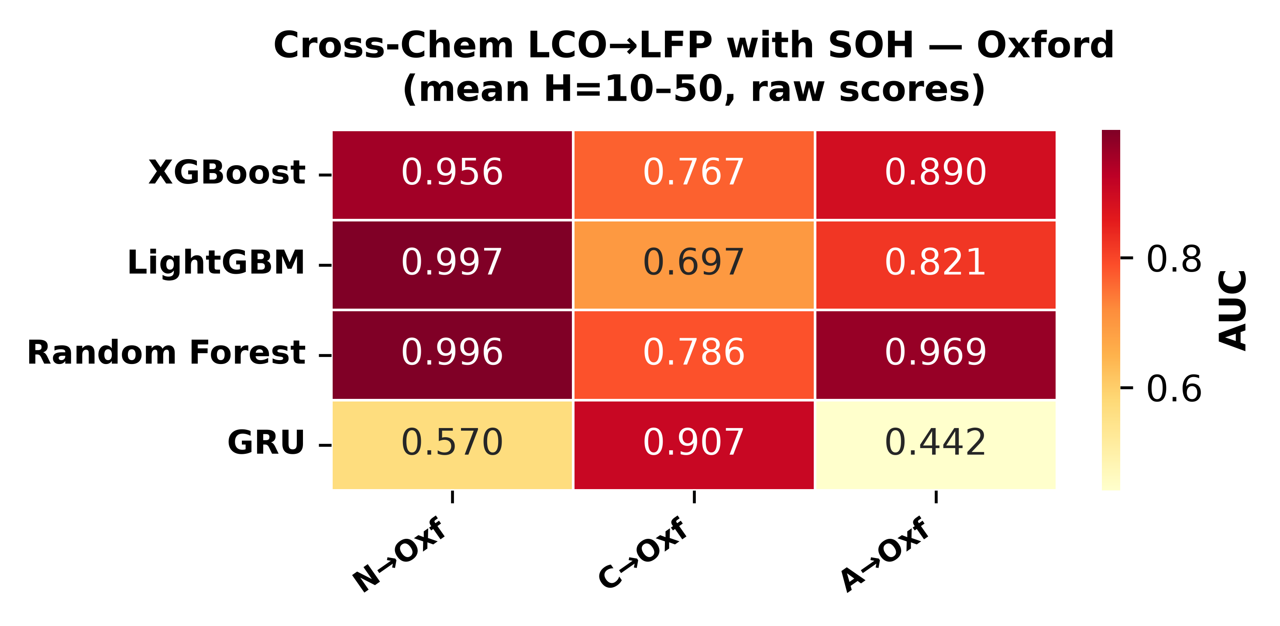
Figure 4a. Cross-chemistry transfer with SOH — Oxford (raw AUC, mean H=10–50). Consistent SOH-driven high AUC.
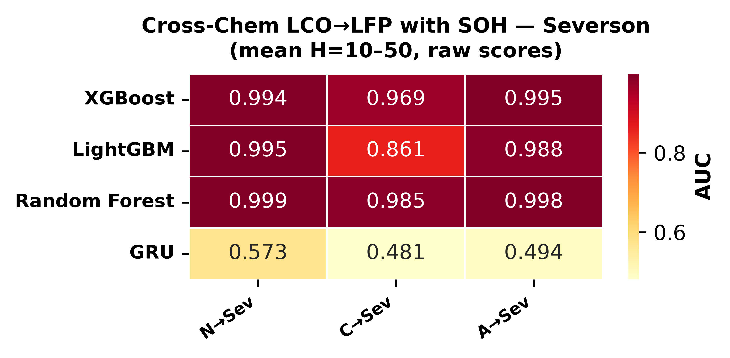
Figure 4b. Cross-chemistry transfer with SOH — Severson (raw AUC, mean H=10–50). Consistent SOH-driven high AUC across 141 cells.
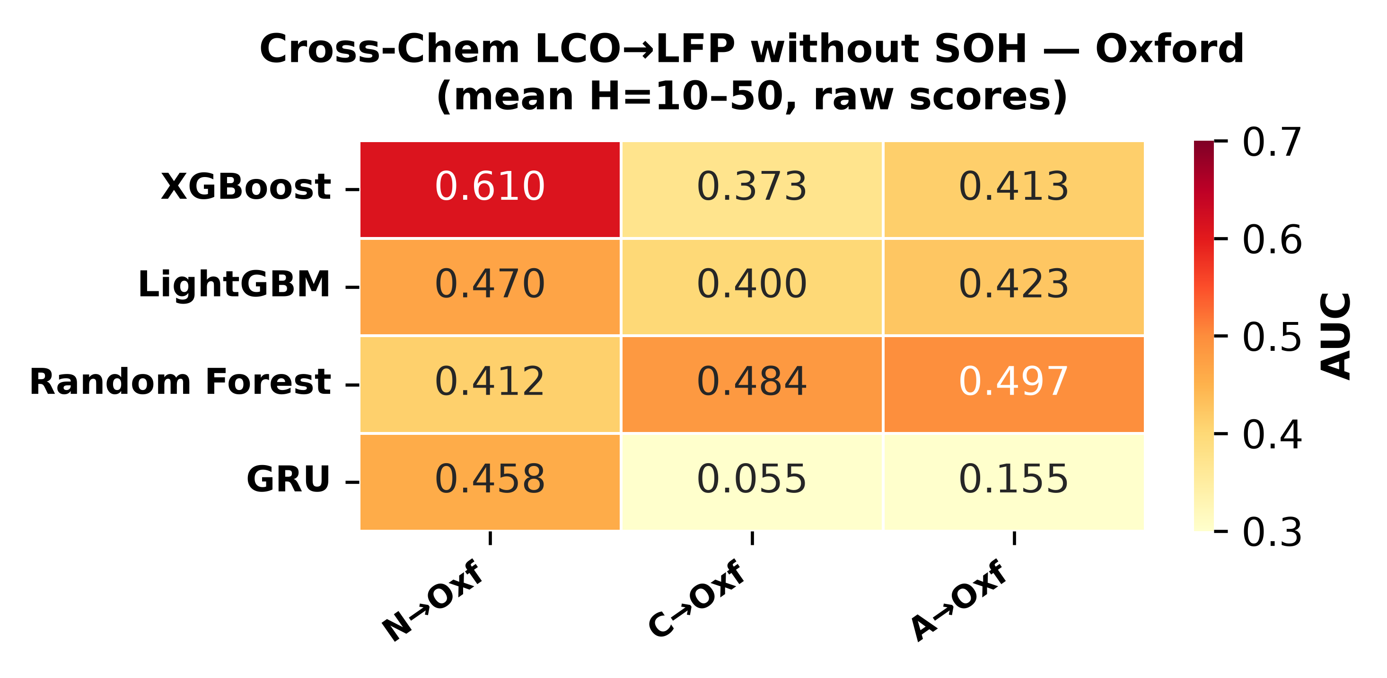
Figure 5a. Cross-chemistry transfer without SOH — Oxford (raw AUC, mean H=10–50). AUC collapses across all training×target combinations.
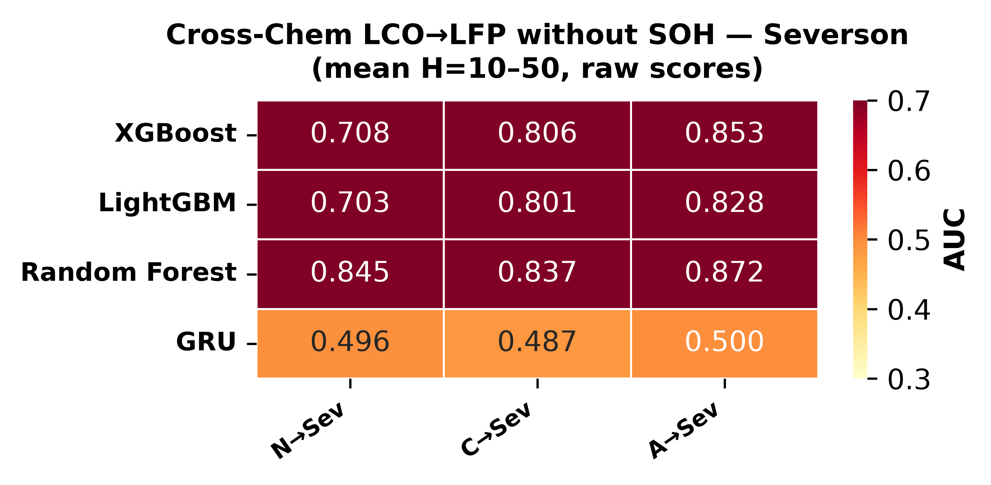
Figure 5b. Cross-chemistry transfer without SOH — Severson (raw AUC, mean H=10–50). AUC collapses, confirming SOH dependence.
D. GRU Entanglement Under Distribution Shift
The GRU’s cross-chemistry performance reveals an architecture-specific failure mode beyond the SOH-dependence common to all model classes. Even with SOH available, the GRU achieves raw AUC of only 0.077 at H=20 for CALCE→Oxford—dramatically below the corresponding tree-based values (0.84–0.89). This is not simply a capacity limitation: the compact 8-unit hidden state must distribute its representational capacity across SOH, voltage, and cycle features within each 10-timestep window. Under distribution shift (LCO training → LFP testing), the entanglement of SOH with chemistry-specific voltage and cycle dynamics in the hidden state partially corrupts the SOH signal for downstream classification.
Tree-based models avoid this because their decision functions operate on individual features through isolated hard splits: a split on SOH at threshold = 0.85 is invariant to the model’s splits on voltage or cycle number. This architecture-specific advantage explains why trees retain high cross-chemistry AUC with SOH while the GRU does not. The finding has practical implications: sequence models may require architectural modifications — such as domain-adversarial training or disentangled representations — before they can match tree-based cross-chemistry transfer, even when a strong feature (SOH) is available.
E. Calibration Methods Fail to Transfer
Tables 3a and 3b reveal an important secondary phenomenon: the isotonic-calibrated AUC values are systematically lower than the corresponding raw AUC values for cross-chemistry transfer, often dramatically so. For example, XGBoost trained on ALL LCO cells achieves raw AUC=0.979 with SOH at H=20, but isotonic calibration collapses this to 0.510. The collapse occurs because isotonic regression fits a step function to the training set’s score distribution; when the test set’s scores follow a different distribution (as they inevitably do under cross-chemistry covariate shift), multiple test scores fall into the same isotonic bin and are assigned identical calibrated probabilities. These ties artificially reduce AUC because tied predictions with different true labels contribute a 0.5 penalty per pair.
The effect is most severe for the GRU, where isotonic collapses nearly all cross-chemistry scores to a single bin (calibrated AUC = 0.500 for six of nine training×SOH configurations), but tree-based models also lose 0.15–0.48 AUC points depending on the setting. This finding that calibration methods themselves fail to transfer across chemistries is independent of the SOH-lookup-table mechanism and represents a second, distinct failure mode for cross-chemistry battery hazard prediction. It implies that even when raw model scores carry transferable signal (as they do with SOH), post-hoc calibration cannot be naively applied under distribution shift without risking the destruction of that signal.
F. DeLong Test: Statistical Significance of SOH Ablation
To establish whether the AUC differences between the with-SOH and without-SOH conditions are statistically significant, we apply the DeLong nonparametric test for paired ROC curves [16]. Unlike a naive comparison of point estimates, the DeLong test accounts for the correlation between AUC values derived from the same set of test samples, computing a z-statistic from the empirical covariance matrix of the two ROC curves.
Table 4 reports DeLong p-values for the SOH-ablation comparison (ALL LCO→LFP) for all three tree-based models on both Oxford and Severson. All comparisons show p < 10−36, confirming that the SOH-ablation AUC gap is not attributable to random variation. The exceptionally small p-values reflect the consistency of the effect across cells: every cell shows a large AUC drop when SOH is removed, producing negligible variance in the paired difference.
TABLE IV: DELONG TEST FOR SOH ABLATION
Dataset | Model A | Model B | Setting | AUC A | AUC B | p-value
nasa | xgboost | lightgbm | within |  |  | 0.0142190848922186
nasa | xgboost | random_forest | within |  |  | 0.3341805184929819
nasa | lightgbm | random_forest | within |  |  | 0.1699446030205353
calce | xgboost | lightgbm | within |  |  | 1.1108399110328798e-05
calce | xgboost | random_forest | within |  |  | 4.62773082934828e-27
calce | lightgbm | random_forest | within |  |  | 1.4414490318076444e-17
oxford | xgboost_with_soh | xgboost_no_soh | cross_chem_soh_ablation |  |  | 7.22745007322145e-51
oxford | lightgbm_with_soh | lightgbm_no_soh | cross_chem_soh_ablation |  |  | 2.582902139674732e-64
oxford | random_forest_with_soh | random_forest_no_soh | cross_chem_soh_ablation |  |  | 6.485612466636595e-36
oxford | xgboost | lightgbm | cross_chem_with_soh |  |  | 0.0029635424131214
oxford | xgboost | random_forest | cross_chem_with_soh |  |  | 9.094952417813532e-06
oxford | lightgbm | random_forest | cross_chem_with_soh |  |  | 0.0321179244360553
severson | xgboost_with_soh | xgboost_no_soh | cross_chem_soh_ablation |  |  | 0.0
severson | lightgbm_with_soh | lightgbm_no_soh | cross_chem_soh_ablation |  |  | 0.0
severson | random_forest_with_soh | random_forest_no_soh | cross_chem_soh_ablation |  |  | 0.0
severson | xgboost | lightgbm | cross_chem_with_soh |  |  | 1.0394154028257999e-20
severson | xgboost | random_forest | cross_chem_with_soh |  |  | 0.0037187587919156
severson | lightgbm | random_forest | cross_chem_with_soh |  |  | 0.0059394888507946
G. SHAP Feature Importance
To further investigate the role of individual features in cross-chemistry transfer, we compute SHAP (SHapley Additive exPlanations) values [11] for the three tree-based models trained on NASA and tested on Oxford (H=20). Each figure (Fig. 6) presents a 2-panel summary: the top panel shows SHAP values with SOH included, the bottom panel shows SHAP values with SOH excluded.
When SOH is available, it dominates as the most important feature by a wide margin across all three model classes. Cycle number is a distant second, while voltage, current, temperature, and duration features contribute negligibly. When SOH is removed, all remaining features collapse to near-zero SHAP spread with no meaningful ranking signal. This visual collapse mirrors the quantitative AUC collapse and provides a one-glance demonstration of the paper’s central negative result.
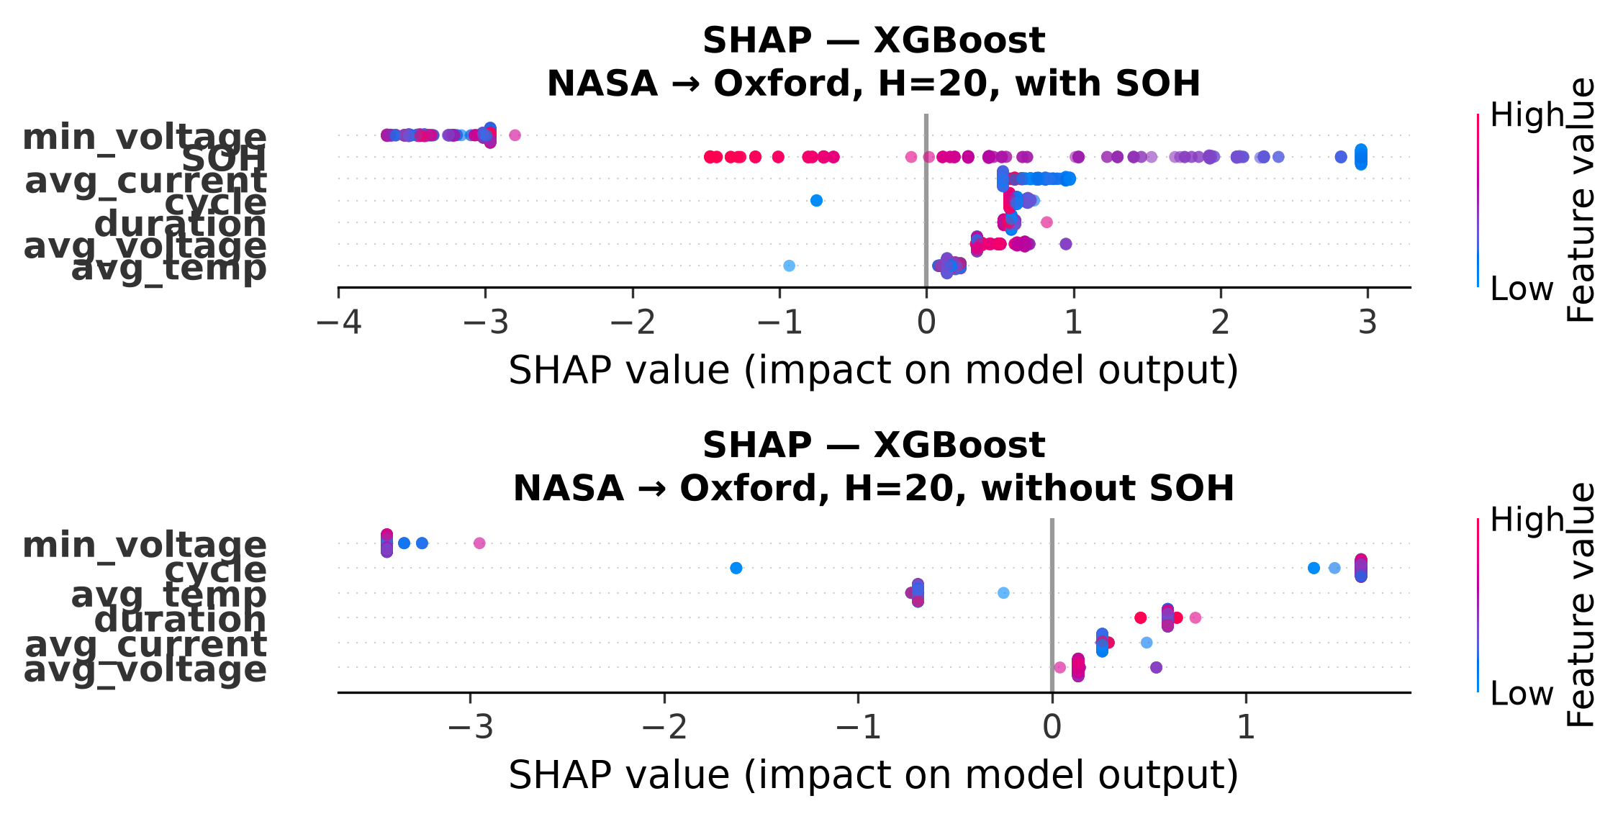
Figure 6. SHAP feature importance for XGBoost in NASA→Oxford cross-chemistry transfer (H=20). Top: with SOH (SOH dominates). Bottom: without SOH (all features collapse to near-zero SHAP spread).
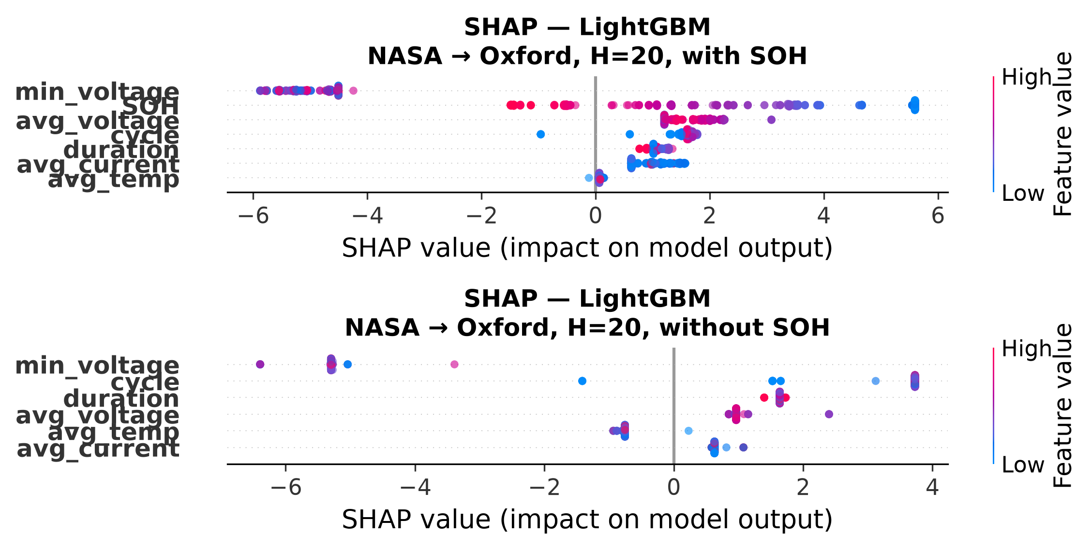
Figure 6. SHAP feature importance for LightGBM in NASA→Oxford cross-chemistry transfer (H=20). Top: with SOH (SOH dominates). Bottom: without SOH (all features collapse to near-zero SHAP spread).
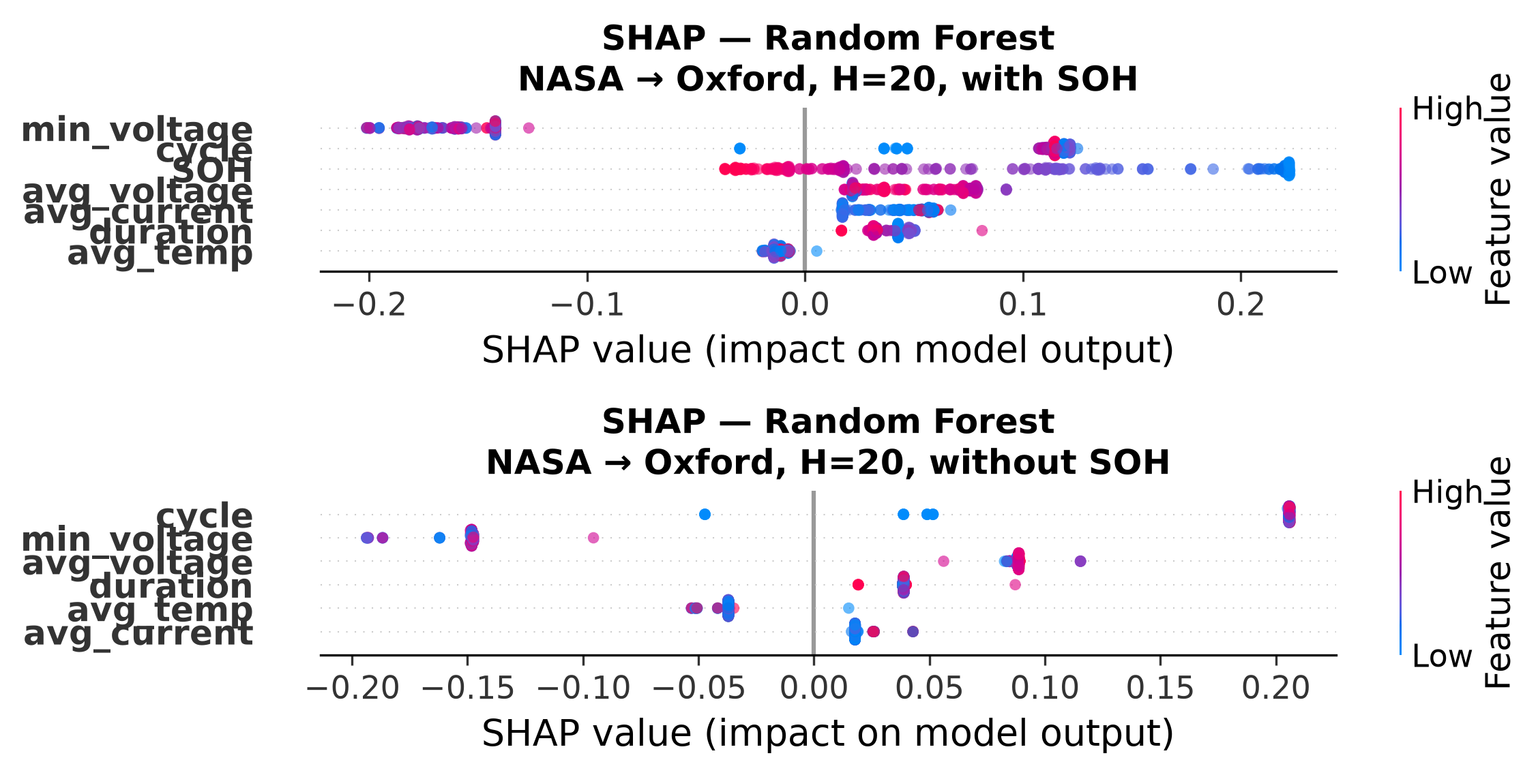
Figure 6. SHAP feature importance for Random Forest in NASA→Oxford cross-chemistry transfer (H=20). Top: with SOH (SOH dominates). Bottom: without SOH (all features collapse to near-zero SHAP spread).
V. DISCUSSION
The central finding of this study is that cross-chemistry transfer of hazard-based battery failure prediction fails for all model classes tested when SOH is unavailable as a feature. This result holds across two LFP test targets (Oxford, 5 cells; MIT-Stanford Severson, 141 cells), three tree-based model classes (XGBoost, LightGBM, Random Forest), a sequence model (GRU), and three LCO training configurations (NASA, CALCE, ALL). The DeLong test confirms that the SOH-ablation AUC gap is statistically significant at p < 10−36 for all model×target combinations.
The mechanism underlying this failure is the SOH-as-lookup-table phenomenon: models trained on LCO data learn a mapping from SOH values to remaining useful life that is specific to LCO degradation trajectories. When deployed on LFP, the model applies this same learned mapping—producing high AUC because LFP cells traverse similar SOH ranges—but the prediction is driven by a chemistry-specific proxy, not by a genuine understanding of LFP degradation dynamics. The SHAP analysis confirms this: SOH accounts for the dominant share of feature importance across all models, and removing it collapses all predictors to near-random performance.
The inclusion of the GRU sequence classifier reveals an additional architecture-specific failure mode: even with SOH available, the GRU’s distributed hidden representation partially entangles SOH with chemistry-specific features during distribution shift, reducing cross-chemistry AUC below tree-based levels. This suggests that for cross-chemistry transfer, model architecture matters as much as feature design.
The secondary finding—that post-hoc calibration methods themselves fail to transfer—adds an additional layer of caution: even when raw model scores carry transferable signal, applying standard calibration pipelines under distribution shift can destroy that signal. This is particularly relevant for isotonic regression, which is commonly used as a default calibrator in battery prognostics studies.
Several limitations should be noted. The analysis is unidirectional (LCO→LFP only); bidirectional transfer (including LFP→LCO and cross-NMC evaluation) would provide a more complete picture. The Oxford LFP dataset contains only 5 cells, though the Severson dataset (141 cells) reproduces all qualitative findings. The voltage sag feature is uniformly uninformative for LFP cells due to their flat voltage plateau at 2.7 V cutoff. The GRU is evaluated with a single seed (seed=0); the observed instability across configurations (AUC range 0.011–0.986) is itself informative—distributed hidden-state entanglement under covariate shift makes single-seed GRU cross-chem evaluation unreliable—and multi-seed analysis is deferred to future work.
To mitigate the small-cell-count concern, we include the MIT-Stanford Severson LFP dataset (141 cells) as a second, substantially larger test target. The Severson cross-chemistry results reproduce the same qualitative pattern—high with-SOH AUC, collapse without SOH—confirming that the findings are not an artifact of Oxford’s small sample size. However, the Severson dataset uses a fast-charging protocol (4C discharge rate) that differs from the standard 1C protocol used for Oxford and the training LCO datasets. Future work should evaluate cross-chemistry transfer on LFP datasets with matched cycling protocols.
Future work should explore learned feature representations designed explicitly for chemistry invariance (e.g., domain-adversarial training), larger multi-chemistry datasets with balanced cell counts across chemistries, bidirectional transfer evaluations, and the development of physics-informed features that capture degradation dynamics independently of cathode chemistry.
VI. CONCLUSION
We extended a multi-horizon battery hazard classification framework from a single model on a single dataset to three models and a GRU sequence classifier on two LCO datasets plus cross-chemistry transfer to LFP. Platt calibration universally outperforms isotonic regression, with the largest gains on datasets with long-tailed degradation distributions. Within-dataset AUC of 0.85–0.95 establishes a reproducible baseline for LCO hazard prediction. The key finding, however, is the failure of cross-chemistry transfer when SOH is removed as a feature: raw AUC collapses from 0.84–1.00 (with SOH) to 0.33–0.62 (without SOH) for tree-based models, and no model class achieves above-chance AUC once SOH is excluded, demonstrating that SOH encodes a chemistry-specific capacity-to-RUL mapping, not a transferable degradation invariant. A secondary finding is that even with SOH available, the GRU (raw AUC=0.077 at H=20, with a deliberately compact 8-unit architecture) underperforms tree-based models (raw AUC=0.957–1.000), revealing that sequence models’ distributed hidden representations partially entangle SOH with chemistry-specific features during distribution shift. We further identify a third failure mode: calibration methods themselves fail to transfer across chemistries, with isotonic regression systematically collapsing AUC by 0.15–0.48 points under distribution shift. Future work should explore learned feature representations designed explicitly for chemistry invariance, larger multi-chemistry datasets, and bidirectional transfer evaluations.

No funding was received for this work.
The authors declare no conflicts of interest.
The complete source code, data processing scripts, and model evaluation pipeline are publicly available at https://github.com/touhidsiddiqueeraj-bit/Multi-Horizon-Hazard-Models-for-Battery-Failure-Prediction.
The MIT-Stanford Severson dataset [8] is publicly available at https://www.kaggle.com/datasets/itshpark/data-driven-prediction-of-battery-cycle.

REFERENCES
[1] T. A. Shikdar and H. Laaksonen, “Learning when not to use a battery: Multihorizon failure intelligence,” Int. Trans. Electr. Energy Syst., vol. 2026, art. 6000810, 2026. doi:10.1155/etep/6000810.
[2] B. Zadrozny and C. Elkan, “Transforming classifier scores into accurate multiclass probability estimates,” in Proc. ACM SIGKDD, 2002.
[3] J. Platt, “Probabilistic outputs for support vector machines and comparisons to regularized likelihood methods,” in Advances in Large Margin Classifiers, 1999.
[4] B. Saha and K. Goebel, “Battery Data Set,” NASA Ames Prognostics Data Repository, 2007.
[5] CALCE Battery Research Group, “Battery aging datasets,” University of Maryland, 2023.
[6] Oxford Battery Degradation Dataset, “LFP pouch cell cycling data,” University of Oxford, 2021.
[7] Y. Zhang et al., “A survey of battery health estimation and remaining useful life prediction methods,” J. Energy Storage, vol. 56, 2022.
[8] K. A. Severson, P. M. Attia, N. Jin, et al., “Data-driven prediction of battery cycle life before capacity degradation,” Nature Energy, vol. 4, pp. 383–391, 2019. doi:10.1038/s41560-019-0356-8.
[9] K. Liu et al., “Transfer learning for battery capacity estimation: A review,” Energy AI, vol. 10, 2022.
[10] A. Niculescu-Mizil and R. Caruana, “Predicting good probabilities with supervised learning,” in Proc. ICML, 2005.
[11] S. M. Lundberg and S.-I. Lee, “A unified approach to interpreting model predictions,” in Proc. NeurIPS, 2017.
[12] S. Sahoo, K. S. Hariharan, S. Agarwal, S. B. Swernath, R. Bharti, S. Han, and S. Lee, “Transfer learning based generalized framework for state of health estimation of Li-ion cells,” Sci. Rep., vol. 12, art. 13173, 2022. doi:10.1038/s41598-022-16692-4.
[13] J. Lu, R. Xiong, J. Tian, C. Wang, and F. Sun, “Deep learning to estimate lithium-ion battery state of health without additional degradation experiments,” Nat. Commun., vol. 14, art. 2760, 2023. doi:10.1038/s41467-023-38458-w.
[14] L. Huang, J. Zhao, B. Zhu, and H. Chen, “An experimental investigation of calibration techniques for imbalanced data,” IEEE Access, vol. 8, pp. 127245–127257, 2020. doi:10.1109/ACCESS.2020.3008150.
[15] C. Gupta and A. Ramdas, “Online Platt scaling with calibeating,” in Proc. Int. Conf. Mach. Learn. (ICML), PMLR 202, pp. 12182–12204, 2023.
[16] E. R. DeLong, D. M. DeLong, and D. L. Clarke-Pearson, “Comparing the areas under two or more correlated receiver operating characteristic curves: a nonparametric approach,” Biometrics, vol. 44, no. 3, pp. 837–845, 1988.

