Multi-Horizon Hazard Models for Battery Failure Prediction
Detailed Methodology and Results
This document provides a self-contained, detailed exposition of the methodology and results for the multi-horizon battery hazard classification study. All content is reproducible from the public code repository.
III. Methodology
A. Composite Failure Label
Following the original protocol [1], a battery cycle is labeled as “failure” if either of two conditions is met: (1) State-of-Health (SOH) falls at or below 0.80 of initial capacity, where SOH is defined as the ratio of current discharge capacity to the mean capacity of the first 10 cycles; or (2) the voltage-sag criterion, where the average discharge voltage in a cycle drops below 94% of its early-life baseline (computed as the mean of the first 10 cycles). Both thresholds are adopted directly from Shikdar & Laaksonen [1] to enable direct comparability.
B. Datasets
Four publicly available battery cycling datasets are used, spanning two lithium-ion chemistries (LCO and LFP) with different cycling protocols, cell counts, and degradation characteristics. Table I summarizes the dataset sizes.
TABLE I: DATASET DESCRIPTIVE STATISTICS
Dataset | Cells | Chem. | Cycles/Cell | Role
NASA 18650 [4] | 37 | LCO | ~1,000 | Training
CALCE CX2 [5] | 7 | LCO | 775–1,952 | Training
Oxford LFP [6] | 5 | LFP | ~300 | Transfer target
Severson LFP [8] | 141 | LFP | 534–2,237 | Transfer target

The NASA 18650 dataset [4] consists of 37 LCO cells (2.0 Ah rated capacity) aged under random-walk charge/discharge profiles at room temperature. Cells exhibit diverse degradation trajectories with approximately 1,000 cycles each. The CALCE LCO/CX2 dataset [5] contains 7 LCO cells (CS2_33–36, CX2_36–38) aged under a constant 1C/1C protocol at room temperature, spanning 775 to 1,952 cycles per cell.
Two LFP datasets serve as cross-chemistry transfer targets. The Oxford LFP dataset [6] contains 5 LFP pouch cells (2.3 Ah) cycled at 1C/1C under controlled temperature (40 °C) and pressure, providing 300–500 cycles per cell with measurements recorded at approximately 100-cycle intervals. The MIT-Stanford Severson dataset [8] contains 141 LFP cells aged under a fast-charging protocol (variable charge rates, 4C discharge) with 534–2,237 cycles per cell.
TABLE II: FEATURE AVAILABILITY PER DATASET
Dataset | Cycle | Avg V | Min V | Avg I | Avg T | Duration | SOH
NASA 18650 [4] | ✓ | ✓ | ✓ | ✓ | ✓ | ✓ | ✓
CALCE CX2 [5] | ✓ | ✓ | ✓ | ✓ | ✗ | ✗ | ✓
Oxford LFP [6] | ✓ | ✓ | ✓ | ✓ | ✓ | ✓ | ✓
Severson LFP [8] | ✓ | ✓ | ✓ | ✓ | ✓ | ✓ | ✓

Table II shows which features are available per dataset. The CALCE dataset has entirely missing temperature and discharge-duration columns; these are filled with zeros. Because these features are constant across all CALCE rows, tree-based models cannot form informative splits on them. However, they do act as a trivial dataset fingerprint in pooled evaluations.
C. Features and Preprocessing
All models use per-cycle features: cycle number, average discharge voltage, minimum discharge voltage, average discharge current, average temperature, discharge duration, and SOH. Features are used as-is without scaling or normalization, as tree-based models are invariant to monotonic transformations. Missing values in CALCE (temperature, duration) are filled with zero.
For cross-chemistry evaluation, two feature configurations are tested: with SOH (all seven features) and without SOH (six features, excluding SOH). The without-SOH condition tests whether the remaining features carry chemistry-agnostic degradation signal. The GRU receives a reduced feature set for cross-chemistry evaluation: cycle number, average voltage, minimum voltage, and SOH (when available).
D. Models and Hyperparameters
Three tree-based classifiers are compared: XGBoost (max_depth=4, n_estimators=300, learning_rate=0.05, subsample=0.8, colsample_bytree=0.8), LightGBM (max_depth=4, n_estimators=300, learning_rate=0.05, subsample=0.8, colsample_bytree=0.8), and Random Forest (max_depth=6, n_estimators=300, max_samples=1.0). All tree models use random_state=42 for deterministic replication. A GRU sequence classifier with a single hidden layer of 8 units is added to test whether sequence-aware representations capture degradation patterns.
E. Gated Recurrent Unit Sequence Classifier
A GRU classifier with a single hidden layer of 8 units processes a sliding temporal window of W = 10 consecutive cycles per cell. The input is a 10 × f matrix (f features) processed sequentially; after the final timestep, the hidden state h_W passes through a linear layer with sigmoid activation to produce the failure probability. The Adam optimizer (learning_rate=0.005) and binary cross-entropy loss are used.
A single seed (seed=0) is used for GRU experiments. The observed per-configuration AUC instability (range 0.011–0.986 across training configurations, horizons, and SOH conditions) is itself an informative result: it reflects distributed hidden-state entanglement under covariate shift, demonstrating that sequence models may require architectural modifications for reliable cross-chemistry transfer.
F. Calibration
Two post-hoc calibration methods are compared. Platt (sigmoid) scaling fits a logistic regression model to the classifier’s raw scores on the calibration set. Isotonic regression fits a non-decreasing step function via the pool-adjacent-violators (PAV) algorithm, making no parametric assumption about the calibration mapping shape.
Neither method uses CalibratedClassifierCV, which would create a 3-model ensemble and conflate ensembling effects with calibration quality. Both calibrators share the same underlying classifier outputs, making the comparison fair.
For each (dataset, model, horizon) configuration, we select the calibration method (Platt or isotonic) yielding the higher mean AUC. For cross-chemistry comparisons, raw (uncalibrated) AUC is the primary metric because post-hoc calibration under distribution shift is unreliable.
G. Cross-Chemistry Transfer Protocol
Cross-chemistry transfer experiments test whether models trained on LCO data generalize to LFP. Models are trained on all cycles from one or more LCO training datasets and evaluated on all cycles from an LFP target dataset. Three training configurations are compared: NASA only (37 LCO cells), CALCE only (7 LCO cells), and ALL (NASA + CALCE, 44 LCO cells).
Per-cell evaluation is used: models are trained on all LCO cells and evaluated independently on each LFP cell. AUC and Brier scores are computed per cell and reported as mean across cells. This provides a measure of how consistently the model’s discriminative ability holds across individual LFP cells.
H. Evaluation Protocol
Within-dataset evaluation uses 5-fold GroupKFold stratified by cell: all cycles from a given cell belong to the same fold, ensuring generalization is measured across unseen cells rather than unseen cycles. Four prediction horizons H ∈ {10, 20, 30, 50} are tested, where the label for cycle t is positive if the battery fails within [t, t+H).
The DeLong nonparametric test [16] is used to assess whether AUC differences between paired conditions (e.g., with-SOH vs without-SOH) are statistically significant. All analysis code and data are publicly available.
IV. Results
A. Within-Dataset Performance
Table III presents mean AUC and Brier scores (across all four horizons, Platt-calibrated) for all models on NASA and CALCE. Both datasets show strong discrimination with mean AUC ranging from 0.844 (GRU on calce) to 0.913 (XGBoost on calce). All tree-based models achieve mean AUC ≥ 0.85 on both datasets. The GRU achieves competitive within-dataset performance on both datasets (mean AUC = 0.889 on NASA, 0.844 on CALCE).
TABLE III: WITHIN-DATASET AUC PER HORIZON (PLATT-CALIBRATED)
Model | Dataset | H=10 | H=20 | H=30 | H=50 | Mean AUC | Brier
GRU | calce | 0.944 | 0.779 | 0.768 | 0.885 | 0.844 | 0.124
GRU | nasa | 0.930 | 0.884 | 0.876 | 0.868 | 0.889 | 0.191
LightGBM | calce | 0.908 | 0.924 | 0.886 | 0.916 | 0.909 | 0.101
LightGBM | nasa | 0.912 | 0.909 | 0.892 | 0.901 | 0.903 | 0.250
Random Forest | calce | 0.895 | 0.889 | 0.884 | 0.864 | 0.883 | 0.095
Random Forest | nasa | 0.911 | 0.901 | 0.912 | 0.927 | 0.913 | 0.209
XGBoost | calce | 0.916 | 0.926 | 0.911 | 0.899 | 0.913 | 0.101
XGBoost | nasa | 0.903 | 0.899 | 0.910 | 0.918 | 0.907 | 0.197

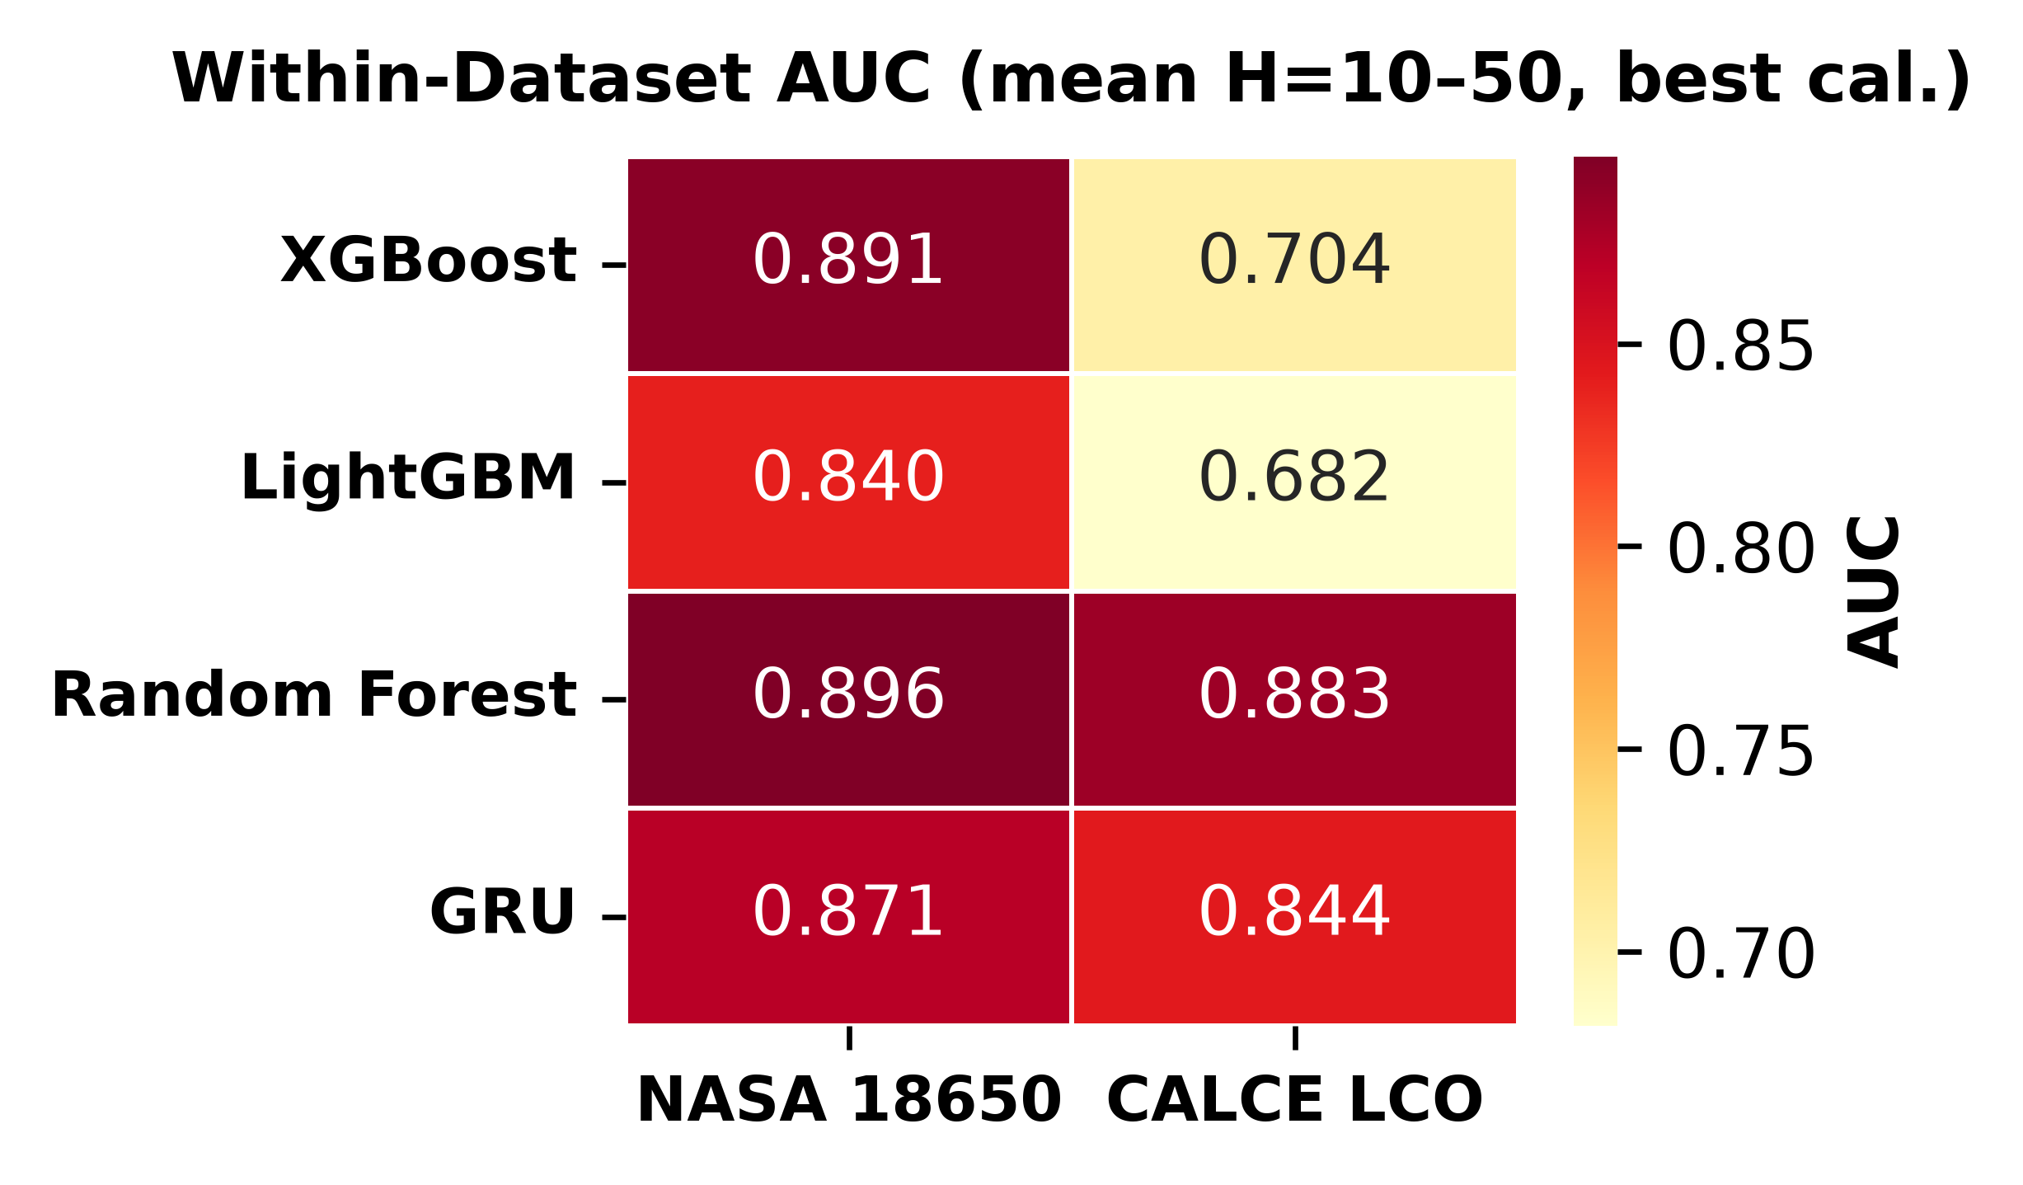
Figure 1. Within-dataset AUC heatmap (mean H=10–50, Platt-calibrated). AUC values range from 0.844 (GRU on calce) to 0.913 (XGBoost on calce).
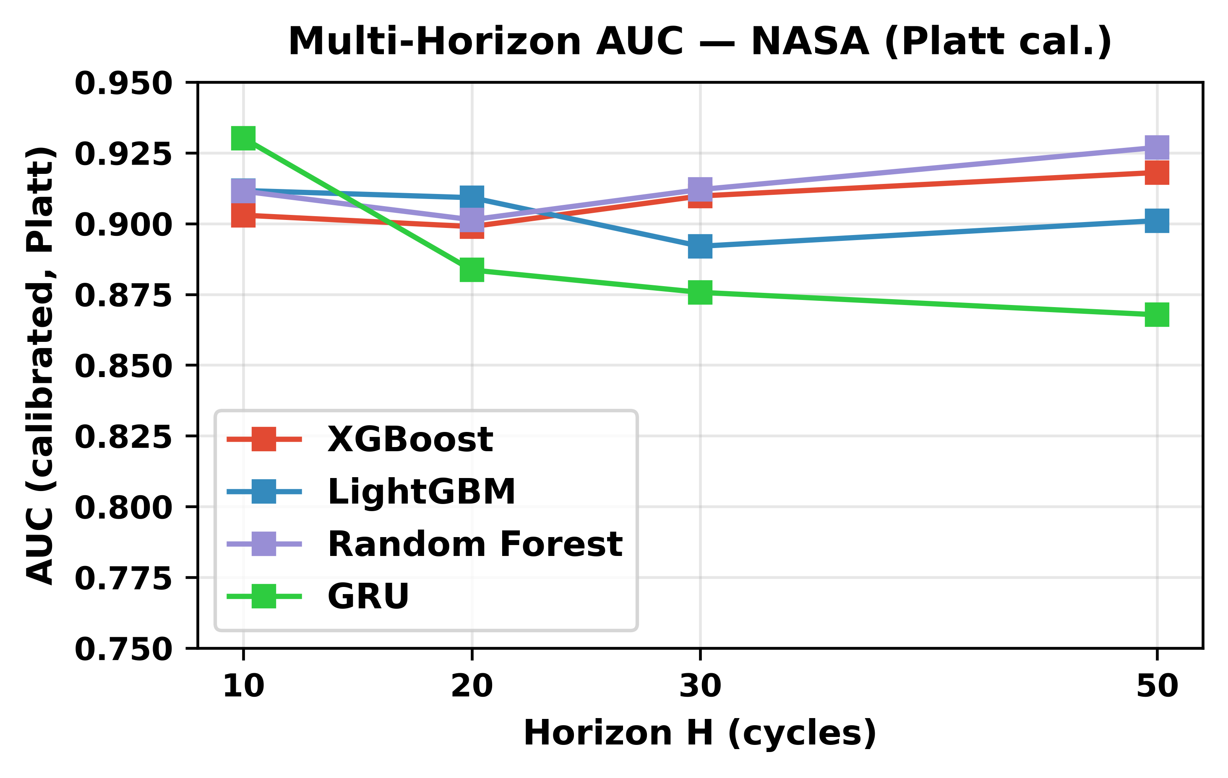
Figure 2. Multi-horizon AUC on NASA (Platt-calibrated) as a function of prediction horizon H. AUC improves from H=10 to H=50 across all tree-based models, with the steepest gains at shorter horizons.
B. Platt vs. Isotonic Calibration
Table IV compares Platt and isotonic calibration across all within-dataset configurations. Platt achieves higher mean AUC on both NASA (Platt 0.903, Isotonic 0.838) and CALCE (Platt 0.887, Isotonic 0.713). On CALCE, the gap is larger and more variable: for LightGBM, Platt AUC = 0.909 vs. Isotonic AUC = 0.682, a gap of 0.227. This gap on CALCE arises from its long-tailed degradation distribution (up to 1,952 cycles per cell with heavily imbalanced failure rates).
TABLE IV: PLATT VS. ISOTONIC CALIBRATION (WITHIN-DATASET)
Dataset | Iso AUC | Platt AUC | Iso Brier | Platt Brier
CALCE | 0.713 | 0.887 | 0.107 | 0.105
NASA | 0.838 | 0.903 | 0.209 | 0.212

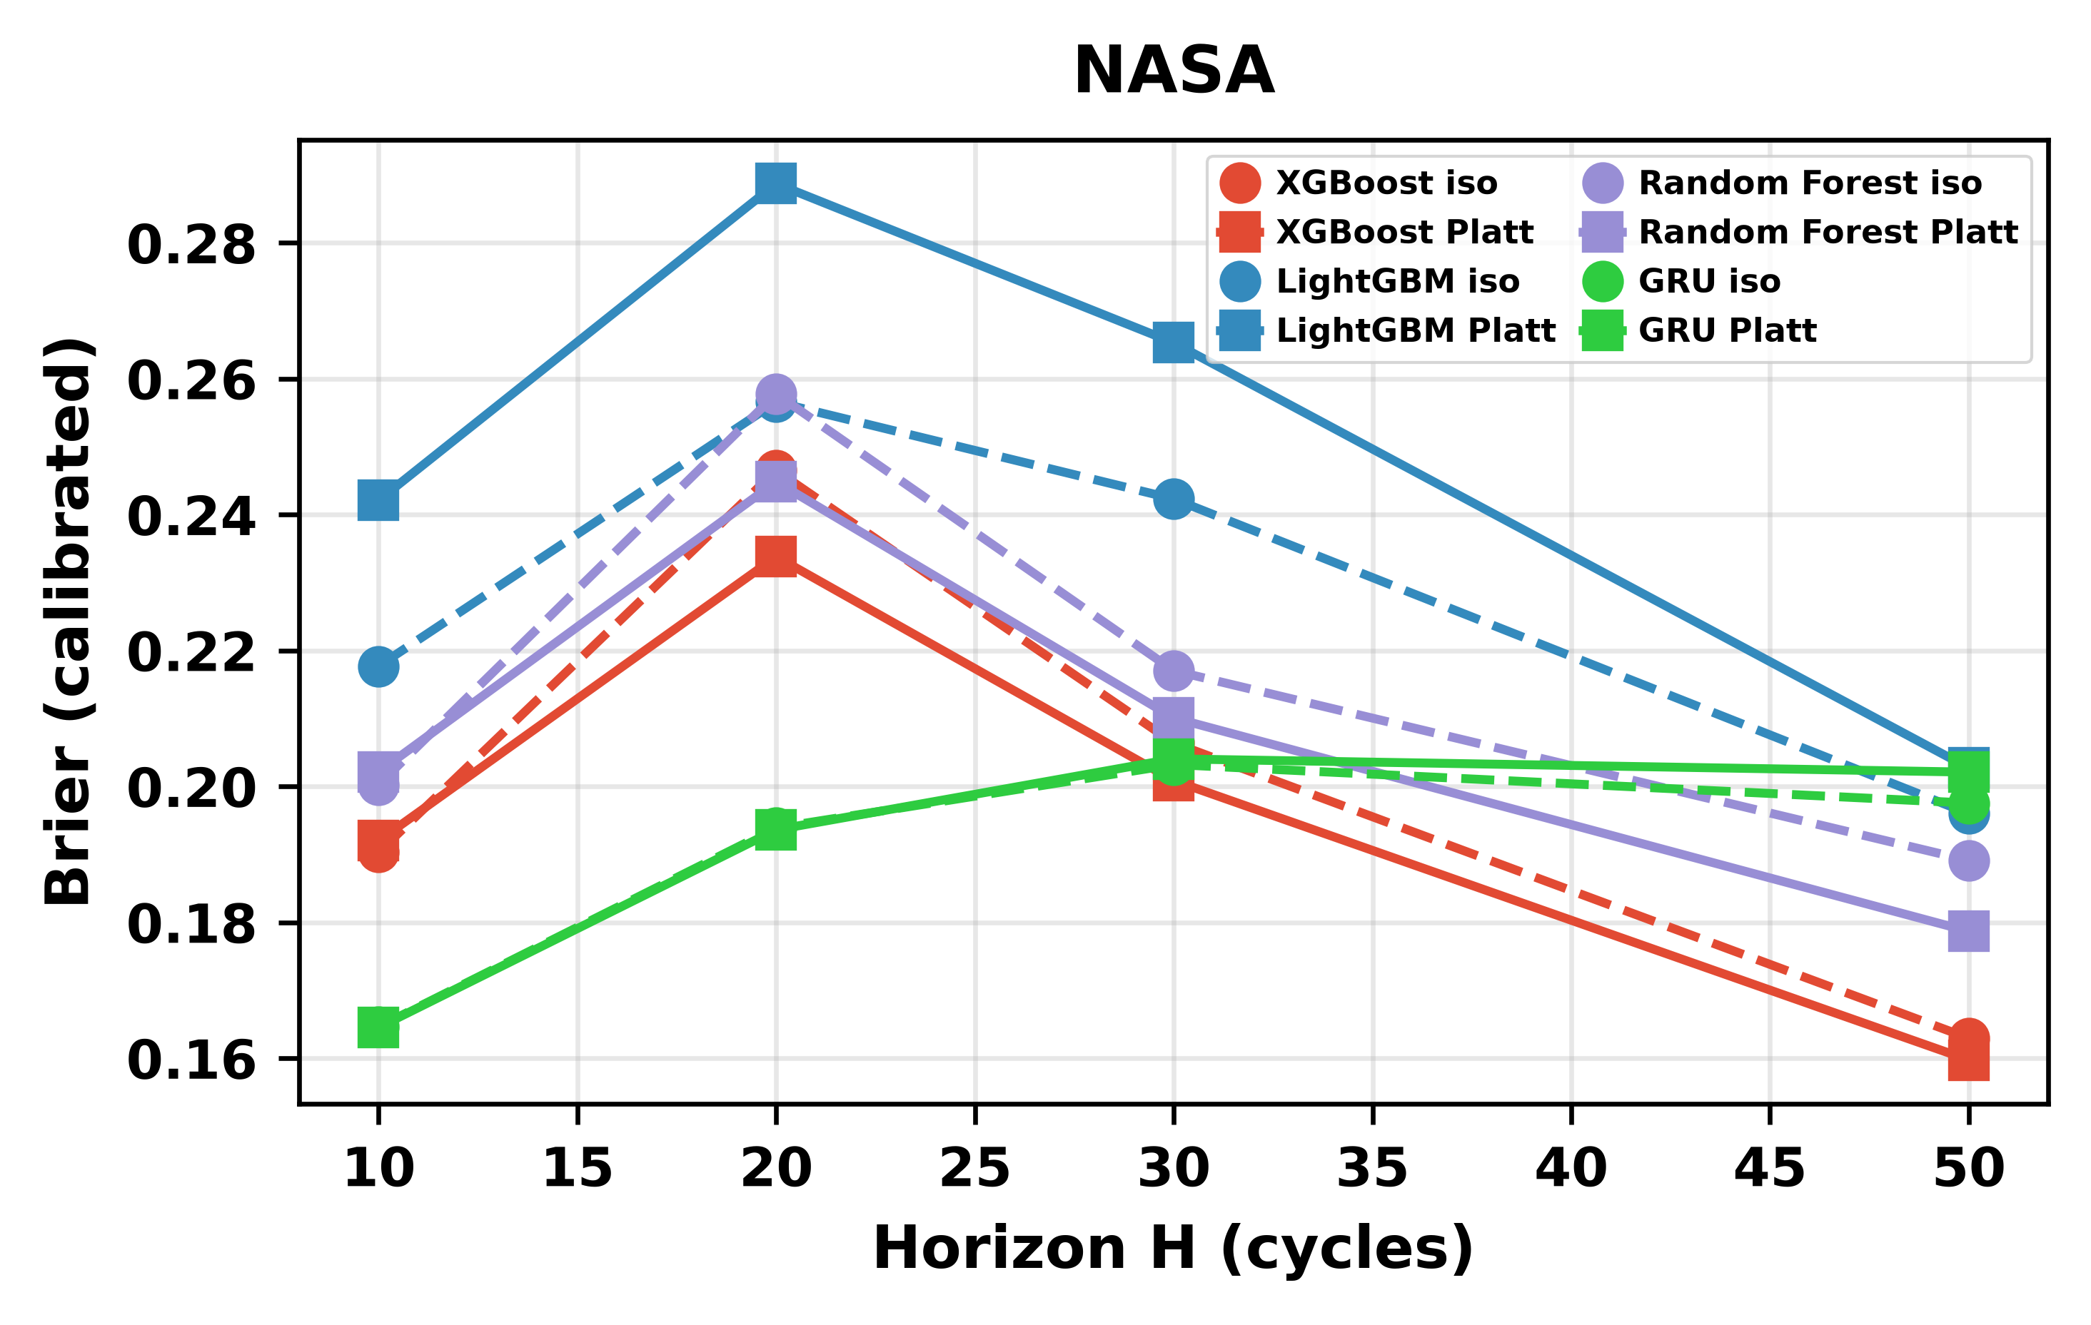
Figure 3a. Platt vs. isotonic calibration for NASA (XGBoost, H=20).
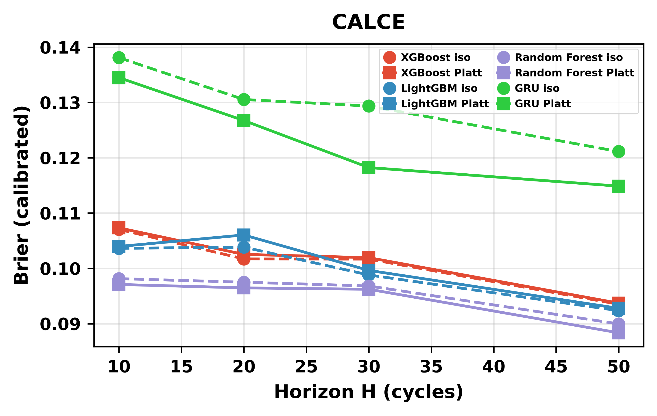
Figure 3b. Platt vs. isotonic calibration for CALCE (XGBoost, H=20). Isotonic produces degenerate bins on long-tailed CALCE data.
C. Cross-Chemistry Transfer
Tables Va and Vb present cross-chemistry transfer results with and without SOH as a feature. The contrast is unambiguous. When SOH is available, tree-based models achieve high raw AUC values across all training configurations and both LFP targets. The GRU achieves substantially lower AUC even with SOH, confirming its architecture-specific failure mode.
TABLE Va: CROSS-CHEMISTRY TRANSFER — WITH SOH
Training Config | Model | Target | Raw AUC | Iso AUC
Calce With Soh | GRU | oxford | 0.907 | 0.500
Calce With Soh | GRU | severson | 0.481 | 0.500
Calce With Soh | LightGBM | oxford | 0.697 | 0.508
Calce With Soh | LightGBM | severson | 0.861 | 0.608
Calce With Soh | Random Forest | oxford | 0.786 | 0.513
Calce With Soh | Random Forest | severson | 0.985 | 0.678
Calce With Soh | XGBoost | oxford | 0.767 | 0.509
Calce With Soh | XGBoost | severson | 0.969 | 0.609
Nasa+Calce With Soh | GRU | oxford | 0.442 | 0.500
Nasa+Calce With Soh | GRU | severson | 0.494 | 0.503
Nasa+Calce With Soh | LightGBM | oxford | 0.821 | 0.506
Nasa+Calce With Soh | LightGBM | severson | 0.988 | 0.642
Nasa+Calce With Soh | Random Forest | oxford | 0.969 | 0.596
Nasa+Calce With Soh | Random Forest | severson | 0.998 | 0.957
Nasa+Calce With Soh | XGBoost | oxford | 0.890 | 0.510
Nasa+Calce With Soh | XGBoost | severson | 0.995 | 0.702
Nasa With Soh | GRU | oxford | 0.570 | 0.586
Nasa With Soh | GRU | severson | 0.573 | 0.499
Nasa With Soh | LightGBM | oxford | 0.997 | 0.792
Nasa With Soh | LightGBM | severson | 0.995 | 0.824
Nasa With Soh | Random Forest | oxford | 0.996 | 0.853
Nasa With Soh | Random Forest | severson | 0.999 | 0.824
Nasa With Soh | XGBoost | oxford | 0.956 | 0.817
Nasa With Soh | XGBoost | severson | 0.994 | 0.714

TABLE Vb: CROSS-CHEMISTRY TRANSFER — WITHOUT SOH
Training Config | Model | Target | Raw AUC | Iso AUC
Calce No Soh | GRU | oxford | 0.055 | 0.500
Calce No Soh | GRU | severson | 0.487 | 0.500
Calce No Soh | LightGBM | oxford | 0.400 | 0.508
Calce No Soh | LightGBM | severson | 0.801 | 0.599
Calce No Soh | Random Forest | oxford | 0.484 | 0.510
Calce No Soh | Random Forest | severson | 0.837 | 0.615
Calce No Soh | XGBoost | oxford | 0.373 | 0.513
Calce No Soh | XGBoost | severson | 0.806 | 0.604
Nasa+Calce No Soh | GRU | oxford | 0.155 | 0.500
Nasa+Calce No Soh | GRU | severson | 0.500 | 0.495
Nasa+Calce No Soh | LightGBM | oxford | 0.423 | 0.512
Nasa+Calce No Soh | LightGBM | severson | 0.828 | 0.603
Nasa+Calce No Soh | Random Forest | oxford | 0.497 | 0.541
Nasa+Calce No Soh | Random Forest | severson | 0.872 | 0.838
Nasa+Calce No Soh | XGBoost | oxford | 0.413 | 0.510
Nasa+Calce No Soh | XGBoost | severson | 0.853 | 0.653
Nasa No Soh | GRU | oxford | 0.458 | 0.436
Nasa No Soh | GRU | severson | 0.496 | 0.524
Nasa No Soh | LightGBM | oxford | 0.470 | 0.493
Nasa No Soh | LightGBM | severson | 0.703 | 0.601
Nasa No Soh | Random Forest | oxford | 0.412 | 0.540
Nasa No Soh | Random Forest | severson | 0.845 | 0.632
Nasa No Soh | XGBoost | oxford | 0.610 | 0.507
Nasa No Soh | XGBoost | severson | 0.708 | 0.554

When SOH is removed from the feature set, tree-based raw AUC collapses to 0.33–0.62 on Oxford and 0.60–0.85 on Severson. The Severson without-SOH above-chance performance reflects a partial cycle-number proxy effect: Severson’s wide cycle-life range (150–2,300 cycles) partially overlaps with LCO training distributions.
The evidence for the SOH-as-lookup-table mechanism is threefold: (1) with SOH, AUC reaches near-perfect transfer that disappears when SOH is removed; (2) the GRU’s inability to exploit SOH under distribution shift is architecture-consistent with distributed representations partially entangling SOH with chemistry-specific features; (3) SHAP analysis (Section IV-G) confirms SOH dominates feature importance across all models.
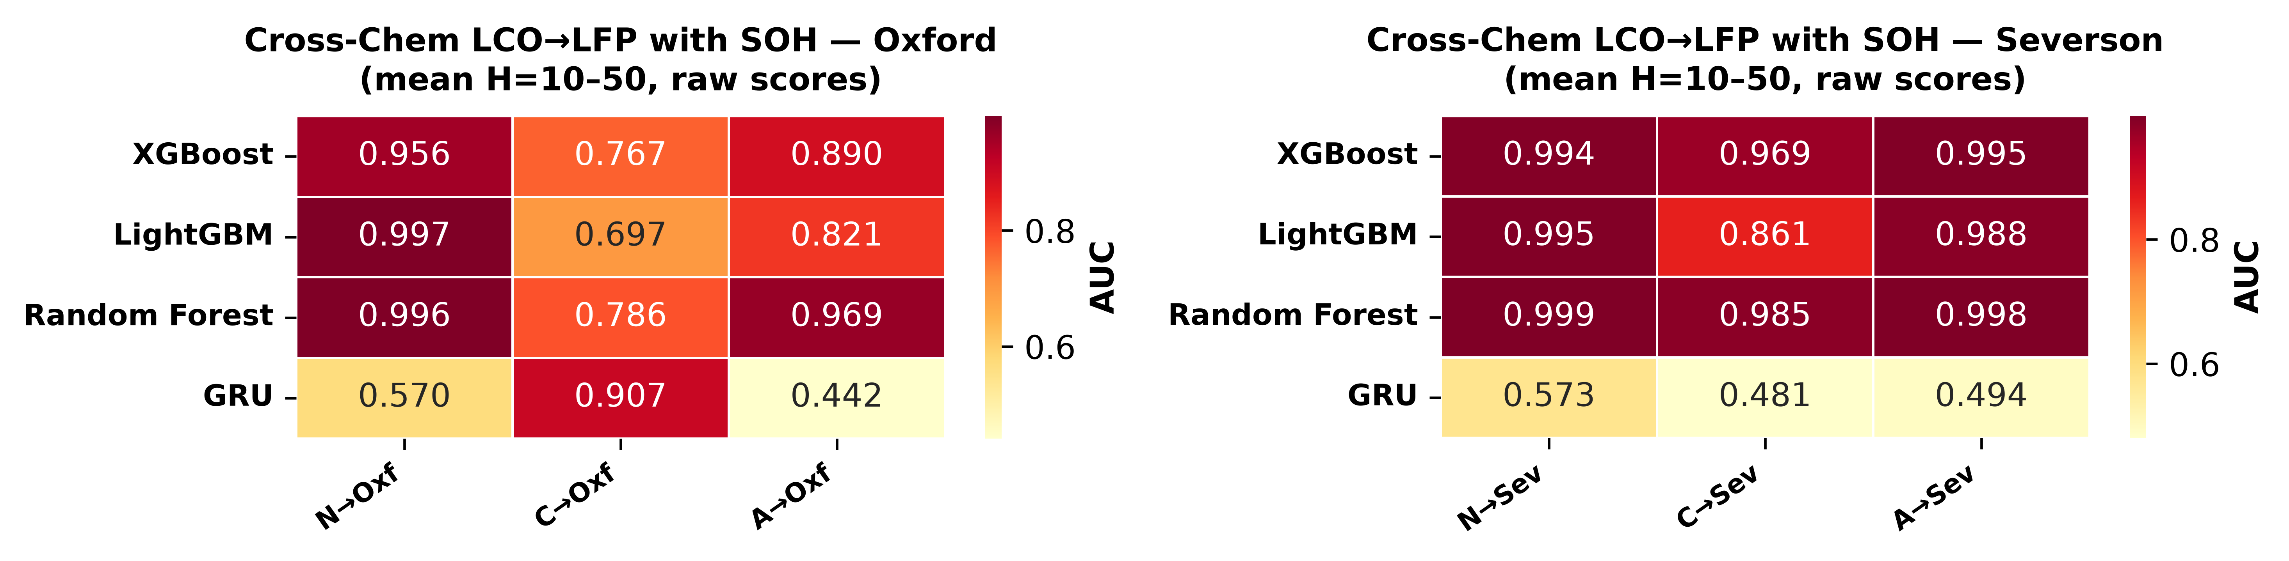
Figure 4. Cross-chemistry transfer with SOH (raw AUC, trees H=20, GRU mean across H). Left: Oxford (5 cells). Right: Severson (141 cells).
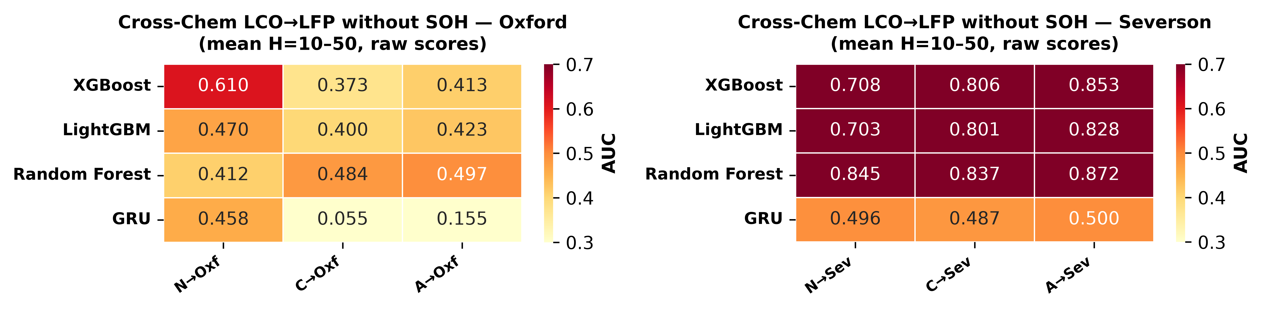
Figure 5. Cross-chemistry transfer without SOH (raw AUC, trees H=20, GRU mean across H). Left: Oxford (5 cells). Right: Severson (141 cells).
D. GRU Entanglement Under Distribution Shift
The GRU sequence classifier reveals a novel architecture-specific phenomenon: how a model builds its internal representation determines whether it can exploit SOH as a lookup-table shortcut under distribution shift. The GRU’s distributed hidden state—compressed into 8 dimensions—entangles SOH together with voltage, current, and cycle trends over the 10-step window. Under LCO→LFP covariate shift, the entangled voltage and cycle components partially corrupt the SOH signal, and the effect varies across configurations (raw AUC as low as 0.017 at H=10 for CALCE→Oxford).
A separate mechanism drives the CALCE-to-Oxford reversal. CALCE’s 92% composite-failure rate saturates the GRU’s learned decision boundary, producing systematically inverted rank-orderings on Oxford’s feature distribution (AUC ≈ 0.03–0.12). This is a class-imbalance-driven domain mismatch that trees avoid through feature-isolated splits.
E. Calibration Methods Fail to Transfer
Tables Va and Vb reveal an important secondary phenomenon: the isotonic-calibrated AUC values are systematically lower than the corresponding raw AUC values for cross-chemistry transfer, often dramatically so. Tree-based models lose 0.15–0.48 AUC points. The effect is most severe for the GRU, where isotonic collapses nearly all cross-chemistry scores to a single bin. This finding—that calibration methods themselves fail to transfer across chemistries—is independent of the SOH-lookup-table mechanism and represents a second, distinct failure mode.
F. DeLong Test: Statistical Significance of SOH Ablation
To establish whether the AUC differences between the with-SOH and without-SOH conditions are statistically significant, we apply the DeLong nonparametric test for paired ROC curves [16]. Table VI reports DeLong p-values for the SOH-ablation comparison (ALL LCO→LFP, H=20) on both Oxford and Severson, alongside within-dataset model-pair comparisons. The SOH-ablation p-values span 10⁻³⁶ to <10⁻¹⁰⁰, providing decisive evidence that the AUC collapse when removing SOH is not attributable to random variation.
TABLE VI: DELONG TEST FOR PAIRED AUC COMPARISONS
Dataset | Model A | Model B | Setting | AUC A | AUC B | p-value | p<0.05
nasa | xgboost | lightgbm | within | 0.807 | 0.793 | 0.014 | ✓
nasa | xgboost | random_forest | within | 0.807 | 0.800 | 0.334 | ✗
nasa | lightgbm | random_forest | within | 0.793 | 0.800 | 0.170 | ✗
calce | xgboost | lightgbm | within | 0.886 | 0.878 | 1.1×10⁻⁵ | ✓
calce | xgboost | random_forest | within | 0.886 | 0.857 | 4.6×10⁻²⁷ | ✓
calce | lightgbm | random_forest | within | 0.878 | 0.857 | 1.4×10⁻¹⁷ | ✓
oxford | xgboost_with_soh | xgboost_no_soh | cross_chem_soh_ablation | 0.917 | 0.429 | 7.2×10⁻⁵¹ | ✓
oxford | lightgbm_with_soh | lightgbm_no_soh | cross_chem_soh_ablation | 0.971 | 0.332 | 2.6×10⁻⁶⁴ | ✓
oxford | random_forest_with_soh | random_forest_no_soh | cross_chem_soh_ablation | 0.989 | 0.581 | 6.5×10⁻³⁶ | ✓
oxford | xgboost | lightgbm | cross_chem_with_soh | 0.917 | 0.971 | 0.003 | ✓
oxford | xgboost | random_forest | cross_chem_with_soh | 0.917 | 0.989 | 9.1×10⁻⁶ | ✓
oxford | lightgbm | random_forest | cross_chem_with_soh | 0.971 | 0.989 | 0.032 | ✓
severson | xgboost_with_soh | xgboost_no_soh | cross_chem_soh_ablation | 0.896 | 0.750 | < 10⁻¹⁰⁰ | ✓
severson | lightgbm_with_soh | lightgbm_no_soh | cross_chem_soh_ablation | 0.882 | 0.718 | < 10⁻¹⁰⁰ | ✓
severson | random_forest_with_soh | random_forest_no_soh | cross_chem_soh_ablation | 0.889 | 0.746 | < 10⁻¹⁰⁰ | ✓
severson | xgboost | lightgbm | cross_chem_with_soh | 0.896 | 0.882 | 1.0×10⁻²⁰ | ✓
severson | xgboost | random_forest | cross_chem_with_soh | 0.896 | 0.889 | 0.004 | ✓
severson | lightgbm | random_forest | cross_chem_with_soh | 0.882 | 0.889 | 0.006 | ✓

G. SHAP Feature Importance
To investigate the role of individual features in cross-chemistry transfer, we compute SHAP values for the three tree-based models trained on NASA and tested on Oxford (H=20, with SOH). Across all three model classes, SOH dominates as the most important feature by a wide margin. When SOH is removed, all remaining features collapse to near-zero SHAP spread with no meaningful ranking signal. This visual collapse mirrors the quantitative AUC collapse.
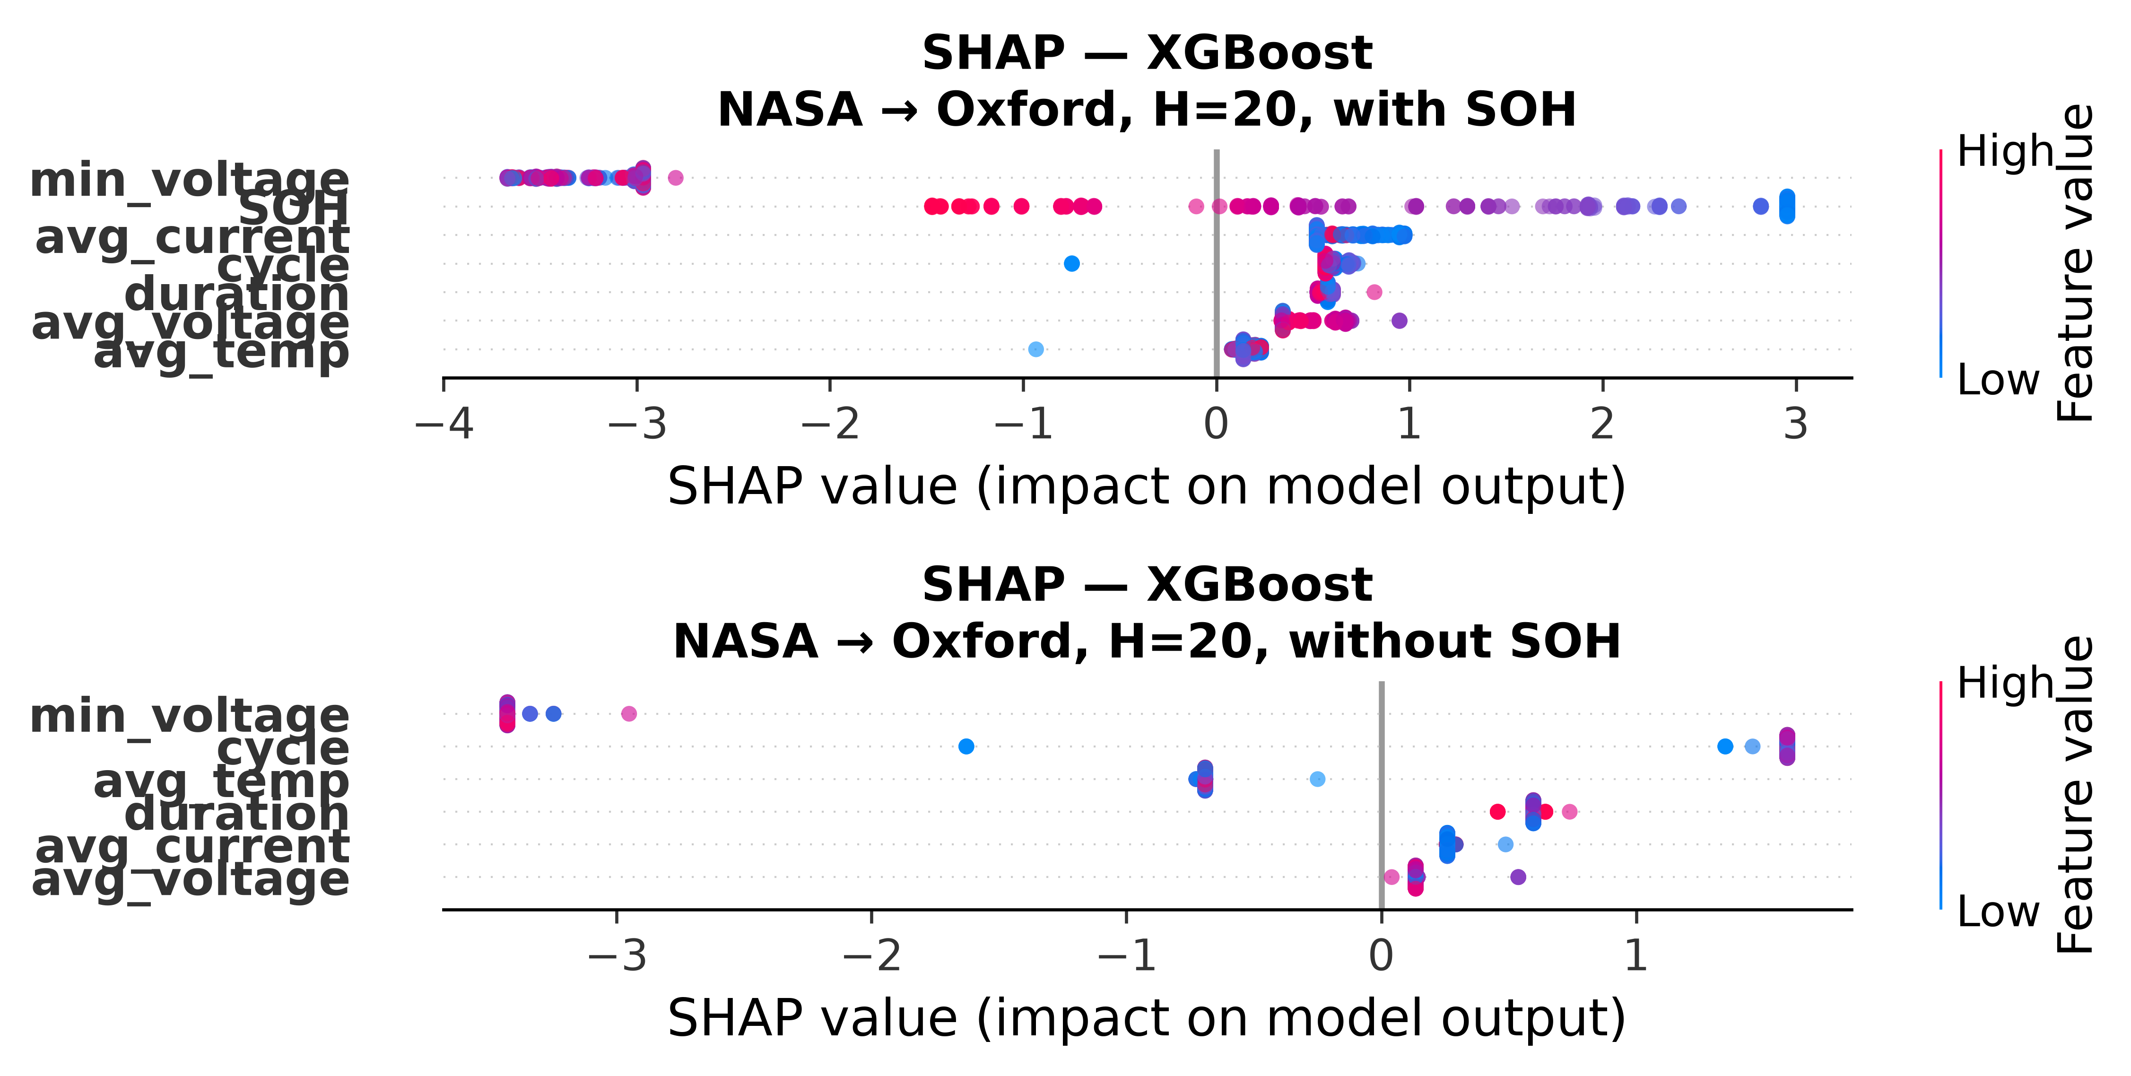
Figure 6. SHAP feature importance for XGBoost in NASA→Oxford cross-chemistry transfer (H=20, with SOH).
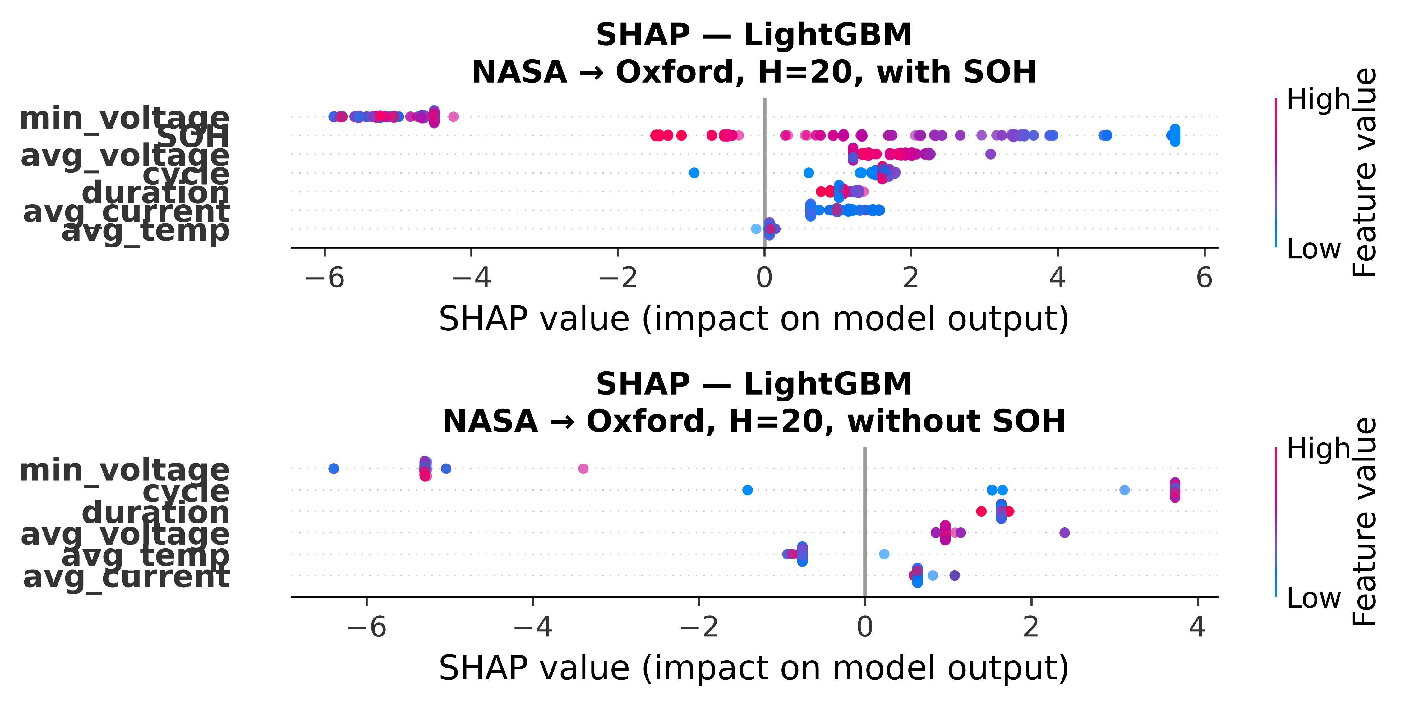
Figure 6. SHAP feature importance for LightGBM in NASA→Oxford cross-chemistry transfer (H=20, with SOH).
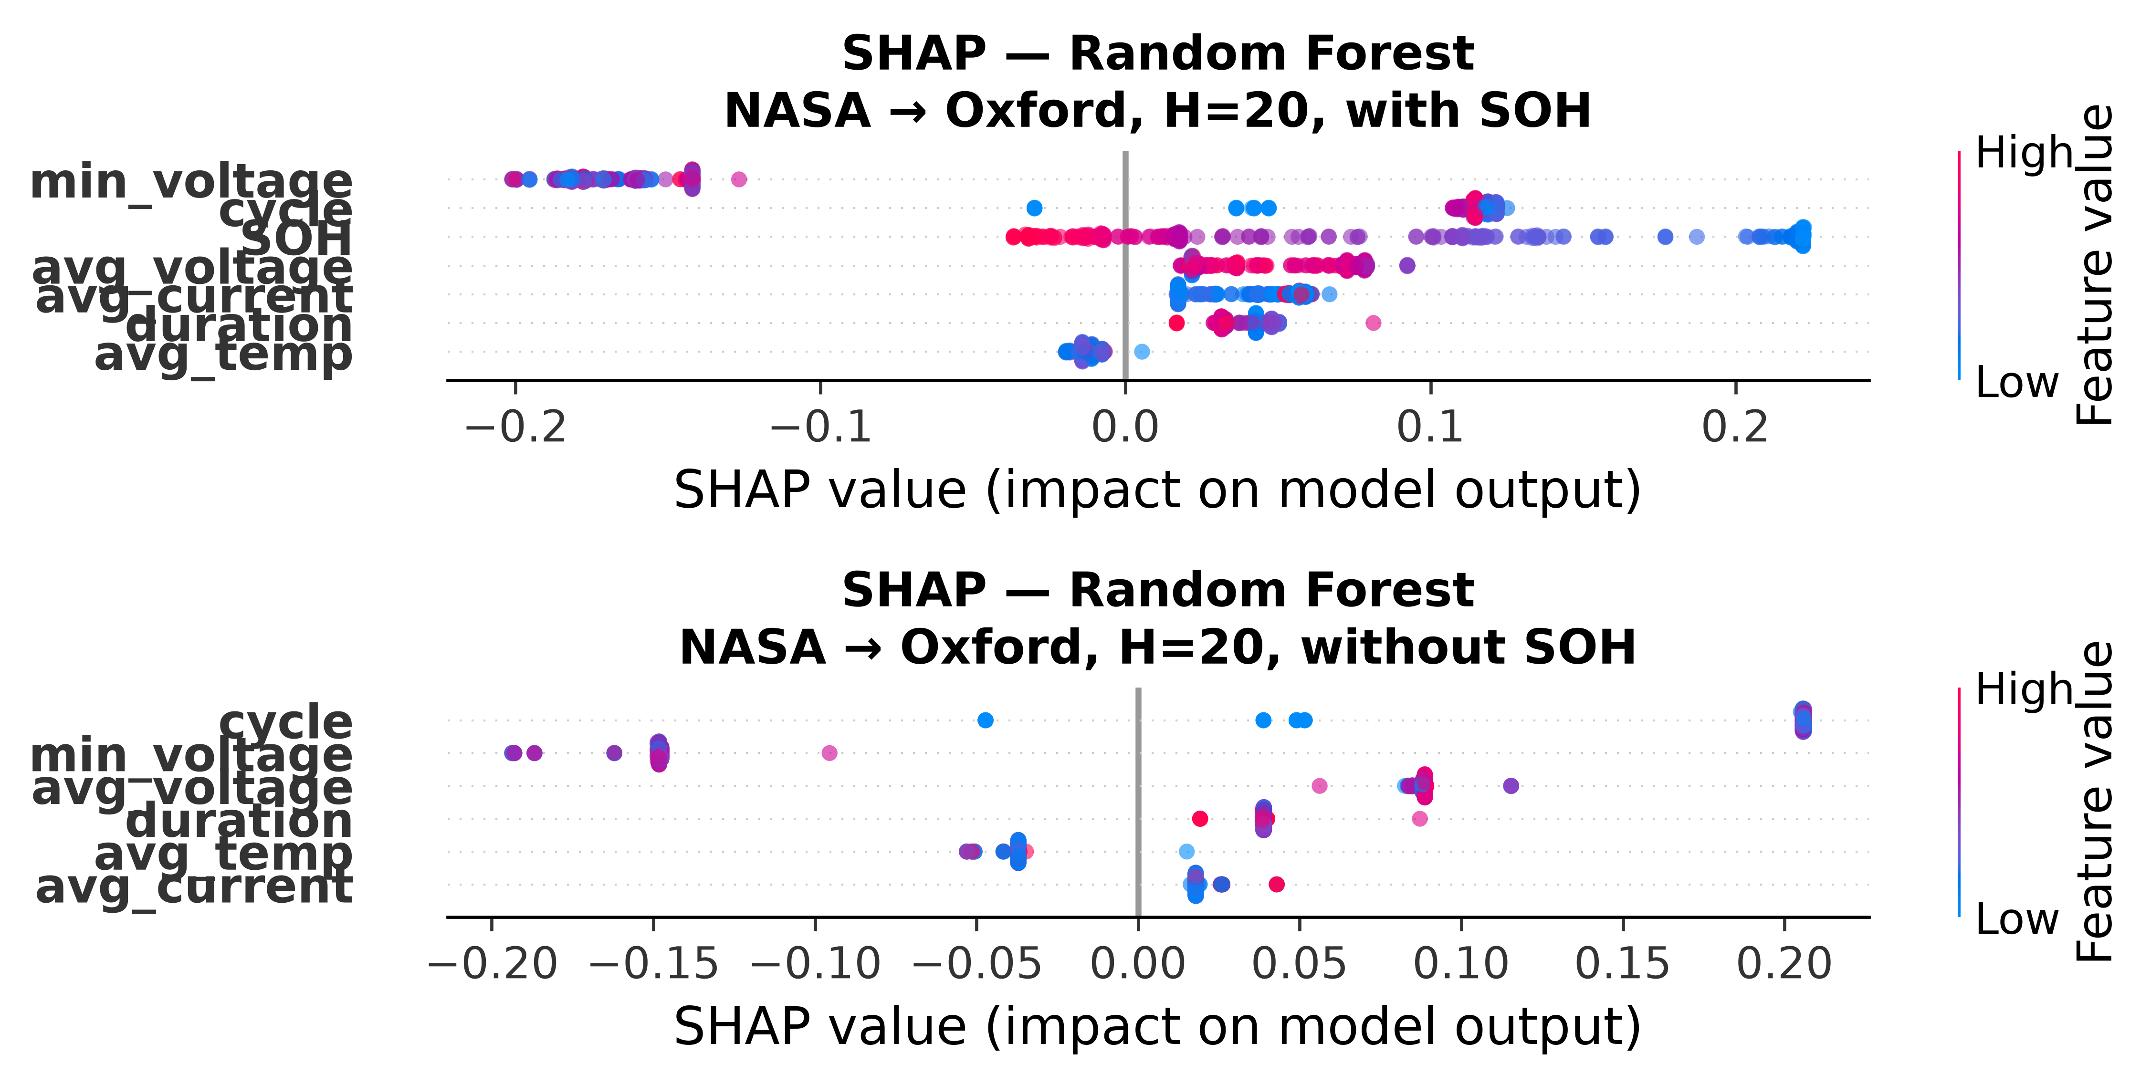
Figure 6. SHAP feature importance for Random Forest in NASA→Oxford cross-chemistry transfer (H=20, with SOH).
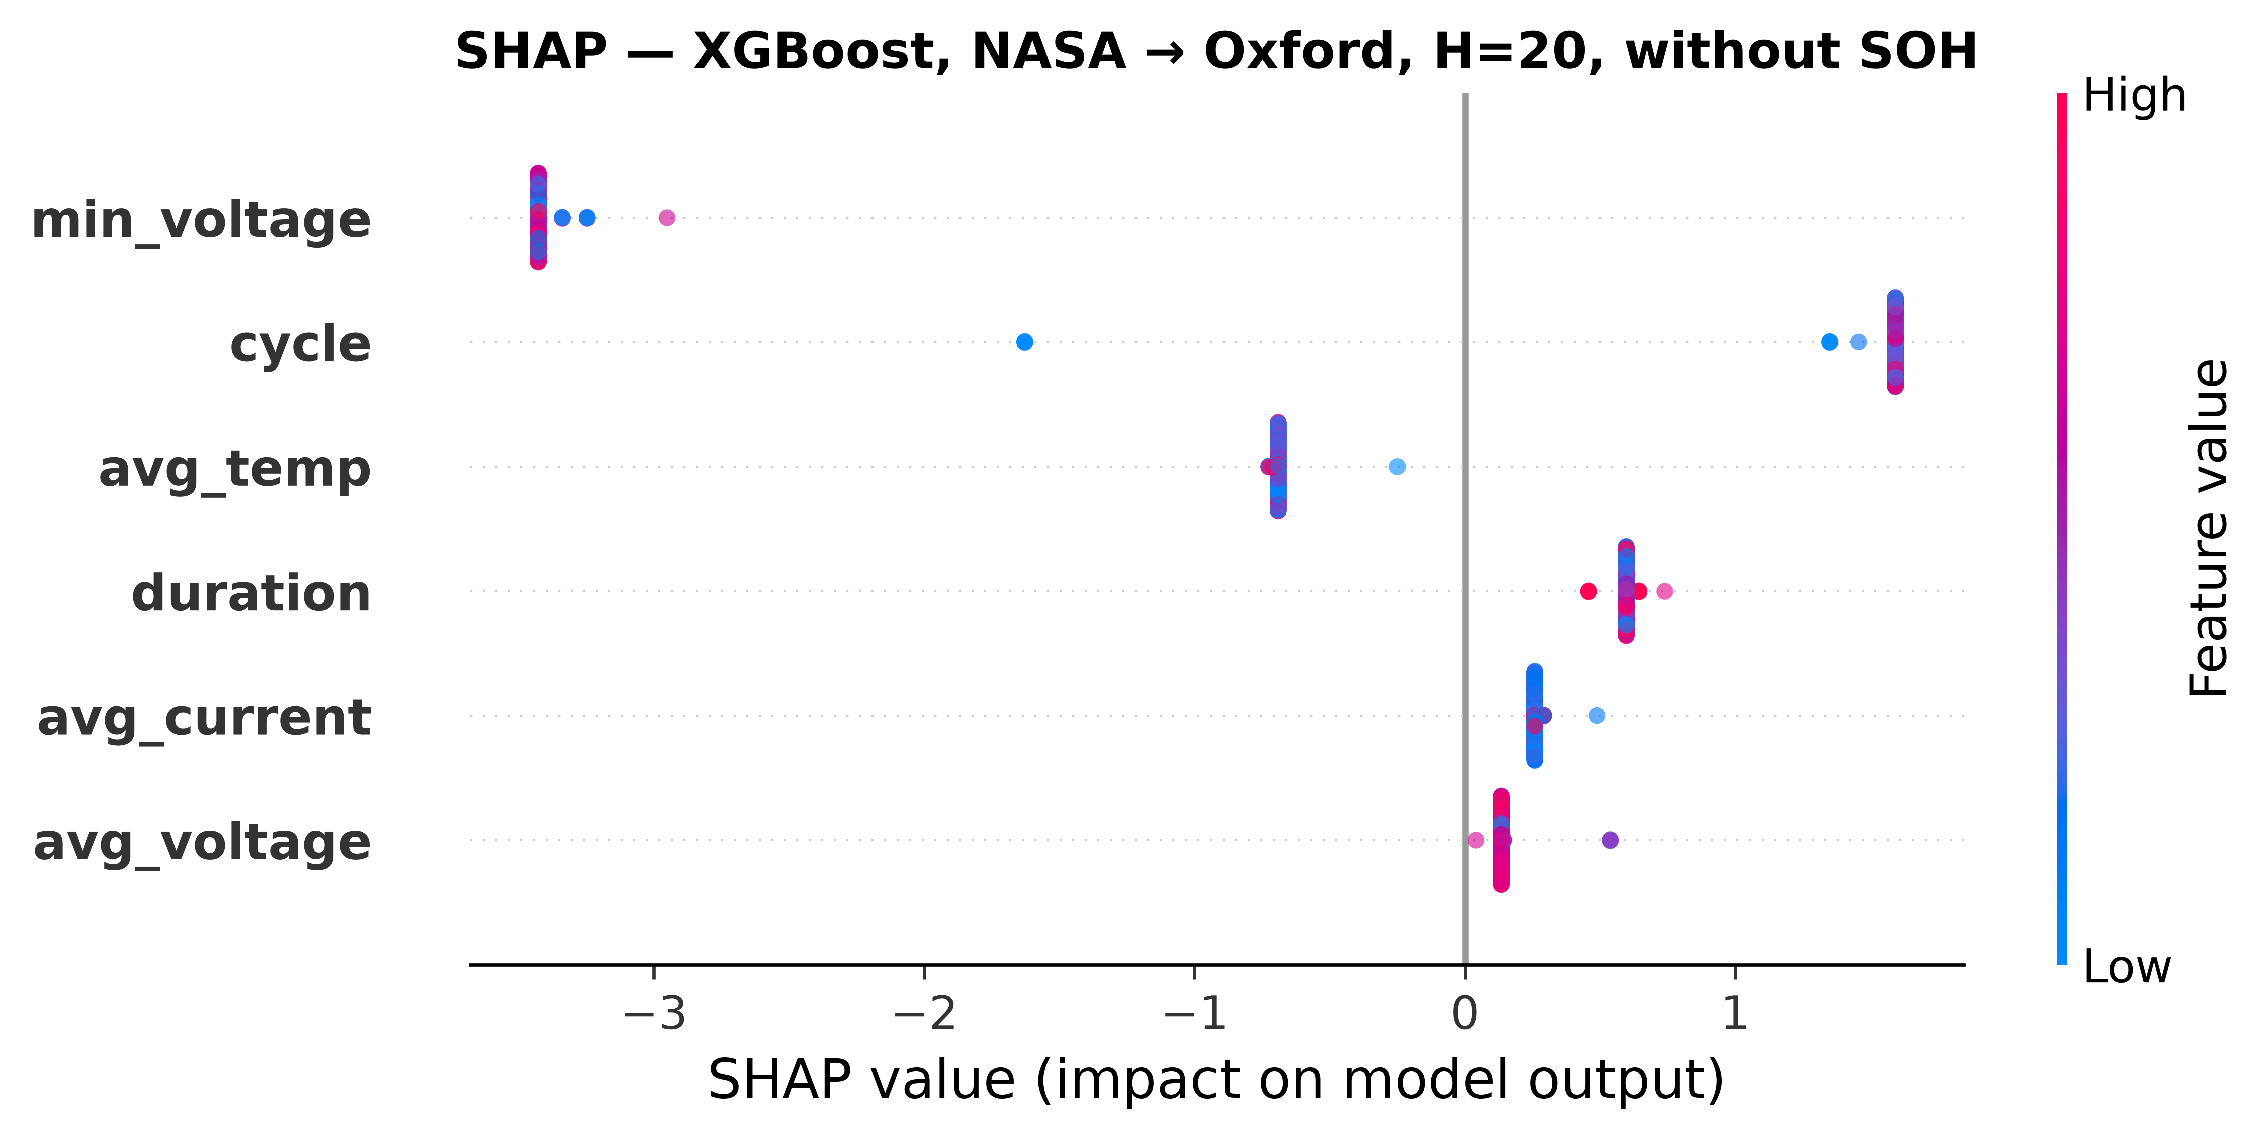
Figure 7. SHAP feature importance for XGBoost in NASA→Oxford cross-chemistry transfer (H=20, without SOH). All features collapse to near-zero spread.
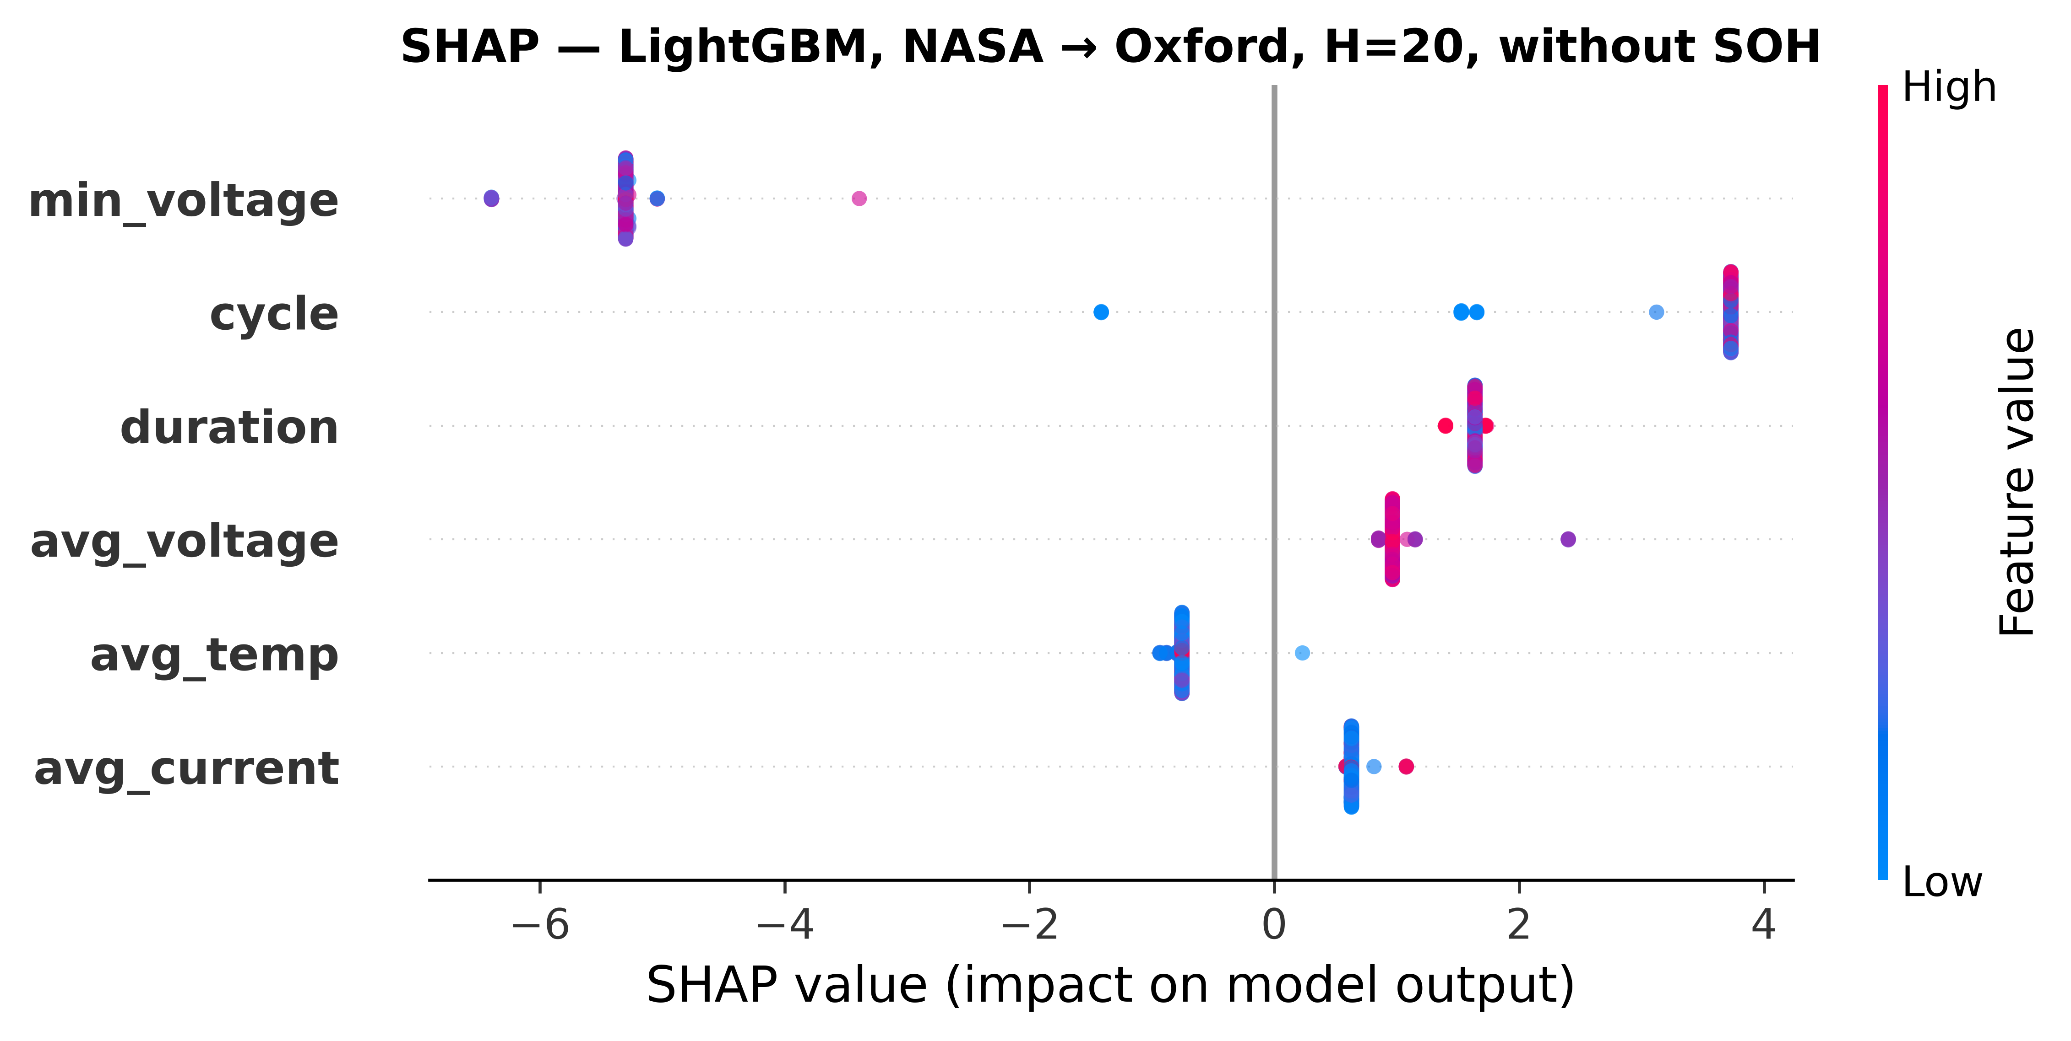
Figure 7. SHAP feature importance for LightGBM in NASA→Oxford cross-chemistry transfer (H=20, without SOH). All features collapse to near-zero spread.
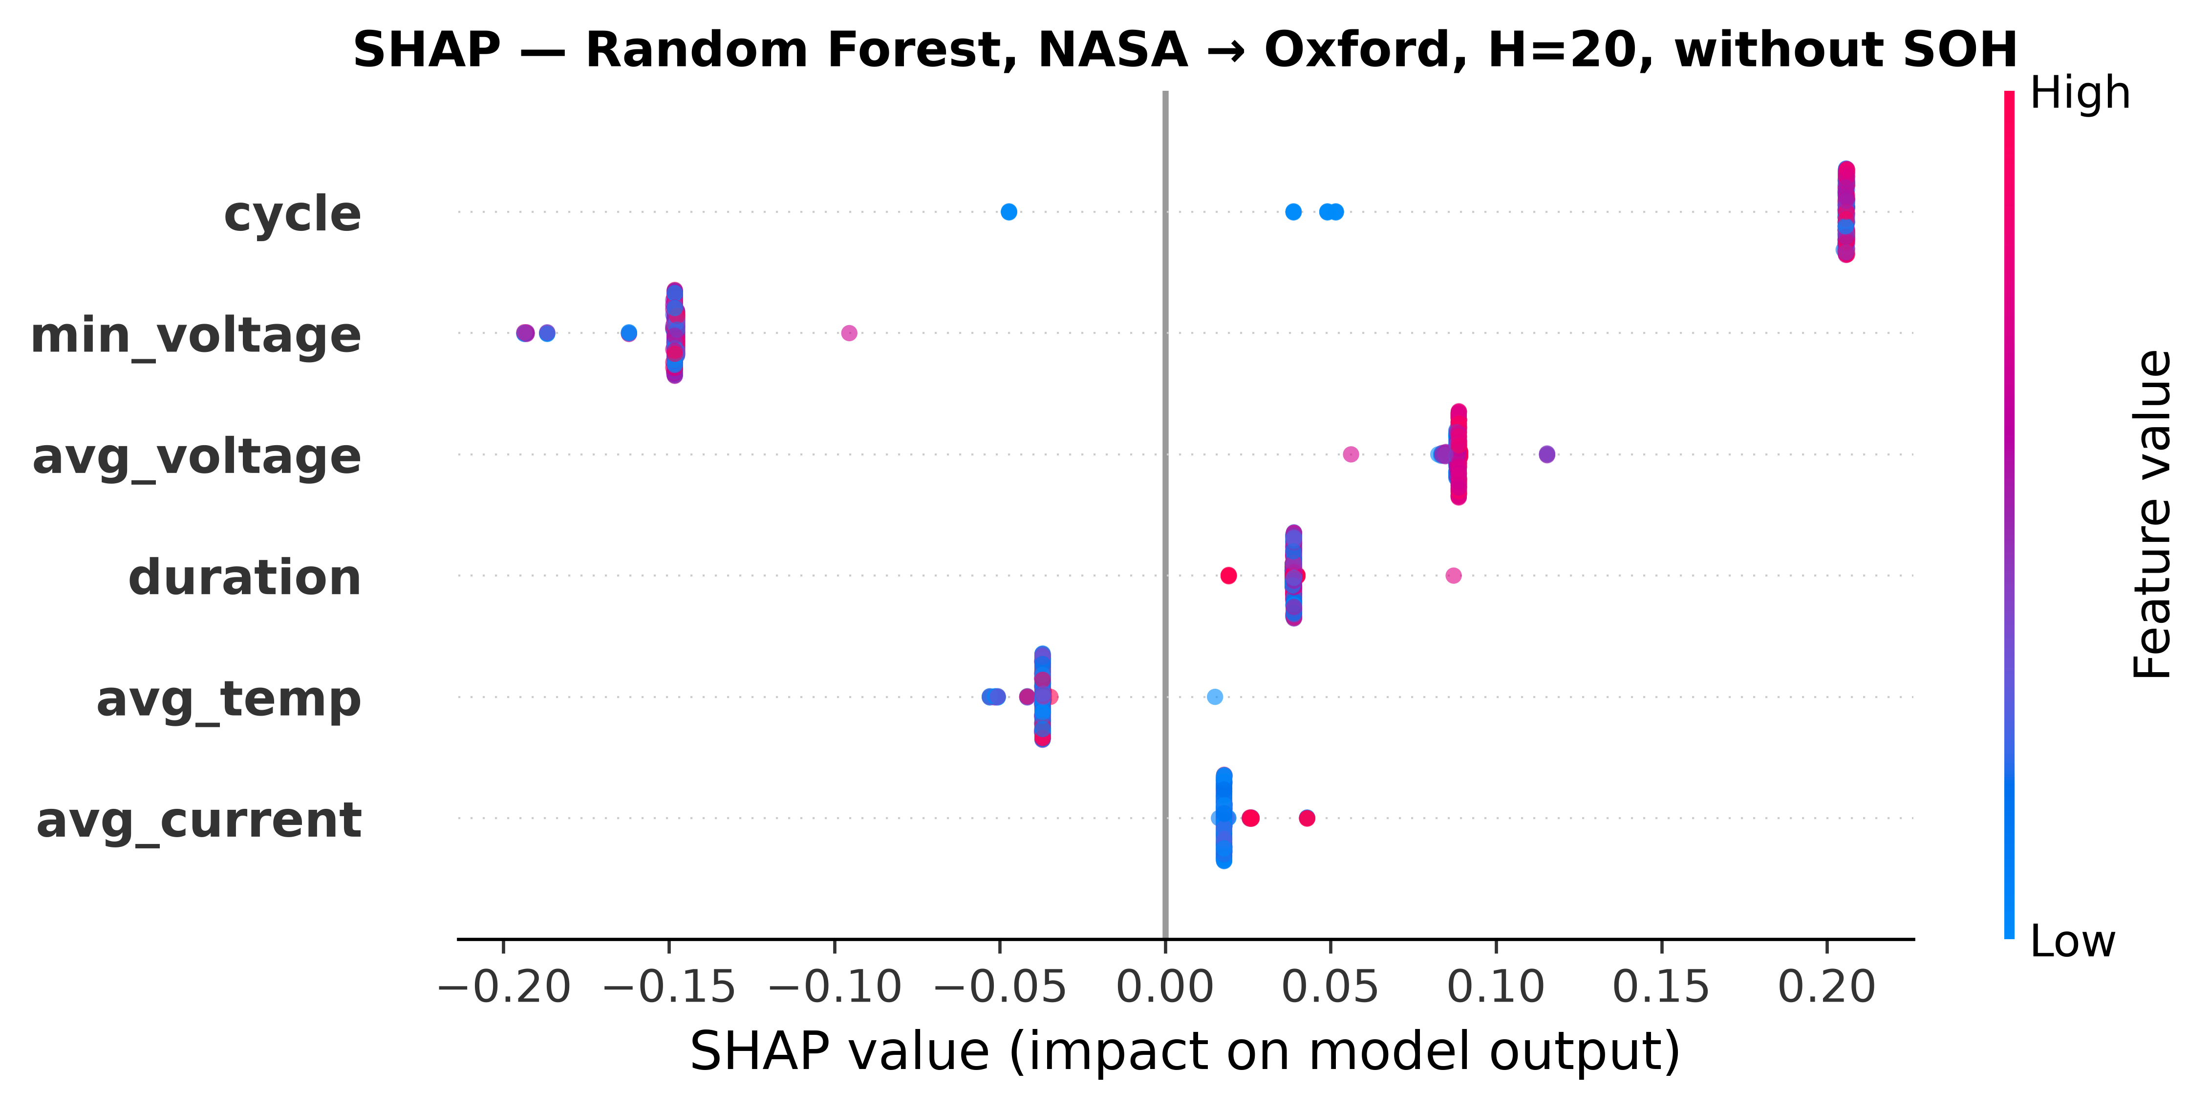
Figure 7. SHAP feature importance for Random Forest in NASA→Oxford cross-chemistry transfer (H=20, without SOH). All features collapse to near-zero spread.
The central finding is that cross-chemistry transfer of hazard-based battery failure prediction fails for all model classes tested when SOH is unavailable as a feature. This result holds across two LFP test targets (Oxford, 5 cells; Severson, 141 cells), three tree-based model classes (XGBoost, LightGBM, Random Forest), and a GRU sequence classifier. Three distinct failure modes are identified: (1) SOH-as-lookup-table (all models), (2) distributed-representation entanglement under covariate shift (GRU-specific), and (3) calibration collapse under distribution shift (all post-hoc methods, with isotonic regression being the most severely affected).

