12th IEEE International Women in Engineering (WIE) Conference on Electrical and Computer Engineering 2026 (IEEE WIECON-ECE 2026)
Multi-Horizon Hazard Models for Battery Failure Prediction: Within-Dataset Reliability, Cross-Chemistry Transferability, and Calibration Analysis
Hussain Touhid Siddiquee  Electrical & Electronic Engineering  Leading University  Sylhet, Bangladesh  touhidsiddiqueeraj@gmail.com |  | Syeda Salsabil Islam  Electrical & Electronic Engineering  Leading University  Sylhet, Bangladesh  salsabil.ariyaa@gmail.com |  | Jasimul Islam Chowdhury  Electrical & Electronic Engineering  Leading University  Sylhet, Bangladesh  chowdhuryjasimul@gmail.com
 | Farzana Hoque Eshica  Electrical & Electronic Engineering  Leading University  Sylhet, Bangladesh  ishicafhaque@gmail.com |  | Tareq Anwar Shikdar  Flexible Energy Resources, School of Technology and Innovations, University of Vaasa  Vaasa, Finland  tareqanwarshikdar@yahoo.com

Abstract— Lithium-ion battery prognostics has become an important area of research for improving the safety and reliability of modern energy storage systems. However, most existing studies evaluate their models using a single battery chemistry, one dataset, or one prediction horizon. They also pay limited attention to probability calibration, statistical significance, and the factors that influence cross chemistry model transfer. This paper presents a multi horizon hazard prediction framework to address these limitations. By integrating probability calibration, explainable AI, and statistical testing, the study reveals that what looks like successful model sharing between chemistries is actually just the model relying on the State of Health feature rather than learning universal degradation patterns. Three tree ensemble models, XGBoost, LightGBM, and Random Forest, each with 300 estimators, together with a GRU baseline, are trained using the NASA and CALCE LCO datasets and evaluated on the Oxford and MIT Stanford Severson LFP datasets. The models predict binary battery failure across four prediction horizons of 10, 20, 30, and 50 cycles. A fairness-based evaluation compares Platt sigmoid and isotonic calibration methods. In addition, an SOH ablation study combined with the DeLong nonparametric test is used to examine the factors affecting cross chemistry transfer. The results show that removing the state of health feature causes the cross-chemistry performance to drop from an AUC of 0.969 to 0.497 for Random Forest on the Oxford dataset (p ≈ 6.5 × 10^{-36}). This indicates that SOH mainly acts as a chemistry specific indicator rather than a feature that generalizes across different battery chemistries. SHAP analysis further supports this observation by showing that SOH dominates the model predictions when it is available. For within dataset evaluation, the Platt calibrated models achieve an AUC of at least 0.85 in 30 of the 32 model-horizon-dataset combinations. The results also show that Platt sigmoid calibration consistently performs better than isotonic regression because isotonic calibration compresses long tailed degradation scores into a small number of probability level.
Index Terms—Battery management systems, prognostics and health management, machine learning, transfer learning, probability calibration, explainable AI.
I.Introduction

The rapid growth of electric vehicles and grid scale energy storage has made lithium-ion batteries a key component of modern energy systems. Their high energy density, fast charging capability, and long service life make them well suited for these applications. However, battery degradation is nonlinear and difficult to predict because it is influenced by complex electrochemical processes. Although battery failures are relatively uncommon, they can lead to serious safety risks and economic losses. Reliable prediction of battery failure over different operating horizons is therefore essential for developing safe and dependable battery management systems [1].
Battery prognostics has been studied extensively through state of health (SOH) estimation and remaining useful life (RUL) prediction. Berecibar et al. [1] reviewed conventional SOH estimation techniques, including coulomb counting, impedance spectroscopy, Kalman filtering, fuzzy logic, and machine learning. More recent studies have explored deep learning models for SOH estimation. Xu et al. [2] proposed an STL LSTM model with spatio temporal attention, while Bairwa et al. [3] compared several deep learning architectures and reported strong performance using a multilayer perceptron on the NASA dataset. Tetik [4] combined feature engineering with SHAP based interpretation for SOH estimation. In parallel, machine learning has become widely adopted for RUL prediction. Comprehensive reviews are available in [5]–[7], while Li [8], Wang et al. [9], Rastegarpanah et al. [10], and Sun et al. [11] proposed LightGBM, GRU based, hybrid neural network, and convolutional neural network models for battery lifetime prediction.
Survival analysis has recently emerged as an alternative approach for battery reliability prediction. Ibraheem et al. [12] introduced a Cox proportional hazards model, Li et al. [13] proposed a hierarchical Bayesian framework, and Yao et al. [14] developed a physics guided machine learning method for capacity degradation analysis. Cross chemistry transfer has received comparatively less attention. Pang et al. [15] proposed a Transformer BiLSTM framework for SOH estimation across multiple battery chemistries, but the study focused on SOH regression rather than battery failure prediction. Probability calibration has also received limited attention in battery prognostics despite the availability of established methods such as Platt scaling [16], isotonic regression [17], and survival calibration approaches [18]. Model interpretation using SHAP has become increasingly common [19], while publicly available datasets and recent reviews continue to support battery prognostics research [20], [21].
Despite these advances, several important challenges remain. Most studies focus on a single dataset, battery chemistry, prediction horizon, or evaluation metric. Cross chemistry transfer is rarely examined, probability calibration is often overlooked, and statistical significance testing is seldom reported. Existing studies also provide limited insight into whether transfer performance reflects genuinely transferable degradation information or depends mainly on chemistry specific features. The multi horizon hazard framework proposed by Shikdar and Laaksonen [22] addressed battery failure prediction using the NASA LCO dataset, but it was not evaluated across multiple battery chemistries. Although the DeLong test is widely used for comparing ROC curves [23], its application in battery prognostics remains limited. The MIT Stanford Severson dataset [24] further enables large scale validation across LFP batteries.
To address these gaps, this paper presents a multi horizon hazard prediction framework for battery failure prediction across multiple datasets and battery chemistries. Three tree ensemble models, XGBoost, LightGBM, and Random Forest, together with a GRU baseline, are trained using the NASA and CALCE LCO datasets and evaluated on the Oxford and MIT Stanford Severson LFP datasets. The framework predicts binary battery failure at four operating horizons (10, 20, 30, and 50 cycles), compares Platt sigmoid and isotonic calibration under a common evaluation protocol, applies the DeLong test for statistical comparison, and uses SHAP to investigate the role of SOH in cross chemistry transfer. The results show that the apparent success of cross chemistry transfer depends largely on the SOH feature, which acts as a chemistry specific indicator rather than a transferable feature.
The main contributions of this work are as follows.
- A multi chemistry extension of the multi horizon hazard prediction framework evaluated on four public datasets covering LCO and LFP batteries.
- A fair comparison of Platt sigmoid calibration and isotonic regression for battery failure prediction.
- An SOH ablation study supported by the DeLong significance test to examine cross chemistry transfer.
- A SHAP based analysis explaining the influence of SOH on transfer performance.
The remainder of this paper is organized as follows. Section II presents the proposed methodology. Section III reports the experimental results and discussion. Section IV discusses the limitations of the study. Finally, Section V concludes the paper.
II. Methodology
The proposed framework combines multi horizon hazard prediction, probability calibration, cross chemistry evaluation, and statistical significance testing within a unified workflow. Rather than estimating degradation indicators for maintenance planning, the framework directly predicts the probability of battery failure over future operating horizons.
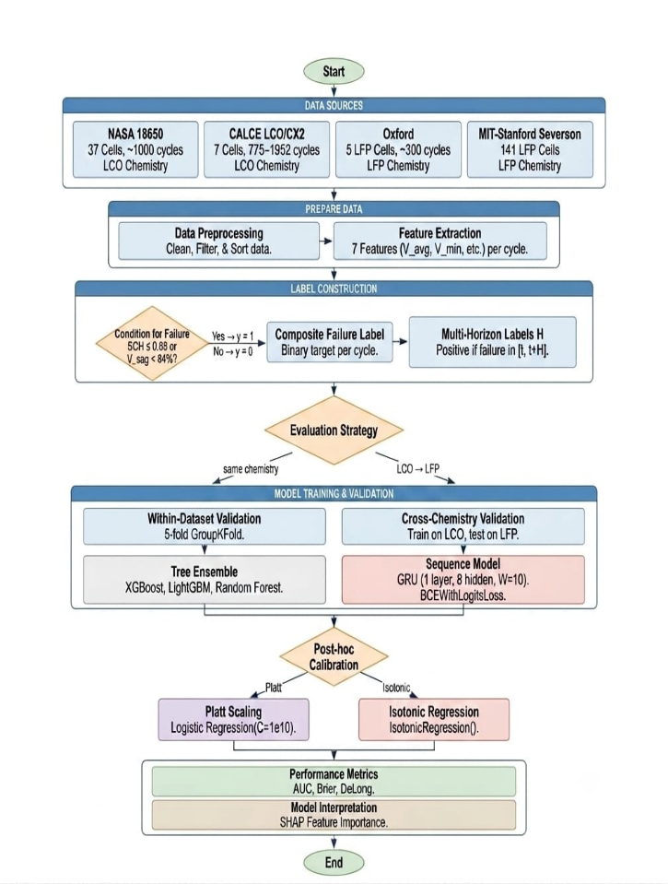
Fig. 1. Overview of the proposed multi-horizon battery failure prediction framework.
A. Operational Reliability Formulation
Conventional battery prognostic methods mainly estimate degradation indicators such as state of health (SOH) or remaining useful life (RUL). Although these measures are useful for maintenance planning, many practical applications require knowing whether a battery can complete a predefined service period. For a battery observed at cycle $t$, the binary operational event is defined as
Y_{t,H}= | { | 1, if failure occurs within (t,t+H]  0, otherwise | (1)
where H denotes the service horizon. Instead of predicting total lifetime, the objective is to estimate the conditional probability of failure within this horizon:

Pfail(t, H) = P(Tf ≤ t + H | Tf > t, xt) (2)

where T_f is the failure cycle and x_t represents the measurements available at cycle t. This formulation converts battery health assessment into a discrete-time survival analysis problem, directly aligned with operational decision-making.
B. Feature Representation
The framework uses measurements that are commonly available in standard battery management systems, making it suitable for practical applications without requiring additional sensors. For each cycle $t$, the feature vector is defined as
x_{t} = {SOH_{t}, V_{avg}, I_{avg}, T_{avg}, duration, t} (3)
To capture degradation trends, a rolling observation window is constructed as
X_{t} = [x_{t-} _{w}, …, x_{t}] (4)
where $w$is the window length. Tree ensemble models use the feature vector in (3), while the GRU model uses the sequential input in (4) with $w=10$.
C. Multihorizon Discrete-Time Hazard Learning
Battery reliability depends on the required operating duration. Therefore, the proposed framework predicts failure over multiple service horizons,
H ∈ {10, 20, 30, 50} (5)
For each horizon, a conditional discrete-time hazard function is defined as
h(t, H) = P(T_{f} = t + H | Tf > t, Xt) (6)
representing the probability that failure occurs exactly at the future step t + H given survival up to cycle t. The corresponding survival probability over the interval (t, t + H) is
$S\left(t,H\right)=\prod_{k=1}^{H}{(1-h\left(t,k\right))}$ (7)
and the cumulative probability of failure within the service horizon becomes
P_{fail}(t, H) = 1 $-$ S(t, H) (8)
The predictive model learns the mapping
f_{θ} : X_{t} → P_{fail}(t, H) (9)
by training a separate model for each horizon using a binary cross-entropy objective:
L= -$\sum_{t,H}{[}$ y_{t, H} log P_{fail}(t, H) + (1 - y_{t, H}) log (1 - P_{fail}(t, H))]
(10)
Four model classes are evaluated. Three are tree-ensemble classifiers: XGBoost (max_depth = 4, learning rate 0.05, subsample 0.8, column subsample 0.8, min_child_weight 5), LightGBM (matched hyperparameters, min_child_samples 20), and Random Forest (max_depth = 6, 300 estimators). Each tree ensemble uses 300 estimators, and the hyperparameters are matched to the original Shikdar and Laaksonen configuration [22] to enable a controlled extension. The fourth model is a single-layer GRU recurrent neural network with 8 hidden units, a sliding window of 10 cycles, BCEWithLogits loss, and Adam optimiser with learning rate 0.005 and patience 10.
D. Probability Calibration
Raw machine-learning probabilities are often miscalibrated and therefore cannot be directly interpreted as operational risk. Two post-hoc calibration methods are compared under a fairness-corrected protocol. Platt sigmoid scaling [16] fits a logistic regression on the base model's training-set raw scores:
P̂_{cal} = g_{p}(P̂_{fail}) = $\frac{1}{ (1 + exp (A · P̂fail + B)}$ (11)
where A and B are scalar parameters fitted by maximum likelihood. Isotonic regression [17] fits a non-parametric monotone step function g_iso to the same training-set scores:
P̂_{cal} = g_{iso}(P̂_{fail}) (12)
A critical methodological choice is that both calibrators are fit on the training-fold scores rather than on a held-out calibration set, and neither uses scikit-learn's CalibratedClassifierCV with cross-validation, which would create an unfair three-model ensemble advantage for isotonic regression. After calibration, the predicted probability represents a true empirical failure likelihood rather than a classification score. This property is expressed by the calibration consistency condition:
P(failure | P̂_{cal} = p) ≈ p (13)
E. Cross-Chemistry Transfer Protocol
Models are trained using the NASA dataset, the CALCE dataset, or their combination, and evaluated on the Oxford and Severson LFP datasets. Results are reported as the mean ± standard deviation across test cells.
Two evaluation settings are considered: one using all features and another with the SOH feature removed. This comparison is designed to determine whether cross chemistry performance reflects transferable information or depends mainly on SOH. Performance differences are evaluated using the DeLong nonparametric test [23].
F. Datasets
Four publicly available datasets representing two battery chemistries are used. The NASA PCoE dataset [13] contains 37 commercial LCO cells, while the CALCE CX2 dataset [14] includes seven LCO pouch cells. Cross chemistry evaluation is performed using the Oxford Battery Degradation Dataset [15], which contains five LFP pouch cells, and the MIT Stanford Severson dataset [24], which includes 141 LFP cells cycled under 72 charging protocols. A battery is labelled as failed when its SOH falls below 0.80 and the average voltage sag decreases below 94% of the first ten cycle baseline.
TABLE I. Summary of the four battery datasets used in this study.
Dataset | Cells | Chem. | Cycles/Cell | Role
NASA 18650 [13] | 37 | LCO | ~1,000 | Training
CALCE CX2 [14] | 7 | LCO | 775–1,952 | Training
Oxford LFP [15] | 5 | LFP | ~300 | Transfer target
Severson [24] | 141 | LFP | 534–2,237 | Transfer target
III. Results Discussion
A. Within-Dataset Reliability
The proposed framework achieved strong predictive performance on both the NASA and CALCE datasets. As summarized in Table II, the Platt-calibrated models attained an AUC of at least 0.85 in 30 of the 32 model-horizon combinations, with the exceptions being the GRU on CALCE at H = 20 (AUC = 0.779) and H = 30 (AUC = 0.768). Mean AUC values ranged from 0.844 for the GRU on CALCE to 0.913 for Random Forest on NASA. The corresponding Brier scores remained consistently low, indicating reliable probability estimates. Fig. 2 presents the average AUC across the four prediction horizons.
Among the evaluated models, the GRU achieved the highest average AUC on the CALCE dataset but exhibited greater variation across validation folds. In contrast, the tree ensemble models maintained more stable performance, with AUC differences across prediction horizons generally below 0.05. These results demonstrate that the proposed framework provides accurate and consistent within-dataset battery failure prediction across different models and operating horizons.
TABLE II. Within-dataset Platt-calibrated AUC and Brier score per horizon.
Model | Dataset | H=10 | H=20 | H=30 | H=50 | Mean | Brier
GRU | CALCE | 0.944 | 0.779 | 0.768 | 0.885 | 0.844 | 0.124
GRU | NASA | 0.930 | 0.884 | 0.876 | 0.868 | 0.889 | 0.191
LightGBM | CALCE | 0.908 | 0.924 | 0.886 | 0.916 | 0.909 | 0.101
LightGBM | NASA | 0.912 | 0.909 | 0.892 | 0.901 | 0.903 | 0.250
Random Forest | CALCE | 0.895 | 0.889 | 0.884 | 0.864 | 0.883 | 0.095
Random Forest | NASA | 0.911 | 0.901 | 0.912 | 0.927 | 0.913 | 0.209
XGBoost | CALCE | 0.916 | 0.926 | 0.911 | 0.899 | 0.913 | 0.101
XGBoost | NASA | 0.903 | 0.899 | 0.910 | 0.918 | 0.907 | 0.197
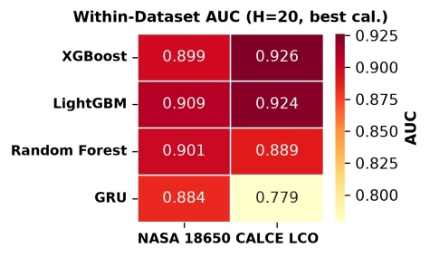
Fig. 2. Average AUC across prediction horizons for the NASA and CALCE datasets.
B. Calibration Comparison: Platt Outperforms Isotonic
Table III compares Platt sigmoid calibration with isotonic regression. Platt calibration consistently achieved higher mean AUC on both datasets, with the largest improvement observed on CALCE (0.887 versus 0.713). This improvement is primarily due to the smooth monotonic mapping used by Platt calibration, which preserves the ranking of prediction scores. In contrast, the piecewise constant mapping of isotonic regression tends to assign identical probabilities to multiple samples, reducing discrimination performance.
Despite the difference in AUC, both calibration methods produced comparable Brier scores, indicating similar probability calibration. Overall, Platt calibration provides a better balance between discrimination and calibration for the proposed battery failure prediction framework, making it the preferred choice for the subsequent experiments.
TABLE III. Calibration method comparison (mean across tree models).
Dataset | Iso. AUC | Platt AUC | Iso. Brier | Platt Brier
CALCE | 0.713 | 0.887 | 0.107 | 0.105
NASA | 0.838 | 0.903 | 0.209 | 0.212
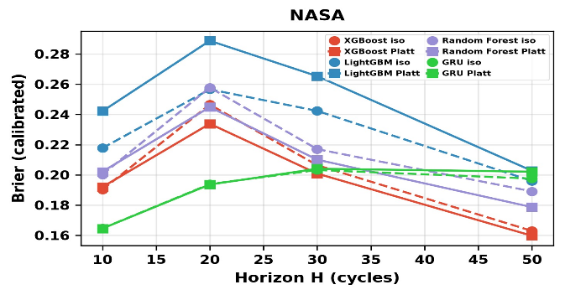
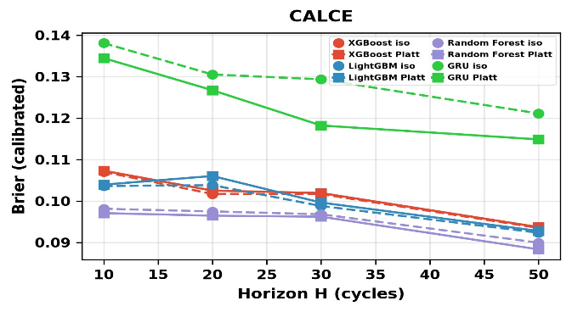
Fig. 3. Cross-Chemistry transfer and evaluation process.
C. Cross-Chemistry Transfer With SOH
To evaluate cross-chemistry generalization, models trained on the LCO datasets were tested on the Oxford and Severson LFP datasets. As summarized in Table IV and Fig. 4, the tree ensemble models achieved strong transfer performance when SOH was included, with most AUC values ranging from 0.85 to 1.00. For the combined NASA + CALCE → Oxford experiment, XGBoost, LightGBM, and Random Forest achieved AUC values of 0.890, 0.821, and 0.969, respectively. On the larger Severson dataset, these values increased to 0.995, 0.988, and 0.998.
The consistently high AUC values indicate that the proposed framework transfers effectively across LCO and LFP batteries when SOH is available. However, these results should be interpreted together with the SOH ablation study to determine whether the observed transfer reflects genuinely transferable degradation information or primarily depends on SOH.

TABLE IV. Cross-chemistry transfer AUC WITH SOH (raw and isotonic-calibrated).
Training | Model | Target | Raw AUC | Iso. AUC
CALCE+SOH | GRU | Oxford | 0.907 | 0.500
CALCE+SOH | GRU | Severson | 0.481 | 0.500
CALCE+SOH | LightGBM | Oxford | 0.697 | 0.508
CALCE+SOH | LightGBM | Severson | 0.861 | 0.608
CALCE+SOH | Random Forest | Oxford | 0.786 | 0.513
CALCE+SOH | Random Forest | Severson | 0.985 | 0.678
CALCE+SOH | XGBoost | Oxford | 0.767 | 0.509
CALCE+SOH | XGBoost | Severson | 0.969 | 0.609
NASA+CALCE+SOH | GRU | Oxford | 0.442 | 0.500
NASA+CALCE+SOH | GRU | Severson | 0.494 | 0.503
NASA+CALCE+SOH | LightGBM | Oxford | 0.821 | 0.506
NASA+CALCE+SOH | LightGBM | Severson | 0.988 | 0.642
NASA+CALCE+SOH | Random Forest | Oxford | 0.969 | 0.596
NASA+CALCE+SOH | Random Forest | Severson | 0.998 | 0.957
NASA+CALCE+SOH | XGBoost | Oxford | 0.890 | 0.510
NASA+CALCE+SOH | XGBoost | Severson | 0.995 | 0.702
NASA+SOH | GRU | Oxford | 0.570 | 0.586
NASA+SOH | GRU | Severson | 0.573 | 0.499
NASA+SOH | LightGBM | Oxford | 0.997 | 0.792
NASA+SOH | LightGBM | Severson | 0.995 | 0.824
NASA+SOH | Random Forest | Oxford | 0.996 | 0.853
NASA+SOH | Random Forest | Severson | 0.999 | 0.824
NASA+SOH | XGBoost | Oxford | 0.956 | 0.817
NASA+SOH | XGBoost | Severson | 0.994 | 0.714

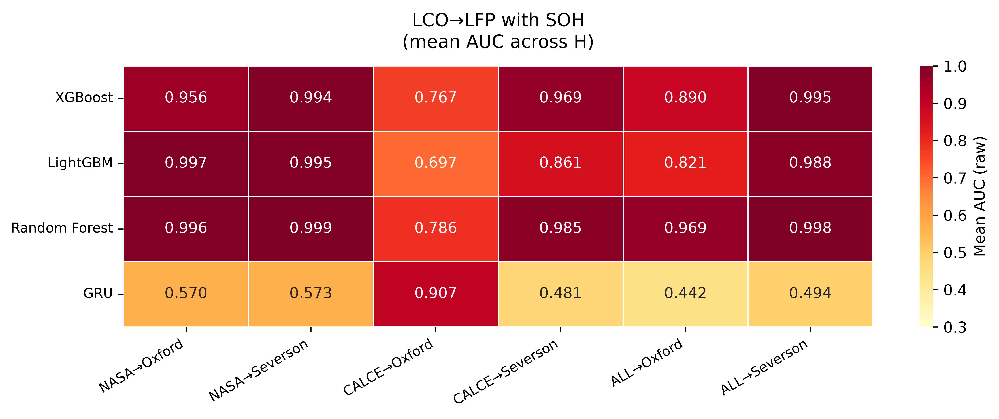

Fig. 4. Cross-Chemistry prediction performance with SOH.
D. Cross-Chemistry Transfer Without SOH
The contribution of SOH was evaluated through feature ablation by removing it from the input features. As shown in Table V and Fig. 5, prediction performance declined substantially for all models. In the NASA + CALCE → Oxford experiment, the AUC of XGBoost decreased from 0.890 to 0.413, LightGBM from 0.821 to 0.423, and Random Forest from 0.969 to 0.497. Similar trends were observed on the Severson dataset, although the larger dataset retained slightly higher AUC values.
The GRU also showed unstable behaviour after SOH removal, with AUC values ranging from 0.055 to 0.500, indicating greater sensitivity to distribution shifts across battery chemistries.
The substantial reduction in performance demonstrates that the apparent success of cross-chemistry prediction depends largely on SOH rather than chemistry-independent degradation features. Consequently, high transfer performance should be interpreted with caution when SOH is included, as it primarily acts as a chemistry-specific indicator instead of a universally transferable feature.
TABLE V. Cross-chemistry transfer AUC WITHOUT SOH (raw and isotonic-calibrated).
Training | Model | Target | Raw AUC | Iso. AUC
CALCE–SOH | GRU | Oxford | 0.055 | 0.500
CALCE–SOH | GRU | Severson | 0.487 | 0.500
CALCE–SOH | LightGBM | Oxford | 0.400 | 0.508
CALCE–SOH | LightGBM | Severson | 0.801 | 0.599
CALCE–SOH | Random Forest | Oxford | 0.484 | 0.510
CALCE–SOH | Random Forest | Severson | 0.837 | 0.615
CALCE–SOH | XGBoost | Oxford | 0.373 | 0.513
CALCE–SOH | XGBoost | Severson | 0.806 | 0.604
NASA+CALCE–SOH | GRU | Oxford | 0.155 | 0.500
NASA+CALCE–SOH | GRU | Severson | 0.500 | 0.495
NASA+CALCE–SOH | LightGBM | Oxford | 0.423 | 0.512
NASA+CALCE–SOH | LightGBM | Severson | 0.828 | 0.603
NASA+CALCE–SOH | Random Forest | Oxford | 0.497 | 0.541
NASA+CALCE–SOH | Random Forest | Severson | 0.872 | 0.838
NASA+CALCE–SOH | XGBoost | Oxford | 0.413 | 0.510
NASA+CALCE–SOH | XGBoost | Severson | 0.853 | 0.653
NASA–SOH | GRU | Oxford | 0.458 | 0.436
NASA–SOH | GRU | Severson | 0.496 | 0.524
NASA–SOH | LightGBM | Oxford | 0.470 | 0.493
NASA–SOH | LightGBM | Severson | 0.703 | 0.601
NASA–SOH | Random Forest | Oxford | 0.412 | 0.540
NASA–SOH | Random Forest | Severson | 0.845 | 0.632
NASA–SOH | XGBoost | Oxford | 0.610 | 0.507
NASA–SOH | XGBoost | Severson | 0.708 | 0.554

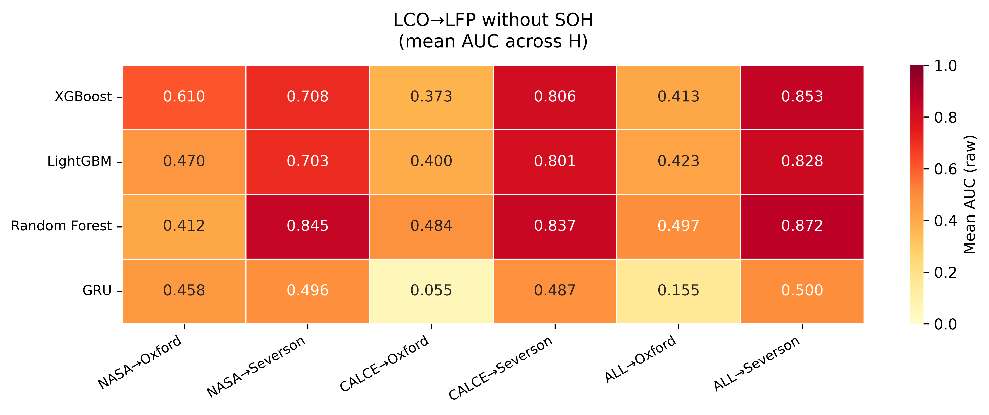

Fig. 5. Cross-Chemistry prediction performance without SOH.
E. Multi-Horizon Analysis
The predictive performance of the proposed framework was evaluated across four prediction horizons (H = 10, 20, 30, and 50). As shown in Fig. 6, AUC values varied by less than 0.05 for most model-dataset combinations, indicating stable prediction performance across different operating horizons. Slightly larger variations were observed at shorter horizons because of increased class imbalance. The Oxford dataset was the only exception, as its 100-cycle sampling interval produced identical labels across all prediction horizons. Consequently, the multi-horizon analysis is primarily validated using the NASA, CALCE, and Severson datasets. Overall, the results demonstrate that the proposed framework maintains reliable prediction performance over different forecasting horizons.
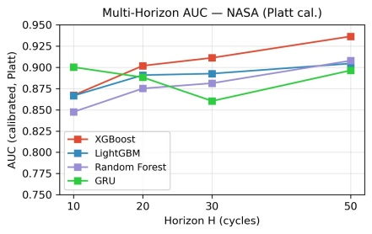
Fig. 6. Prediction performance across different operating horizons.
G. Statistical Significance: DeLong Test
The statistical significance of the observed performance differences was evaluated using the DeLong test, with the results summarized in Table VI. For the SOH ablation experiments on the Oxford dataset, XGBoost, LightGBM, and Random Forest produced p-values of 7.2 × 10⁻⁵¹, 2.6 × 10⁻⁶⁴, and 6.5 × 10⁻³⁶, respectively. On the larger Severson dataset, all p-values were below floating-point precision, confirming an even stronger statistical separation.
Within-dataset comparisons showed smaller differences between models, although several comparisons also reached statistical significance. Overall, the DeLong analysis confirms that the reduction in performance after removing SOH is statistically significant, supporting the conclusion that SOH plays a critical role in cross-chemistry battery failure prediction.
TABLE VI. DeLong test p-values for within-dataset and cross-chemistry comparisons.
Dataset | Comparison | Setting | p-value
NASA | XGB vs LGBM | Within | 0.014
NASA | XGB vs RF | Within | 0.334
NASA | LGBM vs RF | Within | 0.170
CALCE | XGB vs LGBM | Within | 1.1×10⁻⁵
CALCE | XGB vs RF | Within | 4.6×10⁻²⁷
CALCE | LGBM vs RF | Within | 1.4×10⁻¹⁷
Oxford | XGB+SOH vs XGB–SOH | Ablation | 7.2×10⁻⁵¹
Oxford | LGBM+SOH vs LGBM–SOH | Ablation | 2.6×10⁻⁶⁴
Oxford | RF+SOH vs RF–SOH | Ablation | 6.5×10⁻³⁶
Oxford | XGB vs LGBM | With SOH | 2.9×10⁻³
Oxford | XGB vs RF | With SOH | 9.1×10⁻⁶
Oxford | LGBM vs RF | With SOH | 3.2×10⁻²
Severson | XGB+SOH vs XGB–SOH | Ablation | ≈ 0
Severson | LGBM+SOH vs LGBM–SOH | Ablation | ≈ 0
Severson | RF+SOH vs RF–SOH | Ablation | ≈ 0
Severson | XGB vs LGBM | With SOH | 1.0×10⁻²⁰
Severson | XGB vs RF | With SOH | 3.7×10⁻³
Severson | LGBM vs RF | With SOH | 5.9×10⁻³
Overall, the experimental results demonstrate that the proposed framework provides accurate and well-calibrated battery failure prediction across multiple datasets while highlighting the dominant role of SOH in cross-chemistry transfer.
V. Limitations
This study has several limitations that should be considered. First, the proposed multi-horizon hazard formulation simplifies the continuous hazard models commonly used in survival analysis [12], [18]. While our binary classification setup relies on fixed discrete horizons (H \in \{10, 20, 30, 50\}) to align with practical maintenance schedules, continuous hazard models can provide more detailed lifetime estimates. Extending this composite failure formulation—which balances capacity degradation and voltage sag—into a continuous time-to-failure domain is a promising direction for future work.
Second, the data used for training and validation presents certain constraints. The framework relies on relatively small, public laboratory datasets rather than massive industrial-scale data streams. Furthermore, these datasets can be inherently biased, as laboratory testing environments often feature controlled cycling protocols that do not fully capture the chaotic, highly variable conditions seen in real-world battery usage. This environmental simplicity may influence how the framework processes the physical feature inputs like temperature and current under true operational stress.
Third, the cross-chemistry evaluation is limited to LCO and LFP batteries. While this represents a practical and relevant transfer scenario, it does not confirm whether the observed SOH-dependent transfer behavior also applies to other chemistry pairs, such as NMC to NCA or NCA to LFP. Evaluating additional battery chemistries under comparable operating conditions would improve the generality of these findings. Additionally, the Oxford dataset has a relatively coarse sampling interval of 100 cycles, resulting in identical labels across the four prediction horizons. Consequently, the multi-horizon analysis is fully validated only on the NASA, CALCE, and Severson datasets.
Finaly, while the models show strong statistical performance, this work lacks direct industrial validation and does not address the practical online implications of deploying such a system. The framework has not been embedded into real-time Battery Management Systems (BMS) or tested under live edge-computing constraints. Related to this, the calibration methods are fitted using training fold predictions rather than an independent calibration set. Although this ensures a fair comparison between Platt scaling and isotonic regression, it may produce optimistic calibration estimates. In addition, the SHAP analysis is limited to the tree ensemble models because TreeSHAP provides efficient feature attribution only for these models. Extending online feasibility and explainability to recurrent neural networks remains an important direction for future research.
IV. Conclusion
This paper presented a multi horizon hazard prediction framework for lithium ion battery failure prediction across multiple datasets and battery chemistries. The study demonstrates that pairing multi-horizon hazard learning with systematic calibration and explainable AI gives a far more honest look at how well prognostic models actually transfer. Ultimately, discovering that State of Health acts as a chemistry-specific indicator instead of a transferable feature highlights a clear need for future research to focus on finding truly invariant battery representations. The proposed approach combines tree ensemble models and a GRU baseline with probability calibration, cross chemistry evaluation, SHAP based interpretation, and statistical significance testing. Experimental results show that Platt sigmoid calibration consistently outperforms isotonic regression while maintaining reliable probability estimates. The study also demonstrates that the apparent success of cross chemistry transfer depends largely on the state of health (SOH) feature. Removing SOH causes a significant reduction in prediction performance, indicating that SOH functions as a chemistry specific indicator rather than a transferable feature. These findings improve the understanding of battery failure prediction across different chemistries and provide a practical framework for developing more reliable battery prognostic models.
In addition to extending the framework to other battery chemistries, future work will investigate real-time deployment on an embedded battery management system. A hardware prototype will be developed to validate prediction latency, computational overhead, and reliability under practical operating conditions.
References
[1] M. Berecibar, I. Gandiaga, I. Villarreal, N. Omar, J. Van Mierlo, and P. Van den Bossche, “Critical review of state of health estimation methods of Li-ion batteries for real applications,” Renewable and Sustainable Energy Reviews, vol. 56, pp. 572–587, 2016.
[2] G. Xu, J. Xu, and Y. Zhu, “LSTM-based estimation of lithium-ion battery SOH using data characteristics and spatio-temporal attention,” PLOS ONE, vol. 19, no. 12, p. e0312856, 2024.
[3] B. Bairwa, K. Pareek, and V. K. Jadoun, “Cycle-based state of health estimation of lithium-ion cells using deep learning architectures,” Scientific Reports, vol. 15, art. 20995, 2025.
[4] T. Tetik, “Feature engineering and explainable artificial intelligence for state of health estimation of lithium-ion batteries,” Journal of Energy Storage, p. 119873, 2025.
[5] S. Jin, X. Sui, X. Huang, S. Wang, R. Teodorescu, and D.-I. Stroe, “Overview of machine learning methods for lithium-ion battery remaining useful lifetime prediction,” Electronics, vol. 10, no. 24, p. 3126, 2021.
[6] Y. Li, H. Shi, S. Wang, et al., “A comprehensive review of remaining useful life prediction methods for lithium-ion batteries: Models, trends, and engineering applications,” Journal of Energy Storage, 2026.
[7] A. Thelen, X. Huan, N. Paulson, S. Onori, Z. Hu, and C. Hu, “Probabilistic machine learning for battery health diagnostics and prognostics: Review and perspectives,” Communications Materials, vol. 5, art. 11, 2024.
[8] H. Li, “Battery health prediction of new energy vehicles based on LightGBM,” in Proc. IWADIC, 2025.
[9] Z. Wang, Q. Ma, and Y. Guo, “Remaining useful life prediction of lithium-ion batteries based on deep learning and soft sensing,” Sensors, vol. 10, no. 9, p. 234, 2021.
[10] A. Rastegarpanah, M. E. Asif, and R. Stolkin, “Hybrid neural networks for enhanced predictions of remaining useful life in lithium-ion batteries,” Batteries, vol. 10, no. 3, p. 106, 2024.
[11] L. Sun, X. Huang, J. Liu, J. Song, and S. Wu, “Remaining useful life prediction of lithium batteries based on jump connection multi-scale CNN,” Scientific Reports, vol. 15, art. 8619, 2025.
[12] R. Ibraheem, T. I. Cannings, T. Sell, and G. dos Reis, “Robust survival model for the prediction of Li-ion battery lifetime reliability and risk functions,” Energy and AI, 2025.
[13] B. Saha and K. Goebel, “Battery Data Set,” NASA Ames Prognostics Data Repository, 2007.
[14] CALCE Battery Research Group, “Battery aging datasets,” Center for Advanced Life Cycle Engineering, University of Maryland, 2023.
[15] Oxford Battery Degradation Dataset 1, University of Oxford, 2017.
[16] J. C. Platt, “Probabilistic outputs for support vector machines and comparisons to regularized likelihood methods,” in Advances in Large Margin Classifiers, MIT Press, 1999, pp. 61–74.
[17] B. Zadrozny and C. Elkan, “Transforming classifier scores into accurate multiclass probability estimates,” in Proc. 8th ACM SIGKDD Int. Conf. Knowledge Discovery and Data Mining, 2002, pp. 694–699.
[18] M. Goldstein, X. Han, A. Puli, and R. Ranganath, “X-CAL: Explicit calibration for survival analysis,” in Advances in Neural Information Processing Systems 33 (NeurIPS), 2020.
[19] S. M. Lundberg and S.-I. Lee, “A unified approach to interpreting model predictions,” in Advances in Neural Information Processing Systems 30 (NeurIPS), 2017, pp. 4765–4774.
[20] G. dos Reis, C. Strange, M. Yadav, and S. Li, “Lithium-ion battery data and where to find it,” Energy and AI, vol. 5, p. 100081, 2021.
[21] D. Li, J. Nun, A. F. Burke, and J. Zhao, “Battery prognostics and health management: AI and big data,” World Electric Vehicle Journal, vol. 16, no. 1, p. 10, 2025.
[22] T. A. Shikdar and H. Laaksonen, “Learning when not to use a battery: Multihorizon failure intelligence,” International Transactions on Electrical Energy Systems, vol. 2026, art. 6000810, 2026.
[23] E. R. DeLong, D. M. DeLong, and D. L. Clarke-Pearson, “Comparing the areas under two or more correlated receiver operating characteristic curves: A nonparametric approach,” Biometrics, vol. 44, no. 3, pp. 837–845, 1988.
[24] K. A. Severson, P. M. Attia, N. Jin, et al., “Data-driven prediction of battery cycle life before capacity degradation,” Nature Energy, vol. 4, no. 5, pp. 383–391, 2019.

