MULTI-HORIZON HAZARD MODELS FOR BATTERY FAILURE PREDICTION
1
Multi-Horizon Hazard Models for Battery Failure
Prediction:
Within-Dataset Reliability,
Cross-Chemistry Transferability,
and Embedded
Edge Deployment
Anonymous
horizon H, the model predicts whether failure, defined as
Abstract—Predicting whether
a lithium-ion cell
will
fail
inside a short operating window is a different question from
SOH below 0.80 or average voltage sag beyond 6%, occurs
estimating its
remaining useful
life,
and it
is
the one that
within the next H cycles. Their histogram-based gradient
matters most for real-time dispatch in electric vehicles and grid
boosting model
on the NASA 18650 set (37 LCO cells)
storage.
This paper widens a recently proposed multi-horizon
reached AUC of 0.87–0.90 across H ∈ {10, 20, 30, 50}.
hazard classification framework, first shown on one model and
That work left three gaps open.
First,
one model
on
one dataset, into a study that covers four model families, three
LCO training configurations,
and two lithium-iron-phosphate
one dataset says nothing about sensitivity to the learner,
(LFP) transfer targets.
Within-dataset reliability holds across
the hyperparameters,
or the calibration method.
Second,
the board, with area under the curve (AUC) of 0.85 or better
there was no cross-chemistry check,
so nothing stopped
in 30 of 32 configurations under Platt calibration.
A fairness-
a model
trained on LCO from being trusted on LFP
corrected comparison shows
Platt
scaling beats
isotonic re-
or
NMC cells.
Third,
no path existed from a Python
gression on discrimination,
with the largest gap on the long-
tailed CALCE set (AUC 0.713 to 0.887).
The central
result
research prototype to the microcontroller where a battery
is a controlled State-of-Health (SOH) ablation: removing SOH
management system actually runs.
collapses cross-chemistry AUC from 0.76–1.00 to 0.32–0.61 on
This paper closes all
three.
The contributions are:
(i)
Oxford LFP and to 0.54–0.88 on the 141-cell
MIT–Stanford
a four-model benchmark, three tree ensembles (XGBoost,
−64
Severson set, with DeLong p values ranging down to 2.6×10
−100
LightGBM,
Random Forest) plus a GRU sequence clas-
on Oxford and below 10
on Severson.
SOH therefore acts
as a chemistry-specific lookup key rather than a transferable
sifier,
run on two LCO datasets (NASA 18650,
CALCE
degradation signal,
and isotonic calibration fails
to transfer
LCO/CX2) under a unified 5-fold GroupKFold protocol;
as well. On the deployment side, all three tree ensembles (900
(ii)
a controlled LCO-to-LFP transfer
study onto two
trees, 26,336 nodes) pack into a 372 kB binary and run on a $12
independent targets,
the 5-cell
Oxford pouch set and the
ESP32-S3 through a hand-written C tree walker,
reproducing
−6
141-cell
MIT–Stanford Severson set,
with and without
the Python training libraries to within 1.1 × 10
across all
1,028 validation rows,
with measured single-row latency of
SOH as
a feature,
analyzed with DeLong significance
0.50–1.29 ms with all
three models in PSRAM and 0.32–0.50
tests
and SHAP explanations;
(iii)
a fairness-corrected
ms for a single model
held in internal
SRAM.
comparison of
isotonic
and Platt
calibration;
and (iv)
Index Terms—Battery failure prediction, multi-horizon haz-
a complete embedded deployment
that
packs
all
three
ard classification, cross-chemistry transfer, probability calibra-
ensembles into one flat binary and runs them on an ESP32-
tion,
SHAP,
embedded machine learning,
ESP32-S3.
S3 through a hand-written C tree walker.
Removing SOH drops cross-chemistry AUC from near-
I.
Introduction
perfect to near-chance, and the drop comes from a specific
L
ITHIUM-ION batteries sit underneath the electrifi-
mechanism rather than random noise.
Trees exploit SOH
cation of transport and the decarbonization of grids,
with isolated hard splits
that
behave like a chemistry-
yet
their
long-term reliability remains
hard to certify
specific capacity-to-horizon lookup table,
and that table
in the field.
Conventional
prognostics casts the problem
does not transfer.
A second,
independent result is that
as remaining-useful-life (RUL) regression,
where a model
calibration methods
themselves
fail
to
transfer,
since
predicts a continuous cycle count to end of life [2]–[4]. RUL
isotonic
regression bins
distribution-shifted scores
into
regression is fine for capacity-fade studies,
but it answers
degenerate steps.
a question operators rarely ask in real
time.
A battery
management system needs to know whether a specific cell
II.
Related Work
will survive the next mission, not how many cycles it has
A.
From RUL regression to hazard classification
left in aggregate.
Shikdar and Laaksonen [1] recast the problem as multi-
Data-driven battery prognostics
has
historically been
horizon hazard classification.
For
a given cycle
t
and
regression.
Meng and Li
[2]
group prior
methods
into
physics-based,
purely data-driven,
and hybrid families.
This manuscript is under review;
author identities withheld for
Tree ensembles, such as Random Forest [3], XGBoost [4],
blind review.
MULTI-HORIZON HAZARD MODELS FOR BATTERY FAILURE PREDICTION
2
and LightGBM [5], have been applied to capacity and RUL
discharge cycle t in cell c is labeled as failing within horizon
estimation,
but their use for binary hazard classification
H if any cycle k ∈ [t, t+H) meets either of two criteria,

at multiple horizons is recent [1].
(c)

1,
∃ k ∈ [t, t+H) :
SOH
≤ 0.80 or


k
(c,H)
¯
¯
(c)
(2)
y
=
(c)
V
< 0.94
V
,
B.
Cross-chemistry and transfer learning
t

k


0,
otherwise,
Transfer learning for battery state estimation is picking
up.
Sahoo et al.
[10]
fine-tuned an SOH estimator across
and once triggered the label stays 1 for all later cycles. The
NASA and CALCE cells,
and Lu et al.
[11]
pretrained
task is to estimate the conditional
probability of
failure
on large-scale degradation data before adapting to new
over the horizon,
cell
types.
Both target regression-based SOH estimation
(
)
(c,H)
(c)
rather
than classification-based hazard prediction.
The
p
= Pr
T
≤ t+H | T
> t,
x
,
(3)
f
f
t
t
hazard setting adds two complications: the label depends
(c)
where T
is the failure cycle and x
is the feature vector
on the chosen horizon H, and the calibration of probability
f
t
measured at cycle t.
Datasets without voltage data,
or
outputs,
which decisions depend on,
may degrade under
where voltage sits at the cutoff as in Oxford’s flat LFP
distribution shift.
plateau,
fall
back to the SOH criterion alone.
C.
Calibration of classifier outputs
B.
Datasets
Post-hoc calibration maps raw classifier scores to prob-
Four public aging datasets are used.
NASA 18650 [6]
abilities.
Platt scaling [12]
fits a sigmoid through logistic
has 37 LCO cells aged under randomized charge–discharge
regression on the model’s scores, while isotonic regression
profiles at room temperature, roughly 1,000 cycles per cell,
[13]
fits a non-decreasing step function.
Niculescu-Mizil
with diverse failure modes. CALCE LCO/CX2 [7] provides
and Caruana [14]
showed Platt is safer on small
datasets
7 cells (CS2_33–36, CX2_36–38) at 1C/1C with per-cycle
and isotonic can overfit,
and Huang et al.
[15]
extended
voltage, current, and capacity. On the LFP side, Oxford [8]
this to imbalanced classification.
No prior study,
to our
has 5 pouch cells at 1C/1C under controlled temperature
knowledge, has compared the two calibrators under cross-
with 300–500 cycles each, and MIT–Stanford Severson [9]
chemistry distribution shift in battery prognostics.
has
141 LFP cells
under
a fast-charging protocol
with
534–2,237 cycles each (about 117K total).
D.
Explainability and edge deployment
TreeSHAP [16]
gives
consistent
feature
attributions
C.
Features and preprocessing
grounded in Shapley values and has become the standard
Each cycle is
described by seven scalar
features:
cy-
tool
for
diagnosing
which inputs
drive
an ensemble.
cle index,
average discharge voltage,
minimum discharge
On deployment,
moving inference onto a microcontroller
voltage,
average discharge current,
average temperature,
removes latency,
connectivity requirements,
and privacy
discharge duration, and SOH. Trees are scale-invariant, so
concerns [17].
Porting tree ensembles to embedded plat-
no standardization is applied to them;
the GRU receives
forms through model-to-code compilation has been done
per-feature standardization using training-set
statistics.
before [18],
but the specific combination of multi-horizon
Missing CALCE values
(temperature and duration are
hazard models with a hand-written C tree walker on a
unlogged) are filled with zero.
$12 ESP32-S3 has not.
III.
Methodology
D.
Tree models and hyperparameters
A.
Composite failure label
Three tree ensembles are benchmarked with hyperpa-
rameters matched to the original
study [1]:
XGBoost [4]
Following the original
protocol
[1],
the State-of-Health
with max_depth 4, 300 estimators, learning rate 0.05, sub-
of
cell
c at cycle k is the ratio of
the discharge capacity
sample 0.8, colsample_bytree 0.8, and min_child_weight
to the mean capacity over the first 10 cycles,
5; LightGBM [5] with the same depth, count, and rate; and
(c)
Random Forest [3] with max_depth 6 and 300 estimators.
Q
(c)
k
,
SOH
=
All
use random_state 42 for deterministic replication.
¯
k
Q
(c)
(1)
∑
10
1
¯
(c)
(c)
Q
,
Q
=
E.
GRU sequence classifier
i
10
i=1
A compact
GRU tests
whether
sequence-aware
rep-
(c)
where
Q
is
the
discharge
capacity at
cycle
k.
The
resentations
capture
trajectories
that
transfer
across
k
¯
(c)
early-life voltage baseline is defined analogously,
V
=
chemistries.
It ingests a sliding window of W =10 consec-
∑
¯
¯
(c)
(c)
10
1
V
,
with
V
the average discharge voltage.
A
utive cycles per cell as a 10×f tensor and runs one GRU
i
i
i=1
10
MULTI-HORIZON HAZARD MODELS FOR BATTERY FAILURE PREDICTION
3
layer with 8 hidden units.
At each timestep the standard
since pooling conflates within-cell
ranking with between-
update equations apply,
cell differences and can hide degenerate behavior where a
model
assigns nearly identical
scores to every cell.
r
= σ(W
x
+ U
h
),
t
r
t
r
t−1
z
= σ(W
x
+ U
h
),
t
z
t
z
t−1
H.
Evaluation and statistical
testing
(4)
˜
h
= tanh(W
x
+ U
(r
⊙ h
)),
Within-dataset
evaluation applies
5-fold GroupKFold
t
h
t
h
t
t−1
with cells
as
grouping
units,
so
every
cycle
from a
˜
h
= (1 − z
) ⊙ h
+ z
⊙
h
,
t
t
t−1
t
t
given cell
stays in one fold.
This removes the optimistic
and the final
hidden state maps through a linear layer
bias from leaking a cell’s cycles into both training and
⊤
with sigmoid activation,
p = σ(w
h
+ b),
to give the
test.
Models are retrained from scratch per horizon.
The
W
failure probability.
Adam with learning rate 0.005 and
DeLong nonparametric test [19]
for paired ROC curves
binary cross-entropy loss are used.
The 8-unit width was
judges whether the AUC difference between with-SOH and
chosen to match the small
number of training cells (7 to
without-SOH conditions is significant.
The test evaluates
37); wider layers overfit severely. For cross-chemistry runs
the normalized difference of the two areas,
the feature set is reduced to avoid unit and availability
A
− A
1
2
mismatches:
average
current
is
dropped (amperes
for
√
,
(7)
z =
V
+ V
− 2V
LCO,
milliamperes
for
LFP),
as
are
temperature
and
11
22
12
duration.
The remaining features,
cycle number,
average
where A
is the empirical area under the j-th ROC curve
j
voltage,
minimum voltage,
and SOH when enabled,
are
and V
are the elements of its covariance matrix estimated
ij
standardized with training-set statistics.
nonparametrically from the same test instances.
F.
Calibration protocol
I.
Embedded deployment architecture
Two post-hoc calibration schemes are compared under
The
deployment
pipeline
exports
the
three
trained
a fairness-corrected protocol.
Platt scaling fits a sigmoid
models into one flat binary and runs them on an ESP32-
to the base model’s raw scores s
,
S3 through a hand-written C tree
walker.
The
layout
i
is deliberately simple:
a 12-byte file header,
a 3×4-byte
1
,
(5)
p
=
offset table,
and per-model
sections holding a 4-byte tree
i
1 + exp(−αs
− β)
i
count followed by consecutive per-tree node arrays.
Each
by
high-regularization
logistic
regression
node stores the split feature index,
the split threshold as
10
(LogisticRegression,
C=10
).
Isotonic
regression
fits
a 32-bit
float,
and child indices;
leaves store the class-
the non-decreasing step function that minimizes squared
1 probability directly.
The walker
is one C function of
error,
∑
(
)
about 70 lines that follows child pointers,
sums the leaf
2
g =
arg min
y
− g(s
)
,
(6)
contributions per tree,
and applies the per-model
output
i
i
g non-decreasing
i
transform.
Writing ℓ
for the leaf
value reached in tree t
t
implemented with scikit-learn’s
IsotonicRegression and
and T for the number of
trees,
Random Forest averages
out-of-bounds clipping. Both calibrators are fit on the base
and clamps its leaf probabilities,
model’s training-fold scores, so they share identical inputs
)
(
∑
T
1
and any difference in output comes from the calibration
ℓ
,
0,
1
,
(8)
p = clamp
t
function alone, isolating it from the confound of retraining
T
t=1
or data splitting.
while XGBoost and LightGBM pass the summed score
A reproducibility note is warranted. The original study
through a sigmoid,
[1]
reported Brier scores around 0.032;
our re-execution
1
of
the released code yields Brier values between roughly
,
(9)
p =
(
)
∑
0.09 and 0.29,
an eightfold-or-larger
gap we could not
T
1 + exp
−
ℓ
− s
t
0
t=1
resolve from the available source. Our AUC values (0.80–
where s
is the model’s initialization score (s
̸
= 0 only
0
0
0.90) fall
within the published range,
and our qualitative
for XGBoost).
Fig.
1 shows the wiring.
Three validation
conclusions hold. The Brier gap does not affect the relative
stages confirm correctness:
a Python walker that mirrors
comparisons that form the core of this paper.
the C logic and is compared against predict_proba(),
a
cross-compiled C binary tested on desktop x86_64,
and
G.
Cross-chemistry transfer protocol
on-target execution on an ESP32-S3-DevKitC-1 reading
Transfer is evaluated by training on LCO cells (NASA
the binary from flash.
All
three must report maximum
alone,
CALCE alone,
or both) and testing independently
−5
absolute error below 10
on every row before deployment
on each cell of the two LFP targets. Three configurations
is accepted.
are explored:
NASA→LFP (37 cells),
CALCE→LFP (7
cells),
and ALL-LCO→LFP (44 cells).
Each is evaluated
with and without SOH. Performance is reported as per-cell
mean ± standard deviation rather than one pooled score,
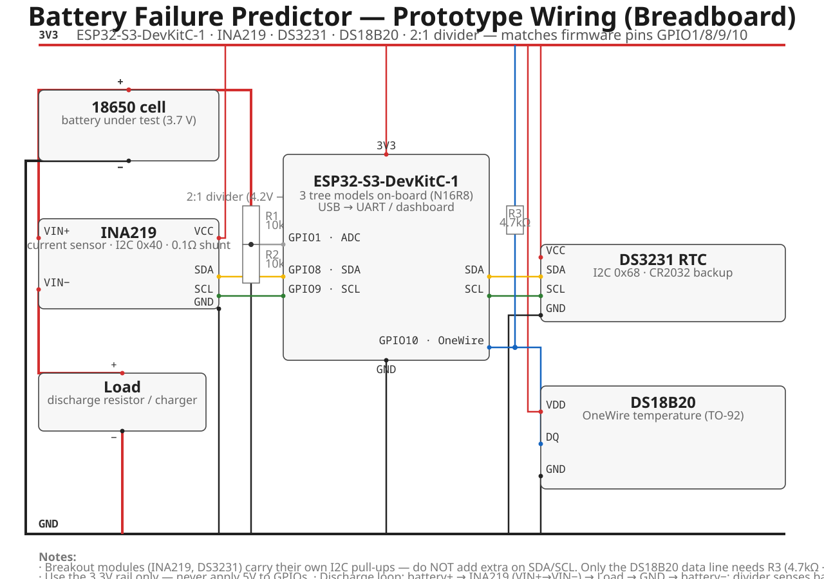
MULTI-HORIZON HAZARD MODELS FOR BATTERY FAILURE PREDICTION
4
Fig.
1.
Prototype wiring for the ESP32-S3 deployment.
The battery discharges through the INA219 shunt into a load,
the 2:1 divider
senses cell voltage at ADC GPIO1, and I2C (GPIO8/9) serves the INA219 and DS3231 while OneWire (GPIO10) reads the DS18B20. The
boards are a $12 ESP32-S3-DevKitC-1 and two breakout modules.
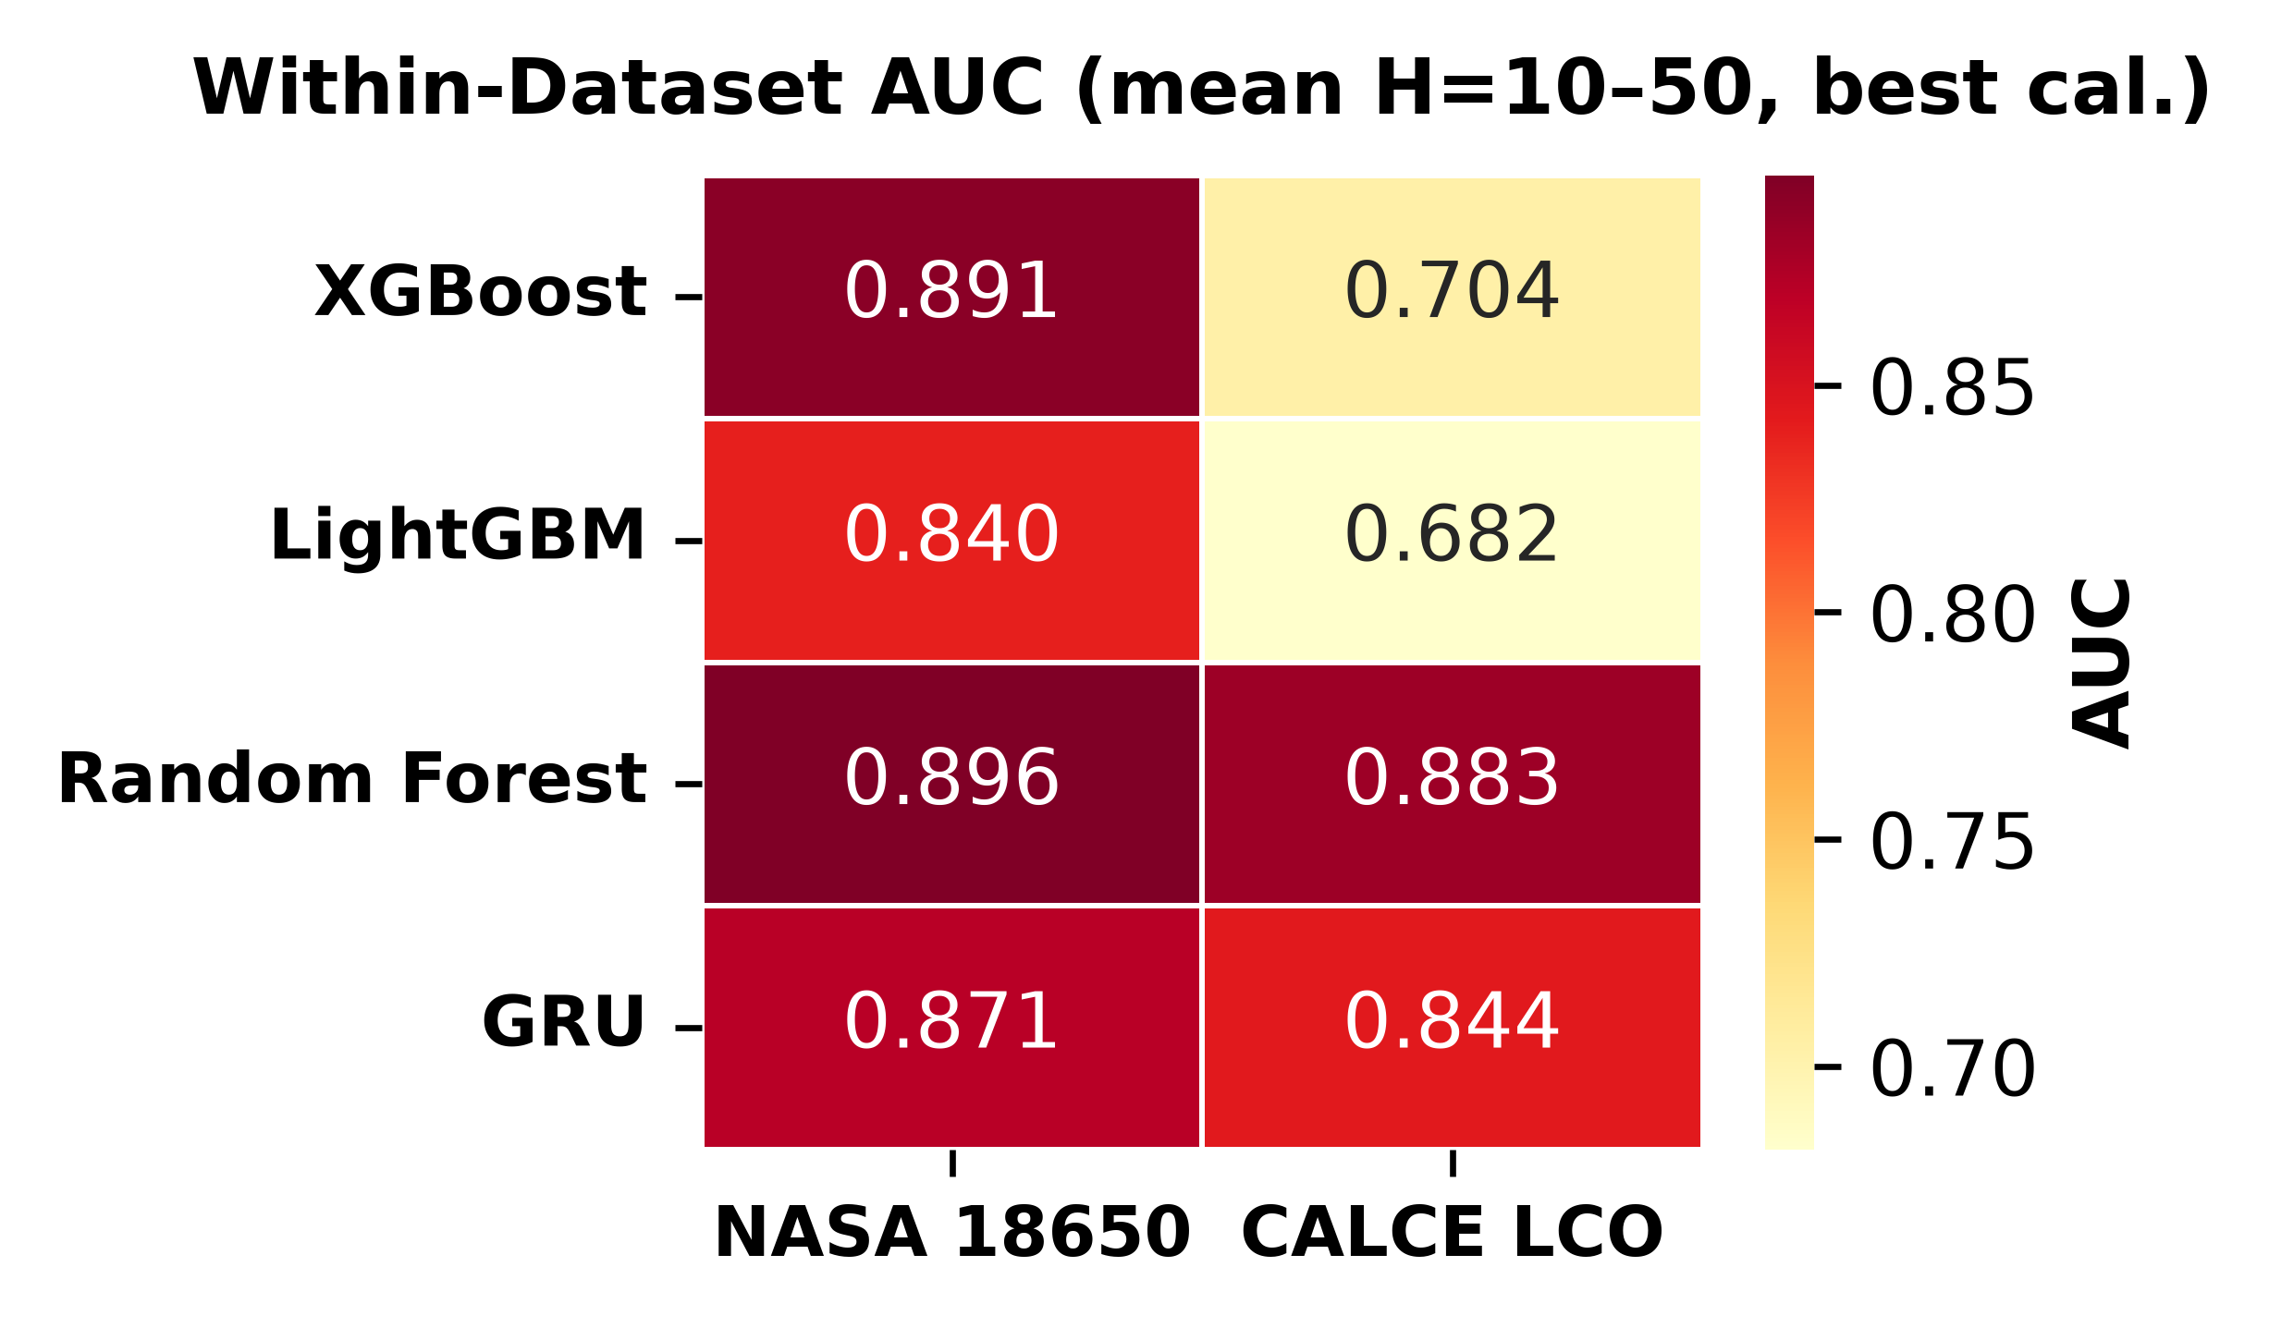
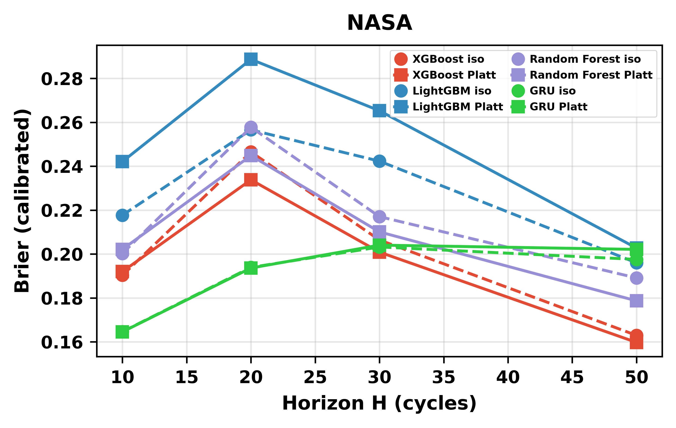
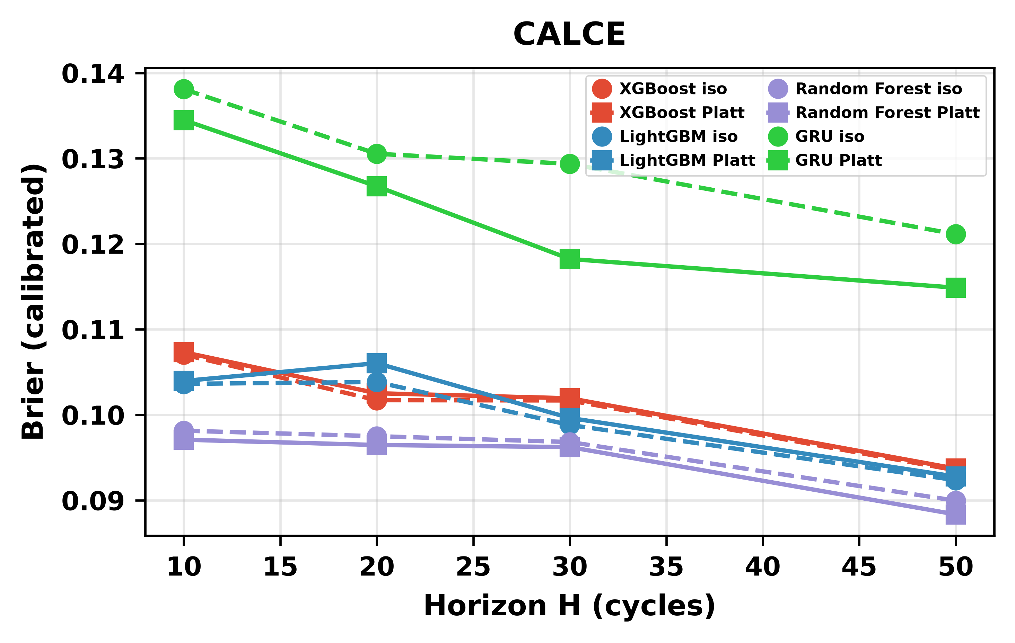
MULTI-HORIZON HAZARD MODELS FOR BATTERY FAILURE PREDICTION
5
IV.
Results
A.
Within-dataset performance
Fig. 2.
Within-dataset AUC heatmap, mean across horizons, Platt-
calibrated.
Table I summarizes within-dataset performance across
the
four
horizons
for
both LCO datasets
under
Platt
calibration.
Discrimination is
strong throughout.
Mean
AUC runs from 0.844 (GRU on CALCE) to 0.913 (Ran-
dom Forest on NASA and XGBoost on CALCE).
Every
tree-model
configuration clears
the
0.85 bar;
the
only
two configurations
that
fall
short
are
both the
GRU
on CALCE,
at H=20 (0.779) and H=30 (0.768),
where
the
sequence
model
overfits
a
dataset
whose
per-cell
degradation tails run to nearly 2,000 cycles.
B.
Platt versus isotonic calibration
Fig. 3.
Reliability diagrams for NASA (top) and CALCE (bottom),
XGBoost at H=20. Isotonic produces degenerate bins on long-tailed
CALCE data.
C.
Cross-chemistry transfer with and without SOH
Table II compares the two calibration methods, (5) and
Table III reports transfer at H=20 with SOH kept. Tree
(6), averaged over models and horizons. Brier scores barely
models reach high raw AUC across every configuration,
move (NASA:
0.209 isotonic versus 0.212 Platt;
CALCE:
while the GRU struggles:
its distributed hidden state en-
0.107 versus
0.105).
The AUC picture is
different.
On
tangles SOH with chemistry-specific features under shift.
NASA,
Platt
lifts
mean AUC from 0.838 to 0.903;
on
Removing SOH changes the picture completely (Table IV).
CALCE the
gain is
much larger,
0.713 to 0.887.
The
On Oxford,
raw AUC falls
to 0.32–0.61 across
all
tree
asymmetry comes from CALCE’s long-tailed degradation
models and all training configurations, at or below chance.
(up to
1,952
cycles
per
cell),
which pushes
extreme
On Severson the drop is smaller in absolute terms (0.54–
scores into degenerate isotonic bins, while Platt’s sigmoid
0.88)
but
the
within-pair
gap stays
around 0.14–0.16
compresses them smoothly.
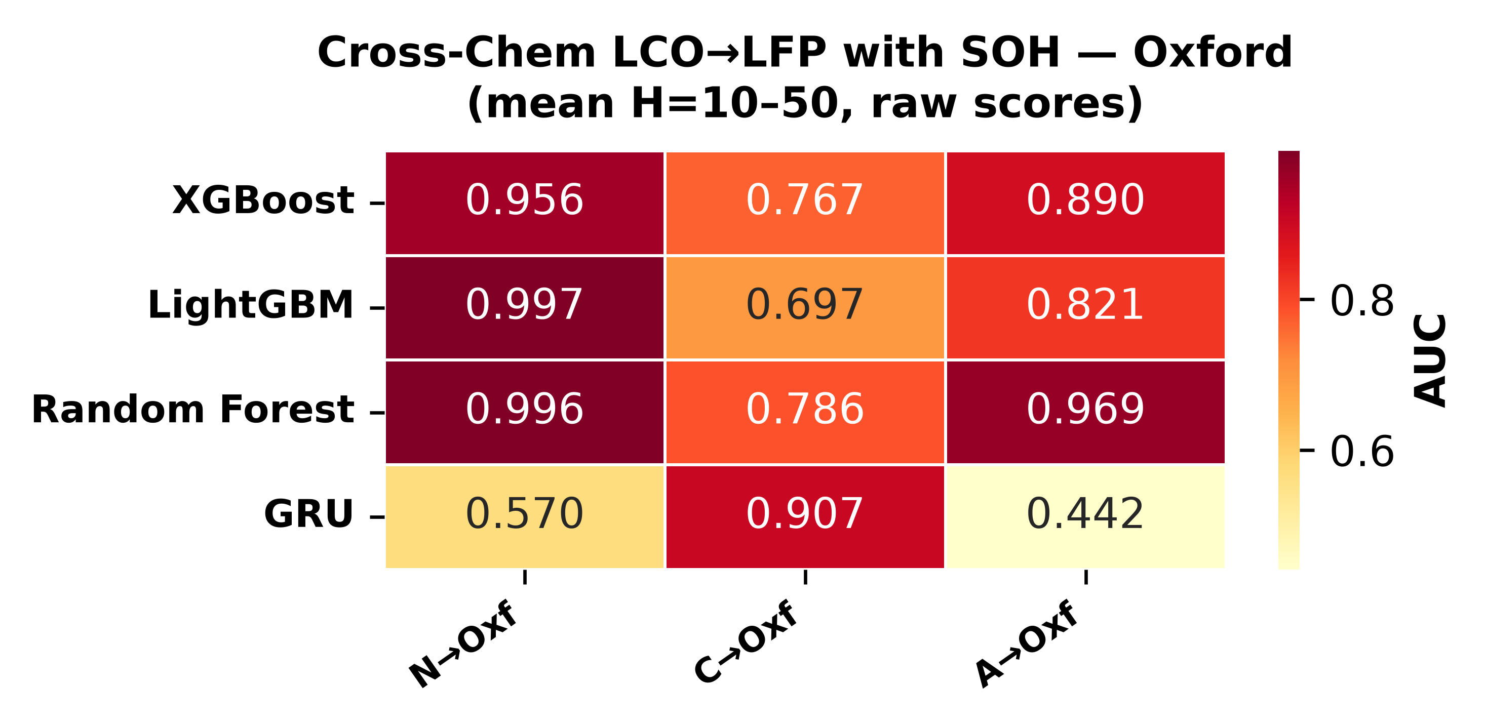
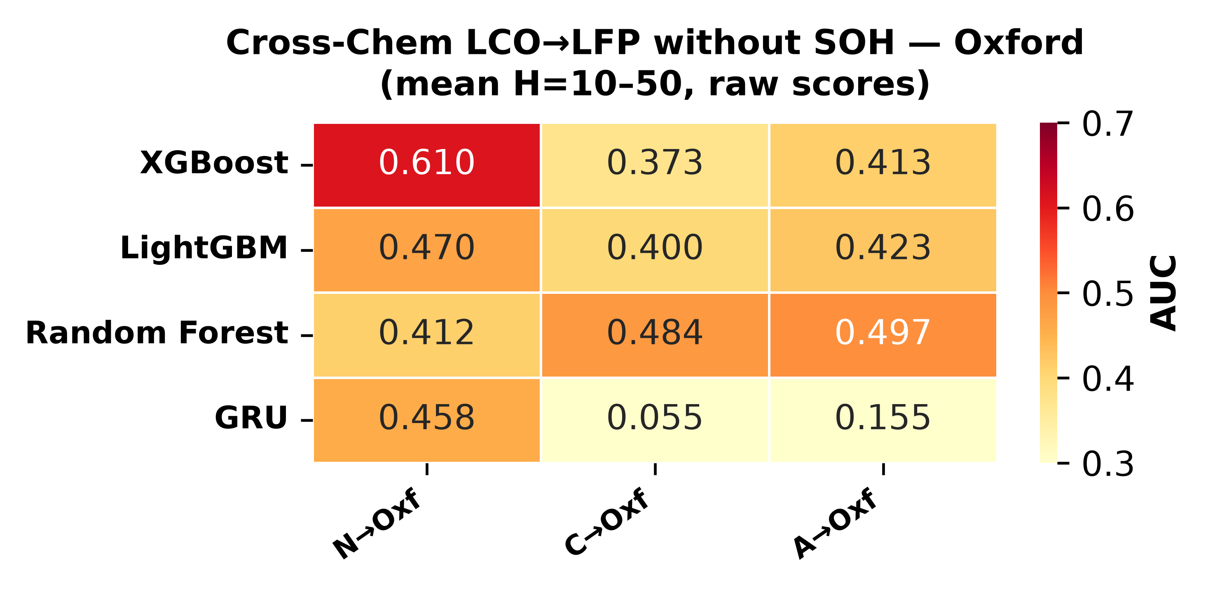
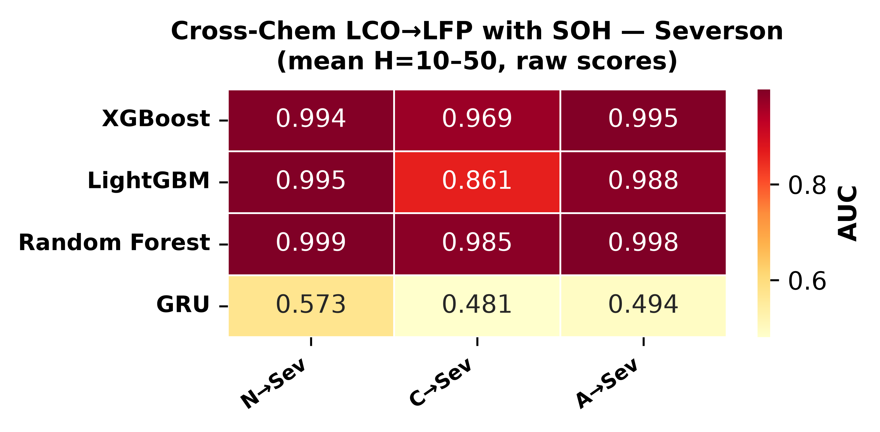
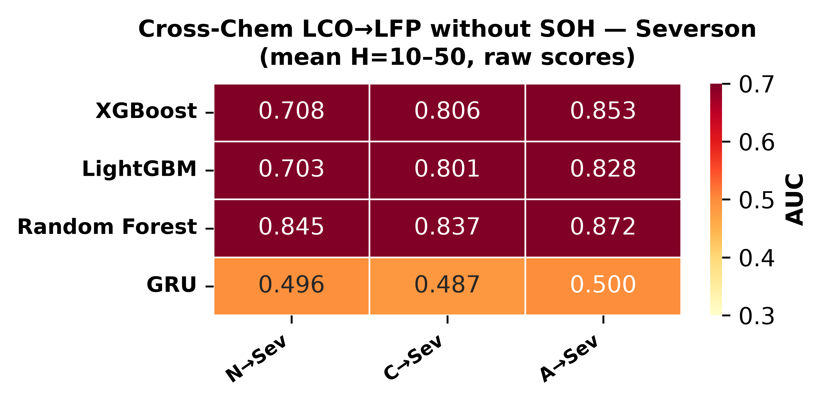
MULTI-HORIZON HAZARD MODELS FOR BATTERY FAILURE PREDICTION
6
TABLE I
Within-Dataset Platt-Calibrated AUC and Brier Scores Across Four Horizons. GroupKFold by Cell; Values Are Fold Means.
Model
Dataset
H=10
H=20
H=30
H=50
Mean AUC
Brier
XGBoost
NASA
0.903
0.899
0.910
0.918
0.907
0.197
XGBoost
CALCE
0.916
0.926
0.911
0.899
0.913
0.101
LightGBM
NASA
0.912
0.909
0.892
0.901
0.903
0.250
LightGBM
CALCE
0.908
0.924
0.886
0.916
0.909
0.101
Random Forest
NASA
0.911
0.901
0.912
0.927
0.913
0.209
Random Forest
CALCE
0.895
0.889
0.884
0.864
0.883
0.095
GRU
NASA
0.930
0.884
0.876
0.868
0.889
0.191
GRU
CALCE
0.944
0.779
0.768
0.885
0.844
0.124
TABLE II
Calibration Method Comparison Averaged Over Models and
Horizons. Both Methods Operate on Identical Training-Fold Scores.
Dataset
Iso. AUC
Platt AUC
Iso. Brier
Platt Brier
NASA
0.838
0.903
0.209
0.212
CALCE
0.713
0.887
0.107
0.105
Fig.
5.
Cross-chemistry transfer
without
SOH,
raw AUC.
Top:
Oxford, bottom: Severson.
D.
GRU entanglement under distribution shift
The GRU shows
an architecture-specific failure that
differs
from the
trees.
Its
8-dimensional
hidden state
compresses SOH together with voltage, current, and cycle
trends
across
the 10-step window.
Under
LCO-to-LFP
shift the entangled voltage and cycle components partially
Fig. 4.
Cross-chemistry transfer with SOH, raw AUC. Top: Oxford,
bottom: Severson.
corrupt the SOH signal,
producing raw AUC as low as
0.077 for CALCE-to-Oxford at H=20 against 0.76–0.84
for
the trees.
A separate mechanism drives
a CALCE-
trained GRU to invert its Oxford rankings (AUC about
AUC,
and the DeLong test
(Section IV-F)
confirms
it
0.03–0.12): CALCE’s 92% composite-failure rate saturates
is significant.
the learned decision boundary, which then ranks Oxford’s
The combined evidence points to SOH as a chemistry-
feature distribution backwards.
specific lookup key rather
than a transferable feature.
With SOH available,
a model
learns
a mapping such
E.
Calibration methods themselves fail
to transfer
as “SOH 0.85 means roughly 50 cycles to failure” from
LCO data and applies it unchanged to LFP,
where the
A second,
independent
failure
appears
in the
cross-
mapping is numerically similar for unrelated electrochem-
chemistry tables
when isotonic
calibration is
applied.
ical
reasons.
Without SOH,
the remaining features carry
Tree
models
lose
0.15–0.48 AUC points
depending on
no chemistry-invariant signal suﬀicient for cross-chemistry
the configuration. The collapse happens because isotonic’s
discrimination.
step function is fit to the training distribution; when test
MULTI-HORIZON HAZARD MODELS FOR BATTERY FAILURE PREDICTION
7
TABLE III
Cross-Chemistry Transfer at H=20 With SOH. AUC Reported as Per-Cell Mean Across Test Cells.
Training
Model
Target
Raw AUC
Iso. AUC
NASA
XGBoost
Oxford
0.959
0.773
NASA
XGBoost
Severson
0.997
0.532
NASA
LightGBM
Oxford
1.000
0.969
NASA
LightGBM
Severson
0.992
0.988
NASA
Random Forest
Oxford
1.000
0.782
NASA
Random Forest
Severson
0.999
0.523
CALCE
XGBoost
Oxford
0.763
0.510
CALCE
XGBoost
Severson
0.957
0.624
CALCE
LightGBM
Oxford
0.837
0.513
CALCE
LightGBM
Severson
0.952
0.617
CALCE
Random Forest
Oxford
0.766
0.510
CALCE
Random Forest
Severson
0.996
0.664
ALL LCO
XGBoost
Oxford
0.826
0.510
ALL LCO
XGBoost
Severson
0.995
0.630
ALL LCO
LightGBM
Oxford
0.969
0.510
ALL LCO
LightGBM
Severson
0.993
0.580
ALL LCO
Random Forest
Oxford
0.992
0.572
ALL LCO
Random Forest
Severson
0.996
0.952
TABLE IV
Cross-Chemistry Transfer at H=20 Without SOH.
Training
Model
Target
Raw AUC
Iso. AUC
NASA
XGBoost
Oxford
0.519
0.508
NASA
XGBoost
Severson
0.676
0.516
NASA
LightGBM
Oxford
0.448
0.448
NASA
LightGBM
Severson
0.535
0.491
NASA
Random Forest
Oxford
0.442
0.541
NASA
Random Forest
Severson
0.836
0.500
CALCE
XGBoost
Oxford
0.360
0.513
CALCE
XGBoost
Severson
0.806
0.614
CALCE
LightGBM
Oxford
0.410
0.513
CALCE
LightGBM
Severson
0.830
0.606
CALCE
Random Forest
Oxford
0.435
0.510
CALCE
Random Forest
Severson
0.870
0.622
ALL LCO
XGBoost
Oxford
0.415
0.510
ALL LCO
XGBoost
Severson
0.860
0.725
ALL LCO
LightGBM
Oxford
0.316
0.510
ALL LCO
LightGBM
Severson
0.808
0.595
ALL LCO
Random Forest
Oxford
0.608
0.541
ALL LCO
Random Forest
Severson
0.876
0.836
scores shift, several different scores land in one bin and get
TABLE V
DeLong Test p-Values for the SOH Ablation (ALL-LCO → LFP,
identical calibrated probabilities, which drags AUC down
H=20). AUCs Are Pooled Across Test Cells (See Table III for
through tied predictions.
Per-Cell Means). All Comparisons Are Significant at α = 0.05.
F.
DeLong test:
statistical
significance of
the SOH abla-
Target
Model
AUC w/ SOH
AUC w/o SOH
p-value
tion
−51
Oxford
XGBoost
0.917
0.429
7.2 × 10
−64
Oxford
LightGBM
0.971
0.332
2.6 × 10
Table V reports DeLong p-values,
computed with (7),
−36
Oxford
Random Forest
0.989
0.581
6.5 × 10
−100
Severson
XGBoost
0.896
0.750
< 10
for the ALL-LCO→LFP ablation at H=20. On Oxford the
−100
Severson
LightGBM
0.882
0.718
< 10
−36
values range from 6.5 × 10
(Random Forest) down to
−100
Severson
Random Forest
0.889
0.746
< 10
−64
2.6 × 10
(LightGBM); on Severson all three fall below
−100
10
. The test accounts for the correlation between with-
SOH and without-SOH AUCs
computed on the
same
SOH kept: SOH dominates by a wide margin, cycle index
instances,
so these numbers
are decisive rather
than a
a distant second,
and the voltage,
current,
temperature,
quirk of paired sampling.
and duration features contribute little.
Figs.
9–11 repeat
the same comparisons with SOH removed,
and every re-
G.
SHAP feature importance
maining feature collapses to near-zero SHAP spread. That
visual collapse matches the quantitative AUC collapse and
TreeSHAP [16]
gives a direct test of
the lookup-table
reads as a one-glance demonstration of the paper’s central
hypothesis.
Figs.
6–8 show the attributions for the three
negative result.
tree models in NASA-to-Oxford transfer at H=20 with
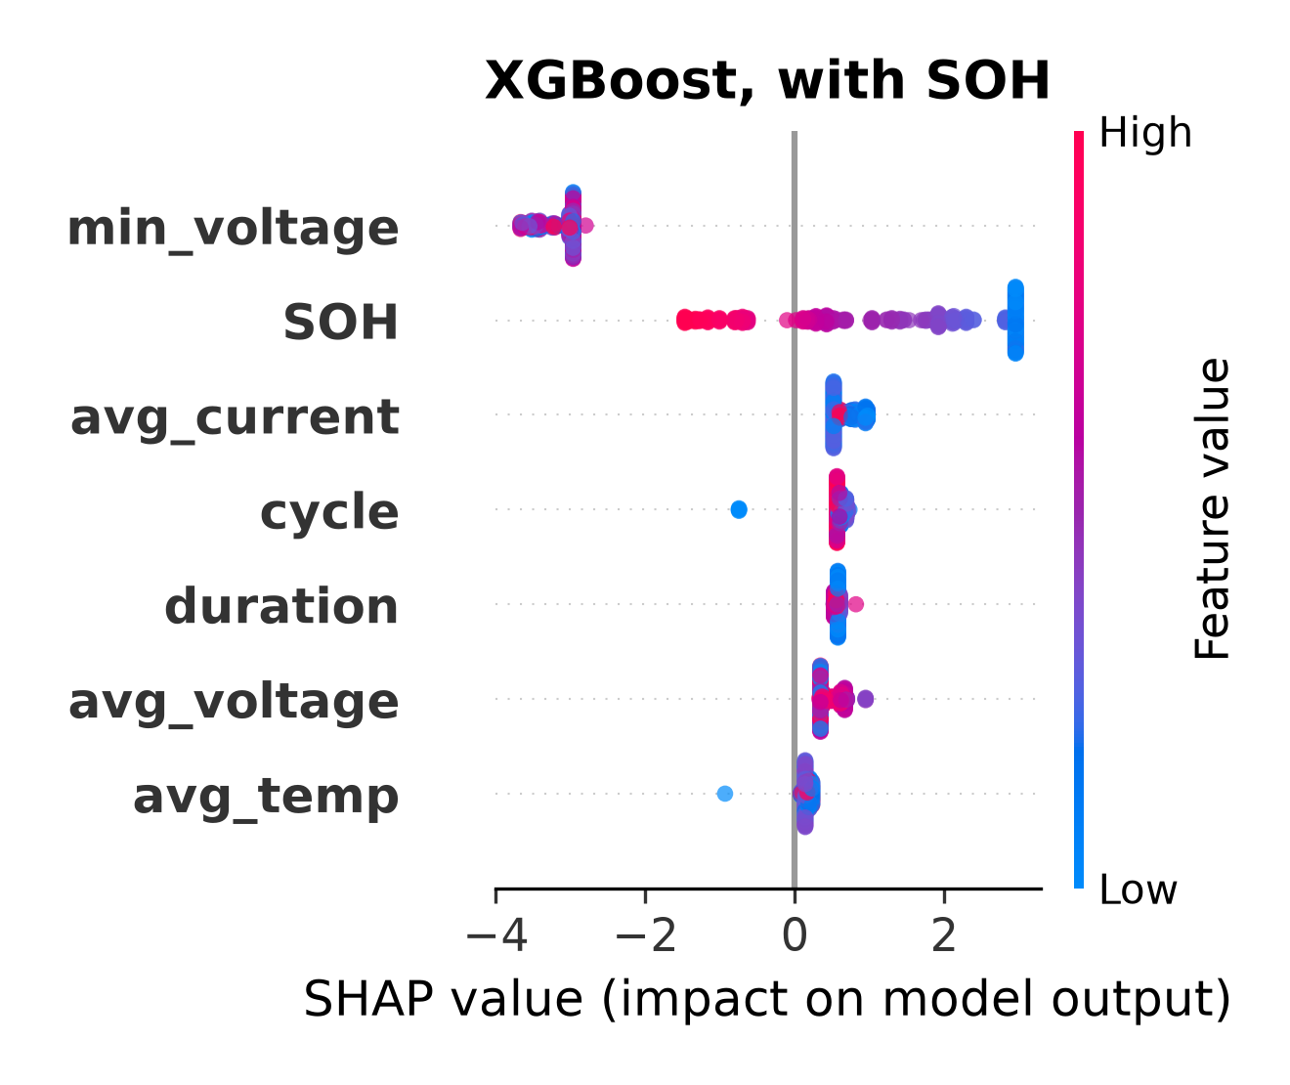
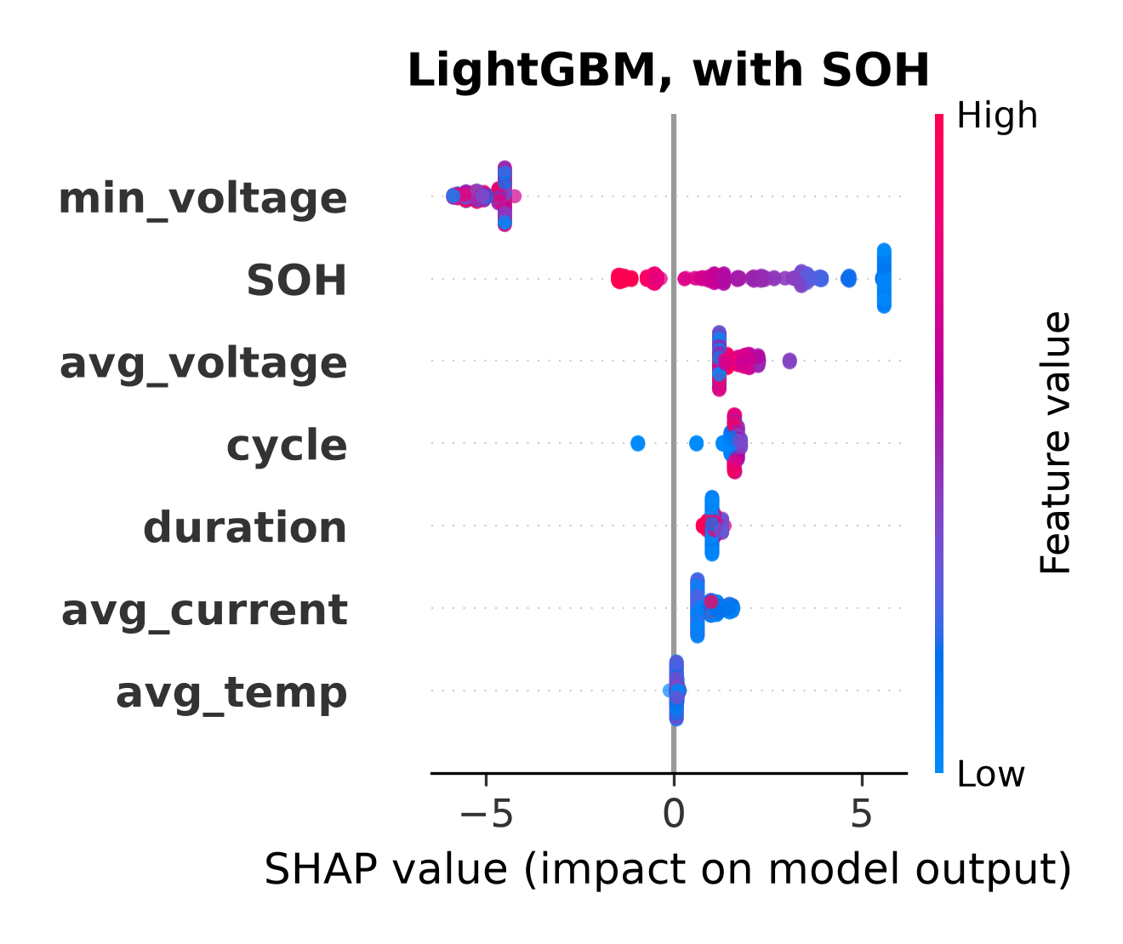
MULTI-HORIZON HAZARD MODELS FOR BATTERY FAILURE PREDICTION
8
TABLE VI
Embedded Deployment: Model Size, Accuracy, On-Device Validation Error, and Measured Inference Time. Errors Are Maximum |C
engine − predict_proba()| Over All 1,028 Rows, Measured on the ESP32-S3. Timings Measured On-Device at 240 MHz With the Binary
in Flash (PROGMEM), PSRAM, or a Single Model in Internal SRAM. The AUC Column Is the 5-Fold GroupKFold Platt Value at H=20
From Table I (Deployed Models Are Retrained on the Full Data).
Model
Nodes
AUC (H=20)
Max Err
Flash
PSRAM
SRAM (1 model)
−7
XGBoost
3,272
0.899
2.4 × 10
0.76 ms
0.50 ms
0.32 ms
−6
LightGBM
7,000
0.909
1.1 × 10
1.55 ms
0.93 ms
0.43 ms
−8
Random Forest
16,064
0.901
3.0 × 10
2.36 ms
1.29 ms
0.50 ms
All three
26,336
—
—
4.7 ms
2.7 ms
—
Fig. 6.
SHAP feature importance for XGBoost in NASA-to-Oxford
Fig. 7.
SHAP feature importance for LightGBM in NASA-to-Oxford
transfer at H=20, with SOH. SOH dominates by a wide margin.
transfer at H=20, with SOH. SOH dominates by a wide margin.
SRAM. The full 372 kB binary does not fit internal SRAM,
H.
Embedded deployment validation
whose free heap is roughly 320 kB,
but each individual
Three independent validation stages confirm that the
model
does (XGBoost is about 46 kB,
LightGBM 98 kB,
C tree engine reproduces
the Python training libraries
Random Forest 225 kB), and the firmware runs one model
through the output transforms of
(8) and (9):
a Python
at a time, so the SRAM-resident numbers are the realistic
walker over the extracted trees,
the same walker cross-
per-inference cost. Both flash and PSRAM land well above
checked on the
full
1,028-row set,
and the
C engine
the 150–250 µs we first projected, because the working set
run
on-device
on
an
ESP32-S3
against
the
library’s
exceeds the ESP32-S3’s data cache and nearly every node
predict_proba().
Fig.
13 plots
every one
of
the
1,028
read misses;
PSRAM is about 1.5× faster than flash for
on-device predictions
against
the Python values
for
all
the same reason.
The all-three PSRAM path still
clears
three models;
the points sit on the identity line and the
the 100 ms per-cycle budget by roughly 37×, and a single
residual histograms are pinned to zero. The measured on-
model
from SRAM runs close to the original
projection.
−7
device maximum absolute error is 2.4×10
for XGBoost,
−6
−8
1.1 × 10
for LightGBM,
and 3.0 × 10
for Random
V.
Discussion
−5
Forest,
all
far inside the 10
tolerance.
A.
The SOH-as-lookup-table mechanism
Table VI lists the models’ sizes, their NASA H=20 Platt
AUC,
the on-device validation error,
and the measured
The
central
negative
result
reads
best
as
a leakage
inference time,
and Fig.
12 plots the latency,
the speed–
diagnosis rather than a generic failure of transfer learning.
accuracy trade-off, and the footprint. The three ensembles
SOH is a capacity ratio, and capacity declines with age in
occupy 372 kB in the flat
binary.
Measured single-row
both LCO and LFP cells, so both chemistries traverse SOH
inference at 240 MHz depends on where the binary sits:
values from 1.0 down to 0.8. What differs is the mapping
0.76 ms,
1.55 ms,
and 2.36 ms for XGBoost,
LightGBM,
from SOH to remaining cycles:
LCO degrades faster per
and Random Forest from memory-mapped flash; 0.50 ms,
cycle,
so a given SOH corresponds
to fewer
remaining
0.93 ms,
and 1.29 ms from PSRAM;
and 0.32 ms,
0.43
cycles.
A model
that learned the LCO mapping assigns
ms, and 0.50 ms when a single model is placed in internal
high failure
probability at
the
appropriate
LCO cycle
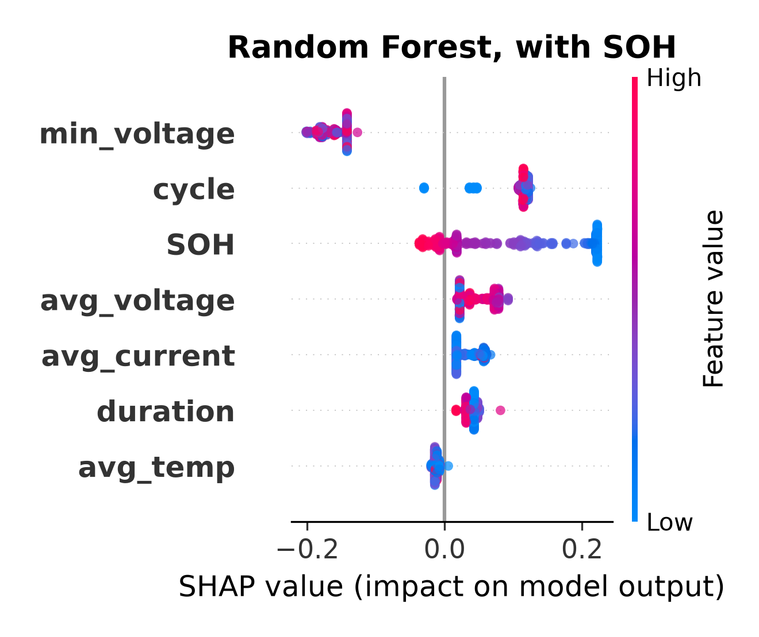
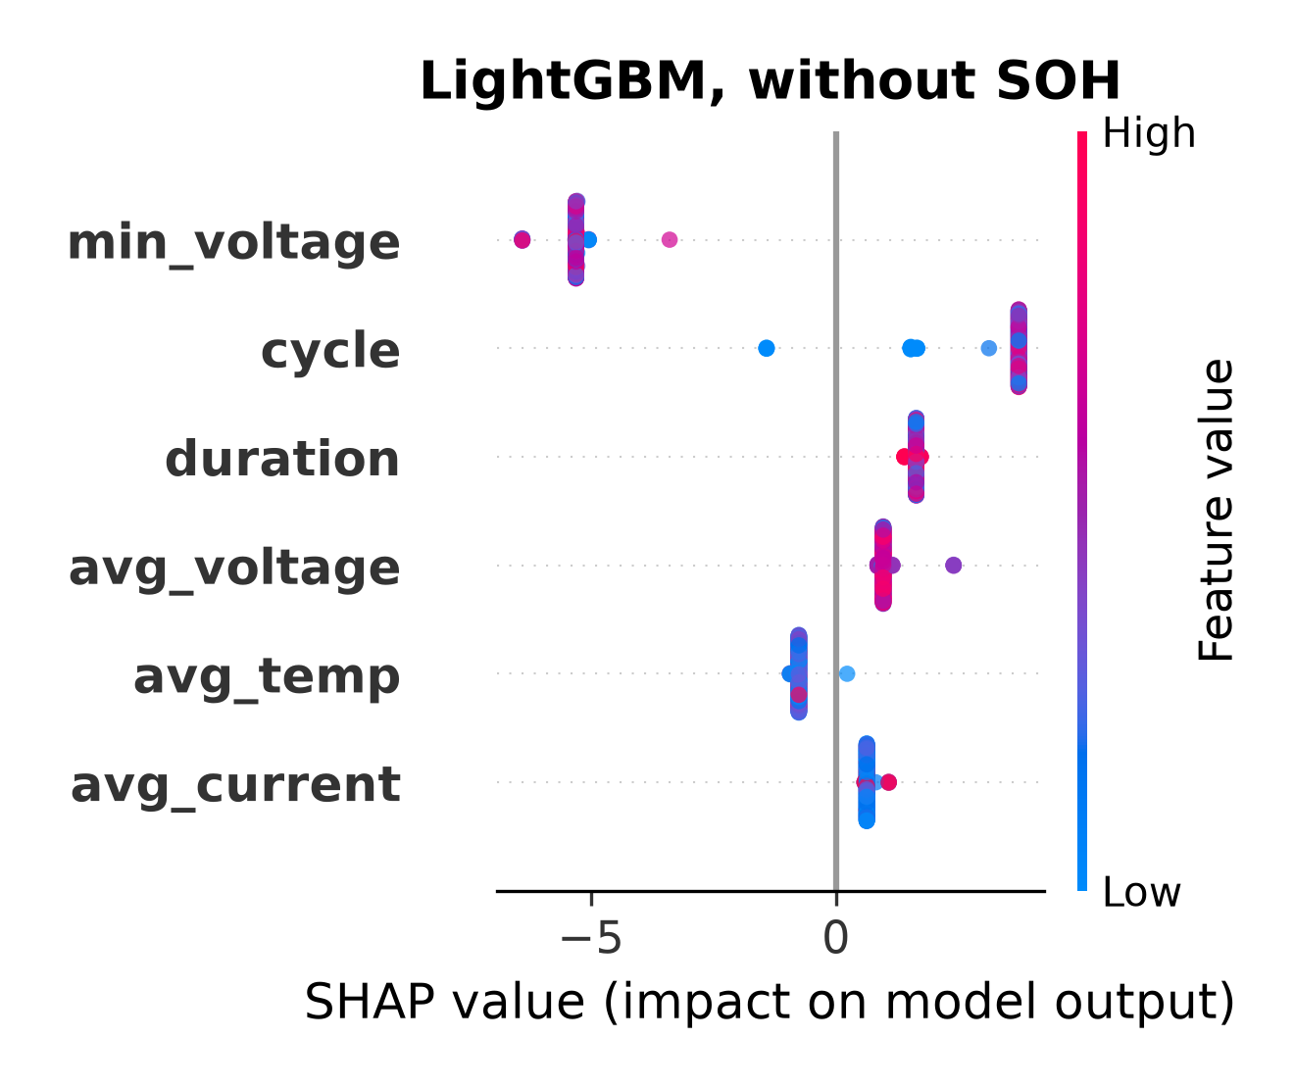
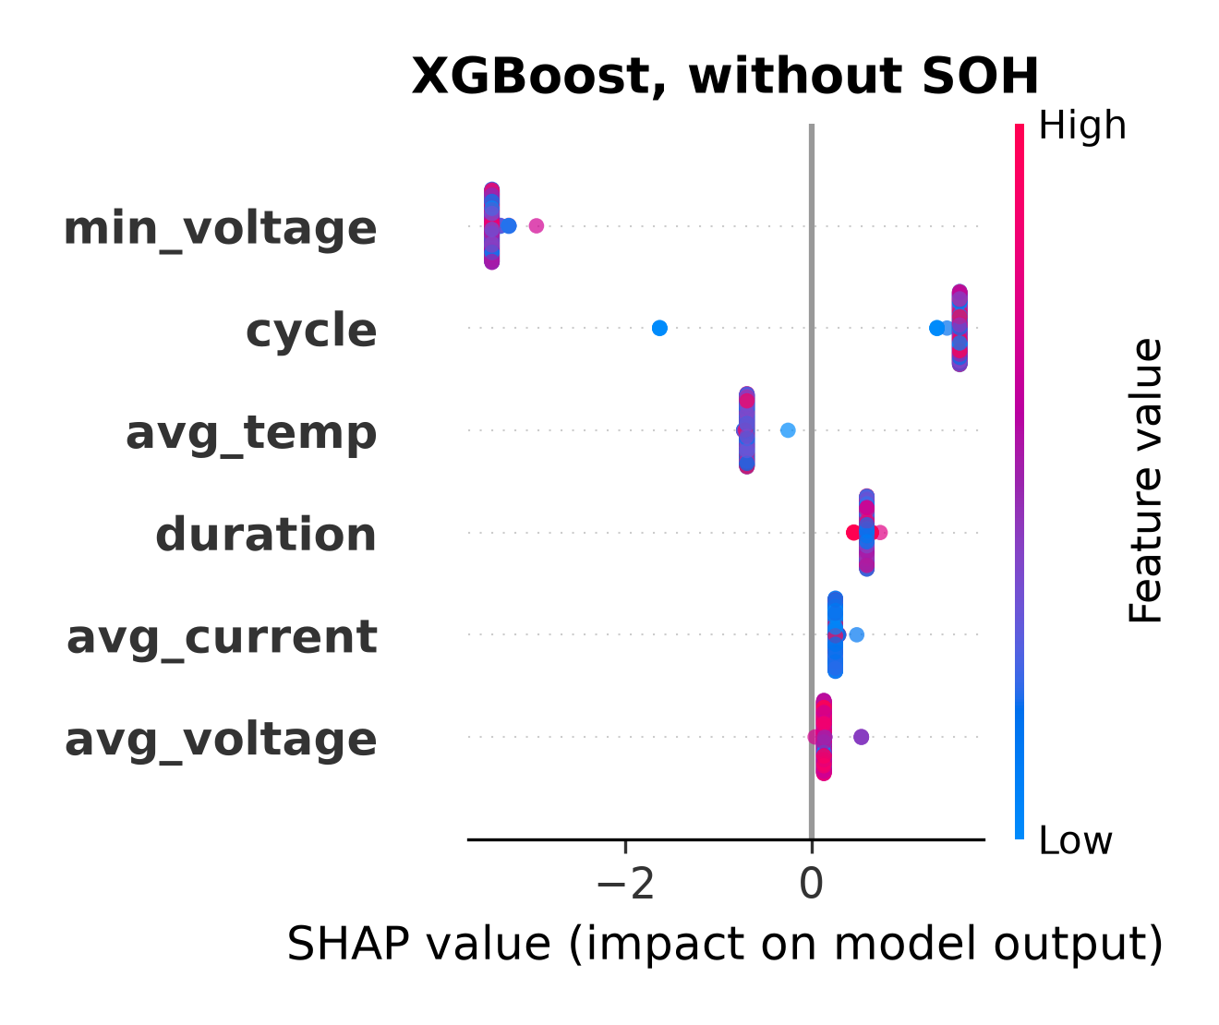
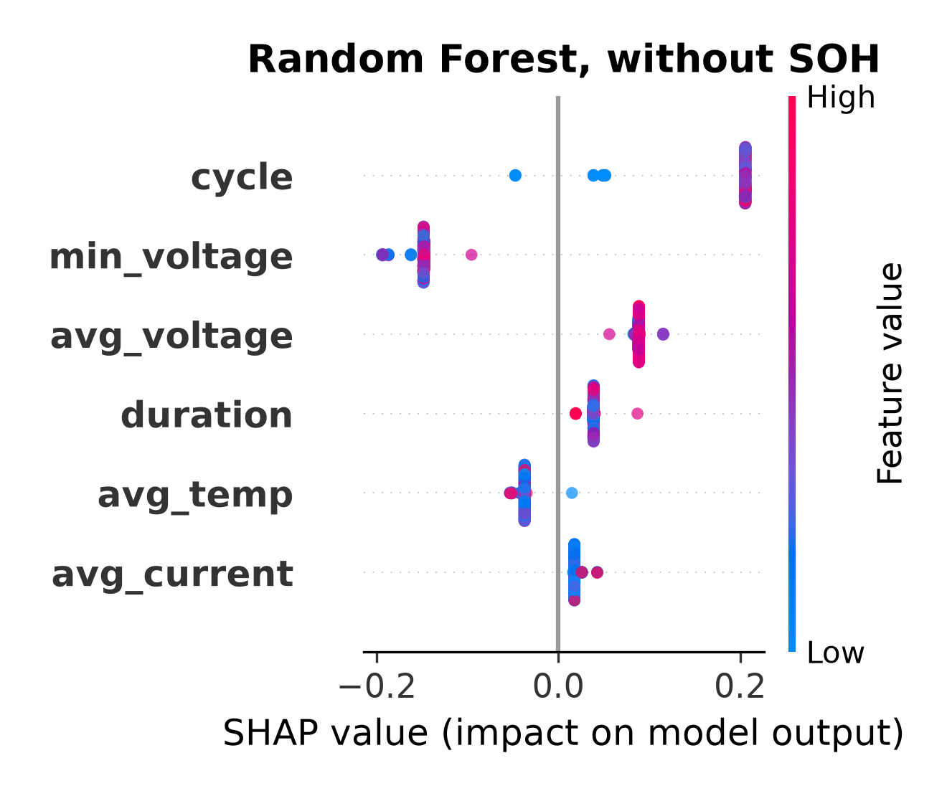
MULTI-HORIZON HAZARD MODELS FOR BATTERY FAILURE PREDICTION
9
Fig.
8.
SHAP feature importance for Random Forest in NASA-
Fig.
10.
SHAP feature importance for
LightGBM in NASA-to-
to-Oxford transfer at H=20,
with SOH.
SOH dominates by a wide
Oxford transfer at H=20, without SOH. All features collapse to near-
margin.
zero spread.
Fig.
11.
SHAP feature importance for Random Forest in NASA-
Fig. 9.
SHAP feature importance for XGBoost in NASA-to-Oxford
to-Oxford transfer at H=20,
without SOH.
All
features collapse to
transfer at H=20,
without SOH.
All
features collapse to near-zero
near-zero spread.
spread, so no chemistry-invariant signal remains.
on a $12 microcontroller. Second, cross-chemistry transfer
count even on LFP test cells,
which produces high AUC,
should not
be
assumed;
without
SOH no model
class
but
the
prediction rides
on a chemistry-specific
proxy
clears
chance,
and with SOH the
GRU’s
distributed
rather than any real
understanding of
LFP degradation.
representation still
offers no guarantee of
generalization.
SHAP confirms
that
SOH carries
the
dominant
share
Third, post-hoc calibration, especially isotonic regression,
of
feature importance in every model,
and removing it
should not be applied blindly under distribution shift; raw
collapses every predictor to near-random performance.
scores give a more dependable discriminative signal
for
cross-chemistry deployment.
B.
Implications for battery management practitioners
Three practical
points
follow.
First,
within-chemistry
C.
Limitations
hazard models built from standard charge and discharge
features (voltage,
current,
temperature,
cycle count) are
The
Oxford set
holds
only five
cells,
too few for
a
reliable,
reaching AUC of
0.85 and above
with Platt
reliable within-dataset evaluation and enough to blunt the
calibration,
and the deployment
results
show they run
precision of
the per-cell
standard deviation;
the 141-cell
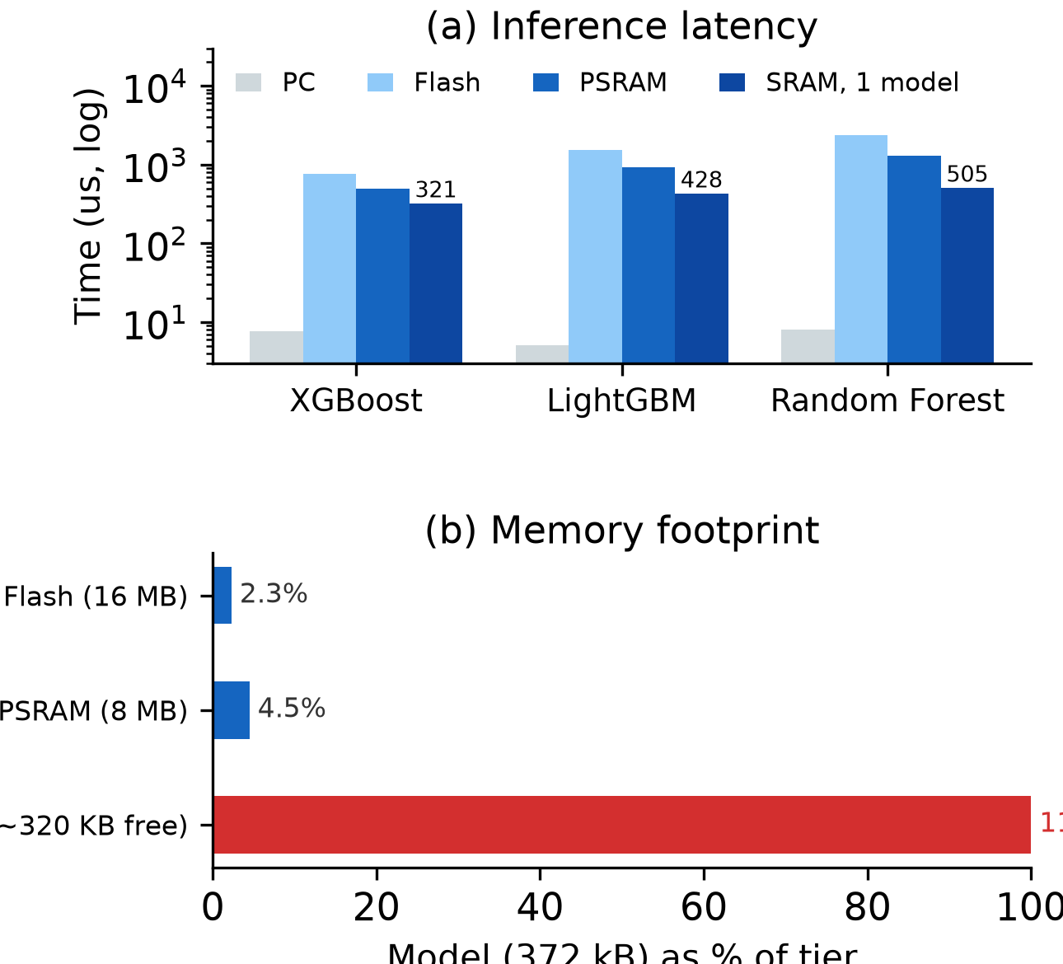
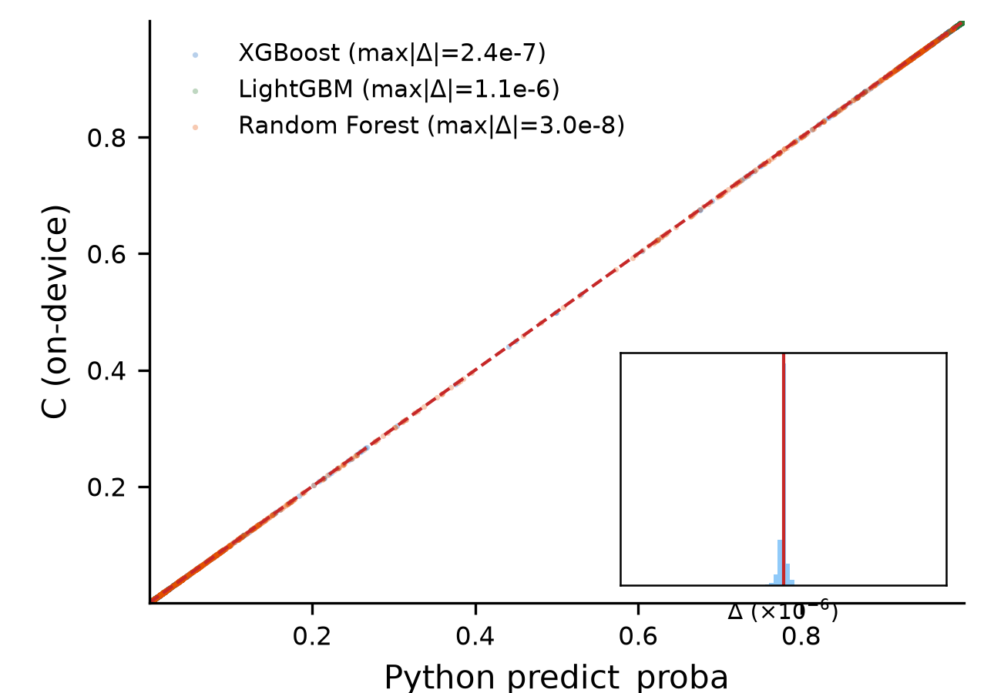
MULTI-HORIZON HAZARD MODELS FOR BATTERY FAILURE PREDICTION
10
gets and a complete embedded deployment on an ESP32-
S3. Three findings stand out. Within-dataset performance
is consistent across model
classes (mean AUC 0.84–0.91)
and Platt
calibration beats
isotonic throughout.
Cross-
chemistry transfer fails for every model
class once SOH
is removed,
and the failure comes from SOH acting as
a chemistry-specific lookup key rather
than a transfer-
able degradation invariant. Post-hoc calibration produces
a further,
independent
failure
mode
in which isotonic
regression destroys cross-chemistry discriminative power
under distribution shift.
The
embedded deployment
adds
a concrete
positive
result to these cautions. Three ensembles totaling 900 trees
and 26,336 nodes fit into 372 kB, run on a $12 microcon-
troller in about 2.7 ms for all three models from PSRAM,
about 0.5 ms for a single model
kept in internal
SRAM,
and reproduce
the
Python training libraries
to within
−6
1.1 × 10
across more than a thousand validation rows.
Future work should pursue learned feature representations
built for chemistry invariance,
bidirectional
transfer,
and
multi-seed GRU evaluation.
Fig.
12.
Deployment trade-offs:
(a) measured single-row inference
time per model at 240 MHz (PC, and ESP32-S3 with the binary in
flash,
PSRAM,
or a single model
in internal
SRAM);
(b) memory
Acknowledgment
footprint of the 372 kB binary as a share of each tier, exceeding the
ESP32-S3’s roughly 320 kB of free internal SRAM.
This
work
received
no
external
funding.
The
authors
declare
no
conflicts
of
interest.
The
source
code,
data,
trained
models,
firmware,
and
validation
pipeline
are
publicly
available
at
https://github.com/touhidsiddiqueeraj-bit/
Multi-Horizon-Hazard-Models-for-Battery-Failure-Prediction.
References
[1]
T.
A.
Shikdar and H.
Laaksonen,
“Learning when not to use
a battery: Multihorizon failure intelligence,” Int. Trans. Electr.
Energy Syst., vol. 36, Art. no. 6000810, 2026.
[2]
H.
Meng and Y.
Li,
“A review on prognostics
and health
management (PHM) methods of lithium-ion batteries,” Renew.
Sustain. Energy Rev., vol. 116, Art. no. 109405, 2019.
[3]
L. Breiman, “Random forests,” Mach. Learn., vol. 45, no. 1, pp.
5–32, 2001.
[4]
T. Chen and C. Guestrin, “XGBoost: A scalable tree boosting
system,” in Proc. ACM SIGKDD, 2016, pp. 785–794.
[5]
G. Ke, Q. Meng, T. Finley, et al., “LightGBM: A highly eﬀicient
gradient boosting decision tree,” in Proc. NeurIPS, vol. 30, 2017,
Fig.
13.
On-device
C engine
predictions
versus
Python pre-
pp. 3146–3154.
dict_proba() over all 1,028 rows and three models (agreement scatter
[6]
B.
Saha and K.
Goebel,
“Battery data set,” NASA Ames
on the identity line,
inset residual
histogram of C minus Python in
Prognostics Data Repository, 2007.
−6
−7
units of 10
). Maximum absolute errors are 2.4 × 10
(XGBoost),
[7]
CALCE Battery Research Group,
“Battery aging datasets,”
−6
−8
1.1 × 10
(LightGBM), and 3.0 × 10
(Random Forest).
Univ. Maryland, 2023.
[8]
C.
R.
Birkl
and D.
A.
Howey,
“Oxford battery degradation
dataset 1,” Univ. Oxford, 2017.
Severson set is included specifically to offset this and it
[9]
K.
A.
Severson,
P.
M.
Attia,
N.
Jin,
et
al.,
“Data-driven
prediction of
battery cycle life before capacity degradation,”
reproduces
every qualitative finding.
The analysis
runs
Nature Energy, vol. 4, pp. 383–391, 2019.
one direction,
LCO to LFP,
and bidirectional
transfer
[10]
S. Sahoo, K. S. Hariharan, S. Agarwal, et al., “Transfer learning
would round out the picture. The GRU is evaluated with
based generalized framework for state of
health estimation of
Li-ion cells,” Sci. Rep., vol. 12, Art. no. 13173, 2022.
a single seed; the instability across configurations is itself
[11]
J. Lu, R. Xiong, J. Tian, C. Wang, and F. Sun, “Deep learning to
informative, but multi-seed analysis is left to future work.
estimate lithium-ion battery state of health without additional
degradation experiments,” Nat.
Commun.,
vol.
14,
Art.
no.
2760, 2023.
VI.
Conclusion
[12]
J. C. Platt, “Probabilistic outputs for support vector machines
This study widens a multi-horizon hazard classification
and comparisons to regularized likelihood methods,” in Adv.
Large Margin Classifiers, MIT Press, 1999, pp. 61–74.
framework,
first
shown on one model
and one dataset,
[13]
B.
Zadrozny and C.
Elkan,
“Transforming classifier
scores
to four model
families on two LCO datasets,
with cross-
into accurate multiclass probability estimates,” in Proc.
ACM
chemistry transfer checked on two independent LFP tar-
SIGKDD, 2002, pp. 694–699.
MULTI-HORIZON HAZARD MODELS FOR BATTERY FAILURE PREDICTION
11
[14]
A.
Niculescu-Mizil
and R.
Caruana,
“Predicting good proba-
bilities
with supervised learning,” in Proc.
ICML,
2005,
pp.
625–632.
[15]
L. Huang, J. Zhao, B. Zhu, H. Chen, and S. K. L. M. v. Broucke,
“An experimental
investigation of
calibration techniques
for
imbalanced data,” IEEE Access,
vol.
8,
pp.
127343–127352,
2020.
[16]
S.
M.
Lundberg,
G.
G.
Erion,
H.
Chen,
et
al.,
“From local
explanations to global
understanding with explainable AI for
trees,” Nat. Mach. Intell., vol. 2, no. 1, pp. 56–67, 2020.
[17]
P.
Grzesik and D.
Mrozek,
“Combining machine learning and
edge computing:
Opportunities,
challenges,
platforms,
frame-
works, and use cases,” Electronics, vol. 13, no. 3, Art. no. 640,
2024.
[18]
C. Gupta and A. Ramdas, “Online Platt scaling with calibeat-
ing,” in Proc. ICML, PMLR 202, 2023, pp. 12182–12204.
[19]
E.
R.
DeLong,
D.
M.
DeLong,
and D.
L.
Clarke-Pearson,
“Comparing the areas under two or more correlated receiver
operating characteristic curves:
A nonparametric approach,”
Biometrics, vol. 44, no. 3, pp. 837–845, 1988.

