Multi-Horizon Failure-Risk Models for Battery Failure Prediction: Within-Dataset Reliability, Cross-Chemistry Transferability, and Calibration Analysis
Abstract— This paper presents a multi-horizon failure-risk prediction framework for lithium-ion battery failure that integrates probability calibration, cross-dataset evaluation, and statistical significance testing, and uses it to answer a validity question: when failure-risk models appear to transfer between datasets and chemistries, is degradation knowledge actually transferring, or is the model reading a health-state variable that encodes proximity to the failure criterion itself? Three tree ensembles (XGBoost, LightGBM, Random Forest) and a GRU baseline are trained on the NASA and CALCE LCO datasets under cell-disjoint folds with leakage-free, cross-fitted calibration, and evaluated on the Oxford and MIT–Stanford Severson LFP datasets across four horizons (10, 20, 30, 50 cycles). Under the clean protocol, every model–horizon–dataset combination reaches a fold-mean AUC of at least 0.85 (32 of 32), and Platt scaling better preserves discrimination than isotonic regression while achieving comparable or better calibration error. The central result is a controlled State-of-Health (SOH) ablation: apparent cross-dataset, cross-chemistry transfer with SOH included (pooled AUC up to 1.00) collapses without SOH (at best 0.58 at $H=20$), and an unfitted distance-to-threshold rule on SOH alone reproduces most of the with-SOH transfer. Because SOH also enters the failure definition, all with-SOH numbers are upper bounds that partly measure label proximity: relabeling failure by voltage sag alone cuts with-SOH transfer by a quarter. Same-chemistry cross-laboratory controls show the collapse is driven by dataset shift at least as much as by chemistry, so SOH acts as a dataset- and chemistry-dependent health-state shortcut rather than a chemistry-specific transferable signal.
Index Terms— battery management systems, machine learning, probability calibration, prognostics and health management, transfer learning, dataset shift

I. Introduction and Related Work
Lithium-ion batteries are fundamental to electric vehicles and grid-scale energy storage because of their high energy density, fast charging capability, and long cycle life. Their degradation is highly nonlinear, governed by complex electrochemical processes, which makes battery failure prediction challenging. Although failures are relatively infrequent, they can cause significant safety hazards and economic losses, motivating reliable multi-horizon prognostics for advanced battery management systems [1]. Battery prognostics has primarily focused on state-of-health (SOH) estimation and remaining useful life (RUL) prediction. Berecibar et al. [1] reviewed conventional SOH methods, including coulomb counting, impedance spectroscopy, Kalman filtering, fuzzy logic, and machine learning. Recent studies have adopted deep learning, including STL-LSTM with spatio-temporal attention [2], multilayer perceptrons [3], and SHAP-assisted feature engineering [4]. Extensive reviews of RUL prediction are available in [5]–[7], while LightGBM [8], GRU-based [9], hybrid neural [10], and convolutional architectures [11] have demonstrated competitive lifetime prediction. Survival analysis has recently emerged as an alternative paradigm [12]–[14]. Cross-chemistry transfer has received little direct attention: Pang et al. [15] proposed a Transformer–BiLSTM framework for multi-chemistry SOH estimation, though their focus was SOH rather than failure prediction. Probability calibration is similarly underexplored, despite established methods [16]–[18]. Model interpretability using SHAP [19] and public benchmark datasets [20], [21] continue to advance the field.
Nevertheless, a clear research gap remains. Most studies evaluate a single dataset, chemistry, horizon, or metric, while cross-dataset transfer, calibration, and significance testing are rarely studied together. More fundamentally, it is unclear whether apparent transfer performance reflects genuine degradation knowledge or a health-state shortcut, since the composite failure label is defined from SOH while SOH is also the strongest input feature. The DeLong test [22] is common for ROC comparison but treats every cycle-level prediction as independent even though cycles within a cell are strongly correlated, and while the Severson dataset [23] enables large-scale LFP validation, it has not been widely paired with cross-chemistry experiments.
This paper addresses that gap. We train XGBoost, LightGBM, Random Forest, and a GRU baseline on the NASA and CALCE LCO datasets under cell-disjoint folds, evaluate on the Oxford and Severson LFP datasets across four horizons (10, 20, 30, 50 cycles), compare Platt and isotonic calibration under a leakage-free cross-fitted protocol, run an SOH ablation with cell-level bootstrap confidence intervals, and add same-chemistry cross-laboratory controls (NASA$↔$CALCE and Severson$→$Oxford) that separate dataset shift from chemistry shift. The key finding is that apparent cross-chemistry transfer success depends largely on SOH acting as a dataset- and chemistry-dependent health-state shortcut, not a shared degradation pattern.

II. Methodology
Fig. 1 overviews the workflow: LCO training cells and LFP transfer targets are represented by per-cycle features and composite failure labels, four model families are trained per horizon, calibrated with leakage-free cross-fitted functions, and evaluated with cell-disjoint reliability checks, transfer experiments, and shortcut controls.
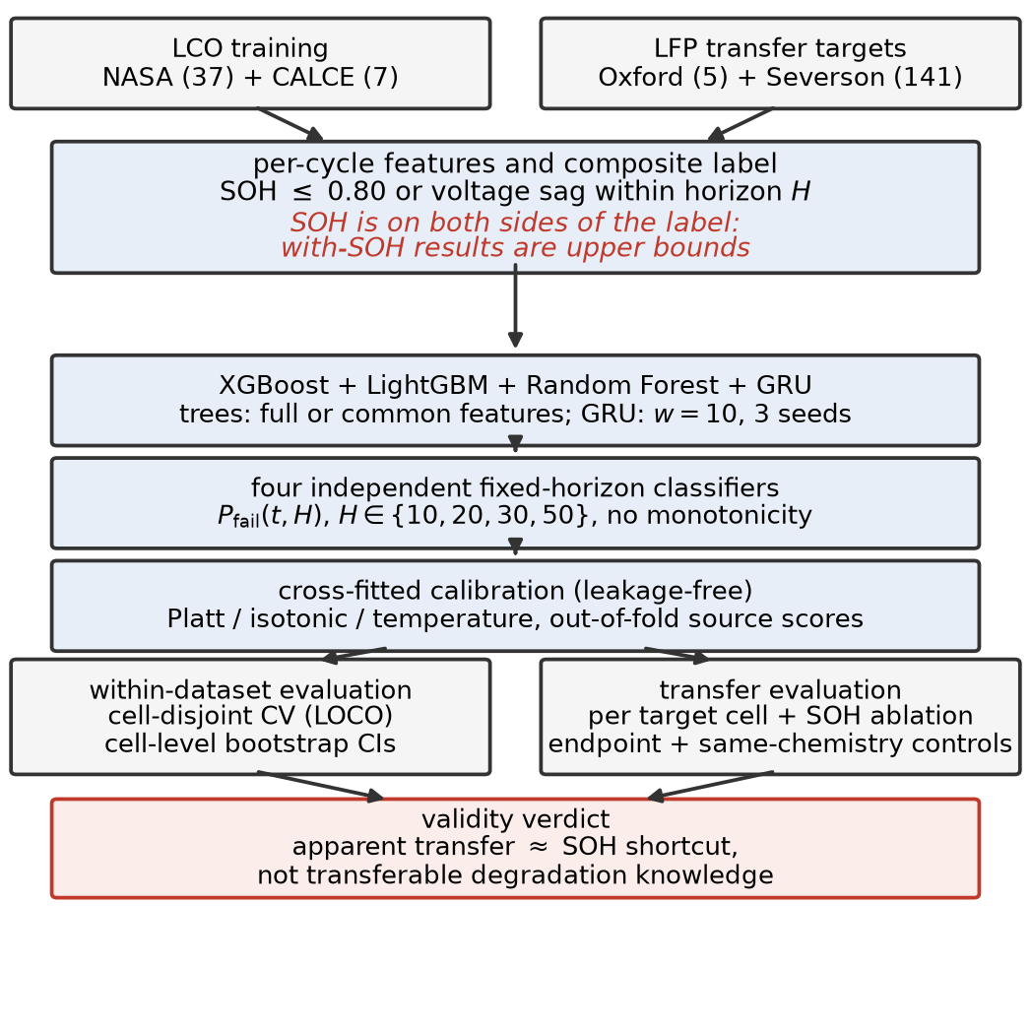
Overview of the proposed multi-horizon failure-risk framework: datasets, features and labels, model families, per-horizon classifiers, cross-fitted calibration, and the reliability, transfer, and shortcut-control evaluations.

II-A Datasets and Feature Representation
Four public datasets spanning two battery chemistries are used (Table I). The NASA PCoE [24] and CALCE CX2 [25] datasets are used for training, while the Oxford Battery Degradation Dataset [26] and MIT–Stanford Severson [23] datasets serve as cross-chemistry transfer targets. A battery is labeled as failed when SOH falls below 0.80 or the average voltage sag drops below 94% of the first ten-cycle baseline.
Summary of the Four Battery Datasets
Dataset | Cells | Chem. | Cycles/Cell | Role
NASA 18650 [24] | 37 | LCO | 1–445 | Training
CALCE CX2 [25] | 7 | LCO | 775–1,961 | Training
Oxford LFP [26] | 5 | LFP | 46–78 | Transfer
Severson [23] | 141 | LFP | 101–2,237 | Transfer
Two properties of these datasets matter for interpretation. First, the Oxford release logs discharge summaries at roughly 100-cycle intervals, so after preprocessing only 46–78 usable cycles per cell remain and every horizon is shorter than the sampling interval; Oxford failure labels are identical across all four horizons, and Oxford scores measure pooled failure detection rather than horizon-resolved prediction (per-cell statistics effectively cover four of its five cells). Second, because chemistry, laboratory, cell manufacturer, cycling protocol, and logging resolution all change simultaneously between any source and target, the shift evaluated here is cross-dataset as well as cross-chemistry; “cross-chemistry” is used as shorthand and Section II-E describes the controls that separate the two.
The feature vector consists of standard battery management system (BMS) measurements requiring no additional sensors,
$$x_{t}=\{{SOH}_{t},{\overset{‾}{V}}_{t},I_{t},T_{t},{dur}_{t},t\}, \text{(1)}$$
used directly by the tree ensembles, while the GRU processes a rolling window of $w=10$ cycles,
$$X_{t}^{(w)}=\left[x_{t−w+1}, …, x_{t}\right]∈R^{w×d}. \text{(2)}$$
In the CALCE dataset, average temperature and duration are completely missing and are zero-imputed for the tree models; this is harmless within a single dataset but a constant-zero column can act as a dataset identifier in pooled training, which Section III-C controls for with a common-feature variant. The GRU excludes those two features and uses only cycle, average voltage, minimum voltage, and SOH during transfer; the tree ensembles are additionally evaluated on this identical common feature set, so that architecture and feature availability are not confounded when comparing models under shift.

II-B Operational Reliability Formulation
Rather than estimate SOH or remaining useful life directly, we predict failure probability within a fixed operating horizon,
$$Y_{t,H}=\left\{\begin{matrix}1, & \text{if failure occurs within }(t,t+H] \\ 0, & \text{otherwise}\end{matrix}\right. \text{(3)}$$
with conditional failure probability
$$P_{fail}(t,H)=P​\left(T_{f}≤t+H∣T_{f}>t, x_{t}\right), \text{(4)}$$
where $T_{f}$ is the failure cycle. This framing treats battery prognostics as a discrete-time survival problem, aligned with how a BMS would use the output operationally. Two honesty notes are essential. First, (5) is a fixed-horizon cumulative failure-risk target: each horizon is an independent binary classifier, no cycle-level hazard or survival product is estimated, and no monotonicity constraint $P_{10}≤P_{20}≤P_{30}≤P_{50}$ is enforced (violations reach up to 46% of within-dataset rows), which is why we say failure-risk classification rather than hazard modeling. Second, the label is partially defined by SOH itself and SOH is also an input feature (Eq. (1)); with-SOH results are upper bounds that include this label-proximity leakage, and Section III-E quantifies it directly.

II-C Models and Training
We evaluate XGBoost (max_depth 4, learning rate 0.05, subsample 0.8, colsample 0.8, min_child_weight 5), LightGBM with matched hyperparameters, Random Forest (300 trees, max_depth 6), and a single-layer GRU (8 hidden units, 10-cycle window, Adam at learning rate 0.005, early stopping). Within-dataset evaluation uses 5-fold cell-grouped cross-validation on NASA (37 cells) and leave-one-cell-out on CALCE (7 cells): every cycle from a given cell stays on one side of every split, models are retrained per horizon, and the cell — not the cycle — is the experimental unit.

II-D Probability Calibration
Raw predictions are calibrated with Platt scaling [16],
$$P_{cal}=\frac{1}{1+exp(A s+B)}, \text{(5)}$$
which fits the logistic parameters $A$ and $B$ on out-of-fold scores $s$, and isotonic regression [17],
Pcal=giso(s), giso=arg ming non-decreasingi​(yi−g(si))2, (6)
a non-decreasing step fit, with temperature scaling ($P_{cal}=σ​\left(lns/{1−s}/T\right)$) as a reference. The protocol is leakage-clean: calibrators are fitted only on out-of-fold scores produced by an inner cell-disjoint split of the training cells, and the untouched test cells are scored by a model trained on all training cells. No calibrator is ever fitted on the scores it is applied to, which removes the optimistic bias of in-sample fitting (an earlier version of this study fitted calibrators directly on training-fold predictions; the absolute calibration numbers here are accordingly more conservative). Calibration quality is assessed by the Brier score, expected calibration error (ECE, ten equal-width bins), and the slope of a logistic recalibration of the predicted probabilities (slope 1 indicates perfect probabilistic calibration).

II-E Transfer Protocol and Statistical Testing
Models are trained on NASA, CALCE, or their combination and evaluated per cell on Oxford and Severson, with pooled results accompanied by cell-level bootstrap 95% confidence intervals (resampling cells, not cycles). We consider two feature settings — the full feature set and SOH removed — to test whether cross-chemistry performance reflects transferable degradation or mainly depends on SOH, and additionally a distance-to-threshold baseline that scores each cycle by the unfitted rule $0.80−SOH$, which is the correct first baseline if the health state itself is what transfers. Significance is assessed with the DeLong test [22] as secondary evidence only: the test treats every cycle-level prediction as independent, so within-cell correlation inflates its $p$-values (pseudoreplication), and we read it as a directional consistency check, never as a precise significance statement.

III. Results and Discussion

III-A Within-Dataset Reliability
Table II shows fold-mean Platt-calibrated AUC per horizon. Every one of the 32 model–horizon–dataset combinations reaches a fold-mean AUC of at least 0.85 under the clean protocol (Fig. 2); the GRU shows the largest fold-to-fold variance while the tree ensembles remain stable, and Brier scores stay low. Platt calibration preserves these rankings at comparable calibration error (Table III).
Within-Dataset Platt-Calibrated Fold-Mean AUC and Mean Brier Score per Horizon (Cell-Disjoint CV; CALCE Is Leave-One-Cell-Out)
Model | Dataset | H=10 | H=20 | H=30 | H=50 | Mean | Brier
XGBoost | NASA | 0.903 | 0.899 | 0.910 | 0.918 | 0.907 | 0.182
XGBoost | CALCE | 0.965 | 0.967 | 0.967 | 0.943 | 0.961 | 0.075
LightGBM | NASA | 0.912 | 0.909 | 0.892 | 0.901 | 0.903 | 0.206
LightGBM | CALCE | 0.967 | 0.968 | 0.943 | 0.942 | 0.955 | 0.075
Random Forest | NASA | 0.911 | 0.901 | 0.912 | 0.927 | 0.913 | 0.201
Random Forest | CALCE | 0.934 | 0.933 | 0.917 | 0.903 | 0.922 | 0.070
GRU | NASA | 0.872 | 0.893 | 0.884 | 0.856 | 0.876 | 0.307
GRU | CALCE | 0.952 | 0.959 | 0.935 | 0.921 | 0.942 | 0.130
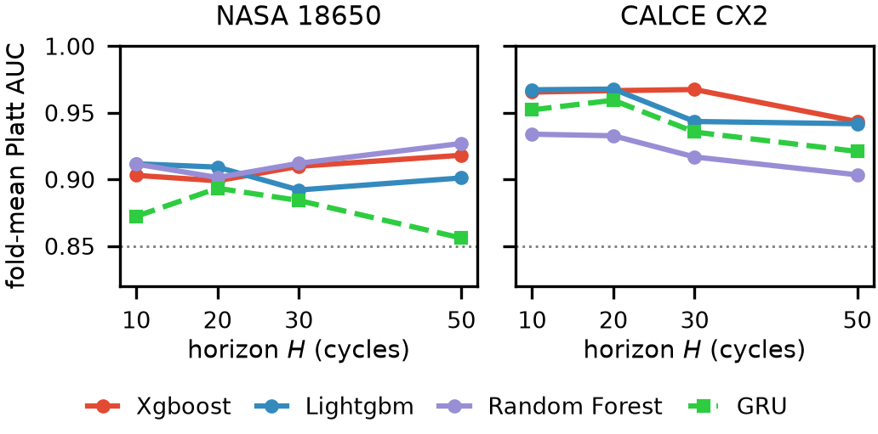
Within-dataset fold-mean Platt AUC across prediction horizons (NASA and CALCE, cell-disjoint CV).
Calibration Method Comparison (Mean Across Tree Models; Calibrators Fitted on Cross-Fitted Out-of-Fold Scores)
Dataset | Method | AUC | Brier | ECE | Slope
NASA | Isotonic | 0.854 | 0.207 | 0.151 | 0.48
NASA | Platt | 0.908 | 0.196 | 0.136 | 0.90
NASA | Temperature | 0.908 | 0.178 | 0.107 | 1.22
CALCE | Isotonic | 0.915 | 0.067 | 0.049 | 0.41
CALCE | Platt | 0.946 | 0.073 | 0.029 | 0.01
CALCE | Temperature | 0.945 | 0.080 | 0.067 | 0.53

III-B Calibration: Platt Preserves Discrimination Best
Table III compares the three calibrators. A fitted calibrator is a monotone re-mapping, so per-fold ranking is preserved up to the ties it introduces and fold-mean AUC differences are small; but isotonic’s tied step groups cost precision–recall dearly, and Platt’s fitted slope on CALCE is only 0.01 — under leave-one-cell-out the out-of-fold sigmoid washes confidence toward the base rate while preserving ranking. We therefore read the comparison as: Platt preserves discrimination best while achieving calibration error comparable to or better than isotonic — a materially weaker and more defensible claim than “Platt is the better calibrator” — and raw scores remain the safest ranking signal whenever the operating context is uncertain (Fig. 3).
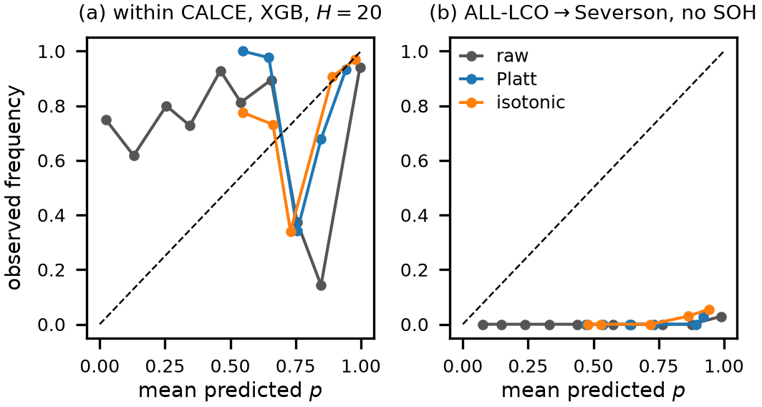
Reliability diagrams under the cross-fitted protocol. (a) Within CALCE (XGBoost, $H=20$; ECE: raw 0.11, Platt 0.04, isotonic 0.05). (b) ALL-LCO$→$Severson without SOH ($H=20$): no source-fitted calibrator lands near the diagonal on the shifted target.

III-C Cross-Dataset Transfer and the SOH Shortcut
Table IV compares transfer at $H=20$ with and without SOH as a feature; transfer is reported in raw AUC because calibration parameters are dataset-specific. With SOH included, the tree ensembles reach pooled AUC between 0.85 and 1.00. Removing SOH collapses every tree model: on NASA+CALCE$→$Oxford, XGBoost falls from 0.917 to 0.429, no no-SOH configuration exceeds 0.58 on Oxford or 0.77 on Severson, and several fall below chance — the remaining sensors rank the target distribution backwards. The GRU is highly unstable across training seeds under shift (per-cell AUC from 0.21 to 1.00 at fixed settings) and offers no transfer advantage even though it sees the same common feature set as the trees in the matched comparison.
Cross-Dataset Transfer at $H=20$: Pooled Raw AUC With and Without SOH (GRU Rows Use the Common Feature Set and Average Three Seeds)
Training | Model | Oxford (w/$−$SOH) | Severson (w/$−$SOH)
NASA | XGBoost | 0.957 / 0.518 | 0.871 / 0.595
NASA | LightGBM | 1.000 / 0.533 | 0.849 / 0.527
NASA | Random Forest | 1.000 / 0.521 | 0.861 / 0.674
NASA | GRU | 0.143 / 0.152 | 0.832 / 0.766
CALCE | XGBoost | 0.850 / 0.416 | 0.850 / 0.682
CALCE | LightGBM | 0.889 / 0.462 | 0.863 / 0.643
CALCE | Random Forest | 0.850 / 0.501 | 0.902 / 0.665
CALCE | GRU | 0.120 / 0.100 | 0.777 / 0.524
NASA+CALCE | XGBoost | 0.917 / 0.429 | 0.896 / 0.750
NASA+CALCE | LightGBM | 0.971 / 0.332 | 0.882 / 0.718
NASA+CALCE | Random Forest | 0.989 / 0.581 | 0.889 / 0.746
NASA+CALCE | GRU | 0.053 / 0.015 | 0.799 / 0.748
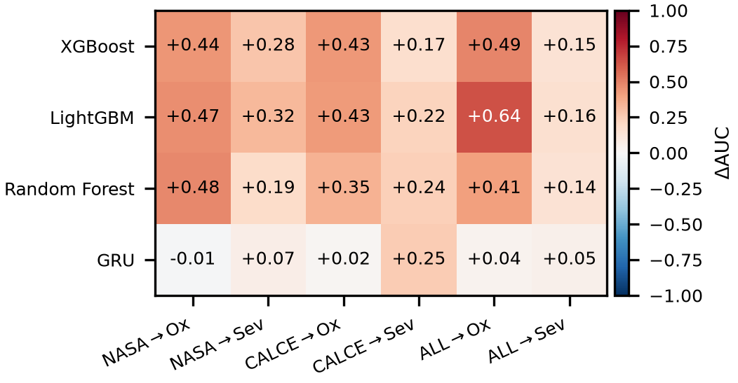
Transferability collapse map at $H=20$: AUC drop from removing SOH, per source$→$target pair and model.
A first control is the distance-to-threshold rule $0.80−SOH$, which involves no fitting at all: it transfers to Severson at pooled AUC 0.912 (95% CI [0.84, 1.00]) for the ALL-LCO source — within the confidence range of the tuned ensembles — so most of the apparent transfer is the SOH coordinate itself. The remaining controls are the subject of the next subsection.

III-D Failure-Definition Ablation and Same-Chemistry Controls
The ablation of Table V relabels failure by a single endpoint at a time — SOH $≤0.80$ only, voltage sag only, or both — and its signature is clean: with-SOH transfer tracks how much SOH defines the label. Under an SOH-only label (the model is, in effect, reading the label criterion) transfer to Severson saturates at 0.985; under the combined label it is 0.896; relabeling by voltage sag alone, a criterion SOH takes no part in, cuts it to 0.723 — a drop of roughly a quarter. The residual with-SOH advantage under the voltage label (0.723 versus 0.611 without SOH) is consistent with genuine but weak health-state information: cells far below nominal capacity do fail sooner under almost any definition.
Failure-Definition Ablation at $H=20$ (XGBoost, ALL-LCO Source): Pooled Raw AUC With and Without SOH as a Feature
Label endpoint | Oxford w/ SOH | Oxford no SOH | Severson w/ SOH | Severson no SOH
Combined (SOH or sag) | 0.917 | 0.429 | 0.896 | 0.750
SOH only | 0.995 | 0.464 | 0.985 | 0.759
Voltage sag only | — | — | 0.723 | 0.611
Same-Chemistry Cross-Laboratory Controls at $H=20$ (XGBoost): Pooled Raw AUC With and Without SOH
Pair | w/ SOH | no SOH
NASA$→$CALCE (LCO$→$LCO) | 0.870 | 0.849
CALCE$→$NASA (LCO$→$LCO) | 0.543 | 0.566
Severson$→$Oxford (LFP$→$LFP) | 0.997 | 0.471
Oxford$→$Severson (LFP$→$LFP) | 0.688 | 0.500
If the collapse were a chemistry effect, transfer should survive when chemistry is held constant; Table VI shows it does not. Severson$→$Oxford (both LFP) reproduces the full pattern of the cross-chemistry shifts — 0.997 with SOH collapsing to 0.471 without, an inverted 0.428 on the common feature set — and NASA$→$CALCE (both LCO) behaves like the cross-chemistry pairs. Conversely, CALCE$→$NASA stays near chance even with SOH, showing that a small, heterogeneous source limits transfer in both directions. The supported conclusion is deliberately narrower than “SOH is chemistry-specific”: much of the observed cross-dataset, cross-chemistry discrimination is attributable to SOH, partly because SOH defines the failure criterion itself, and same-chemistry controls attribute the collapse to dataset shift at least as much as to chemistry.

III-E Multi-Horizon Analysis, Monotonicity, and a Discrete-Time Hazard Model
Across the fixed-horizon classifiers, fold-mean AUC varies by less than 0.05 over $H∈\{10,20,30,50\}$ on both training datasets (Fig. 2), with slightly larger variation at short horizons due to class imbalance. Because the four horizons are independent classifiers, however, cumulative risk coherence is not guaranteed: the requirement $P_{10}≤P_{20}≤P_{30}≤P_{50}$ is violated in 32–45% of within-dataset rows and up to 96% of rows on the transferred Severson target — for a hazard-style output, an incoherent quantity to quote to an operator.
Fixed-Horizon XGBoost Versus the Discrete-Time Hazard Model (Survival Product), Fold-Mean AUC Within Dataset and Pooled Raw AUC on Transfer at $H=20$ (Both With SOH)
Setting | Fixed $H=20$ | Hazard $H=20$ | Fixed $H=50$ | Hazard $H=50$
NASA | 0.899 | 0.935 | 0.918 | 0.927
CALCE | 0.967 | 0.893 | 0.943 | 0.889
NASA$→$Oxford | 0.957 | 0.971
NASA$→$Severson | 0.871 | 0.884
CALCE$→$Oxford | 0.850 | 0.466
CALCE$→$Severson | 0.850 | 0.737
NASA+CALCE$→$Oxford | 0.917 | 0.314
NASA+CALCE$→$Severson | 0.896 | 0.866
We therefore also fit an explicit discrete-time hazard model. For each observed cycle $t$ and offset $ℓ∈\{1,…,L\}$ with $L=50$, the hazard conditional on the features measured at $t$ (operational: no future measurements) is
$$h_{ℓ}(t)=P\left(T_{f}=t+ℓ∣T_{f}≥t+ℓ, x_{t}\right), \text{(7)}$$
estimated by one pooled classifier on the offset-expanded at-risk training rows $(x_{t},ℓ)$ with $ℓ$ as an additional input feature. Cumulative failure risk follows the survival product
$$R(t,H)=1−\prod_{ℓ=1}^{H}{\left(1−{\hat{h}}_{ℓ}(t)\right)}, \text{(8)}$$
which is monotone non-decreasing in $H$ by construction and yields all four horizons from a single fit (Table VII). Within datasets the survival product matches the fixed-horizon classifier at no cost. Under transfer it inherits the same SOH dependence as every other model — formulating the output does not exempt the inputs from dataset shift — and behaves source-dependently (0.97 down to 0.31 pooled on Oxford), but it removes the monotonicity incoherence entirely: its violation rate is zero by construction.

III-F Operational Cost Analysis
AUC treats all errors as equal; a BMS does not. We select the decision threshold on source out-of-fold scores with a 10% false-alarm budget and apply it unchanged to the target (Table VIII). On Severson with SOH, the transferred threshold misses 32% of target failures while holding false alarms to 4%; without SOH the miss rate more than doubles to 70% with the full budget spent, and calibrated scores differ only marginally — under shift the ranking is the asset and the ranking is what collapsed. On Oxford, nearly every row is positive under the coarse pooled labels, so no discriminating operating point exists at all (Section II-B).
Operational Evaluation at $H=20$ (XGBoost, ALL-LCO Source): Threshold Selected on Source Out-of-Fold Scores With a 10% False-Alarm Budget, Then Applied Unchanged to the Target — Target FNR% / FPR%
Target | Features | raw | Platt | Isotonic
Oxford | with SOH | 0 / 93 | 0 / 93 | 0 / 93
Oxford | no SOH | 0 / 92 | 0 / 92 | 0 / 92
Severson | with SOH | 32 / 4 | 32 / 4 | 31 / 6
Severson | no SOH | 70 / 10 | 70 / 10 | 67 / 12
SOH Ablation at $H=20$ (ALL-LCO Source): Pooled AUC With and Without SOH, Paired Cell-Level Bootstrap 95% CI on the Difference (Primary), and Cycle-Level DeLong $p$-Value (Secondary; Inflated by Within-Cell Correlation)
Target | Model | w/ SOH | w/o | $Δ$AUC [CI] | DeLong $p$
Oxford | XGBoost | 0.917 | 0.429 | +0.488 (5 cells) | $7.2e−51$
Oxford | LightGBM | 0.971 | 0.332 | +0.639 (5 cells) | $2.6e−64$
Oxford | Random Forest | 0.989 | 0.581 | +0.409 (5 cells) | $6.5e−36$
Severson | XGBoost | 0.896 | 0.750 | +0.146 [0.10, 0.23] | $<{10}^{−300}$
Severson | LightGBM | 0.882 | 0.718 | +0.164 [0.13, 0.23] | $<{10}^{−300}$
Severson | Random Forest | 0.889 | 0.746 | +0.143 [0.11, 0.23] | $<{10}^{−300}$
Table IX states the central comparison with the cell as the experimental unit. On Severson the bootstrap interval on $Δ$AUC excludes zero by a wide margin for every model; on Oxford the equivalent interval is uninformative (five cells, effectively four) and we say so rather than lean on the astronomically small cycle-level DeLong $p$-values, which are inflated by pseudoreplication. Within-dataset model comparisons at $H=20$ are mostly not significant after honest accounting (DeLong on pooled rows: XGBoost vs. LightGBM $1.4×{10}^{−2}$ on NASA, $6.9×{10}^{−28}$ on CALCE; XGBoost vs. Random Forest $3.3×{10}^{−1}$ and $8.5×{10}^{−1}$), so no architecture superiority is claimed.

IV. Conclusion
This paper presented a multi-horizon failure-risk framework for predicting lithium-ion battery failure across multiple datasets and chemistries, and used it to run a validity analysis rather than only a benchmark. Under cell-disjoint evaluation with leakage-free cross-fitted calibration, within-dataset performance is uniformly strong (fold-mean AUC $≥0.85$ in all 32 model–horizon–dataset combinations). The cross-dataset results support a narrower and more useful conclusion than apparent transfer success suggests: much of the observed cross-dataset, cross-chemistry discrimination is attributable to SOH — partly because SOH defines the failure criterion itself, which the failure-endpoint ablation quantifies — rather than to degradation information in the remaining measured features, and same-chemistry controls attribute the collapse to dataset shift at least as much as to chemistry. Platt scaling preserves discrimination best at comparable calibration error, though no source-fitted calibrator repairs calibration on the shifted target.
Several limitations bound these claims: the fixed-horizon classifiers have no enforced monotonicity across horizons; Oxford’s coarse 100-cycle sampling limits it to pooled-detection use; CALCE contributes only seven cells; cross-chemistry evaluation covered LCO and LFP only; and all datasets are laboratory-scale. Future work will extend the framework to minimal-feature baselines as standard practice, controlled same-laboratory cross-chemistry campaigns, continuous time-to-failure modeling, and validation on large-scale industrial datasets.

Acknowledgment
The authors would like to acknowledge the use of writing-support and language-enhancement tools, including OpenAI ChatGPT, Grammarly, and QuillBot, during the preparation of this manuscript. These tools were used to assist with grammar correction, readability improvement, language refinement, and sentence restructuring. All technical content, analysis, interpretations, and research contributions are those of the authors.
M. Berecibar, I. Gandiaga, I. Villarreal, N. Omar, J. Van Mierlo, and P. Van den Bossche, “Critical review of state of health estimation methods of Li-ion batteries for real applications,” Renewable and Sustainable Energy Reviews, vol. 56, pp. 572–587, 2016, doi: 10.1016/j.rser.2015.11.042.
G. Xu, J. Xu, and Y. Zhu, “LSTM-based estimation of lithium-ion battery SOH using data characteristics and spatio-temporal attention,” PLoS ONE, vol. 19, no. 12, Art. no. e0312856, 2024, doi: 10.1371/journal.pone.0312856.
B. Bairwa, K. Pareek, and V. K. Jadoun, “Cycle based state of health estimation of lithium-ion cells using deep learning architectures,” Scientific Reports, vol. 15, Art. no. 37078, 2025, doi: 10.1038/s41598-025-20995-7.
T. Tetik, “Feature engineering and explainable artificial intelligence for state of health estimation of lithium-ion batteries,” Journal of Energy Storage, vol. 144, Art. no. 119873, 2026, doi: 10.1016/j.est.2025.119873.
S. Jin, X. Sui, X. Huang, S. Wang, R. Teodorescu, and D.-I. Stroe, “Overview of machine learning methods for lithium-ion battery remaining useful lifetime prediction,” Electronics, vol. 10, no. 24, Art. no. 3126, 2021, doi: 10.3390/electronics10243126.
Y. Li, H. Shi, S. Wang, Q. Huang, C. Liu, S. Nie, X. Jia, and T. Luo, “A comprehensive review of remaining useful life prediction methods for lithium-ion batteries: Models, trends, and engineering applications,” Journal of Energy Chemistry, vol. 112, pp. 384–414, 2026, doi: 10.1016/j.jechem.2025.08.056.
A. Thelen, X. Huan, N. Paulson, S. Onori, Z. Hu, and C. Hu, “Probabilistic machine learning for battery health diagnostics and prognostics—review and perspectives,” npj Materials Sustainability, vol. 2, Art. no. 14, 2024, doi: 10.1038/s44296-024-00011-1.
H. Li, “Battery health prediction of new energy vehicles based on LightGBM,” in Proc. Int. Workshop on Advances in Deep Learning for Image Analysis and Computer Vision (IWADIC 2025), 2026, pp. 80–89, doi: 10.2991/978-94-6239-648-7_10.
Z. Wang, Q. Ma, and Y. Guo, “Remaining useful life prediction of lithium-ion batteries based on deep learning and soft sensing,” Actuators, vol. 10, no. 9, Art. no. 234, 2021, doi: 10.3390/act10090234.
A. Rastegarpanah, M. E. Asif, and R. Stolkin, “Hybrid neural networks for enhanced predictions of remaining useful life in lithium-ion batteries,” Batteries, vol. 10, no. 3, Art. no. 106, 2024, doi: 10.3390/batteries10030106.
L. Sun, X. Huang, J. Liu, J. Song, and S. Wu, “Remaining useful life prediction of lithium batteries based on jump connection multi-scale CNN,” Scientific Reports, vol. 15, Art. no. 32873, 2025, doi: 10.1038/s41598-025-08619-6.
R. Ibraheem, T. I. Cannings, T. Sell, and G. dos Reis, “Robust survival model for the prediction of Li-ion battery lifetime reliability and risk functions,” Energy and AI, vol. 19, Art. no. 100465, 2025, doi: 10.1016/j.egyai.2024.100465.
T. Li, Z. Zhou, A. Thelen, D. A. Howey, and C. Hu, “Predicting battery lifetime under varying usage conditions from early aging data,” Cell Reports Physical Science, vol. 5, no. 4, Art. no. 101891, 2024, doi: 10.1016/j.xcrp.2024.101891.
J. Yao, Q. Gao, T. Gao, B. Jiang, and K. M. Powell, “A physics-guided machine learning approach to capacity fading mechanism detection and fading rate prediction using early cycle data,” Batteries, vol. 10, no. 8, Art. no. 283, 2024, doi: 10.3390/batteries10080283.
H. Pang, X. Qu, K. Chen, X. Yan, A. F. Burke, and J. Zhao, “A transferable deep learning framework for cross-chemistry and cross-scale state of health estimation in lithium-ion batteries,” Energy, vol. 354, Art. no. 141079, 2026, doi: 10.1016/j.energy.2026.141079.
J. C. Platt, “Probabilistic outputs for support vector machines and comparisons to regularized likelihood methods,” in Advances in Large Margin Classifiers, Cambridge, MA, USA: MIT Press, 1999, pp. 61–74.
B. Zadrozny and C. Elkan, “Transforming classifier scores into accurate multiclass probability estimates,” in Proc. 8th ACM SIGKDD Int. Conf. Knowledge Discovery and Data Mining, Edmonton, AB, Canada, 2002, pp. 694–699.
M. Goldstein, X. Han, A. Puli, and R. Ranganath, “X-CAL: Explicit calibration for survival analysis,” in Advances in Neural Information Processing Systems 33 (NeurIPS 2020), 2020, pp. 12759–12771.
S. M. Lundberg and S.-I. Lee, “A unified approach to interpreting model predictions,” in Advances in Neural Information Processing Systems 30 (NeurIPS 2017), 2017, pp. 4768–4777.
G. dos Reis, C. Strange, M. Yadav, and S. Li, “Lithium-ion battery data and where to find it,” Energy and AI, vol. 5, Art. no. 100081, 2021, doi: 10.1016/j.egyai.2021.100081.
D. Li, J. Nan, A. F. Burke, and J. Zhao, “Battery prognostics and health management: AI and big data,” World Electric Vehicle Journal, vol. 16, no. 1, p. 10, 2025, doi: 10.3390/wevj16010010.
E. R. DeLong, D. M. DeLong, and D. L. Clarke-Pearson, “Comparing the areas under two or more correlated receiver operating characteristic curves: A nonparametric approach,” Biometrics, vol. 44, no. 3, pp. 837–845, 1988.
K. A. Severson, P. M. Attia, N. Jin, et al., “Data-driven prediction of battery cycle life before capacity degradation,” Nature Energy, vol. 4, pp. 383–391, 2019, doi: 10.1038/s41560-019-0356-8.
B. Saha and K. Goebel, “Battery Data Set,” NASA Ames Prognostics Data Repository, NASA Ames Research Center, Moffett Field, CA, USA, 2007.
CALCE Battery Research Group, “Battery aging datasets,” Center for Advanced Life Cycle Engineering, Univ. of Maryland, College Park, MD, USA, 2023.
D. Howey and C. Birkl, “Oxford Battery Degradation Dataset 1,” Univ. of Oxford, Oxford, U.K., 2017.

