Quantization and Sampling Effects in a Digitally Controlled PID Buck-Boost Converter: A Simulation Study
Syeda Salsabil Islam Ariya and Jasimul Islam Chowdhury and Hussain Touhid Siddiquee

Introduction
Digital control loops are now standard in switching power converters, driven by programmability, immunity to analog component drift, and integration with digital loads . The complete digital loop contains two unavoidable quantizers: the analog-to-digital converter (ADC) that samples the output voltage, and the digital pulse-width modulator (DPWM) that resolves the duty ratio. Their resolutions, together with the sampling period of the controller, jointly determine regulation quality. Classic work established that coarse quantization causes steady-state limit cycling and conditions between DPWM and ADC resolution for its elimination , while quantization-effect modeling permits quantitative prediction of these oscillations . Recent work extends the analysis to MHz-range GaN converters using dither and sigma-delta modulation and to design guidelines for two-loop current-mode digital controllers .
Digital control relieves the analog constraints of passive compensation, enables programmability and auto-tuning, and integrates naturally with digital loads . In exchange, the designer accepts three implementation-quantized quantities that an analog loop never sees: the ADC resolution of the measured output, the DPWM resolution of the commanded duty, and the sampling period at which controller and power stage are synchronized.
The theoretical basis is well established. Peterchev and Sanders derived conditions on ADC/DPWM resolution trade-offs for limit-cycle elimination and introduced digital dither to recover effective DPWM resolution . Peng, Prodić, Alarcón, and Maksimović derived static and dynamic quantization models explaining the origins of limit-cycle oscillations , and Maksimović and Zane provided the small-signal discrete-time framework used to design digitally controlled converters . A fuller survey appears in . On the application side, low-resolution non-uniform ADC quantization has been shown to improve dynamic response , and the full control loop benefits from predictive structures .
Two observations motivate this work. First, most quantization studies isolate a single stage, whereas a practical controller is constrained in all three quantities simultaneously; the interaction between sampling period, ADC word length, and PWM word length is rarely treated as one design problem. Second, the buck-boost converter, whose inverted output and non-minimum phase control path make regulation inherently harder, is underrepresented in the digital-control literature: most buck-boost-specific digital studies consider time-domain or PID structures at a single resolution and do not sweep the full implementation space. The classical converter model itself is textbook material .
This paper reports a controlled simulation study of a digitally controlled inverting buck-boost converter under simultaneous quantization of sampling period, ADC resolution, and PWM resolution. Contributions: (1) a 79-run factorial study that separates the individual effect of each quantizer from their combined effect and locates the critical sampling boundary; (2) an objective worst-case selection made after the sweep, not a priori; (3) the identification of a half-scale ADC coincidence ($V_{ref}=−FS/2$) that masks steady-state error at low ADC resolutions; (4) formal evidence that interactions between the three stages amplify beyond additivity, quantified by an interaction index; (5) design guidance linking sampling period and resolution choices, summarized as a performance map; and (6) operating-point robustness checks confirming the conclusions away from the nominal point. Section II develops the converter and controller models; Section III defines the experimental protocol; Section IV presents results; Section V discusses design implications; Section VI concludes.

System Model and Digital Control
The plant is an ideal inverting buck-boost converter (Fig. 1) with input $V_{in}=+12$ V, reference $V_{ref}=−12$ V, $L=100 μ$H, $C=220 μ$F, switching frequency $f_{sw}=100$ kHz ($T_{sw}=10 μ$s), and load $R=10 Ω$.
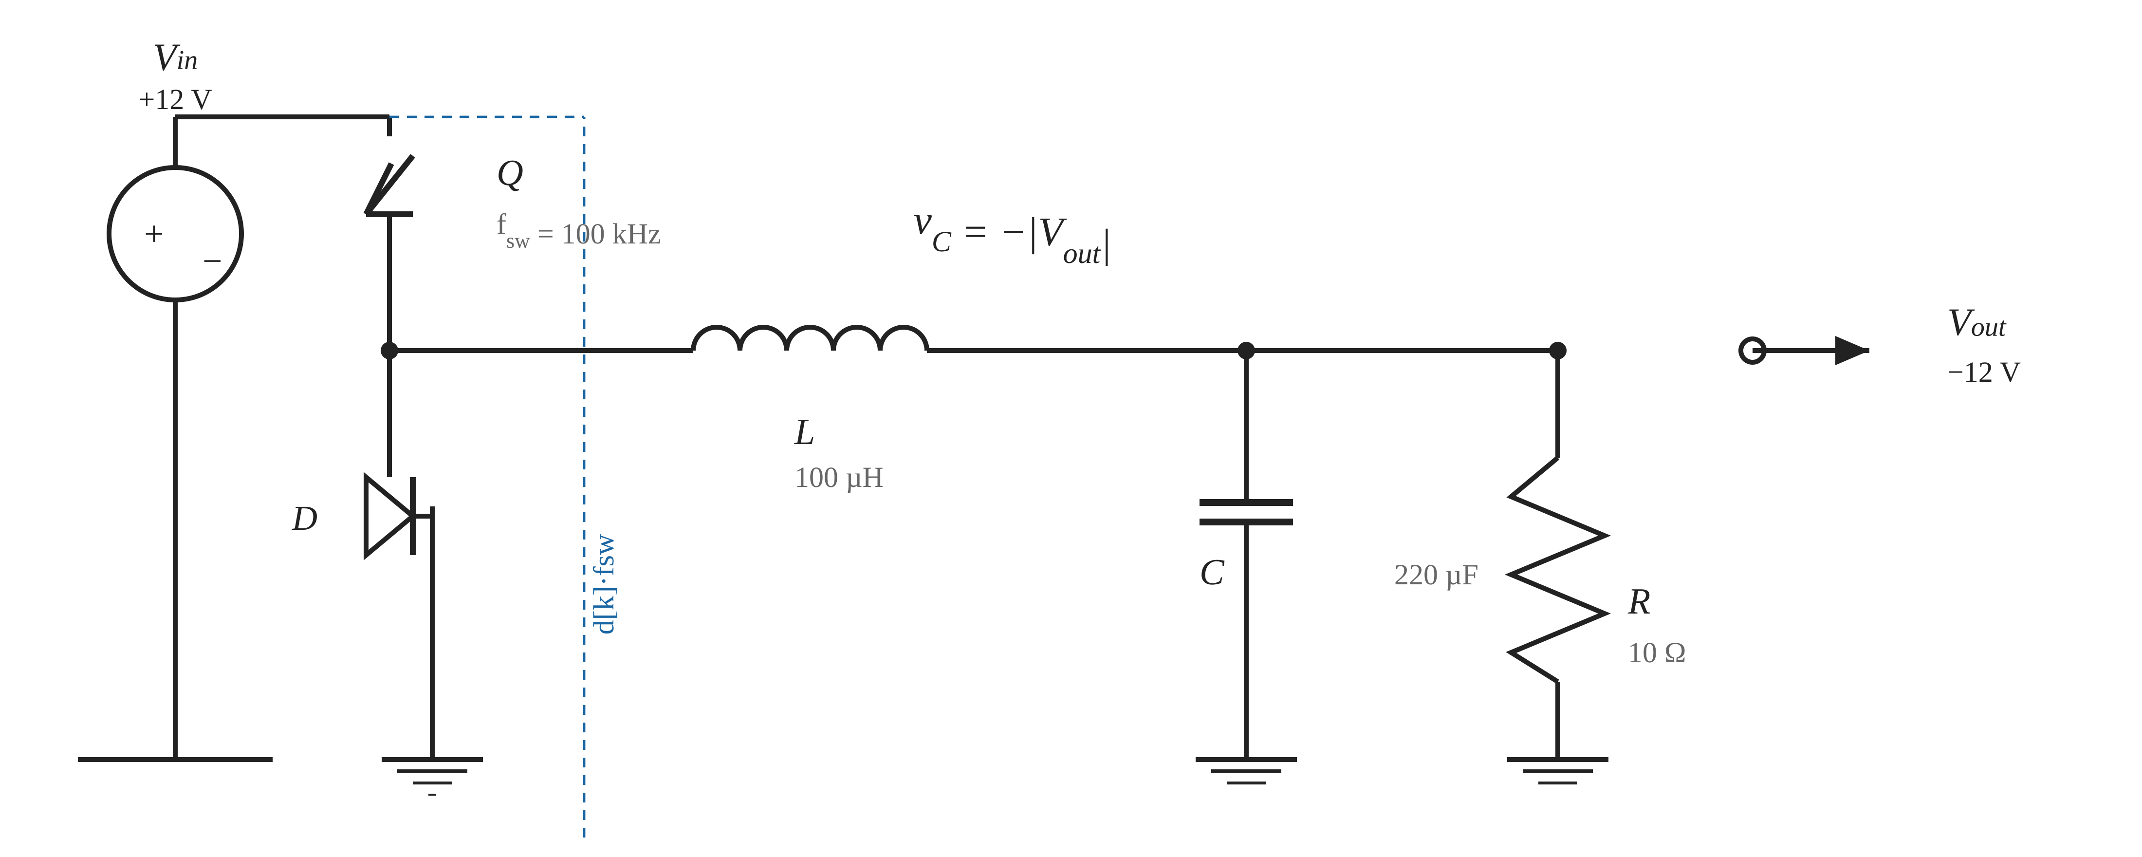
Inverting buck-boost power stage used in the study ($V_{in}=+12$ V, $L=100 μ$H, $C=220 μ$F, $f_{sw}=100$ kHz, $R=10 Ω$; output $V_{out}≈−12$ V at $D=0.5$).
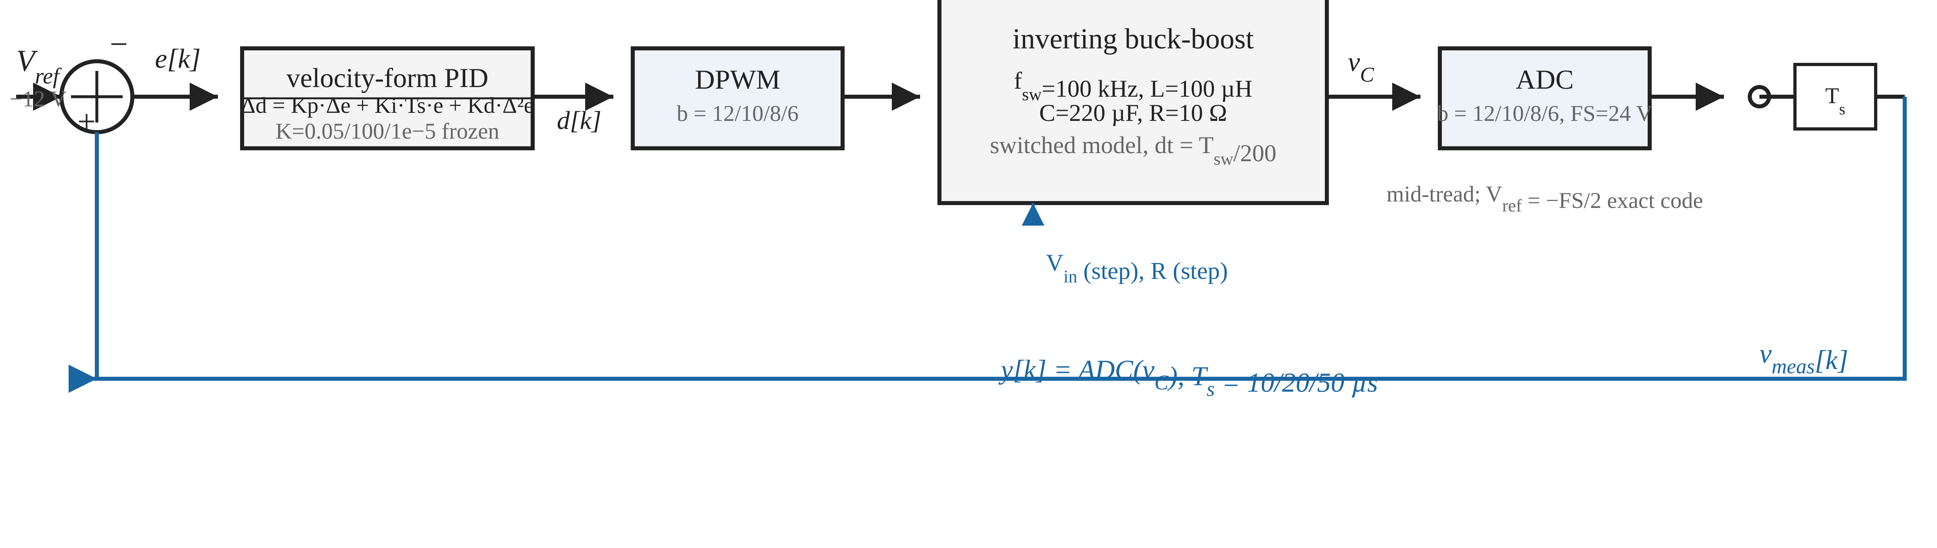
Digital control loop: velocity-form PID, DPWM and ADC quantizers ($b∈\{12,10,8,6\}$ bit, FS = 24 V), and sampling at $T_{s}=10/20/50 μ$s. The reference sits exactly at the half-scale code $V_{ref}=−FS/2$.
During OFF, the inductor current is held at zero when it would otherwise reverse (zero-current boundary), which counts discontinuous-mode (DCM) cycles and keeps the model valid in DCM without clamping the output. Many simplified studies go silent on this point. All reported results are obtained on this switched-state model, not on an averaged approximation, so quantization artifacts (limit cycles, DCM chatter) appear faithfully.
$$\text{ON:} \frac{di_{L}}{dt}=\frac{+V_{in}}{L}, \frac{dv_{C}}{dt}=−\frac{v_{C}}{RC}$$
$$\text{OFF:} \frac{di_{L}}{dt}=\frac{v_{C}}{L}, \frac{dv_{C}}{dt}=−\frac{i_{L}+v_{C}/R}{C}$$

Digital Controller and Quantization
A velocity-form digital PID with positive gains (Fig. 2) operates at the sampling period $T_{s}$:
$$d[k]=d[k−1]+K_{p}\left(e[k]−e[k−1]\right)+K_{i}T_{s} e[k]+\frac{K_{d}}{T_{s}}\left(e[k]−2e[k−1]+e[k−2]\right)$$
with $e[k]=v_{meas}[k]−V_{ref}$, duty saturated to $[0.05, 0.95]$, and no separate integrator state (inherent anti-windup). The measurement, duty, and update cadence are each quantized independently:
- Sampling: the controller updates every $T_{s}∈\{T_{sw}, 2T_{sw}, 5T_{sw}\}$ (10, 20, 50 $μ$s);
ADC: mid-tread quantizer, full-scale $FS=24$ V, 12/10/8/6 bits. Note $V_{ref}=−FS/2$, so the reference is exactly representable at every resolution;
PWM: duty quantized to $2^{b}$ levels, $b∈\{12,10,8,6\}$.
A continuous-ideal baseline recomputes the same PID every $dt$ with no quantization (true analog reference). The frozen controller gains were obtained once, deterministically, before any quantization study: grid search over $K_{p}∈\{0.005,0.01,0.02,0.05\}$, $K_{i}∈\{20,100,500,2000\}$, $K_{d}∈\{0,2×{10}^{−6},{10}^{−5}\}$ with cost $J=o_{v}/10+t_{s}/5 \text{ms}+\text{IAE}/0.05$ under constraints overshoot $≤10\%$ and $|e_{ss}|≤60$ mV, re-validated on the switched model: $K_{p}=0.05$, $K_{i}=100.0$, $K_{d}={10}^{−5}$. No parameter was touched during the quantization study.

Simulation Framework
The study executes 79 simulations (Table [tab:plan]): the continuous baseline, the ideal digital controller ($T_{s}=T_{sw}$, 16-bit ADC, 16-bit PWM), three sampling-only points, a six-point focused sampling sweep across the critical boundary, four ADC-only, four PWM-only runs, the full $3×4×4$ factorial sweep (48 runs), six disturbance runs (input step $12→9$ V and load step $10→5 Ω$, applied at $t=60$ ms, on the continuous baseline, the ideal digital controller, and the objectively selected worst configuration), and six operating-point robustness runs ($V_{in}=10,15$ V on three configurations).
Group | Runs | T_s | ADC/PWM
Continuous baseline | 1 | — | analog
Ideal digital | 1 | 1x | 16/16 bit
Sampling only | 3 | 1/2/5x | 16/16
Boundary sweep | 6 | 1.5-4x | 16/16
ADC only | 4 | 1x | 12/10/8/6, 16
PWM only | 4 | 1x | 16, 12/10/8/6
Factorial sweep | 48 | all | all
Disturbances | 6 | selected | 3 configs
Op-point robustness | 6 | selected | 3 configs
Metrics: 2\% settling time, overshoot, steady-state error, peak-to-peak ripple (limit cycle), IAE, ITAE, and DCM-cycle count. For disturbance runs all metrics are evaluated on the post-step 60 ms window and ripple on its final 50\%. The worst configuration is selected objectively after the sweep, as the run with the largest normalized degradation of steady-state error, IAE, and limit cycle relative to the ideal digital controller. No configuration is pre-declared worst.

Results

Continuous versus Ideal Digital
The conversion from analog to ideal digital control already costs measurable quality (Table [tab:base]): the 16-bit/one-cycle system settles 36\% slower (2.66 vs 1.96 ms) and shows a 12.76 mV steady-state offset and 39.6 mV limit cycle against the continuous 0.44 mV / 26.7 mV. The 12.8 mV floor is the quantization-limited operating point for these gains; every further result is expressed relative to it.
 | Continuous | Ideal digital
Settling (ms) | 1.96 | 2.66
Overshoot (%) | 0.07 | 0.02
|e_ss| (mV) | 0.44 | 12.76
Limit cycle (mV) | 26.7 | 39.6
IAE | 0.0058 | 0.0109
DCM cycles | 0 | 0

Individual Stage Effects
Fig. 3 isolates the sampling stage at 16-bit resolution and locates the critical boundary. Settling degrades smoothly as $T_{s}/T_{sw}$ rises from 1 to 3.5 (2.66 to 6.38 ms, all still regulation-valid), then the loop loses regulation outright at $4×$: it never settles, the limit cycle jumps to 1.59 V, and 101 736 DCM cycles accrue in 60 ms. The practical boundary therefore sits between $3.5×$ and $4×T_{sw}$ (35–40 $μ$s); $T_{s}=5T_{sw}$ fails in every configuration, alone or combined.
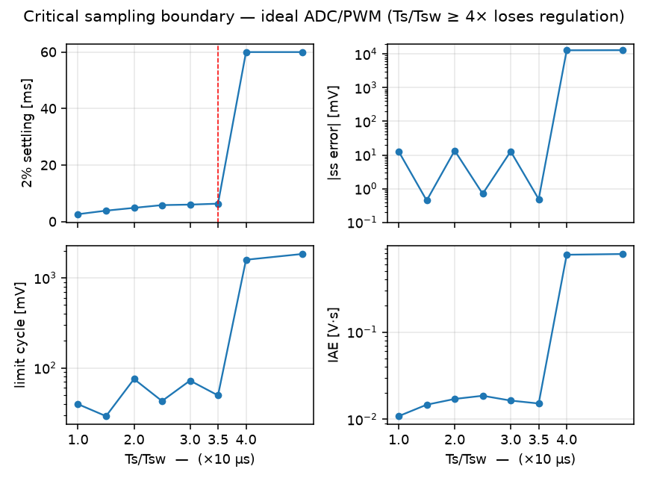
Sampling-period boundary sweep at 16-bit ADC/PWM: settling time, steady-state error, limit cycle, and IAE versus $T_{s}/T_{sw}$. Regulation is lost between $3.5×$ and $4×T_{sw}$.
ADC resolution couples to the reference in a subtle way (Fig. 4): because $V_{ref}=−FS/2$ is exactly representable, the 8-bit and 6-bit ADCs lock onto the exact code and reduce the measured steady-state error to 0.44 mV while masking a worse transient (overshoot rises from 0.06\% at 12-bit to 0.85\% at 6-bit; settling from 2.70 to 3.49 ms). This is a half-scale coincidence, not an ADC benefit.
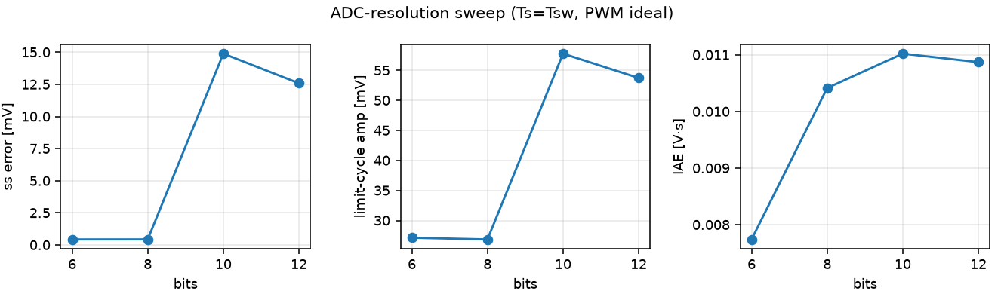
PWM resolution below 8 bits dominates the limit cycle (Fig. 5): 6-bit PWM adds a 204.8 mV ripple versus $≈$39.5 mV at 12/10/8-bit. Duty quantization is the direct source of steady-state ripple, as predicted by limit-cycle analysis ; at 6-bit the DPWM step is $2/64=31.25$ mV of duty, which maps through the control-to-output gain into the observed 204.8 mV ripple. This is precisely the regime addressed by finer DPWM controller implementations and by noise-shaping modulators .
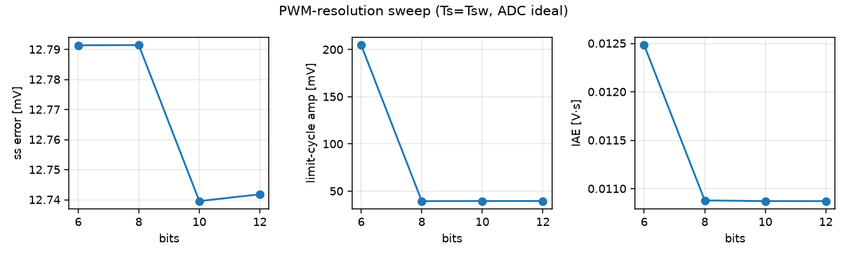

Combined Sweep and Interactions
In the 48-run factorial sweep the worst configuration is $T_{s}=5T_{sw}$, ADC=8-bit, PWM=12-bit (normalized degradation score 1309.2): settling never completes within 60 ms, steady-state error $−13.43$ V, limit-cycle amplitude 7.33 V, IAE 0.789, 127 075 DCM cycles. Fig. 6 classifies every combination against explicit thresholds (settling $≤6$ ms, $|e_{ss}|≤120$ mV, limit cycle $≤120$ mV, overshoot, DCM) into excellent / acceptable / marginal / unusable. Sampled at $T_{s}=T_{sw}$, 13 of 16 combinations are excellent and the rest acceptable; at $2×$ all are acceptable or marginal; at $5×$ all 16 are unusable.
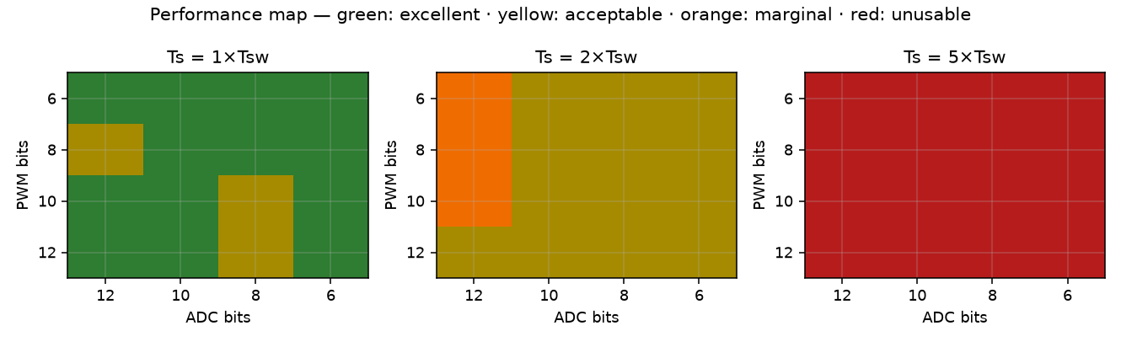
Performance map of the 48-run sweep. Thresholds: excellent ($t_{settle}≤4$ ms, $|e_{ss}|≤60$ mV, LC $≤60$ mV, ov $≤5\%$), acceptable ($t_{settle}≤6$ ms, $|e_{ss}|,\text{LC}≤120$ mV), marginal, unusable ($t_{settle}≥50$ ms).
The worst configuration is far worse than any individual degradation: $−13.43$ V versus the $−13.07$ V of sampling alone, but with 127 075 DCM cycles and a 7.33 V limit cycle that the sampling-only run does not exhibit. The super-additivity is quantitative: with $D$ the normalized partial degradation (steady-state error, IAE, and limit cycle relative to the ideal digital controller), the individual terms are $D_{sampling}(5×)=1141.6$, $D_{ADC}(8\text{-bit})=0.6$, and $D_{PWM}(12\text{-bit})=0.0$; the additive prediction is 1142.2, whereas the measured combined degradation is $D_{total}=1309.2$, an interaction of $+167$ ($+15\%$). The 8-bit ADC coincidence, harmless alone, converts a slowly sampling loop into deep limit-cycle chatter once the 12-bit PWM pulls the operating point across the coincidence.

Disturbance Rejection
Table [tab:dist] summarizes the six disturbance runs (step at $t=60$ ms; recovery time $=t_{settle}−60$ ms). Both healthy controllers reject input and load steps in under 1.5 ms with negligible IAE. The worst configuration never re-regulates within the observation window: it settles into deep DCM chatter with $>$5 V of steady-state error and over 160 000 DCM cycles per event (Fig. 7).
Config | Event | Recovery | |e_ss| / IAE
Continuous | Vin step | 1.43 ms | 0.0 mV / 0.0014
Continuous | Load step | 0.94 ms | 0.3 mV / 0.0013
Ideal dig. | Vin step | 0.92 ms | 14.9 mV / 0.0017
Ideal dig. | Load step | 0.84 ms | 26.1 mV / 0.0019
Worst | Vin step | never | 8.9 V / 0.535
Worst | Load step | never | 5.9 V / 0.353
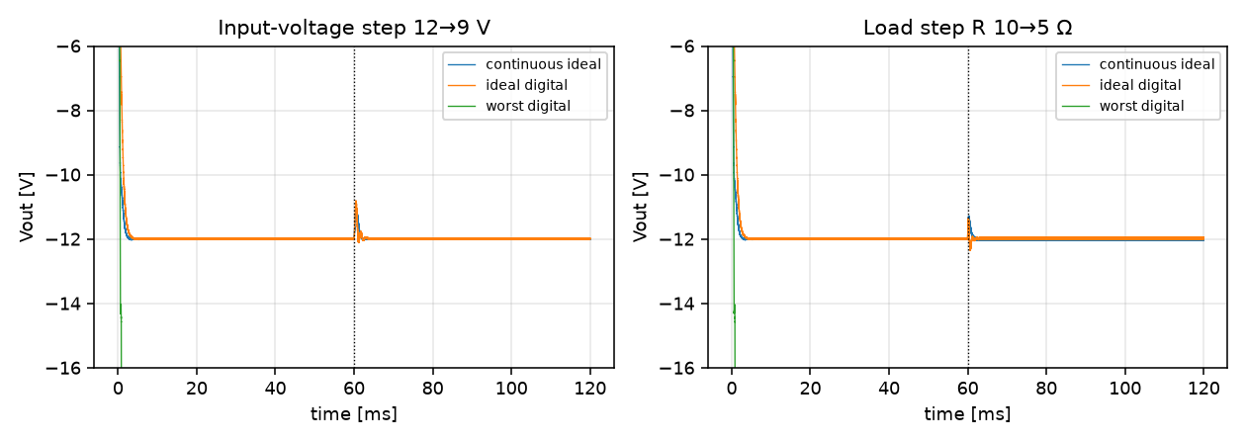

Operating-Point Robustness
The main conclusions are not an artifact of the single nominal point ($V_{in}=12$ V, $V_{ref}=−12$ V, $R=10 Ω$). Table [tab:op] repeats the ideal, a representative good ($1×$, 10-bit, 10-bit), and a representative poor ($2×$, 6-bit, 6-bit) configuration at $V_{in}=10$ and 15 V with the same frozen gains. Ideal and good configurations retain full regulation (2.5–2.7 ms settling, sub-100 mV limit cycle) across the input range. The poor configuration holds at $10$ and $12$ V but degrades sharply at $V_{in}=15$ V. It settles only at the very edge of the 60 ms window (59.3 ms), with a 561 mV limit cycle and 18 DCM excursions. Marginal designs are therefore operating-point sensitive, not merely sampling-sensitive.
config | 10 V | 12 V | 15 V
ideal (1×,16,16) | 2.74 / 67.9 | 2.66 / 39.6 | 2.55 / 28.9
good (1×,10,10) | 2.69 / 28.6 | 2.64 / 57.8 | 2.52 / 80.6
poor (2×,6,6) | 5.40 / 28.9 | 5.11 / 27.7 | 59.3 / 561*

Embedded Implementation Feasibility
To test whether the quantized controller of Section~II is realizable in hardware, the velocity-form PID and the mid-tread ADC/DPWM quantizers were ported to an ESP32-S3 (240 MHz) under the Arduino core and executed on the bench. The plant is emulated in feedback with two pins: a 100 kHz LEDC PWM output on GPIO2 is wired directly to ADC1 input GPIO1, so the sensed pin voltage is the duty-scaled rail voltage, mapped into the paper’s $V_{ref}=−12$ V, $FS=24$ V frame by the inverting gain $V_{out}=−V_{pin}⋅24/3.3$. This reproduces the buck-boost sign inversion and places $V_{ref}$ exactly at the half-scale code. The loop runs identical arithmetic: 8-bit mid-tread ADC quantization, velocity-form PID with the paper’s gains, and 8-bit DPWM quantization written to the LEDC.
Table [tab:emb] reports the measured quantities. The controller compute is not the constraint: the float32 pipeline averages 6.7 $μ$s and the int32 fixed-point pipeline 1.3 $μ$s for the 12-bit ADC / 12-bit DPWM configuration, both inside the $10 μ$s budget of the fastest simulated period. Two hardware limits do bind. First, the on-chip LEDC peripheral, clocked at 80 MHz, rejects duty resolutions above 8~bit at a 100 kHz switching request (Fig. 8a), so the simulation’s 10/12-bit DPWM regimes are physically unrealizable at this switching frequency and the 8/6-bit regimes are the implementable subspace. Second, the SAR ADC acquisition dominates the loop: the calibrated millivolt read averages 86.6 $μ$s and even the raw 12-bit read 59.7 $μ$s, an order of magnitude above the nominal $T_{s}$. Recovering the mean of a 100 kHz-commutated pin therefore requires oversampling that reduces the noise floor as $σ≈1.65/\sqrt{N}$ V (Fig. 8b), and the measured step period reaches $6.8$ ms at $N=64$, capping the closed-loop rate at 0.15 kHz.
Quantity | Measured | Simulation assumption
PID pipeline, float32 (12/12 bit) | 6.7 µs avg | ≤ 50 µs
PID pipeline, int32 (12/12 bit) | 1.3 µs avg | ≤ 50 µs
ADC raw read (12 bit) | 59.7 µs avg | 0
ADC mV read | 86.6 µs avg | 0
LEDC resolution @ 100 kHz | 8 bit max | 12 bit
Oversampled step, N=64 | 6.8 ms | 10–50 µs
Closed-loop op point (retuned) | d = 0.507, |ess| = 0.06 V | d ≈ 0.5
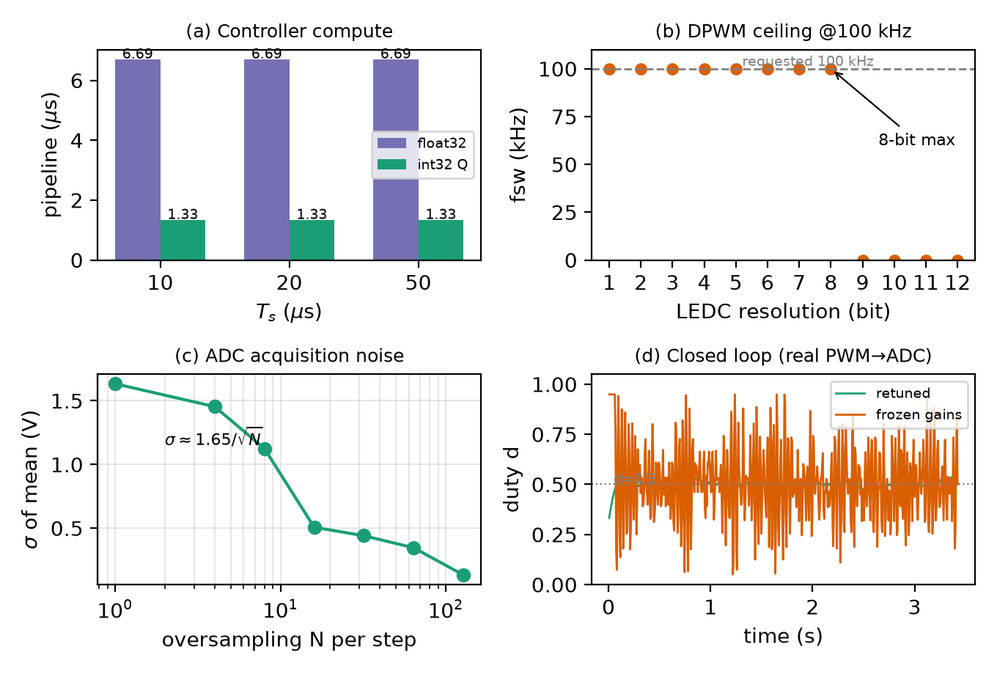
On-chip feasibility measurements. (a) Control-pipeline latency for float32 and int32 at the simulated periods. (b) LEDC duty resolution achievable at a 100 kHz request; 9–12 bit requests are rejected by the 80 MHz clock. (c) ADC acquisition noise floor versus oversampling factor at 50\% duty. (d) Closed-loop duty over the GPIO1–GPIO2 jumper: the paper’s frozen gains thrash between the limits, while the bandwidth-limited retune settles at d = 0.5.
Closing the loop on the jumper reproduces the paper’s core result on real silicon (Fig. 8d). With the paper’s frozen gains, the derivative path amplifies the residual ADC noise and the duty thrashes between the 0.05 and 0.95 limits, exactly the limit-cycle regime predicted for coarse quantization. Retiming the gains to the ADC-bound sample period (slow integral, no derivative) settles the loop at the designed operating point $d=0.507$ with a steady-state error below 0.06 V and a duty ripple of $±4$ \%. The quantitative simulation hierarchy of Section~III therefore survives porting: the controller cannot outrun its acquisition stage, and the DPWM resolution that matters is the one the switching peripheral can actually emit.

Discussion
The results position the three quantizers on a clear hierarchy for this converter: sampling period dominates (a $200 μ$s loop is unstable regardless of resolution); DPWM resolution sets the achievable steady-state ripple; ADC resolution interacts with the reference placement. This ordering matches the known limit-cycle conditions: DPWM quantization bounds the smallest controllable output step, and the controller can only hold the output within half an ADC code of the reference ; our 12.8 mV ideal-digital floor is consistent with the static quantization model of . The survey reveals that sampling-period choices are a prerequisite, and resolution techniques are refinements on top: sigma-delta and dither recover effective PWM resolution but cannot rescue an unstable sampling rate, while predictor- and ADC-side remedies are complementary to the sampling constraint. As a practical rule, sampling at or below $3.5×T_{sw}$ with mid-range resolutions keeps regulation inside the acceptable band; slow sampling combined with a coarse quantizer is the only unusable regime . The bench results underscore the same hierarchy: on the ESP32-S3 the controller compute is negligible, and the binding constraints are the acquisition period and the switching peripheral’s own DPWM resolution ceiling.

Conclusion
Sampling period is the dominant quantization-stage effect for this converter: a $200 μ$s loop period is unstable alone and in every combination. Regulation degrades smoothly to $3.5×T_{sw}$ and fails between $3.5×$ and $4×$; ADC and PWM resolution contribute distinct, additive-but-interacting artifacts, and resolution choices cannot be made independently of the sampling period. The ideal digital controller captures 95\% of continuous-loop performance, the remaining gap being the quantization floor, and the conclusions hold across the tested operating points. Porting to an ESP32-S3 confirmed that compute is not the limiting factor and that the binding hardware constraints, acquisition period and DPWM resolution at the switching frequency, correspond exactly to the simulation’s dominant terms.

Acknowledgment
The authors thank Tareq Anwar Shikdar for guidance; no external funding was received.

