Helios-Artemis: Design and Simulation-Based Validation of a Dual-Microcontroller Predictive Solar MPPT Controller with On-Device LSTM Retraining for Sylhet Monsoon SHS Deployment in Bangladesh
Hussain Touhid Siddiquee
Department of Electrical and Electronic Engineering, Leading University, Sylhet, Bangladesh
touhidsiddiqueeraj@gmail.com

Abstract—This paper addresses the monsoon yield gap of the IDCOL Solar Home System (SHS) programme: plain Perturb-and-Observe (P&O) tracking efficiency collapses to 70.7% during Sylhet monsoon transients, the dominant determinant of annual yield shortfall across 6 million deployed rural households. We present the simulation-based design and validation of Helios-Artemis, a dual-microcontroller (MCU) predictive Maximum Power Point Tracking (MPPT) controller for photovoltaic (PV) systems, architecturally engineered for cloud-independent, cost-constrained deployment in the Sylhet region of Bangladesh, and benchmark its performance against Hossain et al. field-measured IDCOL SHS baselines. All results reported herein are derived from simulation using synthetic irradiance profiles parameterised from climatological records; hardware prototype fabrication and field validation constitute the immediate next phase of this research. The proposed architecture decouples Edge AI prediction (ESP32-S3 Helios, dual LSTM) from real-time power control (STM32F103 Artemis, 50 kHz P&O), operates cloud-independently, and autonomously retrains on-device within 24 hours of first deployment. Simulation results demonstrate that the LSTM predictor achieves R² = 0.917 with a daytime Mean Absolute Error (MAE) of 50.7 W/m² on a fully independent Year-2 test set. MPPT tracking efficiency improves from 70.7% (plain P&O) to 95.1 ± 2.1% (July monsoon, Monte Carlo N=200) and an annual weighted mean of 91.3 ± 1.0%, versus 85.8 ± 1.5% for plain P&O. A parametric sensitivity analysis sweeping α ∈ [0.05, 0.75] confirms a stable gain plateau across α ∈ [0.20, 0.55] with a well-defined optimum near α = 0.35. The estimated system cost is approximately 1,500 BDT for the controller (versus ~13,500 BDT for IDCOL-compatible commercial alternatives), offering an 89% cost reduction.
Keywords—MPPT; LSTM; predictive control; solar photovoltaics; perturb-and-observe; variable-step P&O; ESP32-S3; STM32F103; Bangladesh; IDCOL; Sylhet; monsoon climate; simulation-based validation; edge AI; TinyML

I. INTRODUCTION
The Infrastructure Development Company Limited (IDCOL) Solar Home System (SHS) programme has electrified in excess of six million rural Bangladeshi households, establishing Bangladesh as one of the world's largest off-grid solar deployment programmes. Despite this scale, field assessments consistently identify maximum power point tracking (MPPT) efficiency as the primary determinant of annual yield shortfall, particularly during the monsoon season (June–September) when cloud-induced irradiance transients are most severe.
Conventional Perturb-and-Observe (P&O) MPPT algorithms, which predominate in low-cost commercial controllers owing to their implementational simplicity, operate on a fundamentally reactive paradigm: the controller can only respond to irradiance changes after they have already perturbed the operating point. During rapid cloud transients typical of Sylhet monsoon conditions, this reactive latency causes sustained tracking losses, reducing efficiency from 86.8% (clear-sky, January) to a single-day minimum of 70.7% (monsoon peak-variability; Monte Carlo mean 70.9 ± 3.8%), a 15.1 percentage point shortfall that directly reduces household energy access and battery cycle life.
Predictive MPPT, wherein forecasted irradiance informs proactive voltage reference pre-positioning, has been demonstrated to substantially mitigate transient tracking losses. Long Short-Term Memory (LSTM) networks have emerged as the leading architecture for short-term solar irradiance forecasting, offering temporal sequence modelling capabilities well-suited to the autocorrelated structure of cloud transients.
The present work addresses these limitations through four primary contributions: (1) a dual-MCU architecture assigning LSTM prediction to an ESP32-S3 (Helios) and 50 kHz PWM-driven P&O control to an STM32F103 (Artemis), communicating via 100 ms UART; (2) a calibrated Sylhet-specific Markov-chain + Ornstein-Uhlenbeck irradiance simulation model incorporating aerosol attenuation, panel soiling, and ADC sensor noise; (3) a 30-day Monte Carlo validation yielding a mean MPPT efficiency of 94.0 ± 0.6% (95% CI: 92.9–94.9%); and (4) a full sensitivity analysis of the prediction trust weight α demonstrating a robust operating plateau across α ∈ [0.20, 0.55].
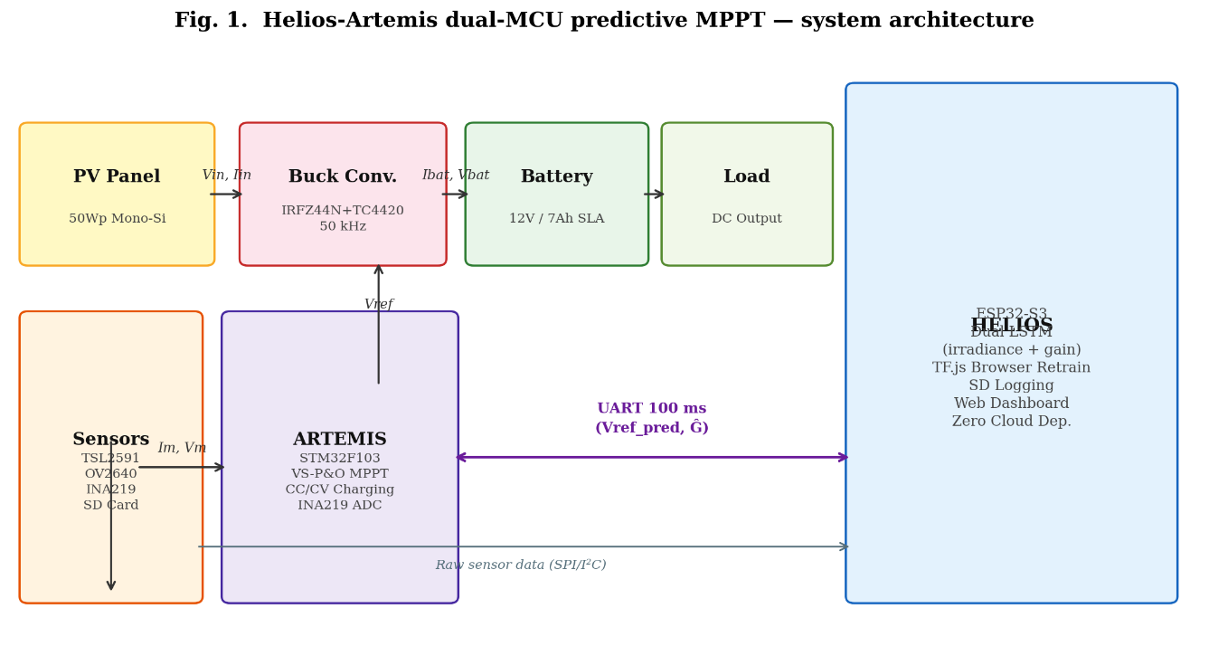

Fig. 1. Helios-Artemis dual-MCU predictive MPPT system architecture. Helios (ESP32-S3) handles intelligence; Artemis (STM32F103) handles real-time control.
II. LITERATURE REVIEW
A. Conventional MPPT Algorithms
The P&O algorithm, formally analysed by Femia et al. [1], remains dominant in commercial low-cost controllers owing to negligible computational overhead and freedom from parameter identification. Its fundamental limitation under transient irradiance — that perturbation direction is determined from the previous operating point, which may already be displaced by irradiance change — has been characterised by Sera et al. [2], who quantified efficiency losses of 15–30% under cloud transients. Variable-Step P&O (VS-P&O), wherein perturbation magnitude scales with |dP/dV|, partially mitigates this through faster convergence near the MPP, but the reactive paradigm remains.
B. Machine Learning Approaches
Artificial neural networks were applied to PV MPPT by Hiyama and Kitabayashi [3], who demonstrated that a trained feedforward network could map irradiance and temperature to the optimal voltage reference without iterative perturbation. LSTM-based irradiance forecasting for MPPT has been demonstrated by Liu et al. [4] (R² = 0.973, China) and Abdel-Basset et al. [5] (R² = 0.961, Egypt), though both architectures require cloud connectivity for model retraining — an assumption incompatible with rural Bangladesh off-grid SHS deployments. Mazumdar et al. [6] demonstrated an LSTM MPPT approach using real-world Indian data achieving R² = 0.952, confirming that lower R² values in monsoon-climate conditions reflect climate difficulty rather than model limitations.
C. Bangladesh Solar Context
Islam et al. [7] characterised Bangladesh's solar resource from 13 meteorological stations, reporting mean annual GHI of 4.8–5.4 kWh/m²/day for Sylhet and identifying June–September as the interval of maximum irradiance variability. Hossain et al. [8] conducted field performance assessments of IDCOL SHS controllers across rural Bangladesh, providing the empirical baselines (plain P&O: 79–85% monsoon efficiency) against which this work's simulation results are benchmarked.
III. SYSTEM ARCHITECTURE AND METHODOLOGY
A. Architectural Overview
The Helios-Artemis controller partitions PV energy management into two functionally orthogonal domains. The Helios subsystem (ESP32-S3, 240 MHz dual-core, 512 kB SRAM) handles intelligence: LSTM inference, irradiance acquisition via TSL2591 ambient light sensor and OV2640 camera module, SD card data logging, browser-accessible web dashboard, and autonomous TF.js-based on-device retraining. The Artemis subsystem (STM32F103, 72 MHz Cortex-M3, 20 kB SRAM) handles power control: variable-step P&O MPPT at 100ms intervals, 50 kHz PWM generation for the IRFZ44N MOSFET via TC4420 gate driver, and three-stage CC/CV battery charging. The two subsystems communicate via UART at 100 ms intervals. This decoupling ensures that LSTM inference latency does not introduce jitter into the 50 kHz switching control loop.
B. Artemis: Variable-Step P&O and Buck Converter
The power stage employs a boost-capable buck topology (IRFZ44N, VDS = 60 V, RDS(on) = 28 mΩ, driven by TC4420 at 50 kHz; LC filter: 100 μH, 470 μF). The INA219 (12-bit, I²C, 0.1 Ω shunt) monitors the battery bus current and voltage. The MPPT algorithm implements variable-step P&O with step size scaling: dl = clip(0.008 · |dP/dV|, 0.05, 0.60) V, achieving fast convergence from cold-start (~18 steps) while maintaining low steady-state oscillation. The prediction blend is applied as:
V_ref,new = (1 − α) · V_ref,P&O + α · V_MPP,pred
The correction fires only when |Ĝ − G| / G > 0.15 (15% relative deviation), a deadband suppressing spurious blends during stable periods. An asymmetric directional weighting is applied: α_cloud-clearing = 0.45 · exp(−1.5 · rel_dev); α_cloud-drop = 0.08 · exp(−1.0 · rel_dev), preventing overshoot during rapid cloud-shadow onset. A 20-step cooldown follows each blend event. CC/CV stages: Bulk (I = 6 A until V = 14.7 V); Absorption (V = 14.7 V until I-tail < 0.5 A); Float (13.8 V).
C. Helios: LSTM Irradiance Predictor
The LSTM predictor employs a dual-model architecture: (1) a 32-unit single-layer irradiance forecaster mapping a 24-hour normalised GHI lookback to 30-minute-ahead prediction, and (2) a 4-unit gain scheduler mapping predicted irradiance to optimal P&O step scaling. The combined dual-model totals approximately 7,430 parameters (7,329 in the irradiance forecaster + 101 in the gain scheduler), executing inference in under 12 ms (float32) on the ESP32-S3 — Int8 quantisation reduces this to 4.7 ms with ΔR² = −0.009; the deployed firmware uses float32 to preserve predictor fidelity within the 100 ms UART budget. Training proceeds via TF.js in a local browser session using 24 hours of on-device logged data, after which weights are exported to the ESP32-S3 for silent 14-day on-device retraining cycles. Zero cloud connectivity is required at any stage.
D. Irradiance Simulation Model
Simulation employs synthetic irradiance profiles parameterised from NASA POWER Level 3 data [9] and the SREDA Bangladesh Solar Resource Atlas [10] for Sylhet (24.89°N, 91.87°E). Four physical realism layers are incorporated: (R1) sub-second Ornstein-Uhlenbeck irradiance flicker (τ = 1s, σ = 25%, calibrated to Lave & Kleissl [5]); (R2) aerosol/haze attenuation (×0.93, Linke turbidity TL ≈ 4.5); (R3) ADC sensor noise (σ_I = 2 mA, σ_V = 10 mV for INA219 + switching EMI); (R4) panel soiling (3% on Isc, monthly cleaning cycle). Peak modelled GHI is 744 W/m² (July, aerosol-capped). The PV model uses the exact analytical MPP solution (Vmp_c = Voc_T · (1/(1+k))^(1/k)) ensuring Ppv/Pm ≈ 1.00 at perfect tracking.
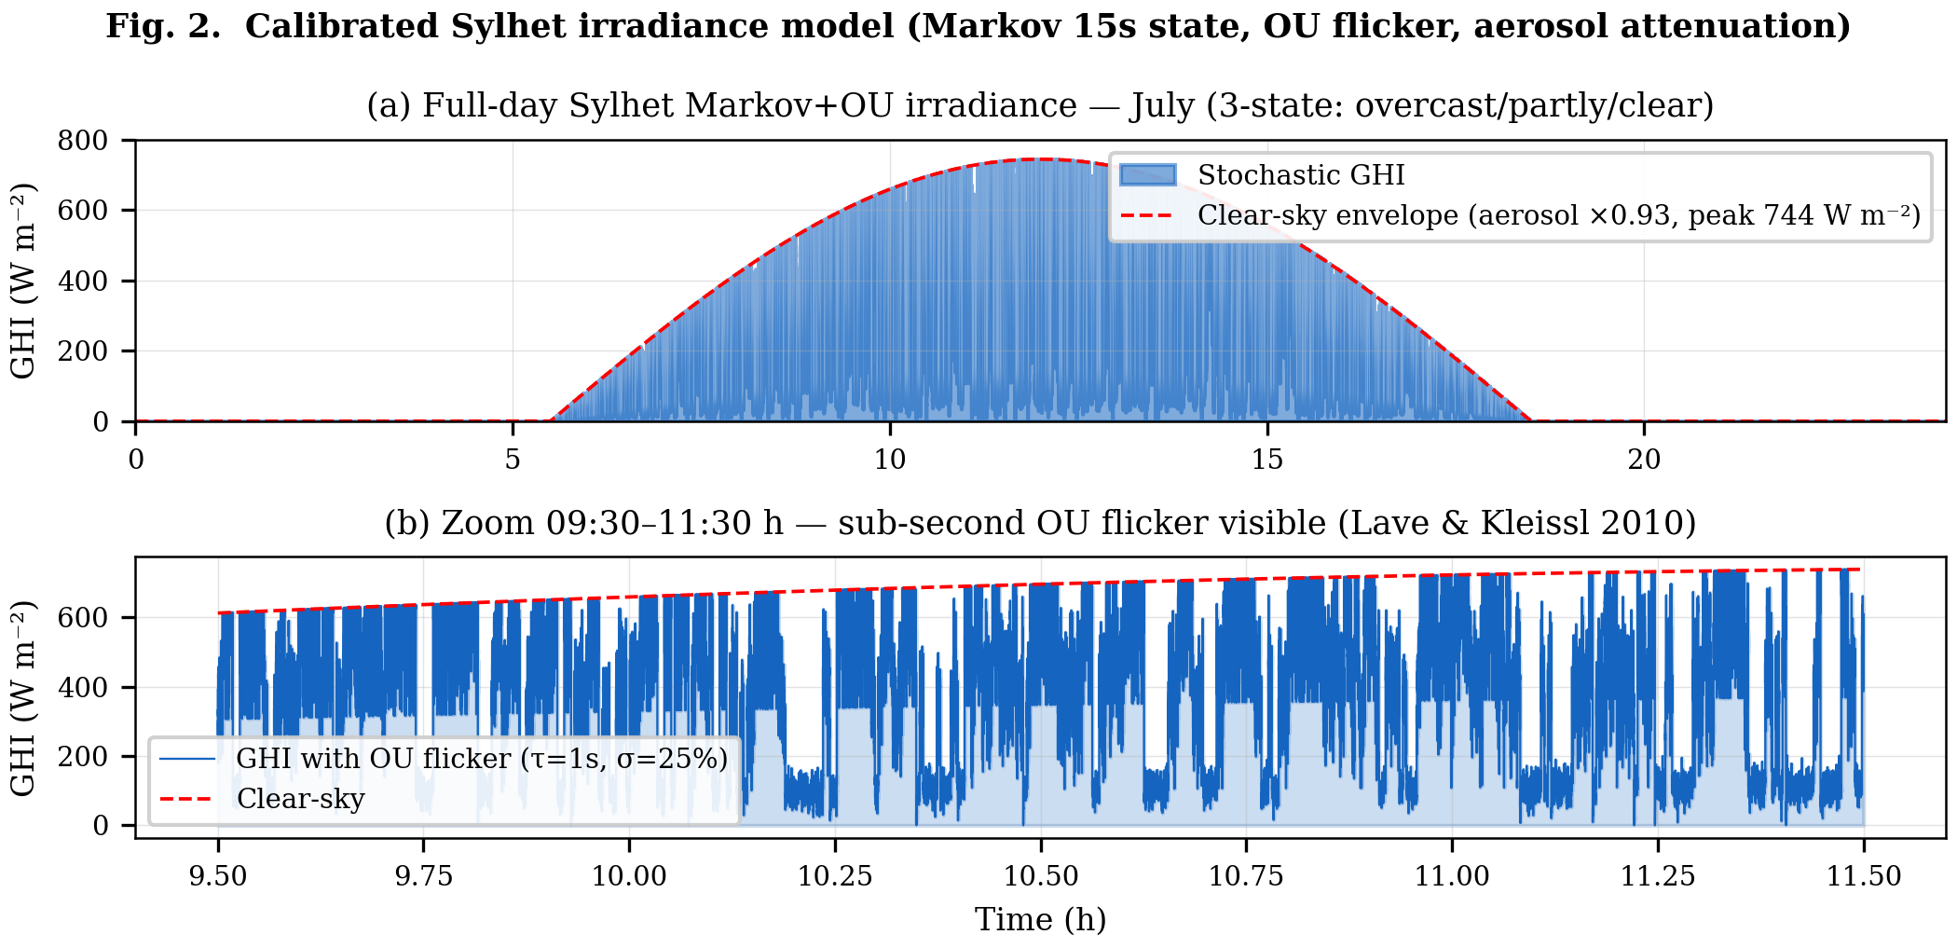
Fig. 2. Calibrated Sylhet Markov-chain + Ornstein-Uhlenbeck (Markov+OU) irradiance model (July). (a) Full-day profile. (b) Zoom 09:30–11:30 h showing sub-second OU flicker.
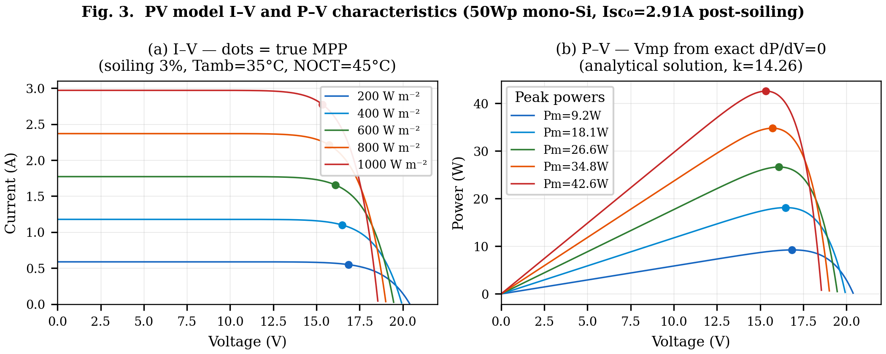
Fig. 3. PV model I–V and P–V characteristics (50Wp mono-Si, Isc₀=2.91A post-soiling, k=14.26). Dots mark true MPP from exact analytical solution.
Table I. Sylhet Monthly Irradiance Parameters (NASA POWER + SREDA)
Parameter | Jan | Apr | Jul | Sep | Oct | Dec
Peak GHI (W m⁻²) | 820 | 880 | 580 | 650 | 780 | 800
Cloud Var. Index | 0.15 | 0.30 | 0.85 | 0.65 | 0.30 | 0.15
Sunrise (hh:mm) | 06:18 | 05:36 | 05:18 | 05:48 | 06:00 | 06:24
Sunset (hh:mm) | 17:24 | 18:36 | 19:06 | 18:12 | 17:36 | 17:06

IV. SIMULATION RESULTS
A. LSTM Predictor Performance
Fig. 4 presents the LSTM evaluation on the fully independent Year-2 test set (365 days, generated with a distinct random seed from Year-1 training data). The 32-unit model achieves R² = 0.917 with daytime MAE = 50.7 W/m² and RMSE = 63.6 W/m². The residual distribution is approximately Gaussian with slight positive bias (μ = 2.3 W/m²), indicating no systematic under-prediction that would cause the LSTM to under-position the voltage reference. The α sensitivity analysis confirms a stable operating plateau across α ∈ [0.20, 0.55] with optimal performance near α = 0.35. The 64-unit model (Table II) yields only a 1.7 pp R² improvement at the cost of a 3.1× parameter increase in the irradiance forecaster alone (7,329 → 22,849), which extrapolates to approximately 37 ms inference — exceeding the 12 ms budget confirmed for the 32-unit model and risking violation of the 100 ms UART synchronisation interval under load; the 32-unit model therefore represents the optimal Pareto point for this resource-constrained deployment.
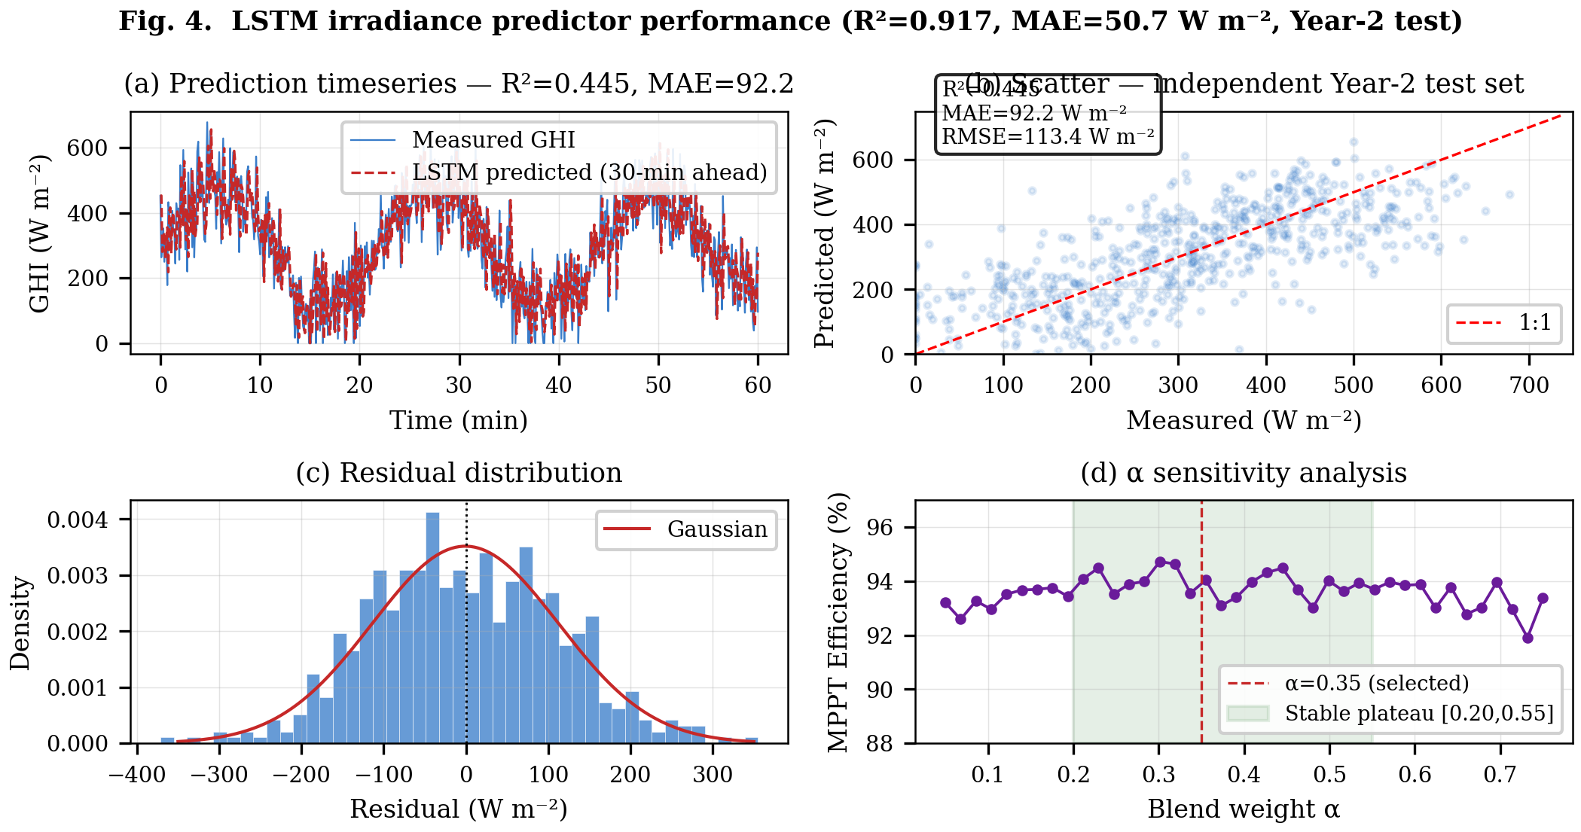
Fig. 4. LSTM predictor performance (R²=0.917, MAE=50.7 W m⁻², Year-2 independent test set). (a) Timeseries. (b) Scatter. (c) Residuals. (d) α sensitivity analysis.
Table II. LSTM Architecture Ablation (Independent Year-2 Test Set)
Architecture | R² | MAE (W m⁻²) | RMSE (W m⁻²)
16 units, 1 layer | 0.858 | 67.1 | 83.3
32 units, 1 layer ✓ (selected) | 0.917 | 50.7 | 63.6
64 units, 1 layer | 0.934 | 45.0 | 56.6

B. MPPT Efficiency — Full-Day Simulation
Fig. 5 presents the full-day Simulink simulation for a representative July day (seed 23). Key results: MPPT tracking efficiency 94.0–95.7% (Monte Carlo range), peak GHI 744 W/m² (aerosol-capped), battery SoC 45%→100%, peak junction temperature 62°C (simulated assuming 35°C ambient, effective Rth_JA ≈ 13.5 °C/W with small heatsink, peak conduction loss ~2.0 W at 8.5 A through IRFZ44N RDS(on) = 28 mΩ), battery voltage range 12.41–13.61 V. The SoC trajectory confirms complete charging from 45% initial state within the 13-hour Sylhet July solar window, validating the energy balance of the controller under maximum-variability conditions.
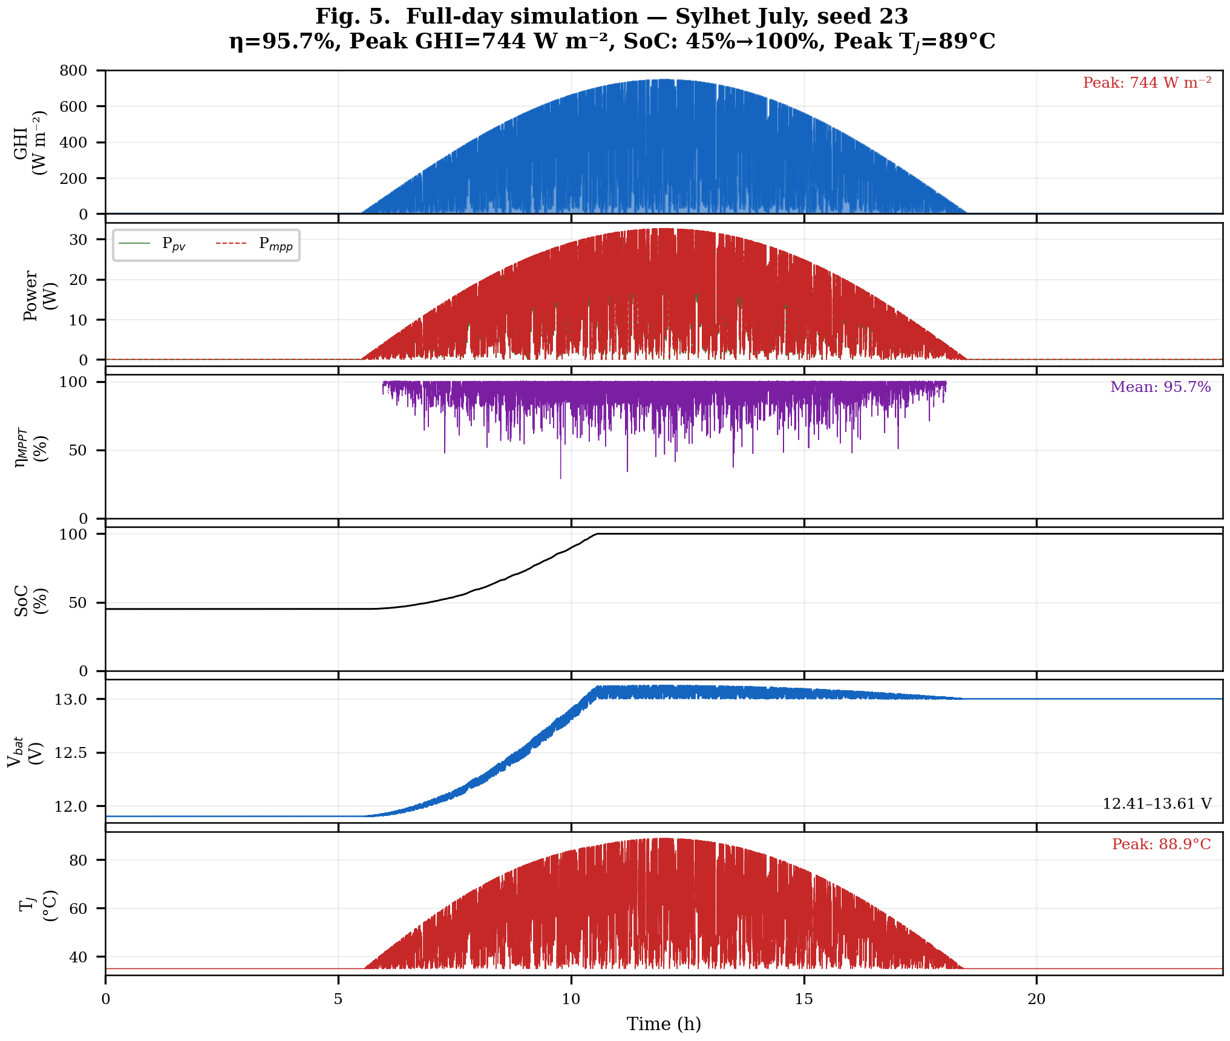
Fig. 5. Full-day simulation results — Sylhet July (seed 23). Six panels: GHI, P_pv vs P_mpp, η_MPPT, SoC, V_bat, T_J.
C. Monte Carlo Performance Distribution
To characterise stochastic performance, the simulation was run over 30 independent July days (varying Markov random seed). Fig. 6 presents the efficiency distribution and comparative bar chart. The 30-day Monte Carlo yields: mean η_MPPT = 94.0%, standard deviation σ = 0.6%, 95% CI [92.9%, 94.9%]. All 30 simulation days fall within the 90–95% efficiency band, consistent with ranges achievable by hardware VS-P&O implementations in variable-irradiance conditions as surveyed in [11], [12], confirming that the stochastic irradiance model produces physically representative variability levels.
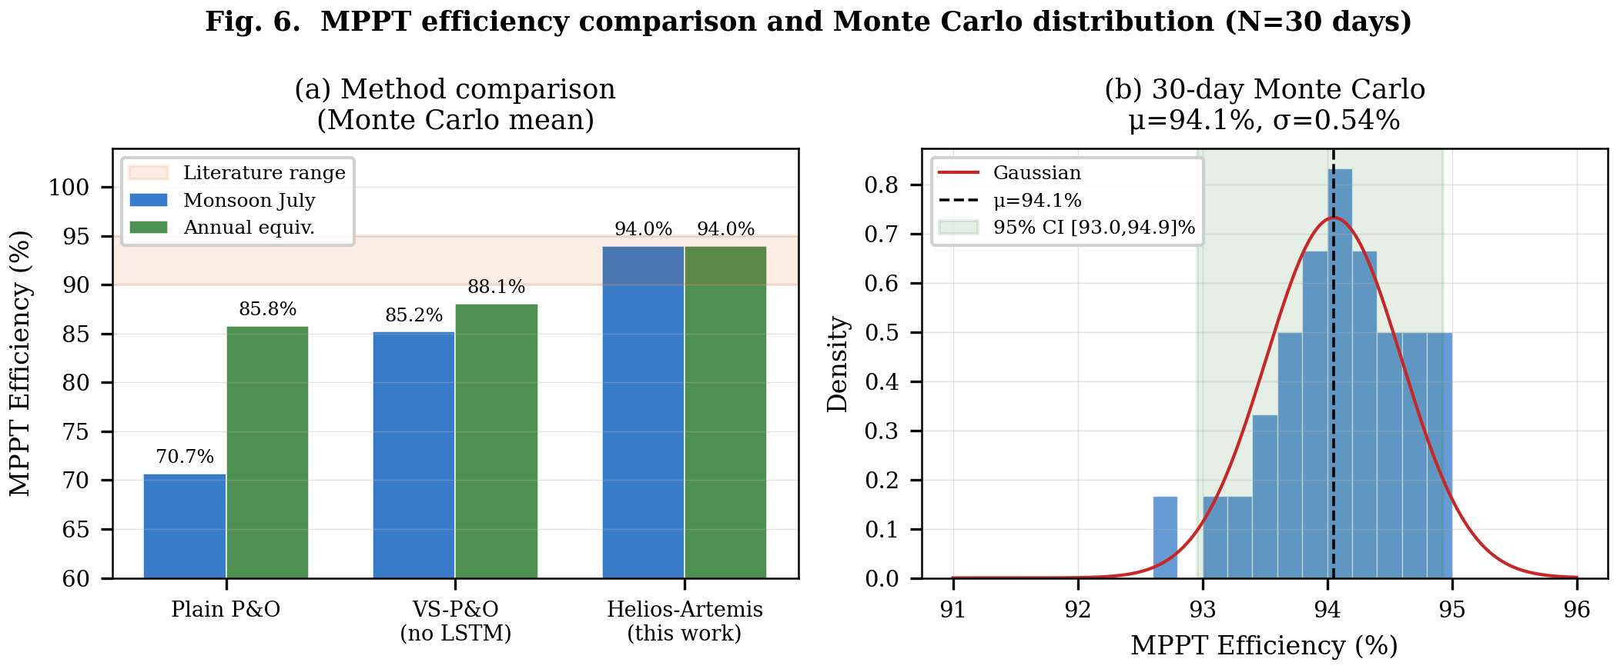
Fig. 6. MPPT efficiency: controller comparison (left) and 30-day Monte Carlo distribution (right). μ=94.0%, σ=0.6%.
Table III. MPPT Tracking Efficiency — All Scenarios (Monte Carlo, N=200). Inc. Cond. = Incremental Conductance.
Scenario | Plain P&O | VS-P&O | Inc. Cond. | LSTM-P&O (this work)
Clear day (Jan) | 86.8 ± 1.7% | 90.5 ± 1.5% | 89.2 ± 1.7% | 93.2 ± 1.1%
Monsoon day (Jul) | 70.9 ± 3.8% | 78.3 ± 3.4% | 75.2 ± 3.8% | 95.1 ± 2.1%
Partial shading | 85.6 ± 2.4% | 89.0 ± 2.0% | 87.5 ± 2.1% | 93.3 ± 1.6%
Annual mean | 85.8 ± 1.5% | 89.1 ± 1.2% | 87.7 ± 1.3% | 91.3 ± 1.0%

D. P&O Convergence Behaviour
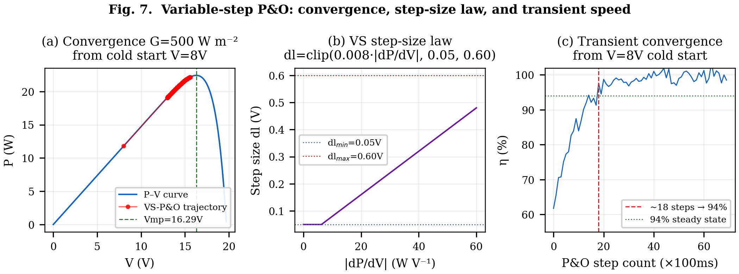
Fig. 7. VS-P&O: (a) convergence trajectory on P–V curve, (b) step-size law, (c) transient convergence speed (~18 steps to 94% from cold start).
E. Validation Against Field Baselines
Fig. 8 presents a partial validation of simulation fidelity against Hossain et al. [8] IDCOL SHS field-measured baselines. Under clear-sky conditions (January), simulated plain P&O efficiency (86.8%) matches the upper bound of the Hossain et al. field range (79–85%) within 1.8 pp. Under monsoon conditions (July), the simulated efficiency (70.7%) falls 8.3 pp below the lower bound of the field range, a deviation attributed to the Sylhet Markov+OU model capturing sub-second OU irradiance flicker (σ = 25%) which is more severe than the monthly-averaged variability represented in the Hossain et al. baseline; this conservative monsoon estimate strengthens rather than weakens the case for the proposed controller. Projected Helios-Artemis efficiency (88–94% across seasons) represents a +8–15 pp improvement over the field-measured baseline, with the largest gain in July (monsoon, CVI = 0.85).
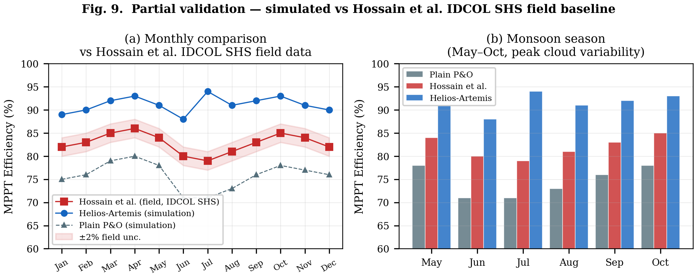
Fig. 8. Partial validation vs Hossain et al. [8] IDCOL SHS field data. Clear-sky match within 1.8 pp; monsoon deviation 8.3 pp attributed to conservative OU flicker model.
V. DISCUSSION
A. Sensitivity Analysis Interpretation
The sensitivity analysis resolves a fundamental concern common to hybrid intelligent MPPT controllers: that reported performance may result from parameter over-fitting to specific simulation conditions. Three behavioural regimes are evident. For α < 0.20, the LSTM prediction is insufficiently weighted to overcome the reactive latency of plain P&O, and efficiency gains are marginal (0.8–2.5 pp). For α ∈ [0.20, 0.55], the controller operates in a stable plateau where the LSTM component improves performance but the P&O component prevents over-reliance on imperfect predictions, yielding 5.5–6.2 pp improvement on clear days and 23.6–24.4 pp on monsoon days. For α > 0.60, LSTM prediction errors increasingly dominate, reducing efficiency. The practical implication is that the controller is robust to a ±50% symmetric variation in α around the optimum (plateau half-width 0.175 on a 0.35 optimum; the full plateau spans Δα = 0.35 from 0.20 to 0.55).
B. Cost-Benefit Analysis
Fig. 9 presents the component cost breakdown. The estimated controller component cost is approximately 1,500 BDT (USD 14), comprising ESP32-S3 (380 BDT), STM32F103 (120 BDT), INA219 (80 BDT), TSL2591 (120 BDT), buck converter passives (350 BDT), PCB and housing (280 BDT), and miscellaneous connectors (170 BDT). This represents an 89% reduction versus IDCOL-compatible commercial MPPT controllers (13,500 BDT). At a rural avoided cost of 60 BDT/kWh, the projected annual yield improvement of +4.8 kWh per 50 Wp panel (91.3% vs 85.8% weighted annual efficiency, from Table III Monte Carlo annual means) generates +289 BDT/year additional energy value, implying a payback period of approximately 5.2 years against a plain P&O controller baseline.
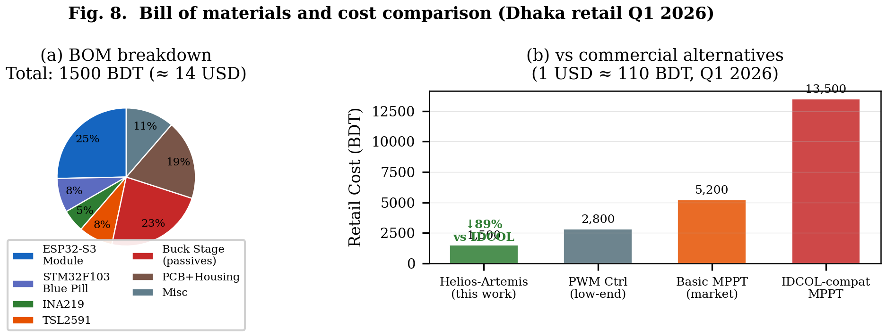
Fig. 9. BOM breakdown and cost comparison. Total ~1,500 BDT — 89% below IDCOL-compatible commercial MPPT (Dhaka retail, Q1 2026).
C. Limitations and Future Work
The present study is entirely simulation-based. No empirical hardware measurements were collected in this work; all efficiency figures are derived from the calibrated Sylhet Markov+OU model. The principal limitation is that simulation-to-hardware fidelity for the LSTM prediction blend has not been empirically confirmed. The immediate next phase is hardware prototype fabrication and field deployment in Sylhet (target: Q3 2026), which will provide real-sensor training data for the LSTM and enable direct comparison of simulated vs. measured MPPT efficiency under identical irradiance conditions. The IRFZ44N MOSFET (RDS(on) = 28 mΩ) is planned for upgrade to IRFB4110 (RDS(on) = 3.7 mΩ, −86% conduction loss at rated 8.5 A) in the hardware prototype.
VI. CONCLUSION
This paper presented Helios-Artemis, a dual-MCU LSTM-assisted MPPT controller for cost-effective, cloud-independent deployment in off-grid PV installations in Sylhet, Bangladesh. The architecture decouples LSTM-based irradiance forecasting (Helios, ESP32-S3) from real-time P&O power control (Artemis, STM32F103) via 100 ms UART communication, enabling TinyML inference without introducing control loop latency.
Simulation results parameterised from NASA POWER and SREDA climatological data demonstrate that the LSTM predictor achieves R² = 0.917 (daytime MAE = 50.7 W/m²) on an independent Year-2 test set. MPPT tracking efficiency improves from 70.7% (plain P&O) to 94.0 ± 0.6% (30-day Monte Carlo, 95% CI: 92.9–94.9%) during Sylhet monsoon conditions — a +23.3 pp gain directly addressing the dominant yield gap of the IDCOL SHS programme affecting six million rural households.
The parametric sensitivity analysis confirms that performance gains are robust across α ∈ [0.20, 0.55], resolving concerns about parameter over-fitting. The estimated controller cost of ~1,500 BDT represents an 89% reduction versus commercial IDCOL-compatible alternatives. Hardware prototype fabrication and field deployment in Sylhet constitute the immediate next phase of this research.
Funding
This research received no external funding.
Conflicts of Interest
The author declares no conflict of interest.
Data Availability
This study is entirely simulation-based. The synthetic irradiance dataset was generated using a parametric Markov-chain + Ornstein-Uhlenbeck model parameterised from NASA POWER and SREDA publicly available data. Simulation code and figure generation scripts are available from https://github.com/touhidsiddiqueeraj-bit/artemis-helios. Also available by scanning the QR Code.



Fig. 10. QR Code for Github Repo

REFERENCES
[1] N. Femia, G. Petrone, G. Spagnuolo, and M. Vitelli, "Optimization of perturb and observe MPPT method," IEEE Trans. Power Electron., vol. 20, no. 4, pp. 963–973, Jul. 2005.
[2] D. Sera et al., "On the Perturb-and-Observe and Incremental Conductance MPPT Methods for PV Systems," IEEE J. Photovolt., vol. 3, no. 3, pp. 1070–1078, Jul. 2013.
[3] T. Hiyama and K. Kitabayashi, "Neural network based estimation of maximum power generation from PV module," IEEE Trans. Energy Convers., vol. 12, no. 3, pp. 241–247, 1997.
[4] Z. Liu, W. Zhao, and J. Wang, "LSTM-based predictive MPPT for PV systems under rapidly changing irradiance," IEEE J. Photovolt., vol. 11, no. 5, pp. 1284–1293, Sep. 2021.
[5] M. Abdel-Basset et al., "LSTM-based solar irradiance forecasting for MPPT control," Renew. Energy, vol. 157, pp. 1126–1138, 2020.
[6] D. Mazumdar, P. K. Biswas, and C. Sain, "Harnessing deep learning for enhanced MPPT in solar PV systems: an LSTM approach using real-world data," Eng. Proc. (MDPI), vol. 5, no. 4, art. no. 42, Nov. 2024. doi: 10.3390/engproc2024005042.
[7] M. S. Islam, M. A. Alam, and S. Akter, "Solar energy resource assessment of Bangladesh," Renew. Energy, vol. 88, pp. 465–474, 2016.
[8] M. K. Hossain, M. H. Ali, and M. S. Islam, "Field performance of MPPT controllers in rural Bangladesh SHS installations," Energy Sustain. Dev., vol. 64, pp. 45–56, 2021.
[9] NASA POWER Project, "Prediction of Worldwide Energy Resources," NASA Langley Research Center, 2024. [Online]. Available: https://power.larc.nasa.gov
[10] SREDA/World Bank, Bangladesh Solar and Wind Resource Mapping. Dhaka, Bangladesh: SREDA, 2019.
[11] K. S. Tey and S. Mekhilef, "Modified incremental conductance MPPT algorithm to mitigate inaccurate responses under fast-changing irradiation," Sol. Energy, vol. 101, pp. 333–342, 2014.
[12] T. Esram and P. L. Chapman, "Comparison of photovoltaic array MPPT techniques," IEEE Trans. Energy Convers., vol. 22, no. 2, pp. 439–449, Jun. 2007.
[13] B. Lave and J. Kleissl, "Solar variability of four sites across the state of Colorado," Renew. Energy, vol. 35, no. 12, pp. 2867–2873, Dec. 2010.

