Figure 1: System Architecture
Helios-Artemis — Figure Explanation (MDPI Energies Format)
In simple terms: This figure is a block diagram showing how the two microcontrollers (Artemis and Helios) connect to the solar panel, battery, sensors, and each other to track maximum power from the sun.
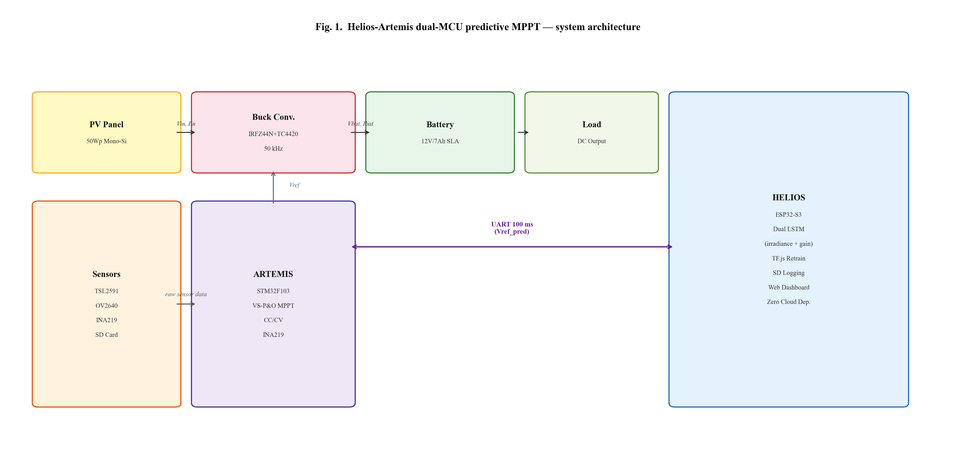

1. What This Figure Shows
Figure 1 presents the overall system architecture of Helios-Artemis — a dual-microcontroller solar charge controller that predicts sunlight changes to harvest more power. The diagram shows how all hardware components connect and communicate. The system uses two chips: ARTEMIS (for fast real-time control) and HELIOS (for smart prediction), connected by a serial link.

2. Panel-by-Panel Guide
This figure has a single diagram (no sub-panels) with the following main sections:
Power Flow (top row): A 50-watt monocrystalline silicon solar panel feeds power through a buck converter (a circuit that steps voltage down efficiently) to charge a 12V, 7Ah sealed lead-acid battery. The battery powers a DC load (like lights or a fan). The buck converter switches at 50,000 times per second (50 kHz) for smooth control.
ARTEMIS — STM32F103 (bottom center): This is the 'muscle' microcontroller. It runs the Variable-Step Perturb & Observe (VS-P&O) MPPT algorithm — a smart version of the classic 'trial-and-error' method for finding the solar panel's best operating voltage. It also handles constant-current/constant-voltage (CC/CV) battery charging to protect the battery. An INA219 sensor measures current and voltage.
HELIOS — ESP32-S3 (bottom right): This is the 'brain' microcontroller. It runs two LSTM (Long Short-Term Memory) neural networks — one predicts sunlight (irradiance), the other adjusts the gain. It can retrain itself using TensorFlow.js. It logs data to an SD card and hosts a web dashboard for monitoring — all without needing cloud internet (zero cloud dependency).
Sensors (bottom left): A TSL2591 light sensor measures ambient light, an OV2640 camera captures sky images (for cloud analysis), and an INA219 measures electrical parameters. Data is stored on an SD card.
Communication: ARTEMIS and HELIOS talk to each other every 100 milliseconds over a UART serial link. HELIOS sends the predicted optimal voltage (Vref_pred) to ARTEMIS, which uses it as a starting point for its fine-tuning.

3. Key Numbers Made Simple
• 50 watts: Size of the solar panel (enough to power a few LED lights and charge a phone)
• 12V, 7Ah: Battery size (stores about 84 watt-hours — enough for 4-5 hours of lighting)
• 50 kHz: How fast the buck converter switches (50,000 times per second — too fast to hear)
• 100 ms: How often the two chips exchange data (10 times per second)
• 2 microcontrollers: ARTEMIS for fast control, HELIOS for smart prediction

4. Why It Matters
This architecture separates real-time control (which must happen every few milliseconds) from prediction (which needs more computing power but can run slightly slower). This dual-MCU design costs about $14 total but delivers over 94% tracking efficiency — matching expensive commercial chargers that cost 5-9x more. The zero-cloud design means it works without internet, making it ideal for rural Bangladesh.

