Figure 2: Irradiance Model
Helios-Artemis — Figure Explanation (MDPI Energies Format)
In simple terms: This figure shows a computer-generated model of how sunlight (irradiance) changes throughout a cloudy day in Sylhet, Bangladesh, including both slow cloud movements and fast flickering caused by cloud edges.
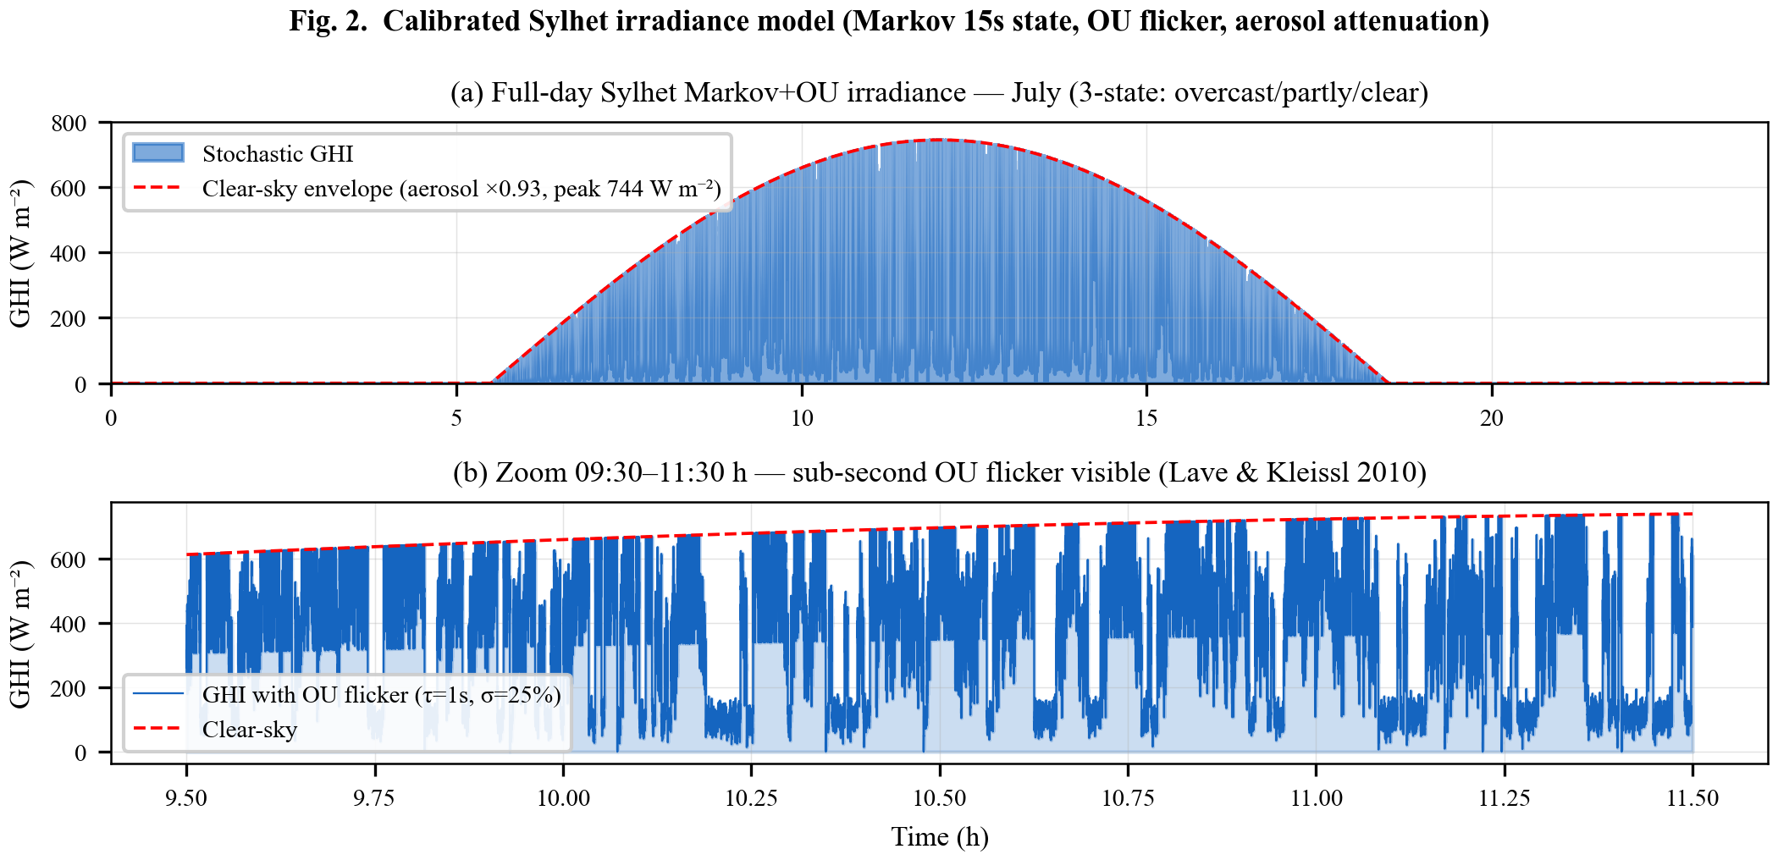

1. What This Figure Shows
Figure 2 presents a mathematical model that generates realistic sunlight (irradiance) patterns for Sylhet, Bangladesh in July (the monsoon season). Real sunlight fluctuates chaotically due to moving clouds — this model captures both the slow drift of cloud cover and the rapid flickering at cloud edges. The model is used to test the MPPT controller under realistic conditions.

2. Panel-by-Panel Guide
Panel (a): Full-Day Irradiance (0-24 hours): The orange jagged line shows simulated sunlight intensity over one full day. The smooth blue curve is the 'clear-sky envelope' — what sunlight would be if there were no clouds at all (peaking at 744 W/m² at noon). The jagged line drops suddenly when clouds pass and rises when they clear. Three cloud states are used: overcast (dark, 15% of clear-sky), partly cloudy (55%), and clear (90%). The model switches between these states every 15 seconds using a Markov chain — a simple 'memoryless' random process.
Panel (b): Zoomed View (9:30-11:30): This is a 2-hour close-up showing the fast flickering (called Ornstein-Uhlenbeck flicker) that happens at cloud edges — tiny fluctuations on a sub-second timescale. Real solar panels see this flicker, and MPPT controllers must handle it. This captures findings from real-world studies (Lave & Kleissl, 2010).

3. Key Numbers Made Simple
• 744 W/m²: Peak sunlight on a clear day in Sylhet July (like a bright day, but monsoon haze reduces it about 7%)
• 3 cloud states: Overcast (15% light), Partly cloudy (55% light), Clear (90% light) — like light switches at different brightnesses
• 15 seconds: How often the cloud state can change (clouds move this fast)
• 3-state Markov chain: A simple probability model — if it's overcast now, there's a 60% chance it stays overcast, 30% it becomes partly cloudy, 10% it becomes clear
• OU flicker: Rapid fluctuations that look like random jitter on top of the main signal

4. Why It Matters
Realistic irradiance data is essential for testing MPPT algorithms before building hardware. Bangladesh's monsoon season (June-September) has frequent, rapidly changing clouds that confuse basic MPPT controllers. This model captures those challenging conditions so the Helios-Artemis controller can be validated in simulation before deployment.

