Figure 3: I-V and P-V Curves
Helios-Artemis — Figure Explanation (MDPI Energies Format)
In simple terms: This figure shows how the solar panel's electrical behavior changes with different sunlight levels — less light means less current, and the graphs help find the voltage that gives maximum power.
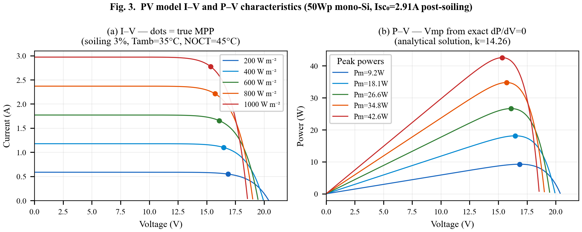

1. What This Figure Shows
Figure 3 shows the electrical characteristics of the 50-watt monocrystalline silicon solar panel used in this project. Every solar panel has a unique current-voltage (I-V) and power-voltage (P-V) relationship that changes with sunlight (irradiance). Finding the voltage where power is highest (the Maximum Power Point, or MPP) is the job of the MPPT controller. This figure plots those curves at five different sunlight levels.

2. Panel-by-Panel Guide
Panel (a): I-V Curves (Current vs Voltage): The five curves show current (amps) vs voltage (volts) at sunlight levels of 200, 400, 600, 800, and 1000 W/m² (from bottom to top). At any voltage, higher sunlight gives more current. The black dots mark the Maximum Power Point (MPP) — the voltage where power is highest. Notice that the MPP voltage stays roughly constant (around 17-18V) regardless of sunlight, which is why simpler 'fixed voltage' methods can work, but less efficiently. The model includes 3% soiling (dust on panels) and 35°C ambient temperature.
Panel (b): P-V Curves (Power vs Voltage): The same five curves but showing power (watts) instead of current. Each curve has a clear peak — that's the Maximum Power Point. The dots show where the analytical formula (dP/dV = 0) finds the peak mathematically. At 1000 W/m² (full sun), peak power is about 50 watts (matching the panel rating). At 200 W/m² (cloudy), it drops to about 10 watts. The key insight: if the controller keeps voltage near the MPP, it extracts maximum available power.

3. Key Numbers Made Simple
• 50Wp: Panel rating — produces up to 50 watts in full sun (enough to run a small DC fan)
• Isc0 = 2.91A: Short-circuit current (amps when terminals are shorted) after 3% soiling loss
• Voc0 = 21.6V: Open-circuit voltage (volts when nothing is connected)
• 3% soiling: Dust on the panel reduces current by 3% (typical in Bangladesh)
• k = 14.26: A 'shape factor' that determines how sharply the I-V curve bends (higher = sharper corner)
• Analytical MPP: Instead of trial-and-error, the MPP voltage is calculated directly from the formula — faster and more accurate

4. Why It Matters
Understanding the I-V and P-V curves is the foundation of any MPPT system. The analytical MPP solution used here (dP/dV=0) is more accurate than numerical search methods and provides a theoretical baseline. The figure also shows that at low light (200 W/m²), the available power is only ~10W — so the controller must work efficiently even in weak sunlight to avoid wasting energy.

