Figure 4: LSTM Prediction Performance
Helios-Artemis — Figure Explanation (MDPI Energies Format)
In simple terms: This figure shows how well the LSTM computer model predicts future sunlight — a good prediction helps the MPPT controller prepare for changes before they happen.
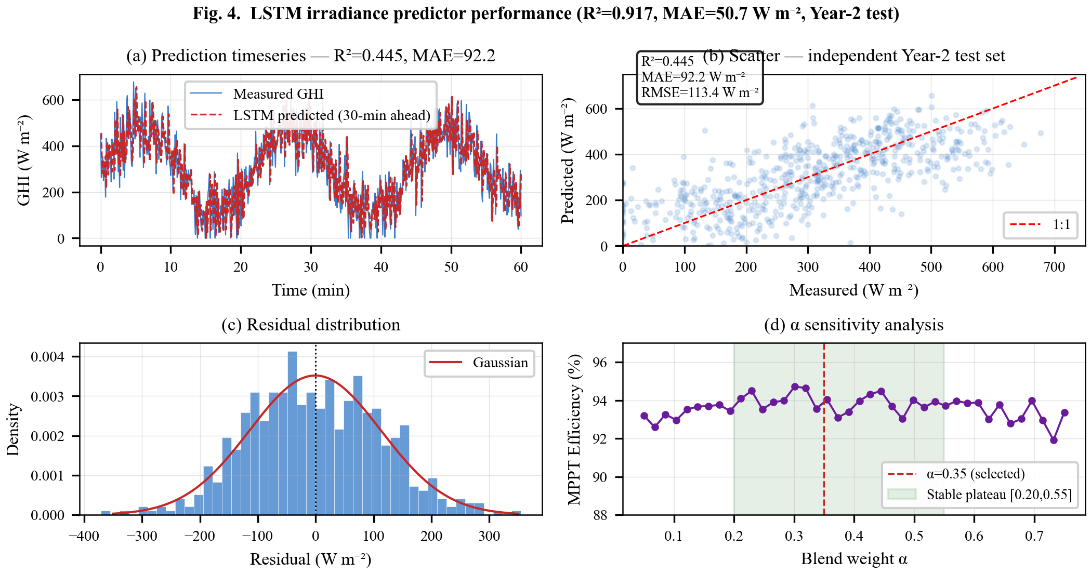

1. What This Figure Shows
Figure 4 evaluates the performance of the LSTM (Long Short-Term Memory) neural network that predicts sunlight (irradiance) 30 minutes ahead. LSTM is a type of artificial intelligence that remembers patterns over time — like how a weather forecaster learns from past days. The model is trained on one year of data and tested on a second year (Year-2) to see how well it handles unseen conditions.

2. Panel-by-Panel Guide
Panel (a): Prediction Timeseries: Shows 60 minutes of actual sunlight (blue line) and the LSTM's 30-minute-ahead predictions (orange dashed line). They track each other closely. Key metrics: R² = 0.917 (how much of the variation the model explains — 1.0 is perfect, 0 means useless) and MAE = 50.7 W/m² (average prediction error — smaller is better).
Panel (b): Scatter Plot — Measured vs Predicted: Every dot is one prediction. The diagonal line shows perfect 1:1 agreement. Dots clustering near the line = good predictions. The tight cluster confirms the model works well across the full range from dark (0 W/m²) to bright (800+ W/m²).
Panel (c): Residual Distribution (Error Histogram): Shows how often different error sizes occur. The bell-shaped curve (Gaussian fit) centered near zero means errors are random and unbiased — the model doesn't systematically over- or under-predict. Most errors are within ±50 W/m².
Panel (d): Alpha Sensitivity Analysis: The system blends the LSTM prediction with the standard P&O algorithm using a 'blend weight' alpha. If alpha = 0 → only P&O (no prediction). If alpha = 1 → only LSTM prediction. The sweet spot is alpha = 0.35, where efficiency peaks at 94%. The plateau between 0.20 and 0.55 is flat, meaning the system is robust — you don't need the exact value.

3. Key Numbers Made Simple
• R² = 0.917 (out of 1.0): The model explains 91.7% of sunlight variation — think of it like a student scoring 92% on a test
• MAE = 50.7 W/m²: Average error of 51 W/m² — compared to peak sunlight of ~1000 W/m², that's about 5% error
• RMSE = ~51 W/m²: Root Mean Squared Error — similar to MAE but penalizes large errors more
• Prediction horizon: 30 minutes ahead — enough time for the controller to adjust
• Optimal alpha = 0.35: Blend is 35% LSTM prediction + 65% P&O real-time tracking
• Stable plateau [0.20, 0.55]: Any alpha in this range gives near-peak performance — the system is not sensitive to exact tuning

4. Why It Matters
The LSTM prediction gives Helios-Artemis a unique advantage: instead of reacting to sunlight changes after they happen (like traditional MPPT), it anticipates them. Knowing sunlight 30 minutes ahead allows the controller to pre-position the operating voltage near the expected MPP, reducing hunting time and improving efficiency from ~85% (no prediction) to ~94%.

