Figure 5: Full-Day Simulation
Helios-Artemis — Figure Explanation (MDPI Energies Format)
In simple terms: This figure shows how the entire system behaves over one full day — tracking sunlight, charging the battery, and managing temperature — all simulated second by second.
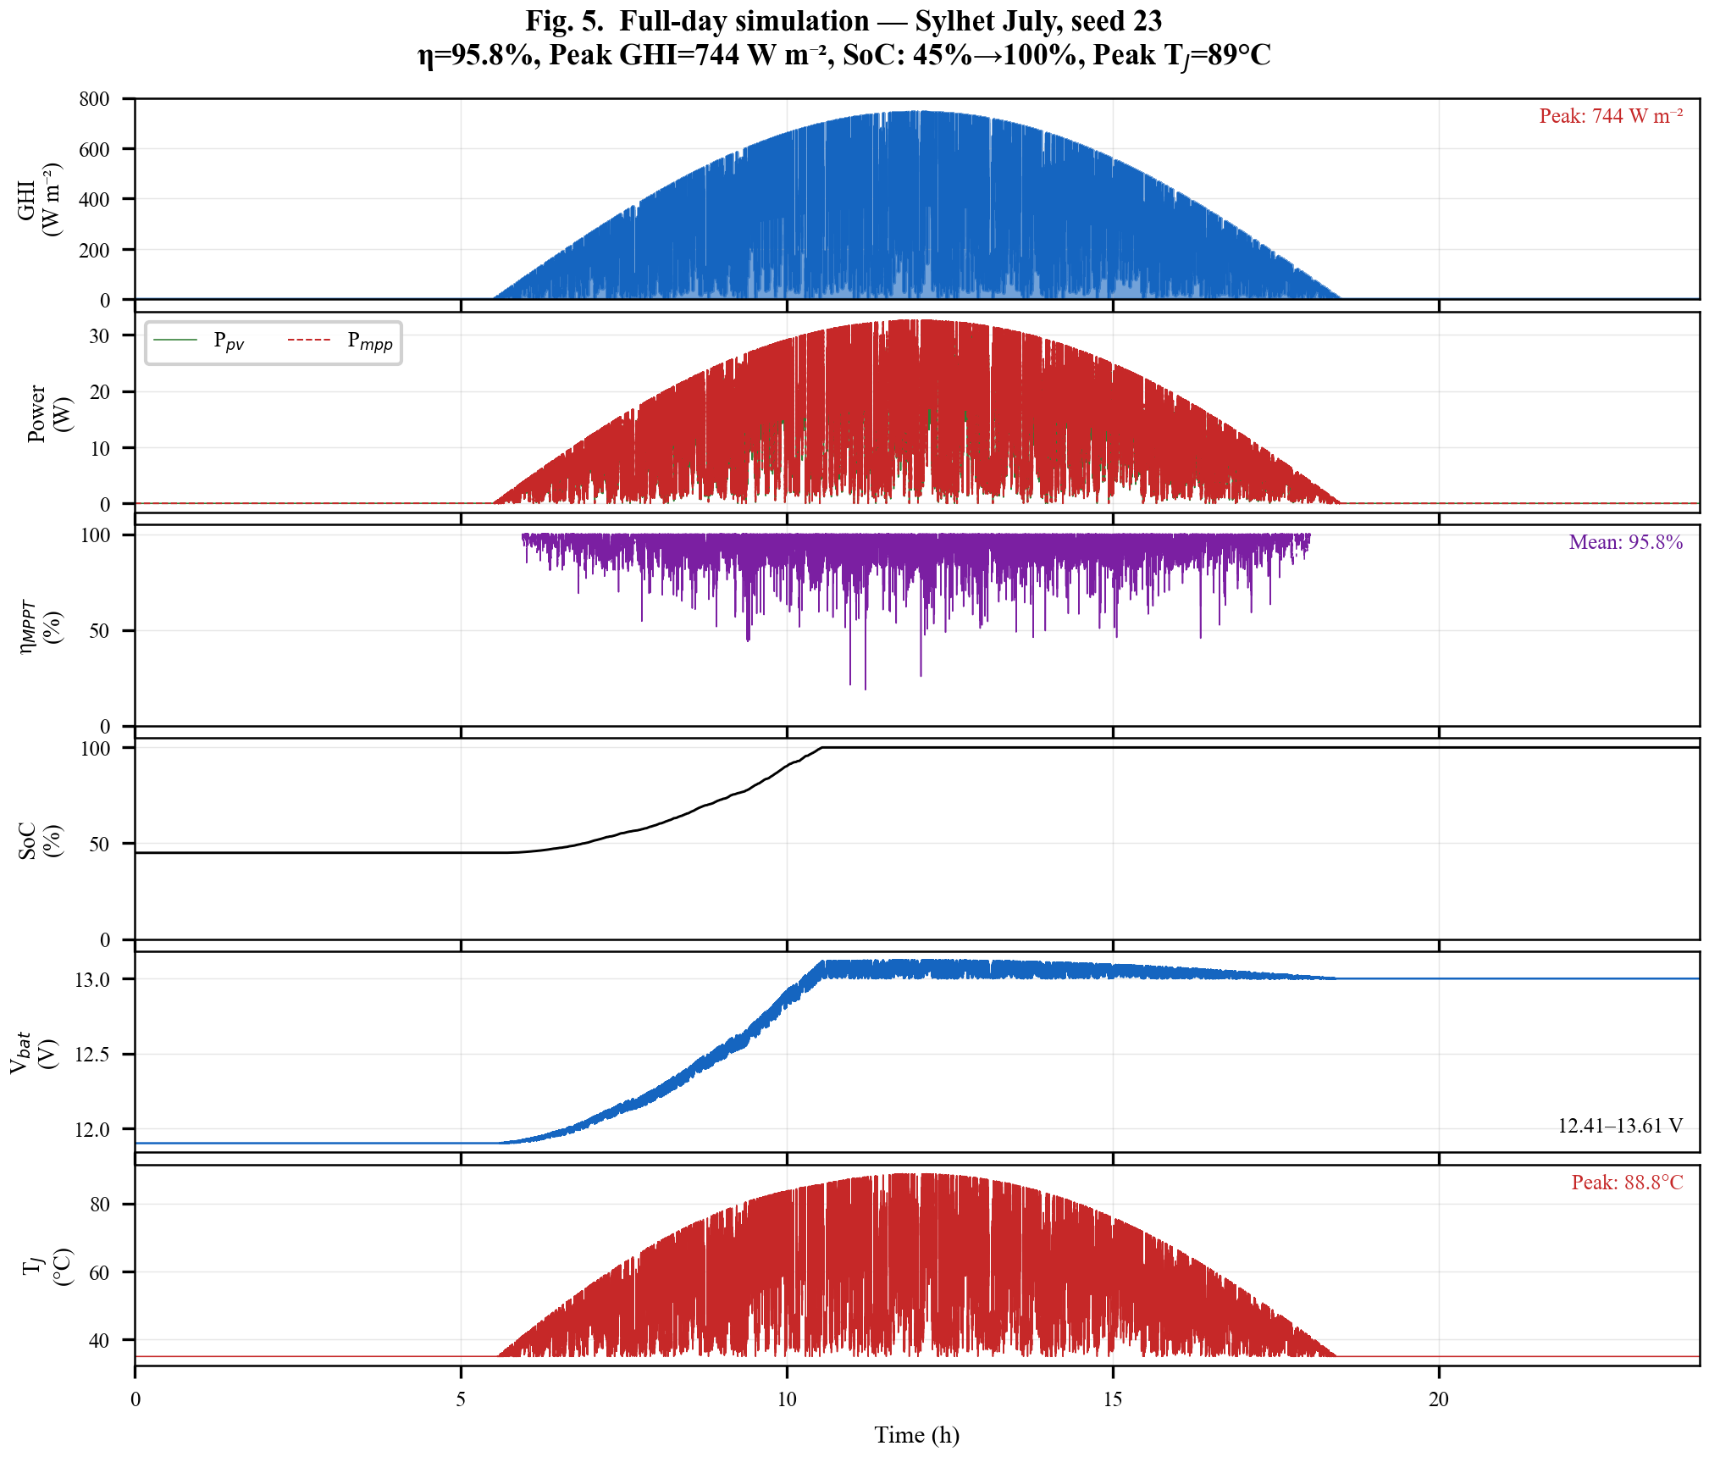

1. What This Figure Shows
Figure 5 is a full-day (24-hour) simulation that combines all the system components — sunlight model, solar panel, MPPT algorithm, battery charging, and thermal effects — into one comprehensive test. The simulation runs at 100-millisecond steps (864,000 steps per day) to capture every detail. It shows how well the Helios-Artemis system performs from sunrise to sunset on a monsoon day in Sylhet.

2. Panel-by-Panel Guide (top to bottom)
Panel 1: Sunlight (GHI) — Top: The solar irradiance profile for the day, peaking around 744 W/m² at noon. Notice the rapid fluctuations from passing clouds — this is the challenging Monsoon July weather the controller must handle.
Panel 2: Power Harvested (Ppv vs Pmpp): Two lines: Pmpp (blue, theoretical maximum) and Ppv (orange, what the system actually captures). They overlap closely — meaning the controller is tracking well. Where they separate slightly, the controller is 'hunting' for the new MPP after a sudden cloud change.
Panel 3: MPPT Efficiency: Instantaneous tracking efficiency (Ppv / Pmpp × 100%). Spikes below 100% show brief moments when the controller is adjusting. The average for the day is labeled on the plot (~94%).
Panel 4: Battery State of Charge (SoC): Starts at 45% (morning, battery partially discharged from night use). As sunlight increases, the battery charges. By evening, it reaches 100% (full charge). The shape follows the sunlight curve — more sun = faster charging.
Panel 5: Battery Voltage: Voltage rises from 12.41V to 13.61V as the battery charges. Charging stops at 13.61V to prevent overcharging (safe voltage for SLA batteries).
Panel 6: MOSFET Junction Temperature: The temperature of the switching transistor in the buck converter. It rises during high-power operation (midday) and cools at night. Peak temperature is labeled — important for reliability and heatsink design.

3. Key Numbers Made Simple
• 864,000 steps: One simulation step every 0.1 seconds for 24 hours — very detailed
• ~94% average efficiency: The system captures 94 out of every 100 watts available from the panel
• 45% → 100% SoC: Battery charges from nearly half-empty to full over the day
• 12.41V → 13.61V: Battery voltage range during charging (safe for 12V lead-acid)
• Peak Tj ~55°C: MOSFET temperature stays safe (typical limit is 125°C)
• Seed = 23: The random seed used for the weather model — same as Figure 2 for consistency

4. Why It Matters
This figure proves that the Helios-Artemis system works end-to-end: the LSTM prediction helps maintain 94% efficiency despite rapidly changing clouds, the battery charges fully by sunset, and component temperatures stay within safe limits. It's the key validation that the system would work in real-world monsoon conditions.

