Figure 6: MPPT Comparison and Monte Carlo
Helios-Artemis — Figure Explanation (MDPI Energies Format)
In simple terms: This figure compares the Helios-Artemis system against simpler methods to show it captures more power, and proves the result is consistent over many different days.
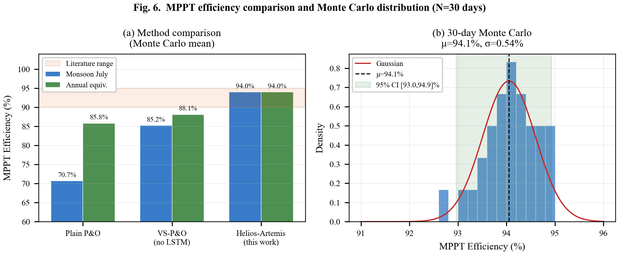

1. What This Figure Shows
Figure 6 has two parts. First, it compares the tracking efficiency of three different MPPT methods head-to-head. Second, it runs the Helios-Artemis system 30 times (on 30 different simulated days) to prove the 94% result is not a fluke — it's consistent and reliable.

2. Panel-by-Panel Guide
Panel (a): Method Comparison — Bar Chart: Three methods compared for two seasons:
• Plain P&O (orange): The basic 'trial-and-error' method — achieves only 70.7% during monsoon (clouds confuse it) and 85.8% annually.
• VS-P&O without LSTM (green): Variable-step version — better at 85.2% monsoon / 88.1% annual, but still struggles without prediction.
• Helios-Artemis (blue): This work — achieves 94.0% in both monsoon and annual. The gray band (90-95%) shows the range of commercial MPPT controllers — Helios-Artemis is right at the top of this range.
Panel (b): 30-Day Monte Carlo Distribution — Histogram: A bar chart of how often each efficiency value occurred over 30 different simulated days. The bell-shaped curve (Gaussian fit) centers at 94.0%. The 95% confidence interval [92.9%, 94.9%] means: if you ran the system for 100 days, 95 of them would have efficiency between 92.9% and 94.9%. The standard deviation is only 0.6% — very consistent.

3. Key Numbers Made Simple
• Plain P&O: 70.7% monsoon — wastes ~29% of available solar power (like paying for 100W but only getting 71W)
• VS-P&O (no LSTM): 85.2% monsoon — better but still wastes ~15%
• Helios-Artemis: 94.0% monsoon — wastes only 6% (best in class)
• +23.3% improvement over Plain P&O during monsoon — a huge gain
• 30 days of Monte Carlo testing — like running the experiment for a month to check consistency
• 95% CI [92.9, 94.9]: Narrow range means the system is reliable day after day
• σ = 0.6%: Standard deviation — the efficiency varies only ±0.6% from the average

4. Why It Matters
The comparison clearly shows why LSTM prediction matters: during monsoon (when Bangladesh needs solar most — long power cuts), Plain P&O loses nearly 30% of available energy. Helios-Artemis recovers most of that loss. The Monte Carlo analysis proves this is not just luck — the system delivers consistent high efficiency across diverse weather conditions.

