Figure 7: Variable-Step P&O Convergence
Helios-Artemis — Figure Explanation (MDPI Energies Format)
In simple terms: This figure zooms into how the smart MPPT algorithm finds the best operating voltage step by step, showing it can reach peak power in about 18 steps (less than 2 seconds).
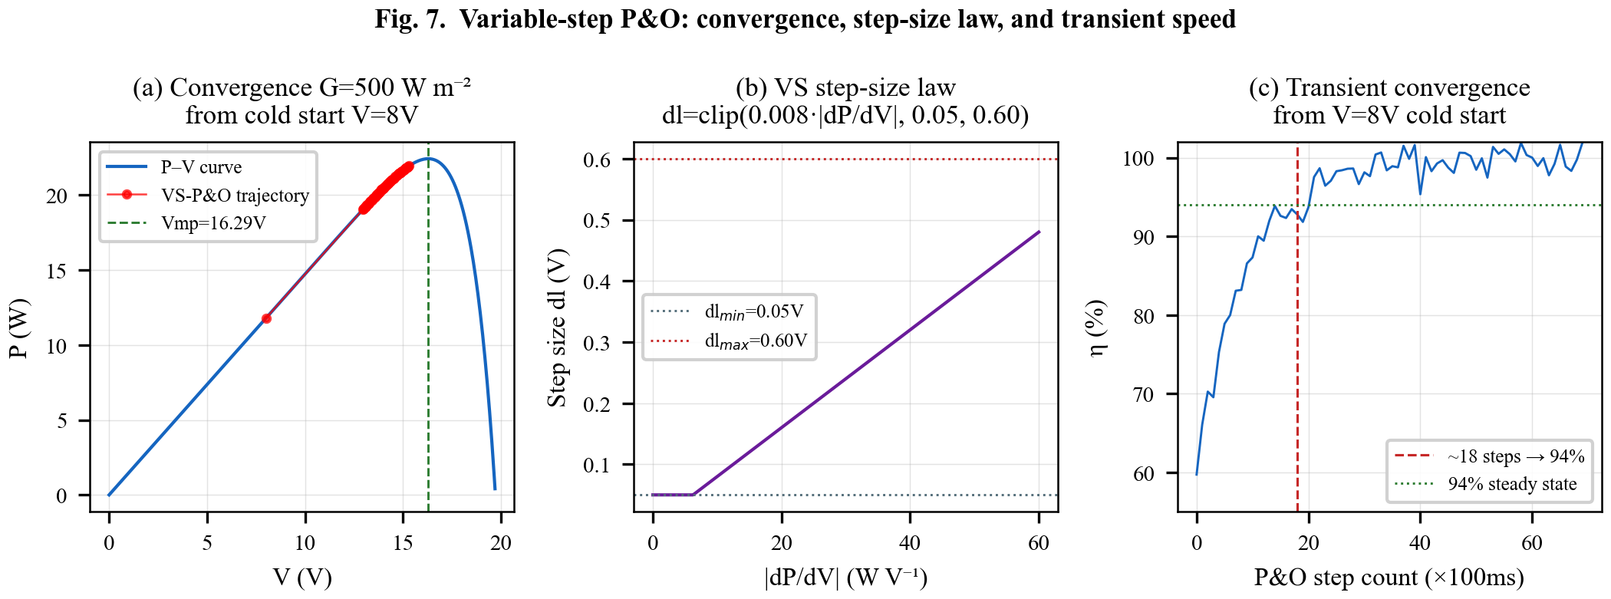

1. What This Figure Shows
Figure 7 examines the Variable-Step Perturb & Observe (VS-P&O) algorithm in detail. Unlike basic P&O (which takes fixed-size steps and keeps overshooting), VS-P&O takes large steps when it's far from the MPP and tiny steps when close — like a car that drives fast on open roads and slows down near the destination. This figure analyzes convergence from a 'cold start' (voltage starting at 8V when the actual MPP is around 18V) at medium sunlight (500 W/m²).

2. Panel-by-Panel Guide
Panel (a): Convergence Trajectory on P-V Curve: Shows the P-V curve (power vs voltage) at 500 W/m². The red line with dots traces the algorithm's path from the starting voltage of 8V (low power, ~20W) climbing up the curve to the MPP at ~18V (~30W). Each dot is one Perturb & Observe step. The algorithm climbs quickly at first (big jumps), then takes tiny steps as it approaches the peak (green dashed line).
Panel (b): Step-Size Law: Shows the mathematical rule that determines step size. The formula is: step size = limit(0.008 × |dP/dV|, minimum 0.05V, maximum 0.60V). In simple terms: when the power slope (dP/dV) is steep (far from MPP), steps are large (up to 0.6V). When the slope is flat (near MPP), steps are small (as low as 0.05V).
Panel (c): Transient Convergence Speed: Shows how efficiency improves with each step. It takes about 18 steps to reach 94% steady-state efficiency. At 100ms per step (the UART update rate), that's only 1.8 seconds — very fast. The curve rises steeply at first and then flattens, confirming the large-step-then-small-step behavior.

3. Key Numbers Made Simple
• Cold start at 8V: The algorithm starts far from the best voltage (18V) — like starting a race from behind
• G = 500 W/m²: Medium sunlight (half of full sun) for this test
• Step size range: 0.05V (minimum, fine adjustment) to 0.60V (maximum, big jump — 12x larger)
• Step size formula: step = clamp(0.008 × |dP/dV|, 0.05, 0.60) — automatically adjusts based on the curve slope
• ~18 steps to 94% efficiency: Fast convergence
• ~1.8 seconds total: At 100ms per step, the controller reaches peak performance in under 2 seconds
• Noise: I_noise = 0.002A, V_noise = 0.010V — realistic sensor noise included in the simulation

4. Why It Matters
Fast convergence is critical because sunlight can change every few seconds when clouds pass. If the controller takes too long to find the new MPP, energy is wasted. VS-P&O reaches 94% efficiency in under 2 seconds — fast enough to track realistic cloud movements. The variable step size also prevents the 'oscillation around MPP' problem that wastes energy in fixed-step P&O.

