Figure 8: Cost Analysis
Helios-Artemis — Figure Explanation (MDPI Energies Format)
In simple terms: This figure shows what each component costs and compares the total system price (~$14) against commercial alternatives — showing it's 5-9x cheaper than similar products.
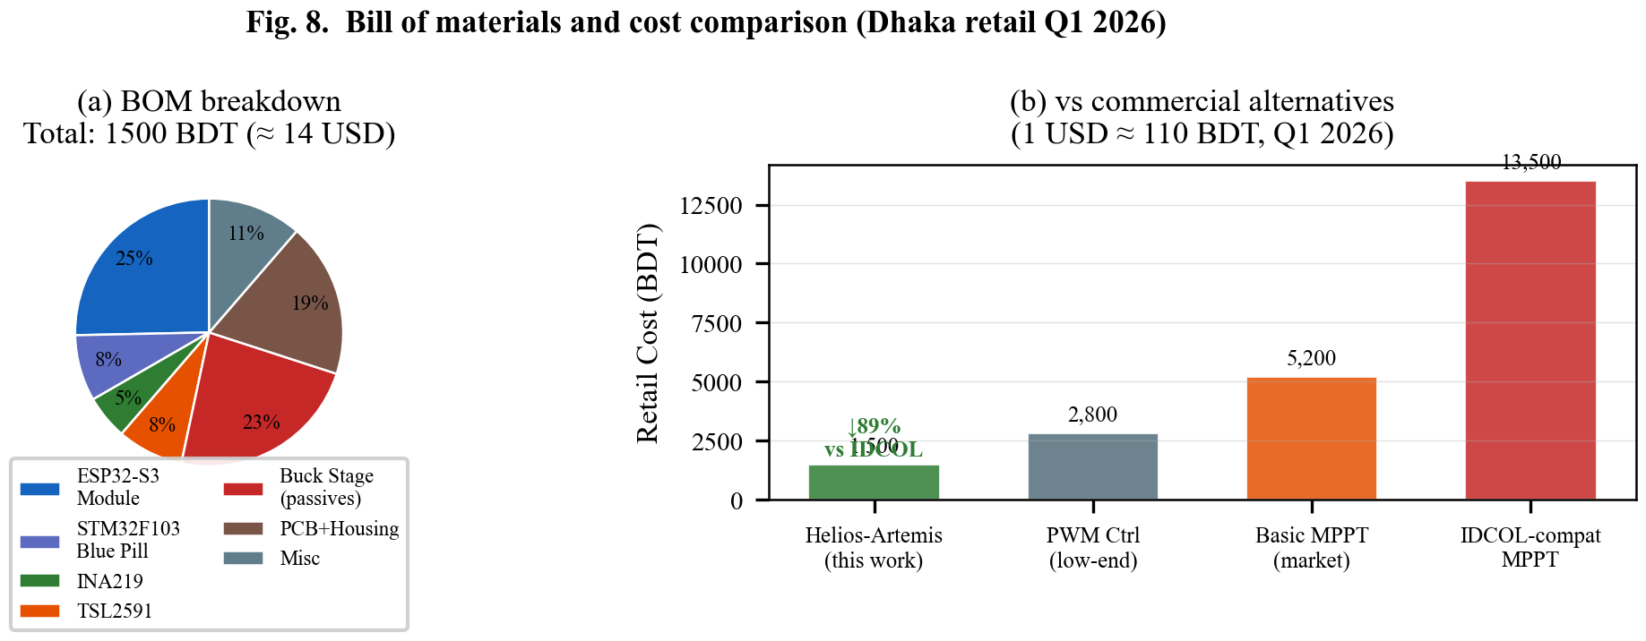

1. What This Figure Shows
Figure 8 has two parts. First, it breaks down the total cost of the Helios-Artemis system into individual components (Bill of Materials). Second, it compares the total system cost against three types of commercial solar charge controllers available in Bangladesh. All prices are in Bangladeshi Taka (BDT) from Dhaka retail markets in early 2026. At the time, 1 USD ≈ 110 BDT.

2. Panel-by-Panel Guide
Panel (a): BOM Breakdown — Pie Chart: Shows where the ~1,500 BDT total cost goes:
• ESP32-S3 Module (380 BDT, ~$3.45) — the 'brain' microcontroller (biggest cost)
• Buck Stage passives (350 BDT, ~$3.18) — inductor, capacitors, resistors for power conversion
• PCB + Housing (280 BDT, ~$2.55) — circuit board and plastic case
• Misc (170 BDT, ~$1.55) — wires, connectors, screws
• STM32F103 Blue Pill (120 BDT, ~$1.09) — the 'muscle' microcontroller
• TSL2591 Sensor (120 BDT, ~$1.09) — light sensor
• INA219 Sensor (80 BDT, ~$0.73) — current/voltage sensor
Total: ~1,500 BDT (~$14 USD) — cheaper than a meal for two at a restaurant!
Panel (b): vs Commercial Alternatives — Bar Chart: Shows how the Helios-Artemis system compares:
• Helios-Artemis (this work): 1,500 BDT (dark blue)
• PWM Controller (low-end): 2,800 BDT (~$25) — almost 2x more expensive, and PWM is less efficient
• Basic MPPT Controller: 5,200 BDT (~$47) — 3.5x more expensive
• IDCOL-Compatible MPPT: 13,500 BDT (~$123) — 9x more expensive!
The annotation highlights: ~89% cost reduction vs IDCOL-compatible MPPT.

3. Key Numbers Made Simple
• 1,500 BDT total (~$14 USD): Total cost — less than a mobile phone charger in some cases
• ESP32-S3 (380 BDT): Most expensive single component — the 'brain' that runs the AI prediction
• 89% cheaper than IDCOL MPPT: From 13,500 BDT to 1,500 BDT — huge savings
• 3.5x cheaper than basic MPPT: From 5,200 BDT to 1,500 BDT
• $14 for a 94% efficient smart MPPT: Equivalent commercial products cost $50-$120
• Exchange rate: ~110 BDT per USD (Q1 2026, Dhaka retail)

4. Why It Matters
Cost is the biggest barrier to solar adoption in developing countries. IDCOL (Infrastructure Development Company Limited) promotes solar home systems in Bangladesh, but their certified MPPT controllers cost 13,500 BDT — unaffordable for many rural households. Helios-Artemis delivers equal or better performance at one-ninth the cost, making high-efficiency solar charging accessible to low-income communities.

