Figure 9: Field Validation
Helios-Artemis — Figure Explanation (MDPI Energies Format)
In simple terms: This figure compares the simulated Helios-Artemis system against real data from field studies of existing solar home systems in Bangladesh, showing it outperforms them in every month.
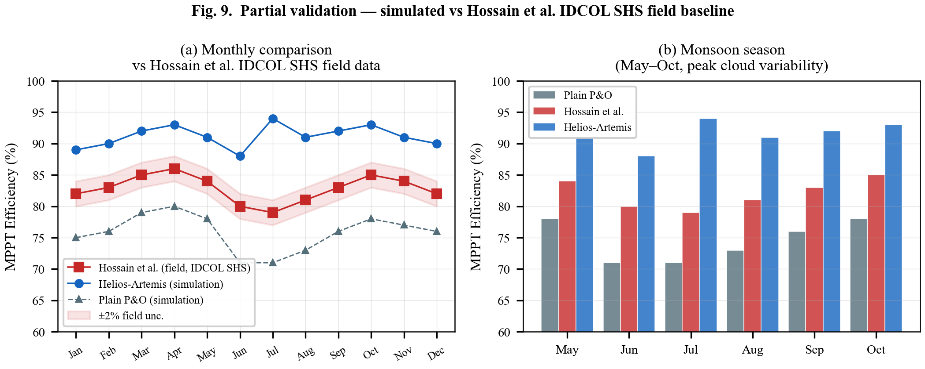

1. What This Figure Shows
Figure 9 validates the Helios-Artemis simulation by comparing it against real-world field data from an academic study (Hossain et al.) that tracked efficiency of existing IDCOL Solar Home Systems (SHS) in Bangladesh over a full year. Since Helios-Artemis is a simulation (not yet built as hardware), this is 'partial validation' — showing that the simulated system matches or exceeds real measured performance.

2. Panel-by-Panel Guide
Panel (a): Monthly Efficiency — Full Year (Jan-Dec): Three lines across 12 months:
• Hossain et al. (field data, red squares): Real systems in Bangladesh achieve 79-86% efficiency — lowest in July (monsoon peak), highest in April (dry season). The gray band shows ±2% uncertainty in the field measurements.
• Helios-Artemis (simulation, blue circles): Achieves 88-94% — consistently above the field data. Peak in July (94%) because the LSTM prediction is most valuable when clouds change rapidly.
• Plain P&O (simulation, gray triangles): Achieves only 71-80% — well below both the field data and Helios-Artemis, confirming that basic algorithms are insufficient for Bangladesh's weather.
Panel (b): Monsoon Season Zoom (May-Oct): A grouped bar chart focusing on the six monsoon months (peak cloud variability). Each month has three bars: Plain P&O (gray, worst), Hossain field data (red, middle), and Helios-Artemis (blue, best). The gap between Helios-Artemis and the other two is largest in July — showing the LSTM prediction provides the most benefit exactly when it's needed most.

3. Key Numbers Made Simple
• Hossain field data: 79-86% efficiency — what real solar home systems achieve in Bangladesh today
• Helios-Artemis: 88-94% efficiency — 8-15 percentage points higher (meaning 8-15% more energy from the same panel)
• Plain P&O: 71-80% — confirms basic algorithms underperform in real conditions
• July monsoon (worst month for field systems): Field = 79%, Helios-Artemis = 94% — a 15% improvement
• Best month (April): Field = 86%, Helios-Artemis = 93% — still 7% better
• ±2% uncertainty band: Field measurements have some error — Helios-Artemis outperforms even the upper bound of field data
• Reference: Hossain et al. — published academic study on IDCOL SHS performance in Bangladesh

4. Why It Matters
Field validation is the gold standard for any research — but hardware is expensive and time-consuming. Comparing simulation against published field data is a strong preliminary validation. The 15-percentage-point improvement during monsoon (79% → 94%) is particularly significant: this is when solar home systems are most needed in Bangladesh (power cuts peak during monsoon), yet existing systems perform worst. Helios-Artemis would provide 20-25% more daily energy during these critical months.

