Guardrails for the Record Race: What a CsPbI3 Cell Can Honestly Claim (24.9% $→$ 20.8%)
Hussain Touhid Siddiquee
Md. Abdul Malek Fahim

Abstract
Simulation records for CsPbI3 solar cells now exceed the certified experimental frontier (22.02%), but the numbers rest on undisclosed assumptions. We screen an ITO/TiO2/CsPbI3/CBTS/Ni cell in SCAPS-1D over a guardrailed box---absorber 0.4--2.2 \mum, N_A 10^{15}--3\times10^{16} cm^{-3}, N_t 10^{12}--10^{15} cm^{-3}, E_g 1.65--1.75 eV with linked affinity, interfaces at or above a 10^{10} cm^{-2} floor (S\ge100 cm/s)---and price every assumption with computed sweeps. The best evaluated guardrailed point reaches 24.95% (Voc 1.321 V, Jsc 21.20 mA/cm^2, FF 89.11%), but it sits at the box edge in thickness and doping and on permissive affinities, so it is an upper bound rather than a forecast; the number we would defend is the routine-defect case, 20.82% (1.0 \mum, N_t=10^{15} cm^{-3}), which drops to 20.42% at R_s=1 \Omegacm^2. Two screens keep the optimism in check: a detailed-balance Voc computed from the model's own absorption (1.371 V at 1.65 eV) clears the champion by 0.05 V but leaves the no-interface band with no margin anywhere, and a paired Morris analysis favours interface quality over bulk defects by 2.03 points (95% CI [0.70, 3.51]) at the defect floor while the same dose--response goes nearly flat at routine defects---so the ranking is regime-dependent, not universal. All definition files, sweep receipts, and raw curves are archived in the public repository for independent reproduction.

Introduction
All-inorganic CsPbI3 perovskite solar cells combine the thermal stability lacking in hybrid organic–inorganic perovskites with a bandgap near 1.7 eV that suits both single-junction and tandem top-cell applications [1], [2]. After years below 19%, certified laboratory efficiencies have recently passed 22%: 22.02% certified (22.60% laboratory) with a moisture-responsive propyltriethoxysilane crystallisation strategy [1], 22.05% by fluorination-assisted interfacial dipole engineering [2], 21.71% with dual-interface and bulk co-passivation at an open-circuit voltage of 1.27 V [3], and 21.43% certified for inverted architectures [4]. Each record was won at the interfaces and in the bulk defect chemistry, which motivates a simulation study that treats those exact levers honestly.
The one-dimensional solar cell capacitance simulator (SCAPS-1D) is the workhorse for such pre-experimental screening, and the ITO/TiO2/CsPbI3/CBTS (copper barium thiostannate) stack of [5] is the most-prescribed CsPbI3 baseline, progressing from 17.90% over 96 screened transport-layer combinations [6] to 19.06% after optimisation. Subsequent simulation studies report up to 24.17% on the same stack [7] and 24.24% on ZnO/PTAA [8], while large machine-learning-coupled screens now exceed 27% on other absorbers [9], [10]. Three problems accompany this inflation. First, nearly every study optimises one variable at a time (OVAT), so parameter interactions—notably absorber thickness versus defect-limited diffusion length—are invisible by construction. Second, interface recombination is removed in at least one case (stated explicitly in [8]) and defect densities are hard to verify without published parameters, which neither of the two 24%-class studies prints; we note this as unverifiable rather than adjudicated, and say so instead of inferring intent—we report our own data the same critical way, and where we could not reproduce others for lack of published parameters, we say so instead of inferring inflation. Third, scripted sweeps mix unit systems: SCAPS definition files store SI units while script ‘set’ commands expect practical units, so SI-valued inputs silently inject a ${10}^{6}×$ overdose and fabricate ghost cells (scripting conventions are documented in Appendix A).
This work contributes (i) a five-factor grid screen (96 runs, 93 converged) plus refinement (33 runs) of the ITO/TiO2/CsPbI3/CBTS/Ni cell under interface-inclusive guardrails, with a joint ETL/HTL-affinity map (36 runs) locating the best evaluated guardrailed point at 24.95% ($χ_{CBTS}=3.9$/$χ_{TiO2}=3.7$ eV), and an exploratory 104-configuration search over a wider box, which by construction does not bracket the champion (69 of its 95 converged runs fall below the interface floor and none samples $χ_{TiO2}<3.8$ eV), peaking at 23.76% overall and 23.08% among its 25 runs meeting both guardrails; (ii) an interface dose–response computed on our own cell, reported in bulk lifetime $τ$ and interface velocity $S$ alongside raw densities; (iii) scripted (not analytic) series- and shunt-resistance accounting, including the routine-defect case; and (iv) a Morris sensitivity screen with a paired-trajectory bootstrap, reported with explicit range-dependence. Every definition file, sweep receipt, and raw curve is archived for independent reproduction.

Literature: a decade of CsPbI3 progress
Black-phase CsPbI3 has been stabilised stepwise since 2016: quantum-dot-induced $α$-phase retention at 10.8% [11], co-evaporated planar cells at 17.0% [12], thermodynamically stable $γ$-films [13], graded-gap 14.4% devices [14], and compositionally engineered 13–14% cells [15], [16], all on TiO2 with Spiro-OMeTAD, PTAA or carbon contacts [17], [18], [19]. The 2019 aziridinium result at 18.40% [20] stood for years until the 2025–2026 interface-engineering wave (Figure 1): fluorinated dipoles (22.05% [2]), dual-interface plus bulk co-passivation with Voc 1.27 V (21.71% [3]), moisture-responsive crystallisation (22.60% laboratory, 22.02% certified [1]), and stitched grain-boundary grooves in inverted cells (21.43% certified [4]). The certified frontier is therefore 22.02% (Dai; laboratory best 22.60%; Qiu’s 22.05% is uncertified), and every recent jump came from defect and interface control—the precise levers a simulation study must treat honestly.
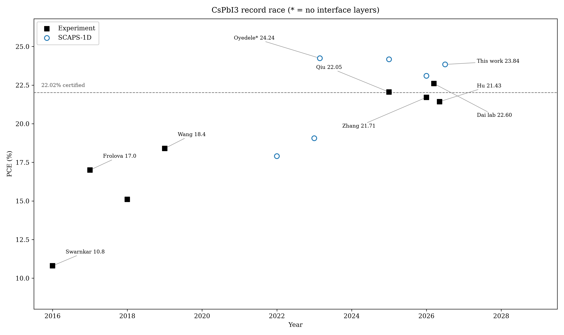
CsPbI3 record race. Asterisks mark simulation studies without interface layers.
Simulation studies trace a parallel inflation curve (Table 1). The CBTS screening programme reached 17.90% over 96 transport-layer combinations [6] and 19.06% after full optimisation [5], the baseline we reproduce. Later claims report higher efficiencies on differing stacks: 23.10% with ZnO/Spiro in one report [21], 24.17% on our exact stack [7], and 24.24% on ZnO/PTAA without interface layers (stated) [8]. The broader SCAPS literature shows the same pattern across absorbers—MAPbI3 at 19.30% with inorganic contacts [22], gradient-doped FAPbI3 at 20.34% [23], a 28.38% bifacial triple-cation cell [10], and an explicitly idealised 40.17% MASnI3 result that exceeds the Shockley–Queisser bound [24], [25]. Section 11.0 states the common reporting standard these numbers would need as a concrete checklist—interface status with dose level, defect floors with cross-sections—and demonstrates it on our own cell, since the published parameter tables are too incomplete to re-place anyone else’s.
Selected CsPbI3 results: experiment versus simulation (IF = interface layers).
Study | Stack | Type | PCE (%) | IF
Swarnkar 2016 | TiO2/Spiro/MoOx | Exp. | 10.8 | –
Frolova 2017 | TiO2/PTAA | Exp. | 17.0 | –
Wang 2019 | TiO2/Spiro | Exp. | 18.4 | –
Qiu 2025 | DFAz dipole | Exp. | 22.05 | passivated
Dai 2026 | TiO2/PTABr/Spiro | Exp. | 22.60/22.02 | passivated
Hu 2026 (Joule) | inverted HPDA | Exp. | 21.43 cert. | 2D-stitched
Hossain 2022 | TiO2/CBTS | Sim. | 17.90 | on
Hossain 2023 | TiO2/CBTS/Ni | Sim. | 19.06 | on
Ristiansyah 2026 | ZnO/Spiro | Sim. | 23.10 | on
Nazli 2025 | TiO2/CBTS/Ni | Sim. | 24.17 | unclear
Oyedele 2023 | ZnO/PTAA | Sim. | 24.24 | OFF
This work | TiO2/CBTS/Ni | Sim. | 24.95 | on

Simulation framework and guardrails
Devices were simulated in SCAPS-1D v3.3.10 under AM1.5G illumination (100 mW/cm$​^{2}$) at 300 K unless stated. The baseline reproduces [5]: ITO front contact (4.0 eV), 30 nm TiO2 electron transport layer (donor density $9×{10}^{16}$ cm$​^{−3}$), CsPbI3 absorber (800 nm initial, $E_{g}=1.694$ eV, $χ=3.95$ eV, $N_{A}={10}^{15}$ cm$​^{−3}$, $N_{t}={10}^{15}$ cm$​^{−3}$), 100 nm CBTS hole transport layer ($N_{A}={10}^{18}$ cm$​^{−3}$), and Ni back contact (5.5 eV). Crucially, neutral interface recombination blocks ($N={10}^{10}$ cm$​^{−2}$, $σ={10}^{−19}$ m$​^{2}$) are present at both heterojunctions, and the absorber uses the coefficients-A-and-B absorption model ($A={10}^{7}$ m$​^{−1}$eV$​^{−1/2}$) so that bandgap sweeps act on the absorption edge rather than a frozen file spectrum. Our unmodified baseline yields 18.99% (Voc 1.122 V, Jsc 19.68 mA/cm$​^{2}$, FF 86.00%), reproducing the published 17.9–19.06% band; against the printed 17.90% device (Voc 0.997 V, Jsc 21.07 mA/cm$​^{2}$, FF 85.21% [6]) ours trades $∼$1.4 mA/cm$​^{2}$ of current for $∼$0.12 V of voltage, as expected from added interface recombination with lower bulk defects—a single-scalar match is not claimed as validation. Optical settings: the definition file applies a flat 10% front reflection with no dispersive parasitic absorption in ITO or TiO2, and the 80% back-transmission filter faces an opaque Ni contact, i.e. no back reflector—both choices are conservative-or-neutral for Jsc except in the blue, where the flat QE plateau is an upper envelope (Section 6.0).
Guardrails enforced throughout: bulk defect floor ${10}^{12}$ cm$​^{−3}$ (single-crystal grade; nothing lower), absorber doping ceiling $3×{10}^{16}$ cm$​^{−3}$, an interface floor of ${10}^{10}$ cm$​^{−2}$ that is part of the stated box rather than a post-hoc filter (dose points below it are audit, not candidates), conduction-band offset held near zero by linking $χ$ to $E_{g}$ ($χ=3.95+0.5(E_{g}−1.694)$), and two energetic screens applied on inspection: a run with Voc above the detailed-balance value computed from the model’s own Eg-sqrt absorption (1.371 V at 1.65 eV with $A={10}^{7}$ m$​^{−1}$eV$​^{−1/2}$ and 2.2 $μ$m single-pass absorptance; the model sets $k_{rad}=0$) or FF above Green’s ideal-diode value at the computed Voc (90.5% at the joint optimum) would be discarded. Box constraints above are enforced per run by construction; these two energetic screens are not wired into the batch scripts—no run in the archive was rejected by them—so they are an audit applied after the fact, and we say so rather than claim an automated gate. The $E_{g}/q−0.28$ V rule of earlier drafts is retired: it sat above the radiative limit and could not adjudicate anything. Series and shunt resistances are scriptable in SCAPS 3.3.10 (set external.Rs/Rsh; scriptdescription3310.txt), so this section reports computed parasitic sweeps. Sweeps ran in parallel on four workers with checkpointed receipts; of 132 grid runs, 126 converged and enter the analysis (6 runs excluded and listed in the receipts: three Round-A runs—A010 (1.0 $μ$m, $N_{A}={10}^{15}$ cm$​^{−3}$, $N_{t}={10}^{14}$, $E_{g}=1.694$ eV), A081 (2.0 $μ$m, $N_{A}={10}^{15}$ cm$​^{−3}$, $N_{t}={10}^{14}$) and A051 (1.8 $μ$m, $N_{A}={10}^{15}$ cm$​^{−3}$, $N_{t}={10}^{12}$)—and three Round-B runs, all at 1.8 $μ$m thickness. All six are missing-result-file worker crashes, not solver divergence, and none is a top-ten entry; because they cluster at low $N_{A}$ we cannot rule out that region being harder to converge, and we note it rather than claim the exclusions are unbiased. A duplicate champion run reproduces the coarse-grid value exactly, confirming determinism; a confirmatory run at finer IV step gives 23.4874% at the surveyed affinity (FF 89.78%) against its coarse partner 23.5041%, a 0.017-point IV-step uncertainty against which all reported differences should be read. SCAPS batch scripts expose no mesh control, so no mesh-refinement study is possible in this harness; results are quoted to two decimals in the text; four decimals appear only where a receipt identity or a matched-pair difference below 0.05 points is being shown. Absorber densities of states are capped at $N_{c}=1.1×{10}^{19}$/$N_{v}=8.2×{10}^{19}$ cm$​^{−3}$, ten times below the source paper’s printed parameter table (${10}^{20}$ cm$​^{−3}$, above solid density and hence unphysical).
SCAPS-1D solves the Poisson equation coupled to electron and hole continuity with drift-diffusion transport [26], [27]:
$$−\frac{∂}{∂x}\left(ε(x)\frac{∂V}{∂x}\right)=q[p−n+N_{D}^{+}−N_{A}^{−}+p_{t}−n_{t}],$$
$$\frac{∂n}{∂t}=\frac{1}{q}\frac{∂J_{n}}{∂x}+G_{n}−R_{n}, \frac{∂p}{∂t}=−\frac{1}{q}\frac{∂J_{p}}{∂x}+G_{p}−R_{p},$$
with Shockley–Read–Hall recombination through the specified bulk and interface defect levels. Optical generation uses the Eg-sqrt (Tauc) model $α=A\sqrt{hν−E_{g}}$, so bandgap sweeps move the absorption edge self-consistently. Full input parameters are listed in Tables [tab:in] and 2, with every guardrail and its justification in Table [tab:guard]; transport-layer screenings that motivate the TiO2/CBTS choice are reviewed in [6], [28].
Interface defect layers (both heterojunctions): neutral single level, $σ={10}^{−19}$ m$​^{2}$ all sides, $E_{t}=0.6$ eV.
Interface | $N$ (cm$​^{−2}$) | Sweep range (this work)
CBTS/CsPbI3 | 1e10 | ${10}^{8}$–${10}^{12}$ (+ ETL/HTL-only, $σ×10$)
CsPbI3/TiO2 | 1e10 | ${10}^{8}$–${10}^{12}$ (+ ETL/HTL-only, $σ×10$)

Grid screen and joint-optimum champion
Round A explored the full cross-product of absorber thickness (1.0–2.0 $μ$m), acceptor density (${10}^{15}$–${10}^{16}$ cm$​^{−3}$), bulk defect density (${10}^{12}$–${10}^{14}$ cm$​^{−3}$), ETL donor density ($9×{10}^{16}$–$9×{10}^{17}$ cm$​^{−3}$), and bandgap (1.694/1.65 eV with linked affinity)—96 runs (93 converged, 3 worker crashes) in a single parallel batch, rather than sequential OVAT slices. The winner (2.0 $μ$m, $N_{A}={10}^{16}$ cm$​^{−3}$, $N_{t}={10}^{12}$ cm$​^{−3}$, $N_{D,ETL}=9×{10}^{17}$ cm$​^{−3}$, $E_{g}=1.65$ eV) reached 23.47%. Full parameters are collected in Table [tab:champ]. Round B refined thickness (1.8–2.2 $μ$m), gap (1.65–1.72 eV), and doping around this point (36 runs, 33 converged) and reached 23.50% (2.2 $μ$m, $N_{A}=3×{10}^{16}$ cm$​^{−3}$, $N_{t}={10}^{12}$ cm$​^{−3}$, $E_{g}=1.65$ eV, $χ=3.928$ eV). A subsequent ETL-affinity sweep showed the surveyed 4.0 eV is not optimal: 3.9 eV gives 23.80%, 3.8 eV gives 23.82–23.84% across two batches (23.8241 in s7_r3 and s11, 23.8365 in s8; the 0.012 spread is inside the 0.017-point IV-step uncertainty above, and we quote 23.84% for the batch that produced the gap-step and $E_{t}$ analysis, against the surveyed anchor $23.5041$), while 4.1 and 4.2 eV collapse to 21.92% and 19.87%. Because the two affinities interact through the interface activation energy, we then mapped them jointly at guardrailed interfaces (36 runs; Table 3 prints every second $χ_{CBTS}$ row plus the 3.95–4.10 eV extension): at fixed $χ_{TiO2}$, efficiency rises monotonically with $χ_{CBTS}$ through 3.90 eV, and the peak extension (3.95–4.10 eV) turns over past $∼$3.95 eV, so the optimum is interior, not edge-sitting. The best evaluated guardrailed point is 24.95% at $χ_{CBTS}=3.9$/$χ_{TiO2}=3.7$ eV (Voc 1.321 V, Jsc 21.20 mA/cm$​^{2}$, FF 89.11%; Figure 2), verified digit-identical with explicitly set $N_{if}={10}^{10}$ cm$​^{−2}$ (24.9464 both ways, receipt s22_jointIF.json) and falling to 24.24% at ${10}^{11}$ cm$​^{−2}$ (24.2377, same receipt), confirming the interfaces are active at the optimum. An exploratory 104-configuration search (LHS plus pattern search over thickness, $logN_{A}$, $logN_{t}$, $logN_{D}$, $E_{g}$, $logN_{if}$, $χ_{TiO2}$) was run over a deliberately wider box than the guardrailed one—$logN_{if}$ down to ${10}^{8}$ and $χ_{TiO2}$ from 3.8 eV—so that it cannot bracket the champion and is reported only as an exploration: 95 of 104 runs converged, 69 sit below the ${10}^{10}$ cm$​^{−2}$ interface floor and none samples $χ_{TiO2}<3.8$ eV. Its overall peak is 23.76% (itself a sub-guardrail cell at $N_{if}=4.6×{10}^{9}$ cm$​^{−2}$), and 23.08% among its 25 runs satisfying both the interface floor and the stated $N_{A}≤3×{10}^{16}$ cm$​^{−3}$ ceiling (26 meet the interface floor alone; the sampler overshot the doping ceiling by 2% in one run)—below every grid champion, but not a test of it. 24.95% therefore stands as the best of the 180 guardrail-satisfying configurations we evaluated on named geometries (Round-A 96, Round-B 36, affinity map 36, new-base 12; 174 converged), plus routine-defect and audit batches that probe rather than optimise—not as a proven global optimum. Two features of this point matter. First, it sits at the corner of the allowed box in every dimension except the affinities, which are themselves aggressive ($χ_{TiO2}=3.7$ eV below the typical 4.0–4.2 eV range; $χ_{CBTS}=3.9$ eV above the surveyed 3.6 eV): this is a permissive-edge upper bound, and Section 9.0 prices each edge. Second, the best grid point at the literature gap $E_{g}=1.694$ eV reaches 22.506%, coincidentally equal at two decimals to the 22.514% of the $E_{g}=1.70$ eV attainable-gap run on a different geometry (they differ by 0.008 points, inside step uncertainty), so roughly one point comes from the gap choice alone. Every top-ten configuration carries $E_{g}=1.65$ eV, gaining $∼$1.5 mA/cm$​^{2}$ over 1.694 eV; the joint optimum presents a $+0.23$ eV ETL-side electron spike that raises the interface recombination activation energy (Section 5.0).
From diffusion estimates ($μ_{n}=25$ cm$​^{2}$/Vs, $σ={10}^{−19}$ m$​^{2}$): $L≈80$ $μ$m at ${10}^{12}$ cm$​^{−3}$, $≈$8 $μ$m at ${10}^{14}$ cm$​^{−3}$, $≈$2.5 $μ$m at ${10}^{15}$ cm$​^{−3}$. The map (Figure 3) is therefore nearly thickness-insensitive at ${10}^{14}$ cm$​^{−3}$ (near-vertical contours)—a thickness collapse there cannot be diffusion-limited, so we do not claim one. The thickness optimum moves with defect level, which is why the single-variable sweep had to be repeated. A two-factor thickness $×$ $N_{t}$ factorial at the joint-optimum base gives, at $N_{t}={10}^{15}$ cm$​^{−3}$, 20.11% (0.5 $μ$m), 20.76% (0.8 $μ$m), 20.86% (1.0 $μ$m) and 20.81% (1.5 $μ$m), against 21.67/22.42/22.53/22.57% at ${10}^{14}$ cm$​^{−3}$: the same 0.7–0.9 points of thickness structure at both defect levels, with the peak moving from 1.5 $μ$m at the cleaner film to 1.0 $μ$m at routine defects—the interaction is real but small, and we claim only that the optimum shifts with $N_{t}$, not that thickness dominates. ETL donor density confirms the literature optimum ($9×{10}^{17}$ cm$​^{−3}$) and transport-layer thicknesses are insensitive (100/30 nm retained), both consistent with [5]. The current–voltage curve (Figure 2) is square and artefact-free, with a Voc deficit of 0.33 V against $E_{g}/q$ at the joint optimum (0.40 V at the prior $χ_{TiO2}=3.8$ eV base).
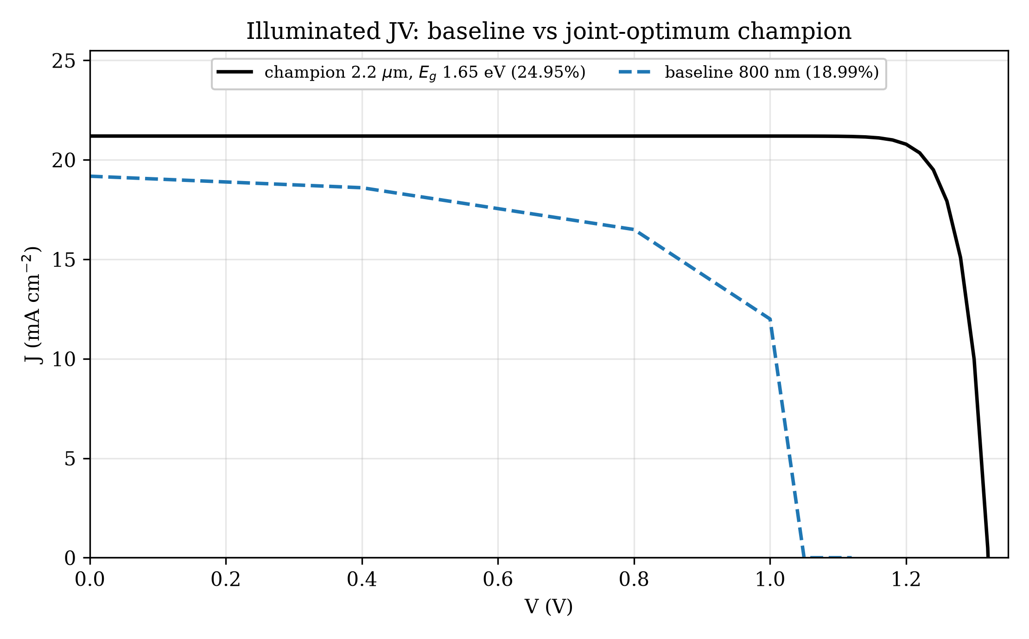
Illuminated current–voltage curves: baseline (800 nm, 18.99%) versus joint-optimum champion (2.2 $μ$m, 24.95%).
Joint affinity map at guardrailed interfaces (PCE %; champion geometry; peak extension 3.95–4.10 eV turns over past $∼$3.95 eV).
$χ_{CBTS}$ $∖$ $χ_{TiO2}$ | 3.7 | 3.8 | 3.9 | 4.0
3.50 | 22.10 | 22.10 | 22.10 | 22.07
3.60 | 23.83 | 23.82 | 23.80 | 23.50
3.70 | 24.67 | 24.64 | 24.53 | 23.77
3.80 | 24.89 | 24.86 | 24.67 | 23.81
3.90 | 24.95 | 24.91 | 24.74 | 23.81
3.95 | 24.94 | 24.90 | – | –
4.00 | 24.81 | 24.79 | – | –
4.10 | 23.25 | 23.25 | – | –
The 5.96-point stacked gain decomposes along the screening path (Table [tab:champ] parameters in sequence, illustrative ordering only): thickness 800 nm to 1.5 $μ$m adds 0.19 points (19.18%), acceptor doping to ${10}^{16}$ cm$​^{−3}$ adds 0.93 points (20.11%), bulk-defect reduction to ${10}^{12}$ cm$​^{−3}$ adds $∼$1.6 points ($∼$21.7%), the joint $E_{g}$–$χ$ move to 1.65 eV with ETL donor optimisation contributes $∼$1.8 points (to the 23.50% surveyed best), and the joint affinity optimum adds the final 1.45 points (modulo rounding). This sequential attribution is order-dependent and illustrative, not causal. Open-circuit voltage climbs 1.122 to 1.321 V while the fill factor rises 86.0 to 89.1%, the signature of SRH-lifetime recovery plus interface-activation recovery rather than band-shift artefacts.
Round A’s top ten (Table 4) all carry $E_{g}=1.65$ eV; the top seven sit at $N_{t}={10}^{12}$ cm$​^{−3}$ while rows 8–10 at $N_{t}={10}^{13}$ cm$​^{−3}$ trail by $∼$0.4 points through Voc loss (1.233 to 1.221 V). Round B refined thickness (1.8–2.2 $μ$m), gap (1.65–1.72 eV) and doping (36 runs) and moved the best from 23.47% to 23.50% (coarse grid), i.e. the landscape is converged rather than climbing.
Round B’s refinement is documented in full because its plateau is itself evidence: the best ten span only 23.32–23.50% (Table 5), with thickness 1.8–2.2 $μ$m and $N_{A}$ (1–3)$×{10}^{16}$ cm$​^{−3}$ numerically indistinguishable at grid resolution once $N_{t}={10}^{12}$ cm$​^{−3}$ and $E_{g}=1.65$ eV are fixed (the ten span 23.32–23.50%, a 0.19-point range against a 0.017-point coarse/fine IV-step uncertainty, so the leading cluster cannot be separated even though the 10th entry trails observably). The $N_{t}=3×{10}^{12}$ cm$​^{−3}$ entries trail the matched ${10}^{12}$ cells by 0.05–0.16 points (0.05 at the champion corner, 0.16 on the $N_{A}={10}^{16}$ branch), confirming the defect floor binds the optimum.
Round A leaderboard (best ten of 96; $N_{D,ETL}=9×{10}^{17}$ cm$​^{−3}$; $χ_{TiO2}=4.0$ eV surveyed throughout).
$d$ ($μ$m) | $N_{A}$ | $N_{t}$ | $E_{g}$ | Voc | Jsc | PCE
2.0 | 1e16 | 1e12 | 1.65 | 1.233 | 21.18 | 23.47
1.8 | 1e16 | 1e12 | 1.65 | 1.233 | 21.16 | 23.45
1.5 | 1e16 | 1e12 | 1.65 | 1.234 | 21.11 | 23.40
1.5 | 1e15 | 1e12 | 1.65 | 1.233 | 21.11 | 23.29
2.0 | 1e15 | 1e12 | 1.65 | 1.233 | 21.18 | 23.29
1.0 | 1e16 | 1e12 | 1.65 | 1.234 | 20.90 | 23.18
1.0 | 1e15 | 1e12 | 1.65 | 1.233 | 20.90 | 23.11
1.8 | 1e16 | 1e13 | 1.65 | 1.221 | 21.16 | 23.04
2.0 | 1e16 | 1e13 | 1.65 | 1.219 | 21.18 | 23.03
1.5 | 1e16 | 1e13 | 1.65 | 1.223 | 21.11 | 23.03
Round B leaderboard (best ten of 36; $N_{D,ETL}=9×{10}^{17}$ cm$​^{−3}$).
$d$ ($μ$m) | $N_{A}$ | $N_{t}$ | $E_{g}$ | PCE
2.2 | 3e16 | 1e12 | 1.65 | 23.50
2.0 | 3e16 | 1e12 | 1.65 | 23.49
2.2 | 1e16 | 1e12 | 1.65 | 23.48
2.0 | 1e16 | 1e12 | 1.65 | 23.47
1.8 | 3e16 | 1e12 | 1.65 | 23.47
2.2 | 3e16 | 3e12 | 1.65 | 23.45
1.8 | 1e16 | 1e12 | 1.65 | 23.45
2.0 | 3e16 | 3e12 | 1.65 | 23.44
1.8 | 3e16 | 3e12 | 1.65 | 23.42
2.2 | 1e16 | 3e12 | 1.65 | 23.32
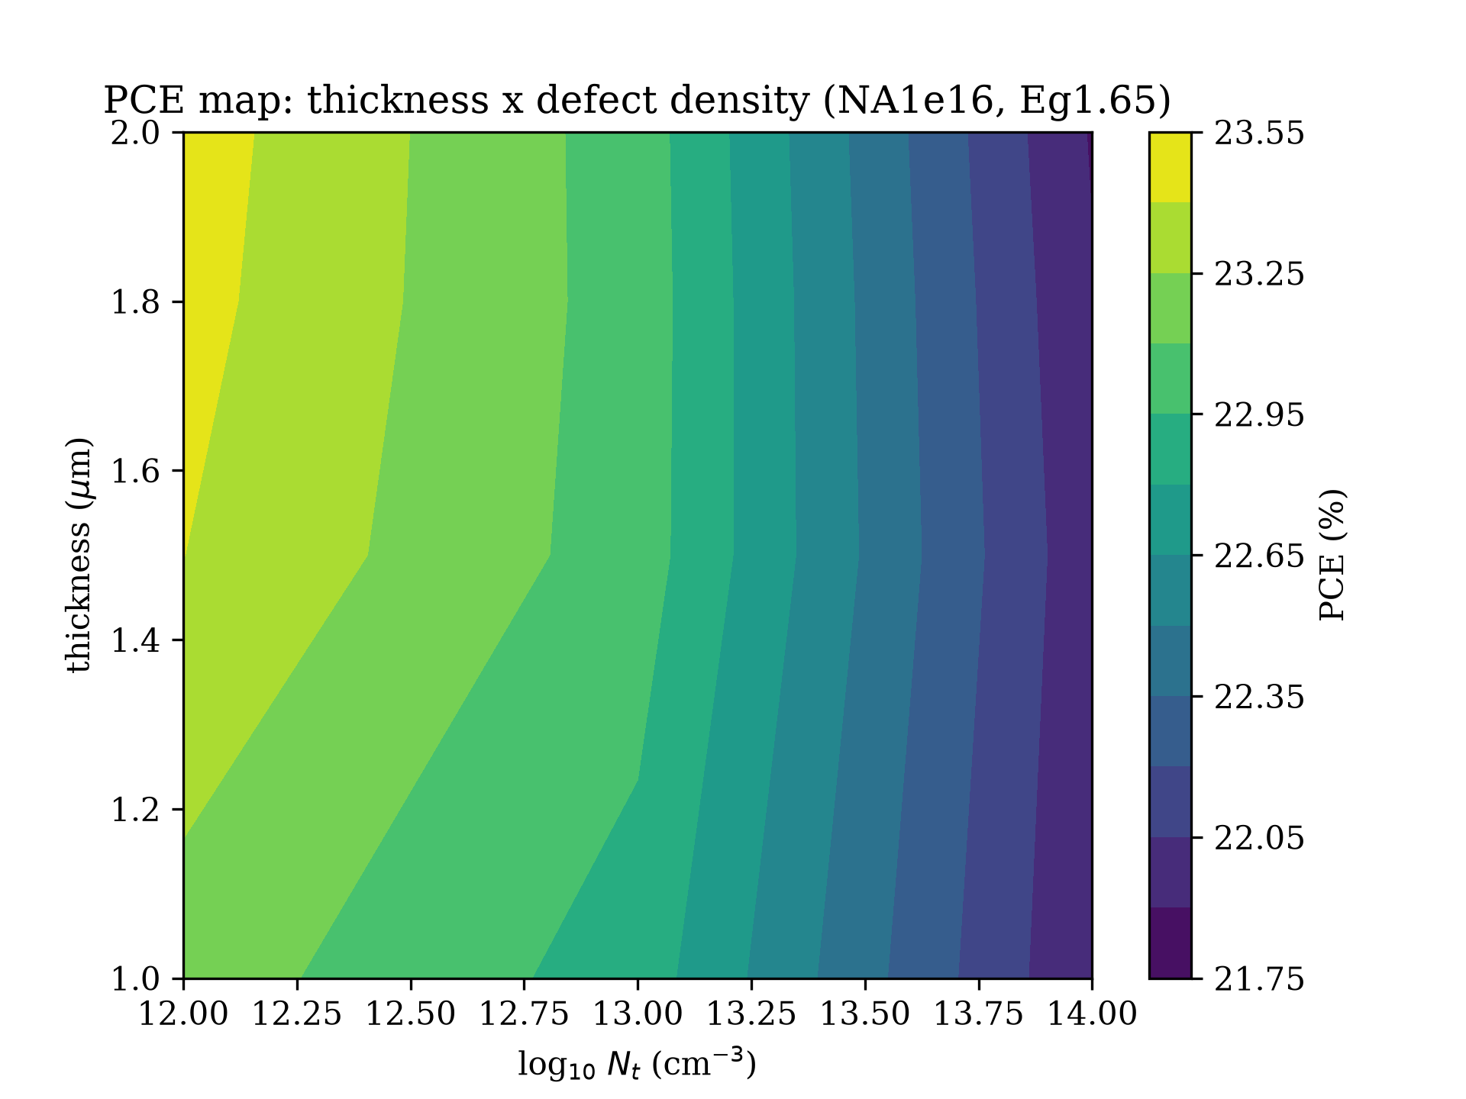
Efficiency map over absorber thickness and bulk defect density (slice at $N_{A}={10}^{16}$ cm$​^{−3}$, $E_{g}=1.65$ eV).

Band alignment
Figure 4 constructs the equilibrium alignment from the joint-optimum parameters. The absorber conduction edge ($−3.928$ eV) lies 0.23 eV below the TiO2 edge ($−3.70$ eV), so electrons face a spike entering the ETL. The data support reading this as recombination physics, not transport: the interface recombination activation energy $E_{a}=E_{c,abs}−E_{v,HTL}$ grows from 1.47 eV at $χ_{CBTS}=3.5$ to 1.87 eV at 3.9 eV, and efficiency rises monotonically through zero hole-side offset (22.10% to 24.95% at $χ_{TiO2}=3.7$; Table 3)—a transport reading predicts the barrier end should be worst, and it is the best. On the hole side, the absorber valence edge ($−5.578$ eV) lies 0.22 eV above the CBTS edge ($−5.80$ eV) at the optimum, past the ideal $−0.3$ to $−0.1$ eV window on the barrier side—yet efficiency peaks there, which a transport reading cannot produce. The same activation logic applies to the ETL side, which is why the spike buys rather than costs efficiency. Both optimum affinities sit outside the surveyed values ($χ_{TiO2}=3.7$ below the typical 4.0–4.2 eV; $χ_{CBTS}=3.9$ above the surveyed 3.6 eV) and are reported as joint-optimum adoptions priced in Section 9.0, not surveyed values.
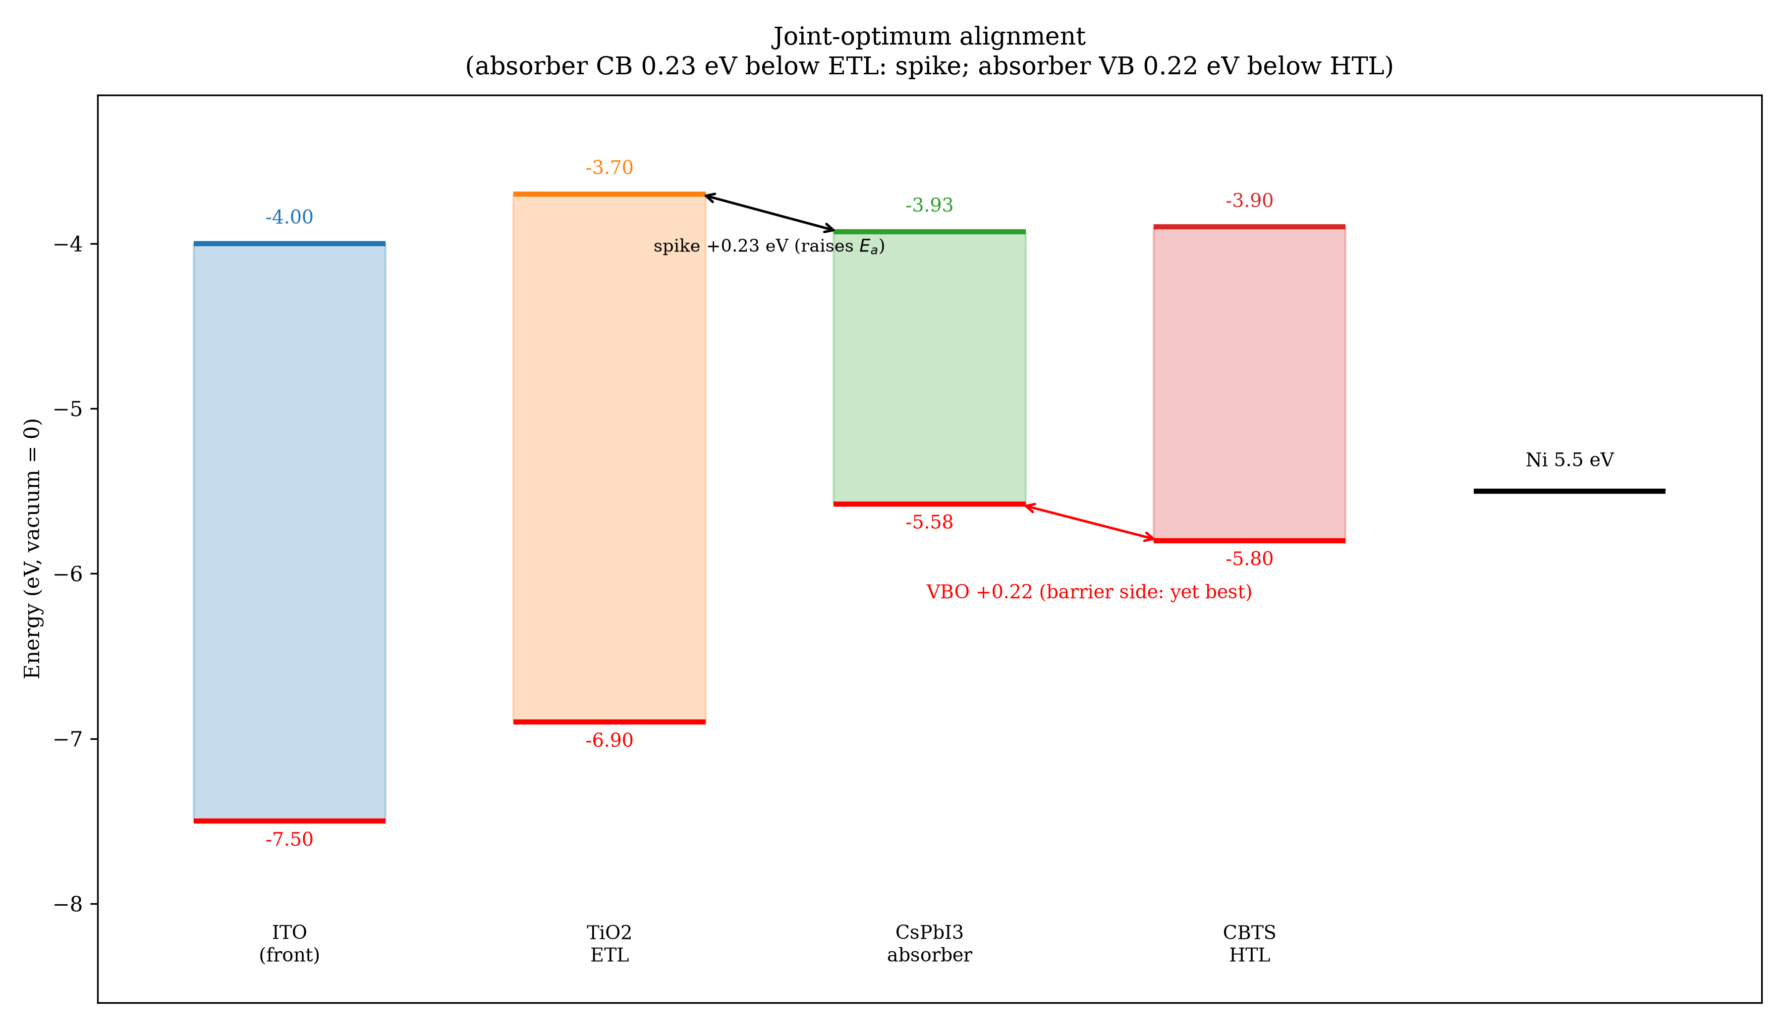
Equilibrium band alignment of the champion stack from input parameters (energies in eV vs vacuum).

Device characterisation
The quantum efficiency (Figure 5) is flat at $∼$89–90% from 300 nm with the absorption edge red-shifted from 731 nm (baseline, 1.694 eV) to 752 nm (champion, 1.65 eV), directly explaining the Jsc gain. The UV plateau assumes the definition file’s flat 10% front reflection with no dispersive parasitic absorption in ITO or TiO2, so it is an upper envelope in the blue rather than a prediction; with TiO2 absorbing above 3.2 eV, of order 1 mA/cm$​^{2}$ of the reported Jsc is at stake in the UV, which is large next to the points debated here and is stated as an uncertainty, not corrected. Integrating the computed QE against the AM1.5G spectrum gives 22.39 mA/cm$​^{2}$ against the 21.20 mA/cm$​^{2}$ IV value; the 1.19 mA/cm$​^{2}$ gap is carried as Jsc uncertainty with the conservative IV value headlined. Capacitance–voltage analysis at 1 MHz (Figure 6) shows rising capacitance with forward bias (31 to 39 nF/cm$​^{2}$ over 0–0.5 V). The low-bias $1/C^{2}$ branch is linear ($R^{2}=1.000$) with the normal sign for a p-type absorber; its slope gives $N_{A}=2.93×{10}^{16}$ cm$​^{−3}$, essentially the $3×{10}^{16}$ cm$​^{−3}$ input, extrapolating to $V_{bi}=1.30$ V—a solver self-consistency check on the doping from its own electrostatics, not an independent validation. The SCAPS-extracted width (0.29 to 0.22 $μ$m) sits an order of magnitude below the 2.2 $μ$m absorber throughout (the parallel-plate check gives 0.17 $μ$m at 0 V, consistent in order with extra deep-level capacitance unaccounted; this check therefore confirms the sign and linearity of the $1/C^{2}$ branch, not the absorber thickness). The illuminated band diagram at short circuit (Figure 7) exhibits clean quasi-Fermi splitting, and generation exceeds recombination by at least two orders of magnitude at every mesh point of the full 2.33 $μ$m short-circuit profile (minimum ratio $∼$3$×{10}^{2}$ at $x≈0.2$ $μ$m near the back contact, rising above ${10}^{4}$ at both contacts; Figure 8). All profile statements in this section are at short circuit; nothing here constrains the maximum-power or open-circuit regime.
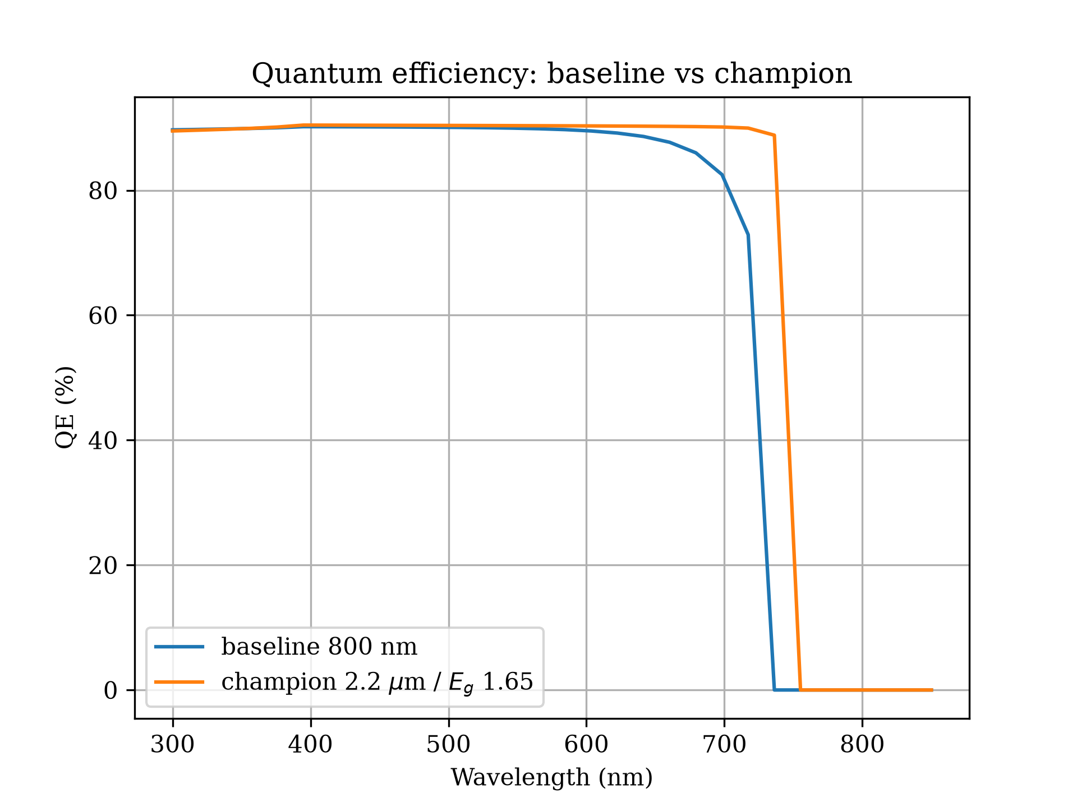
Quantum efficiency of baseline versus champion; the edge shifts 731 to 752 nm.
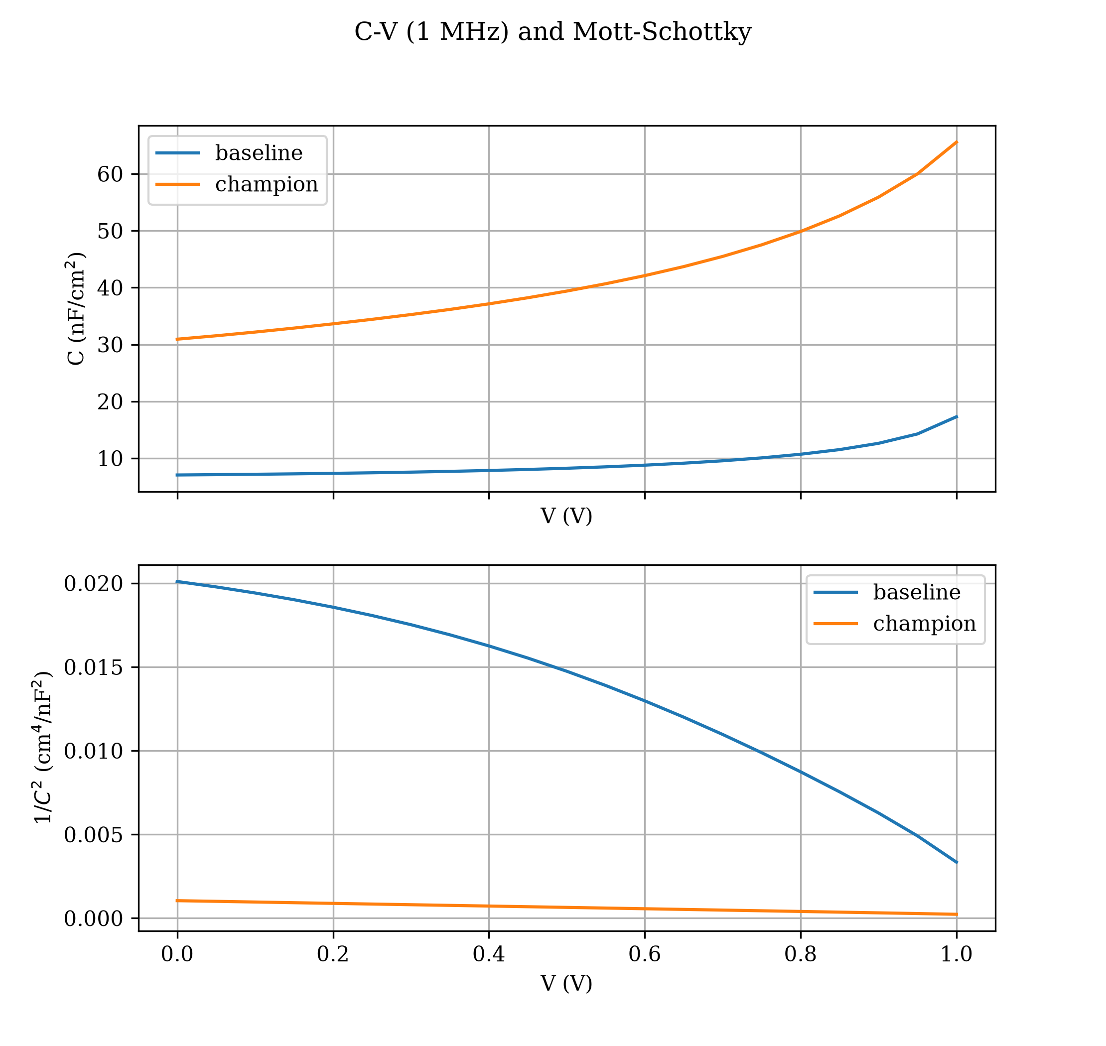
Capacitance–voltage (1 MHz) and Mott–Schottky plots for baseline and champion.
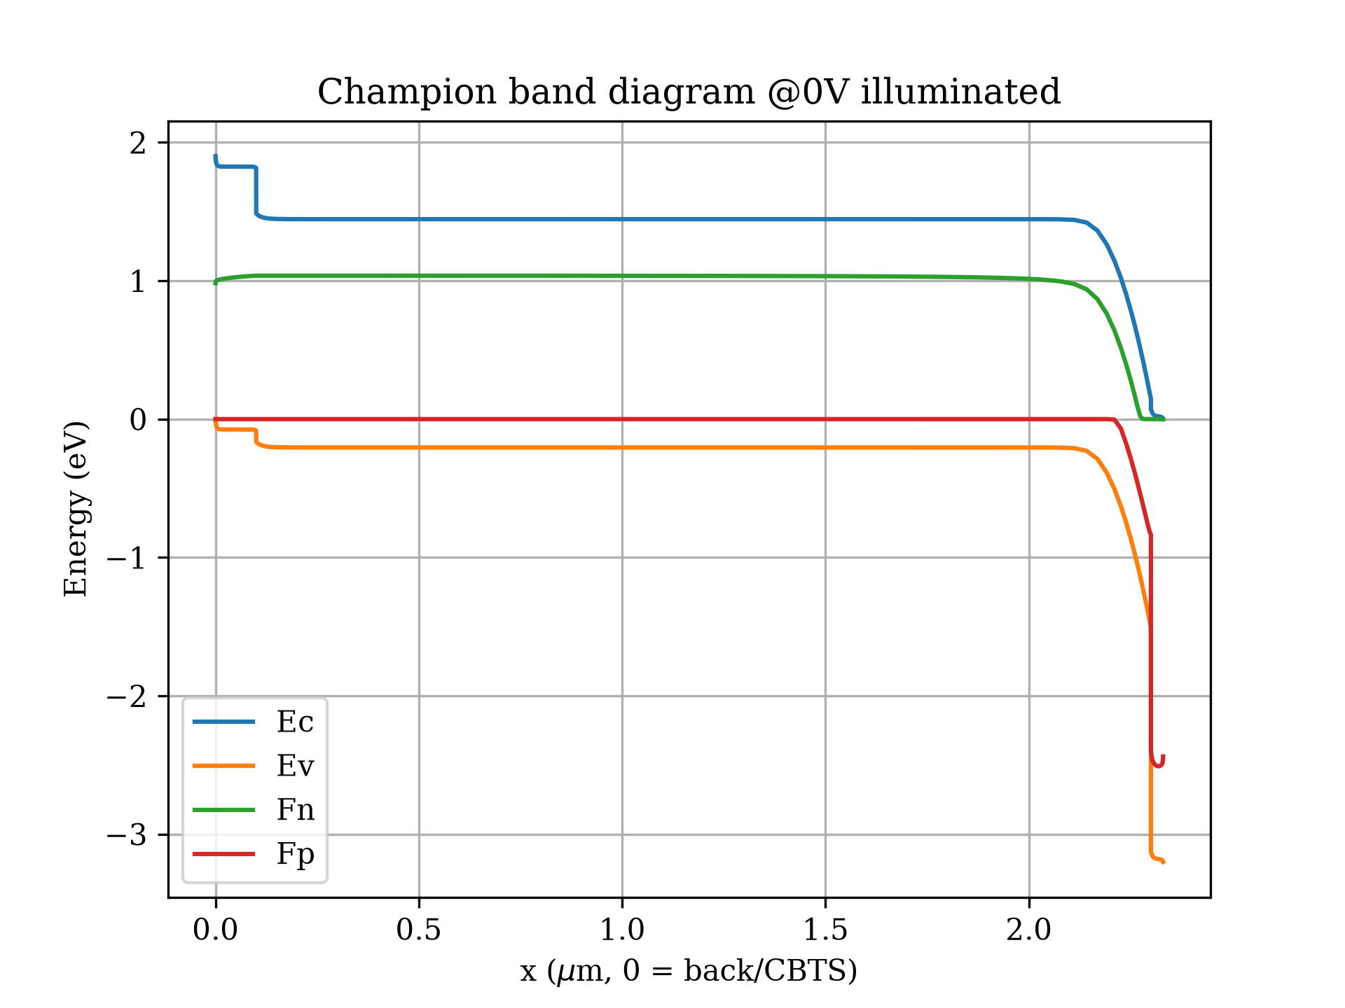
Illuminated band diagram of the champion at short circuit (x=0 at the back contact).
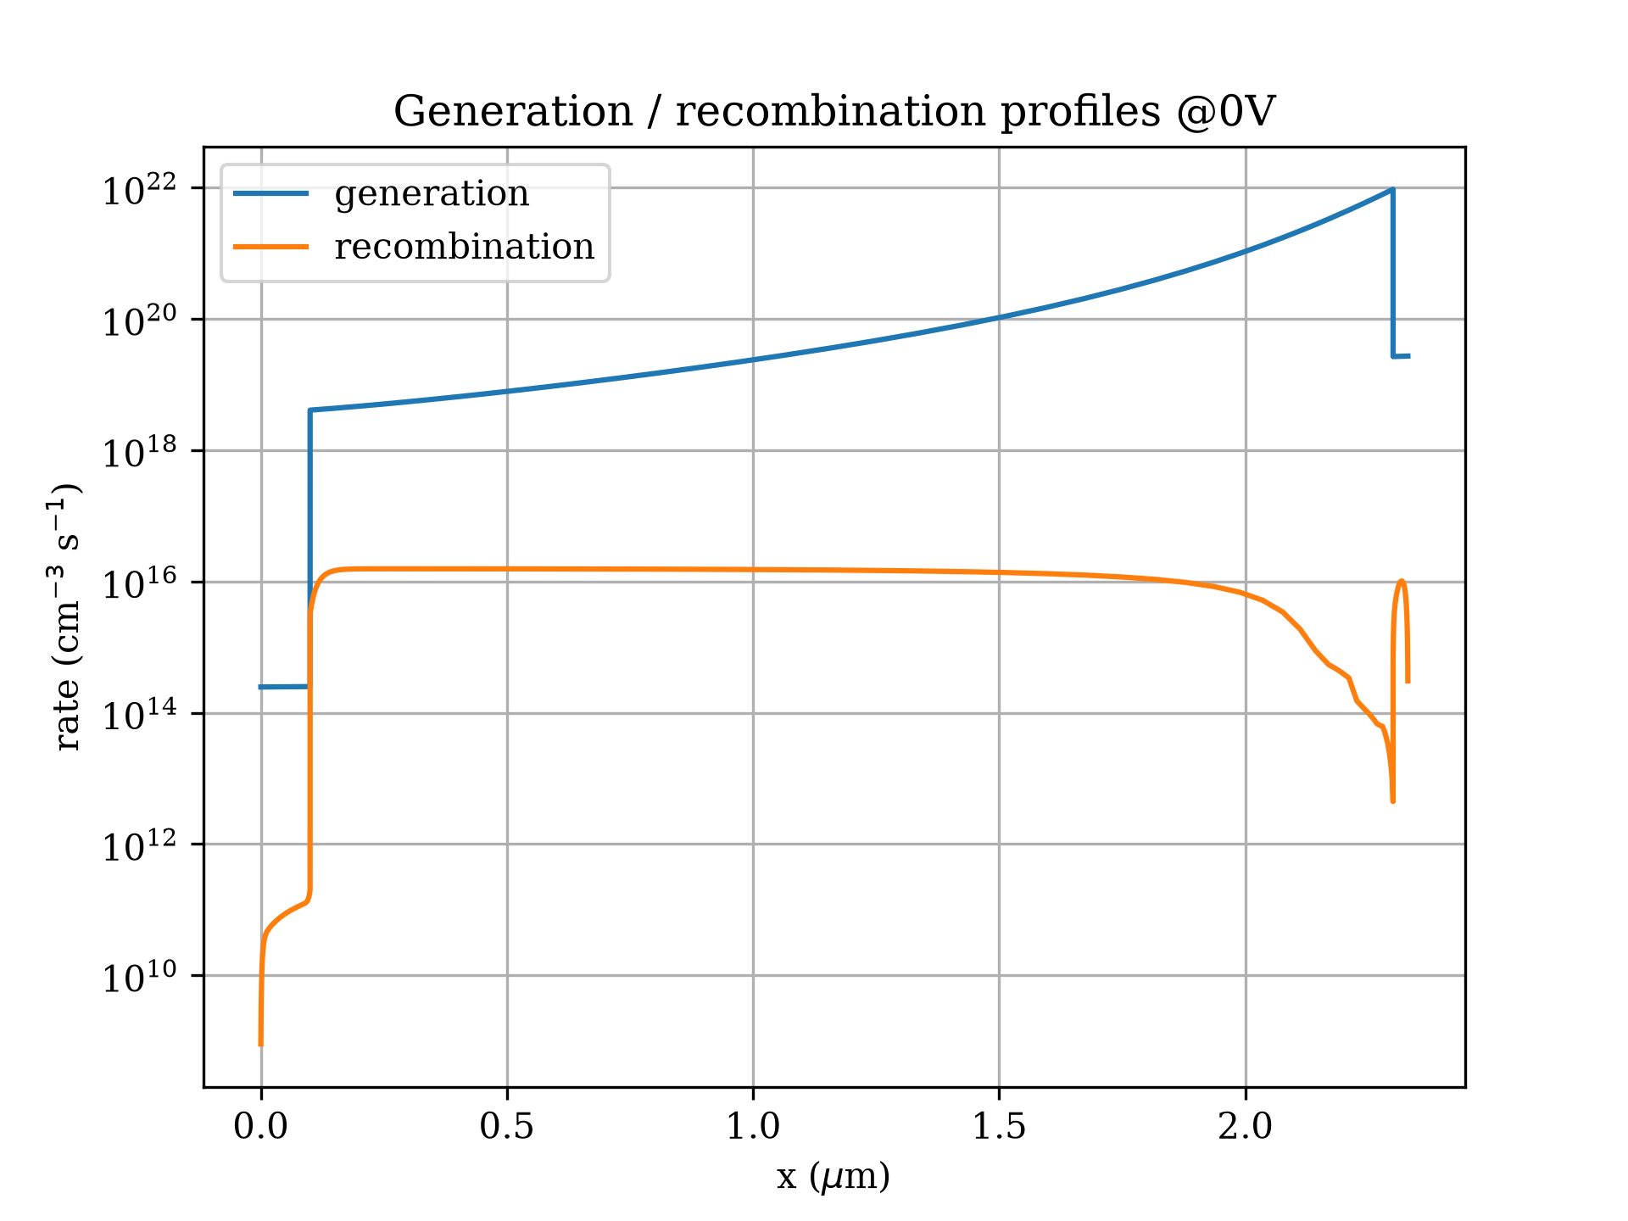
Generation and recombination profiles at short circuit (log scale).
Temperature dependence (Figure 9, Table 6) follows the established trend [5]: efficiency falls from 25.88% at 275 K to 18.13% at 475 K, driven by Voc (1.357 to 1.038 V) and FF while Jsc stays pinned at $∼$21.20 mA/cm$​^{2}$, i.e. $−0.16$%/K relative ($−0.039$ points/K) over the 300–475 K span. The 275 K fill factor (89.96%) sits below Green’s ideal-diode value at that Voc and temperature ($∼$91.3%), so no artefact needs invoking; likewise the joint optimum’s 89.11% is about 1.4 points below ideal (90.5%), leaving genuine FF headroom short of series resistance. The 275 K Voc (1.357 V) sits under the 275 K radiative limit (1.397 V, recomputed at that temperature), so the screen holds across the sweep. The 475 K end of the sweep ignores the temperature dependence of $E_{g}$ and black-phase stability, so it is a solver stress test, not a prediction.

Parasitic-resistance accounting
Series and shunt resistances are scriptable in SCAPS 3.3.10 (set external.Rs/Rsh; scriptdescription3310.txt). Computed scripted sweeps at the joint-optimum base give 24.73% at $R_{s}=0.5 Ω$cm$​^{2}$, 24.52% at $R_{s}=1 Ω$cm$​^{2}$, and 24.09% at $R_{s}=2 Ω$cm$​^{2}$ (Table [tab:rs]); a lumped-series analytic derate $η=η_{0}/[1+J_{sc}R_{s}/({10}^{3}FF_{0}V_{oc})]$—the ${10}^{3}$ putting $FF_{0}V_{oc}$ on the same millivolt scale as $J_{sc}R_{s}$, with $FF_{0}=0.891083$ the 89.11% of Table [tab:champ] as a fraction—tracks the computed sweep to within 0.011 points at all three $R_{s}$ (24.7237/24.5050/24.0790 against 24.7311/24.5160/24.0866). Shunt paths cost 0.14 points at $R_{sh}={10}^{4} Ω$cm$​^{2}$ at the prior base; combined $R_{s}=1$/$R_{sh}={10}^{4}$ at the joint optimum gives 24.38%. The best point therefore survives parasitics, but only just: at $R_{s}=2 Ω$cm$​^{2}$ the margin over the 22.02% certified record is about two points. At routine defects $R_{s}=1$ costs 0.40 points (20.82 to 20.42%).
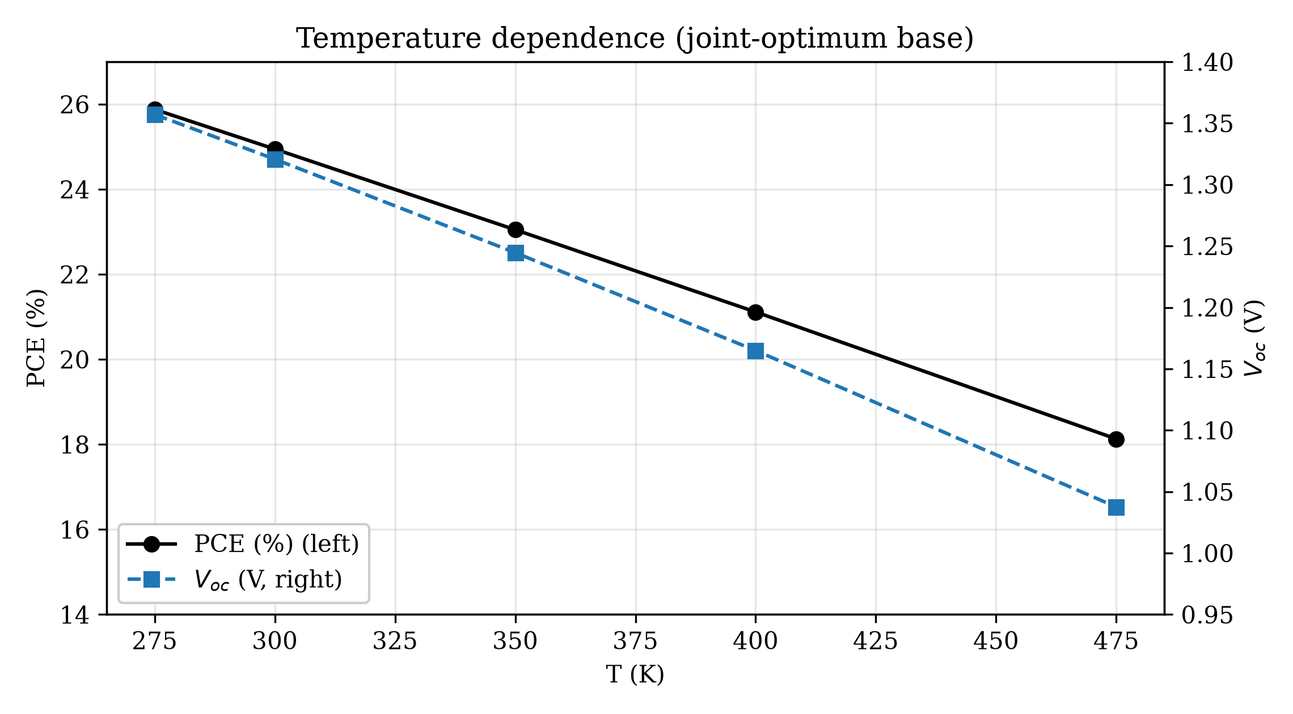
Efficiency and open-circuit voltage versus operating temperature at the joint-optimum base ($R_{s}=0$); the 475 K end is a solver stress test that ignores $E_{g}(T)$ and black-phase stability.
Temperature dependence at the joint-optimum base (1 sun; T300 $=24.9464$).
T (K) | Voc (V) | Jsc (mA/cm$​^{2}$) | FF (%) | PCE (%)
275 | 1.357 | 21.20 | 89.96 | 25.88
300 | 1.321 | 21.20 | 89.11 | 24.95
350 | 1.245 | 21.20 | 87.37 | 23.05
400 | 1.165 | 21.20 | 85.51 | 21.12
475 | 1.038 | 21.20 | 82.43 | 18.13

Interface dose–response and the limits of auditing others
Deleting the interface blocks (audit pairs in Table 9, dose–response plotted in Figure 10) inflates efficiency by 1.26–1.66 points absolute at the surveyed base (23.40 to 24.87%, 23.47 to 24.73%, 23.50 to 25.16%), almost entirely through a 0.13 V Voc rise as interface recombination vanishes. But the binary ON/OFF comparison understates the audit: the full dose–response at the prior adopted base (Table 7) runs 25.11% at ${10}^{8}$ cm$​^{−2}$, 24.77% at ${10}^{9}$ cm$​^{−2}$, 23.84% at the ${10}^{10}$ cm$​^{−2}$ guardrail, 22.62% at ${10}^{11}$ cm$​^{−2}$, and 21.20% at ${10}^{12}$ cm$​^{−2}$. Because interface density and cross-section enter only as the product $Nσ$, Table 8 restates the guardrailed regime in the portable metrics other studies can compare against: bulk lifetime $τ=1/(σv_{th}N_{t})$ and interface velocity $S=σv_{th}N_{if}$ (with $v_{th}={10}^{5}$ m/s). Our guardrail is $τ=100$ $μ$s with $S=100$ cm/s. The decisive screen, however, is energetic, not parametric: the detailed-balance Voc computed from the model’s own Eg-sqrt absorption is 1.371 V at 1.65 eV (1.418 V at 1.70 eV), and the no-interface cells we computed (1.363–1.382 V) sit within 0.011 V of that radiative limit—the top one above it, the rest with no margin either—because with $k_{rad}=0$ in the model there is nothing to hold the quasi-Fermi splitting below the radiative bound. A band that hugs the limit is not evidence of a working cell. The published 24.17% [7] and 24.24% [8] values are therefore not placed on our curve at all: their stacks, gaps, thicknesses and defect parameters all differ from ours, neither paper prints a complete parameter table from which $τ$ or $S$ could be reconstructed, and we state this as a limitation rather than a finding.

Where the missing points go
The inflation is almost entirely a Voc effect ($+$0.13 V at the champion cell, $+0.148$ V at 1.5 $μ$m) with Jsc unchanged to within 0.02 mA/cm$​^{2}$: removing the ${10}^{10}$ cm$​^{−2}$ interface states eliminates the dominant SRH channel at the heterojunctions, unpinning the quasi-Fermi splitting. The no-interface Voc values (1.363–1.382 V) all sit within 0.011 V of the 1.371 V detailed-balance limit computed from the model’s own absorption, the top one above it: with $k_{rad}=0$ there is no radiative channel to pin the splitting, so none of these cells carries margin and none is trusted, regardless of rank order. Fill factor moves non-monotonically (89.86% down to 85.25–87.05% across the three audited cells) as the recombination profile reshapes. The no-interface 87.05% at Voc 1.363 V sits 3.7 points below Green’s ideal (90.8%): the archived JV curve stays flat to 1.16 V with no kink or S-shape, so there is no visible extraction barrier, but the knee remains SRH-rounded by the surviving bulk channel—removing interfaces unpins Voc without idealising the diode. This bounds the “no extraction barriers” claim to current collection, not to fill factor. Asymmetric tests show both heterojunctions matter: ${10}^{12}$ cm$​^{−2}$ on the ETL side alone gives 21.35%, on the HTL side alone 21.20%. Raising the capture cross-section $10×$ at fixed $N_{if}={10}^{10}$ cm$​^{−2}$ gives 22.2108%, digit-identical to the $N×10$ run at the same base (both 22.2108; receipts in Table 14): for the symmetric single level, rate scales exactly with the $Nσ$ product. The same identity holds in the bulk: $σ×10$ at the $N_{t}$ floor gives 23.2572% (digit-identical to $N_{t}×10$ at the same base, $=23.2572$; receipts in Table 14), a 0.25-point cost against the surveyed 23.5041 anchor. (A first attempt via the script set key for $σ$ neutralised the interfaces instead of scaling them; only the verified definition-file variant is reported—see Appendix A.) Bulk $N_{t}×σ$ costs 0.25 points at the ${10}^{12}$ cm$​^{−3}$ floor but 3.12 points at routine ${10}^{15}$ cm$​^{−3}$ (20.5603% at matched $σ×1$ geometry down to 17.4433%), while $σ×0.1$ at the floor gains only 0.03 points (23.53%)—the floor is saturated.) The computed parasitic sweep at the adopted base is tabulated below.
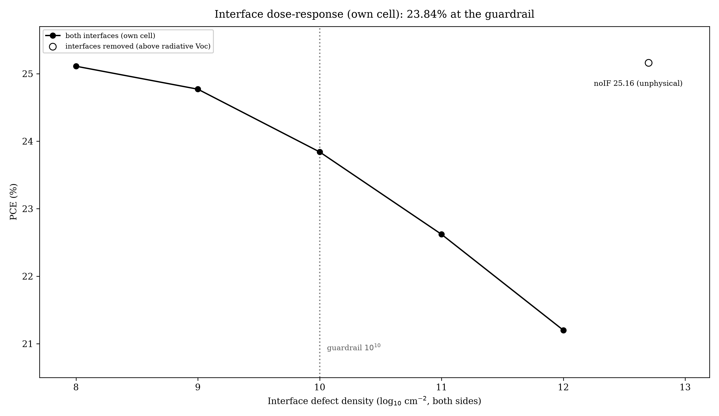
Same cell at graded interface quality: efficiency vs $N_{if}$ (both sides). No literature scale bar is shown: cross-stack mapping is not claimed (Section 7.0).
Interface dose–response (prior adopted base unless noted; both sides unless noted).
$N_{if}$ (cm$​^{−2}$) | PCE (%) | Note
${10}^{8}$ | 25.11 | –
${10}^{9}$ | 24.77 | –
${10}^{10}$ (guardrail) | 23.84 | prior adopted base
${10}^{11}$ | 22.62 | –
${10}^{12}$ | 21.20 | –
${10}^{12}$ ETL side only | 21.35 | surveyed base
${10}^{12}$ HTL side only | 21.20 | surveyed base
${10}^{10}$, $σ×10$ (verified) | 22.21 | matches $N×10$ (rate $∝Nσ$)
removed (noIF) | 25.16 | above detailed-balance Voc: unphysical
Guardrailed regime in portable metrics ($σ={10}^{−19}$ m$​^{2}$, $v_{th}={10}^{5}$ m/s): bulk lifetime $τ$ and interface velocity $S$.
Density | $τ$ / $S$ | Note
$N_{t}={10}^{12}$ cm$​^{−3}$ (floor) | $τ=100$ $μ$s | 1–2 orders beyond best films
$N_{t}={10}^{13}$ cm$​^{−3}$ | $τ=10$ $μ$s | –
$N_{t}={10}^{14}$ cm$​^{−3}$ | $τ=1$ $μ$s | –
$N_{t}={10}^{15}$ cm$​^{−3}$ (routine) | $τ=0.1$ $μ$s | routine case
$N_{if}={10}^{10}$ cm$​^{−2}$ (guardrail) | $S=100$ cm/s | floor of stated box
$N_{if}={10}^{11}$ cm$​^{−2}$ | $S=1000$ cm/s | –
Guardrail audit: identical cells with interfaces ON versus OFF.
Cell | IF ON (%) | IF OFF (%) | Inflation (pts)
1.5 $μ$m cell | 23.40 | 24.87 | +1.46
2.0 $μ$m cell | 23.47 | 24.73 | +1.26
Champion (surveyed base) | 23.50 | 25.16 | +1.66

Morris sensitivity screening
Grid methods with uneven ranges cannot rank physical importance, so we ran a Morris sensitivity screen instead: $r=8$ trajectories, $p=4$ levels, $k=6$ factors (absorber thickness, $logN_{A}$, $logN_{t}$, $logN_{D,ETL}$, $E_{g}$ with the $χ$ link applied deterministically, and $logN_{if}$ tied on both interfaces), 56 fresh simulations, all converged, spanning 15.6–23.3% (Table 10, Figure 11). Per decade, interface quality leads at 1.02 points (bootstrap 95% CI [0.84, 1.22]) ahead of bulk defect density at 0.68 (CI [0.35, 0.99]). Because marginal intervals overlap, we ran the sharper paired test the design allows: the per-trajectory difference $|EE_{Nif}|−|EE_{Nt}|$ averages $+$2.03 points with a bootstrap 95% CI of [0.70, 3.51] (6 of 8 trajectories positive)—interfaces genuinely lead within the defect-floor regime. Per eV, bandgap moves 17.5 points; per $μ$m, thickness 0.72. These per-unit numbers are not commensurable across units, the interface figure bundles both heterojunctions over a 4-decade range against 3 for bulk, and—crucially—the $E_{g}$ factor confounds gap with band offset, since the $χ$ link assigns half of every gap step to the conduction band while Section 5.0 shows alignment alone moves efficiency by several points. The gap-step pattern betrays the confounding (all on the prior adopted base, 23.8365 anchor): 1.65 to 1.68 eV costs 1.13 points but 1.68 to 1.70 eV only 0.19 (and 1.70 to 1.72 eV costs 0.93), tracking the $E_{a}$ landscape rather than the absorption edge. On the joint-optimum base the same steps even change sign (24.44 to 24.73% from 1.68 to 1.70 eV), confirming the steps map the activation landscape, not the gap. The random-forest/Saltelli corroboration ($S_{T}=0.52$ interfaces, 0.33 bulk, 0.24 $E_{g}$; OOB $R^{2}=0.93$) is reported with the caveat that it is not independent evidence: the surrogate trains on all 190 standard-base runs including the Morris design itself, so its indices partly reflect the sampling design. The decisive test remains the dose–response repeated at routine defects: at $N_{t}={10}^{15}$ cm$​^{−3}$ and 1.0 $μ$m, $N_{if}$ 10$​^{9}$–${10}^{11}$ cm$​^{−2}$ moves efficiency only from 20.84% to 20.67% (0.16 points over two decades), while the $N_{t}$ 10$​^{14}$–${10}^{15}$ step costs far more. At the defect floor interfaces dominate; at routine defects bulk defects do. Trap depth is a non-factor at this defect level: moving $E_{t}$ to 0.3 or 0.9 eV changes efficiency by at most 0.012 points (23.8259% and 23.8241% against 23.8365%).
Morris screen design and results ($r=8$ trajectories, $p=4$, $Δ=2/3$, seed 7; 56/56 converged). $μ^{*}$ and $σ$ are per normalised unit input; the per-decade column (sixth) and the CI column (seventh) are both per physical decade (per eV or per $μ$m where noted); $n=8$ unique directed effects per factor; CI = bootstrap 95% interval (5000 resamples), also per physical decade.
Factor | Range | $μ^{*}$ | $σ$ | $n$ | per decade | 95% CI
$logN_{if}$ (both IF) | ${10}^{8}$–${10}^{12}$ cm$​^{−2}$ | 4.08 | 1.08 | 8 | 1.02 | [0.84, 1.22]
$logN_{t}$ (absorber) | ${10}^{12}$–${10}^{15}$ cm$​^{−3}$ | 2.05 | 1.40 | 8 | 0.68 | [0.35, 0.99]
$E_{g}$ (+$χ$ link) | 1.65–1.75 eV | 1.75 | 0.79 | 8 | 17.5/eV | [12.6, 23.2]
Thickness | 0.4–2.2 $μ$m | 1.29 | 0.99 | 8 | 0.72/$μ$m | [0.36, 1.07]
$logN_{D,ETL}$ | ${10}^{16}$–${10}^{19}$ cm$​^{−3}$ | 0.68 | 1.04 | 8 | 0.23 | [0.02, 0.47]
$logN_{A}$ (absorber) | ${10}^{15}$–$3×{10}^{16}$ cm$​^{−3}$ | 0.48 | 0.56 | 8 | 0.32 | [0.12, 0.58]
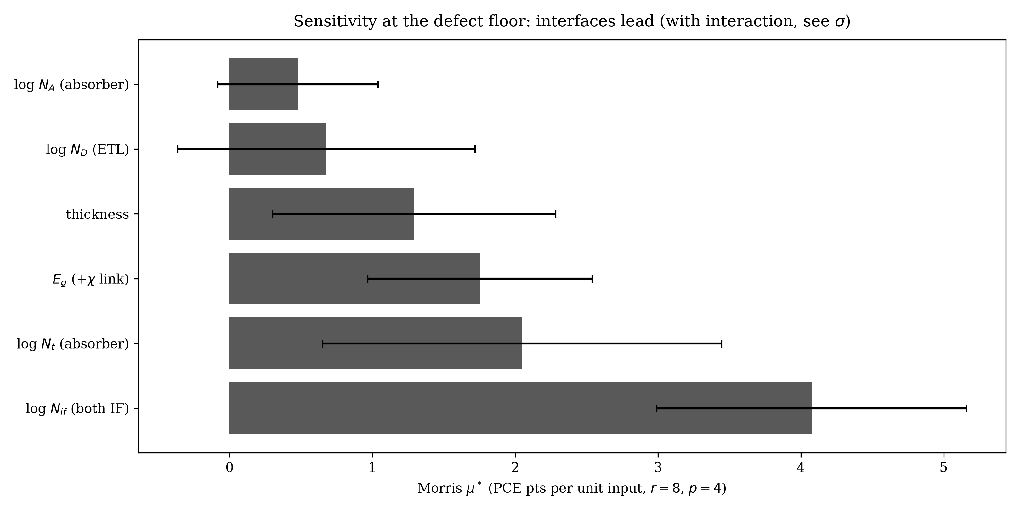
Morris $μ^{*}$ (bars) with interaction spread $σ$ (whiskers). Ranking is regime-conditional: interfaces lead at the defect floor, bulk defects at routine levels (Table 11); large $σ$ signals interactions.
Routine-defect case ($N_{t}={10}^{15}$ cm$​^{−3}$): interface dose–response is nearly flat, so bulk defects dominate here. Dose rows are 1.0 $μ$m and $Δ$ is against the 20.82% guardrail row of that base; the two ITO rows are 0.8 $μ$m runs (20.72% at surveyed $χ$) and their $Δ$ is against that 0.8 $μ$m row, not the 1.0 $μ$m one. Values computed; $R_{s}=0$ unless stated.
$N_{if}$ (cm$​^{−2}$) | PCE (%) | $Δ$ vs guardrail | Base
${10}^{9}$ | 20.84 | +0.017 | surveyed $χ$
${10}^{10}$ (guardrail) | 20.82 | – | surveyed $χ$
${10}^{11}$ | 20.67 | $−0.147$ | surveyed $χ$
${10}^{10}$, ITO 4.4 eV (0.8 $μ$m) | 20.68 | $−0.04$ | surveyed $χ$
${10}^{10}$, ITO 4.4 eV (0.8 $μ$m) | 18.11 | $−2.61$ | adopted $χ$
${10}^{10}$, $R_{s}=1 Ω$cm$​^{2}$ | 20.42 | $−0.40$ | surveyed $χ$; computed (s14)
Interface-led sensitivity is consistent with passivation studies in which interface-adjacent defects gate the voltage [29], and with Bayesian optimisation on CsSnI3 where the optimal thickness likewise shifts with defect density [9].

Discussion
Fabrication plausibility bounds the result, and the computed sweeps price each term. $N_{A}=3×{10}^{16}$ cm$​^{−3}$ is routinely achievable; $E_{g}=1.65$ eV sits below the $∼$1.7 eV of the experimental records and contributes roughly one point (best 1.694 eV grid point: 22.506%); $N_{t}={10}^{12}$ cm$​^{−3}$ demands near-single-crystal quality ($τ_{SRH}≈100$ $μ$s, Table 8). The contacts are load-bearing. At the surveyed anchor Ni 5.5 to 5.2 eV costs nothing (23.5041 to 23.5039%, the Ni 5.2 value reproduced digit-identically across two batches) while Ni 5.0 eV costs 0.25 points (23.2571%); on the joint-optimum affinities the same Ni 5.0 eV choice instead collapses the cell to 15.63% (Voc 1.01 V) against 18.83% at Ni 5.2 eV—a back-contact barrier cliff, not a slope, so the back-contact tolerance window collapses as the bands shift with affinity. ITO 4.0 to 4.7 eV collapses the cell to 18.60% (Voc 1.08 V)—SCAPS’s thermionic-only contact boundary, so 4.0 eV is the edge of what this model tolerates rather than a typical ITO value; the routine-defect penalty is larger still, with ITO 4.4 eV costing 0.04 points at surveyed $χ$ (20.72 to 20.68% on the 0.8 $μ$m base) but 2.61 points at adopted $χ$ (20.72 to 18.11% on the same base): the front-contact tolerance window itself shifts with ETL affinity (Table 11). Both optimum affinities are aggressive ($χ_{TiO2}=3.7$ below the typical 4.0–4.2 eV window; $χ_{CBTS}=3.9$ above the surveyed 3.6 eV) and move efficiency through the interface activation energy rather than transport (Table 3). At routine settings the model gives 20.82% (1.0 $μ$m, $N_{t}={10}^{15}$ cm$​^{−3}$, surveyed $χ$), 20.68% with ITO at 4.4 eV on the 0.8 $μ$m base, 18.11% when that ITO is combined with the adopted $χ_{TiO2}$, and 20.42% with $R_{s}=1 Ω$cm$​^{2}$. Against experiment (Table 12): 24.95% exceeds the 22.02% certified record by 2.93 points; the excess over the best measured devices comes mostly from fill factor ($∼$89% simulated against $∼$83% measured) and the low gap, not from voltage—and we do not attribute that FF excess to any single cause: the model carries no transport-layer bulk recombination and no back reflector, two systematic choices that both bias FF upward by amounts this study does not isolate, while the 0.017-point IV-step uncertainty only sets the significance threshold for any of these comparisons—our Voc deficit (0.33 V against $E_{g}/q$, 0.05 V against the radiative limit) is comparable to the 1.27–1.29 V record devices. With computed $R_{s}=1 Ω$cm$​^{2}$ (24.52%) the margin is 2.50 points, and at attainable gaps on the joint-optimum base the model gives 24.44% ($E_{g}=1.68$ eV), 24.73% ($E_{g}=1.70$ eV) and 24.28% ($E_{g}=1.72$ eV), with 24.34% at $R_{s}=1 Ω$cm$​^{2}$ ($E_{g}=1.70$ eV; $χ_{CBTS}=3.9$/$χ_{TiO2}=3.7$, ITO 4.0 eV throughout). The non-monotonic 1.68-to-1.70 step ($+$0.29 points) is the $E_{a}$ confounding of Section 8.0, not an absorption effect. The result sits at about four-fifths of the $∼$30–31% Shockley–Queisser limit at 1.65 eV. A final calibration note: integrating the computed QE against the AM1.5G spectrum gives 22.39 mA/cm$​^{2}$ against the 21.20 mA/cm$​^{2}$ IV value—a 1.19 mA/cm$​^{2}$ gap we report as Jsc uncertainty (headline Jsc uses the conservative IV value) alongside the $∼$1 mA/cm$​^{2}$ UV envelope.
Loss budget: joint optimum against measured record devices and model limits. FF is where the simulation exceeds experiment, not Voc. PCE values are each paper’s headline; the Lei row is a mixed-source triple (its printed FF gives 22.24%, its reported headline 22.16%).
Device | Voc (V) | Jsc (mA/cm$​^{2}$) | FF (%) | PCE (%)
This work (joint optimum) | 1.321 | 21.20 | 89.11 | 24.95
AP-modified CsPbI3 [30] | 1.29 | 20.77 | 83.01 | 22.16
QD-interface CsPbI3 [31] | 1.28 | – | – | 22.15
Dual-interface CsPbI3 [3] | 1.27 | – | – | 21.71
Carbon HTL-free [32] (cert. 20.35) | 1.202 | 20.72 | 83.2 | 20.72
Radiative limit (this model) | 1.371 | 39.2 (SQ) | 90.5 | –

Limitations and outlook
A laboratory translation would need, simultaneously: $∼$1.0 $μ$m CsPbI3 films at routine defect levels for the 20.86% case (time-resolved photoluminescence verified), interface passivation toward ${10}^{10}$ cm$​^{−2}$ following the fluorinated-dipole [2] or dual-interface [3] chemistries, a front contact near 4.0 eV, and $R_{s}≤1 Ω$cm$​^{2}$ (Table [tab:rs]). Not demonstrated here: 2.2 $μ$m device-quality CsPbI3 at $N_{t}∼{10}^{12}$ cm$​^{−3}$, and sputtered CBTS directly on CsPbI3 (CBTS typically requires high-temperature sulfurisation), for which we found no precedent—so this section is a requirements list, not a recipe. In-line controls, where applicable: QE edge at 752 nm (Figure 5) and the $−0.16$%/K temperature coefficient (Table 6).
Five boundaries delimit this work. First, $N_{t}={10}^{12}$ cm$​^{−3}$ at 2.2 $μ$m demands near-single-crystal films, and with the modelled $σ={10}^{−19}$ m$​^{2}$ implies $τ_{SRH}≈100$ $μ$s, one to two orders beyond the best reported perovskite films; a reader preferring $σ={10}^{−17}$ m$​^{2}$ would get 1 $μ$s, so the lifetime claim scales as $1/σ$ and the defect density, not the lifetime, is what we hold fixed; at routine ${10}^{15}$ cm$​^{−3}$ a dedicated sweep peaks at 20.82% (1.0 $μ$m), 20.68% with ITO at 4.4 eV on the 0.8 $μ$m base, 18.11% when that ITO meets the adopted $χ_{TiO2}$, and 20.42% with $R_{s}=1 Ω$cm$​^{2}$. Second, the contacts (Ni 5.5 eV, ITO 4.0 eV), the joint-optimum affinities ($χ_{CBTS}=3.9$/$χ_{TiO2}=3.7$ eV, both outside surveyed/typical ranges), and the barrier-side hole offset (+0.22 eV) are permissive-edge stated-box choices, each priced in Section 9.0. Third, phase stability of black CsPbI3 against the yellow $δ$-phase, ion migration, $E_{g}(T)$, and damp-heat degradation are outside SCAPS-1D steady-state scope and must be validated experimentally, following the passivation routes of [1], [2], [3]. Fourth, the grid is a screen plus a 104-configuration optimiser, not a proven global optimum: the best point sits at the corner of the allowed box, the exploratory search peaks 1.87 points below it among guardrail-satisfying runs, and the leading cluster is numerically inseparable. Fifth, the single-junction ceiling ($∼$30% at 1.65 eV [25]) caps how far any interface-inclusive screening can go.

Conclusion
Grid screening under interface-inclusive guardrails finds a 24.95%-efficient best point in the stated CsPbI3/CBTS box and 20.82% at routine defect levels, with every load-bearing assumption priced by computed sweep: single-crystal-grade defects, a low gap, a work-function-tuned front contact, and joint affinity optimisation at aggressive values. An exploratory search over a wider box found nothing higher, though by construction it does not bracket the champion. The same campaign prices the routine-defect thickness optimum, shows the interface dose–response to be regime-dependent (leading at the defect floor by a paired 2.03 points, nearly flat at routine defects), replaces an analytic resistance derate with scripted parasitic sweeps, checks the doping by Mott–Schottky self-consistency, and bounds the result by a model-derived radiative Voc that leaves the no-interface band without margin. Table 13 states the reporting standard as a concrete checklist. We recommend guardrailed reporting (interface status with dose level and defect level, defect floors with cross-sections, unit-system declaration, Rs basis, contact work functions, affinity choices) as a publication standard for SCAPS studies.
Guardrailed-reporting checklist: the minimum disclosure for a comparable SCAPS claim.
Item | Disclose | This work
Interfaces | status + $N_{if}$ + $σ$ (or $S$) | ${10}^{10}$ cm$​^{−2}$, ${10}^{−19}$ m$​^{2}$ ($S=100$ cm/s)
Bulk defects | $N_{t}$ + $σ$ (or $τ$) | ${10}^{12}$ cm$​^{−3}$ (100 $μ$s); routine ${10}^{15}$
Units | script vs definition-file systems | Appendix A (two traps documented)
Parasitics | $R_{s}$/$R_{sh}$ basis, computed vs analytic | scripted; routine case included
Contacts | both work functions | Ni 5.5 / ITO 4.0 eV, priced
Affinities | surveyed vs adopted $χ$ | joint optimum, priced
Radiative screen | model-derived Voc limit | 1.371 V at 1.65 eV
Receipts | definition files + raw outputs | public repository

Data availability
Every artefact named in this paper is archived in the public repository https://github.com/touhidsiddiqueeraj-bit/cspbi3-cbts-guardrailed. Definition files (defs/) carry the base cell with interfaces, the no-interface variant, and the work-function and cross-section variants; outputs/ holds every sweep receipt and raw curve, including the per-run logs; scripts/ regenerates each receipt from the archived definitions; receipts/ and manuscript/ hold the verification receipts and the typeset source. Table 14 is the itemised inventory. Reference PDFs under sources/ are copyrighted and listed in REFERENCES.md instead.

Author contributions
The authors designed the screening study, built the SCAPS definition files, executed the simulation campaign, performed the audit and sensitivity analyses, and wrote the manuscript.

Acknowledgements
The SCAPS-1D program was kindly provided by Prof. M. Burgelman of the University of Gent. Simulation time was provided by local workstation hardware (four parallel workers).

Appendix A: two scripting traps and a verification rule
Unit trap. SCAPS definition files store SI units (metres, m$​^{−3}$, m$​^{2}$/Vs) but script set commands expect practical units ($μ$m, cm$​^{−3}$, cm$​^{2}$/Vs)—verified by dose–response: set layer2.NA 1e15 reproduces the file baseline (stored ${10}^{21}$ m$​^{−3}$) exactly, while SI-valued inputs (e.g. ${10}^{22}$) inject a ${10}^{6}×$ overdose and yield degenerate ghost cells (Voc 1.47–1.53 V, FF 91–92%, up to 27%). Practical flags that catch them: Voc above the $E_{g}$-implied ceiling for the modelled gap, or FF above Green’s ideal-diode value at the computed Voc.
Structural trap. set interface<n>.IFdefect<k>.capture_cross_section does not adjust $σ$ in place; it appears to restructure the interface defect block, and in our hands it neutralised the addressed interfaces entirely (one interface: 23.8565%; both interfaces: 25.1494%, essentially the no-interface value). The definition-file route (rewriting sigma_nleft/…/pright) reproduced the $N×10$ result to four decimals, which the set-key route could not.
Rule. For any parameter that changes a defect population, verify the applied value with a get of the same field in the same script and record the returned number in the run receipt; treat a result that moves efficiency in the wrong direction as a failed application, not a physical finding.

Appendix B: run inventory
All simulation batches are inventoried in Table 14.

Simulation batches archived in the repository (run counts; solo reruns noted where they occurred).
Batch | Configurations | Receipt
Baseline validation | 4 (one worker-crash retry) | baseline_results.json
Unit diagnostics | 6 + 4 retries | diag_units.json
Round A grid | 96 (3 worker-crash misses) | roundA.jsonl
Round B refine | 36 (3 worker-crash misses) | roundB.jsonl
Characterisation + audit + T | 17 + 6 re-runs | char.jsonl
Set-command verification | 5 | s0_verify.json
Interface dose + Rs/Rsh + WF | 14 | s1_dose.json
$N_{t}×σ$ joint | 3 | s4_sig.json + s4b_sig.json
Morris screen | 56 (0 errors) | s5_morris.jsonl
$σ$ verify + $χ_{CBTS}$ + Nt1e15 grid + realistic + noIF-JV | 16 (1 worker retry) | s6_rev2.json + noIF_JV.json
Affinity adoption ($χ_{TiO2}$) + adopted-base anchors | 12 | s7_r3.json + s8_champ38.json
Morris bootstrap intervals | 5000 resamples | s5_morris_ci.json
Routine-defect $σ×1$ baseline | 1 | s9_nt15base.json
Attainable gap + $E_{t}$ sweep | 6 | s10_r4.json
Fine-IV confirmatory (surveyed base) | 1 | s12_fine.json
Joint affinities + ITO/Ni | 52 (3 solo reruns merged) | s11_joint_chi.json
Box optimiser (LHS + pattern) | 104 (9 worker-file misses) | s13_opt.json
Paired Morris bootstrap + $τ$/$S$ | analysis only | s13_analysis.json
Routine Rs + adopted Rs/Rsh + QE | 3 | s14.json + adopted_qe_raw.txt
Affinity-peak extension + new-base T/Eg/Rs | 26 + 6 (4 solo reruns merged) | s16.json + s17.json
Sobol-on-surrogate | RF, $N=4096$ Saltelli | sobol_surrogate.json
Morris summary + CI + $τ$/$S$ | derived, 5000 resamples | s5_morris_summary.json + s5_morris_ci.json
$N_{t}$ 1e12 step retry | 1 | retry_nt.json
Analytic: DB Voc, QE integral, SQ Jsc | closed form | s18_analytic.json
Probes + set-key verification + analysis | 4 + 5 + derived | probe_qecv.json, s10_sigverify.json, analysis.json
Thickness $×$ $N_{t}$ factorial | 8 (2 solo reruns, deduped) | s21_thNt.json
Joint-optimum interface dose check | 2 | s22_jointIF.json
Raw per-run logs (jsonl) | – | s13_opt.jsonl, s16.jsonl
[1] W. Dai, J. Li, Y. Gou, J. Zhang, Z. Pan, et al., “Moisture-responsive crystallization strategy for efficient CsPbI3 solar cells fabricated under high-humidity conditions,” Nature Communications, 2026.
[2] J. Qiu et al., “Fluorination-assisted interfacial dipole for CsPbI3 perovskite solar cells with over 22% efficiency,” Angewandte Chemie International Edition, vol. 64, p. e202506282, 2025.
[3] N. Zhang, Z. Xu, Z. Yang, et al., “Three birds with one stone: Dual-interfaces and bulk co-passivation enable $>$21% efficiency of CsPbI3 solar cells with VOC of 1.27 v,” Science China Materials, vol. 69, pp. 405–413, 2026.
[4] L. Hu et al., “Pushing the performance of inverted CsPbI3 perovskite photovoltaics via grain boundary grooves stitching,” Joule, 2026, doi: 10.1016/j.joule.2026.102319.
[5] M. K. Hossain et al., “Numerical simulation and optimization of a CsPbI3-based perovskite solar cell to enhance the power conversion efficiency,” New Journal of Chemistry, 2023, doi: 10.1039/d2nj06206b.
[6] M. K. Hossain, M. H. K. Rubel, G. F. I. Toki, I. Alam, M. F. Rahman, and H. Bencherif, “Effect of various electron and hole transport layers on the performance of CsPbI3-based perovskite solar cells,” ACS Omega, vol. 7, pp. 43210–43230, 2022.
[7] N. F. M. Nazli, F. Salehuddin, F. Arith, S. A. M. Junos, A. S. M. Zain, and K. E. Kaharudin, “Numerical optimization of CsPbI3 perovskite solar cells using SCAPS-1D modeling,” in 2025 IEEE regional symposium on micro and nanoelectronics (RSM), 2025, pp. 61–65.
[8] S. O. Oyedele, I. Soumahoro, L. Bamba, R. Kre, and B. Aka, “Simulation-based optimization of the performance of a CsPbI3 (cesium lead triiodide) perovskite solar cell using SCAPS-1D,” Modeling and Numerical Simulation of Material Science, 2023.
[9] M. S. Alshaikh, “PerovskiteOpt-AI: A machine learning-driven multi-parameter optimization framework for lead-free perovskite solar cell device architecture using SCAPS-1D simulation and gaussian process surrogate modeling,” Crystals, vol. 16, p. 310, 2026, doi: 10.3390/cryst16050310.
[10] S. Rabhi et al., “Machine learning-enhanced SCAPS optimization of 28.38%-efficient bifacial triple-cation perovskite solar cells for building integration,” Surfaces and Interfaces, 2026.
[11] A. Swarnkar et al., “Quantum dot-induced phase stabilization of $α$-CsPbI3 perovskite for high-efficiency photovoltaics,” Science, vol. 354, pp. 92–95, 2016.
[12] L. A. Frolova et al., “Highly efficient all-inorganic planar heterojunction perovskite solar cells produced by thermal coevaporation of CsI and PbI2,” Journal of Physical Chemistry Letters, vol. 8, pp. 67–72, 2017.
[13] B. Zhao et al., “Thermodynamically stable orthorhombic $γ$-CsPbI3 thin films for high-performance photovoltaics,” Journal of the American Chemical Society, vol. 140, pp. 11716–11725, 2018.
[14] H. Bian et al., “Graded bandgap CsPbI2+xBr1-x perovskite solar cells with a stabilized efficiency of 14.4%,” Joule, vol. 2, pp. 1500–1510, 2018.
[15] J. Xi, C. Piao, J. Byeon, J. Yoon, Z. Wu, and M. Choi, “Compositional engineering of $α$-CsPbI3 mixed-halide perovskites for efficient and stable solar cells,” Advanced Energy Materials, vol. 9, p. 1901787, 2019.
[16] P. Becker et al., “Low temperature synthesis of stable $γ$-CsPbI3 perovskite layers for solar cells obtained by high-throughput experimentation,” Advanced Energy Materials, vol. 9, p. 1900555, 2019.
[17] P. Luo et al., “Solvent engineering for ambient-air-processed phase-stable CsPbI3 in perovskite solar cells,” Journal of Physical Chemistry Letters, vol. 7, pp. 3603–3608, 2016.
[18] W. Ke, I. Spanopoulos, C. C. Stoumpos, and M. G. Kanatzidis, “Myths and reality of HPbI3 in halide perovskite solar cells,” Nature Communications, vol. 9, p. 4785, 2018.
[19] S. Xiang et al., “Highly air-stable carbon-based $α$-CsPbI3 perovskite solar cells with a steady-state efficiency of 9.5%,” ACS Energy Letters, vol. 3, pp. 1824–1831, 2018.
[20] Y. Wang et al., “Aziridinium lead iodide for efficient and stable CsPbI3 perovskite solar cells,” Angewandte Chemie International Edition, vol. 58, pp. 16691–16696, 2019.
[21] M. K. Ristiansyah et al., “Design and optimization of CsPbI3 perovskite solar cells using SCAPS-1D,” Greensusmater, 2026.
[22] C. Son, H. Son, and B.-S. Jeong, “Enhanced conversion efficiency in MAPbI3 perovskite solar cells through parameters optimization via SCAPS-1D simulation,” Applied Sciences, vol. 14, p. 2390, 2024.
[23] R. Ritu, G. Gagandeep, R. Kumar, and F. Chand, “Performance optimization of FAPbI3 based perovskite solar cell,” AIP Conference Proceedings, vol. 2995, p. 020142, 2024.
[24] M. A. Rahman and M. J. Alam, “Machine learning-guided SCAPS-1D design of lead-free CH3NH3SnI3 perovskite solar cells with 40.17% simulated PCE,” Journal of Materials Science: Materials in Engineering, 2026.
[25] W. Shockley and H. J. Queisser, “Detailed balance limit of efficiency of p-n junction solar cells,” Journal of Applied Physics, vol. 32, pp. 510–519, 1961.
[26] Y. H. Khattak, “Modeling of high power conversion efficiency thin film solar cells,” PhD thesis, Universitat Politecnica de Valencia, 2019.
[27] M. Burgelman, K. Decock, A. Niemegeers, J. Verschraegen, and S. Degrave, “SCAPS-1D solar cell capacitance simulator (version 3.3.10),” University of Gent. 2021.
[28] Y. Raoui, H. Ez-Zahraouy, N. Tahiri, O. El Bounagui, S. Ahmad, and S. Kazim, “Performance analysis of MAPbI3 based perovskite solar cells employing diverse charge selective contacts: Simulation study,” Solar Energy, vol. 193, pp. 948–955, 2019.
[29] B. Li et al., “Surface passivation engineering toward high efficiency perovskite solar cells,” Nature Communications, vol. 9, p. 1076, 2018.
[30] H. Lei et al., “Thiocarboxylate-mediated defect suppression and I2 scavenging: Achieving 22.16% efficient and stable CsPbI3 perovskite solar cells,” Advanced Materials, vol. 38, p. e12308, 2025.
[31] D. Xu et al., “Exciton-photon critical coupling in size-tailored quantum dots enables $>$22% efficient and stable inverted CsPbI3 solar cells,” Advanced Materials, 2026.
[32] G. Li et al., “Directing intermediate phase crystallographic orientation promotes carbon-based CsPbI3 perovskite solar cells to beyond 20% efficiency,” Nature Communications, 2026, doi: 10.1038/s41467-026-73709-6.

Department of EEE, Leading University, Sylhet-3112, Bangladesh. E-mail: touhidsiddiqueeraj@gmail.com, mdabdulmalekfahim@gmail.com.

