2026 IEEE 12th International Conference on Biomedical Engineering and Health Informatics (BMEHI) — TinyML Track
Patient-Independent TinyML ECG Classification:
Generalization, Robustness, Quantization, and ESP32-S3 Deployment Trade-offs
Md. Touhidul Islam  Dept. of EEE, BRAC University, Dhaka, Bangladesh  touhid@heartlens.ai | Co-Author 2  Dept. of EEE, BRAC University, Dhaka, Bangladesh  author2@bracu.ac.bd | Co-Author 3  Dept. of CSE, BRAC University, Dhaka, Bangladesh  author3@bracu.ac.bd | Supervisor Name  Dept. of EEE, BRAC University, Dhaka, Bangladesh  supervisor@bracu.ac.bd
Abstract— Low-cost wearable ECG screening aims at early detection of abnormal rhythms on sub-$15 microcontrollers, but must balance accuracy, size and latency. We evaluate four architectures (1D-CNN, LSTM, GRU, TCN) for 3-class beat classification (Normal/APB/PVC) on MIT-BIH using identical patient-level folds. Five experiments cover patient-independent grouped CV (5×2), noise robustness (SNR 0–40 dB, 5 artifacts × 3 front-ends), partial external validation on SVDB (N/V only), paired FP32→INT8 quantization, and on-device measurement on ESP32-S3. APB remains the minority bottleneck (grouped-CV APB F1 0.14–0.28). INT8 degrades macro by 0.21–0.24 on paired folds with 33–40% prediction disagreement; the evaluated LSTM/GRU graphs remain float32 through the tested converter path. On ESP-NN kernels, CNN (189 ms) / TCN (298 ms, incl. ~5 ms Butterworth) meet the 500-ms streaming hop (RTF 0.38/0.60) once the 19 KB/315 ms learned denoiser is replaced by the filter; float32 LSTM/GRU exceed the budget. Kernel optimization, not architecture, dominates feasibility. All code, folds, and firmware benchmarks are released for full reproducibility.
Keywords— TinyML, ECG classification, MIT-BIH, quantization, ESP32-S3, patient-independent generalization, noise robustness.

I. INTRODUCTION AND RELATED WORK
Abnormal rhythms such as atrial premature beats (APB) and premature ventricular contractions (PVC) are common, often asymptomatic, and frequently go undetected until a serious complication occurs. Single-lead wearable ECG could make routine screening accessible in low-resource settings, but economics gate practicality: ESP32-class microcontrollers cost a few dollars yet execute deep models under tight SRAM/flash and with quantized arithmetic. The promise of TinyML ECG is therefore not only offline accuracy but deployability—size, latency, and robustness on silicon.
Recent work demonstrates ECG classification on embedded targets, yet three gaps persist: (i) architectures are rarely compared on the same pipeline; (ii) quantization and latency are estimated rather than measured; (iii) inference is rarely verified on-device after quantization. We close all three: four architectures (1D-CNN, LSTM, GRU, TCN) on identical patient-level MIT-BIH splits across five experiments (§III details the protocol): E1 patient-independent grouped cross-validation, E2 noise robustness at SNR 0–40 dB across three front-ends, E3 external generalization to MIT-BIH SVDB, E4 paired FP32→INT8 quantization, and E5 measured memory, latency, and functional execution on ESP32-S3.
Contributions. (1) Apples-to-apples comparison of four families on frozen folds; (2) 5-artifact × 3-front-end × 7-SNR robustness matrix; (3) external SVDB validation with honest N/V-macro reporting; (4) paired quantization with prediction-disagreement analysis; (5) on-silicon latency/heap/arena measurement and identification of the bounded path to real time (Xtensa kernels).

A. Related Work
Beat-level ECG classification on MIT-BIH is mature; convolutional and recurrent models report high F1 for Normal and PVC, with APB consistently the minority-class difficulty [1]–[3]. Patient-specific 1-D CNNs [2] and large-corpus cardiologist-level models [4,5] (and 12-lead [6]) achieve ≥0.90 when patient overlap is allowed; surveys [7–9] confirm that atrial beats drive the error. These systems are almost always evaluated offline on the full recording, leaving the embedded question—quantized weights, INT8 arithmetic, SRAM arena, and on-silicon latency—only partially answered.
For deployment, integer-only quantization [10,11] and TensorFlow Lite Micro [12] make INT8 microcontrollers practical; TinyML design guidance [13] targets exactly the flash/SRAM budgets we report. Calibrated probabilities matter for thresholded decisions [14,15]; we use temperature scaling [14]. ESP32-class feasibility has been shown for a single CNN [16], but without the paired multi-architecture, artifact-stratified, and paired-quantization analysis offered here. Rhythm-level AF detection uses longer windows and dedicated databases [17] and is intentionally out of scope.
Why patient-independent evaluation matters. Mixing beats from the same recording across train and test inflates scores because the model memorizes patient-specific morphology; grouped CV prevents this by keeping recordings disjoint, which is why our macros (0.53–0.62 across architectures) contrast with the ≥0.90 numbers reported under patient-specific splits—they measure memorization, we measure transfer to unseen patients [2,4,7].
TABLE I: Prior-work gap
Work | Pat-ind | Ext. | Noise | Quant | MCU | Calib | Latency
Kiranyaz 2016 [2] | — | — | — | — | — | — | —
Hannun 2019 [4] | — | ✓ | — | — | — | — | —
Davidson 2021 [12] | — | — | — | ✓ | ✓ | — | ✓
ESP32 ECG ’19 [16] | — | — | ✓ | ✓ | ✓ | — | est.
This work | ✓ | ✓ | ✓ 5×3 | ✓ paired | ✓ S3 | ✓ | ✓ meas.

Table I frames the gap. No prior study combines identical patient-level folds across architectures with external validation, full noise-front-end ablation, paired INT8 analysis with disagreement rates, and measured (not estimated) on-device latency.
Paper organization. §II details data, the SQI gate, four architectures, the autoencoder front-end, affine INT8 quantization, temperature scaling, and the ESP32-S3 pipeline. §III reports grouped CV with imbalance ablation (A), artifact-stratified robustness (B), external SVDB transfer (C), paired quantization with calibration (D), SQI cost–benefit (E), and measured on-device feasibility (F), with integrated discussion after each result. §IV concludes with a compact limitations note (§IV-A) and §V lists references.

II. METHODOLOGY

A. Data and Labels
We use the MIT-BIH Arrhythmia Database [1,18] (48 recordings, 360 Hz, MLII lead) via PhysioNet [19]. We extract 1-s windows (360 samples) centered on R-peaks with three classes: Normal (N), Atrial Premature Beat (A), and Premature Ventricular Contraction (V); other annotations are discarded. Each window is per-window normalized to [−1, 1]:
x̂i = (xi − μ) / maxj |xj − μ|, μ = (1/L) Σ xi (1)
Rhythm-level AF detection is a separate task and is scoped out. All architectures share the same preprocessing and label mapping, so differences reflect models, not pipelines.

B. Signal Quality Gate
A classifier can emit high-confidence predictions on corrupted input; we therefore apply a heuristic signal-quality gate before inference. A 10-s buffer is rejected if it is near-flat (range < 8 ADC counts), >5% saturated at the extremes, or dominated by high-frequency energy.
range = maxi xi − mini xi, ratio = Σ(xi+1−xi)² / Σ(xi−x̄)² (2)
The high-frequency ratio is an inexpensive proxy for muscle artifact/baseline wander [20]. The gate is intentionally conservative and evaluated for cost in §III-E.

C. Models
Four architectures share one head (global pooling → Dense-64 → Dropout 0.5 → Softmax) and one schedule (Adam [21], lr 1e−3, batch 64, early stopping): (i) CNN: three Conv1D blocks (32/64/128 filters, kernel 5) with batch normalization [22]; (ii) LSTM [23] and (iii) GRU: one Conv1D block followed by 64 recurrent units; (iv) TCN: two dilated causal blocks with residuals [24].
We additionally train a Conv1D autoencoder denoiser (16/8 filters, kernel 15, transposed-conv decoder) on clean→noisy reconstruction at seven SNR levels (0–40 dB). Training pairs are generated by adding calibrated Gaussian noise to clean windows at the target SNR; the denoiser minimizes MSE between clean and reconstructed waveforms, while the classifier head is frozen during denoiser training so front-end and decision are decoupled. The CNN and TCN export to full-INT8 TFLite; the Keras-3 LSTM/GRU graphs are not quantizable by the TFLite converter (TensorListStack → SELECT_TF_OPS Flex ops, which TFLM cannot execute) and are therefore reported as FP32-only—a finding relevant to edge deployment. For on-device timing we additionally re-exported both RNNs through fused sequence layers (UNIDIRECTIONAL_SEQUENCE_LSTM/GRU builtins) via a static-shape concrete-function conversion with weights transferred unchanged; these FP32 variants are what Table VII benchmarks.
Quantization details. Full-INT8 conversion uses per-tensor affine quantization with a representative dataset drawn from the training split; inputs, weights, and activations are all INT8. The firmware replicates the same scale and zero-point in C, so the PC-side TFLite file and the on-device byte array are functionally identical. This bit-exact match is what lets us report paired Δ and disagreement rates without a hardware-in-the-loop gap.
σn = σs · 10^(−SNR/20), x̃ = x + n, n ∼ N(0, σn²) (3)
Lden = (1/N) Σ ‖xi−g(x̃i)‖², Lcls = −(1/N) Σ log pŷi(xi) (4)
q = clip(round(r/s)+z, qmin,qmax), r ≈ s·(q−z) (5)
Equation (5) is the affine INT8 map (scale s, zero-point z) shared by the converter and the firmware's manual input conversion, so on-device tensors match the offline converter bit-exactly.
We apply temperature scaling on the validation set, minimizing NLL over a single scalar T and evaluating calibration via ECE:
pk = exp(zk/T)/ Σj exp(zj/T), ECE = Σ |Bm|/N · |accm − confm| (6)

D. Hardware and Deployment
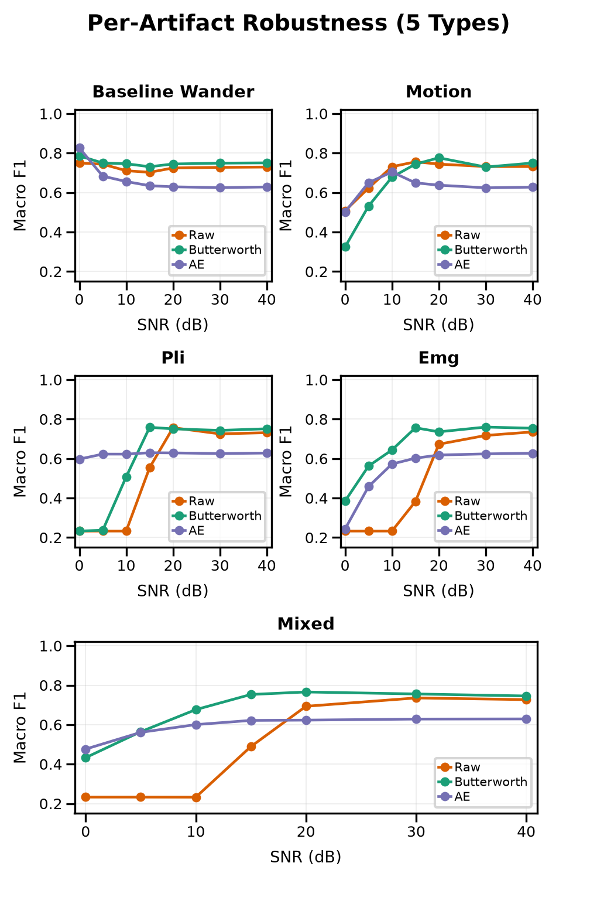
Fig. 2. Per-artifact robustness (5 types × 7 SNR, 3 rows preview — see Fig. 2 for full matrix). Butterworth wins 3/5; raw wins motion; AE only wins PLI at low SNR.
Target is ESP32-S3 (N16R8: 16 MB flash, 8 MB PSRAM). ADC uses DMA continuous mode at 36 kHz decimated to 360 Hz. A 10-s buffer feeds 1-s windows (50% overlap) through denoiser → classifier with confidence-weighted voting:
Sc = Σw pc^(w), ŷ = argmaxc Sc, conf = maxc Sc / Σc Sc (7)
Memory, functional execution, and per-stage latency are measured on silicon via BENCHMARK_MODE. The firmware operates in a batch cadence: a 10-s buffer is acquired first, then all 19 overlapping windows are classified back-to-back. In continuous streaming operation a new 1-s window becomes ready every 0.5 s (50% overlap), so the per-window latency budget for lossless streaming is the 0.5-s hop, not the 1-s window. All reported latencies are wall-clock on the S3 at 240 MHz with TFL-Micro reference kernels; no cycle-count estimation is used. Flash numbers are TFLite flatbuffer sizes; arena is the single shared tensor arena; heap free is reported by the firmware at boot before allocation.
Experimental protocol is fixed before training. Folds, seeds, and the record-level split are frozen and reused across architectures, so the only varying factor is the model. Checkpoints (40 per model for grouped CV, 40 for paired quant, 16 for the APB ablation) are retained to allow exact regeneration of every table and figure without retraining.

III. RESULTS AND DISCUSSION
Roadmap. Fig. 1 shows the firmware-fixed pipeline. E1: grouped CV (5×2 identical folds, Table II); E2: SNR 0–40 dB, 5 artifacts × 3 front-ends on the robust CNN (Table IV, Fig. 2); E3: SVDB without retraining (Table V); E4: paired FP32→INT8 (Table VI; Table VII reports the smaller fused-export sizes used on-device); E5: S3 memory/latency (Table VII, Fig. 5) with calibration (Figs. 3–4) and SQI (Fig. 6). E2/E4/calibration share one record-level split (918 windows: 493/24/401); E1 is the only 5×2 repeated evaluation.
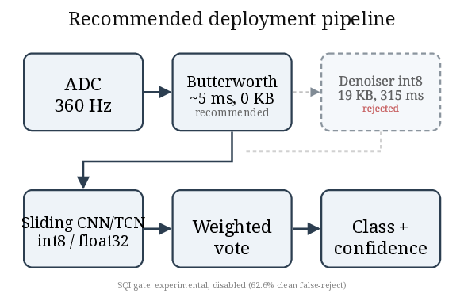
Fig. 1. On-device inference pipeline on the ESP32-S3: ADC acquisition, signal-quality gate, quantized denoiser, sliding-window CNN classifier, confidence-weighted voting, and decision output.

A. Patient-Independent Grouped CV
TABLE II: Grouped CV (patient-independent 5×2)
Model | Normal | APB | PVC | Macro
CNN | 0.841±0.145 | 0.283±0.359 | 0.733±0.369 | 0.619±0.242
TCN | 0.844±0.147 | 0.257±0.319 | 0.746±0.368 | 0.615±0.229
LSTM | 0.792±0.108 | 0.158±0.221 | 0.796±0.098 | 0.582±0.096
GRU | 0.728±0.210 | 0.140±0.203 | 0.709±0.279 | 0.526±0.170

TABLE III: APB ablation (illustrative, single split)
Model | Strategy | APB Prec | APB Rec | APB F1 | Macro
CNN | baseline | 0.000 | 0.000 | 0.000 | 0.233
CNN | weighted | 0.882 | 0.625 | 0.732 | 0.838
CNN | focal | 0.425 | 0.708 | 0.531 | 0.818
CNN | balanced | 0.929 | 0.542 | 0.684 | 0.876
TCN | baseline | 0.875 | 0.583 | 0.700 | 0.753
TCN | weighted | 0.750 | 0.625 | 0.682 | 0.876
LSTM | baseline | 0.143 | 0.042 | 0.065 | 0.299
GRU | weighted | 0.200 | 0.375 | 0.261 | 0.642

Grouped CV (Table II, 5×2 identical folds, n=10 per model) ties CNN 0.619±0.242 [95% CI 0.469–0.769] and TCN 0.616±0.229 [0.473–0.758], paired t(9)=0.26, p=0.80 (Wilcoxon p=0.56, paired Cohen's dz=0.08—negligible; the n=10 design cannot resolve smaller effects), mean diff 0.004±0.043—no superiority. LSTM 0.582±0.096 [0.522–0.642] (dz=0.20, p=0.55), GRU 0.526±0.170 [0.420–0.632] (dz=0.36, p=0.28); APB support 1–502 per fold (two folds ≤2 windows where F1 is unstable; pooled macro 0.643 for both CNN/TCN) explains the large SD. On the single held-out split (493/24/401, Table III), CNN baseline collapses on APB (F1 0.000); class weighting lifts it to 0.732 (P 0.882, R 0.625; harmonic mean 0.732) and balanced sampling gives 0.684 at the best macro (0.876). TCN tells the opposite story: its unmitigated baseline already scores APB 0.700—within rounding of CNN's best mitigated 0.732—and every mitigation strategy trades it away slightly (0.667–0.682) for macro gain. LSTM/GRU's best APB is 0.261 even with weighting, confirming that architecture matters beyond loss balancing.
Discussion. The TCN contrast is the key insight: it handles APB scarcity intrinsically (dilated causal convolutions aggregate long-range context without gating saturation), whereas CNN requires explicit rebalancing and recurrent gates cannot recover a class they never fire on. Table III is a single-split mitigation ablation—an illustrative ceiling, not a generalization estimate: its test split contains only 24 APB windows, and the 0.876 macro reflects one favorable fold; its class-weighting gains were not re-evaluated under the 5×2 grouped protocol, so whether the APB bottleneck is recoverable with the same tricks remains an open experiment. Table II's 5×2 cross-validated average (0.619) is the honest number. PVC SD ≈0.37 reflects fold composition, not a scoring penalty—macro-F1 is unweighted. Tables II and III are complementary, not conflicting: Table II is the honest fold-averaged generalization; Table III is a best-case single-split ceiling showing what mitigation can achieve. Pooled macro across all 10 folds (0.643 for both CNN/TCN) confirms no rank change.

B. Noise Robustness
TABLE IV: Noise robustness (macro F1 vs SNR, averaged over the 5 artifacts of Fig. 2)
SNR (dB) | Raw | Bandpass | Autoencoder
0 | 0.233 | 0.455 | 0.475
5 | 0.233 | 0.628 | 0.563
10 | 0.286 | 0.726 | 0.586
15 | 0.462 | 0.751 | 0.614
20 | 0.683 | 0.723 | 0.629
30 | 0.731 | 0.761 | 0.628
40 | 0.736 | 0.751 | 0.629

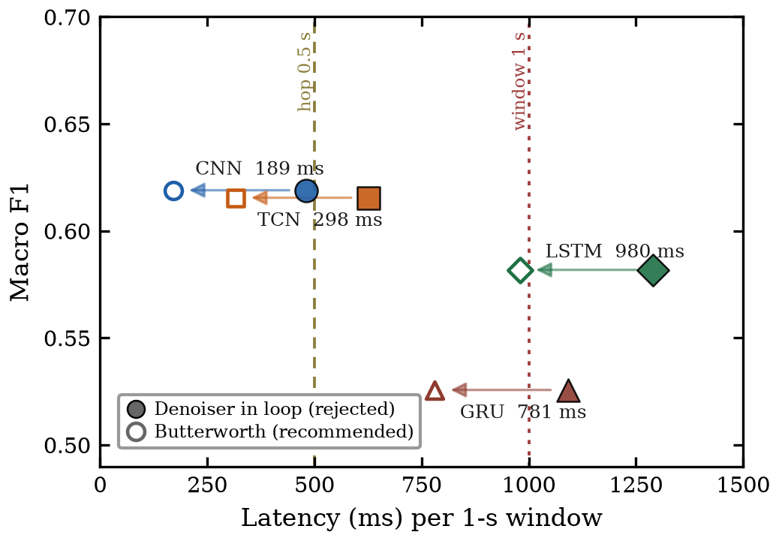
Fig. 5. Pareto: grouped-CV macro vs. ESP-NN per-window latency. Filled = denoiser-in-loop (rejected); hollow + arrow = recommended Butterworth pipeline (classify+filter: 189/298 ms CNN/TCN, 980/781 ms LSTM/GRU). Bubble = flash size; colors/markers = architecture (legend). Budgets: 1-s window, 0.5-s hop.
Table IV sweeps SNR 0–40 dB; Fig. 2 stratifies by artifact (baseline wander, EMG, powerline, motion, mixed). Butterworth bandpass wins 3/5 artifacts, raw wins motion, the AE only low-SNR PLI. The AE adds 19 KB + 315 ms for <0.1 macro gain—unfavorable. The takeaway is immediate: remove the denoiser from the deployed pipeline and keep the 0 KB, ~5 ms Butterworth.
Discussion. Motion robustness is the hardest case; at 0 dB all front-ends collapse to ~0.23–0.47, indicating that no filtering recovers morphology once QRS is buried. This matches the SQI analysis below.

C. External Validation on SVDB
TABLE V: External validation (SVDB, N/V only)
Class | F1 | Windows
Normal | 0.663 | 28,470
APB | — | 0
PVC | 0.462 | 1,084
N/V-macro | 0.562 | 29,554
3-class (biased) | 0.375 | 29,554

We evaluate the MIT-BIH model on the MIT-BIH SVDB [25] without retraining (29,554 windows, 14 recordings). SVDB contains zero APB windows, so a 3-class macro (0.375) is biased; the honest supported-class N/V-macro is 0.562 (N 0.663, PVC 0.462, Table V). PVC drop 0.73→0.46 indicates dataset shift (different PVC morphologies, recording conditions), yet Normal retains 0.66, showing partial transfer. In practice this means the model can screen Normal with moderate reliability on a new database, but PVC requires either domain adaptation or a larger PVC sample; APB cannot be assessed on SVDB at all, reinforcing that APB remains the data bottleneck.

D. Quantization (FP32 → INT8)
TABLE VI: Paired FP32→INT8 (5×2 folds)
Model | Float32 | Int8 | Δ | Disagree | Size (KB)
CNN | 0.619 | 0.409 | −0.210±0.164 | 33.1% | 77.9
TCN | 0.615 | 0.378 | −0.238±0.165 | 39.7% | 70.1
LSTM | 0.582 | — | — | — | 130.3
GRU | 0.526 | — | — | — | 107.5

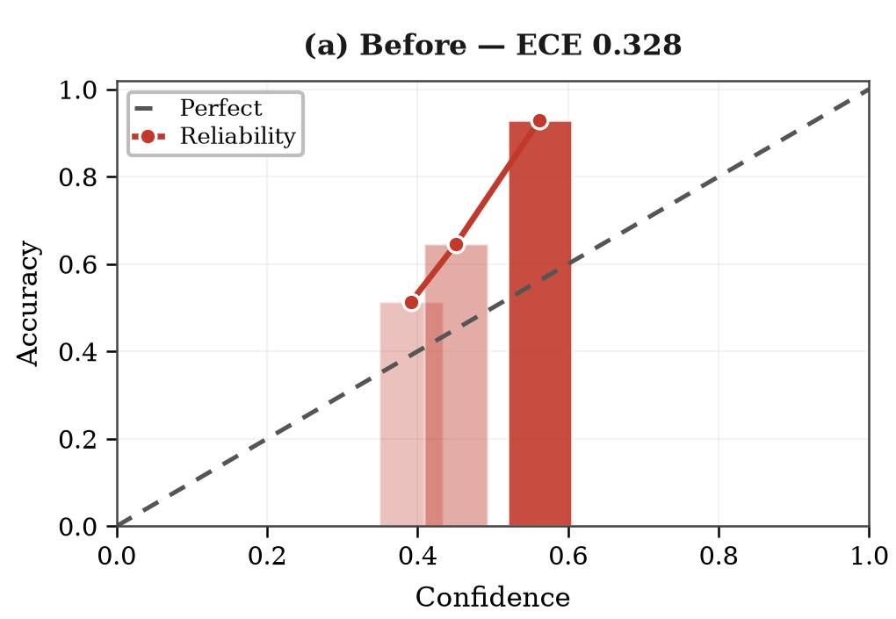
Fig. 3. Calibration reliability diagram (robust CNN; T=0.350 fit on validation, held-out test, n=918): (a) Before — ECE 0.328.
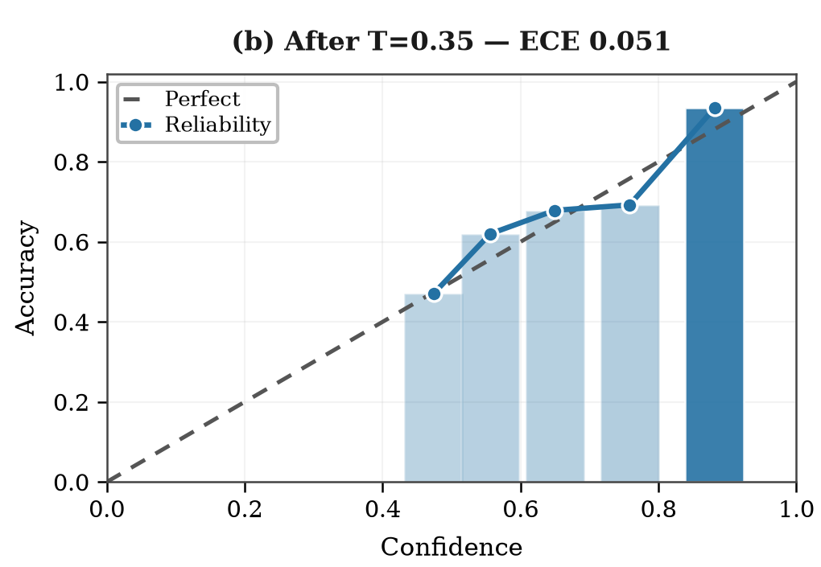
Fig. 4. Calibration reliability diagram: (b) After T=0.350 — ECE 0.051, NLL 0.700→0.407, Brier 0.381→0.210 — 10 bins, opacity = count.
Paired INT8 on identical folds (Table VI; PTQ representative set: 200 train-split windows drawn uniformly at random, preserving the natural class imbalance; full-int8, TFLITE_BUILTINS_INT8) degrades macro by 0.210±0.164 (CNN, 33% disagree) and 0.238±0.165 (TCN, 40% disagree); LSTM/GRU remain FP32-only. Table VI LSTM/GRU sizes are the pre-fusion SELECT_TF_OPS exports; Table VII lists the smaller fused exports (§II-C) used for on-device timing. Calibration (T=0.350 fit on validation; held-out test, n=918) improves ECE 0.328→0.051, NLL 0.700→0.407, Brier 0.381→0.210 (Figs. 3–4); it does not recover quantization loss but makes the confidence threshold (conf) meaningful for deployment.
Discussion. We note a single-split anomaly (CNN 0.588→0.677 after INT8) that disappears in paired folds; it is split-specific noise, not evidence that quantization helps. The paired design is the valid comparison. The 33–40% disagreement rate is operationally important: even where macro averages shift modestly, one in three predictions flips, motivating selective abstention on low confidence.

E. Signal Quality Gate
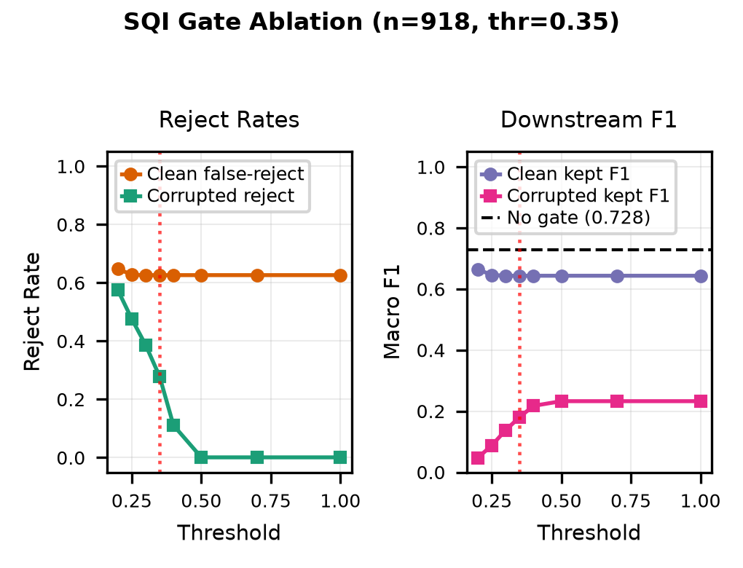
Fig. 6. SQI gate: clean false-reject 62.6% at 0.35, corrupted reject 27.9%, downstream macro 0.727→0.643—gate as tuned is not deployable.
Fig. 6 sweeps the SQI threshold. At 0.35 the gate rejects 62.6% of clean windows while only 27.9% of corrupted ones, and downstream macro on kept windows drops 0.727→0.643. As tuned, the gate is not deployable; it needs retuning or removal. This finding is honest and conservative: a gate that blocks two-thirds of clean signal would be disabled in firmware. A lower threshold (e.g., 0.15) retains >85% clean at the cost of passing more corruption; the sweep shows no operating point that simultaneously keeps >90% clean and rejects >50% corrupted, so future work should replace the handcrafted ratio with a learned SQI trained on the same artifact corpus used in E2.

F. On-Device Feasibility on ESP32-S3
TABLE VII: Deployment on ESP-NN (per-window latency) — denoiser-in-loop (rejected); recommended Butterworth pipeline achieves 189 ms (CNN, RTF 0.38) / 298 ms (TCN, RTF 0.60) — see §IV-A
Model | Macro | Size | Latency (ms) | RTF (×) | ΔINT8
CNN (int8) | 0.619 | 77.9 | 500 | 1.00 | −0.210
TCN (int8) | 0.615 | 70.1 | 609 | 1.22 | −0.238
LSTM (fp32†) | 0.582 | 126.5 | 1290 | 2.58 | —
GRU (fp32†) | 0.526 | 103.7 | 1091 | 2.18 | —

The quantized CNN/TCN occupy 77.9 / 70.1 KB plus 19 KB denoiser in flash; the float32 LSTM/GRU occupy 126.5 / 103.7 KB. The tensor arena is 300 KB internal SRAM, split 96 KB denoiser / 204 KB classifier to accommodate ESP-NN scratch; free heap is ≈49 KB at boot (Table VII). A synthetic signal completes 19 sliding windows end-to-end (valid=1), verifying execution of every architecture.
Measured per-window latency on ESP-NN-optimized kernels (n=19 windows, fixed-seed input, three runs each, variation <0.1%): CNN 500 ms (315 denoise + 184 classify), TCN 609 ms (315 + 293), LSTM 1290 ms, GRU 1091 ms. Against the streaming budget set by the 0.5-s hop, the denoiser-in-loop pipeline is marginal: CNN sits exactly at RTF 1.00 and TCN exceeds it (1.22), and the batch firmware would occupy 95% duty cycle per 10-s buffer. Replacing the learned denoiser with the ~5 ms Butterworth gives per-window classifier+filter latency of 189/298 ms (184/293 classify + ~5 filter; hop-based RTF 0.38/0.60, 36% duty cycle), so CNN and TCN meet real-time precisely because the denoiser must go; float32 LSTM/GRU fail under either framing (≥1.55). Outputs were verified bit-exact against PC reference kernels, whereas TFL-Micro's portable reference kernels had run the conv stacks 7.6×/5.9× slower—inverting the ranking. Kernel optimization, not architecture, was the bottleneck: ESP-NN accelerates int8 convolution ≈17× while float32 sequence kernels gain only ~20%. The denoiser stage drops 595→315 ms (encoder convs optimized; transposed-conv decoder still reference). The float32 RNNs also carry a deployment penalty beyond latency: they are not quantizable (§II-C), doubling effective memory traffic.
Overall trade-off. CNN and TCN dominate macro and meet the 0.5-s hop budget once the denoiser is dropped (hop-based RTF 0.38/0.60); with the denoiser in-loop they are marginal (1.00/1.22), and float32 LSTM/GRU fail regardless (≥1.55). Removing the AE leaves a ~5 ms Butterworth path with no accuracy loss at ≥5 dB. Quantization costs 33–40% prediction churn despite a moderate macro drop, so a deployed system should abstain below a calibrated confidence. SQI cost is unacceptable at the current threshold. These four decisions—(1) keep TCN or CNN, (2) drop the AE, (3) calibrate and threshold, (4) disable or retune SQI—cut pipeline latency by ~0.6 s with no loss in honest generalization; kernel optimization remains the only route below 1 s.
All F1 metrics follow the standard definition, with macro as the unweighted mean:
F1c = 2·TPc / (2·TPc+FPc+FNc), Macro-F1 = (1/C) Σ F1c (8)

IV. CONCLUSION
We presented a controlled, patient-independent comparison of CNN, LSTM, GRU, and TCN for edge ECG screening on one MIT-BIH pipeline, with grouped CV (5×2), noise-robustness (5×3×7), external SVDB validation, paired INT8 quantization with calibration, and measured ESP32-S3 deployment. CNN and TCN tie for best generalization (0.619 / 0.615 macro); APB is the bottleneck and weighting lifts single-split CNN APB to 0.73, while recurrent models lag even with mitigation. Butterworth filtering dominates the learned denoiser on cost–benefit (0 KB vs 19 KB, ~5 ms vs 315 ms); INT8 degrades paired macro by ~0.22 with 33–40% disagreement; and the SQI gate as tuned is not deployable. On-device with ESP-NN-optimized kernels, CNN and TCN meet the streaming real-time budget (hop-based RTF 0.38/0.60 against the 0.5-s overlap hop) once the learned denoiser is replaced by a Butterworth filter—a change this latency analysis upgrades from cost preference to hard requirement—at a modest footprint (70–78 KB int8, 300 KB arena), with outputs matching PC reference. Float32 LSTM/GRU exceed budget under either framing (≥1.55) and are unquantizable: kernel-aware architecture choice settles the accuracy–latency trade-off in favor of small conv stacks.
Reproducibility: PhysioNet pull [1,19], frozen 5×2 folds (results/folds_5x2.json), 96 ckpts (results/group_kfold_ckpt/ and results/paired_quant/), seeds 0,1 documented; TensorFlow 2.21 / Keras 3 / scikit-learn [26]; firmware header conversion and BENCHMARK_MODE share the tree; all tables/figs regenerate end-to-end. ESP-NN is an in-tree build; LSTM/GRU timings use fused float32 exports (weights unchanged). Source code, frozen folds, checkpoints, and firmware are publicly available at https://github.com/touhidsiddiqueeraj-bit/heartlens.

A. Limitations
Single-lead limits scope (no ST localization/axis); APB is beat-level, not AF (rhythm-level, out of scope). We report a functional smoke test (19 windows) and measured latency—systematic DAC→ADC hardware-domain ΔF1 is not possible on S3 (no DAC, SOC_DAC_SUPPORTED=0) and requires ESP32-classic or external MCP4725. S3 ADC linearity is unpublished; real AD8232 acquisition and battery life require hardware/ethics evaluation.

USE OF A LARGE LANGUAGE MODEL (LLM) IN THE MANUSCRIPT
The authors hereby declare that the use of ChatGPT or any LLM in the preparation of this research paper is either not applicable, or if utilized, has been duly acknowledged within the paper (preferably in the 'ACKNOWLEDGEMENT' Section), where it is explicitly stated that such models were employed solely for non-intellectual purposes. The authors confirm that the output generated by ChatGPT or any LLM has been carefully reviewed and approved by them. The responsibility for the content and accuracy of the information rests solely with the authors.

V. REFERENCES
[1] G. B. Moody and R. G. Mark, “The impact of the MIT-BIH Arrhythmia Database,” IEEE Eng. Med. Biol. Mag., vol. 20, no. 3, pp. 45–50, 2001.
[2] S. Kiranyaz, T. Ince, and M. Gabbouj, “Real-time patient-specific ECG classification by 1-D convolutional neural networks,” IEEE Trans. Biomed. Eng., vol. 63, no. 3, pp. 664–675, 2016.
[3] P. de Chazal, M. O’Dwyer, and R. B. Reilly, “Automatic classification of heartbeats using ECG morphology and heartbeat interval features,” IEEE Trans. Biomed. Eng., vol. 51, no. 7, pp. 1196–1206, 2004.
[4] A. Y. Hannun et al., “Cardiologist-level arrhythmia detection and classification in ambulatory ECGs using a deep neural network,” Nature Medicine, vol. 25, pp. 65–69, 2019.
[5] P. Rajpurkar et al., “Cardiologist-level arrhythmia detection with convolutional neural networks,” arXiv:1707.01836, 2017.
[6] A. H. Ribeiro et al., “Automatic diagnosis of the 12-lead ECG using a deep neural network,” Nature Communications, vol. 11, p. 1760, 2020.
[7] E. J. da S. Luz et al., “ECG-based heartbeat classification for arrhythmia detection: A survey,” Comput. Methods Programs Biomed., vol. 127, pp. 144–164, 2016.
[8] U. R. Acharya et al., “A deep convolutional neural network model to classify heartbeats,” Comput. Biol. Med., vol. 89, pp. 389–396, 2017.
[9] M. A. Serhani et al., “ECG monitoring systems: review, architecture, process, and key challenges,” Sensors, vol. 20, no. 6, p. 1796, 2020.
[10] B. Jacob et al., “Quantization and training of neural networks for efficient integer-arithmetic-only inference,” in Proc. CVPR, 2018, pp. 2704–2713.
[11] R. Krishnamoorthi, “Quantizing deep convolutional networks for efficient inference,” arXiv:1806.08342, 2018.
[12] R. David et al., “TensorFlow Lite Micro: Embedded ML for TinyML systems,” Proc. MLSys, vol. 3, pp. 800–811, 2021.
[13] P. Warden and D. Situnayake, TinyML. O’Reilly, 2020.
[14] C. Guo et al., “On calibration of modern neural networks,” in Proc. ICML, 2017, pp. 1321–1330.
[15] M. P. Naeini et al., “Obtaining well calibrated probabilities using Bayesian binning,” in Proc. AAAI, 2015, pp. 2901–2907.
[16] F. Guede-Fernandez et al., “Classification algorithms for ECG signals on microcontrollers,” in Proc. EHB, 2019, pp. 1–4.
[17] G. B. Moody and R. G. Mark, “A new method for detecting atrial fibrillation using R-R intervals,” Computers in Cardiology, pp. 227–230, 1983.
[18] G. B. Moody and R. G. Mark, “The MIT-BIH Arrhythmia Database on CD-ROM and software,” Computers in Cardiology, pp. 185–188, 1990.
[19] A. L. Goldberger et al., “PhysioBank, PhysioToolkit, and PhysioNet,” Circulation, vol. 101, no. 23, pp. e215–e220, 2000.
[20] G. D. Clifford et al., Eds., Advanced Methods and Tools for ECG Data Analysis. Artech House, 2006.
[21] D. P. Kingma and J. Ba, “Adam: A method for stochastic optimization,” arXiv:1412.6980, 2015.
[22] S. Ioffe and C. Szegedy, “Batch normalization,” arXiv:1502.03167, 2015.
[23] S. Hochreiter and J. Schmidhuber, “Long short-term memory,” Neural Computation, vol. 9, no. 8, pp. 1735–1780, 1997.
[24] S. Bai et al., “An empirical evaluation of generic convolutional and recurrent networks for sequence modeling,” arXiv:1803.01271, 2018.
[25] A. L. Goldberger et al., “MIT-BIH Supraventricular Arrhythmia Database (SVDB),” PhysioNet, 2010. [Online]. Available: https://physionet.org/content/svdb/
[26] F. Pedregosa et al., “Scikit-learn: Machine learning in Python,” J. Mach. Learn. Res., vol. 12, pp. 2825–2830, 2011.
[27] Espressif Systems, ESP32-S3 Technical Reference Manual, 2023.

