Comprehensive Numerical Optimization of a Lead-Free RbGeI₃ Absorber Perovskite Solar Cell with TiO₂/CuI Charge Transport Layers Using SCAPS-1D
Md. Abdul Malek Fahim^{1,a)}, Rafiqul Islam^{1,b)}, and Ishmam Ahmed Chowdhury^{1,c)}
¹⁾Department of Electrical and Electronic Engineering, Leading University, Sylhet, Bangladesh
^{a)}Electronic mail: fahim.eee@lus.ac.bd
(Dated: 11 July 2026)
Abstract. The outstanding rise of lead-halide perovskite solar cells has been tempered by the toxicity and environmental persistence of lead, motivating a sustained search for lead-free absorbers that retain favourable optoelectronic properties. Rubidium germanium iodide (RbGeI₃) is a promising candidate, offering a direct and tunable bandgap, strong optical absorption, and improved environmental compatibility. In this work, we report a comprehensive numerical optimization of an RbGeI₃-based perovskite solar cell using the one-dimensional Solar Cell Capacitance Simulator (SCAPS-1D, version 3.3.10). Eight planar heterojunction configurations were first screened by combining two electron transport layers (TiO₂ and PCBM) with four hole transport layers (NiO, CuI, CBTS, and Spiro-OMeTAD). The FTO/TiO₂/RbGeI₃/CuI/Au architecture delivered the best initial performance (PCE = 21.11 %) and was selected for further optimization. Eleven device parameters—absorber thickness, absorber defect density, dielectric constant, electron affinity, bandgap, conduction- and valence-band effective density of states, ETL and HTL thicknesses, and the interfacial defect densities at both heterojunctions—were varied sequentially under AM 1.5G illumination at 300 K. The optimized device reaches a power conversion efficiency of 26.69 %, with an open-circuit voltage of 1.1127 V, a short-circuit current density of 30.32 mA/cm², and a fill factor of 79.13 %. These figures surpass previously reported SCAPS-1D results for RbGeI₃ devices (24.62 %) and the experimental baseline (10.11 %) by more than 16 percentage points. The quantum efficiency spectrum exhibits a broad plateau of 99–100 % between 400 and 650 nm, and the equilibrium energy band diagram confirms favourable band alignment at both heterojunctions. The results identify the TiO₂/CuI transport-layer pair as an efficient combination for environmentally benign RbGeI₃ photovoltaics and provide quantitative design guidelines for future experimental realization.
Keywords: lead-free perovskite; RbGeI₃; SCAPS-1D; numerical simulation; CuI hole transport layer; TiO₂ electron transport layer; defect density; interface engineering; solar cell optimization.

I. INTRODUCTION
Global electricity demand continues to climb as populations grow, economies industrialize, and urbanization accelerates. Fossil fuels still supply the bulk of this demand [1,2], but their depletion and the environmental cost of carbon emissions have made renewable energy a strategic priority rather than an alternative. Among renewable sources, solar energy stands out for its abundance and for the steady decline in the levelized cost of photovoltaic (PV) electricity, which has made solar the fastest-expanding renewable technology worldwide [3]. The global installed PV capacity surpassed 1.6 TW in 2024, and continued growth relies on identifying photovoltaic materials that combine high efficiency with low environmental impact and low fabrication cost.
Photovoltaic devices are commonly classified into three generations based on the absorber material and fabrication technology. First-generation crystalline silicon (c-Si) cells dominate the commercial market thanks to their high efficiency and long operational lifetime, but they require energy-intensive processing and rigid substrates. Second-generation thin-film technologies—including CdTe, CIGS, and amorphous silicon—reduce material consumption and offer flexible substrates, but their efficiencies remain modest and some rely on scarce or toxic elements. The third generation, which includes dye-sensitized solar cells, organic photovoltaics, quantum-dot cells, and perovskite solar cells (PSCs) [4,5], promises high efficiency at low processing cost and is therefore the focus of intense research activity.
Perovskite absorbers follow the general formula ABX₃, in which A is a monovalent cation, B is a divalent metal, and X represents a halide anion. They combine several attractive properties: high optical absorption coefficients, tunable direct bandgaps, long carrier diffusion lengths, low exciton binding energies, and balanced electron and hole transport [6,7]. These properties have driven certified power conversion efficiencies (PCEs) above 26 % for single-junction lead-based devices [8,9], and perovskite–silicon tandems have already exceeded 33 % [3]. However, the highest-performing absorbers, such as methylammonium lead iodide (MAPbI₃) and formamidinium lead iodide (FAPbI₃), rely on toxic lead, which raises serious concerns about contamination during fabrication, operation, and end-of-life disposal [10,11]. Replacing lead with environmentally benign elements such as tin (Sn), germanium (Ge), bismuth (Bi), and antimony (Sb) has therefore become one of the central research directions in the field [12,13].
Tin-based perovskites initially attracted the most attention as lead substitutes because Sn²⁺ has a similar lone-pair electronic configuration to Pb²⁺ [14]. Unfortunately, Sn²⁺ readily oxidizes to Sn⁴⁺ in air, generating high densities of deep defects and accelerating device degradation [12,14]. Germanium-based perovskites have emerged as a complementary alternative because germanium offers a similar lone-pair electronic structure to lead, supports a direct and tunable bandgap, and is significantly less toxic [15]. Among Ge-based absorbers, rubidium germanium iodide (RbGeI₃) is particularly attractive thanks to its suitable bandgap (~1.3 eV), strong optical absorption coefficient, and good thermal stability [16,17,18]. Recent density-functional theory (DFT) calculations have confirmed that RbGeI₃ has a favourable direct bandgap and a high optical absorption coefficient comparable to that of MAPbI₃ [19,20,21], making it a promising candidate for single-junction photovoltaic applications.
Because experimental optimization of a multilayer photovoltaic device is both time-consuming and expensive, numerical simulation has become an indispensable tool for screening materials and parameters before fabrication. The Solar Cell Capacitance Simulator in one dimension (SCAPS-1D), developed at the Department of Electronics and Information Systems (ELIS) of Ghent University, Belgium, has been widely adopted for this purpose [22,23,24]. SCAPS-1D solves the Poisson equation together with the electron and hole continuity equations self-consistently across the device stack [22], capturing carrier generation, transport, and recombination under either dark or illuminated conditions. The software allows the user to vary material and interface parameters independently, which is essential for disentangling their individual contributions to device performance.
Although several SCAPS-1D studies of RbGeI₃ devices have been reported, most have optimized only a limited set of parameters or explored a single device configuration. The present work addresses this gap by combining an eight-configuration electron-transport-layer (ETL)/hole-transport-layer (HTL) screening with a sequential optimization of eleven absorber, interface, and transport-layer parameters for the most promising structure, FTO/TiO₂/RbGeI₃/CuI/Au. The optimized device is then compared with recently reported RbGeI₃-based and other lead-free Ge/Sn-based perovskite solar cells to evaluate its competitiveness and to identify remaining challenges for experimental realization. The remainder of this paper is organized as follows: Section II reviews the relevant literature and identifies the research gap; Section III describes the methodology; Section IV presents the results and discussion; Section V compares the proposed device with the state of the art; Section VI discusses limitations and future work; and Section VII concludes.

II. LITERATURE REVIEW AND RESEARCH GAP
Over the past five years, SCAPS-1D—often combined with first-principles DFT calculations—has become the workhorse numerical tool for designing and optimizing lead-free perovskite solar cells before experimental fabrication. Table I summarizes the most relevant recent studies on Ge-based and Sn-based absorbers, highlighting the device structure, the photovoltaic performance, and the principal limitation of each work.
TABLE I. Summary of recent SCAPS-1D studies on lead-free Ge-based and Sn-based perovskite solar cells.
Study (Year) | Device Structure | PCE (%) | Key Limitation
Pindolia et al. (2022) [25] | FTO/TiO₂/RbGeI₃/NiO/Ag | 10.11 | Single device; limited parametric sweep
Saikia et al. (2023) [26] | FTO/TiO₂/CsGeI₃/CuI/Au | 10.80 | No multi-HTL comparison
Bouazizi et al. (2022) [16] | FTO/PCBM/CsSn₀.₅Ge₀.₅I₃/Spiro/Au | 18.13 | Mixed Ge/Sn absorber; thermal sensitivity
Hossain et al. (2023) [27] | ITO/PCBM/CsSnI₃/CuI/Au | 10.10 | Fixed defect density 10¹⁵ cm⁻³ (unrealistic)
Loumachi et al. (2024) [28] | ITO/C₆₀/RbGeI₃/CBTS/Au | 24.62 | No interface defect optimization
Raj et al. (2025) [29] | FTO/TiO₂/RbGeI₃/PEDOT:PSS/Au | 18.44 | Organic HTL limits stability
Pathak et al. (2026) [30] | FTO/TiO₂/RbGeI₃/Spiro-OMeTAD/Au | 26.47 | Ge²⁺ oxidation not addressed
Samaki et al. (2023) [17] | RbGeI₃ optoelectrical modelling | — | Interface-specific study only
Bisht et al. (2025) [31] | Comparative Ge-based PSCs | — | Material comparison; no full optimization
Chen et al. (2025) [32] | RbGeI₃ gradient doping | — | Doping profile only; no ETL/HTL screening

Several observations emerge from this review. First, the experimental baseline for RbGeI₃ devices remains modest—Pindolia et al. reported a PCE of only 10.11 % for the FTO/TiO₂/RbGeI₃/NiO/Ag architecture [25]—and there is clearly substantial room for improvement through numerical optimization. Second, simulation-based studies have progressively pushed the predicted PCE of RbGeI₃ devices upward, from 10.11 % in 2022 to 24.62 % in 2024 [28] and 26.47 % in 2026 [30], but each of these works optimized only a limited subset of device parameters. Third, the ETL–HTL combinations explored for RbGeI₃ have been narrow: most studies used TiO₂ as the ETL and either Spiro-OMeTAD, NiO, or CBTS as the HTL, while the TiO₂/CuI combination adopted in this work has received comparatively little attention despite the well-documented advantages of CuI as an HTL.
CuI is a wide-bandgap (Eg ≈ 3.1 eV) p-type semiconductor with high hole mobility (up to ~100 cm²V⁻¹s⁻¹ in single-crystal form), excellent optical transparency in the visible spectrum, and a valence-band edge that aligns well with the valence band of RbGeI₃ [33,34]. Unlike organic HTLs such as Spiro-OMeTAD or PEDOT:PSS, CuI is solution-processable, inexpensive, and thermally stable [35,36], which makes it attractive for large-scale fabrication. Despite these advantages, the specific TiO₂/RbGeI₃/CuI stack—combined with a comprehensive optimization of the absorber and interface parameters—has not been reported in the open literature. The present study fills this gap by screening eight ETL–HTL combinations and then performing a sequential optimization of eleven parameters on the most promising architecture.
Beyond RbGeI₃, SCAPS-1D investigations of several related perovskite absorbers have established useful methodological precedents for transport-layer screening and defect-density optimization, including CsPbI₃ [27,37], the lead-free double perovskite Cs₂BiAgI₆ [38], and lead-free CsSnI₃ [39]. These studies demonstrate that the choice of ETL/HTL combination and the control of interfacial defect densities are at least as important as the absorber composition itself in determining the final PCE, which is the central premise of the present work.

III. METHODOLOGY

A. SCAPS-1D Simulation Tool
All simulations were carried out with SCAPS-1D version 3.3.10 [22,23], a one-dimensional numerical solver widely used for thin-film photovoltaic devices. SCAPS-1D was originally developed at the Department of Electronics and Information Systems (ELIS) of Ghent University, Belgium, and is freely available to academic researchers. The software solves three coupled semiconductor equations self-consistently across the device stack: the Poisson equation (1), which determines the electrostatic potential distribution; the electron continuity equation (2), which governs the generation, transport, and recombination of electrons; and the hole continuity equation (3), which describes the corresponding behaviour for holes.
∂/∂x [ε(x) ∂ψ/∂x] = -q [p(x) - n(x) + N_D⁺(x) - N_A⁻(x) ± ρ_t(x)] (1)
dJ_n/dx = G(x) - R(x), J_n = q μ_n n E + q D_n dn/dx (2)
dJ_p/dx = R(x) - G(x), J_p = q μ_p p E - q D_p dp/dx (3)
Here ε is the dielectric permittivity, ψ is the electrostatic potential, q is the elementary charge, n and p are the electron and hole concentrations, N_D and N_A are the ionized donor and acceptor densities, ρ_t is the trapped charge density, J_n and J_p are the electron and hole current densities, G is the carrier generation rate, R is the recombination rate, μ is the carrier mobility, and D is the diffusion coefficient. The user specifies the bandgap, electron affinity, dielectric constant, effective density of states, carrier mobilities, doping concentrations, and defect densities for each layer, together with the interface defect densities at each heterojunction. SCAPS-1D then returns the current density–voltage (J–V) characteristics, the quantum efficiency (QE) spectrum, and the equilibrium energy band diagram, from which the open-circuit voltage (V_OC), short-circuit current density (J_SC), fill factor (FF), and PCE are extracted. Fig. 1 shows the graphical user interface of SCAPS-1D version 3.3.10 as used in this study.
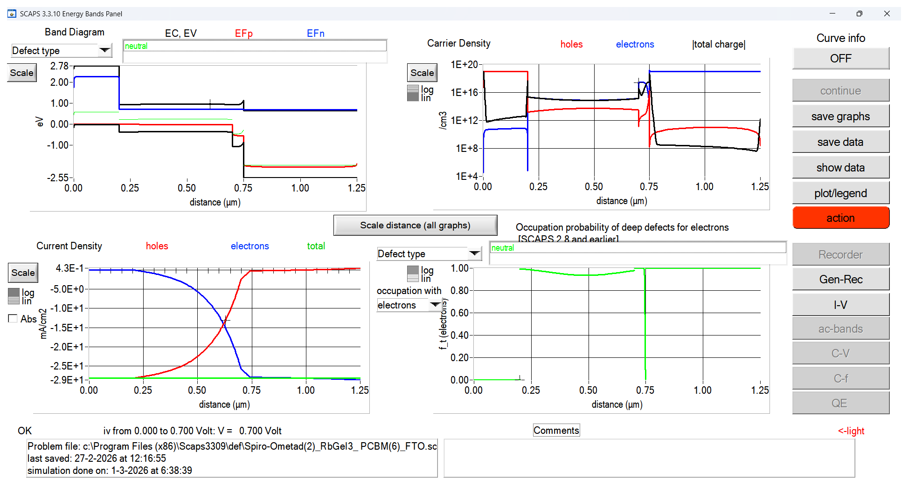
FIG. 1. Graphical user interface of SCAPS-1D (version 3.3.10) used for device simulation, showing the energy band diagram, carrier density, current density, and defect occupation panels at a bias of 0.700 V.

B. Device Structure and Working Principle
The proposed device follows a conventional n-i-p planar heterojunction architecture: FTO/TiO₂/RbGeI₃/CuI/Au. Fluorine-doped tin oxide (FTO) acts as the transparent front electrode [40], titanium dioxide (TiO₂) serves as the ETL, RbGeI₃ is the photoactive absorber, copper iodide (CuI) acts as the HTL, and gold (Au) provides the rear ohmic contact. This layer sequence was chosen because it provides efficient charge separation, rapid carrier transport, and suitable energy-level alignment while eliminating the environmental and health concerns associated with lead-based perovskite absorbers.
When sunlight is incident on the front surface of the device, photons first pass through the transparent FTO electrode and the thin TiO₂ layer before reaching the RbGeI₃ absorber. Photons with energies greater than the absorber bandgap are absorbed within the RbGeI₃ layer, generating electron–hole pairs. The built-in electric field established across the heterojunction then separates these photogenerated carriers: electrons are transported from the absorber into the TiO₂ electron transport layer and subsequently collected by the FTO electrode, while holes move toward the CuI hole transport layer before being collected by the Au back contact. This directional carrier transport minimizes carrier recombination and contributes to improved photovoltaic performance.
TiO₂ was chosen as the ETL because of its wide bandgap (Eg ≈ 3.2 eV), suitable conduction-band position, chemical stability, and well-documented compatibility with perovskite absorbers [41,42]. CuI was selected as the HTL because of its high hole mobility, wide bandgap (Eg ≈ 3.1 eV), low fabrication cost, and favourable valence-band alignment with RbGeI₃ [33,34]. Gold was used as the rear metal contact because of its high work function (~5.1 eV), excellent electrical conductivity, and superior chemical stability, which together establish an ohmic contact with the CuI hole transport layer and reduce contact resistance [43].

C. Material Parameters and Simulation Conditions
The accuracy of any SCAPS-1D simulation depends critically on the selection of appropriate material parameters for each layer of the solar cell. The initial electrical and optical parameters used in this study were collected from previously published experimental and numerical studies of RbGeI₃ and related lead-free perovskites [16,17,25,26]. These values were then used as the starting point for the sequential optimization. Table II summarizes the initial input parameters for each of the four semiconductor layers, and Table III lists the interface defect densities applied at the two heterojunctions.
TABLE II. Initial electrical and optical parameters used in the SCAPS-1D simulation of the proposed FTO/TiO₂/RbGeI₃/CuI/Au solar cell.
Parameter | FTO | TiO₂ | RbGeI₃ | CuI
Thickness (nm) | 500 | 30 | 400 | 100
Bandgap, Eg (eV) | 3.2 | 3.2 | 1.31 | 3.1
Electron affinity, χ (eV) | 4.4 | 4.0 | 3.9 | 2.1
Dielectric permittivity, εr | 9 | 9 | 23.01 | 6.5
CB effective DOS, NC (cm⁻³) | 2.2×10¹⁸ | 2×10¹⁸ | 1.4×10¹⁹ | 2.8×10¹⁹
VB effective DOS, NV (cm⁻³) | 1.8×10¹⁹ | 1.8×10¹⁹ | 2.8×10¹⁹ | 1×10¹⁹
Electron mobility, μe (cm²/Vs) | 20 | 20 | 28.6 | 100
Hole mobility, μp (cm²/Vs) | 10 | 10 | 27.3 | 43.9
Donor density, ND (cm⁻³) | 1×10¹⁹ | 9×10¹⁶ | 1×10⁹ | 0
Acceptor density, NA (cm⁻³) | 0 | 0 | 1×10⁹ | 1×10¹⁸
Defect density, Nt (cm⁻³) | 1×10¹⁴ | 1×10¹⁵ | 1×10¹⁵ | 1×10¹⁵

TABLE III. Initial interface defect density applied at each heterojunction.
Interface | Nt (cm⁻²)
TiO₂ / RbGeI₃ | 1 × 10¹⁴
RbGeI₃ / CuI | 1 × 10¹⁴

All simulations were performed under the standard AM 1.5G solar spectrum at an incident power density of 100 mW/cm² (1000 W/m²) and a temperature of 300 K, following standard test conditions (STC). During each optimization step, only one parameter was varied while all others were held constant, and the optimum value obtained from each step was carried forward as the input for the next step. This sequential one-at-a-time strategy is widely used in SCAPS-based studies because it allows the contribution of each parameter to be evaluated cleanly, without confounding effects from simultaneous variations.

D. Optimization Procedure
Fig. 2 illustrates the sequential optimization procedure adopted in this study. The process begins with the initial unoptimized FTO/TiO₂/RbGeI₃/CuI/Au device (configuration D4 selected from the screening step described in Section IV A). Each parameter is then swept in turn—absorber thickness, absorber defect density, dielectric constant, electron affinity, conduction- and valence-band effective density of states, absorber bandgap, ETL thickness, HTL thickness, and the interfacial defect densities at both heterojunctions—and the optimum value from each step is fed forward as the input to the next step. After all eleven parameters have been optimized, the final J–V curve, QE spectrum, and equilibrium energy band diagram are extracted from the optimized device for analysis. The overall research methodology is summarized in Fig. 3.
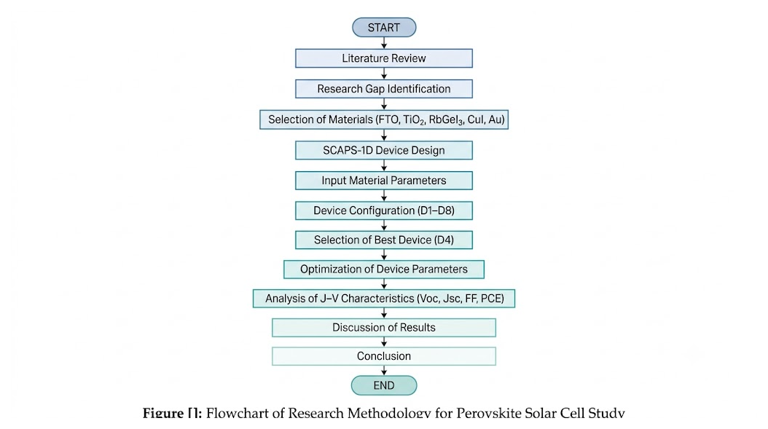
FIG. 2. Overall research methodology adopted in this study, from the initial literature review through material selection, device screening, parametric optimization, and final performance comparison. The sequential optimization flowchart is shown in Fig. 2.

E. Performance Metrics
Four metrics extracted from the simulated J–V curve were used to evaluate device performance. The open-circuit voltage V_OC is the maximum voltage generated when no external current flows and reflects the splitting of the electron and hole quasi-Fermi levels. The short-circuit current density J_SC is the current density at zero applied voltage and is governed by the absorption and collection of photogenerated carriers. The fill factor FF measures the rectangularity of the J–V curve and is given by
FF = (V_mp × J_mp) / (V_oc × J_sc) (4)
where V_mp and J_mp are the voltage and current density at the maximum power point. The power conversion efficiency PCE represents the fraction of incident solar power converted into electrical power and is defined as
PCE = (V_oc × J_sc × FF) / P_in × 100 % (5)
where P_in is the incident optical power density (100 mW/cm² under AM 1.5G). These four parameters were tracked throughout the optimization process and used to compare the proposed device with previously reported RbGeI₃ and related lead-free perovskite solar cells.

IV. RESULTS AND DISCUSSION

A. Screening of Device Configurations
Eight planar heterojunction configurations were constructed by combining the two ETL candidates (TiO₂ and PCBM) with four HTL candidates (NiO, CuI, CBTS, and Spiro-OMeTAD), all sharing the same RbGeI₃ absorber. The eight devices—labelled D1 through D8—were simulated under identical conditions, and the resulting photovoltaic parameters are summarized in Table IV. Device D4, corresponding to the FTO/TiO₂/RbGeI₃/CuI/Au architecture, achieved the highest initial PCE of 21.11 % [25], with V_OC = 0.82 V, J_SC = 30.46 mA/cm², and FF = 84.72 %. D4 was therefore selected as the baseline for all subsequent optimization.
The advantage of D4 over the other configurations can be traced to two factors. First, the favourable conduction-band alignment between TiO₂ (χ = 4.0 eV) and RbGeI₃ (χ = 3.9 eV) produces only a small conduction-band offset (~0.10 eV) [41,44], which supports efficient electron extraction without introducing a significant barrier. Second, the small valence-band offset between RbGeI₃ and CuI (ΔE_v ≈ 0.01 eV) allows holes to be extracted with minimal resistance, while the large conduction-band offset at the same interface (ΔE_c ≈ 1.8 eV) acts as an effective electron-blocking barrier [34]. Together, these two features suppress interfacial recombination and support the high FF and V_OC observed for D4.
TABLE IV. Initial photovoltaic performance of the eight screened device configurations. ★ Selected as the baseline for full parametric optimization.
Dev. | Architecture | V_OC (V) | J_SC (mA/cm²) | FF (%) | PCE (%)
D1 | FTO/PCBM/RbGeI₃/NiO/Au | 0.81 | 30.10 | 83.68 | 20.52
D2 | FTO/TiO₂/RbGeI₃/NiO/Au | 0.82 | 30.46 | 84.48 | 21.08
D3 | FTO/PCBM/RbGeI₃/CuI/Au | 0.81 | 30.10 | 83.96 | 20.55
D4 ★ | FTO/TiO₂/RbGeI₃/CuI/Au | 0.82 | 30.46 | 84.72 | 21.11
D5 | FTO/PCBM/RbGeI₃/CBTS/Au | 0.82 | 30.20 | 82.36 | 20.30
D6 | FTO/TiO₂/RbGeI₃/CBTS/Au | 0.82 | 30.55 | 82.13 | 20.68
D7 | FTO/PCBM/RbGeI₃/Spiro-OMeTAD/Au | 0.81 | 30.07 | 85.01 | 20.77
D8 | FTO/TiO₂/RbGeI₃/Spiro-OMeTAD/Au | 0.82 | 30.46 | 75.76 | 18.92

B. Absorber Thickness
The absorber thickness governs the trade-off between optical absorption and carrier collection. A thicker layer absorbs more photons but also forces photogenerated carriers to travel farther, which raises the probability of bulk recombination. To map this trade-off, the RbGeI₃ thickness was swept from 0.3 μm to 1.0 μm while the other parameters were held constant. The results are shown in Fig. 3 and Table V. The PCE rose sharply from 18.57 % at 0.3 μm to a peak of 20.70 % at 0.7 μm and then declined gently to 20.46 % at 1.0 μm, in line with the expected onset of recombination losses in thicker absorbers. J_SC increased monotonically from 28.14 to 34.11 mA/cm² because more photons were absorbed, while V_OC and FF decreased gradually as the absorber became thicker (V_OC fell from 0.823 V to 0.767 V, and FF from 80.18 % to 78.20 %). A thickness of 700 nm was therefore adopted as the optimum, since it maximizes efficiency without paying the cost of an unnecessarily thick absorber.
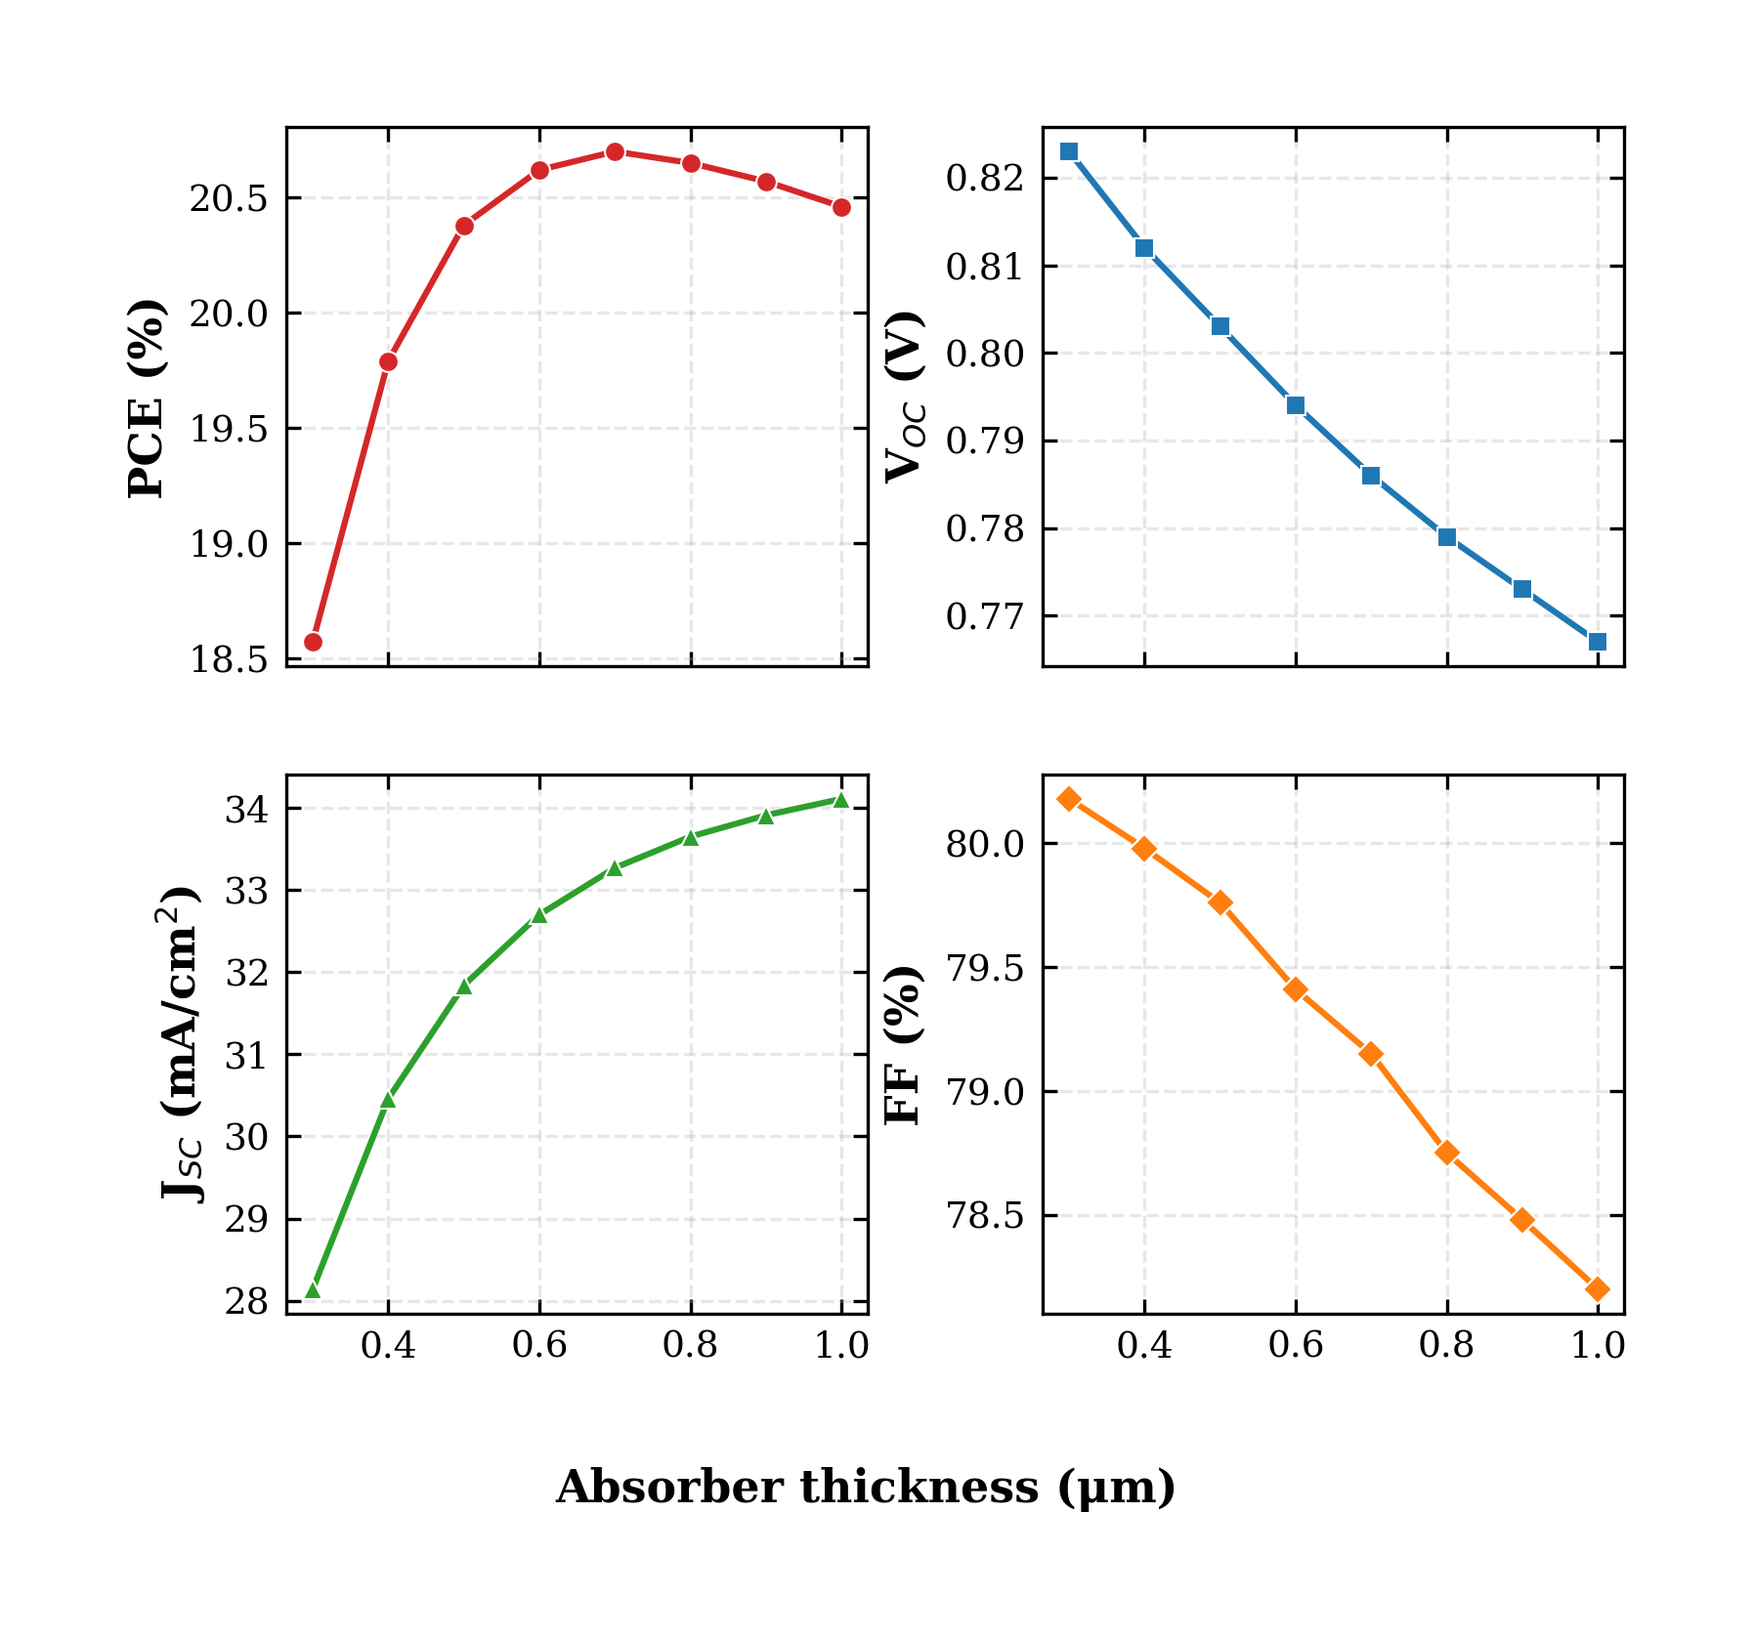
FIG. 3. Variation of PCE, V_OC, J_SC, and FF with RbGeI₃ absorber thickness. The PCE peaks at 0.7 μm, beyond which recombination losses offset the gain in optical absorption.
TABLE V. Variation of PCE, V_OC, J_SC, and FF with RbGeI₃ absorber thickness.
Thickness (μm) | PCE (%) | V_OC (V) | J_SC (mA/cm²) | FF (%)
0.3 | 18.57 | 0.823 | 28.14 | 80.18
0.4 | 19.79 | 0.812 | 30.46 | 79.98
0.5 | 20.38 | 0.803 | 31.84 | 79.76
0.6 | 20.62 | 0.794 | 32.70 | 79.41
0.7 ★ | 20.70 | 0.786 | 33.27 | 79.15
0.8 | 20.65 | 0.779 | 33.65 | 78.75
0.9 | 20.57 | 0.773 | 33.91 | 78.48
1.0 | 20.46 | 0.767 | 34.11 | 78.20

C. Absorber Defect Density
Bulk defect density is one of the most damaging parameters in perovskite devices because trap states act as Shockley–Read–Hall (SRH) recombination centres that capture and annihilate photogenerated carriers. To quantify this effect, the defect density of the RbGeI₃ layer was varied from 10¹² to 10¹⁸ cm⁻³ while all other parameters were held constant. The results are shown in Fig. 4 and Table VI. Below 10¹⁵ cm⁻³ the device performance was essentially insensitive, with PCE remaining close to 20.5 %. Above 10¹⁵ cm⁻³ the degradation became severe: PCE dropped to 13.78 % at 10¹⁷ cm⁻³ and to only 7.58 % at 10¹⁸ cm⁻³, while V_OC fell from 0.86 V to 0.55 V. J_SC also decreased substantially at high defect densities (from 30.46 to 26.61 mA/cm²) because the trapped carriers recombined before being collected. Although the best simulated result was obtained at 10¹² cm⁻³, such a low defect density is not realistic for an experimental Ge-based perovskite film, where Ge²⁺ oxidation typically introduces defect densities of at least 10¹³–10¹⁴ cm⁻³ [30,31]. A defect density of 10¹⁴ cm⁻³ was therefore selected as a practical compromise that retains more than 99 % of the maximum efficiency.
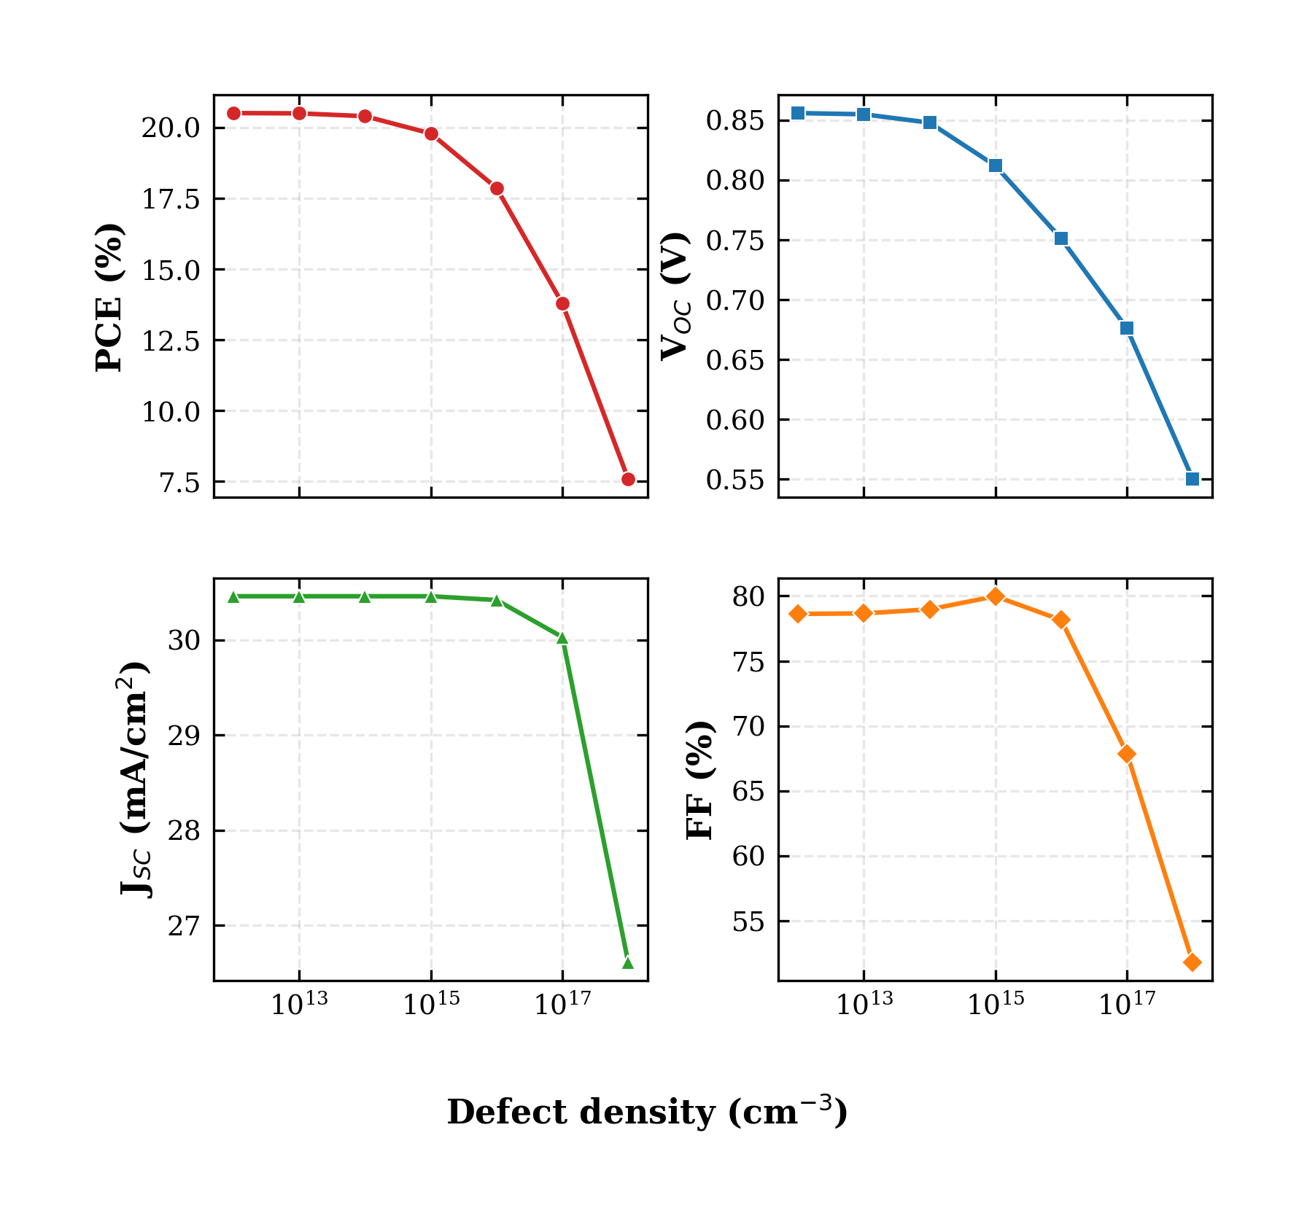
FIG. 4. Variation of PCE, V_OC, J_SC, and FF with RbGeI₃ absorber defect density. The device is essentially insensitive to defect densities below 10¹⁵ cm⁻³ but degrades sharply at higher values due to SRH recombination.
TABLE VI. Variation of PCE, V_OC, J_SC, and FF with RbGeI₃ absorber defect density.
N_t (cm⁻³) | PCE (%) | V_OC (V) | J_SC (mA/cm²) | FF (%)
10¹² | 20.51 | 0.856 | 30.46 | 78.62
10¹³ | 20.50 | 0.855 | 30.46 | 78.66
10¹⁴ ★ | 20.40 | 0.848 | 30.46 | 78.97
10¹⁵ | 19.79 | 0.812 | 30.46 | 79.98
10¹⁶ | 17.86 | 0.751 | 30.42 | 78.15
10¹⁷ | 13.78 | 0.676 | 30.03 | 67.87
10¹⁸ | 7.58 | 0.550 | 26.61 | 51.79

D. Dielectric Constant
The dielectric constant of the absorber influences the electrostatic potential distribution, the screening of charged defects, and the electric field across the depletion region. To evaluate its effect, the relative permittivity ε_r of the RbGeI₃ layer was varied from 15 to 23.1 while all other parameters were held constant. The results are shown in Fig. 5 and Table VII. Increasing ε_r caused only a marginal reduction in device performance: PCE decreased from 19.92 % at ε_r = 15 to 19.79 % at ε_r = 23.1, while V_OC dropped slightly from 0.819 V to 0.812 V. J_SC remained almost unchanged at 30.46 mA/cm², and FF showed a very small improvement from 79.87 % to 79.98 %. The decrease in PCE can therefore be attributed almost entirely to the small reduction in V_OC, which arises because a higher dielectric constant reduces the built-in electric field across the depletion region. Although the effect is small within the studied range, the lower dielectric constant is slightly more favourable, and a value of ε_r = 15 was adopted for the optimized device.
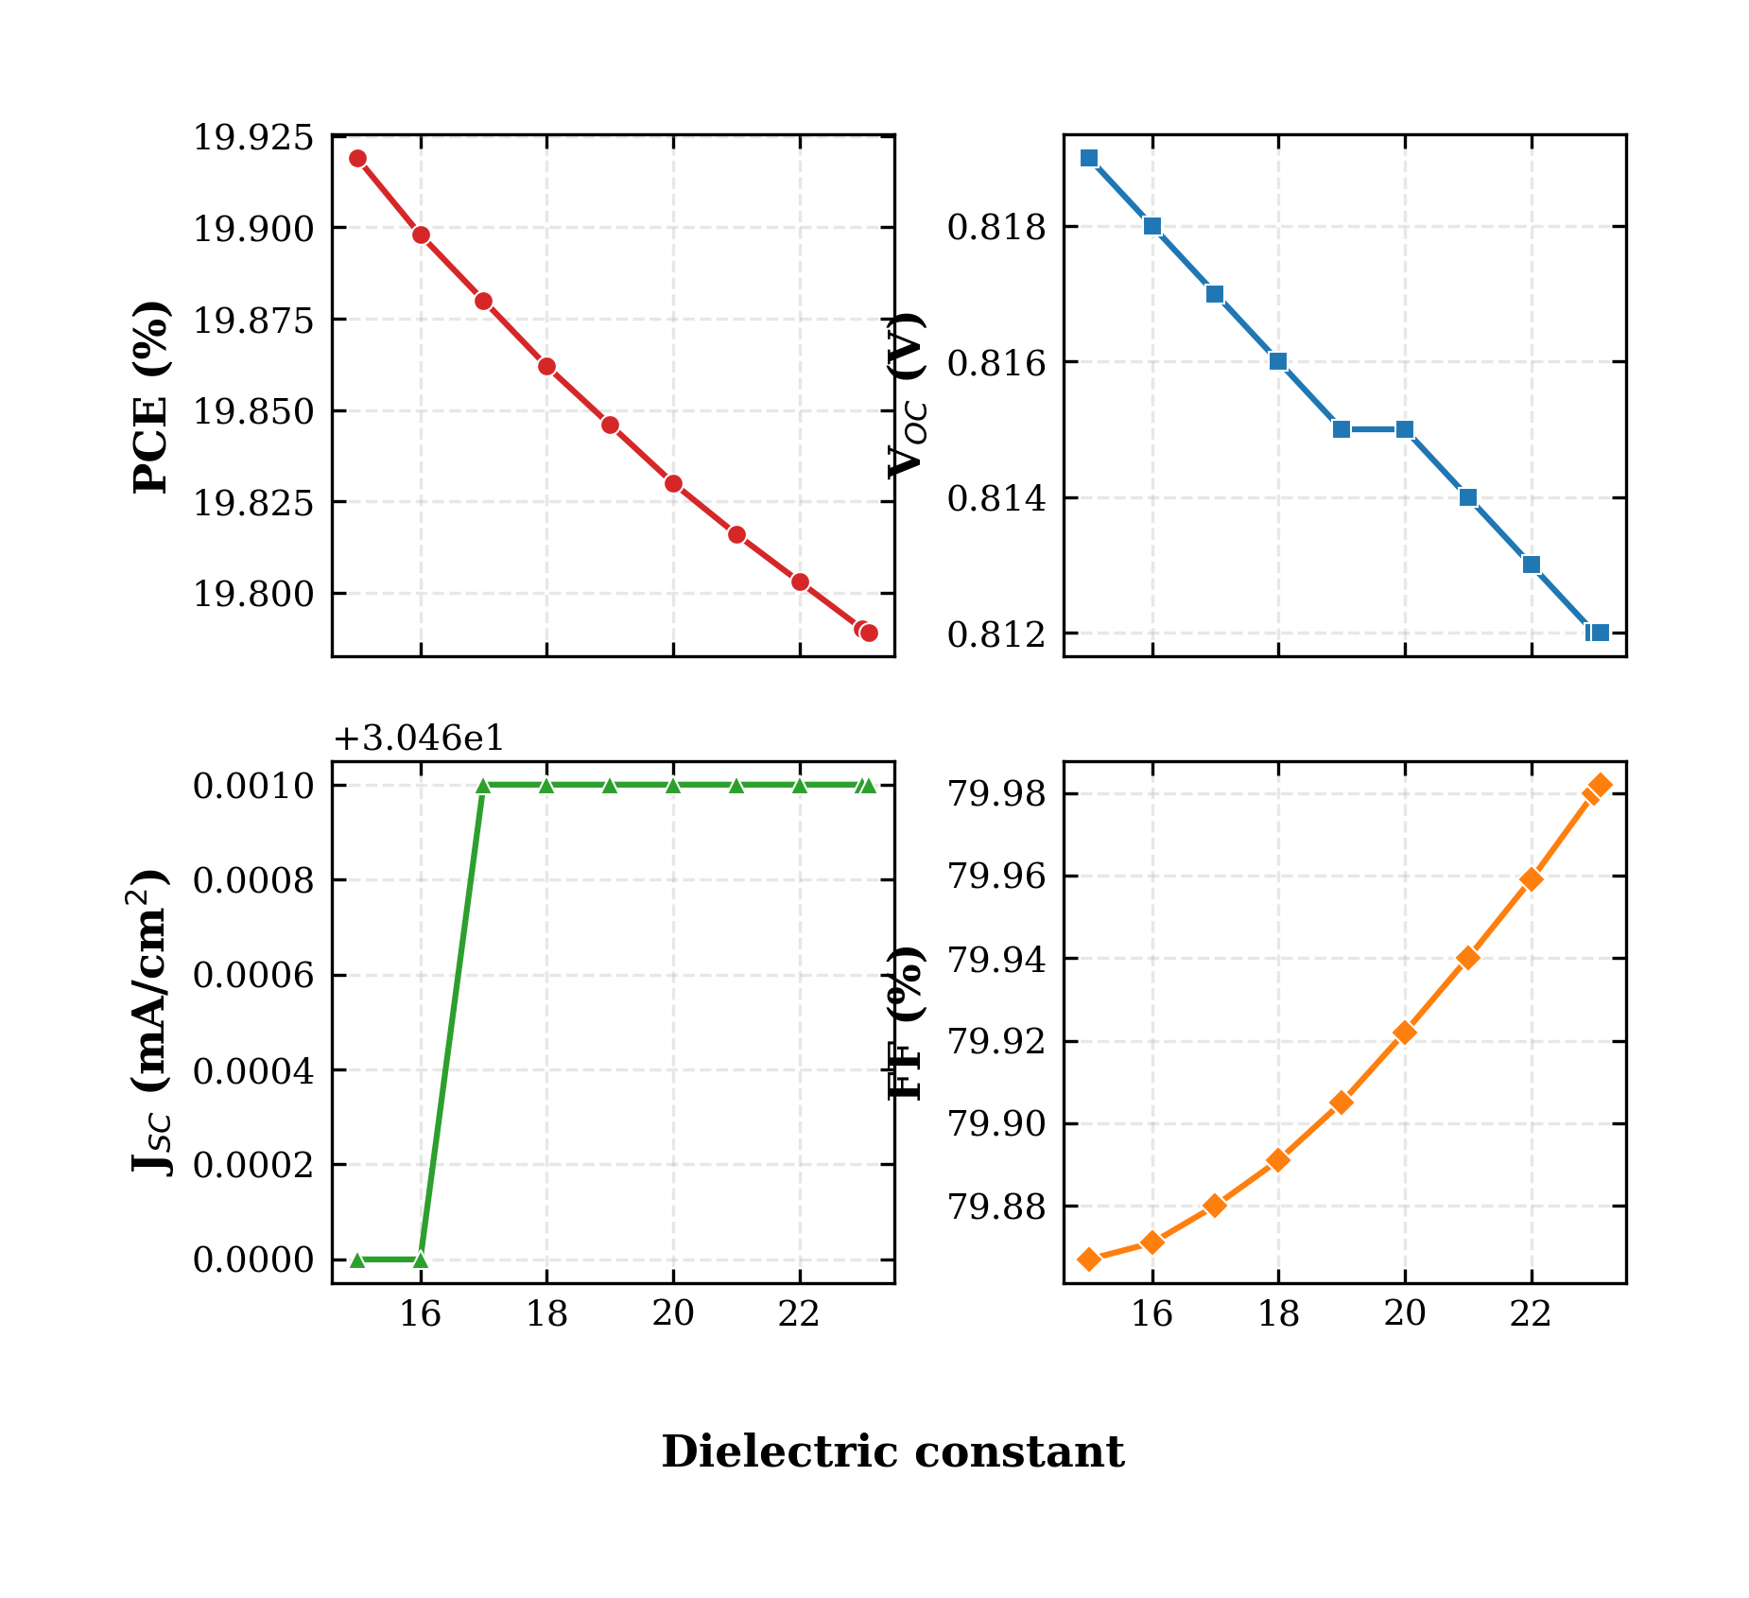
FIG. 5. Variation of PCE, V_OC, J_SC, and FF with the RbGeI₃ absorber dielectric constant. The effect is small within the studied range, with lower ε_r values being slightly more favourable.
TABLE VII. Variation of PCE, V_OC, J_SC, and FF with RbGeI₃ absorber dielectric constant.
ε_r | PCE (%) | V_OC (V) | J_SC (mA/cm²) | FF (%)
15 ★ | 19.92 | 0.819 | 30.46 | 79.87
17 | 19.88 | 0.817 | 30.46 | 79.88
19 | 19.85 | 0.815 | 30.46 | 79.91
21 | 19.82 | 0.814 | 30.46 | 79.94
23 | 19.79 | 0.812 | 30.46 | 79.98

E. Electron Affinity
The electron affinity χ of the absorber directly controls the conduction-band offset at the absorber/ETL interface and is therefore one of the most sensitive parameters in the device. To evaluate its effect, χ was swept from 3.9 eV to 4.2 eV while all other parameters were held constant. The results are shown in Fig. 6 and Table VIII. V_OC dropped sharply from 0.812 V at χ = 3.9 eV to 0.710 V at χ = 4.2 eV, while J_SC remained nearly constant at 30.46 mA/cm². The PCE decreased from 19.79 % at 3.9 eV to 17.81 % at 4.2 eV, with the loss driven almost entirely by the voltage. FF actually increased slightly from 79.98 % to 82.33 % over the same range, but this was insufficient to offset the V_OC loss. The optimum value of χ = 3.9 eV gives a small positive conduction-band spike (ΔE_c ≈ 0.10 eV) at the TiO₂/RbGeI₃ interface, which is known to suppress electron back-transfer without significantly impeding extraction. Higher values of χ move the absorber conduction band below that of TiO₂, creating a cliff that facilitates recombination and reduces V_OC.
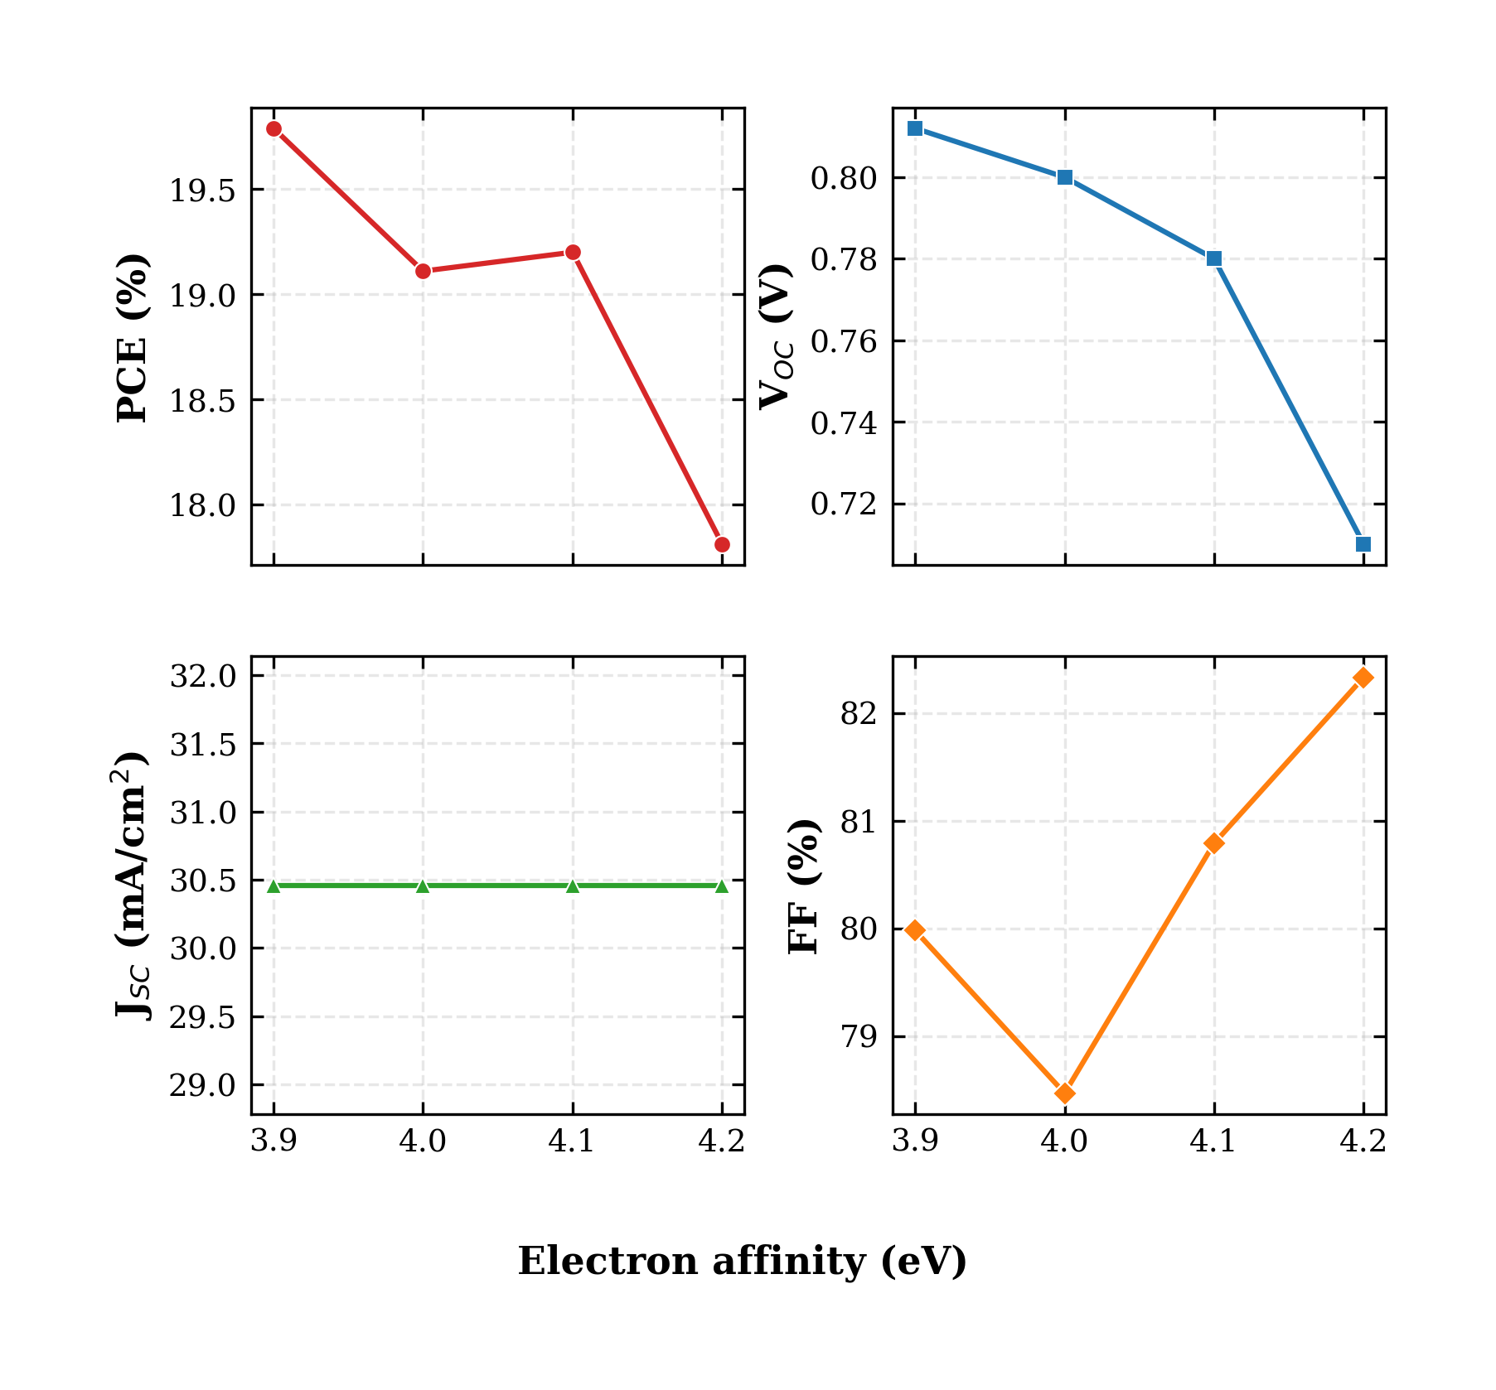
FIG. 6. Variation of PCE, V_OC, J_SC, and FF with the RbGeI₃ absorber electron affinity. V_OC drops sharply as χ increases beyond 3.9 eV due to an unfavourable conduction-band cliff at the TiO₂/RbGeI₃ interface.
TABLE VIII. Variation of PCE, V_OC, J_SC, and FF with RbGeI₃ absorber electron affinity.
χ (eV) | PCE (%) | V_OC (V) | J_SC (mA/cm²) | FF (%)
3.9 ★ | 19.79 | 0.812 | 30.46 | 79.98
4.0 | 19.11 | 0.800 | 30.46 | 78.47
4.1 | 19.20 | 0.780 | 30.46 | 80.79
4.2 | 17.81 | 0.710 | 30.46 | 82.33

F. Interfacial Defect Densities
Interfacial defects are particularly harmful because they sit directly in the carrier extraction path. Two interfaces were examined: TiO₂/RbGeI₃ (absorber/ETL) and RbGeI₃/CuI (absorber/HTL). At the absorber/ETL interface (Fig. 7, Table IX), increasing the defect density from 10¹² to 10¹⁸ cm⁻² caused a steep collapse of performance: PCE fell from 21.04 % to 8.40 %, V_OC from 0.827 V to 0.439 V, J_SC from 30.46 to 28.09 mA/cm², and FF from 83.52 % to 68.11 %. This degradation occurs because interfacial defects act as recombination centres where photogenerated electrons and holes recombine before being collected at the electrodes.
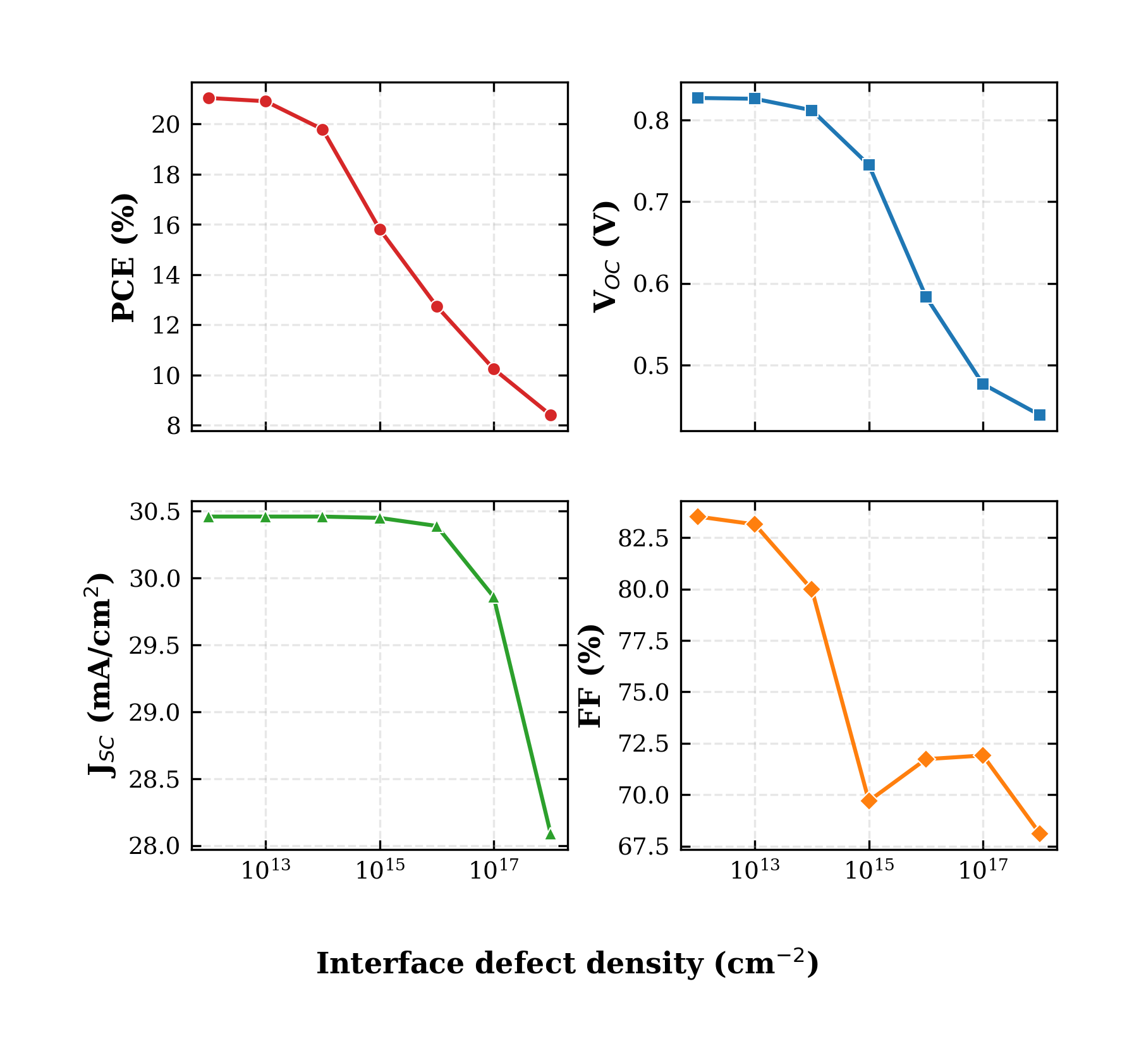
FIG. 7. Variation of PCE, V_OC, J_SC, and FF with the TiO₂/RbGeI₃ interfacial defect density. Performance degrades sharply above 10¹⁴ cm⁻², indicating high sensitivity to absorber/ETL interface quality.
TABLE IX. Variation of PCE, V_OC, J_SC, and FF with TiO₂/RbGeI₃ interfacial defect density.
N_t (cm⁻²) | PCE (%) | V_OC (V) | J_SC (mA/cm²) | FF (%)
10¹² | 21.04 | 0.827 | 30.46 | 83.52
10¹³ | 20.91 | 0.826 | 30.46 | 83.14
10¹⁴ ★ | 19.79 | 0.812 | 30.46 | 79.98
10¹⁵ | 15.81 | 0.745 | 30.45 | 69.70
10¹⁶ | 12.74 | 0.584 | 30.39 | 71.73
10¹⁷ | 10.24 | 0.477 | 29.86 | 71.91
10¹⁸ | 8.40 | 0.439 | 28.09 | 68.11

The HTL/absorber interface (Fig. 8, Table X) proved significantly more tolerant than the absorber/ETL interface: the device output stayed essentially unchanged up to 10¹⁵ cm⁻² (PCE = 19.78 %, V_OC = 0.811 V) and only degraded noticeably at higher defect densities, reaching 18.19 % at 10¹⁸ cm⁻². This asymmetry is consistent with the band alignment at the two junctions. The large conduction-band offset at the CuI/RbGeI₃ interface (ΔE_c ≈ 1.8 eV) acts as an electron-blocking barrier that limits the impact of interfacial traps, whereas the small offset at the TiO₂/RbGeI₃ interface (ΔE_c ≈ 0.10 eV) offers less protection. A realistic interface defect density of 10¹⁴ cm⁻² was adopted at this junction as well, matching the value used at the absorber/ETL interface.
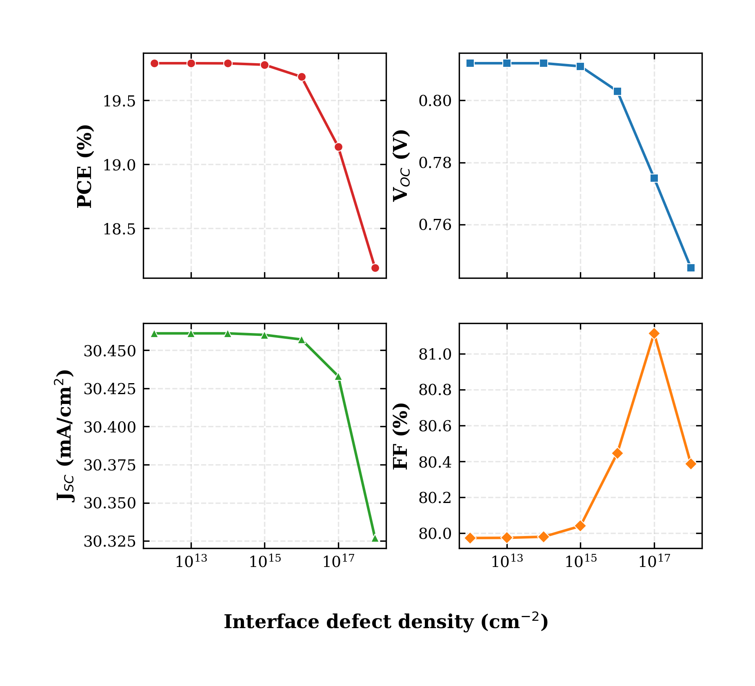
FIG. 8. Variation of PCE, V_OC, J_SC, and FF with the RbGeI₃/CuI interfacial defect density. The HTL/absorber interface is markedly more tolerant than the absorber/ETL interface, thanks to the large conduction-band offset at the CuI/RbGeI₃ junction.
TABLE X. Variation of PCE, V_OC, J_SC, and FF with RbGeI₃/CuI interfacial defect density.
N_t (cm⁻²) | PCE (%) | V_OC (V) | J_SC (mA/cm²) | FF (%)
10¹² | 19.79 | 0.812 | 30.46 | 79.97
10¹³ | 19.79 | 0.812 | 30.46 | 79.97
10¹⁴ ★ | 19.79 | 0.812 | 30.46 | 79.98
10¹⁵ | 19.78 | 0.811 | 30.46 | 80.04
10¹⁶ | 19.69 | 0.803 | 30.46 | 80.45
10¹⁷ | 19.14 | 0.775 | 30.43 | 81.11
10¹⁸ | 18.19 | 0.746 | 30.33 | 80.39

G. Absorber Bandgap
The bandgap of the absorber determines the spectral range of photon absorption and therefore sets a fundamental trade-off between V_OC and J_SC: a wider bandgap increases V_OC but excludes an increasing fraction of the solar spectrum, reducing J_SC. To map this trade-off, the RbGeI₃ bandgap was swept from 1.3 eV to 1.7 eV while all other parameters were held constant. The results are shown in Fig. 9 and Table XI. V_OC rose steadily from 0.803 V at 1.3 eV to 0.997 V at 1.7 eV, as expected from the increased quasi-Fermi-level splitting. J_SC, however, dropped sharply from 30.79 mA/cm² at 1.3 eV to 17.95 mA/cm² at 1.7 eV because the wider gap excludes an increasing fraction of the solar spectrum. The PCE peaked at 19.87 % for a bandgap of 1.4 eV, which represents the best compromise between voltage and current. This value is also close to the optimum bandgap of a single-junction cell predicted by the Shockley–Queisser detailed-balance limit (~1.34 eV) [45], and was therefore adopted for the final device.
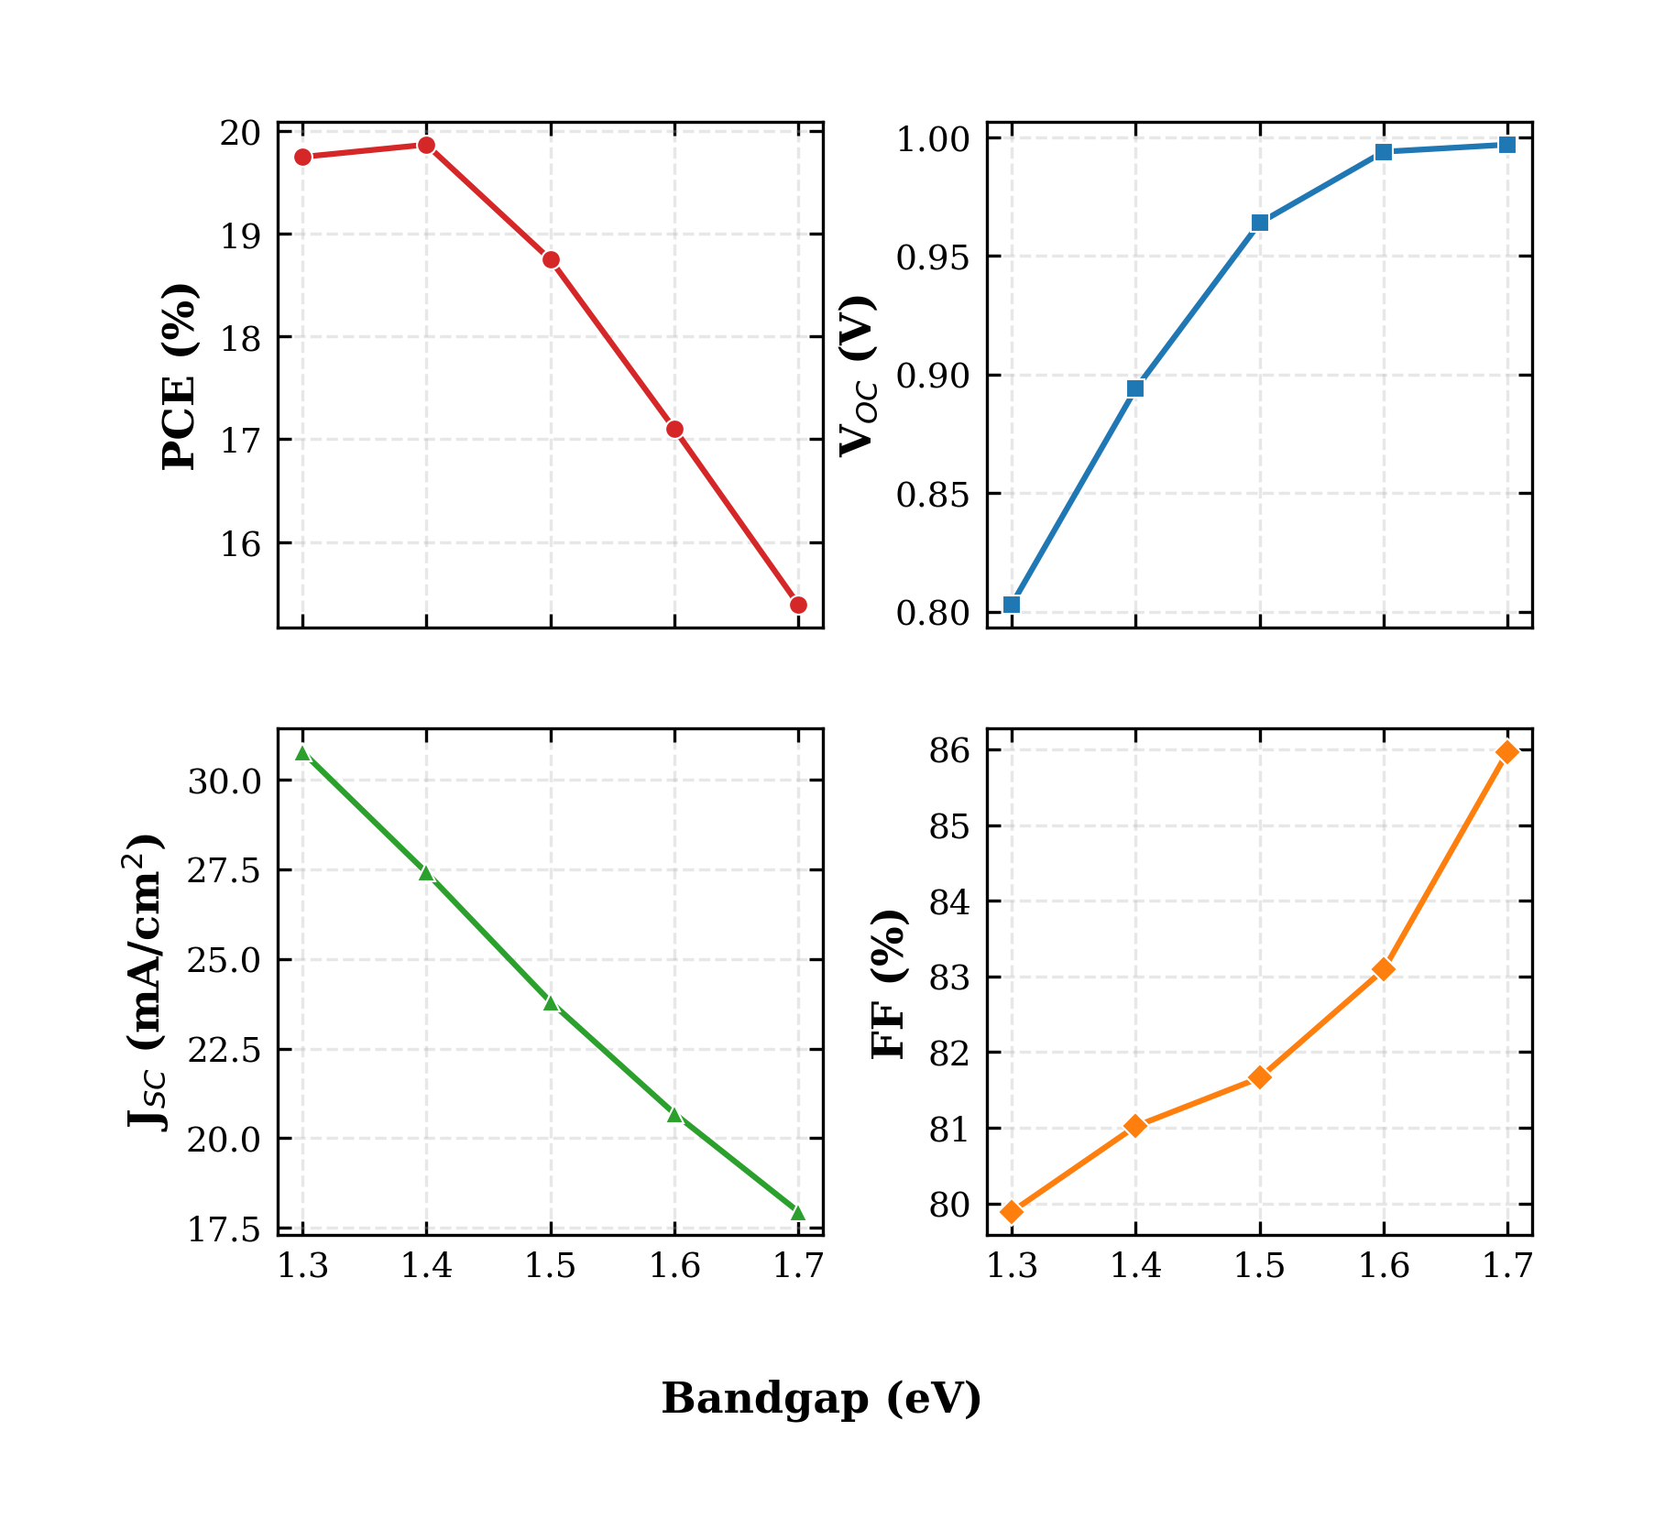
FIG. 9. Variation of PCE, V_OC, J_SC, and FF with the RbGeI₃ absorber bandgap. The PCE peaks at 1.4 eV, close to the Shockley–Queisser optimum for a single-junction cell.
TABLE XI. Variation of PCE, V_OC, J_SC, and FF with RbGeI₃ absorber bandgap.
E_g (eV) | PCE (%) | V_OC (V) | J_SC (mA/cm²) | FF (%)
1.3 | 19.75 | 0.803 | 30.79 | 79.89
1.4 ★ | 19.87 | 0.894 | 27.42 | 81.02
1.5 | 18.75 | 0.964 | 23.81 | 81.66
1.6 | 17.10 | 0.994 | 20.69 | 83.09
1.7 | 15.39 | 0.997 | 17.95 | 85.97

H. ETL Thickness
The TiO₂ ETL thickness influences electron extraction, carrier transport, and optical transmission. To investigate its effect, the TiO₂ thickness was varied from 0.01 μm to 0.09 μm while all other parameters were held constant. The results are shown in Fig. 10 and Table XII. The highest PCE of 21.12 % was obtained at an ETL thickness of 0.01 μm (10 nm), and the efficiency decreased as the ETL became thicker, reaching a local minimum of 18.72 % at 0.04 μm before partially recovering to 19.97 % at 0.09 μm. J_SC remained nearly constant at 30.46 mA/cm² throughout, indicating that the ETL thickness mainly affects V_OC and FF through the electron transport path rather than through optical absorption. A 10 nm TiO₂ layer was therefore adopted for the optimized device.
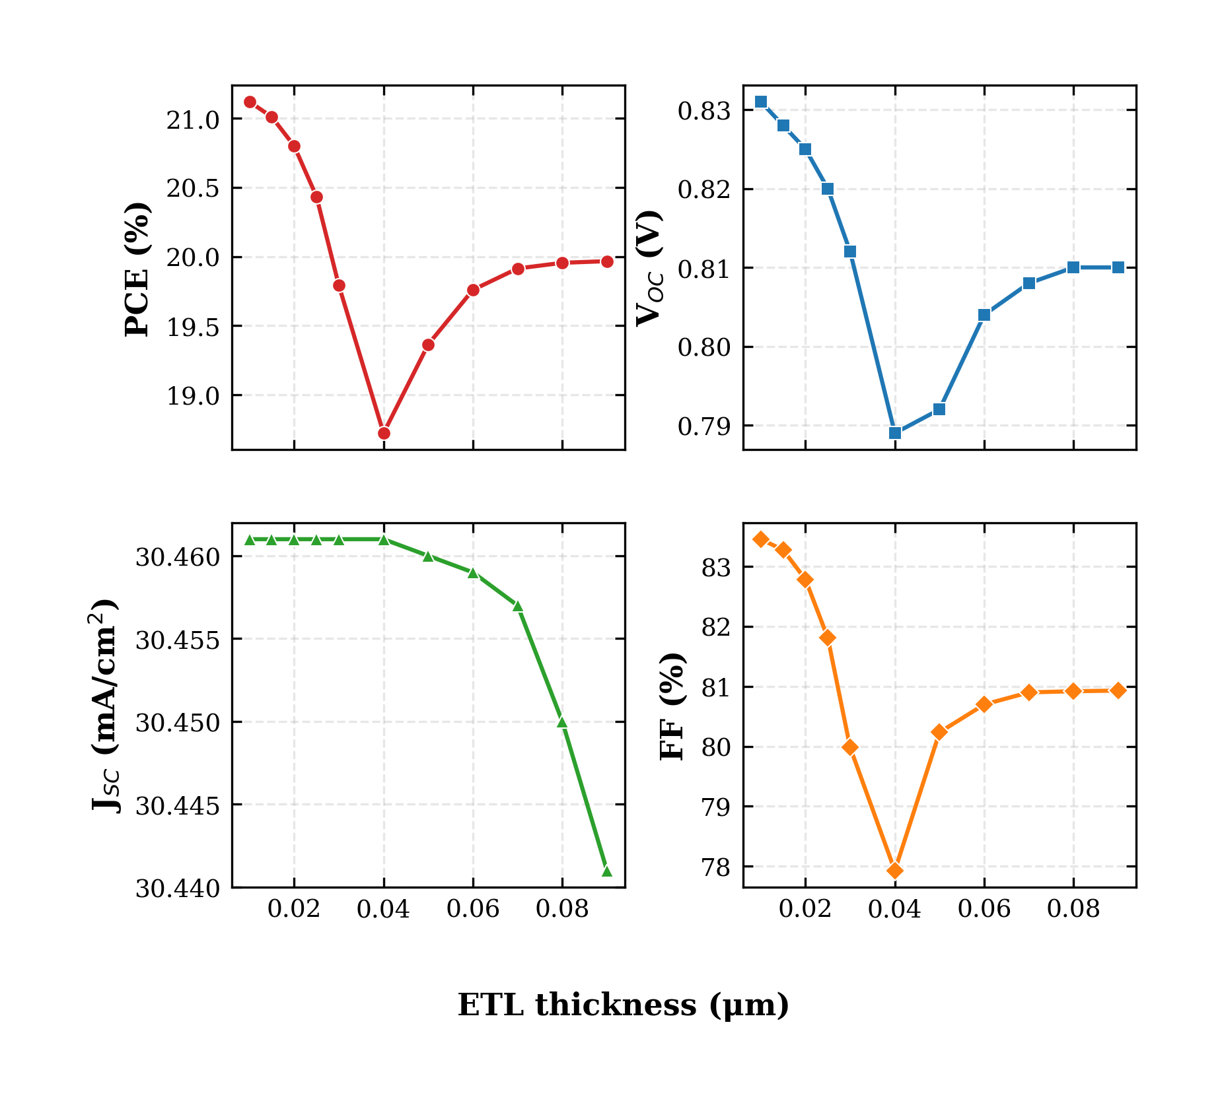
FIG. 10. Variation of PCE, V_OC, J_SC, and FF with the TiO₂ ETL thickness. The PCE is highest at the thinnest ETL (10 nm), reflecting the shorter electron transport path.
TABLE XII. Variation of PCE, V_OC, J_SC, and FF with TiO₂ ETL thickness.
Thickness (μm) | PCE (%) | V_OC (V) | J_SC (mA/cm²) | FF (%)
0.01 ★ | 21.12 | 0.831 | 30.46 | 83.46
0.02 | 20.80 | 0.825 | 30.46 | 82.79
0.03 | 20.43 | 0.820 | 30.46 | 81.81
0.04 | 18.72 | 0.789 | 30.46 | 77.93
0.05 | 19.36 | 0.792 | 30.46 | 80.23
0.07 | 19.91 | 0.808 | 30.46 | 80.90
0.09 | 19.97 | 0.810 | 30.44 | 80.93

I. HTL Thickness
The CuI HTL thickness was swept from 0.1 μm to 1.9 μm to investigate its effect on device performance. The results are shown in Fig. 11 and Table XIII. In stark contrast to the ETL, the HTL thickness had almost no influence on device performance: PCE increased by less than 0.002 percentage points across the entire range, and the variations in V_OC, J_SC, and FF were similarly negligible. This is because CuI already provides effective hole transport at 0.1 μm thanks to its high hole mobility (~100 cm²V⁻¹s⁻¹), and any further increase in thickness simply adds parasitic absorption without improving charge collection. A thickness of 100 nm was therefore selected for the final device to keep material usage low.
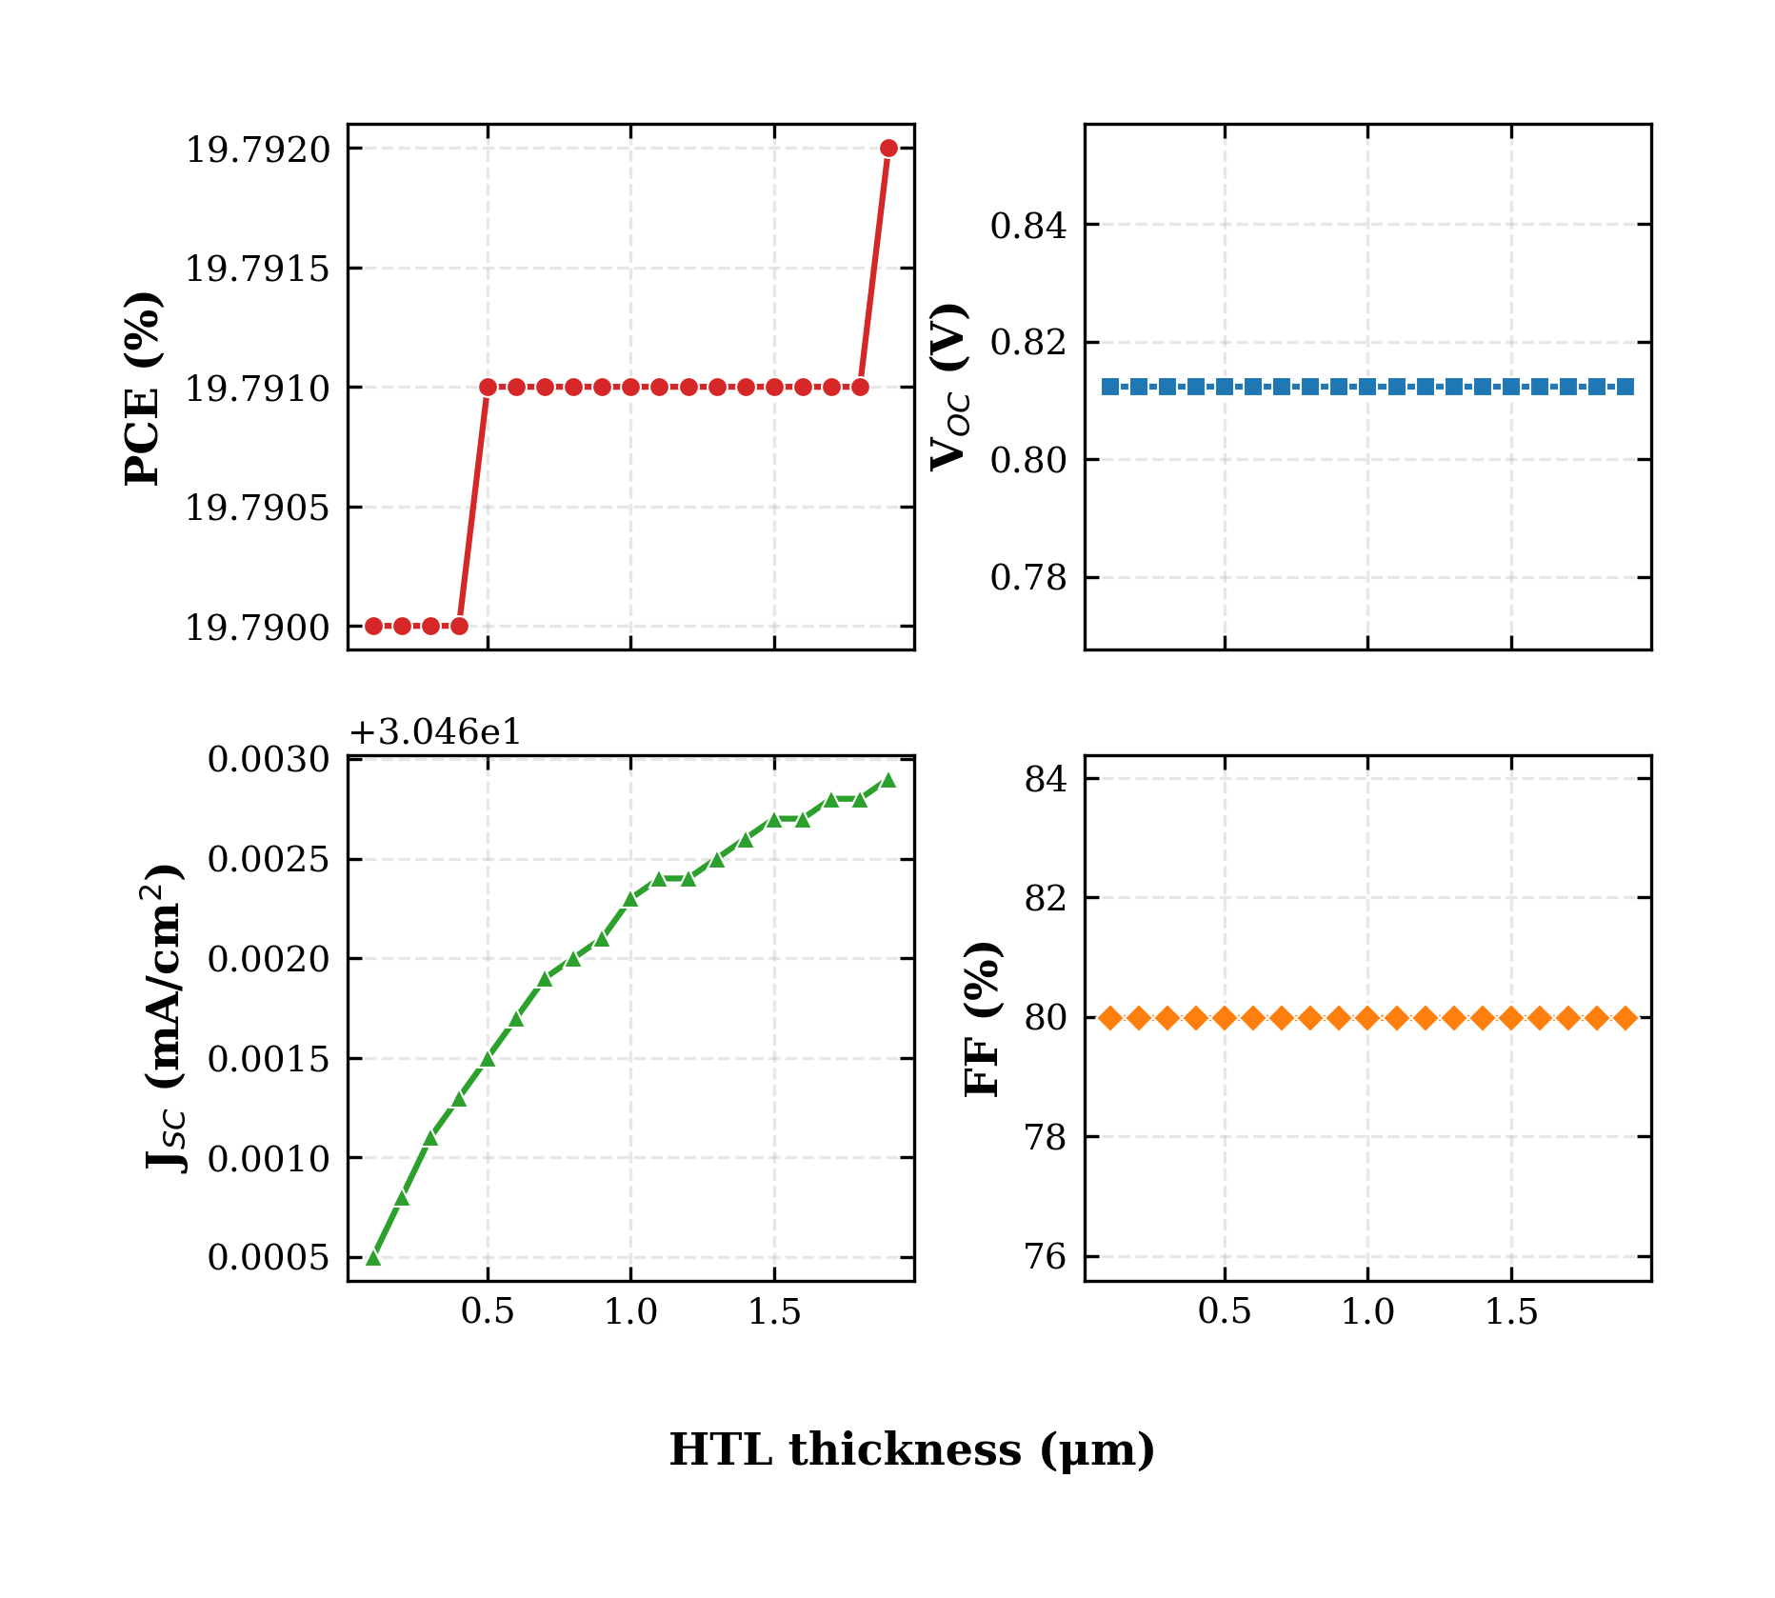
FIG. 11. Variation of PCE, V_OC, J_SC, and FF with the CuI HTL thickness. The HTL thickness has negligible influence on device performance.
TABLE XIII. Variation of PCE, V_OC, J_SC, and FF with CuI HTL thickness.
Thickness (μm) | PCE (%) | V_OC (V) | J_SC (mA/cm²) | FF (%)
0.1 ★ | 19.790 | 0.812 | 30.461 | 79.980
0.3 | 19.790 | 0.812 | 30.461 | 79.980
0.5 | 19.791 | 0.812 | 30.462 | 79.980
0.7 | 19.791 | 0.812 | 30.462 | 79.980
1.0 | 19.791 | 0.812 | 30.462 | 79.980
1.5 | 19.791 | 0.812 | 30.463 | 79.980
1.9 | 19.792 | 0.812 | 30.463 | 79.980

J. Conduction-Band Effective Density of States
The conduction-band effective density of states N_C influences the distribution of electrons in the conduction band and plays an important role in determining the electrical properties of the absorber layer. To investigate its effect, N_C was varied from 1×10¹⁷ to 1×10²⁰ cm⁻³ while all other parameters were held constant. The results are shown in Fig. 12 and Table XIV. Increasing N_C reduced PCE gradually from 20.65 % at 1×10¹⁷ cm⁻³ to 18.15 % at 1×10²⁰ cm⁻³, with V_OC dropping from 0.859 V to 0.764 V. J_SC remained nearly unchanged at 30.46 mA/cm². The reduction in PCE is mainly associated with the decrease in V_OC: a higher N_C modifies the carrier concentration and shifts the position of the electron quasi-Fermi level, reducing the quasi-Fermi-level splitting. A value of N_C = 1×10¹⁷ cm⁻³ was therefore selected for the optimized device.
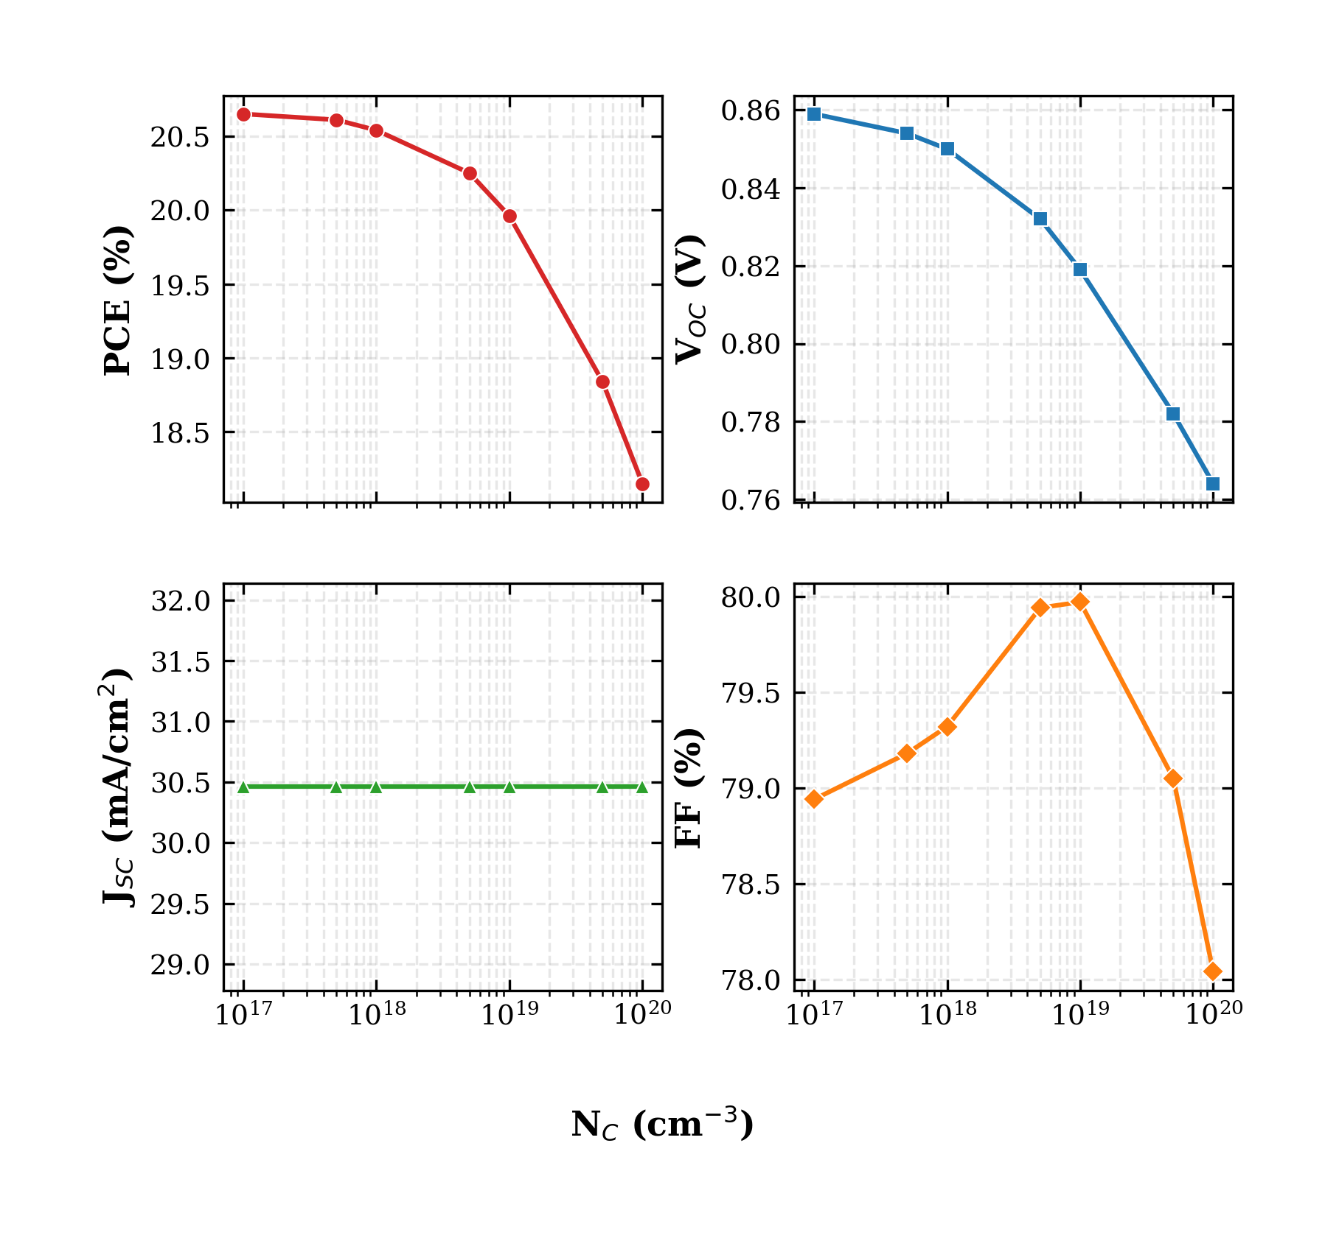
FIG. 12. Variation of PCE, V_OC, J_SC, and FF with the conduction-band effective density of states N_C.
TABLE XIV. Variation of PCE, V_OC, J_SC, and FF with conduction-band effective density of states N_C.
N_C (cm⁻³) | PCE (%) | V_OC (V) | J_SC (mA/cm²) | FF (%)
1×10¹⁷ ★ | 20.65 | 0.859 | 30.46 | 78.94
5×10¹⁷ | 20.61 | 0.854 | 30.46 | 79.18
1×10¹⁸ | 20.54 | 0.850 | 30.46 | 79.32
5×10¹⁸ | 20.25 | 0.832 | 30.46 | 79.94
1×10¹⁹ | 19.96 | 0.819 | 30.46 | 79.97
5×10¹⁹ | 18.84 | 0.782 | 30.46 | 79.05
1×10²⁰ | 18.15 | 0.764 | 30.46 | 78.04

K. Valence-Band Effective Density of States
The valence-band effective density of states N_V was similarly varied from 1×10¹⁷ to 1×10²⁰ cm⁻³. The results are shown in Fig. 13 and Table XV. The effect of N_V was more pronounced than that of N_C. PCE fell from 23.54 % at 1×10¹⁷ cm⁻³ to 18.86 % at 1×10²⁰ cm⁻³, with V_OC decreasing significantly from 0.944 V to 0.780 V. FF also decreased from 81.81 % to 79.40 %, while J_SC again remained nearly unchanged. These reductions arise because a higher N_V shifts the carrier distribution and reduces the quasi-Fermi-level splitting, in much the same way as observed for N_C but with a stronger effect on V_OC. A value of N_V = 1×10¹⁷ cm⁻³ was therefore selected for the optimized device.
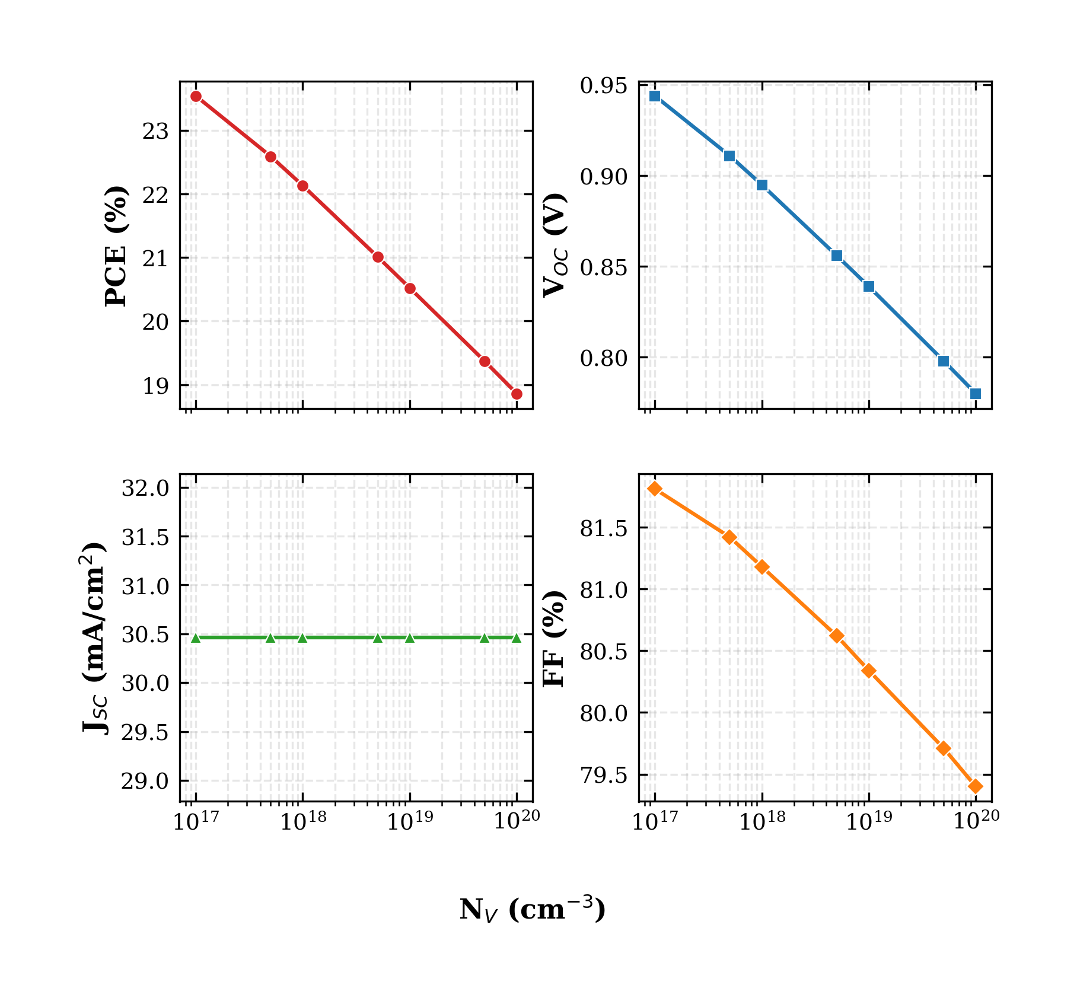
FIG. 13. Variation of PCE, V_OC, J_SC, and FF with the valence-band effective density of states N_V. The effect is more pronounced than for N_C.
TABLE XV. Variation of PCE, V_OC, J_SC, and FF with valence-band effective density of states N_V.
N_V (cm⁻³) | PCE (%) | V_OC (V) | J_SC (mA/cm²) | FF (%)
1×10¹⁷ ★ | 23.54 | 0.944 | 30.46 | 81.81
5×10¹⁷ | 22.59 | 0.911 | 30.46 | 81.42
1×10¹⁸ | 22.13 | 0.895 | 30.46 | 81.18
5×10¹⁸ | 21.01 | 0.856 | 30.46 | 80.62
1×10¹⁹ | 20.52 | 0.839 | 30.46 | 80.34
5×10¹⁹ | 19.37 | 0.798 | 30.46 | 79.71
1×10²⁰ | 18.86 | 0.780 | 30.46 | 79.40

L. Quantum Efficiency Analysis
The external quantum efficiency (EQE) spectrum of the optimized device is shown in Fig. 14. The EQE rises from about 34.5 % at 300 nm to 49.2 % at 350 nm and reaches approximately 100 % at 400 nm. The relatively lower EQE in the ultraviolet region can be attributed to surface recombination of high-energy photons and to optical losses in the FTO and TiO₂ front layers. Between 400 nm and 650 nm, the EQE remains on a broad plateau close to 99–100 %, indicating excellent photon absorption and efficient charge carrier collection within the visible region. As the wavelength increases beyond 650 nm, the EQE gradually decreases from 98.53 % at 650 nm to 76.17 % at 850 nm. A sharp drop in EQE is observed near 900 nm, where the EQE approaches zero. This behaviour corresponds to the absorption edge of the absorber material: photons with wavelengths greater than the cut-off wavelength (λ_c ≈ 1240/E_g ≈ 886 nm for E_g = 1.4 eV) do not have sufficient energy to excite electrons across the bandgap.
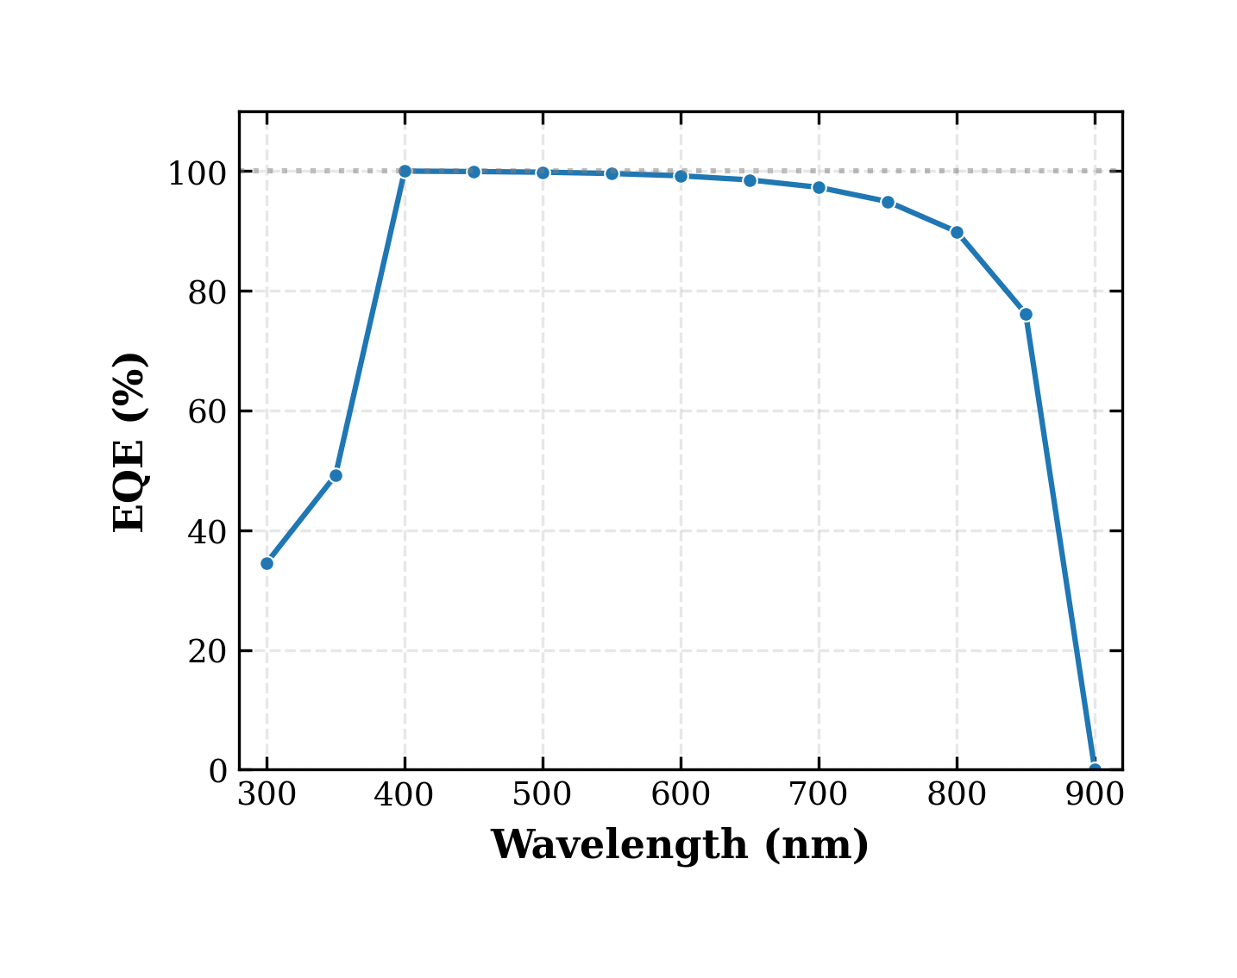
FIG. 14. Variation of external quantum efficiency (EQE) with incident wavelength for the optimized FTO/TiO₂/RbGeI₃/CuI/Au solar cell. The broad plateau of 99–100 % between 400 and 650 nm confirms excellent visible-light response.

M. Energy Band Diagram Analysis
Fig. 15 shows the equilibrium energy band diagram of the optimized CuI/RbGeI₃/TiO₂/FTO device, with the horizontal axis representing the position across the device stack (total thickness 1310 nm: CuI 100 nm + RbGeI₃ 700 nm + TiO₂ 10 nm + FTO 500 nm) and the vertical axis representing the electron energy (eV). At the CuI/RbGeI₃ interface, a pronounced conduction-band discontinuity is observed. Based on the electron affinity values of CuI (χ = 2.1 eV) and RbGeI₃ (χ = 3.9 eV), the conduction-band offset is approximately 1.8 eV, which acts as an effective electron-blocking barrier that suppresses electron back-transfer. The valence-band offset at the same interface is only about 0.01 eV, allowing holes to be extracted with minimal resistance.
Within the 700 nm RbGeI₃ absorber layer, both the conduction-band edge (E_c) and the valence-band edge (E_v) remain nearly constant, indicating a relatively uniform electrostatic potential throughout the bulk absorber. A second band discontinuity appears at the RbGeI₃/TiO₂ interface. Because the electron affinities of RbGeI₃ and TiO₂ are 3.9 eV and 4.0 eV respectively, the conduction-band offset is only about 0.10 eV, providing a small beneficial spike that suppresses electron back-transfer. The valence-band offset at this interface is approximately 1.99 eV, which blocks holes. The electron and hole quasi-Fermi levels remain well separated throughout the absorber, confirming the strong built-in field that drives charge separation and supports the high V_OC of 1.1127 V.
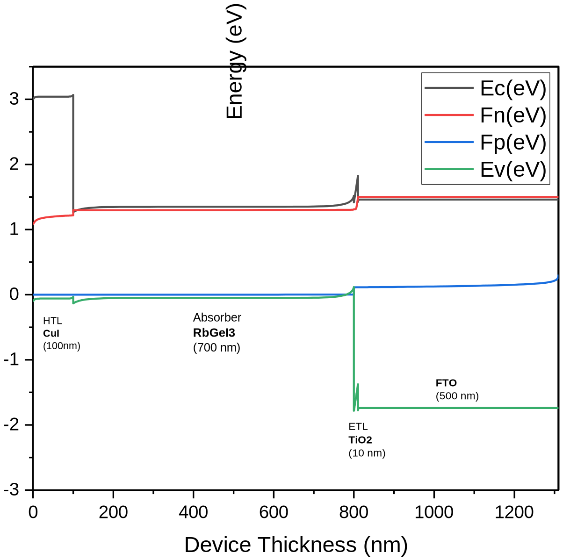
FIG. 15. Equilibrium energy band diagram of the optimized CuI/RbGeI₃/TiO₂/FTO solar cell, showing the conduction-band edge (E_c), valence-band edge (E_v), and quasi-Fermi levels (F_n, F_p) across the device stack.

N. Optimized Device Performance
After the sequential optimization of all eleven parameters, the final FTO/TiO₂/RbGeI₃/CuI/Au device achieves a PCE of 26.69 %, with V_OC = 1.1127 V, J_SC = 30.3156 mA/cm², and FF = 79.13 %. The optimized parameter set is summarized in Table XVI. The improvement from the initial 21.11 % of the unoptimized D4 device to the final 26.69 %—an absolute gain of 5.58 percentage points—is driven primarily by four factors: (i) the reduction of the absorber defect density to 10¹⁴ cm⁻³, which suppresses SRH recombination; (ii) the choice of a 1.4 eV bandgap, which balances V_OC and J_SC near the Shockley–Queisser optimum; (iii) the optimization of the effective density of states to 1×10¹⁷ cm⁻³ for both N_C and N_V, which maximizes the quasi-Fermi-level splitting; and (iv) the adoption of a 10 nm TiO₂ ETL, which minimizes the electron transport path. The high V_OC and FF obtained here are consistent with previous simulation studies of CuI-based perovskite solar cells [33,35], which also reported favourable valence-band alignment and suppressed interfacial recombination at the CuI/absorber junction.
TABLE XVI. Optimized material and device parameters of the proposed FTO/TiO₂/RbGeI₃/CuI/Au solar cell.
Parameter | Optimized Value | Parameter | Optimized Value
Absorber thickness | 700 nm | ETL (TiO₂) thickness | 10 nm
Absorber bandgap | 1.4 eV | HTL (CuI) thickness | 100 nm
Absorber defect density | 1 × 10¹⁴ cm⁻³ | Interface N_t (both) | 1 × 10¹⁴ cm⁻²
Electron affinity | 3.9 eV | Final V_OC | 1.1127 V
Dielectric constant | 15 | Final J_SC | 30.32 mA/cm²
N_C | 1 × 10¹⁷ cm⁻³ | Final FF | 79.13 %
N_V | 1 × 10¹⁷ cm⁻³ | Final PCE | 26.69 %

V. COMPARISON WITH LITERATURE
Table XVII compares the optimized FTO/TiO₂/RbGeI₃/CuI/Au device with recently reported RbGeI₃-based and related lead-free Ge/Sn-based perovskite solar cells. The proposed device delivers the highest PCE (26.69 %) and the highest V_OC (1.1127 V) among the simulation studies, exceeding the previous best RbGeI₃ result of 24.62 % reported by Loumachi et al. [28] by 2.07 percentage points and the 18.44 % reported by Raj et al. [29] by 8.25 percentage points. It also outperforms the experimental baseline of 10.11 % reported by Pindolia et al. [25] by more than 16 percentage points. The performance is competitive with the best tin-based lead-free devices—including the 26.40 % CsSnI₃ device of Hossain et al. [27] and the 25.86 % MASnI₃ device of Islam et al. [46]—while avoiding the Sn²⁺ → Sn⁴⁺ oxidation that limits the long-term stability of tin-based absorbers. The proposed PCE also exceeds that of CZTS-HTL lead-free devices reported by Piñón Reyes et al. [47], confirming the competitiveness of the CuI HTL approach adopted here.
TABLE XVII. Comparison of the proposed device with recently reported lead-free perovskite solar cells.
Device Structure | V_OC (V) | J_SC (mA/cm²) | FF (%) | PCE (%) | Year [Ref.]
FTO/TiO₂/RbGeI₃/NiO/Ag | 0.531 | 28.89 | 63.68 | 10.11 | 2022 [25]
FTO/TiO₂/CsGeI₃/CuI/Au | 0.667 | 22.06 | 73.49 | 10.80 | 2023 [26]
FTO/PCBM/CsSn₀.₅Ge₀.₅I₃/Spiro/Au | — | — | — | 18.13 | 2022 [16]
ITO/PCBM/CsSnI₃/CuI/Au | 0.667 | 22.06 | 68.46 | 10.10 | 2023 [27]
ITO/C₆₀/RbGeI₃/CBTS/Au | 0.99 | 33.20 | 82.80 | 24.62 | 2024 [28]
FTO/TiO₂/RbGeI₃/PEDOT:PSS/Au | 0.813 | 30.84 | 74.19 | 18.44 | 2025 [29]
FTO/TiO₂/RbGeI₃/Spiro-OMeTAD/Au | — | — | — | 26.47 | 2026 [30]
FTO/TiO₂/MASnI₃/CBTS/Au | 1.030 | 30.24 | 83.41 | 25.86 | 2026 [46]
FTO/TiO₂/CsSnI₃/P3HT/Au | 0.972 | 34.70 | 78.21 | 26.40 | 2023 [39]
FTO/TiO₂/RbGeI₃/CuI/Au (this work) | 1.1127 | 30.32 | 79.13 | 26.69 | This work

VI. LIMITATIONS AND FUTURE WORK
Although the simulated performance of the proposed device is encouraging, several limitations should be acknowledged. First, SCAPS-1D is a one-dimensional solver that assumes idealized conditions, including uniform material composition, abrupt and defect-free interfaces, and stable material parameters over the device lifetime. None of these assumptions is strictly guaranteed in experimental practice, where grain boundaries, interdiffusion, and degradation pathways can substantially degrade performance. Second, the defect densities adopted in this study (10¹⁴ cm⁻³ in the absorber and 10¹⁴ cm⁻² at both interfaces), although realistic for well-passivated films, remain challenging to achieve consistently in RbGeI₃, where Ge²⁺ oxidation introduces deep defect states [30,31] during film preparation and operation. Third, the present study does not account for optical losses in the FTO and metal contact, for parasitic absorption in the transport layers, or for the temperature dependence of material parameters, all of which would reduce the achievable experimental PCE.
Translating the simulated 26.69 % PCE into an experimental device will require advances on several fronts. Ge²⁺ stabilization is the single most important obstacle to high-performance Ge-based perovskite solar cells, and effective encapsulation, controlled-atmosphere deposition, and the use of Ge²⁺-stabilizing additives will be essential. The high sensitivity of the absorber/ETL interface to defect densities above 10¹⁴ cm⁻² calls for dedicated passivation strategies—such as self-assembled monolayers (SAMs) [48,49], low-temperature atomic-layer-deposited interlayers, or chemical bath deposition of thin Al₂O₃—to suppress interfacial recombination. Anti-reflection coatings, surface texturing, plasmonic nanoparticles, and light-trapping structures could increase photon absorption without increasing absorber thickness. Future research should also investigate the influence of humidity, oxygen exposure, thermal stress, ultraviolet illumination, and ion migration on the performance degradation of RbGeI₃ devices, and the present one-dimensional electrical simulation could be complemented by coupled optical–electrical simulations [22,23] (e.g., using TCAD, COMSOL Multiphysics, or Lumerical) to capture the full carrier-transport, electric-field, and thermal behaviour. Finally, the optimized RbGeI₃ absorber, with its 1.4 eV bandgap, is also well-suited as the top cell in a tandem architecture with a silicon or CIGS bottom cell [3,45,50], which could push the overall efficiency beyond the single-junction limit.

VII. CONCLUSION
This work has presented a comprehensive SCAPS-1D optimization of a lead-free RbGeI₃ absorber perovskite solar cell with the structure FTO/TiO₂/RbGeI₃/CuI/Au. Eight ETL–HTL configurations were screened by combining two electron transport layers (TiO₂ and PCBM) with four hole transport layers (NiO, CuI, CBTS, and Spiro-OMeTAD), and the TiO₂/RbGeI₃/CuI combination (device D4) was identified as the most promising. A sequential optimization of eleven device parameters—absorber thickness, absorber defect density, dielectric constant, electron affinity, bandgap, conduction- and valence-band effective density of states, ETL thickness, HTL thickness, and the interfacial defect densities at both heterojunctions—was carried out under standard AM 1.5G illumination at 300 K.
The optimized device achieves a final PCE of 26.69 %, with V_OC = 1.1127 V, J_SC = 30.32 mA/cm², and FF = 79.13 %. The optimized device outperforms previously reported RbGeI₃ simulations (the previous best was 24.62 %) and the experimental baseline of 10.11 %, and remains competitive with the best tin-based lead-free devices while avoiding the Sn²⁺ oxidation problem. The quantum efficiency spectrum exhibits a broad plateau of 99–100 % between 400 and 650 nm, and the equilibrium energy band diagram confirms favourable band alignment at both heterojunctions. The results identify the TiO₂/CuI transport-layer pair as an efficient combination for environmentally benign RbGeI₃ photovoltaics and provide quantitative design guidelines for future experimental work. Realizing the simulated 26.69 % PCE in practice will depend on advances in Ge²⁺ stabilization, interface passivation, and encapsulation.

REFERENCES
1. RENEWABLES 2024 Global Status Report (REN21, 2024). Available at: https://www.ren21.net/gsr-2024/.
2. World Energy Outlook 2024 (International Energy Agency, IEA, 2024). Available at: https://www.iea.org/reports/world-energy-outlook-2024.
3. M. A. Green et al., “Solar cell efficiency tables (Version 64),” Prog. Photovolt.: Res. Appl. (2024). doi:10.1002/pip.3831.
4. R. A. Afre and D. Pugliese, “Perovskite solar cells: A review of the latest advances in materials, fabrication techniques, and stability enhancement strategies,” Micromachines 15(2), 192 (2024). doi:10.3390/mi15020192.
5. A. Kojima, K. Teshima, Y. Shirai, and T. Miyasaka, “Organometal halide perovskites as visible-light sensitizers for photovoltaic cells,” J. Am. Chem. Soc. 131(17), 6050–6051 (2009). doi:10.1021/ja809598r.
6. N.-G. Park, M. Grätzel, T. Miyasaka, K. Zhu, and K. Emery, “Towards stable and commercially available perovskite solar cells,” Nat. Energy 1(11), 16152 (2016). doi:10.1038/nenergy.2016.152.
7. “Compositional engineering of perovskite materials for high-performance solar cells,” Nature 517(7535), 476–480 (2015). doi:10.1038/nature14133.
8. National Renewable Energy Laboratory, “Best research-cell efficiency chart” (NREL, 2024). Available at: https://www.nrel.gov/pv/cell-efficiency.html.
9. H. J. Snaith, “Perovskites: The emergence of a new era for low-cost, high-efficiency solar cells,” J. Phys. Chem. Lett. 4(21), 3623–3630 (2013). doi:10.1021/jz4020162.
10. J. Burschka, N. Pellet, S.-J. Moon, R. Humphry-Baker, P. Gao, M. K. Nazeeruddin, and M. Grätzel, “Sequential deposition as a route to high-performance perovskite-sensitized solar cells,” Nature 499(7458), 316–319 (2013). doi:10.1038/nature12340.
11. M. M. Lee, J. Teuscher, T. Miyasaka, T. N. Murakami, and H. J. Snaith, “Efficient hybrid solar cells based on meso-superstructured organometal halide perovskites,” Science 338(6107), 643–647 (2012). doi:10.1126/science.1228604.
12. I. Ahmed, K. Prakash, and S. M. Mobin, “Lead-free perovskites for solar cell applications: recent progress, ongoing challenges, and strategic approaches,” Chem. Commun. 61(37), 6691–6721 (2025). doi:10.1039/D4CC06835A.
13. S. Kinza Fatima et al., “Lead-free perovskites for next-generation applications: a comprehensive computational and data-driven review,” Mater. Adv. 6(21), 7634–7661 (2025). doi:10.1039/D5MA00681C.
14. A. K. Jena, A. Kulkarni, and T. Miyasaka, “Halide perovskite photovoltaics: Background, status, and future prospects,” Chem. Rev. 119(5), 3036–3103 (2019). doi:10.1021/acs.chemrev.8b00539.
15. P. Afrin, K. Farjana, A. Vumije, and M. N. Uddin, “An investigation on the impact of temperature variation over the performance of formamidinium tin iodide perovskite solar cell using SCAPS simulation,” AIP Adv. 14(7) (2024). doi:10.1063/5.0209332.
16. S. Bouazizi, W. Tlili, A. Bouich, B. M. Soucase, and A. Omri, “Design and efficiency enhancement of FTO/PC60BM/CsSn0.5Ge0.5I3/Spiro-OMeTAD/Au perovskite solar cell utilizing SCAPS-1D simulator,” Mater. Res. Express 9(9), 096402 (2022). doi:10.1088/2053-1591/ac8d52.
17. S. Samaki, F. Tchangnwa Nya, G. M. Dzifack Kenfack, and A. Laref, “Materials and interfaces properties optimization for high-efficient and more stable RbGeI3 perovskite solar cells: optoelectrical modelling,” Sci. Rep. 13, 15517 (2023). doi:10.1038/s41598-023-42471-w.
18. T. Salim, S. Sun, Y. Abe, A. Krishna, A. C. Grimsdale, and Y. M. Lam, “Perovskite-based solar cells: Impact of materials processing and device architecture,” J. Mater. Chem. A 3(17), 8943–8969 (2015). doi:10.1039/C4TA05226A.
19. P. K. Dash, P. Banarjee, A. Nyayban, and S. Panda, “Optoelectronic properties and performance optimization for photovoltaic applications of R3m-RbGeX3 (X = Cl, Br, I) perovskites: A combined DFT and SCAPS-1D study,” arXiv:2505.09362 (2025).
20. N. A. Abdulkareem, “A DFT study of structural, electronic and optical properties of lead-free and Ge-based cubic perovskite RbGeX3 (X = I, Br and Cl),” Passer J. Basic Appl. Sci. 5(1), 46–51 (2023). doi:10.24271/psr.2023.371069.1187.
21. Z. Iqbal et al., “Interface modification for energy levels alignment and charge extraction in CsPbI3 perovskite solar cells,” arXiv:2307.13174 (2023).
22. M. Burgelman, P. Nollet, and S. Degrave, “Modelling polycrystalline semiconductor solar cells,” Thin Solid Films 361–362, 527–532 (2000). doi:10.1016/S0040-6090(99)00825-1.
23. M. Burgelman, M. Debucquoy, K. Decock, J. Verschraegen, and S. Degrave, SCAPS-1D simulation program for thin film solar cells, version 3.3.10 (ELIS, University of Gent, Belgium, 2024).
24. A. Nakane, S. Feldmann, H. S. Emmer, et al., “Quantitative determination of optical and recombination losses in thin-film photovoltaic devices based on external quantum efficiency analysis,” arXiv:1604.04491 (2016).
25. G. Pindolia, S. M. Shinde, and P. K. Jha, “Optimization of an inorganic lead-free RbGeI3 based perovskite solar cell by SCAPS-1D simulation,” Sol. Energy 236, 802–821 (2022). doi:10.1016/j.solener.2022.03.053.
26. D. Saikia, A. Saikia, and P. K. Saikia, “Investigation of photovoltaic performance of lead-free CsSnI3-based perovskite solar cell with different hole transport layers: First-principle calculations and SCAPS-1D analysis,” Sol. Energy 249, 163–173 (2023). doi:10.1016/j.solener.2022.11.025.
27. M. K. Hossain et al., “Numerical simulation and optimization of a CsPbI3-based perovskite solar cell to enhance the power conversion efficiency,” New J. Chem. 47(10), 4801–4817 (2023). doi:10.1039/D2NJ06206B.
28. L. Loumachi, A. Yousfi, O. Saidani, and A. S. Alsubaie, “Strengthen the power conversion efficiency of solar cell based RbGeI3: Numerical approach,” East Eur. J. Phys. (3), 416–424 (2024). doi:10.26565/2312-4334-2024-3-50.
29. M. Raj, A. Aggarwal, A. Kushwaha, and N. Goel, “Moisture-resistant sustainable solar cell with RbGeI3 absorber layer,” J. Mater. Sci. 60(22), 9176–9196 (2025). doi:10.1007/s10853-025-11002-5.
30. A. Pathak et al., “Computational analysis of germanium-based perovskites (MAGeI3, FAGeI3, CsGeI3, RbGeI3) for high-efficiency solar cells using SCAPS-1D,” Research Square (2026).
31. N. Bisht et al., “Comparative performance simulation study of germanium-based perovskite solar cells using SCAPS-1D,” Mater. Chem. Phys. 345, 131241 (2025). doi:10.1016/j.matchemphys.2025.131241.
32. S. Chen, W. Fan, W. Fang, M. Zhang, and J. Wu, “SCAPS-1D simulation of RbGeI3-based solar cells with gradient doping and no hole transport layer,” in Proc. Int. Conf. Power Electron. Technol. Grid Syst. (PETGS 2025), SPIE, May 2025. doi:10.1117/12.3067927.
33. R. Pau et al., “Solution-processed CuI as a hole transport layer for Sn–Pb perovskite solar cells,” J. Mater. Chem. A 13(48), 42118–42127 (2025). doi:10.1039/D5TA06770G.
34. Q. Sun, A. Sadhu, S. Lie, and L. H. Wong, “Critical review of Cu-based hole transport materials for perovskite solar cells: From theoretical insights to experimental validation,” Adv. Mater. (2024). doi:10.1002/adma.202402412.
35. J. Z. Mbese, “Advancements in inorganic hole-transport materials for perovskite solar cells: A comparative review,” Energies 18(9), 2374 (2025). doi:10.3390/en18092374.
36. W. Yang et al., “The CuI/NiO gradient hole transport layer for enhanced carrier efficiency in large-area perovskite solar cell,” Appl. Phys. Lett. 128(14) (2026). doi:10.1063/5.0326539.
37. M. K. Hossain et al., “Effect of various electron and hole transport layers on the performance of CsPbI3-based perovskite solar cells: A numerical investigation in DFT, SCAPS-1D, and wxAMPS frameworks,” arXiv:2211.02968 (2023).
38. M. K. Hossain et al., “Combined DFT, SCAPS-1D, and wxAMPS frameworks for design optimization of efficient Cs2BiAgI6-based perovskite solar cells with different charge transport layers,” arXiv:2212.13237 (2023).
39. H.-J. Park, H. Son, and B.-S. Jeong, “SCAPS-1D simulation for device optimization to improve efficiency in lead-free CsSnI3 perovskite solar cells,” Inorganics 12(4), 123 (2024). doi:10.3390/inorganics12040123.
40. L. T. C. Tuyen, S.-R. Jian, N. T. Tien, and P. H. Le, “Nanomechanical and material properties of fluorine-doped tin oxide thin films prepared by ultrasonic spray pyrolysis: Effects of F-doping,” Materials 12(10), 1665 (2019). doi:10.3390/ma12101665.
41. A. J. Olasoji and S. H. Im, “Perspective chapter: TiO2 electron transporting layers for perovskite solar cells,” in Titanium Dioxide – Uses, Applications, and Advances (IntechOpen, 2024). doi:10.5772/intechopen.1007266.
42. K. Valadi, S. Gharibi, R. Taheri-Ledari, S. Akin, A. Maleki, and A. E. Shalan, “Metal oxide electron transport materials for perovskite solar cells: A review,” Environ. Chem. Lett. 19(3), 2185–2207 (2021). doi:10.1007/s10311-020-01171-x.
43. T. Minemoto and M. Murata, “Impact of work function of back contact of perovskite solar cells without hole transport material analyzed by device simulation,” Curr. Appl. Phys. 14(11), 1428–1433 (2014). doi:10.1016/j.cap.2014.08.002.
44. L. Ji, T. Zhang, and S. Li, “Band alignment of TiO2 by controlling Cl content for high-efficiency perovskite solar cells,” J. Mater. Chem. C 12(36), 14597–14604 (2024). doi:10.1039/D4TC01495B.
45. W. Shockley and H. J. Queisser, “Detailed balance limit of efficiency of p-n junction solar cells,” J. Appl. Phys. 32(3), 510–519 (1961). doi:10.1063/1.1736034.
46. R. Islam, M. N. Uddin, M. J. Hossen, and A. Begum, “Photovoltaic performance of lead-free MASnI3-based perovskite solar cells with kesterite hole transport materials,” AIP Adv. 16(5) (2026). doi:10.1063/5.0315071.
47. A. C. Piñón Reyes et al., “Study of a lead-free perovskite solar cell using CZTS as HTL to achieve a 20 % PCE by SCAPS-1D simulation,” Micromachines 12(12), 1508 (2021). doi:10.3390/mi12121508.
48. S. R. Hosseini et al., “Investigating the effect of non-ideal conditions on the performance of a planar CH3NH3PbI3-based perovskite solar cell through SCAPS-1D simulation,” Heliyon 8(11), e11471 (2022). doi:10.1016/j.heliyon.2022.e11471.
49. O. J. Sandberg and A. Armin, “On the effect of surface recombination in thin film solar cells, light emitting diodes and photodetectors,” arXiv:1905.07291 (2019).
50. M. A. Green, “Intrinsic concentration, effective densities of states, and effective mass in silicon,” J. Appl. Phys. 67(6), 2944–2954 (1990). doi:10.1063/1.345414.

