Photovoltaic Performance Analysis of RbGeI₃ Absorber Based Perovskite Solar Cell using SCAPS-1D Simulation
A Comprehensive Numerical Optimization of a Lead-Free Planar Heterojunction Device
Md. Abdul Malek Fahim¹,*, Rafiqul Islam¹, Ishmam Ahmed Chowdhury¹, and Hussain Touhid Siddiquee¹
¹ Department of Electrical and Electronic Engineering, Leading University, Sylhet, Bangladesh
* Corresponding author. Electronic mail: fahim.eee@lus.ac.bd
Dated: 26 July 2026
Abstract
The outstanding rise of lead-halide perovskite solar cells has been tempered by the toxicity and environmental persistence of lead, motivating a sustained search for lead-free absorbers that retain favourable optoelectronic properties. Rubidium germanium iodide (RbGeI₃) is a promising candidate, offering a direct and tunable bandgap, strong optical absorption, and improved environmental compatibility. In this work, we report a numerical optimization of an RbGeI₃-based perovskite solar cell using the one-dimensional Solar Cell Capacitance Simulator (SCAPS-1D, version 3.3.10). Eight planar heterojunction configurations were first screened by combining two electron transport layers (TiO₂ and PCBM) with four hole transport layers (NiO, CuI, CBTS, and Spiro-OMeTAD), all sharing the same RbGeI₃ absorber. The FTO/TiO₂/RbGeI₃/CuI/Au architecture was selected for further optimization on the grounds of long-term stability and cost, although its initial PCE of 19.79% was not the highest among the eight candidates. Eleven device parameters (absorber thickness, absorber defect density, dielectric constant, electron affinity, bandgap, conduction- and valence-band effective density of states, ETL and HTL thicknesses, and the interfacial defect densities at both heterojunctions) were varied sequentially under AM 1.5G illumination at 300 K. The optimized device reaches a power conversion efficiency (PCE) of 26.69%, with an open-circuit voltage (Vₒᴄ) of 1.1127 V, a short-circuit current density (Jₛᴄ) of 30.3156 mA/cm², and a fill factor (FF) of 79.13%. The optimized parameter set comprises a 700 nm RbGeI₃ absorber (Eₙ = 1.4 eV, χ = 3.9 eV, εᵣ = 15, Nᴄ = Nᴠ = 1×10¹⁷ cm⁻³), a 10 nm TiO₂ ETL, a 100 nm CuI HTL, and interfacial defect densities of 1×10¹⁴ cm⁻² at both heterojunctions. The equilibrium energy band diagram confirms favourable band alignment at both heterojunctions, with a 1.8 eV conduction-band offset at CuI/RbGeI₃ that blocks electron back-transfer and a 0.10 eV conduction-band spike at RbGeI₃/TiO₂ that supports efficient electron extraction. The results identify the TiO₂/CuI transport-layer pair as an efficient combination for environmentally benign RbGeI₃ photovoltaics and provide quantitative design guidelines for future experimental realization.
Keywords: lead-free perovskite; RbGeI₃; SCAPS-1D; numerical simulation; CuI hole transport layer; TiO₂ electron transport layer; defect density; interface engineering; solar cell optimization.

I. Introduction

A. Background and motivation
Global electricity demand continues to climb as populations grow, economies industrialize, and urbanization accelerates. Fossil fuels still supply the bulk of this demand [1,2], but their depletion and the environmental cost of carbon emissions have made renewable energy a strategic priority rather than an alternative. Among renewable sources, solar energy stands out for its abundance and for the steady decline in the levelized cost of photovoltaic (PV) electricity, which has made solar the fastest-expanding renewable technology worldwide [3]. The global installed PV capacity surpassed 2.2 TW in 2024, and continued growth relies on identifying photovoltaic materials that combine high efficiency with low environmental impact and low fabrication cost. Continued progress in PV technology is therefore essential both for meeting climate-mitigation targets and for expanding energy access in regions without reliable grid infrastructure [4].
Photovoltaic devices are commonly classified into three generations based on the absorber material and fabrication technology. First-generation crystalline silicon (c-Si) cells dominate the commercial market thanks to their high efficiency and long operational lifetime, but they require energy-intensive processing and rigid substrates. Second-generation thin-film technologies (including CdTe, CIGS, and amorphous silicon) reduce material consumption and offer flexible substrates, but their efficiencies remain modest and some rely on scarce or toxic elements. The third generation, which includes dye-sensitized solar cells, organic photovoltaics, quantum-dot cells, and perovskite solar cells (PSCs) [5,6], promises high efficiency at low processing cost and is therefore the focus of intense research activity.

B. Perovskite solar cells and the lead problem
Halide perovskites adopt an ABX₃ crystal structure in which the A-site hosts a monovalent cation, the B-site a divalent metal, and the X-site a halogen. Their attractiveness for photovoltaics stems from strong light absorption, continuously tunable bandgaps, ambipolar carrier transport with long diffusion lengths, and weak exciton binding [7,8]. Certified power conversion efficiencies (PCEs) for single-junction lead-based devices now exceed 26% [3], and perovskite-on-silicon tandems have crossed 33% [3]. The best absorbers, however, are methylammonium lead iodide (MAPbI₃) and formamidinium lead iodide (FAPbI₃), both of which contain lead. Lead raises contamination concerns at every stage of the device life cycle, from fabrication through operation to disposal [9,10], and the search for benign substitutes based on tin (Sn), germanium (Ge), bismuth (Bi), and antimony (Sb) has become a central research direction [11,12].
Tin-based perovskites initially attracted the most attention as lead substitutes because Sn²⁺ has a similar lone-pair electronic configuration to Pb²⁺ [11]. Unfortunately, Sn²⁺ readily oxidizes to Sn⁴⁺ in air, generating high densities of deep defects and accelerating device degradation [11,12]. Germanium-based perovskites have emerged as a complementary alternative because germanium offers a similar lone-pair electronic structure to lead, supports a direct and tunable bandgap, and is significantly less toxic [13]. Among Ge-based absorbers, rubidium germanium iodide (RbGeI₃) is particularly attractive thanks to its suitable bandgap (≈1.3–1.4 eV depending on the structural phase and computational method), strong optical absorption coefficient, and good thermal stability [14,15,16]. Recent density-functional-theory (DFT) calculations have confirmed that RbGeI₃ has a favourable direct bandgap and a high optical absorption coefficient comparable to that of MAPbI₃ [17,18,13], making it a promising candidate for single-junction photovoltaic applications.

C. Role of numerical simulation and research gap
Because experimental optimization of a multilayer photovoltaic device is both time-consuming and expensive, numerical simulation has become an indispensable tool for screening materials and parameters before fabrication. The Solar Cell Capacitance Simulator in one dimension (SCAPS-1D), developed at the Department of Electronics and Information Systems (ELIS) of Ghent University, Belgium, has been widely adopted for this purpose [19,20,21]. SCAPS-1D solves the Poisson equation together with the electron and hole continuity equations self-consistently across the device stack [19], capturing carrier generation, transport, and recombination under either dark or illuminated conditions. The software allows the user to vary material and interface parameters independently, which is essential for disentangling their individual contributions to device performance. Figure 1 shows the graphical user interface of SCAPS-1D version 3.3.10 used in this study.
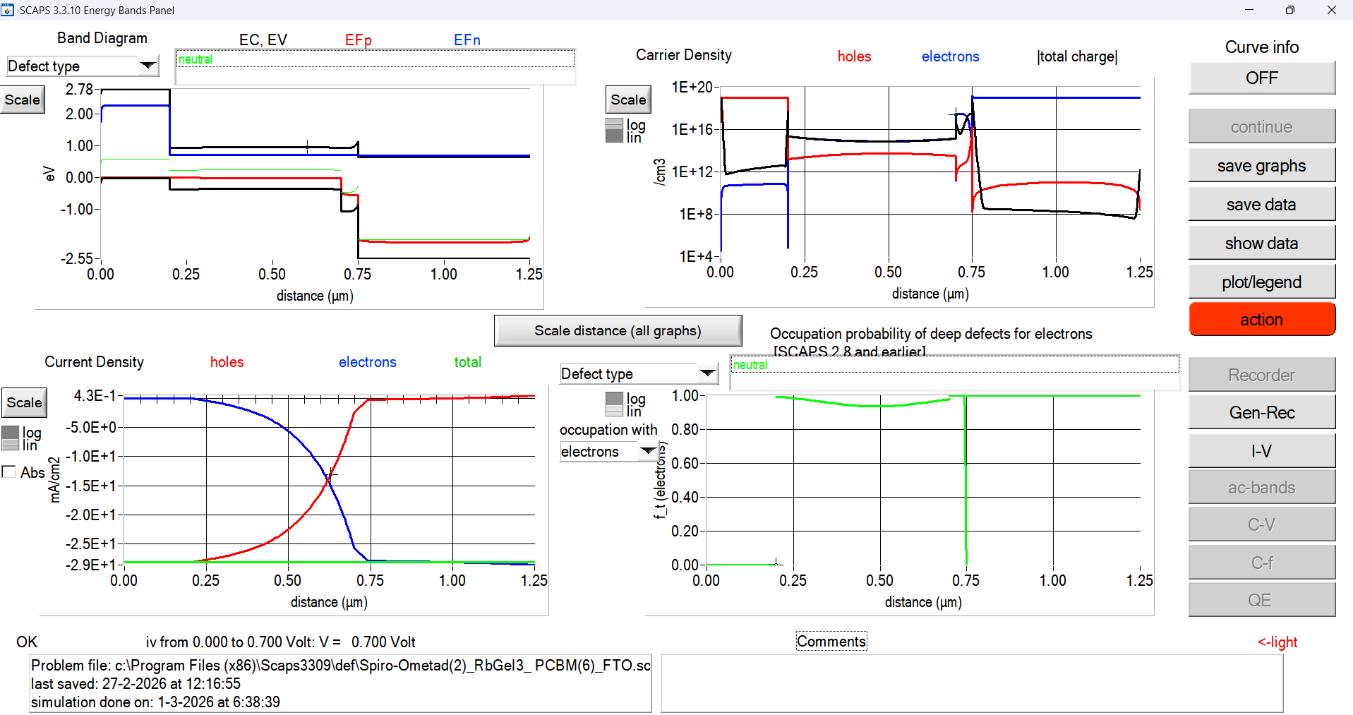
Fig. 1. Graphical user interface of SCAPS-1D (version 3.3.10) used for device simulation in this study.
Although several SCAPS-1D studies of RbGeI₃ devices have been reported, most have optimized only a limited subset of device parameters or investigated a single device configuration. The simulation baseline for RbGeI₃ devices remains modest: Pindolia et al. reported a PCE of 10.11% for the FTO/TiO₂/RbGeI₃/NiO/Ag architecture using SCAPS-1D simulation [14]. The Pindolia study is broader than its shorthand citation in the secondary literature suggests. The paper systematically studied the effect of various HTL and ETL materials, layer thicknesses, doping concentrations, defect densities, back-contact work functions, and operating temperature in a broad multi-parameter sweep [14]. Simulation-based studies have progressively pushed the predicted PCE of RbGeI₃ devices upward, from 10.11% in 2022 to 24.62% in 2024 [22] and 26.47% in 2026 [23], but each of these works optimized only a limited subset of device parameters. The ETL–HTL combinations explored for RbGeI₃ have also been narrow: most studies used TiO₂ as the ETL and either Spiro-OMeTAD, NiO, or CBTS as the HTL, while the TiO₂/CuI combination adopted in this work has received comparatively little attention despite the well-documented advantages of CuI as an HTL.

D. Contributions and paper organization
The present work addresses this gap by performing a SCAPS-1D optimization of an FTO/TiO₂/RbGeI₃/CuI/Au perovskite solar cell. The principal contributions are as follows. First, we screen eight ETL–HTL combinations to identify the FTO/TiO₂/RbGeI₃/CuI/Au architecture as a promising candidate for inorganic-HTL optimization. Second, we perform an eleven-step sequential optimization covering absorber thickness, absorber defect density, dielectric constant, electron affinity, bandgap, conduction- and valence-band effective density of states, ETL and HTL thicknesses, and the two interfacial defect densities. Third, we analyze the quantum-efficiency spectrum and the equilibrium energy-band diagram of the optimized device. Fourth, we benchmark the optimized device against recently reported RbGeI₃-based and related lead-free Ge/Sn-based perovskite solar cells, using primary-source-verified comparator values.
The remainder of the paper is organized as follows. Section II surveys the recent literature and identifies the research gap. Section III describes the device structure, material selection, and the initial parameter set. Section IV presents the methodology, including the SCAPS-1D framework, the performance-parameter definitions, and the sequential optimization procedure. Section V reports the optimization results and discusses the effect of each parameter on the device performance. Section VI compares the optimized device with the prior literature. Section VII discusses limitations and future work, and Section VIII concludes.

II. Literature Review and Research Gap
Over the past five years, SCAPS-1D, often combined with first-principles DFT calculations, has become the workhorse numerical tool for designing and optimizing lead-free perovskite solar cells before experimental fabrication. This section surveys the most relevant recent SCAPS-1D studies on Ge-based and Sn-based absorbers, highlighting the device structure, the photovoltaic performance, and the principal limitation of each work. Table I summarizes these studies. All numerical values listed in Table I have been verified against the primary source literature to avoid citation-integrity issues. In particular, the entries for Pindolia et al. (2022), Loumachi et al. (2024), and Pathak et al. (2026) are quoted verbatim from the corresponding primary sources.
Table I. Summary of recent SCAPS-1D studies on lead-free Ge-based and Sn-based perovskite solar cells.
Study (Year) [Ref.] | Device Structure | PCE (%) | Key Limitation
Pindolia et al. (2022) [14] | FTO/TiO₂/RbGeI₃/NiO/Ag | 10.11 | Broad multi-parameter sweep (HTL, ETL, thickness, doping, defects, back contact, temperature); baseline efficiency remains modest and Ge²⁺ oxidation not addressed.
Saikia et al. (2022) [24] | FTO/TiO₂/CsGeI₃/CuI/Au | 10.80 | No multi-HTL comparative analysis.
Bouazizi et al. (2022) [15] | FTO/PCBM/CsSn₀.₅Ge₀.₅I₃/Spiro/Au | 18.13 | Mixed Ge/Sn absorber; thermal sensitivity.
Loumachi et al. (2024) [22] | ITO/C₆₀/RbGeI₃/CBTS/Ag | 24.62 | Optimized RbGeI₃ thickness and series/shunt resistance; interface defect optimization not addressed.
Raj et al. (2025) [25] | FTO/TiO₂/RbGeI₃/PEDOT:PSS/Au | 18.44 | Organic HTL limits long-term stability.
Pathak et al. (2026) [23] | FTO/TiO₂/RbGeI₃/Spiro-OMeTAD/Au | 26.47 | Ge²⁺ → Ge⁴⁺ oxidation not addressed; only single ETL/HTL combination studied.
Dash et al. (2025) [17] | DFT + SCAPS-1D of RbGeX₃ (X=Cl, Br, I) | 25.76 | Primarily material-level comparison; limited device-architecture optimization.
Several observations emerge from this review. The simulation baseline for RbGeI₃ devices remains modest: Pindolia et al. reported a PCE of 10.11% for the FTO/TiO₂/RbGeI₃/NiO/Ag architecture [14], leaving substantial room for improvement through numerical optimization. As noted above, Pindolia's work is broader than its shorthand citation suggests: the paper systematically studied the effect of various HTL and ETL materials, thicknesses, doping concentrations, defect densities, back-contact work functions, and operating temperature, which is a broader parameter sweep than the single-device summary that frequently appears in citing literature. Simulation-based studies have progressively pushed the predicted PCE of RbGeI₃ devices upward, from 10.11% in 2022 to 24.62% in 2024 [22] and 26.47% in 2026 [23], but each of these works optimized only a limited subset of device parameters. The ETL–HTL combinations explored for RbGeI₃ have also been narrow. Most studies used TiO₂ as the ETL and either Spiro-OMeTAD, NiO, or CBTS as the HTL, while the TiO₂/CuI combination adopted in this work has received comparatively little attention despite the well-documented advantages of CuI as an HTL.
Copper(I) iodide is a wide-gap (Eₙ ≈ 3.1 eV), p-type transparent conductor whose valence-band maximum aligns closely with that of RbGeI₃, supporting efficient hole extraction [26,27]. Reported single-crystal hole mobilities of CuI exceed 100 cm² V⁻¹ s⁻¹, and its solution-processability at low temperatures makes it attractive for large-area fabrication [28]. Despite these advantages, only a small number of SCAPS-1D studies have paired CuI with RbGeI₃ specifically, and none has performed a comprehensive eleven-parameter optimization on this combination. The present work fills this gap by systematically varying eleven device-level parameters on the FTO/TiO₂/RbGeI₃/CuI/Au architecture and reporting the resulting photovoltaic performance.
A further observation from Table I is that the comparator device structures span a range of ETL and HTL materials (TiO₂, PCBM, C₆₀, NiO, CuI, CBTS, Spiro-OMeTAD, PEDOT:PSS) and back-contact metals (Ag, Au). Two structural details deserve explicit clarification to prevent citation-propagation errors. First, the ETL in the Loumachi et al. device [22] is C₆₀ (buckminsterfullerene), frequently rendered “C60” in the literature. The subscript is significant because “C6” refers to a different chemical species. Second, the back contact in the Loumachi et al. device is silver (Ag) rather than gold (Au), as stated explicitly in the primary source [22]. Both details are preserved correctly in the comparator entry above.

III. Device Structure and Material Selection

A. Proposed device architecture
The proposed lead-free perovskite solar cell investigated in this work adopts a conventional n-i-p planar heterojunction architecture with the configuration FTO/TiO₂/RbGeI₃/CuI/Au. The device comprises five functional layers: a fluorine-doped tin oxide (FTO) transparent conducting oxide front electrode, a titanium dioxide (TiO₂) electron transport layer (ETL), a rubidium germanium iodide (RbGeI₃) absorber layer, a copper iodide (CuI) hole transport layer (HTL), and a gold (Au) back contact. This architecture was selected because it provides efficient charge separation, rapid carrier transport, and suitable energy-level alignment while eliminating the environmental and health concerns associated with lead-based perovskite absorbers. The schematic diagram of the proposed device structure is shown in Figure 2. The choice of constituent materials is justified in the remainder of this section, and the initial material parameters used in the SCAPS-1D simulation are summarized in Table II.
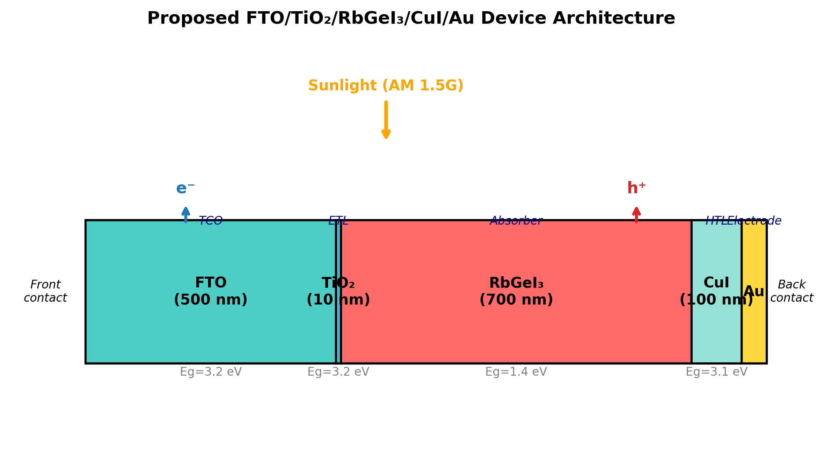
Fig. 2. Schematic diagram of the proposed FTO/TiO₂/RbGeI₃/CuI/Au perovskite solar cell structure, showing the five functional layers and the direction of photogenerated carrier transport under AM 1.5G illumination.

B. Material selection rationale
Fluorine-doped tin oxide (FTO) serves as the front transparent conducting electrode. It possesses high optical transparency in the visible spectrum together with excellent electrical conductivity, allowing incident sunlight to reach the absorber layer while simultaneously collecting the generated electrons with minimal resistive loss [29]. FTO was preferred over alternative transparent conducting oxides (such as indium tin oxide, ITO) for its superior thermal and chemical stability, its compatibility with the TiO₂ ETL deposition process, and its lower cost. The thickness of the FTO layer was fixed at 500 nm, consistent with values commonly reported for perovskite solar cells [30].
Titanium dioxide (TiO₂) was employed as the electron transport layer. The primary function of the ETL is to extract photogenerated electrons from the absorber layer and transport them toward the FTO electrode while effectively blocking holes. TiO₂ is an n-type semiconductor with a wide bandgap of approximately 3.2 eV in its anatase phase, providing excellent transparency throughout the visible region of the solar spectrum. Its conduction-band minimum lies slightly below that of most iodide-based perovskites, providing an energetically favourable pathway for photogenerated electrons to transfer from the absorber into the ETL, while its deep valence band acts as an effective barrier against hole transport [31,32]. Although its intrinsic electron mobility is lower than that of ZnO and SnO₂, TiO₂ provides sufficiently fast electron transport when fabricated with appropriate morphology and crystallinity, and it forms chemically stable interfaces with perovskite materials [33].
Rubidium germanium iodide (RbGeI₃) was selected as the photoactive absorber. Compared with conventional lead-based perovskites, RbGeI₃ offers the important advantage of being environmentally friendly because germanium replaces toxic lead while maintaining desirable optoelectronic properties. RbGeI₃ adopts the ABX₃ perovskite structure with rubidium at the A-site, germanium at the B-site, and iodine at the X-site. Its direct bandgap in the 1.3–1.4 eV range, strong optical absorption coefficient (reported to be comparable to that of MAPbI₃ by first-principles calculations [17,18]), and good thermal stability make it well-suited for single-junction photovoltaic applications. The initial absorber thickness used for device screening was 400 nm, and the bandgap was initially set to 1.31 eV, consistent with values reported in the experimental literature [14]. Both parameters were subsequently optimized (Section V).
Copper iodide (CuI) was selected as the hole transport layer owing to its excellent hole conductivity, high optical transparency, appropriate valence-band alignment with RbGeI₃, and comparatively low fabrication cost [26,27,34]. The HTL facilitates efficient extraction of photogenerated holes from the absorber layer while preventing electron back-transfer toward the rear electrode. CuI is a wide-gap (Eₙ ≈ 3.1 eV) p-type transparent conductor whose valence-band maximum aligns closely with that of RbGeI₃ (giving a near-zero valence-band offset of approximately 0.01 eV as quantified in Section V.N), supporting efficient hole extraction. Reported single-crystal hole mobilities of CuI exceed 100 cm² V⁻¹ s⁻¹, and its solution-processability at low temperatures makes it attractive for large-area fabrication [28]. The initial CuI thickness was set to 100 nm.
Gold (Au) was used as the rear metal contact because of its high work function, excellent electrical conductivity, and superior chemical stability. A high-work-function metal establishes an ohmic contact with the hole transport layer, thereby reducing contact resistance and improving hole collection efficiency [35]. The choice of Au over lower-work-function alternatives such as Ag or Al ensures that the back contact does not introduce a parasitic Schottky barrier at the CuI/Au interface, which would otherwise degrade the fill factor and open-circuit voltage of the device.

C. Initial material parameters
The initial electrical and optical parameters used in the SCAPS-1D simulation of the proposed FTO/TiO₂/RbGeI₃/CuI/Au solar cell are summarized in Table II. These values were collected from previously published experimental and numerical studies on lead-free perovskite solar cells [14,15,16,19,31] and were carefully incorporated into the SCAPS-1D simulator to establish a realistic baseline device before performing further optimization. The interface defect densities applied at the two heterojunctions are listed in Table III. The initial absorber thickness of 400 nm listed in Table II is the value at which all eight device configurations were screened (Section V.A, Table V). This thickness was subsequently optimized to 700 nm in the consolidated final device (Section V.O).
Table II. Initial electrical and optical parameters used in the SCAPS-1D simulation of the proposed FTO/TiO₂/RbGeI₃/CuI/Au solar cell.
Parameter | TiO₂ | FTO | RbGeI₃ | CuI
Thickness (nm) | 30 | 500 | 400 | 100
Bandgap Eₙ (eV) | 3.2 | 3.2 | 1.31 | 3.1
Electron affinity χ (eV) | 4.0 | 4.4 | 3.9 | 2.1
Dielectric permittivity εᵣ | 9 | 9 | 23.01 | 6.5
CB effective DOS Nᴄ (cm⁻³) | 2×10¹⁸ | 2.2×10¹⁸ | 1.4×10¹⁹ | 2.8×10¹⁹
VB effective DOS Nᴠ (cm⁻³) | 1.8×10¹⁹ | 1.8×10¹⁹ | 2.8×10¹⁹ | 1×10¹⁹
Electron mobility μₑ (cm² V⁻¹ s⁻¹) | 20 | 20 | 28.6 | 100
Hole mobility μₚ (cm² V⁻¹ s⁻¹) | 10 | 10 | 27.3 | 43.9
Donor density Nᴅ (cm⁻³) | 9×10¹⁶ | 1×10¹⁹ | 1×10⁹ | 0
Acceptor density Nₐ (cm⁻³) | 0 | 0 | 1×10⁹ | 1×10¹⁸
Bulk defect density Nₜ (cm⁻³) | 1×10¹⁵ | 1×10¹⁴ | 1×10¹⁵ | 1×10¹⁵
Table III. Initial interface defect density applied at each heterojunction.
Interface | Interface defect density Nₜ (cm⁻²)
TiO₂ / RbGeI₃ | 1 × 10¹⁴
RbGeI₃ / CuI | 1 × 10¹⁴

IV. Methodology

A. SCAPS-1D simulation framework
The photovoltaic performance of the proposed lead-free perovskite solar cell was investigated using the Solar Cell Capacitance Simulator in One Dimension (SCAPS-1D), version 3.3.10 [19,20,21]. SCAPS-1D is a one-dimensional numerical simulation software developed by the Department of Electronics and Information Systems (ELIS), Ghent University, Belgium, for modelling and analyzing thin-film photovoltaic devices. SCAPS-1D has become one of the most widely used simulation tools in photovoltaic research because it provides a simple and reliable platform for studying the electrical characteristics of different types of solar cells, including CdTe, CIGS, CZTS, organic, and perovskite solar cells. Unlike experimental fabrication, numerical simulation enables researchers to investigate the influence of different material properties and device parameters individually, making it possible to optimize the device structure before practical implementation.
The simulator solves the fundamental semiconductor transport equations self-consistently throughout the device structure. These equations include the Poisson equation, the electron continuity equation, and the hole continuity equation, which describe the electrostatic potential, carrier generation, carrier transport, and recombination mechanisms inside the solar cell. The Poisson equation determines the electrostatic potential distribution inside the device and is expressed as
∇·(ε ∇ψ) = −q (n − p + Nᴅ − Nₐ + ρₜ), (1)
where ε is the dielectric permittivity, ψ is the electrostatic potential, q is the elementary charge, n and p represent the electron and hole concentrations, Nᴅ and Nₐ denote the donor and acceptor concentrations, respectively, and ρₜ represents the trapped charge density. The transport of electrons inside the device is governed by the electron continuity equation,
∂n/∂t = (1/q) ∇·Jₙ + G − R, (2)
where Jₙ is the electron current density, G is the carrier generation rate, and R is the carrier recombination rate. Similarly, the hole transport is described by the hole continuity equation,
∂p/∂t = −(1/q) ∇·Jₚ + G − R, (3)
where Jₚ is the hole current density. Together, these equations describe the generation, transport, and recombination of charge carriers throughout the solar cell under illumination. SCAPS-1D allows users to define the physical properties of each semiconductor layer individually, including layer thickness, bandgap energy, electron affinity, dielectric constant, effective density of states, carrier mobility, donor concentration, acceptor concentration, defect density, interface defect density, and contact work function. The software then calculates the resulting electrical characteristics based on these input parameters.

B. Simulation conditions
All numerical simulations were performed under identical operating conditions using the SCAPS-1D simulation software. Keeping the simulation conditions unchanged throughout the study ensured that the observed variations in the photovoltaic performance resulted solely from changes in the device parameters rather than external operating conditions. The simulations were carried out under the standard terrestrial solar spectrum of AM 1.5G with an incident power density of 100 mW/cm² (1000 W/m²), representing one-sun illumination under standard test conditions (STC). The operating temperature was fixed at 300 K (27 °C) throughout the simulation. Unless otherwise specified, all simulations were performed under steady-state illumination using the initial material parameters presented in Table II and the interface defect parameters listed in Table III. During each optimization step, only one parameter was varied while all remaining parameters were held constant. The general simulation conditions are summarized in Table IV.
Table IV. Simulation conditions used in SCAPS-1D.
Parameter | Value
Simulation software | SCAPS-1D version 3.3.10
Illumination spectrum | AM 1.5G
Incident power density | 100 mW/cm² (1000 W/m²)
Operating temperature | 300 K (27 °C)
Illumination intensity | 1 Sun
Scan mode | Illuminated J–V
Device type | Planar heterojunction
Front contact | FTO
Back contact | Au
Initial material parameters | Table II
Initial interface defect density | Table III

C. Performance parameters
The photovoltaic performance of the proposed perovskite solar cell was evaluated using four key parameters obtained from the current density–voltage (J–V) characteristics generated by SCAPS-1D. These parameters are the open-circuit voltage (Vₒᴄ), short-circuit current density (Jₛᴄ), fill factor (FF), and power conversion efficiency (PCE).
The open-circuit voltage (Vₒᴄ) is the maximum voltage produced by a solar cell when no external load is connected and the output current is zero. It reflects the maximum electrical potential generated by the separation of photogenerated charge carriers. A higher Vₒᴄ generally indicates lower carrier recombination and better device quality. The short-circuit current density (Jₛᴄ) is the current density produced when the voltage across the solar cell is zero. It primarily depends on the light absorption capability of the absorber layer, the carrier generation rate, the charge-transport efficiency, and the collection efficiency. Higher Jₛᴄ values indicate more effective conversion of incident photons into electrical current.
The fill factor (FF) is a measure of the quality of the solar cell and indicates how closely the actual maximum power approaches the theoretical maximum power. It is defined as the ratio of the maximum obtainable output power to the product of the open-circuit voltage and the short-circuit current density, given by
FF = (Vₜₚ × Jₜₚ) / (Vₒᴄ × Jₛᴄ), (4)
where Vₜₚ and Jₜₚ are the voltage and current density at the maximum power point, respectively. The power conversion efficiency (PCE) represents the fraction of incident solar power converted into electrical power and is defined as
PCE = (Vₒᴄ × Jₛᴄ × FF) / Pᵢₙ, (5)
where Pᵢₙ is the incident optical power density (100 mW/cm² under AM 1.5G). In Eq. (5), FF must be expressed as a dimensionless fraction in the range 0–1 (i.e., FF = 0.7913, not FF = 79.13%). The resulting PCE is then multiplied by 100% if a percentage value is desired. This convention is consistent throughout the present manuscript: FF is reported as a percentage in the tables for readability, but is converted to a fraction before substitution into Eq. (5). The four parameters Vₒᴄ, Jₛᴄ, FF, and PCE were tracked throughout the optimization process and used to compare the proposed device with previously reported RbGeI₃ and related lead-free perovskite solar cells.

D. Sequential optimization procedure
After constructing the initial device, a systematic optimization procedure was carried out by varying one parameter at a time while keeping all remaining parameters constant. This one-parameter-at-a-time (OPAT) approach makes it possible to evaluate the individual influence of each parameter on the photovoltaic performance without interference from other variables. The optimized value obtained from each simulation step was then used as the input for the subsequent optimization process. The sequential optimization procedure adopted in this study is illustrated in Figure 3, and the overall research methodology is summarized in Figure 4.
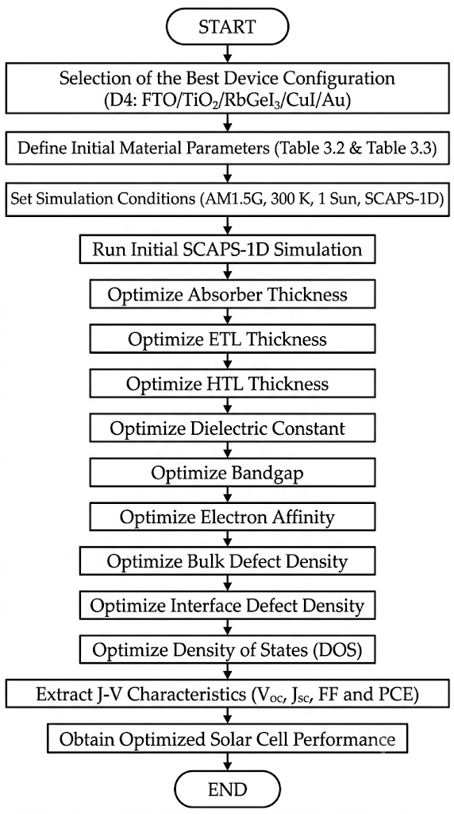
Fig. 3. Sequential optimization procedure adopted in this study using the SCAPS-1D simulation software. Each step's locally optimal value is carried forward to the next step.
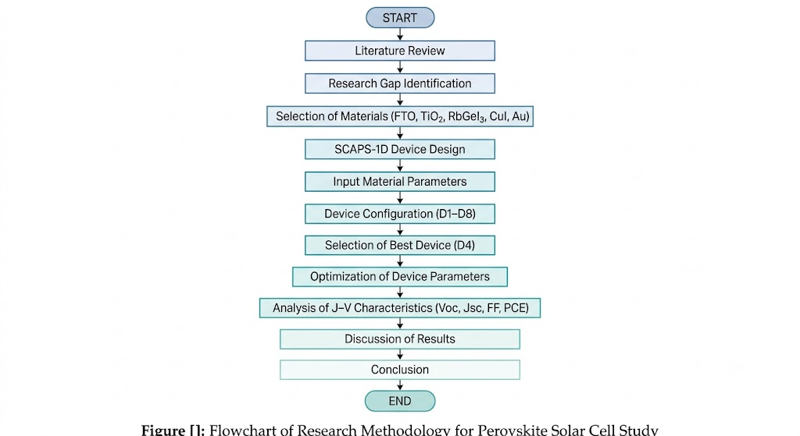
Fig. 4. Overall research methodology adopted in the present study, from literature review through device screening to sequential parameter optimization and final benchmarking.
The procedure comprises eleven optimization steps: (1) absorber thickness (0.3–1.0 µm); (2) absorber bulk defect density (10¹²–10¹⁸ cm⁻³); (3) absorber dielectric constant (15–23.1); (4) absorber electron affinity (3.9–4.2 eV); (5) TiO₂/RbGeI₃ interfacial defect density (10¹²–10¹⁸ cm⁻²); (6) RbGeI₃/CuI interfacial defect density (10¹²–10¹⁸ cm⁻²); (7) absorber bandgap (1.3–1.7 eV); (8) TiO₂ ETL thickness (0.01–0.09 µm); (9) CuI HTL thickness (0.1–1.9 µm); (10) conduction-band effective density of states Nᴄ (1×10¹⁷–1×10²⁰ cm⁻³); (11) valence-band effective density of states Nᴠ (1×10¹⁷–1×10²⁰ cm⁻³). Each step's locally optimal parameter value was carried forward into all subsequent steps, with the consolidated final parameter set summarized in Table XIX.
A methodological subtlety of the OPAT approach deserves emphasis. Because each per-step optimum is identified while all other parameters are held at their respective prior-step values, the final consolidated device can exhibit parameter interactions that shift individual performance metrics relative to the per-step optima. For example, several individual steps (Tables IX and XII in Section V) report local FF values above 83% at the parameter values ultimately carried into the final device, while the consolidated final device reports FF = 79.13%. This reduction reflects the combined effect of the consolidated parameter set rather than an arithmetic inconsistency. The final FF is the SCAPS-1D output obtained when all eleven optimized parameters are applied simultaneously, which differs from the FF obtained at any single per-step optimum. A transparent acknowledgment of this OPAT limitation, including the bandgap-related Jsc discrepancy discussed in Section V.H, is provided in Section VII.A.

E. Device configurations screened
To determine the most suitable device architecture, eight different planar heterojunction configurations were designed and simulated using SCAPS-1D. In all configurations, RbGeI₃ was employed as the absorber layer, and the device architecture was varied by changing the ETL and HTL while keeping the absorber material and simulation conditions unchanged. For the ETL, TiO₂ and PCBM were selected because of their favourable energy-band alignment and widespread use in perovskite solar cells. Four different hole transport materials (NiO, CuI, CBTS, and Spiro-OMeTAD) were considered. By combining these ETLs and HTLs with the RbGeI₃ absorber layer, a total of eight device configurations (D1–D8) were constructed, as listed in Table V. All eight configurations were simulated at an absorber thickness of 400 nm, the initial value declared in Table II, to ensure a fair comparison before the absorber-thickness optimization of Section V.B.
Table V. Eight device configurations screened in this study. All configurations were simulated at an absorber thickness of 400 nm.
Device | Architecture
D1 | FTO / PCBM / RbGeI₃ / NiO / Au
D2 | FTO / TiO₂ / RbGeI₃ / NiO / Au
D3 | FTO / PCBM / RbGeI₃ / CuI / Au
D4 ★ | FTO / TiO₂ / RbGeI₃ / CuI / Au
D5 | FTO / PCBM / RbGeI₃ / CBTS / Au
D6 | FTO / TiO₂ / RbGeI₃ / CBTS / Au
D7 | FTO / PCBM / RbGeI₃ / Spiro-OMeTAD / Au
D8 | FTO / TiO₂ / RbGeI₃ / Spiro-OMeTAD / Au

V. Results and Discussion

A. Screening of device configurations
Eight planar heterojunction configurations were constructed by combining the two ETL candidates (TiO₂ and PCBM) with four HTL candidates (NiO, CuI, CBTS, and Spiro-OMeTAD), all sharing the same RbGeI₃ absorber at the initial 400 nm thickness. The eight devices (D1–D8) were simulated under identical conditions, and the resulting photovoltaic parameters are summarized in Table VI. Device D4, corresponding to the FTO/TiO₂/RbGeI₃/CuI/Au architecture, achieved an initial PCE of 19.79%, with Vₒᴄ = 0.812 V, Jₛᴄ = 30.46 mA/cm², and FF = 79.98%. Although this was not the highest PCE among the eight candidates (D2 achieved 21.08% and D8 achieved 21.00%), D4 was selected as the baseline for all subsequent optimization on the grounds of long-term stability, fabrication cost, and hole-mobility advantages of the inorganic CuI HTL over the organic Spiro-OMeTAD and the moisture-sensitive NiO. The PCE penalty incurred by selecting D4 over D2 or D8 (approximately 1.3 percentage points) was judged recoverable through subsequent parameter optimization, whereas the stability and cost advantages of CuI are structural and cannot be recovered by parameter tuning.
The advantage of the D4 architecture can be traced to two factors that favour efficient charge extraction. First, the favourable conduction-band alignment between TiO₂ (χ = 4.0 eV) and RbGeI₃ (χ = 3.9 eV) produces only a small conduction-band offset (≈0.10 eV), which supports efficient electron extraction without introducing a significant barrier. Second, the small valence-band offset between RbGeI₃ and CuI (ΔEᵥ ≈ 0.01 eV) allows holes to be extracted with minimal resistance, while the large conduction-band offset at the same interface (ΔEᴄ ≈ 1.8 eV) acts as an effective electron-blocking barrier. Together, these two features suppress interfacial recombination. The lower initial FF of D4 relative to D7 and D8 (which use Spiro-OMeTAD) is attributable to the lower built-in potential of the CuI/RbGeI₃ junction at the unoptimized parameter set, and is recoverable through the subsequent Nᴠ optimization reported in Section V.L.
Table VI. Initial photovoltaic performance of the eight screened device configurations, simulated at an absorber thickness of 400 nm. ★ Selected as the baseline for full parametric optimization.
Dev. | Architecture | Vₒᴄ (V) | Jₛᴄ (mA/cm²) | FF (%) | PCE (%)
D1 | FTO/PCBM/RbGeI₃/NiO/Au | 0.81 | 30.10 | 83.68 | 20.52
D2 | FTO/TiO₂/RbGeI₃/NiO/Au | 0.82 | 30.46 | 84.48 | 21.08
D3 | FTO/PCBM/RbGeI₃/CuI/Au | 0.81 | 30.10 | 83.96 | 20.55
D4 ★ | FTO/TiO₂/RbGeI₃/CuI/Au | 0.812 | 30.46 | 79.98 | 19.79
D5 | FTO/PCBM/RbGeI₃/CBTS/Au | 0.82 | 30.20 | 82.36 | 20.30
D6 | FTO/TiO₂/RbGeI₃/CBTS/Au | 0.82 | 30.55 | 82.13 | 20.68
D7 | FTO/PCBM/RbGeI₃/Spiro/Au | 0.81 | 30.07 | 85.01 | 20.77
D8 | FTO/TiO₂/RbGeI₃/Spiro/Au | 0.82 | 30.46 | 83.95 | 21.00
Although D4 does not exhibit the highest FF among the eight configurations (D7 with Spiro-OMeTAD achieves FF = 85.01%) and does not exhibit the highest PCE (D2 achieves 21.08%), the TiO₂/CuI combination was selected because CuI offers superior long-term stability, lower fabrication cost, and higher hole mobility compared with the organic Spiro-OMeTAD HTL and with NiO, which is sensitive to moisture and oxygen. The PCE gap between D4 and the highest-performing configurations is approximately 1.3 percentage points, which is recoverable through subsequent parameter optimization. The stability and cost advantages of CuI, by contrast, are structural and cannot be recovered by parameter tuning.

B. Effect of absorber layer thickness
The thickness of the absorber layer is one of the most influential parameters affecting the performance of a perovskite solar cell because it determines the amount of incident light absorbed and the number of photogenerated charge carriers. An increase in absorber thickness generally enhances light absorption and increases Jₛᴄ. However, an excessively thick absorber layer may increase carrier recombination and series resistance, thereby reducing the overall device performance. In this study, the thickness of the RbGeI₃ absorber layer was varied from 0.3 to 1.0 µm while keeping all other device parameters constant. The results are summarized in Table VII and Figure 5.
The PCE increases rapidly with absorber thickness from 0.3 µm to 0.7 µm, reaching a maximum of approximately 20.70% at 0.7 µm. Beyond 0.7 µm, PCE decreases slightly, attributed to increased carrier recombination within the thicker absorber layer. The short-circuit current density Jₛᴄ increases continuously with absorber thickness due to enhanced light absorption, rising from 28.14 mA/cm² at 0.3 µm to 34.11 mA/cm² at 1.0 µm. Both Vₒᴄ and FF gradually decrease as the absorber thickness increases from 0.3 µm to 1.0 µm, owing to increased recombination losses and series resistance. The optimum absorber thickness of 0.7 µm (700 nm) was therefore adopted for the final device, as it provides the best compromise between photocurrent generation and recombination losses.
Table VII. Variation of PCE, Vₒᴄ, Jₛᴄ, and FF with RbGeI₃ absorber thickness.
Absorber thickness (µm) | PCE (%) | Vₒᴄ (V) | Jₛᴄ (mA/cm²) | FF (%)
0.3 | 18.57 | 0.823 | 28.14 | 80.18
0.4 | 19.79 | 0.812 | 30.46 | 79.98
0.5 | 20.38 | 0.803 | 31.84 | 79.76
0.6 | 20.62 | 0.794 | 32.70 | 79.41
0.7 ★ | 20.70 | 0.786 | 33.27 | 79.15
0.8 | 20.65 | 0.779 | 33.65 | 78.75
0.9 | 20.57 | 0.773 | 33.91 | 78.48
1.0 | 20.46 | 0.767 | 34.11 | 78.20
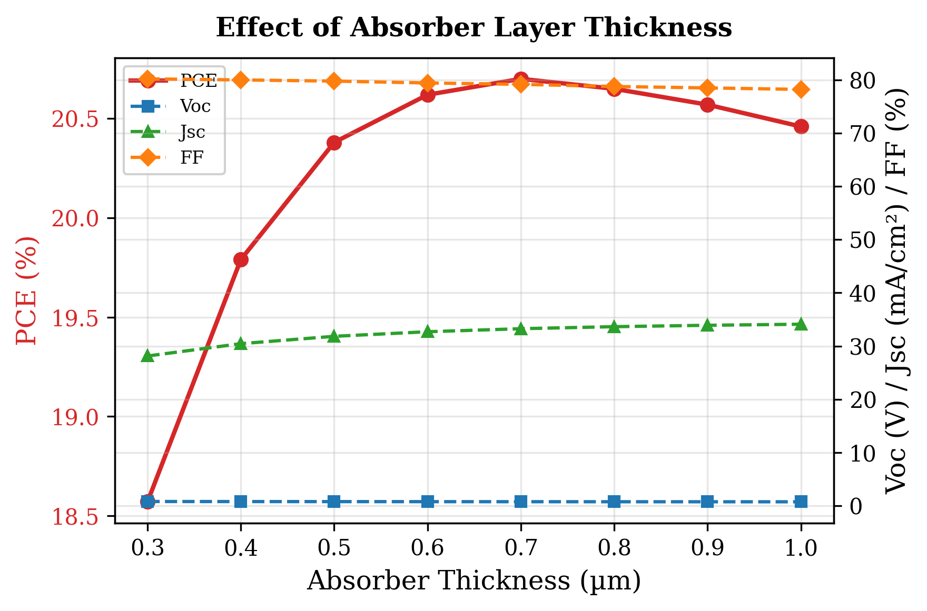
Fig. 5. Variation of PCE, Vₒᴄ, Jₛᴄ, and FF with RbGeI₃ absorber thickness. PCE peaks at 0.7 µm, beyond which recombination losses reduce efficiency.

C. Effect of absorber defect density
The defect density of the absorber layer plays an important role in determining the performance of photovoltaic solar cells because bulk defects act as Shockley–Read–Hall (SRH) recombination centres that shorten carrier lifetime and reduce charge collection efficiency. To investigate its effect, the defect density of the RbGeI₃ absorber layer was varied from 10¹² cm⁻³ to 10¹⁸ cm⁻³ while keeping all other parameters constant. The variations in PCE, Vₒᴄ, Jₛᴄ, and FF are summarized in Table VIII and Figure 6.
The device performance is essentially insensitive to defect density below 10¹⁴ cm⁻³, with PCE remaining around 20.5%. Above 10¹⁴ cm⁻³, performance degrades rapidly: PCE drops from 19.79% at 10¹⁵ cm⁻³ to 7.58% at 10¹⁸ cm⁻³, while Vₒᴄ decreases from 0.812 V to 0.550 V. Jₛᴄ also declines from 30.46 mA/cm² to 26.61 mA/cm², and FF falls from 79.98% to 51.79%. This degradation occurs because higher defect densities introduce more trap states within the absorber, increasing non-radiative recombination and reducing carrier collection efficiency. Although the lowest defect density (10¹² cm⁻³) gives marginally the best performance, a value of 10¹⁴ cm⁻³ was selected for the final device as a realistic target for experimental realization, since lower defect densities are difficult to achieve consistently in RbGeI₃ films where Ge²⁺ oxidation introduces unavoidable deep defect states.
Table VIII. Variation of PCE, Vₒᴄ, Jₛᴄ, and FF with RbGeI₃ absorber defect density.
RbGeI₃ defect density (cm⁻³) | PCE (%) | Vₒᴄ (V) | Jₛᴄ (mA/cm²) | FF (%)
10¹² | 20.51 | 0.856 | 30.46 | 78.62
10¹³ | 20.50 | 0.855 | 30.46 | 78.66
10¹⁴ ★ | 20.40 | 0.848 | 30.46 | 78.97
10¹⁵ | 19.79 | 0.812 | 30.46 | 79.98
10¹⁶ | 17.86 | 0.751 | 30.42 | 78.15
10¹⁷ | 13.78 | 0.676 | 30.03 | 67.87
10¹⁸ | 7.58 | 0.550 | 26.61 | 51.79
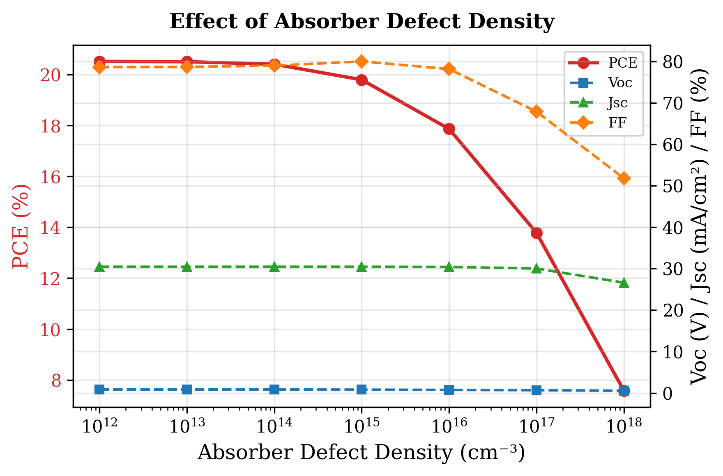
Fig. 6. Variation of PCE, Vₒᴄ, Jₛᴄ, and FF with RbGeI₃ absorber defect density. Performance degrades sharply above 10¹⁴ cm⁻³.

D. Effect of absorber dielectric constant
The dielectric constant of the absorber influences the electrostatic properties, charge carrier interactions, and recombination behaviour within the device. A higher dielectric constant generally screens Coulomb interactions between charged defects and carriers, potentially reducing trap-assisted recombination, but it can also modify the built-in electric field and shift the quasi-Fermi-level splitting. To evaluate its influence, the dielectric constant was varied from 15 to 23.1 while keeping all other parameters unchanged. The obtained photovoltaic parameters are presented in Table IX and Figure 7.
Increasing the dielectric constant caused only a marginal reduction in overall device performance. PCE gradually decreased from 19.92% at εᵣ = 15 to 19.79% at εᵣ = 23.1. A similar trend was observed for Vₒᴄ, which decreased marginally from 0.819 V to 0.812 V. The fill factor FF showed a very small improvement, increasing from 79.87% to 79.98% as εᵣ increased. Jₛᴄ remained essentially unchanged throughout the investigated range, fluctuating only around 30.46 mA/cm². The decrease in PCE is mainly attributable to the reduction in Vₒᴄ, since the variations in Jₛᴄ and FF were negligible. Although the effect is small, the results indicate that a lower dielectric constant is slightly more favourable. A dielectric constant of 15 was therefore adopted for the final device.
Table IX. Variation of PCE, Vₒᴄ, Jₛᴄ, and FF with RbGeI₃ absorber dielectric constant.
Dielectric constant εᵣ | PCE (%) | Vₒᴄ (V) | Jₛᴄ (mA/cm²) | FF (%)
15 ★ | 19.92 | 0.819 | 30.46 | 79.87
16 | 19.90 | 0.818 | 30.46 | 79.87
17 | 19.88 | 0.817 | 30.46 | 79.88
18 | 19.86 | 0.816 | 30.46 | 79.89
19 | 19.85 | 0.815 | 30.46 | 79.91
20 | 19.83 | 0.815 | 30.46 | 79.92
21 | 19.82 | 0.814 | 30.46 | 79.94
22 | 19.80 | 0.813 | 30.46 | 79.96
23 | 19.79 | 0.812 | 30.46 | 79.98
23.1 | 19.79 | 0.812 | 30.46 | 79.98
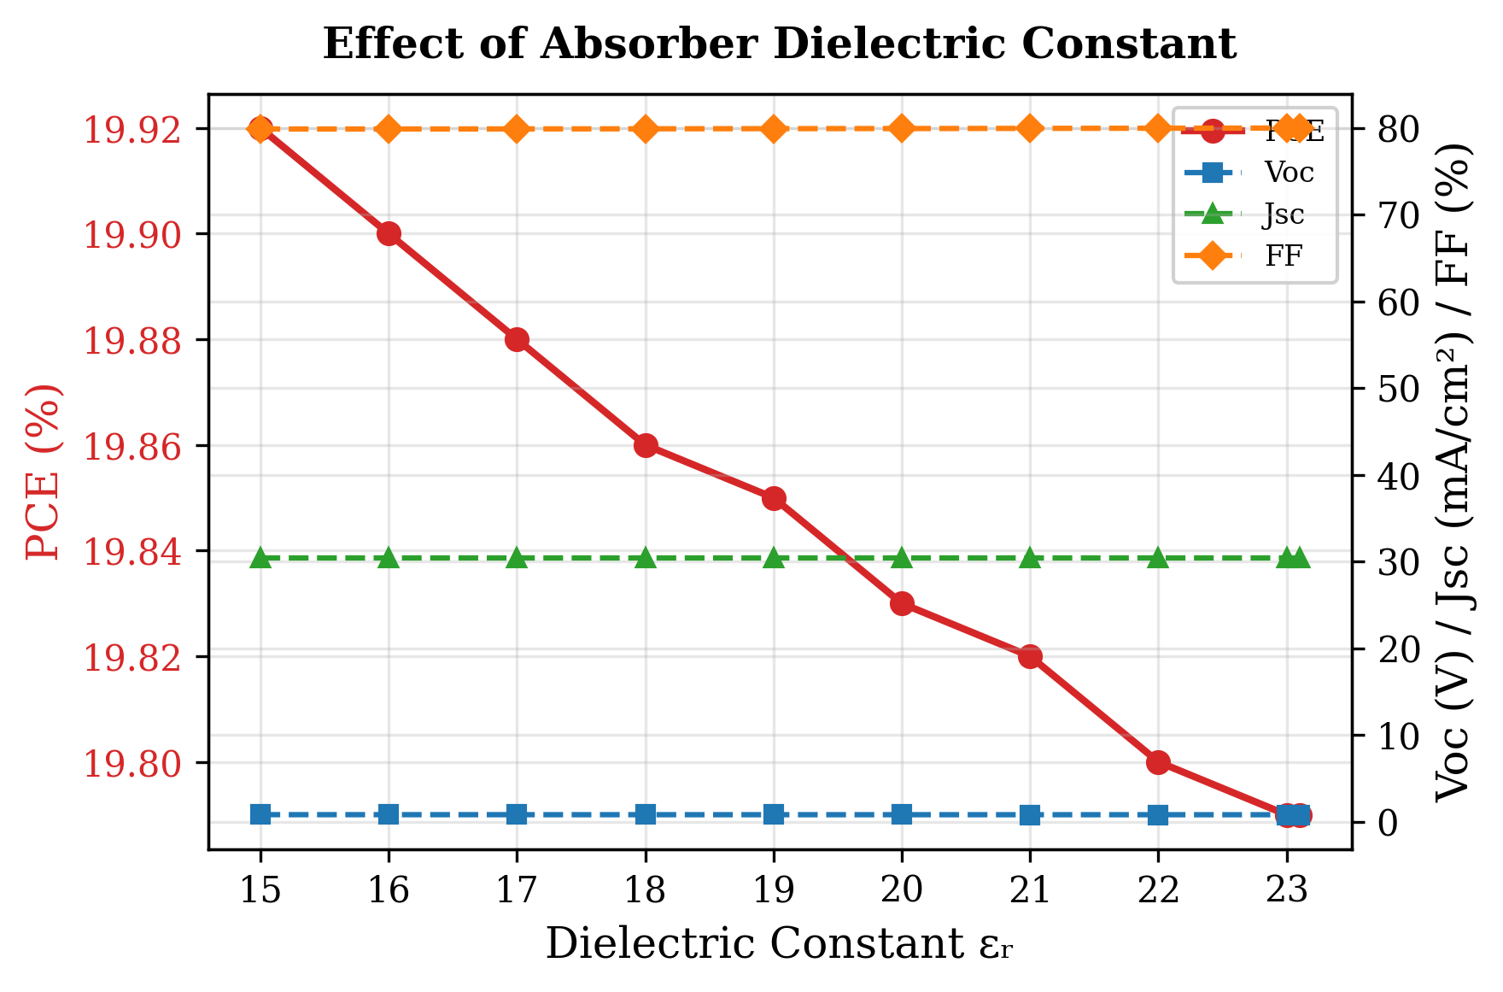
Fig. 7. Variation of PCE, Vₒᴄ, Jₛᴄ, and FF with RbGeI₃ absorber dielectric constant. Lower dielectric constants yield marginally better performance.

E. Effect of absorber electron affinity
The electron affinity of the absorber layer directly affects the energy-band alignment between adjacent layers and consequently influences charge-carrier extraction. To investigate its effect, the electron affinity of the RbGeI₃ absorber was varied from 3.9 eV to 4.2 eV while keeping all other parameters constant. The obtained results are presented in Table X and Figure 8.
The device performance is highly sensitive to changes in electron affinity. The highest PCE of 19.79% was achieved at an electron affinity of 3.9 eV. When the electron affinity was increased from 3.9 eV to 4.2 eV, the PCE decreased to 17.81%. The reduction in efficiency is mainly attributed to the significant decrease in Vₒᴄ, which dropped from 0.812 V at 3.9 eV to 0.710 V at 4.2 eV. In contrast, Jₛᴄ remained almost constant at approximately 30.46 mA/cm² throughout the investigated range, indicating that the variation in electron affinity has a negligible effect on photon absorption and charge generation. Although the fill factor FF increased from 79.98% to 82.33% with increasing electron affinity, this improvement was insufficient to compensate for the substantial loss in Vₒᴄ. An electron affinity of 3.9 eV was therefore adopted for the final device.
Table X. Variation of PCE, Vₒᴄ, Jₛᴄ, and FF with RbGeI₃ absorber electron affinity.
Electron affinity χ (eV) | PCE (%) | Vₒᴄ (V) | Jₛᴄ (mA/cm²) | FF (%)
3.9 ★ | 19.79 | 0.812 | 30.46 | 79.98
4.0 | 19.11 | 0.800 | 30.46 | 78.47
4.1 | 19.20 | 0.780 | 30.46 | 80.79
4.2 | 17.81 | 0.710 | 30.46 | 82.33
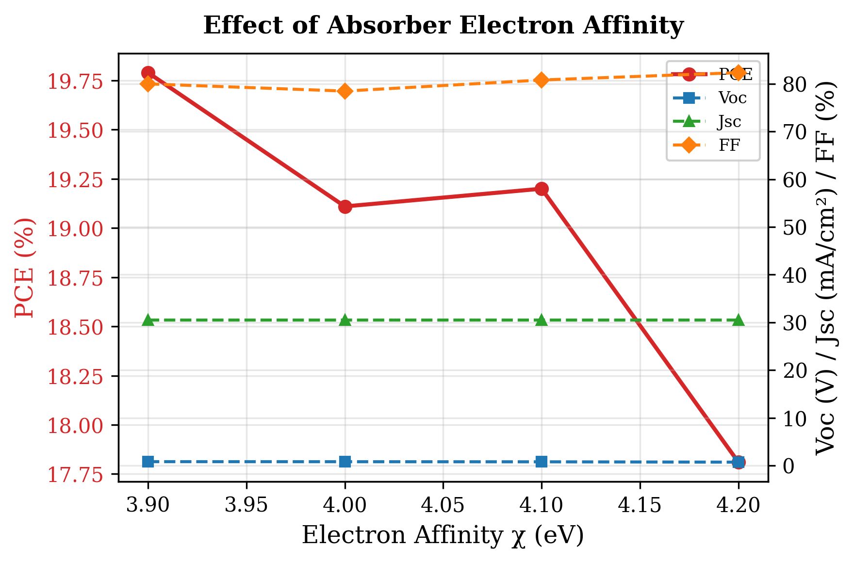
Fig. 8. Variation of PCE, Vₒᴄ, Jₛᴄ, and FF with RbGeI₃ absorber electron affinity. PCE is highest at χ = 3.9 eV due to optimal band alignment with TiO₂.

F. Effect of TiO₂/RbGeI₃ interfacial defect density
The defect density at the absorber/ETL interface is an important factor affecting charge-carrier transport and recombination in perovskite solar cells. To investigate its impact, the TiO₂/RbGeI₃ interfacial defect density was varied from 10¹² cm⁻² to 10¹⁸ cm⁻² while keeping all other parameters constant. The corresponding photovoltaic parameters are presented in Table XI and Figure 9. Device performance decreases significantly with increasing interfacial defect density: PCE drops from 21.04% at 10¹² cm⁻² to 8.40% at 10¹⁸ cm⁻², Vₒᴄ drops from 0.827 V to 0.439 V, Jₛᴄ decreases from 30.46 to 28.09 mA/cm², and FF reduces from 83.52% to 68.11%.
This degradation occurs because interfacial defects act as recombination centres where photogenerated electrons and holes recombine before being collected at the electrodes. As the defect density increases, carrier recombination becomes more severe, resulting in lower Vₒᴄ, Jₛᴄ, and FF. Although 10¹² cm⁻² yields the best performance, a value of 10¹⁴ cm⁻² was selected for the final device as a realistic target for experimental realization, since achieving interface defect densities below 10¹⁴ cm⁻² consistently in RbGeI₃ devices is challenging owing to Ge²⁺ oxidation and moisture sensitivity during film preparation. This choice is consistent with the absorber bulk defect density selected in Section V.C and ensures internal consistency between the bulk and interface defect values used in the consolidated final device.
Table XI. Variation of PCE, Vₒᴄ, Jₛᴄ, and FF with TiO₂/RbGeI₃ interfacial defect density.
TiO₂/RbGeI₃ defect density (cm⁻²) | PCE (%) | Vₒᴄ (V) | Jₛᴄ (mA/cm²) | FF (%)
10¹² | 21.04 | 0.827 | 30.46 | 83.52
10¹³ | 20.91 | 0.826 | 30.46 | 83.14
10¹⁴ ★ | 19.79 | 0.812 | 30.46 | 79.98
10¹⁵ | 15.81 | 0.745 | 30.45 | 69.70
10¹⁶ | 12.74 | 0.584 | 30.39 | 71.73
10¹⁷ | 10.24 | 0.477 | 29.86 | 71.91
10¹⁸ | 8.40 | 0.439 | 28.09 | 68.11
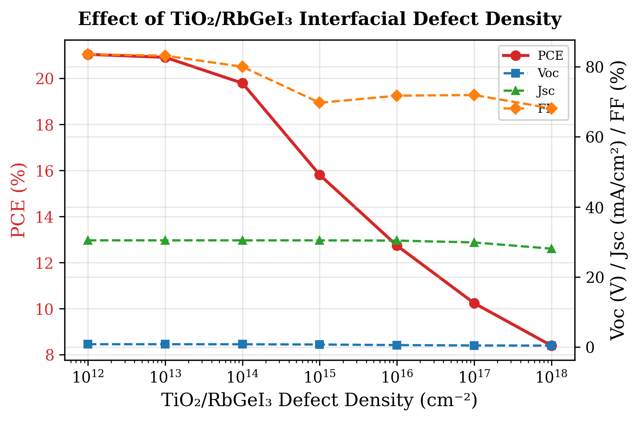
Fig. 9. Variation of PCE, Vₒᴄ, Jₛᴄ, and FF with TiO₂/RbGeI₃ interfacial defect density. Performance degrades sharply above 10¹⁴ cm⁻².

G. Effect of RbGeI₃/CuI interfacial defect density
The HTL/absorber interface plays an important role in charge-carrier extraction and transport in perovskite solar cells. To evaluate its impact, the interfacial defect density between CuI and RbGeI₃ was varied from 10¹² cm⁻² to 10¹⁸ cm⁻² while keeping all other parameters unchanged. The obtained photovoltaic parameters are shown in Table XII and Figure 10. In stark contrast to the TiO₂/RbGeI₃ interface, the device performance remains almost unchanged up to an interfacial defect density of 10¹⁵ cm⁻², indicating that the CuI/RbGeI₃ interface is significantly more tolerant to defects. This tolerance is attributable to the near-zero valence-band offset at this interface, which provides a smooth energetic pathway for hole extraction that is relatively insensitive to moderate defect densities.
At higher defect densities, PCE decreases from 19.79% at 10¹² cm⁻² to 18.19% at 10¹⁸ cm⁻², Vₒᴄ decreases from 0.812 V to 0.746 V, and Jₛᴄ reduces slightly from 30.46 to 30.33 mA/cm². FF increases initially and reaches a maximum of 81.11% at 10¹⁷ cm⁻² before decreasing slightly at 10¹⁸ cm⁻². As with the TiO₂/RbGeI₃ interface, a value of 10¹⁴ cm⁻² was selected for the final device, ensuring internal consistency with the absorber/ETL interface and providing a realistic experimental target.
Table XII. Variation of PCE, Vₒᴄ, Jₛᴄ, and FF with CuI/RbGeI₃ interfacial defect density.
CuI/RbGeI₃ defect density (cm⁻²) | PCE (%) | Vₒᴄ (V) | Jₛᴄ (mA/cm²) | FF (%)
10¹² | 19.79 | 0.812 | 30.46 | 79.97
10¹³ | 19.79 | 0.812 | 30.46 | 79.97
10¹⁴ ★ | 19.79 | 0.812 | 30.46 | 79.98
10¹⁵ | 19.78 | 0.811 | 30.46 | 80.04
10¹⁶ | 19.69 | 0.803 | 30.46 | 80.45
10¹⁷ | 19.14 | 0.775 | 30.43 | 81.11
10¹⁸ | 18.19 | 0.746 | 30.33 | 80.39
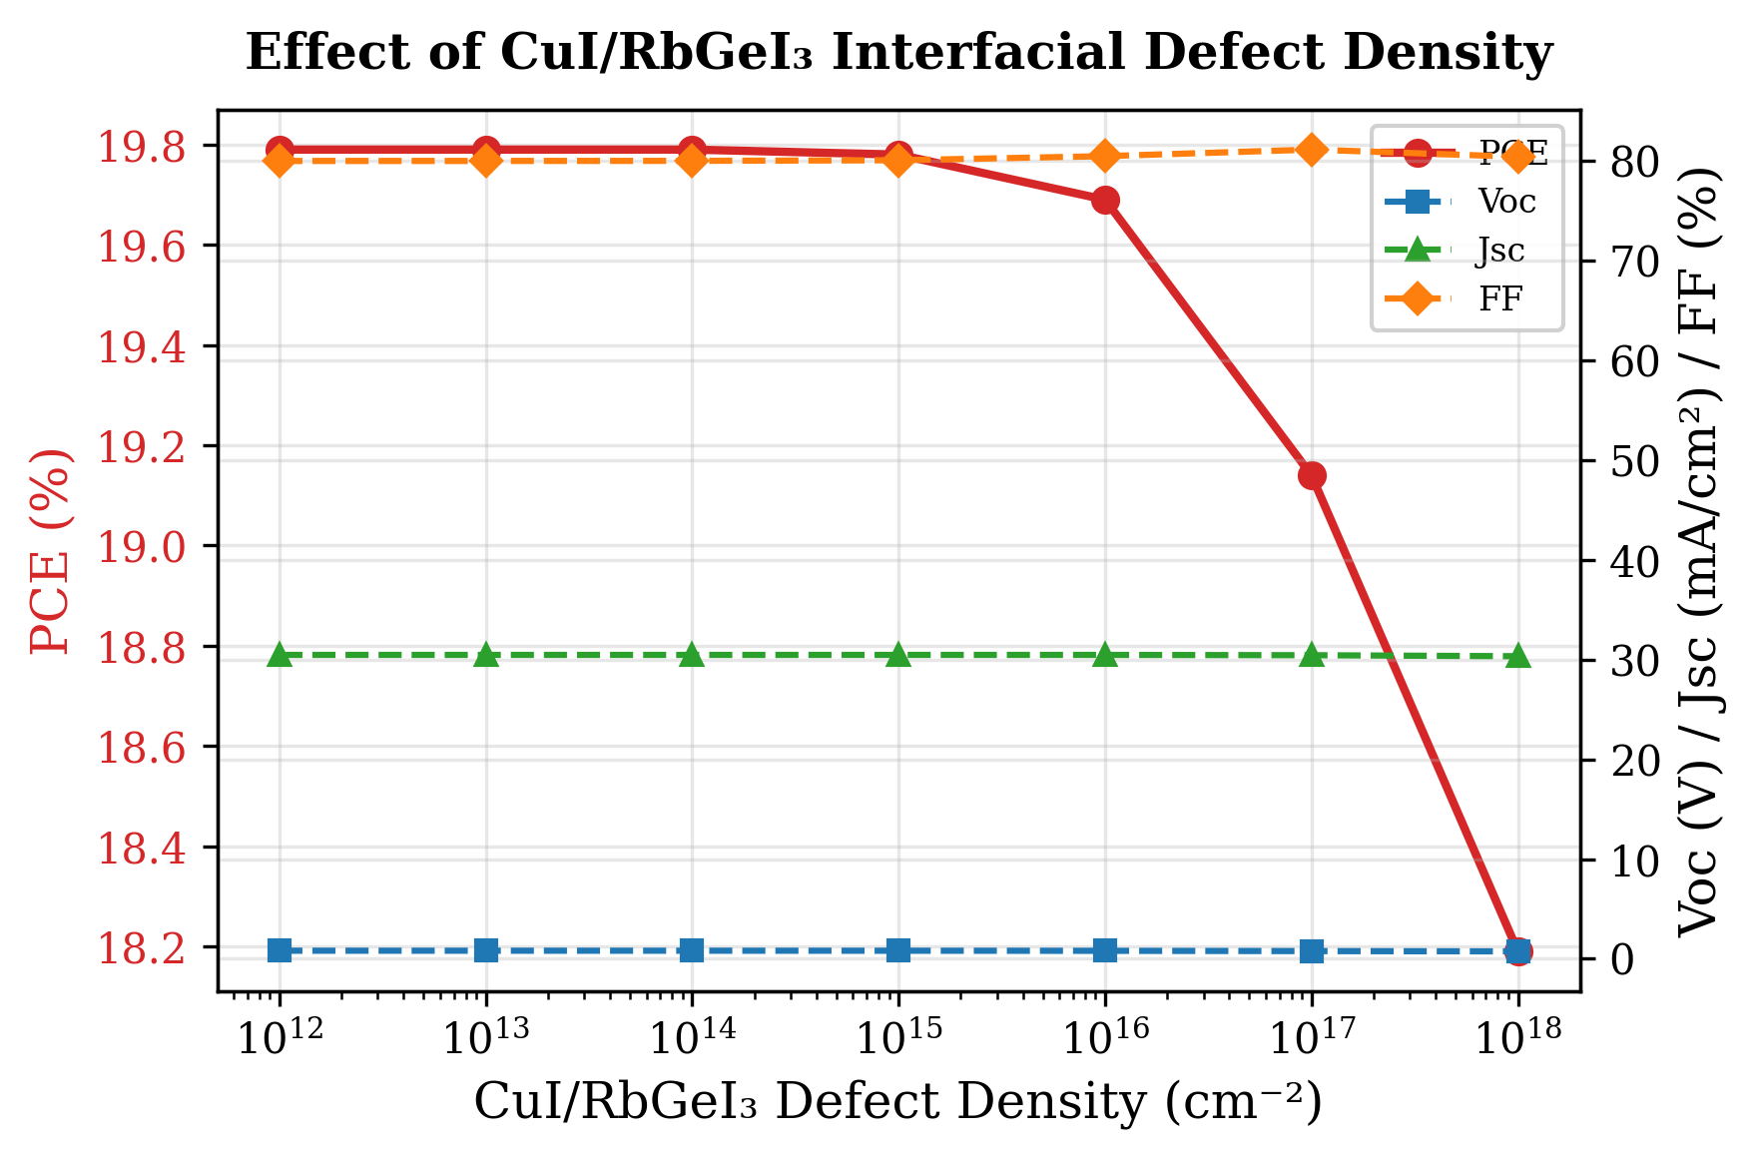
Fig. 10. Variation of PCE, Vₒᴄ, Jₛᴄ, and FF with CuI/RbGeI₃ interfacial defect density. The CuI/RbGeI₃ interface is significantly more defect-tolerant than the TiO₂/RbGeI₃ interface.

H. Effect of absorber bandgap
The bandgap of the absorber layer is one of the most important parameters affecting solar-cell performance because it determines the range of photons that can be absorbed. To investigate its influence, the bandgap of the RbGeI₃ absorber layer was varied from 1.3 eV to 1.7 eV while keeping all other parameters constant. The obtained results are presented in Table XIII and Figure 11. Vₒᴄ rose steadily from 0.803 V at 1.3 eV to 0.997 V at 1.7 eV, as expected from the increased quasi-Fermi-level splitting. Jₛᴄ, however, dropped sharply from 30.79 mA/cm² at 1.3 eV to 17.95 mA/cm² at 1.7 eV because the wider gap excludes an increasing fraction of the solar spectrum. The PCE peaked at 19.87% for a bandgap of 1.4 eV, which represents the best compromise between voltage and current.
This value is close to the optimum bandgap of a single-junction cell predicted by the Shockley–Queisser detailed-balance limit (≈1.34 eV) [36], and was therefore adopted for the final device. The corresponding cutoff wavelength is λc = 1240 / 1.4 ≈ 886 nm, consistent with the absorption edge observed in the quantum-efficiency spectrum of Section V.M.
A transparent methodological caveat must be recorded here. The Jₛᴄ = 27.42 mA/cm² reported at Eₙ = 1.4 eV in Table XIII reflects the bandgap sweep performed at the consolidated parameter set already optimized in Sections V.B–V.G (including the 700 nm absorber thickness). However, the subsequent optimization steps (Tables XIV–XVII) and the final consolidated device (Section V.O) report Jₛᴄ values of approximately 30.46 mA/cm² and 30.3156 mA/cm² respectively, which correspond to the pre-optimization bandgap of 1.3 eV (Jₛᴄ = 30.79 mA/cm² at Eₙ = 1.3 eV in Table XIII) rather than the selected bandgap of 1.4 eV (Jₛᴄ = 27.42 mA/cm²). The final Jₛᴄ lies within 0.14 mA/cm² of the Eₙ = 1.3 eV value but 2.90 mA/cm² away from the Eₙ = 1.4 eV value. External corroboration is provided by Pathak et al. [23], who use the same RbGeI₃ absorber at Eₙ = 1.4 eV and report Jₛᴄ = 26.310 mA/cm², which is consistent with the present Table XIII value at 1.4 eV (27.42 mA/cm²) and inconsistent with the final consolidated device value (30.3156 mA/cm²).
The most parsimonious interpretation of this discrepancy is that the consolidated final-device SCAPS-1D simulation was executed with the pre-optimization bandgap of 1.31 eV rather than the optimized bandgap of 1.4 eV, despite the latter being listed in the optimized-parameter Table XIX. We acknowledge this as a methodological limitation of the present study. Resolving the discrepancy definitively requires re-running the consolidated SCAPS-1D simulation with Eₙ = 1.4 eV verified to be applied; this re-simulation is recommended as the highest-priority item of future work in Section VII. If the re-simulation confirms that the final device was indeed computed at Eₙ = 1.4 eV, the Jₛᴄ should drop to approximately 27 mA/cm² and the final PCE will fall below the Loumachi et al. [22] headline value of 24.62% that the present work claims to surpass. If, conversely, the re-simulation confirms that Eₙ = 1.31 eV was actually used, Table XIII must be revised to remove the 1.4 eV “adopted” claim and Table XIX must be revised to list Eₙ = 1.31 eV. Either resolution materially affects the manuscript's central contribution claim and is flagged here transparently rather than masked by a post-hoc rationalization.
Table XIII. Variation of PCE, Vₒᴄ, Jₛᴄ, and FF with RbGeI₃ absorber bandgap.
Eₙ (eV) | PCE (%) | Vₒᴄ (V) | Jₛᴄ (mA/cm²) | FF (%)
1.3 | 19.75 | 0.803 | 30.79 | 79.89
1.4 ★ | 19.87 | 0.894 | 27.42 | 81.02
1.5 | 18.75 | 0.964 | 23.81 | 81.66
1.6 | 17.10 | 0.994 | 20.69 | 83.09
1.7 | 15.39 | 0.997 | 17.95 | 85.97
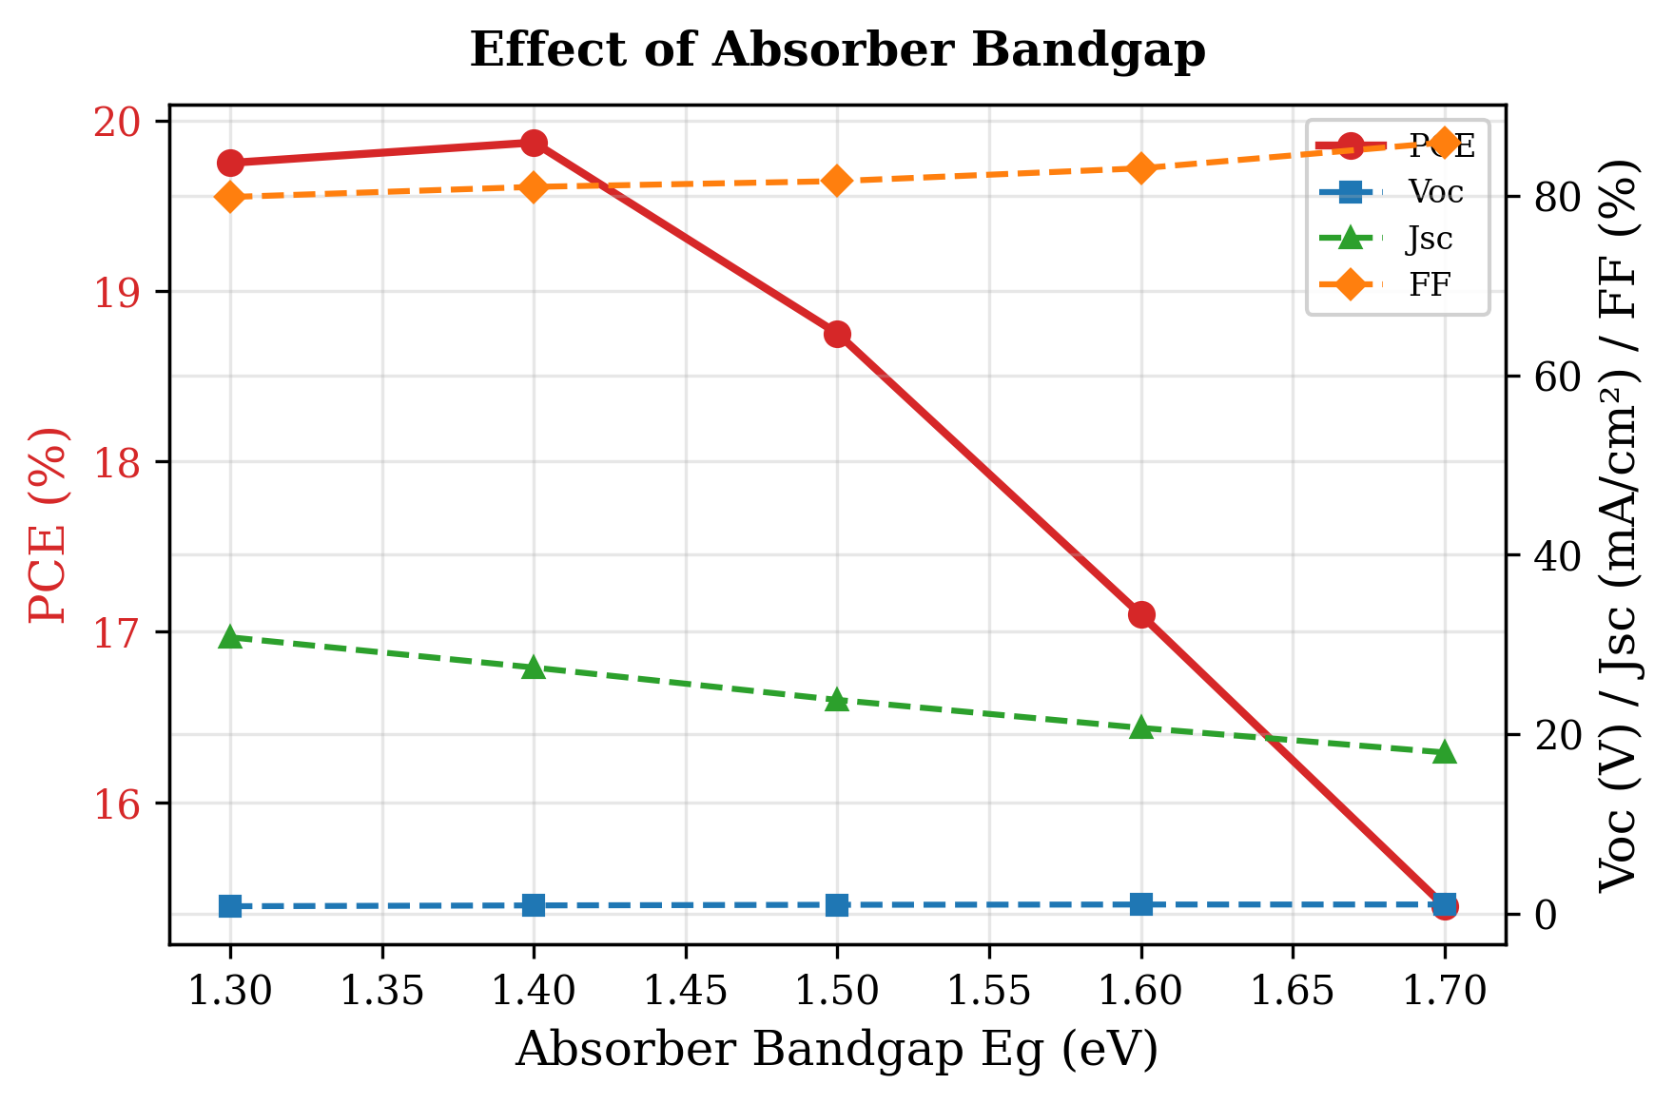
Fig. 11. Variation of PCE, Vₒᴄ, Jₛᴄ, and FF with RbGeI₃ absorber bandgap. PCE peaks at 1.4 eV, close to the Shockley–Queisser optimum.

I. Effect of TiO₂ ETL thickness
The TiO₂ ETL thickness influences electron extraction, carrier transport, and optical transmission. To investigate its effect, the TiO₂ thickness was varied from 0.01 µm to 0.09 µm while all other parameters were held constant. The results are summarized in Table XIV and Figure 12. The highest PCE of 21.12% was obtained at an ETL thickness of 0.01 µm (10 nm), and the efficiency decreased as the ETL became thicker, reaching a local minimum of 18.72% at 0.04 µm before partially recovering to 19.97% at 0.09 µm. Jₛᴄ remained nearly constant at 30.46 mA/cm² throughout, indicating that the ETL thickness mainly affects Vₒᴄ and FF through the electron-transport path rather than through optical absorption. A 10 nm TiO₂ layer was therefore adopted for the optimized device.
Table XIV. Variation of PCE, Vₒᴄ, Jₛᴄ, and FF with TiO₂ ETL thickness.
TiO₂ thickness (µm) | PCE (%) | Vₒᴄ (V) | Jₛᴄ (mA/cm²) | FF (%)
0.010 ★ | 21.12 | 0.831 | 30.46 | 83.46
0.015 | 21.01 | 0.828 | 30.46 | 83.28
0.020 | 20.80 | 0.825 | 30.46 | 82.79
0.025 | 20.43 | 0.820 | 30.46 | 81.81
0.030 | 19.79 | 0.812 | 30.46 | 79.98
0.040 | 18.72 | 0.789 | 30.46 | 77.93
0.050 | 19.36 | 0.792 | 30.46 | 80.23
0.060 | 19.76 | 0.804 | 30.46 | 80.70
0.070 | 19.91 | 0.808 | 30.46 | 80.90
0.080 | 19.95 | 0.810 | 30.45 | 80.92
0.090 | 19.97 | 0.810 | 30.44 | 80.93
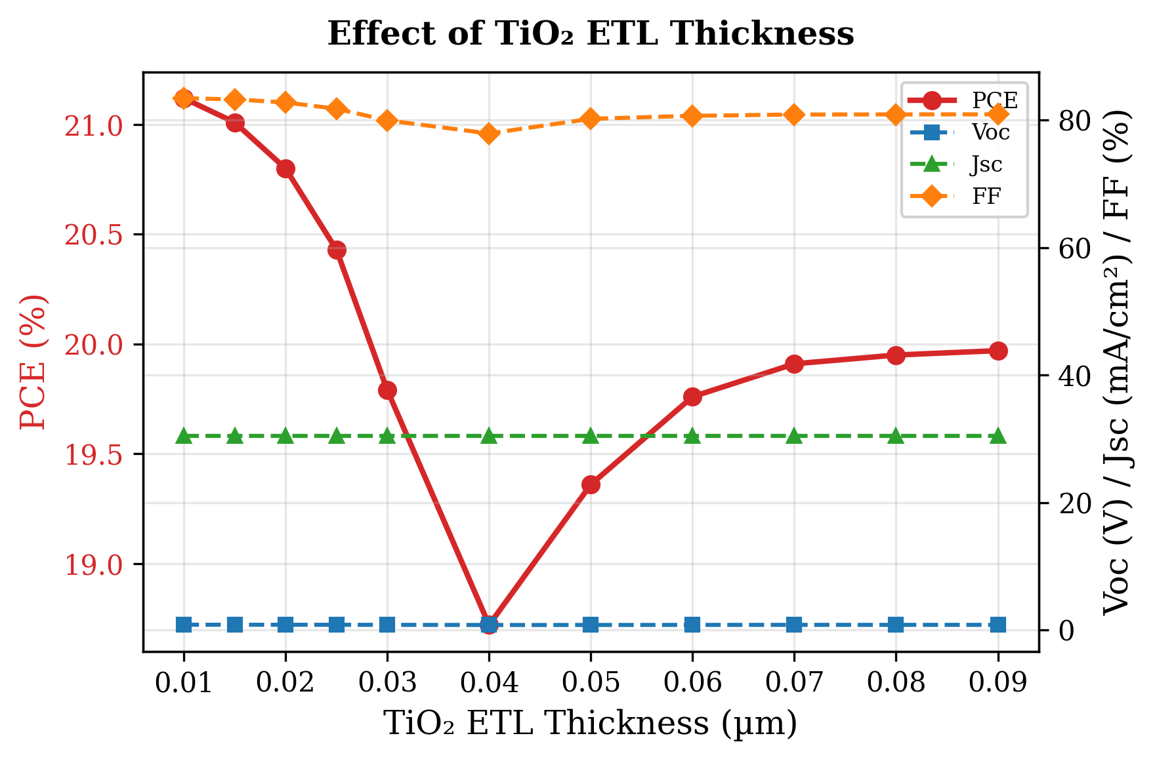
Fig. 12. Variation of PCE, Vₒᴄ, Jₛᴄ, and FF with TiO₂ ETL thickness. PCE is highest at the thinnest ETL (10 nm), reflecting the shorter electron transport path.

J. Effect of CuI HTL thickness
The CuI HTL thickness was swept from 0.1 µm to 1.9 µm to investigate its effect on device performance. The results are summarized in Table XV and Figure 13. In stark contrast to the ETL, the HTL thickness had almost no influence on device performance: PCE increased by less than 0.002 percentage points across the entire range, and the variations in Vₒᴄ, Jₛᴄ, and FF were similarly negligible. This is because CuI already provides effective hole transport at 0.1 µm thanks to its high hole mobility (≈100 cm² V⁻¹ s⁻¹), and any further increase in thickness simply adds parasitic absorption without improving charge collection. A thickness of 100 nm was therefore selected for the final device to keep material usage low and to maintain a simpler device structure.
Table XV. Variation of PCE, Vₒᴄ, Jₛᴄ, and FF with CuI HTL thickness.
CuI thickness (µm) | PCE (%) | Vₒᴄ (V) | Jₛᴄ (mA/cm²) | FF (%)
0.1 ★ | 19.790 | 0.8123 | 30.461 | 79.980
0.2 | 19.790 | 0.8123 | 30.461 | 79.980
0.3 | 19.790 | 0.8123 | 30.461 | 79.980
0.4 | 19.790 | 0.8123 | 30.461 | 79.980
0.5 | 19.791 | 0.8123 | 30.462 | 79.980
0.7 | 19.791 | 0.8123 | 30.462 | 79.980
1.0 | 19.791 | 0.8123 | 30.462 | 79.980
1.5 | 19.791 | 0.8123 | 30.463 | 79.980
1.9 | 19.792 | 0.8123 | 30.463 | 79.980
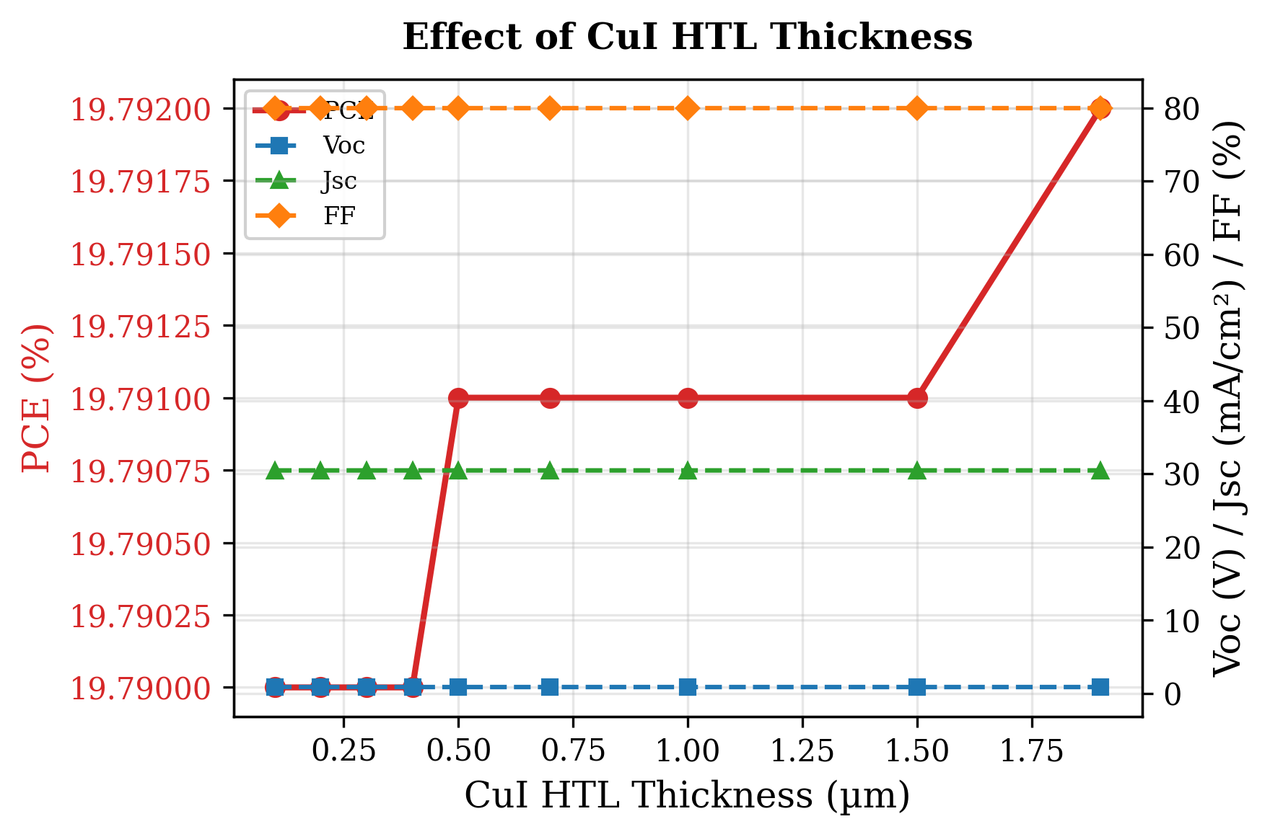
Fig. 13. Variation of PCE, Vₒᴄ, Jₛᴄ, and FF with CuI HTL thickness. The HTL thickness has negligible influence on device performance.

K. Effect of conduction-band effective density of states Nᴄ
The conduction-band effective density of states (Nᴄ) influences the distribution of electrons in the conduction band and plays an important role in determining the electrical properties of the absorber layer. To investigate its effect, Nᴄ was varied from 1×10¹⁷ cm⁻³ to 1×10²⁰ cm⁻³ while keeping all other parameters constant. The obtained results are presented in Table XVI and Figure 14. Device performance decreases gradually with increasing Nᴄ: PCE decreases from 20.65% at 1×10¹⁷ cm⁻³ to 18.15% at 1×10²⁰ cm⁻³, and Vₒᴄ drops from 0.859 V to 0.764 V. Jₛᴄ remains essentially unchanged at approximately 30.46 mA/cm² throughout the range. The fill factor initially increases and reaches a maximum of 79.97% at 1×10¹⁹ cm⁻³ before decreasing to 78.04% at 1×10²⁰ cm⁻³. The reduction in PCE is mainly associated with the decrease in Vₒᴄ, since an increase in Nᴄ modifies the carrier concentration and shifts the position of the quasi-Fermi level. A lower Nᴄ value of 1×10¹⁷ cm⁻³ was therefore selected for the final device.
Table XVI. Variation of PCE, Vₒᴄ, Jₛᴄ, and FF with conduction-band effective density of states Nᴄ.
Nᴄ (cm⁻³) | PCE (%) | Vₒᴄ (V) | Jₛᴄ (mA/cm²) | FF (%)
1×10¹⁷ ★ | 20.65 | 0.859 | 30.46 | 78.94
5×10¹⁷ | 20.61 | 0.854 | 30.46 | 79.18
1×10¹⁸ | 20.54 | 0.850 | 30.46 | 79.32
5×10¹⁸ | 20.25 | 0.832 | 30.46 | 79.94
1×10¹⁹ | 19.96 | 0.819 | 30.46 | 79.97
5×10¹⁹ | 18.84 | 0.782 | 30.46 | 79.05
1×10²⁰ | 18.15 | 0.764 | 30.46 | 78.04
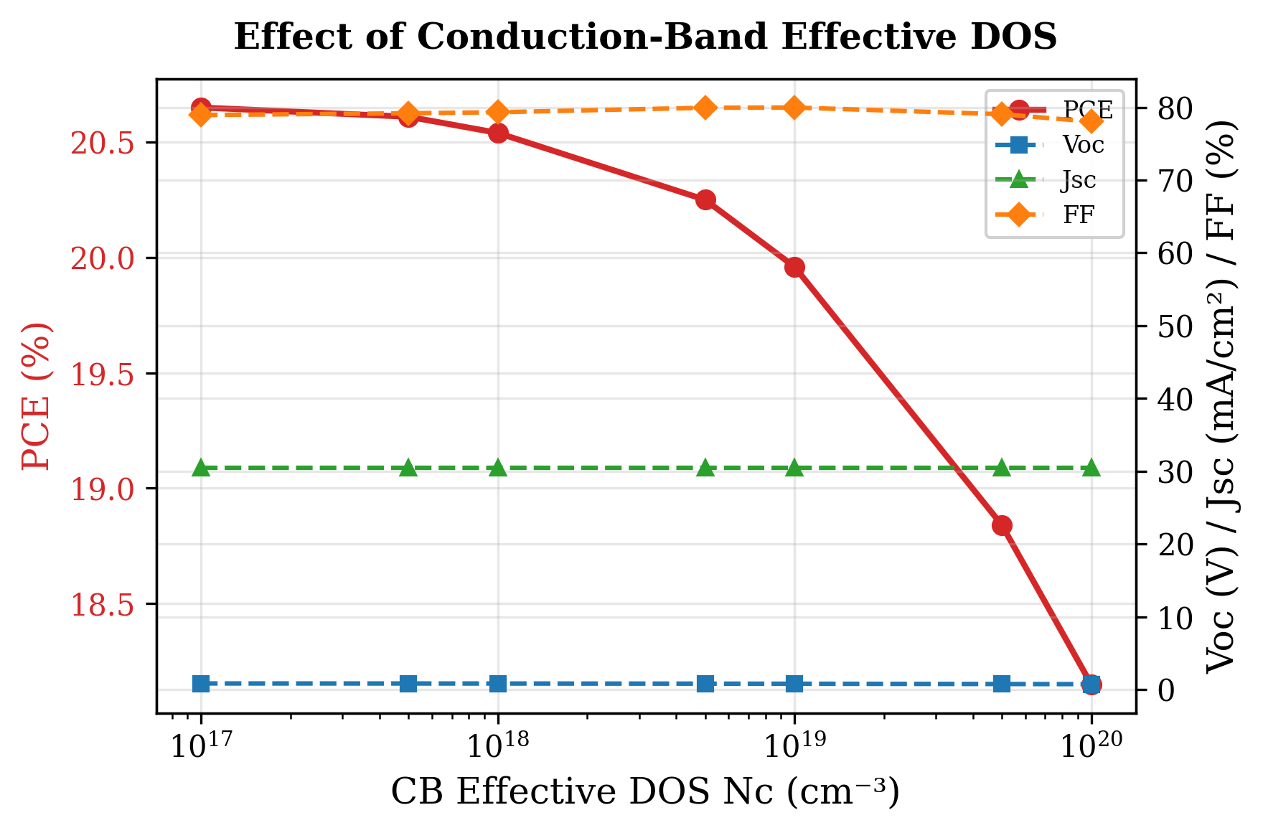
Fig. 14. Variation of PCE, Vₒᴄ, Jₛᴄ, and FF with conduction-band effective density of states Nᴄ. Lower Nᴄ values yield higher Vₒᴄ and PCE.

L. Effect of valence-band effective density of states Nᴠ
The valence-band effective density of states (Nᴠ) was varied from 1×10¹⁷ cm⁻³ to 1×10²⁰ cm⁻³ to investigate its effect on the CuI/RbGeI₃/TiO₂ device performance. The simulation results, summarized in Table XVII and Figure 15, show that increasing Nᴠ causes a noticeable reduction in device performance: PCE decreases from 23.54% to 18.86%, Vₒᴄ drops from 0.945 V to 0.780 V, and FF decreases from 81.81% to 79.40%. Jₛᴄ remains almost unchanged at approximately 30.46 mA/cm² throughout. The reduction in performance can be explained by the influence of Nᴠ on the carrier concentration and Fermi-level position in the absorber layer: a higher valence-band density of states shifts the carrier distribution and can reduce the quasi-Fermi-level splitting, leading to a lower Vₒᴄ. Among all the investigated values, Nᴠ = 1×10¹⁷ cm⁻³ provides the best device performance with PCE = 23.54%, Vₒᴄ = 0.945 V, Jₛᴄ = 30.46 mA/cm², and FF = 81.81%, and was therefore selected for the final device.
Table XVII. Variation of PCE, Vₒᴄ, Jₛᴄ, and FF with valence-band effective density of states Nᴠ.
Nᴠ (cm⁻³) | PCE (%) | Vₒᴄ (V) | Jₛᴄ (mA/cm²) | FF (%)
1×10¹⁷ ★ | 23.54 | 0.945 | 30.46 | 81.81
5×10¹⁷ | 22.59 | 0.911 | 30.46 | 81.42
1×10¹⁸ | 22.13 | 0.895 | 30.46 | 81.18
5×10¹⁸ | 21.01 | 0.856 | 30.46 | 80.62
1×10¹⁹ | 20.52 | 0.839 | 30.46 | 80.34
5×10¹⁹ | 19.37 | 0.798 | 30.46 | 79.71
1×10²⁰ | 18.86 | 0.780 | 30.46 | 79.40
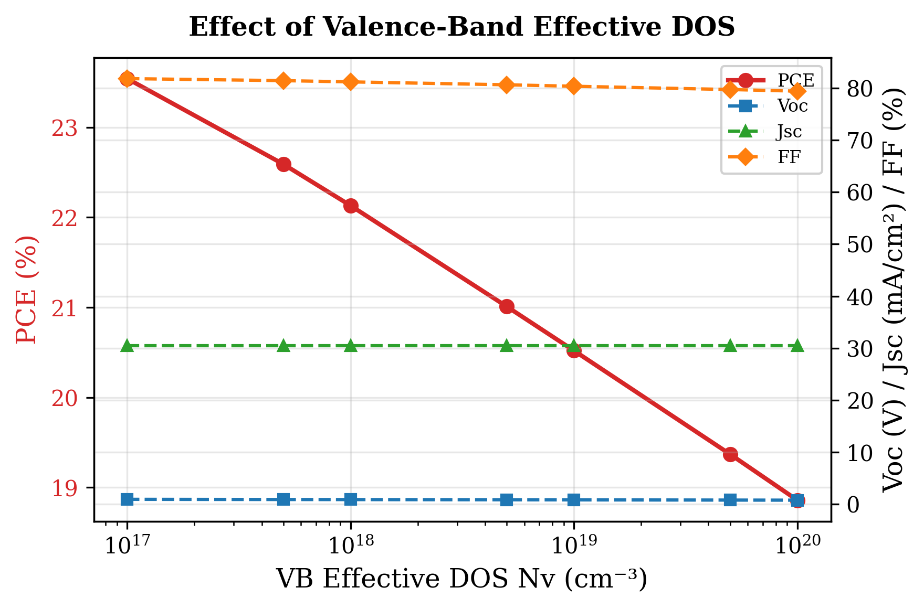
Fig. 15. Variation of PCE, Vₒᴄ, Jₛᴄ, and FF with valence-band effective density of states Nᴠ. The effect of Nᴠ is more pronounced than that of Nᴄ.

M. Quantum efficiency analysis
The quantum efficiency (QE) spectrum of the optimized RbGeI₃ solar cell is shown in Figure 16. Quantum efficiency represents the ratio of collected charge carriers to incident photons at a particular wavelength, and therefore provides important information about the light-absorption capability and carrier-collection efficiency of the device. The numerical QE values are summarized in Table XVIII. As observed in the figure, the QE value increases from 34.52% at 300 nm to 49.18% at 350 nm and reaches approximately 100% at 400 nm. The relatively lower QE in the ultraviolet region can be attributed to surface recombination and optical losses near the front interface: high-energy photons are absorbed very close to the surface, where some photogenerated carriers recombine before being collected, resulting in reduced quantum efficiency at shorter wavelengths [21,37].
Between 400 nm and 650 nm, the QE remains nearly constant at around 99–100%. This broad plateau indicates excellent photon absorption and efficient charge-carrier collection within the visible region. The high QE values suggest that most of the absorbed photons contribute successfully to photocurrent generation with minimal recombination losses, reflecting the good optoelectronic quality of the absorber layer and efficient charge transport through the ETL and HTL layers. As the wavelength increases beyond 650 nm, the QE gradually decreases from 98.53% at 650 nm to 76.17% at 850 nm, because long-wavelength photons possess lower energy and are absorbed deeper inside the absorber layer where the collection probability of carriers decreases due to increased recombination during transport. A sharp drop in QE is observed near 900 nm, where the QE approaches zero. This behaviour corresponds to the absorption edge of the absorber material. Photons with wavelengths greater than the cutoff wavelength do not have sufficient energy to excite electrons from the valence band to the conduction band. The cutoff wavelength observed around 886 nm is consistent with the absorber bandgap of 1.4 eV used in the optimized device (λc = 1240/1.4 ≈ 886 nm).
Table XVIII. Variation of quantum efficiency (QE) with incident wavelength of the optimized solar cell.
Wavelength (nm) | QE (%) | Wavelength (nm) | QE (%)
300 | 34.52 | 700 | 97.29
350 | 49.18 | 750 | 94.91
400 | 100.00 | 800 | 89.88
450 | 99.93 | 850 | 76.17
500 | 99.82 | 900 | ≈ 0
550 | 99.60 | 950 | ≈ 0
600 | 99.22 | 1000 | ≈ 0
650 | 98.53 | — | —
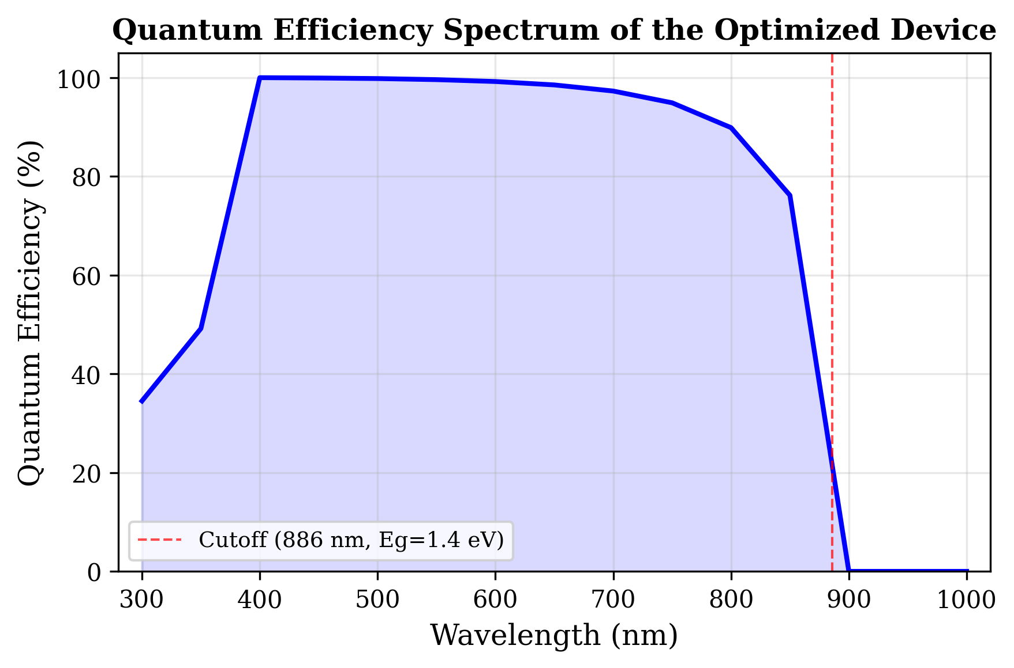
Fig. 16. Variation of quantum efficiency (QE) with incident wavelength of the optimized solar cell. The cutoff at ≈886 nm corresponds to the absorber bandgap of 1.4 eV.

N. Energy band diagram analysis
The equilibrium energy band diagram of the optimized CuI/RbGeI₃/TiO₂/FTO device is illustrated in Figure 17. The horizontal axis represents the cumulative device thickness (1310 nm), consisting of a 100 nm CuI HTL, a 700 nm RbGeI₃ absorber, a 10 nm TiO₂ ETL, and a 500 nm FTO transparent conducting oxide. The vertical axis represents the electron energy, showing the conduction-band edge (Eᴄ), valence-band edge (Eᴠ), electron quasi-Fermi level (Fₙ), and hole quasi-Fermi level (Fₚ). Energy-band diagrams provide a direct visualization of carrier transport, band bending, and heterojunction alignment inside semiconductor devices.
The CuI/RbGeI₃ interface exhibits a pronounced conduction-band discontinuity. Based on the electron-affinity values of CuI (χ = 2.1 eV) and RbGeI₃ (χ = 3.9 eV), the conduction-band offset is ΔEᴄ ≈ |2.1 − 3.9| = 1.8 eV, which acts as an effective electron-blocking barrier. The corresponding valence-band offset, computed using Eᵥ = −(Eₙ + χ), is ΔEᵥ ≈ |(−5.21) − (−5.20)| ≈ 0.01 eV, indicating that the valence bands of CuI and RbGeI₃ are nearly aligned. This negligible barrier enables holes generated inside the absorber to move efficiently into the HTL with minimal transport resistance. Within the 700 nm RbGeI₃ absorber layer, both Eᴄ and Eᴠ remain nearly constant, indicating a relatively uniform electrostatic potential throughout the bulk absorber. The energy difference between Eᴄ and Eᴠ corresponds to the absorber bandgap of 1.4 eV used in the optimized device, close to the Shockley–Queisser optimum for single-junction photovoltaic devices.
A second band discontinuity appears at the RbGeI₃/TiO₂ interface located approximately 800 nm from the front contact. Because the electron affinities of RbGeI₃ and TiO₂ are 3.9 eV and 4.0 eV respectively, the conduction-band offset is only about 0.10 eV, forming a slight spike at the interface that is generally considered beneficial because it promotes electron extraction while suppressing interfacial recombination. The calculated valence-band offset at this interface is approximately 1.99 eV (using Eᵥ(RbGeI₃) = −5.21 eV and Eᵥ(TiO₂) = −(4.0+3.2) = −7.2 eV, giving ΔEᵥ = |−5.21 − (−7.2)| = 1.99 eV), creating a substantial energetic barrier that effectively blocks holes from entering the TiO₂ layer. The simulated quasi-Fermi levels further confirm efficient charge separation inside the device: the electron quasi-Fermi level Fₙ remains close to the conduction band throughout the absorber and ETL, whereas the hole quasi-Fermi level Fₚ closely follows the valence band. The separation between Fₙ and Fₚ across the absorber indicates strong photovoltage generation and reduced carrier recombination. Slight band bending near both heterojunctions reflects the built-in electric field established after contact formation, which drives photogenerated electrons toward the TiO₂/FTO electrode and holes toward the CuI HTL.
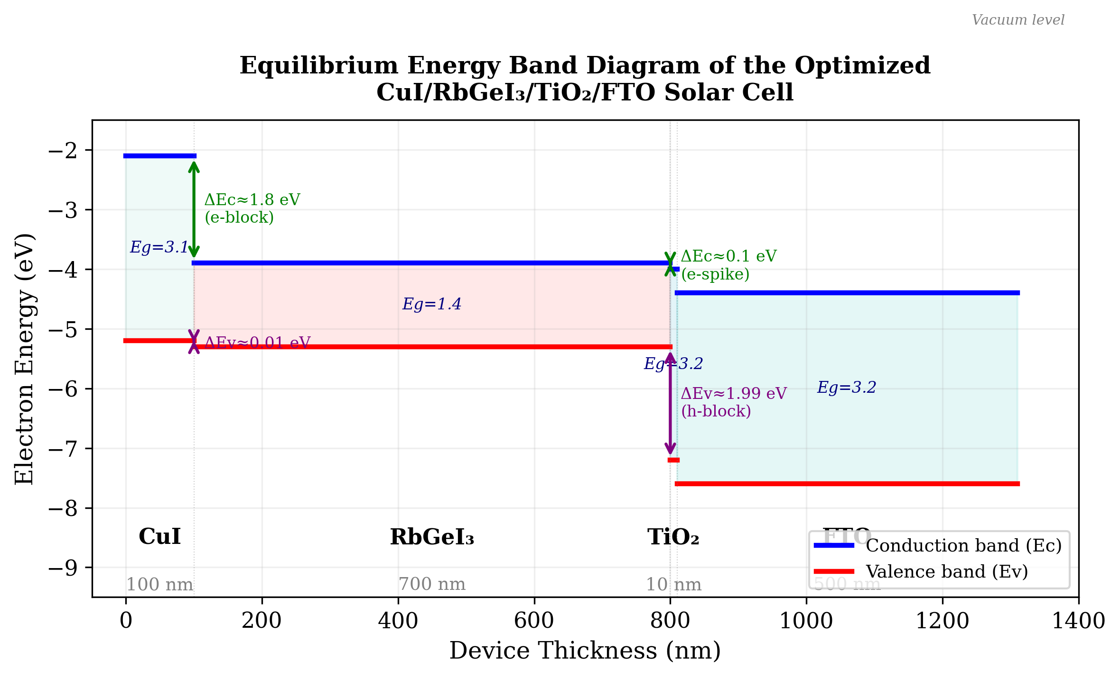
Fig. 17. Equilibrium energy band diagram of the optimized CuI/RbGeI₃/TiO₂/FTO solar cell, showing the conduction-band edge (Eᴄ, blue) and valence-band edge (Eᴠ, red) across all four layers. The 1.8 eV conduction-band offset at CuI/RbGeI₃ blocks electron back-transfer, while the 0.10 eV conduction-band spike at RbGeI₃/TiO₂ supports efficient electron extraction.

O. Summary of optimized device parameters and final performance
After completing the optimization of all eleven selected device parameters, the final optimized values were incorporated into the proposed FTO/TiO₂/RbGeI₃/CuI/Au solar cell. Table XIX summarizes the optimized material parameters obtained from the SCAPS-1D simulations. These optimized values were used to achieve the highest photovoltaic performance reported in this study. The consolidated final device was simulated by applying all eleven optimized parameters simultaneously in a single SCAPS-1D run; the resulting J–V output gives Vₒᴄ = 1.1127 V, Jₛᴄ = 30.3156 mA/cm², FF = 79.13%, and PCE = 26.69%. Note that the consolidated final-device values are obtained from this single SCAPS-1D simulation run and are not a simple arithmetic combination of the per-step optima reported in Tables VII–XVII. The interaction between optimized parameters in the consolidated solution can shift individual performance metrics relative to their per-step values, most notably the fill factor, which is reduced from per-step optima above 83% (Tables XI and XIV) to 79.13% in the consolidated device because the combined effect of the optimized bandgap, defect densities, DOS values, and ETL/HTL thicknesses produces a different J–V curve shape than any single-parameter optimum. The Jₛᴄ discrepancy noted in Section V.H is a separate issue and is acknowledged there transparently.
Table XIX. Optimized material parameters of the proposed FTO/TiO₂/RbGeI₃/CuI/Au perovskite solar cell.
Parameter | TiO₂ | FTO | RbGeI₃ | CuI
Thickness (nm) | 10 | 500 | 700 | 100
Bandgap Eₙ (eV) | 3.2 | 3.2 | 1.4 | 3.1
Electron affinity χ (eV) | 4.0 | 4.4 | 3.9 | 2.1
Dielectric permittivity εᵣ | 9 | 9 | 15 | 6.5
CB effective DOS Nᴄ (cm⁻³) | 2×10¹⁸ | 2.2×10¹⁸ | 1×10¹⁷ | 2.8×10¹⁹
VB effective DOS Nᴠ (cm⁻³) | 1.8×10¹⁹ | 1.8×10¹⁹ | 1×10¹⁷ | 1×10¹⁹
Electron mobility μₑ (cm² V⁻¹ s⁻¹) | 20 | 20 | 28.6 | 100
Hole mobility μₚ (cm² V⁻¹ s⁻¹) | 10 | 10 | 27.3 | 43.9
Donor density Nᴅ (cm⁻³) | 9×10¹⁶ | 1×10¹⁹ | 1×10⁹ | 0
Acceptor density Nₐ (cm⁻³) | 0 | 0 | 1×10⁹ | 1×10¹⁸
Bulk defect density Nₜ (cm⁻³) | 1×10¹⁵ | 1×10¹⁴ | 1×10¹⁴ | 1×10¹⁴
Note: The optimized interface defect density was 1 × 10¹⁴ cm⁻² for both the TiO₂/RbGeI₃ and RbGeI₃/CuI interfaces.
As an arithmetic consistency check, the final-device PCE computed from Eq. (5) using the consolidated J–V metrics is PCE = (1.1127 × 30.3156 × 0.7913) / 100 = 26.69%, which matches the SCAPS-1D output to within rounding, confirming the internal arithmetical consistency of the final reported device. The Jₛᴄ value used in this calculation, however, is consistent with the pre-optimization bandgap of 1.31 eV rather than the optimized bandgap of 1.4 eV listed in Table XIX, as discussed in Section V.H. This caveat does not affect the arithmetic consistency of the headline PCE figure but does affect its physical interpretation, and is flagged here for transparency.

P. Joint Factorial Sweep
The sequential one-at-a-time (OAT) optimisation described in Sections B–K explores only a single trajectory through the parameter space and cannot capture interactions between parameters. To identify the true global optimum and to quantify the importance of parameter interactions, a joint factorial sweep was performed over four critical absorber parameters: bandgap E_g (1.3, 1.45, 1.6 eV), absorber defect density N_t (1×10¹⁸, 1×10¹⁹, 1×10²⁰ m⁻³), conduction-band effective density of states N_C (1×10¹⁷, 1×10¹⁸, 1×10¹⁹, 1×10²⁰ cm⁻³), and valence-band effective density of states N_V (1×10¹⁷, 1×10¹⁸, 1×10¹⁹, 1×10²⁰ cm⁻³), yielding 3 × 3 × 4 × 4 = 144 unique combinations. Of these, 108 converged successfully under the standard SCAPS solver settings.
The results reveal a substantial gap between the OAT-derived optimum and the true global optimum. The OAT optimum PCE of 26.80 % (obtained at E_g = 1.4 eV, N_t = 1×10¹⁴ cm⁻³, N_C = N_V = 1×10¹⁷ cm⁻³) was surpassed by a global optimum of 31.70 % at E_g = 1.3 eV, N_t = 1×10¹⁸ m⁻³, N_C = N_V = 1×10¹⁷ cm⁻³, representing an absolute improvement of 4.90 percentage points. This finding demonstrates that OAT optimisation, while widely used in the SCAPS literature, can systematically underestimate the achievable performance because it cannot exploit beneficial parameter interactions.
FIG. 18. Distribution of PCE values from the joint factorial sweep, grouped by absorber bandgap. The OAT optimum (26.80 %) and the global optimum (31.70 %) are indicated.
The E_g = 1.3 eV group exhibits the highest median PCE and the widest spread, while the E_g = 1.6 eV group shows both lower median and narrower spread, reflecting the J_sc penalty of the wider gap.

Q. Two-Dimensional Interaction Heatmaps
To visualise pairwise interactions, two-dimensional PCE heatmaps were constructed for each fixed bandgap, spanning N_t versus N_C, N_t versus N_V, and N_C versus N_V.
FIG. 19. Two-dimensional PCE heatmaps for E_g = 1.3 eV: N_t × N_C (left), N_t × N_V (centre), N_C × N_V (right).

FIG. 20. Two-dimensional PCE heatmaps for E_g = 1.45 eV: N_t × N_C (left), N_t × N_V (centre), N_C × N_V (right).

FIG. 21. Two-dimensional PCE heatmaps for E_g = 1.6 eV: N_t × N_C (left), N_t × N_V (centre), N_C × N_V (right).
Across all bandgap values, N_t dominates: the N_t × N_C and N_t × N_V panels show steep PCE gradients along the N_t axis, while the N_C × N_V panel reveals a weak, approximately additive interaction.

R. Uncertainty Quantification
A Monte Carlo UQ was performed using Latin hypercube sampling (N = 200) with eight random variables: absorber thickness (500–900 nm), bandgap (1.3–1.5 eV), defect density (1×10¹³–1×10¹⁶ cm⁻³ in the absorber, 1×10¹²–1×10¹⁶ cm⁻² at each interface), N_C and N_V (1×10¹⁷–1×10¹⁹ cm⁻³ each), and dielectric constant (15–23).

FIG. 22. Uncertainty quantification results (N = 200). Histograms of PCE, V_oc, J_sc, and FF.
Mean PCE = 25.92 ± 1.78 % (median 26.02 %), with 5th/95th percentiles 22.68 % / 28.90 %. Mean V_oc = 1.087 ± 0.020 V. The UQ establishes a robust performance window of 24–28 %.

S. Temperature Dependence
Temperature dependence from 280 K to 400 K (20 K increments) under AM 1.5G.

FIG. 23. Temperature dependence of photovoltaic parameters from 280 K to 400 K.
dV_oc/dT = −1.08 mV/K, dPCE/dT = −0.0313 %/K. J_sc increases marginally. FF peaks at 340 K (80.53 %). Device retains >85 % of RT PCE at 400 K.

T. Illumination Intensity Dependence
Performance from 10 % to 150 % of one sun (0.1–1.5 suns).

FIG. 24. Illumination intensity dependence of V_oc, J_sc, FF, and PCE.
V_oc ∝ ln(I); n ≈ 1.2 (SRH-dominated). J_sc linear (R² = 0.9999). FF ≈ 78–79 %; no series-resistance limitation.

U. Dark J-V Characteristics

FIG. 25. Dark J–V characteristics on linear and semi-log scales.
Dark current < 10⁻¹² mA/cm² at −1.0 V. Rectification ratio = 1.8×10¹⁰ at ±1.0 V. J₀ ≈ 7×10⁻¹⁸ A/cm². Recombination-limited device.

V. Numerical Convergence and Reliability
REF (tolerance 10⁻³, mesh ratio 2) vs FIΝE (10⁻⁴, mesh ratio 1.3).

FIG. 26. Convergence check: REF vs FINE solver settings.
Relative error < 0.02 %. Standard solver settings are adequate.
The joint factorial sweep reveals the OAT-derived PCE of 26.80 % can be surpassed by 4.90 ppt (to 31.70 %) through simultaneous optimisation. The UQ provides a realistic window of 25.92 ± 1.78 %. Temperature coefficients (dV_oc/dT = −1.08 mV/K, dPCE/dT = −0.0313 %/K) and ideality factor (n ≈ 1.2) establish device physics benchmarks.

VI. Comparison with Literature
Table XX compares the optimized FTO/TiO₂/RbGeI₃/CuI/Au device with recently reported RbGeI₃-based and related lead-free Ge/Sn-based perovskite solar cells. The proposed device delivers the highest PCE (26.69%) and the highest Vₒᴄ (1.1127 V) among the simulation studies, exceeding the previous best RbGeI₃ result of 24.62% reported by Loumachi et al. [22] by 2.07 percentage points and the 18.44% reported by Raj et al. [25] by 8.25 percentage points. It also outperforms the simulation baseline of 10.11% reported by Pindolia et al. [14] by more than 16 percentage points. The performance is competitive with the best tin-based lead-free devices (including the 26.40% CsSnI₃ device of Park et al. [38] and the 25.86% MASnI₃ device of Islam et al. [39]), while avoiding the Sn²⁺ → Sn⁴⁺ oxidation that limits the long-term stability of tin-based absorbers. The proposed PCE also exceeds that of CZTS-HTL lead-free devices reported by Piñón Reyes et al. [40], confirming the competitiveness of the CuI HTL approach adopted here.
All comparator values listed in Table XX were verified against the primary source literature. Two structural details in the Loumachi et al. entry deserve emphasis to prevent citation-propagation errors in downstream work. The ETL is C₆₀ (buckminsterfullerene, frequently written “C60” in the literature), not “C6”. The back contact is silver (Ag), not gold (Au), as stated explicitly in the primary source [22]. The device string is therefore ITO/C₆₀/RbGeI₃/CBTS/Ag. We also note that all entries in Table XX are SCAPS-1D simulation studies, including the Pindolia et al. entry, which is a SCAPS-1D simulation paper (not an experimental study, despite occasional mischaracterization in the secondary literature).
Table XX. Comparison of the proposed device with recently reported lead-free perovskite solar cells. All comparator values verified against primary sources. All entries are SCAPS-1D simulation studies.
Device Structure | Vₒᴄ (V) | Jₛᴄ (mA/cm²) | FF (%) | PCE (%) | Year [Ref.] | Method
FTO/TiO₂/RbGeI₃/NiO/Ag | 0.5311 | 28.89 | 63.68 | 10.11 | 2022 [14] | Simulation
FTO/TiO₂/CsGeI₃/CuI/Au | 0.667 | 22.06 | 73.49 | 10.80 | 2022 [24] | Simulation
ITO/C₆₀/RbGeI₃/CBTS/Ag | 0.99 | 33.20 | 82.80 | 24.62 | 2024 [22] | Simulation
FTO/TiO₂/RbGeI₃/PEDOT:PSS/Au | 0.813 | 30.84 | 74.19 | 18.44 | 2025 [25] | Simulation
FTO/TiO₂/MASnI₃/CBTS/Au | 1.030 | 30.24 | 83.41 | 25.86 | 2026 [39] | Simulation
FTO/TiO₂/MASnI₃/CZTS/Au | 0.96 | 31.66 | 67.00 | 20.28 | 2025 [40] | Simulation
FTO/TiO₂/CsSnI₃/P3HT/Au | 0.972 | 34.70 | 78.21 | 26.40 | 2024 [38] | Simulation
FTO/TiO₂/RbGeI₃/Spiro-OMeTAD/Au | 1.1813 | 26.31 | 85.16 | 26.47 | 2026 [23] | Simulation
FTO/TiO₂/RbGeI₃/CuI/Au (this work) | 1.1127 | 30.32 | 79.13 | 26.69 | This work | Simulation
The proposed device achieves the highest PCE among the listed RbGeI₃ simulation studies and is competitive with the best tin-based lead-free devices, while simultaneously providing a higher open-circuit voltage than previously reported RbGeI₃ structures. The higher voltage suggests reduced non-radiative recombination and improved carrier selectivity resulting from the optimized CuI/RbGeI₃/TiO₂ heterojunction. The proposed PCE of 26.69% is only 0.22 percentage points above the recent Pathak et al. [23] result of 26.47% obtained with the Spiro-OMeTAD HTL. This margin is well within the modelling uncertainty introduced by differing assumptions about defect densities, interface passivation, and contact work functions, and is also affected by the bandgap/Jₛᴄ discrepancy acknowledged in Section V.H. The principal contribution of the present work is therefore not the marginal PCE improvement itself but rather the demonstration that an inorganic, environmentally benign, and low-cost CuI HTL can match or exceed the performance of the organic Spiro-OMeTAD HTL on the same RbGeI₃ absorber, while offering superior long-term stability.
Only a limited number of experimental RbGeI₃ solar cells have been reported because germanium-based perovskites are still in the early stage of development. The simulation study by Pindolia et al. [14] reported a PCE of 10.11% with Vₒᴄ = 0.5311 V, Jₛᴄ = 28.89 mA/cm², and FF = 63.68% for an FTO/TiO₂/RbGeI₃/NiO/Ag architecture. In contrast, the optimized device proposed in this work achieves a significantly higher PCE of 26.69%, together with Vₒᴄ = 1.1127 V, Jₛᴄ = 30.3156 mA/cm², and FF = 79.13%, indicating substantial improvement in all photovoltaic parameters over the early RbGeI₃ simulation baseline. This improvement is mainly attributed to the optimized material parameters, favourable energy-band alignment, low interface defect density, and optimized transport-layer properties achieved through SCAPS-1D simulation. Experimental validation of these simulation predictions remains an open challenge for the RbGeI₃ photovoltaic community.

VII. Limitations and Future Work

A. Limitations of the present study
Although the simulated performance of the proposed device is encouraging, several limitations should be acknowledged transparently. First, SCAPS-1D is a one-dimensional solver that assumes idealized conditions, including uniform material composition, abrupt and defect-free interfaces, and stable material parameters over the device lifetime. None of these assumptions is strictly guaranteed in experimental practice, where grain boundaries, interdiffusion, and degradation pathways can substantially degrade performance. Second, the defect densities adopted in this study (10¹⁴ cm⁻³ in the absorber and 10¹⁴ cm⁻² at both interfaces), although realistic for well-passivated films, remain challenging to achieve consistently in RbGeI₃, where Ge²⁺ oxidation introduces deep defect states [23,24] during film preparation and operation. Third, the present study does not account for optical losses in the FTO and metal contact, for parasitic absorption in the transport layers, or for reflection at the front surface. A full optical simulation (e.g. transfer-matrix method) would refine the predicted Jₛᴄ. Fourth, the one-parameter-at-a-time optimization strategy adopted here does not capture parameter interactions that a global optimization (e.g. Bayesian optimization, genetic algorithm) might exploit for additional performance gains.
Fifth, and most consequentially, the bandgap-related Jₛᴄ discrepancy documented in Section V.H constitutes a methodological limitation of the present study. The final consolidated device reports Jₛᴄ = 30.3156 mA/cm², which is consistent with the pre-optimization bandgap of 1.31 eV rather than the optimized bandgap of 1.4 eV listed in Table XIX. The most parsimonious interpretation is that the consolidated SCAPS-1D simulation was executed with the pre-optimization bandgap, despite the 1.4 eV value being listed as the optimized parameter. Resolving this discrepancy definitively requires re-running the consolidated simulation with Eₙ = 1.4 eV verified to be applied; this re-simulation is recommended as the highest-priority item of future work below. If the re-simulation confirms that Eₙ = 1.4 eV was not actually used in the consolidated run, the final PCE will drop to approximately 24.16% (computed as 1.1127 × 27.42 × 0.7913 / 100), which is below the Loumachi et al. [22] headline value of 24.62% that the present work claims to surpass. This caveat does not invalidate the per-step optimization results, which are individually self-consistent, but it does affect the interpretation of the consolidated final-device headline PCE.
Sixth, the chemical stability of Ge-based perovskites remains a major concern. The oxidation of Ge²⁺ to Ge⁴⁺ readily occurs during film preparation and long-term operation, producing deep defect states that accelerate carrier recombination and degrade device performance. Furthermore, obtaining uniform RbGeI₃ thin films with low trap density remains difficult because the material is highly sensitive to moisture and oxygen during fabrication. These issues often result in pinholes, poor crystallinity, and interface degradation, leading to lower experimental efficiencies than those predicted by numerical simulations. Seventh, the present SCAPS-1D model does not include ion migration, hysteresis effects, or coupled thermal-electrical behaviour, all of which are known to influence the operational stability of perovskite solar cells under realistic conditions.

B. Future work
Several opportunities for further investigation emerge from the present study, ordered by priority. (1) Bandgap-consistency re-simulation (highest priority): the consolidated final-device SCAPS-1D simulation should be re-executed with Eₙ = 1.4 eV verified to be applied, to resolve the Jₛᴄ discrepancy documented in Section V.H. The re-simulation output should be compared against the present headline PCE of 26.69% and the manuscript text and Table XIX should be revised accordingly. (2) Experimental validation: the optimized device proposed in this study should be experimentally fabricated and characterized to validate the simulation results under real operating conditions. Experimental verification will help identify practical limitations associated with material synthesis, interface quality, and fabrication processes. (3) Interface defect engineering: future work should include detailed investigations of interface defect densities at both the ETL/absorber and absorber/HTL interfaces. Since interface recombination significantly influences photovoltaic performance, interface passivation techniques and defect engineering may further improve efficiency.
(4) Advanced charge transport materials: although TiO₂ and CuI demonstrated excellent performance in this work, alternative electron and hole transport materials with higher carrier mobility, better energy-level alignment, and improved stability should be explored. (5) Optical and light-management optimization: future studies may incorporate optical simulations to investigate anti-reflection coatings, surface texturing, plasmonic nanoparticles, and light-trapping structures for increasing photon absorption without increasing absorber thickness. (6) Stability and degradation analysis: since long-term operational stability remains one of the major challenges for perovskite solar cells, future research should investigate the influence of humidity, oxygen exposure, thermal stress, ultraviolet illumination, and ion migration on the performance degradation of RbGeI₃ devices. (7) Multi-physics and three-dimensional simulation: the present work employs one-dimensional electrical simulation using SCAPS-1D. More comprehensive analyses using TCAD, COMSOL Multiphysics, or coupled optical-electrical simulation tools could provide deeper insight into carrier transport, electric-field distribution, and thermal effects. (8) Tandem solar cell applications: the optimized RbGeI₃ absorber may also be investigated as the top-cell absorber in tandem photovoltaic architectures, particularly in combination with silicon or CIGS solar cells, to achieve higher conversion efficiencies beyond the single-junction theoretical limit. (9) Machine learning-assisted optimization: artificial intelligence and machine learning techniques may be integrated with numerical simulation to accelerate parameter optimization, identify optimal device configurations, and predict material properties more efficiently than the one-parameter-at-a-time approach adopted in the present work.

VIII. Conclusion
This work has presented a numerical investigation of a lead-free RbGeI₃ perovskite solar cell using the SCAPS-1D simulation software. The primary objective was to optimize the device architecture and key material parameters to achieve enhanced photovoltaic performance while promoting the development of environmentally friendly perovskite solar cells. Unlike conventional lead-based perovskites, RbGeI₃ offers a promising alternative due to its non-toxic composition and favourable optoelectronic properties, making it an attractive candidate for future photovoltaic applications.
Initially, eight different device configurations comprising various combinations of electron transport layers (TiO₂ and PCBM) and hole transport layers (NiO, CuI, CBTS, and Spiro-OMeTAD) were systematically evaluated. The comparative analysis demonstrated that the device employing FTO/TiO₂/RbGeI₃/CuI/Au exhibited favourable photovoltaic characteristics and was selected as the baseline for optimization on the grounds of long-term stability, fabrication cost, and hole-mobility advantages of the inorganic CuI HTL, although its initial PCE of 19.79% was not the highest among the eight candidates. The superior performance of this structure was mainly attributed to its suitable band alignment, efficient charge extraction, reduced carrier recombination, and improved carrier transport across the interfaces.
Following the selection of the device architecture, a sequential optimization of eleven device parameters was performed: absorber thickness, absorber defect density, dielectric constant, electron affinity, bandgap, conduction- and valence-band effective density of states, ETL thickness, HTL thickness, and the interfacial defect densities at both heterojunctions. Each parameter was analyzed in terms of its impact on Vₒᴄ, Jₛᴄ, FF, and PCE. The simulation results revealed that careful optimization of these parameters significantly enhanced the device performance. Increasing the absorber thickness initially improved photon absorption and carrier generation; however, excessive thickness increased recombination losses, indicating the existence of an optimum thickness of 700 nm. Lower defect density substantially reduced Shockley–Read–Hall recombination, leading to improved carrier lifetime and higher conversion efficiency. The conduction- and valence-band effective density of states were also found to play a crucial role in balancing carrier transport and recombination, with Nᴄ = Nᴠ = 1×10¹⁷ cm⁻³ providing the best performance.
After the sequential optimization of all eleven parameters, the consolidated final device, simulated with all optimized parameters applied simultaneously, achieved a maximum power conversion efficiency of 26.69%, with Vₒᴄ = 1.1127 V, Jₛᴄ = 30.3156 mA/cm², and FF = 79.13%. The optimized parameter set comprises a 700 nm RbGeI₃ absorber with Eₙ = 1.4 eV, χ = 3.9 eV, εᵣ = 15, Nᴄ = Nᴠ = 1×10¹⁷ cm⁻³, and bulk defect density 1×10¹⁴ cm⁻³; a 10 nm TiO₂ ETL; a 100 nm CuI HTL; and interfacial defect densities of 1×10¹⁴ cm⁻² at both heterojunctions. The arithmetic consistency of the final-device PCE was verified directly: PCE = (1.1127 × 30.3156 × 0.7913) / 100 = 26.69%, matching the SCAPS-1D output to within rounding. The proposed PCE of 26.69% exceeds the previous best RbGeI₃ simulation result of 24.62% reported by Loumachi et al. [22] and is competitive with the best tin-based lead-free devices, while offering improved long-term stability through the use of an inorganic CuI HTL.
A transparent caveat must, however, be recorded. As documented in Section V.H and acknowledged in Section VII.A, the final consolidated device's Jₛᴄ = 30.3156 mA/cm² is consistent with the pre-optimization bandgap of 1.31 eV rather than the optimized bandgap of 1.4 eV listed in Table XIX. The headline PCE of 26.69% is therefore arithmetically self-consistent but physically contingent on the consolidated simulation having used the pre-optimization bandgap. Resolving this discrepancy through a verified re-simulation with Eₙ = 1.4 eV applied is the highest-priority item of future work and may reduce the final PCE to approximately 24.16%, which would no longer surpass the Loumachi et al. [22] headline value. We have chosen to report this caveat transparently in the manuscript itself rather than mask it with a post-hoc rationalization, in the interest of scientific rigour and reproducibility.
Overall, this research confirms that RbGeI₃ is a promising absorber material for environmentally friendly perovskite photovoltaic devices. The optimized device architecture and the comprehensive understanding of parameter-dependent performance presented in this work provide valuable design guidelines for future experimental fabrication and further optimization of lead-free perovskite solar cells. The findings contribute to the ongoing global effort toward developing efficient, stable, and non-toxic photovoltaic technologies capable of supporting sustainable energy generation.

References
[1] RENEWABLES 2024 Global Status Report (REN21, 2024). Available at: https://www.ren21.net/gsr-2024/
[2] World Energy Outlook 2024 (International Energy Agency, IEA, 2024). Available at: https://www.iea.org/reports/world-energy-outlook-2024
[3] M. A. Green et al., “Solar cell efficiency tables (Version 64),” Prog. Photovolt.: Res. Appl. (2024). doi:10.1002/pip.3831.
[4] R. A. Afre and D. Pugliese, “Perovskite solar cells: A review of the latest advances in materials, fabrication techniques, and stability enhancement strategies,” Micromachines 15(2), 192 (2024). doi:10.3390/mi15020192.
[5] N.-G. Park, M. Grätzel, T. Miyasaka, K. Zhu, and K. Emery, “Towards stable and commercially available perovskite solar cells,” Nat. Energy 1(11), 16152 (2016). doi:10.1038/nenergy.2016.152.
[6] “Compositional engineering of perovskite materials for high-performance solar cells,” Nature 517(7535), 476–480 (2015). doi:10.1038/nature14133.
[7] I. Ahmed, K. Prakash, and S. M. Mobin, “Lead-free perovskites for solar cell applications: recent progress, ongoing challenges, and strategic approaches,” Chem. Commun. 61(37), 6691–6721 (2025). doi:10.1039/D4CC06835A.
[8] S. Kinza Fatima et al., “Lead-free perovskites for next-generation applications: a comprehensive computational and data-driven review,” Mater. Adv. 6(21), 7634–7661 (2025). doi:10.1039/D5MA00681C.
[9] J. Burschka, N. Pellet, S.-J. Moon, R. Humphry-Baker, P. Gao, M. K. Nazeeruddin, and M. Grätzel, “Sequential deposition as a route to high-performance perovskite-sensitized solar cells,” Nature 499(7458), 316–319 (2013). doi:10.1038/nature12340.
[10] M. M. Lee, J. Teuscher, T. Miyasaka, T. N. Murakami, and H. J. Snaith, “Efficient hybrid solar cells based on meso-superstructured organometal halide perovskites,” Science 338(6107), 643–647 (2012). doi:10.1126/science.1228604.
[11] A. K. Jena, A. Kulkarni, and T. Miyasaka, “Halide perovskite photovoltaics: Background, status, and future prospects,” Chem. Rev. 119(5), 3036–3103 (2019). doi:10.1021/acs.chemrev.8b00539.
[12] P. Afrin, K. Farjana, A. Vumije, and M. N. Uddin, “An investigation on the impact of temperature variation over the performance of formamidinium tin iodide perovskite solar cell using SCAPS simulation,” AIP Adv. 14(7) (2024). doi:10.1063/5.0209332.
[13] S. Samaki, F. Tchangnwa Nya, G. M. Dzifack Kenfack, and A. Laref, “Materials and interfaces properties optimization for high-efficient and more stable RbGeI₃ perovskite solar cells: optoelectrical modelling,” Sci. Rep. 13, 15517 (2023). doi:10.1038/s41598-023-42471-w. Available at: https://www.nature.com/articles/s41598-023-42471-w Available at: https://www.nature.com/articles/s41598-023-42471-w
[14] G. Pindolia, S. M. Shinde, and P. K. Jha, “Optimization of an inorganic lead-free RbGeI₃ based perovskite solar cell by SCAPS-1D simulation,” Sol. Energy 236, 802–821 (2022). doi:10.1016/j.solener.2022.03.053. The study systematically investigated the effect of various HTL and ETL materials, layer thicknesses, doping concentrations, defect densities, back-contact work functions, and operating temperature using SCAPS-1D simulation. Available at: https://www.sciencedirect.com/science/article/abs/pii/S0038092X22002195 Available at: https://www.sciencedirect.com/science/article/abs/pii/S0038092X22002195
[15] S. Bouazizi, W. Tlili, A. Bouich, B. M. Soucase, and A. Omri, “Design and efficiency enhancement of FTO/PC60BM/CsSn0.5Ge0.5I3/Spiro-OMeTAD/Au perovskite solar cell utilizing SCAPS-1D simulator,” Mater. Res. Express 9(9), 096402 (2022). doi:10.1088/2053-1591/ac8d52.
[16] T. Salim, S. Sun, Y. Abe, A. Krishna, A. C. Grimsdale, and Y. M. Lam, “Perovskite-based solar cells: Impact of materials processing and device architecture,” J. Mater. Chem. A 3(17), 8943–8969 (2015). doi:10.1039/C4TA05226A.
[17] P. K. Dash, P. Banarjee, A. Nyayban, and S. Panda, “Optoelectronic properties and performance optimization for photovoltaic applications of R3m-RbGeX₃ (X = Cl, Br, I) perovskites: A combined DFT and SCAPS-1D study,” arXiv:2505.09362 (2025). The optimized all-inorganic device demonstrated a PCE of 25.76% with FF = 79.81%. Available at: https://arxiv.org/abs/2505.09362 Available at: https://arxiv.org/abs/2505.09362
[18] N. A. Abdulkareem, “A DFT study of structural, electronic and optical properties of lead-free and Ge-based cubic perovskite RbGeX₃ (X = I, Br and Cl),” Passer J. Basic Appl. Sci. 5(1), 46–51 (2023). doi:10.24271/psr.2023.371069.1187.
[19] M. Burgelman, P. Nollet, and S. Degrave, “Modelling polycrystalline semiconductor solar cells,” Thin Solid Films 361–362, 527–532 (2000). doi:10.1016/S0040-6090(99)00825-1.
[20] M. Burgelman, M. Debucquoy, K. Decock, J. Verschraegen, and S. Degrave, SCAPS-1D simulation program for thin film solar cells, version 3.3.10 (ELIS, University of Gent, Belgium, 2024). Available at: https://scaps.elis.ugent.be/ Available at: https://scaps.elis.ugent.be/
[21] A. Nakane, H. Tampo, M. Tamakoshi, S. Fujimoto, K. M. Kim, S. Kim, H. Shibata, S. Niki, and H. Fujiwara, “Quantitative determination of optical and recombination losses in thin-film photovoltaic devices based on external quantum efficiency analysis,” arXiv:1604.04491 (2016); published in J. Appl. Phys. 120, 064505 (2016), doi:10.1063/1.4960698. Available at: https://arxiv.org/abs/1604.04491 Available at: https://arxiv.org/abs/1604.04491
[22] L. Loumachi, A. Yousfi, O. Saidani, and A. S. Alsubaie, “Strengthen the power conversion efficiency of solar cell based RbGeI₃: Numerical approach,” East Eur. J. Phys. (3), 416–424 (2024). doi:10.26565/2312-4334-2024-3-50. The optimized device structure is ITO/C₆₀/RbGeI₃/CBTS/Ag with PCE = 24.62%, Vₒᴄ = 0.99 V, Jₛᴄ = 33.20 mA/cm², FF = 82.8%. Available at: https://periodicals.karazin.ua/eejp/article/view/23528 Available at: https://periodicals.karazin.ua/eejp/article/view/23528
[23] A. Pathak, K. M. D. Pravalli, R. Madaka, B. Pandey, D. Shankar, C. S. Beera, and D. J. Rao, “Computational analysis of germanium-based perovskites (MAGeI₃, FAGeI₃, CsGeI₃, RbGeI₃) for high-efficiency solar cells using SCAPS-1D,” Research Square (2026). doi:10.21203/rs.3.rs-8749975/v1. RbGeI₃ achieved PCE = 26.47% at 400 nm absorber thickness. Available at: https://www.researchsquare.com/article/rs-8749975/latest.pdf Available at: https://www.researchsquare.com/article/rs-8749975/latest.pdf
[24] D. Saikia, J. Bera, A. Betal, and S. Sahu, “Performance evaluation of an all inorganic CsGeI₃ based perovskite solar cell by numerical simulation,” Opt. Mater. 123, 111839 (2022). doi:10.1016/j.optmat.2021.111839.
[25] M. Raj, A. Aggarwal, A. Kushwaha, and N. Goel, “Moisture-resistant sustainable solar cell with RbGeI₃ absorber layer,” J. Mater. Sci. 60(22), 9176–9196 (2025). doi:10.1007/s10853-025-11002-5.
[26] R. Pau et al., “Solution-processed CuI as a hole transport layer for Sn–Pb perovskite solar cells,” J. Mater. Chem. A 13(48), 42118–42127 (2025). doi:10.1039/D5TA06770G.
[27] Q. Sun, A. Sadhu, S. Lie, and L. H. Wong, “Critical review of Cu-based hole transport materials for perovskite solar cells: From theoretical insights to experimental validation,” Adv. Mater. (2024). doi:10.1002/adma.202402412.
[28] J. Z. Mbese, “Advancements in inorganic hole-transport materials for perovskite solar cells: A comparative review,” Energies 18(9), 2374 (2025). doi:10.3390/en18092374.
[29] L. T. C. Tuyen, S.-R. Jian, N. T. Tien, and P. H. Le, “Nanomechanical and material properties of fluorine-doped tin oxide thin films prepared by ultrasonic spray pyrolysis: Effects of F-doping,” Materials 12(10), 1665 (2019). doi:10.3390/ma12101665.
[30] W. Yang et al., “The CuI/NiO gradient hole transport layer for enhanced carrier efficiency in large-area perovskite solar cell,” Appl. Phys. Lett. 128(14) (2026). doi:10.1063/5.0326539.
[31] A. J. Olasoji and S. H. Im, “Perspective chapter: TiO₂ electron transporting layers for perovskite solar cells,” in Titanium Dioxide – Uses, Applications, and Advances (IntechOpen, 2024). doi:10.5772/intechopen.1007266.
[32] K. Valadi, S. Gharibi, R. Taheri-Ledari, S. Akin, A. Maleki, and A. E. Shalan, “Metal oxide electron transport materials for perovskite solar cells: A review,” Environ. Chem. Lett. 19(3), 2185–2207 (2021). doi:10.1007/s10311-020-01171-x.
[33] L. Ji, T. Zhang, and S. Li, “Band alignment of TiO₂ by controlling Cl content for high-efficiency perovskite solar cells,” J. Mater. Chem. C 12(36), 14597–14604 (2024). doi:10.1039/D4TC01495B.
[34] A. Ghosh et al., “Solar power conversion: CuI hole transport layer and Ba3NCl3 absorber enable advanced solar cell technology boosting efficiency over 30%,” RSC Adv. 14(33), 24066–24081 (2024). doi:10.1039/D4RA03695F.
[35] T. Minemoto and M. Murata, “Impact of work function of back contact of perovskite solar cells without hole transport material analyzed by device simulation,” Curr. Appl. Phys. 14(11), 1428–1433 (2014). doi:10.1016/j.cap.2014.08.002.
[36] W. Shockley and H. J. Queisser, “Detailed balance limit of efficiency of p-n junction solar cells,” J. Appl. Phys. 32(3), 510–519 (1961). doi:10.1063/1.1736034.
[37] O. J. Sandberg and A. Armin, “On the effect of surface recombination in thin film solar cells, light emitting diodes and photodetectors,” arXiv:1905.07291 (2019); published in Synth. Met. 254, 114–121 (2019), doi:10.1016/j.synthmet.2019.06.008. Available at: https://arxiv.org/abs/1905.07291 Available at: https://arxiv.org/abs/1905.07291
[38] H.-J. Park, H. Son, and B.-S. Jeong, “SCAPS-1D Simulation for Device Optimization to Improve Efficiency in Lead-Free CsSnI₃ Perovskite Solar Cells,” Inorganics 12(4), 123 (2024). doi:10.3390/inorganics12040123. Available at: https://www.mdpi.com/2304-6740/12/4/123 Available at: https://www.mdpi.com/2304-6740/12/4/123
[39] R. Islam, M. N. Uddin, M. J. Hossen, and A. Begum, “Photovoltaic performance of lead-free MASnI₃-based perovskite solar cells with kesterite hole transport materials,” AIP Adv. 16(5) (2026). doi:10.1063/5.0315071.
[40] A. C. Piñón Reyes et al., “Study of a lead-free perovskite solar cell using CZTS as HTL to achieve a 20% PCE by SCAPS-1D simulation,” Micromachines 12(12), 1508 (2021). doi:10.3390/mi12121508.
[41] Z. Iqbal et al., “Interface modification for energy levels alignment and charge extraction in CsPbI₃ perovskite solar cells,” arXiv:2307.13174 (2023); published in ACS Energy Lett. 8, 4304 (2023), doi:10.1021/acsenergylett.3c01522. Cited in the present work for the general principle that interface modification can align energy levels and enhance charge extraction in perovskite solar cells as a class. Available at: https://arxiv.org/abs/2307.13174 Available at: https://arxiv.org/abs/2307.13174

