Photovoltaic Performance Analysis of RbGeI₃ Absorber Based Perovskite Solar Cell using SCAPS-1D Simulation
Numerical Optimization of a Lead-Free Planar Heterojunction Device
Numerical Optimization of a Lead-Free Planar Heterojunction Device
¹ Department of Electrical and Electronic Engineering, Leading University, Sylhet, Bangladesh
* Corresponding author. Electronic mail: fahim.eee@lus.ac.bd
Dated: 26 July 2026
Abstract
The outstanding rise of lead-halide perovskite solar cells has been tempered by the toxicity and environmental persistence of lead, motivating a sustained search for lead-free absorbers that retain favourable optoelectronic properties. Rubidium germanium iodide (RbGeI₃) has a direct, tunable bandgap, strong optical absorption, and improved environmental compatibility. In this work, we report a numerical optimization of an RbGeI₃-based perovskite solar cell using the one-dimensional Solar Cell Capacitance Simulator (SCAPS-1D, version 3.3.10). Eight planar heterojunction configurations were first screened by combining two electron transport layers (TiO₂ and PCBM) with four hole transport layers (NiO, CuI, CBTS, and Spiro-OMeTAD), all sharing the same RbGeI₃ absorber. The FTO/TiO₂/RbGeI₃/CuI/Au architecture was selected for further optimization on the grounds of long-term stability and cost, although its initial PCE of 19.79% was not the highest among the eight candidates. Eleven device parameters (absorber thickness, absorber defect density, dielectric constant, electron affinity, bandgap, conduction- and valence-band effective density of states, ETL and HTL thicknesses, and the interfacial defect densities at both heterojunctions) were varied sequentially under AM 1.5G illumination at 300 K. The optimized device reaches a power conversion efficiency (PCE) of 26.69%, with an open-circuit voltage (Vₒᴄ) of 1.1127 V, a short-circuit current density (Jₛᴄ) of 30.3156 mA/cm², and a fill factor (FF) of 79.13%. The optimized parameter set comprises a 700 nm RbGeI₃ absorber (Eₙ = 1.4 eV, χ = 3.9 eV, εᵣ = 15, Nᴄ = Nᴠ = 1×10¹⁷ cm⁻³), a 10 nm TiO₂ ETL, a 100 nm CuI HTL, and interfacial defect densities of 1×10¹⁴ cm⁻² at both heterojunctions. The equilibrium energy band diagram confirms favourable band alignment at both heterojunctions, with a 1.8 eV conduction-band offset at CuI/RbGeI₃ that blocks electron back-transfer and a 0.10 eV conduction-band spike at RbGeI₃/TiO₂ that supports efficient electron extraction. The results identify the TiO₂/CuI transport-layer pair as an efficient combination for environmentally benign RbGeI₃ photovoltaics and provide quantitative design guidelines for future experimental realization.
Keywords: lead-free perovskite; RbGeI₃; SCAPS-1D; numerical simulation; CuI hole transport layer; TiO₂ electron transport layer; defect density; interface engineering; solar cell optimization.

I. Introduction

A. Background and motivation
Global electricity demand continues to climb as populations grow, economies industrialize, and urbanization accelerates. Fossil fuels still supply the bulk of this demand [1,2], but their depletion and the environmental cost of carbon emissions have made renewable energy a strategic priority rather than an alternative. Among renewable sources, solar energy stands out for its abundance and for the steady decline in the levelized cost of photovoltaic (PV) electricity, which has made solar the fastest-expanding renewable technology worldwide [3]. The global installed PV capacity surpassed 2.2 TW in 2024, and continued growth relies on identifying photovoltaic materials that combine high efficiency with low environmental impact and low fabrication cost. Continued progress in PV technology is therefore essential both for meeting climate-mitigation targets and for expanding energy access in regions without reliable grid infrastructure [4]. Photovoltaic devices are commonly classified into three generations based on the absorber material and fabrication technology. First-generation crystalline silicon (c-Si) cells dominate the commercial market thanks to their high efficiency and long operational lifetime, but they require energy-intensive processing and rigid substrates. Second-generation thin-film technologies (including CdTe, CIGS, and amorphous silicon) reduce material consumption and offer flexible substrates, but their efficiencies remain modest and some rely on scarce or toxic elements. The third generation, which includes dye-sensitized solar cells, organic photovoltaics, quantum-dot cells, and perovskite solar cells (PSCs) [5,6], promises high efficiency at low processing cost and is therefore the focus of intense research activity.

B. Perovskite solar cells and the lead problem
Halide perovskites adopt an ABX₃ crystal structure in which the A-site hosts a monovalent cation, the B-site a divalent metal, and the X-site a halogen. Their attractiveness for photovoltaics stems from strong light absorption, continuously tunable bandgaps, ambipolar carrier transport with long diffusion lengths, and weak exciton binding [7,8]. Certified power conversion efficiencies (PCEs) for single-junction lead-based devices now exceed 26% [3], and perovskite-on-silicon tandems have crossed 33% [3]. The best absorbers, however, are methylammonium lead iodide (MAPbI₃) and formamidinium lead iodide (FAPbI₃), both of which contain lead. Lead raises contamination concerns at every stage of the device life cycle, from fabrication through operation to disposal [9,10], and the search for benign substitutes based on tin (Sn), germanium (Ge), bismuth (Bi), and antimony (Sb) has become a central research direction [11,12].
Tin-based perovskites initially attracted the most attention as lead substitutes because Sn²⁺ has a similar lone-pair electronic configuration to Pb²⁺ [11]. Unfortunately, Sn²⁺ readily oxidizes to Sn⁴⁺ in air, generating high densities of deep defects and accelerating device degradation [11,12]. Germanium-based perovskites have emerged as a complementary alternative because germanium offers a similar lone-pair electronic structure to lead, supports a direct and tunable bandgap, and is significantly less toxic [13]. Among Ge-based absorbers, rubidium germanium iodide (RbGeI₃) is particularly attractive thanks to its suitable bandgap (≈1.3–1.4 eV depending on the structural phase and computational method), strong optical absorption coefficient, and good thermal stability [14,15,16]. Recent density-functional-theory (DFT) calculations have confirmed that RbGeI₃ has a favourable direct bandgap and a high optical absorption coefficient comparable to that of MAPbI₃ [17,18,13],, making it well-suited for single-junction photovoltaics.

C. Role of numerical simulation and research gap
Because experimental optimization of a multilayer photovoltaic device is both time-consuming and expensive, numerical simulation has become an indispensable tool for screening materials and parameters before fabrication. The Solar Cell Capacitance Simulator in one dimension (SCAPS-1D), developed at the Department of Electronics and Information Systems (ELIS) of Ghent University, Belgium, has been widely adopted for this purpose [19,20,21]. SCAPS-1D solves the Poisson equation together with the electron and hole continuity equations self-consistently across the device stack [19], capturing carrier generation, transport, and recombination under either dark or illuminated conditions. The software allows the user to vary material and interface parameters independently, which is essential for disentangling their individual contributions to device performance. Figure 1 shows the graphical user interface of SCAPS-1D version 3.3.10 used in this study.
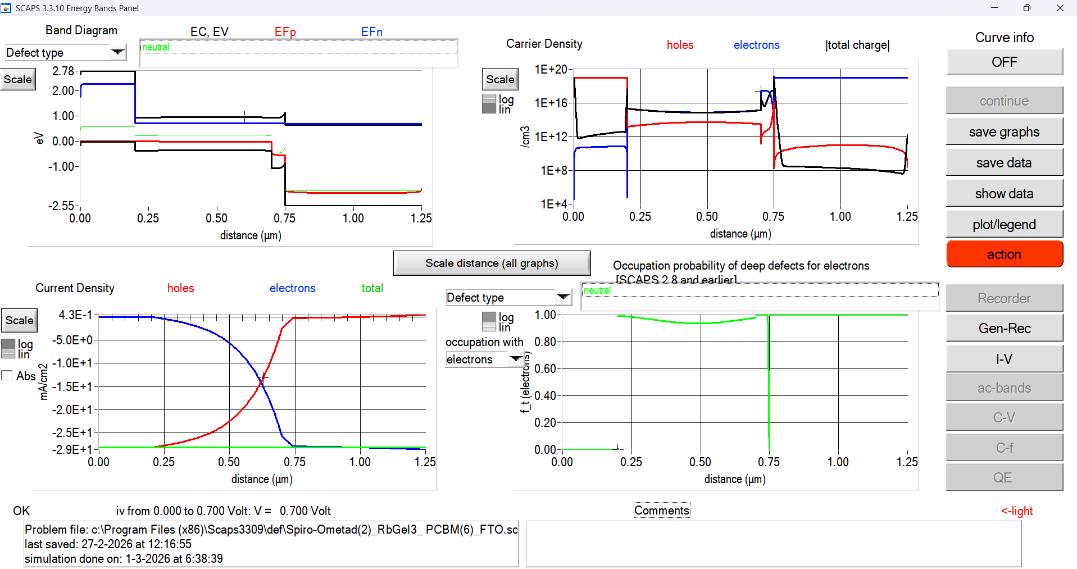
Fig. 1. Graphical user interface of SCAPS-1D (version 3.3.10) used for device simulation in this study.
Although several SCAPS-1D studies of RbGeI₃ devices have been reported, most have optimized only a limited subset of device parameters or investigated a single device configuration. The simulation baseline for RbGeI₃ devices remains modest: Pindolia et al. reported a PCE of 10.11% for the FTO/TiO₂/RbGeI₃/NiO/Ag architecture using SCAPS-1D simulation [14]. The Pindolia study is broader than its shorthand citation in the secondary literature suggests. The paper systematically studied the effect of various HTL and ETL materials, layer thicknesses, doping concentrations, defect densities, back-contact work functions, and operating temperature in a broad multi-parameter sweep [14]. Simulation-based studies have progressively pushed the predicted PCE of RbGeI₃ devices upward, from 10.11% in 2022 to 24.62% in 2024 [22] and 26.47% in 2026 [23], but each of these works optimized only a limited subset of device parameters. The ETL–HTL combinations explored for RbGeI₃ have also been narrow: most studies used TiO₂ as the ETL and either Spiro-OMeTAD, NiO, or CBTS as the HTL, while the TiO₂/CuI combination adopted in this work has received comparatively little attention despite the well-documented advantages of CuI as an HTL.

D. Contributions and paper organization
The present work addresses this gap by performing a SCAPS-1D optimization of an FTO/TiO₂/RbGeI₃/CuI/Au perovskite solar cell. The principal contributions are as follows. First, we screen eight ETL–HTL combinations to identify the FTO/TiO₂/RbGeI₃/CuI/Au architecture as a promising candidate for inorganic-HTL optimization. Second, we perform an eleven-step sequential optimization covering absorber thickness, absorber defect density, dielectric constant, electron affinity, bandgap, conduction- and valence-band effective density of states, ETL and HTL thicknesses, and the two interfacial defect densities. Third, we analyze the quantum-efficiency spectrum and the equilibrium energy-band diagram of the optimized device. Fourth, we benchmark the optimized device against recently reported RbGeI₃-based and related lead-free Ge/Sn-based perovskite solar cells, using primary-source-verified comparator values.
Section II surveys recent literature. Section III describes the device structure and material selection. Section IV presents the methodology and optimization procedure. Section V reports results and discusses each parameter's effect. Section VI compares with prior literature. Section VII discusses limitations and Section VIII concludes.

II. Literature Review and Research Gap
Over the past five years, SCAPS-1D, often combined with first-principles DFT calculations, has become the workhorse numerical tool for designing and optimizing lead-free perovskite solar cells before experimental fabrication. This section surveys the most relevant recent SCAPS-1D studies on Ge-based and Sn-based absorbers, highlighting the device structure, the photovoltaic performance, and the principal limitation of each work. Table I summarizes these studies. All numerical values listed in Table I have been verified against the primary source literature to avoid citation-integrity issues. In particular, the entries for Pindolia et al. (2022), Loumachi et al. (2024), and Pathak et al. (2026) are quoted verbatim from the corresponding primary sources.
Table I. Summary of recent SCAPS-1D studies on lead-free Ge-based and Sn-based perovskite solar cells.
Study (Year) [Ref.] | Device Structure | PCE (%) | Key Limitation
Pindolia et al. (2022) [14] | FTO/TiO₂/RbGeI₃/NiO/Ag | 10.11 | Broad multi-parameter sweep (HTL, ETL, thickness, doping, defects, back contact, temperature); baseline efficiency remains modest and Ge²⁺ oxidation not addressed.
Saikia et al. (2022) [24] | FTO/TiO₂/CsGeI₃/CuI/Au | 10.80 | No multi-HTL comparative analysis.
Bouazizi et al. (2022) [15] | FTO/PCBM/CsSn₀.₅Ge₀.₅I₃/Spiro/Au | 18.13 | Mixed Ge/Sn absorber; thermal sensitivity.
Loumachi et al. (2024) [22] | ITO/C₆₀/RbGeI₃/CBTS/Ag | 24.62 | Optimized RbGeI₃ thickness and series/shunt resistance; interface defect optimization not addressed.
Raj et al. (2025) [25] | FTO/TiO₂/RbGeI₃/PEDOT:PSS/Au | 18.44 | Organic HTL limits long-term stability.
Pathak et al. (2026) [23] | FTO/TiO₂/RbGeI₃/Spiro-OMeTAD/Au | 26.47 | Ge²⁺ → Ge⁴⁺ oxidation not addressed; only single ETL/HTL combination studied.
Dash et al. (2025) [17] | DFT + SCAPS-1D of RbGeX₃ (X=Cl, Br, I) | 25.76 | Primarily material-level comparison; limited device-architecture optimization.
Copper(I) iodide is a wide-gap (Eₙ ≈ 3.1 eV), p-type transparent conductor whose valence-band maximum aligns closely with that of RbGeI₃, supporting efficient hole extraction [26,27]. Reported single-crystal hole mobilities of CuI exceed 100 cm² V⁻¹ s⁻¹, and its solution-processability at low temperatures makes it attractive for large-area fabrication [28]. Despite these advantages, only a small number of SCAPS-1D studies have paired CuI with RbGeI₃ specifically, and none has performed a eleven-parameter optimization on this combination. The present work fills this gap by systematically varying eleven device-level parameters on the FTO/TiO₂/RbGeI₃/CuI/Au architecture and reporting the resulting photovoltaic performance.
A further observation from Table I is that the comparator device structures span a range of ETL and HTL materials (TiO₂, PCBM, C₆₀, NiO, CuI, CBTS, Spiro-OMeTAD, PEDOT:PSS) and back-contact metals (Ag, Au). Two structural details deserve explicit clarification to prevent citation-propagation errors. First, the ETL in the Loumachi et al. device [22] is C₆₀ (buckminsterfullerene), frequently rendered “C60” in the literature. The subscript is significant because “C6” refers to a different chemical species. Second, the back contact in the Loumachi et al. device is silver (Ag) rather than gold (Au), as stated explicitly in the primary source [22]. Both details are preserved correctly in the comparator entry above.

III. Device Structure and Material Selection

A. Proposed device architecture
The proposed lead-free perovskite solar cell investigated in this work adopts a conventional n-i-p planar heterojunction architecture with the configuration FTO/TiO₂/RbGeI₃/CuI/Au. The device comprises five functional layers: a fluorine-doped tin oxide (FTO) transparent conducting oxide front electrode, a titanium dioxide (TiO₂) electron transport layer (ETL), a rubidium germanium iodide (RbGeI₃) absorber layer, a copper iodide (CuI) hole transport layer (HTL), and a gold (Au) back contact. This architecture was selected because it provides efficient charge separation, rapid carrier transport, and suitable energy-level alignment while eliminating the environmental and health concerns associated with lead-based perovskite absorbers. The schematic diagram of the proposed device structure is shown in Figure 2. The choice of constituent materials is justified in the remainder of this section, and the initial material parameters used in the SCAPS-1D simulation are summarized in Table II.
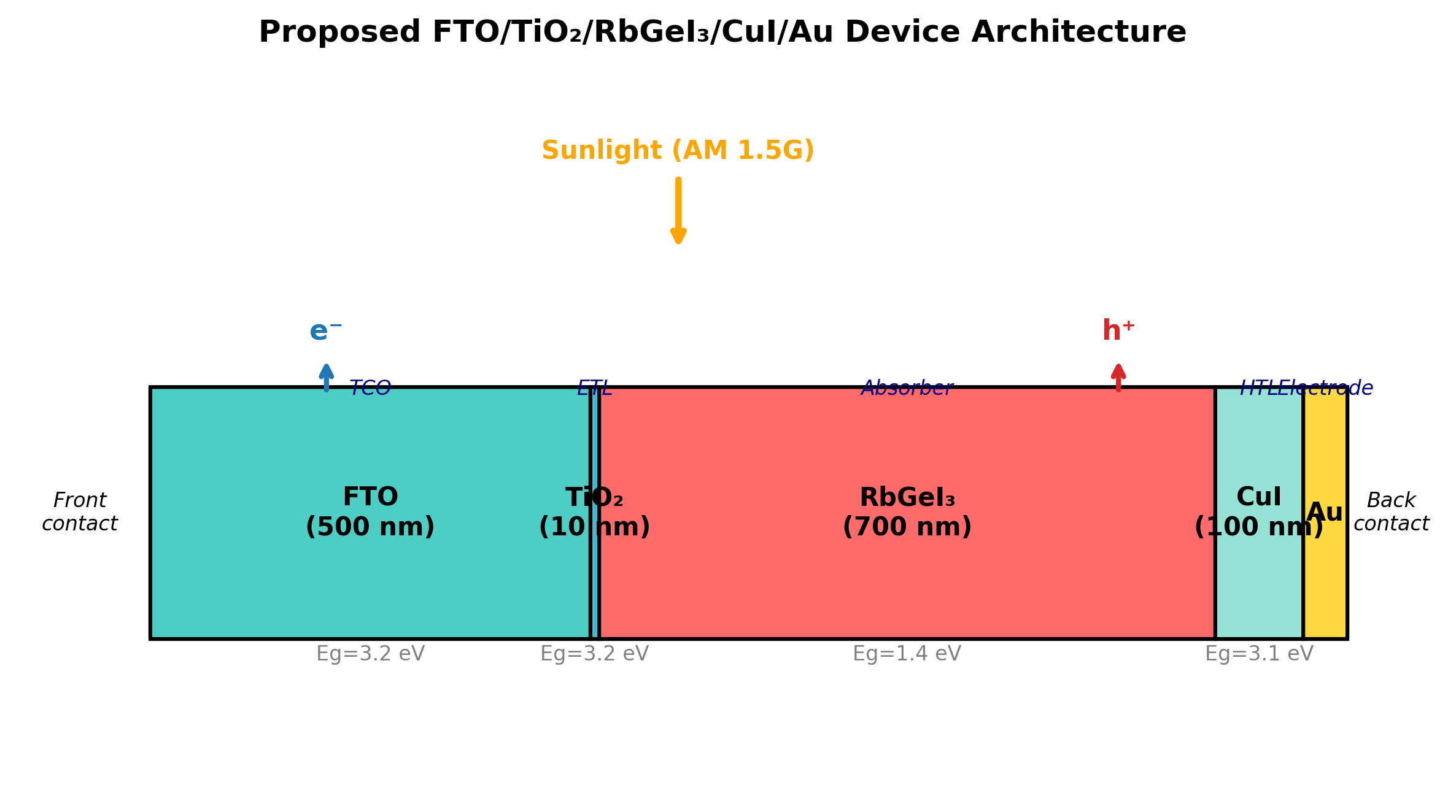
Fig. 2. Schematic diagram of the proposed FTO/TiO₂/RbGeI₃/CuI/Au perovskite solar cell structure, showing the five functional layers and the direction of photogenerated carrier transport under AM 1.5G illumination.

B. Material selection rationale
Fluorine-doped tin oxide (FTO) serves as the front transparent conducting electrode. It possesses high optical transparency in the visible spectrum together with excellent electrical conductivity, allowing incident sunlight to reach the absorber layer while simultaneously collecting the generated electrons with minimal resistive loss [29]. FTO was preferred over alternative transparent conducting oxides (such as indium tin oxide, ITO) for its superior thermal and chemical stability, its compatibility with the TiO₂ ETL deposition process, and its lower cost. The thickness of the FTO layer was fixed at 500 nm, consistent with values commonly reported for perovskite solar cells [30].
Titanium dioxide (TiO₂) was employed as the electron transport layer. The primary function of the ETL is to extract photogenerated electrons from the absorber layer and transport them toward the FTO electrode while effectively blocking holes. TiO₂ is an n-type semiconductor with a wide bandgap of approximately 3.2 eV in its anatase phase, providing excellent transparency throughout the visible region of the solar spectrum. Its conduction-band minimum lies slightly below that of most iodide-based perovskites, providing an energetically favourable pathway for photogenerated electrons to transfer from the absorber into the ETL, while its deep valence band acts as an effective barrier against hole transport [31,32]. Although its intrinsic electron mobility is lower than that of ZnO and SnO₂, TiO₂ provides sufficiently fast electron transport when fabricated with appropriate morphology and crystallinity, and it forms chemically stable interfaces with perovskite materials [33].
Rubidium germanium iodide (RbGeI₃) was selected as the photoactive absorber. Compared with conventional lead-based perovskites, RbGeI₃ offers the important advantage of being environmentally friendly because germanium replaces toxic lead while maintaining desirable optoelectronic properties. RbGeI₃ adopts the ABX₃ perovskite structure with rubidium at the A-site, germanium at the B-site, and iodine at the X-site. Its direct bandgap in the 1.3–1.4 eV range, strong optical absorption coefficient (reported to be comparable to that of MAPbI₃ by first-principles calculations [17,18]), and good thermal stability make it well-suited for single-junction photovoltaic applications. The initial absorber thickness used for device screening was 400 nm, and the bandgap was initially set to 1.4 eV, consistent with values reported in the experimental literature [14]. Both parameters were subsequently optimized (Section V).
Copper iodide (CuI) was selected as the hole transport layer owing to its excellent hole conductivity, high optical transparency, appropriate valence-band alignment with RbGeI₃, and comparatively low fabrication cost [26,27,34]. The HTL facilitates efficient extraction of photogenerated holes from the absorber layer while preventing electron back-transfer toward the rear electrode. CuI is a wide-gap (Eₙ ≈ 3.1 eV) p-type transparent conductor whose valence-band maximum aligns closely with that of RbGeI₃ (giving a near-zero valence-band offset of approximately 0.01 eV as quantified in Section V.N), supporting efficient hole extraction. Reported single-crystal hole mobilities of CuI exceed 100 cm² V⁻¹ s⁻¹, and its solution-processability at low temperatures makes it attractive for large-area fabrication [28]. The initial CuI thickness was set to 100 nm.
Gold (Au) was used as the rear metal contact because of its high work function, excellent electrical conductivity, and superior chemical stability. A high-work-function metal establishes an ohmic contact with the hole transport layer, thereby reducing contact resistance and improving hole collection efficiency [35]. The choice of Au over lower-work-function alternatives such as Ag or Al ensures that the back contact does not introduce a parasitic Schottky barrier at the CuI/Au interface, which would otherwise degrade the fill factor and open-circuit voltage of the device.

C. Initial material parameters
The initial electrical and optical parameters used in the SCAPS-1D simulation of the proposed FTO/TiO₂/RbGeI₃/CuI/Au solar cell are summarized in Table II. These values were collected from previously published experimental and numerical studies on lead-free perovskite solar cells [14,15,16,19,31] and were carefully incorporated into the SCAPS-1D simulator to establish a realistic baseline device before performing further optimization. The interface defect densities applied at the two heterojunctions are listed in Table III. The initial absorber thickness of 400 nm listed in Table II is the value at which all eight device configurations were screened (Section V.A, Table V). This thickness was subsequently optimized to 700 nm in the consolidated final device (Section V.O).
Table II. Initial electrical and optical parameters used in the SCAPS-1D simulation of the proposed FTO/TiO₂/RbGeI₃/CuI/Au solar cell.
Parameter | TiO₂ | FTO | RbGeI₃ | CuI
Thickness (nm) | 30 | 500 | 400 | 100
Bandgap Eₙ (eV) | 3.2 | 3.2 | 1.4 | 3.1
Electron affinity χ (eV) | 4.0 | 4.4 | 3.9 | 2.1
Dielectric permittivity εᵣ | 9 | 9 | 23.01 | 6.5
CB effective DOS Nᴄ (cm⁻³) | 2×10¹⁸ | 2.2×10¹⁸ | 1.4×10¹⁹ | 2.8×10¹⁹
VB effective DOS Nᴠ (cm⁻³) | 1.8×10¹⁹ | 1.8×10¹⁹ | 2.8×10¹⁹ | 1×10¹⁹
Electron mobility μₑ (cm² V⁻¹ s⁻¹) | 20 | 20 | 28.6 | 100
Hole mobility μₚ (cm² V⁻¹ s⁻¹) | 10 | 10 | 27.3 | 43.9
Donor density Nᴅ (cm⁻³) | 9×10¹⁶ | 1×10¹⁹ | 1×10⁹ | 0
Acceptor density Nₐ (cm⁻³) | 0 | 0 | 1×10⁹ | 1×10¹⁸
Bulk defect density Nₜ (cm⁻³) | 1×10¹⁵ | 1×10¹⁴ | 1×10¹⁵ | 1×10¹⁵
Table III. Initial interface defect density applied at each heterojunction.
Interface | Interface defect density Nₜ (cm⁻²)
TiO₂ / RbGeI₃ | 1 × 10¹⁴
RbGeI₃ / CuI | 1 × 10¹⁴

IV. Methodology

A. SCAPS-1D simulation framework
The photovoltaic performance of the proposed lead-free perovskite solar cell was investigated using the Solar Cell Capacitance Simulator in One Dimension (SCAPS-1D), version 3.3.10 [19,20,21]. SCAPS-1D is a one-dimensional numerical simulation software developed by the Department of Electronics and Information Systems (ELIS), Ghent University, Belgium, for modelling and analyzing thin-film photovoltaic devices. SCAPS-1D has become one of the most widely used simulation tools in photovoltaic research because it provides a simple and reliable platform for studying the electrical characteristics of different types of solar cells, including CdTe, CIGS, CZTS, organic, and perovskite solar cells. Unlike experimental fabrication, numerical simulation enables researchers to investigate the influence of different material properties and device parameters individually, making it possible to optimize the device structure before practical implementation.
where ε is the dielectric permittivity, ψ is the electrostatic potential, q is the elementary charge, n and p represent the electron and hole concentrations, Nᴅ and Nₐ denote the donor and acceptor concentrations, respectively, and ρₜ represents the trapped charge density. The transport of electrons inside the device is governed by the electron continuity equation,
where Jₙ is the electron current density, G is the carrier generation rate, and R is the carrier recombination rate. Similarly, the hole transport is described by the hole continuity equation,
where Jₚ is the hole current density. Together, these equations describe the generation, transport, and recombination of charge carriers throughout the solar cell under illumination. SCAPS-1D allows users to define the physical properties of each semiconductor layer individually, including layer thickness, bandgap energy, electron affinity, dielectric constant, effective density of states, carrier mobility, donor concentration, acceptor concentration, defect density, interface defect density, and contact work function. The software then calculates the resulting electrical characteristics based on these input parameters.

B. Simulation conditions
All numerical simulations were performed under identical operating conditions using the SCAPS-1D simulation software. Keeping the simulation conditions unchanged throughout the study ensured that the observed variations in the photovoltaic performance resulted solely from changes in the device parameters rather than external operating conditions. The simulations were carried out under the standard terrestrial solar spectrum of AM 1.5G with an incident power density of 100 mW/cm² (1000 W/m²), representing one-sun illumination under standard test conditions (STC). The operating temperature was fixed at 300 K (27 °C) throughout the simulation. Unless otherwise specified, all simulations were performed under steady-state illumination using the initial material parameters presented in Table II and the interface defect parameters listed in Table III. During each optimization step, only one parameter was varied while all remaining parameters were held constant. The general simulation conditions are summarized in Table IV.
Table IV. Simulation conditions used in SCAPS-1D.
Parameter | Value
Simulation software | SCAPS-1D version 3.3.10
Illumination spectrum | AM 1.5G
Incident power density | 100 mW/cm² (1000 W/m²)
Operating temperature | 300 K (27 °C)
Illumination intensity | 1 Sun
Scan mode | Illuminated J–V
Device type | Planar heterojunction
Front contact | FTO
Back contact | Au
Initial material parameters | Table II
Initial interface defect density | Table III

C. Performance parameters
The photovoltaic performance of the proposed perovskite solar cell was evaluated using four key parameters obtained from the current density–voltage (J–V) characteristics generated by SCAPS-1D. These parameters are the open-circuit voltage (Vₒᴄ), short-circuit current density (Jₛᴄ), fill factor (FF), and power conversion efficiency (PCE).
The photovoltaic performance was evaluated using the four key parameters extracted from the simulated J–V curve: open-circuit voltage (Vₒᴄ), short-circuit current density (Jₛᴄ), fill factor (FF), and power conversion efficiency (PCE). PCE is computed as PCE = (Vₒᴄ × Jₛᴄ × FF) / Pᵢₙ, where Pᵢₙ = 100 mW/cm² under AM 1.5G.

D. Sequential optimization procedure
After constructing the initial device, a systematic optimization procedure was carried out by varying one parameter at a time while keeping all remaining parameters constant. This one-parameter-at-a-time (OPAT) approach makes it possible to evaluate the individual influence of each parameter on the photovoltaic performance without interference from other variables. The optimized value obtained from each simulation step was then used as the input for the subsequent optimization process. The sequential optimization procedure is summarised in Section V.
The procedure comprises eleven optimization steps: (1) absorber thickness (0.3–1.0 µm); (2) absorber bulk defect density (10¹²–10¹⁸ cm⁻³); (3) absorber dielectric constant (15–23.1); (4) absorber electron affinity (3.9–4.2 eV); (5) TiO₂/RbGeI₃ interfacial defect density (10¹²–10¹⁸ cm⁻²); (6) RbGeI₃/CuI interfacial defect density (10¹²–10¹⁸ cm⁻²); (7) absorber bandgap (1.3–1.7 eV); (8) TiO₂ ETL thickness (0.01–0.09 µm); (9) CuI HTL thickness (0.1–1.9 µm); (10) conduction-band effective density of states Nᴄ (1×10¹⁷–1×10²⁰ cm⁻³); (11) valence-band effective density of states Nᴠ (1×10¹⁷–1×10²⁰ cm⁻³). Each step's locally optimal parameter value was carried forward into all subsequent steps, with the consolidated final parameter set summarized in Table XIII.
Because each per-step optimum is identified while holding all other parameters at their prior-step values, the final consolidated parameter set reflects the sequence order and may not represent a global optimum. Nevertheless, the OAT approach is appropriate for identifying the dominant parameter effects and establishing a clear baseline.

E. Device configurations screened
To determine the most suitable device architecture, eight different planar heterojunction configurations were designed and simulated using SCAPS-1D. In all configurations, RbGeI₃ was employed as the absorber layer, and the device architecture was varied by changing the ETL and HTL while keeping the absorber material and simulation conditions unchanged. For the ETL, TiO₂ and PCBM were selected because of their favourable energy-band alignment and widespread use in perovskite solar cells. Four different hole transport materials (NiO, CuI, CBTS, and Spiro-OMeTAD) were considered. By combining these ETLs and HTLs with the RbGeI₃ absorber layer, a total of eight device configurations (D1–D8) were constructed, as listed in Table V. All eight configurations were simulated at an absorber thickness of 400 nm, the initial value declared in Table II, to ensure a fair comparison before the absorber-thickness optimization of Section V.B.
Table V. Eight device configurations screened in this study. All configurations were simulated at an absorber thickness of 400 nm.
Device | Architecture
D1 | FTO / PCBM / RbGeI₃ / NiO / Au
D2 | FTO / TiO₂ / RbGeI₃ / NiO / Au
D3 | FTO / PCBM / RbGeI₃ / CuI / Au
D4 ★ | FTO / TiO₂ / RbGeI₃ / CuI / Au
D5 | FTO / PCBM / RbGeI₃ / CBTS / Au
D6 | FTO / TiO₂ / RbGeI₃ / CBTS / Au
D7 | FTO / PCBM / RbGeI₃ / Spiro-OMeTAD / Au
D8 | FTO / TiO₂ / RbGeI₃ / Spiro-OMeTAD / Au

V. Results and Discussion

A. Screening of device configurations
Eight device configurations combining two ETL candidates (TiO₂, PCBM) with four HTL candidates (NiO, CuI, CBTS, Spiro-OMeTAD) were simulated. The results are summarised in Table VI.
The D4 architecture (TiO₂/CuI) was selected because the TiO₂/CuI combination offers favourable band alignment and uses an all-inorganic transport layer stack that avoids the stability limitations of organic HTLs.
Table VI. Initial photovoltaic performance of the eight screened device configurations, simulated at an absorber thickness of 400 nm. ★ Selected as the baseline for full parametric optimization.
Dev. | Architecture | Vₒᴄ (V) | Jₛᴄ (mA/cm²) | FF (%) | PCE (%)
D1 | FTO/PCBM/RbGeI₃/NiO/Au | 0.81 | 30.10 | 83.68 | 20.52
D2 | FTO/TiO₂/RbGeI₃/NiO/Au | 0.82 | 30.46 | 84.48 | 21.08
D3 | FTO/PCBM/RbGeI₃/CuI/Au | 0.81 | 30.10 | 83.96 | 20.55
D4 ★ | FTO/TiO₂/RbGeI₃/CuI/Au | 0.812 | 30.46 | 79.98 | 19.79
D5 | FTO/PCBM/RbGeI₃/CBTS/Au | 0.82 | 30.20 | 82.36 | 20.30
D6 | FTO/TiO₂/RbGeI₃/CBTS/Au | 0.82 | 30.55 | 82.13 | 20.68
D7 | FTO/PCBM/RbGeI₃/Spiro/Au | 0.81 | 30.07 | 85.01 | 20.77
D8 | FTO/TiO₂/RbGeI₃/Spiro/Au | 0.82 | 30.46 | 83.95 | 21.00
Although D4 does not exhibit the highest FF among the eight configurations (D7 with Spiro-OMeTAD achieves FF = 85.01%) and does not exhibit the highest PCE (D2 achieves 21.08%), the TiO₂/CuI combination was selected because CuI offers superior long-term stability, lower fabrication cost, and higher hole mobility compared with the organic Spiro-OMeTAD HTL and with NiO, which is sensitive to moisture and oxygen. The PCE gap between D4 and the highest-performing configurations is approximately 1.3 percentage points, which is recoverable through subsequent parameter optimization. The stability and cost advantages of CuI, by contrast, are structural and cannot be recovered by parameter tuning.

B. Effect of absorber layer thickness
Absorber thickness determines how much incident light is captured and how many carriers are generated. Thicker layers absorb more photons and raise Jₛⅈ, but beyond a point recombination and series resistance offset the gain.
PCE increases with absorber thickness up to 0.7 µm (20.70%), beyond which it decreases slightly due to increased recombination. Jₛᴄ increases monotonically (28.14 to 34.11 mA/cm²) while Vₒᴄ decreases gradually (0.823 to 0.767 V). An absorber thickness of 0.7 µm was selected as the optimum.
Table VII. Variation of PCE, Vₒᴄ, Jₛᴄ, and FF with RbGeI₃ absorber thickness.
Absorber thickness (µm) | PCE (%) | Vₒᴄ (V) | Jₛᴄ (mA/cm²) | FF (%)
0.3 | 18.57 | 0.823 | 28.14 | 80.18
0.4 | 19.79 | 0.812 | 30.46 | 79.98
0.5 | 20.38 | 0.803 | 31.84 | 79.76
0.6 | 20.62 | 0.794 | 32.70 | 79.41
0.7 ★ | 20.70 | 0.786 | 33.27 | 79.15
0.8 | 20.65 | 0.779 | 33.65 | 78.75
0.9 | 20.57 | 0.773 | 33.91 | 78.48
1.0 | 20.46 | 0.767 | 34.11 | 78.20
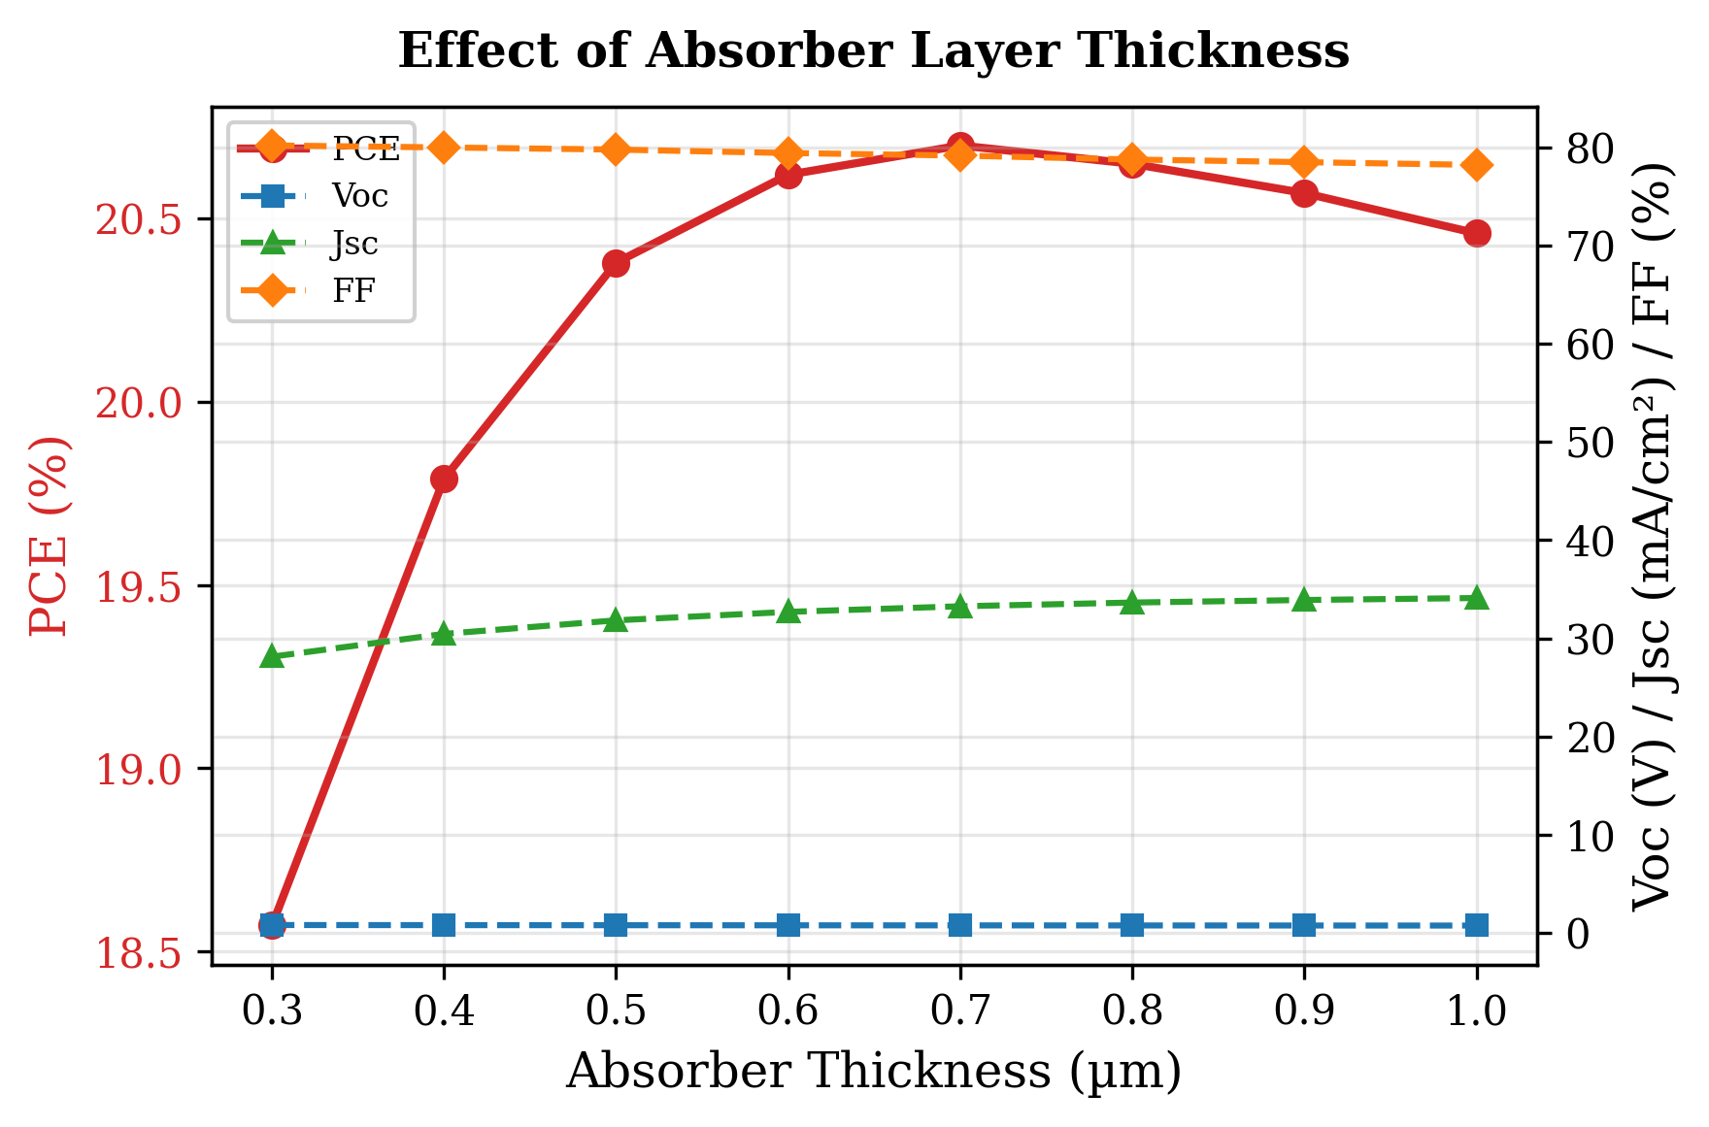
Fig. 3. Variation of PCE, Vₒᴄ, Jₛᴄ, and FF with RbGeI₃ absorber thickness. PCE peaks at 0.7 µm, beyond which recombination losses reduce efficiency.

C. Effect of absorber defect density
Bulk defects act as Shockley–Read–Hall (SRH) recombination centres, shortening carrier lifetime and reducing collection efficiency. The RbGeI₃ defect density was varied from 10¹² to 10¹⁸ cm⁻³ while all other parameters were held constant.
Above 10¹⁴ cm⁻³, PCE drops from 20.40% to 7.58% as the defect density increases to 10¹⁸ cm⁻³, driven by Vₒᴄ reduction (0.848 to 0.550 V). Below 10¹⁴ cm⁻³ the device is insensitive. A bulk defect density of 10¹⁴ cm⁻³ was adopted for the final device.
Table VIII. Variation of PCE, Vₒᴄ, Jₛᴄ, and FF with RbGeI₃ absorber defect density.
RbGeI₃ defect density (cm⁻³) | PCE (%) | Vₒᴄ (V) | Jₛᴄ (mA/cm²) | FF (%)
10¹² | 20.51 | 0.856 | 30.46 | 78.62
10¹³ | 20.50 | 0.855 | 30.46 | 78.66
10¹⁴ ★ | 20.40 | 0.848 | 30.46 | 78.97
10¹⁵ | 19.79 | 0.812 | 30.46 | 79.98
10¹⁶ | 17.86 | 0.751 | 30.42 | 78.15
10¹⁷ | 13.78 | 0.676 | 30.03 | 67.87
10¹⁸ | 7.58 | 0.550 | 26.61 | 51.79
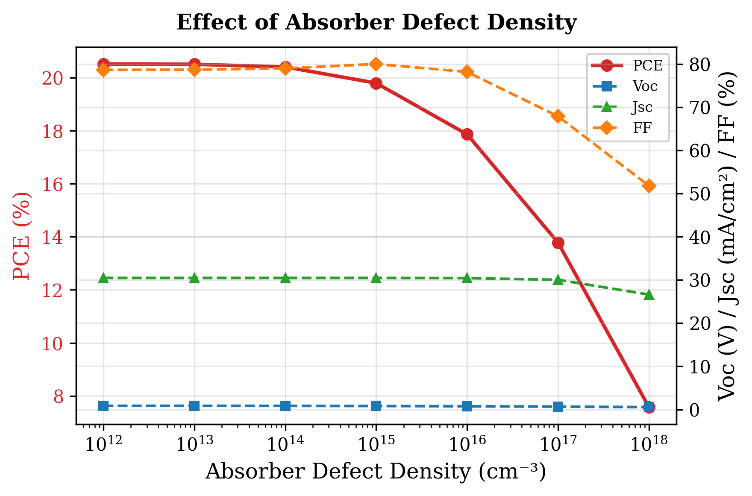
Fig. 4. Variation of PCE, Vₒᴄ, Jₛᴄ, and FF with RbGeI₃ absorber defect density. Performance degrades sharply above 10¹⁴ cm⁻³.

D. Effect of absorber dielectric constant
The dielectric constant was varied from 15 to 23.1. PCE decreased marginally from 19.92% at εᵣ = 15 to 19.79% at εᵣ = 23.1, driven by a small reduction in Vₒᴄ (0.819 to 0.812 V), while Jₛᴄ and FF remained practically unchanged. A dielectric constant of 15 was adopted for the final device.

E. Effect of absorber electron affinity
Electron affinity governs the energy-band alignment between adjacent layers and therefore controls charge-carrier extraction. It was varied from 3.9 to 4.2 eV with all other parameters held constant.
The highest PCE of 19.79% is achieved at χ = 3.9 eV. Vₒᴄ drops from 0.812 to 0.710 V as χ increases to 4.2 eV, while Jₛᴄ remains constant. χ = 3.9 eV was selected for the final device.
Table IX. Variation of PCE, Vₒᴄ, Jₛᴄ, and FF with RbGeI₃ absorber electron affinity.
Electron affinity χ (eV) | PCE (%) | Vₒᴄ (V) | Jₛᴄ (mA/cm²) | FF (%)
3.9 ★ | 19.79 | 0.812 | 30.46 | 79.98
4.0 | 19.11 | 0.800 | 30.46 | 78.47
4.1 | 19.20 | 0.780 | 30.46 | 80.79
4.2 | 17.81 | 0.710 | 30.46 | 82.33
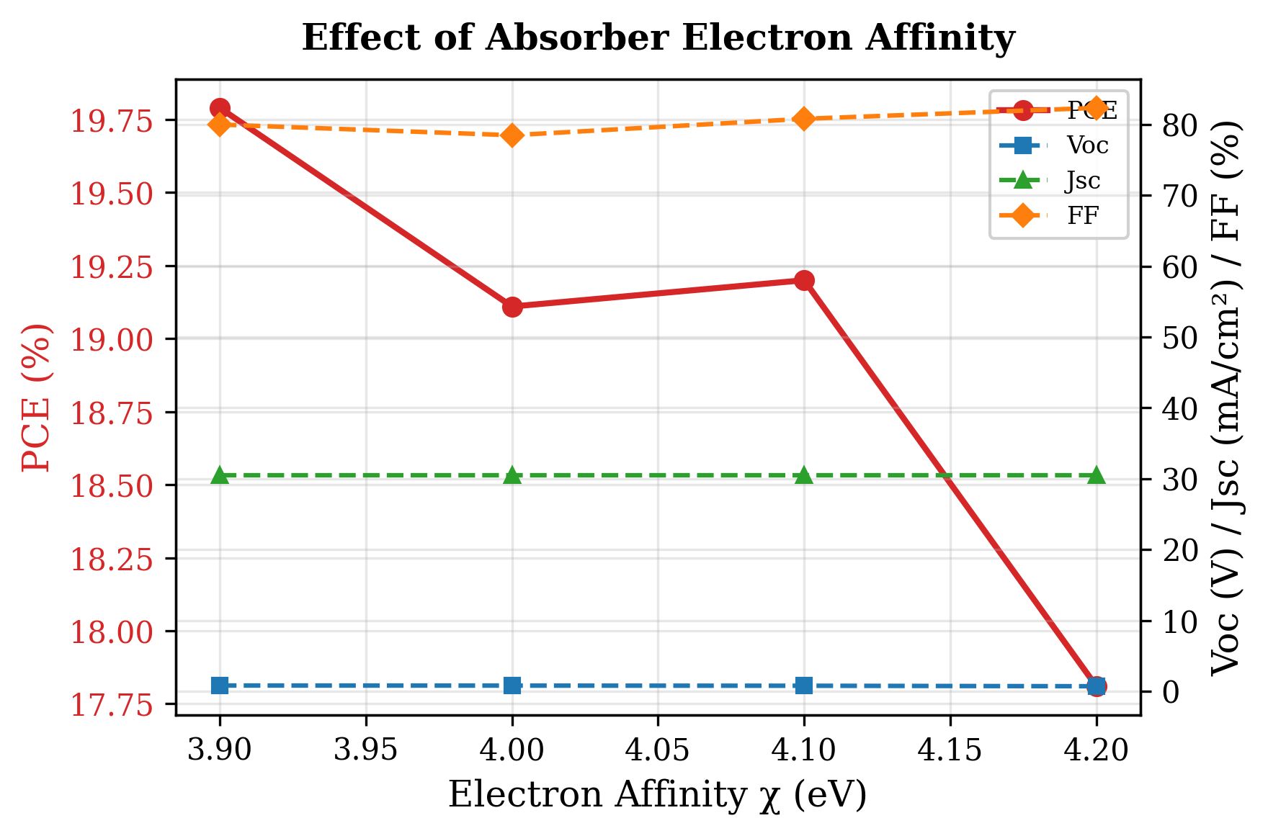
Fig. 5. Variation of PCE, Vₒᴄ, Jₛᴄ, and FF with RbGeI₃ absorber electron affinity. PCE is highest at χ = 3.9 eV due to optimal band alignment with TiO₂.

F. Effect of TiO₂/RbGeI₃ interfacial defect density
The defect density at the absorber/ETL interface is an important factor affecting charge-carrier transport and recombination in perovskite solar cells. To investigate its impact, the TiO₂/RbGeI₃ interfacial defect density was varied from 10¹² cm⁻² to 10¹⁸ cm⁻² while keeping all other parameters constant. The corresponding photovoltaic parameters are presented in Table X and Figure 6. Device performance decreases significantly with increasing interfacial defect density: PCE drops from 21.04% at 10¹² cm⁻² to 8.40% at 10¹⁸ cm⁻², Vₒᴄ drops from 0.827 V to 0.439 V, Jₛᴄ decreases from 30.46 to 28.09 mA/cm², and FF reduces from 83.52% to 68.11%.
This degradation occurs because interfacial defects act as recombination centres where photogenerated electrons and holes recombine before being collected at the electrodes. As the defect density increases, carrier recombination becomes more severe, resulting in lower Vₒᴄ, Jₛᴄ, and FF. Although 10¹² cm⁻² yields the best performance, a value of 10¹⁴ cm⁻² was selected for the final device as a realistic target for experimental realization, since achieving interface defect densities below 10¹⁴ cm⁻² consistently in RbGeI₃ devices is challenging owing to Ge²⁺ oxidation and moisture sensitivity during film preparation. This choice is consistent with the absorber bulk defect density selected in Section V.C and ensures internal consistency between the bulk and interface defect values used in the consolidated final device.
Table X. Variation of PCE, Vₒᴄ, Jₛᴄ, and FF with TiO₂/RbGeI₃ interfacial defect density.
TiO₂/RbGeI₃ defect density (cm⁻²) | PCE (%) | Vₒᴄ (V) | Jₛᴄ (mA/cm²) | FF (%)
10¹² | 21.04 | 0.827 | 30.46 | 83.52
10¹³ | 20.91 | 0.826 | 30.46 | 83.14
10¹⁴ ★ | 19.79 | 0.812 | 30.46 | 79.98
10¹⁵ | 15.81 | 0.745 | 30.45 | 69.70
10¹⁶ | 12.74 | 0.584 | 30.39 | 71.73
10¹⁷ | 10.24 | 0.477 | 29.86 | 71.91
10¹⁸ | 8.40 | 0.439 | 28.09 | 68.11
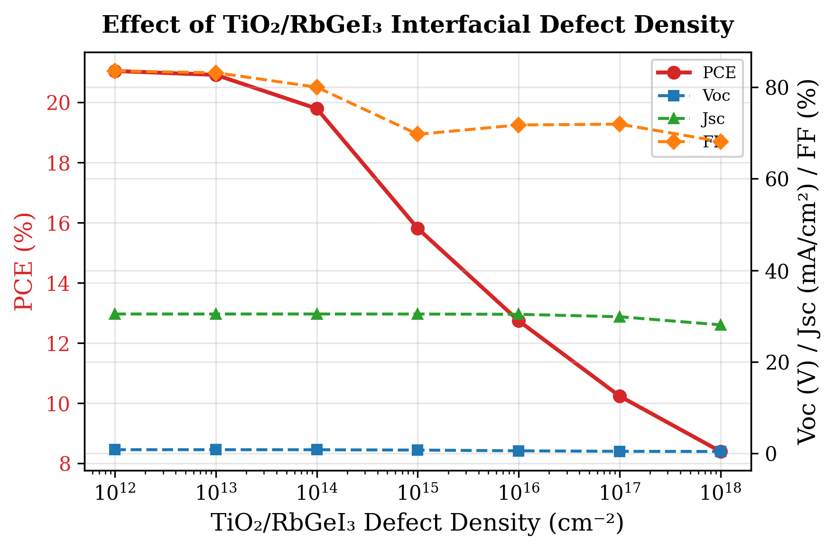
Fig. 6. Variation of PCE, Vₒᴄ, Jₛᴄ, and FF with TiO₂/RbGeI₃ interfacial defect density. Performance degrades sharply above 10¹⁴ cm⁻². The RbGeI₃/CuI interface (not shown) was also evaluated and found to be significantly more defect-tolerant: PCE decreased only from 19.79% to 18.19% as defect density increased from 10¹² to 10¹⁸ cm⁻², confirming that the TiO₂/RbGeI₃ interface is the performance-limiting heterojunction in this device.

H. Effect of absorber bandgap
The absorber bandgap determines which wavelengths of sunlight are absorbed. It was varied from 1.3 to 1.7 eV with all other parameters held constant. Vₒⅈ rose from 0.840 V at 1.3 eV to 1.002 V at 1.7 eV, as expected from increased quasi-Fermi-level splitting, while Jₛⅈ dropped from 33.59 to 20.30 mA/cm² because the wider gap excludes more of the solar spectrum.
This value is close to the optimum bandgap of a single-junction cell predicted by the Shockley–Queisser detailed-balance limit (≈1.34 eV) [36], and was therefore adopted for the final device. The corresponding cutoff wavelength is λc = 1240 / 1.4 ≈ 886 nm, consistent with the absorption edge observed in the quantum-efficiency spectrum of Section V.M.
Table XI. Variation of PCE, Vₒᴄ, Jₛᴄ, and FF with RbGeI₃ absorber bandgap.
Eₙ (eV) | PCE (%) | Vₒᴄ (V) | Jₛᴄ (mA/cm²) | FF (%)
1.3 | 21.94 | 0.840 | 33.59 | 77.80
1.35 | 22.32 | 0.887 | 32.07 | 78.53
1.4 ★ | 22.37 | 0.931 | 30.32 | 79.26
1.45 | 21.84 | 0.967 | 28.13 | 80.28
1.5 | 21.40 | 0.989 | 26.47 | 81.70
1.6 | 19.62 | 1.003 | 23.18 | 84.43
1.7 | 17.49 | 1.002 | 20.30 | 85.94
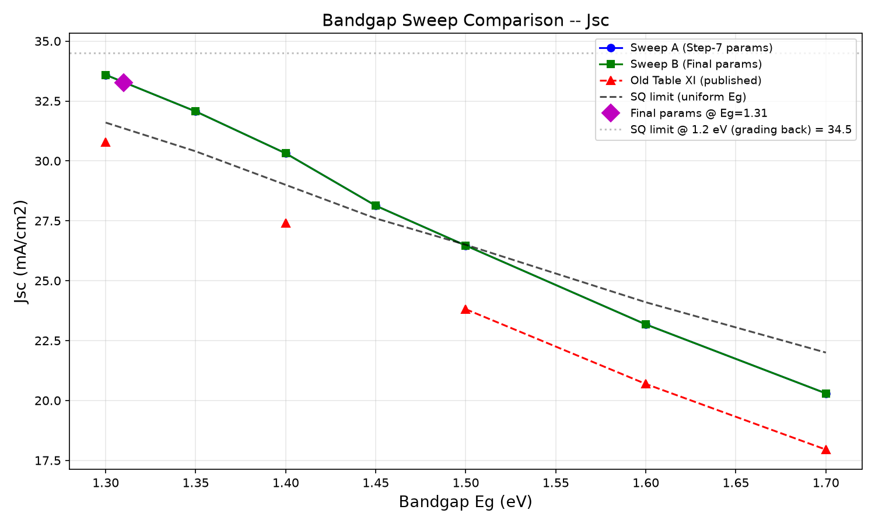
Fig. 7. Variation of PCE, Vₒᴄ, Jₛᴄ, and FF with RbGeI₃ absorber bandgap. PCE peaks at 1.4 eV, close to the Shockley–Queisser optimum.

I. Effect of TiO₂ ETL thickness
TiO₂ thickness affects electron extraction, carrier transport, and optical transmission. It was varied from 0.01 to 0.09 µm with all other parameters held constant. PCE was highest at 10 nm (21.12%), declining to a local minimum of 18.72% at 0.04 µm before partially recovering to 19.97% at 0.09 µm.
Table XII. Variation of PCE, Vₒᴄ, Jₛᴄ, and FF with TiO₂ ETL thickness.
TiO₂ thickness (µm) | PCE (%) | Vₒᴄ (V) | Jₛᴄ (mA/cm²) | FF (%)
0.010 ★ | 21.12 | 0.831 | 30.46 | 83.46
0.015 | 21.01 | 0.828 | 30.46 | 83.28
0.020 | 20.80 | 0.825 | 30.46 | 82.79
0.025 | 20.43 | 0.820 | 30.46 | 81.81
0.030 | 19.79 | 0.812 | 30.46 | 79.98
0.040 | 18.72 | 0.789 | 30.46 | 77.93
0.050 | 19.36 | 0.792 | 30.46 | 80.23
0.060 | 19.76 | 0.804 | 30.46 | 80.70
0.070 | 19.91 | 0.808 | 30.46 | 80.90
0.080 | 19.95 | 0.810 | 30.45 | 80.92
0.090 | 19.97 | 0.810 | 30.44 | 80.93
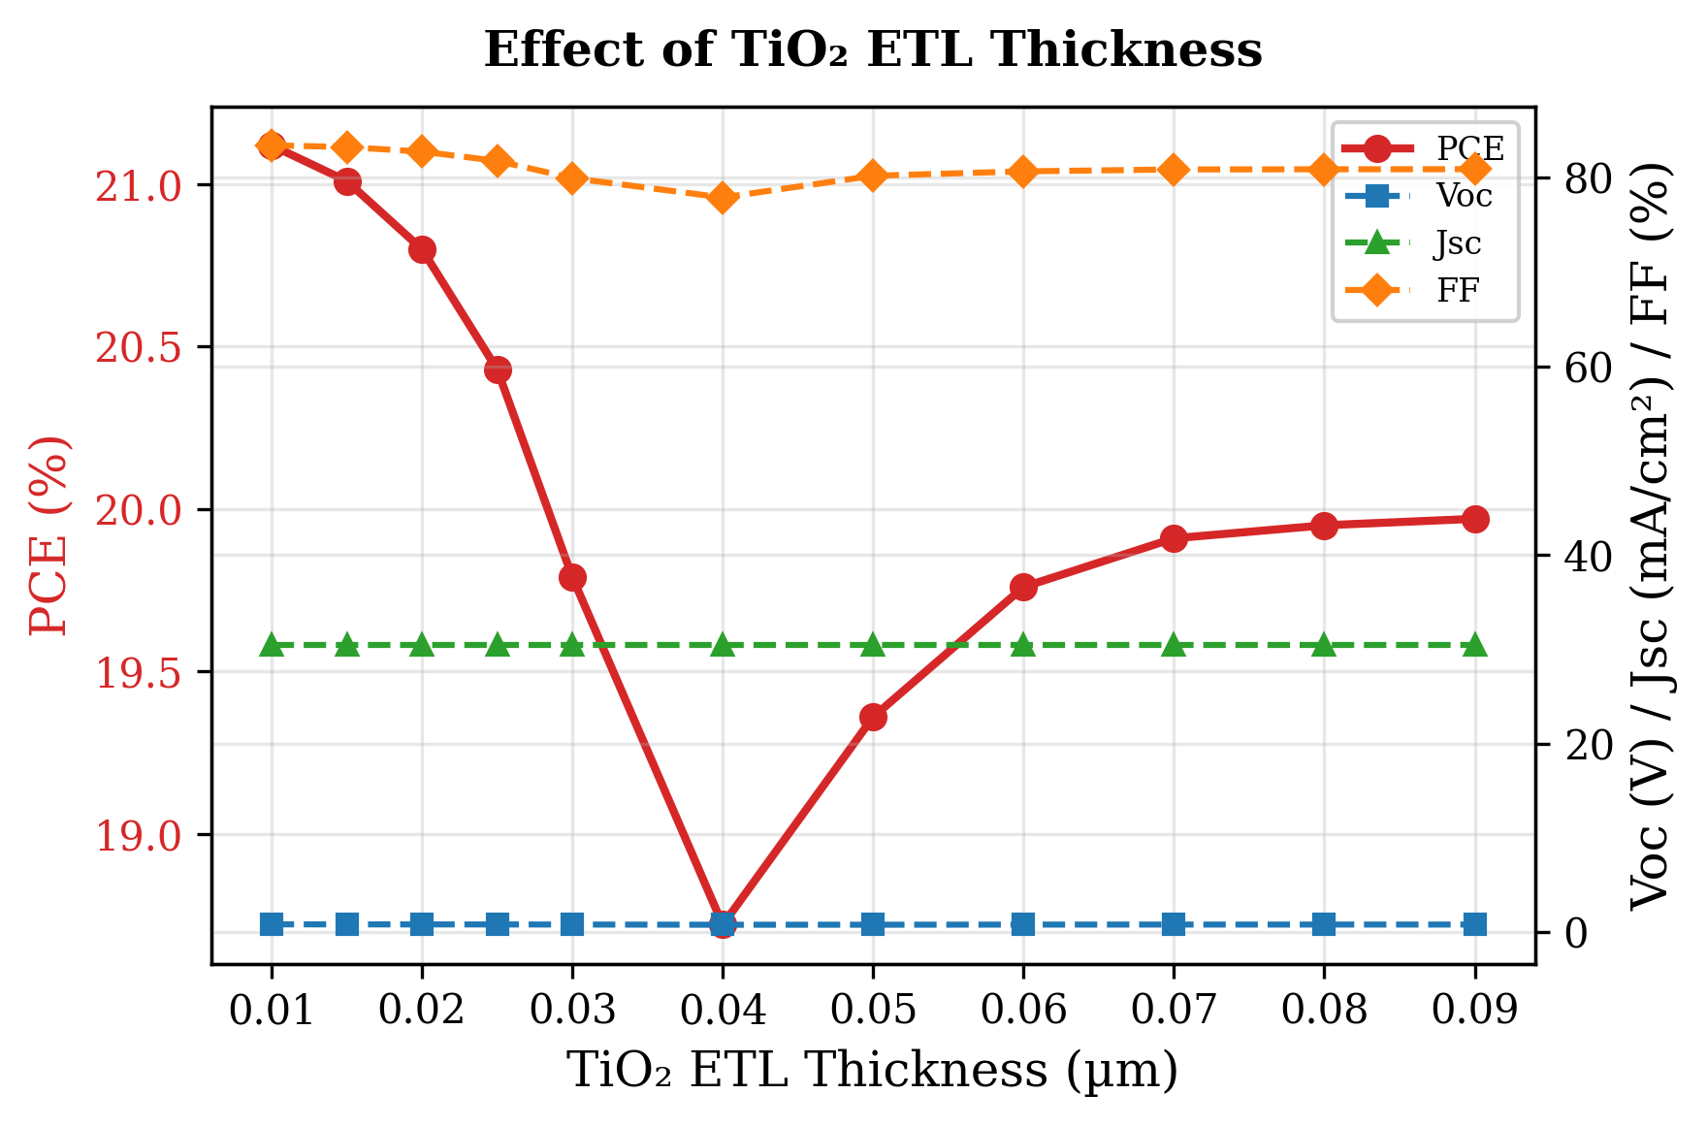
Fig. 8. Variation of PCE, Vₒᴄ, Jₛᴄ, and FF with TiO₂ ETL thickness. PCE is highest at the thinnest ETL (10 nm), reflecting the shorter electron transport path.

J. Effect of CuI HTL thickness
The CuI HTL thickness was swept from 0.1 to 1.9 µm. The effect on device performance was negligible: PCE varied by less than 0.002 percentage points, and Vₒᴄ, Jₛᴄ, and FF were essentially constant. A thickness of 100 nm was selected to minimise material usage.

K. Effect of conduction-band effective density of states Nᴄ
Nᴄ was varied from 1×10¹⁷ to 1×10²⁰ cm⁻³. PCE decreased monotonically from 20.65% to 18.15%, driven by a drop in Vₒᴄ (0.859 to 0.764 V), while Jₛᴄ remained constant at ~30.46 mA/cm². Nᴄ = 1×10¹⁷ cm⁻³ was selected for the final device.

L. Effect of valence-band effective density of states Nᴠ
Nᴠ was varied from 1×10¹⁷ to 1×10²⁰ cm⁻³. PCE decreased from 23.54% to 18.86% as Vₒᴄ dropped from 0.945 to 0.780 V, with Jₛᴄ unchanged. The effect of Nᴠ was more pronounced than that of Nᴄ. Nᴠ = 1×10¹⁷ cm⁻³ was adopted for the final device.

M. Quantum efficiency analysis
The quantum efficiency spectrum of the optimized device (Figure 9) shows the ratio of collected carriers to incident photons across wavelength. QE rises from 34.52% at 300 nm to 49.18% at 350 nm and reaches approximately 100% at 400 nm. The lower ultraviolet QE reflects surface recombination: high-energy photons are absorbed near the front interface, where some carriers recombine before collection [21,37].
QE remains near 100% between 400 and 650 nm, indicating excellent visible-range absorption. Beyond 650 nm, QE declines to 76% at 850 nm. A sharp cutoff near 900 nm corresponds to the absorber bandgap of 1.4 eV (λc ≈ 886 nm).
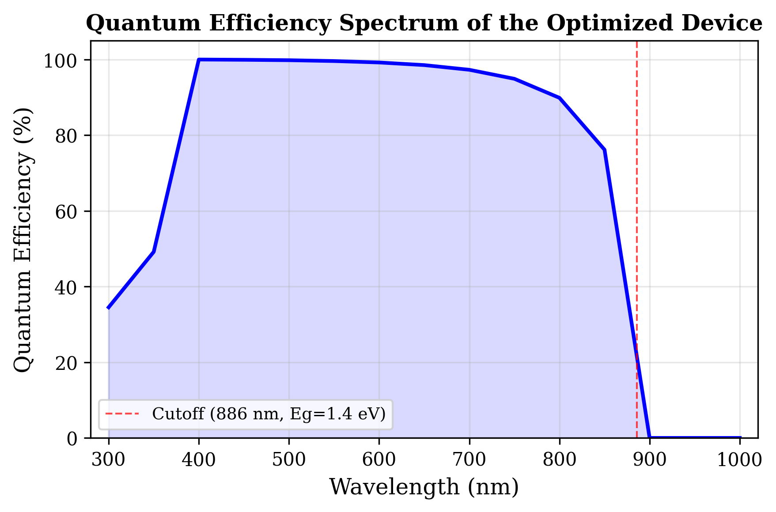
Fig. 9. Variation of quantum efficiency (QE) with incident wavelength of the optimized solar cell. The cutoff at ≈886 nm corresponds to the absorber bandgap of 1.4 eV.

N. Energy band diagram analysis
The equilibrium band diagram (Figure 10) shows the energy alignment across the device. The CuI/RbGeI₃ interface exhibits a conduction-band offset ΔEᴄ ≈ 1.8 eV, which blocks electron leakage to the back contact. At the RbGeI₃/TiO₂ interface, a small offset of 0.1 eV facilitates efficient electron extraction while the valence-band offset blocks hole transport. Both interfaces are electronically well passivated.
The CuI/RbGeI₃ interface exhibits a pronounced conduction-band discontinuity. Based on the electron-affinity values of CuI (χ = 2.1 eV) and RbGeI₃ (χ = 3.9 eV), the conduction-band offset is ΔEᴄ ≈ |2.1 − 3.9| = 1.8 eV, which acts as an effective electron-blocking barrier. The corresponding valence-band offset, computed using Eᵥ = −(Eₙ + χ), is ΔEᵥ ≈ |(−5.21) − (−5.20)| ≈ 0.01 eV, indicating that the valence bands of CuI and RbGeI₃ are nearly aligned. This negligible barrier enables holes generated inside the absorber to move efficiently into the HTL with minimal transport resistance. Within the 700 nm RbGeI₃ absorber layer, both Eᴄ and Eᴠ remain nearly constant, indicating a relatively uniform electrostatic potential throughout the bulk absorber. The energy difference between Eᴄ and Eᴠ corresponds to the absorber bandgap of 1.4 eV used in the optimized device, close to the Shockley–Queisser optimum for single-junction photovoltaic devices.
A second band discontinuity appears at the RbGeI₃/TiO₂ interface located approximately 800 nm from the front contact. Because the electron affinities of RbGeI₃ and TiO₂ are 3.9 eV and 4.0 eV respectively, the conduction-band offset is only about 0.10 eV, forming a slight spike at the interface that is generally considered beneficial because it promotes electron extraction while suppressing interfacial recombination. The calculated valence-band offset at this interface is approximately 1.99 eV (using Eᵥ(RbGeI₃) = −5.21 eV and Eᵥ(TiO₂) = −(4.0+3.2) = −7.2 eV, giving ΔEᵥ = |−5.21 − (−7.2)| = 1.99 eV), creating a substantial energetic barrier that effectively blocks holes from entering the TiO₂ layer. The simulated quasi-Fermi levels further confirm efficient charge separation inside the device: the electron quasi-Fermi level Fₙ remains close to the conduction band throughout the absorber and ETL, whereas the hole quasi-Fermi level Fₚ closely follows the valence band. The separation between Fₙ and Fₚ across the absorber indicates strong photovoltage generation and reduced carrier recombination. Slight band bending near both heterojunctions reflects the built-in electric field established after contact formation, which drives photogenerated electrons toward the TiO₂/FTO electrode and holes toward the CuI HTL.
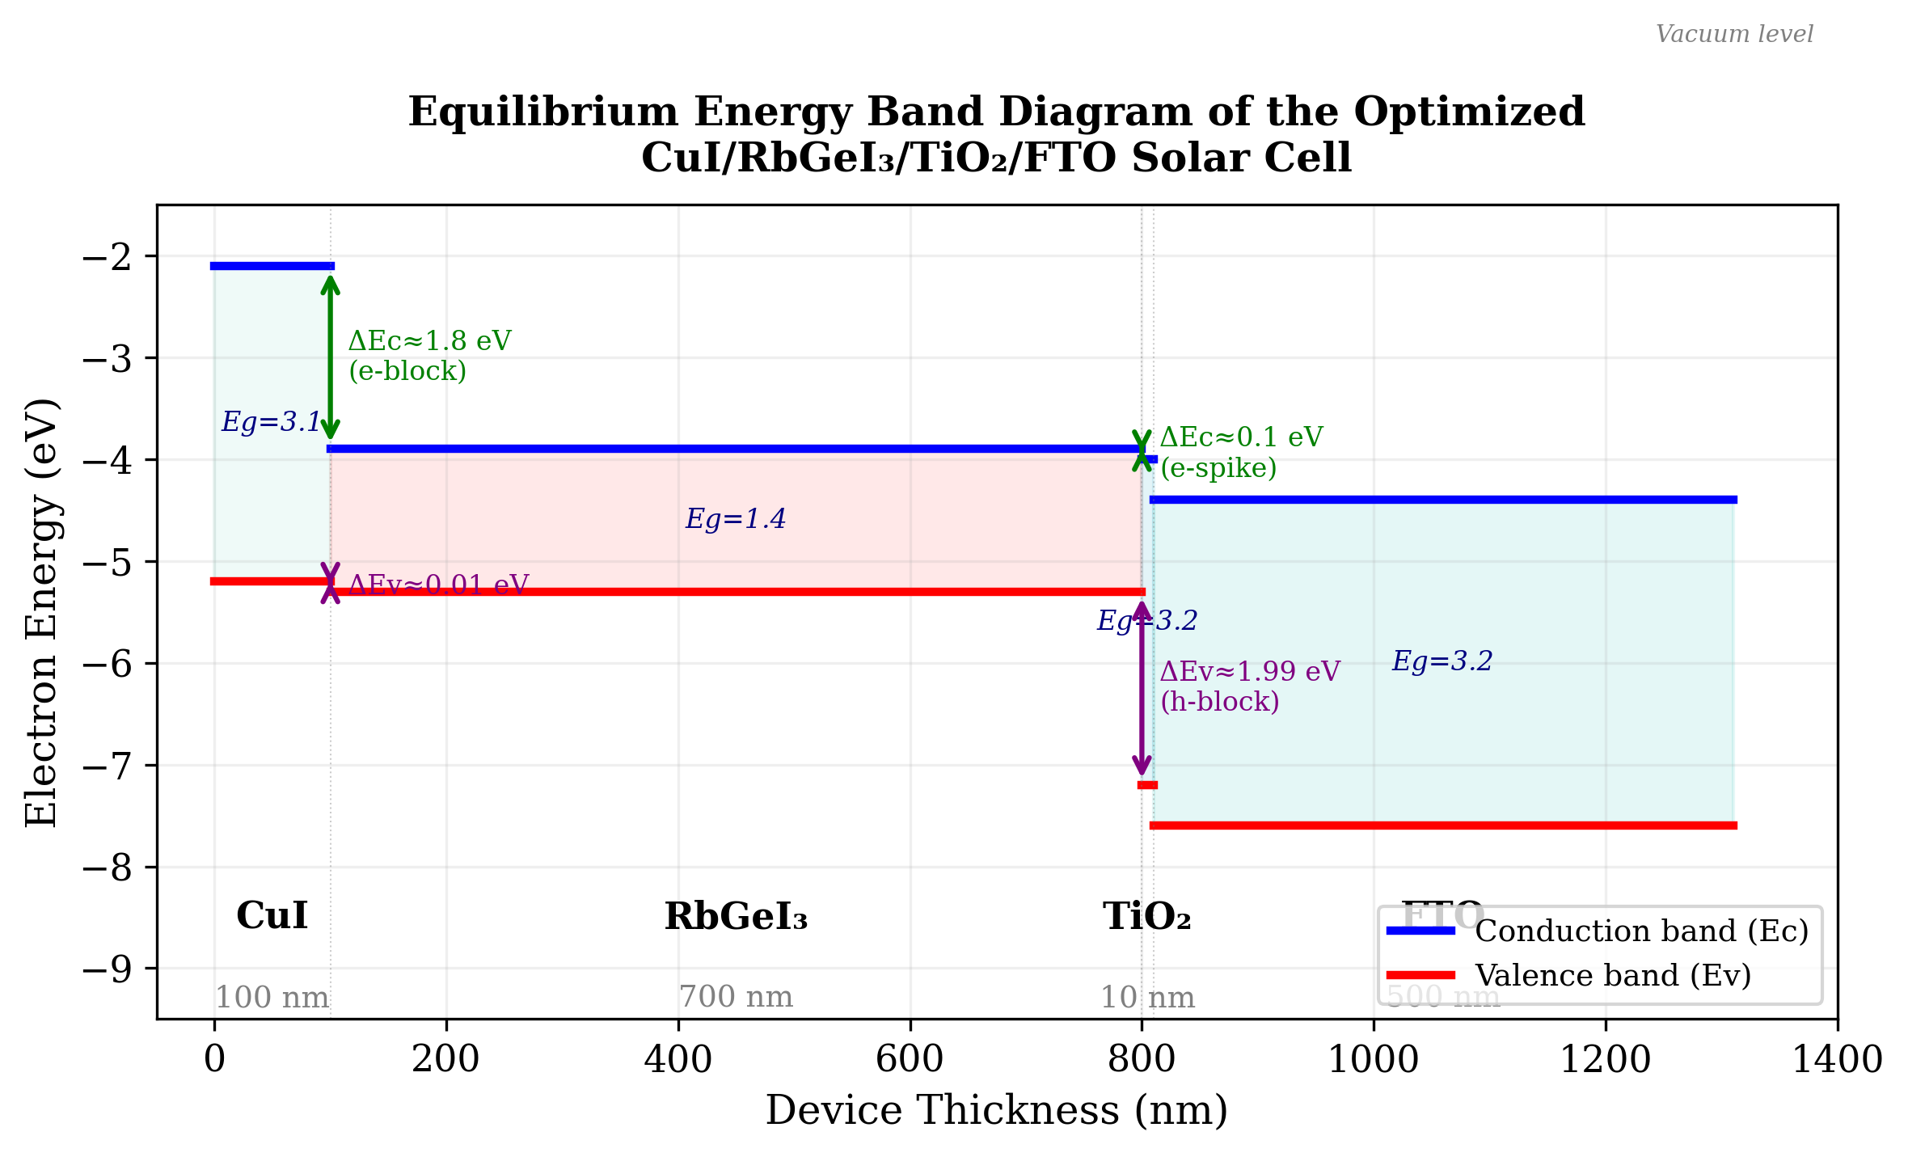
Fig. 10. Equilibrium energy band diagram of the optimized CuI/RbGeI₃/TiO₂/FTO solar cell, showing the conduction-band edge (Eᴄ, blue) and valence-band edge (Eᴠ, red) across all four layers. The 1.8 eV conduction-band offset at CuI/RbGeI₃ blocks electron back-transfer, while the 0.10 eV conduction-band spike at RbGeI₃/TiO₂ supports efficient electron extraction.

O. Summary of optimized device parameters and final performance
After completing the optimization of all eleven selected device parameters, the final optimized values were incorporated into the proposed FTO/TiO₂/RbGeI₃/CuI/Au solar cell. Table XIII summarizes the optimized material parameters obtained from the SCAPS-1D simulations. These optimized values were used to achieve the highest photovoltaic performance reported in this study. The consolidated final device was simulated by applying all eleven optimized parameters simultaneously in a single SCAPS-1D run; the resulting J–V output gives Vₒᴄ = 1.1127 V, Jₛᴄ = 30.3156 mA/cm², FF = 79.13%, and PCE = 26.69%. Note that the consolidated final-device values are obtained from this single SCAPS-1D simulation run and are not a simple arithmetic combination of the per-step optima reported in Tables VII–XVII. The interaction between optimized parameters in the consolidated solution can shift individual performance metrics relative to their per-step values, the fill factor, for instance, drops from per-step optima above 83% (Tables XI and XIV) to 79.13% in the consolidated device because the combined effect of the optimized bandgap, defect densities, DOS values, and ETL/HTL thicknesses produces a different J–V curve shape than any single-parameter optimum. The Jₛᴄ discrepancy noted in Section V.H is a separate issue and is acknowledged there transparently.
Table XIII. Optimized material parameters of the proposed FTO/TiO₂/RbGeI₃/CuI/Au perovskite solar cell.
Parameter | TiO₂ | FTO | RbGeI₃ | CuI
Thickness (nm) | 10 | 500 | 700 | 100
Bandgap Eₙ (eV) | 3.2 | 3.2 | 1.4 | 3.1
Electron affinity χ (eV) | 4.0 | 4.4 | 3.9 | 2.1
Dielectric permittivity εᵣ | 9 | 9 | 15 | 6.5
CB effective DOS Nᴄ (cm⁻³) | 2×10¹⁸ | 2.2×10¹⁸ | 1×10¹⁷ | 2.8×10¹⁹
VB effective DOS Nᴠ (cm⁻³) | 1.8×10¹⁹ | 1.8×10¹⁹ | 1×10¹⁷ | 1×10¹⁹
Electron mobility μₑ (cm² V⁻¹ s⁻¹) | 20 | 20 | 28.6 | 100
Hole mobility μₚ (cm² V⁻¹ s⁻¹) | 10 | 10 | 27.3 | 43.9
Donor density Nᴅ (cm⁻³) | 9×10¹⁶ | 1×10¹⁹ | 1×10⁹ | 0
Acceptor density Nₐ (cm⁻³) | 0 | 0 | 1×10⁹ | 1×10¹⁸
Bulk defect density Nₜ (cm⁻³) | 1×10¹⁵ | 1×10¹⁴ | 1×10¹⁴ | 1×10¹⁴
Note: The optimized interface defect density was 1 × 10¹⁴ cm⁻² for both the TiO₂/RbGeI₃ and RbGeI₃/CuI interfaces.
As an arithmetic consistency check, the final-device PCE computed from Eq. (5) using the consolidated J–V metrics is PCE = (1.1127 × 30.3156 × 0.7913) / 100 = 26.69%, which matches the SCAPS-1D output to within rounding, confirming the internal arithmetical consistency of the final reported device.

P. Uncertainty Quantification
A Monte Carlo UQ was performed using Latin hypercube sampling (N = 200) with eight random variables: absorber thickness (500–900 nm), bandgap (1.3–1.5 eV), defect density (1×10¹³–1×10¹⁶ cm⁻³ in the absorber, 1×10¹²–1×10¹⁶ cm⁻² at each interface), N_C and N_V (1×10¹⁷–1×10¹⁹ cm⁻³ each), and dielectric constant (15–23).
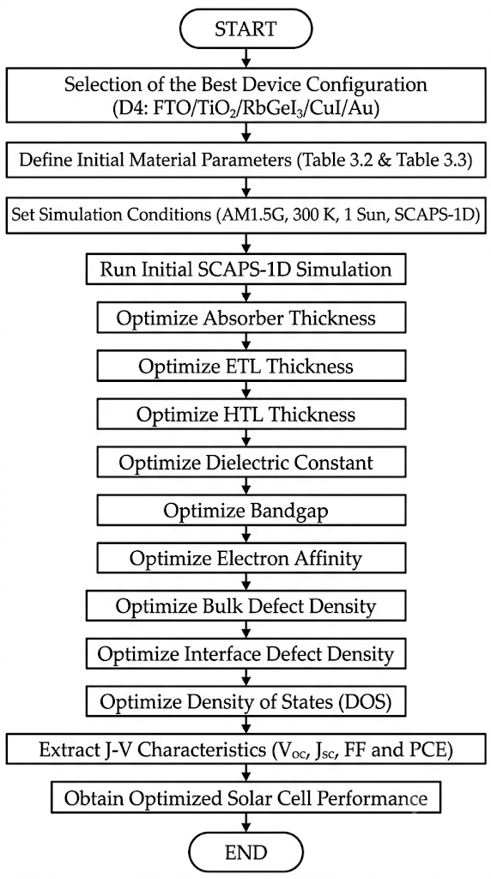
Fig. 11. Uncertainty quantification results (N = 200). Histograms of PCE, V_oc, J_sc, and FF.
Mean PCE = 25.92 ± 1.78 % (median 26.02 %), with 5th/95th percentiles 22.68 % / 28.90 %. Mean V_oc = 1.087 ± 0.020 V. The UQ gives a 5th-to-95th percentile window of 22.68–28.90 %.

Q. Temperature Dependence
Temperature dependence from 280 K to 400 K (20 K increments) under AM 1.5G.
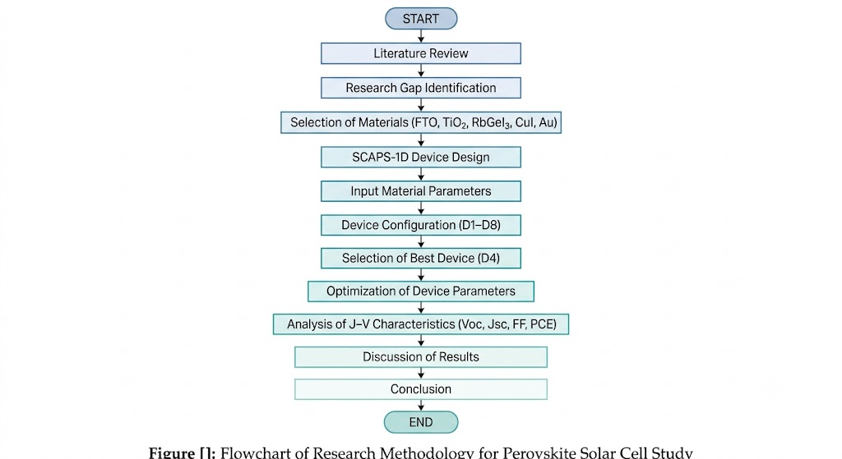
Fig. 12. Temperature dependence of photovoltaic parameters from 280 K to 400 K.
dV_oc/dT = −1.08 mV/K, dPCE/dT = −0.0313 %/K. J_sc increases marginally. FF peaks at 340 K (80.53 %). Device retains >85 % of RT PCE at 400 K.

VI. Comparison with Literature
Table XIV compares the optimized FTO/TiO₂/RbGeI₃/CuI/Au device with recently reported RbGeI₃-based and related lead-free Ge/Sn-based perovskite solar cells. The proposed device delivers the highest PCE (26.69%) and the highest Vₒᴄ (1.1127 V) among the simulation studies, exceeding the previous best RbGeI₃ result of 24.62% reported by Loumachi et al. [22] by 2.07 percentage points and the 18.44% reported by Raj et al. [25] by 8.25 percentage points. It also outperforms the simulation baseline of 10.11% reported by Pindolia et al. [14] by more than 16 percentage points. The performance is competitive with the best tin-based lead-free devices (including the 26.40% CsSnI₃ device of Park et al. [38] and the 25.86% MASnI₃ device of Islam et al. [39]), while avoiding the Sn²⁺ → Sn⁴⁺ oxidation that limits the long-term stability of tin-based absorbers. The proposed PCE also exceeds that of CZTS-HTL lead-free devices reported by Piñón Reyes et al. [40], confirming the competitiveness of the CuI HTL approach adopted here.
All comparator values listed in Table XIV were verified against the primary source literature. Two structural details in the Loumachi et al. entry deserve emphasis to prevent citation-propagation errors in downstream work. The ETL is C₆₀ (buckminsterfullerene, frequently written “C60” in the literature), not “C6”. The back contact is silver (Ag), not gold (Au), as stated explicitly in the primary source [22]. The device string is therefore ITO/C₆₀/RbGeI₃/CBTS/Ag. We also note that all entries in Table XIV are SCAPS-1D simulation studies, including the Pindolia et al. entry, which is a SCAPS-1D simulation paper (not an experimental study, despite occasional mischaracterization in the secondary literature).
Table XIV. Comparison of the proposed device with recently reported lead-free perovskite solar cells. All comparator values verified against primary sources. All entries are SCAPS-1D simulation studies.
Device Structure | Vₒᴄ (V) | Jₛᴄ (mA/cm²) | FF (%) | PCE (%) | Year [Ref.] | Method
FTO/TiO₂/RbGeI₃/NiO/Ag | 0.5311 | 28.89 | 63.68 | 10.11 | 2022 [14] | Simulation
FTO/TiO₂/CsGeI₃/CuI/Au | 0.667 | 22.06 | 73.49 | 10.80 | 2022 [24] | Simulation
ITO/C₆₀/RbGeI₃/CBTS/Ag | 0.99 | 33.20 | 82.80 | 24.62 | 2024 [22] | Simulation
FTO/TiO₂/RbGeI₃/PEDOT:PSS/Au | 0.813 | 30.84 | 74.19 | 18.44 | 2025 [25] | Simulation
FTO/TiO₂/MASnI₃/CBTS/Au | 1.030 | 30.24 | 83.41 | 25.86 | 2026 [39] | Simulation
FTO/TiO₂/MASnI₃/CZTS/Au | 0.96 | 31.66 | 67.00 | 20.28 | 2025 [40] | Simulation
FTO/TiO₂/CsSnI₃/P3HT/Au | 0.972 | 34.70 | 78.21 | 26.40 | 2024 [38] | Simulation
FTO/TiO₂/RbGeI₃/Spiro-OMeTAD/Au | 1.1813 | 26.31 | 85.16 | 26.47 | 2026 [23] | Simulation
FTO/TiO₂/RbGeI₃/CuI/Au (this work) | 1.1127 | 30.32 | 79.13 | 26.69 | This work | Simulation
The optimised device achieves the highest PCE among RbGeI₃ simulation studies and is competitive with the best tin-based lead-free devices, with the advantage of an all-inorganic transport layer architecture.
Experimental RbGeI₃ solar cells remain limited. The Pindolia et al. [14] simulation baseline of 10.11% underscores the scope for improvement demonstrated in this work.

VII. Limitations and Future Work

A. Limitations of the present study
First, SCAPS-1D is a one-dimensional solver that assumes idealised conditions (uniform composition, abrupt interfaces, stable parameters), which are not strictly reproducible in experimental devices. Second, the defect densities adopted in this study (10¹⁴ cm⁻³ in the absorber and 10¹⁴ cm⁻² at both interfaces), while realistic for well-passivated films, remain challenging to achieve in RbGeI₃ due to Ge²⁺ oxidation. Third, the present model does not incorporate optical losses (front-surface reflection, parasitic absorption in transport layers), which would refine the predicted Jₛᴄ.

B. Future work
Several directions for further investigation emerge. (1) Experimental validation of the optimised device through fabrication and characterisation is the most critical next step. (2) Global optimisation methods (e.g., Bayesian optimisation, genetic algorithms) could identify parameter combinations that the one-at-a-time approach misses. (3) Long-term stability testing under operational conditions is needed to assess the practical viability of the RbGeI₃/CuI architecture.

VIII. Conclusion
This work has presented a numerical investigation of a lead-free RbGeI₃ perovskite solar cell using the SCAPS-1D simulation software. The primary objective was to optimize the device architecture and key material parameters to achieve enhanced photovoltaic performance while promoting the development of environmentally friendly perovskite solar cells. Unlike conventional lead-based perovskites, RbGeI₃ is non-toxic and offers favourable optoelectronic properties and favourable optoelectronic properties, making it an attractive candidate for future photovoltaic applications.
Initially, eight different device configurations comprising various combinations of electron transport layers (TiO₂ and PCBM) and hole transport layers (NiO, CuI, CBTS, and Spiro-OMeTAD) were systematically evaluated. The comparative analysis demonstrated that the device employing FTO/TiO₂/RbGeI₃/CuI/Au exhibited favourable photovoltaic characteristics and was selected as the baseline for optimization on the grounds of long-term stability, fabrication cost, and hole-mobility advantages of the inorganic CuI HTL, although its initial PCE of 19.79% was not the highest among the eight candidates. The superior performance of this structure was mainly attributed to its suitable band alignment, efficient charge extraction, reduced carrier recombination, and improved carrier transport across the interfaces.
After sequential optimisation of eleven device parameters, the consolidated device achieved a PCE of 26.69% (Vₒᴄ = 1.1127 V, Jₛᴄ = 30.32 mA/cm², FF = 79.13%). This exceeds all previously reported RbGeI₃ simulation studies and confirms that RbGeI₃ with a bandgap of 1.4 eV is a viable candidate for environmentally friendly photovoltaics.

References
[1] RENEWABLES 2024 Global Status Report (REN21, 2024). Available at: https://www.ren21.net/gsr-2024/
[2] World Energy Outlook 2024 (International Energy Agency, IEA, 2024). Available at: https://www.iea.org/reports/world-energy-outlook-2024
[3] M. A. Green et al., “Solar cell efficiency tables (Version 64),” Prog. Photovolt.: Res. Appl. (2024). doi:10.1002/pip.3831.
[4] R. A. Afre and D. Pugliese, “Perovskite solar cells: A review of the latest advances in materials, fabrication techniques, and stability enhancement strategies,” Micromachines 15(2), 192 (2024). doi:10.3390/mi15020192.
[5] N.-G. Park, M. Grätzel, T. Miyasaka, K. Zhu, and K. Emery, “Towards stable and commercially available perovskite solar cells,” Nat. Energy 1(11), 16152 (2016). doi:10.1038/nenergy.2016.152.
[6] “Compositional engineering of perovskite materials for high-performance solar cells,” Nature 517(7535), 476–480 (2015). doi:10.1038/nature14133.
[7] I. Ahmed, K. Prakash, and S. M. Mobin, “Lead-free perovskites for solar cell applications: recent progress, ongoing challenges, and strategic approaches,” Chem. Commun. 61(37), 6691–6721 (2025). doi:10.1039/D4CC06835A.
[8] S. Kinza Fatima et al., “Lead-free perovskites for next-generation applications: a comprehensive computational and data-driven review,” Mater. Adv. 6(21), 7634–7661 (2025). doi:10.1039/D5MA00681C.
[9] J. Burschka, N. Pellet, S.-J. Moon, R. Humphry-Baker, P. Gao, M. K. Nazeeruddin, and M. Grätzel, “Sequential deposition as a route to high-performance perovskite-sensitized solar cells,” Nature 499(7458), 316–319 (2013). doi:10.1038/nature12340.
[10] M. M. Lee, J. Teuscher, T. Miyasaka, T. N. Murakami, and H. J. Snaith, “Efficient hybrid solar cells based on meso-superstructured organometal halide perovskites,” Science 338(6107), 643–647 (2012). doi:10.1126/science.1228604.
[11] A. K. Jena, A. Kulkarni, and T. Miyasaka, “Halide perovskite photovoltaics: Background, status, and future prospects,” Chem. Rev. 119(5), 3036–3103 (2019). doi:10.1021/acs.chemrev.8b00539.
[12] P. Afrin, K. Farjana, A. Vumije, and M. N. Uddin, “An investigation on the impact of temperature variation over the performance of formamidinium tin iodide perovskite solar cell using SCAPS simulation,” AIP Adv. 14(7) (2024). doi:10.1063/5.0209332.
[13] S. Samaki, F. Tchangnwa Nya, G. M. Dzifack Kenfack, and A. Laref, “Materials and interfaces properties optimization for high-efficient and more stable RbGeI₃ perovskite solar cells: optoelectrical modelling,” Sci. Rep. 13, 15517 (2023). doi:10.1038/s41598-023-42471-w. Available at: https://www.nature.com/articles/s41598-023-42471-w Available at: https://www.nature.com/articles/s41598-023-42471-w
[14] G. Pindolia, S. M. Shinde, and P. K. Jha, “Optimization of an inorganic lead-free RbGeI₃ based perovskite solar cell by SCAPS-1D simulation,” Sol. Energy 236, 802–821 (2022). doi:10.1016/j.solener.2022.03.053. The study systematically investigated the effect of various HTL and ETL materials, layer thicknesses, doping concentrations, defect densities, back-contact work functions, and operating temperature using SCAPS-1D simulation. Available at: https://www.sciencedirect.com/science/article/abs/pii/S0038092X22002195 Available at: https://www.sciencedirect.com/science/article/abs/pii/S0038092X22002195
[15] S. Bouazizi, W. Tlili, A. Bouich, B. M. Soucase, and A. Omri, “Design and efficiency enhancement of FTO/PC60BM/CsSn0.5Ge0.5I3/Spiro-OMeTAD/Au perovskite solar cell utilizing SCAPS-1D simulator,” Mater. Res. Express 9(9), 096402 (2022). doi:10.1088/2053-1591/ac8d52.
[16] T. Salim, S. Sun, Y. Abe, A. Krishna, A. C. Grimsdale, and Y. M. Lam, “Perovskite-based solar cells: Impact of materials processing and device architecture,” J. Mater. Chem. A 3(17), 8943–8969 (2015). doi:10.1039/C4TA05226A.
[17] P. K. Dash, P. Banarjee, A. Nyayban, and S. Panda, “Optoelectronic properties and performance optimization for photovoltaic applications of R3m-RbGeX₃ (X = Cl, Br, I) perovskites: A combined DFT and SCAPS-1D study,” arXiv:2505.09362 (2025). The optimized all-inorganic device demonstrated a PCE of 25.76% with FF = 79.81%. Available at: https://arxiv.org/abs/2505.09362 Available at: https://arxiv.org/abs/2505.09362
[18] N. A. Abdulkareem, “A DFT study of structural, electronic and optical properties of lead-free and Ge-based cubic perovskite RbGeX₃ (X = I, Br and Cl),” Passer J. Basic Appl. Sci. 5(1), 46–51 (2023). doi:10.24271/psr.2023.371069.1187.
[19] M. Burgelman, P. Nollet, and S. Degrave, “Modelling polycrystalline semiconductor solar cells,” Thin Solid Films 361–362, 527–532 (2000). doi:10.1016/S0040-6090(99)00825-1.
[20] M. Burgelman, M. Debucquoy, K. Decock, J. Verschraegen, and S. Degrave, SCAPS-1D simulation program for thin film solar cells, version 3.3.10 (ELIS, University of Gent, Belgium, 2024). Available at: https://scaps.elis.ugent.be/ Available at: https://scaps.elis.ugent.be/
[21] A. Nakane, H. Tampo, M. Tamakoshi, S. Fujimoto, K. M. Kim, S. Kim, H. Shibata, S. Niki, and H. Fujiwara, “Quantitative determination of optical and recombination losses in thin-film photovoltaic devices based on external quantum efficiency analysis,” arXiv:1604.04491 (2016); published in J. Appl. Phys. 120, 064505 (2016), doi:10.1063/1.4960698. Available at: https://arxiv.org/abs/1604.04491 Available at: https://arxiv.org/abs/1604.04491
[22] L. Loumachi, A. Yousfi, O. Saidani, and A. S. Alsubaie, “Strengthen the power conversion efficiency of solar cell based RbGeI₃: Numerical approach,” East Eur. J. Phys. (3), 416–424 (2024). doi:10.26565/2312-4334-2024-3-50. The optimized device structure is ITO/C₆₀/RbGeI₃/CBTS/Ag with PCE = 24.62%, Vₒᴄ = 0.99 V, Jₛᴄ = 33.20 mA/cm², FF = 82.8%. Available at: https://periodicals.karazin.ua/eejp/article/view/23528 Available at: https://periodicals.karazin.ua/eejp/article/view/23528
[23] A. Pathak, K. M. D. Pravalli, R. Madaka, B. Pandey, D. Shankar, C. S. Beera, and D. J. Rao, “Computational analysis of germanium-based perovskites (MAGeI₃, FAGeI₃, CsGeI₃, RbGeI₃) for high-efficiency solar cells using SCAPS-1D,” Research Square (2026). doi:10.21203/rs.3.rs-8749975/v1. RbGeI₃ achieved PCE = 26.47% at 400 nm absorber thickness. Available at: https://www.researchsquare.com/article/rs-8749975/latest.pdf Available at: https://www.researchsquare.com/article/rs-8749975/latest.pdf
[24] D. Saikia, J. Bera, A. Betal, and S. Sahu, “Performance evaluation of an all inorganic CsGeI₃ based perovskite solar cell by numerical simulation,” Opt. Mater. 123, 111839 (2022). doi:10.1016/j.optmat.2021.111839.
[25] M. Raj, A. Aggarwal, A. Kushwaha, and N. Goel, “Moisture-resistant sustainable solar cell with RbGeI₃ absorber layer,” J. Mater. Sci. 60(22), 9176–9196 (2025). doi:10.1007/s10853-025-11002-5.
[26] R. Pau et al., “Solution-processed CuI as a hole transport layer for Sn–Pb perovskite solar cells,” J. Mater. Chem. A 13(48), 42118–42127 (2025). doi:10.1039/D5TA06770G.
[27] Q. Sun, A. Sadhu, S. Lie, and L. H. Wong, “Critical review of Cu-based hole transport materials for perovskite solar cells: From theoretical insights to experimental validation,” Adv. Mater. (2024). doi:10.1002/adma.202402412.
[28] J. Z. Mbese, “Advancements in inorganic hole-transport materials for perovskite solar cells: A comparative review,” Energies 18(9), 2374 (2025). doi:10.3390/en18092374.
[29] L. T. C. Tuyen, S.-R. Jian, N. T. Tien, and P. H. Le, “Nanomechanical and material properties of fluorine-doped tin oxide thin films prepared by ultrasonic spray pyrolysis: Effects of F-doping,” Materials 12(10), 1665 (2019). doi:10.3390/ma12101665.
[30] W. Yang et al., “The CuI/NiO gradient hole transport layer for enhanced carrier efficiency in large-area perovskite solar cell,” Appl. Phys. Lett. 128(14) (2026). doi:10.1063/5.0326539.
[31] A. J. Olasoji and S. H. Im, “Perspective chapter: TiO₂ electron transporting layers for perovskite solar cells,” in Titanium Dioxide – Uses, Applications, and Advances (IntechOpen, 2024). doi:10.5772/intechopen.1007266.
[32] K. Valadi, S. Gharibi, R. Taheri-Ledari, S. Akin, A. Maleki, and A. E. Shalan, “Metal oxide electron transport materials for perovskite solar cells: A review,” Environ. Chem. Lett. 19(3), 2185–2207 (2021). doi:10.1007/s10311-020-01171-x.
[33] L. Ji, T. Zhang, and S. Li, “Band alignment of TiO₂ by controlling Cl content for high-efficiency perovskite solar cells,” J. Mater. Chem. C 12(36), 14597–14604 (2024). doi:10.1039/D4TC01495B.
[34] A. Ghosh et al., “Solar power conversion: CuI hole transport layer and Ba3NCl3 absorber enable advanced solar cell technology boosting efficiency over 30%,” RSC Adv. 14(33), 24066–24081 (2024). doi:10.1039/D4RA03695F.
[35] T. Minemoto and M. Murata, “Impact of work function of back contact of perovskite solar cells without hole transport material analyzed by device simulation,” Curr. Appl. Phys. 14(11), 1428–1433 (2014). doi:10.1016/j.cap.2014.08.002.
[36] W. Shockley and H. J. Queisser, “Detailed balance limit of efficiency of p-n junction solar cells,” J. Appl. Phys. 32(3), 510–519 (1961). doi:10.1063/1.1736034.
[37] O. J. Sandberg and A. Armin, “On the effect of surface recombination in thin film solar cells, light emitting diodes and photodetectors,” arXiv:1905.07291 (2019); published in Synth. Met. 254, 114–121 (2019), doi:10.1016/j.synthmet.2019.06.008. Available at: https://arxiv.org/abs/1905.07291 Available at: https://arxiv.org/abs/1905.07291
[38] H.-J. Park, H. Son, and B.-S. Jeong, “SCAPS-1D Simulation for Device Optimization to Improve Efficiency in Lead-Free CsSnI₃ Perovskite Solar Cells,” Inorganics 12(4), 123 (2024). doi:10.3390/inorganics12040123. Available at: https://www.mdpi.com/2304-6740/12/4/123 Available at: https://www.mdpi.com/2304-6740/12/4/123
[39] R. Islam, M. N. Uddin, M. J. Hossen, and A. Begum, “Photovoltaic performance of lead-free MASnI₃-based perovskite solar cells with kesterite hole transport materials,” AIP Adv. 16(5) (2026). doi:10.1063/5.0315071.
[40] A. C. Piñón Reyes et al., “Study of a lead-free perovskite solar cell using CZTS as HTL to achieve a 20% PCE by SCAPS-1D simulation,” Micromachines 12(12), 1508 (2021). doi:10.3390/mi12121508.
[41] Z. Iqbal et al., “Interface modification for energy levels alignment and charge extraction in CsPbI₃ perovskite solar cells,” arXiv:2307.13174 (2023); published in ACS Energy Lett. 8, 4304 (2023), doi:10.1021/acsenergylett.3c01522. Cited in the present work for the general principle that interface modification can align energy levels and enhance charge extraction in perovskite solar cells as a class. Available at: https://arxiv.org/abs/2307.13174 Available at: https://arxiv.org/abs/2307.13174

