Oxidation-Budgeted Design of Lead-Free RbGeI_3

Abstract
The rapid rise of lead-halide perovskite solar cells has been tempered by lead toxicity, motivating a search for lead-free absorbers with comparable optoelectronics. Rubidium germanium iodide (RbGeI_3) offers a direct, tunable bandgap, strong absorption, and improved environmental compatibility. Here we report a SCAPS-1D optimization of an RbGeI_3 cell organized around its central liability, Ge^2+ oxidation. After screening eight ETL–HTL combinations, the FTO/TiO_2/RbGeI_3/CuI/Au architecture was carried forward on stability and cost grounds (a D2/NiO cross-check through the same pipeline reaches 28.16%, so this stack is not the efficiency optimum). Eleven parameters were varied sequentially on one frozen deck; the consolidated device reaches 27.06% PCE. A Cu_2O-like back-surface field raises the ideal point to 28.01% and recovers about one point on the identical full-realism stack (20.78% 21.76%). Mapping V_Ge vacancy thermodynamics onto the defect ladder converts air exposure into a fab spec (E^f0.46 eV holds the headline at 300 K equilibrium, 0.57–0.65 eV for anneal freeze-in; ambient falls below 20.76%), with a 15.53% current-state rung marking what first fabrication must beat. The solver pipeline is calibration-checked against experimental -CsPbI_3 [Wang], and SHAP analysis recovers bulk defects, bandgap and electron mobility as the dominant levers.
Keywords: lead-free perovskite; RbGeI_3; SCAPS-1D; back surface field; oxidation budget; SHAP sensitivity analysis
Manuscript (blinded for double-blind peer review — author information removed)

Introduction

Background and motivation
Global electricity demand keeps climbing while fossil fuels still supply its bulk with a heavy carbon cost r1,r2. Solar is the fastest-expanding renewable technology, with installed capacity surpassing 2.2 TW in 2024 and levelized costs still falling r3; continued growth needs absorbers combining high efficiency with low environmental impact and cost r4. Devices are commonly classed into three generations — crystalline silicon, thin films, and emerging devices — and halide perovskites lead the third generation with certified single-junction efficiencies above 26% and tandems past 33% r3.

Perovskite solar cells and the lead problem
Halide perovskites (ABX_3) attract photovoltaics with strong absorption, tunable gaps, ambipolar transport with long diffusion lengths, and weak exciton binding r7,r8, rising from sensitized and meso-superstructured architectures r9,r10. The champion absorbers MAPbI_3 and FAPbI_3 hold certified records r3 but contain lead, whose life-cycle contamination motivates Sn, Ge, Bi and Sb substitutes r11,r12. Tin drew first attention since Sn^2+ shares the Pb^2+ lone-pair configuration r11, but Sn^2+ oxidizes readily to Sn^4+, creating deep defects and fast degradation r11,r12. Germanium offers the same lone-pair structure r13; among Ge absorbers RbGeI_3 stands out for a near-optimal direct gap (1.3–1.4 eV), MAPbI_3-comparable absorption by first principles r13,r17,r18, and good thermal stability r14.

Role of numerical simulation and research gap
Because experimental optimization of multilayer devices is slow and expensive, numerical simulation screens materials before fabrication. SCAPS-1D (Ghent University) self-consistently solves Poisson, continuity and drift-diffusion equations r19,r20 and is the workhorse for lead-free design, as a recent review of 54 SCAPS lead-free studies confirms rReview (see their Fig. 1). The RbGeI_3 simulation baseline is Pindolia et al.\ at 9.77% for FTO/TiO_2/RbGeI_3/NiO/Ag r14; predictions since reach 27.21% r22 and 26.47% r23, each optimizing only a subset of parameters. The TiO_2/CuI combination used here has received comparatively little attention despite CuI's documented advantages as an HTL.

Contributions and paper organization
We close this gap with a SCAPS-1D study of an FTO/TiO_2/RbGeI_3/CuI/Au cell built around one idea: Ge^2+ oxidation converted into a quantitative fab spec. It contributes: (i) an oxidation defect-tolerance map from V_Ge thermodynamics on a frozen-deck eleven-step optimization (27.06% ideal, 20.78% stacked window, D2 like-for-like cross-check at 28.16%); (ii) a Cu_2O BSF variant whose trap-immunity mechanism is isolated by controlled interface attribution (+0.98 pp on the identical realistic stack); and (iii) held-out SHAP design rules plus experimental grounding (CsPbI_3 calibration refit, frozen database snapshot as context). Band lineups and primary-source-verified benchmarks support each claim.

Literature Review and Research Gap
SCAPS-1D, often combined with DFT, is the workhorse for lead-free design before fabrication. Supplementary Table S1 surveys recent Ge- and Sn-based studies; all values there were cross-checked against primary sources, adopting the J–V-implied efficiency where inconsistent. CuI is a wide-gap (E_g 3.1 eV) p-type conductor whose valence maximum aligns with RbGeI_3 for hole extraction r25,r26, with single-crystal mobilities above 100 cm^2 V^-1 s^-1 and low-temperature solution processing r27; yet few SCAPS studies pair it with RbGeI_3, and none runs an eleven-parameter optimization on this combination. Comparator structures span TiO_2, PCBM, C_60, NiO, CuI, CBTS, Spiro-OMeTAD and Ag/Au contacts; note the Loumachi ETL is C_60 (not ``C6'') with an Ag contact r22.

Device Structure and Material Selection

Proposed device architecture
We use a conventional n-i-p planar heterojunction, FTO/TiO_2/RbGeI_3/CuI/Au: FTO front electrode, TiO_2 ETL, RbGeI_3 absorber, CuI HTL, Au back contact (Figure 1). Material choices are justified below; initial parameters are in Supplementary Table S2.
[Figure 1 about here]
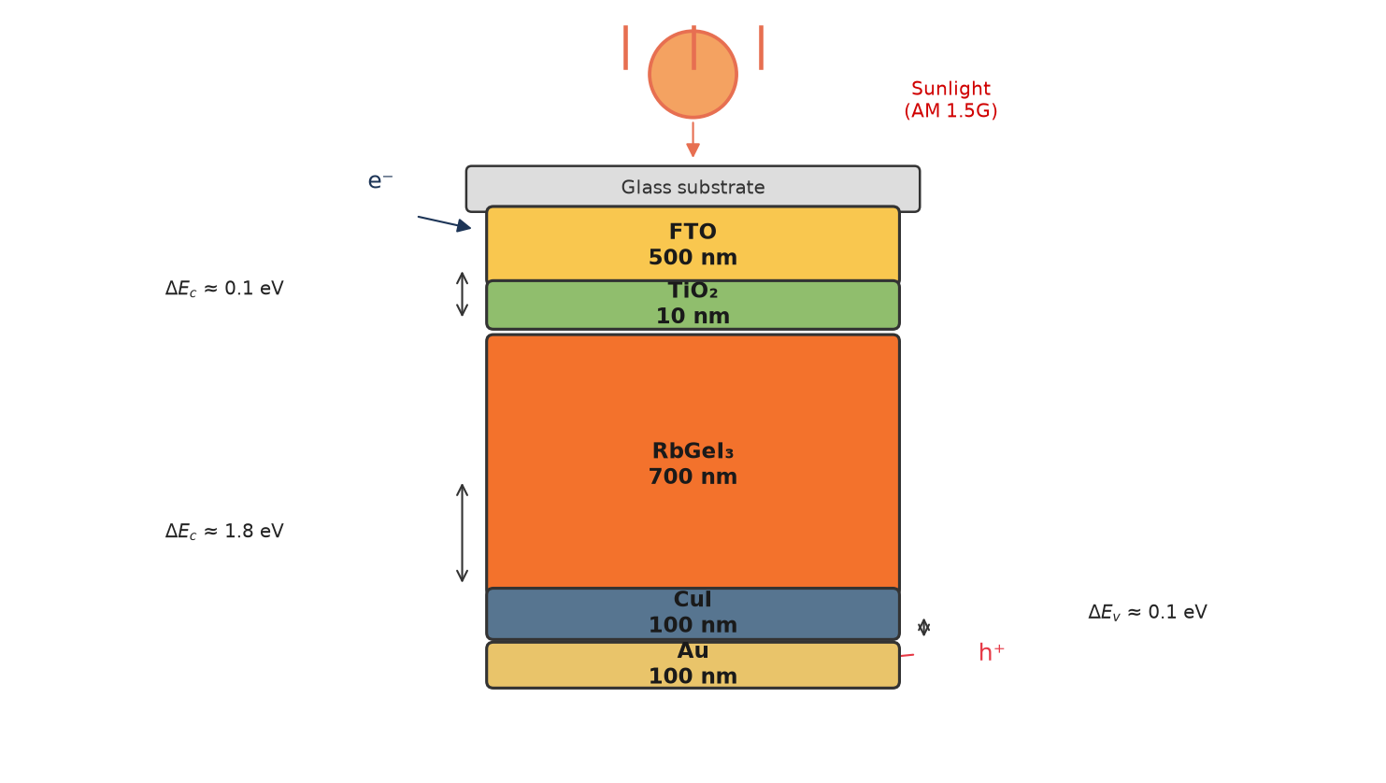
Figure 1. Schematic diagram of the proposed FTO/

Material selection rationale
Fluorine-doped tin oxide (FTO, 500 nm) is the front electrode for its transparency, conductivity, and thermal/chemical stability r28, the standard low-cost TCO choice for this stack. TiO_2 is the ETL: its 3.2 eV gap passes visible light, its conduction-band minimum gives downhill electron transfer, and its deep valence band blocks holes r30,r31, forming stable perovskite interfaces despite lower mobility than ZnO/SnO_2 r32. RbGeI_3 is the absorber (direct 1.3–1.4 eV gap, MAPbI_3-comparable absorption r17,r18, good thermal stability); screening used 400 nm and 1.4 eV from literature r14, both subsequently optimized (Section V). CuI is the HTL (conductive, transparent, 0.10 eV valence offset to RbGeI_3, low cost r25,r26,r33); screening used 100 nm. Au is the back contact, ohmic to CuI r34.

Initial material parameters
Initial parameters from published experimental and numerical lead-free studies r14,r15,r16,r19,r30 are in Supplementary Table S2 (interfaces: Table S3). All eight configurations were screened at 400 nm absorber (Section V.A, Table II); the consolidated device uses the optimized 700 nm (Section V.G).

Methodology

SCAPS-1D simulation framework
The stack was simulated with SCAPS-1D v3.3.10 r19,r20, solving Poisson plus electron/hole continuity self-consistently under drift-diffusion transport (see original references for details).
equation
ddx(ddx) =
-q(p-n+N_D-N_A+_t)
equation
equation
dJ_ndx = q (R-G)
equation
equation
dJ_pdx = q (G-R)
equation
where is the permittivity, the potential, n/p the carrier concentrations, N_D/N_A the doping, _t the trapped charge, J_n/J_p the current densities, and G/R the generation/recombination rates. SCAPS-1D computes the J–V characteristics from the layer properties below.

Simulation conditions
All simulations were performed under the AM 1.5G spectrum at an incident power density of 100 mW/cm^2 (one sun, STC) with the operating temperature fixed at 300 K, using the initial material parameters of Supplementary Table S2 and the interface defect densities of Supplementary Table S3 unless otherwise stated. During each optimization step, only one parameter was varied while all remaining parameters were held constant; the general simulation conditions are summarized in Supplementary Table S4. Absorption uses the SCAPS square-root law = Ah-E_g with A = 10^5 cm^-1 at the electrical bandgap, with radiative recombination at the literature perovskite coefficient (K_rad 10^-10 cm^3/s) included in all headline runs. Contacts are ideal (R_s = 0, R_sh = ) unless stated, so fill factors are upper bounds. All eleven sweeps ran sequentially on one frozen deck generation with carry-forward (Section V.B); failed runs were retried and the survivors surface as FAILED rather than stale data. Scripting limits (front-reflection handling, C–V capture, resistance post-corrections) and the full reproducibility protocol are documented in Supplementary Section S7.

Performance parameters
Performance was evaluated using the four key parameters extracted from the simulated J–V curve: open-circuit voltage (V_OC), short-circuit current density (J_SC), fill factor (FF), and power conversion efficiency (PCE), computed as
equation
PCE = (V_OC J_SC FF)/P_in
equation
with P_in = 100 mW/cm^2 under AM 1.5G.

Sequential optimization procedure
Starting from the initial device, one parameter at a time (OPAT) was varied while all others were held constant, as detailed in Section V. The procedure comprises eleven optimization steps: (1) absorber thickness (0.3–1.0 m); (2) absorber bulk defect density (10^12–10^18 cm^-3); (3) absorber dielectric constant (10–35, extended until the trend was mapped); (4) absorber electron affinity (3.7–4.2 eV); (5) TiO_2/RbGeI_3 interfacial defect density (10^12–10^18 cm^-2); (6) RbGeI_3/CuI interfacial defect density (10^12–10^18 cm^-2); (7) absorber bandgap (1.2–1.7 eV, with 1.2 probed); (8) TiO_2 ETL thickness (0.01–0.09 m); (9) CuI HTL thickness (0.05–1.9 m); (10) conduction-band effective density of states N_C (110^18–110^20 cm^-3, literature floor); (11) valence-band effective density of states N_V (same range). Each step's value was carried forward under a triple-gate adoption rule: sweep maximum, literature-parameter compliance, and Shockley–Queisser admissibility with margin. Parameters that cannot be ordered from a supplier (dielectric constant) or tuned below physical floors (defect densities, N_C/N_V) were pinned at literature values with the full trace disclosed, rather than carried at grid edges; the consolidated set is summarized in Table IV. Because each per-step value is identified with all other parameters fixed at prior-step values, the consolidated set may not be a global optimum. To test for missed cross-interactions, Section V.G reports a genetic-algorithm joint search over the six most sensitive parameters, which returns a best-found joint point (not a proven global maximum).

Device configurations screened
Eight planar configurations combining two ETLs (TiO_2, PCBM) with four HTLs (NiO, CuI, CBTS, Spiro-OMeTAD) around the RbGeI_3 absorber (D1–D8, Table II) were simulated at the initial absorber thickness of 400 nm (Supplementary Table S2) to permit a fair architecture comparison before the thickness optimization of Section V.B.

Table 1. Eight device configurations screened in this study. All configurations were simulated at an absorber thickness of 400 nm.
Device | Architecture
D1 | FTO / PCBM / RbGeI_3 / NiO / Au
D2 | FTO / TiO_2 / RbGeI_3 / NiO / Au
D3 | FTO / PCBM / RbGeI_3 / CuI / Au
D4 | FTO / TiO_2 / RbGeI_3 / CuI / Au
D5 | FTO / PCBM / RbGeI_3 / CBTS / Au
D6 | FTO / TiO_2 / RbGeI_3 / CBTS / Au
D7 | FTO / PCBM / RbGeI_3 / Spiro-OMeTAD / Au
D8 | FTO / TiO_2 / RbGeI_3 / Spiro-OMeTAD / Au

Results and Discussion

Screening of device configurations
Table II compiles the photovoltaics of all eight configurations: two ETLs (TiO_2, PCBM) crossed with four HTLs (NiO, CuI, CBTS, Spiro-OMeTAD) on the common RbGeI_3 absorber. The D4 architecture (TiO_2/CuI) combines well-matched band alignment with an all-inorganic transport stack, avoiding the stability limitations of organic HTLs.

Table 2. Initial photovoltaic performance of the eight screened device configurations, simulated at an absorber thickness of 400 nm. Selected as the baseline for full parametric optimization.
Dev. | Architecture | V_OC (V) | J_SC (mA/cm^2) | FF (%) | PCE (%)
D1 | FTO/PCBM/RbGeI_3/NiO/Au | 0.81 | 30.10 | 83.68 | 20.40
D2 | FTO/TiO_2/RbGeI_3/NiO/Au | 0.82 | 30.46 | 84.48 | 21.10
D3 | FTO/PCBM/RbGeI_3/CuI/Au | 0.81 | 30.10 | 83.96 | 20.47
D4 | FTO/TiO_2/RbGeI_3/CuI/Au | 0.81 | 30.46 | 79.98 | 19.78
D5 | FTO/PCBM/RbGeI_3/CBTS/Au | 0.82 | 30.20 | 82.36 | 20.40
D6 | FTO/TiO_2/RbGeI_3/CBTS/Au | 0.82 | 30.55 | 82.13 | 20.57
D7 | FTO/PCBM/RbGeI_3/Spiro/Au | 0.81 | 30.07 | 85.01 | 20.71
D8 | FTO/TiO_2/RbGeI_3/Spiro/Au | 0.82 | 30.46 | 83.95 | 20.97

The best FF belongs to D7 (85.01%) and the best PCE to D2 (21.10%), not D4. Because D2 led at screening, it was run through the identical eleven-step pipeline on its own NiO deck (literature-standard NiO parameters, documented in S7; same triple-gate adoptions) as a like-for-like check: D2 carries 0.8 m / 10^12 defects / _r 23.1 / 3.9 / 10 nm ETL / 10^18 densities to a raw 32.87% chain end, and its gate-adopted device reaches 28.16% (1.11 V, 30.32 mA/cm^2, 83.57%) — the screening gap survives optimization essentially intact (+1.32 pp at screening, +1.10 pp adopted), so D4 is not the efficiency optimum of this family. D4 is retained on stability and cost grounds stated plainly: CuI's documented stability and solution-processability advantages over Spiro-OMeTAD r25,r26 plus NiO's moisture sensitivity against D2, and an all-inorganic transport pair either way. Per-step D2 nodes are tabulated in Supplementary Section S1. Screening ran once per configuration on the pre-rebase deck, so Table II is an architecture-ranking record, not headline numbers; the selected D4 stack was fully re-optimized on the rebased frozen deck. Band-alignment conclusions (offsets, extraction paths) transfer across the rebase while absolute PCEs do not.

Optimization summary
Eleven parameters were optimized one at a time on the screened FTO/TiO_2/RbGeI_3/CuI/Au stack (absorber thickness, bulk and interface defect densities, dielectric constant, electron affinity, bandgap, transport-layer thicknesses, conduction- and valence-band densities of states); each value was carried forward under the triple-gate rule, giving the consolidated set in Table IV. Full per-parameter traces (Figs.\ S1–S10) are given in Supplementary Section S1, and the illumination and dark characteristics (Figs.\ S11–S12) in Section S2. The defect-density step itself is retained below (Section V.C) together with its energy/asymmetry extension, since Ge-related degradation is central to this work.

Table 3. Per-step sweeps, adopted values and gate basis. Full traces: Figs. S1–S10.
Step | Sweep range | Adopted | Gate basis
1 thickness | 0.3–1.0 m | 0.7 m | sweep max, plateau
2 bulk N_t | 1e12–1e18 cm^-3 | 1e14 | passivated-film pin (max at 1e12 shown)
3 _r | 10–35 | 15 | sweep-flat pin
4 | 3.7–4.2 eV | 3.9 eV | interior max (3.7 non-convergent)
5/6 interface N_t | 1e12–1e18 cm^-2 | 1e14 | passivated-film pin (max at 1e12 shown)
7 E_g | 1.2–1.7 eV | 1.4 eV | SQ-margin gate (max at 1.3 rejected)
8 TiO_2 | 10–90 nm | 10 nm | sweep max + pinhole caveat
9 CuI | 0.05–1.9 m | 100 nm | sweep-flat pin
10/11 N_C/N_V | 1e18–1e20 cm^-3 | 1e18 | literature floor (sub-floor 0.13 pp)

Effect of absorber defect density
Swept 10^12–10^18 cm^-3, PCE peaks at 25.27% at the 10^12 cm^-3 floor, reads 23.37% at the adopted passivated-film pin of 10^14 cm^-3, then collapses (23.37 6.79%) through falling V_OC (0.964 0.559 V), saturating past 10^17 cm^-3. Beyond the total trap density, the energetic position E_t of the dominant defect and the electron/hole capture asymmetry (_n, _p) were swept to model Ge-related degradation explicitly. At the H1 baseline (N_t = 10^14 cm^-3), moving E_t from 0.2 eV to 1.2 eV above E_v traces a shallow symmetric minimum centred at mid-gap: PCE falls from 27.27% at the band edges to 27.06% for E_t = 0.4-1.0 eV (Fig. 10), the textbook SRH fingerprint that mid-gap states are the most lethal recombination centres. The level position is thus immaterial at baseline densities (27.06-27.27%). A two-point check at N_t = 10^15 cm^-3 gives 25.07% (0.2 eV) and 24.40% (0.7 eV), consistent with the bulk-ladder penalty rather than a level effect. Capture asymmetry at mid-gap (Fig. 11) is significant: symmetric large traps (_n=_p=10^-17 m^2) collapse to 20.76%, the worst case; at fixed large _n=10^-17 m^2, shrinking _p recovers 21.91% (10^-19 m^2) and then 27.59% (10^-21 m^2); small _n (10^-19 m^2) is benign at any _p (26.99–27.80%). Electron capture sets the damage. The oxidation threat (Ge^2+ Ge^4+, Ge vacancies) therefore cannot be reduced to a single N_t number: its energy and capture character jointly set the damage, and dense symmetric traps are the worst case.
[Figure 2 about here]
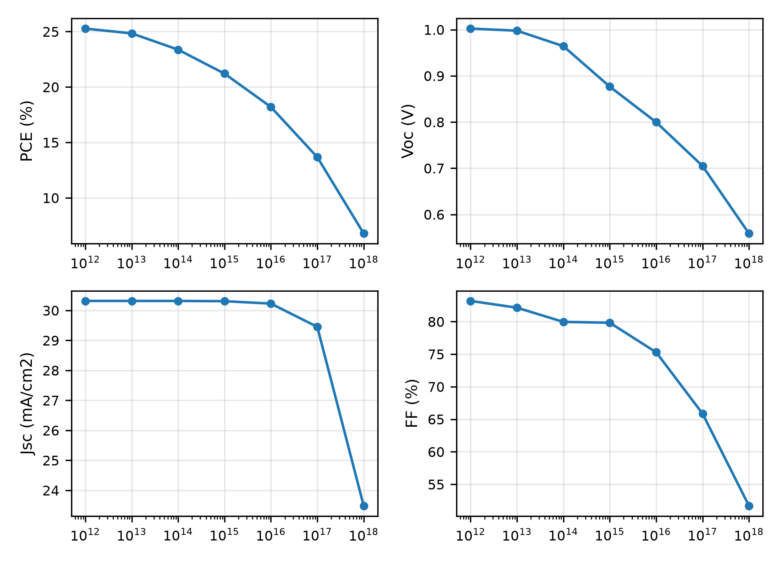
Figure 2. Variation of PCE, V_OC

Energy band diagram analysis
The band diagram under illumination (Figure 3) shows clean extraction at both heterojunctions. At CuI/RbGeI_3 the 1.8 eV conduction offset blocks electrons while the 0.10 eV valence step passes holes; at RbGeI_3/TiO_2 a 0.10 eV conduction step assists extraction while a 1.90 eV valence offset blocks holes. The peak bulk quasi-Fermi splitting reaches 1.13 V while the terminal V_OC is 1.06 V: the 70 mV gap is interface recombination plus quasi-Fermi bending toward the contacts (visible in Fig. 3), i.e.\ a quantified contact loss, not an inconsistency.
[Figure 3 about here]
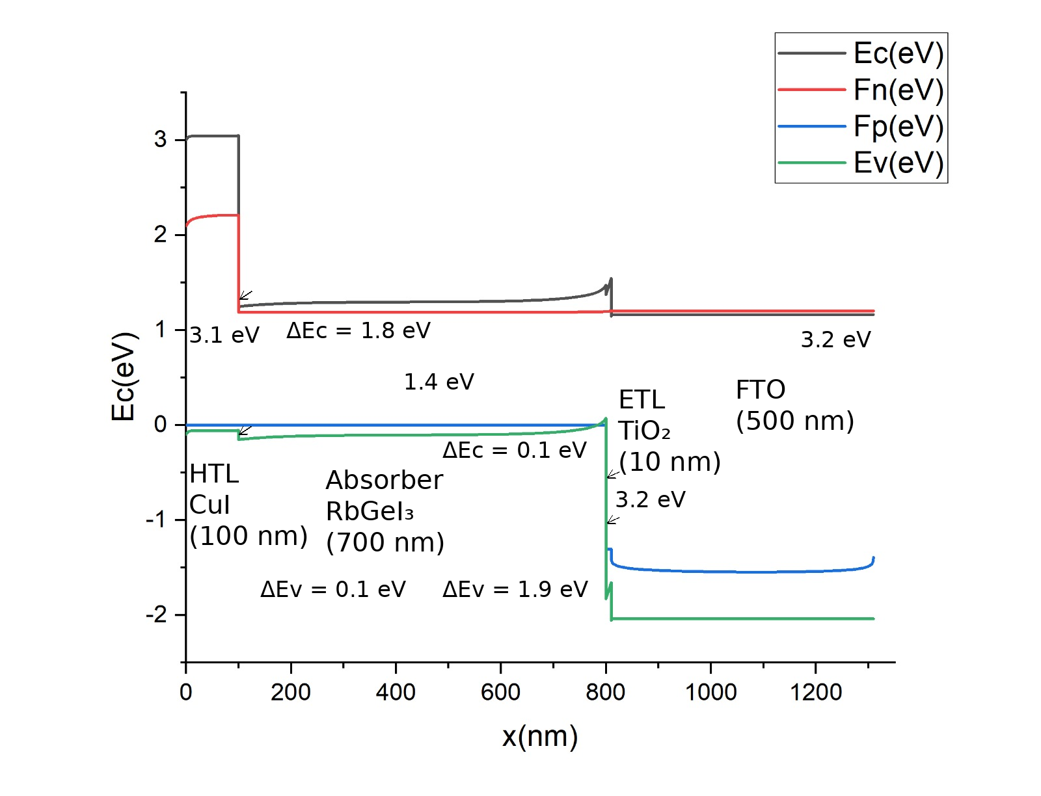
Figure 3. Energy band diagram of the optimized FTO/

Current density–voltage characteristics
The consolidated J–V under AM 1.5G (Figure 4) is sharply rectangular: V_OC = 1.06 V, J_SC = 30.32 mA/cm^2, FF = 84.11%, PCE = 27.06%, with no s-kink or rollover.
[Figure 4 about here]
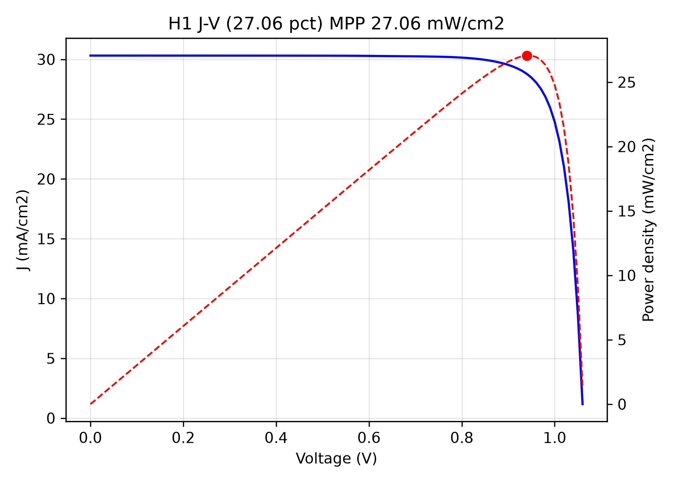
Figure 4. Current density–voltage (J–V) curve of the optimized FTO/

Summary of optimized device parameters and final performance
After completing the eleven sequential steps, the adopted values were incorporated into the proposed FTO/TiO_2/RbGeI_3/CuI/Au cell (Table IV): adopted means triple-gate values (Section IV.D), not raw sweep maxima — defect densities pinned at the passivated-film 10^14 level, N_C/N_V at the 10^18 literature floor, dielectric constant at 15 (sweep-flat), CuI at 100 nm (sweep-flat). The consolidated device was simulated in a single SCAPS-1D run with detailed-balance-consistent radiative recombination throughout: V_OC = 1.06 V, J_SC = 30.32 mA/cm^2, FF = 84.11%, PCE = 27.06%. The V_OC climb from the 0.81 V screening point is accounted for: bulk N_t 10^1510^14 adds 0.09 V (0.8770.964 V in the sweep), and the N_C/N_V literature floor adds 0.09 + 0.06 V across their sweeps, with the remainder from thickness/affinity alignment — no single step carries it. Every metric sits below its R\"uhle Shockley–Queisser limit at 1.4 eV (32.88 mA/cm^2, 1.122 V, 89.3%, 32.91%) r36. A six-parameter genetic-algorithm search (population 10, six generations, 62 SCAPS evaluations; crossover plus Gaussian mutation with elitism; seeded, archived) returns a best-found joint point at E_g = 1.36 eV, N_t 1.6 10^13 cm^-3, interface N_t 6 10^11 cm^-2, N_C/N_V 1.6 10^18 cm^-3, absorber 0.72 m, giving 1.04 V, 31.55 mA/cm^2, 85.87%, 28.30% (Fig. 7, Table V) — also fully SQ-admissible, but reported as best-found optimizer reach rather than an admissible device: its N_t1.610^13 cm^-3 and interface N_t610^11 cm^-2 sit below the triple-gate floors, not a proven global maximum. Section VI.C stacks all realism losses onto Table IV for a single realistic window (Fig. 9).

Table 4. Optimized material parameters of the proposed FTO/
Parameter | TiO_2 | FTO | RbGeI_3 | CuI
Thickness (nm) | 10 | 500 | 700 | 100
Bandgap E_g (eV) | 3.2 | 3.2 | 1.4 | 3.1
Electron affinity (eV) | 4.0 | 4.4 | 3.9 | 2.1
Dielectric permittivity | 9 | 9 | 15 | 6.5
CB effective DOS N_C (cm^-3) | 210^18 | 2.210^18 | 110^18 | 2.810^19
VB effective DOS N_V (cm^-3) | 1.810^19 | 1.810^19 | 110^18 | 110^19
Electron mobility e (cm^2 V^-1 s^-1) | 20 | 20 | 28.6 | 100
Hole mobility p (cm^2 V^-1 s^-1) | 10 | 10 | 27.3 | 43.9
Donor density N_D (cm^-3) | 910^16 | 110^19 | 110^9 | 0
Acceptor density N_A (cm^-3) | 0 | 0 | 110^9 | 110^18
Bulk defect density N_t (cm^-3) | 110^15 | 110^14 | 110^14 | 110^14

Table 5. Adopted reference device versus GA best-found point and sensitivity rows (defect rows re-simulated, Fig. 8; optics row reports PCE_1-sun
Device | V_OC (V) | J_SC (mA/cm^2) | FF (%) | PCE (%)
Adopted reference (Table IV) | 1.06 | 30.32 | 84.11 | 27.06
GA best-found (E_g 1.36 eV) | 1.04 | 31.55 | 85.87 | 28.30
Reference, N_C=N_V=1e19 | 0.97 | 30.32 | 84.09 | 24.82
Reference + realistic optics (0.9 sun) | 1.06 | 27.28 | 83.97 | 24.28

As an arithmetic consistency check, the final-device PCE computed from Eq. (eq:pce) using the consolidated J–V metrics is PCE = (1.0613 30.3161 0.8411) / 100 = 27.06%, matching the SCAPS-1D output to within rounding.

Uncertainty quantification
Monte Carlo UQ used Latin hypercube sampling (N = 200, seed 11) over eight variables on the H1 deck: gap 1.35–1.45 eV (E_g moves co-move ), bulk 510^13–510^15 cm^-3, interfaces 510^13–510^14 cm^-2 each side, N_C/N_V 510^16–510^17 cm^-3, _n/_p 15–50 cm^2/Vs.
[Figure 5 about here]
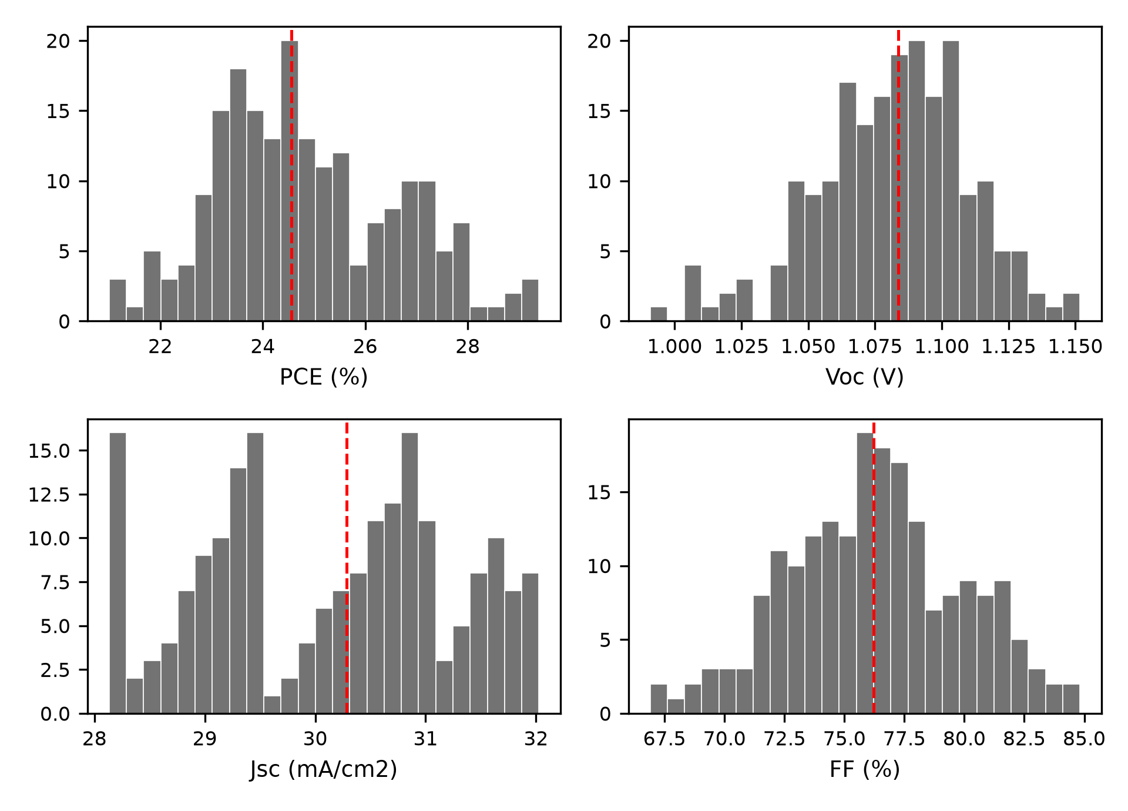
Figure 5. Uncertainty quantification results (N = 200). Histograms of PCE, V_OC
Mean PCE 24.86 1.77 % (median 24.55 %; 5th/95th 22.23/27.79 %; 200/200 converged).

Temperature dependence
Swept 280–400 K (20 K steps) under AM 1.5G.
[Figure 6 about here]
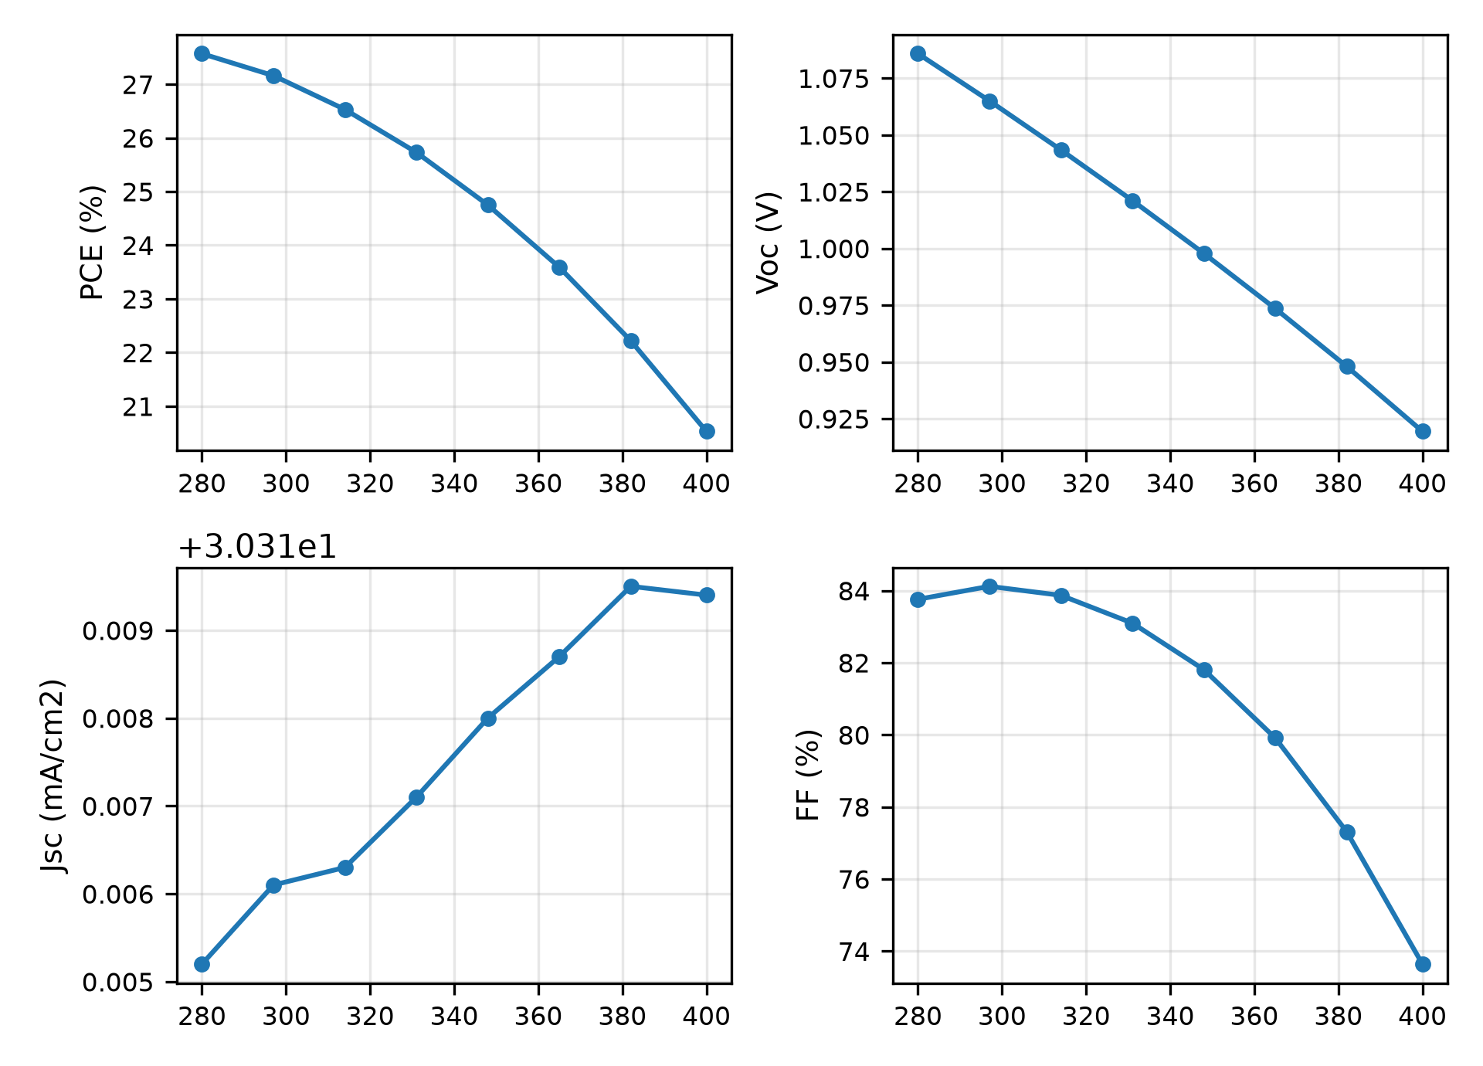
Figure 6. Temperature dependence of photovoltaic parameters from 280 K to 400 K.
dV_OC/dT = -1.38 mV/K, dPCE/dT = -0.058 %/K (PCE falls non-monotonically in FF, so the linear coefficient is descriptive, not predictive); 75 % of RT PCE retained at 400 K. V_OC(T) extrapolates to E_a = 1.48 eV — 0.08 eV above E_g, so this is not a clean bulk-recombination signature but an extrapolation artifact consistent with T-dependent N_C/N_V; it is reported as measured, with the artifact disclosed, rather than as proof of bulk-dominated recombination.
[Figure 7 about here]
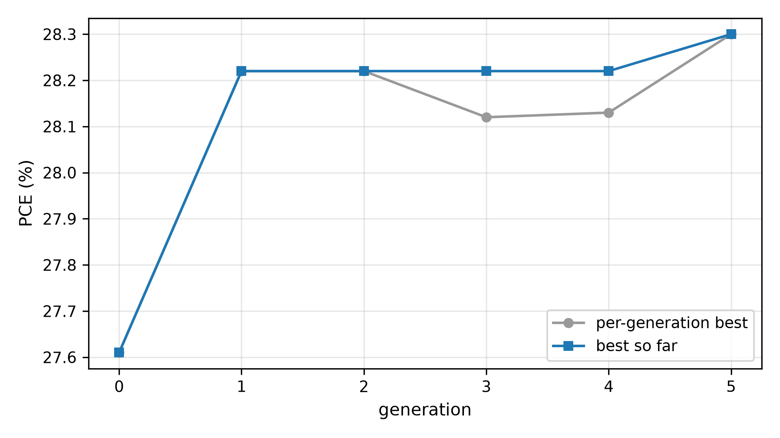
Figure 7. Genetic-algorithm joint search over bandgap, bulk/interface defect densities, N_C
[Figure 8 about here]
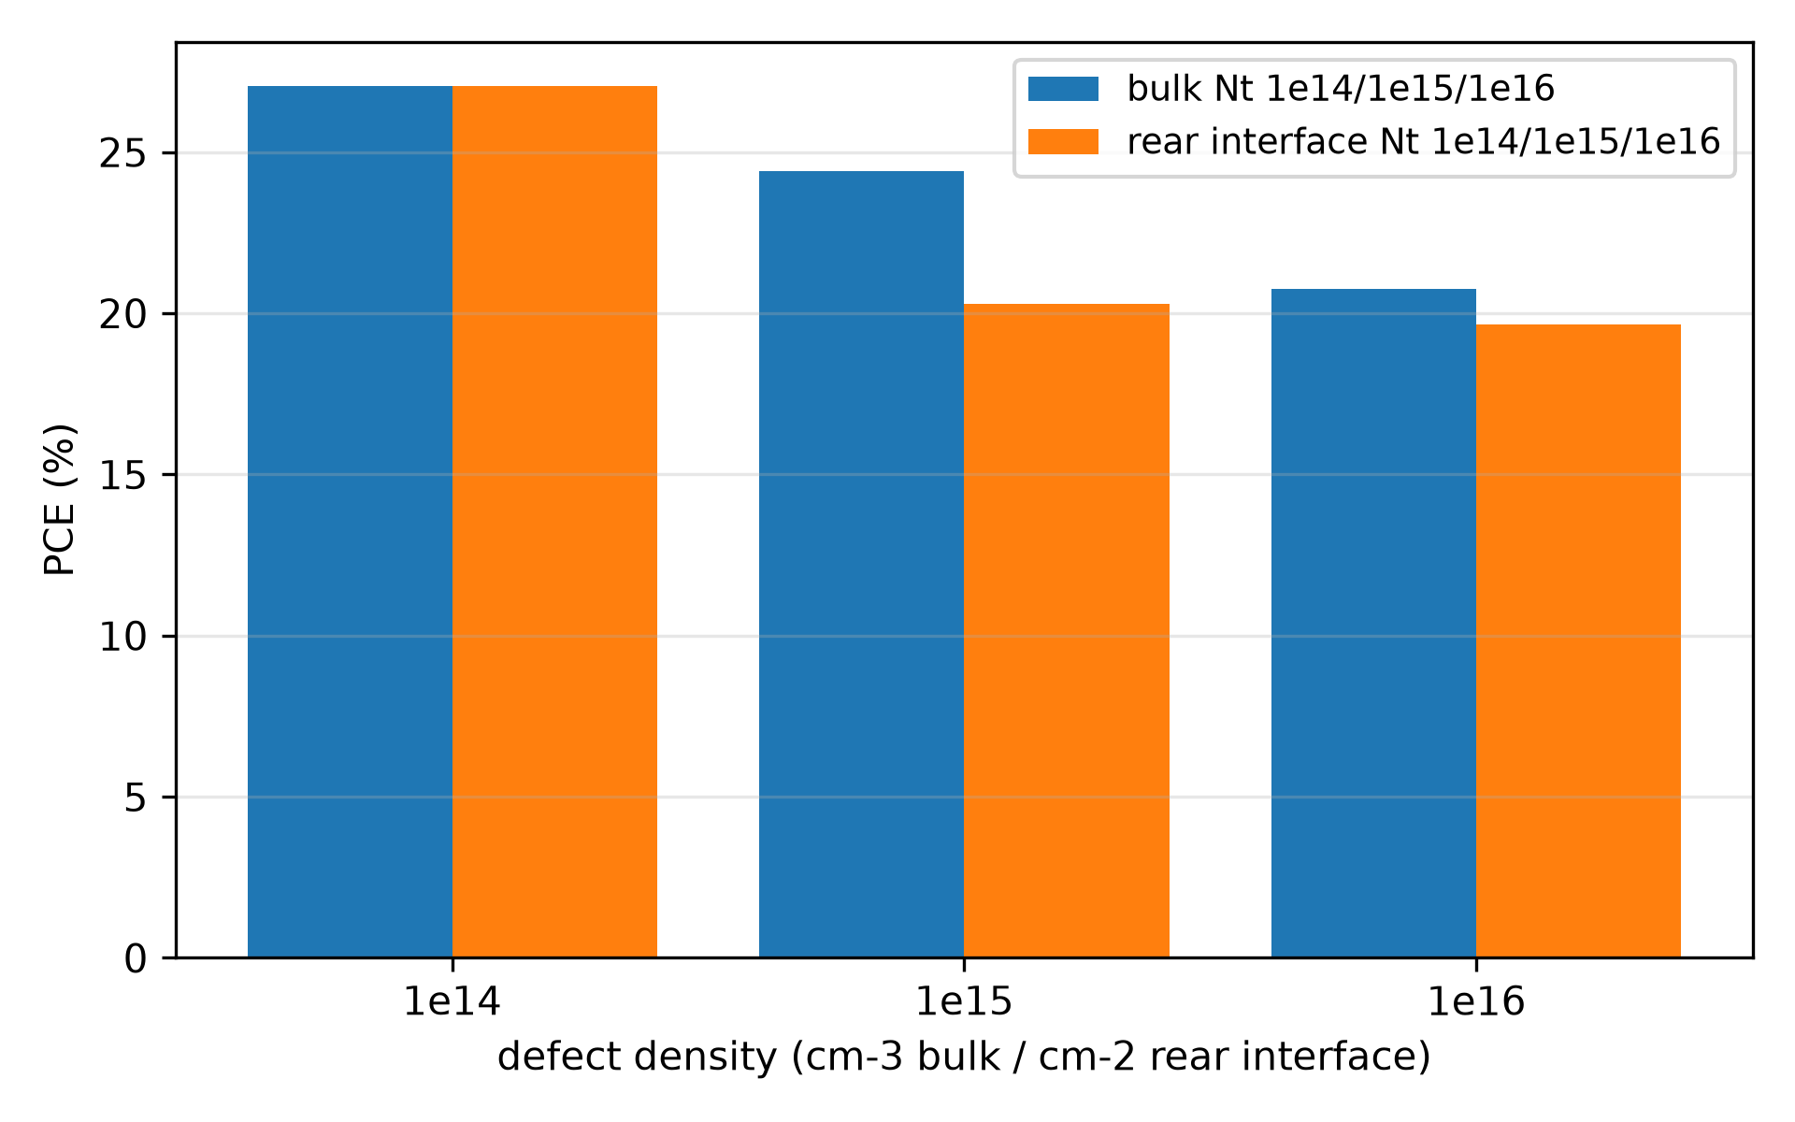
Figure 8. Defect tolerance of the adopted device. Raising bulk N_t
[Figure 9 about here]
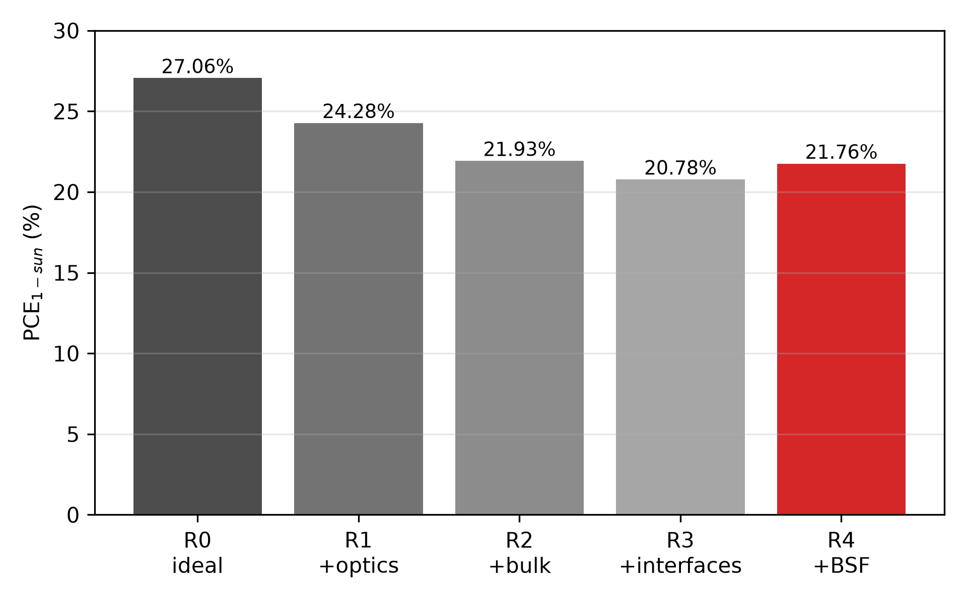
Figure 9. From the adopted 27.06% to the stacked realistic PCE: optics, bulk and interface losses give 20.78% (21.76% with BSF). All nodes re-simulated PCE_1-sun

Effect of background acceptor doping
Each Ge^2+ Ge^4+ oxidation event donates two holes via V_Ge, so background doping is oxidation by another name: sweeping N_A 10^14–10^17 cm^-3 on the stacked point (Fig. 12), PCE peaks at 23.41% near 310^15 cm^-3 and softens past 10^16 cm^-3 (23.12%) before falling at higher doping (22.17% at 10^17) — consistent with the oxidation budget's p2[V_Ge] expectation in Section VI.H, with the penalty soft (0.3 pp at 10^16), not a collapse. Synthetic target: N_A10^16 cm^-3. Tying doping to defects per the budget (N_t=10^15 with N_A=210^15 cm^-3) gives 25.52% against 24.40% untied, so the near-intrinsic absorber used throughout is conservative at this rung, not flattering.

Effect of series resistance: manufacturing tolerance
Corrections were recomputed on the stacked realistic point (20.78%), not the ideal: FF falls 77.75 59.75% and PCE 20.78 15.96% as R_s goes 0 8 cm^2 (Fig. 13, external V - JR_s). Tolerance: R_s4 preserves 20% pre-optics (23.16 20.10%); on the full stack the same R_s gives 18.31%. Shunt analysis on the same point: R_sh 10^2/510^2/10^3/ gives 14.26/19.41/20.09/20.71%, so R_sh10^3 cm^2 holds 20%.

Absorber mobility viability
Electron/hole mobilities were swept jointly from 1 to 100 cm^2/Vs on the stacked point (Fig. 14): PCE is log-linear (18.35% at 1 to 24.32% at 100). Crystallization target: 15 cm^2/Vs.

Extended results: loss budget, sensitivity and experimental grounding

Benchmarking data (discussion in Section VII)
Literature benchmarking (Table VI) and the CsGeI_3 gap control (Table VII, Fig. 16) are discussed in Section VII; the tables and figures are placed here.

Table 6. Comparison of the proposed device with recently reported lead-free perovskite solar cells. All comparator values verified against primary sources. All entries are SCAPS-1D simulation studies.
Device Structure | V_OC (V) | J_SC (mA/cm^2) | FF (%) | PCE (%) | Year [Ref.]
FTO/TiO_2/RbGeI_3/NiO/Ag | 0.5311 | 28.89 | 63.68 | 9.77 | 2022 [14]
FTO/TiO_2/CsGeI_3/CuI/Au | 0.667 | 22.06 | 73.49 | 10.80 | 2022 [24]
ITO/C_60/RbGeI_3/CBTS/Ag | 0.99 | 33.20 | 82.80 | 27.21 | 2024 [22]
FTO/TiO_2/RbGeI_3/PEDOT:PSS/Au | 0.813 | 30.84 | 74.19 | 18.60 | 2025 [39]
FTO/TiO_2/MASnI_3/CBTS/Au | 1.030 | 30.24 | 83.41 | 25.98 | 2026 [41]
FTO/TiO_2/MASnI_3/CZTS/Au | 0.96 | 31.66 | 67.00 | 20.36 | 2025 [42]
FTO/TiO_2/CsSnI_3/P3HT/Au | 0.972 | 34.70 | 78.21 | 26.38 | 2024 [40]
FTO/TiO_2/RbGeI_3/Spiro-OMeTAD/Au | 1.1813 | 26.31 | 85.16 | 26.47 | 2026 [23]
FTO/TiO_2/RbGeI_3/CuI/Au (this work) | 1.06 | 30.32 | 84.11 | 27.06 | This work
FTO/TiO_2/RbGeI_3/Cu_2O-BSF/CuI/Au (this work) | 1.09 | 30.32 | 84.62 | 28.01 | This work

Table 7. RbGeI_3
Device | Condition | V_OC (V) | J_SC (mA/cm^2) | PCE (%)
RbGeI_3 | Ideal (N_t=1e14) | 1.06 | 30.32 | 27.06
CsGeI_3 | Ideal (N_t=1e14) | 1.10 | 23.18 | 19.65
RbGeI_3 | Realistic (N_t=1e15) | 1.02 | 30.31 | 24.40
CsGeI_3 | Realistic (N_t=1e15) | 1.10 | 23.17 | 19.31
RbGeI_3 | High oxidation (N_t=1e16) | 0.96 | 30.22 | 20.76
CsGeI_3 | High oxidation (N_t=1e16) | 1.09 | 23.10 | 17.07

[Figure 10 about here]
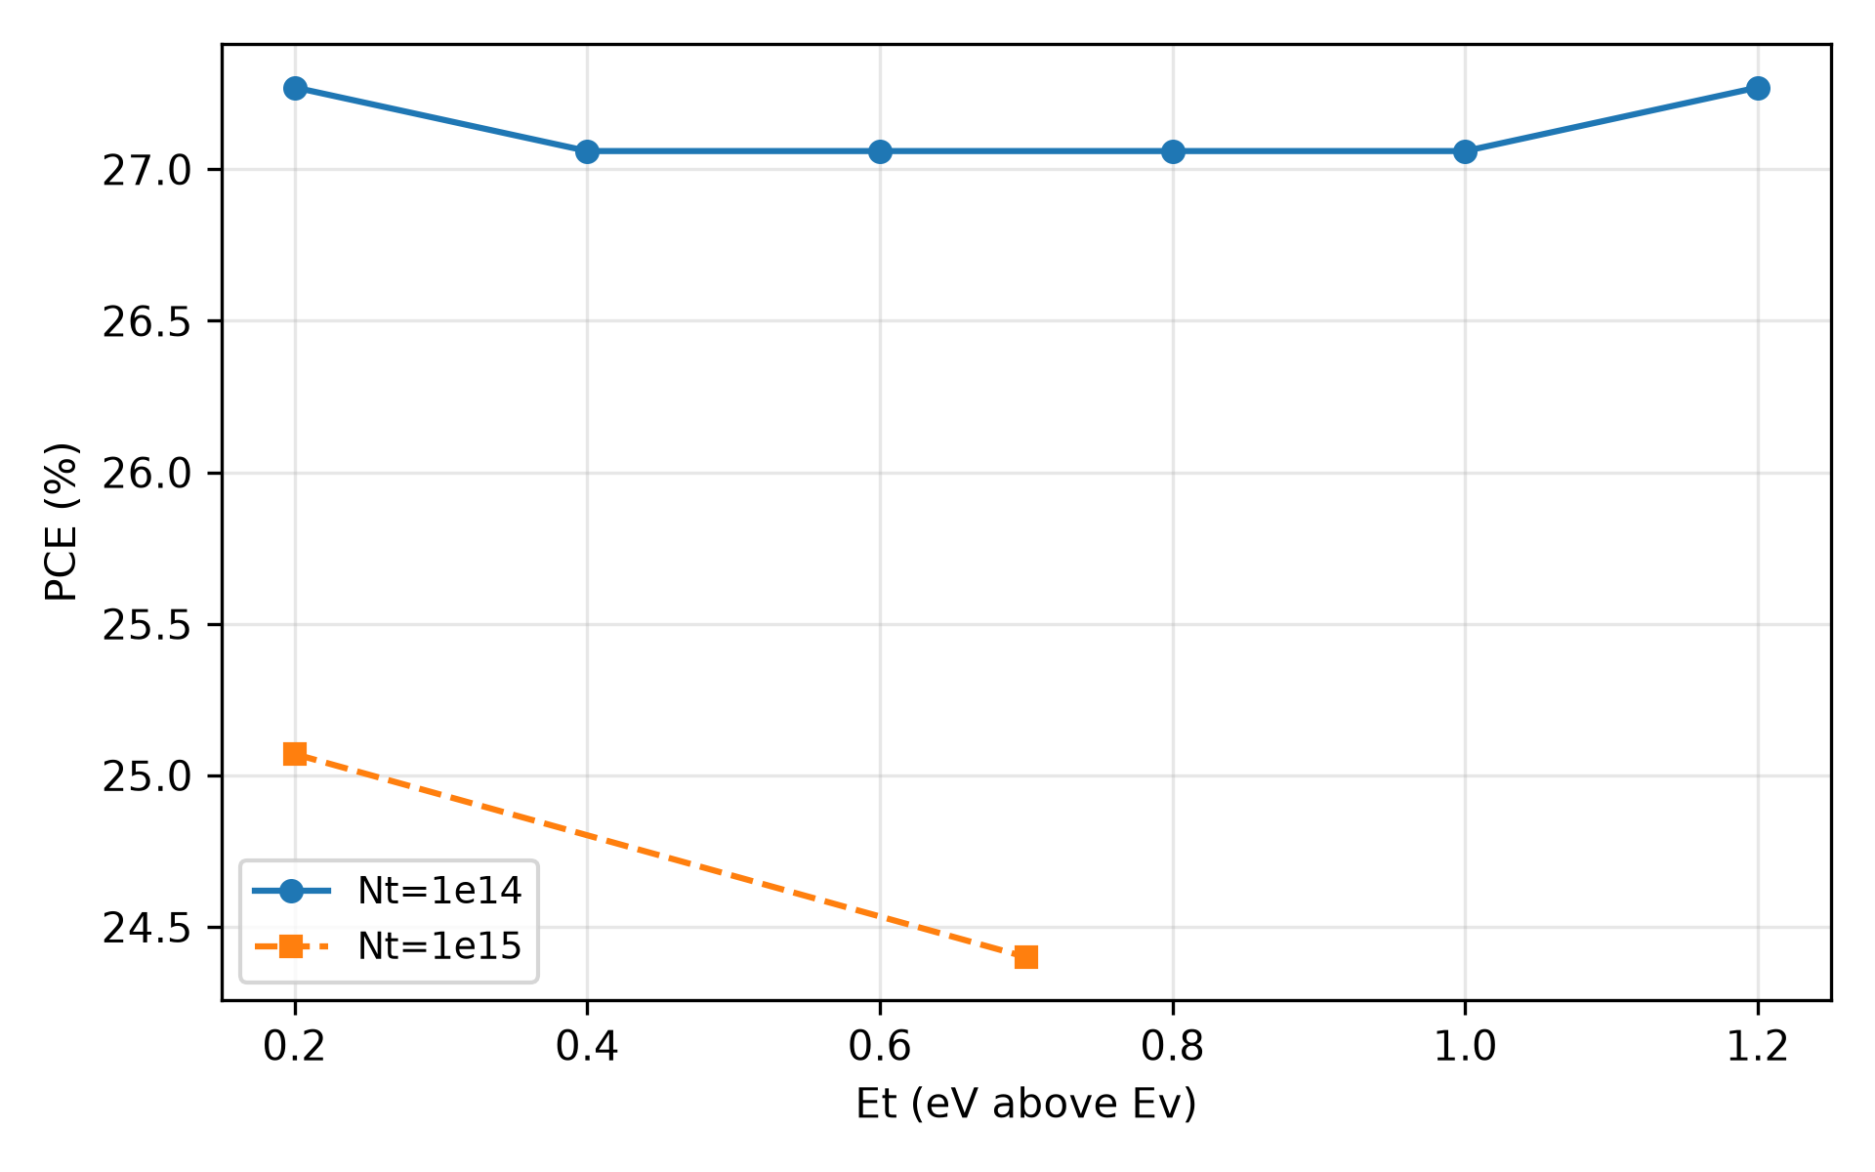
Figure 10. PCE versus defect energy E_t
[Figure 11 about here]
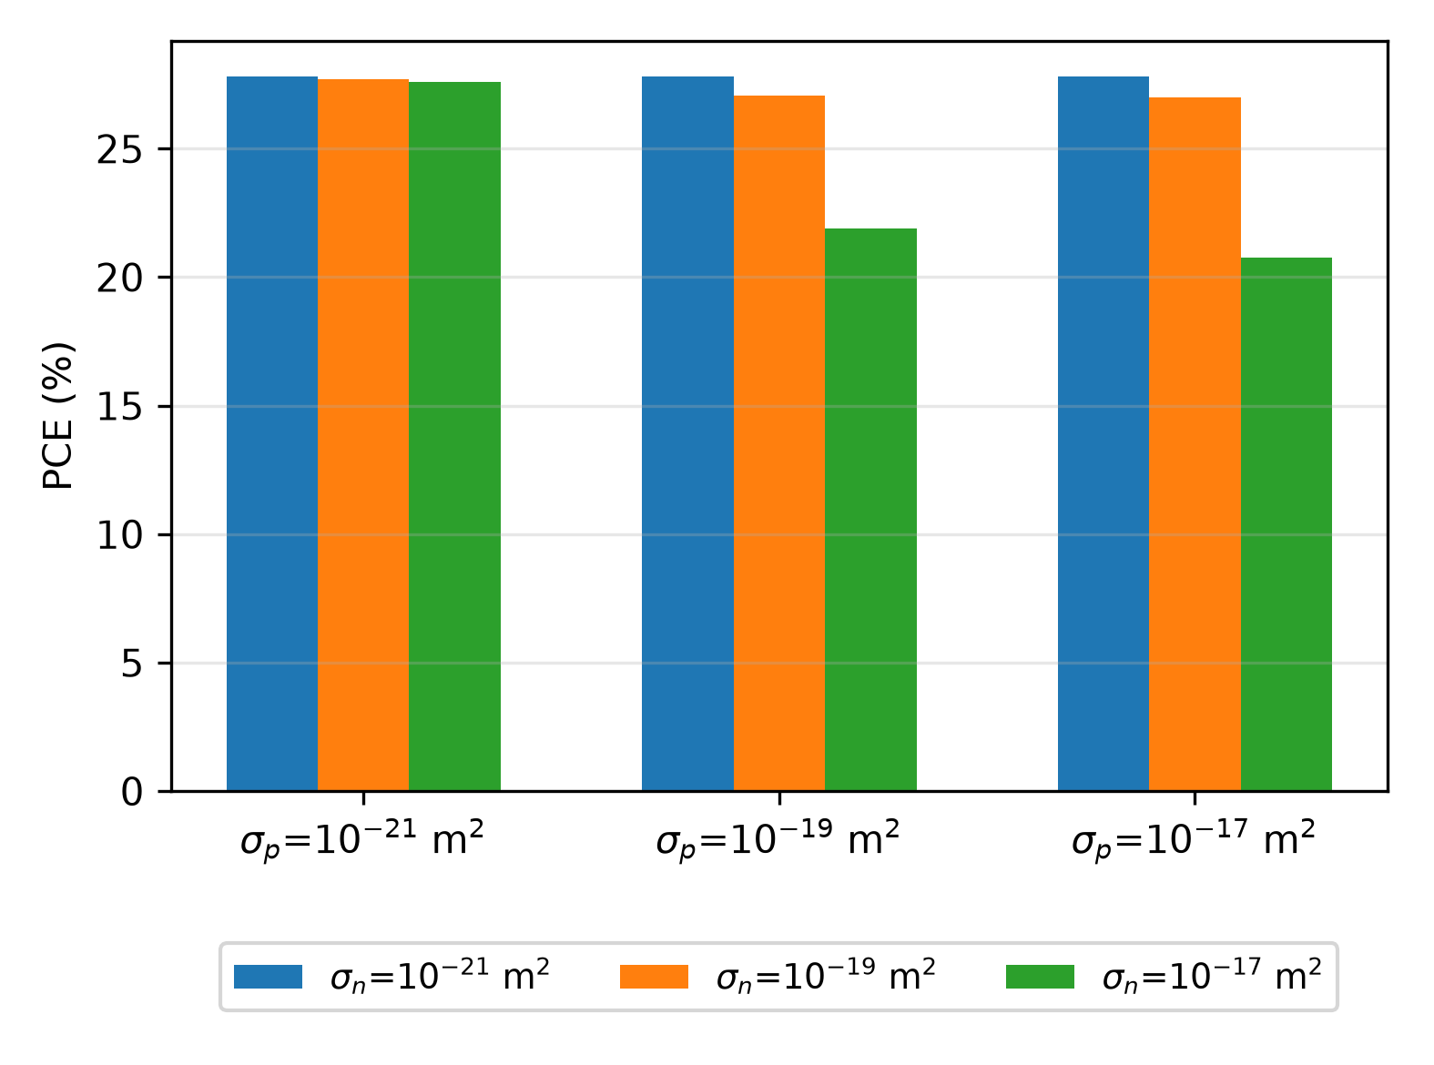
Figure 11. PCE versus capture cross-section asymmetry at mid-gap E_t
[Figure 12 about here]
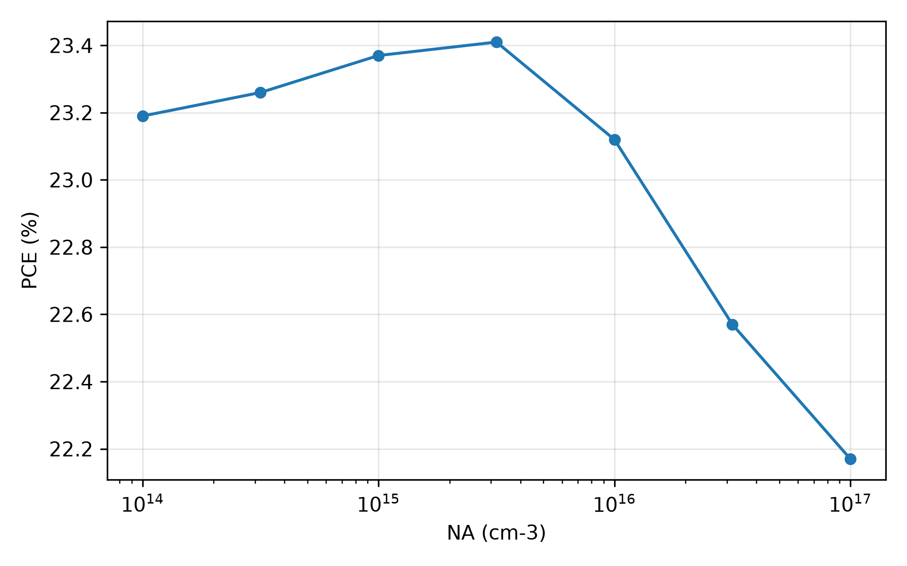
Figure 12. PCE versus background acceptor density on the stacked point. Optimum near 310^15
[Figure 13 about here]
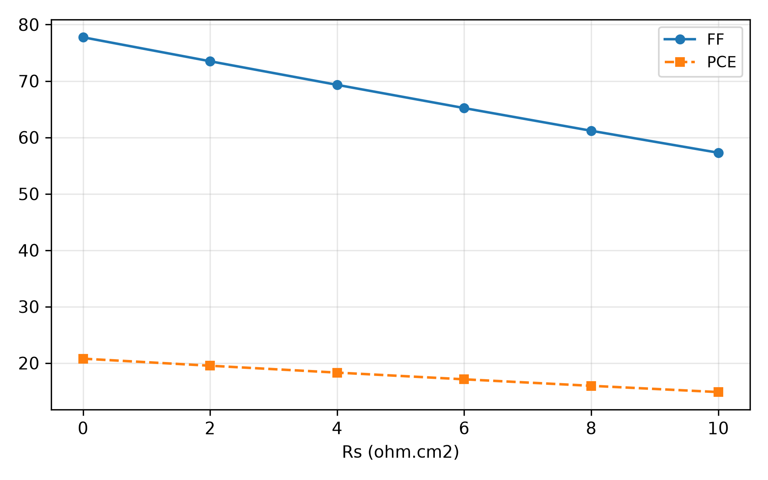
Figure 13. PCE and FF versus series resistance (external V - J x R_s
[Figure 14 about here]
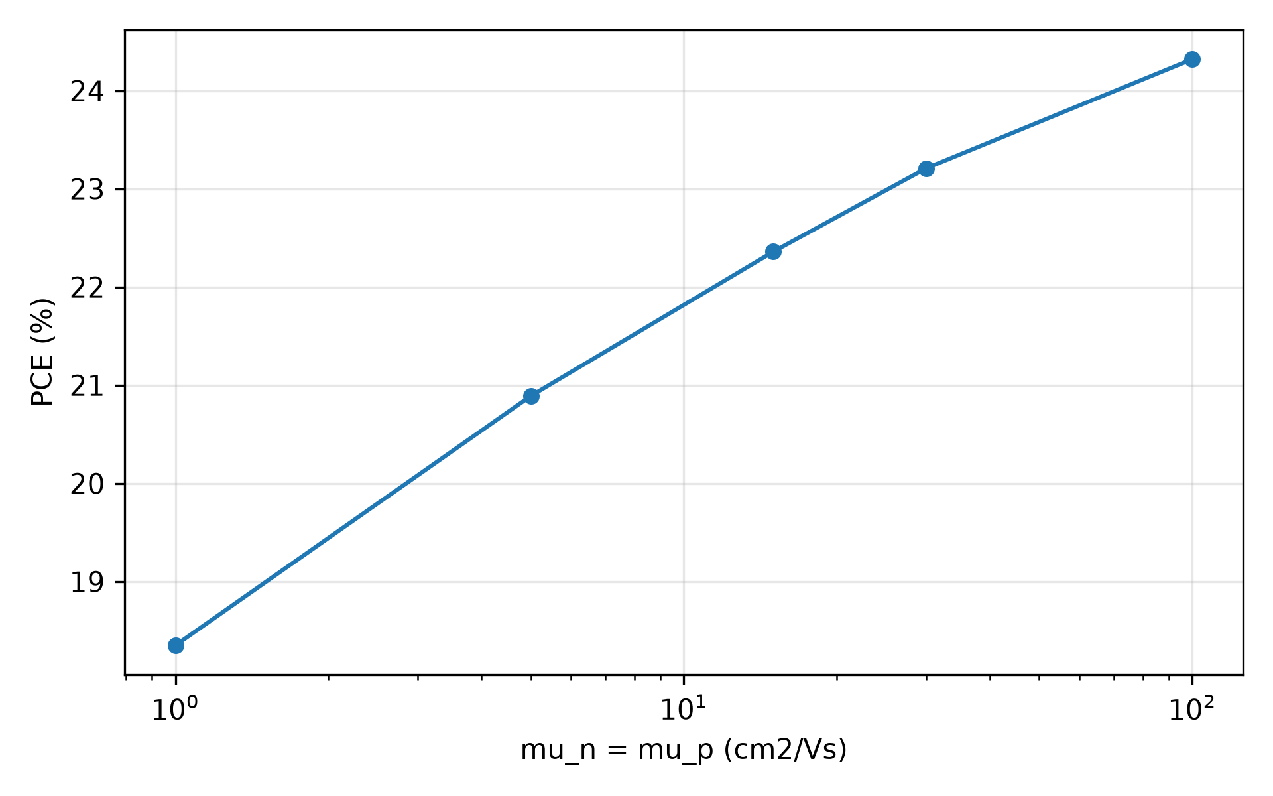
Figure 14. PCE versus absorber mobility (_n
[Figure 15 about here]
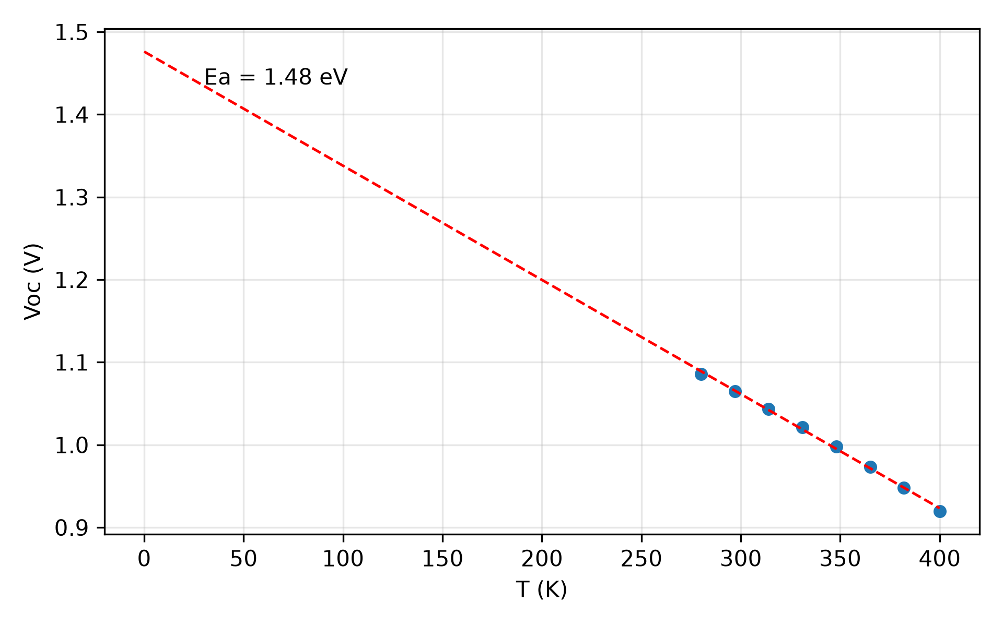
Figure 15. V_OC
[Figure 16 about here]
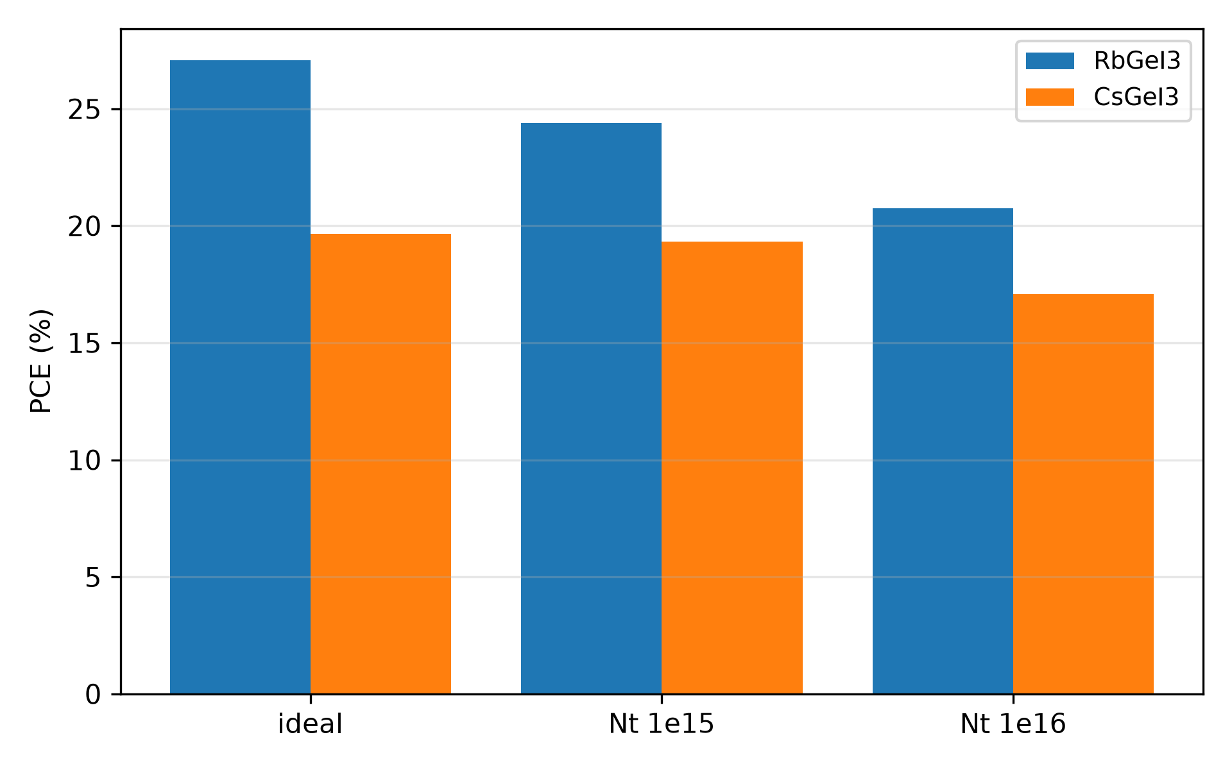
Figure 16. RbGeI_3
[Figure 17 about here]
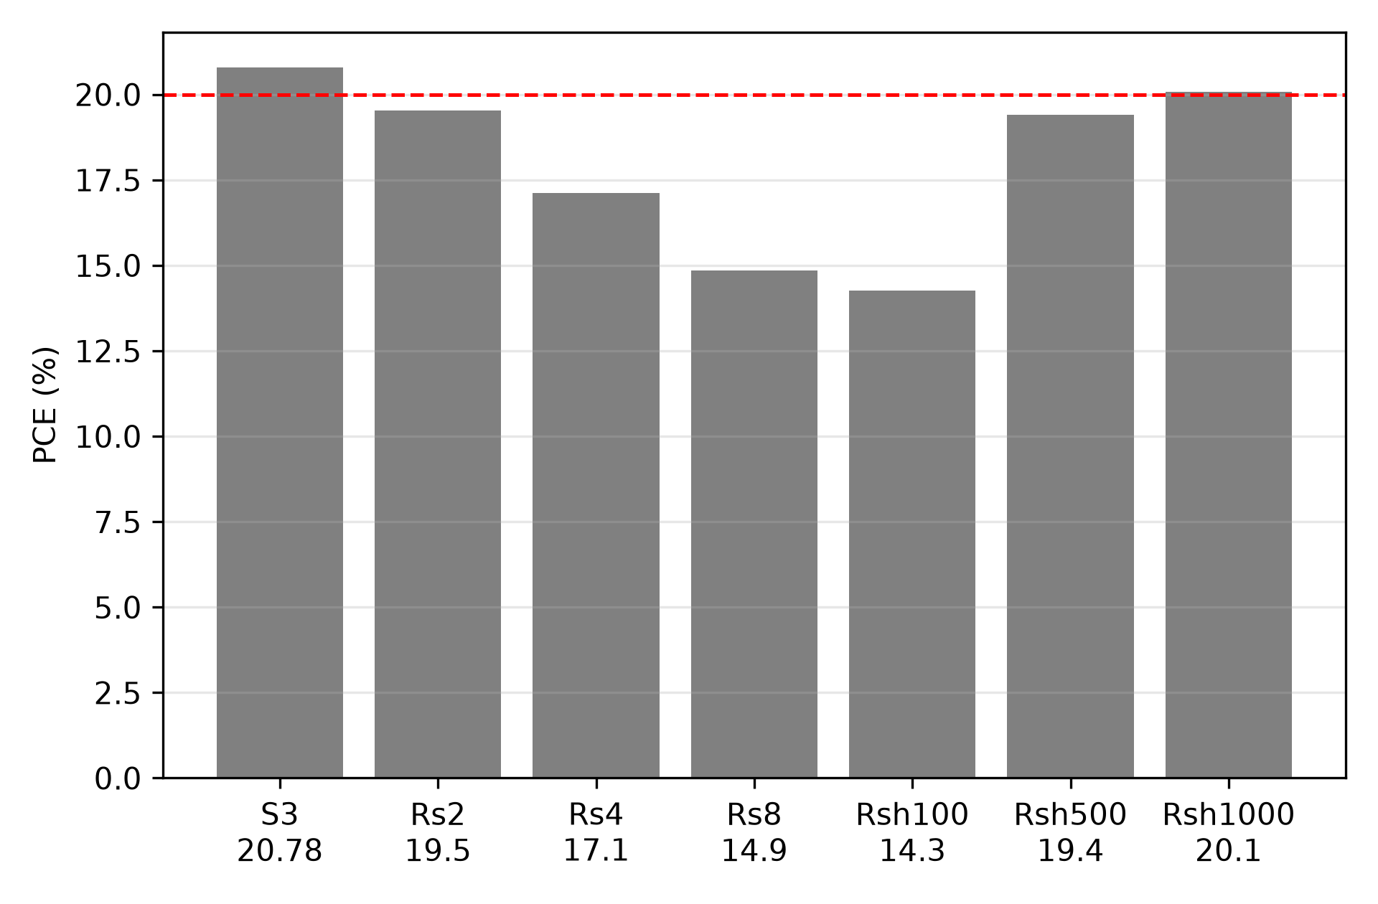
Figure 17. Resistance derating ladder on the stacked 20.78% point (R_s

BSF enhancement of the TiO_2
/RbGeI_3/CuI stack A Cu_2O-like p^+ back-surface field (BSF) inserted between RbGeI_3 and CuI (E_g 2.1 eV, 3.2 eV, _r 7.5, literature-standard Cu_2O parameters for SCAPS perovskite studies rMA) upgrades the same economical stack without changing the absorber or transport pair. The 50 nm, N_A 10^18 cm^-3 pilot converges to 27.93% (+0.87 pp over the 27.06% headline). The full 43 grid (Fig. 18; nodes in Supplementary Table S5) shows doping, not thickness, controls the gain: 10^17 gives 27.55–27.60%, 10^18 gives 27.93–27.94%, 10^19 gives 28.00–28.01%. The optimum reaches 28.01% (1.0915 V, 30.32 mA/cm^2, 84.62%); J_SC is unchanged, so the gain is V_OC (+30 mV) plus FF (+0.5 pp). The mechanism is rear-interface gap widening, not electron reflection (CuI already blocks electrons with 1.8 eV): the BSF removes the 0.10 eV valence cliff – computed from the stated layer offsets, cf.\ the no-BSF lineup in Fig. 3 – that otherwise shrinks the interface recombination gap, and it halves the rear trap penalty — raising rear N_t to 10^16 cm^-2 costs 7.41 pp without BSF (27.06 19.65%) but 3.64 pp with it (28.00 24.36%, Fig. 18, right panel). Block attribution is explicit: both rear blocks (CuI/BSF and BSF/RbGeI_3) carry the raised N_t, and raising only the far CuI/BSF block costs nothing, pinning the damage on the absorber side. A p^+ control interlayer with CuI bands (no new offset, same N_A) gains only +0.76 pp ideally (27.82%) and still loses 6.49 pp under traps (21.33%), so the field contributes a minority share and the offset removal carries the immunity. Gains are non-additive with the N_t=10^15 ladder for the same reason: once the rear gap is widened, further defect cuts buy less. All metrics sit below the R\"uhle limits r35,r36,r37. Cu_2O is routinely sputtered on perovskite stacks, but a direct Cu_2O-on-Ge-perovskite interface is undemonstrated and flagged as the fabrication risk.
[Figure 18 about here]
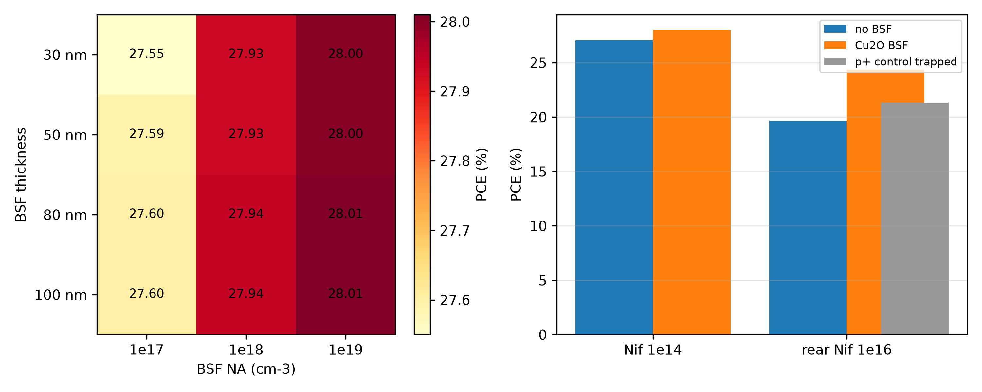
Figure 18. BSF grid PCE (%): N_A

Loss waterfall: what survives realism
Native-defect simulation plus photon-scaling optics and post-processed parasitics bound the experimentally plausible window (Fig. 19; nodes in Supplementary Table S6; PCE_1-sun norm.). Radiative recombination at K_rad 10^-10 cm^3/s costs 0.07 pp (27.13 27.06%), consistent with the detailed-balance value to order of magnitude at the rebased densities; higher K_rad bounds the sensitivity in S6. Auger coefficients 10^-29–10^-27 cm^6/s change nothing at 1-sun (0.00 pp) — a reportable null justifying its omission from the headline budget. Ten percent front reflection costs 2.78 pp (24.28%); realistic bulk defects (10^15 cm^-3) a further 2.35 pp (21.93%); realistic interfaces (10^15 cm^-2) a further 1.15 pp (20.78%). The BSF optimum on the identical full stack gives 21.76%, recovering +0.98 pp. The stack is optics- and defect-limited, not transport-limited, and the BSF pays off precisely where reality lives.
[Figure 19 about here]
Figure 19. Stacked loss waterfall (PCE_1-sun

Carrier-lifetime baseline
SRH statistics (^-1= v_thN_t) give 1000 ns at 10^14 cm^-3 with diffusion length 8.6 m 700 nm absorber, explaining the near-unity collection. Fig. 20 shows the Beer–Lambert generation profile normalized to the H1 J_SC. No built-in potential, depletion width or Mott–Schottky values are reported: the near-intrinsic absorber is fully depleted so the depletion approximation does not apply, and C–V extraction is left for fabricated devices (method note in S7).
[Figure 20 about here]
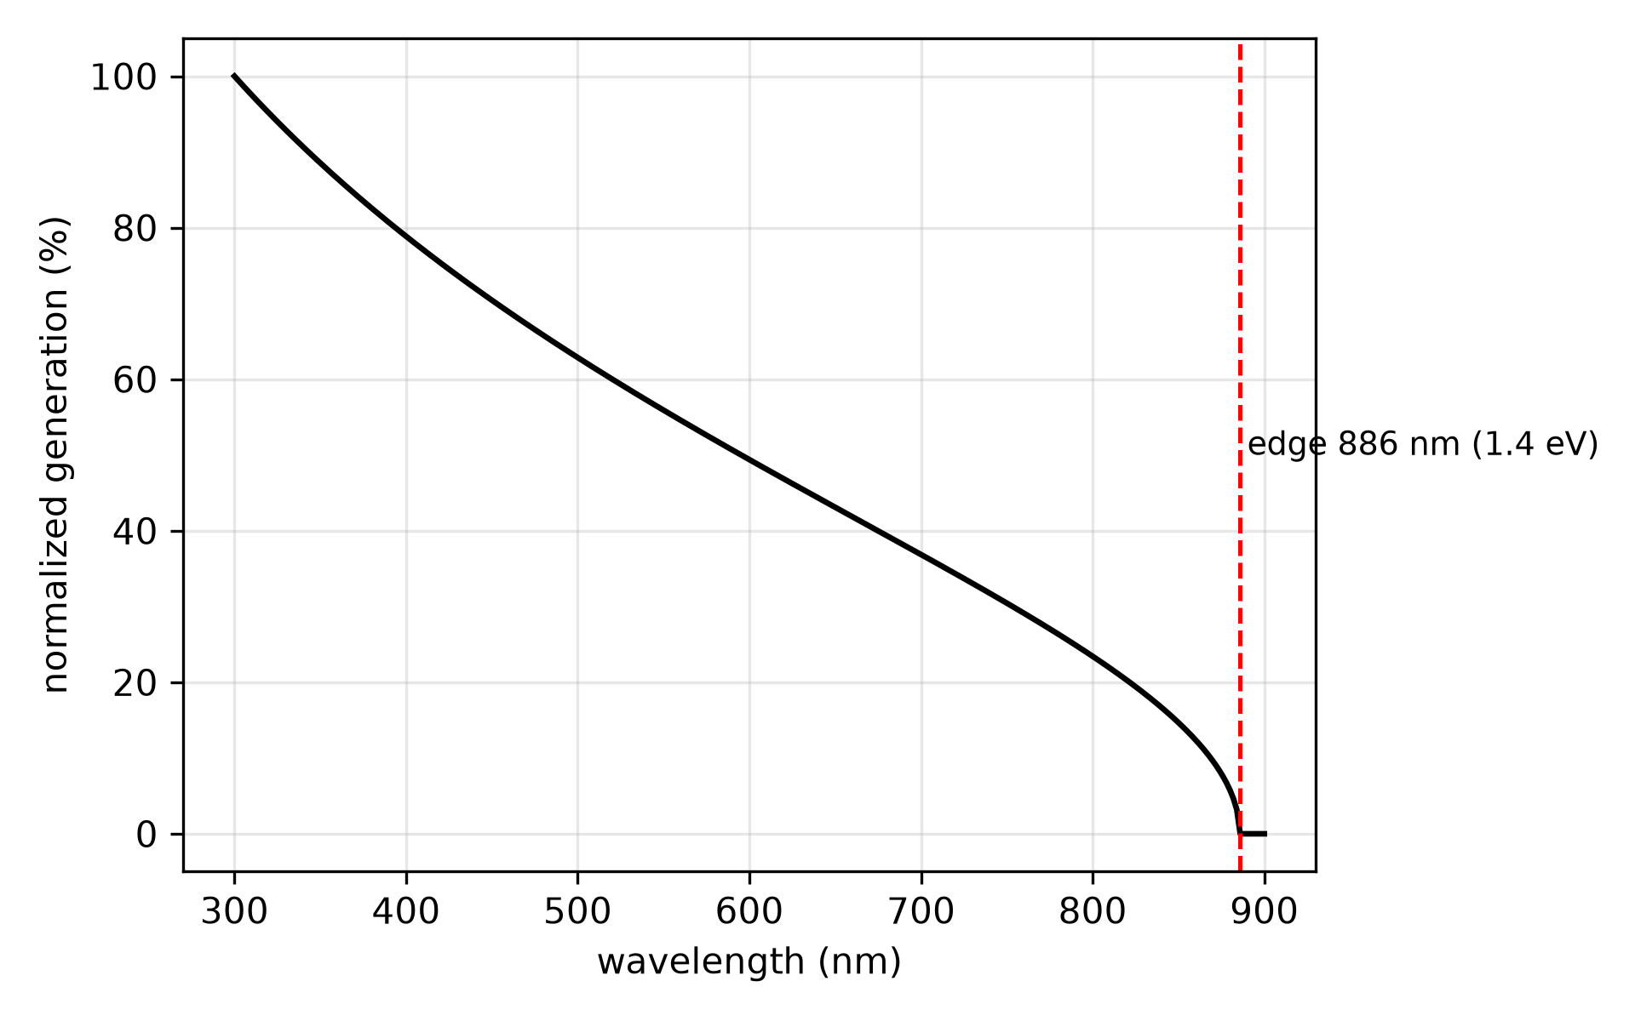
Figure 20. Normalized Beer–Lambert generation profile (square-root law, edge 886 nm). Recombination-profile export is unavailable for this deck (S7); the BSF mechanism rests on the controlled attribution runs (Fig. 18) instead.

Data-driven global sensitivity analysis
An XGBoost surrogate on the 200-point LHS-UQ block (8 features: E_g, N_t, N_C, N_V, _n, _p, both interface N_t; 80/20 held-out split, seed 7; 200/200 converged; E_g moves co-move so gap physics, not misalignment, is measured) gives held-out R^2 0.907, RMSE 0.57 (Fig. 21; random forest agrees at 0.907). SHAP ranks bulk N_t > E_g > _n > CuI-side N_t > TiO_2-side N_t > N_V > _p > N_C (Fig. 22): near the adopted point, bulk defect density dominates, electron mobility outranks hole mobility, and N_C/N_V are inert within the sampled neighborhood (510^16–510^17 cm^-3) — consistent with Table V, where 10^19 costs 2.2 pp outside it. Three hedges: rankings inherit sampled ranges (E_g spans 1.35–1.45 while N_t spans two decades); N_C/N_V are sampled an order of magnitude below the enforced 10^18 floor, so their ``inert'' ranking is a neighborhood statement, not a license to lower them; the interface range tops out at 510^14 cm^-2, excluding the realistic point. The deterministic-solver R^2 is reported on held-out data only; no factorial cross-check figure is shown (the prior 193-row block ran on the pre-rebase deck).
[Figure 21 about here]
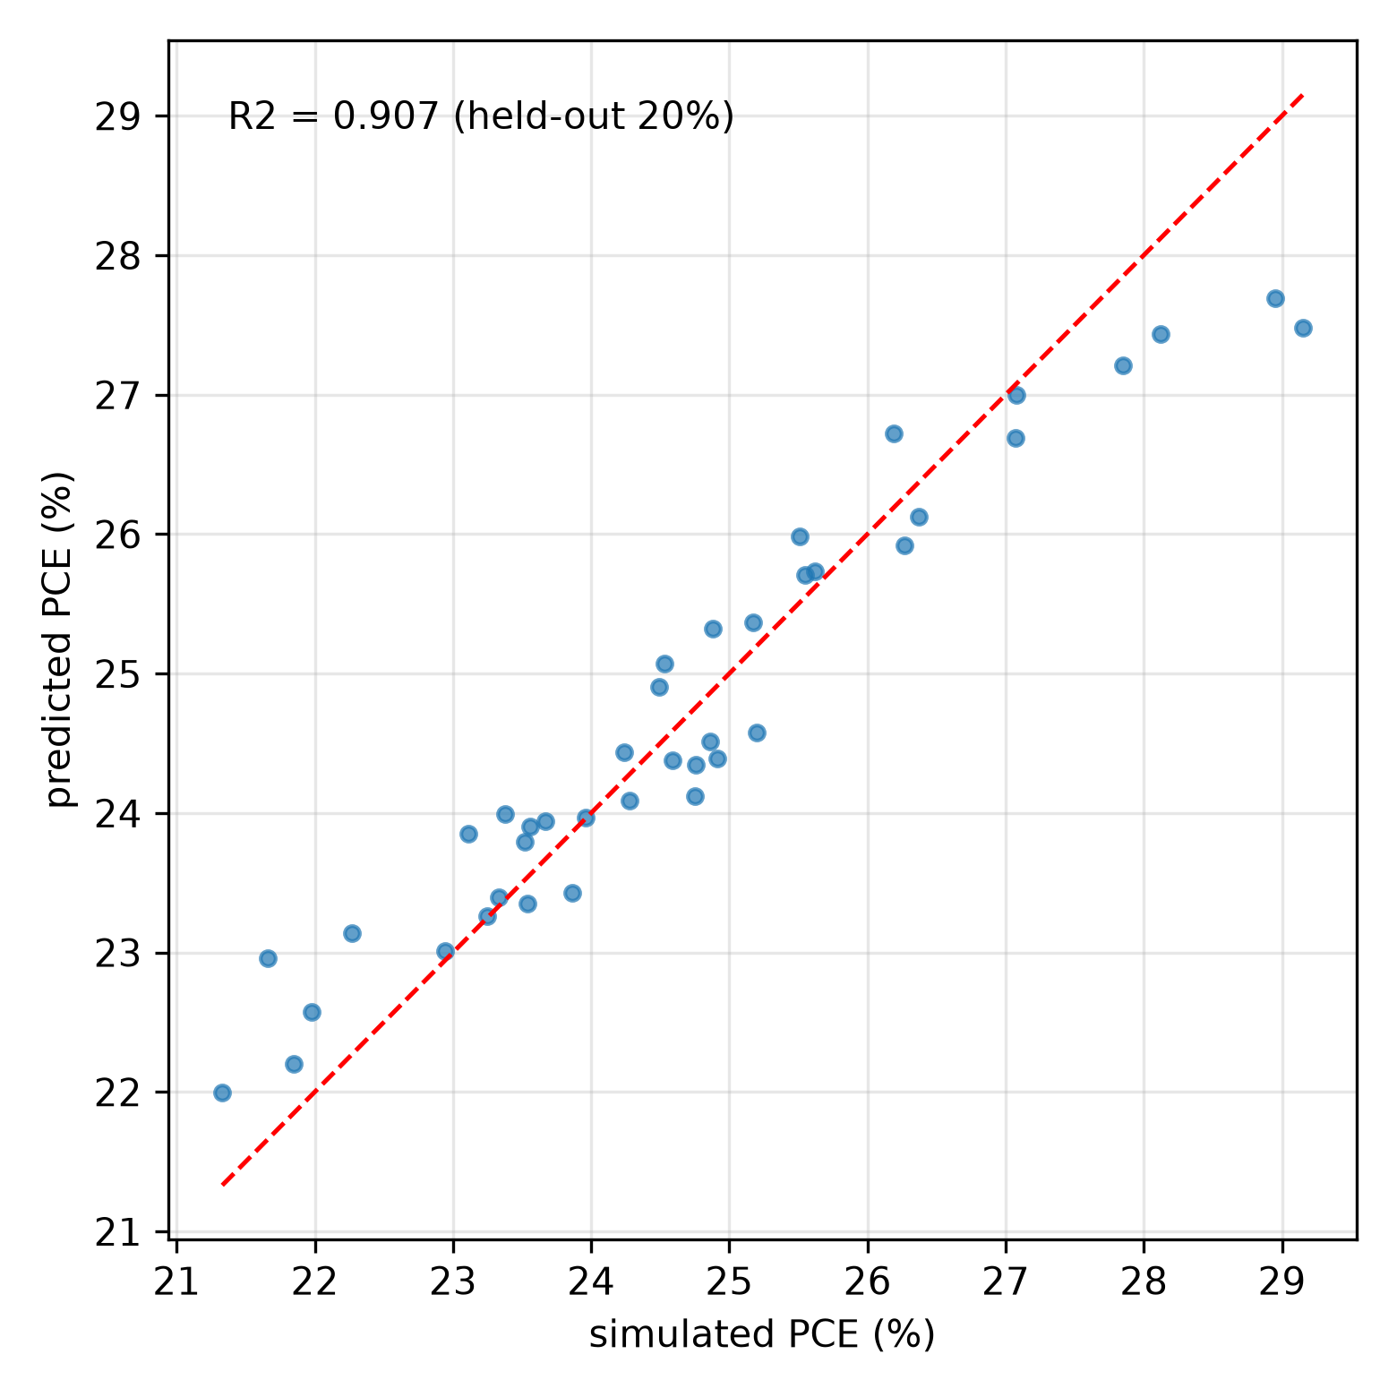
Figure 21. XGBoost parity on the UQ block, held-out 20% (R^2
[Figure 22 about here]
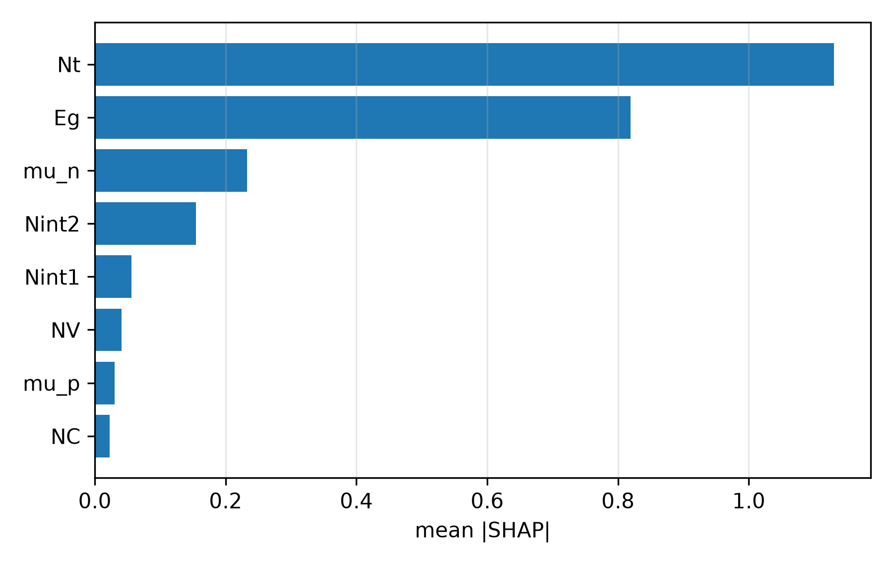
Figure 22. SHAP importance from the UQ surrogate (R^2

Pipeline calibration against an experimental inorganic perovskite
No RbGeI_3 device has been fabricated to date, so direct validation is impossible; we instead run a calibration sanity check of the solver pipeline on the experimentally realized analog -CsPbI_3 of Wang et al.\ rWang (FTO/c-TiO_2/CsPbI_3/spiro-OMeTAD/Ag, 375 nm absorber, J–V measured at 318 K). Rebuilding that stack with literature-pinned bands and fitting only bulk N_t interface N_t reproduces both reported devices (Table VIII, Fig. 23): the CHI-passivated champion at N_t 310^13 cm^-3 / N_t,if 310^13 cm^-2 (18.49% vs 18.4%, all metrics within 2%), and the control at N_t 310^13 cm^-3 / N_t,if 10^14 cm^-2 plus an effective R_s 6.9 cm^2 first-order correction (15.18% vs 15.1%). The control's low FF (0.72) cannot be reached by defects (floor 0.84) and carries the documented cracks, pinholes and hysteresis, justifying the resistive term; the control fit visibly misses the knee, so it is presented as achieved with that caveat. This calibrates that SCAPS-1D with literature bands can reproduce two measured inorganic devices by tuning defect densities (plus one resistive correction) — it tests the solver pipeline, not CuI, Ge chemistry, the oxidation map or the BSF, none of which appear in the analog; full provenance is in Supplementary Section S5.

Table 8. Calibration check: SCAPS rebuild vs measured -CsPbI_3
Device | V_OC (V) | J_SC (mA/cm^2) | FF (%) | PCE (%)
Wang control (measured) | 1.05 | 20.03 | 72.0 | 15.10
SCAPS rebuild + R_s 6.9 | 1.060 | 19.92 | 71.88 | 15.18
Wang champion (measured) | 1.11 | 20.0 | 82.0 | 18.40
SCAPS rebuild | 1.127 | 19.92 | 82.37 | 18.49

[Figure 23 about here]
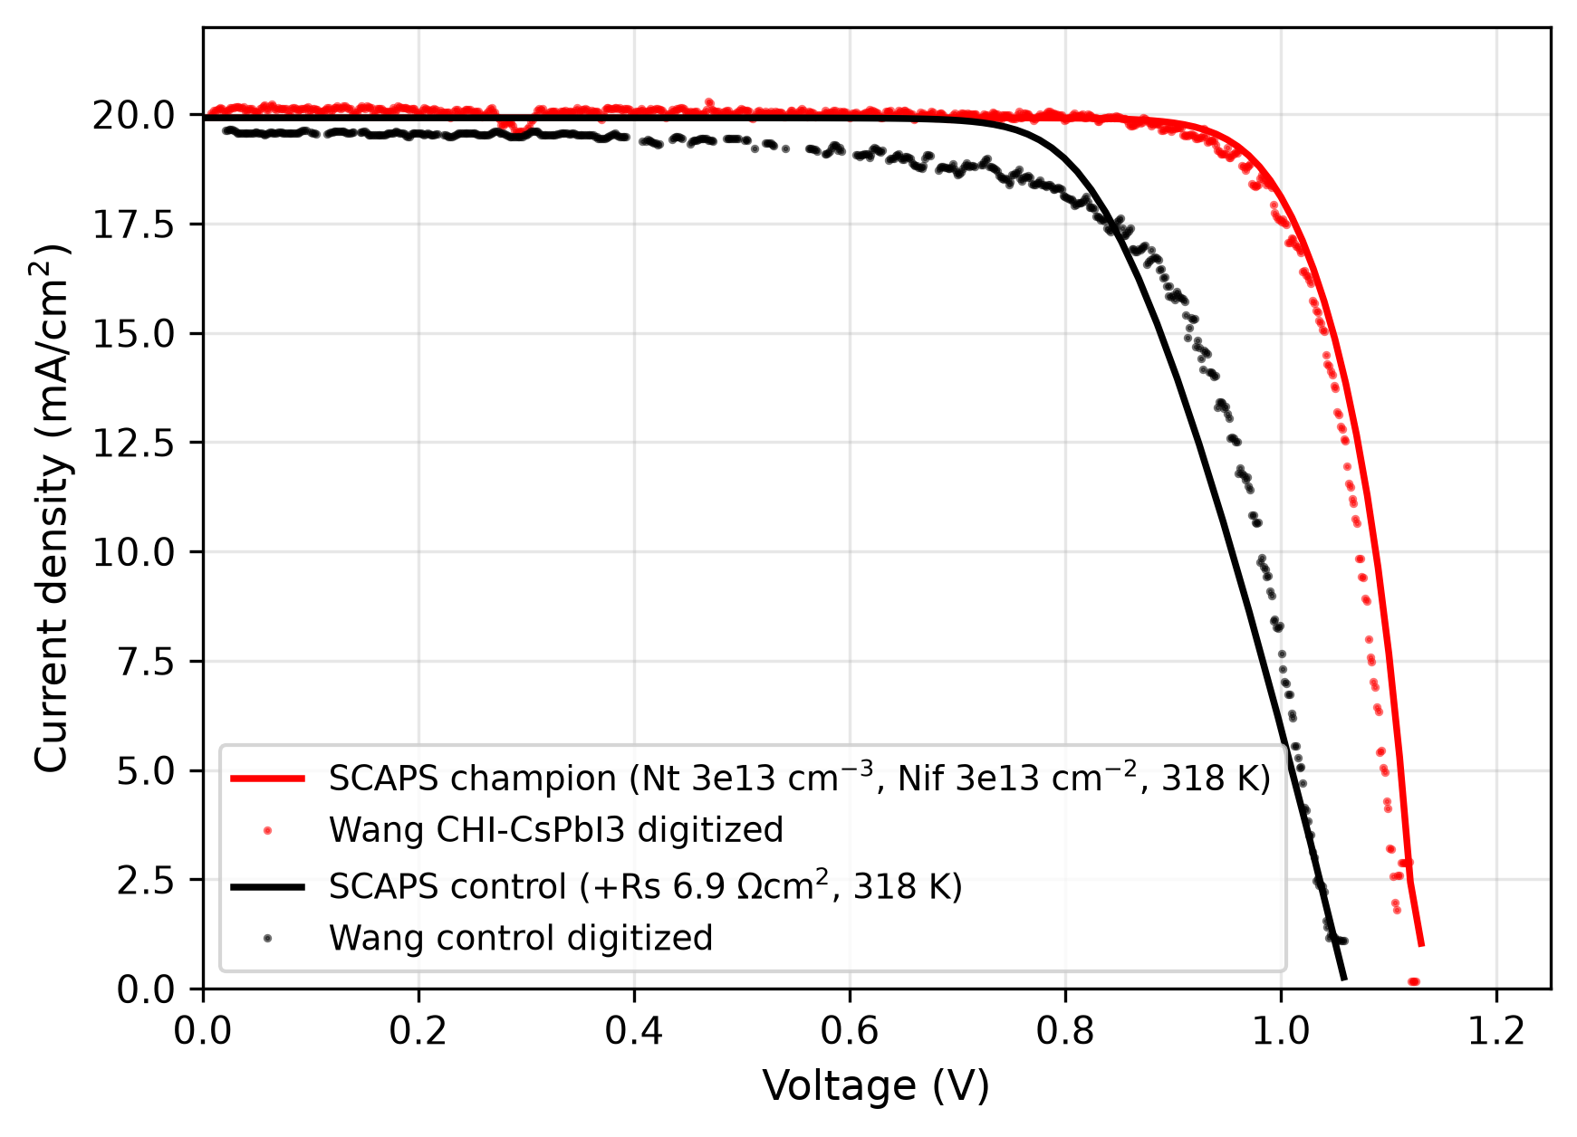
Figure 23. Calibration overlay: SCAPS rebuilds vs digitized J–V of Wang et al.\ rWang

Inorganic context from a frozen database snapshot
We place the loss-budget window against the Perovskite Database Project via NOMAD rPDB as era-bounded context, not a benchmark: 41,316 one-sun entries (43,106 raw fetch; validity filters in S5), of which 2,141 analysis-clean strictly inorganic entries (raw fetch 2,201) include 421 CsPbI_3 and just 5 Ge-bearing devices (zero RbGeI_3). The snapshot runs to early 2020 plus author uploads, so recent inorganic cells (20.6–21.5%+) postdate it and no superiority over the present state of the art is claimed. Within the snapshot, our stacked 20.78% point (21.76% with BSF) sits above its inorganic max of 18.22% (Fig. 24) — a statement about the gap between simulation upper bounds and that era's inorganic state of the art, not evidence of realism; the refit champion marker (18.49%) is our own calibration point plotted for scale, not an independent device, and its FF (82.37%) sits just above the snapshot's realized FF max (0.82).
[Figure 24 about here]
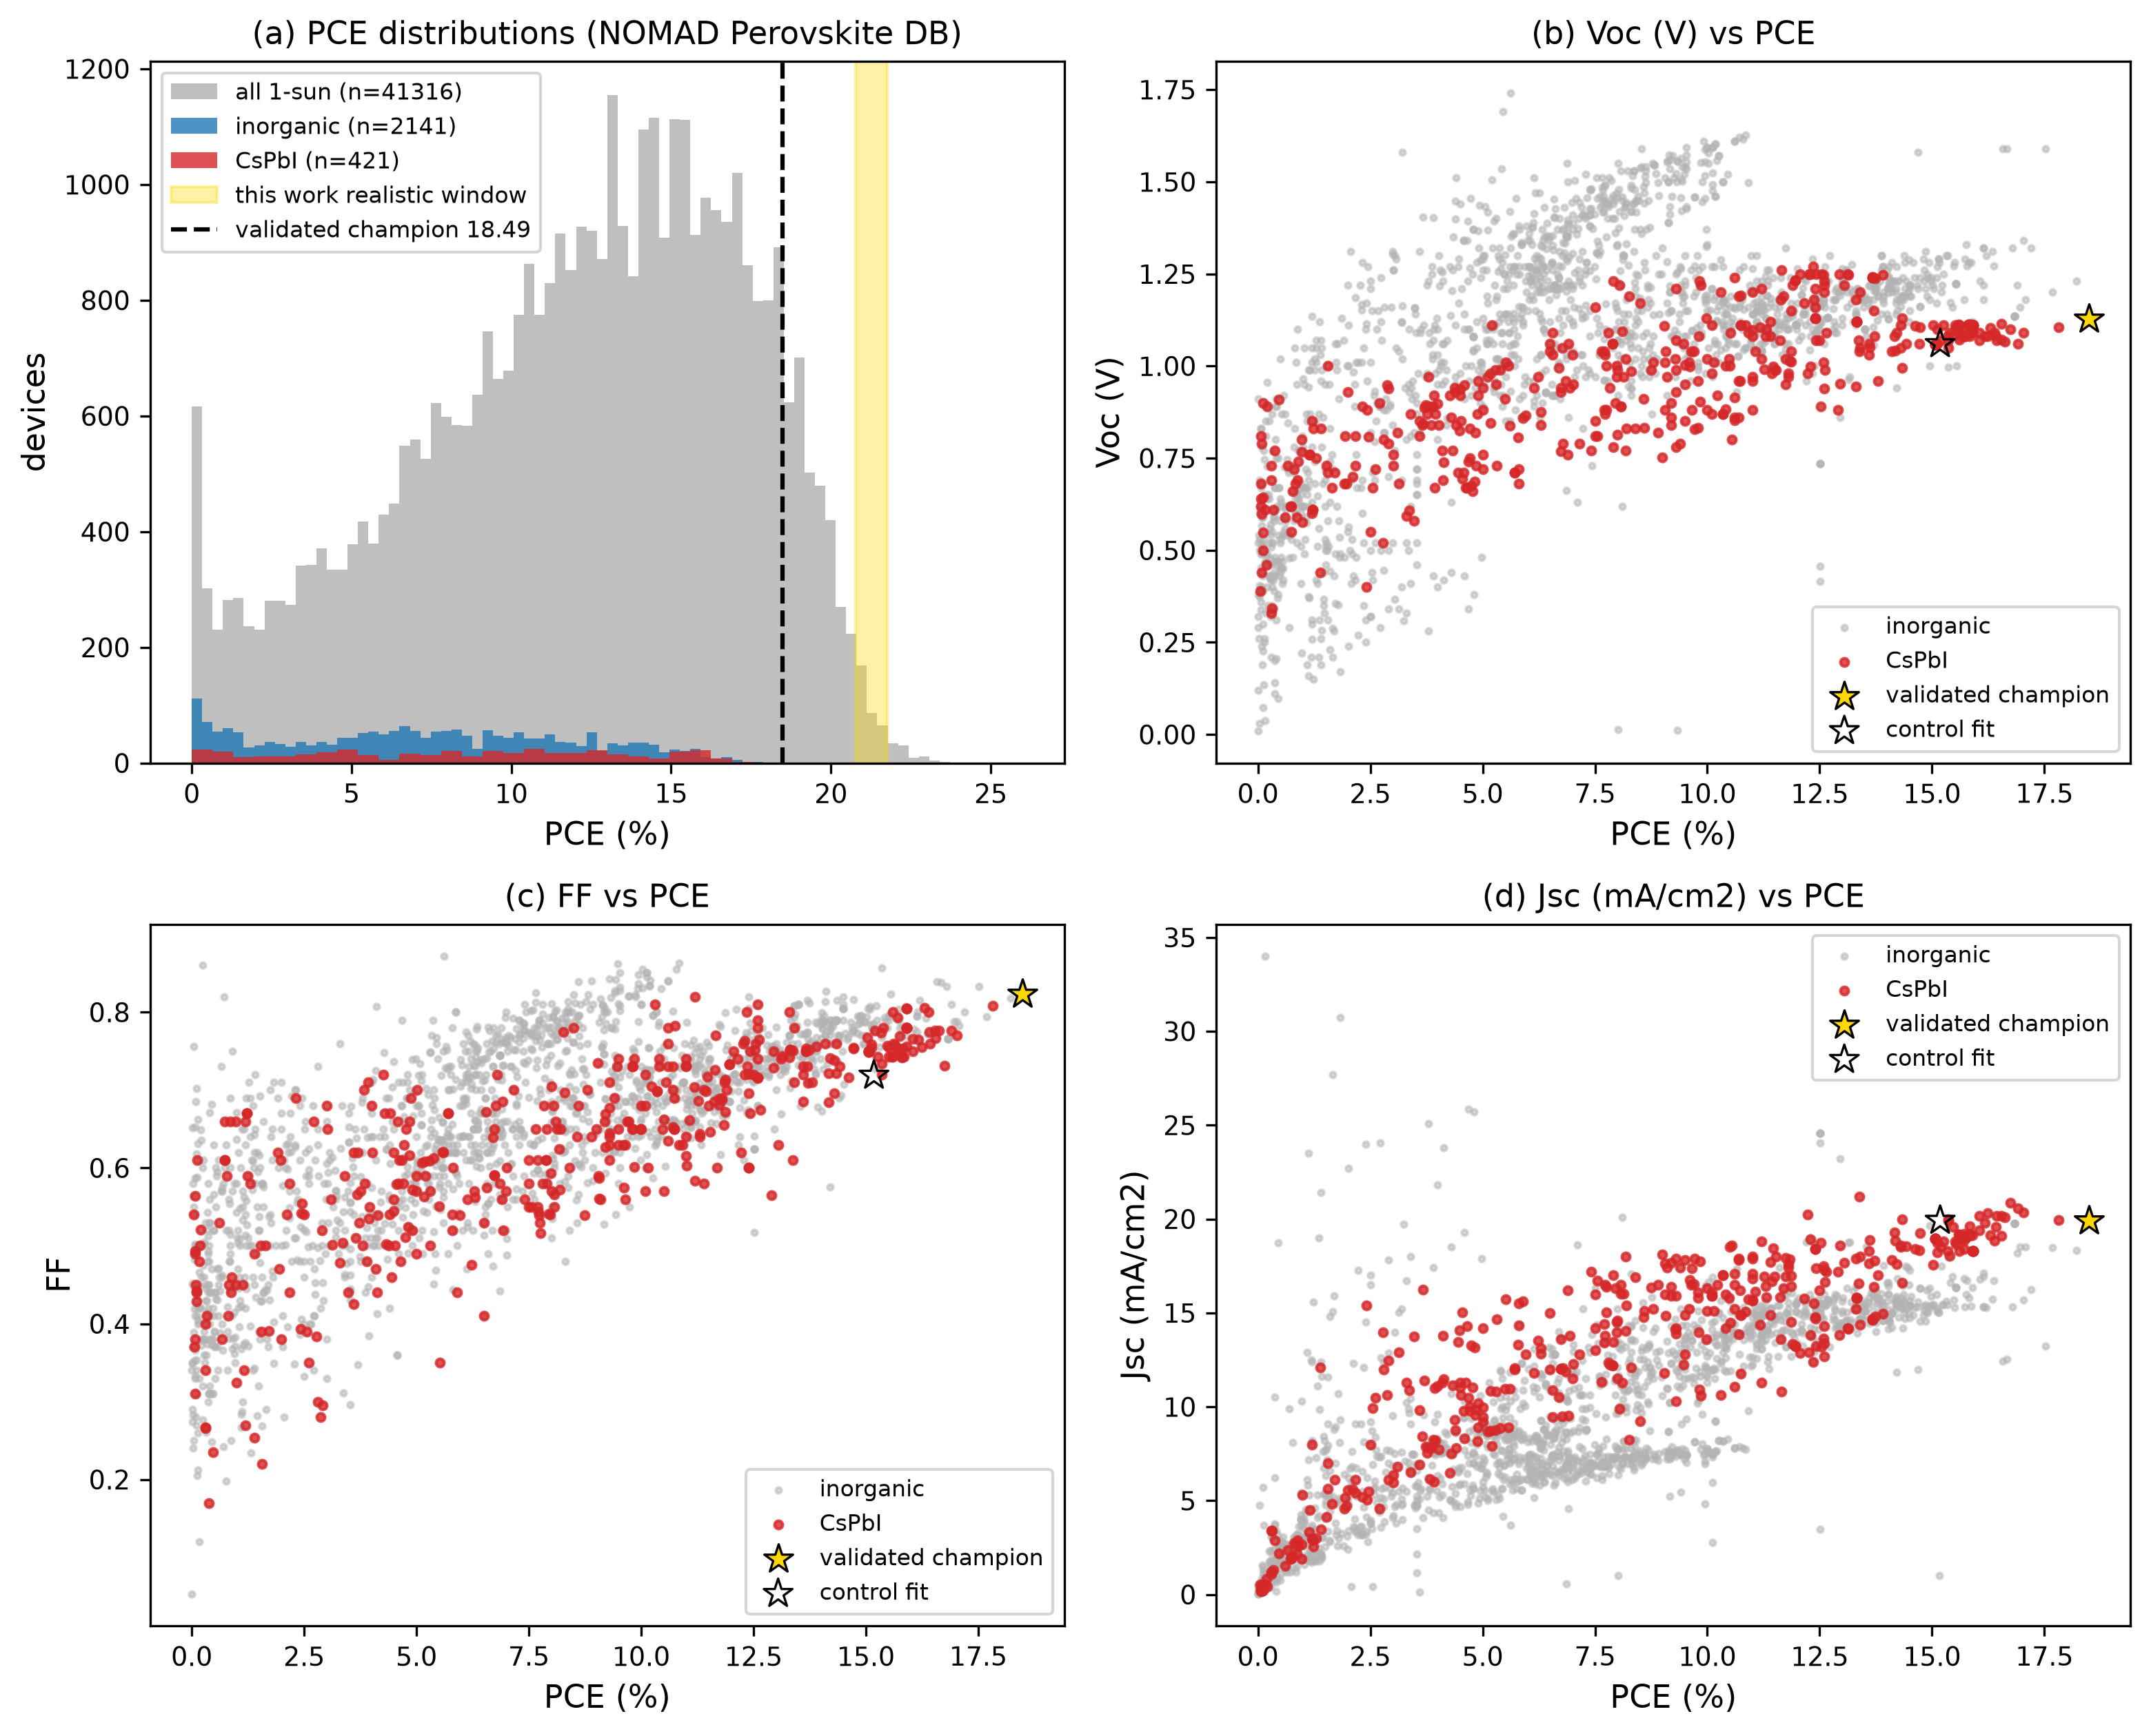
Figure 24. (a) PCE histograms (NOMAD Perovskite DB rPDB

Oxidation budget: from vacancy thermodynamics to fab spec
Our defect densities are not free parameters: each Ge^2+ Ge^4+ oxidation event creates a Ge vacancy (V_Ge), the dominant native acceptor in CsGeI_3 DFT rMing, so air exposure sets N_t directly. Mapping equilibrium V_Ge concentrations (N=N_sites(-E^f/kT), N_sites=4.8710^21 cm^-3) onto the consolidated N_t ladder (Fig. 25) yields a quantitative fab spec: E^f0.46 eV (good glovebox, Ge-rich chemistry) holds the 27.06% headline; E^f0.40 eV (marginal) lands on the realistic 24.40%; brief air exposure (E^f0.35 eV) pushes p2[V_Ge] past 10^16 cm^-3, where the N_A penalty stays soft (0.3 pp); ambient processing (E^f0.30 eV) falls below the high-oxidation 20.76%. These are 300 K equilibrium values and hence lower bounds: defects frozen in from typical 100–150 ^C anneals shift every threshold up by 0.11–0.19 eV (holding 10^14 cm^-3 then needs E^f0.57–0.65 eV), and the processing-condition bands are illustrative Ef assumptions, not derived Ge/O chemical-potential regimes. At the Ge-poor limit vacancies reach 10^19 cm^-3 and the absorber goes metallic, as Ming et al.\ predict rMing — consistent with rapid Ge oxidation rThirumal and with no reported RbGeI_3 device to date (phase stability of cubic vs.\ R3m is separately unaddressed here). The mapping is corroborated from three sides: sub-ns TRPL lifetimes invert to N_t10^17, so real Ge films today are 100–1000 over budget rGeRev (S6) — and a current-state rung at N_t=10^17 cm^-3 on the adopted stack gives 15.53%, the number a first fabrication should expect to beat; the 1%-Ge optimum in CsPb(I,Br)_3 (19.70% rGeDope) marks the same proliferation threshold from the doping side; and passivation chemistries that remove deep levels — PCCMAI (+3.29 pp rPCCMAI), Lewis bases in DFT rKino — are N_t reduction in waterfall language. The competing V_I deep-trap picture is functional-dependent (benign under HSE+SOC rZhangPRX), so this budget rests on V_Ge + Cs_I rZhang24; CsGeI_3 energetics transfer to RbGeI_3 since the A-site carries no band-edge weight. Derivation, bounds and kinetic caveats in S6.
[Figure 25 about here]
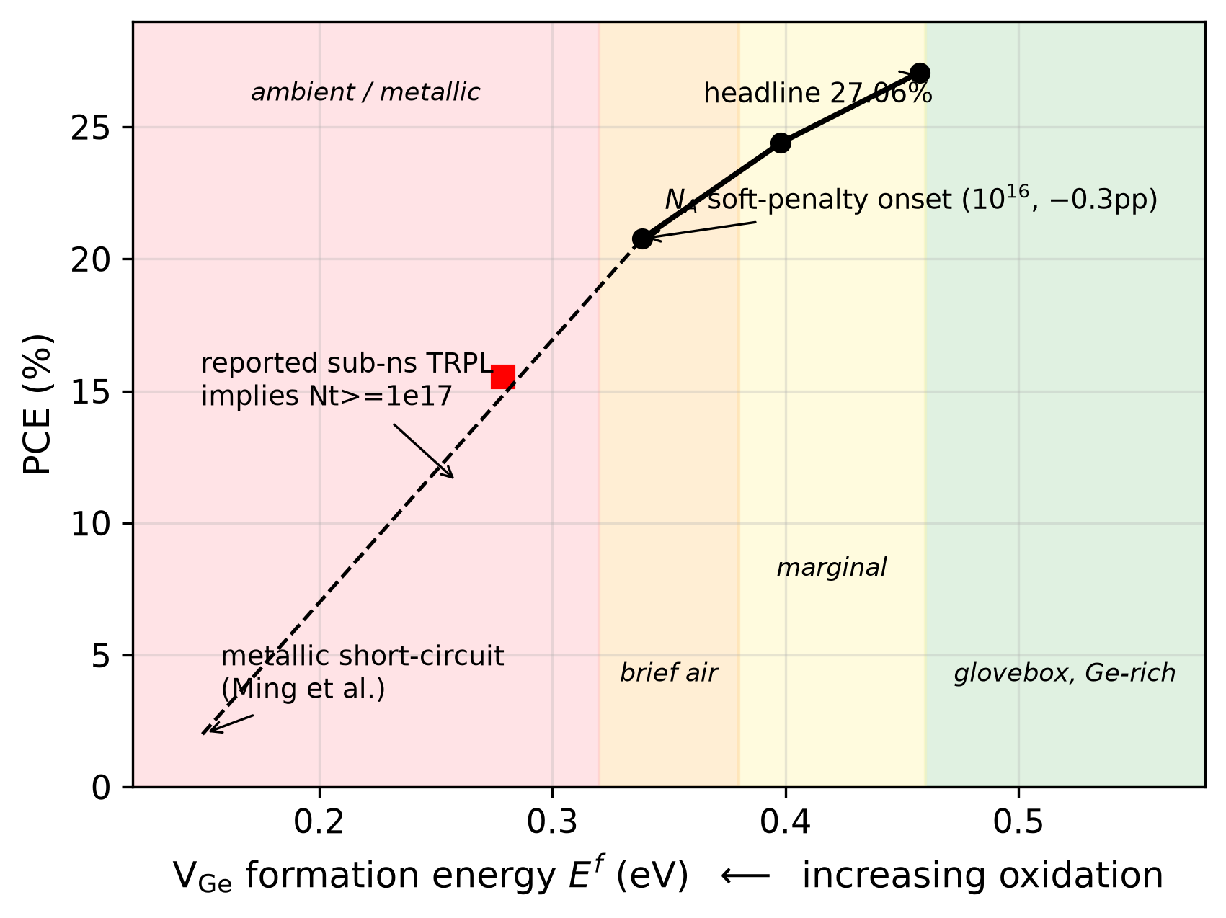
Figure 25. Oxidation budget: consolidated PCE vs V_Ge

Comparison with Literature

Benchmarking against recent literature
Table VI compares the optimized FTO/TiO_2/RbGeI_3/CuI/Au device with recently reported RbGeI_3-based and related lead-free Ge/Sn-based perovskite solar cells. The proposed device achieves a PCE of 27.06%, within 0.15 pp of the best reported RbGeI_3 value (27.21%, Loumachi et al. r22), exceeding the 26.47% of Pathak et al. r23 (preprint) by 0.59 pp, the 18.60% of Raj et al. r39 by 8.46 pp, and the 9.77% simulation baseline of Pindolia et al. r14 by 17.29 pp. The performance is competitive with the best tin-based devices (26.38% CsSnI_3 r40, 25.98% MASnI_3 r41) while sidestepping Sn^2+ Sn^4+ solution oxidation (Ge brings its own Ge^2+ Ge^4+ liability, budgeted in Section VI.H), and exceeds CZTS-HTL devices r42. All comparator values were cross-checked against primary sources (adopting the efficiency implied by reported V_OC, J_SC, FF where inconsistent); all entries are SCAPS-1D simulations, and the Loumachi string is ITO/C_60/RbGeI_3/CBTS/Ag (Section II). In short, the optimized device lands within 0.15 pp of the best published RbGeI_3 simulation (27.21% r22), and stays competitive with the top tin-based lead-free cells, all with an all-inorganic transport stack. With the Cu_2O-like BSF the ideal point reaches 28.01% while keeping the cheap TiO_2/CuI pair (cf.\ Sb_2S_3-route 30.35% rRahman — numerically equal from an independent stack, not the same device — and IGZO/Cu_2O 33.84% rReza); the BSF-realistic 21.76% is the number an experimentalist should target, reported with the full loss decomposition most entries omit. The ML R^2 (0.907 held out) sits with recent SCAPS+ML reports rJCE,rMA,rML40. The Pindolia et al. r14 baseline of 9.77% leaves a wide gap for improvement. Working RbGeI_3 solar cells are still rare, so experimental confirmation remains the bottleneck.

Gap-plus-alignment control (fixed- protocol)
To isolate the gap effect, CsGeI_3 was simulated in the identical stack changing only the bandgap (1.4 1.6 eV) at fixed ; a control rerun at 1.4 eV reproduces the RbGeI_3 point exactly (27.06%), proving the isolation is computational. The CsGeI_3 point (Table VII) gives 1.0966 V, 23.1755 mA/cm^2, 77.3%, 19.65%: Cs wins V_OC by 0.035 V through the wider gap while Rb wins J_SC by 7.14 mA/cm^2 and FF by 6.8 pp. The J_SC gap is dominated by photon harvest — the 1.6 eV gap excludes the entire 775–886 nm band under this protocol — while the 0.30 eV cliff's signature is the pinned V_OC (1.10 V across a 100 change in N_t: 19.65/19.31/17.07%) and the FF deficit, i.e.\ interface limitation rather than intrinsic robustness. This is therefore evidence about gap-plus-alignment, not A-site chemistry proper — stated plainly because the same fixed- choice underlies the comparison. The ranking survives derating (10^15: 24.40 vs 19.31%; 10^16: 20.76 vs 17.07%, Fig. 16).

Limitations and Future Work

Limitations of the present study
The stacked ladder reads 27.06% ideal 24.28% (optics) 21.93% (bulk 10^15) 20.78% (interfaces 10^15), with R_s/R_sh post-corrections (Fig. 16). Five caveats bound these results. First, the 27.06% adopted device is an ideal-coupling upper bound at literature-pinned densities; the unconstrained sweep maxima ( Eg 1.3, N_C/N_V below 10^18) were rejected by the triple-gate rule, not hidden. Second, the adopted 10^14 densities require well-passivated films: bulk 10^15 (10^16) drops PCE to 24.40% (20.76%), rear interfaces 10^15 (10^16) to 20.29% (19.65%), with J_SC nearly unchanged and V_OC/FF collapsing (Fig. 8); holding 10^14 in RbGeI_3 is hard because Ge^2+ oxidizes readily to Ge^4+ in ambient. Third, SCAPS-1D assumes uniform composition and abrupt interfaces that cannot be built exactly. Fourth, the sequential procedure misses cross-interactions by construction; the GA best-found point (28.30%) is reported as optimizer reach, not a proven maximum, and it sits below the triple-gate density floors so it is not an admissible device under our own rules. Fifth, the oxidation map is an equilibrium bound (300 K values are lower bounds; 100–150 ^C freeze-in shifts thresholds up 0.11–0.19 eV): real oxidation is kinetic, dose-dependent and surface-localized, and CsGeI_3 energetics transfer to RbGeI_3 by framework analogy, not calculation.

Future work
The obvious next step is to build and test the optimized device under strict inert processing (<0.1 ppm O2/H2O glovebox), with Ge^2+ stabilization (reducing additives, trap passivation, alloying, encapsulation) and stability testing. On the modelling side, three extensions are queued: (i) a full 11-parameter global optimization (Bayesian or surrogate-assisted, 500 evaluations) to confirm the six-gene GA maximum; (ii) a transfer-matrix optical model coupled to the drift-diffusion solution using measured RbGeI_3 n/k spectra; and (iii) replacing the numerical grading with a realizable composition grade re-optimized in SCAPS.

Conclusion
We optimized a lead-free RbGeI_3 perovskite solar cell in SCAPS-1D and converted its central liability — Ge^2+ oxidation — into a quantitative fab spec. From eight ETL–HTL combinations, FTO/TiO_2/RbGeI_3/CuI/Au was selected on durability, cost, and alignment rather than raw efficiency (D2 outscored it 21.10% to 19.78% at screening). After sequential optimization of eleven parameters on one frozen deck, the consolidated device reaches 27.06% (V_OC = 1.06 V, J_SC = 30.32 mA/cm^2, FF = 84.11%), within 0.15 pp of the best prior RbGeI_3 simulation, with every metric below its Shockley–Queisser limit; the D2/NiO cross-check through the same pipeline reaches 28.16%, so the reported stack trades the efficiency crown for stability and cost. Joint search returns 28.30% as optimizer reach below the adoption floors (E_g = 1.36 eV, 62 evaluations), while stacked optical, defect and parasitic losses bound the realistic window to a single number: 20.78% (21.76% with BSF). Defect-energy, doping, resistance, mobility, and gap-control sweeps (Sections V.C, V.J–V.L, VII.B) convert the headline into tolerances recomputed on the stacked point: R_s 4 (pre-optics), R_sh 10^3 cm^2, N_A 10^16 cm^-3, 15 cm^2/Vs. Fixing the economical TiO_2/RbGeI_3/CuI stack, a p^+ BSF adds +0.94 pp ideally (27.06 28.00%, 28.01% at the grid optimum) and +0.98 pp on the identical full stack (20.78 21.76%) by widening the rear interface gap, with block-level trap attribution and a p^+ control isolating the offset share; and SHAP sensitivity yields design rules (bulk N_t, E_g, _n) that one-at-a-time sweeps alone cannot provide. Targets for the lab: N_A(BSF) 10^19 cm^-3 (30 nm suffices), bulk N_t 10^15 cm^-3, and an oxidation budget of E^f0.46 eV at 300 K equilibrium (0.57–0.65 eV for anneal freeze-in) for the headline, with 15.53% marking the rung current films must beat. The pipeline behind these targets reproduces two experimental -CsPbI_3 devices within 2% in a calibration refit, and its stacked window is placed against a frozen inorganic snapshot as context — the ideal-to-realistic bridge this field needs before first fabrication.

Data availability
All SCAPS decks (initial, H1-adopted, D2, BSF, stacked, attribution controls), run scripts and archived result JSONs listed in Supplementary Section S7 are available on reasonable request; digitized validation curves and database caches are documented in Supplementary Section S5.

References
[1] RENEWABLES 2024 Global Status Report (REN21, 2024).
[2] World Energy Outlook 2024 (International Energy Agency, IEA, 2024).
[3] M. A. Green et al., ``Solar cell efficiency tables (Version 64),'' Prog. Photovolt.: Res. Appl. (2024). doi:10.1002/pip.3831.
[4] R. A. Afre and D. Pugliese, ``Perovskite solar cells: A review of the latest advances in materials, fabrication techniques, and stability enhancement strategies,'' Micromachines 15(2), 192 (2024). doi:10.3390/mi15020192.
[5] N.-G. Park, M. Grätzel, T. Miyasaka, K. Zhu, and K. Emery, ``Towards stable and commercially available perovskite solar cells,'' Nat. Energy 1(11), 16152 (2016). doi:10.1038/nenergy.2016.152.
[6] N. J. Jeon, J. H. Noh, Y. C. Kim, W. S. Yang, S. Ryu and S. I. Seok, ``Compositional engineering of perovskite materials for high-performance solar cells,'' Nature 517(7535), 476–480 (2015). doi:10.1038/nature14133.
[7] I. Ahmed, K. Prakash, and S. M. Mobin, ``Lead-free perovskites for solar cell applications: recent progress, ongoing challenges, and strategic approaches,'' Chem. Commun. 61(37), 6691–6721 (2025). doi:10.1039/D4CC06835A.
[8] S. Kinza Fatima et al., ``Lead-free perovskites for next-generation applications: a comprehensive computational and data-driven review,'' Mater. Adv. 6(21), 7634–7661 (2025). doi:10.1039/D5MA00681C.
[9] J. Burschka, N. Pellet, S.-J. Moon, R. Humphry-Baker, P. Gao, M. K. Nazeeruddin, and M. Grätzel, ``Sequential deposition as a route to high-performance perovskite-sensitized solar cells,'' Nature 499(7458), 316–319 (2013). doi:10.1038/nature12340.
[10] M. M. Lee, J. Teuscher, T. Miyasaka, T. N. Murakami, and H. J. Snaith, ``Efficient hybrid solar cells based on meso-superstructured organometal halide perovskites,'' Science 338(6107), 643–647 (2012). doi:10.1126/science.1228604.
[11] A. K. Jena, A. Kulkarni, and T. Miyasaka, ``Halide perovskite photovoltaics: Background, status, and future prospects,'' Chem. Rev. 119(5), 3036–3103 (2019). doi:10.1021/acs.chemrev.8b00539.
[12] P. Afrin, K. Farjana, A. Vumije, and M. N. Uddin, ``An investigation on the impact of temperature variation over the performance of formamidinium tin iodide perovskite solar cell using SCAPS simulation,'' AIP Adv. 14(7) (2024). doi:10.1063/5.0209332.
[13] S. Samaki, F. Tchangnwa Nya, G. M. Dzifack Kenfack, and A. Laref, ``Materials and interfaces properties optimization for high-efficient and more stable RbGeI_3 perovskite solar cells: optoelectrical modelling,'' Sci. Rep. 13, 15517 (2023). doi:10.1038/s41598-023-42471-w.
[14] G. Pindolia, S. M. Shinde, and P. K. Jha, ``Optimization of an inorganic lead-free RbGeI_3 based perovskite solar cell by SCAPS-1D simulation,'' Sol. Energy 236, 802–821 (2022). doi:10.1016/j.solener.2022.03.053.
[15] S. Bouazizi, W. Tlili, A. Bouich, B. M. Soucase, and A. Omri, ``Design and efficiency enhancement of FTO/PC_60BM/CsSn0.5Ge0.5I3/Spiro-OMeTAD/Au perovskite solar cell utilizing SCAPS-1D simulator,'' Mater. Res. Express 9(9), 096402 (2022). doi:10.1088/2053-1591/ac8d52.
[16] T. Salim, S. Sun, Y. Abe, A. Krishna, A. C. Grimsdale, and Y. M. Lam, ``Perovskite-based solar cells: Impact of materials processing and device architecture,'' J. Mater. Chem. A 3(17), 8943–8969 (2015). doi:10.1039/C4TA05226A.
[17] P. K. Dash, P. Banarjee, A. Nyayban, and S. Panda, ``Optoelectronic properties and performance optimization for photovoltaic applications of R3m-RbGeX_3 (X = Cl, Br, I) perovskites: A combined DFT and SCAPS-1D study,'' arXiv:2505.09362 (2025).
[18] N. A. Abdulkareem, ``A DFT study of structural, electronic and optical properties of lead-free and Ge-based cubic perovskite RbGeX_3 (X = I, Br and Cl),'' Passer J. Basic Appl. Sci. 5(1), 46–51 (2023). doi:10.24271/psr.2023.371069.1187.
[19] M. Burgelman, P. Nollet, and S. Degrave, ``Modelling polycrystalline semiconductor solar cells,'' Thin Solid Films 361–362, 527–532 (2000). doi:10.1016/S0040-6090(99)00825-1.
[20] M. Burgelman, M. Debucquoy, K. Decock, J. Verschraegen, and S. Degrave, SCAPS-1D simulation program for thin film solar cells, version 3.3.10 (ELIS, University of Gent, Belgium, 2024).
[21] L. Loumachi, A. Yousfi, O. Saidani, and A. S. Alsubaie, ``Strengthen the power conversion efficiency of solar cell based RbGeI_3: Numerical approach,'' East Eur. J. Phys. (3), 416–424 (2024). doi:10.26565/2312-4334-2024-3-50
[22] A. Pathak, K. M. D. Pravalli, R. Madaka, B. Pandey, D. Shankar, C. S. Beera, and D. J. Rao, ``Computational analysis of germanium-based perovskites (MAGeI_3, FAGeI_3, CsGeI_3, RbGeI_3) for high-efficiency solar cells using SCAPS-1D,'' Research Square (2026). doi:10.21203/rs.3.rs-8749975/
[23] D. Saikia, J. Bera, A. Betal, and S. Sahu, ``Performance evaluation of an all inorganic CsGeI_3 based perovskite solar cell by numerical simulation,'' Opt. Mater. 123, 111839 (2022). doi:10.1016/j.optmat.2021.111839.
[24] R. Pau et al., ``Solution-processed CuI as a hole transport layer for Sn–Pb perovskite solar cells,'' J. Mater. Chem. A 13(48), 42118–42127 (2025). doi:10.1039/D5TA06770G.
[25] Q. Sun, A. Sadhu, S. Lie, and L. H. Wong, ``Critical review of Cu-based hole transport materials for perovskite solar cells: From theoretical insights to experimental validation,'' Adv. Mater. (2024). doi:10.1002/adma.202402412.
[26] J. Z. Mbese, ``Advancements in inorganic hole-transport materials for perovskite solar cells: A comparative review,'' Energies 18(9), 2374 (2025). doi:10.3390/en18092374.
[27] L. T. C. Tuyen, S.-R. Jian, N. T. Tien, and P. H. Le, ``Nanomechanical and material properties of fluorine-doped tin oxide thin films prepared by ultrasonic spray pyrolysis: Effects of F-doping,'' Materials 12(10), 1665 (2019). doi:10.3390/ma12101665.
[28] A. J. Olasoji and S. H. Im, ``Perspective chapter: TiO_2 electron transporting layers for perovskite solar cells,'' in Titanium Dioxide – Uses, Applications, and Advances (IntechOpen, 2024). doi:10.5772/intechopen.1007266.
[29] K. Valadi, S. Gharibi, R. Taheri-Ledari, S. Akin, A. Maleki, and A. E. Shalan, ``Metal oxide electron transport materials for perovskite solar cells: A review,'' Environ. Chem. Lett. 19(3), 2185–2207 (2021). doi:10.1007/s10311-020-01171-x.
[30] L. Ji, T. Zhang, and S. Li, ``Band alignment of TiO_2 by controlling Cl content for high-efficiency perovskite solar cells,'' J. Mater. Chem. C 12(36), 14597–14604 (2024). doi:10.1039/D4TC01495B.
[31] A. Ghosh et al., ``Solar power conversion: CuI hole transport layer and Ba3NCl3 absorber enable advanced solar cell technology boosting efficiency over 30%,'' RSC Adv. 14(33), 24066–24081 (2024). doi:10.1039/D4RA03695F.
[32] T. Minemoto and M. Murata, ``Impact of work function of back contact of perovskite solar cells without hole transport material analyzed by device simulation,'' Curr. Appl. Phys. 14(11), 1428–1433 (2014). doi:10.1016/j.cap.2014.08.002.
[33] W. Shockley and H. J. Queisser, ``Detailed balance limit of efficiency of p-n junction solar cells,'' J. Appl. Phys. 32(3), 510–519 (1961). doi:10.1063/1.1736034.
[34] S. Rühle, ``Tabulated values of the Shockley–Queisser limit for single junction solar cells,'' Sol. Energy 130, 139–147 (2016). doi:10.1016/j.solener.2016.02.015.
[35] C. H. Henry, ``Limiting efficiencies of ideal single and multiple energy gap terrestrial solar cells,'' J. Appl. Phys. 51(8), 4494–4500 (1980). doi:10.1063/1.328272.
[36] O. J. Sandberg and A. Armin, ``On the effect of surface recombination in thin film solar cells, light emitting diodes and photodetectors,'' arXiv:1905.07291 (2019); published in Synth. Met. 254, 114–121 (2019), doi:10.1016/j.synthmet.2019.06.008.
[37] M. Raj, A. Aggarwal, A. Kushwaha, and N. Goel, ``Moisture-resistant sustainable solar cell with RbGeI_3 absorber layer,'' J. Mater. Sci. 60(22), 9176–9196 (2025). doi:10.1007/s10853-025-11002-5.
[38] H.-J. Park, H. Son, and B.-S. Jeong, ``SCAPS-1D Simulation for Device Optimization to Improve Efficiency in Lead-Free CsSnI_3 Perovskite Solar Cells,'' Inorganics 12(4), 123 (2024). doi:10.3390/inorganics12040123.
[39] R. Islam, M. N. Uddin, M. J. Hossen, and A. Begum, ``Photovoltaic performance of lead-free MASnI_3-based perovskite solar cells with kesterite hole transport materials,'' AIP Adv. 16(5) (2026). doi:10.1063/5.0315071.
[40] A. C. Piñón Reyes et al., ``Study of a lead-free perovskite solar cell using CZTS as HTL to achieve a 20% PCE by SCAPS-1D simulation,'' Micromachines 12(12), 1508 (2021). doi:10.3390/mi12121508.
[41] V. H. D. Ara\'ujo, A. F. Nogueira, J. C. Trist\ ao and L. J. dos Santos, ``Advances in lead-free perovskite solar cell design via SCAPS-1D simulations,'' RSC Sustain.\ 3, 4314–4335 (2025). doi:10.1039/D5SU00526D.
[42] M. M. Rahman et al., ``Numerical modeling and extensive analysis of an extremely efficient RbGeI_3-based perovskite solar cell by incorporating a variety of ETL and HTL materials,'' Energy Adv.\ 3(9), 2377–2398 (2024). doi:10.1039/D4YA00323C.
[43] M. S. Reza et al., ``Optimizing charge transport layers to enhance the performance of lead-free RbGeI_3 perovskite solar cells,'' Langmuir 41(11), 7865–7885 (2025).
[44] U. F. Ali et al., ``Integrated simulation and machine learning framework for high-performance lead-free RbGeI_3 perovskite solar cells with WS_2/CuI transport layers,'' J.\ Comput.\ Electron.\ 25, 37 (2026). doi:10.1007/s10825-025-02476-2.
[45] T. M. Khan et al., ``Investigating the impact of non-ideal conditions on the performance of an RbGeI_3 perovskite solar cell through a combination of SCAPS-1D, machine learning and deep learning approaches,'' Mater.\ Adv.\ (2026). doi:10.1039/D5MA01427A.
[46] M. A. Rahman and M. J. Alam, ``Machine learning–guided SCAPS-1D design of lead-free CH_3NH_3SnI_3 perovskite solar cells with 40.17% simulated PCE,'' J.\ Mater.\ Sci.: Mater.\ Eng.\ (2026). doi:10.1186/s40712-026-00426-9.
[47] W. Ming, H. Shi and M.-H. Du, ``Large dielectric constant, high acceptor density, and deep electron traps in perovskite solar cell material CsGeI_3,'' J.\ Mater.\ Chem.\ A 4, 13852–13858 (2016). doi:10.1039/C6TA04685A.
[48] K. Thirumal et al., ``Lead-free germanium iodide perovskite materials for photovoltaic applications,'' J.\ Mater.\ Chem.\ A 3, 23829–23832 (2015). doi:10.1039/C5TA05741H.
[49] C. Zhang et al., ``A systematical study on bands and defects of CsBX_3 (B = Pb, Sn, Ge; X = Cl, Br, I) perovskite based on first principles,'' Molecules 29(11), 2479 (2024). doi:10.3390/molecules29112479.
[50] J. Zhang, X. Zhang, M. E. Turiansky and C. G. Van de Walle, ``Iodine vacancies do not cause nonradiative recombination in halide perovskites,'' PRX Energy 2, 013008 (2023). doi:10.1103/PRXEnergy.2.013008.
[51] S. Mohammadi, L. J. A. Koster and S. Akbari Nia, ``Enhanced stability and efficiency in Ge–Pb-based perovskite solar cells through PCCMAI-induced Ge defect passivation,'' Energy Environ.\ Mater.\ 8, e70052 (2025). doi:10.1002/eem2.70052.
[52] R. Chen et al., ``Enhanced stability of Ge-doped CsPb(I_1-xBr_x)_3 perovskite solar cells,'' J.\ Mater.\ Chem.\ A 13, 9822–9829 (2025). doi:10.1039/D4TA08572H.
[53] E. Kino et al., ``A theoretical study of the molecular passivation of p-/n-type defects on tin- and germanium-mixed perovskite surfaces using Lewis base/acid,'' Phys.\ Chem.\ Chem.\ Phys.\ 27, 7429–7439 (2025). doi:10.1039/D4CP03817G.
[54] W. J. Jang, P. J. Park, W.-J. Ong and S. Y. Kim, ``Stable and eco-friendly inorganic lead-free perovskite solar cells: structural, electronic, and defect engineering,'' Commun.\ Mater.\ 7 (2026). doi:10.1038/s43246-026-01158-1.
[55] Y. Wang et al., ``Thermodynamically stabilized -CsPbI_3–based perovskite solar cells with efficiencies >18%,'' Science 365, 591–595 (2019). doi:10.1126/science.aav8680.
[56] T. J. Jacobsson et al., The Perovskite Database Project (perovskitedatabase.com, dataset to Feb.\ 2020 + author uploads), via NOMAD (nomad-lab.eu, Perovskite Solar Cells Database, 43,106 entries accessed Oct.\ 2026).

