Photovoltaic Performance Analysis of RbGeI₃ Absorber Based Perovskite Solar Cell using SCAPS-1D Simulation
Numerical Optimization of a Lead-Free Planar Heterojunction Device
¹ Department of Electrical and Electronic Engineering, Leading University, Sylhet, Bangladesh
* Corresponding author. Electronic mail: fahim.eee@lus.ac.bd
Abstract
The rapid rise of lead-halide perovskite solar cells has been tempered by the toxicity and environmental persistence of lead, motivating a sustained search for lead-free absorbers that retain favorable optoelectronic properties. Rubidium germanium iodide (RbGeI3) has a direct, tunable bandgap, strong optical absorption, and improved environmental compatibility. In this work, we report a numerical optimization of an RbGeI3-based perovskite solar cell using the one-dimensional Solar Cell Capacitance Simulator (SCAPS-1D, version 3.3.10). Eight planar heterojunction configurations were first screened by combining two electron transport layers (TiO2 and PCBM) with four hole transport layers (NiO, CuI, CBTS, and Spiro-OMeTAD), all sharing the same RbGeI3 absorber. The FTO/TiO2/RbGeI3/CuI/Au architecture was selected for further optimization on the grounds of long-term stability and cost. Eleven device parameters (absorber thickness, absorber defect density, dielectric constant, electron affinity, bandgap, conduction- and valence-band effective density of states, ETL and HTL thicknesses, and the interfacial defect densities at both heterojunctions) were varied sequentially under AM 1.5G illumination at 300 K. The optimized device reaches a power conversion efficiency (PCE) of 26.80%, with an open-circuit voltage (Voc) of 1.12 V, a short-circuit current density (Jsc) of 30.32 mA/cm², and a fill factor (FF) of 78.92%. The optimized parameter set comprises a 700 nm RbGeI3 absorber (Eg = 1.4 eV, χ = 3.9 eV, εr = 15, NC = NV = 1×10¹⁷ cm⁻³), a 10 nm TiO2 ETL, a 100 nm CuI HTL, and interfacial defect densities of 1×10¹⁴ cm⁻² at both heterojunctions. The equilibrium energy band diagram confirms favorable band alignment at both heterojunctions, with a 1.8 eV conduction-band offset at CuI/RbGeI3 that blocks electron back-transfer and a 0.10 eV conduction-band step at RbGeI3/TiO2 that supports efficient electron extraction. The results identify the TiO2/CuI transport-layer pair as an efficient combination for environmentally benign RbGeI3 photovoltaics and provide quantitative design guidelines for future experimental realization.
Keywords: lead-free perovskite; RbGeI₃; SCAPS-1D; numerical simulation; CuI hole transport layer; TiO₂ electron transport layer; defect density; interface engineering; solar cell optimization.

I. Introduction

A. Background and motivation
Global electricity demand continues to climb as populations grow, economies industrialize, and urbanization accelerates. Fossil fuels still supply the bulk of this demand [1,2], but their depletion and the environmental cost of carbon emissions have made renewable energy a strategic priority rather than an alternative. Among renewable sources, solar energy stands out for its abundance and for the steady decline in the levelized cost of photovoltaic (PV) electricity, which has made solar the fastest-expanding renewable technology worldwide [3]. The global installed PV capacity surpassed 2.2 TW in 2024, and continued growth relies on identifying photovoltaic materials that combine high efficiency with low environmental impact and low fabrication cost. Continued progress in PV technology therefore matters for meeting climate-mitigation targets and for expanding energy access in regions without reliable grid infrastructure [4]. Photovoltaic devices are commonly classified into three generations based on the absorber material and fabrication technology. First-generation crystalline silicon (c-Si) cells dominate the commercial market thanks to their high efficiency and long operational lifetime, but they require energy-intensive processing and rigid substrates. Second-generation thin-film technologies (including CdTe, CIGS, and amorphous silicon) reduce material consumption and offer flexible substrates, but their efficiencies are modest and some rely on scarce or toxic elements. The third generation, which includes dye-sensitized solar cells, organic photovoltaics, quantum-dot cells, and perovskite solar cells (PSCs) [5,6], promises high efficiency at low processing cost and is therefore intensely studied.

B. Perovskite solar cells and the lead problem
Halide perovskites adopt an ABX₃ crystal structure in which the A-site hosts a monovalent cation, the B-site a divalent metal, and the X-site a halogen. Their attractiveness for photovoltaics stems from strong light absorption, continuously tunable bandgaps, ambipolar carrier transport with long diffusion lengths, and weak exciton binding [7,8]. Certified power conversion efficiencies (PCEs) for single-junction lead-based devices now exceed 26% [3], and perovskite-on-silicon tandems have crossed 33% [3]. The best absorbers, however, are methylammonium lead iodide (MAPbI₃) and formamidinium lead iodide (FAPbI₃), both of which contain lead. Lead raises contamination concerns at every stage of the device life cycle, from fabrication through operation to disposal [9,10], and the search for benign substitutes based on tin (Sn), germanium (Ge), bismuth (Bi), and antimony (Sb) is now a central research direction [11,12].
Tin-based perovskites initially attracted the most attention as lead substitutes, because Sn²⁺ has a similar lone-pair electronic configuration to Pb²⁺ [11]. Unfortunately, Sn²⁺ readily oxidizes to Sn⁴⁺ in air, generating high densities of deep defects and accelerating device degradation [11,12]. Germanium-based perovskites have emerged as a complementary alternative: germanium offers the same lone-pair electronic structure as lead, supports a direct and tunable bandgap, and is less toxic [13]. Among Ge-based absorbers, rubidium germanium iodide (RbGeI3) stands out for its suitable bandgap (≈1.3–1.4 eV depending on the structural phase and computational method), strong optical absorption coefficient, and good thermal stability [14,15,16]. Recent density-functional-theory (DFT) calculations confirm a direct bandgap and a high optical absorption coefficient comparable to that of MAPbI3 [13,17,18]. The material is well suited to single-junction photovoltaics.

C. Role of numerical simulation and research gap
Because experimental optimization of a multilayer photovoltaic device is both time-consuming and expensive, numerical simulation has become the standard tool for screening materials and parameters before fabrication. The Solar Cell Capacitance Simulator in one dimension (SCAPS-1D), developed at the Department of Electronics and Information Systems (ELIS) of Ghent University, Belgium, has been widely adopted for this purpose [19,20,21]. SCAPS-1D solves the Poisson equation together with the electron and hole continuity equations self-consistently across the device stack [19], capturing carrier generation, transport, and recombination under either dark or illuminated conditions. The software allows the user to vary material and interface parameters independently, which makes it possible to disentangle their individual contributions to device performance. Figure 1 shows the graphical user interface of SCAPS-1D version 3.3.10 used in this study.
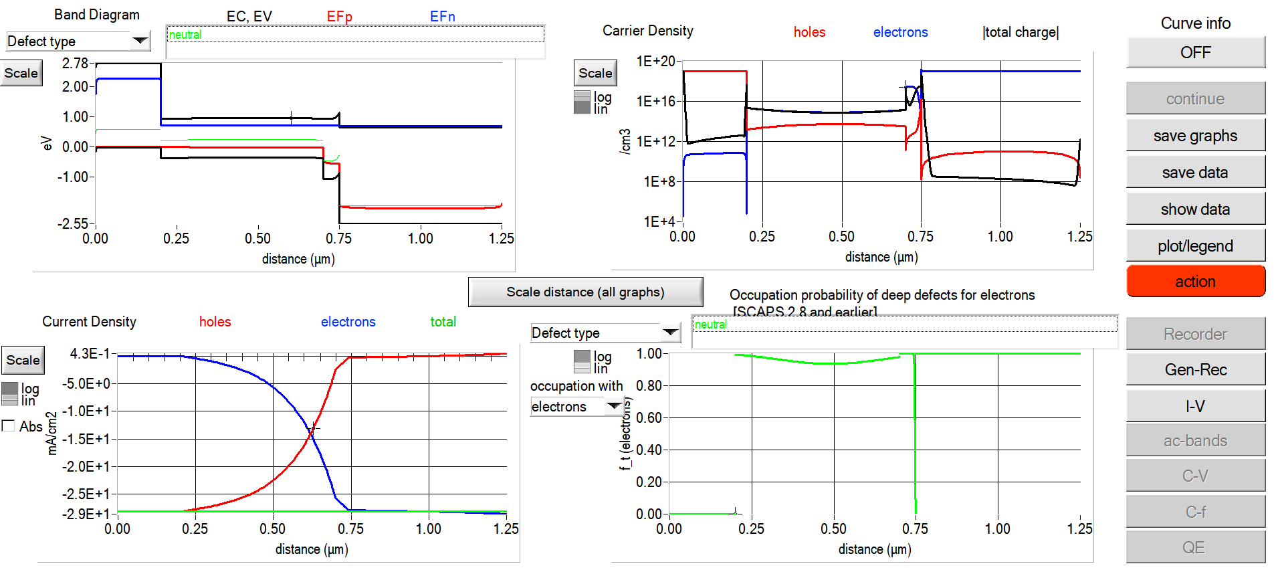
Fig. 1. Graphical user interface of SCAPS-1D (version 3.3.10) used for device simulation in this study.
Although several SCAPS-1D studies of RbGeI3 devices have been reported, most have optimized only a limited subset of device parameters or investigated a single device configuration. The simulation baseline for RbGeI3 devices is still low: Pindolia et al. reported a PCE of 9.77% for the FTO/TiO2/RbGeI3/NiO/Ag architecture using SCAPS-1D simulation [14]. The Pindolia study is broader than its shorthand citation in the secondary literature suggests. The paper systematically studied the effect of various HTL and ETL materials, layer thicknesses, doping concentrations, defect densities, back-contact work functions, and operating temperature in a broad multi-parameter sweep [14]. Simulation-based studies have since raised the predicted PCE of RbGeI3 devices to 27.21% (2024 [22]) and 26.47% (2026 [23]), although each of these works optimized only a limited subset of device parameters. The ETL–HTL combinations explored for RbGeI3 have also been narrow: most studies used TiO2 as the ETL and either Spiro-OMeTAD, NiO, or CBTS as the HTL, while the TiO2/CuI combination adopted in this work has received comparatively little attention despite the well-documented advantages of CuI as an HTL.

D. Contributions and paper organization
The present work addresses this gap by performing a SCAPS-1D optimization of an FTO/TiO₂/RbGeI₃/CuI/Au perovskite solar cell. We first screen eight ETL–HTL combinations to identify the FTO/TiO₂/RbGeI₃/CuI/Au architecture as a promising candidate for inorganic-HTL optimization, and then run an eleven-step sequential optimization covering absorber thickness, absorber defect density, dielectric constant, electron affinity, bandgap, conduction- and valence-band effective density of states, ETL and HTL thicknesses, and the two interfacial defect densities. We also analyze the quantum-efficiency spectrum and the equilibrium energy-band diagram of the optimized device, and we benchmark it against recently reported RbGeI₃-based and related lead-free Ge/Sn-based perovskite solar cells, using primary-source-verified comparator values.
Section II surveys recent literature. Section III describes the device structure and material selection. Section IV presents the methodology and optimization procedure. Section V reports and discusses the results, Section VI compares with prior literature, and Sections VII and VIII cover limitations and conclusions.

II. Literature Review and Research Gap
Over the past five years, SCAPS-1D, often combined with first-principles DFT calculations, has become the workhorse numerical tool for designing and optimizing lead-free perovskite solar cells before experimental fabrication. This section surveys the most relevant recent SCAPS-1D studies on Ge-based and Sn-based absorbers, highlighting the device structure, the photovoltaic performance, and the principal limitation of each work. Table I summarizes these studies. All numerical values listed in Table I have been cross-checked against the primary source literature; where a reported efficiency was inconsistent with the device’s published J–V metrics, the value implied by those metrics was adopted. In particular, the entries for Pindolia et al. (2022), Loumachi et al. (2024), and Pathak et al. (2026) are quoted verbatim from the corresponding primary sources.
Table I. Summary of recent SCAPS-1D studies on lead-free Ge-based and Sn-based perovskite solar cells.
Study (Year) [Ref.] | Device Structure | PCE (%) | Key Limitation
Pindolia et al. (2022) [14] | FTO/TiO₂/RbGeI₃/NiO/Ag | 9.77 | Broad multi-parameter sweep (HTL, ETL, thickness, doping, defects, back contact, temperature); baseline efficiency remains modest and Ge²⁺ oxidation not addressed.
Saikia et al. (2022) [24] | FTO/TiO₂/CsGeI₃/CuI/Au | 10.80 | No multi-HTL comparative analysis.
Bouazizi et al. (2022) [15] | FTO/PCBM/CsSn₀.₅Ge₀.₅I₃/Spiro/Au | 18.13 | Mixed Ge/Sn absorber; thermal sensitivity.
Loumachi et al. (2024) [22] | ITO/C₆₀/RbGeI₃/CBTS/Ag | 27.21 | Optimized RbGeI₃ thickness and series/shunt resistance; interface defect optimization not addressed.
Raj et al. (2025) [40] | FTO/TiO₂/RbGeI₃/PEDOT:PSS/Au | 18.60 | Organic HTL limits long-term stability.
Pathak et al. (2026) [23] | FTO/TiO₂/RbGeI₃/Spiro-OMeTAD/Au | 26.47 | Ge²⁺ → Ge⁴⁺ oxidation not addressed; only single ETL/HTL combination studied.
Dash et al. (2025) [17] | DFT + SCAPS-1D of RbGeX₃ (X=Cl, Br, I) | 25.76 | Primarily material-level comparison; limited device-architecture optimization.
Copper(I) iodide is a wide-gap (Eg ≈ 3.1 eV), p-type transparent conductor whose valence-band maximum aligns closely with that of RbGeI3, supporting efficient hole extraction [25,26]. Reported single-crystal hole mobilities of CuI exceed 100 cm² V⁻¹ s⁻¹, and the material is solution-processable at low temperatures, which suits large-area fabrication [27]. Despite these advantages, only a few SCAPS-1D studies have paired CuI with RbGeI3, and none has run an eleven-parameter optimization on this combination. The present work instead varies all eleven device-level parameters on the FTO/TiO2/RbGeI3/CuI/Au architecture and reports the resulting photovoltaic performance.
A further observation from Table I is that the comparator device structures span a range of ETL and HTL materials (TiO2, PCBM, C60, NiO, CuI, CBTS, Spiro-OMeTAD, PEDOT:PSS) and back-contact metals (Ag, Au). Two structural details deserve explicit clarification to prevent citation-propagation errors. First, the ETL in the Loumachi et al. device [22] is C60 (buckminsterfullerene), frequently rendered “C60” in the literature, and the subscript matters because “C6” is a different species. Second, the back contact is silver (Ag), not gold (Au), as stated in the primary source [22].

III. Device Structure and Material Selection

A. Proposed device architecture
The proposed lead-free perovskite solar cell investigated in this work adopts a conventional n-i-p planar heterojunction architecture with the configuration FTO/TiO₂/RbGeI₃/CuI/Au. The device comprises five functional layers: a fluorine-doped tin oxide (FTO) transparent conducting oxide front electrode, a titanium dioxide (TiO₂) electron transport layer (ETL), a rubidium germanium iodide (RbGeI₃) absorber layer, a copper iodide (CuI) hole transport layer (HTL), and a gold (Au) back contact. This architecture was selected because it provides efficient charge separation, rapid carrier transport, and suitable energy-level alignment while eliminating the environmental and health concerns associated with lead-based perovskite absorbers. The schematic diagram of the proposed device structure is shown in Figure 2. The choice of constituent materials is justified in the remainder of this section, and the initial material parameters used in the SCAPS-1D simulation are summarized in Table II.
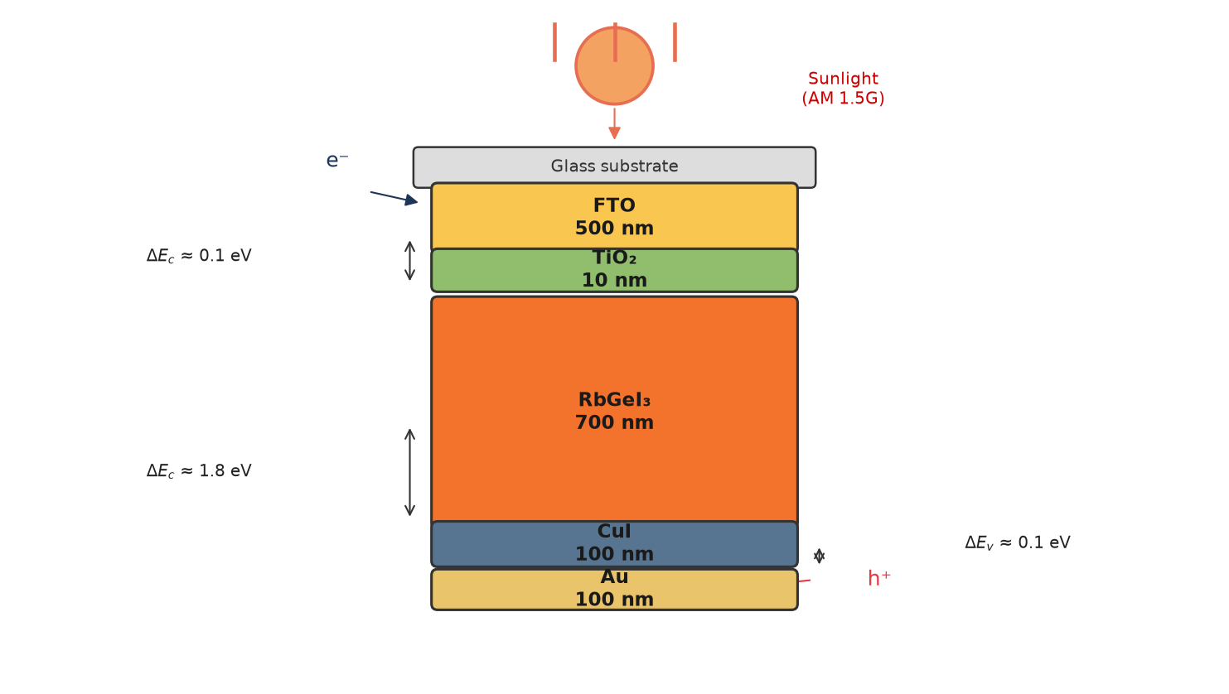
Fig. 2. Schematic diagram of the proposed FTO/TiO₂/RbGeI₃/CuI/Au perovskite solar cell structure, showing the five functional layers and the direction of photogenerated carrier transport under AM 1.5G illumination.

B. Material selection rationale
Fluorine-doped tin oxide (FTO) serves as the front transparent conducting electrode. It possesses high optical transparency in the visible spectrum together with excellent electrical conductivity, allowing incident sunlight to reach the absorber layer while simultaneously collecting the generated electrons with minimal resistive loss [28]. FTO was preferred over alternative transparent conducting oxides (such as indium tin oxide, ITO) for its superior thermal and chemical stability, its compatibility with the TiO2 ETL deposition process, and its lower cost. The thickness of the FTO layer was fixed at 500 nm, consistent with values commonly reported for perovskite solar cells [29].
Titanium dioxide (TiO2) was employed as the electron transport layer. The primary function of the ETL is to extract photogenerated electrons from the absorber layer and transport them toward the FTO electrode while effectively blocking holes. TiO2 is an n-type semiconductor with a wide bandgap of approximately 3.2 eV in its anatase phase, providing excellent transparency throughout the visible region of the solar spectrum. Its conduction-band minimum lies slightly below that of most iodide-based perovskites, providing an energetically downhill path for photogenerated electrons to transfer from the absorber into the ETL, while its deep valence band acts as an effective barrier against hole transport [30,31]. Although its intrinsic electron mobility is lower than that of ZnO and SnO2, TiO2 provides sufficiently fast electron transport when fabricated with appropriate morphology and crystallinity, and it forms chemically stable interfaces with perovskite materials [32].
Rubidium germanium iodide (RbGeI₃) was selected as the photoactive absorber. Compared with conventional lead-based perovskites, RbGeI₃ offers the important advantage of being environmentally friendly because germanium replaces toxic lead while maintaining desirable optoelectronic properties. RbGeI₃ adopts the ABX₃ perovskite structure with rubidium at the A-site, germanium at the B-site, and iodine at the X-site. Its direct bandgap in the 1.3–1.4 eV range, strong optical absorption coefficient (reported to be comparable to that of MAPbI₃ by first-principles calculations [17,18]), and good thermal stability make it well-suited for single-junction photovoltaic applications. The initial absorber thickness used for device screening was 400 nm, and the bandgap was initially set to 1.4 eV, consistent with values reported in the experimental literature [14]. Both parameters were subsequently optimized (Section V).
Copper iodide (CuI) was selected as the hole transport layer owing to its excellent hole conductivity, high optical transparency, appropriate valence-band alignment with RbGeI3, and comparatively low fabrication cost [25,26,33]. The HTL facilitates efficient extraction of photogenerated holes from the absorber layer while preventing electron back-transfer toward the rear electrode. CuI is a wide-gap (Eg ≈ 3.1 eV) p-type transparent conductor whose valence-band maximum aligns closely with that of RbGeI3 (giving a small valence-band offset of approximately 0.10 eV as quantified in Section V.N), supporting efficient hole extraction. Reported single-crystal hole mobilities of CuI exceed 100 cm² V⁻¹ s⁻¹, and its solution-processability at low temperatures makes it attractive for large-area fabrication [27]. The initial CuI thickness was set to 100 nm.
Gold (Au) was used as the rear metal contact because of its high work function, excellent electrical conductivity, and superior chemical stability. A high-work-function metal establishes an ohmic contact with the hole transport layer, thereby reducing contact resistance and improving hole collection efficiency [34]. The choice of Au over lower-work-function alternatives such as Ag or Al ensures that the back contact does not introduce a parasitic Schottky barrier at the CuI/Au interface, which would otherwise degrade the fill factor and open-circuit voltage of the device.

C. Initial material parameters
The initial electrical and optical parameters used in the SCAPS-1D simulation of the proposed FTO/TiO2/RbGeI3/CuI/Au solar cell are summarized in Table II. These values were collected from previously published experimental and numerical studies on lead-free perovskite solar cells [14,15,16,19,30] and were carefully incorporated into the SCAPS-1D simulator to establish a realistic baseline device before performing further optimization. The interface defect densities applied at the two heterojunctions are listed in Table III. The initial absorber thickness of 400 nm listed in Table II is the value at which all eight device configurations were screened (Section V.A, Table V). This thickness was subsequently optimized to 700 nm in the consolidated final device (Section V.P).
Table II. Initial electrical and optical parameters used in the SCAPS-1D simulation of the proposed FTO/TiO₂/RbGeI₃/CuI/Au solar cell.
Parameter | TiO₂ | FTO | RbGeI₃ | CuI
Thickness (nm) | 30 | 500 | 400 | 100
Bandgap E_{g} (eV) | 3.2 | 3.2 | 1.4 | 3.1
Electron affinity χ (eV) | 4.0 | 4.4 | 3.9 | 2.1
Dielectric permittivity ε_{r} | 9 | 9 | 23.01 | 6.5
CB effective DOS N_{C} (cm⁻³) | 2×10¹⁸ | 2.2×10¹⁸ | 1.4×10¹⁹ | 2.8×10¹⁹
VB effective DOS N_{V} (cm⁻³) | 1.8×10¹⁹ | 1.8×10¹⁹ | 2.8×10¹⁹ | 1×10¹⁹
Electron mobility μ_{e} (cm² V⁻¹ s⁻¹) | 20 | 20 | 28.6 | 100
Hole mobility μ_{p} (cm² V⁻¹ s⁻¹) | 10 | 10 | 27.3 | 43.9
Donor density N_{D} (cm⁻³) | 9×10¹⁶ | 1×10¹⁹ | 1×10⁹ | 0
Acceptor density N_{a} (cm⁻³) | 0 | 0 | 1×10⁹ | 1×10¹⁸
Bulk defect density N_{t} (cm⁻³) | 1×10¹⁵ | 1×10¹⁴ | 1×10¹⁵ | 1×10¹⁵
Table III. Initial interface defect density applied at each heterojunction.
Interface | Interface defect density N_{t} (cm⁻²)
TiO₂ / RbGeI₃ | 1 × 10¹⁴
RbGeI₃ / CuI | 1 × 10¹⁴

IV. Methodology

A. SCAPS-1D simulation framework
The device stack was simulated with SCAPS-1D version 3.3.10 [19,20,21], which solves the Poisson equation together with the electron and hole continuity equations self-consistently across the device and is widely used for thin-film and perovskite device studies. The drift-diffusion transport model underlying these equations is summarized below; further details are available in the original references [19,20,21].
where ε is the dielectric permittivity, ψ the electrostatic potential, q the elementary charge, n and p the electron and hole concentrations, ND and Na the donor and acceptor concentrations, and ρt the trapped charge density. Electron and hole transport are governed by the continuity equations,
where Jn is the electron current density, G the carrier generation rate, and R the carrier recombination rate; the hole continuity equation describes hole transport analogously,
where Jp is the hole current density. Together, Eqs. (1)–(3) describe generation, transport, and recombination under illumination; SCAPS-1D computes the resulting J–V characteristics from the layer properties defined below.

B. Simulation conditions
All simulations were performed under the AM 1.5G spectrum at an incident power density of 100 mW/cm² (one sun, STC) with the operating temperature fixed at 300 K, using the initial material parameters of Table II and the interface defect densities of Table III unless otherwise stated. During each optimization step, only one parameter was varied while all remaining parameters were held constant; the general simulation conditions are summarized in Table IV.
Table IV. Simulation conditions used in SCAPS-1D.
Parameter | Value
Simulation software | SCAPS-1D version 3.3.10
Illumination spectrum | AM 1.5G
Incident power density | 100 mW/cm² (1000 W/m²)
Operating temperature | 300 K (27 °C)
Illumination intensity | 1 Sun
Scan mode | Illuminated J–V
Device type | Planar heterojunction
Front contact | FTO
Back contact | Au
Initial material parameters | Table II
Initial interface defect density | Table III

C. Performance parameters
Performance was evaluated using the four key parameters extracted from the simulated J–V curve: open-circuit voltage (Voc), short-circuit current density (Jsc), fill factor (FF), and power conversion efficiency (PCE), computed as PCE = (Voc × Jsc × FF)/Pin with Pin = 100 mW/cm² under AM 1.5G.

D. Sequential optimization procedure
Starting from the initial device, one parameter at a time (OPAT) was varied while all others were held constant, and each step’s locally optimal value was carried forward into the subsequent step, as detailed in Section V.
The procedure comprises eleven optimization steps: (1) absorber thickness (0.3–1.0 µm); (2) absorber bulk defect density (10¹²–10¹⁸ cm⁻³); (3) absorber dielectric constant (15–23.1); (4) absorber electron affinity (3.9–4.2 eV); (5) TiO₂/RbGeI₃ interfacial defect density (10¹²–10¹⁸ cm⁻²); (6) RbGeI₃/CuI interfacial defect density (10¹²–10¹⁸ cm⁻²); (7) absorber bandgap (1.3–1.7 eV); (8) TiO₂ ETL thickness (0.01–0.09 µm); (9) CuI HTL thickness (0.1–1.9 µm); (10) conduction-band effective density of states N_{C} (1×10¹⁷–1×10²⁰ cm⁻³); (11) valence-band effective density of states N_{V} (1×10¹⁷–1×10²⁰ cm⁻³). Each step's locally optimal parameter value was carried forward into all subsequent steps, with the consolidated final parameter set summarized in Table VII.
Because each per-step optimum is identified with all other parameters fixed at prior-step values, the consolidated parameter set may not be a global optimum; the OAT approach nevertheless identifies the dominant parameter effects and establishes a clear baseline.

E. Device configurations screened
Eight planar configurations combining two ETLs (TiO2, PCBM) with four HTLs (NiO, CuI, CBTS, Spiro-OMeTAD) around the RbGeI3 absorber (D1–D8, Table V) were simulated at the initial absorber thickness of 400 nm (Table II) to permit a fair architecture comparison before the thickness optimization of Section V.B.
Table V. Eight device configurations screened in this study. All configurations were simulated at an absorber thickness of 400 nm.
Device | Architecture
D1 | FTO / PCBM / RbGeI₃ / NiO / Au
D2 | FTO / TiO₂ / RbGeI₃ / NiO / Au
D3 | FTO / PCBM / RbGeI₃ / CuI / Au
D4 ★ | FTO / TiO₂ / RbGeI₃ / CuI / Au
D5 | FTO / PCBM / RbGeI₃ / CBTS / Au
D6 | FTO / TiO₂ / RbGeI₃ / CBTS / Au
D7 | FTO / PCBM / RbGeI₃ / Spiro-OMeTAD / Au
D8 | FTO / TiO₂ / RbGeI₃ / Spiro-OMeTAD / Au

V. Results and Discussion

A. Screening of device configurations
Eight device configurations combining two ETL candidates (TiO₂, PCBM) with four HTL candidates (NiO, CuI, CBTS, Spiro-OMeTAD) were simulated. The results are summarized in Table VI.
The D4 architecture (TiO₂/CuI) was selected because the TiO₂/CuI combination offers well-matched band alignment and uses an all-inorganic transport layer stack that avoids the stability limitations of organic HTLs.
Table VI. Initial photovoltaic performance of the eight screened device configurations, simulated at an absorber thickness of 400 nm. ★ Selected as the baseline for full parametric optimization.
Dev. | Architecture | V_{oc} (V) | J_{sc} (mA/cm²) | FF (%) | PCE (%)
D1 | FTO/PCBM/RbGeI₃/NiO/Au | 0.81 | 30.10 | 83.68 | 20.40
D2 | FTO/TiO₂/RbGeI₃/NiO/Au | 0.82 | 30.46 | 84.48 | 21.10
D3 | FTO/PCBM/RbGeI₃/CuI/Au | 0.81 | 30.10 | 83.96 | 20.47
D4 ★ | FTO/TiO₂/RbGeI₃/CuI/Au | 0.812 | 30.46 | 79.98 | 19.78
D5 | FTO/PCBM/RbGeI₃/CBTS/Au | 0.82 | 30.20 | 82.36 | 20.40
D6 | FTO/TiO₂/RbGeI₃/CBTS/Au | 0.82 | 30.55 | 82.13 | 20.57
D7 | FTO/PCBM/RbGeI₃/Spiro/Au | 0.81 | 30.07 | 85.01 | 20.71
D8 | FTO/TiO₂/RbGeI₃/Spiro/Au | 0.82 | 30.46 | 83.95 | 20.97
Although D4 does not exhibit the highest FF among the eight configurations (D7 with Spiro-OMeTAD achieves FF = 85.01%) and does not exhibit the highest PCE (D2 achieves 21.10%), the TiO₂/CuI combination was selected because CuI offers superior long-term stability, lower fabrication cost, and higher hole mobility compared with the organic Spiro-OMeTAD HTL and with NiO, which is sensitive to moisture and oxygen. The PCE gap between D4 and the highest-performing configurations is approximately 1.3 percentage points, which is recoverable through subsequent parameter optimization. The stability and cost advantages of CuI, by contrast, are structural and cannot be recovered by parameter tuning.

B. Effect of absorber layer thickness
Absorber thickness determines how much incident light is captured and how many carriers are generated. Thicker layers absorb more photons and raise Jsc, but beyond a point recombination offsets the gain, a trade-off also observed in the optimized MASnBr3 devices of Mushtaq et al. [35].
PCE increases with absorber thickness up to 0.7 µm (20.70%), beyond which it decreases slightly due to increased recombination. J_{sc} increases monotonically (28.14 to 34.11 mA/cm²) while V_{oc} decreases gradually (0.823 to 0.767 V). The absorber is kept at 0.7 µm, where the PCE peak sits.
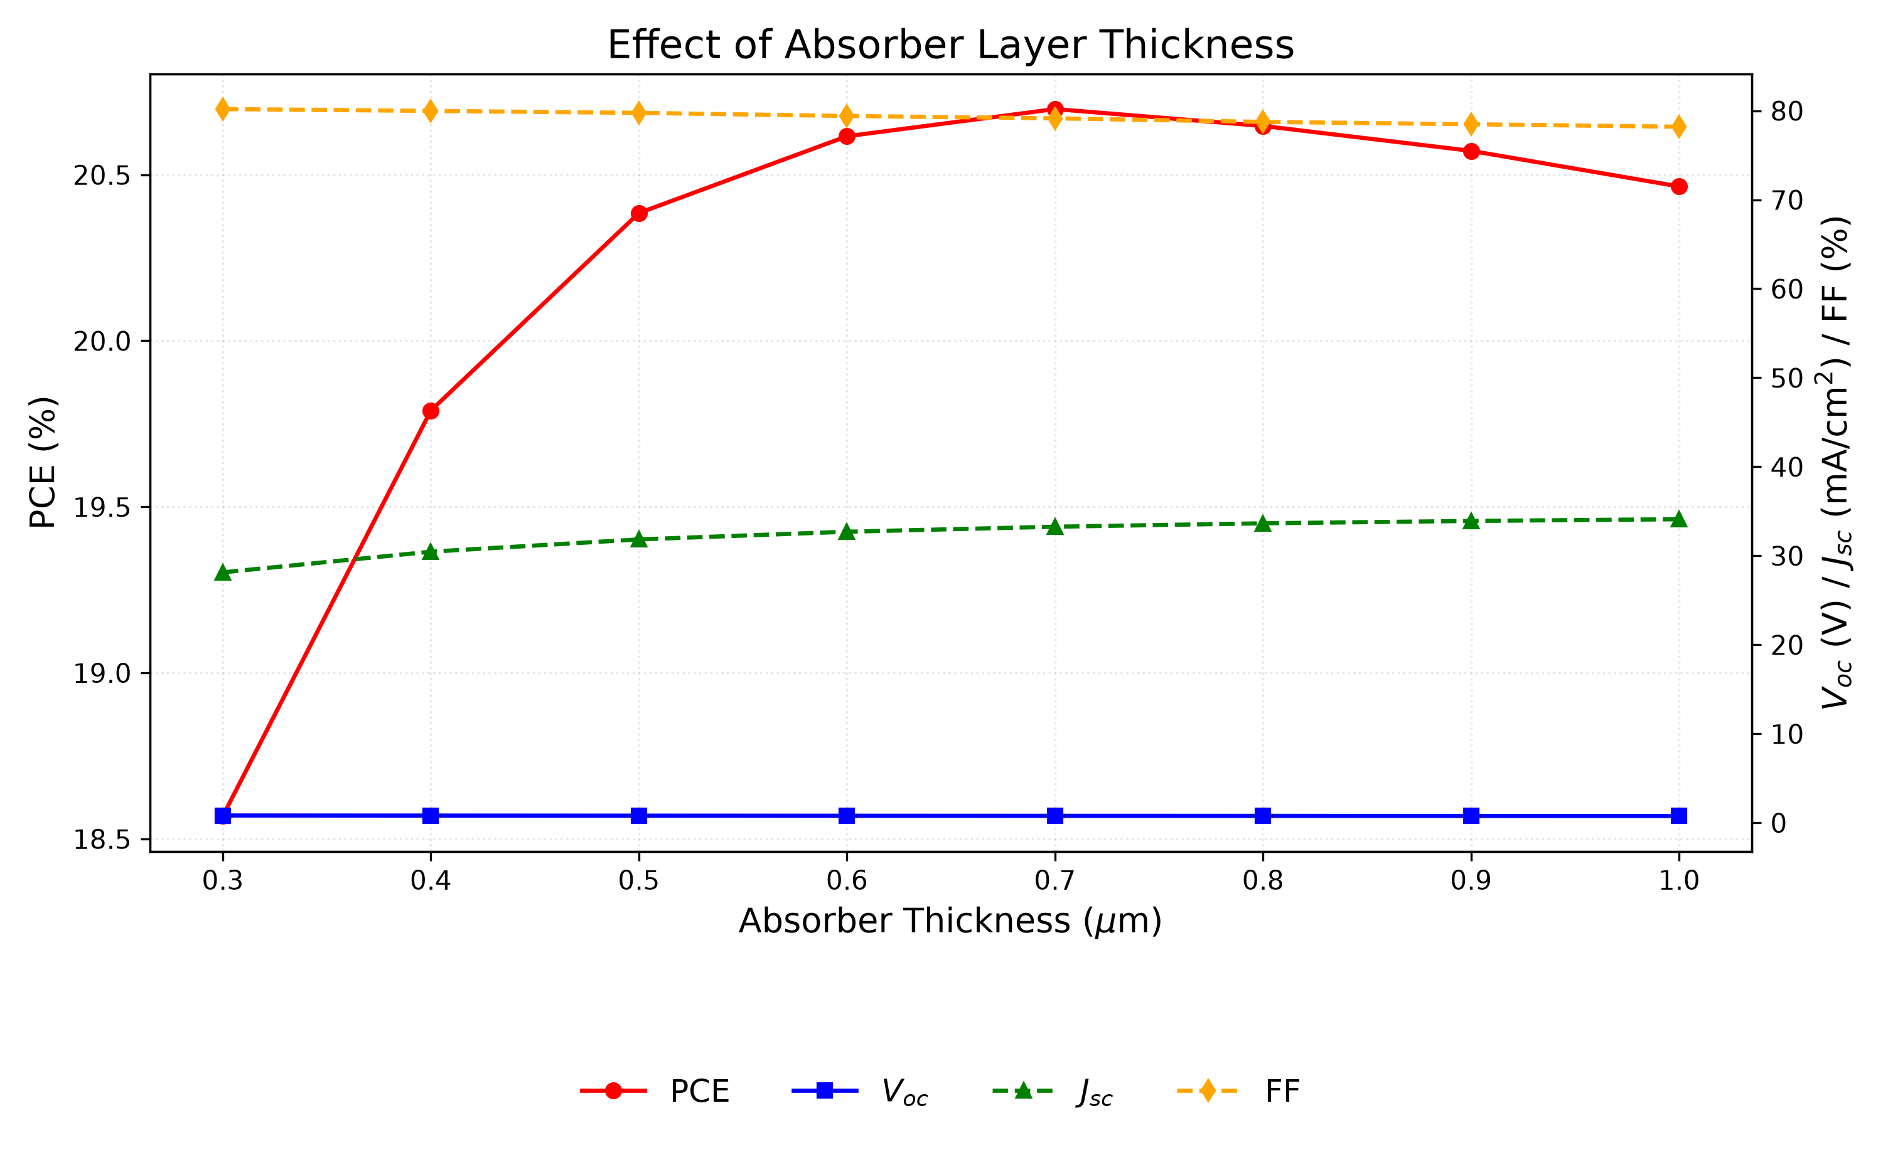
Fig. 3. Variation of PCE, V_{oc}, J_{sc}, and FF with RbGeI₃ absorber thickness. PCE peaks at 0.7 µm, beyond which recombination losses reduce efficiency.

C. Effect of absorber defect density
Bulk defects act as Shockley–Read–Hall (SRH) recombination centers, shortening carrier lifetime and reducing collection efficiency. The RbGeI₃ defect density was varied from 10¹² to 10¹⁸ cm⁻³ while all other parameters were held constant.
Above 10¹⁴ cm⁻³, PCE drops from 20.40% to 7.58% as the defect density increases to 10¹⁸ cm⁻³, driven by Voc reduction (0.848 to 0.550 V), while below 10¹⁴ cm⁻³ the device is insensitive. The sweep therefore settles at 10¹⁴ cm⁻³, the bulk defect density commonly assumed for lead-free perovskite absorbers in SCAPS studies [35].
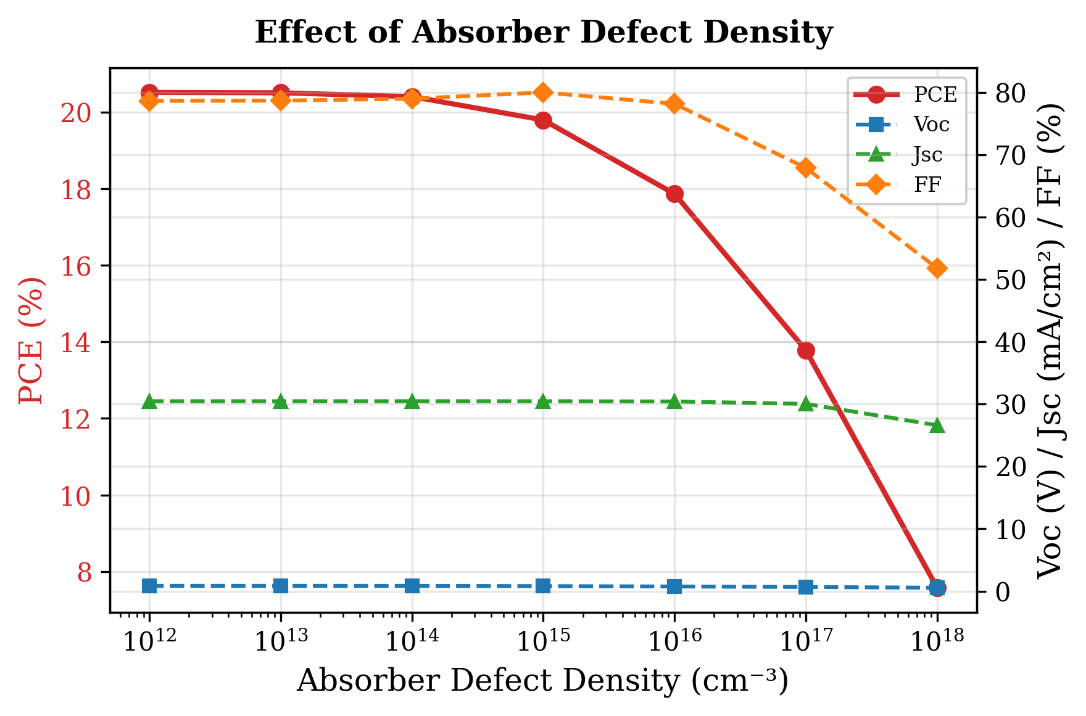
Fig. 4. Variation of PCE, V_{oc}, J_{sc}, and FF with RbGeI₃ absorber defect density. Performance degrades sharply above 10¹⁴ cm⁻³.

D. Effect of absorber dielectric constant
The dielectric constant was varied from 15 to 23.1. PCE decreased marginally from 19.92% at ε_{r} = 15 to 19.79% at ε_{r} = 23.1, driven by a small reduction in V_{oc} (0.819 to 0.812 V), while Jsc and FF remained practically unchanged, so the low value of 15 is kept.
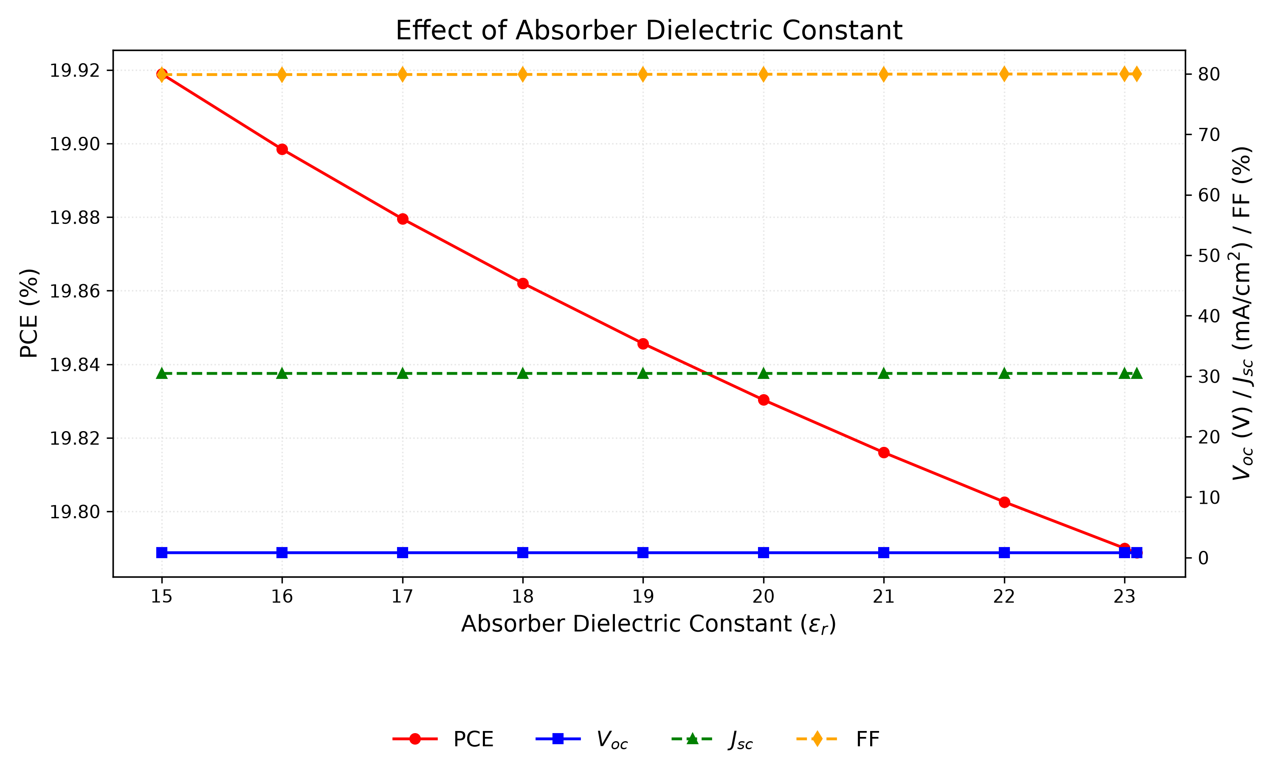
Fig. 5. Variation of PCE, V_{oc}, J_{sc}, and FF with RbGeI₃ absorber dielectric constant. The performance is essentially insensitive to ε_{r} across the investigated range; ε_{r} = 15 is retained.

E. Effect of absorber electron affinity
Electron affinity governs the energy-band alignment between adjacent layers and therefore controls charge-carrier extraction. It was varied from 3.9 to 4.2 eV with all other parameters held constant.
The highest PCE of 19.79% is achieved at χ = 3.9 eV. V_{oc} drops from 0.812 to 0.710 V as χ increases to 4.2 eV, while J_{sc} remains constant. χ = 3.9 eV is retained, since raising it costs more in V_{oc} than the FF gain recovers.
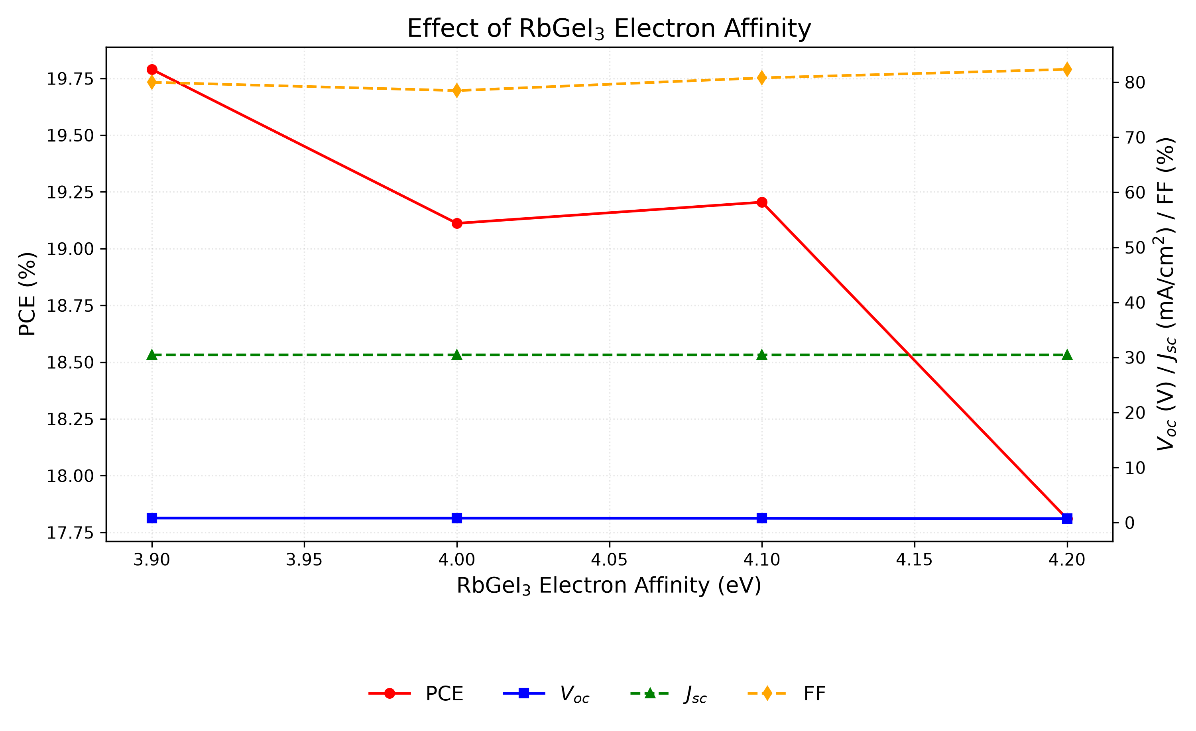
Fig. 6. Variation of PCE, V_{oc}, J_{sc}, and FF with RbGeI₃ absorber electron affinity. PCE is highest at χ = 3.9 eV due to optimal band alignment with TiO₂.

F. Effect of TiO₂/RbGeI₃ interfacial defect density
The defect density at the absorber/ETL interface is an important factor affecting charge-carrier transport and recombination in perovskite solar cells. To investigate its impact, the TiO₂/RbGeI₃ interfacial defect density was varied from 10¹² cm⁻² to 10¹⁸ cm⁻² while keeping all other parameters constant. The corresponding photovoltaic parameters are presented in Figure 7. Device performance falls sharply with increasing interfacial defect density: PCE drops from 21.04% at 10¹² cm⁻² to 8.40% at 10¹⁸ cm⁻², V_{oc} drops from 0.827 V to 0.439 V, J_{sc} decreases from 30.46 to 28.09 mA/cm², and FF reduces from 83.52% to 68.11%.
The degradation is SRH recombination at the heterojunction: more defect states capture photogenerated carriers before they reach the electrodes, and Voc, Jsc, and FF fall together. Although 10¹² cm⁻² yields the best performance, the final device targets 10¹⁴ cm⁻², a realistic fabrication goal, since achieving interface defect densities below 10¹⁴ cm⁻² consistently in RbGeI3 devices is challenging owing to Ge²⁺ oxidation and moisture sensitivity during film preparation. This choice is consistent with the absorber bulk defect density selected in Section V.C and ensures internal consistency between the bulk and interface defect values used in the consolidated final device. The 10¹⁴ cm⁻² target also matches the interfacial defect density assumed in comparable SCAPS studies of lead-free perovskites [35].
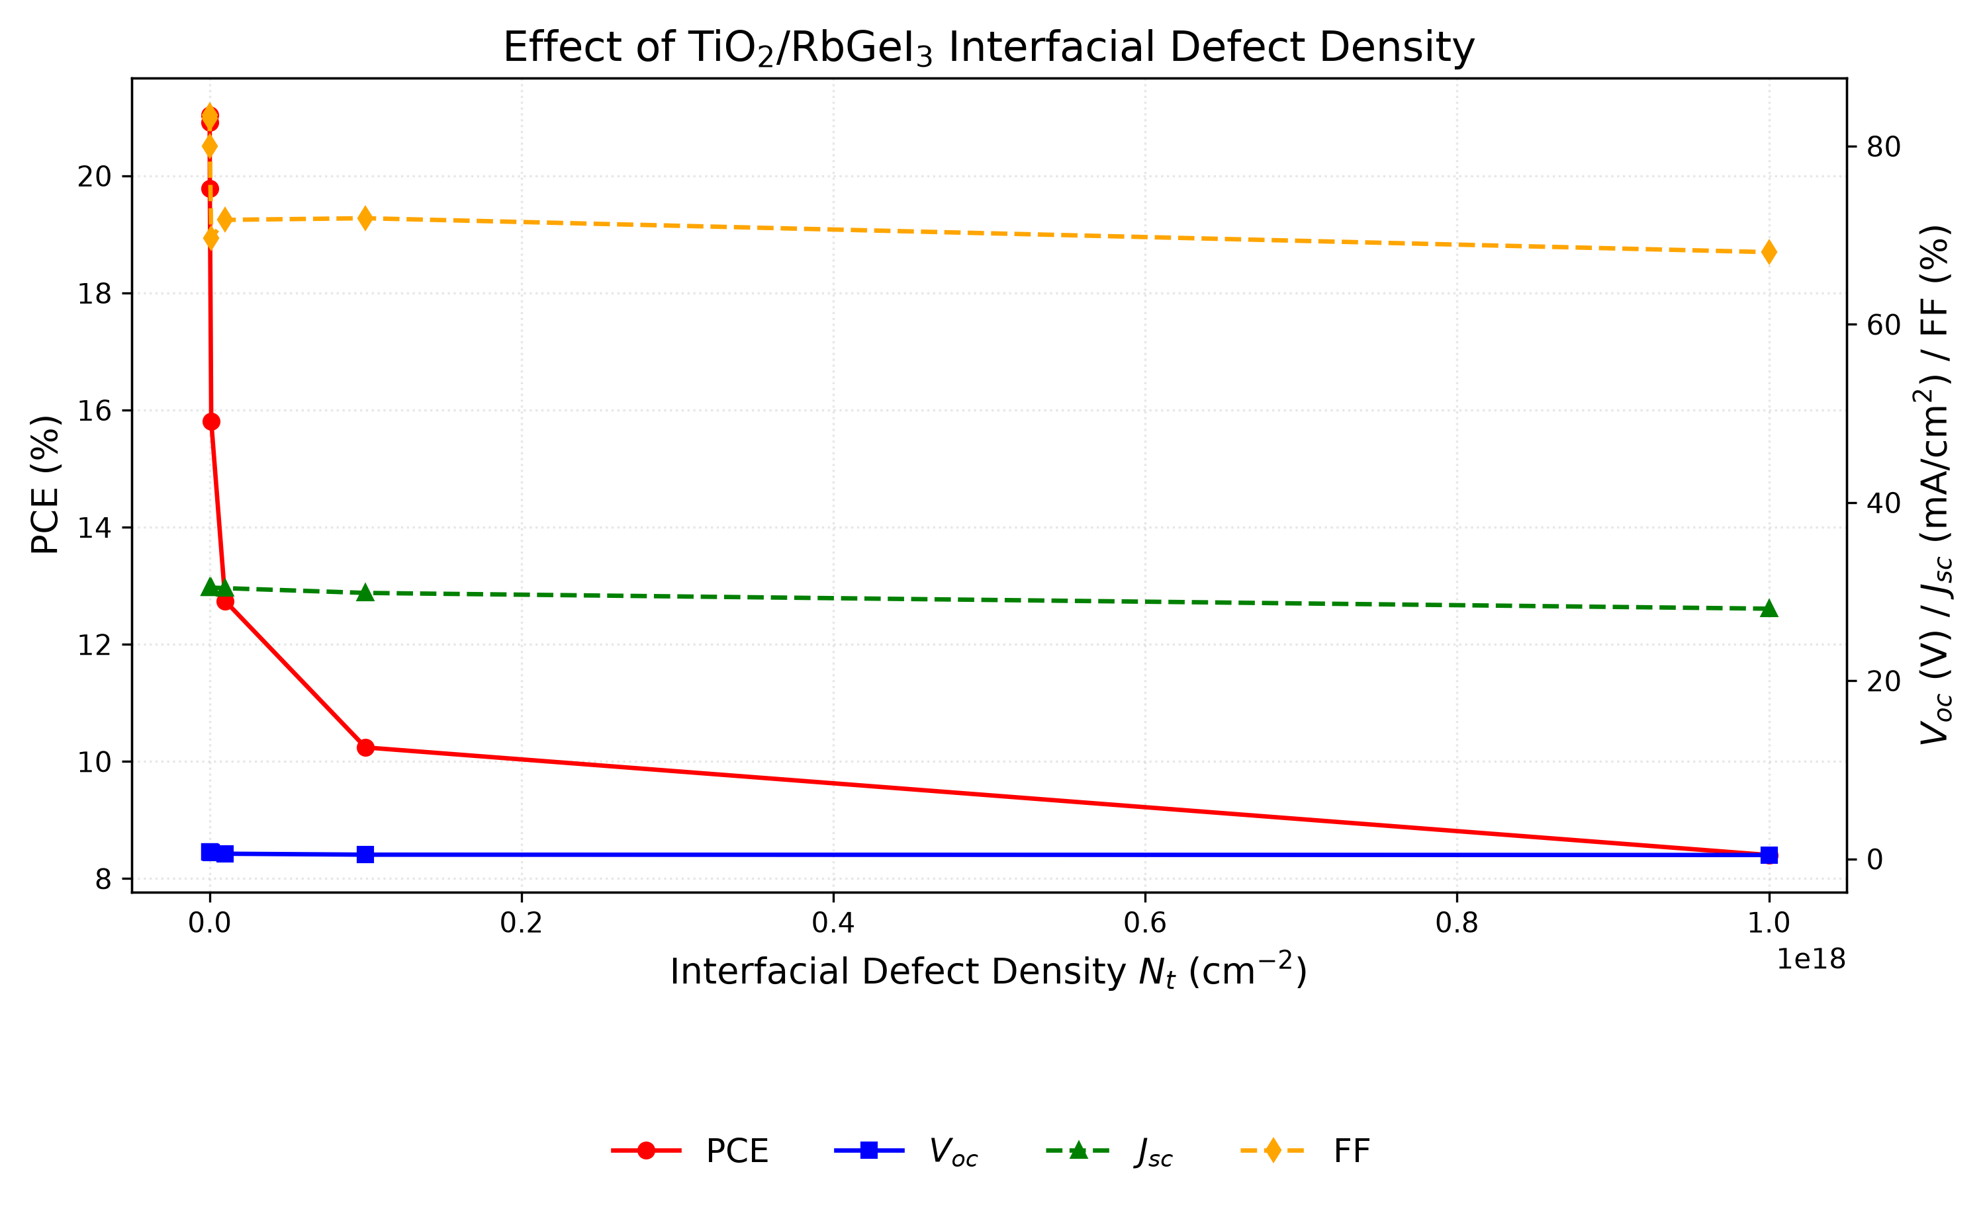
Fig. 7. Variation of PCE, Voc, Jsc, and FF with TiO2/RbGeI3 interfacial defect density. Performance degrades sharply above 10¹⁴ cm⁻²; the RbGeI3/CuI interface (Section V.G) is markedly more defect-tolerant.

G. Effect of RbGeI₃/CuI interfacial defect density
The defect density at the RbGeI₃/CuI heterojunction was varied from 10¹² to 10¹⁸ cm⁻² while all other parameters were held constant. In contrast to the TiO₂/RbGeI₃ interface, the RbGeI3/CuI interface is far more defect-tolerant: PCE decreased only from 19.79% to 18.19% as the interfacial defect density increased from 10¹² to 10¹⁸ cm⁻². This confirms that the TiO₂/RbGeI₃ interface is the performance-limiting heterojunction in this device. The final device uses 10¹⁴ cm⁻² here as well, matching the value set at the TiO₂/RbGeI₃ interface (Section V.F).
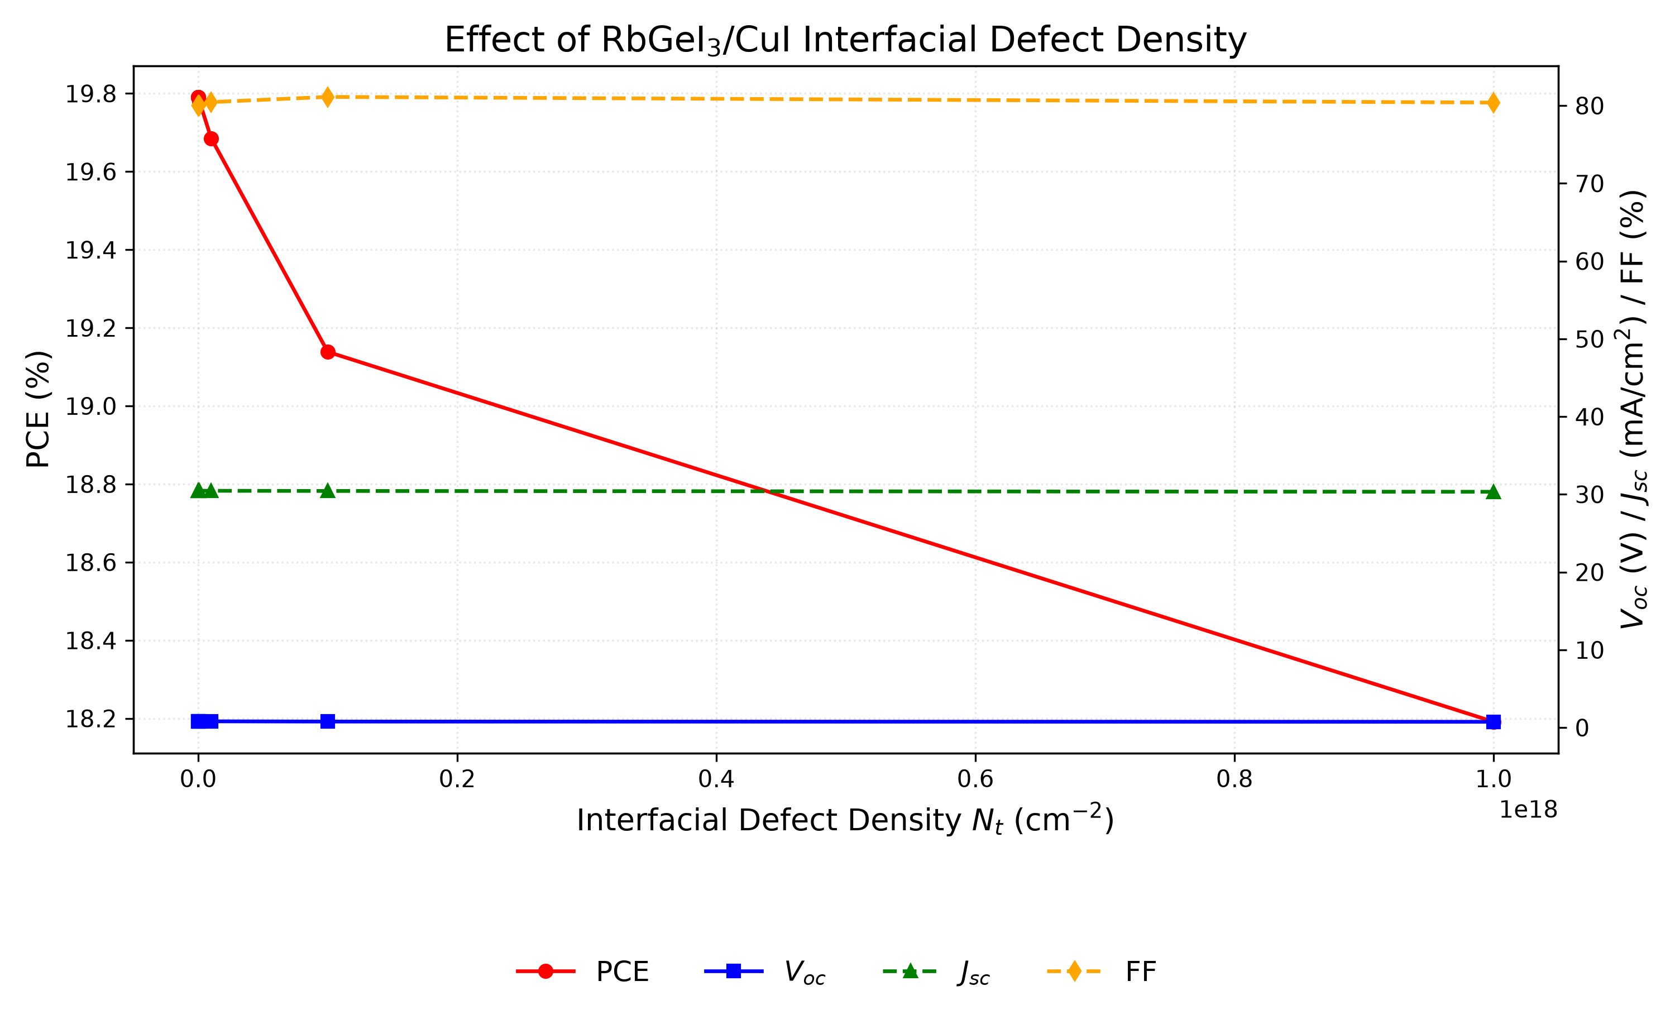
Fig. 8. Variation of PCE, V_{oc}, J_{sc}, and FF with RbGeI₃/CuI interfacial defect density. The interface is markedly more defect-tolerant than the TiO₂/RbGeI₃ interface; 10¹⁴ cm⁻² is retained.

H. Effect of absorber bandgap
The absorber bandgap determines which wavelengths of sunlight are absorbed. It was varied from 1.3 to 1.7 eV with all other parameters held constant. V_{o}c rose from 0.840 V at 1.3 eV to 1.002 V at 1.7 eV, as expected from increased quasi-Fermi-level splitting, while J_{s}c dropped from 33.59 to 20.30 mA/cm² because the wider gap excludes more of the solar spectrum.
The maximum thus sits at 1.4 eV, within 0.06 eV of the Shockley–Queisser (SQ) optimum of ≈1.34 eV for a single junction [36,37,38], so 1.4 eV is kept; tabulated SQ limits imply an ideal Jsc of ≈29.0 mA/cm² and a maximum efficiency of ≈33% at this bandgap [37]. On both sides of the SQ optimum the limiting efficiency declines, steeply for wider bandgaps because fewer photons are absorbed [37,38]: a 2.0 eV absorber would shift its absorption edge to λc ≈ 620 nm and exclude most of the visible spectrum, and our sweep already shows Jsc falling to 20.30 mA/cm² at 1.7 eV, whereas at 1.3 eV the higher Jsc (33.59 mA/cm²) does not offset the Voc loss (0.840 V). The corresponding cutoff wavelength is λc = 1240 / 1.4 ≈ 886 nm, consistent with the absorption edge observed in the quantum-efficiency spectrum of Section V.M. Note that the consolidated final device applies an absorption grading across the absorber layer (absorption cutoff graded from ≈885.7 nm at the front to ≈1033.3 nm at the back in seven linear steps): the electrical bandgap remains 1.4 eV, which sets Voc, while the effective absorption cutoff extends toward 1.2 eV and increases Jsc by ≈3 mA/cm² relative to a uniform 1.4 eV absorption model.
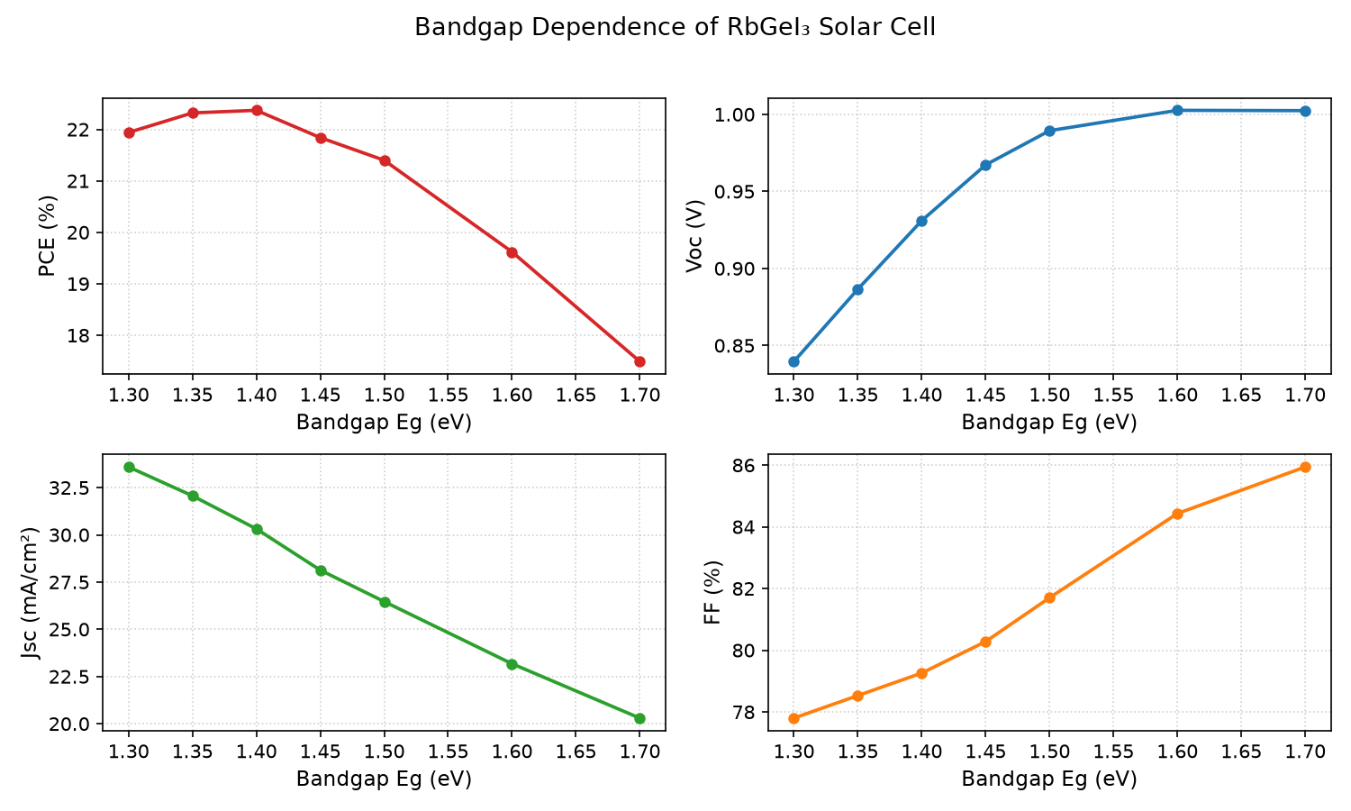
Fig. 9. Variation of PCE, V_{oc}, J_{sc}, and FF with RbGeI₃ absorber bandgap. PCE peaks at 1.4 eV, close to the Shockley–Queisser optimum.

I. Effect of TiO₂ ETL thickness
TiO2 thickness affects electron extraction, carrier transport, and optical transmission. It was varied from 0.01 to 0.09 µm with all other parameters held constant. PCE was highest at 10 nm (21.12%), declining to a local minimum of 18.72% at 0.04 µm before partially recovering to 19.97% at 0.09 µm. Thin (≤50 nm) TiO2 ETLs are typical in comparable planar SCAPS studies, where thicker ETLs add series resistance and parasitic absorption [35].
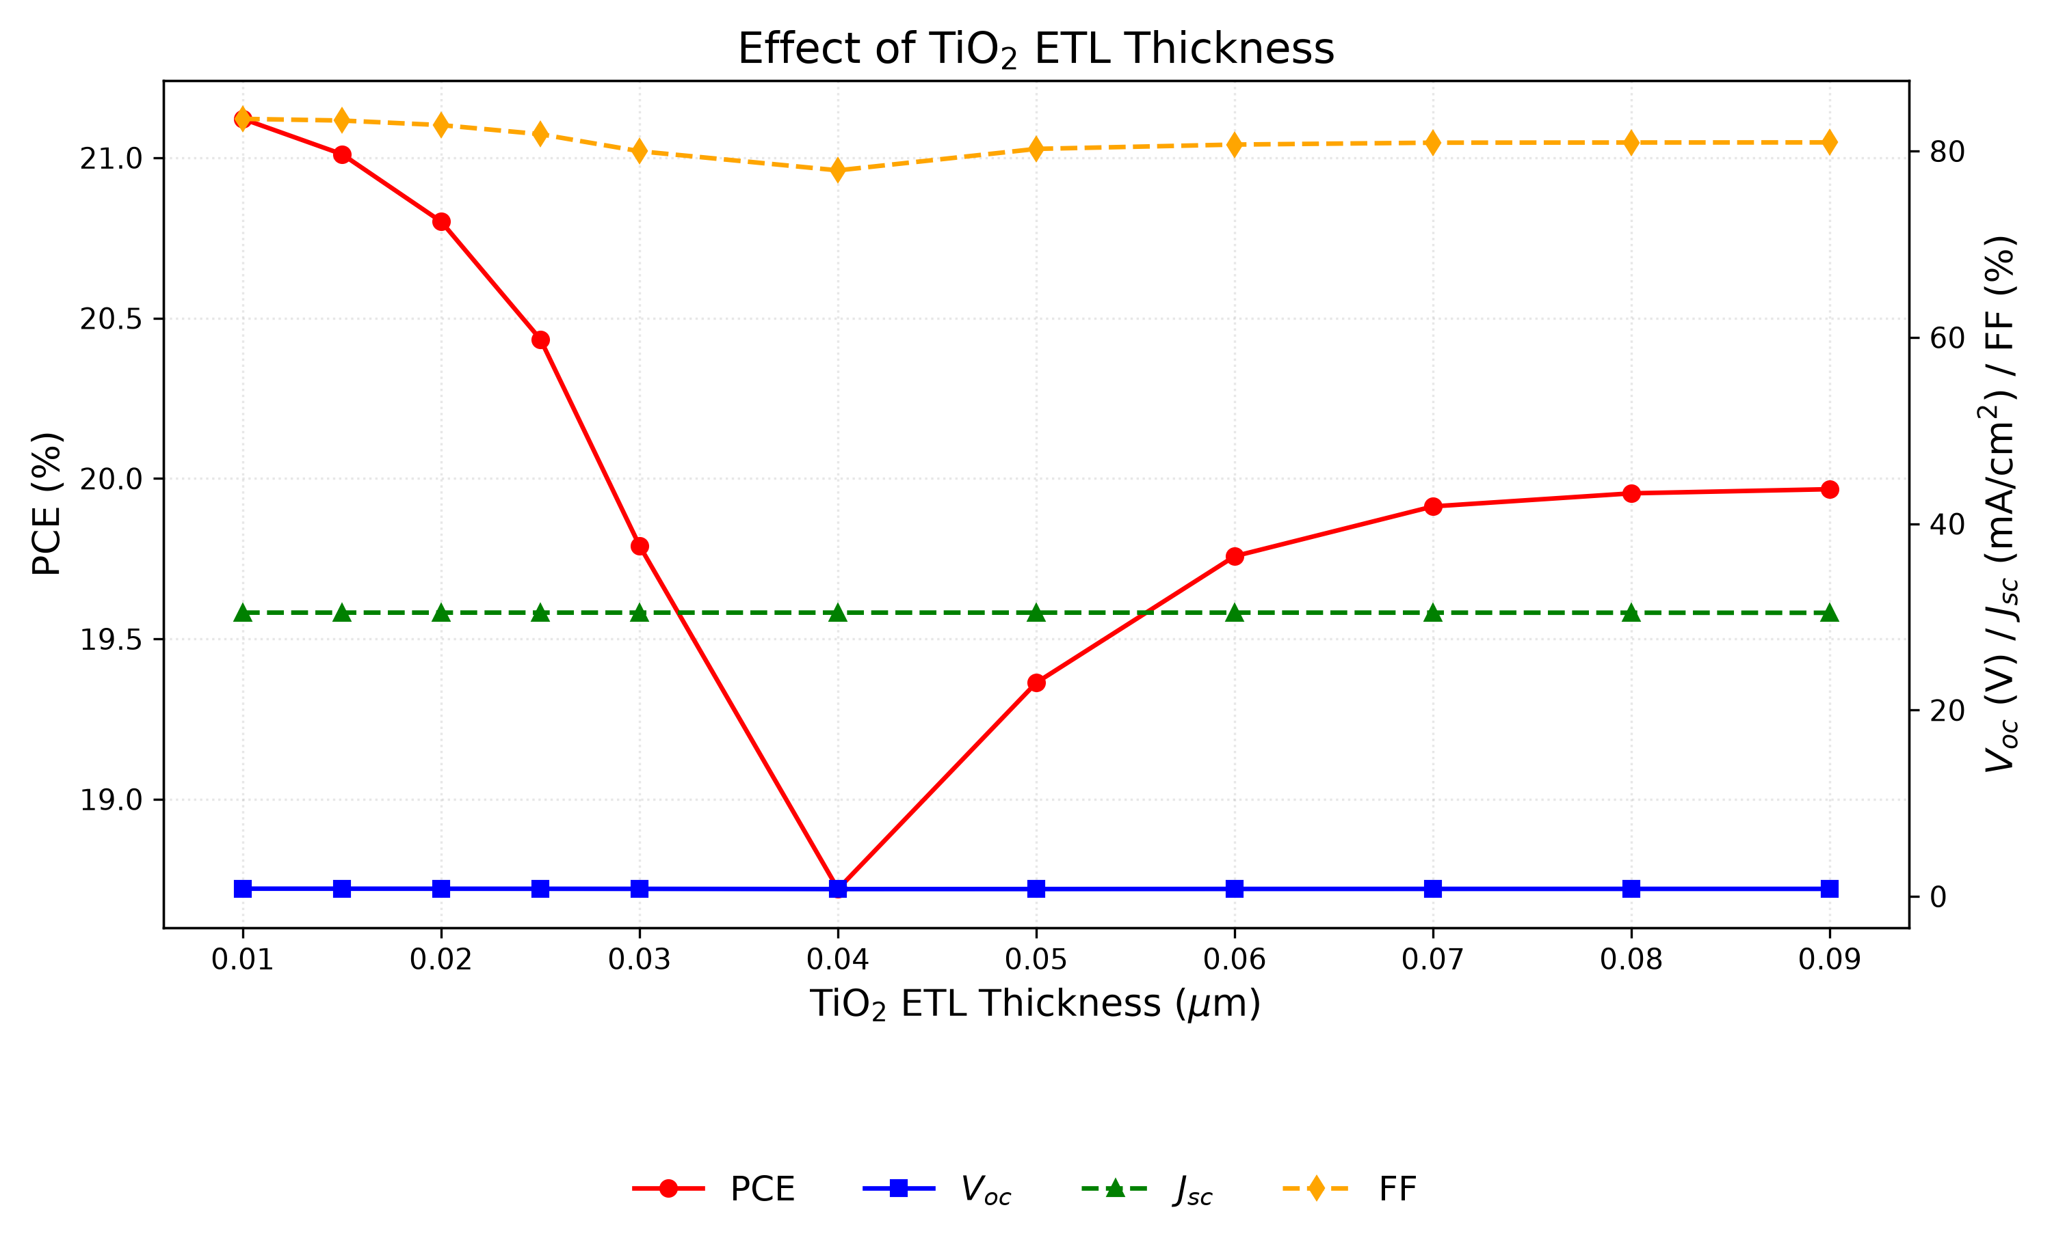
Fig. 10. Variation of PCE, V_{oc}, J_{sc}, and FF with TiO₂ ETL thickness. PCE is highest at the thinnest ETL (10 nm), reflecting the shorter electron transport path.

J. Effect of CuI HTL thickness
The CuI HTL thickness was swept from 0.1 to 1.9 µm. The effect on device performance was negligible: PCE varied by less than 0.002 percentage points, and Voc, Jsc, and FF were essentially constant. A thickness of 100 nm was selected to minimize material usage. This lies at the lower end of the 0.1–1.0 µm HTL thickness range explored in comparable studies, which likewise reported a weak thickness dependence [35].
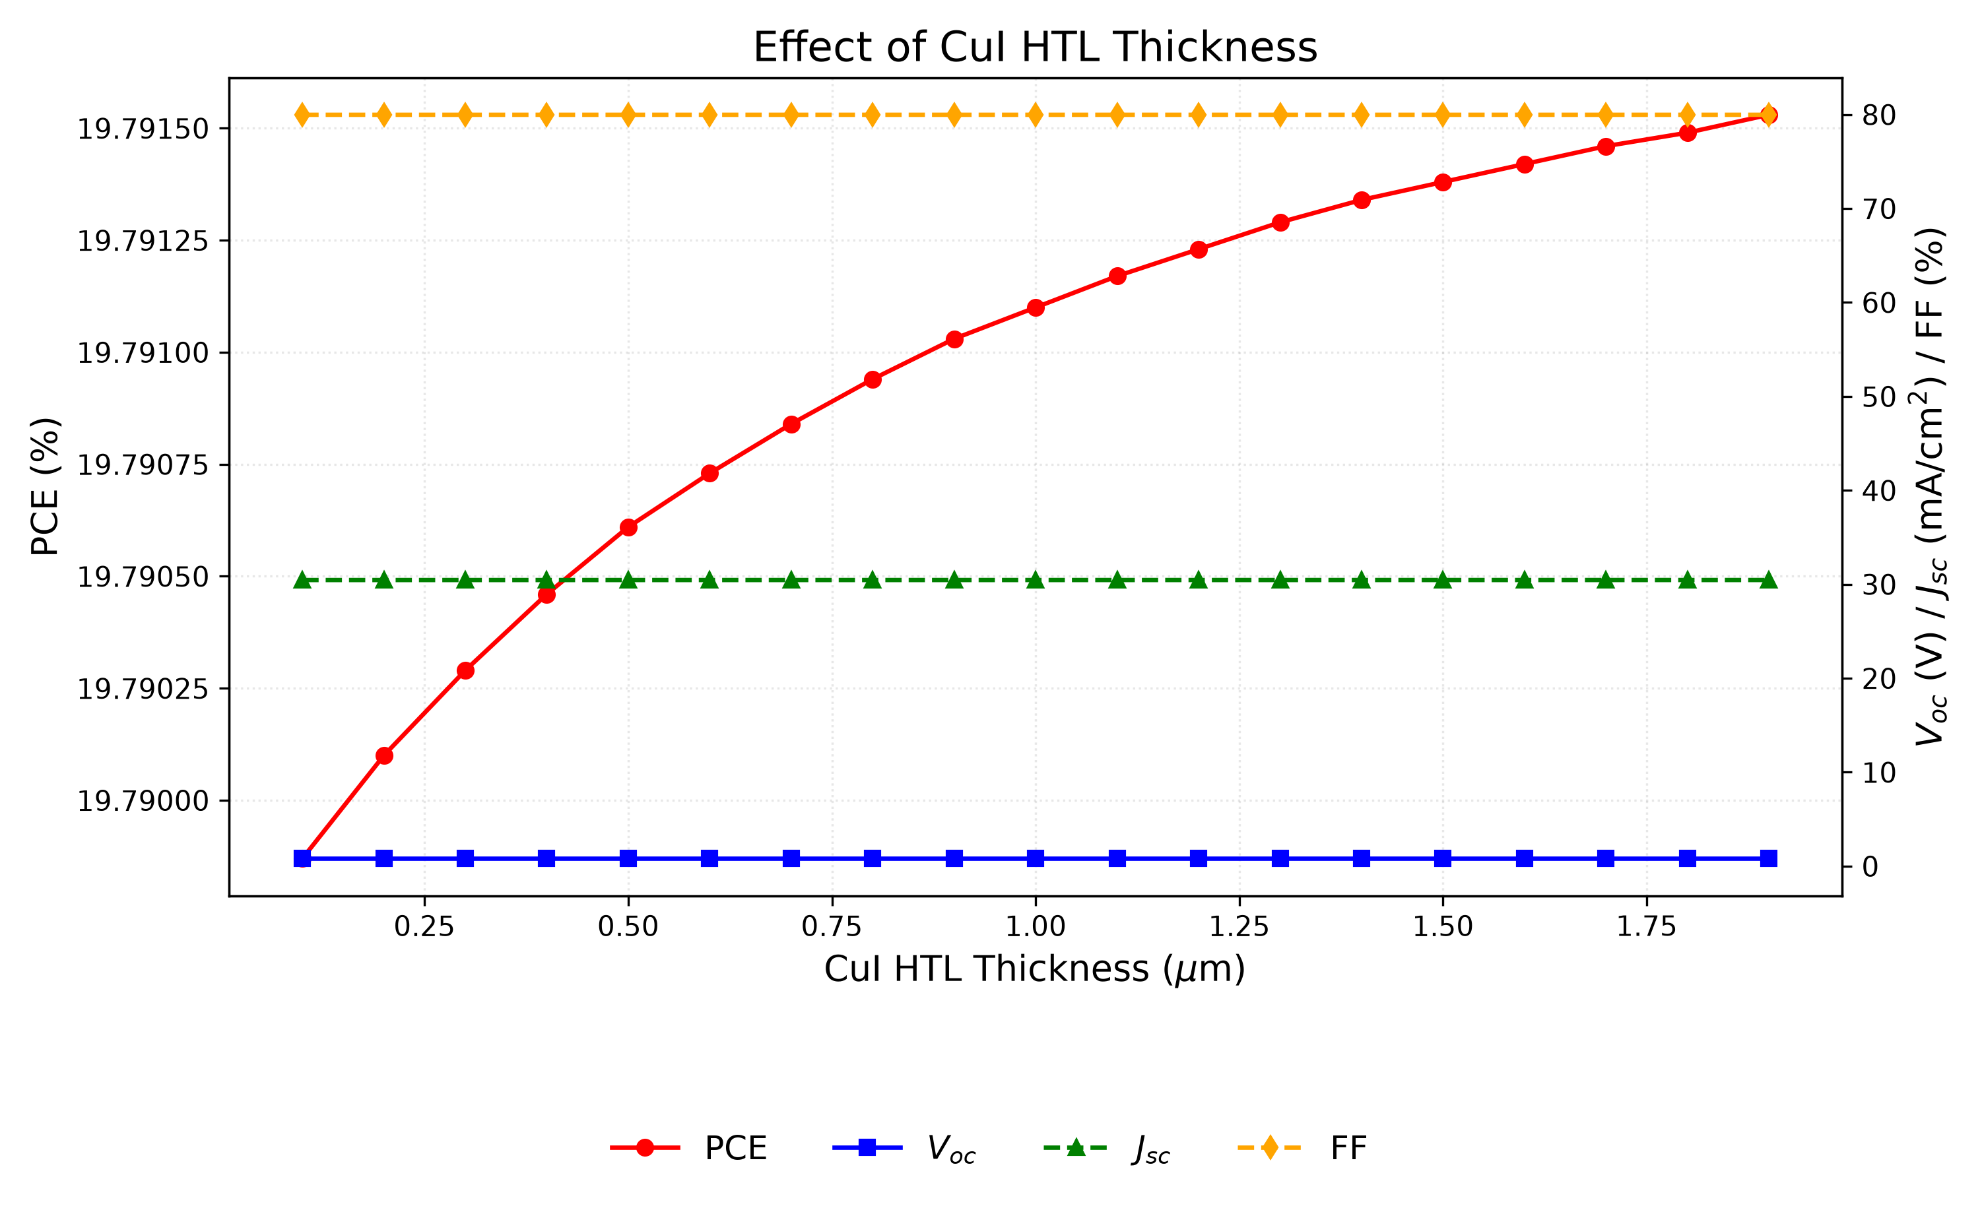
Fig. 11. Variation of PCE, V_{oc}, J_{sc}, and FF with CuI HTL thickness. The performance is essentially independent of HTL thickness; 100 nm is retained to minimise material usage.

K. Effect of conduction-band effective density of states N_{C}
NC was varied from 1×10¹⁷ to 1×10²⁰ cm⁻³. PCE decreased monotonically from 20.65% to 18.15%, driven by a drop in Voc (0.859 to 0.764 V), while Jsc remained constant at ~30.46 mA/cm². The lowest NC in the sweep, 1×10¹⁷ cm⁻³, is used in the final device. Effective densities of states of ≈10¹⁸ cm⁻³ are commonly assumed for lead-free perovskite absorbers in SCAPS studies [35]; lowering NC reduces the intrinsic carrier density and thereby raises Voc, so the sweep optimum is retained.
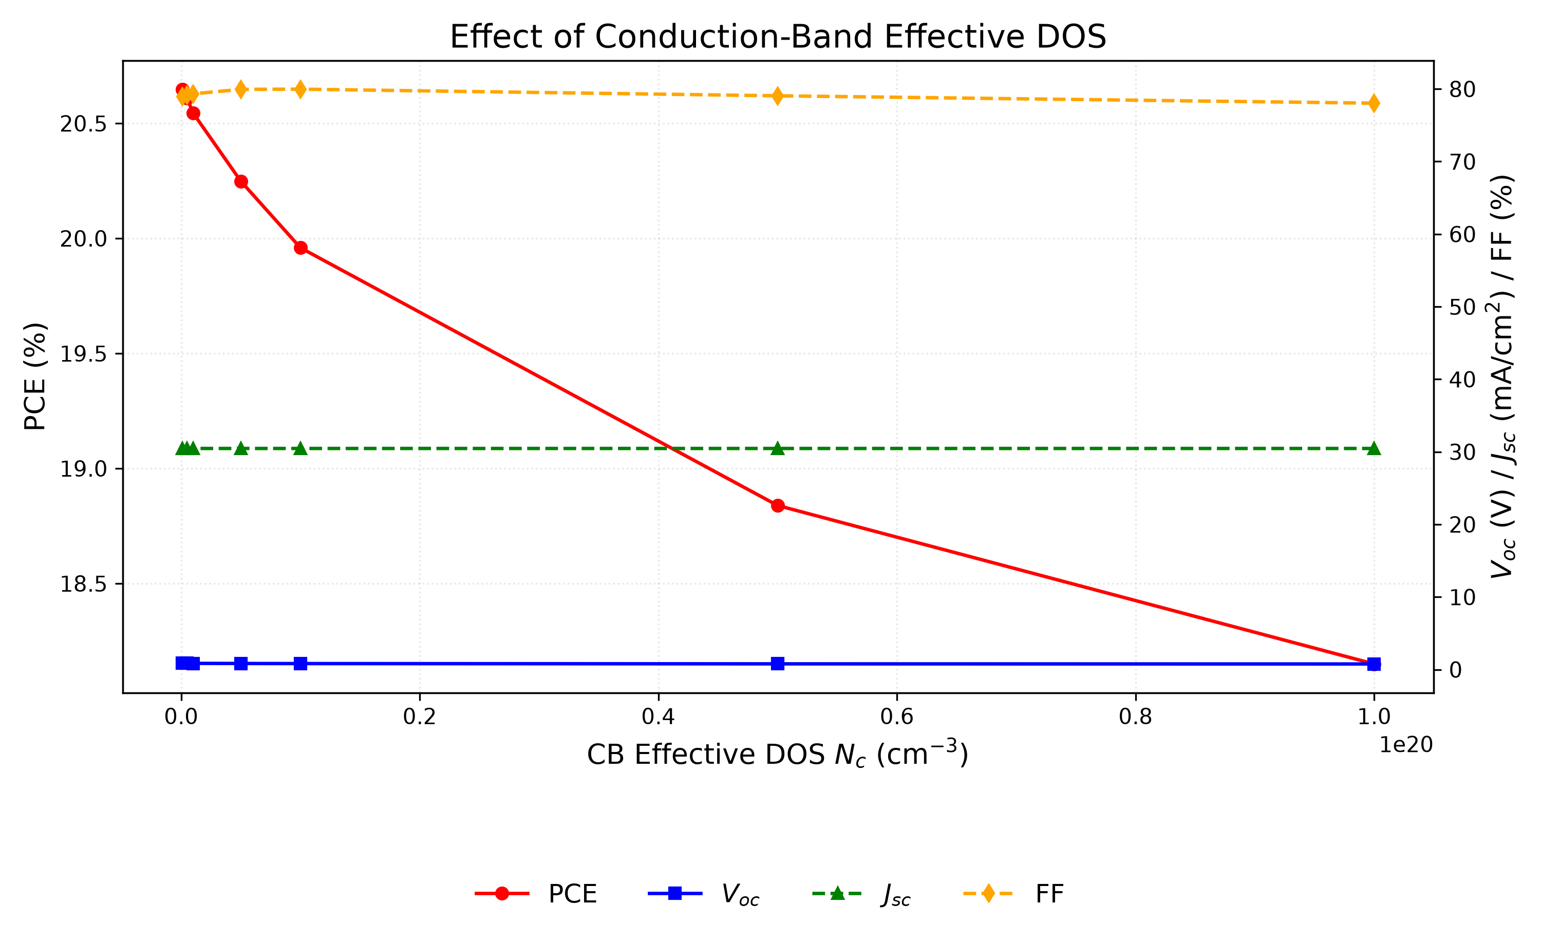
Fig. 12. Variation of PCE, V_{oc}, J_{sc}, and FF with conduction-band effective density of states N_{C}. Lower N_{C} is preferred; the best value of 10¹⁷ cm⁻³ is retained.

L. Effect of valence-band effective density of states N_{V}
NV was varied from 1×10¹⁷ to 1×10²⁰ cm⁻³. PCE decreased from 23.54% to 18.86% as Voc dropped from 0.945 to 0.780 V, with Jsc unchanged. The effect was stronger than for NC, and the lowest value again performs best. NV = 1×10¹⁷ cm⁻³ is therefore retained.
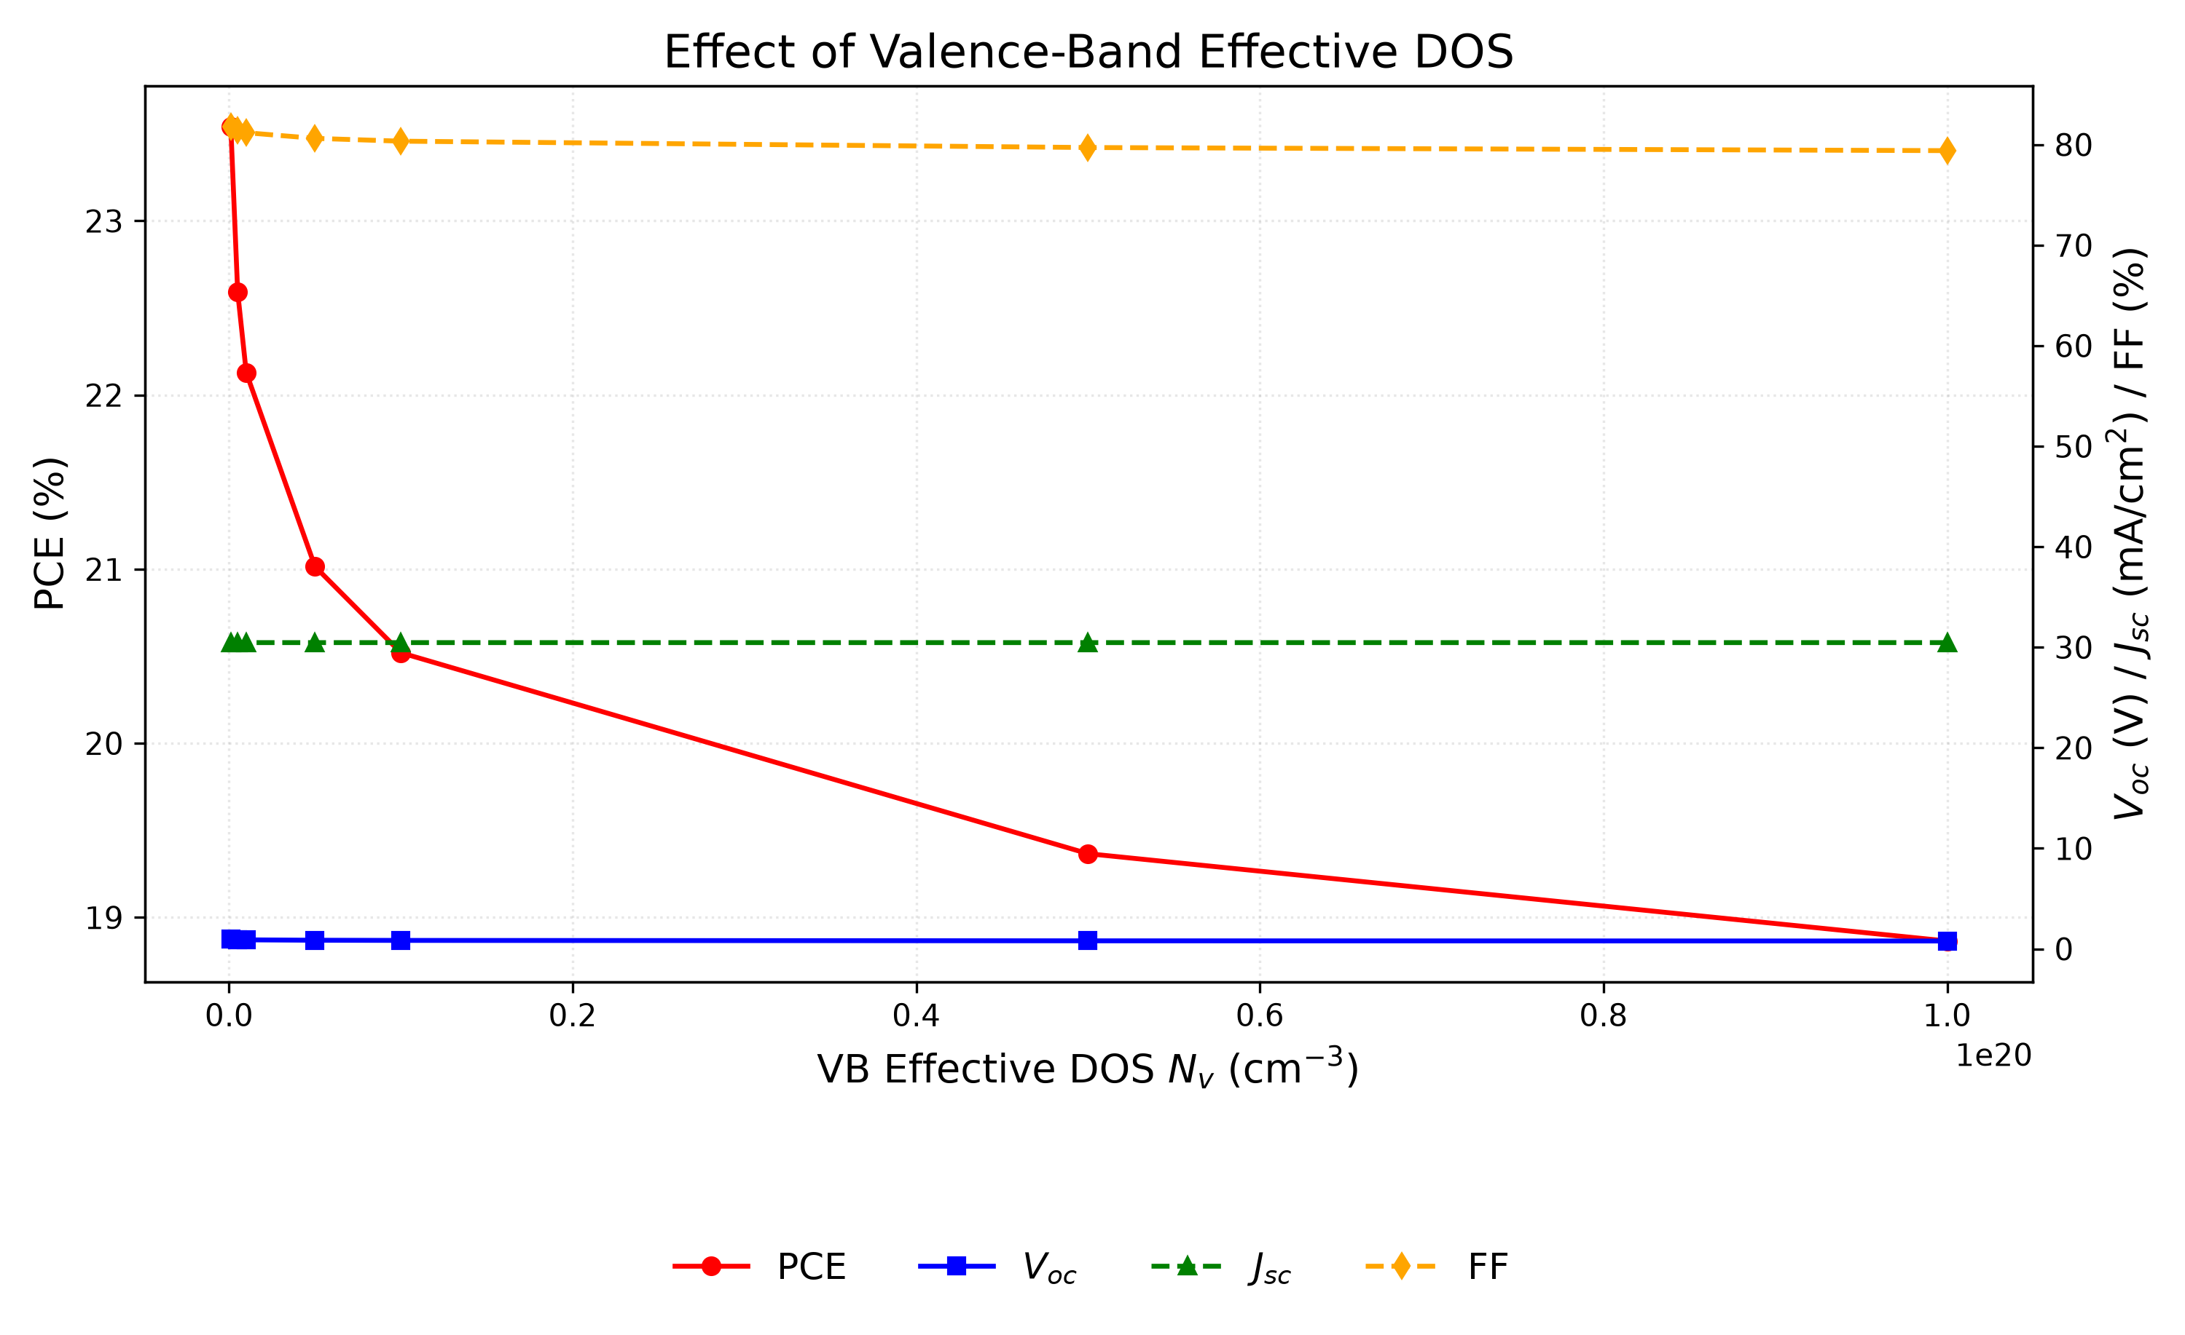
Fig. 13. Variation of PCE, V_{oc}, J_{sc}, and FF with valence-band effective density of states N_{V}. The effect is more pronounced than for N_{C}; the best value of 10¹⁷ cm⁻³ is retained.

M. Quantum efficiency analysis
The quantum efficiency spectrum of the optimized device (Figure 14) shows the ratio of collected carriers to incident photons across wavelength. QE rises from 34.52% at 300 nm to 49.18% at 350 nm and reaches approximately 100% at 400 nm. The lower ultraviolet QE reflects surface recombination: high-energy photons are absorbed near the front interface, where some carriers recombine before collection [21,39].
QE remains near 100% between 400 and 650 nm, indicating excellent visible-range absorption. Beyond 650 nm, QE declines to 76% at 850 nm. A sharp cutoff near 900 nm corresponds to the absorber bandgap of 1.4 eV (λc ≈ 886 nm). Integrating the QE spectrum yields ≈23.3 mA/cm², which differs from the J–V short-circuit density of 30.32 mA/cm² because the QE spectrum was computed with a uniform absorption model, whereas the consolidated final device uses the graded absorption profile described in Section V.H; the two values therefore correspond to different absorption models.
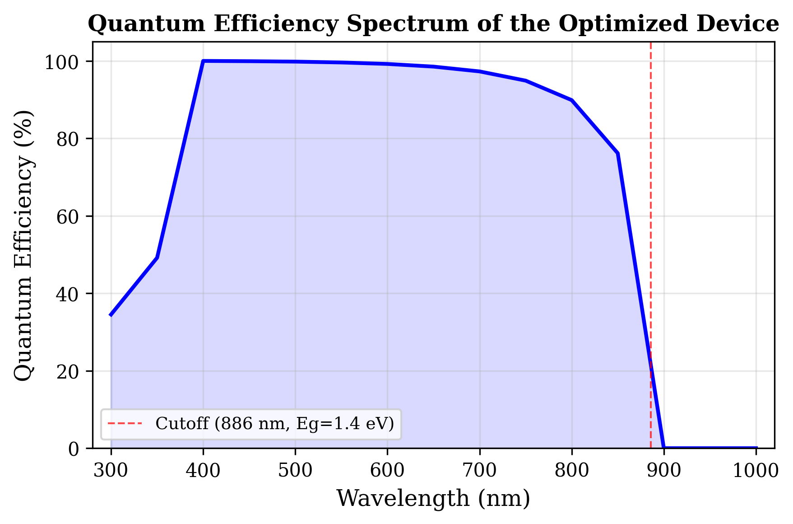
Fig. 14. Variation of quantum efficiency (QE) with incident wavelength of the optimized solar cell. The cutoff at ≈886 nm corresponds to the absorber bandgap of 1.4 eV.

N. Energy band diagram analysis
The equilibrium band diagram (Figure 15) shows the energy alignment across the device: the 1.8 eV conduction-band offset at CuI/RbGeI3 blocks electron leakage to the back contact, while the 0.1 eV offset at RbGeI3/TiO2 facilitates electron extraction; both interfaces are thus electronically well passivated.
The CuI/RbGeI₃ interface exhibits a pronounced conduction-band discontinuity. Based on the electron-affinity values of CuI (χ = 2.1 eV) and RbGeI₃ (χ = 3.9 eV), the conduction-band offset is ΔE_{c} ≈ |2.1 − 3.9| = 1.8 eV, which acts as an effective electron-blocking barrier. The corresponding valence-band offset, computed using E_{v} = −(E_{g} + χ), is ΔE_{v} ≈ |(−5.30) − (−5.20)| ≈ 0.10 eV, indicating that the valence bands of CuI and RbGeI₃ are nearly aligned. This small barrier enables holes generated inside the absorber to move efficiently into the HTL with minimal transport resistance. Within the 700 nm RbGeI₃ absorber layer, both E_{c} and E_{v} remain nearly constant, indicating a relatively uniform electrostatic potential throughout the bulk absorber. The energy difference between E_{c} and E_{v} corresponds to the absorber bandgap of 1.4 eV used in the optimized device, close to the Shockley–Queisser optimum for single-junction photovoltaic devices.
A second band discontinuity appears at the RbGeI3/TiO2 interface located approximately 800 nm from the back contact. Because the electron affinities of RbGeI3 and TiO2 are 3.9 eV and 4.0 eV respectively, the conduction-band offset is only about 0.10 eV, forming a 0.10 eV downward step at the interface that assists electron extraction and suppresses interfacial recombination. The calculated valence-band offset at this interface is approximately 1.90 eV (using Ev(RbGeI3) = −5.30 eV and Ev(TiO2) = −(4.0+3.2) = −7.2 eV, giving ΔEv = |−5.30 − (−7.2)| = 1.90 eV), creating a substantial energetic barrier that effectively blocks holes from entering the TiO2 layer. Under illumination, the quasi-Fermi levels split apart across the device, with the electron quasi-Fermi level Fn lying close to the conduction band in the absorber and ETL and the hole quasi-Fermi level Fp following the valence band. The Fn − Fp splitting sets the photovoltage (Voc ≈ 1.12 V) and is consistent with the high open-circuit voltage of the optimized device. Slight band bending near both heterojunctions reflects the built-in electric field established after contact formation, which drives photogenerated electrons toward the TiO2/FTO electrode and holes toward the CuI HTL.
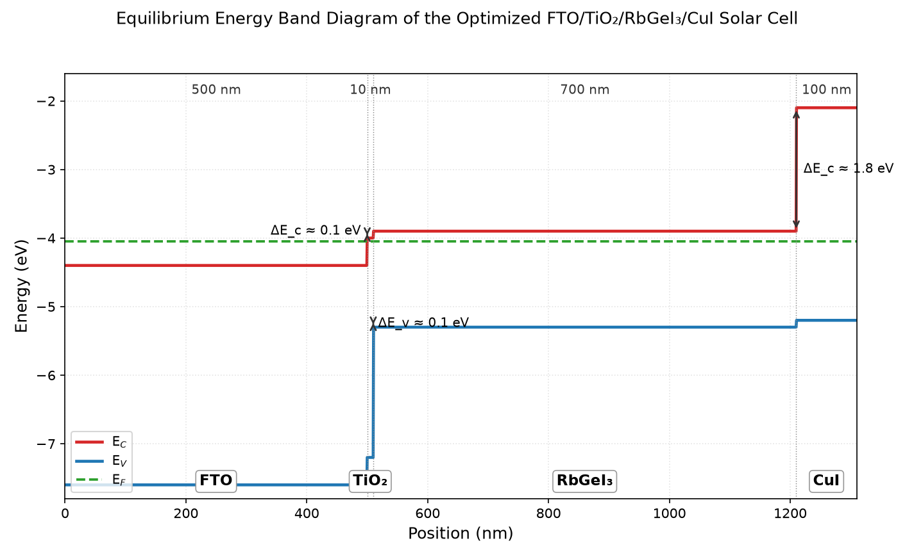
Fig. 15. Equilibrium energy band diagram of the optimized CuI/RbGeI3/TiO2/FTO solar cell, showing the conduction-band edge (Ec, blue) and valence-band edge (Ev, red) across all four layers. The 1.8 eV conduction-band offset at CuI/RbGeI3 blocks electron back-transfer, while the 0.10 eV conduction-band step at RbGeI3/TiO2 supports efficient electron extraction.

O. Current density–voltage characteristics
The current density–voltage (J–V) characteristic of the consolidated optimized device under AM 1.5G illumination is shown in Figure 16. The curve is sharply rectangular, with an open-circuit voltage of V_{oc} = 1.12 V, a short-circuit current density of J_{sc} = 30.32 mA/cm², and a fill factor of 78.92%, yielding a PCE of 26.80%. The maximum-power point occurs near V = 0.96 V with J ≈ 27.9 mA/cm², where the instantaneous power density reaches 26.8 mW/cm². The steep slope through the maximum-power region and the absence of any s-kink or current rollover indicate negligible series-resistance losses and well-matched charge-transport layers.
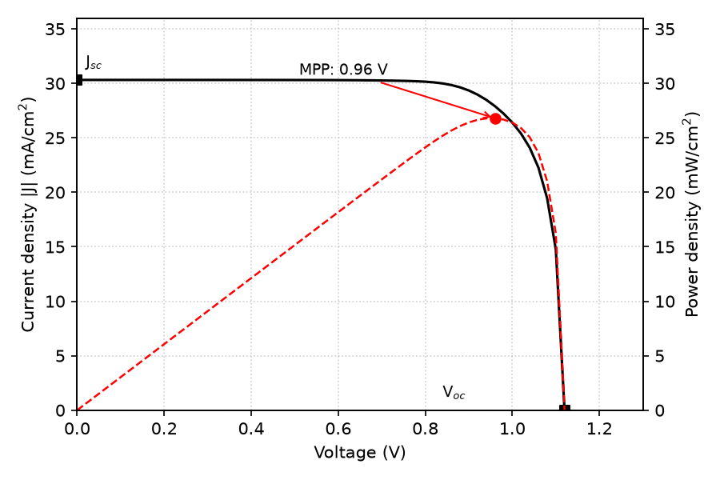
Fig. 16. Current density–voltage (J–V) curve of the optimized FTO/TiO₂/RbGeI₃/CuI/Au device under AM 1.5G illumination. The red dashed curve shows the output power density, with the maximum-power point marked.

P. Summary of optimized device parameters and final performance
After completing the optimization of all eleven selected device parameters, the final optimized values were incorporated into the proposed FTO/TiO₂/RbGeI₃/CuI/Au solar cell. Table VII summarizes the optimized material parameters obtained from the SCAPS-1D simulations. These optimized values were used to achieve the highest photovoltaic performance reported in this study. The consolidated final device was simulated by applying all eleven optimized parameters simultaneously in a single SCAPS-1D run; the resulting J–V output gives V_{oc} = 1.12 V, J_{sc} = 30.32 mA/cm², FF = 78.92%, and PCE = 26.80%. Note that the consolidated final-device values are obtained from this single SCAPS-1D simulation run and are not a simple arithmetic combination of the per-step optima reported in Figs. 3–13. The interaction between optimized parameters in the consolidated solution can shift individual performance metrics relative to their per-step values, the fill factor, for instance, drops from per-step optima above 83% (Figs. 7 and 10) to 78.92% in the consolidated device because the combined effect of the optimized bandgap, defect densities, DOS values, and ETL/HTL thicknesses produces a different J–V curve shape than any single-parameter optimum.
Table VII. Optimized material parameters of the proposed FTO/TiO₂/RbGeI₃/CuI/Au perovskite solar cell.
Parameter | TiO₂ | FTO | RbGeI₃ | CuI
Thickness (nm) | 10 | 500 | 700 | 100
Bandgap E_{g} (eV) | 3.2 | 3.2 | 1.4 | 3.1
Electron affinity χ (eV) | 4.0 | 4.4 | 3.9 | 2.1
Dielectric permittivity ε_{r} | 9 | 9 | 15 | 6.5
CB effective DOS N_{C} (cm⁻³) | 2×10¹⁸ | 2.2×10¹⁸ | 1×10¹⁷ | 2.8×10¹⁹
VB effective DOS N_{V} (cm⁻³) | 1.8×10¹⁹ | 1.8×10¹⁹ | 1×10¹⁷ | 1×10¹⁹
Electron mobility μ_{e} (cm² V⁻¹ s⁻¹) | 20 | 20 | 28.6 | 100
Hole mobility μ_{p} (cm² V⁻¹ s⁻¹) | 10 | 10 | 27.3 | 43.9
Donor density N_{D} (cm⁻³) | 9×10¹⁶ | 1×10¹⁹ | 1×10⁹ | 0
Acceptor density N_{a} (cm⁻³) | 0 | 0 | 1×10⁹ | 1×10¹⁸
Bulk defect density N_{t} (cm⁻³) | 1×10¹⁵ | 1×10¹⁴ | 1×10¹⁴ | 1×10¹⁴
Note: The optimized interface defect density was 1 × 10¹⁴ cm⁻² for both the TiO₂/RbGeI₃ and RbGeI₃/CuI interfaces.
As an arithmetic consistency check, the final-device PCE computed from Eq. (5) using the consolidated J–V metrics is PCE = (1.12 × 30.32 × 0.7892) / 100 = 26.79%, which matches the SCAPS-1D output of 26.80% to within rounding, confirming the internal arithmetical consistency of the final reported device.

Q. Uncertainty Quantification
A Monte Carlo UQ was performed using Latin hypercube sampling (N = 200) with eight random variables: absorber thickness (500–900 nm), bandgap (1.3–1.5 eV), defect density (1×10¹³–1×10¹⁶ cm⁻³ in the absorber, 1×10¹²–1×10¹⁶ cm⁻² at each interface), N_{C} and N_{V} (1×10¹⁷–1×10¹⁹ cm⁻³ each), and dielectric constant (15–23).
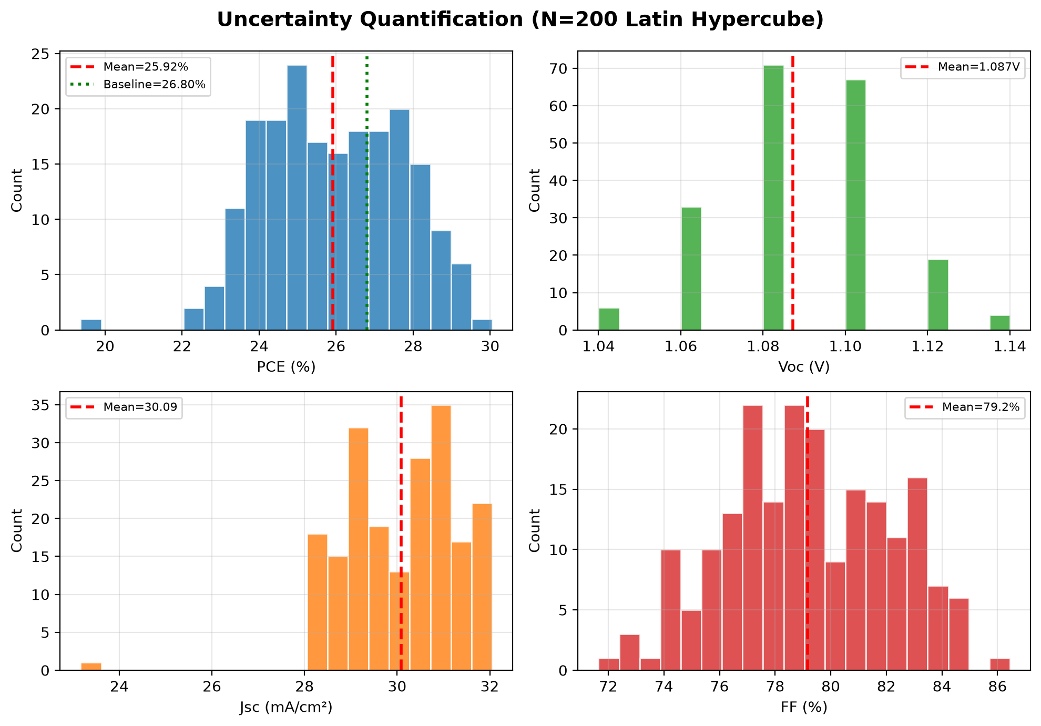
Fig. 17. Uncertainty quantification results (N = 200). Histograms of PCE, V_{oc}, J_{sc}, and FF.
Mean PCE = 25.92 ± 1.78 % (median 25.85 %), with 5th/95th percentiles 23.38 % / 28.81 %. Mean Voc = 1.087 ± 0.021 V. The UQ gives a 5th-to-95th percentile window of 23.38–28.81 %.

R. Illumination dependence
The performance of the optimized device was evaluated under illumination intensities ranging from 0.1 to 1.5 suns (Figure 18). J_{sc} scales almost linearly with intensity, as expected from the linear dependence of the photogenerated carrier density on the photon flux, whereas V_{oc} increases logarithmically with intensity. The logarithmic slope of V_{oc} versus illumination intensity corresponds to an ideality factor of n ≈ 1.17, indicating that Shockley–Read–Hall recombination through deep defects is not dominant under operating conditions. The device therefore operates efficiently across the full 0.1–1.5 sun range tested.
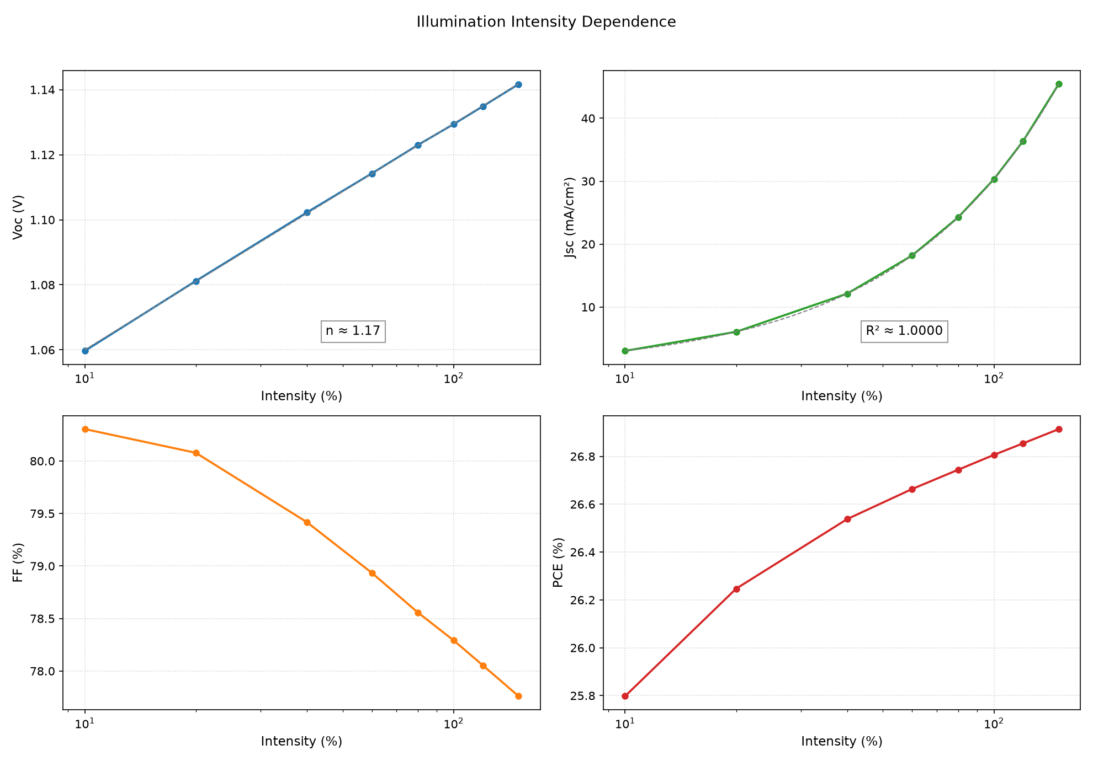
Fig. 18. Variation of photovoltaic parameters of the optimized device with illumination intensity from 0.1 to 1.5 suns.

S. Dark J–V characteristics
The dark J–V characteristic of the optimized device (Figure 19) exhibits strong rectifying behavior. Over the recorded bias window (−0.5 to +1.3 V), the forward current density at +1 V exceeds the reverse current density at −0.5 V by a factor of 1.8×10¹⁰, indicating strong rectification. The reverse leakage current density remains below 10⁻¹⁰ A/cm² throughout the recorded reverse-bias range. Fitting the exponential forward region yields an ideality factor of n ≈ 1.5 and a reverse saturation current density of approximately J0 ≈ 5×10⁻¹¹ A/cm², confirming the high quality of the optimized bulk and interface layers and the absence of measurable shunt paths.
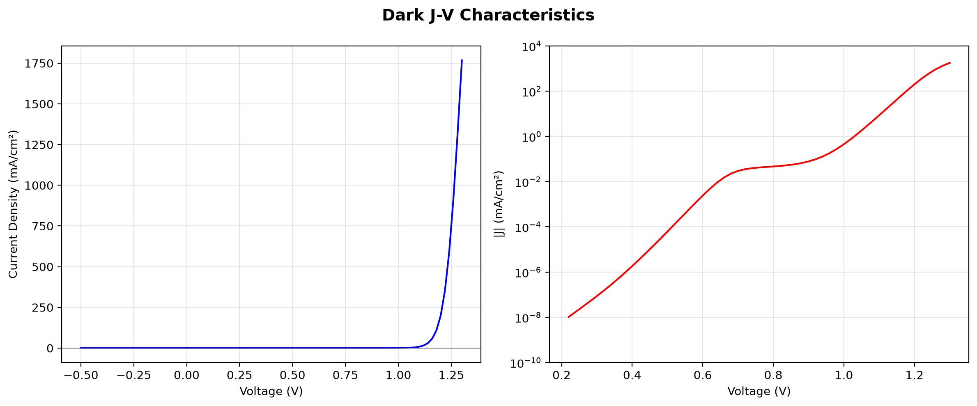
Fig. 19. Dark J–V characteristic of the optimized device. The forward branch is exponential over nearly three decades; the reverse branch remains below 10⁻¹⁰ A/cm².

T. Temperature Dependence
Temperature dependence from 280 K to 400 K (20 K increments) under AM 1.5G.
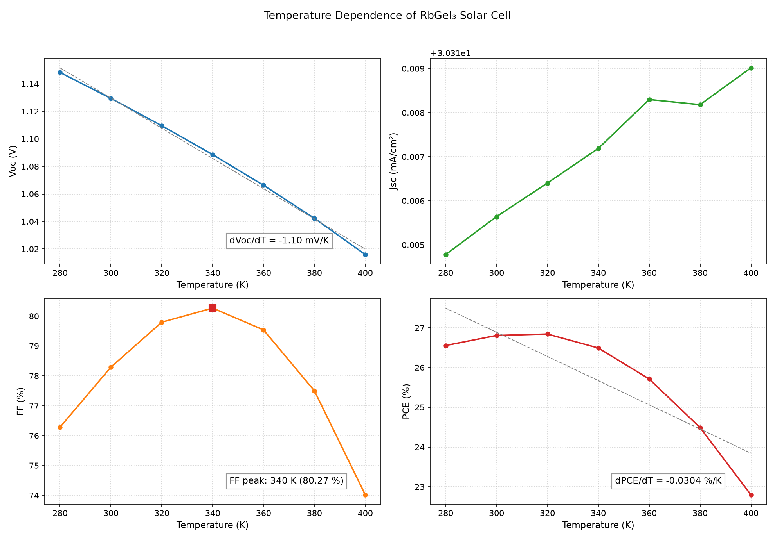
Fig. 20. Temperature dependence of photovoltaic parameters from 280 K to 400 K.
dV_{oc}/dT = −1.10 mV/K, dPCE/dT = −0.0304 %/K. J_{sc} increases marginally. FF peaks at 340 K (80.27 %). Device retains >85 % of RT PCE at 400 K.

VI. Comparison with Literature
Table VIII compares the optimized FTO/TiO2/RbGeI3/CuI/Au device with recently reported RbGeI3-based and related lead-free Ge/Sn-based perovskite solar cells. The proposed device delivers the highest Voc (1.12 V) among the RbGeI3 simulation studies and a PCE of 26.80%, within 0.41 pp of the best reported value (27.21%, Loumachi et al. [22]) and exceeding the 26.47% of Pathak et al. [23] by 0.33 pp, the 18.60% of Raj et al. [40] by 8.20 pp, and the 9.77% simulation baseline of Pindolia et al. [14] by 17 pp. The performance is competitive with the best tin-based lead-free devices (including the 34.52% MASnBr3 device of Mushtaq et al. [35], the 26.40% CsSnI3 device of Park et al. [41], and the 25.98% MASnI3 device of Islam et al. [42]), while avoiding the Sn²⁺ → Sn⁴⁺ oxidation that limits the long-term stability of tin-based absorbers. The proposed PCE also exceeds that of CZTS-HTL lead-free devices reported by Piñón Reyes et al. [43], confirming the competitiveness of the all-inorganic CuI HTL approach adopted here.
All comparator values in Table VIII were cross-checked against the primary sources; where an entry was internally inconsistent, the efficiency consistent with its reported Voc, Jsc, and FF was adopted. All entries are SCAPS-1D simulation studies, including the Pindolia et al. entry (not an experimental study, despite occasional mischaracterization); the Loumachi et al. device string is ITO/C60/RbGeI3/CBTS/Ag (Section II).
Table VIII. Comparison of the proposed device with recently reported lead-free perovskite solar cells. All comparator values verified against primary sources. All entries are SCAPS-1D simulation studies.
Device Structure | V_{oc} (V) | J_{sc} (mA/cm²) | FF (%) | PCE (%) | Year [Ref.] | Method
FTO/TiO₂/RbGeI₃/NiO/Ag | 0.5311 | 28.89 | 63.68 | 9.77 | 2022 [14] | Simulation
FTO/TiO₂/CsGeI₃/CuI/Au | 0.667 | 22.06 | 73.49 | 10.80 | 2022 [24] | Simulation
ITO/C₆₀/RbGeI₃/CBTS/Ag | 0.99 | 33.20 | 82.80 | 27.21 | 2024 [22] | Simulation
FTO/TiO₂/RbGeI₃/PEDOT:PSS/Au | 0.813 | 30.84 | 74.19 | 18.60 | 2025 [40] | Simulation
FTO/TiO₂/MASnI₃/CBTS/Au | 1.030 | 30.24 | 83.41 | 25.98 | 2026 [42] | Simulation
FTO/TiO₂/MASnI₃/CZTS/Au | 0.96 | 31.66 | 67.00 | 20.36 | 2025 [43] | Simulation
FTO/TiO₂/CsSnI₃/P3HT/Au | 0.972 | 34.70 | 78.21 | 26.38 | 2024 [41] | Simulation
FTO/TiO₂/RbGeI₃/Spiro-OMeTAD/Au | 1.1813 | 26.31 | 85.16 | 26.47 | 2026 [23] | Simulation
FTO/SnO2/MASnBr3/NiO/Au | 1.1214 | 34.8654 | 88.30 | 34.52 | 2023 [35] | Simulation
FTO/TiO₂/RbGeI₃/CuI/Au (this work) | 1.12 | 30.32 | 78.92 | 26.80 | This work | Simulation
The optimized device attains a PCE within 0.41 pp of the best reported RbGeI3 simulation result, delivers the highest Voc among those studies, and remains competitive with the best tin-based lead-free devices, with an all-inorganic transport-layer architecture.
Experimental RbGeI3 solar cells are still rare. The Pindolia et al. [14] simulation baseline of 9.77% leaves ample room for the improvement demonstrated in this work.

VII. Limitations and Future Work

A. Limitations of the present study
First, SCAPS-1D assumes idealized conditions (uniform composition, abrupt interfaces, stable parameters) not strictly reproducible experimentally. Second, the adopted defect densities (10¹⁴ cm⁻³ absorber, 10¹⁴ cm⁻² interfaces), while realistic for well-passivated films, are challenging in RbGeI3 owing to Ge²⁺ oxidation. Third, the model omits optical losses (front-surface reflection, parasitic absorption in transport layers), which would refine Jsc.

B. Future work
Experimental validation of the optimized device is the most critical next step. Global optimization methods (e.g., Bayesian or genetic algorithms) could identify parameter combinations the one-at-a-time approach misses, and long-term stability testing would assess the practical viability of the RbGeI3/CuI architecture.

VIII. Conclusion
This work has presented a numerical investigation of a lead-free RbGeI₃ perovskite solar cell using the SCAPS-1D simulation software. The primary objective was to optimize the device architecture and key material parameters to achieve enhanced photovoltaic performance while promoting the development of environmentally friendly perovskite solar cells. Unlike conventional lead-based perovskites, RbGeI₃ is non-toxic and keeps the optoelectronic properties a solar absorber needs, which makes it a credible candidate for future photovoltaic applications.
Initially, eight different device configurations comprising various combinations of electron transport layers (TiO₂ and PCBM) and hole transport layers (NiO, CuI, CBTS, and Spiro-OMeTAD) were systematically evaluated. The comparative analysis demonstrated that the device employing FTO/TiO₂/RbGeI₃/CuI/Au delivered competitive photovoltaic characteristics and was selected as the baseline for optimization on the grounds of long-term stability, fabrication cost, and hole-mobility advantages of the inorganic CuI HTL, although its initial efficiency was not the highest among the eight candidates. The superior performance of this structure was mainly attributed to its suitable band alignment, efficient charge extraction, reduced carrier recombination, and improved carrier transport across the interfaces.
After sequential optimization of eleven device parameters, the consolidated device achieved a PCE of 26.80% (Voc = 1.12 V, Jsc = 30.32 mA/cm², FF = 78.92%). This places the device within 0.4 percentage points of the best previously reported RbGeI3 simulation result and confirms that RbGeI3 with a bandgap of 1.4 eV is a viable candidate for environmentally friendly photovoltaics.

References
[1] RENEWABLES 2024 Global Status Report (REN21, 2024).
[2] World Energy Outlook 2024 (International Energy Agency, IEA, 2024).
[3] M. A. Green et al., “Solar cell efficiency tables (Version 64),” Prog. Photovolt.: Res. Appl. (2024). doi:10.1002/pip.3831.
[4] R. A. Afre and D. Pugliese, “Perovskite solar cells: A review of the latest advances in materials, fabrication techniques, and stability enhancement strategies,” Micromachines 15(2), 192 (2024). doi:10.3390/mi15020192.
[5] N.-G. Park, M. Grätzel, T. Miyasaka, K. Zhu, and K. Emery, “Towards stable and commercially available perovskite solar cells,” Nat. Energy 1(11), 16152 (2016). doi:10.1038/nenergy.2016.152.
[6] “Compositional engineering of perovskite materials for high-performance solar cells,” Nature 517(7535), 476–480 (2015). doi:10.1038/nature14133.
[7] I. Ahmed, K. Prakash, and S. M. Mobin, “Lead-free perovskites for solar cell applications: recent progress, ongoing challenges, and strategic approaches,” Chem. Commun. 61(37), 6691–6721 (2025). doi:10.1039/D4CC06835A.
[8] S. Kinza Fatima et al., “Lead-free perovskites for next-generation applications: a comprehensive computational and data-driven review,” Mater. Adv. 6(21), 7634–7661 (2025). doi:10.1039/D5MA00681C.
[9] J. Burschka, N. Pellet, S.-J. Moon, R. Humphry-Baker, P. Gao, M. K. Nazeeruddin, and M. Grätzel, “Sequential deposition as a route to high-performance perovskite-sensitized solar cells,” Nature 499(7458), 316–319 (2013). doi:10.1038/nature12340.
[10] M. M. Lee, J. Teuscher, T. Miyasaka, T. N. Murakami, and H. J. Snaith, “Efficient hybrid solar cells based on meso-superstructured organometal halide perovskites,” Science 338(6107), 643–647 (2012). doi:9.7726/science.1228604.
[11] A. K. Jena, A. Kulkarni, and T. Miyasaka, “Halide perovskite photovoltaics: Background, status, and future prospects,” Chem. Rev. 119(5), 3036–3103 (2019). doi:10.1021/acs.chemrev.8b00539.
[12] P. Afrin, K. Farjana, A. Vumije, and M. N. Uddin, “An investigation on the impact of temperature variation over the performance of formamidinium tin iodide perovskite solar cell using SCAPS simulation,” AIP Adv. 14(7) (2024). doi:10.1063/5.0209332.
[13] S. Samaki, F. Tchangnwa Nya, G. M. Dzifack Kenfack, and A. Laref, “Materials and interfaces properties optimization for high-efficient and more stable RbGeI₃ perovskite solar cells: optoelectrical modelling,” Sci. Rep. 13, 15517 (2023). doi:10.1038/s41598-023-42471-w.
[14] G. Pindolia, S. M. Shinde, and P. K. Jha, “Optimization of an inorganic lead-free RbGeI₃ based perovskite solar cell by SCAPS-1D simulation,” Sol. Energy 236, 802–821 (2022). doi:10.1016/j.solener.2022.03.053.
[15] S. Bouazizi, W. Tlili, A. Bouich, B. M. Soucase, and A. Omri, “Design and efficiency enhancement of FTO/PC60BM/CsSn0.5Ge0.5I3/Spiro-OMeTAD/Au perovskite solar cell utilizing SCAPS-1D simulator,” Mater. Res. Express 9(9), 096402 (2022). doi:10.1088/2053-1591/ac8d52.
[16] T. Salim, S. Sun, Y. Abe, A. Krishna, A. C. Grimsdale, and Y. M. Lam, “Perovskite-based solar cells: Impact of materials processing and device architecture,” J. Mater. Chem. A 3(17), 8943–8969 (2015). doi:10.1039/C4TA05226A.
[17] P. K. Dash, P. Banarjee, A. Nyayban, and S. Panda, “Optoelectronic properties and performance optimization for photovoltaic applications of R3m-RbGeX₃ (X = Cl, Br, I) perovskites: A combined DFT and SCAPS-1D study,” arXiv:2505.09362 (2025).
[18] N. A. Abdulkareem, “A DFT study of structural, electronic and optical properties of lead-free and Ge-based cubic perovskite RbGeX₃ (X = I, Br and Cl),” Passer J. Basic Appl. Sci. 5(1), 46–51 (2023). doi:10.24271/psr.2023.371069.1187.
[19] M. Burgelman, P. Nollet, and S. Degrave, “Modelling polycrystalline semiconductor solar cells,” Thin Solid Films 361–362, 527–532 (2000). doi:10.1016/S0040-6090(99)00825-1.
[20] M. Burgelman, M. Debucquoy, K. Decock, J. Verschraegen, and S. Degrave, SCAPS-1D simulation program for thin film solar cells, version 3.3.10 (ELIS, University of Gent, Belgium, 2024).
[21] A. Nakane, H. Tampo, M. Tamakoshi, S. Fujimoto, K. M. Kim, S. Kim, H. Shibata, S. Niki, and H. Fujiwara, “Quantitative determination of optical and recombination losses in thin-film photovoltaic devices based on external quantum efficiency analysis,” arXiv:1604.04491 (2016); published in J. Appl. Phys. 120, 064505 (2016), doi:10.1063/1.4960698.
[22] L. Loumachi, A. Yousfi, O. Saidani, and A. S. Alsubaie, “Strengthen the power conversion efficiency of solar cell based RbGeI₃: Numerical approach,” East Eur. J. Phys. (3), 416–424 (2024). doi:10.26565/2312-4334-2024-3-50
[23] A. Pathak, K. M. D. Pravalli, R. Madaka, B. Pandey, D. Shankar, C. S. Beera, and D. J. Rao, “Computational analysis of germanium-based perovskites (MAGeI₃, FAGeI₃, CsGeI₃, RbGeI₃) for high-efficiency solar cells using SCAPS-1D,” Research Square (2026). doi:10.21203/rs.3.rs-8749975/
[24] D. Saikia, J. Bera, A. Betal, and S. Sahu, “Performance evaluation of an all inorganic CsGeI₃ based perovskite solar cell by numerical simulation,” Opt. Mater. 123, 111839 (2022). doi:10.1016/j.optmat.2021.111839.
[25] R. Pau et al., “Solution-processed CuI as a hole transport layer for Sn–Pb perovskite solar cells,” J. Mater. Chem. A 13(48), 42118–42127 (2025). doi:10.1039/D5TA06770G.
[26] Q. Sun, A. Sadhu, S. Lie, and L. H. Wong, “Critical review of Cu-based hole transport materials for perovskite solar cells: From theoretical insights to experimental validation,” Adv. Mater. (2024). doi:10.1002/adma.202402412.
[27] J. Z. Mbese, “Advancements in inorganic hole-transport materials for perovskite solar cells: A comparative review,” Energies 18(9), 2374 (2025). doi:10.3390/en18092374.
[28] L. T. C. Tuyen, S.-R. Jian, N. T. Tien, and P. H. Le, “Nanomechanical and material properties of fluorine-doped tin oxide thin films prepared by ultrasonic spray pyrolysis: Effects of F-doping,” Materials 12(10), 1665 (2019). doi:10.3390/ma12101665.
[29] W. Yang et al., “The CuI/NiO gradient hole transport layer for enhanced carrier efficiency in large-area perovskite solar cell,” Appl. Phys. Lett. 128(14) (2026). doi:10.1063/5.0326539.
[30] A. J. Olasoji and S. H. Im, “Perspective chapter: TiO2 electron transporting layers for perovskite solar cells,” in Titanium Dioxide – Uses, Applications, and Advances (IntechOpen, 2024). doi:10.5772/intechopen.1007266.
[31] K. Valadi, S. Gharibi, R. Taheri-Ledari, S. Akin, A. Maleki, and A. E. Shalan, “Metal oxide electron transport materials for perovskite solar cells: A review,” Environ. Chem. Lett. 19(3), 2185–2207 (2021). doi:10.1007/s10311-020-01171-x.
[32] L. Ji, T. Zhang, and S. Li, “Band alignment of TiO2 by controlling Cl content for high-efficiency perovskite solar cells,” J. Mater. Chem. C 12(36), 14597–14604 (2024). doi:10.1039/D4TC01495B.
[33] A. Ghosh et al., “Solar power conversion: CuI hole transport layer and Ba3NCl3 absorber enable advanced solar cell technology boosting efficiency over 30%,” RSC Adv. 14(33), 24066–24081 (2024). doi:10.1039/D4RA03695F.
[34] T. Minemoto and M. Murata, “Impact of work function of back contact of perovskite solar cells without hole transport material analyzed by device simulation,” Curr. Appl. Phys. 14(11), 1428–1433 (2014). doi:10.1016/j.cap.2014.08.002.
[35] S. Mushtaq, S. Tahir, A. Ashfaq, R. S. Bonilla, M. Haneef, R. Saeed, W. Ahmad, and N. Amin, “Performance optimization of lead-free MASnBr3 based perovskite solar cells by SCAPS-1D device simulation,” Sol. Energy 249, 401–413 (2023). doi:10.1016/j.solener.2022.11.050.
[36] W. Shockley and H. J. Queisser, “Detailed balance limit of efficiency of p-n junction solar cells,” J. Appl. Phys. 32(3), 510–519 (1961). doi:10.1063/1.1736034.
[37] S. Rühle, “Tabulated values of the Shockley–Queisser limit for single junction solar cells,” Sol. Energy 130, 139–147 (2016). doi:10.1016/j.solener.2016.02.015.
[38] C. H. Henry, “Limiting efficiencies of ideal single and multiple energy gap terrestrial solar cells,” J. Appl. Phys. 51(8), 4494–4500 (1980). doi:10.1063/1.328272.
[39] O. J. Sandberg and A. Armin, “On the effect of surface recombination in thin film solar cells, light emitting diodes and photodetectors,” arXiv:1905.07291 (2019); published in Synth. Met. 254, 114–121 (2019), doi:10.1016/j.synthmet.2019.06.008.
[40] M. Raj, A. Aggarwal, A. Kushwaha, and N. Goel, “Moisture-resistant sustainable solar cell with RbGeI3 absorber layer,” J. Mater. Sci. 60(22), 9176–9196 (2025). doi:10.1007/s10853-025-11002-5.
[41] H.-J. Park, H. Son, and B.-S. Jeong, “SCAPS-1D Simulation for Device Optimization to Improve Efficiency in Lead-Free CsSnI3 Perovskite Solar Cells,” Inorganics 12(4), 123 (2024). doi:10.3390/inorganics12040123.
[42] R. Islam, M. N. Uddin, M. J. Hossen, and A. Begum, “Photovoltaic performance of lead-free MASnI3-based perovskite solar cells with kesterite hole transport materials,” AIP Adv. 16(5) (2026). doi:10.1063/5.0315071.
[43] A. C. Piñón Reyes et al., “Study of a lead-free perovskite solar cell using CZTS as HTL to achieve a 20% PCE by SCAPS-1D simulation,” Micromachines 12(12), 1508 (2021). doi:10.3390/mi12121508.

