Supplemental Materials
Machine Learning Surrogates of Three-Dimensional Finite Element Analysis for Layer-Wise Critical Strains, Fatigue and Rutting Life of Flexible Pavements
Touqeer Ali Rind, Shiraz Ahmed, Hafiz Ahmed Waqas and Muhammad Arsalan Khan
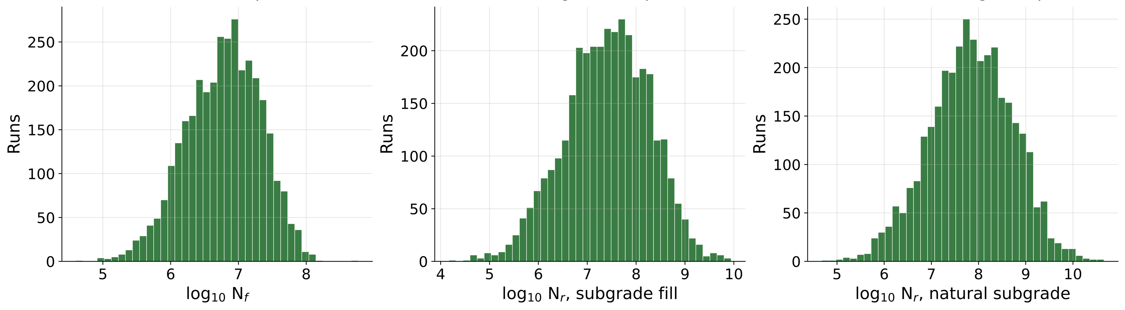
Fig. S1. Distributions of the fatigue life and the two rutting lives (log₁₀ repetitions) in the 3,465 runs used for learning.
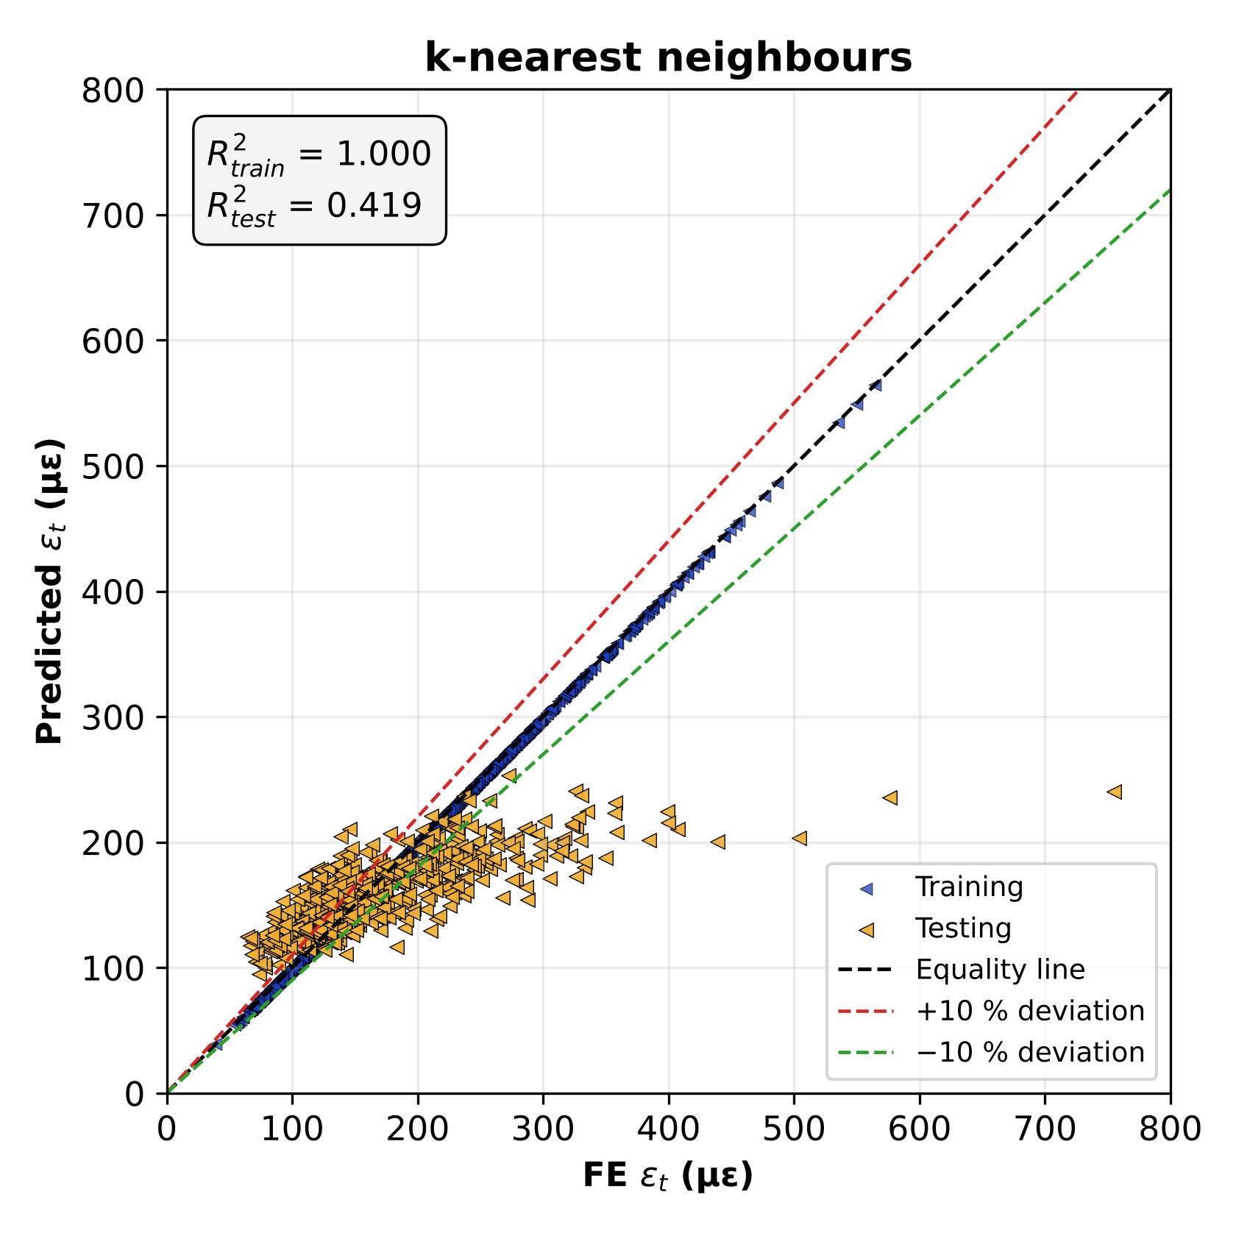
Fig. S2. Predicted against FE tensile strain at the bottom of the asphalt base course for the k-nearest neighbours model: training (2,425 runs) and testing (521 runs), with the equality line and ±10% deviation lines.
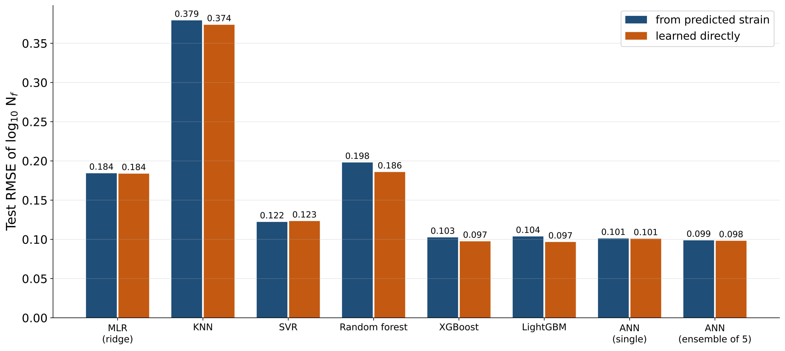
Fig. S3. Test RMSE of log₁₀ Nf obtained from the predicted strain through the transfer function and by learning log₁₀ Nf directly, for each model (single network and five-network ensemble shown separately).

