Automated Robust First Peak Detection in a Time Signal using Computational Intelligence

M.Eng Information Technology
Computational Intelligence
Debasish Dutta
1343753
debasish.dutta@stud.fra-uas.de

Md Toriquzzaman Touqir
1429813
toriquzzaman.touqir@stud.fra-uas.de

Sonia Akter
1447471
sonia.akter@stud.fra-uas.de

Abstract—The capacity to identify and evaluate peaks in a time-series noisy periodic signal is crucial for solving several computational issues in the domains of engineering and data science. This skill has numerous applications. Finding peaks in any type of data may be very helpful in understanding abrupt rises or reductions. In this study, we offer our in-depth investigation utilizing two methods: first, we use libraries to assist us discover or detect a signal's initial peak using signal processing. Second, by training, predicting, and detecting the signal peaks using Machine Learning (ML) techniques like Support Vector Machine (SVM) and Linear Regression. Our research demonstrates the efficacy and comparability of these two algorithms.
Keywords— peak detection, local maxima and minima, Machine Learning, Linear Regression, Support Vector Machine

Introduction
In many signal processing applications, identifying signal peaks is an essential task. Any data's peaks can provide important information to society, including abrupt increases or decreases in the value of gasoline, traffic data, heart monitors, stock market values, and many other things. Finding the peaks in a multivariable time series is easy, but in order to avoid subjectivity and develop algorithms that can find the peaks in any time series, the idea of a peak must be completely implemented. The current peak detection techniques do not meet the requirement of being easy to use, which encourages the creation of a straightforward and practical peak detection algorithm for noisy signal analysis.
Any algorithm's wide range of applications can be preserved by taking certain actions, such as finding all local maxima points, using intelligence techniques to manually find the real peaks, and observing a peak detection efficiency that is reasonably resilient to both high- and low-frequency noise [1].
In data processing applications, identifying peaks in a signal and determining their thresholds, positions, altitudes, widths, or other attributes is an essential function. Making use of the zero-crossing of a peak's first derivative at the peak maximum is one technique. Including functions from the scientific computation library, such as SciPy (science Python), which is a subset of NumPy, is one method for identifying the initial peak of a time-series signal.
Hilbert transform [2], Kalman filtering [3], wavelet transforms [4], a combination of Hilbert, adaptive thresholding, and wavelet transforms [5], non-linear filtering [6–9], K-Means Clustering [10], Gabor filtering [11], Gaussian second derivative filtering [12], histogram or cumulative distribution function [13], and linear prediction analysis [14] are just a few of the numerous techniques that have been developed up to this point. In addition to these signal prediction algorithms, there are two other approaches that are very effective when combined with noise filtering and the machine learning methodology to identify the first peak. They are Support Vector Machines and Linear Regression. These techniques are what we're employing in our model to filter out the noise so it can forecast the first peak of a particular time signal.
In this study, we will describe our model methodology, which began with developing our own technique to use signal processing software to find the first peak of the provided test data files. Next, we looked at a different strategy that made use of machine learning to find a reliable and automated way to identify the peak signal. Using scientific computing libraries, we executed this strategy and found the first peaks in both test data sets. The project's implementation will be covered in Section II, where we will go through the procedures involved in setting up the environment, installing necessary packages, and creating a GUI (Graphical User Interface) for peak recognition in the signal waveforms. In-depth details about the methods we learned to use for pre-processing data for signal processing and machine learning (ML) techniques to include into our model are provided in Section III. This part also includes a quick discussion of the outputs and findings. Ultimately, we draw a thorough knowledge of our work on peak identification of noisy signals as we wrap off our investigation.

Project Implementation

Background studies
Proficiency in recognizing and utilizing signal peaks is essential in several disciplines, including engineering and economics. Any functional value's maxima and minima are defined or determined by the peaks. In order to make any given information clearly foreseeable, it is crucial to incorporate the location and values of any statistical data.
In this function, each sample having two primary neighbors with lesser amplitudes is considered a peak or local maximum. The middle sample's index is returned when there are several samples with comparable amplitude widths. In noisy signals, local maxima can shift in place, although peak positions can differ. In some circumstances, think about flattening the signal before looking for peaks, or use alternative peak identification and fitting techniques [15].

We first construct a function that can predict the peaks using the test dataset that has been supplied. We conducted our study in many phases for that procedure, which are detailed in full below.

Software Engineering Workflow
We attempted to use an agile and iterative software development methodology here. There were three cycles to it. First, for the first peak detection stage of signal processing.
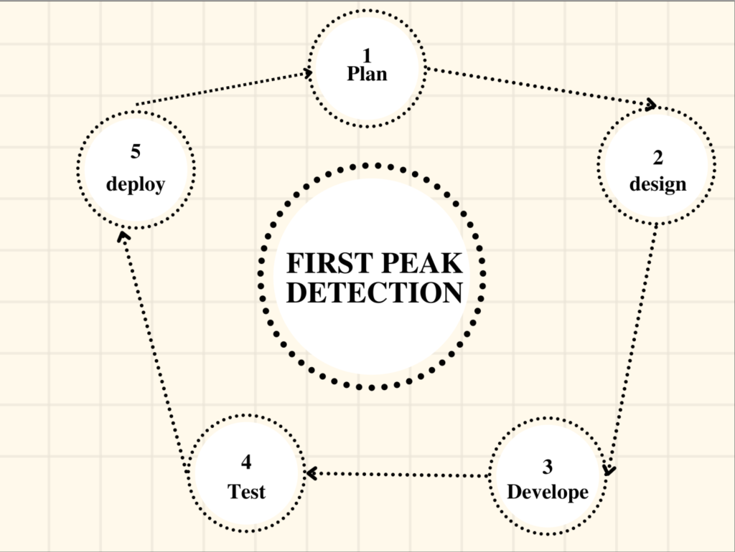

Secondly, for labeling and noise filtering.
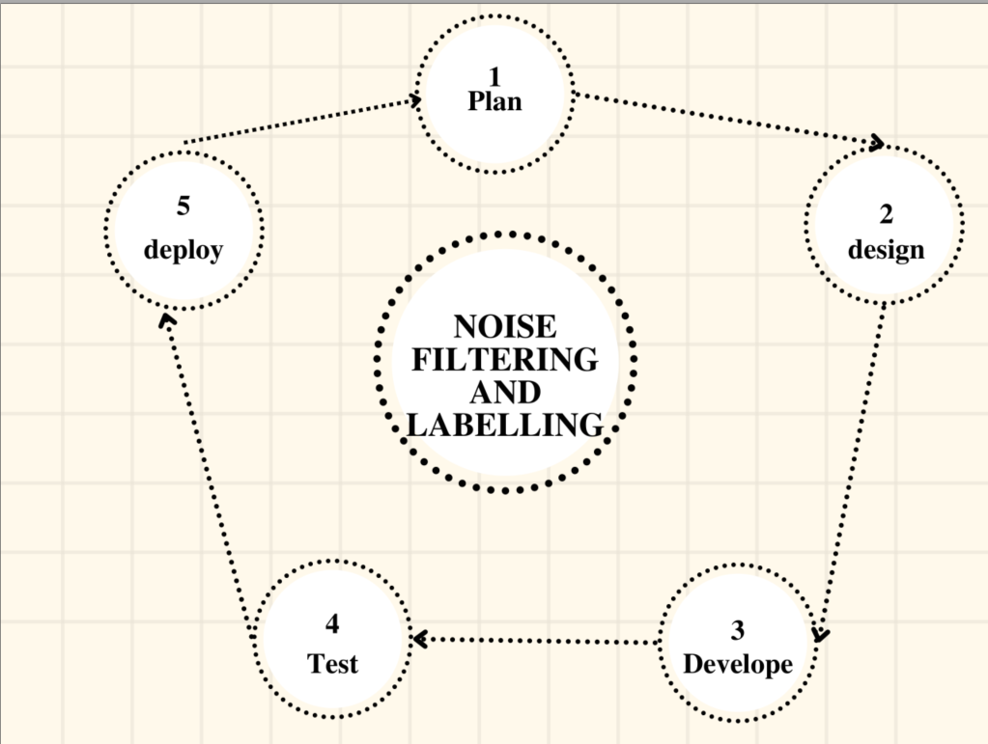

Third, for methods based on machine learning.


Environment Setup
Building and executing the project on our machine is the first step in beginning our experiment. We prepared the surroundings. We decided to develop our research using the Python programming language in order to establish an algorithm that may produce the desired results. Python offers a wide range of artificial intelligence libraries because to its rich technology. Numerous programming paradigms, such as object-oriented and functional programming, are compatible with Python.
First, Python 3.8 or a later version must be installed on the computer. Next, the machine has to have the PyCharm community edition or the Anaconda environment installed. Management and distribution of packages are made easier using this console.

User Interface
Installed and utilized to produce graphical interaction is the GUI (graphical user interface) toolkit known as Tkinter, or Tk. Tk is dependent on Python. If TKinter is correctly installed on your computer, you may be able to see a basic Tk interface by running a certain command from the prompt [16]. We imported "file dialog" modules from Tkinter, which lets users quickly choose which file has to be uploaded or opened.

python -m tkinter

Installed packeges and libraries
After completing the prior setup, we may begin installing the specific packages needed to operate our project. Those commands can be used to install the packages listed below directly. Because AI is increasingly complex to deal with, these programs include more sophisticated algorithms that are easier to use. Using an artificial intelligence method, we must implement packages such as Matplotlib (v3.6.0), NumPy (v1.23.3), openpyxl (v3.0.10), Pandas (v1.5.0), SciPy (v1.9.1), and Tkinter to operate with our model in order for it to create robust signal peaks with noise filtration.
To display the signal in a graphical framework, libraries such as matplotlib are utilized. The function "find_peaks" is imported to enable it to locate the first local maxima of the given data. Second, after pre-processing the data, the test datasheets are rendered legible by the pandas program and made available in Excel format. Signal processing programs are being installed using the Scipy package.
Our machine learning strategy makes use of the Scikit-learn package. It displays strategies for clustering, regression, and classification. For example, we tested our experiment using SVM (Support Vector Machine) models for data testing and training, as well as linear regression.

from scipy.signal import find_peaks
from matplotlib import pyplot as plt
import numpy as np
import tkinter as tk
import pandas as pd
from tkinter import filedialog

Python IDE
With an IDE (Integrated Development Environment), Python programs are developed. For this project, a Pycharm tool was used to write the Python script. Additionally, Pycharm may be installed using Anaconda.
A very easy-to-use web-based or machine application tool is Pycharm. After installation, open the anaconda command prompt and type jupyter notebook to launch the Jupyter Notebook. This IDE provides a wide range of essential Python development tools that are intricately linked to provide a comfortable setting for productive Python, web, and data science research.

Implemantation

Signal processing approch
- Pre processing
Since the data was gathered in a noisy setting, noise reduction filtering is required. We utilized the'remove_noisy_peaks(pulses, found_peaks)' function to do that.

def remove_noisy_peaks(pulses, found_peaks):
peak_heights = found_peaks[1]['peak_heights']
peak_positions = pulses[found_peaks[0]]

- Peak detection
We decided to utilize the "scipy.signal.find_peaks()" method, which locates all of a signal's peaks, to locate peaks. But we just require the initial peak. Furthermore, our problem and this function's concept of "peak" differ somewhat. In order to discover the initial peak, we did a little processing on these peaks.

import csv
import numpy as np
import matplotlib.pyplot as plt
from scipy.signal import find_peaks
import pandas as pd
import os

def find_all_peaks(y_axis):
return find_peaks(y_axis, height=y_axis, distance=1000)

def remove_noisy_peaks(pulses, found_peaks):
peak_heights = found_peaks[1]['peak_heights']
peak_positions = pulses[found_peaks[0]]

new_positions = []
new_heights = []

peak_mean = np.average(peak_heights)

for i in range(0, len(peak_heights) - 1):
if peak_heights[i] > peak_mean:
new_heights.append(peak_heights[i])
new_positions.append(peak_positions[i])

return new_positions, new_heights

def draw_peaks(pulses, y_axis, peak_pos, peak_h):
print(f"First peak position: {peak_pos[0]}, height: {peak_h[0]}")
fig = plt.figure()
ax = fig.subplots()
ax.plot(pulses, y_axis)
ax.scatter(peak_pos[0], peak_h[0], color='r', s=15, marker='D', label='Maxima')
plt.show()

def read_xlsx_file(path, starting_column, row_number):
df = pd.read_excel(path)
selected_row = df.iloc[row_number - 1, starting_column:].values
return selected_row.astype(float)

def get_pulse_data():
file_path = input('Provide the file path: ')
starting_col = int(input('Provide the starting column(e.g. 6, 17 etc.): '))
selected_row = int(input('Provide the row you want to find peak(e.g. 30): '))
yaxis = np.array(read_xlsx_file(file_path, starting_col, selected_row))

pulses = np.array(list(range(0, len(yaxis))))
return pulses, yaxis

if _name_ == '_main_':
x, y = get_pulse_data()

if x is not None and y is not None:
peaks = find_all_peaks(y)
peak_positions, peak_heights = remove_noisy_peaks(x, peaks)
draw_peaks(x, y, peak_positions, peak_heights)

We created an array of data by using the indexes that the "find_peaks" method gives. After that, we calculated the average. Subsequently, all the peaks that surpass the preceding and subsequent peaks and are above average are selected. The intended peaks for our solution are these. We also selected the option "First Peak" since we need the first peak.

Results
The output signals that result from noise filtering are produced as indicated below.


Fig 1. The Graphical User Interface for getting input.

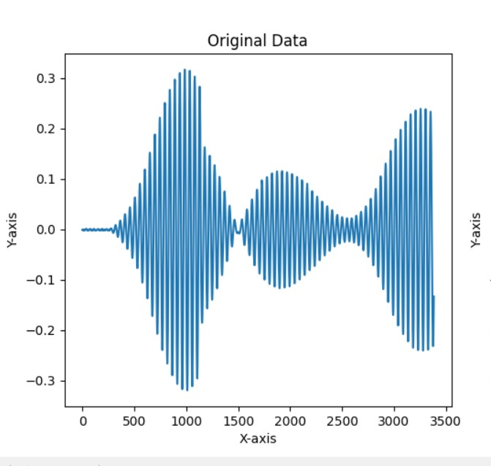

Fig 2. Generated noisy signal of 1st Dataset.
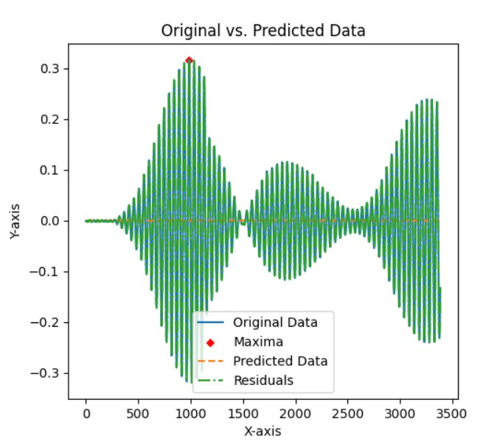
Fig 3. Filtered signal of 1st Dataset.

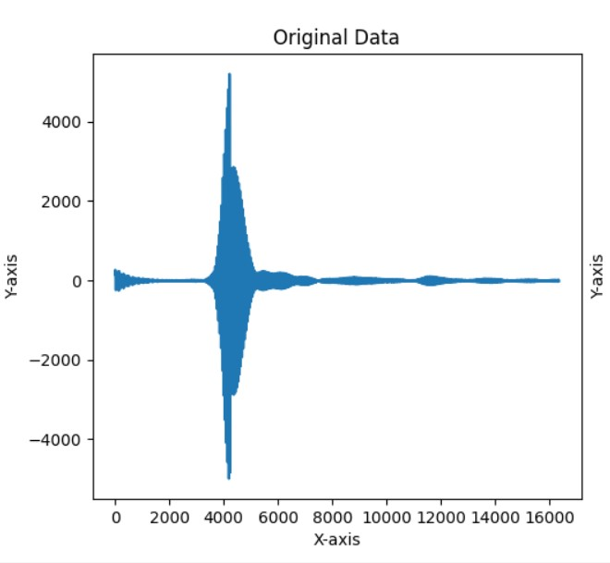

Fig 4. Generated noisy signal of 2nd Dataset.

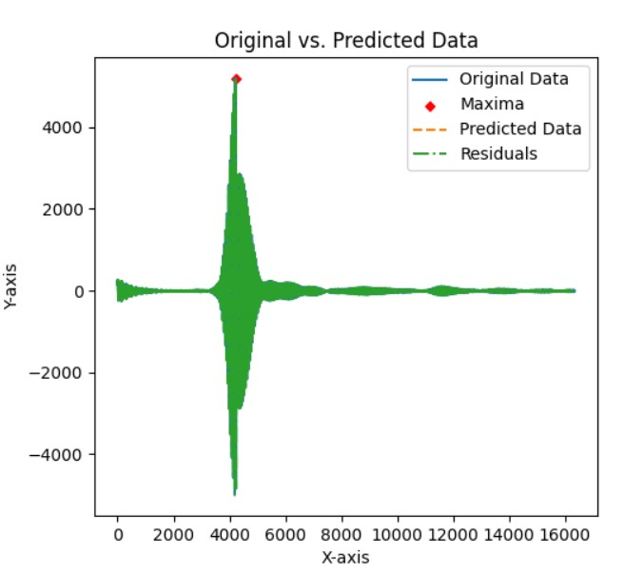

Fig 5. Filtered signal of 2nd Dataset.

Here, the initial estimated peak is represented by the red dot on the signal. These are similar to test data two.

Discussion and Conclusion
In this research, we have used signal processing to formally explain the idea of locating the first peak in a noisy periodic signal. For any simulated or real-time data, the two methods we have shown have some drawbacks.
Using functions for noise filtering, we first pre-processed the data in the signal processing technique. Subsequently, we examined the first and precise peak that yields the index locations of the local maxima of a periodic signal using a different package and function. The noisy signal's initial peak was discernible, although it was not strong. We found that adding several conditions for every change in the signal is necessary to achieve resilience in peak generation. This can hinder the performance of both high- and low-frequency signals and is seen as a drawback when utilizing signal processing techniques.
Therefore, we may infer that while the first peak is accurately recognized at the site when utilizing a signal processing technique, the other signal types do not yield exact results. However, using the ML technique, the first peak may be identified in any kind of data, even whether it is closer to the precise first peak or at a factually erroneous location.

Acknowledgment

We would like to take this time to thank Dr. Andreas Pech, our instructor, for all of his help, support, and guidance in letting us work on this project. It would not have been possible without our Professor's amazing help and direction.
We also respectfully admit that the group's members and its writers alone carried out the study and gathered the information for this report, with help from online open source platforms and our subject-matter professors. We have taken every effort to ensure that the literature and research publications contain the correct citations.

References

- Felix Scholkmann, Jens Boss, Martin Wolf.; “An Efficient Algorithm for Automatic Detection in Noisy Periodic and Quasi-Periodic signal.”, Algorithms, 2012, 5, www.mdpi.com/journal/algorithms
- Benitez, D.; Gaydecki, P.A.; Zaidi, A.; Fitzpatrick, A.P. “The use of the Hilbert transform in ECG signal analysis.” Comput. Biol. Med. 2001, 31, 399–406.
- Tzallas, A.T.; Oikonomou, V.P.; Fotiadis, D.I. “Epileptic spike detection using a Kalman filter based approach.” In Proceedings of the 28th IEEE EMBS Annual International Conference, New York, NY, USA, 2006; pp. 501–504.
- Singh, O.; Sunkaria, R.K. “A robust R-peak detection algorithm using wavelet packets.” Int. J. Comput. Appl. 2011, 36, 37–43.
- Rabbani, H.; Mahjoob, M.P.; Farahabadi, E.; Farahabadi, “A. R peak detection in electrocardiogram signal based on an optimal combination of wavelet transform, Hilbert transform, and adaptive thresholding.” J. Med. Signals Sens. 2011, 1, 91–98.
- Sun, Y.; Suppappola, S.; Wrublewski, T.A. “Microcontroller-Based real-time QRS detection.” Biomed. Instrum. & Technol. 1992, 26, 477–484.
- 24. Ferdi, Y.; Herbeuval, J.P.; Charaf, A.; Boucheham, B. “R wave detection using fractional digital differentiation.” ITBM-RBM 2003, 24, 273–280.
- 25. Aboy, M.; McNames, J.; Thong, T.; Tsunami, D.; Ellenby, M.S.; Goldstein, B. “An automatic beat detection algorithm for pressure signals.” IEEE Trans. Biomed. Eng. 2005, 52, 1662–1670.
- 26. Shim, B.; Min, H.; Yoon, S. “Nonlinear preprocessing method for detecting peaks from gas chromatograms.” BMC Bioinf. 2009, doi:10.1186/1471-2105-10-378.
- Mehta, S.S.; Sheta, D.A.; Lingayat, N.S.; Chouhan, V.S. “K-Means algorithm for the detection and delineation of QRS-complexes in electrocardiogram.” IRBM 2010, 31, 48–54.
- Nguyen, N.; Huang, H.; Oraintara, S.; Vo, “A. Peak detection in mass spectrometry by Gabor filters and envelope analysis.” J. Bioinf. Comput. Biol. 2009, 7, 547–569.
- Fredriksson, M.J.; Petersson, P.; Axelsson, B.O.; Bylund, D. “An automatic peak finding method for LC-MS data using Gaussian second derivative filtering.” J. Seperation Sci. 2009, 32, 3906–3918.
- Sezan, M.I. “A peak detection algorithm and its application to histogram-based image data reduction.” Comput Vis. Graph. Image Proc. 1990, 49, 36–51.
- Lin, K.-P. “QRS feature extraction using linear prediction.” IEEE Trans. Biomed. Eng. 1989, 36, 1050–1055.
- https://docs.scipy.org/doc/scipy/reference/generated/scipy.signal.find_peaks.html

