Name: ABDOUL S. TOURE JR
ID: 26161
Course Title: SOFTWARE ENGINEERING COMPREHENSIVE PRATICE
Course Code: CSENG 402
Date: FEBRUARY 23,2026

FULL IMPLEMENTATION PLAN
Portfolio Website Development Using Agile Model

Course: Software Engineering Comprehensive Practice (CSENG 402)
Student: Abdoul S. Toure Jr
Client: C. Kima S.J. Wea (DOB: October 18, 2000)
Submission Date: February 23, 2026

1. INTRODUCTION
1.1 Project Overview
This project involves the design and development of a professional portfolio website for C. Kima S.J. Wea. The system serves as a centralized digital hub to showcase the client’s biography, technical skills, and past projects. Developed using Next.js, SQLite, Prisma ORM, and Tailwind CSS, the project adheres to the Agile Software Development Model to ensure flexibility and alignment with client expectations.

1.2 Purpose of the System
• Professional Branding: Establish a unique digital identity.
• Skill Visualization: Categorize and display technical proficiencies.
• Lead Generation: Provide a secure contact channel for recruiters and collaborators.
• Data Persistence: Store visitor inquiries in a structured local database.

2. REQUIREMENT ENGINEERING
2.1 User Stories (Agile Methodology)
• As a Visitor: I want to view Kima’s professional background so that I can understand his expertise.
• As a Recruiter: I want to view specific projects to verify technical claims and coding style.
• As a Client: I want a responsive interface so that my portfolio looks professional on both mobile and desktop devices.
• As a Visitor: I want to submit a contact form so that I can send inquiries directly to the client.

2.2 Functional Requirements
• Display: Profile, biography, skills, and project gallery.
• Interaction: Functional contact form with server-side validation.
• Persistence: Message storage in SQLite via Prisma.

2.3 Non-Functional Requirements
• Performance: Fast loading times using Next.js Server-Side Rendering (SSR).
• Responsiveness: Fluid user interface across all screen sizes using Tailwind CSS.
• Availability: 24/7 uptime through Vercel hosting.

2.4 Scope of the System
In-Scope
• Interactive user interface
• Prisma-driven data layer
• Automated deployment

Out-of-Scope
• User account creation
• Payment systems
• Third-party blog integrations

3. AGILE IMPLEMENTATION STRATEGY
The project follows an iterative lifecycle divided into four distinct sprints.
Sprint 1 – Foundation: Environment setup, Git initialization, and Prisma schema definition.
Sprint 2 – Core UI: Hero section, biography section, and responsive skill cards.
Sprint 3 – Backend Logic: SQLite integration, API routes for contact form, and validation.
Sprint 4 – QA & Deployment: Cross-browser testing, Vercel deployment, and client sign-off.

4. PROJECT PLAN
The project plan outlines the phases, duration, milestones, and status of the portfolio website development.
Duration | Phase | Milestone | Status
February | Requirement Gathering | Project overview, user stories, functional and non-functional requirements | Completed
March 1 – March 3 | System Design | Flowchart, Wireframe, Use Case Diagram, ER Diagram | Completed
March 8 – March 16 | Development / Iteration | Coding, UI development using Next.js and Tailwind CSS, database setup with SQLite and Prisma | In Progress
March 22 – March 23 | Testing / Quality Assurance | Unit testing, integration testing, system testing | Pending
March 29 – March 30 | Feedback / Evaluation | Client review, faculty evaluation, and final improvements | Pending

5. SYSTEM ARCHITECTURE & DATA MODEL
5.1 Technical Stack
Framework: Next.js (Full-stack capabilities)
Database: SQLite (Lightweight file-based database)
ORM: Prisma (Type-safe database interaction)
Styling: Tailwind CSS (Utility-first responsive design)

5.2 Data Schema (Prisma Model)
model Message {
id Int @id @default(autoincrement())
name String
email String
subject String
content String
createdAt DateTime @default(now())
}

6. TESTING & RISK MITIGATION
6.1 Testing Strategy
• Unit Testing: Validating React components and utility functions.
• Integration Testing: Verifying the data flow between the contact form and SQLite database.
• User Acceptance Testing (UAT): Final review with the client to ensure alignment with requirements.

6.2 Risk Management
• Scope Creep: Controlled by adhering strictly to the defined project scope.
• Database Reliability: Prisma migrations ensure schema consistency.
• Error Handling: Avoid exposing sensitive server details in error messages.
• Spam Protection: Input validation prevents automated spam submissions.

7. SEARCH ENGINE OPTIMIZATION (SEO)
Search Engine Optimization ensures that the portfolio website can be easily discovered through search engines.
• Performance Optimization: Fast loading pages improve user experience and ranking.
• Mobile Optimization: Responsive design improves mobile search ranking.
• Next.js SEO Features: Server-side rendering enhances indexing.
• Semantic HTML Structure: Proper headings improve readability.
• Meta Tags Optimization: Each webpage includes optimized title and description tags.

8. SECURITY IMPLEMENTATION
Security measures are necessary to protect the website from unauthorized access and data misuse.
• HTTPS encryption through Vercel deployment
• Input validation on both client and server sides
• Protection against SQL injection through Prisma ORM
• Secure handling of form submissions
• Prevention of sensitive data exposure

9. CONCLUSION
By utilizing the Agile Software Development Model, this implementation plan ensures that the portfolio website is developed iteratively with continuous client feedback. The combination of Next.js and Prisma provides a modern and scalable technical foundation while fulfilling the academic requirements of Software Engineering Comprehensive Practice.

Project Plan

Duration | Phase | Mile stone | Status
February | Require Gathering
March 1 – 3 | Design | - Flow chart  - Wire frame  - Use-case Diagrams  - ER-Diagram
March 8 - 16 | Development /Iteration | - Coding
March 22 – 23 | Testing / Quality | - Unit Testing  - System Testing
March 9 - 30 | Feedback / Quality  - User  - Faculty

Signed: _____________________

Approved: ___________________

SOFTWARE REQUIREMENTS SPECIFICATION (SRS)
Portfolio Website for C. Kima S.J. Wea
Course: Software Engineering Comprehensive Practice (CSENG 402)
Student: Abdoul S. Toure Jr.
Client: C. Kima S.J. Wea
Technology Stack: Next.js, SQLite, Prisma ORM, Tailwind CSS
Development Model: Agile Model
Submission Date: February 26, 2026

1. INTRODUCTION
1.1 Purpose
This Software Requirements Specification (SRS) document provides a detailed description of the requirements for the Portfolio Website System for C. Kima S.J. Wea.
The purpose of this document is to clearly define the system’s functional requirements, non-functional requirements, system constraints, and operating environment.
This document will guide the development, testing, and deployment of the portfolio website.

1.2 Scope
The Portfolio Website System is a web-based application that allows the client to present personal and professional information online.
The website will allow visitors to view the client's biography, professional skills, explore completed projects, and send messages through a contact form.
The system will store messages submitted by visitors in a database.
The website will provide a professional online presence for the client and improve access to personal and professional information.

1.3 Definitions, Acronyms, and Abbreviations
SRS – Software Requirements Specification
SEO – Search Engine Optimization
ORM – Object Relational Mapping
UI – User Interface
UAT – User Acceptance Testing
Agile – Iterative software development model

1.4 Document Overview
This document includes sections describing the system overview, functional requirements, non-functional requirements, system architecture, database design, security requirements, and system testing.

2. OVERALL DESCRIPTION
2.1 Product Perspective
The Portfolio Website System is a standalone web application accessible through modern web browsers.
The system will consist of three main components: the frontend interface, backend server, and SQLite database.
The system will be hosted online using modern cloud deployment platforms.

2.2 Product Functions
The system will display the client's biography, professional skills, and portfolio projects. It will also allow visitors to send messages and store those messages in the database while providing a responsive interface for different devices.

2.3 User Classes and Characteristics
Visitors: Individuals who access the website to learn about the client. They can browse information and send messages.
Client (Website Owner): The owner benefits from professional online representation and receiving messages from visitors.

2.4 Operating Environment
Frontend: Next.js
Styling: Tailwind CSS
Database: SQLite
ORM: Prisma
Hosting: Vercel
Browser Support: Chrome, Firefox, Edge

2.5 Design and Implementation Constraints
The system must be developed using Next.js, use SQLite as the database, use Prisma ORM, support responsive design, and be deployable on the web.

2.6 Assumptions and Dependencies
The client will provide biography and project information. Internet connectivity will be available for deployment, and users will access the website through web browsers.

3. EXTERNAL INTERFACE REQUIREMENTS
3.1 User Interface
The system will provide a simple and user-friendly interface with the following pages: Home, Biography, Skills, Projects, and Contact.
The interface will be responsive for both mobile and desktop devices.

3.2 Software Interface
The system will interact with Prisma ORM for database operations, SQLite database for message storage, and Next.js for application development.

3.3 Hardware Interface
The system will operate on smartphones, tablets, and desktop computers.

3.4 Communication Interface
The website will communicate using HTTP/HTTPS protocols, with secure HTTPS communication implemented during deployment.

4. FUNCTIONAL REQUIREMENTS
4.1 Biography Display
The system shall display the client's biography including personal introduction, educational background, and professional information.

4.2 Skills Display
The system shall display the client's professional skills such as programming skills, technical competencies, and other professional abilities.

4.3 Project Portfolio
The system shall display projects with a title, description, and technologies used.

4.4 Contact Form
The system shall provide a contact form allowing visitors to submit their name, email, subject, and message.

4.5 Message Storage
The system shall store submitted messages in the database including name, email, subject, message content, and date/time.

5. NON-FUNCTIONAL REQUIREMENTS
5.1 Performance Requirements
The system should load pages quickly and respond efficiently to user requests.

5.2 Usability Requirements
The system should provide a simple and easy-to-navigate interface.

5.3 Availability Requirements
The website should be accessible online at all times.

5.4 Security Requirements
Security measures include input validation, protection against SQL injection, and secure HTTPS communication.

5.5 Responsiveness
The system must function properly on mobile devices, tablets, and desktop computers.

6. DATABASE DESIGN
The database will store messages from the contact form.
Fields include: name, email, subject, content, and created date/time.

7. SYSTEM TESTING
Unit Testing: Individual components tested separately.
Integration Testing: Contact form interaction with the database tested.
User Acceptance Testing (UAT): Client reviews system before deployment.

8. FUTURE ENHANCEMENTS
Possible improvements include a blog system, analytics integration, LinkedIn integration, and an admin dashboard.

9. CONCLUSION
The Portfolio Website System will provide a professional platform for showcasing the client's achievements and skills online. Using modern technologies and Agile development ensures flexibility, scalability, and efficient system performance.

SOFTWARE DESIGN DOCUMENT (SDD)
Portfolio Website for C. Kima S.J. Wea

Course: Software Engineering Comprehensive Practice (CSENG 402)
Student: Abdoul S. Toure Jr.
Client: C. Kima S.J. Wea
Technology Stack: Next.js, SQLite, Prisma ORM, Tailwind CSS
Development Model: Agile Model
Submission Date: February 2026

1. INTRODUCTION
1.1 Purpose
The purpose of this Software Design Document (SDD) is to describe the architecture and design of the Portfolio Website System for C. Kima S.J. Wea.
This document explains how the system will be implemented based on the requirements defined in the Software Requirements Specification (SRS).

1.2 Scope
The Portfolio Website System is designed to provide a professional online platform where visitors can learn about the client’s biography, skills, and projects.
The system also allows visitors to send messages through a contact form, and these messages will be stored in a database.

1.3 Definitions and Acronyms
SRS – Software Requirements Specification
SDD – Software Design Document
ORM – Object Relational Mapping
UI – User Interface
API – Application Programming Interface

2. SYSTEM ARCHITECTURE
The Portfolio Website System follows a Three-Tier Architecture consisting of the Presentation Layer, Application Layer, and Data Layer.

Presentation Layer
This layer manages the user interface of the system.
Technologies Used: Next.js, Tailwind CSS
Functions: Displays website pages and handles user interaction.

Application Layer
This layer contains the application logic of the system.
Functions: Processes user requests, handles form submissions, and communicates with the database.
Technology Used: Next.js API Routes

Data Layer
This layer manages and stores system data.
Technologies Used: SQLite Database, Prisma ORM
Functions: Stores visitor messages and retrieves stored data when needed.

3. SYSTEM COMPONENT DESIGN
Home Page Component – Displays welcome message, profile introduction, and navigation menu.
Biography Component – Displays detailed information about the client including education and experience.
Skills Component – Displays professional and technical skills.
Projects Component – Displays portfolio projects completed by the client.
Contact Form Component – Allows visitors to send messages to the client.

4. DATABASE DESIGN
The database stores messages submitted by visitors through the contact form.
Fields: id, name, email, subject, content, createdAt.

Prisma Schema Example:
model Message {
id Int @id @default(autoincrement())
name String
email String
subject String
content String
createdAt DateTime @default(now())
}

5. USER INTERFACE DESIGN
The website includes the following pages:
Home Page – Welcome message and introduction.
Biography Page – Personal and educational information.
Skills Page – Professional competencies.
Projects Page – Portfolio projects with descriptions.
Contact Page – Message submission form.

6. SYSTEM FLOW
1. A visitor opens the website.
2. The visitor navigates through different pages.
3. The visitor fills out the contact form.
4. The system validates the input.
5. The message is stored in the SQLite database.
6. The system confirms successful message submission.

7. SECURITY DESIGN
Security measures include input validation, SQL injection protection, secure HTTPS communication, and email format validation.

8. DEPLOYMENT DESIGN
The system will be deployed using Vercel.
Deployment steps: Build the Next.js app, connect to GitHub, deploy on Vercel, and configure the database.

9. TESTING STRATEGY
Unit Testing – Testing individual components.
Integration Testing – Testing interaction between components.
User Acceptance Testing – Client verifies system requirements.

10. CONCLUSION
The SDD describes the architecture and design of the portfolio website system and ensures efficient, scalable, and maintainable implementation using modern technologies.

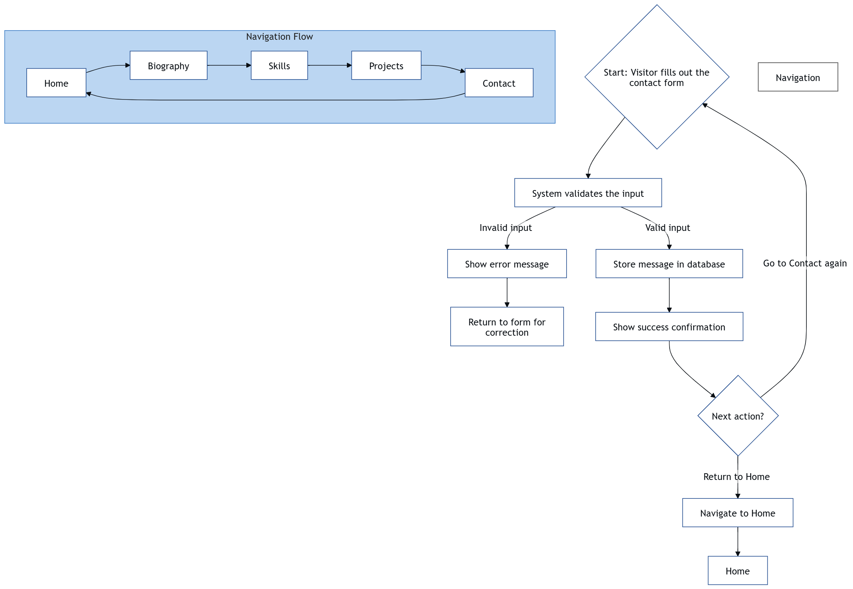
FLOW CHART

WIRE FRAME
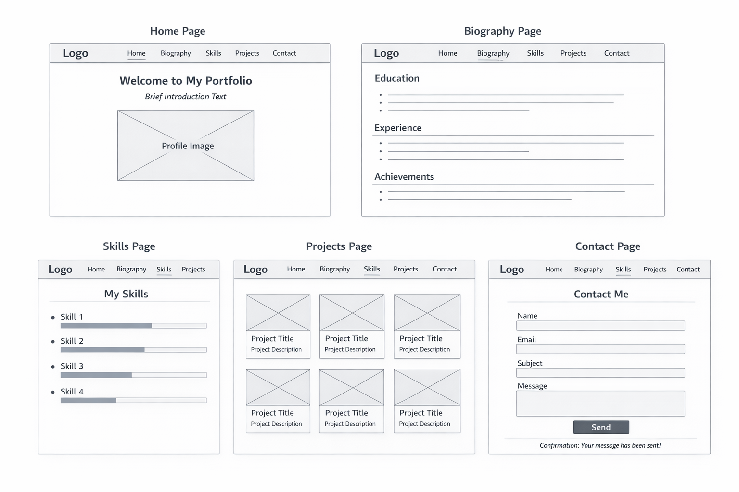
USE CASE DIAGRAM
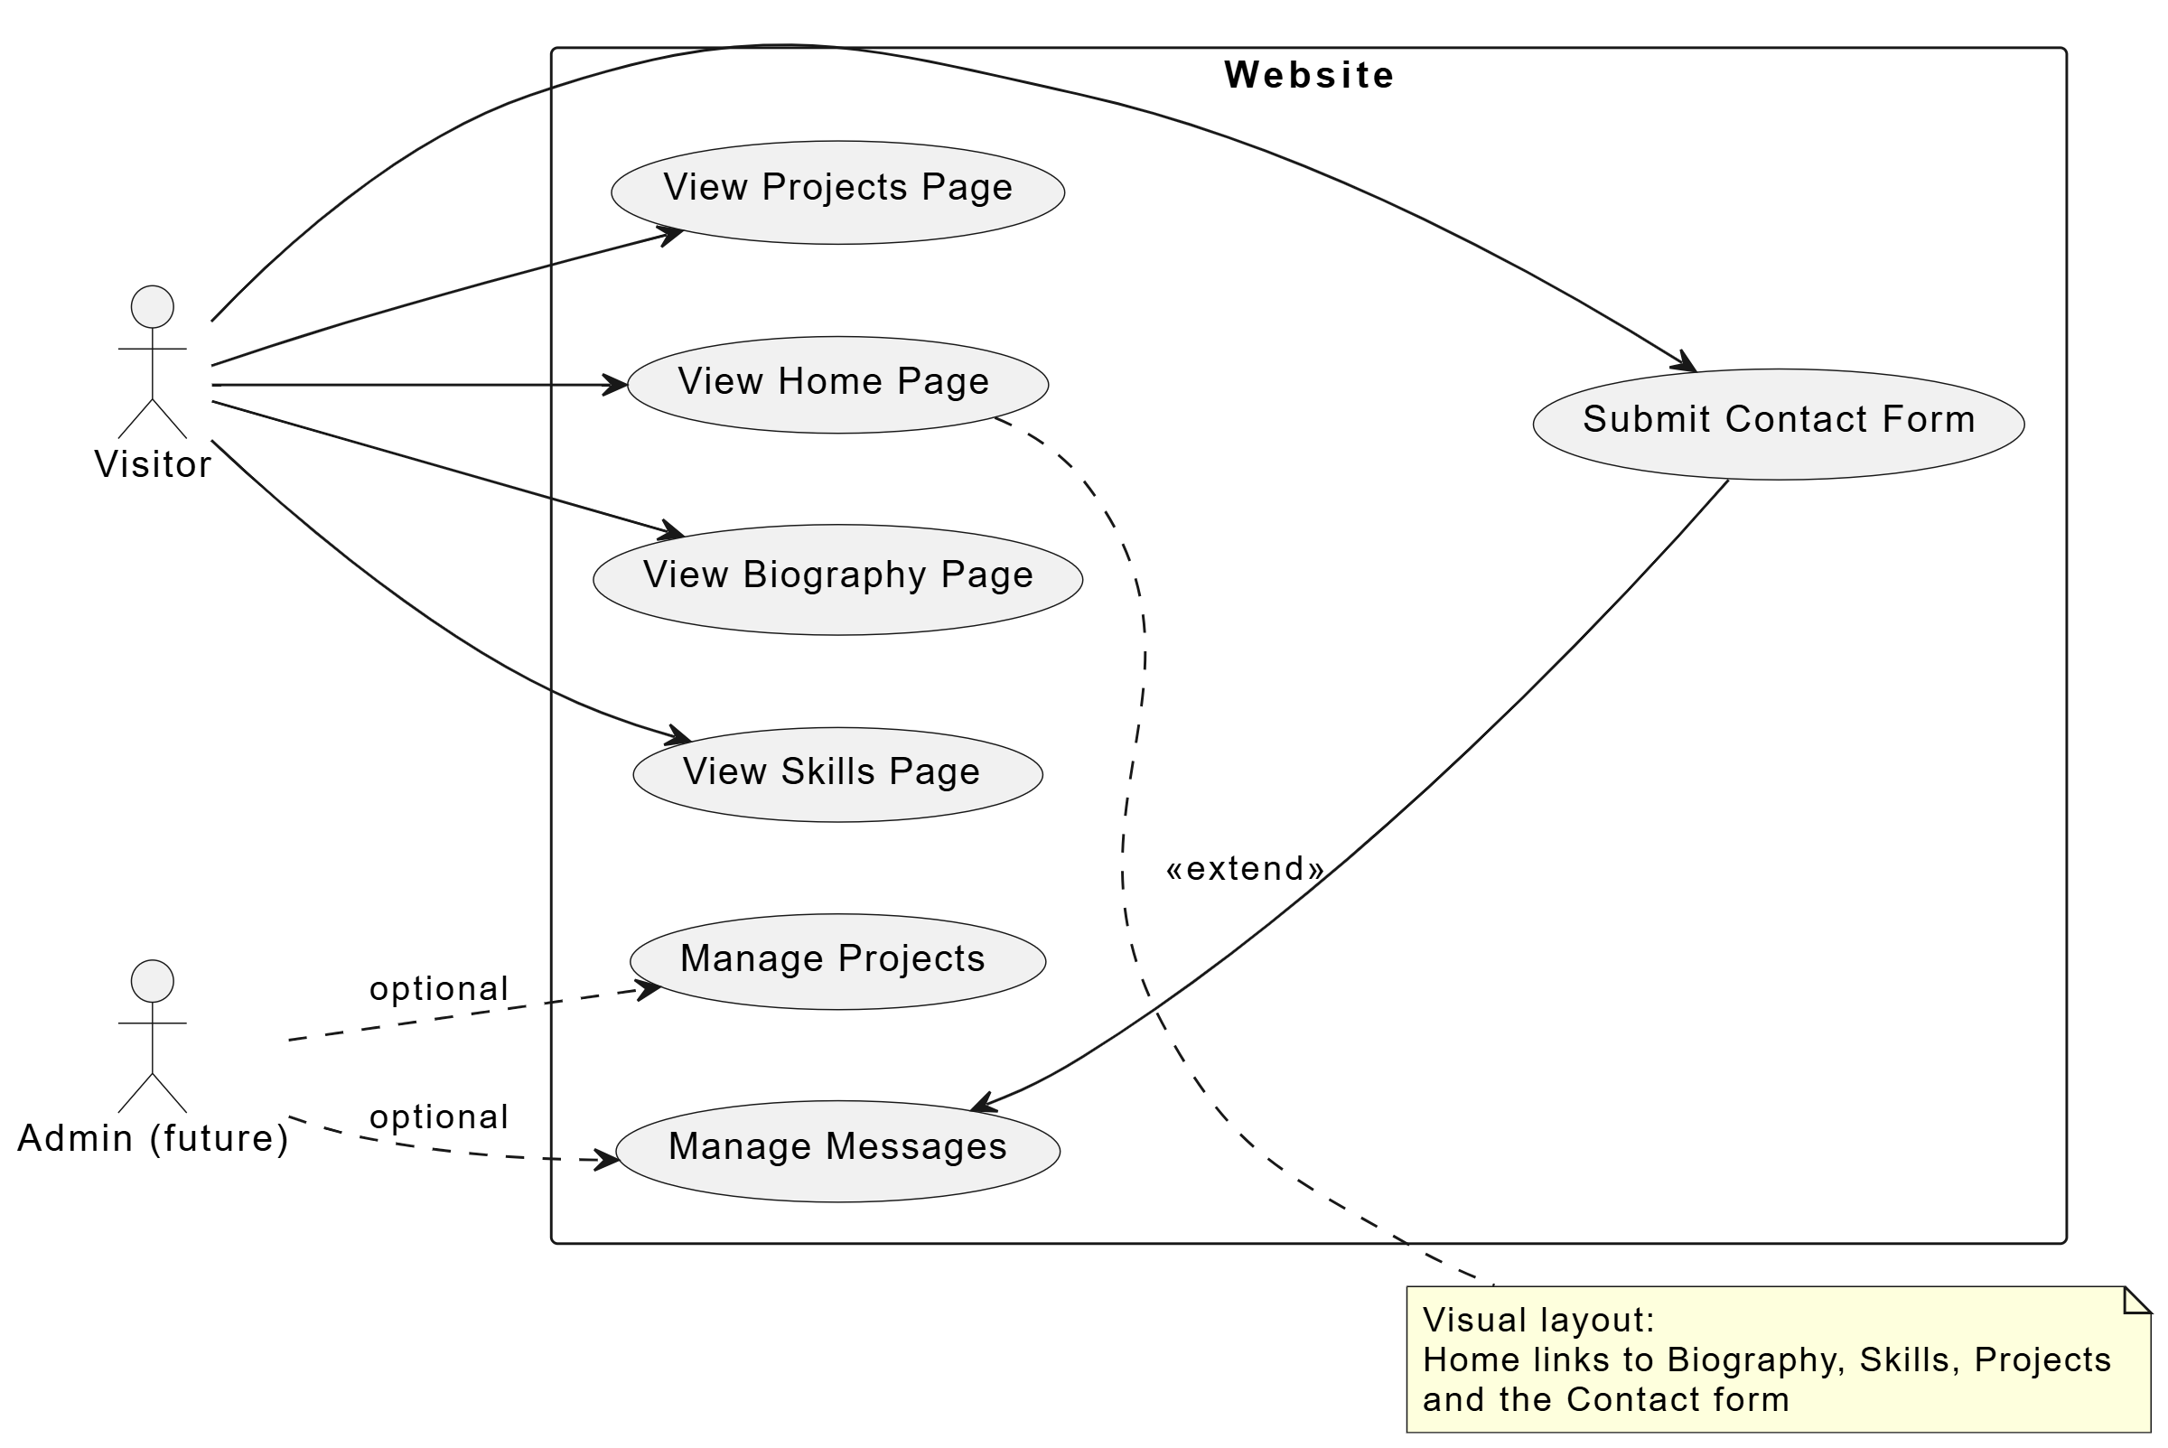
ER—DIAGRAM
