**Neuron Sandbox Expanded Worksheets**

### Will Hanna

Thomas County Middle School

### Christina Gardner-McCune

University of Florida

### David Touretzky

Carnegie Mellon University



This work was funded by National Science Foundation awards DRL-2049029 and DRL-2048502.

#1. Can I make a peanut butter and jelly sandwich? I need both peanut butter and jelly.

| **INPUTS** | | **Compute Weighted input 1:** | **Compute Weighted input 2:** | **ACTIVATION** | **Do we want the activation to be greater than the threshold?**  *This answer should be based on the desired output.* | **Determine the threshold:**  *What decimal number is greater than your Ns but less than your Ys?* | **Is activation greater than threshold?**  *If the answer doesn’t match the 1 or 0 in the desired output, change your threshold* | **DESIRED OUTPUT** |
| --- | --- | --- | --- | --- | --- | --- | --- | --- |
| Input1  Have peanut butter  0 - No  1 - Yes | Input2  Have Jelly  0 - No  1 - Yes | W1 = 1  Input1 x W1 = __ | W2 = 1  Input2 x W2= __ | Sum of weighted Inputs 1 & 2 | (Y or N) | Threshold | Activation > Threshold ?  Write 0 for no and 1 for yes. | 0 - No  1 - Yes |
| 0 | 0 | 0 x 1 = 0 | 0 x 1 = 0 |  |  |  |  |  |
| 0 | 1 | ___ x 1 =___ | ___ x 1 = ___ |  |  |  |  |
| 1 | 0 |  |  |  |  |  |  |
| 1 | 1 |  |  |  |  |  |  |
|  | | | | | | | | |
|  | | **B** | | **C** | **D** | **E** | **F** | **A** |

#1. Can I make a peanut butter and jelly sandwich? I need both peanut butter and jelly.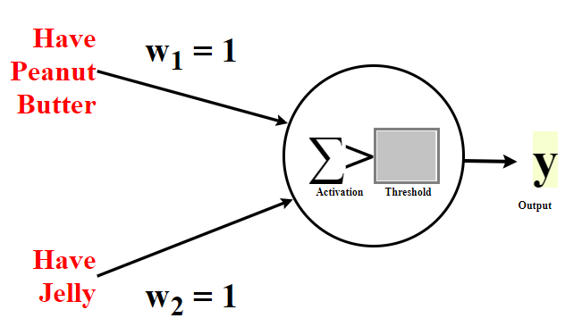

#2. Should I wear boots today? I should wear boots when it is raining or snowing.

| **INPUTS** | | **Compute Weighted input 1:** | **Compute Weighted input 2:** | **ACTIVATION** | **Do we want the activation to be greater than the threshold?**  *This answer should be based on the desired output.* | **Determine the threshold:**  *What decimal number is greater than your Ns but less than your Ys?* | **Is activation greater than threshold?**  *If the answer doesn’t match the 1 or 0 in the desired output, change your threshold* | **DESIRED OUTPUT** |
| --- | --- | --- | --- | --- | --- | --- | --- | --- |
| Input1  Is it raining?  0 - No  1 - Yes | Input2  Is it snowing?  0 - No  1 - Yes | W1 = 1  Input1 x W1 = __ | W2 = 1  Input2 x W2= __ | Sum of weighted Inputs 1 & 2 | (Y or N) | Threshold | Activation > Threshold ?  Write 0 for no and 1 for yes. | 0 - No  1 - Yes |
| 0 | 0 | 0 x 1 = . | 0 x 1 = . |  |  |  |  |  |
| 0 | 1 | x 1 = . | x 1 = . |  |  |  |  |
| 1 | 0 |  |  |  |  |  |  |
| 1 | 1 |  |  |  |  |  |  |
|  | | | | | | | | |
|  | | **B** | | **C** | **D** | **E** | **F** | **A** |

#2. Should I wear boots today? I should wear boots when it is raining or snowing.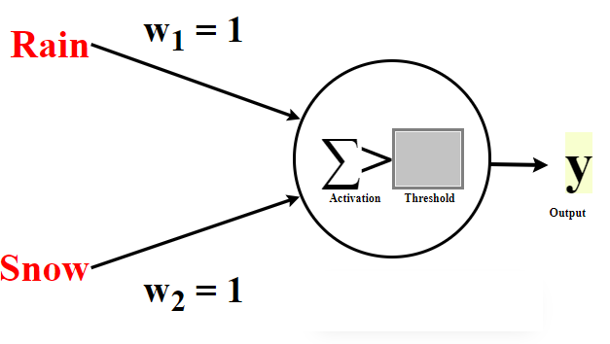

#3. John is planning a picnic with friends. He wonders if today is a good day for a picnic. It is a good day for a picnic if it is sunny outside and his friends are available today.

| **INPUTS** | | **Compute Weighted input 1:** | **Compute Weighted Input 2:** | **ACTIVATION** | **Do we want the activation to be greater than the threshold?**  *This answer should be based on the desired output.* | **Determine the threshold:**  *What decimal number is greater than your Ns but less than your Ys?* | **Is activation greater than threshold?**  *If the answer doesn’t match the 1 or 0 in the desired output, change your threshold* | **DESIRED OUTPUT** |
| --- | --- | --- | --- | --- | --- | --- | --- | --- |
| Input1  Is it sunny?  0 - No  1 - Yes | Input2  Are friends available?  0 - No  1 - Yes | W1 = 2  Input1 x W1 = __ | W2 = 2  Input2 x W2= __ | Sum of weighted Inputs 1 & 2 | (Y or N) | Threshold | Activation > Threshold ?  Write 0 for no and 1 for yes. | 0 - No  1 - Yes |
| 0 | 0 | 0 x 2 = | 0 x 2 = |  |  |  |  |  |
| 0 | 1 | ___ x 2 =__ | ___ x 2 = __ |  |  |  |  |
| 1 | 0 |  |  |  |  |  |  |
| 1 | 1 |  |  |  |  |  |  |
|  | | | | | | | | |
|  | | **B** | | **C** | **D** | **E** | **F** | **A** |

#3. John is planning a picnic with friends. He wonders if today is a good day for a picnic. It is a good day for a picnic if it is sunny outside and his friends are available today.

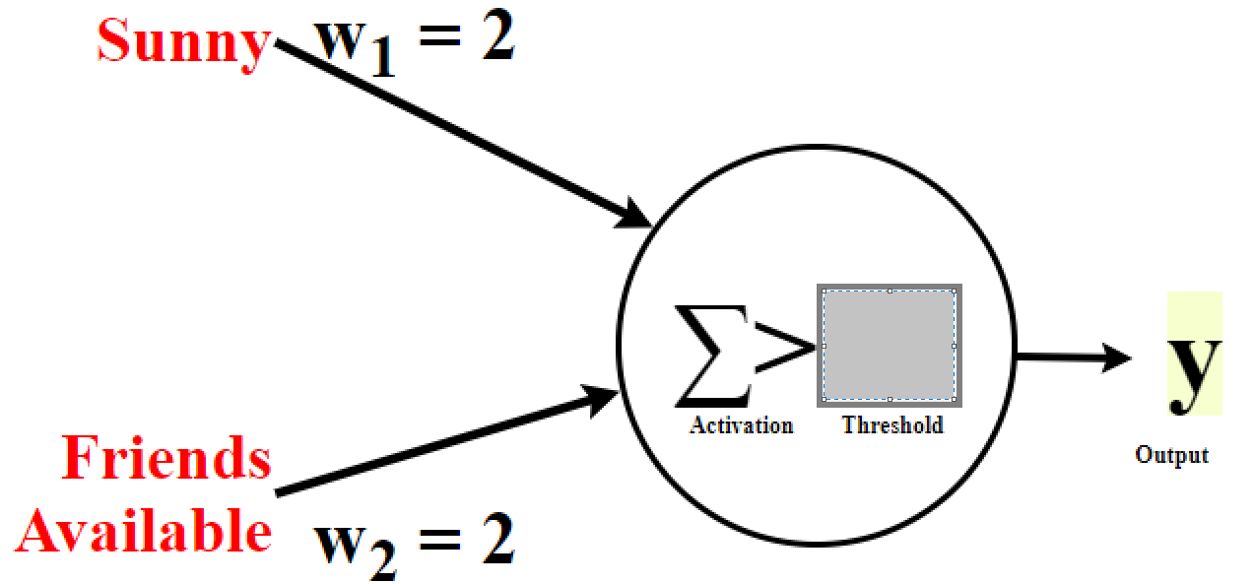

#4. Should I play outside? I would play outside either if I need exercise or if it's sunny.

| **INPUTS** | | **Should activation be above threshold?** *Answer should be based on the desired output (column A)* | **Type of constraint on weight W1**  *Either “greater than” or “less than”* | **Margins for Weight W1** | **Solution for Weight W1**  *What value for W1 satisfies all constraints in columns C+D?* | **Compute Weighted input 1** | **Weighted input 2** | **ACTIVATION** | **Is activation greater than threshold?**  *If the answer doesn’t match the 1 or 0 in the desired output, go back to column E* | **DESIRED OUTPUT** |
| --- | --- | --- | --- | --- | --- | --- | --- | --- | --- | --- |
| Input1  0 - Don’t Need Exercise  1 - Need Exercise | Input2  0 - Not Sunny  1 - Sunny | (Y or N) | If column B is “Y”, put “>” here.  If column B is “N”, put “<” here. | Take the threshold 0.5 and subtract Weighted Input 2 (column G) | Example: If C+D says “> 0.5” then the value of W1 must be something greater than 0.5 | W1 = ___ from E  Input1 x W1= __ | W2 = 1  Input2 x W2= __ | Sum of weighted Inputs 1 & 2 (columns F and G) | Activation > Threshold ?  Is column H > 0.5  Write 0 for no or 1 for yes. | 0 - no  1 - yes |
| 0 | 0 |  | **Constraints on W1 only make sense when Input1 is active (not 0)** | |  | 0 x __ = __ | 0 x 1 = **0** |  |  |  |
| 0 | 1 |  | 0 x __ = __ | 1 x 1 = **1** |  |  |  |
| 1 | 0 |  |  | 0.5 - __= __ | 1 x __ = __ | 0 x 1 = **0** |  |  |  |
| 1 | 1 |  |  | 0.5 - __ = __ | 1 x __ = __ | 1 x 1 = **1** |  |  |  |
|  | | | | | | | | | | |
|  | | B | C | D | E | F | G | H | I | A |

#4. Should I play outside? I would play outside either if I need exercise or if it's sunny.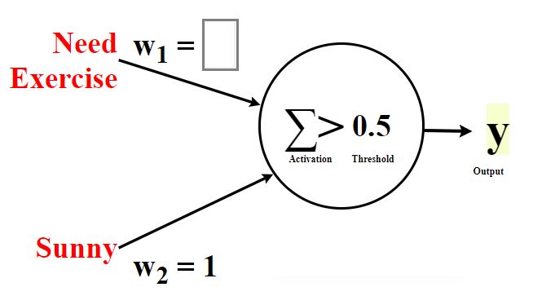

**Answer to:**  
#4. Should I play outside? I would play outside either if I need exercise or if it's sunny.

| **INPUTS** | | **Should activation be above threshold?** *Answer should be based on the desired output (column A)* | **Type of constraint on weight W1**  *Either “greater than” or “less than”* | **Margins for Weight W1** | **Solution for Weight W1**  *What value for W1 satisfies all constraints in columns C+D?* | **Compute Weighted input 1** | **Weighted input 2** | **Activation** | **Is activation greater than threshold?**  *If the answer doesn’t match the 1 or 0 in the desired output, go back to column E* | **Desired Output** |
| --- | --- | --- | --- | --- | --- | --- | --- | --- | --- | --- |
| Input1  0 - Don’t Need Exercise  1 - Need Exercise | Input2  0 - Not Sunny  1 - Sunny | (Y or N) | If column B is “Y”, put “>” here.  If column B is “N”, put “<” here. | Take the threshold 0.5 and subtract Weighted Input 2 (column G) | Example: If C+D says “> 0.5” then the value of W1 must be something greater than 0.5 | W1 = ___ from E  Input1 x W1= __ | W2 = 1  Input2 x W2= __ | Sum of weighted Inputs 1 & 2 (columns F and G) | Activation > Threshold ?  Is column H > 0.5  Write 0 for no or 1 for yes. | 0 - no  1 - yes |
| 0 | 0 | N | **Constraints on W1 only make sense when Input1 is active (not 0)** | | 1  (could be any value greater than 0.5) | 0 x 1 = 0 . | 0 x 1 = **0** | 0 | 0 | 0 |
| 0 | 1 | Y | 0 x 1 = 0 . | 1 x 1 = **1** | 1 | 1 | 1 |
| 1 | 0 | Y | > | 0.5 - 0 = 0.5 | 1 x 1 = 1 . | 0 x 1 = **0** | 1 | 1 | 1 |
| 1 | 1 | Y | > | 0.5 - 1 = -0.5 | 1 x 1 = 1 . | 1 x 1 = **1** | 2 | 1 | 1 |
|  | | | | | | | | | | |
|  | | B | C | D | E | F | G | H | I | A |

#5. Can I make a ham and cheese sandwich? I need both ham and cheese.

| **INPUTS** | | **Should activation be above threshold?** *Answer should be based on the desired output (column A)* | **Type of constraint on weight W1**  *Either “greater than” or “less than”* | **Margins for Weight W1** | **Solution for Weight W1**  *What value for W1 satisfies all constraints in columns C+D?* | **Compute Weighted input 1** | **Weighted input 2** | **Activation** | **Is activation greater than threshold?**  *If the answer doesn’t match the 1 or 0 in the desired output, go back to column E* | **Desired Output** |
| --- | --- | --- | --- | --- | --- | --- | --- | --- | --- | --- |
| Input1  0 - Don’t Have Ham  1 - Have Ham | Input2  0 - Don’t Have Cheese  1 - Have Cheese | (Y or N) | If column B is “Y”, put “>” here.  If column B is “N”, put “<” here. | Take the threshold 1.5 and subtract Weighted Input 2 (column G) | Example: If C+D says “> 0.5” then the value of W1 must be something greater than 0.5 | W1 = ___ from E  Input1 x W1= __ | W2 = 1  Input2 x W2= __ | Sum of weighted Inputs 1 & 2 (columns F and G) | Activation > Threshold ?  Is column H > 1.5  Write 0 for no or 1 for yes. | 0 - no  1 - yes |
| 0 | 0 |  | **Constraints on W1 only make sense when Input1 is active (not 0)** | |  | 0 x __ = __ | 0 x 1 = **0** |  |  |  |
| 0 | 1 |  | 0 x __ = __ | 1 x 1 = **1** |  |  |  |
| 1 | 0 |  |  | 1.5 - __= __ | 1 x __ = __ | 0 x 1 = **0** |  |  |  |
| 1 | 1 |  |  | 1.5 - __ = __ | 1 x __ = __ | 1 x 1 = **1** |  |  |  |
|  | | | | | | | | | | |
|  | | B | C | D | E | F | G | H | I | A |

#5. Can I make a ham and cheese sandwich? I need both ham and cheese.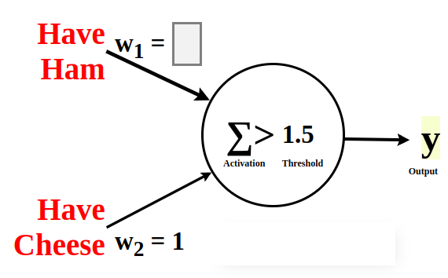  
**Answer to:**  
#5. Can I make a ham and cheese sandwich? I need both ham and cheese.

| **INPUTS** | | **Should activation be above threshold?** *Answer should be based on the desired output (column A)* | **Type of constraint on weight W1**  *Either “greater than” or “less than”* | **Margins for Weight W1** | **Solution for Weight W1**  *What value for W1 satisfies all constraints in columns C+D?* | **Compute Weighted input 1** | **Weighted input 2** | **Activation** | **Is activation greater than threshold?**  *If the answer doesn’t match the 1 or 0 in the desired output, go back to column E* | **Desired Output** |
| --- | --- | --- | --- | --- | --- | --- | --- | --- | --- | --- |
| Input1  0 - Don’t Have Ham  1 - Have Ham | Input2  0 - Don’t Have Cheese  1 - Have Cheese | (Y or N) | If column B is “Y”, put “>” here.  If column B is “N”, put “<” here. | Take the threshold 1.5 and subtract Weighted Input 2 (column G) | Example: If C+D says “> 0.5” then the value of W1 must be something greater than 0.5 | W1 = ___ from E  Input1 x W1= __ | W2 = 1  Input2 x W2= __ | Sum of weighted Inputs 1 & 2 (columns F and G) | Activation > Threshold ?  Is column H > 1.5  Write 0 for no or 1 for yes. | 0 - no  1 - yes |
| 0 | 0 | N | **Constraints on W1 only make sense when Input1 is active (not 0)** | | 1  (could be any value between 0.5 and 1.5) | 0 x 1 = 0 . | 0 x 1 = **0** | 0 | 0 | 0 |
| 0 | 1 | N | 0 x 1 = 0 . | 1 x 1 = **1** | 1 | 0 | 0 |
| 1 | 0 | N | < | 1.5 - 0 = 1.5 | 1 x 1 = 1 . | 0 x 1 = **0** | 1 | 0 | 0 |
| 1 | 1 | Y | > | 1.5 - 1 = 0.5 | 1 x 1 = 1 . | 1 x 1 = **1** | 2 | 1 | 1 |
|  | | | | | | | | | | |
|  | | B | C | D | E | F | G | H | I | A |