Report 1
Title: Implement Security Group Test Use cases on a fresh EC2 Instance

[1] All Outbound Traffic allowed (Default)

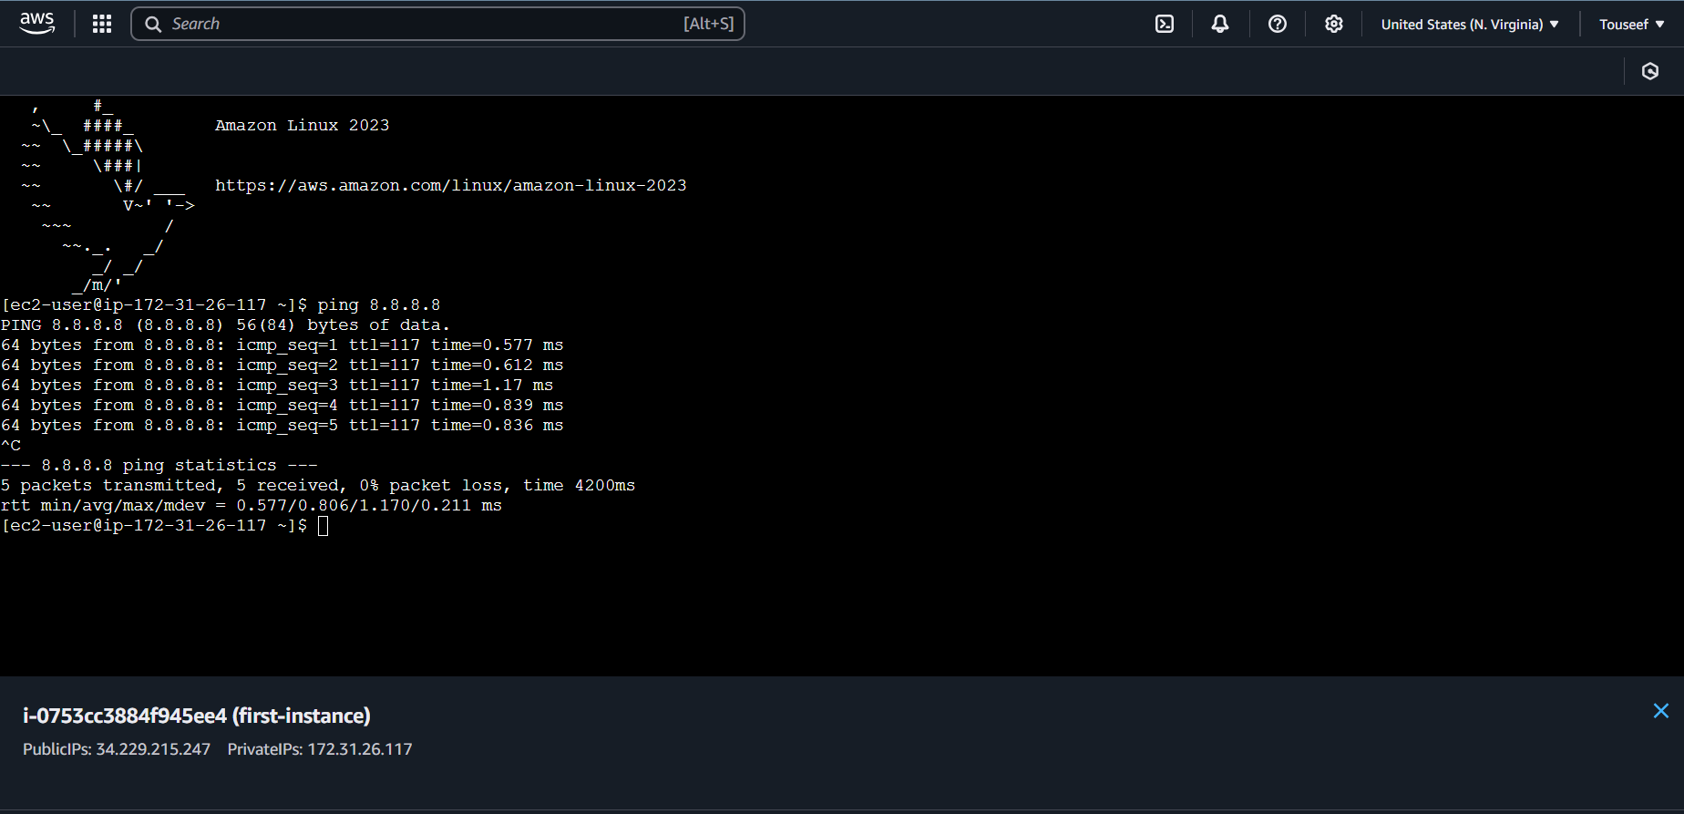
Executed ping command for 8.8.8.8 and we can see that it was successful. We are getting response from the server.

[2] All Inbound Traffic not allowed (Default)
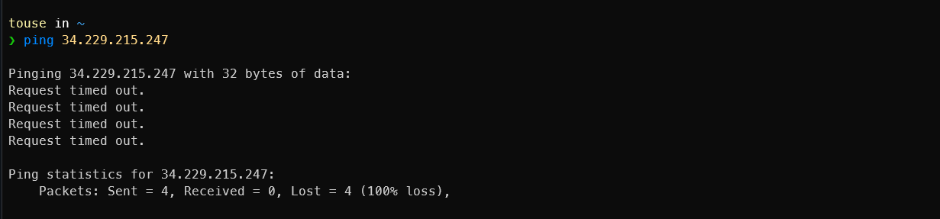
Executed ping command for out instance pubic IPv4 34.229.215.247 but got no response

[3] All Inbound Traffic allowed (Custom Rule)

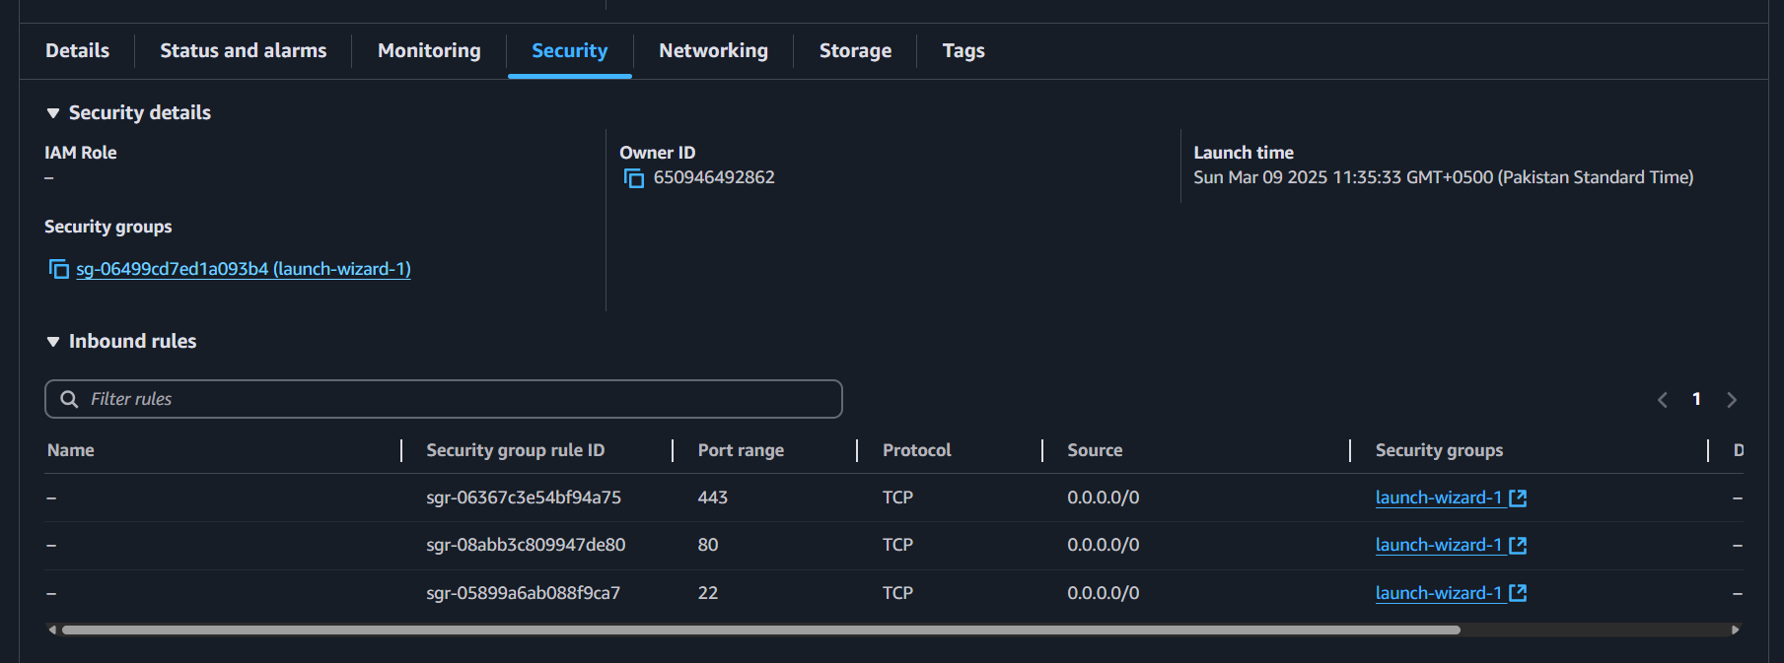
Opening current set security group of our instance

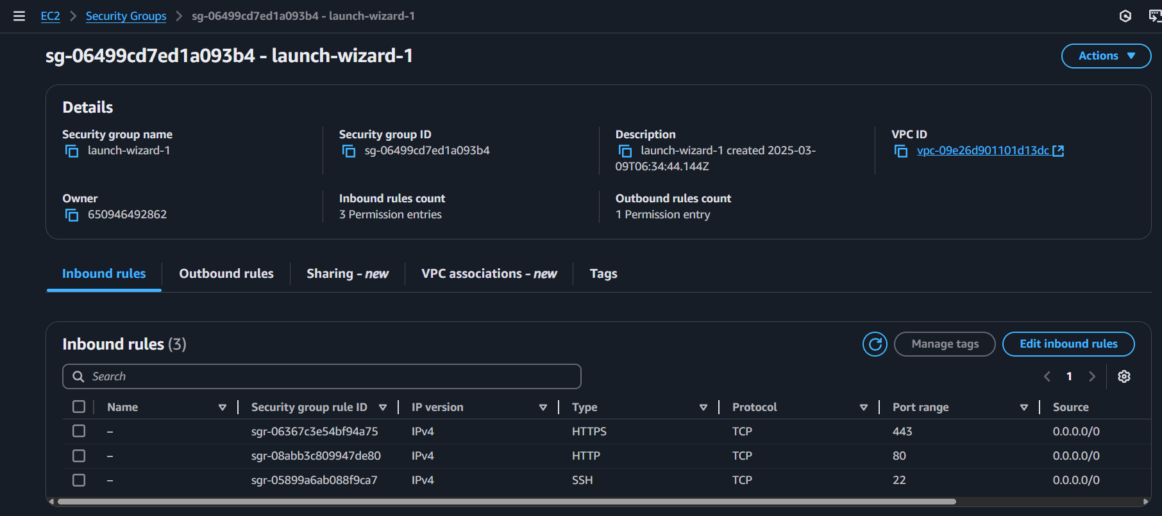
Going to `Edit Inbound Rules`

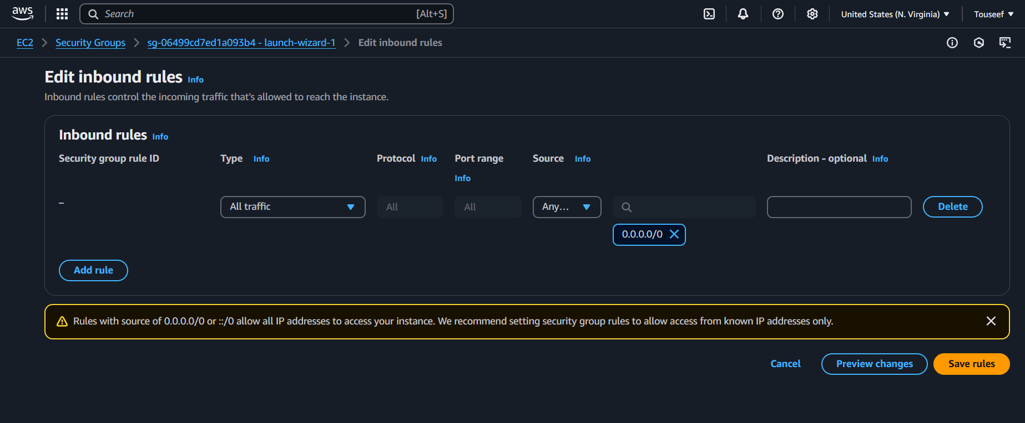
Delete all existing Inbound rules and add an Inbound rule that Allows all traffic from IPv4.

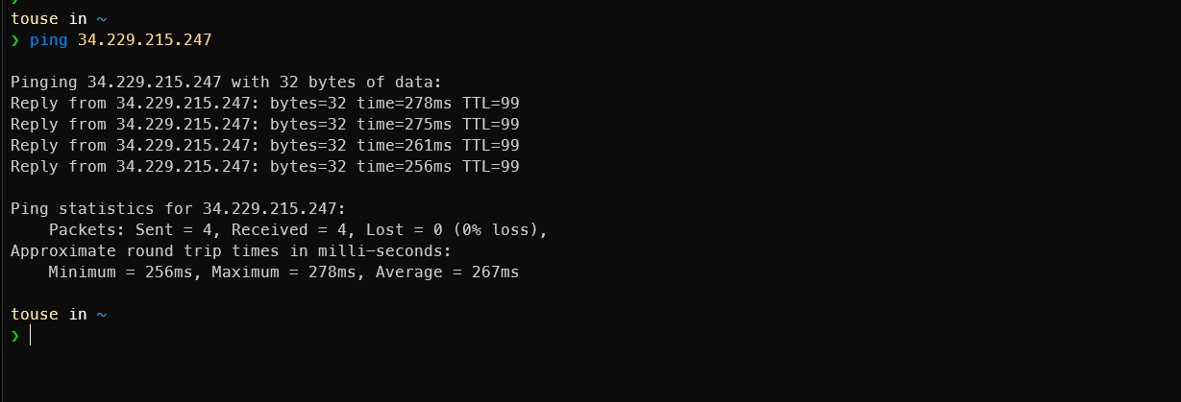
Now the ping is working form our local machine.

[4] Restrict All Outbound Traffic (Custom Rule)

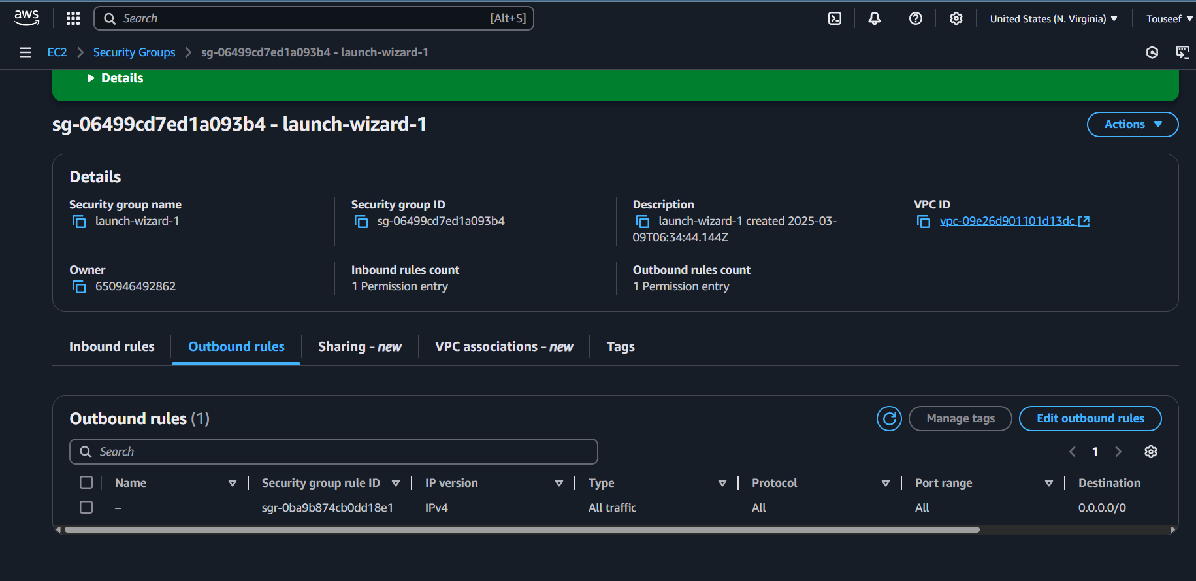
Inside the Security Group, going to `Edit Outbound Rules`

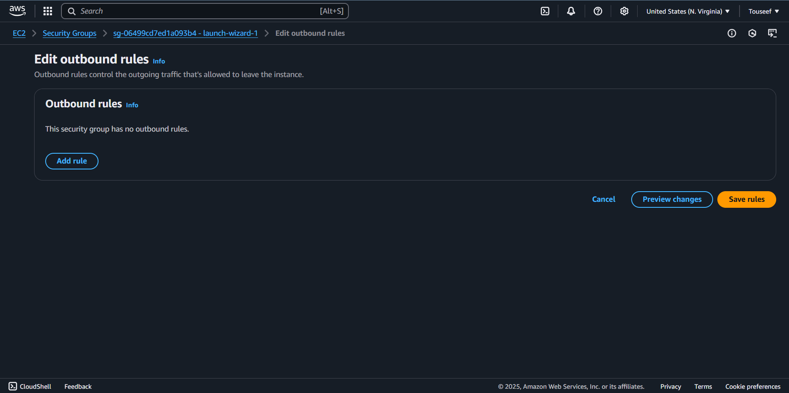
Deleted all existing Outbound rules and saved

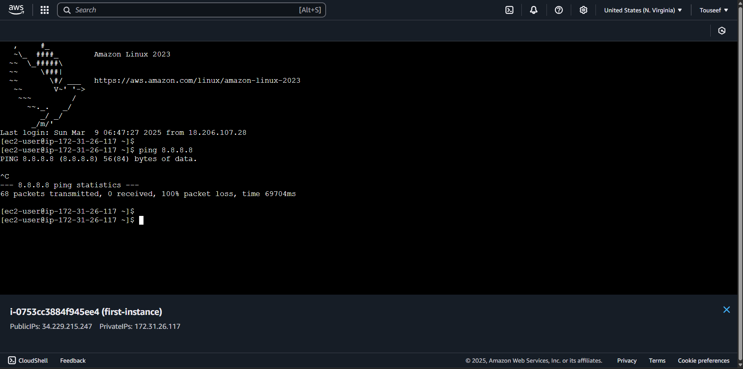
Now we are unable to ping the public IP 8.8.8.8

