Report
Title: Amazon FSx for Windows File Server

Setup
- Setup the AWS managed Microsoft AD
- Setup Amazon FSx
- Setup Windows File Server EC2 Instance

Procedure

In order to setup the FSX for windows, you first need the Active Directory (AD). You can either provide your self managed AD or use the AWS managed Microsoft AD.
For this lab, we will first create the AWS managed Microsoft AD.
Open the AWS Management Console and navigate to the Amazon FSx service.
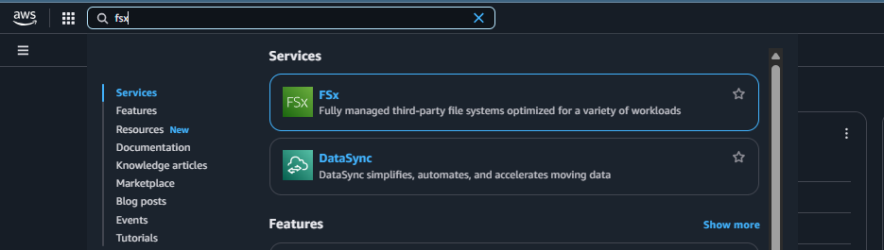
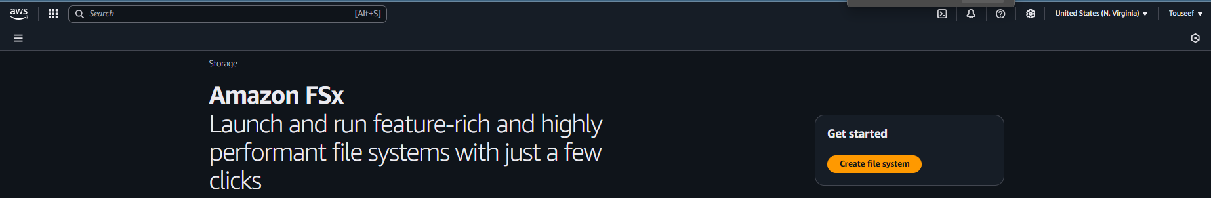
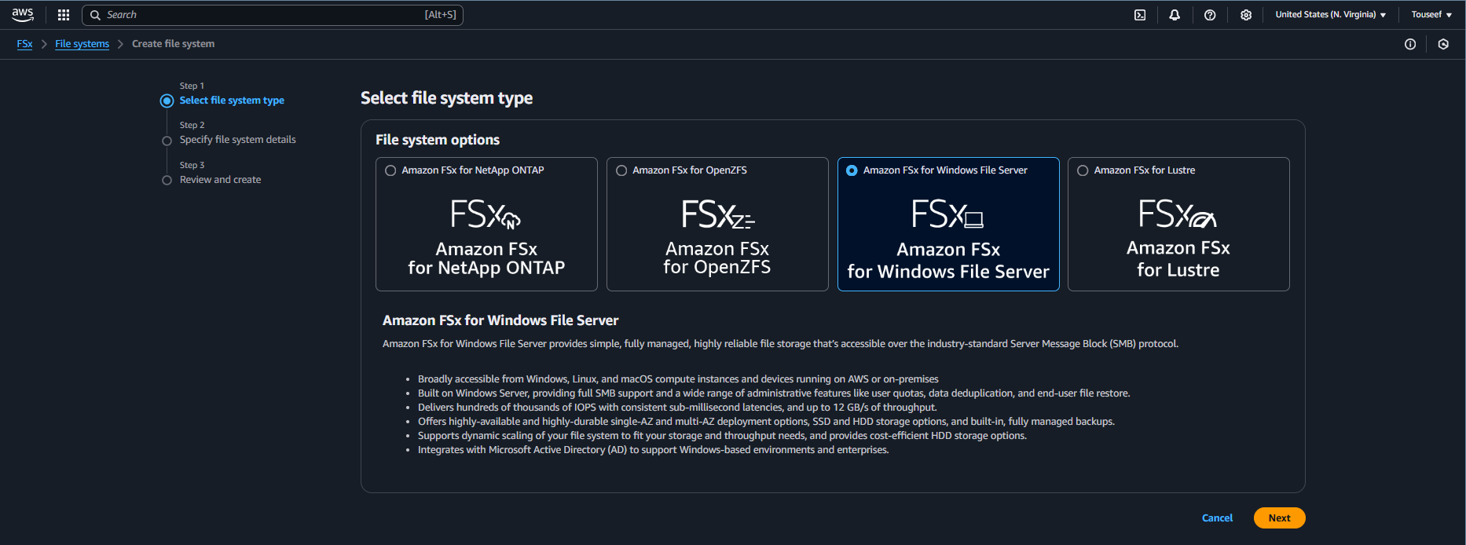
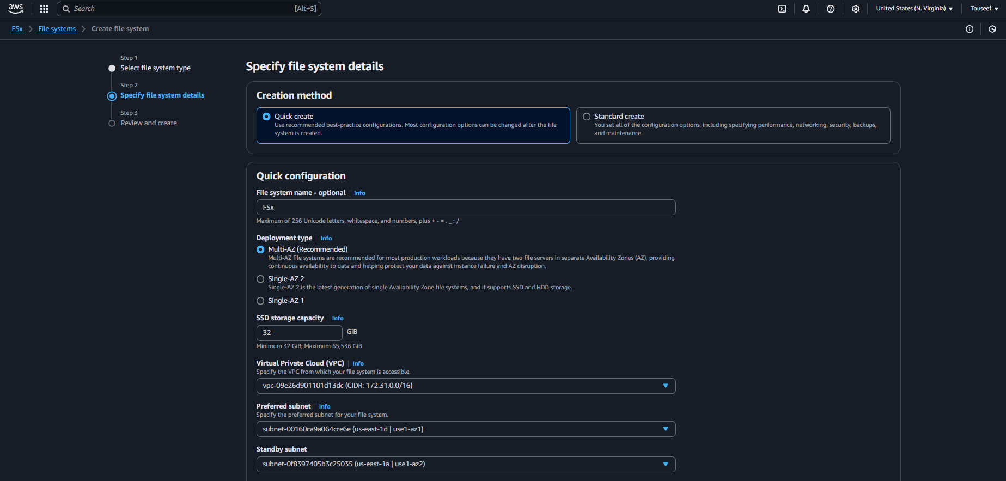

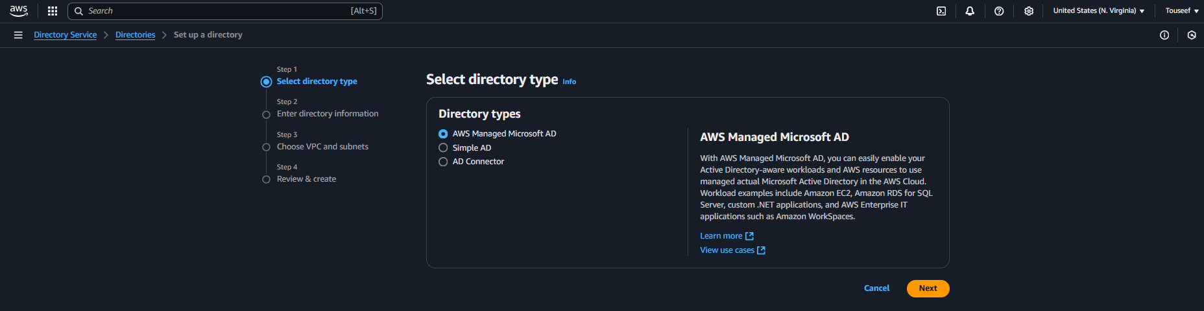
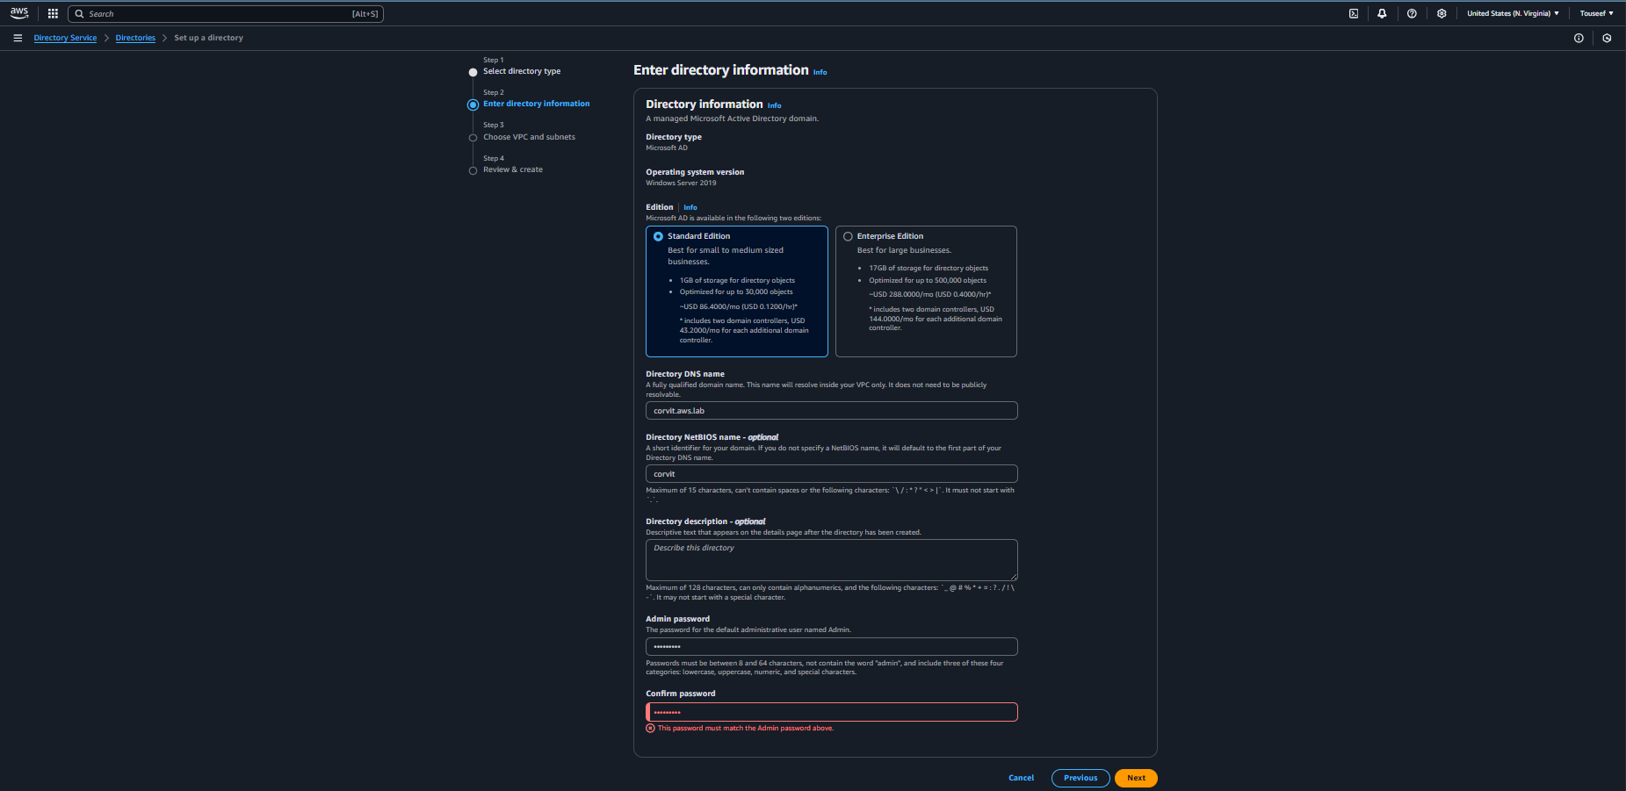
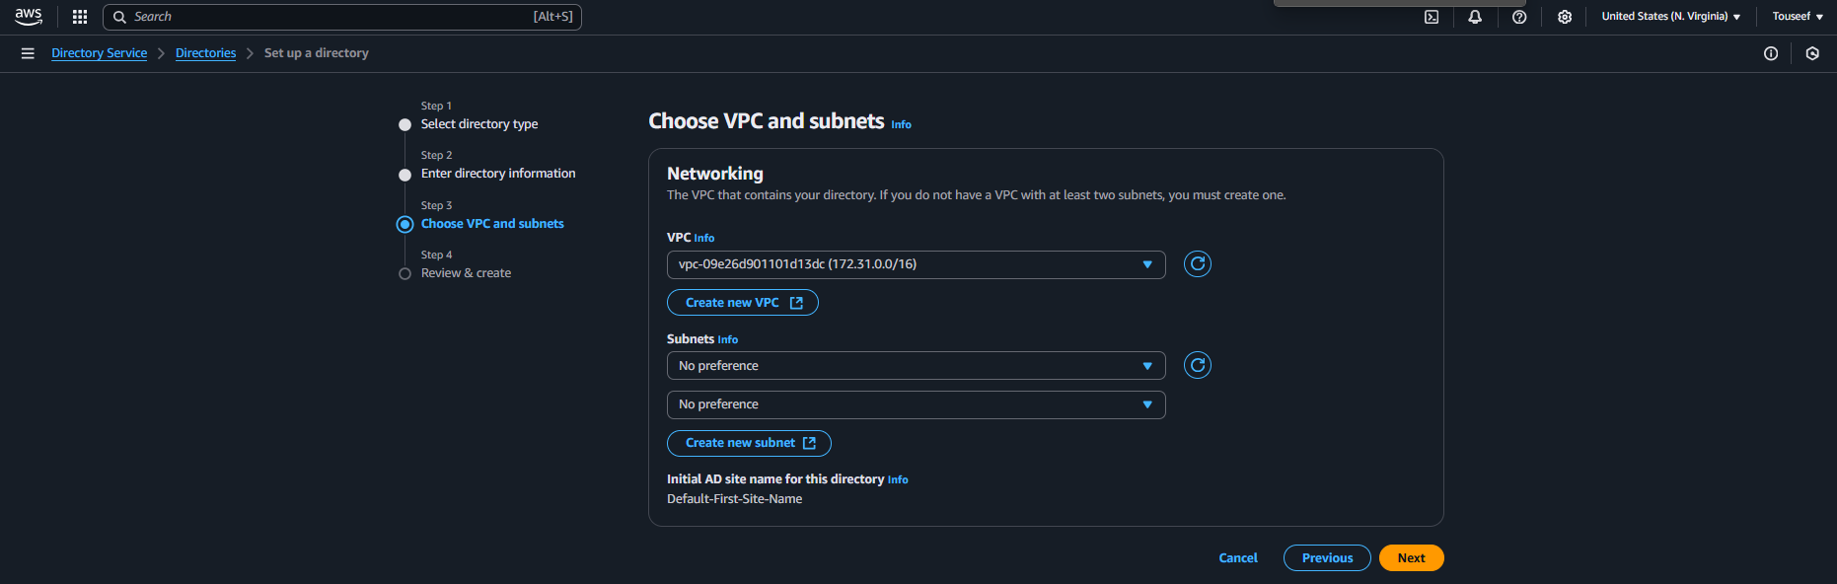
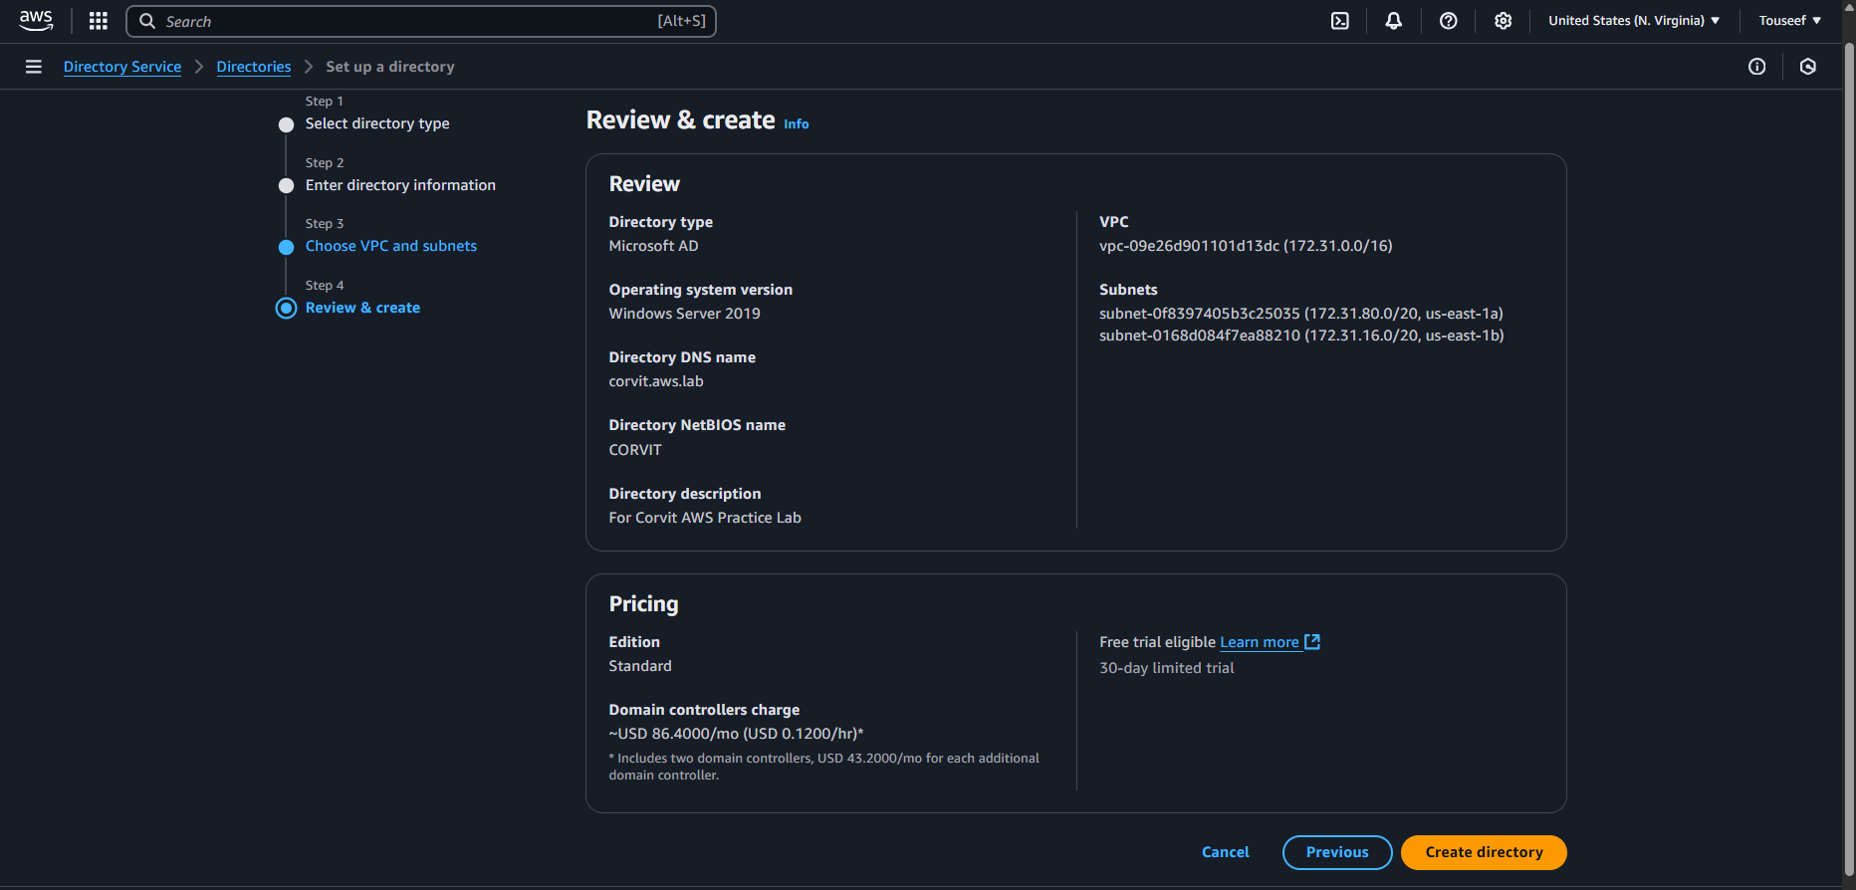
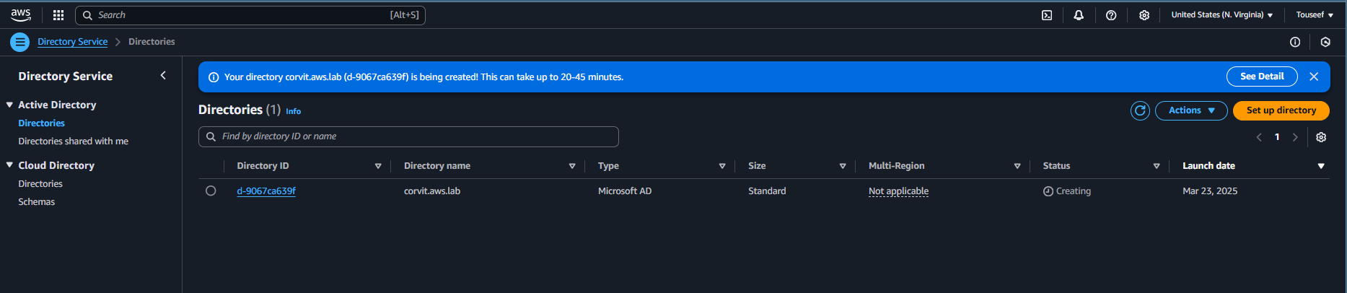
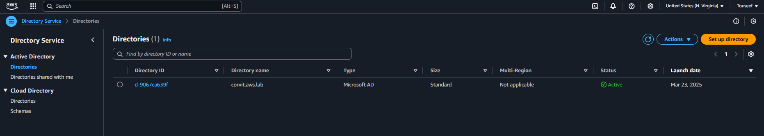
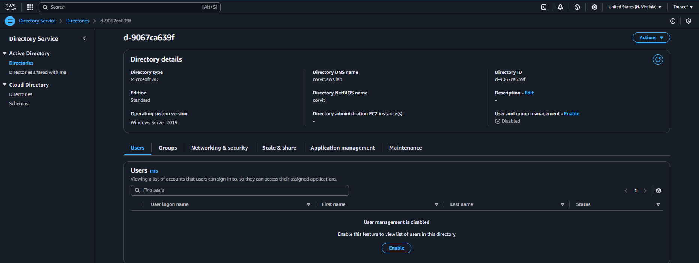



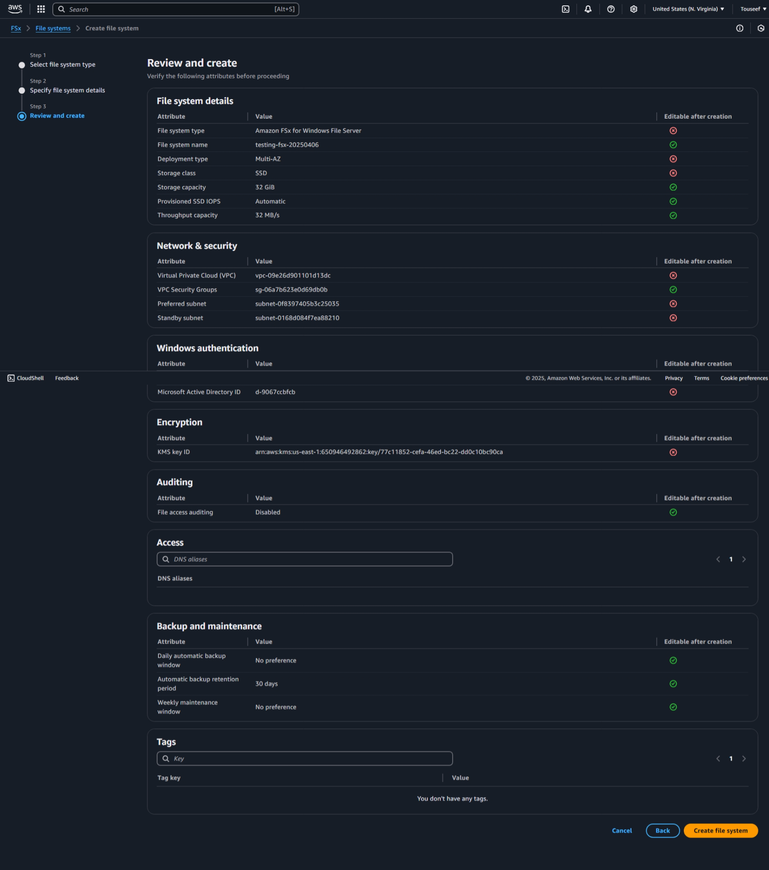
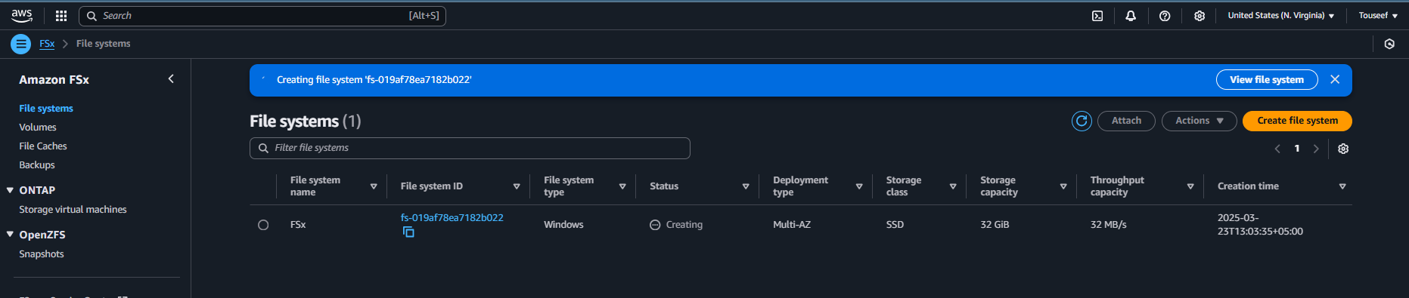
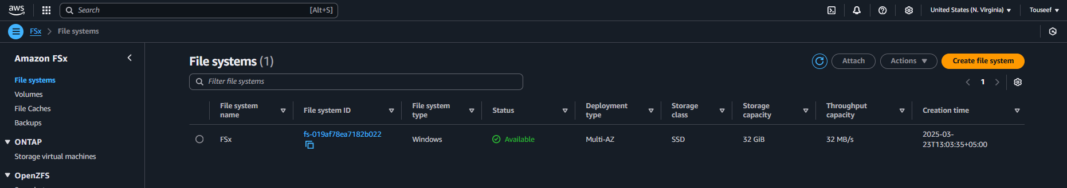

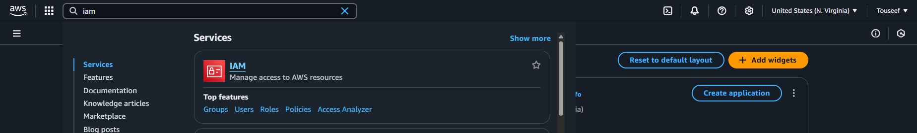
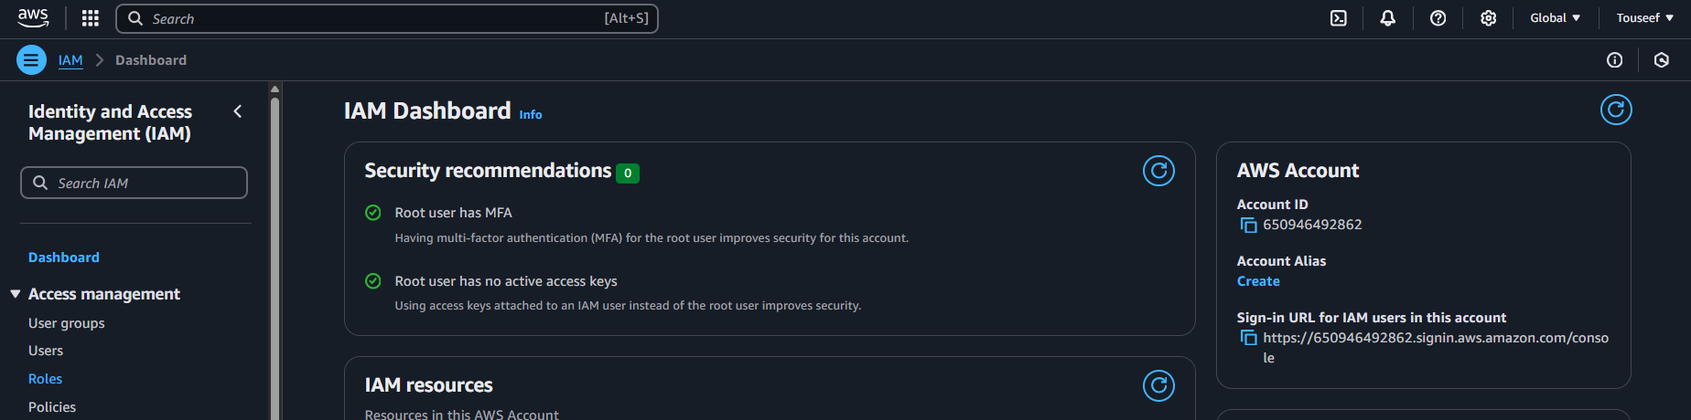
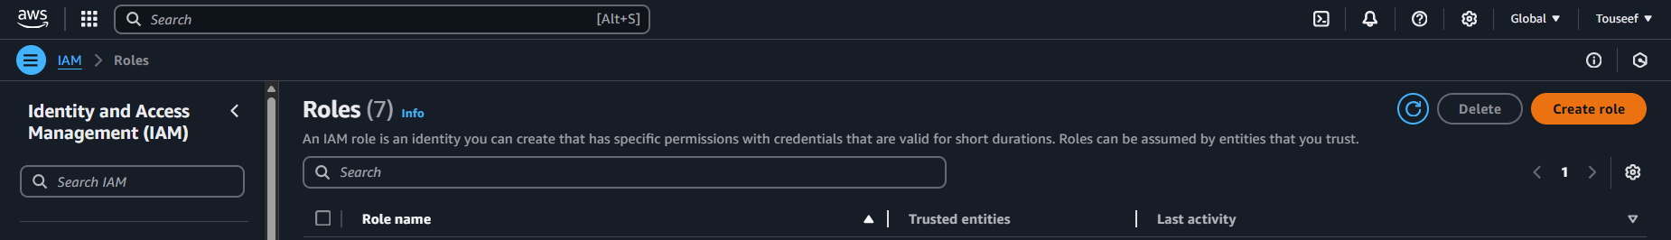
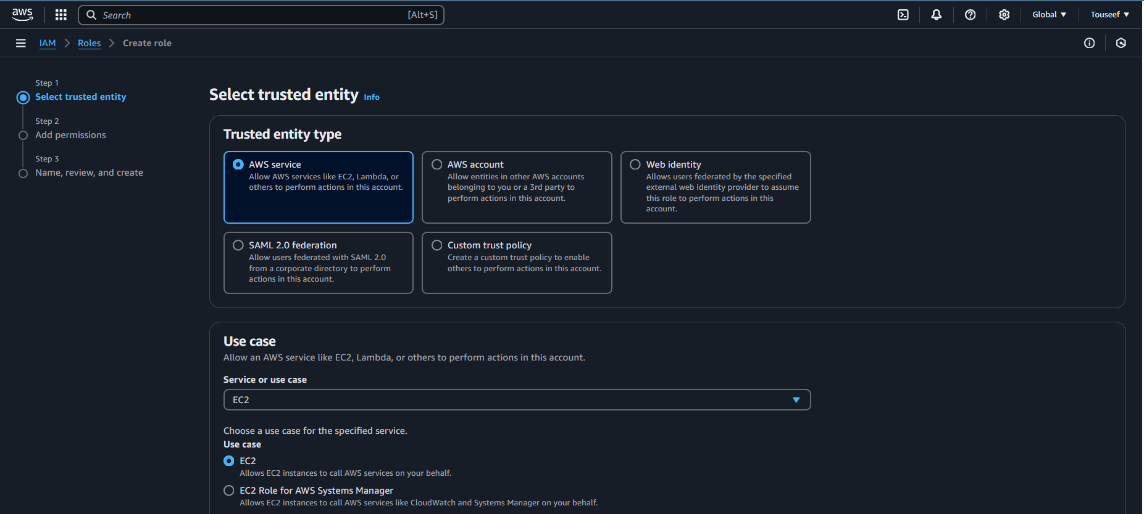
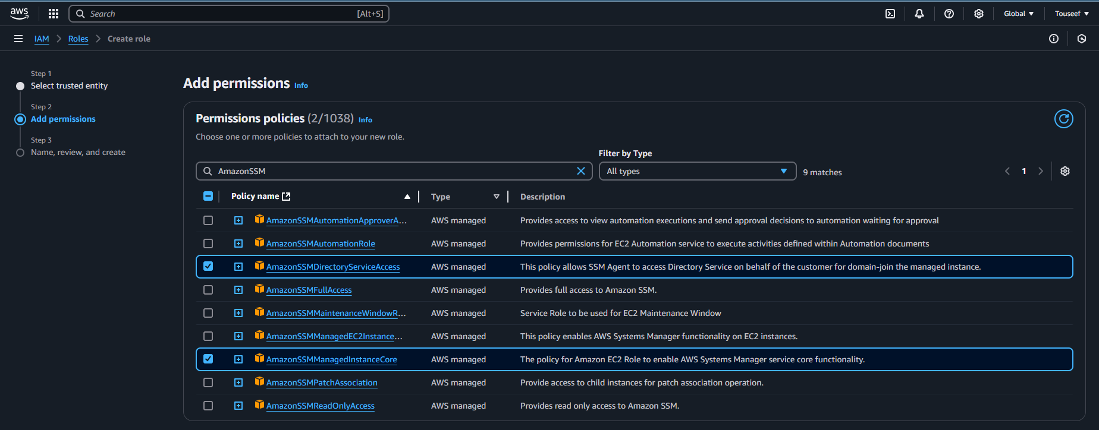
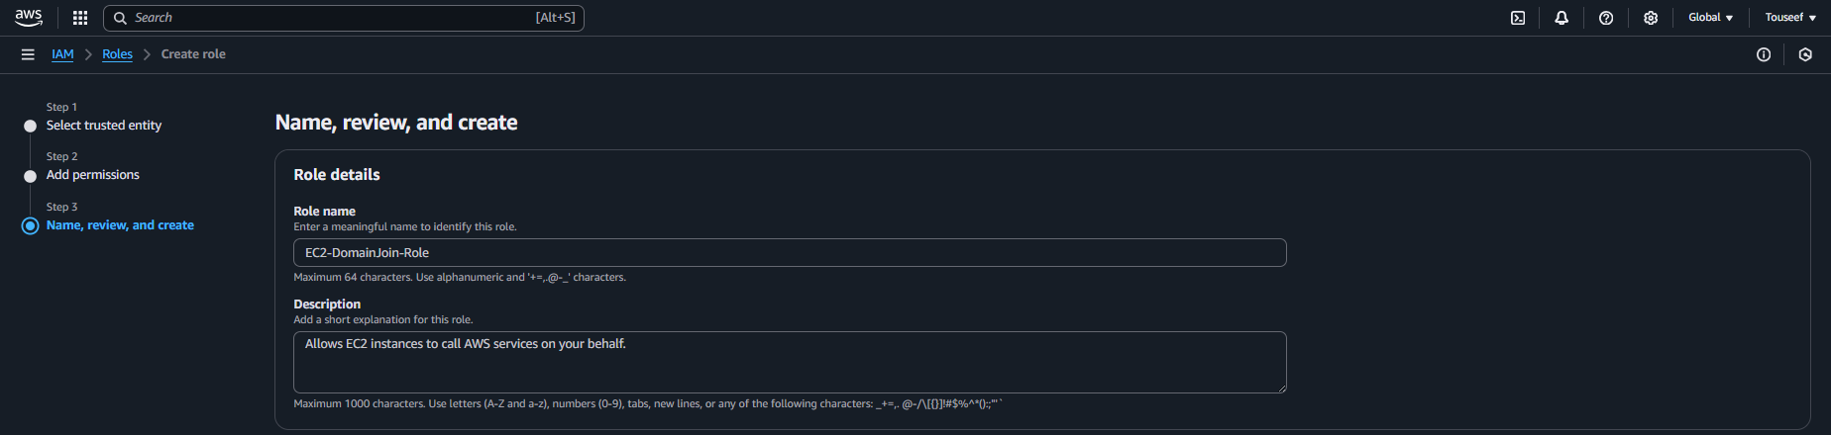

Now create a fresh instance of windows EC2 instance as we did in previous labs.
This time we to configure the File Systems on our instance by going into the Storage(volumes) configurations and expand the File Systems section; refresh the available File Systems and select the one you recently created.
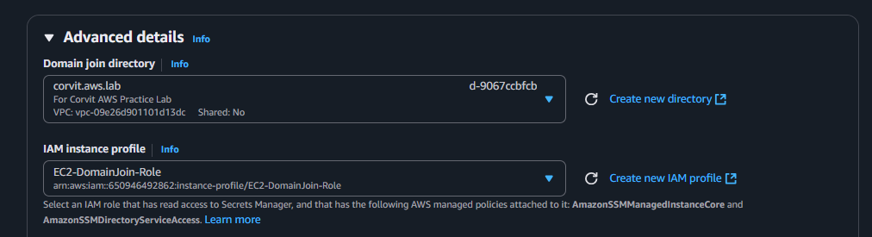
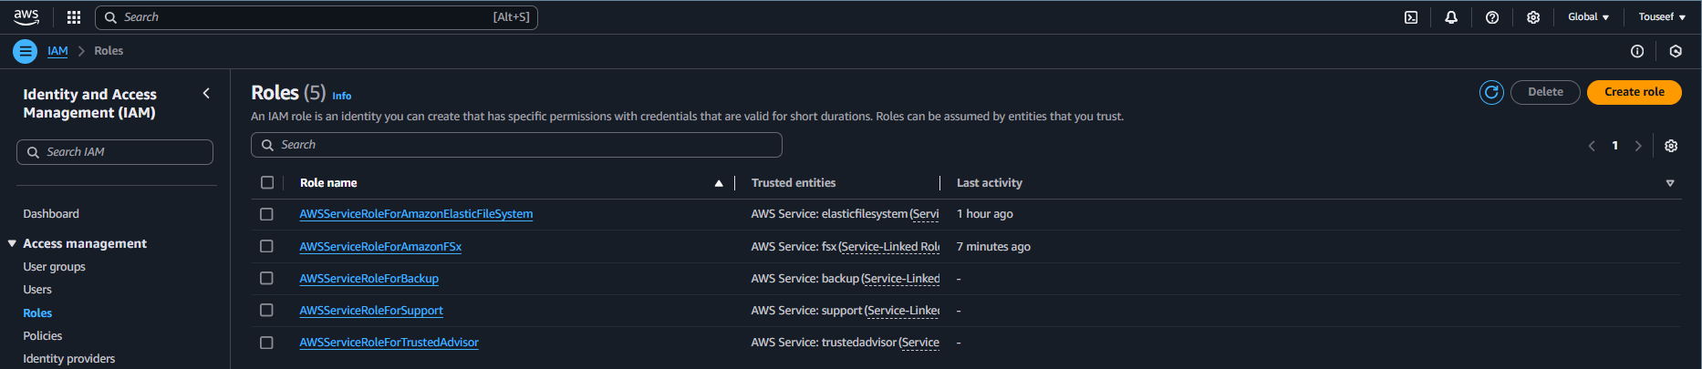
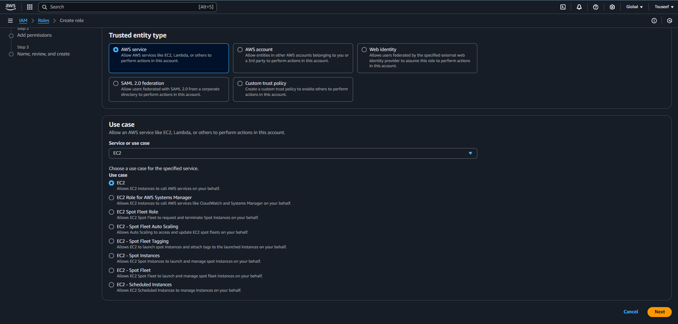
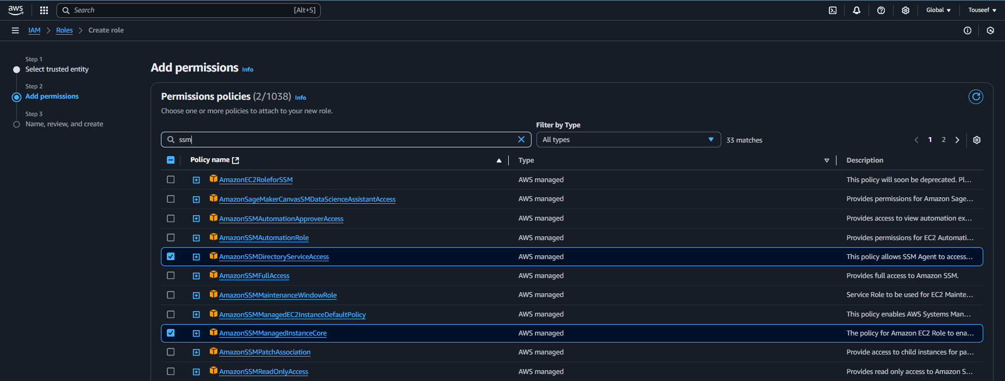
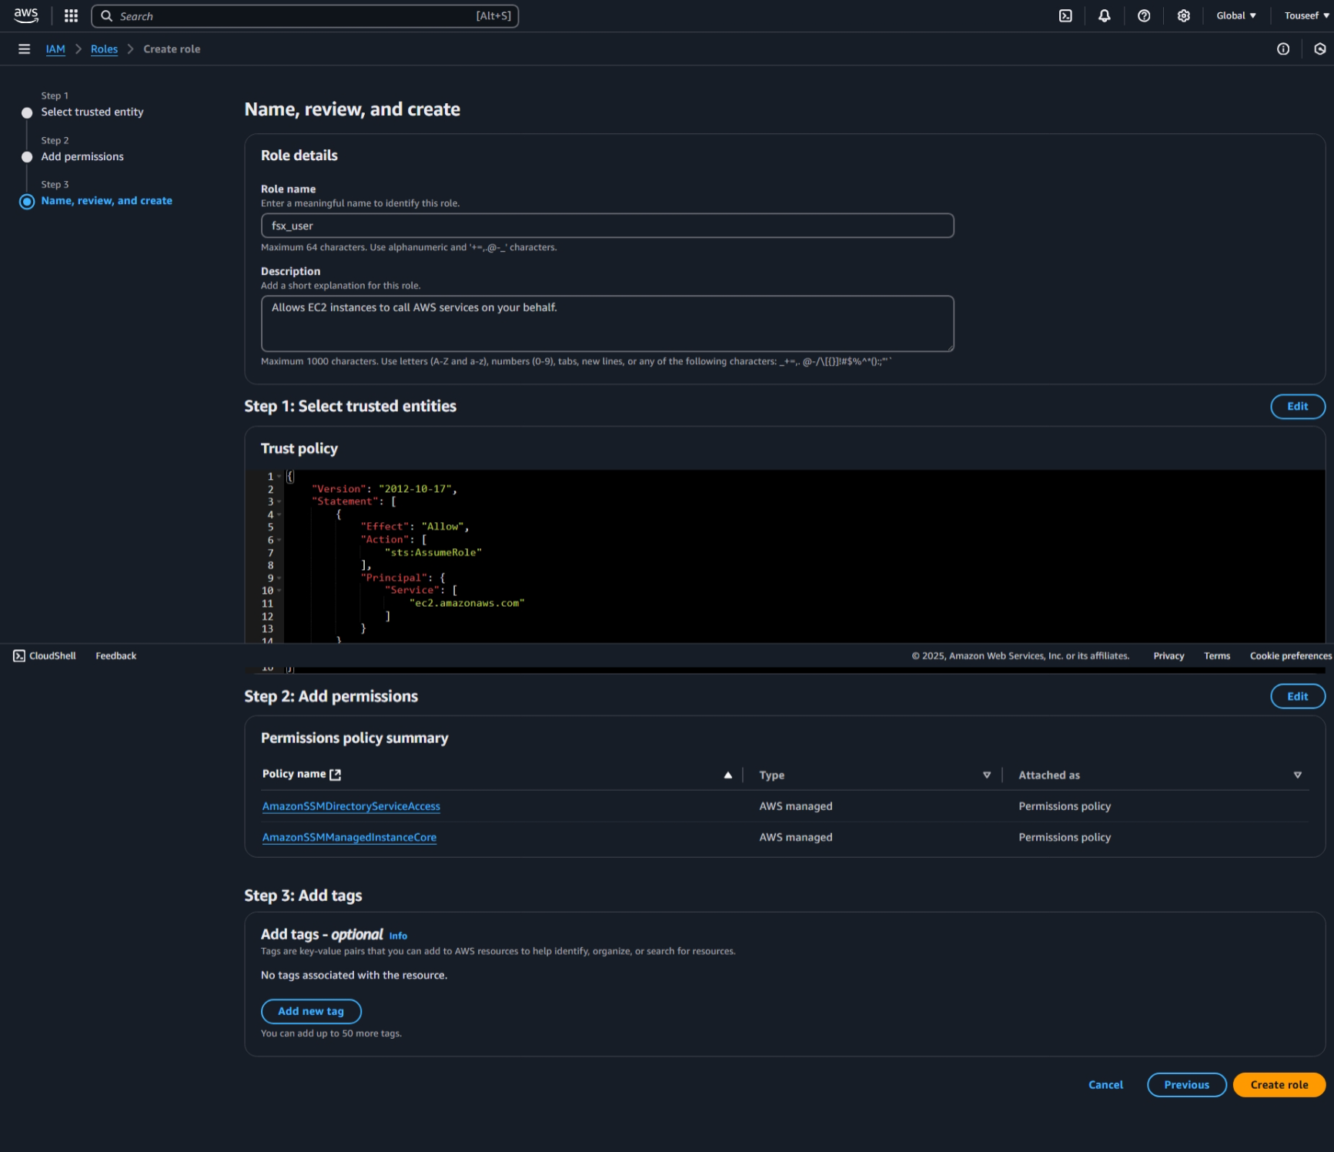

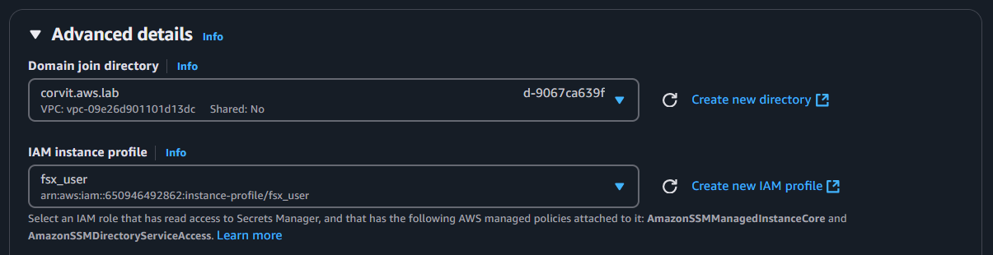
Now proceed and create the instance. And connect to it using RDP as we did in previous labs.

