Report
Title: Configuring Apache Web Server on AWS EC2

Setup
Create a fresh EC2 instance with following configs;
- No Key Value Pair Encryption
- Allow http/https Traffic
- Everything else to default values

Procedure
- Connect to your freshly created AWS instance using browser;
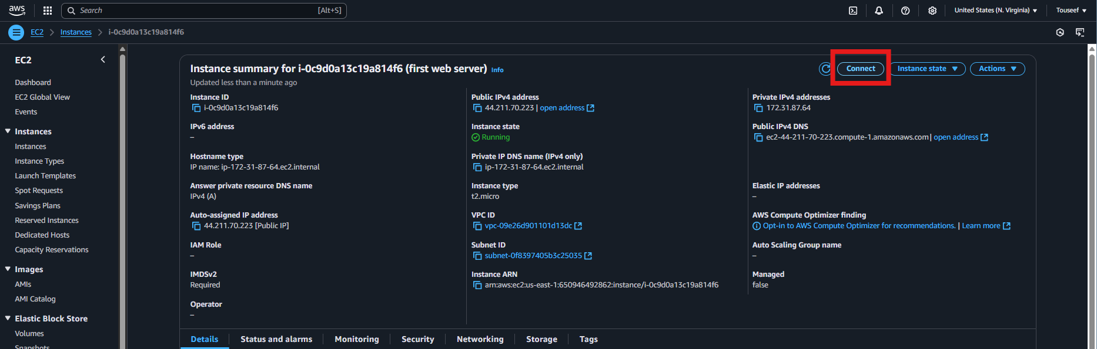
- Switch to root user with following command; 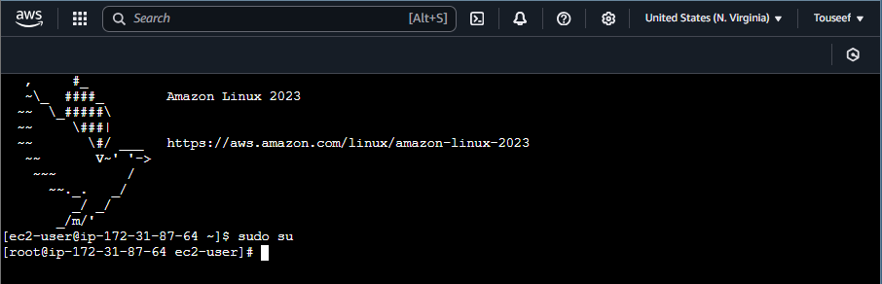
- Update the machine packages with following command; 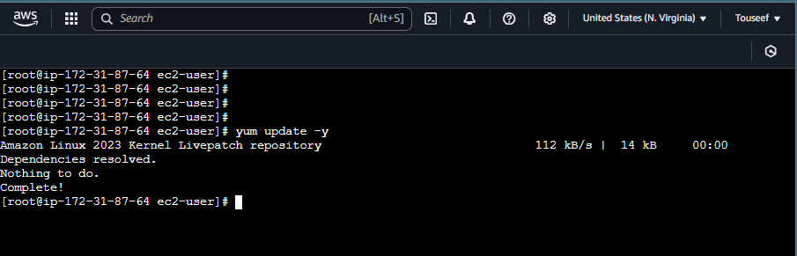
- Install the Apache web server using the following command; 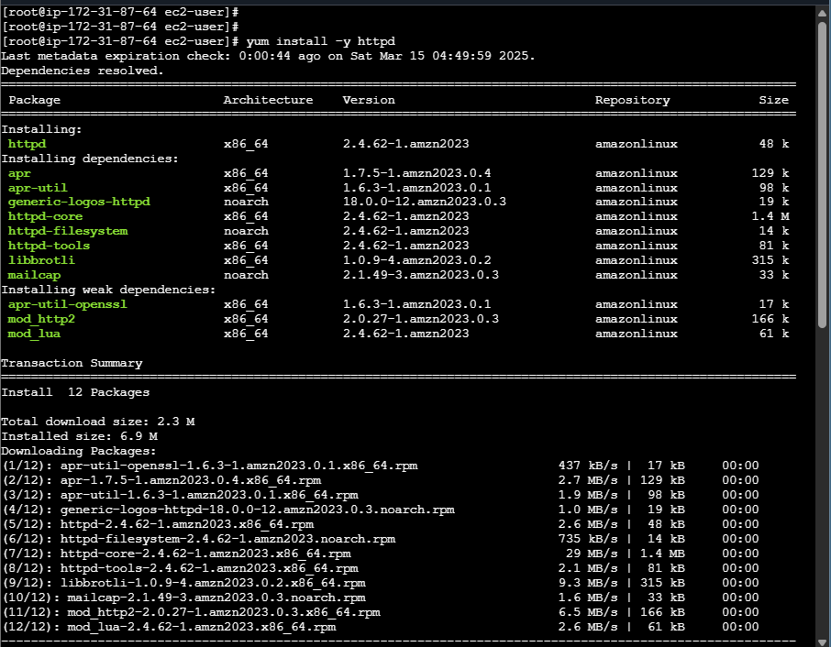
- Start the installed Apache web server using the following command; 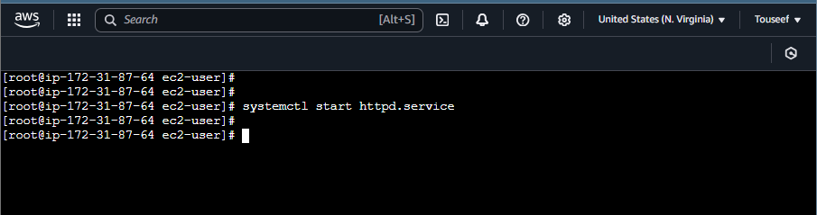
- Also enable the installed Apache web server service so that it can auto start when the EC2 instance restarts. Use the following command; 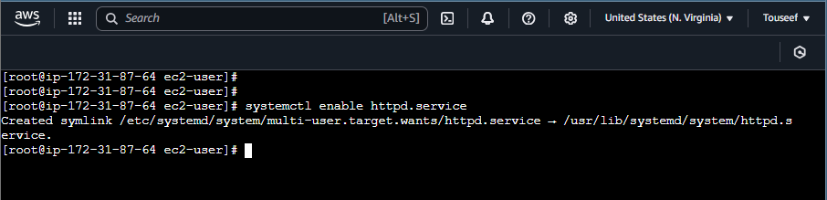
- Create a custom index.html file at /var/www/html/index.html path of your machine which would be automatically returned by the web server upon client web request. 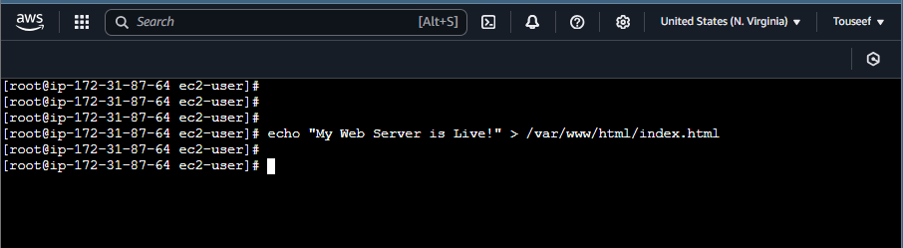
- Now copy the public IP of your EC2 machine and send the http request from your browser. You should be able to see content of your index.html file in the browser body. 