Report
Title: Configuring the NGINX on AWS EC2

Setup
Create a fresh EC2 instance with following configs;
- No Key Value Pair Encryption
- Allow http/https Traffic
- Everything else to default values

Procedure
- Connect to your freshly created AWS instance using browser;
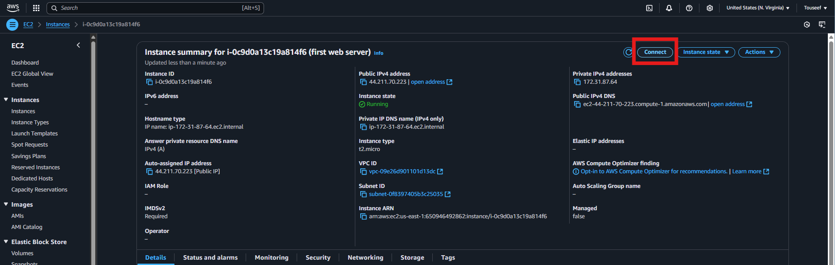
- Switch to root user, if Apache Server already configured on the machine, stop the Apache Server and disable the Apache Server service (so it does not auto start when EC2 restarts) with following command;
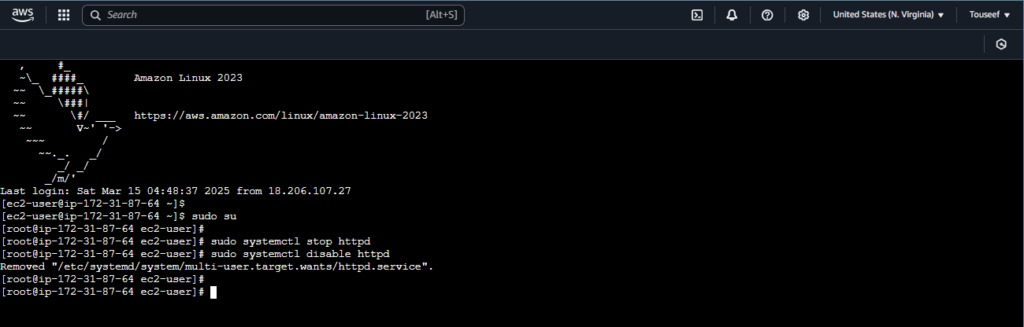
- Update the machine packages with following command; 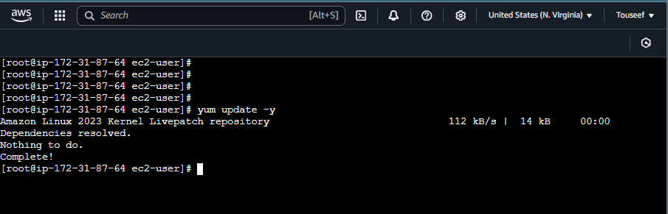
- Install the Nginx server using the following command; 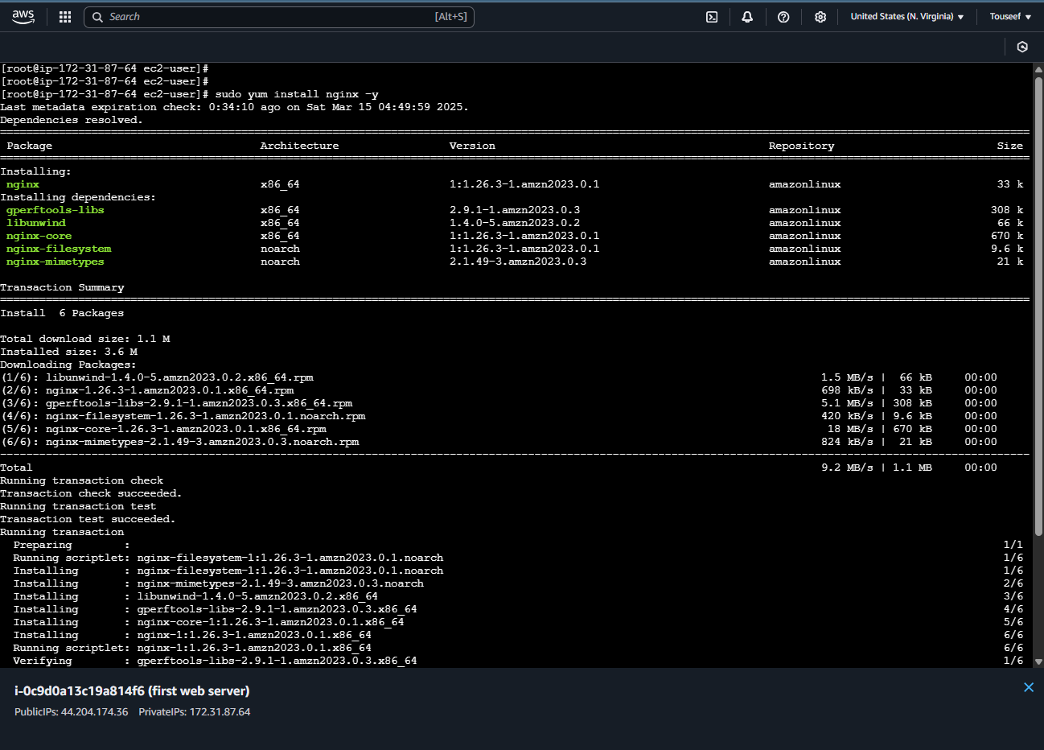
- Start the installed Nginx server using the following command; 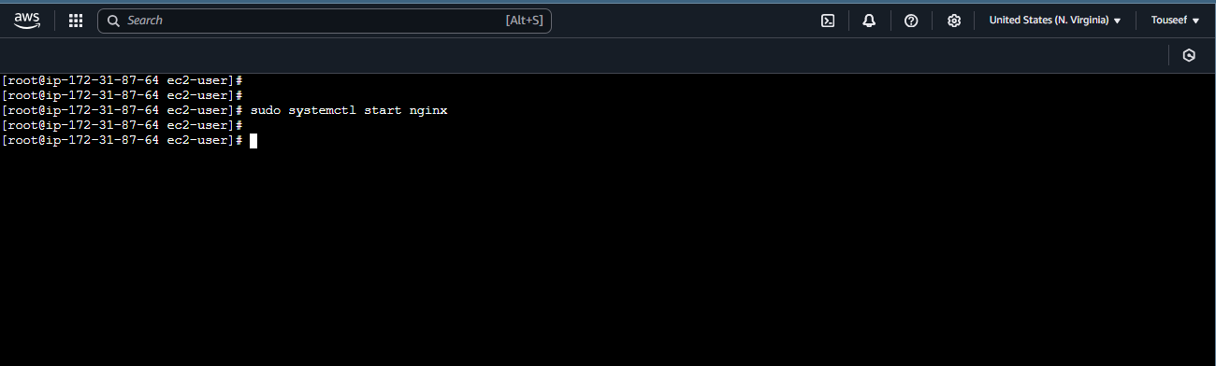
- Also enable the installed Nginx server service so that it can auto start when the EC2 instance restarts. Use the following command; 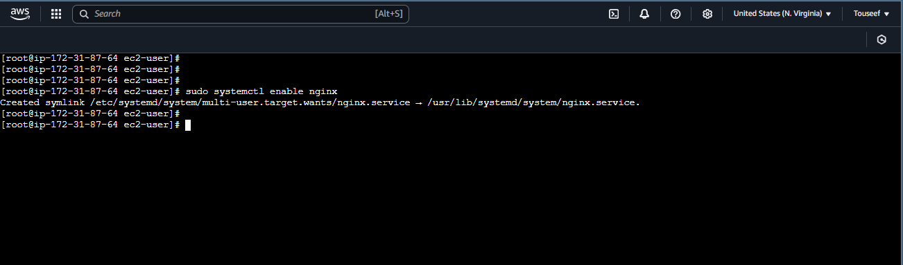
- Create a custom index.html file at /usr/share/nginx/html/index.html path of your machine which would be automatically returned by the web server upon client web request.
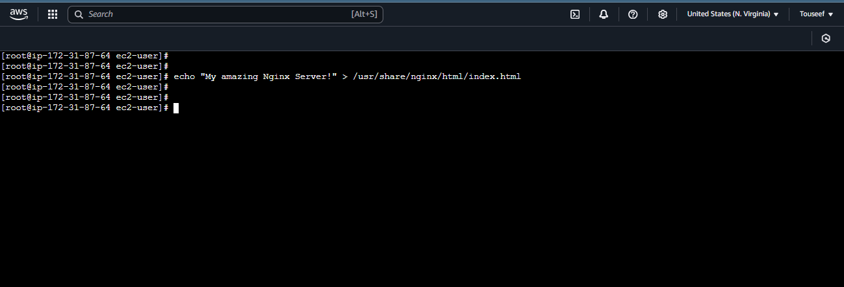
- Now copy the public IP of your EC2 machine and send the http request from your browser. You should be able to see content of your index.html file in the browser body. 