Report
Title: Experimenting with Volumes on Windows VM

Setup
Creating a fresh EC2 instance with following configs;
- AMI => Windows OS
- Instance Type => T3.micro
- Create New Key Value Pair Encryption (it will download the .pem file on your machine)
- Select a zone from subnet inside Network Details
- Allow RDP traffic
- Keep other at Default

Procedure
Create a fresh windows VM using the setup described above in the zone us-east-1a by setting the subnet as shown below;
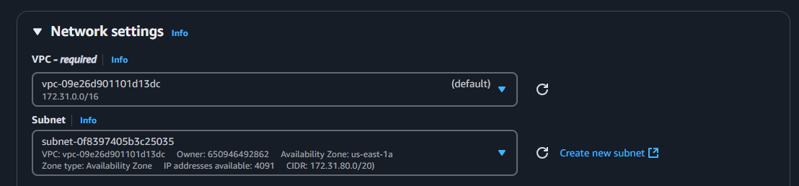
Go to Connect section of your instance.
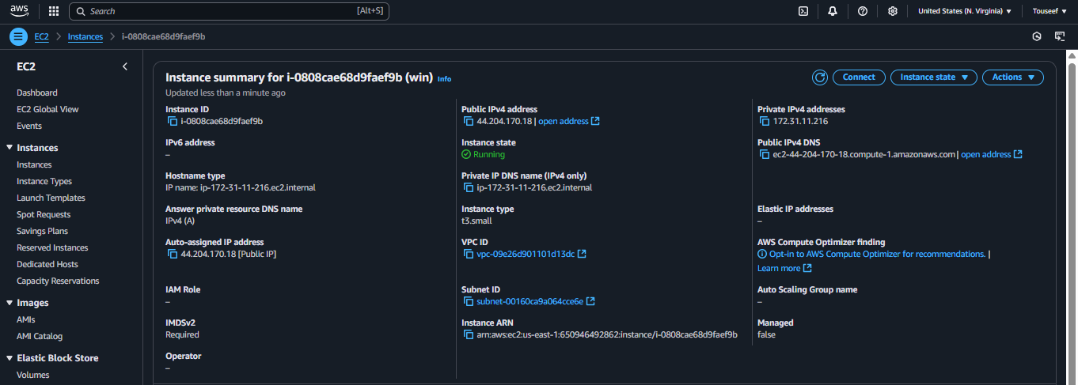

Go to RDP tab, click on get password link, upload your .pem file (which was downloaded when create key pairs) to decrypt the password.
Note down the username and password to connect to your windows instance in future.
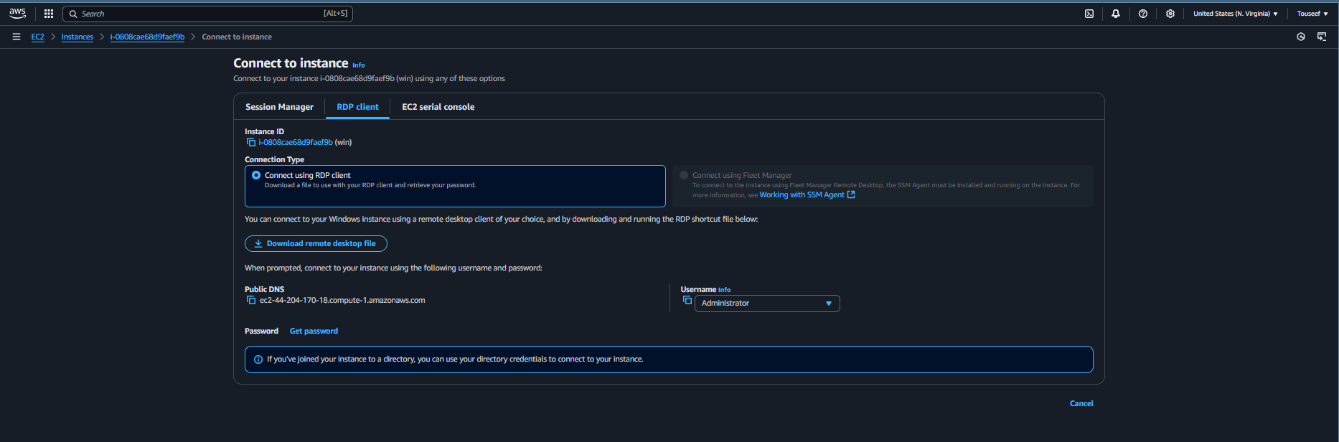
Copy public IPv4 DNS address of your instance as follows;
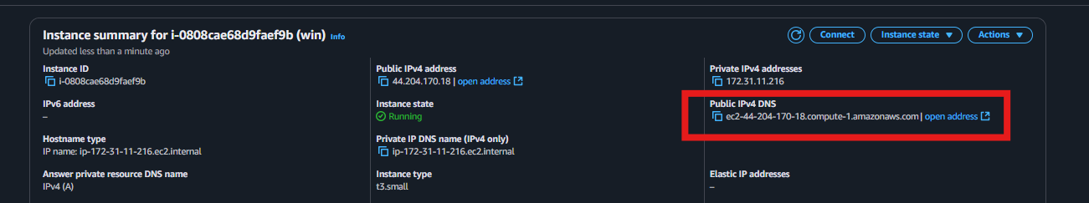
Inside MobaXterm, select Session from the toolbar. Select RDP from the top session types.
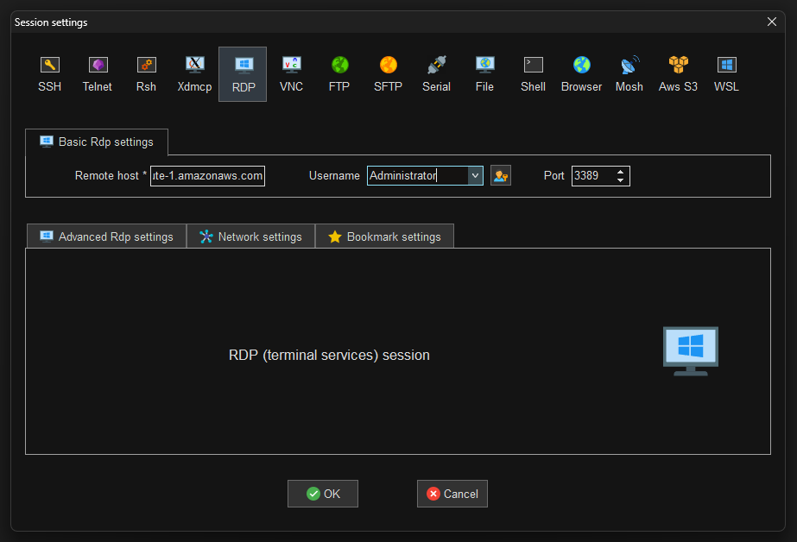
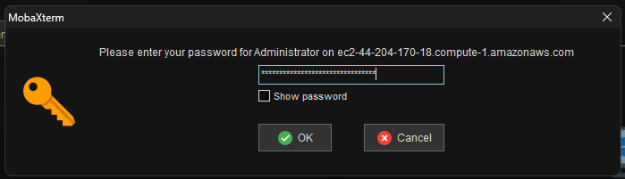
Now you will be connected to the instance as follows;
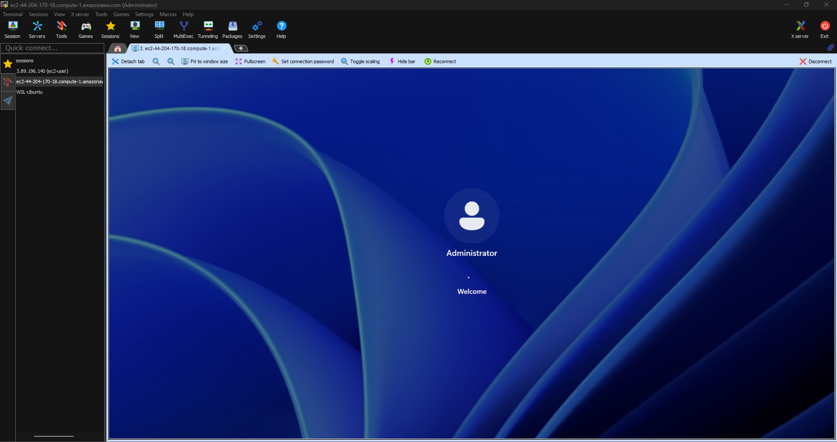

Create a new 1GiB volume in the same zone as the instance as follows;
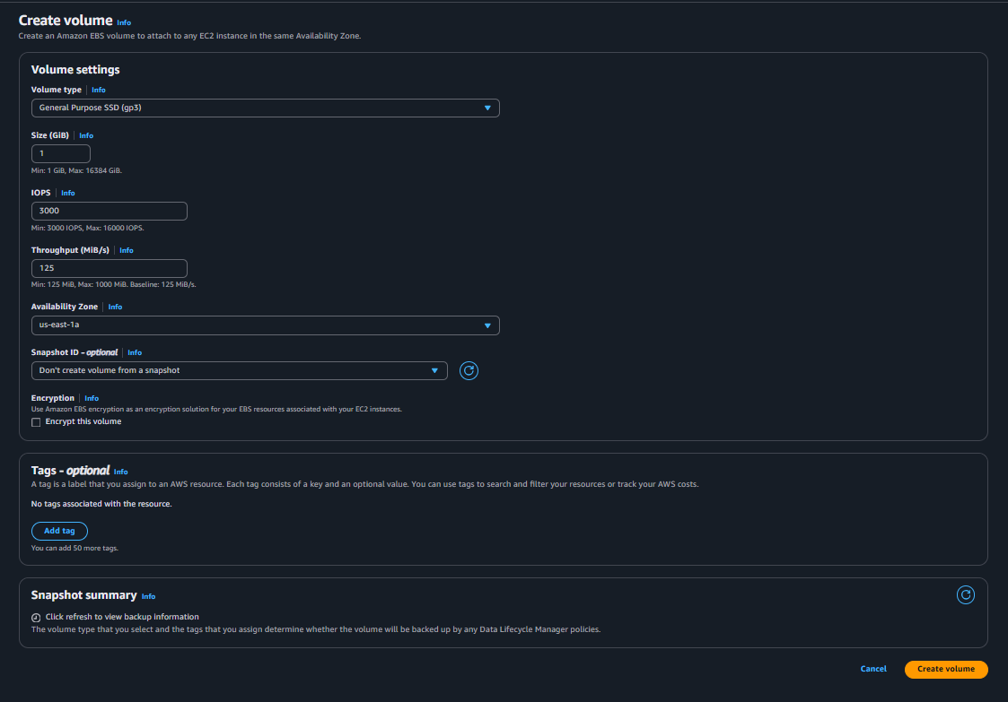

Attach the newly created volume to the newly created windows VM as follows;
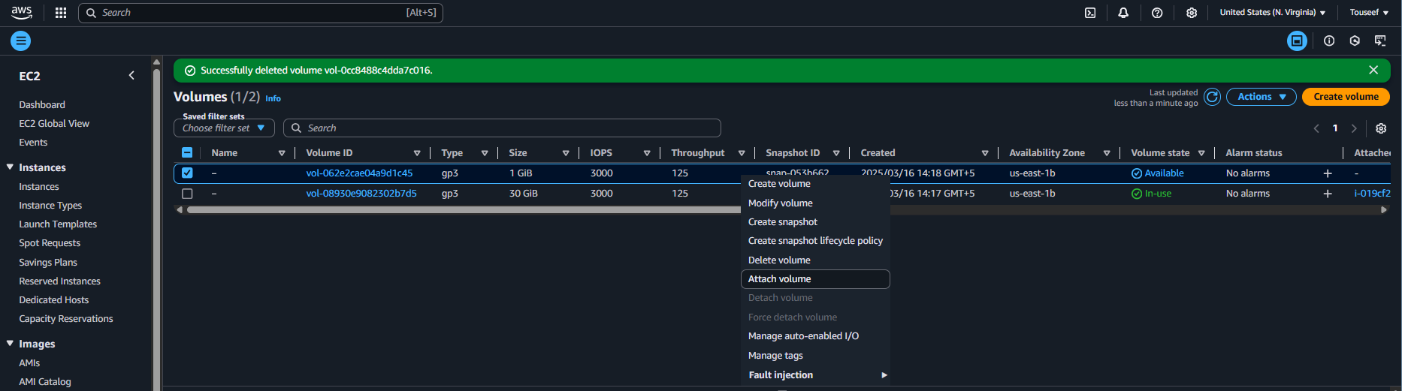
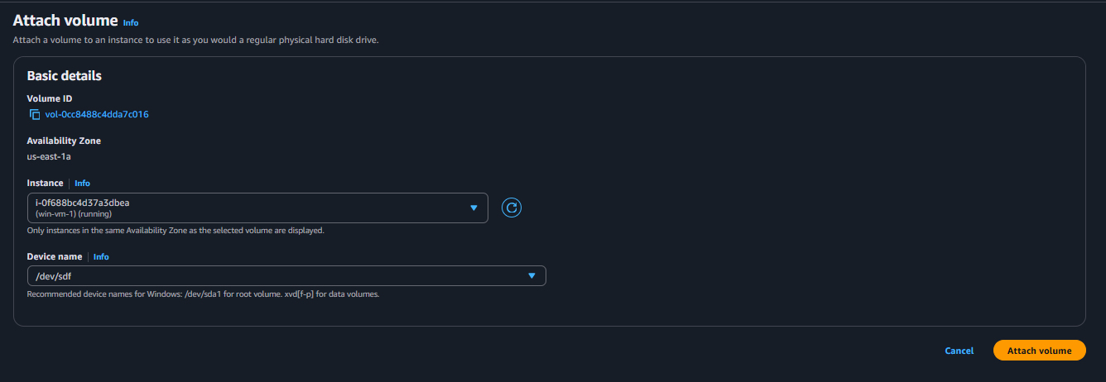
If you are unable to view your instance in the list, then it probably means that the volume and the instance both are in different zones.

Now go to your instance and open the Disk Management Setup of the windows by entering the diskmgmt.msc command in the Run dialogue box as shown in the pictures below.
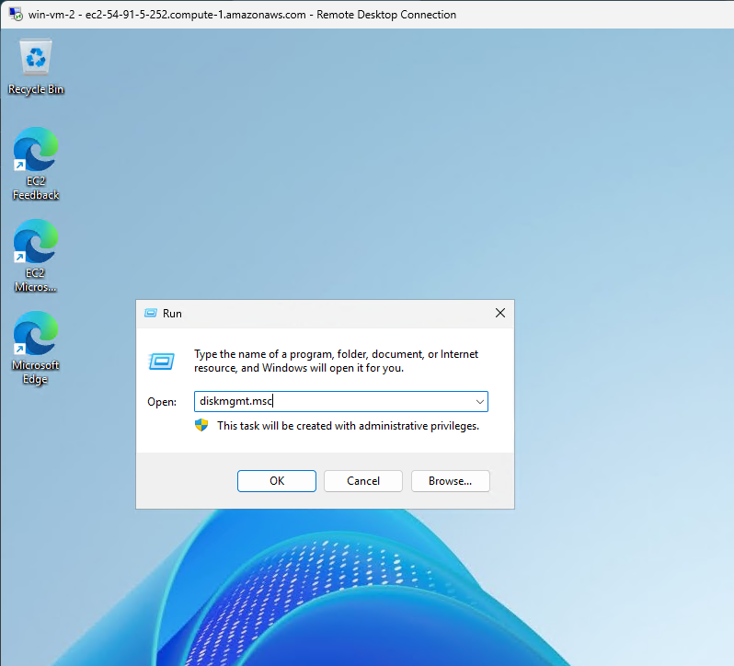
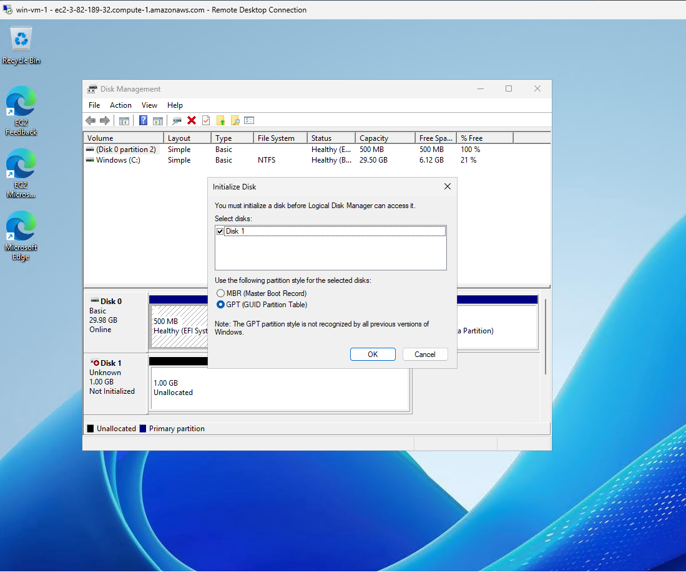

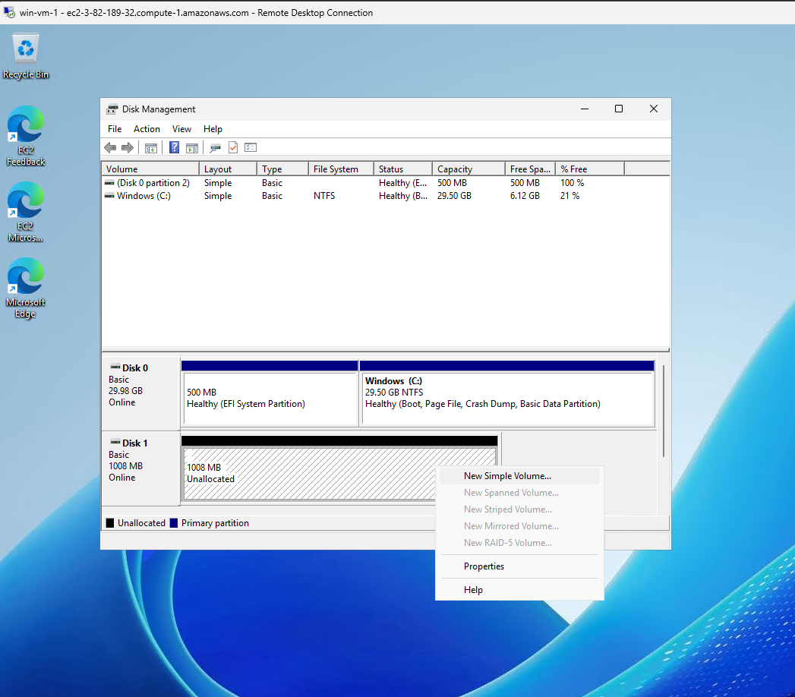
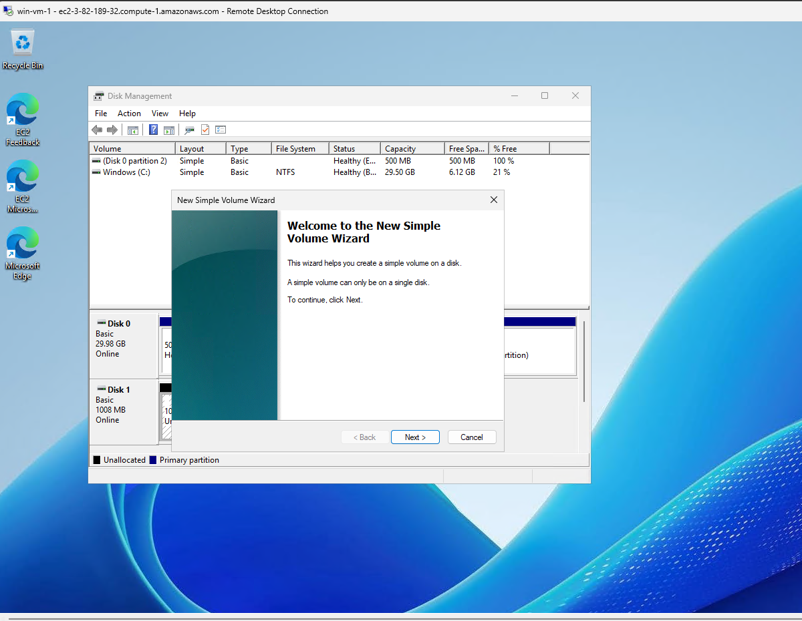
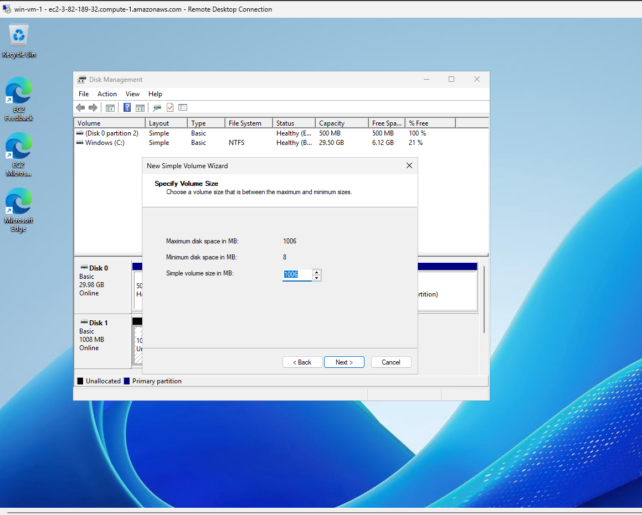
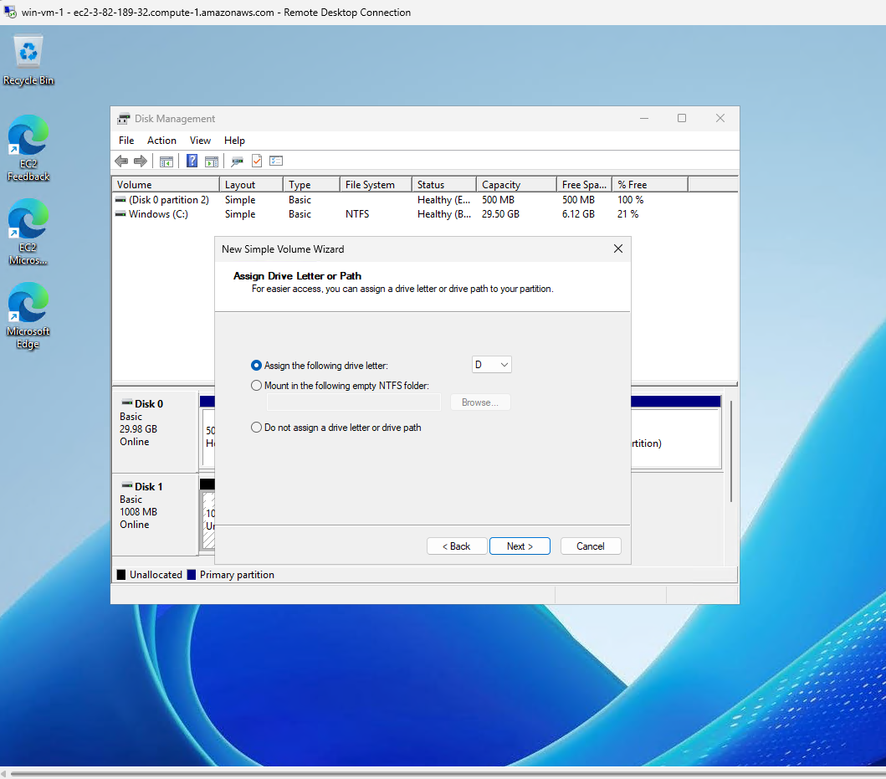
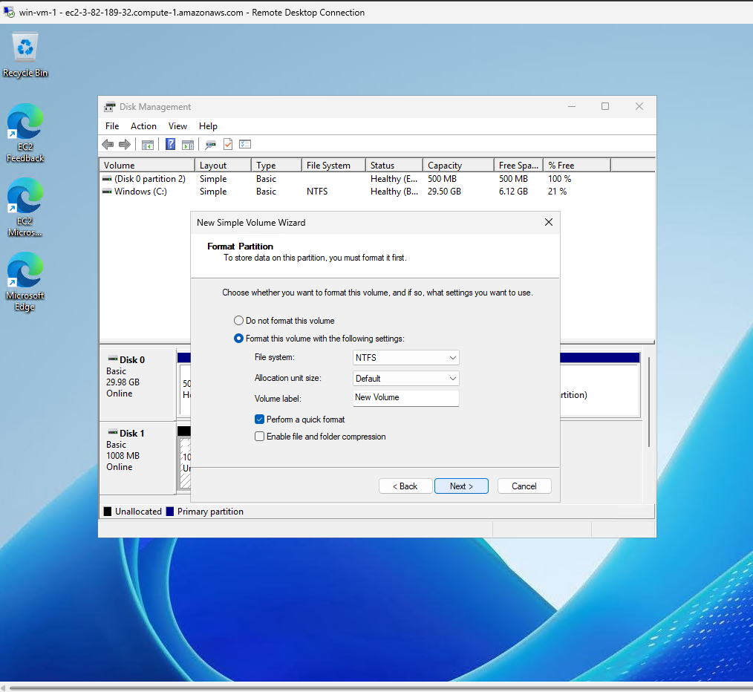
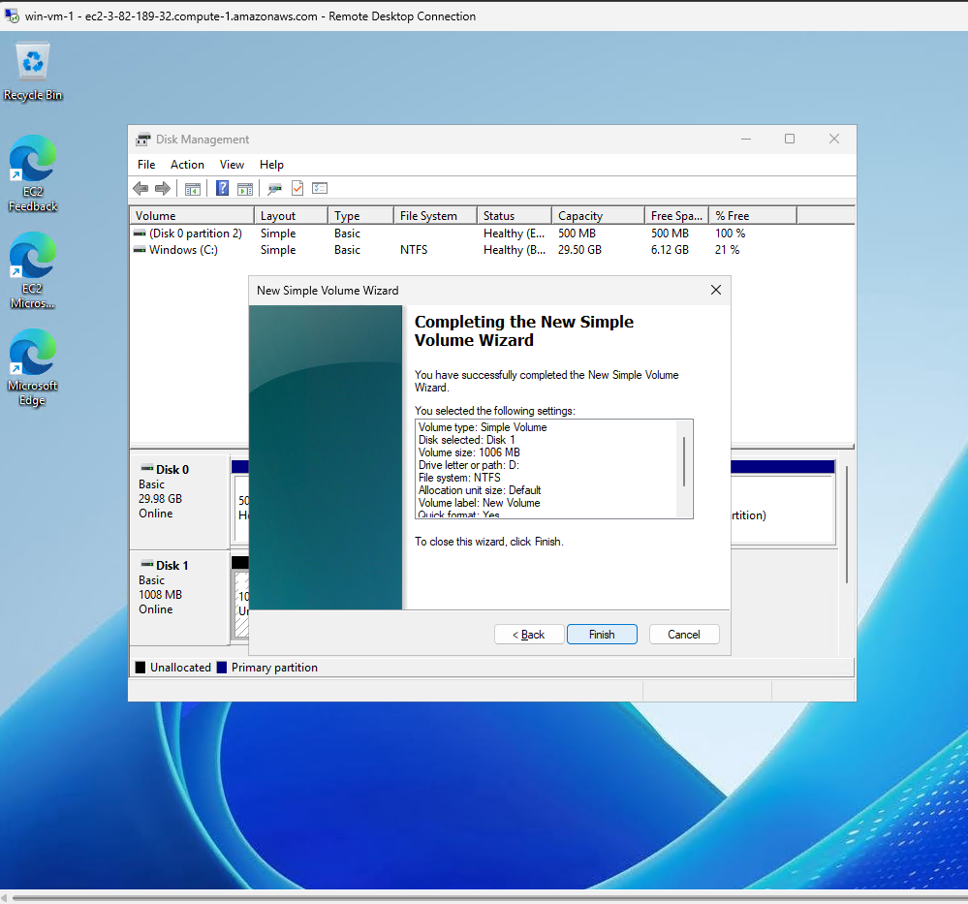

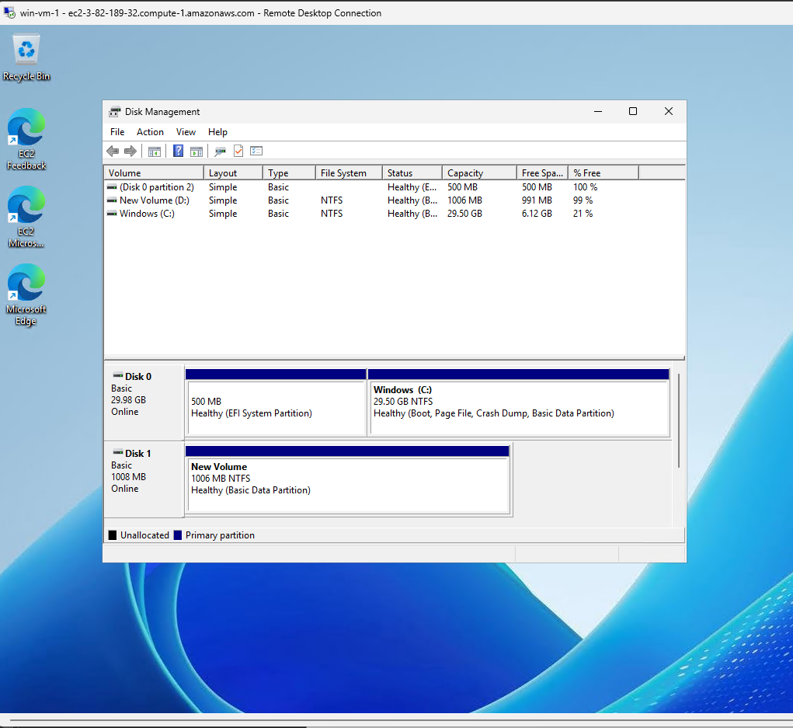
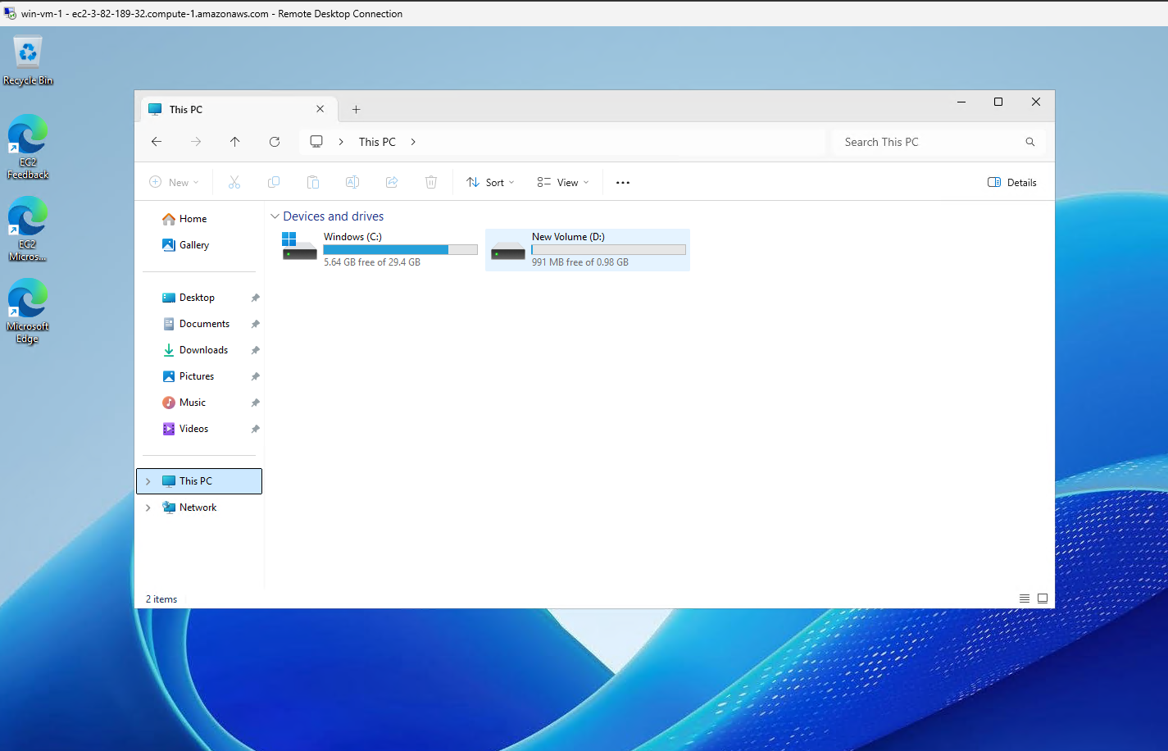

Create a file in the newly mounted volume as shown in the figure below;
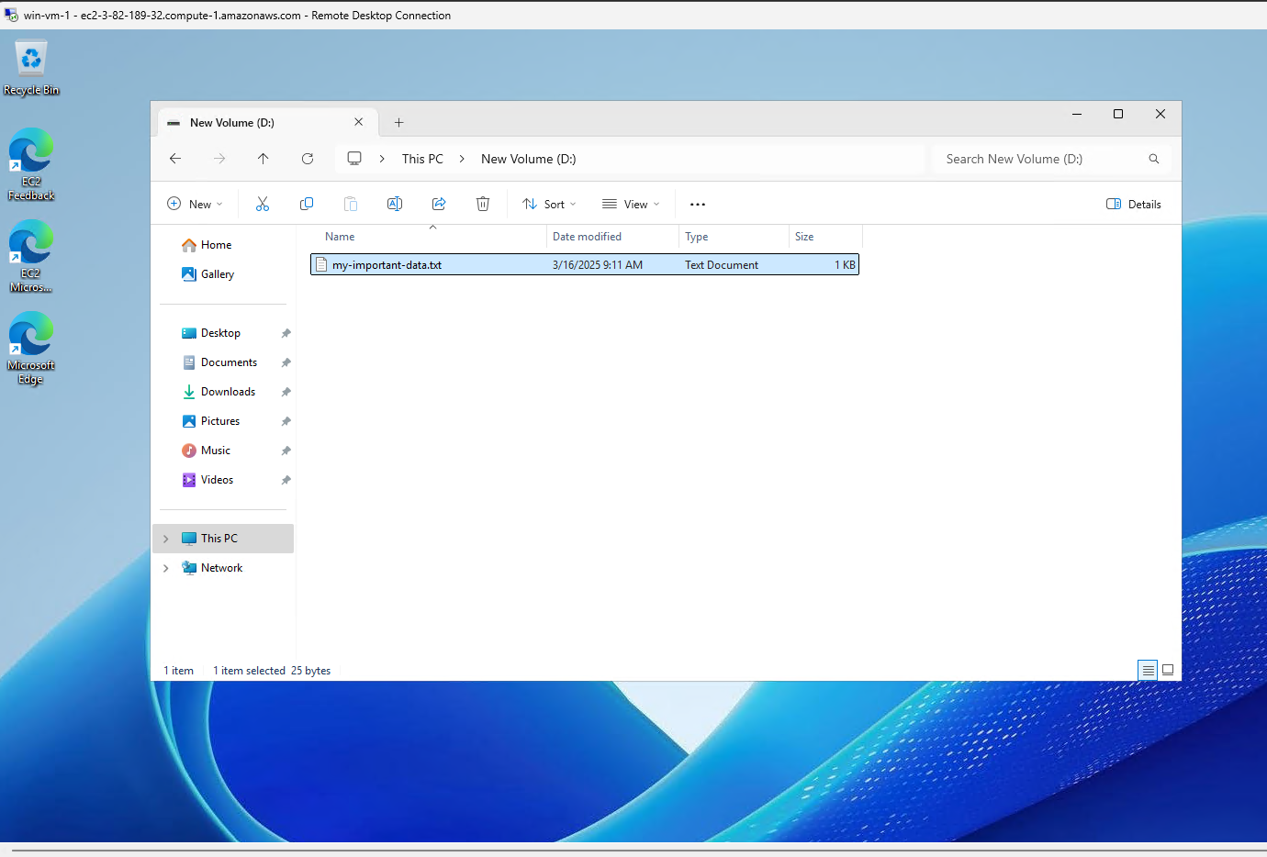

Now create a snapshot of the volume as follows;
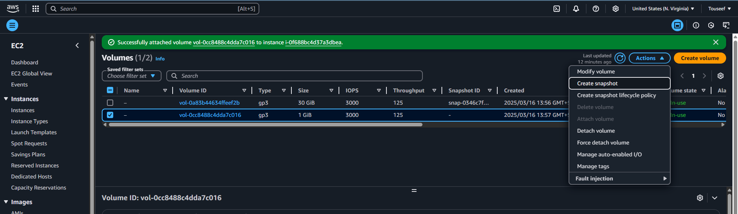
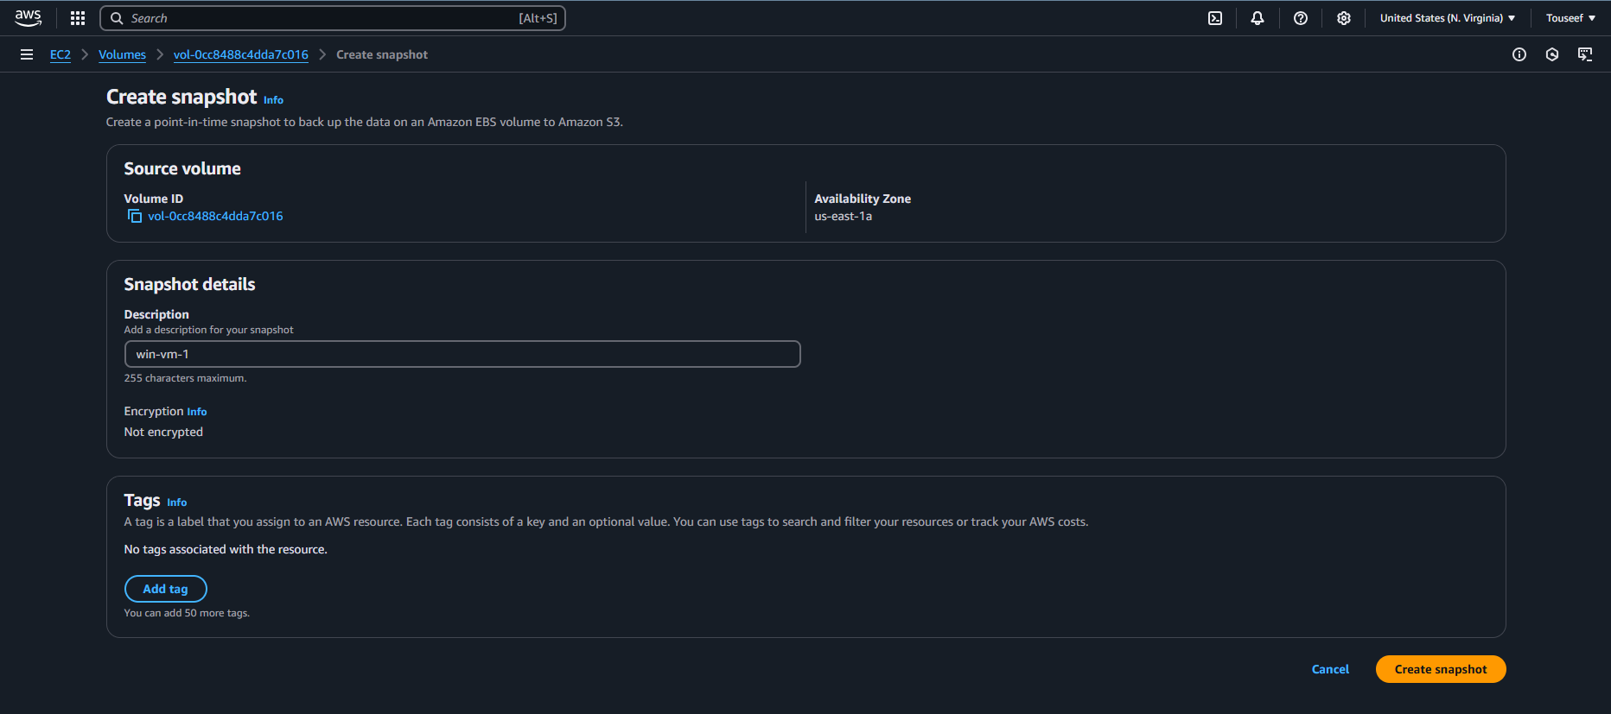

The snapshot will take time to finish. Make sure it’s finished from the progress and status of the snapshot as shown in the pictures below.
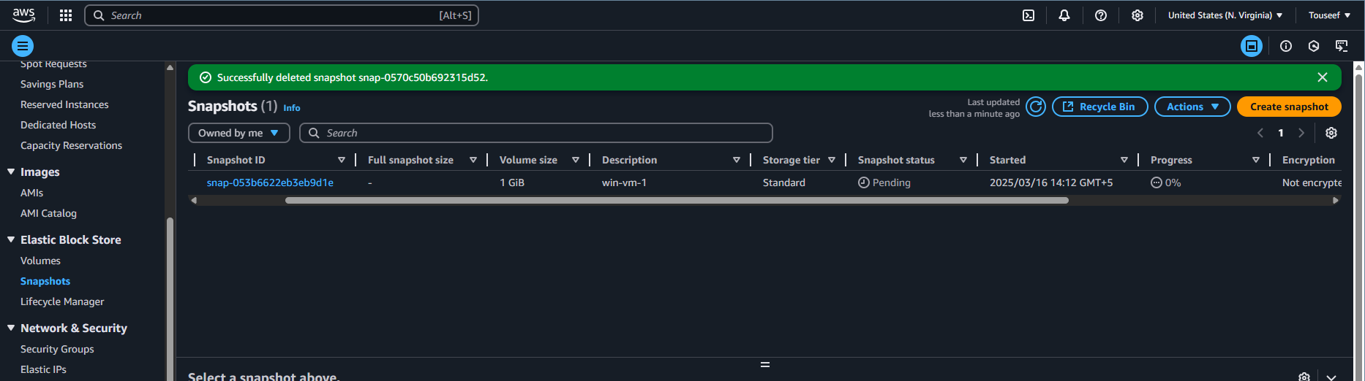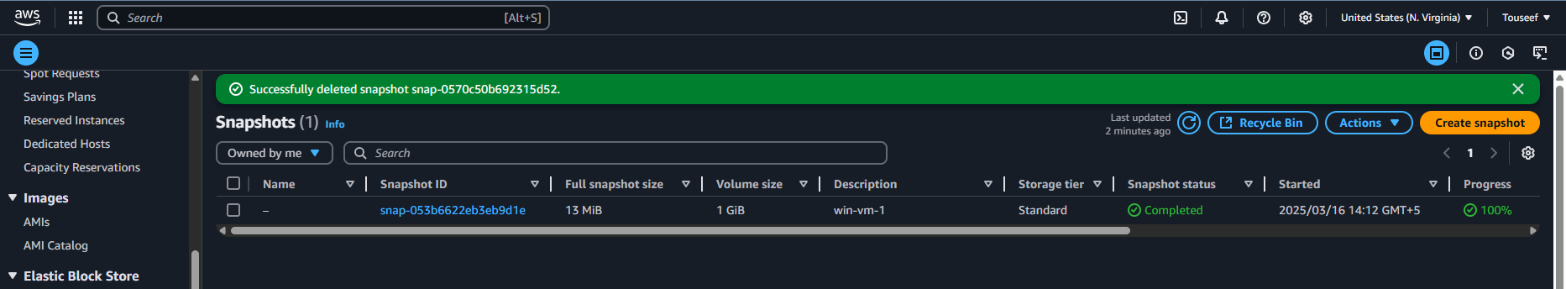

Now create a fresh windows VM using the setup described above in the zone us-east-1b by setting the subnet as shown below;
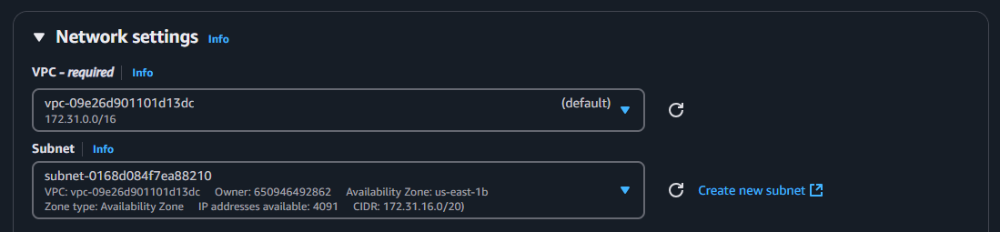

Create a volume from the snapshot (just taken) in the same zone as your instance. Refer to below diagrams for guidance.
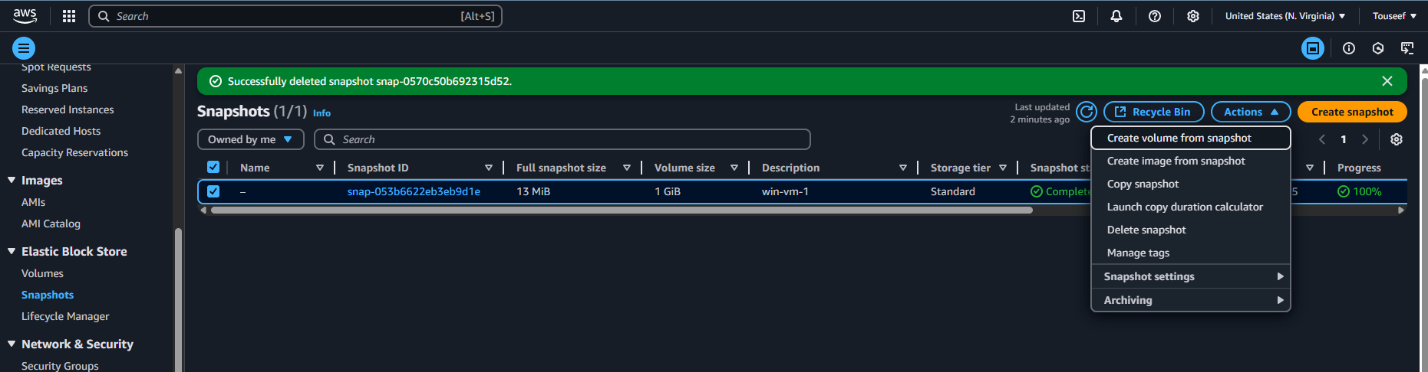
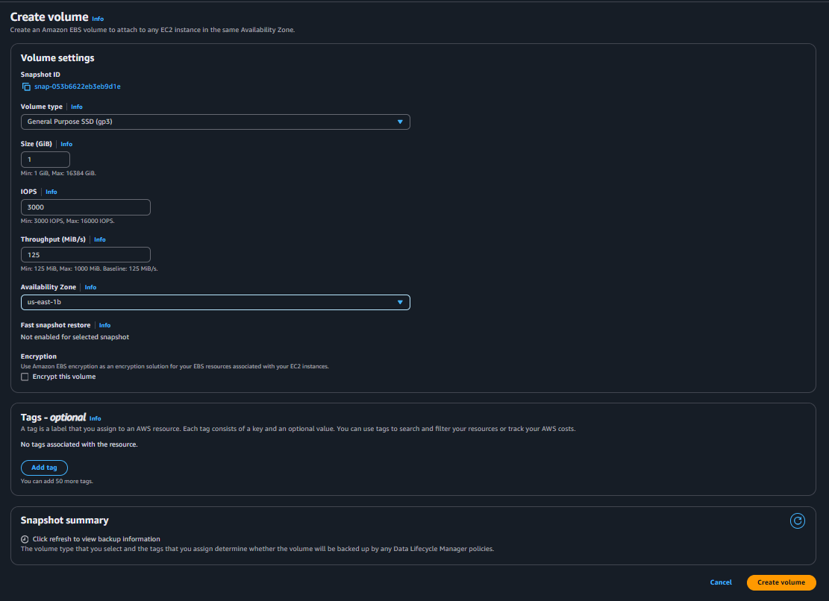
Now attach the newly created volume to newly created windows VM. Refer to the diagram below for guidance.

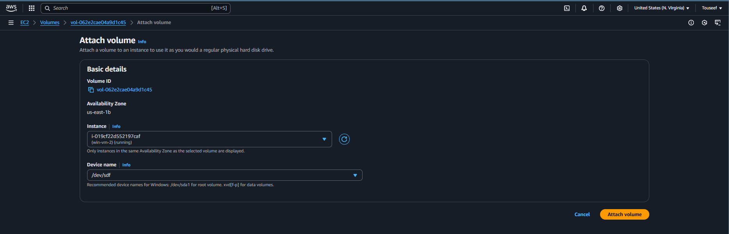

Now connect to your Windows VM using RDP client from your local machine and open the Disk Management Wizard as we did previously.
Now you can see that the new volume is already available and mounted on drive D. And inside the File Explorer, you will be able to see the same data.

