SOFTWARE DESIGN
DOCUMENT

Project Name: Procurement Intelligence
& Vendor Risk Platform
<Project Reference:>

Project Sponsor: | ChatGPT & Claude
Business Project Manager: | Toushif Hossain
IT Project Manager: | Toushif Hossain
Business Analyst: | Toushif Hossain

Document Author: | Toushif Hossain
Version Number: | V0.1
Last Updated: | 16/09/26
Status: | Draft/Released
DOCUMENT CONTROL
<Blue italic text is included to provide guidance to the author and should be deleted before publishing>
Contacts
<Contacts that would be useful to provide for business information>
Name: | <Contact name>
Title: | <Contact title>
Location: | <Where the contact can be located>
Contact Number: | <Contact internal/external number>
Email: | < The email correspondence for the contact>

Document Approval
<Enter details of all stakeholders who will be subject to approval of this document>
Approver | Title | Business Area | Approval Date

Document Distribution
<Enter details of all stakeholders who will be subject to receipt of this document for reference purposes>
Name | Title | Business Area

Revision History
<Initially a document will be numbered 0.1 to 0.9 until it becomes the first issue for approval at which point the document is numbered 1.0. For future updates the document will be numbered using decimals to 1 place until it adopts the next whole number for issue>
Date | Author | Version | Summary Of Changes | Status

Related Documents
<List any significant documents that precede and relate to the project>
Document Name | Version | Author | Date

<Not all of the following sections may be applicable to the work being performed. If so, the preference would be to keep the section heading, but make a note such as “This section is not applicable for this process” and provide an explanation for the reasons why>

Table of Contents

1 Introduction 4
1.1 Document Purpose 4
1.2 Document Scope 4
2 Database Design 4
2.1 Entity Relation Diagram 4
2.2 Logical Data Model 4
2.3 Physical Data Model 4
3 API Design 5
3.1 Endpoints 5
3.2 Payloads 5
3.3 Authentication 5
4 Component Design 5
4.1 Services 5
4.2 Modules 5
4.3 Responsibilities 5
4.3.1 Threat Model 5

Introduction

Document Purpose

Document Scope

Database Design

Entity Relation Diagram
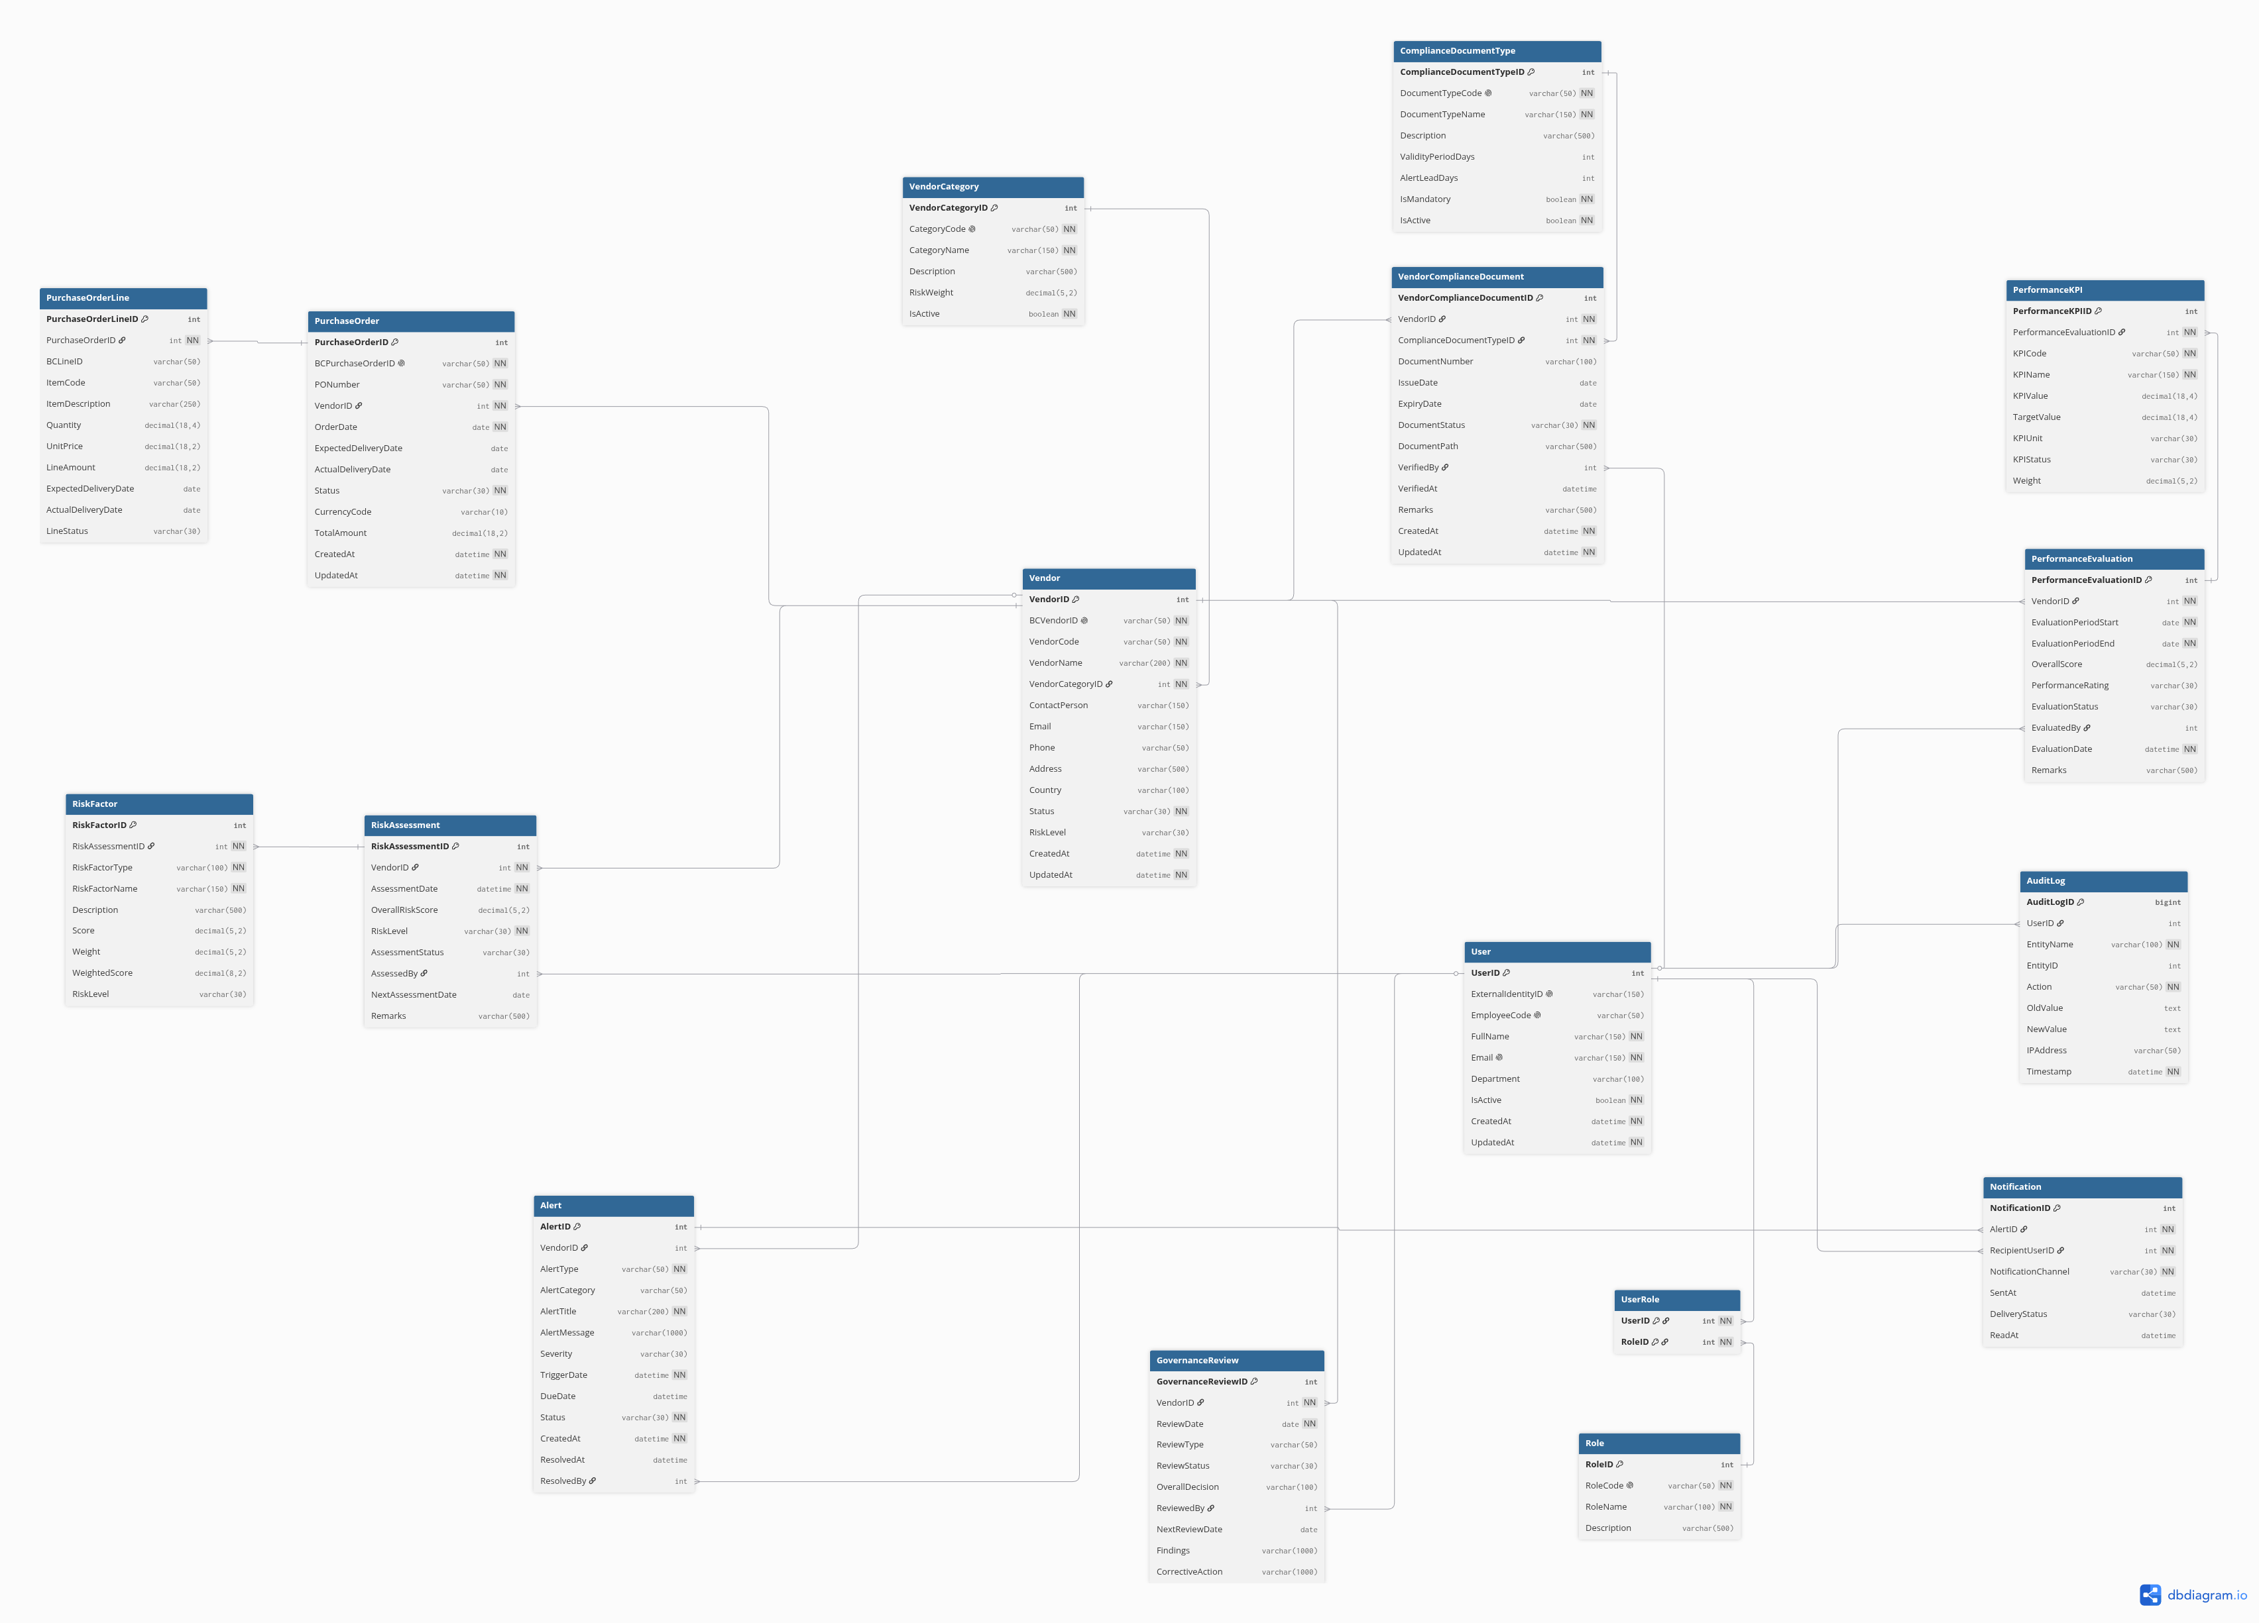

Logical Data Flow Diagram

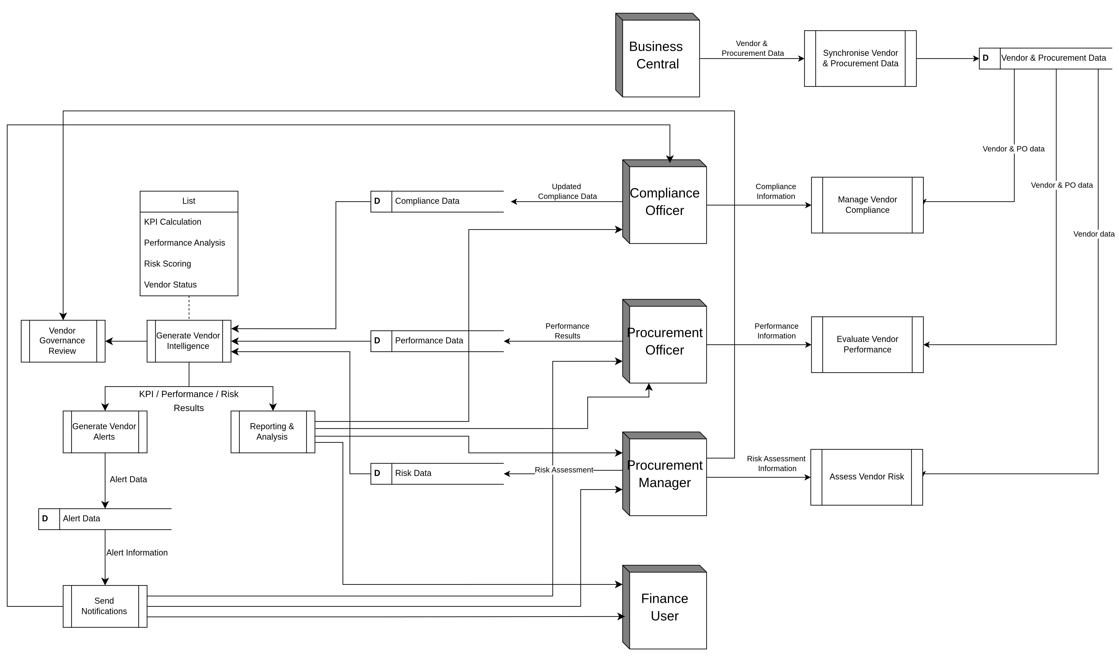

Physical Data Model

API Design

Endpoints

Payloads

Authentication

Component Design

Services

Modules

Responsibilities

Sequence Diagrams

Deployment Design

Error Handling

Logging & Monitoring

