SOLUTION ARCHITECTURE
DOCUMENT

Project Name: Procurement Intelligence
& Vendor Risk Platform
<Project Reference:>

Project Sponsor: | ChatGPT & Claude
Business Project Manager: | Toushif Hossain
IT Project Manager: | Toushif Hossain
Business Analyst: | Toushif Hossain

Document Author: | Toushif Hossain
Version Number: | V0.1
Last Updated: | 20/08/26
Status: | Draft/Released
DOCUMENT CONTROL
<Blue italic text is included to provide guidance to the author and should be deleted before publishing>
Contacts
<Contacts that would be useful to provide for business information>
Name: | <Contact name>
Title: | <Contact title>
Location: | <Where the contact can be located>
Contact Number: | <Contact internal/external number>
Email: | < The email correspondence for the contact>

Document Approval
<Enter details of all stakeholders who will be subject to approval of this document>
Approver | Title | Business Area | Approval Date

Document Distribution
<Enter details of all stakeholders who will be subject to receipt of this document for reference purposes>
Name | Title | Business Area

Revision History
<Initially a document will be numbered 0.1 to 0.9 until it becomes the first issue for approval at which point the document is numbered 1.0. For future updates the document will be numbered using decimals to 1 place until it adopts the next whole number for issue>
Date | Author | Version | Summary Of Changes | Status

Related Documents
<List any significant documents that precede and relate to the project>
Document Name | Version | Author | Date

<Not all of the following sections may be applicable to the work being performed. If so, the preference would be to keep the section heading, but make a note such as “This section is not applicable for this process” and provide an explanation for the reasons why>

Table of Contents

1 Introduction 5
1.1 Document Purpose 5
1.2 Document Scope 5
1.3 Document Audience 5
1.4 Definitions 6
2 Solution Architecture 7
2.1 Solution Objectives 7
2.2 Solution Scope 7
2.2.1 In Scope 7
2.2.2 Out of Scope 8
2.2.3 Assumptions 9
2.2.4 Constraints 9
2.2.5 Dependencies 9
2.2.6 Key Architecture Decisions 10
3 Business Context 11
3.1 Business Capabilities 11
3.2 Key Business Requirements 11
3.2.1 Key Business Processes 13
3.2.2 Business Users 19
3.3 Non-Functional Requirements 19
4 Conceptual Solution Overview 21
4.1 Conceptual Solution Architecture Diagram 21
5 Solution Architecture 22
5.1 Information Architecture 22
5.1.1 Data Object Inventory 22
5.1.2 System of Record vs System of Insight 22
5.2 Application Architecture 22
5.2.1 Application Inventory 22
5.3 Integration Architecture 22
5.3.1 Interface Inventory 22
5.4 Infrastructure Architecture 23
5.4.1 Infrastructure Repository 23
5.5 Security Architecture 23
5.5.1 Identity and Access Management 23
5.5.2 Threat Model 23

Introduction

Document Purpose
The purpose of this document is to define the target solution architecture for the proposed Procurement Intelligence & Vendor Risk Platform. This document describes the architectural approach, solution components, integrations, security considerations, information architecture, infrastructure requirements, and operational considerations required to deliver the business objectives identified within the approved Business Requirements Document (BRD).

The document serves as a reference for business stakeholders, solution architects, developers, testers, project managers, infrastructure teams, and support teams to ensure a common understanding of the proposed solution and its implementation approach.

Document Scope
This document covers the architecture and high-level design of the Procurement Intelligence & Vendor Risk Platform, including:

- Solution architecture principles and decisions.
- Business, application, information, integration, infrastructure, and security architecture.
- Integration with Microsoft Dynamics 365 Business Central.
- Vendor compliance management capabilities.
- Vendor performance monitoring capabilities.
- Vendor risk assessment capabilities.
- Power BI Reporting and notification capabilities.
- Operational and deployment considerations.

This document does not provide detailed technical specifications, database schemas, source code designs, or detailed user interface designs. These will be addressed in subsequent design and implementation artifacts.

Document Audience
This document is intended for the following stakeholders:

Stakeholder Group | Purpose
Business Sponsors | Review solution alignment with business objectives.
Procurement Management | Validate business capabilities and expected outcomes.
Finance and Compliance Teams | Review compliance, governance, and Power BI reporting requirements.
Solution Architects | Define and govern the overall solution architecture.
Technical Leads and Developers | Understand the target architecture and implementation approach.
Integration Specialists | Review integration architecture and interface requirements.
Infrastructure and Operations Teams | Review deployment, support, and operational requirements.
Quality Assurance Team | Understand solution scope and architecture for testing activities.
Project Management Team | Support planning, governance, and delivery activities.

Definitions
Term / Acronym | Definition
API | Application Programming Interface
BRD | Business Requirements Document
ERP | Enterprise Resource Planning
D365 BC | Microsoft Dynamics 365 Business Central
Power BI | Microsoft Power Business Intelligence
KPI | Key Performance Indicator
PO | Purchase Order
SLA | Service Level Agreement
Vendor Risk Score | A calculated measure representing the overall risk level associated with a vendor.
Compliance Document | A vendor document required to satisfy legal, regulatory, or organizational requirements.
Procurement Intelligence | The collection, analysis, and presentation of procurement and supplier-related information to support decision-making.
System of Record | The authoritative source system responsible for maintaining official business data. In this solution, Microsoft Dynamics 365 Business Central serves as the System of Record for vendor and procurement transaction data.
System of Insight | A system that consumes and analyzes business data to generate insights, dashboards, alerts, and decision support information. The Procurement Intelligence & Vendor Risk Platform serves as the System of Insight.
Risk Assessment | The process of evaluating vendor-related risk factors and calculating an overall risk score.
Integration Service | The application component responsible for data synchronization and communication between Business Central and the Procurement Intelligence Platform.
RBAC | Role-Based Access Control
Microsoft Entra ID | Microsoft's cloud-based identity and access management service used for authentication and authorization.

Architecture Principle:
For the purposes of this solution, Microsoft Dynamics 365 Business Central will remain the System of Record, while the Procurement Intelligence & Vendor Risk Platform will operate as the System of Insight and Power BI will operate as reporting system, providing compliance monitoring, performance analysis, risk assessment, Power BI reporting, and decision-support capabilities. This principle guides all subsequent architectural decisions within this document.

Solution Architecture

Solution Objectives
The primary objective of the Procurement Intelligence & Vendor Risk Platform is to provide a centralized solution for monitoring, assessing, and managing vendor compliance, performance, and risk information by leveraging procurement data maintained within Microsoft Dynamics 365 Business Central.

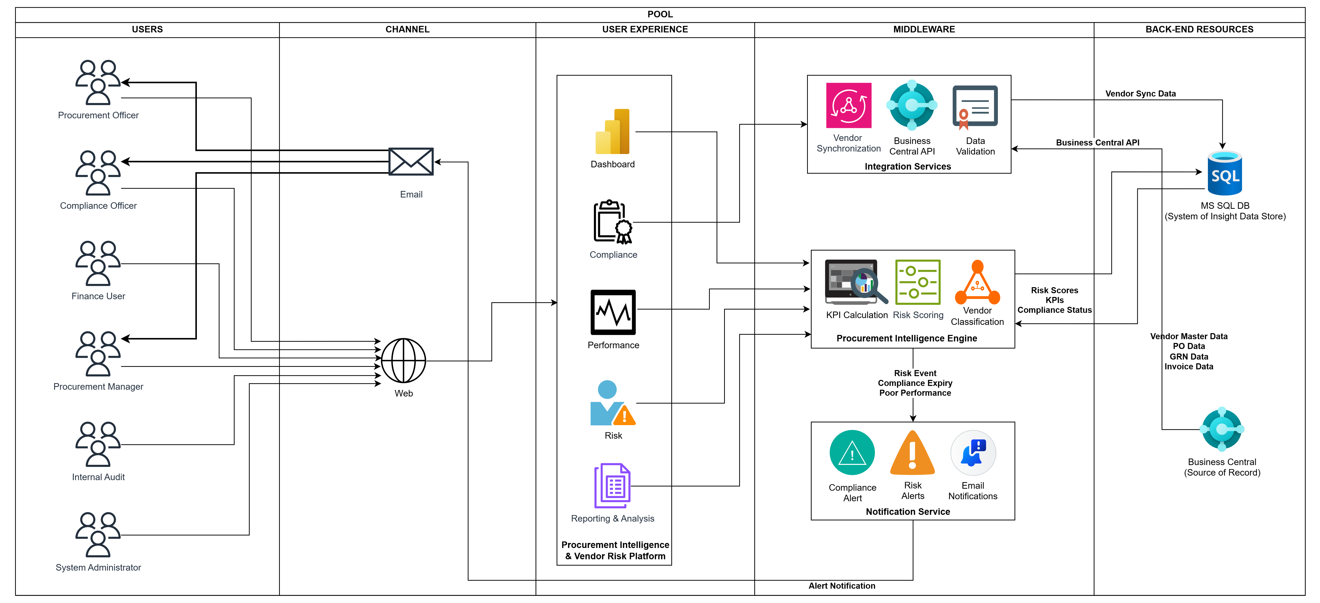

The solution aims to:
- Improve visibility into vendor compliance status and document validity.
- Enable proactive identification of high-risk vendors.
- Standardize vendor performance measurement through defined KPIs.
- Provide management with actionable procurement insights through dashboards and Power BI reporting.
- Reduce manual effort associated with vendor monitoring and Power BI reporting activities.
- Support data-driven procurement and supplier management decisions.
- Establish a scalable foundation for future procurement intelligence and supplier governance capabilities.

Solution Scope

In Scope
The following capabilities are included within the scope of this solution:

Vendor Management
- Vendor master data synchronization from Microsoft Dynamics 365 Business Central.
- Vendor profile management and categorization.
- Centralized vendor information repository.

Compliance Management
- Vendor compliance document management.
- Document upload and maintenance.
- Document expiry tracking.
- Compliance status monitoring.
- Compliance alert generation.

Performance Management
- Vendor performance KPI calculation.
- On-time delivery measurement.
- Purchase order fulfillment measurement.
- Performance scorecard generation.
- Historical performance tracking.

Risk Management
- Vendor risk assessment.
- Automated vendor risk score calculation.
- Risk categorization and classification.
- High-risk vendor identification.
- Risk trend monitoring.

Power BI Reporting and Notifications
- Compliance dashboards.
- Performance dashboards.
- Risk dashboards.
- Management reporting.
- Automated notifications and alerts.

Integration
- Integration with Microsoft Dynamics 365 Business Central through supported APIs.
- Vendor and procurement data synchronization.
- Integration monitoring and logging.

Out of Scope
The following items are not included within the scope of the initial solution release:
- Modification of standard Microsoft Dynamics 365 Business Central procurement processes.
- Purchase order creation or approval workflows.
- Vendor self-service portal.
- Vendor onboarding workflow automation.
- Supplier contract management.
- AI or machine learning-based risk prediction.
- Mobile application development.
- External supplier collaboration features.
- Integration with third-party procurement systems.
- Financial risk assessment using external credit agencies.
- Automated supplier audits.
- Real-time event-driven integration with external systems (future consideration).

Assumptions
The following assumptions have been made during solution definition:

Ref | Assumption
A01 | Microsoft Dynamics 365 Business Central is the authoritative source of vendor and procurement transaction data.
A02 | Required Business Central APIs are available and accessible for integration.
A03 | Vendor performance KPIs can be derived from existing procurement transaction data.
A04 | Compliance documents will be maintained by authorized business users.
A05 | Business stakeholders will define and approve risk scoring rules and thresholds.
A06 | Users have access to corporate authentication services.
A07 | Required procurement data is of sufficient quality to support KPI and risk calculations.
A08 | Historical procurement data required for performance calculations is available within Business Central.

Constraints
The solution must operate within the following constraints:

Ref | Constraint
C01 | Microsoft Dynamics 365 Business Central must remain the System of Record.
C02 | Existing procurement processes within Business Central must not be disrupted or replaced.
C03 | Integration must utilize supported Business Central APIs and authentication mechanisms.
C04 | The initial solution must be implementable using available technology and licensing constraints.
C05 | Access to procurement and vendor information must comply with organizational security policies.
C06 | Risk scoring methodologies must be transparent and explainable to business users.
C07 | The solution should be maintainable by internal technical teams.
C08 | Initial implementation should prioritize core compliance, performance, and risk capabilities before advanced analytics.

Dependencies
The successful implementation of the solution depends on the following:

Ref | Dependency
D01 | Availability of Microsoft Dynamics 365 Business Central APIs.
D02 | Availability of vendor master and procurement transaction data.
D03 | Business approval of KPI definitions and calculation methods.
D04 | Business approval of vendor risk scoring criteria and thresholds.
D05 | Availability of infrastructure and hosting environments.
D06 | Availability of user authentication and access management services.
D07 | User participation in testing, validation, and acceptance activities.
D08 | Availability of compliance requirements and document standards.

Key Architecture Decisions
The following architecture decisions have been established to guide solution design and implementation.

Ref | Architecture Decision | Rationale
AD01 | Microsoft Dynamics 365 Business Central will remain the System of Record. | Prevents duplication of transactional ownership and preserves ERP governance.
AD02 | The Procurement Intelligence & Vendor Risk Platform will act as the System of Insight. | Separates operational processing from analytical and monitoring capabilities.
AD03 | The solution will be implemented as a Modular Monolithic .NET application. | Simplifies development, deployment, and maintenance while supporting future scalability.
AD04 | SQL Server will be used as the primary application database. | Aligns with Microsoft technology stack and enterprise standards.
AD05 | Integration with Business Central will use REST-based APIs. | Utilizes supported Microsoft integration mechanisms.
AD06 | The initial integration model will be read-only from Business Central to the platform. | Reduces implementation risk and protects ERP transactional integrity.
AD07 | Vendor compliance, performance, and risk data will be managed within the platform database. | Establishes clear ownership boundaries for analytical data.
AD08 | Role-Based Access Control (RBAC) will be implemented. | Supports secure access management and segregation of duties.
AD09 | All external communication will be secured using HTTPS/TLS encryption. | Ensures protection of data in transit.
AD10 | Automated notifications will be generated for compliance and risk events. | Supports proactive vendor governance and monitoring.
AD11 | The architecture will support future event-driven integration enhancements. | Enables future scalability without redesigning the core solution.
AD12 | Audit logging will be implemented for critical business actions and data changes. | Supports governance, compliance, and traceability requirements.

Business Context

Business Capabilities
The Procurement Intelligence & Vendor Risk Platform will provide business capabilities that support vendor governance, compliance management, performance monitoring, and risk management activities. These capabilities enable procurement stakeholders to make informed decisions using centralized vendor intelligence.

Capability Area | Description
Vendor Management | Maintain and monitor vendor profiles, classifications, and vendor-related information.
Vendor Compliance Management | Track compliance documents, monitor validity periods, and identify non-compliant vendors.
Vendor Performance Management | Measure vendor performance using standardized procurement KPIs and scorecards.
Vendor Risk Management | Assess and monitor vendor risk based on compliance, performance, and defined risk factors.
Procurement Intelligence | Generate insights, trends, and analytics to support procurement decision-making.
Power BI Reporting & Dashboarding | Provide operational and management reporting through dashboards and visualizations.
Alert & Notification Management | Generate automated alerts for compliance expiries, risk events, and performance issues.
Audit & Governance | Maintain historical records, audit trails, and governance information for vendor management activities.

Key Business Requirements
The following business requirements have been identified as critical to achieving the objectives of the solution.

ID | Business Requirement
BR01 | The business shall maintain a centralized view of vendor information.
BR02 | The business shall monitor vendor compliance status and document validity.
BR03 | The business shall receive proactive alerts for expiring compliance documents.
BR04 | The business shall measure vendor performance using defined KPIs.
BR05 | The business shall evaluate vendors using a standardized risk assessment framework.
BR06 | The business shall identify high-risk vendors for corrective action.
BR07 | Management shall have access to vendor performance, compliance, and risk dashboards.
BR08 | The solution shall maintain historical vendor performance and risk information.
BR09 | Vendor-related activities and changes shall be auditable.
BR10 | Procurement users shall be able to generate management reports and operational insights.
BR11 | Vendor risk assessments shall be based on defined business rules and measurable criteria.
BR12 | The solution shall support data-driven procurement decision-making.

Key Business Processes
The solution supports the following key business processes.
High-Level Flow
Vendor Data Synchronization
Purpose: Maintain synchronized vendor and procurement data between Microsoft Dynamics 365 Business Central and the Procurement Intelligence Platform.

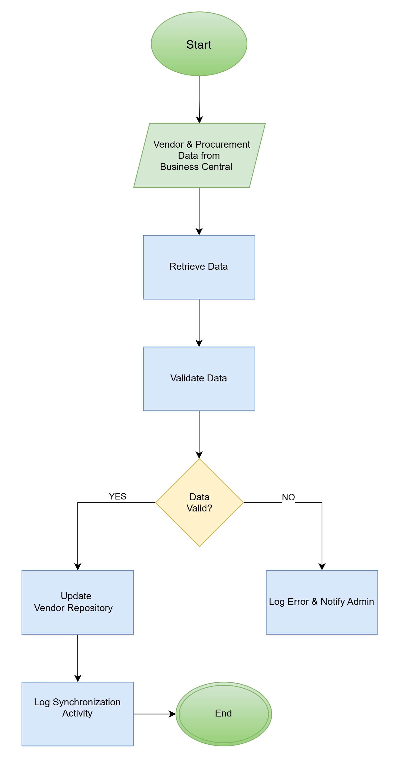

Vendor Compliance Management
Purpose: Maintain an accurate and up-to-date vendor repository.

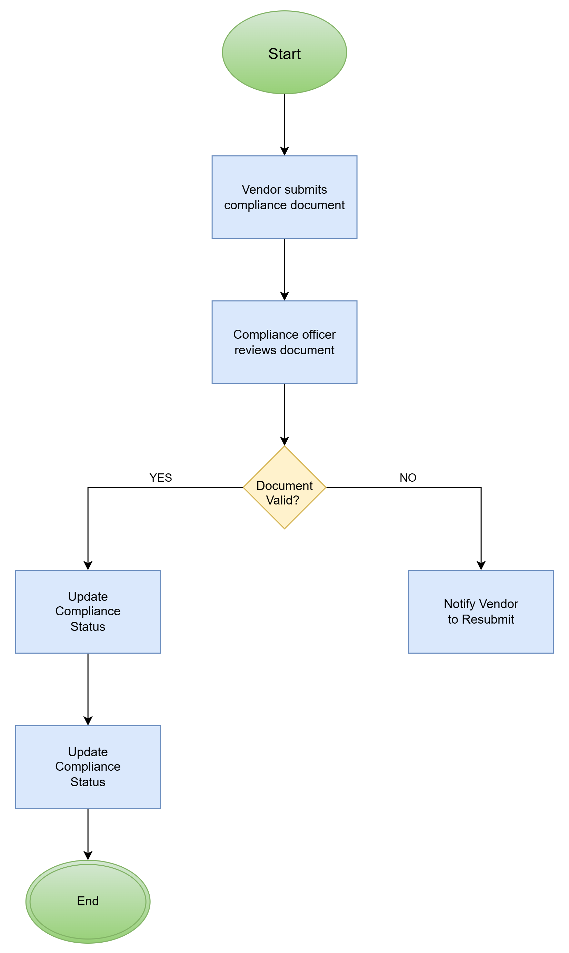

Vendor Performance Evaluation
Purpose: Measure vendor performance using procurement KPIs.

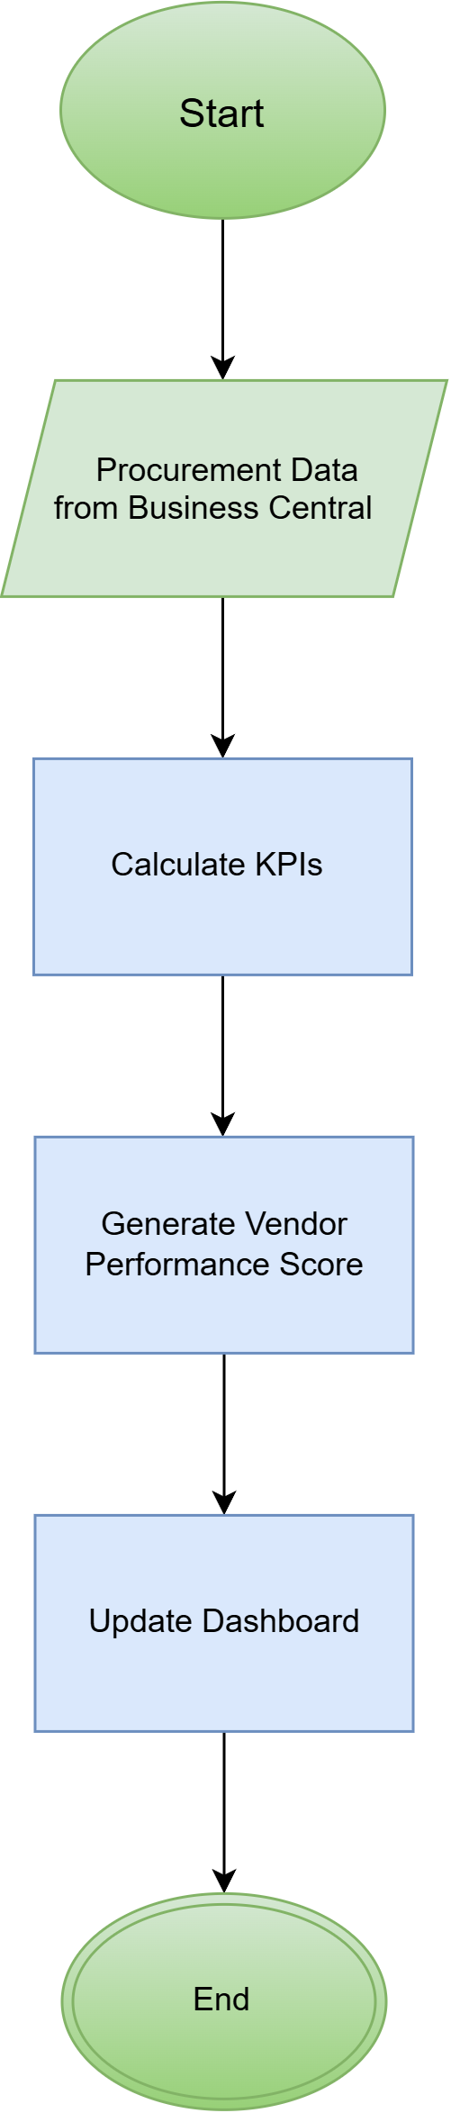

Vendor Risk Assessment
Purpose: Identify and classify vendor risk levels.

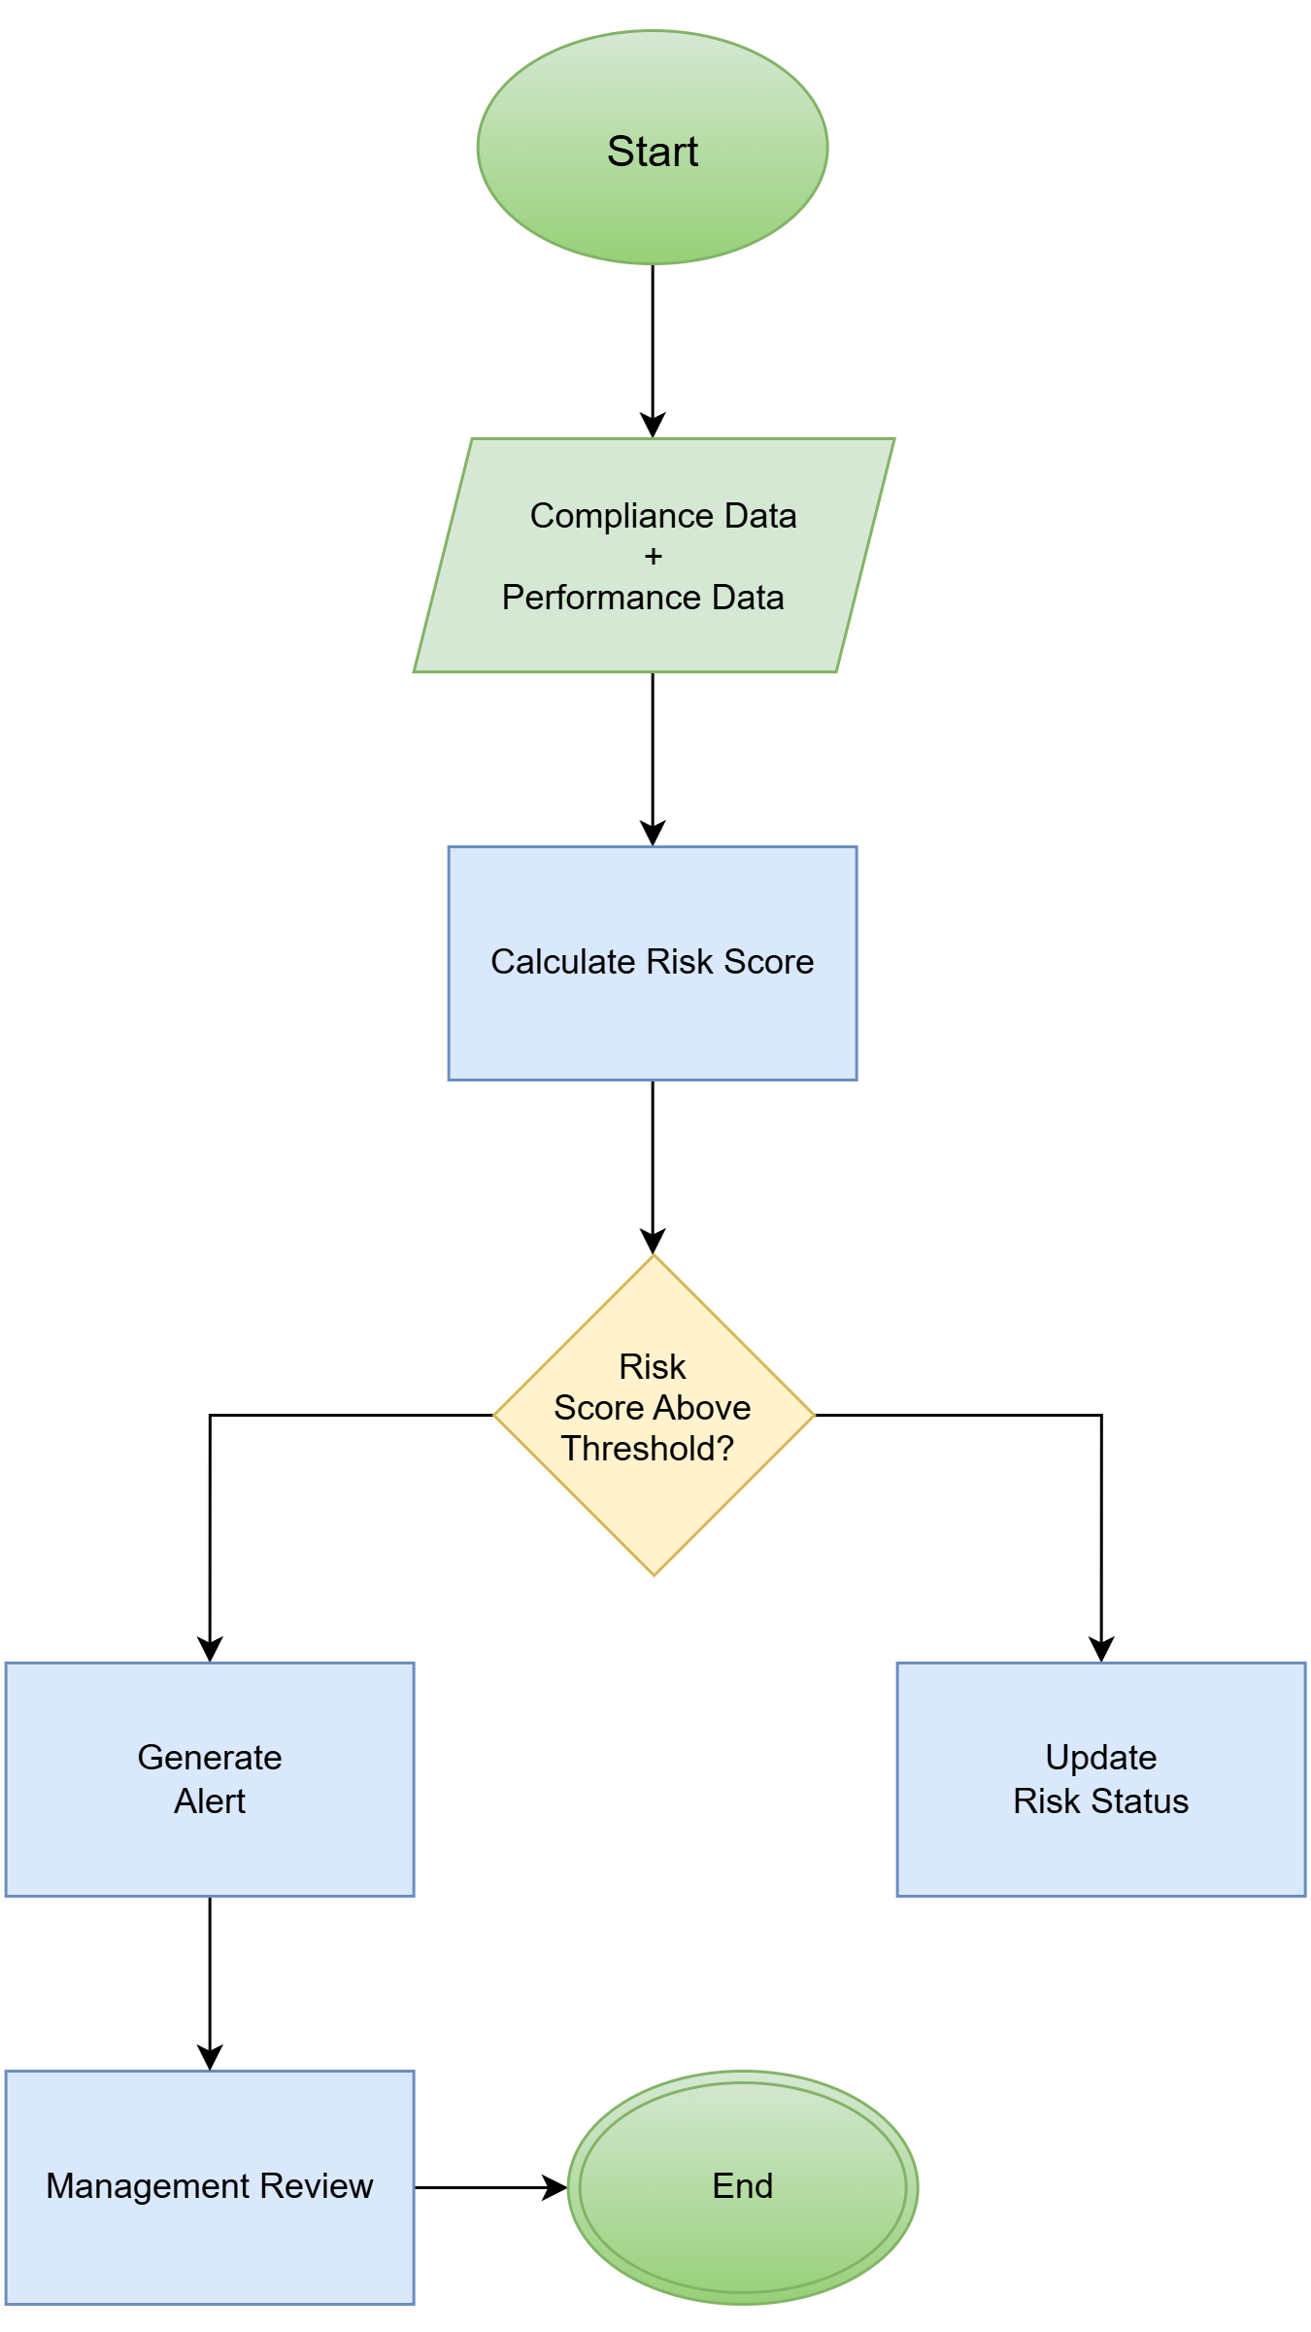

Power BI Reporting & Alert Management
Purpose: Provide visibility into vendor compliance, performance, and risk information while proactively notifying stakeholders of critical events.

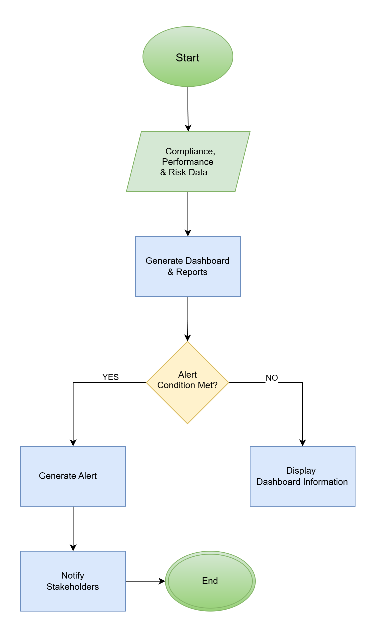
Vendor Governance Review
Purpose: Enable management to review vendor performance, compliance, and risk status and determine appropriate corrective actions.

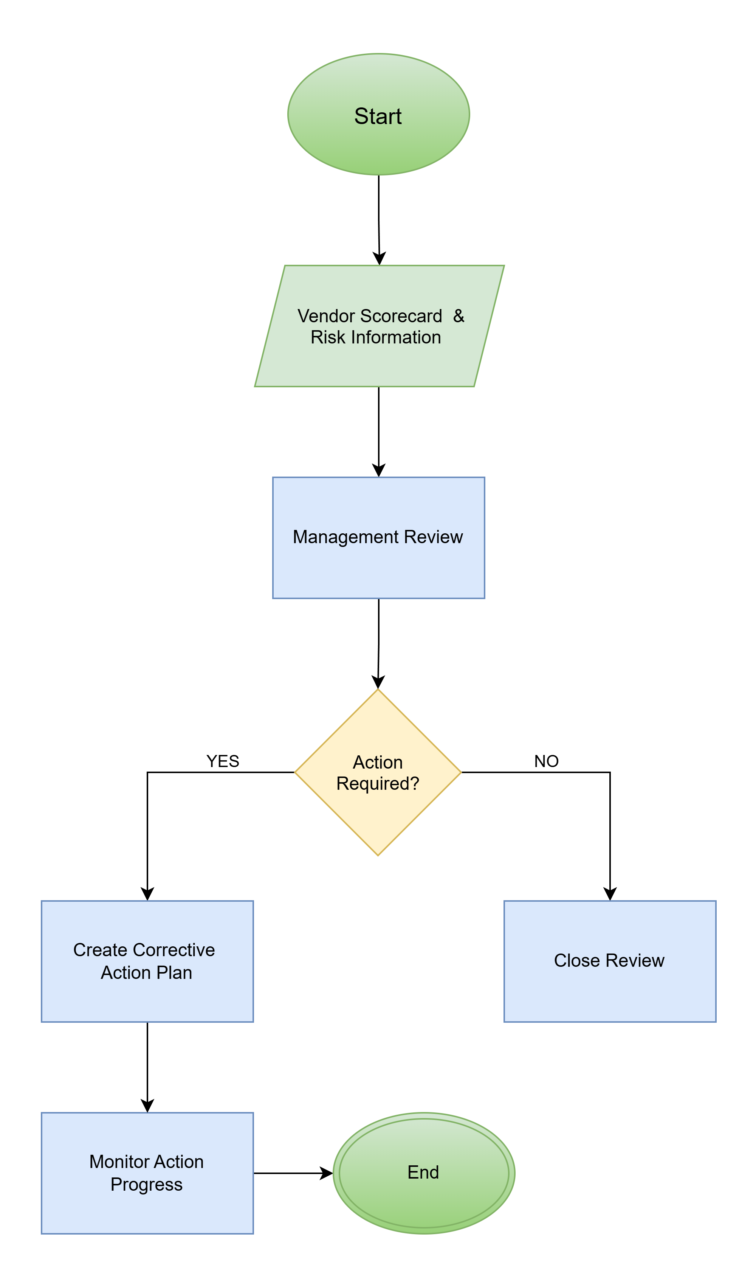

Business Users
The following business users will interact with the solution.

User Group | Responsibilities
Procurement Officer | Maintain vendor information, review compliance status, monitor vendor performance, and respond to alerts.
Procurement Manager | Review vendor performance, approve risk actions, monitor procurement KPIs, and manage vendor governance activities.
Compliance Officer | Manage compliance requirements, review vendor documentation, and monitor compliance violations.
Finance User | Review vendor payment-related information and support financial compliance reviews where required.
Internal Audit | Review audit logs, compliance records, and vendor governance activities.
Management / Executives | Review dashboards, risk summaries, vendor performance trends, and strategic procurement insights.
System Administrator | Manage system configuration, user access, security settings, and operational support activities.

Non-Functional Requirements
The solution shall comply with the following high-level non-functional requirements.

Security
- User authentication shall be required before accessing the application.
- Access shall be controlled using Role-Based Access Control (RBAC).
- All data transmitted between systems shall be encrypted using HTTPS/TLS.
- Sensitive information shall only be accessible to authorized users.

Audit
- Changes to vendor information, compliance records, and risk assessments shall be auditable.
- Audit logs shall record user identity, timestamp, previous value, and new value

Performance
- Standard application pages shall load within 5 seconds under normal operating conditions.
- Vendor dashboards shall load within 5 seconds.
- Risk calculations shall complete within 60 seconds for active vendors.

Availability
- The solution shall be available during business operating hours.
- Target availability shall be 99% excluding planned maintenance windows.

Reliability
- Integration failures shall be logged and retried where applicable.
- System errors shall be captured and monitored for support purposes.

Recovery
- Application data shall be backed up daily.
- Recovery Time Objective (RTO): 4 Hours.
- Recovery Point Objective (RPO): 24 Hours.

Compatibility
- The solution shall integrate with Microsoft Dynamics 365 Business Central using supported APIs.
- The application shall support Microsoft Edge, Google Chrome, and Mozilla Firefox.

Maintainability
- The solution shall follow modular architecture principles.
- Components shall be designed to support future enhancements and integrations.

Usability
- The application shall provide an intuitive user interface requiring minimal user training.
- Dashboard and reporting functions shall present information in a clear and consistent format.

Conceptual Solution Overview

Conceptual Solution Architecture Diagram

Solution Architecture

Information Architecture

Data Object Inventory
Data Object | Description | System of Record
Vendor | Vendor master information | Business Central
Purchase Order | Procurement orders | Business Central
Goods Receipt | Receipt transactions | Business Central
Purchase Invoice | Vendor invoices | Business Central
Compliance Document | Vendor certificates and licenses | Vendor Risk Platform
KPI Score | Calculated performance metrics | Vendor Risk Platform
Risk Score | Vendor risk assessment result | Vendor Risk Platform
Alert | Compliance/risk notifications | Vendor Risk Platform

System of Record vs System of Insight
Data Object | System of Record | System of Insight
Vendor | Business Central | Vendor Risk Platform
Purchase Orders | Business Central | Vendor Risk Platform
Invoices | Business Central | Vendor Risk Platform
Compliance Documents | Vendor Risk Platform | Vendor Risk Platform
KPI Scores | Vendor Risk Platform | Vendor Risk Platform
Risk Scores | Vendor Risk Platform | Vendor Risk Platform

Application Architecture

Application Inventory

Application | Type | Purpose
Business Central | SaaS ERP | Source procurement data
Vendor Risk Platform | Web Application | User-facing application
Integration Service | Middleware Service | Data synchronization
Procurement Intelligence Engine | Business Service | KPI & Risk calculations
Notification Service | Business Service | Alerts and notifications
SQL Database | Database | Analytical data storage

Integration Architecture

Interface Inventory
ID | Source | Target | Interface Type
INT-01 | Business Central | Integration Service | REST API
INT-02 | Integration Service | SQL Database | Data Sync
INT-03 | Intelligence Engine | SQL Database | Database Access
INT-04 | Intelligence Engine | Notification Service | Event
INT-05 | Notification Service | Email | SMTP/API

Infrastructure Architecture

Infrastructure Repository
Component | Hosting Location
Business Central | Microsoft SaaS
Vendor Risk Platform | Azure App Service
Integration Service | Azure App Service
Intelligence Engine | Azure App Service
Notification Service | Azure App Service
SQL Database | Azure SQL Database

Security Architecture

Identity and Access Management
- Microsoft Entra ID Authentication
- Role-Based Access Control (RBAC)
- Multi-Factor Authentication (MFA)

Roles:
- Procurement Officer
- Compliance Officer
- Finance User
- Procurement Manager
- Internal Audit
- System Administrator

Threat Model
Threat | Mitigation
Spoofing | MFA
Tampering | TLS/HTTPS
Repudiation | Audit Logs
Information Disclosure | RBAC
Denial of Service | Rate Limiting
Elevation of Privilege | Least Privilege

